
Shared: Test User
Setup Guide

Last Revised: March 6, 2024
Applies to these SAP Concur solutions:
 Expense
 Professional/Premium edition
 Standard edition
 Travel
 Professional/Premium edition
 Standard edition
 Invoice
 Professional/Premium edition
 Standard edition
 Request
 Professional/Premium edition
 Standard edition

Table of Contents
Section 1: Permissions 1
Section 2: Overview 1
Safeguards 2
Banner in User Interface for Test User 2
What the Test User Feature Can and Cannot Do 2
Section 3: Before You Begin 3
Best Practices 3
Required Roles 4
Users with a Proxy Role 5
Section 4: Working With the Test User Feature 5
Creating the Test User: Configure and Add the Is a Test User? Field 6
Creating the Test User: Assigning the Test User Status 8
Cloning Test Users 9
Searching for Test Users 11
Using the Test User Feature Under Travel 12
Using the Test User Feature Under Single Sign On (SSO) 12
Disabling (Deactivating) Test Users 13
Section 5: Concur Travel Testing 13
Overview 13
Benefits 13
Configuration 13
Testing Guidelines 15
Purging Test Transactions from the System 15
Purging Test User Data From the System 16
Section 6: Appendix A—Testing Guide for Specific Features 16
Working with Groups 16
Leveraging Groups with Test User 16
About Group Configurations 16
Using Groups and Group Configurations 17
Group-Aware Configurations 17
Non-Group Aware Configurations 18
Expense: Working With Credit Card Test Transactions 18
About Credit Card Test Transactions 18
Creating the Test Credit Card Transaction Type 19
Creating a Test Credit Card Import 19
Creating the Test Payment Type 20
Configuring Test Administrators 21
Assigning Test Accounts and Transactions to Test Users 21
Working with Extracts 22
Creating a Test User-Only Extract 22
Excluding Test Transactions from a Production Extract 22
Section 7: Appendix B—List of Tables Affected by Purge 23

Revision History
Date | Notes/Comments/Changes
March 6, 2024 | Added a note that Test User accounts can also be created via Employee Import.
October 1, 2022 | Updated content for the new user experience.
March 7, 2022 | Added a note to the overview that test user transactions are not billable.
January 21, 2022 | Updated the copyright year; no other changes; cover date not updated
April 15, 2021 | Updated the copyright year; no other changes; cover date not updated
July 1, 2020 | Updated information about the existing UI and NextGen UI; made modifications throughout; cover revision date updated
April 27, 2020 | Renamed the Authorization Request check box to Request on the guide’s title page; cover date not updated
January 15, 2020 | Updated the copyright; no other changes; cover date not updated
November 1, 2019 | Updated the SAP Concur Sign In page images
April 2, 2019 | Changed the term "Concur" to "SAP Concur".
March 20, 2019 | Changed the term "payment request" to "invoice" where applicable; no other content changes.
February 11, 2019 | Updated the copyright; no other changes; cover date not updated
October 29, 2018 | Added information about the existing UI and NextGen UI; updated screen shot with new SAP Concur logo; cover revision date updated
April 16, 2018 | Changed the check boxes on the front cover; no other changes; cover date not updated
January 13 2018 | Updated the section Cloning Test Users because the functionality described now also applies to Expense.
December 14 2016 | Changed copyright and cover; no other content changes.
October 27 2016 | Updated the guide content to new corporate style; no content changes.
November 16 2015 | Added clarification around proxies
November 12 2015 | Updated the About Credit Card Test Transactions section.
March 13 2015 | Added new Concur Travel Testing section.
February 17 2015 | Removed references to the current UI; made general updates to the content
December 12 2014 | Added information about cloning test users
October 10 2014 | Added information about the two user interfaces; no other content changes
September 12 2014 | The Invoice Configuration administrator (Unrestricted) may now purge test user data using options in the Purge Test User Transactions window.
July 17 2014 | Updates to explain that this feature is available to the Invoice product
January 23 2014 | Cover and copyright changes; no other content changes
February 27 2013 | Name change from "Travel Request" to "Request" – no other content changes
February 22 2013 | Test user may now delete Company Card transactions, Trip Segments (without creating an expense report) and E-Receipts (Smart Receipts)
December 28 2012 | Made rebranding and/or copyright changes; no content changes
July 13 2012 | The User Administrator can now search for a Test User using the Expense Test Users filter in User Administration.
February 2012 | Changed copyright; no content change
December 31 2010 | Updated the copyright and made rebranding changes; no content changes
Oct. 15 2010 | A Purge action will now purge transactional data for both active and inactive users - prior to this the user had to be active in order for the system to purge the transactions they are associated with
Aug. 19 2010 | Convert to Shared Setup Guide - can be used across the Expense, Invoice, and Travel products
December 2009 | Changed to stand-alone setup guide; no content change
September 18 2009 | Updated:  - Restricted user may now configure Test User  - Test User data does not populate Cognos  - Proxy Test Users may only act on behalf of other Test Users and not Production users
Aug. 2009 (SU46) | Add note specifying that the Test User feature is applicable to the Expense product and no other
Apr. 2009 (SU42) | Added additional details about creating test users, using SSO, working with test credit cards, and reporting
Mar. 2009 (SU41) | Addition of Group functionality
Dec. 2008 (SU38) | Addition of credit card test transaction functionality
Aug. 2008 (SU34) | First publication

Test User
NOTE: Multiple SAP Concur product versions and UI themes are available, so this content might contain images or procedures that do not precisely match your implementation. For example, when SAP Fiori UI themes are implemented, home page navigation is consolidated under the SAP Concur Home menu.

Permissions
A company administrator may or may not have the correct permissions to use this feature. The administrator may have limited permissions, for example, they can affect only certain groups and/or use only certain options (view but not create or edit).
If a company administrator needs to use this feature and does not have the proper permissions, they should contact the company's SAP Concur administrator.
In addition, the administrator should be aware that some of the tasks described in this guide can be completed only by SAP In this case, the client must initiate a service request with support.

Overview
The Test User feature allows you to safely test SAP Concur functionality within the production environment. Test users are effectively contained from the production environment - they cannot view or configure production data just as production users cannot view or configure test data.
Test user transactions are not billable.
Test user is not a role assigned to an employee. Instead test user is an attribute of an employee. In addition, the concept of a test user extends across most of the SAP Concur products. When an employee is a test user, they are a test user for the following products: Concur Expense, Concur Invoice, Concur Request. When the feature is activated from any of those products, it applies to the other listed SAP Concur products.
This guide describes how to:
- Activate the Test User feature
- Enable and create test users
- Work with SSO
- Create credit card test transactions
- Create an extract of only the test transactions
- Exclude the test transactions from a production (real) extract
- Purge all test transactions
- Deactivate test users

Safeguards
The system incorporates certain safeguards that, while allowing testing roles and accessing to areas of the product, prevents test roles and data from being incorporated in "real" system operations, such as extracts, credit card transactions, Cognos database, and so on. In addition, you may generate test-only extracts useful for validating bridge programs for extracts. When you complete the testing activities, you may purge the system of all test employee transactional data.

Banner in User Interface for Test User
When in test user mode, the user interface contains a warning banner across the top of all pages, reminding the user that they are logged in as a test user:
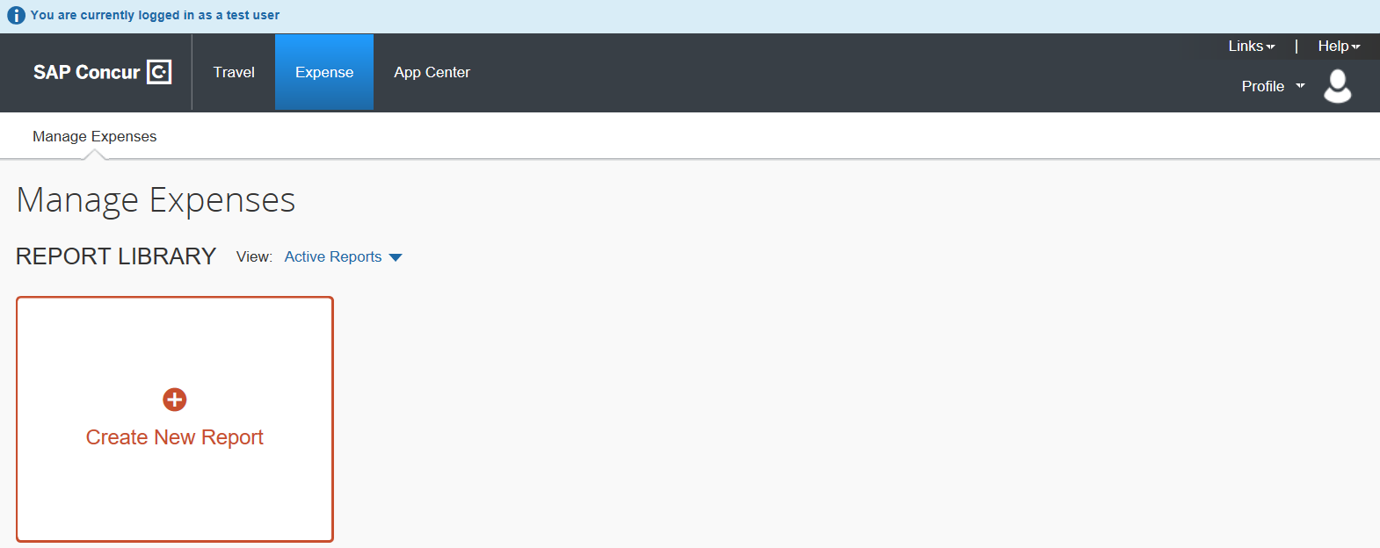

What the Test User Feature Can and Cannot Do
Clients can use the Test User feature for a variety of purposes, such as:
- Performing end-to-end testing beginning with credit card transaction import and ending with report extraction
- Validating and adjusting product configurations such as workflow, forms and fields, audit rules, policies, email notification, imaging, and other configurations
- Importing test lists that can be validated prior to releasing for production use
- Creating test extracts to validate bridge programs for extracts
- Creating training materials from the working environment
- Training employees directly in the working environment
Clients cannot use the Test User feature for the following purposes:
- In general, mix any test employee, data, or transaction into production data; test data is effectively quarantined from "real" working data
- Testing Travel without the zDemo role, the user must have this role to ensure that reservations are automatically cancelled after booking
- IMPORTANT: Transactions created using the zDemo user role are not marked as test and are not purged using the Purge feature. Use current site techniques to remove Concur Travel transactions created using this role.
- For more information, refer to the Concur Travel Testing section of this guide.
- Importing test list items into an existing list being used in production
- Segregate test attendees, attendees types, or attendee forms from production attendees, attendees types, or attendees forms; attendees, attendee types, and attendee forms are available both to test and production users

Before You Begin
Before using the Test User feature, determine what your non-production tasks will be and how best to proceed. For example, if end-to-end testing is desired, a complete set of employees with appropriate roles will be required for workflow testing.
Note the following before activating and using the Test User feature:
- When the feature is activated, an exclusion filter is installed that updates all conditions associated with extracts. This prevents the inclusion of any test transactional data in a standard production extract.
- Test user status is assigned on creation of the employee and can never be changed, or status given to any existing employee. This prevents any employee from having both test expense reports and invoices, and "regular" reports and invoices in the system.
- Clients with Travel integrated with Concur Expense will require additional configuration.
- For more information, refer to the Concur Travel Testing section of this guide.

Best Practices
The following list of best practices should be reviewed (Concur Expense detailed below; other products similar):
- How Many Users?: The number of test users you create depends upon what tasks you intend to undertake. Typically, you would create at least one set of users that allows an expense report to travel the entire workflow beginning with credit card transaction assignment through expense report extraction. Typically, this would include:
- Company Card administrator (to assign test credit card accounts and card transactions to test users)
- Expense report submitter
- Expense report approver (Manager)
- Expense report approver (Authorized Approver—if you use authorized approvers in your workflow then add one for each level of authorized approval in your workflow)
- Expense report processor
If you have multiple expense groups, for example for different countries or business units, then you would create one set of the above users for each expense group. If you use expense report submitter or approver delegates, you may want to create test users for these roles.
- Clear Identification: Test users should have names, employee IDs, login IDs, bank account numbers, and other identifying attributes that clearly identify the user as a test employee. For example, create a test expense report submitter with a first name of Test and a last name of Submitter01. Such naming makes it easier to keep track of the purpose of the users within the workflow.
Employee IDs and login IDs must be unique, so you cannot use values from actual, production users.
- Validation of Workflows: When testing workflow, you should add a sufficient number of test employees to validate all the workflow steps and workflow rules in all their workflows. Typically, this means running a set of test cases where you create a test report that triggers each workflow rule and workflow step.

Required Roles
The following administrative roles are required. Note that these roles may not be available at your site. Contact your SAP Concur administrator to determine how best to implement these tasks (<Product> means Concur Expense, Concur Invoice, or Concur Request – Concur Expense used below in examples):
- <Product> Configuration Administrator: Activates the feature and creates the test payment types required for the use of credit card test transactions by the Test Expense Credit Card Administrator
You may not have access to this role - a Service Request to SAP will allow this task to be completed.
- <Product> Configuration (Restricted) Administrator: Same as the Expense Configuration administrator role, but does not have privileges to purge test user transactions (this requires a Service Request to SAP Concur support)
- <Product> Processor: Provides final approval and other tasks for the report or invoice
- Company Card Administrator (Expense): Works with test credit card test transactions
- Shared Configuration Administrator: Adds the Is a Test User? field to the employee profile form
You may not have access to this role. A Service Request to SAP will allow this task to be completed.
- User Administrator: Adds the new test employees

Users with a Proxy Role
Note the following:
- A proxy who is also a test user can work as a proxy only for other test users.
- A proxy who is not a test user can work as a proxy only for other non-test users.
The only exception involves internal SAP Concur roles. For example, SAP Concur implementation and support can work as proxies for test users.

Working With the Test User Feature
The Allow creation and use of test users field is used to activate the Test User feature. When selected, an exclusion filter is automatically installed for all extract-related conditions to exclude test transactional data from Production extracts. Activation also enables the system to display the Is a Test User? employee field on any employee profile form.
Concur Expense used below; other products similar.
To activate the Test User feature:
- Under Administration click Expense (or Invoice or Requests).
- Click Test User Admin (left menu).
- Select (enable) the Allow creation and use of test users check box.
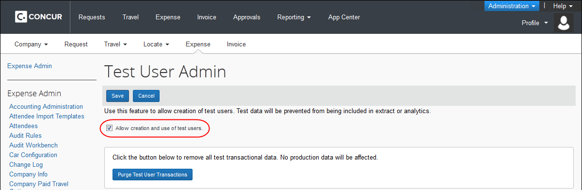
- Click Save.
One of two informational messages appear when the feature is activated:
- Already updated: If the condition(s) have already been updated, the message "The condition to exclude test users has not been added to any extract criteria, because this condition has already been applied manually or programmatically" appears.
- Not updated: If the condition(s) have not yet been updated, the message "The condition to exclude test users has been added to <count> extract criteria" appears.

Creating the Test User: Configure and Add the Is a Test User? Field
Once the Test User feature is activated, the Forms and Fields page is used to add the Is a Test User? field to the employee form. Selecting this field for each new test employee lets the system use options to treat this employee type differently in terms of creating extracts and purging transactional data. Otherwise, the employee's testing actions are treated exactly as any other employee.
To configure the Is a Test User? field:
- Under Administration click Expense (or Invoice or Requests).
- Click Forms and Fields (left menu).
- In the Form Type list, select Employee.
- Click the Fields tab.
- Click the Is a Test User? field.
- Click Modify Field.
- In the Employee Administrator Role list, click Modify.
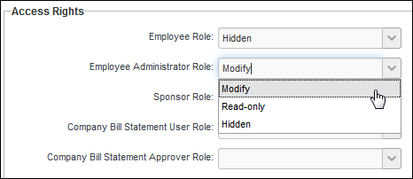
- Click Save.
To add the Is a Test User? field to the employee form:
- Click the Forms tab.
- Click the desired employee form.
- Click Add Fields.
- Click Is a Test User?.
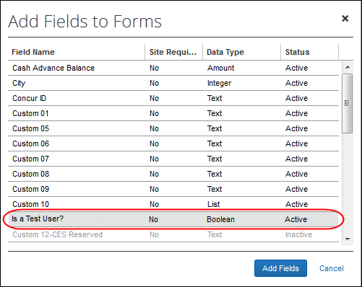
- Click Add Fields.

Creating the Test User: Assigning the Test User Status
The User Administrator tool can be used to create a test user. User accounts marked as test users can be used to work within a production environment without affecting real (production) data.
- Important: The Is a Test User field can only be checked (enabled) when the user is created. An existing user cannot be converted into a Test User and a Test User cannot be converted into a production user. This restriction ensures that a user cannot have a combination of “test” and “production” transaction data.
Test User accounts can also be created through the Employee Import tool. The “Is Test User” attribute is included in the 305 Record Type. For more information, refer to the Employee Import (Record Type 305) Format section of the Shared: Employee Import Specification.
To assign the test user attribute to an employee:
- Click Administration > Company > Company Admin.
- On the Company Administration page, click User Administration on the left menu.
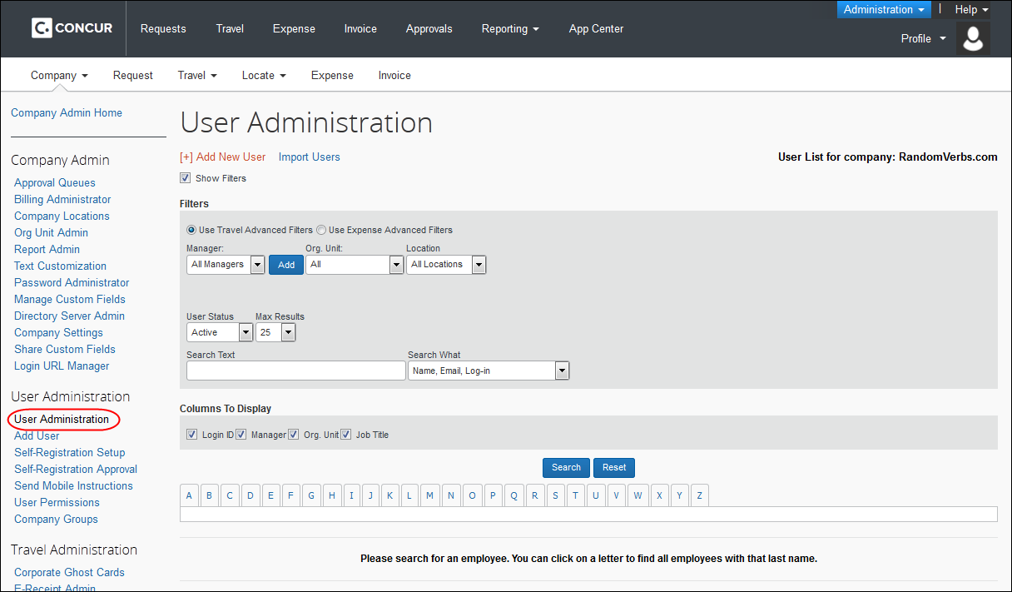
- Click Add New User.
- Add the Login ID and password that will be used to log in as this test user.
The Login ID must use a valid @domain value for your organization. This is how the system recognizes that this user belongs to your organization.
- In the Expense and Invoice Settings section, check (enable) the Is a Test User? check box.
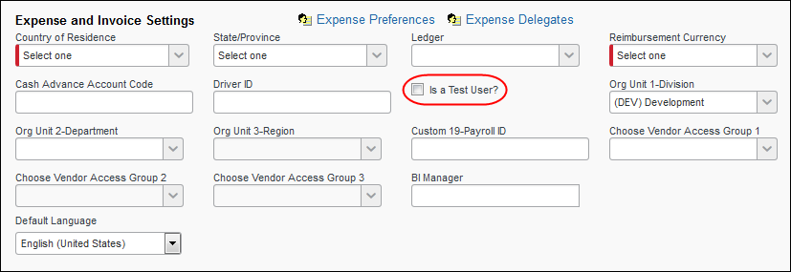
- Configure the new employee as needed for testing purposes.

Cloning Test Users
Concur Expense and Concur Invoice clients are now able to automate the process of creating test users to test new functionality quickly and efficiently. To do this, the client can clone an already existing user to create the desired number of test users (up to 50 at a time, 999 in total) to test workflow and new features.
To access Test User Admin:
- (Optional) In Concur Expense, click Administration > Expense > Expense Admin.
- (Optional) In Concur Expense, click Administration > Invoice > Invoice Processing Admin.
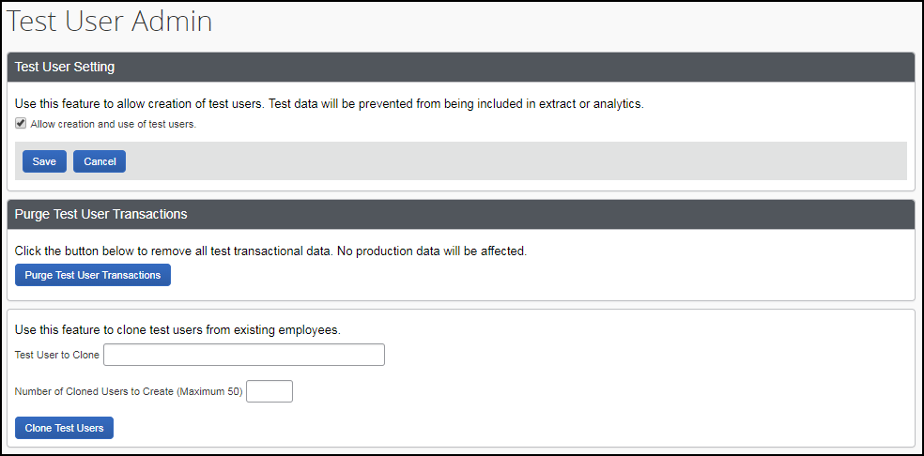
To clone test users:
- On the Test User Admin page, select (enable) the Allow creation and use of test users check box to view the test user clone section.
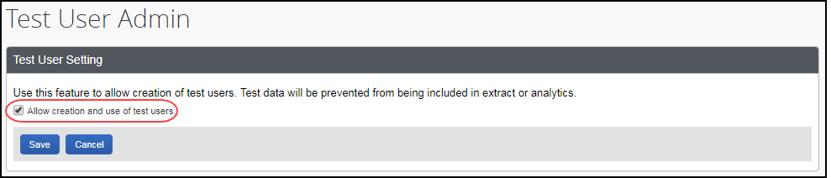
- In the Test User to Clone field, type in the user that you would like to clone. Once you start typing in the user name, the system will search and return a match if one exists.
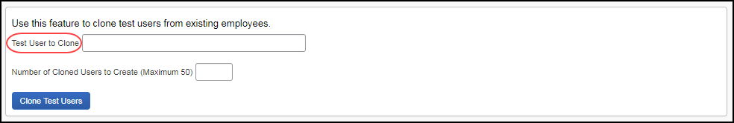
- In the Number of Cloned Users to Create (Maximum 50) field, type the number of test users that you would like to use for testing.
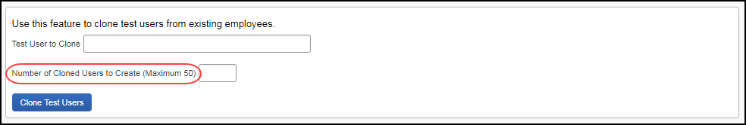
- Click Clone Test Users.
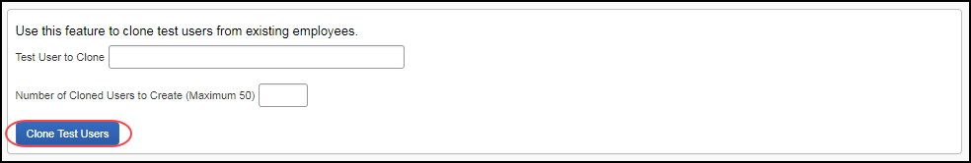
The test users appear in a table below the Clone Test Users button.
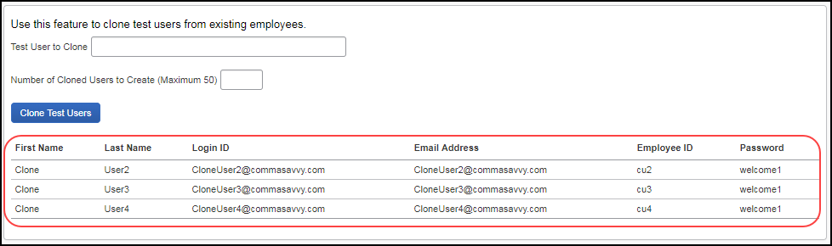
These test users will have the same permissions, roles, and groups as the source user from which they were cloned. However, their preferences will not be copied over but instead set to the default preferences.

Searching for Test Users
The User Administrator can elect to perform a search that includes or excludes Test Users from the search result. To use this feature, click Administration > Company > Company Admin > User Administration. Then, ensure the Show Filters and Use Expense Advanced Filters options (as examples; other products similar) are selected (enabled). Select one of three options under Expense Test Users:
- All Users: The default; does not filter against Test User
- Exclude Test Users: Do not include users of type Test User in the search.
- Only Test Users: Include users of type Test User in the search.
This filter appears only if the system detects that there are Test Users in the system; otherwise, this option is unavailable.
In the figure below, the search will only be conducted on users who are of type Test User; all other user types are ignored:
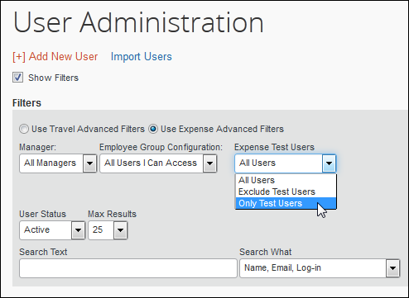

Using the Test User Feature Under Travel
Travel does not use the Is a Test User? field to identify test data, so tests of Travel require some additional configuration. Contact your Travel Administrator to coordinate testing across the SAP Concur products.
- For more information, refer to the Concur Travel Testing section of this guide.

Using the Test User Feature Under Single Sign On (SSO)
Single Sign On (SSO) allows a production user to access different company environments seamlessly, having signed in as a known user only once. People wanting to access test users, however, are essentially acting under two distinct identities: their day-to-day work identity (i.e. production users) and their test-user-related work identity (i.e., test users).
Unless you set up test users with logins in the SSO system, there is no way for production users to log in as test users because the SSO system does not recognize the test users. For this reason, the test users must log in using the login page. This allows enforcement of SSO for production use while allowing access to test users for non-production use.
To log in using the login page, enter this URL into your web browser address field, www.concursolutions.com. The system displays the login page.
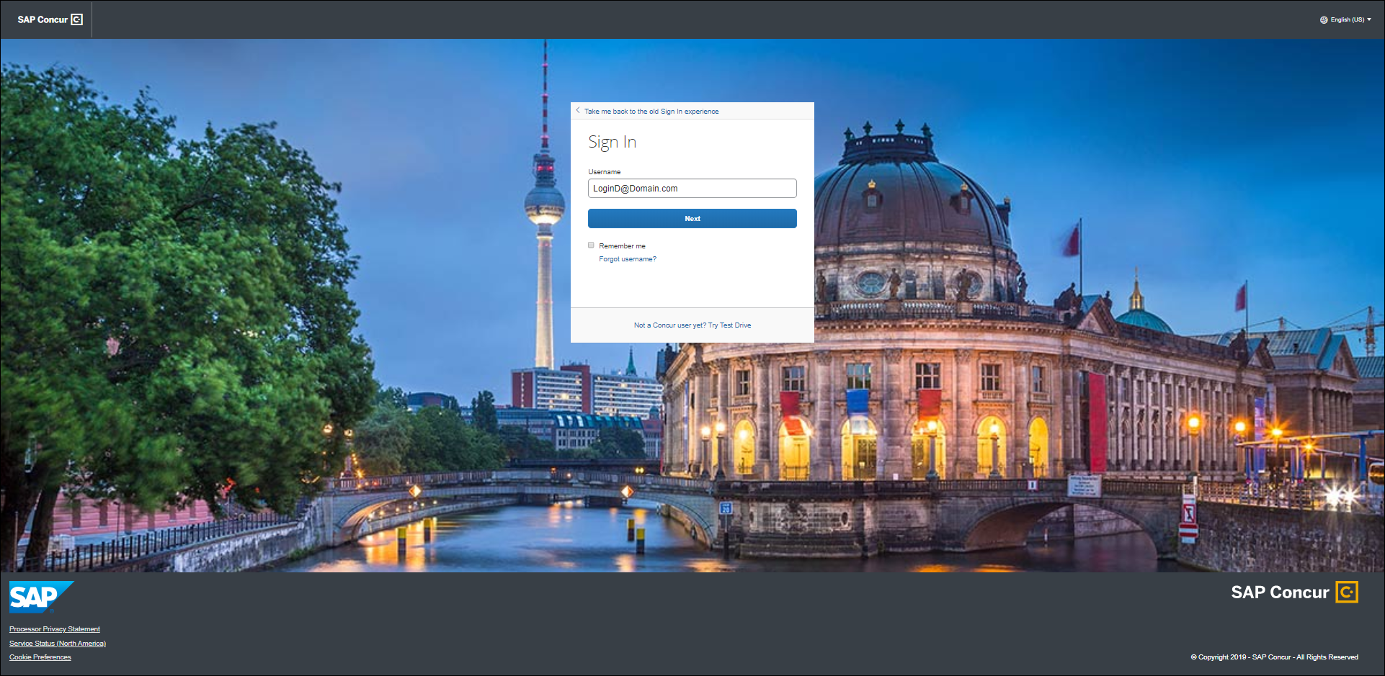
Enter the Login ID and password you assigned to the test user in the User Name and Password fields and click Login.

Disabling (Deactivating) Test Users
Test transactional data associated with a test employee cannot be removed if the employee is deactivated. Be sure to remove the test data prior to deactivating the employee.
- For more information, refer to the Purging Test Transactions from the System section in this guide.
To deactivate a test employee:
Using User Administration, apply a status of Inactive to the employee.
You cannot clear the Is a Test User? check box to remove this attribute from an employee. This check box is not available after initial setup of each employee.

Concur Travel Testing

Overview
These guidelines detail how to set up a test user account within Concur Travel that allows non-billable test bookings. This process does not use the Is Test User? employee attribute.

Benefits
Creating a test user account provides several benefits:
- Allows companies to test new features before company-wide rollout
- Allows companies to test features without being billed by SAP for the transaction
- Allow fulfillment travel agencies to create bookings to test their mid and back office environments
- Filters the Travel reports to exclude test user bookings
- For T&E customers, allows for end to end testing from travel booking to expense report submission

Configuration
The following steps should be taken to set up the test user account.
- Create a user whose first name is “William” and last name is “Never”. The name “William Never” will ensure that SAP will not bill for the reservation. However, the use of fake names can incur debit memos, which are administrative fees charged to the fulfillment travel agency by various airlines; be sure to confirm name assignment with your fulfillment travel agency.
- Assign the user a Login ID that begins with “testbooking.”
Example: testbooking@concur.com
You can define multiple test accounts for different scenarios, such as testbookingsabre@concur.com and testbookingapollo@concur.com.
- Assign the zDemo user permission (Professional Travel only). This permission ensures that bookings created within the product are not automatically booked in the GDS. It is specifically designed to never send the reservation for ticketing. SAP will automatically cancel the reservation 2-5 hours after booking.
- For clients with Travel and Concur Expense, the zDemo permission can be combined with the Is Test User? attribute to provide additional test information. A user with both the Is Test User? attribute and the zDemo permission that books travel will automatically receive demo card transactions in Concur Expense, matching the dates of the booked trip. These card transactions can be added to an expense report to test the entire process end to end.
- Log in as this user and assign test credit card(s). Available test credit cards:
Card Type | Card Number | Number of Characters
MasterCard | 5105 1051 0510 5100 | 16
MasterCard | 5555 5555 5555 4444 | 16
VISA | 4111 1111 1111 1111 | 16
VISA | 4012 8888 8888 1881 | 16
VISA | 422 222 222 222 2 | 13
American Express | 3782 822463 10005 | 15
American Express | 3714 496353 98431 | 15
American Express Corporate | 3787 344936 71000 | 15
Diners Club | 3852 000002 3237 | 14
Diners Club | 3056 930902 5904 | 14
Discover | 6011 1111 1111 1117 | 16
Discover | 6011 0009 9013 9424 | 16
JCB | 3530 1113 3330 0000 | 16
JCB | 3566 0020 2036 0505 | 16
You will need to assign a real/live credit card for the following scenarios:
- Post Ticket Change: A live card is required for the initial ticketing as well as the exchange.
- Direct Connects and Instant Purchase: Some vendors require a live card for all bookings.

Testing Guidelines
SAP recommends the following guidelines for testing in Travel:
- Work with your fulfillment travel agency to review test booking users, define test scenarios, including which vendors to test/avoid
- Book at least six months out
- Verify the hotel cancellation policy to avoid an instant purchase, deposit or non-refundable fare type
- Choose a refundable fare when possible
- Do not book more than one reservation for the same dates and city pairs, the same carrier and traveler
- If you are working in a market where the customer wants to see specific city-pairs, airlines or routes, use different dates for each of the booking requests
- Always use the test credit card when possible
- Ensure your booking has been cancelled or cancel yourself
- Coordinate testing across SAP Concur products, if applicable
- For more information about testing a particular vendor, refer to the appropriate/applicable Travel Service Guide available on the SAP Concur support portal or in Travel Administration online help.

Purging Test Transactions from the System
When you have completed all testing, the test transactions can be purged by the Configuration administrator using the user interface. This action is not available to the Expense Configuration (Restricted) administrator, and the administrator does not need to be a Test User to perform this task.
The procedure below shows Concur Expense.

Purging Test User Data From the System
To remove test employee transactions from the system:
In Test User Admin, click Purge Test User Transactions.
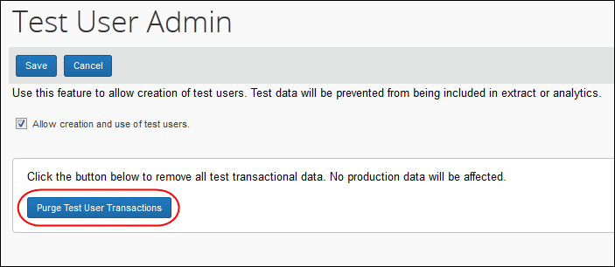

Appendix A—Testing Guide for Specific Features
The following section includes details on testing specific areas within the supported products. Some sections apply only to specific products, such as Concur Expense or Concur Invoice, while others apply globally to two or more products.

Working with Groups

Leveraging Groups with Test User
A powerful capability within each product is the concept of groups. Groups provide a means to segregate the functionality that various groups of employees may interact with. For example, employees who are located in one country or are in one business unit have different data entry and policy compliance requirements than those located in another country or business unit. Groups allow employees in these countries/business units to have different data entry, policy compliance, and other functionality.
Groups can also be a helpful tool when doing non-production tasks. That is, test users can be placed in a test group, thus restricting them from production groups.

About Group Configurations
Configurations for each of these groups are controlled using group configurations. A group configuration is a collection of one or more expense, invoice, tax, or travel allowance groups that share the same configurations.
Contact your SAP Concur Implementation or SAP Concur support specialist to assist you with creating the group configurations.

Using Groups and Group Configurations
With a test group, it is possible to assign group-aware configurations to a test group configuration without impacting the configurations and associated functionality in Production group configurations.

Example: Adding a Country
As an example, using test groups is ideal when adding a new country. In this scenario, there is typically a group configuration, a tax group, and possibly a travel allowance group configuration set up for the country. Each of these groups can act as test groups to validate the expense, tax, and travel allowance configurations for the new country.
Taking this a step further, you can create test users with their associated Country field (on their user profile) set to this country, thus causing the system to assign these user types specifically to these groups. Under this scenario, you can perform a set of user acceptance test cases, each validating the configurations and associated functionality to ensure the functionality meets your requirements. Once satisfied, you can purge all test data and users and then add production users for this country.

Example: Adding a Business Unit
Using a test group is also ideal when adding a new business unit that requires its own group. As with adding a new country, there will be an expense group configured for the business unit to be added. You can create test users with their user profile set so the system will assign these users to this group. How the profile is set depends on how your organization defines expense groups. Typically, this is determined by a field that is a list of business units.
As described above, you can perform a set of user acceptance test cases that validate the configurations and associated functionality to ensure the business unit meets your requirements. Once satisfied, you can purge all test data and users and then add production users for this business unit.
Groups can also be helpful even when not adding a new country or business unit. If you want to validate a group-aware configuration prior to enabling it for production use, you can arrange for SAP to set up a test group configuration. Test users can then be created with their user profile set so the system will automatically assign these users to this group. As above, successful user acceptance testing and validation of the configuration and associated functionality allows assignment to appropriate Product expense groups.

Group-Aware Configurations
Much functionality is controlled by configurations. Most configurations are group-aware. A group-aware configuration is one that can be applied to a group without impacting the configurations for another group.
There are three categories of group aware configurations:
- Groups: These configurations relate to the group the employee filing the report or invoice belongs to. Common examples are expense types, data entry forms, approval routing, audit rules, and email reminders.
- Tax Groups: These configurations relate to calculating tax and reclaim amounts. The employee's country determines the employee's tax group.
- Travel Allowance Groups: These configurations relate to calculating travel allowance. The employee's country determines the employee's travel allowance group.

Non-Group Aware Configurations
There are a few configurations that apply universally to all users, regardless of what groups they belong. For example, attendee spends tracking-related configurations such as attendees, attendee types, and attendees forms. Note that, for these configuration types, there is no viable method to validate these configurations prior to production users accessing them.
- For more information, refer to the product-specific document, for example, the Concur Expense: Expense Group Configurations Setup Guide.

Expense: Working With Credit Card Test Transactions

About Credit Card Test Transactions
Credit Card transactions can be included as a testing component when using the Test User feature. This feature allows the administrator to:
- Create a payment type that is easily identifiable as a test payment type
- Create test card accounts and transactions
- Allow a Test Expense Company Card administrator to work with test credit card transactions while excluding these same transactions from the working, "real" production data
As with creating test employees and reports, these transactions are effectively quarantined from production data, allowing test credit card transactions alongside "real" data in the production environment. Safeguards include the following:
- Test card transactions may only be assigned to test users, and test users can never be assigned non-test card transactions.
- A Company Card administrator configured as a test user is a Test Company Card administrator and a Processor configured as a test user is a Test Processor.
- A search conducted by a Test Company Card administrator will never return a non-test user employee or transaction.
- Test users are always allowed to delete test card transactions, without regard to the company card administrator setting to allow or not allow users to delete card transactions. This ensures that test data may be cleaned up for an individual test user as needed.
- On purge, all test card transactions (and only card transactions of this type) are removed from the system.

Creating the Test Credit Card Transaction Type
Configuring the system for credit card test transactions is a three-step process.
- First, a test credit card import is set up.
- Then, a test user is granted the Expense Company Card administrator role. This creates the Test Company Card administrator role.
- Lastly, the Test Company Card administrator assigns test card accounts and card transactions to test users with the Expense User role allowing them to assign test card transactions to expense reports and submit these reports.

Creating a Test Credit Card Import
SAP will arrange to import a test credit card feed for your organization. When the system imports this feed, it will do the following to make it a test credit card feed:
- To ensure the test account number is distinct from production account numbers in the original credit card feed, the system will append a code – the letter "T" precedes the account number – to all test account numbers, making these accounts test accounts.
NOTE: The "T" is added to the column CT_CREDIT_CARD_ACCOUNT.ACCOUNT_NUMBER
CT_CREDIT_CARD_TRANSACTION.TRANSACTION_ID
- Mark the card transactions associated with these test accounts as test card transactions.
Test accounts and card transactions may be assigned only to test users. Production users cannot access test card transactions. This prevents test transactions appearing in production reports.
Here is what is involved in creating a test credit card import:
- Submit a Service Request asking SAP to set up a test credit card import. An SAP Concur consultant will contact you to make the necessary arrangements outlined below.
- Determine what you would like to use as the source file for the credit card import. Typically, this would be a production credit card file previously processed that you would like to use for test purposes. However, it could also be a production card file you have edited to remove any sensitive data. Your SAP Concur consultant will be able to assist you with this decision.
- The SAP Concur consultant will set up a test payment type and assign this to the credit card import job that will import test credit card feeds. With the test payment type in place, the credit card import job will convert the source file into test card accounts and card transactions.

IMPORTANT: Clearing Account Code
If the credit card is a Company Billed/Company Paid (CBCP) card there must be a Clearing Account Code assigned to the card. The Clearing Account Code must exist in order for an employee to submit a company card transaction expense in an expense report for an expense marked as a Company Billed/Company Paid (CBCP) expense. Otherwise, the employee will receive an error message stating that this field was not completed and will not be able to submit the expense report.
By setting up the test payment type with a clearing account code, the system will assign this code to all card accounts that use this payment type. If this is a CBCP, then you should specify to the SAP Concur consultant which Clearing Account Code you want to use for this card. If this is not done, then you must manually enter this code for each test account number you assign to a test user.

Creating the Test Payment Type
With the Test User site setting enabled, the Test Payment Type check box is exposed in the Payment Type page and may be selected to create a payment type specific to testing (Expense detailed below; other products similar).
To create a test payment type:
- Click Administration > Expense.
- Click Payment Types (left menu). The Payment Types page appears.
- Click New to open the Payment Type window.
- Create the payment type, being sure to configure as follows:
- Payment Type Code: Select a valid code for a credit card (a credit card test transaction cannot be cash or company paid).
- Test Payment Type: Select (enable) this check box to ensure that this payment type is recognized by the system as a component of the Test User feature.
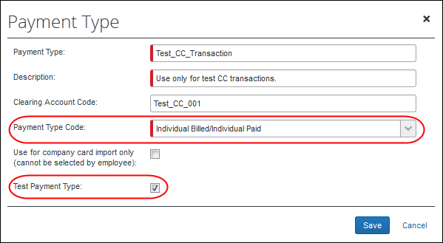
- Click Save.
The Test Payment Type check box is not available on the Edit Payment page to prevent unintentional mixing of the payment type into the production payment types.

Configuring Test Administrators
A Company Card administrator configured as a test user is a Test Company Card administrator, and a Processor configured in this way is a Test Processor. These roles are permitted to manage only test transactions, users, and test-enabled areas of the system. This is done for ease of searching and working with the users, accounts, and data under the Test User feature.
- For information about assigning both the required role and the test user attribute to the employee, refer to the Assign test user status to the new employee section in this document.

Assigning Test Accounts and Transactions to Test Users
Until test card accounts are assigned to test users, test transactions will not appear automatically on test users' Company Card page within Concur Expense. Once the credit card import job has imported the test credit card feed, the Test Company Card administrator can then assign card accounts to test users using the Concur Expense Company Card Administrator tool.
To assign accounts:
- Administration > Company > Tools.
- Click Company Card (left menu).
- Click the Manage Accounts tab.
- In the Manage Accounts page, enter the appropriate search criteria to locate an employee, and then click Search.
TIP: Select Include Deleted Accounts to return a full list of all card types.
- Select a record from the rows that display.
- Click Assign. The Assign Account with Name on Card window displays.
- Input the following information:
- Transaction Release Period (days): Enter a positive whole number from 1 to 999. This number, subtracted from the date of card assignment, specifies the beginning of the date range in which the post date of a transaction must fall for the transaction to be released to the user at card assignment. The date of card assignment represents the end of that date range.
- The Transaction Release Period setting applies only to those transactions imported using a configurable importer. Refer to Settings in this guide for more information on the Transaction Release setting.
- Search: Enter a minimum of three characters of the last name of the employee you will assign the card account to
- Click Assign.
Once you assign all the test account numbers to test users, for any subsequent test credit card imports you have, the credit card import will use these card account assignments to automatically assign the card transactions associated to these accounts to the appropriate test users.

Working with Extracts

Creating a Test User-Only Extract
Contact SAP directly to configure a test employee-only extract. This extract features only the data created by test employees in the system and excludes all production data.
This extract is created by the Technical Consultant who will perform the following steps:
- The Extract Copier tool is used to create a copy of the existing extract
- Conditions associated with the extract are edited within Condition Editor to expressly include only test employees and exclude all other employees
- If no conditions exist, they are created to perform this function in the test employee-only extract

Excluding Test Transactions from a Production Extract
Contact SAP directly to configure a production employee-only extract. This extract features only the data created by production ("real") employees in the system and excludes all test transactional data.
A filter that prevents test transactional data from being included in a true extract is automatically installed to every extract condition that has not yet already been updated. This filter is installed when the feature is first activated (refer to Activating the Test User Feature in this guide).
This extract is edited by the Technical Consultant who will edit the "real" extract to specifically exclude test employee data. This is done either manually, using the Condition Editor, or programmatically, using a stored procedure

Appendix B—List of Tables Affected by Purge
The following is a reference list of tables whose data is changed following the purging process:
CT_REPORT  CT_REPORT_ENTRY  CT_REPORT_EXCEPTION  CT_ATN_ENTRY_MAP  CT_WORKFLOW_STEP_INSTANCE  CT_WORKFLOW_PROCESS_INSTANCE  CT_CREDIT_CARD_TRANSACTION  CT_CREDIT_CARD_ACCOUNT (UPDATE)  CT_EXPENSE_COMMENT  CT_JOURNAL  CT_CAR_LOG_ENTRY  CT_TA_ITINERARY  CT_TA_ITINERARY_ROW  CT_TA_DAY  CT_CAR  CT_CAR_PERIOD  CT_TA_FIXED  CT_TA_REIMBURSABLE  CT_REPORT_ENTRY_TAX  CT_CASH_ADVANCE  CT_CASH_ADVANCE_ENTRY  CT_CASH_ADVANCE_REPORT_MAP  CT_CASH_ADVANCE_COMMENT  CT_PARENT_ENTRY_TOTALS  CT_AUDIT_REPORT_REVIEW  CT_AUDIT_REPORT_EXCEPTION  CT_ALLOCATION  CT_LIST_STAGING  CT_TRAVEL_REQUEST  CT_TRAVEL_REQUEST_ENTRY | CT_TR_EXCEPTION  CT_TR_COMMENT  CT_EMAIL_JOB_RPT_MAP  CT_EMAIL_JOB_TR_MAP  CT_EMAIL_JOB_CCT_MAP  CT_EMAIL_JOB_CA_MAP  CT_EMAIL_JOB_REQ_MAP  CT_REPORT_ENTRY_TAX_ALLOC  CT_REPORT_ENTRY_SEGMENT_MAP  CT_TA_ITIN_REPORT_MAP  CT_REPORT_ENTRY_EXTN  CT_REPORT_ENTRY_TICKET_USAGE  CT_REPORT_PAYMENT_CONF  CT_AS_QUEUE  CT_AS_BILLING  CT_AS_REPORT_REASON_CODE_MAP  CT_EMP_BANK_ACCOUNT_HIST  CT_ATTENDEE_EXCEPTION  CT_REPORT_EXCEPTION_ATN_AMT  CT_REPORT_TRAVEL_REQUEST_MAP  CT_TR_EXCEPTION_ATN_AMT  CT_ATN_TR_ENTRY_MAP  CT_EMP_MERCHANT_NAME_EXP_PREF  CT_EMP_MERCHANT_CODE_EXP_PREF  CT_PERSONAL_CARD_TRANSACTION  CT_PERSONAL_CARD_ENTRY  CT_PERSONAL_CARD_ACCOUNT  CT_MRU  CT_EMP_ATN_MAP

☼

