
Shared: Single Sign-On
Setup Guide

Last Revised: January 22, 2024
Applies to these SAP Concur solutions:
 Expense
 Professional/Premium edition
 Standard edition
 Travel
 Professional/Premium edition
 Standard edition
 Invoice
 Professional/Premium edition
 Standard edition
 Request
 Professional/Premium edition
 Standard edition

Table of Contents
Section 1: Permissions 1
Section 2: Overview 1
Feature Benefits 1
Requirement 2
Section 3: Obtaining Required Permissions 2
Professional Edition Customers with Concur Travel 2
Professional Edition Customers Without Concur Travel; All Standard Edition Customers 2
Section 4: Configuration – Two Methods for Web-Based Services 2
Important! 3
Identity Provider (IdP)-Specific Process 3
General Process 4
Section 5: Configuration for Web-Based Services – General Process 4
Access the Manage Single Sign-On Page 4
Configure an SSO App/Connector Without Encryption 6
Step 1: Obtain the EntityID and ACS Endpoint 6
Step 2: Provide the EntityID and ACS Endpoint 7
Step 3: Provide the Recipient URL and Destination URL 8
Step 4: Ensure the NameID (IdP) Matches the User Login_ID (SAP Concur Solutions) 9
Step 5: Obtain the IdP Metadata 10
Step 6: Upload IdP Metadata to Concur 11
Step 7: Test IdP-Initiated SSO 15
Step 8: Test SP-Initiated SSO 17
Step 9: Enable SSO as Optional or Required 17
Editing SSO Configurations 18
View Previous Changes 19
Configure an SSO App/Connector with Encryption (Optional) 25
Step 1: Obtain and Save the Encryption Key 25
Step 2: Upload the encryption.crt to Your IdP 27
Section 6: FAQ 27
Section 7: Appendix - ADFS Setup 29
Getting Started 29
Configure Your ADFS Application 31
Configure Your SAP Concur Site 40
Test SSO Login 43
Testing IdP-Initiated SSO 43
Test SP-initiated SSO 43
Mobile Single Sign-On (SSO) 45
E-mail Notifications 45
Rollout 45
Section 8: Appendix - Microsoft Azure AD Setup 46
Getting Started 46
Configure Your Azure AD Application 48
Step 1: Create Gallery Application 48
Step 2: Provide Azure ID with Identifier and Reply URL 49
Step 3: Change Unique User Identifier 51
Step 5: Download the Azure AD Metadata File 51
Configure Your SAP Concur Site 52
Test SSO Login 56
Test IdP-initiated SSO 56
Test SP-initiated SSO 57
Mobile Single Sign-On (SSO) 59
E-mail Notifications 59
Rollout 59
Section 9: Appendix – Google Workspace Setup 60
Overview 60
SAP Concur Professional edition: 60
SAP Concur Standard edition: 61
Configure Your Google Workspace (IDP) APP 62
Step 1: Get the SAP Concur metadata 62
Step 2: Set up your own custom SAP Concur SAML app 62
Step 3: Turn on your SAML app 64
Step 4: Configure Your SAP Concur Site 64
Test SSO Login 66
Mobile Single Sign-On (SSO) 67
E-Mail Notifications 68
Rollout 69
View Previous Changes 70
Section 10: Appendix - Idaptive Setup 72
Getting Started 72
Configure Your Idaptive Application 74
Step 1: Create the Idaptive app 74
Configure Your SAP Concur Site 78
Test SSO Login 79
Test IdP-initiated SSO 79
Test SP-initiated SSO 79
Mobile Single Sign-On (SSO) 81
E-mail Notifications 81
Rollout 82
Section 11: Appendix - Okta Setup 82
Getting Started 82
Configure Your Okta Application 84
Step 1: Get the SAP Concur metadata 84
Step 2: Create an application on Okta 86
Step 3: Name ID configuration 88
Step 4: (Optional) Encrypting the application 89
Step 5: Finish the Configuration 93
Step 6: Download the Metadata File 93
Configure Your SAP Concur Site 94
Test SSO Login 97
Test IdP-initiated SSO 97
Test SP-initiated SSO 97
Mobile Single Sign-On (SSO) 98
E-mail Notifications 99
Rollout 100
View Previous Changes 101
Section 12: Appendix - PingOne Setup 101
Getting Started 101
Configure Your PingOne Application 103
Step 1: Create a non-gallery SAML application 103
Step 2: Application details 104
Step 3: Application configuration 105
Step 4: Attribute Mapping 106
Step 5: Provide access to user groups 107
Step 6: Review and finish 108
Configure Your SAP Concur Site 108
Test SSO Login 109
Testing IdP-initiated SSO 109
Testing SP-initiated SSO 110
Mobile Single Sign-On (SSO) 111
E-mail Notifications 111
Rollout 111
Section 13: Appendix - SAP Cloud Identity Services - Identity Authentication Service (SAP IAS) Setup 114
Getting Started 114
Configure Your SAP IAS Application 117
Step 1: Get the SAP Concur metadata 117
Step 2: Create an Application on SAP IAS 118
Step 3: Change Subject Name Identifier 121
Step 4: Change Default Name ID Format 123
Step 5: Download the metadata 124
Configure Your SAP Concur Site 126
Test SSO Login 128
Testing IdP-initiated SSO 128
Testing SP-initiated SSO 129
Mobile Single Sign-On (SSO) 129
E-mail Notifications 130
Rollout 132
View Previous Changes 133
Section 14: Appendix - SAP NetWeaver Setup 135
Overview 135
Configure Your SAP Netweaver Application 138
Step 1: Get the SAP Concur metadata 138
Step 2: Create an application on SAP Netweaver 139
Step 3: Name ID configuration 142
Step 4: Enabling the application 143
Step 5: Download the Metadata File 144
Configure Your SAP Concur Site 144
Test SSO Login 146
Test IdP-initiated SSO 146
Test SP-initiated SSO 147
Mobile Single Sign-On (SSO) 148
E-mail Notifications 149
Rollout 150
View Previous Changes 151
Section 15: Appendix – Google Workspace Setup 153
Overview 153
SAP Concur Professional edition: 154
SAP Concur Standard edition: 155
Configure Your Google Workspace (IDP) APP 155
Step 1: Get the SAP Concur metadata 155
Step 2: Set up your own custom SAP Concur SAML app 156
Step 3: Turn on your SAML app 157
Step 4: Configure Your SAP Concur Site 158
Test SSO Login 160
Mobile Single Sign-On (SSO) 160
E-Mail Notifications 161
Rollout 162
View Previous Changes 163

Revision History
Date | Notes/Comments/Changes
January 22, 2024 | Updated bullet 2 in Getting Started in Section 13.
December 19, 2023 | Updated Section 13 Appendix.
June 21, 2022 | Updated Configure Your SAP Concur Site and View Previous Changes sections throughout
May 18, 2022 | Updated Appendix – ADFS Setup.
March 21, 2022 | Added a comma to the last revised date and fixed a formatting issue. No cover date change.
February 28, 2022 | Added setup instructions for Google Workspace to the appendices
January 19, 2022 | Updated instruction in the Upload IdP Metadata to Concur topic under the Configuration for Web-Based Services – General Process section
July 27, 2021 | Added several appendices with setup instructions for SSO
April 15, 2021 | Updated the copyright year; no other changes; cover date not updated
March 26, 2021 | Added information about the new “View Previous Changes” feature
December 2, 2020 | Fixed a typo. No cover date change
November 14, 2020 | Initial publication

SSO Management
NOTE: Multiple SAP Concur product versions and UI themes are available, so this content might contain images or procedures that do not precisely match your implementation. For example, when SAP Fiori UI themes are implemented, home page navigation is consolidated under the SAP Concur Home menu.

Permissions
This feature requires company administrator permissions.
The administrator should be aware that some of the tasks described in this guide can be completed only by SAP Concur support. In these cases, the customer must initiate a service request with SAP Concur support.

Overview
Single Sign-On (SSO) allows users to access multiple applications using one set of sign-in credentials. The Manage Single Sign-On (SSO) feature provides SAP Concur customers with a self-service option for setting up SSO.
Currently, SAP Concur solutions has two methods for signing in to SAP Concur services: with a username and password or using SSO with identity provider (IdP) credentials, such as a user's sign-in credentials for their organization. SSO is currently supported for Concur Expense, Concur Invoice, Concur Request, and Concur Travel.
By configuring this feature, customers can set up single sign-on for users at their organization.

Feature Benefits
The Manage Single Sign-On feature provides the following:
- A self-service option that enables a company admin to set up both IdP-initiated and SP-initiated SSO at their organization on both web and mobile platforms
- The ability for a company that currently uses the existing SSO functionality to also use the new Manage Single Sign-On feature (both SSO options work concurrently)
- The ability to require SSO for all users
- Improvements to the user sign-in experience
- A higher sign-in success rate for users
This guide describes how to enable and configure the Manage Single Sign-On feature for SAP Concur services.

Requirement
To use this feature, customers must have an IdP (Identity Provider) that supports the SAML 2.0 standard and can generate IdP metadata.

Obtaining Required Permissions
To access the Manage Single Sign-On page, a user must be assigned the Company Administration (Travel) permission.
After the required permission has been assigned to the user, they can access the Manage Single Sign-On page. The method for navigating to the page differs between SAP Concur Professional and Standard editions.
- For instructions on how to access the page in SAP Concur Professional and Standard editions, see Access the Manage Single Sign-On Page in Section 5 of this document.

Professional Edition Customers with Concur Travel
For Professional Edition customers who have Concur Travel, the Authentication Admin menu automatically appears for all users who have the Company Administration (Travel) permission.
To provide access to additional users, the customer can assign the Company Administration (Travel) permission using Administration > Company > Company Admin > User Permissions (left menu) and then click the Travel tab.
- For more information about assigning roles and permissions, refer to the Shared: User Administration User Guide.

Professional Edition Customers Without Concur Travel;
All Standard Edition Customers
For Professional Edition customers who do not have Concur Travel and for Standard Edition customers, call SAP Concur support for assistance obtaining the required permissions. SAP Concur support will assign the permissions to the desired users.

Configuration – Two Methods for Web-Based Services
There are two ways to configure SSO:
- Follow the Identity Provider (IdP)-specific process
– or –
- Follow the general process (described below)

Important!
Both methods are detailed below. However, every admin should review the information in the general processes. In some cases, a step from the general process might be required, even if you have used the information provided by the IdP.

Identity Provider (IdP)-Specific Process
SAP Concur worked with several IdPs to develop a reliable integration process. If your company is using one the following IdPs. The best way to set up SSO is to click the appropriate link in the table below and follow the instructions.
For specific appendix instructions and links in the following table, as content is sourced from the third-party provider, SAP Concur cannot guarantee its accuracy. If you encounter issues, it is recommended that you contact the third-party provider’s support resources.

Identity Provider | Setup URL
ADFS | Refer to the appendix in this guide.
Azure AD | Refer to the appendix in this guide. For further reference: https://docs.microsoft.com/en-us/azure/active-directory/saas-apps/concur-travel-and-expense-tutorial
Idaptive | Refer to the appendix in this guide.
JumpCloud | https://jumpcloud-support.force.com/support/s/article/Single-Sign-On-SSO-with-Concur-Travel-and-Expense
Okta | Refer to the appendix in this guide. For further reference: https://saml-doc.okta.com/SAML_Docs/How-to-Configure-SAML-2.0-for-Concur-Travel-and-Expense.html
OneLogin | Choose one of these:  - For SAP Concur customers in the US (North America) data center:  htpps://{subdomain}.onelogin.com/apps/new/124919  - For SAP Concur customers in the EMEA data center:  https://{subdomain}.onelogin.com/apps/new/125208  - For SAP Concur customers in the China data center:  https://{subdomain}.onelogin.com/apps/new/127148  Note the following:  - Customers must add their OneLogin domain to the URL above as indicated.  - After the customer uses the URL above to add the SAP Concur app to OneLogin, they will see the Setup tab. They must access that tab for instructions about uploading the OneLogin metadata to SAP Concur.
Ping Identity | Refer to the appendix in this guide.
SAP Identity Authentication Service (IAS) | Refer to the appendix in this guide.
SAP NetWeaver | Refer to the appendix in this guide.

General Process
If your company is using an IdP that is not listed in the table above, follow the appropriate procedure in Section 5. Section 5 provides procedures for configuring the following:
- SSO app/connector without encryption
- SSO app/connector with encryption

Configuration for Web-Based Services – General Process
Once the proper permissions are assigned, you can configure SSO. The following pages describe how to:
- Access the Manage Single Sign-On page.
- Configure an SSO App/Connector Without Encryption.
- Configure an SSO App/Connector With Encryption (Optional).

Access the Manage Single Sign-On Page
To access the Manage Single Sign-On page, a user must be assigned the Company Administration (Travel) permission.
- For information about obtaining the required permission, see Section 3.
To access the Manage Single Sign-On Page in Professional or Standard Edition:
- Click Administration > Company > Authentication Admin. The Autentication Administration page appears.
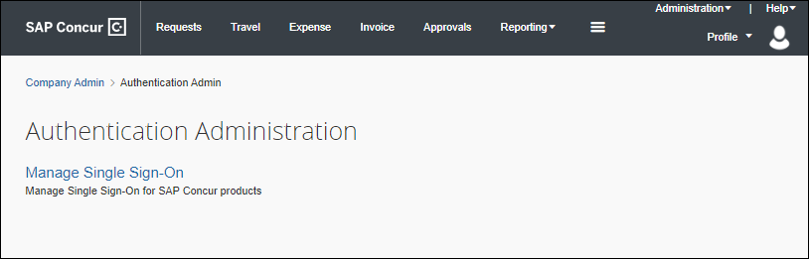
- Click Manage Single Sign-On.
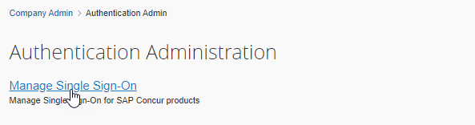
The Manage Single Sign-On page appears.
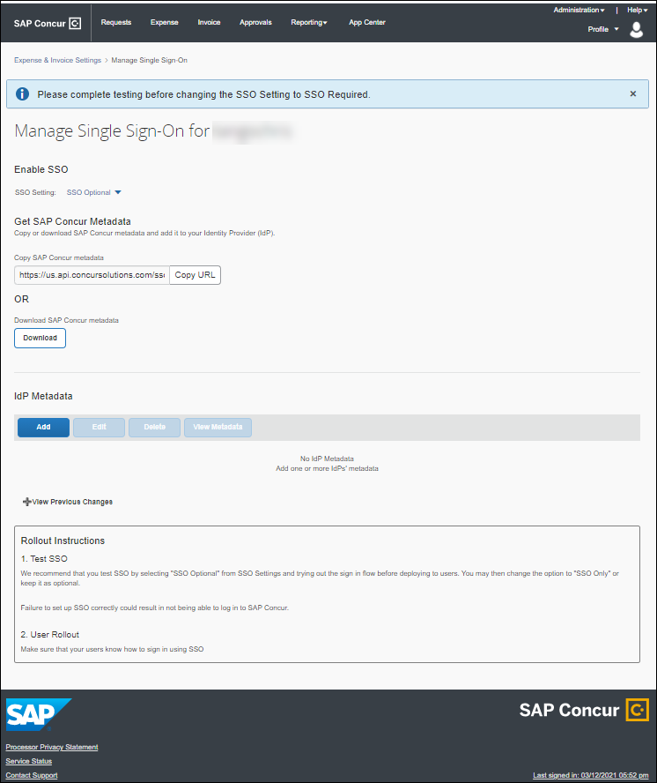
In SAP Concur Standard edition you can also access the Manage Single Sign-On page from Product Settings.
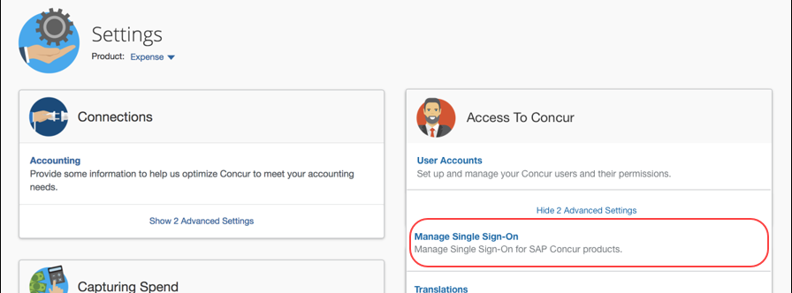

Configure an SSO App/Connector Without Encryption
Step 1 and Step 6 are completed in the SAP Concur service. Contact SAP Concur support for assistance.
Step 2 through Step 5 are completed in your IdP. If you have any questions, contact your Identity Provider for assistance.

Step 1: Obtain the EntityID and ACS Endpoint
The EntityID is a unique identifier of SAP Concur SSO; the ACS endpoint is the endpoint your IdP will use to POST SAML assertions to SAP Concur solutions. Both are required by the IdP.
You can obtain the EntityID and ACS endpoint by viewing the SAP Concur SP metadata. The metadata can be viewed by clicking the URL in this document for the appropriate region (data center) or through the Manage Single Sign-On page.
To Obtain the EntityID and ACS Endpoint by clicking the URL for the region in which your data center is located:
- Click the URL that follows for the region (data center) where your entity is hosted to view the SAP Concur SP metadata:
Google Chrome is the recommended browser.
- US (North America): https://www-us.api.concursolutions.com/sso/saml2/V1/sp/metadata/
- EMEA: https://www-emea.api.concursolutions.com/sso/saml2/V1/sp/metadata/
- China: https://www-cn.api.concurcdc.cn/sso/saml2/V1/sp/metadata
To view the metadata from the Manage Single Sign-On page:
- Click Administration > Company > Authentication Admin, and then click Manage Single Sign-On.
- Click Copy URL or Download.
Below are samples from SAP Concur US SP metadata at https://www-us.api.concursolutions.com/sso/saml2/V1/sp/metadata/.
The red boxes indicate the EntityID and ACS endpoint respectively.

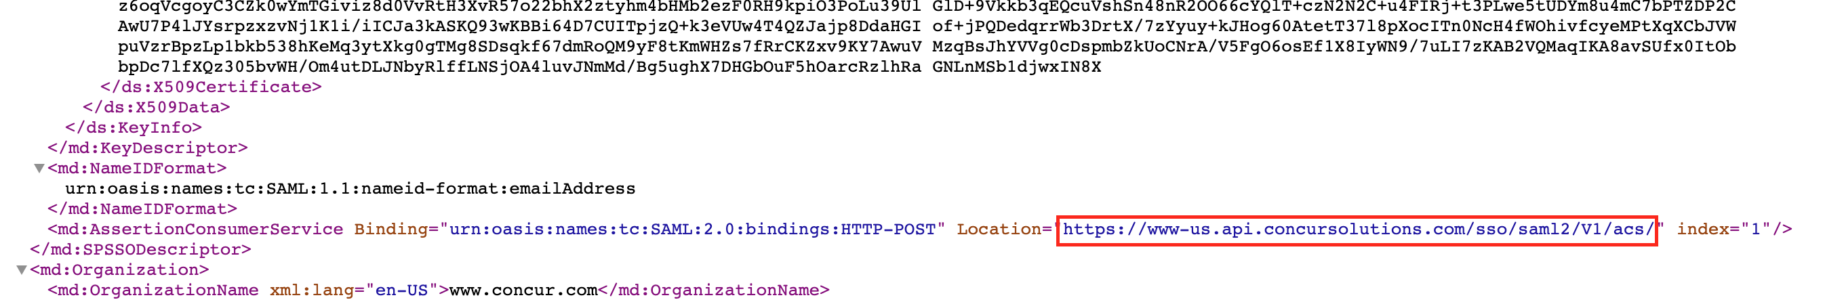

Step 2: Provide the EntityID and ACS Endpoint
Provide the EntityID and ACS Endpoint to the custom app/connector in your IdP.
- IMPORTANT: If your IdP is not listed in the table in the Identity Provider (IdP)-Specific Process section in this guide, do not use your IdP’s gallery/pre-configured SAP Concur app/connector; that is a legacy app/connector with legacy endpoints and will not work with the new SAP Concur SSO service. Instead, use a custom app or connector from your IdP. Return to the Identity Provider (IdP)-Specific Process section frequently to see if your IdP has been added to the table.
Different IdPs use different names for the EntityID and ACS Endpoint. The table below shows the field names for many popular IdPs.
IdP | Name for EntityID | Name for ACS Endpoint
Okta | Audience URI (SP EntityID) | Single sign on URL
Azure AD | Identifier (Entity ID) | Reply URL (Assertion Consumer Service URL)
OneLogin | Audience | ACS (Consumer) URL
Ping | SP entityID | ACS URL
JumpCloud | SP Entity ID / SP Issuer / Audience | Assertion Consumer Service (ACS) URL
If you are not sure where to add EntityID and ACS Endpoint, contact your Identity Provider for assistance.

Step 3: Provide the Recipient URL and Destination URL
Provide the Recipient URL and Destination URL to the custom app/connector in your IdP.
This step is optional for some IdPs but required for others. If the IdP requires the Recipient URL and Destination URL, you can use the ACS Endpoint from the SAP Concur SP metadata to fill those fields.
Below are examples of how IdPs handle adding the Recipient URL and Destination URL.
For Okta, there is an option to use the ACS Endpoint as both Recipient URL and Destination URL.
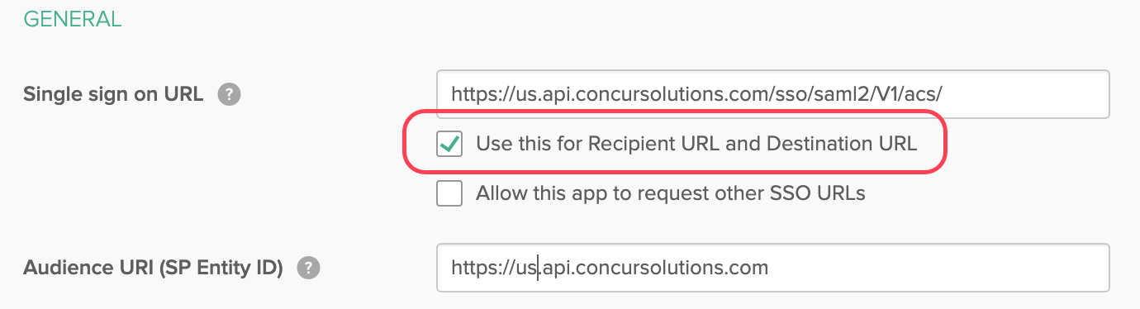
For OneLogin, there is a field to enter the Recipient URL (no destination URL option).
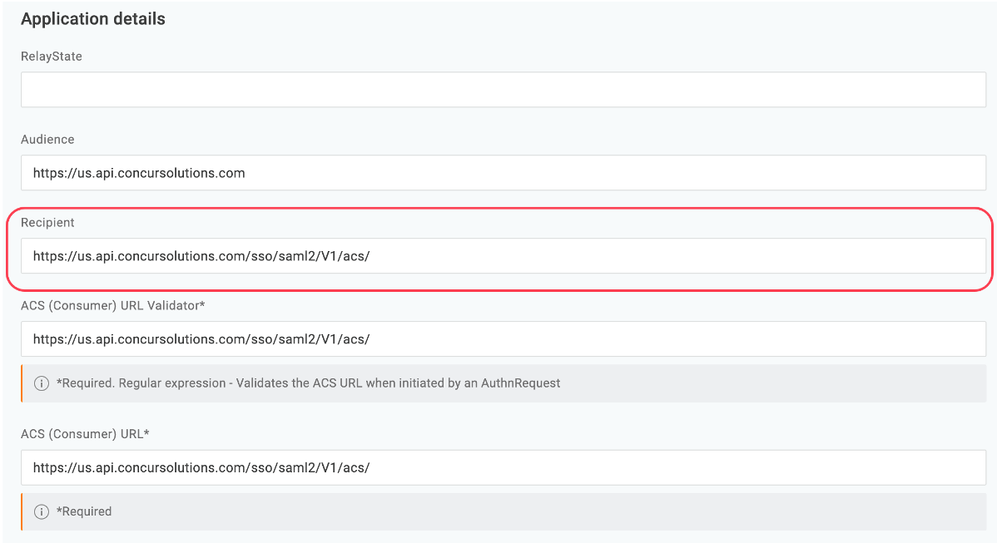

Step 4: Ensure the NameID (IdP) Matches the User Login_ID (SAP Concur Solutions)
Make sure the value of the NameID field matches the SAP Concur user Login_ID. Your IdP will send a SAMLResponse XML file to SAP Concur solutions and within the SAMLResponse file there is a NameID field as shown in the following example:
<saml2:NameID Format="urn:oasis:names:tc:SAML:1.1:nameid-format:emailAddress">username@domain.com</saml2:NameID>
SAP Concur matches username@domain.com from the NameID field to the Login_ID. If they do not match, the sign-in will fail because SAP Concur solutions will not be able to identify the correct user.
If your email address at your IdP does not match the SAP Concur Login_ID, use a custom rule to construct an email address or username that matches Login_ID at Concur.
It is common for the email address from the IdP to be different from the Login_ID at SAP Concur. If this is the case for you, see the following examples of possible configurations on the IdP side:
For Okta:
- In the Name ID format field, select EmailAddress.
- In the Application username field, select Email.
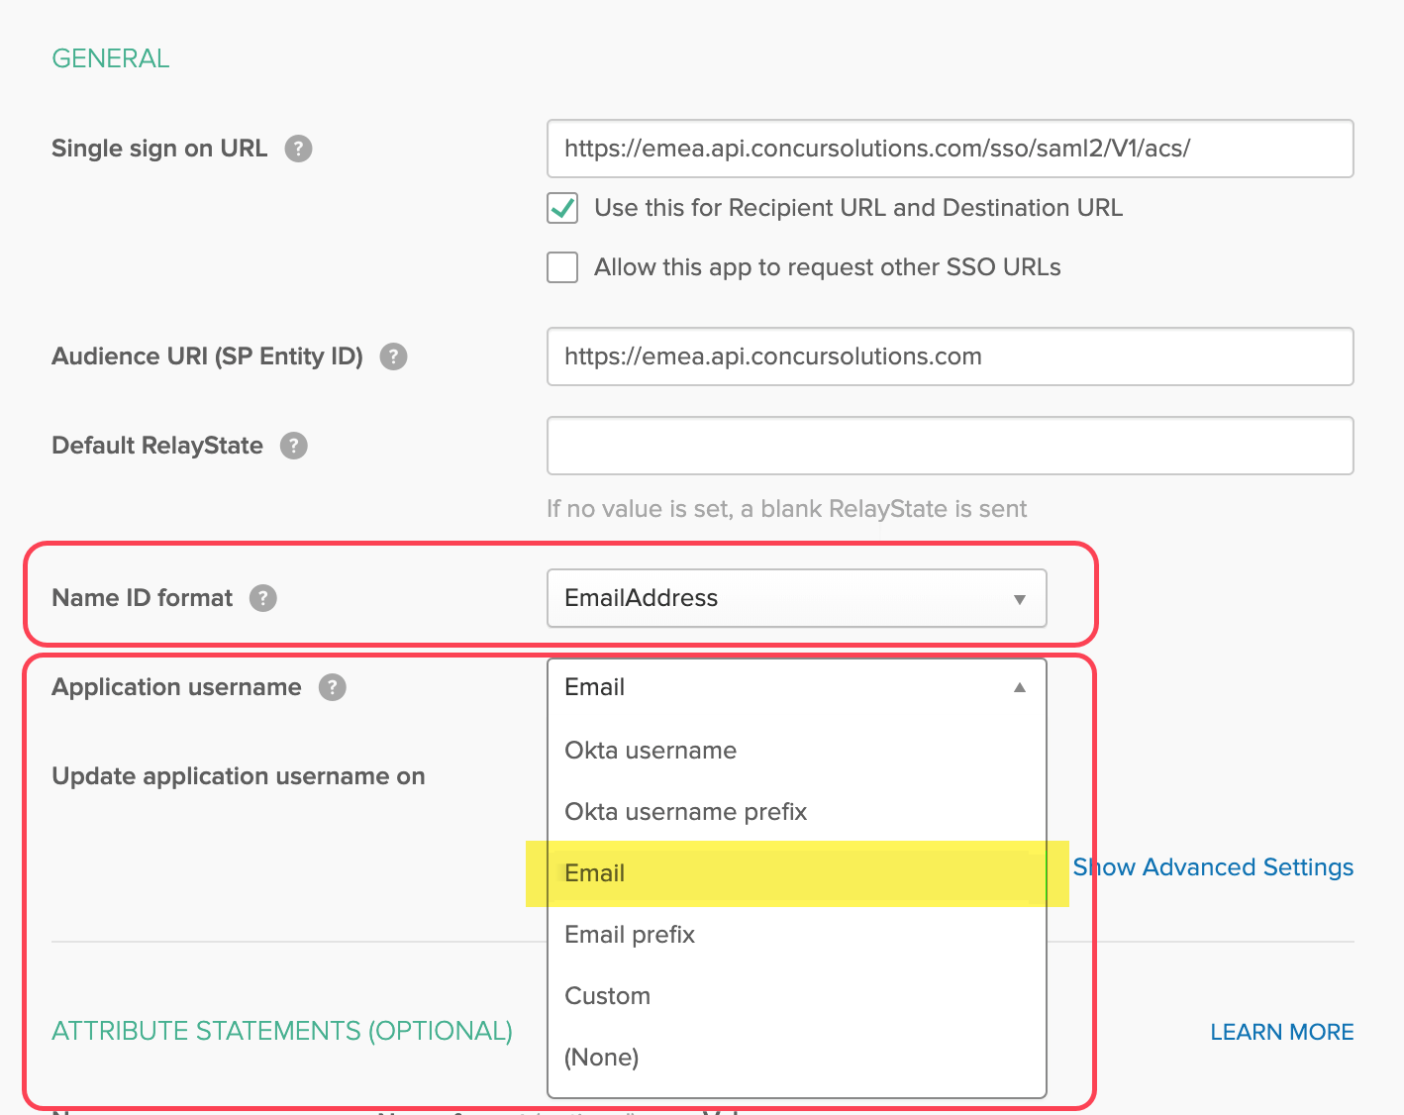
For Azure AD, edit the Unique User Identifier field to user.mail.
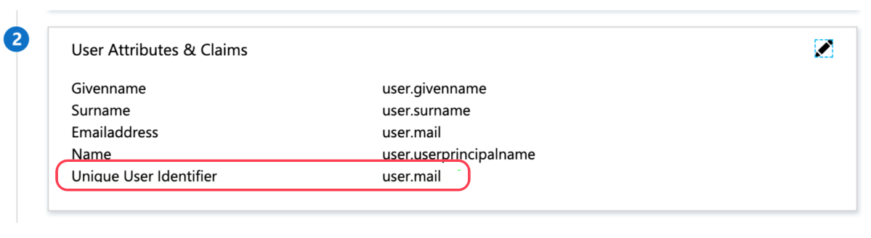
If you are not sure how to configure the NameID field, contact your Identity Provider for assistance.

Step 5: Obtain the IdP Metadata
Your IdP generates an IdP metadata file or an IdP metadata link. Both are supported by SAP Concur solutions. Below are examples from Okta and Azure AD.
For your IdP, if access to the metadata is not obvious, contact your IdP for assistance.
For Okta, use the Identity Provider Metadata link.
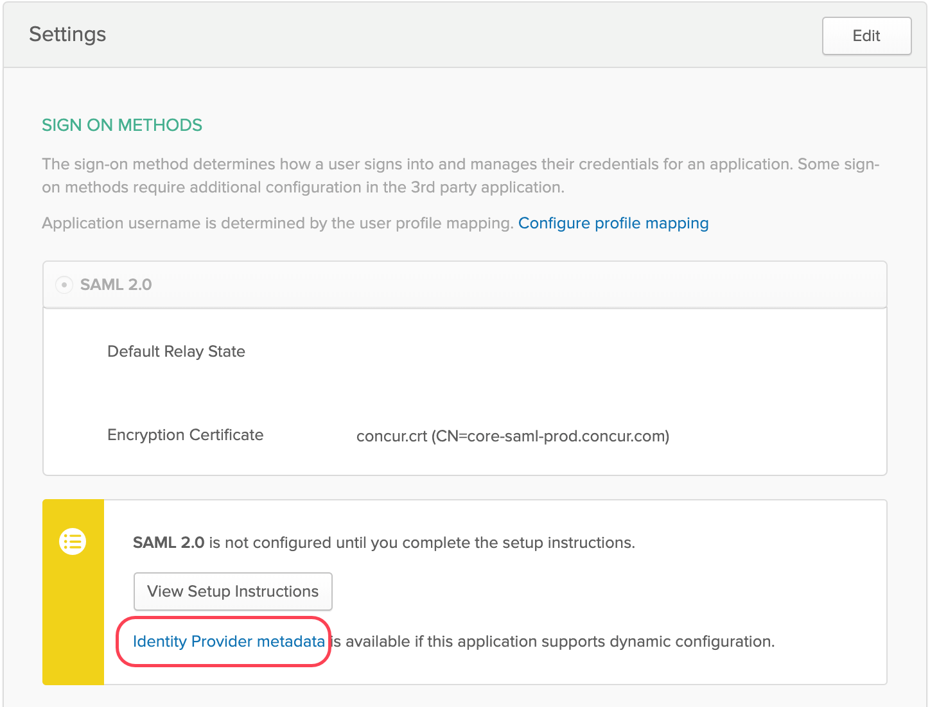
For Azure AD, use the App Federation Metadata Url link or the Federation Metadata XML download.
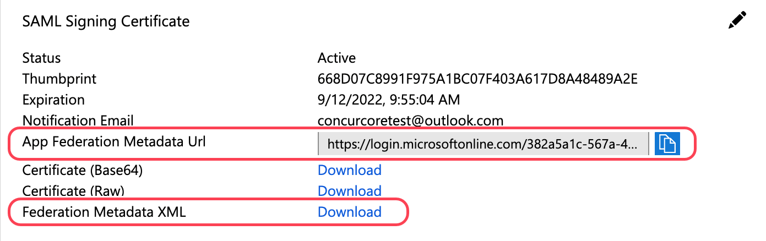

Step 6: Upload IdP Metadata to Concur
- Click Administration > Company > Authentication Admin, and then click Manage Single Sign-On.
- In the IdP Metadata section, click Add.
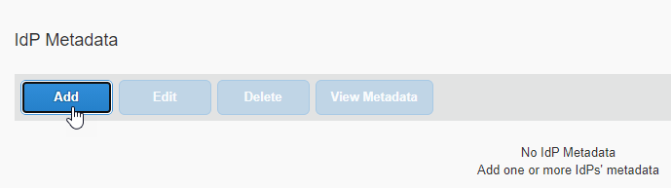
The Add IdP Metadata window appears.
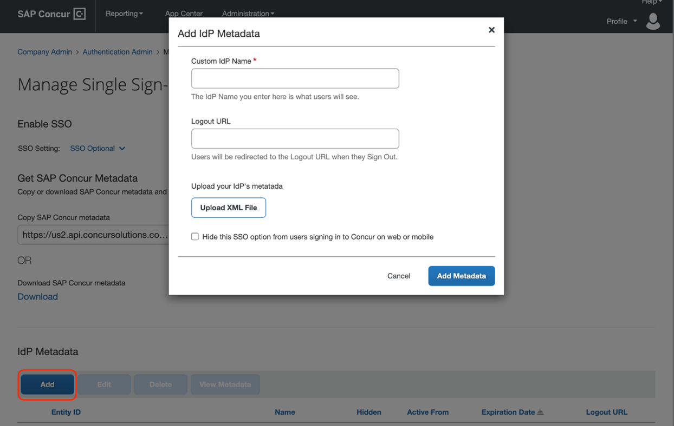
- In the Custom IdP Name field, enter a name.
The name you enter appears to users on the Sign In page. Best practice is to simply enter the IdP name. For example, if your IdP is Okta and if you enter Okta in this field, then the user will see Sign in with Okta.
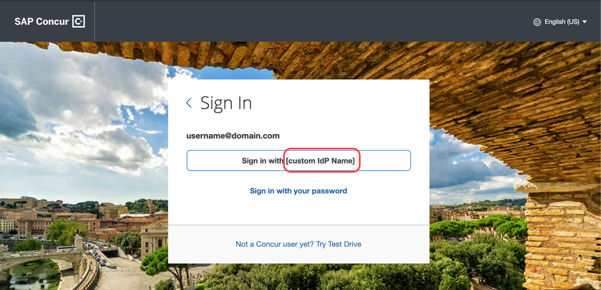
- In the Logout URL field, enter a Logout URL.
By default, if no URL is entered, users will be redirected to where they started the authentication process upon sign out from SAP Concur.
If a custom Logout URL is specified, users are redirected to the specified URL when they sign out of SAP Concur solutions.
- In the Upload your IdP's metadata section, click Upload XML File and upload the metadata file from the IdP.
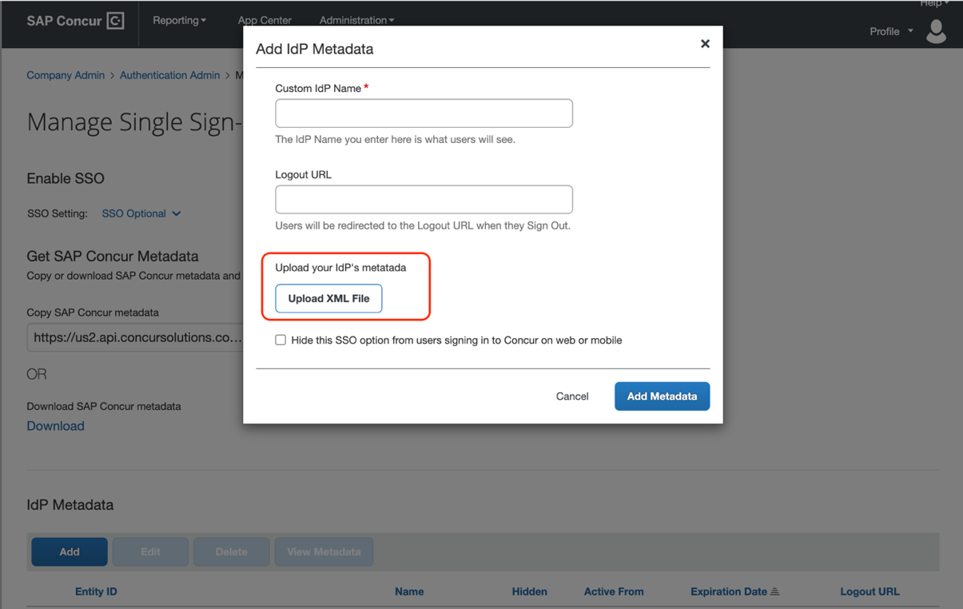
- To hide the sign-in option from users on mobile and signing in through concursolutions.com, select the checkbox Hide this SSO option from users signing in to Concur on web or mobile.
By default, the option is available to users when they begin an SP-initiated sign-in through concursolutions.com or the mobile app. The option can be hidden in those cases that require users to sign-in through an IdP-initiated flow.
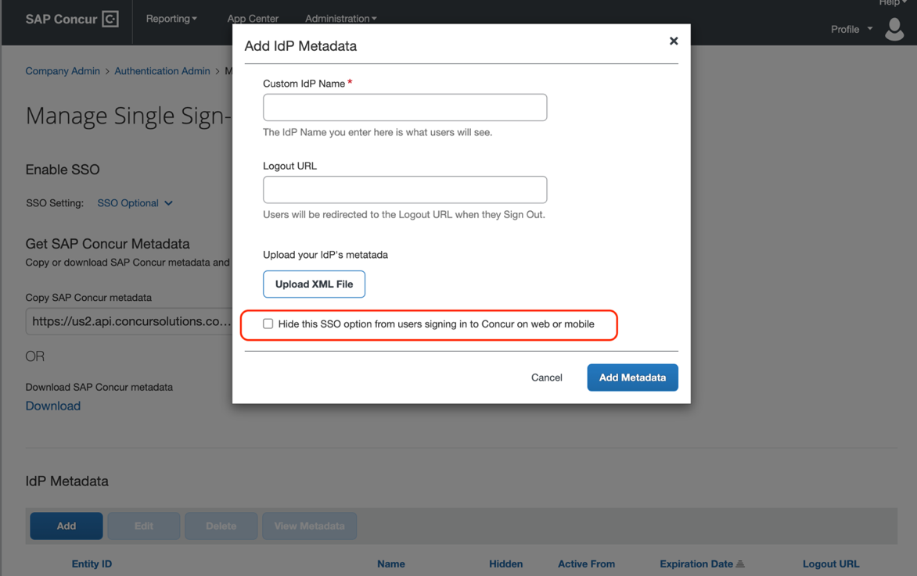
- Click Add Metadata.
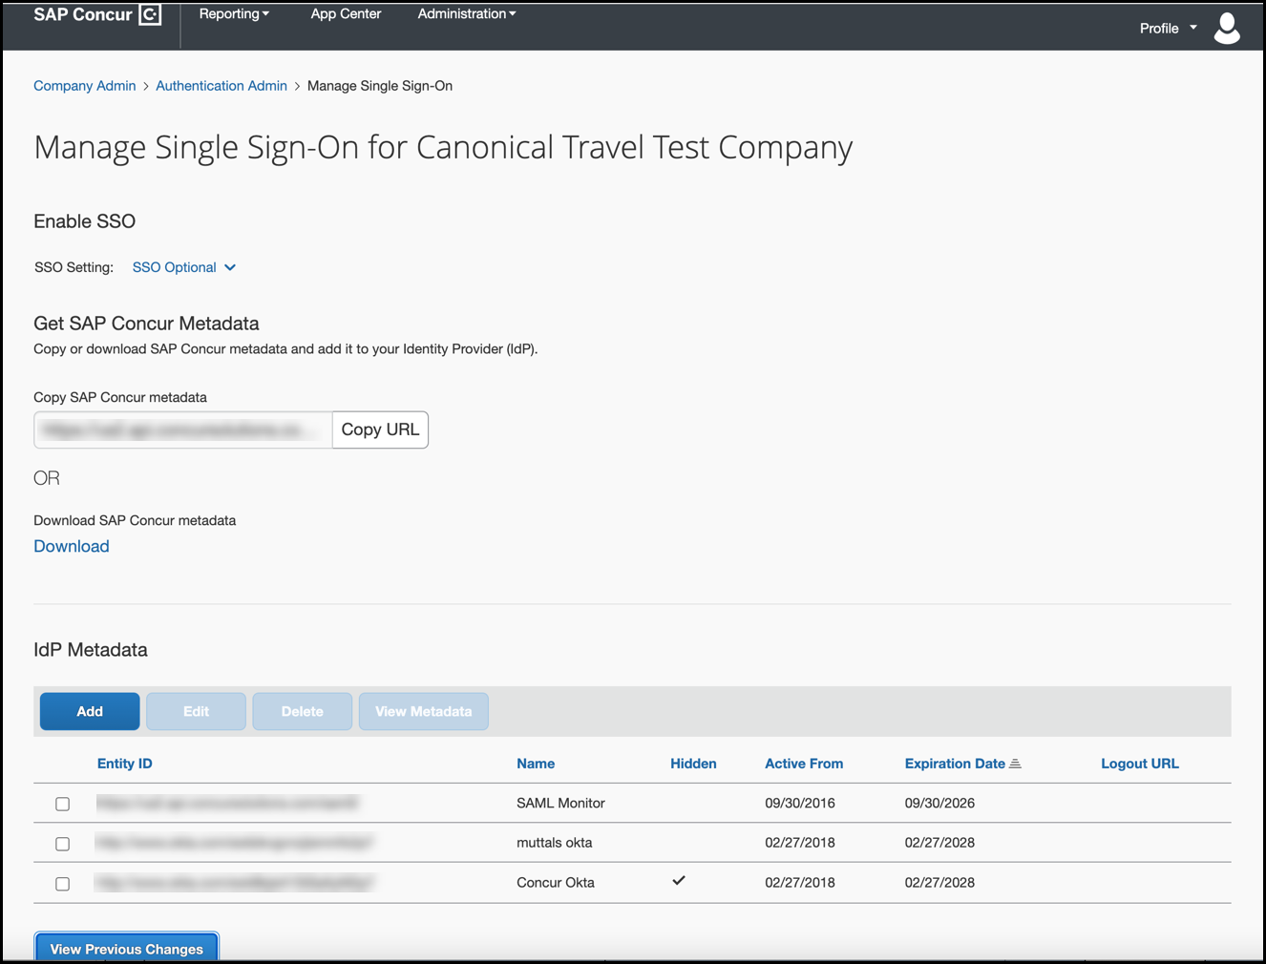
The configuration will be added to the IdP Metadata table, which shows a summary of each configuration.

Error Message
If an error occurs, the following message appears.
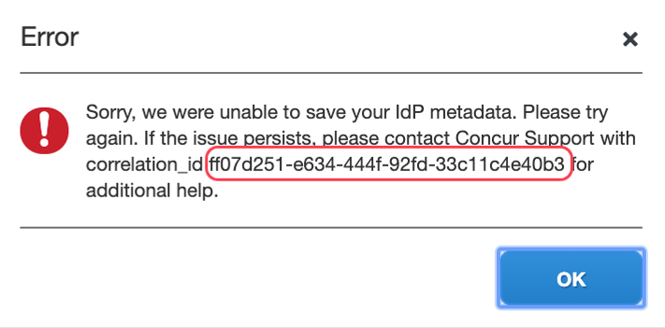
Save the correlation_id, contact SAP Concur support, and provide the correlation_id. SAP Concur support can look up the detailed error message and provide steps for troubleshooting the error.

Step 7: Test IdP-Initiated SSO
You must obtain the IdP-Initiated SSO URL from your Identity Provider. The location of the URL depends on your IdP. Below are examples of testing SSO on Okta and Azure AD. Your IdP will likely be similar.
After you obtain this IdP-Initiated SSO URL, you can paste the URL in the browser and try to sign in.
For Okta, click the app icon (embedded URL) in the Okta portal.
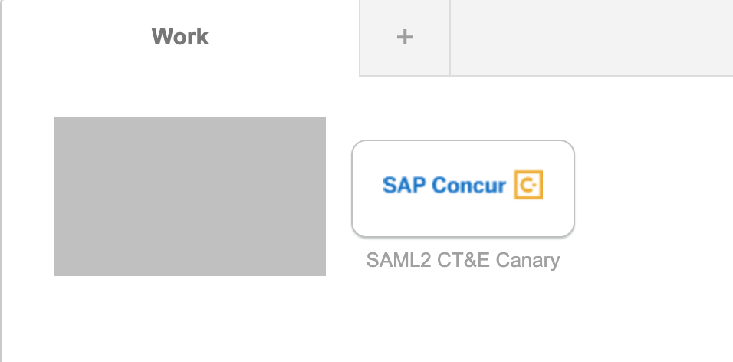
For Azure AD, use one of the following:
- Properties > User access URL
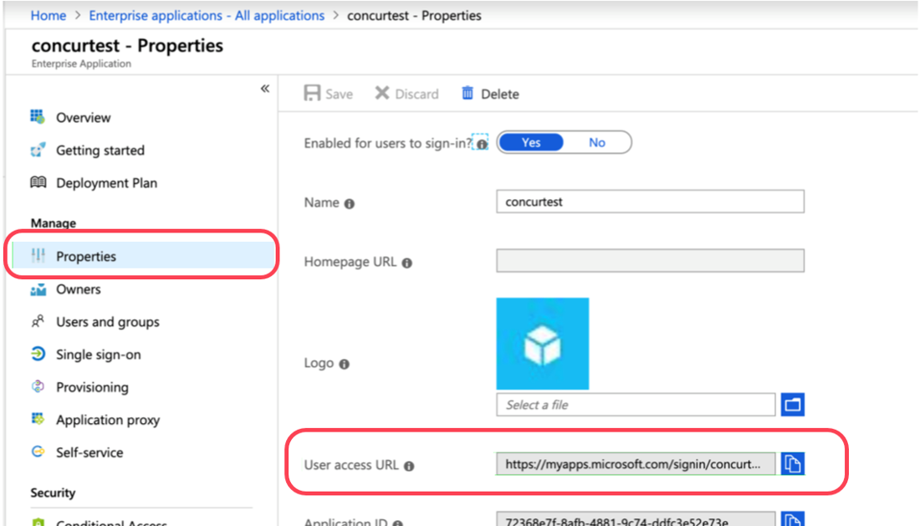
– or –
- Test single sign-on with Concur Travel and Expense
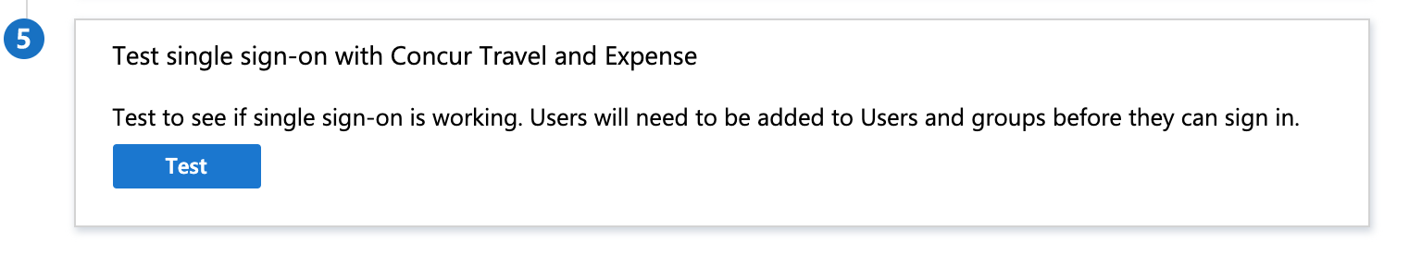
If you have questions about locating the IdP-Initiated SSO URL, contact your Identity Provider for assistance.

Error Message
If the SSO test sign-in fails, a message similar to the following appears.
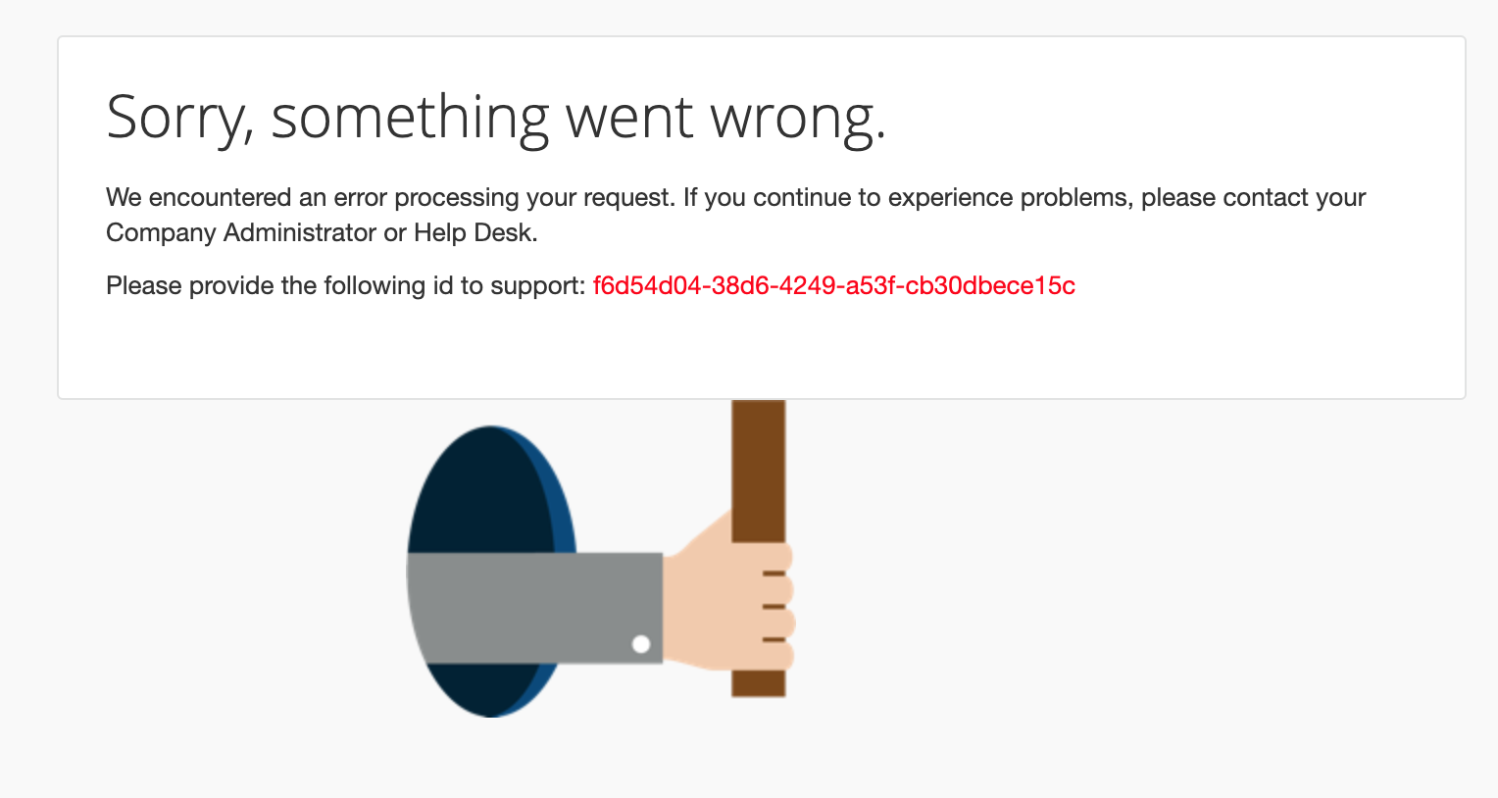
The two most common causes are:
- The user does not exist in SAP Concur solutions.
- The Login_ID does not match between your IdP and SAP Concur user profile.
To determine the cause, do the following:
- Use the SAMLtracer or the Inspect feature of the Chrome browser to locate the SAMLResponse. (Your IdP sends user information to SAP Concur solutions via SAMLResponse.)
- Decode the SAMLResponse with base64decode tools. base64decode tools are readily available online.
- Look for the value in the <saml2:NameID> field. For example:
<saml2:NameID Format="urn:oasis:names:tc:SAML:1.1:nameid-format:emailAddress">username@domain.com</saml2:NameID>
- Compare the value found in the <saml2:NameID> field (in the preceding example, username@domain.com) with the user's SAP Concur Login_ID.
- If you cannot find a match, then you must first create a user with a matching SAP Concur Login_ID and then test again.
- If you do find the user and the user's SAP Concur Login_ID matches the user's Login_ID at your IdP, contact SAP Concur support and provide the error ID that appears in the error message.

Step 8: Test SP-Initiated SSO
To test:
- Go to www.concursolutions.com.
- Enter the SAP Concur username.
- Click Sign in with [Custom IdP Name]. You will be redirected to your IdP. After you authenticate to the IdP, the SAP Concur home page appears.

Step 9: Enable SSO as Optional or Required
In the Enable SSO section, you have the option to change the SSO Setting from SSO Optional (Default value) to SSO Required.
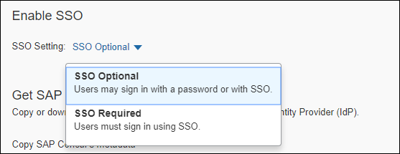
- IMPORTANT! If this account is managed by a TMC, the TMC must be notified before the SSO setting is changed from SSO Optional to SSO Required.
If you change the SSO setting to SSO Required, all users will be required to sign in to concursolutions.com through an IdP using SSO. Users—including TMCs, admins, web services, and test user accounts—will be blocked from signing in to concursolutions.com with their username and password. This could cause a disruption in services for those users.
Best Practice is to use the SSO Optional setting until all users understand how to sign in with SSO. Before you change the setting to SSO Required, we recommend you provide your users with a 60-day notice or a notification timeframe that is standard for your organization.
If you have any questions about making this change, contact SAP Concur Support for assistance.
- IMPORTANT: Changing the SSO Setting to SSO Required affects both web and mobile sign-in. Beginning with the 9.86 (November) version of the SAP Concur mobile app, changing the SSO Setting to SSO Required mandates that users must sign in using SSO on both web and mobile platforms.

Editing SSO Configurations
Once an SSO configuration has been created using the previous steps, it may be edited to change the values of Custom IdP Name, Logout URL, and checkbox to Hide this SSO option from users signing in to Concur on web or mobile. The IdP Metadata is not editable; instead, the recommended best practice is to create a new configuration, test it, and then delete the original configuration.
To edit a configuration, select the configuration to edit, and click Edit.
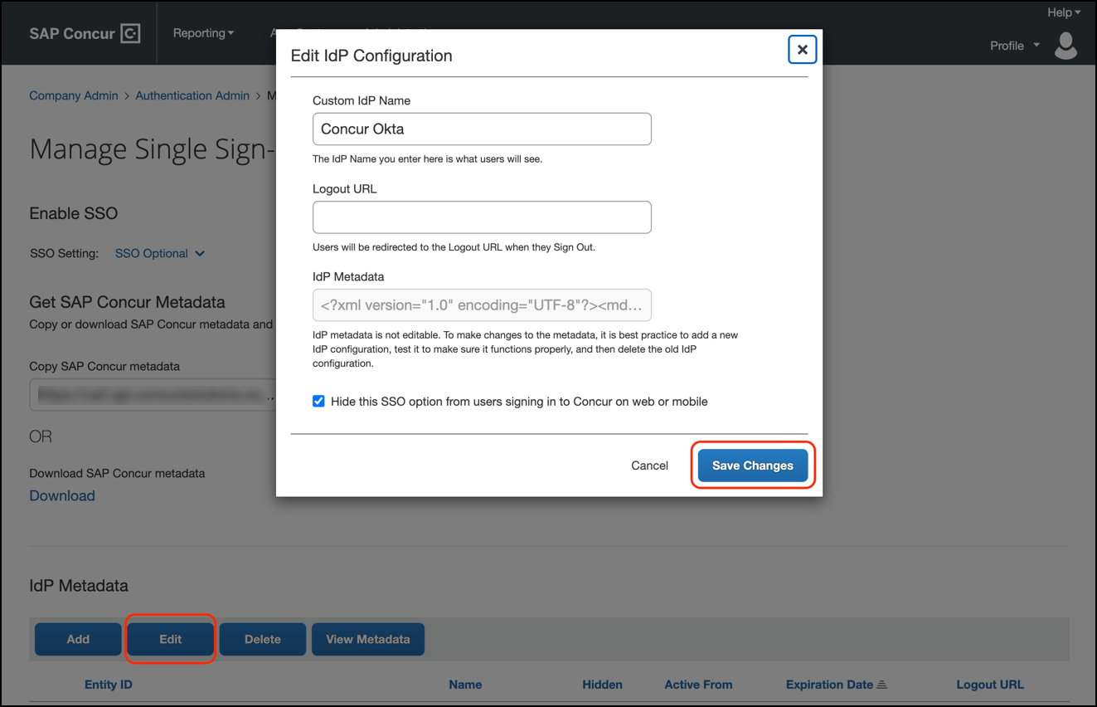
When the desired changes have been made, click Save Changes.

View Previous Changes
To view changes to the SSO configuration that have been made over time, click the View Previous Changes button.
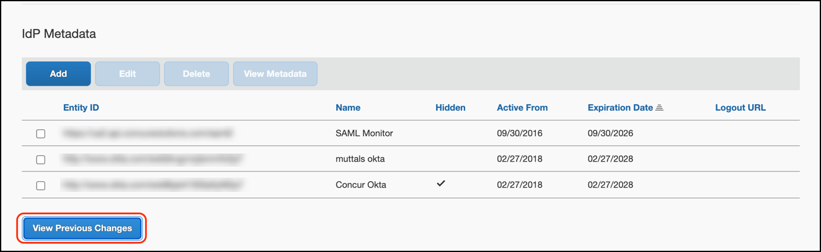
A table listing previous changes appears. The list of changes is sorted in descending order by date and time.
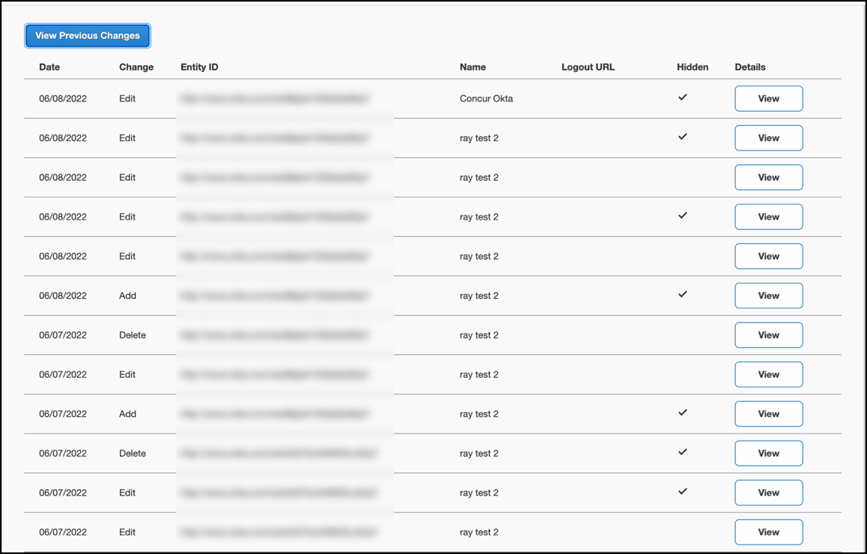
The table can display the last 100 changes. Changes that are listed in the table include:
- Adding a configuration
- Deleting a configuration
- Editing the name in the Custom IdP Name field
- Editing the URL in the Logout URL field
- Editing the Hide this SSO option from users signing in to Concur on web or mobile checkbox value.
To view more detailed information about a specific change listed in the table, click the View link for the desired list item.
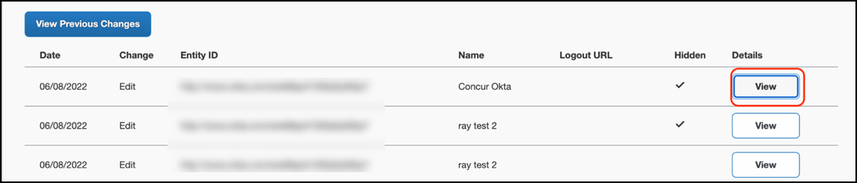
After you click the View link, the View Previous Changes page for the list item appears. The details that appear on the page differ depending on the kind of change that was made.

Deleted Configuration Details
The details that are displayed on the View Previous Changes page when a configuration is deleted include:
- Date Changed
- Type of change (Delete)
- Company that was changed
- Name and UUID for the user who made the change
- Entity ID
- Friendly name
- Logout URL
- Metadata
- Hidden
For configurations that are deleted, the View Previous Changes page includes a Revert button that enables you to reinstate the deleted configuration. After the configuration is reinstated, it will be available to users during the sign-in process.
Example View Previous Changes Page for Deleted Configuration
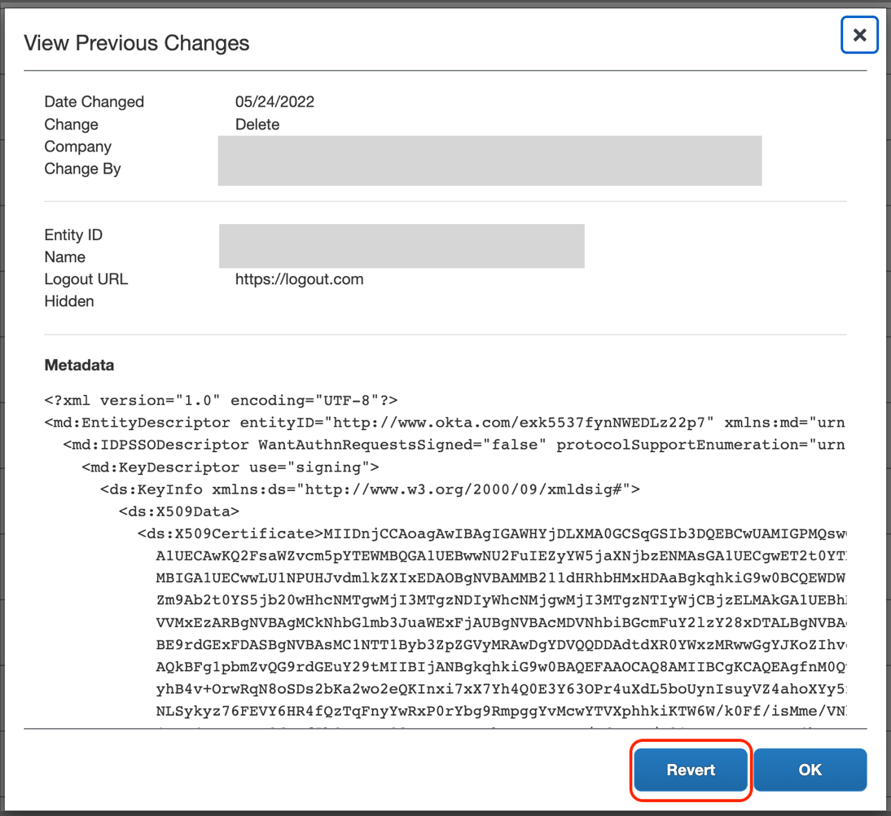
When you click the Revert button, you are prompted to confirm the action to reinstate the configuration. To confirm that you want to reinstate the configuration, click Revert Metadata. To cancel reinstatement of the configuration, on the Confirm Revert page, click Do Not Revert.
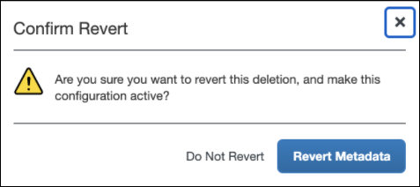
If you choose to reinstate a deleted configuration but the configuration cannot be reinstated, after you click the Revert Metadata button, a message similar to the following appears:
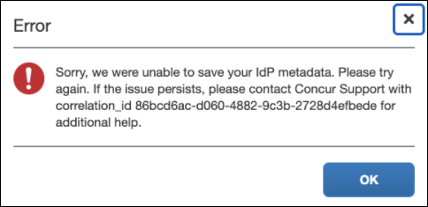

Edited Configuration Details
The details displayed on the View Previous Changes page when a configuration is edited include:
- Date Changed
- Type of change (Edit)
- Company that was changed
- Name and UUID for the user who made the change
- Current Entity ID
- Current friendly name
- Current Logout URL
- Previous Entity ID
- Previous friendly name
- Previous Logout URL
- Metadata
- Hidden
Example View Previous Changes Page for Edited Configuration
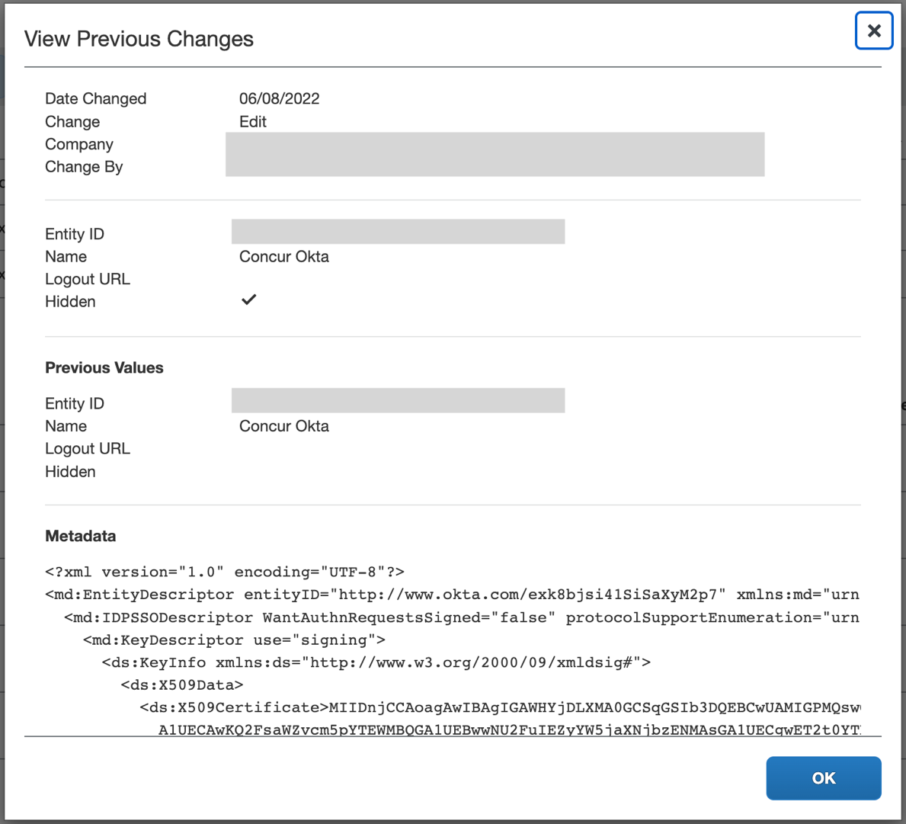

Added Configuration Details
The details that are displayed on the View Previous Changes page when a configuration is added include:
- Date Changed
- Type of change (Add)
- Company that was changed
- Name and UUID for the user who made the change
- Entity ID
- Friendly name
- Logout URL
- Metadata
- Hidden
Example View Previous Changes Page for Added Configuration
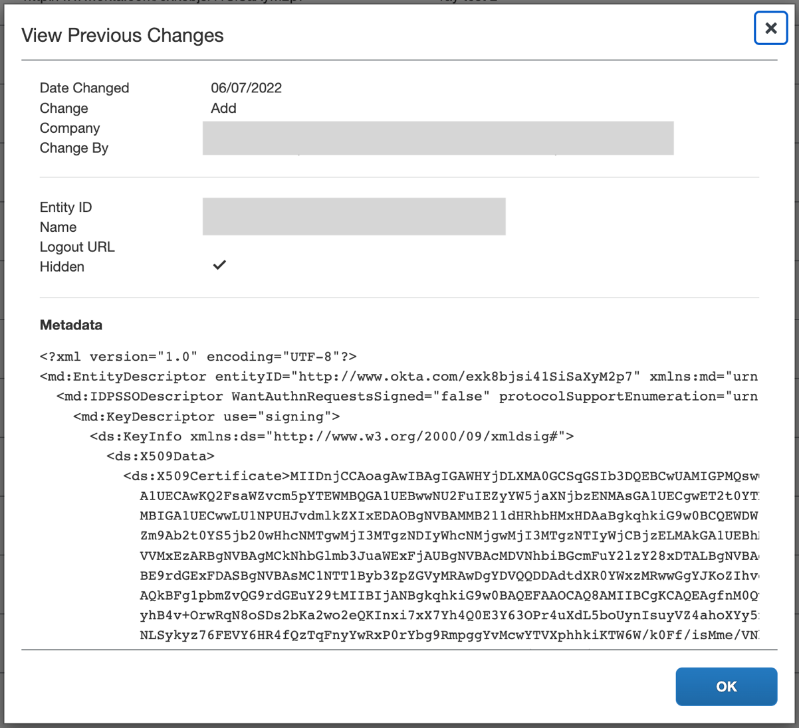

Configure an SSO App/Connector with Encryption (Optional)
Complete all steps described in the Configure an SSO App/Connector Without Encryption section, including testing. Then, check if your IdP supports encrypted SAMLResponse feature. If so, follow the steps below to configure the encryption.

Step 1: Obtain and Save the Encryption Key
Obtain the encryption key from SAP Concur solutions and save it in a encryption.crt file.
To obtain and save the encryption key:
- Click the URL that corresponds to the region (data center) in which your entity is hosted to view the SAP Concur SP metadata (Chrome browser recommended):
- US (North America):
https://www-us.api.concursolutions.com/sso/saml2/V1/sp/metadata/
- EMEA:
https://www-emea.api.concursolutions.com/sso/saml2/V1/sp/metadata/
- China:
https://www-cn.api.concurcdc.cn/sso/saml2/V1/sp/metadata
- Find the encryption key as shown in the following example:
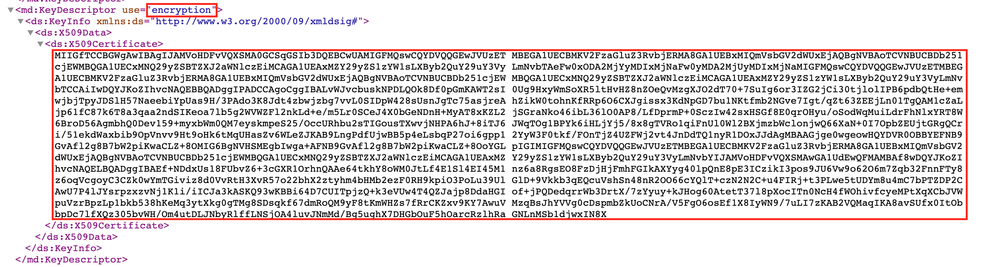
- Copy the encryption certificate into a plain text file.
Do not use a rich text editor like Word.
- Paste between two BEGIN/END CERTIFICATE rows as shown below:
-----BEGIN CERTIFICATE-----
< your copied cert here >
-----END CERTIFICATE-----
- Save as encryption.crt.


Step 2: Upload the encryption.crt to Your IdP
If you have questions about uploading the encryption certificate to your IdP, contact your IdP for assistance.

Examples
For Okta, set the Assertion Encryption field to Encrypted and then upload the encryption certificate.
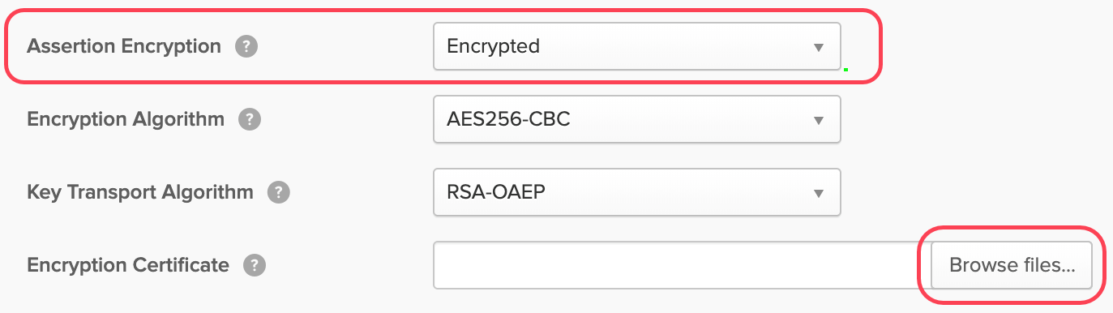
For Azure AD, use the Token encryption (Preview) option to upload the encryption certificate.
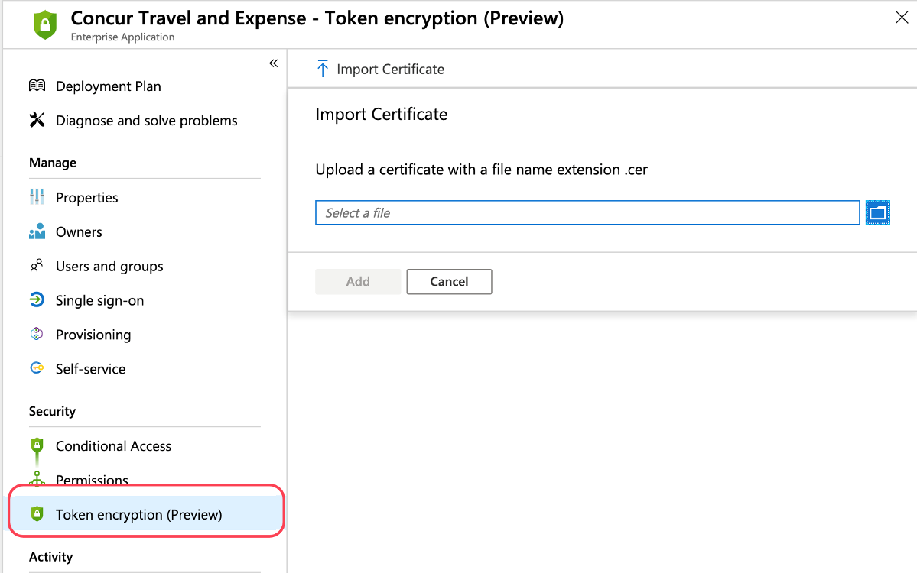

FAQ
Q. Which IdPs are supported by SAP Concur?
A. SAP Concur is compatible with all identity providers that support the SAML 2.0 standard.
Q. How does SSO enforcement work?
A. Currently, SAP Concur supports enforcing SSO at the company level. SAP Concur does not support enforcing SSO based on user role or user group.
There are two options available when setting up SSO: SSO Optional and SSO Required.
SSO Optional is the default value and selecting it means that everyone from your company can sign in to SAP Concur services with a standard username and password or with SSO credentials.
After you have successfully tested SSO sign-in, you can change the SSO Setting to SSO Required.
- IMPORTANT! Changing the SSO setting to SSO Required could cause a disruption in service.
If you change the SSO setting to SSO Required, all users will be required to sign in to concursolutions.com through an IdP using SSO. All users—including TMCs, admins, web services, and test user accounts—will be blocked from signing in to concursolutions.com with their username and password.
- IMPORTANT! If this account is managed by a TMC, the TMC must be notified before the SSO setting is changed to SSO Required.
Q. Can I set up more than one IdP with SAP Concur?
A. Yes. The SSO self-service tool allows you to add unlimited IdPs.
Q. How long do I need to wait to test SSO sign-in after I have uploaded my metadata?
A. Once your IdP's metadata is saved properly at SAP Concur, SSO sign-in should work instantly.
Q. Will configuring SSO on the new self-service platform affect our current SSO configuration on your old platform?
A: No. Configuring SSO on the new self-service platform will not affect your current SSO configuration on the old platform. It is separate from the legacy Concur SSO stack and can safely be used in parallel to the existing SSO configurations. Once the SSO service has been configured, tested, and deployed, existing SSO customers can request the removal of their legacy SSO configurations so they have only a single tool to manage.
Q. Why can’t I see my current SSO configuration on the Manage Single Sign-On page?
A: Your current SSO configuration is part of the old SSO service and that configuration data can be accessed only by SAP Concur employees
Q. Can I set up my mobile SSO via the Manage Single Sign-On page?
A. Yes. Beginning with the 9.86 version of the SAP Concur mobile app, configuring SSO using the processes described in this document enables SSO sign-in for both web and mobile. If you change the SSO Setting from SSO Optional to SSO Required users must sign in using SSO on both the web and mobile platforms.
Q. Does SAP Concur support "Just-In-Time User Provisioning" via SAML SSO?
A. No. It is targeted for a future update.
Q. Does SAP Concur support "Home Realm Discovery"?
A. Yes. Home Realm Discovery service is an API behind the SP-Initiated SSO flow.

Appendix - ADFS Setup
Per the appendix instructions in this section, as content is sourced from the third-party provider, SAP Concur cannot guarantee its accuracy. If you encounter issues, it is recommended that you contact the third-party provider’s support resources.

Getting Started
Before you start the configuration process, ensure that:
- Your users exist in both ADFS and SAP Concur. Auto user provisioning is not currently supported by SAP Concur, so you need to add users separately in there.
- The attribute you are sending from ADFS matches the Login ID (Username / CTE Login Name) field for each employee in SAP Concur.
- You have the Company Administrator (Travel permission) assigned to your SAP Concur account. Once you have the permission, you can access the Manage SSO page by using one of the following paths, depending on your SAP Concur edition.
For SAP Concur Standard edition:
- Go to Administration > Expense Settings.
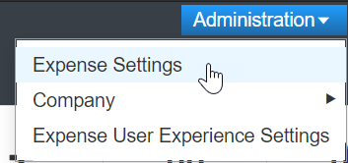
- Under Access to Concur section, click Show 1 Advanced Setting.
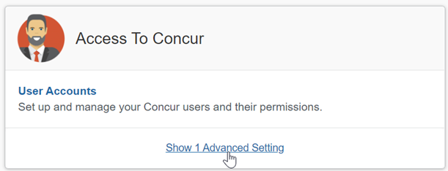
- Click Manage Single Sign-On to access the Manage SSO page.
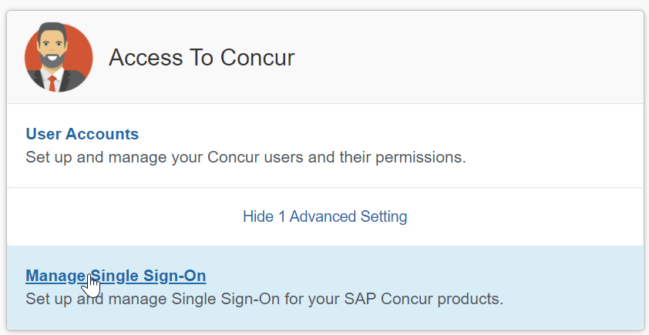
For the SAP Concur Professional edition:
- Go to Administration > Company > Authentication Admin.
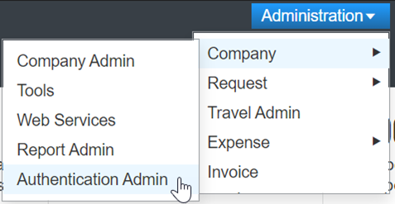
- Click Manage Single Sign-On to access the Manage SSO page.
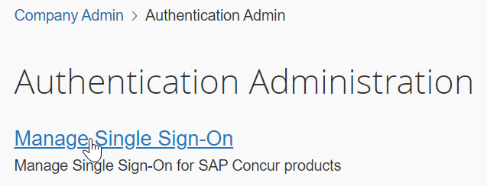
Alternatively, users can access the page using one of the following URLs:
- US DC Prod: https://www.concursolutions.com/nui/authadmin/ssoadmin
- US DC Test: https://implementation.concursolutions.com/nui/authadmin/ssoadmin
- EMEA DC Prod: https://eu1.concursolutions.com/nui/authadmin/ssoadmin
- EMEA DC Test: https://eu1imp.concursolutions.com/nui/authadmin/ssoadmin
- CN DC Prod: https://www.concurcdc.cn/nui/authadmin/ssoadmin
If you don’t have that permission and cannot have this assigned to your profile, please ask an authorized support contact at your company to open a case with SAP Concur support.

Configure Your ADFS Application
- Run the Relying Party Trust wizard.
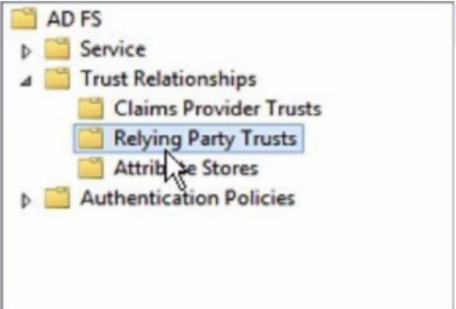
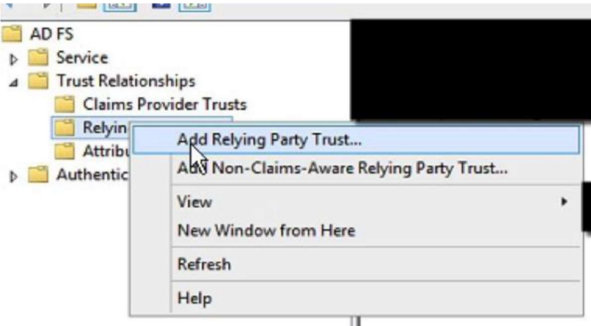
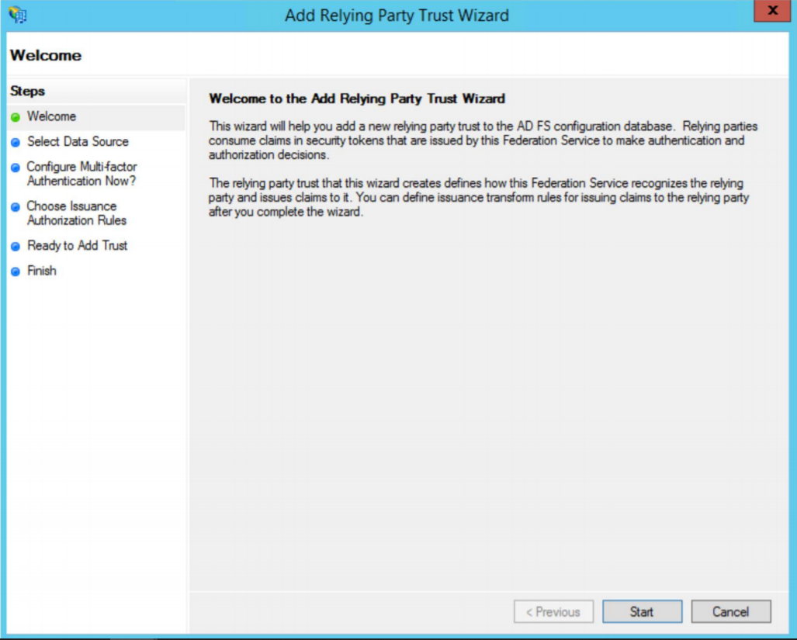
- On the Select Data Source dialog, choose the option of your preference:
  - Import data about the relying party published online or on a local network (if you prefer to upload the metadata URL)
  - Import data about the relying party from a file (if you prefer to upload the metadata xml file)
  - Enter data about the relying party manually (if you prefer to manually fill the configuration fields)
- After choosing your option, click Next.
The metadata file or the metadata URL can be obtained from the Authentication Admin > Manage Single Sign-On page on your SAP Concur account. Please refer to the previous Getting Started section for more information about how to access the page.
If you have chosen Import data about the relying party published online or on a local network or Import data about the relying party from a file this should automatically fill your Configure Certificate, Configure URL and Configure Identifiers sections on ADFS. In that case, please skip to step 8 on this guide. Steps 3-7 will be needed if you have chosen the manual setup.
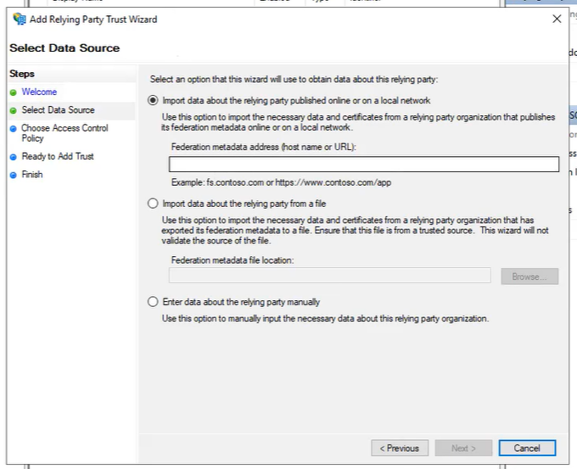
- On the Specify Display Name dialog, in the Display name field, enter the label of your preference and click Next.
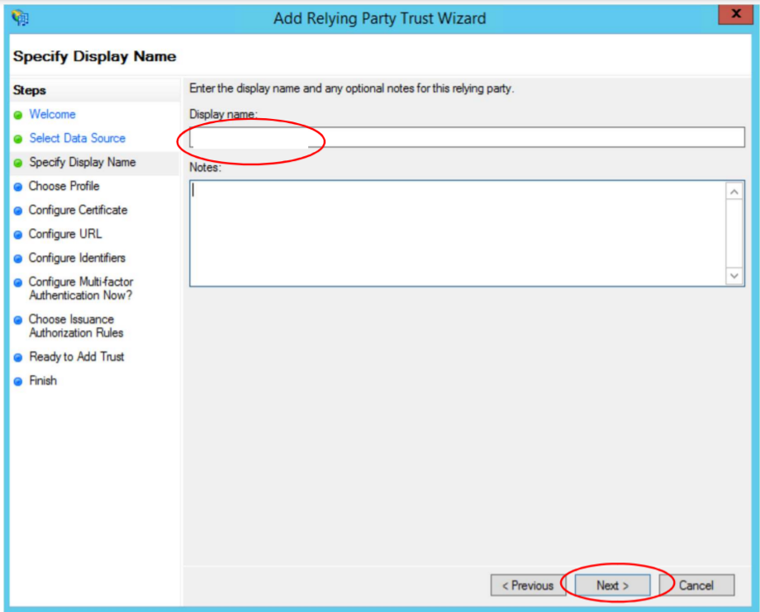
- On the Choose Profile dialog, select ADFS profile option and click Next.
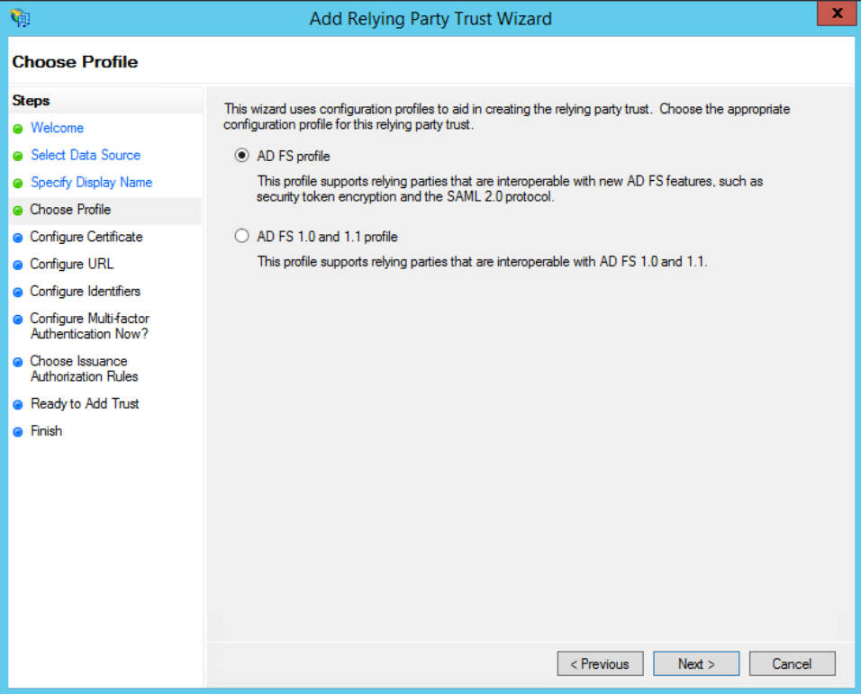
- On the Configure Certificate dialog, manually upload the SAP Concur encryption certificate. It can be obtained from the Manage SSO page in SAP Concur as described in the Getting Started section. Then go to the SAP Concur metadata, extract the encryption certificate and save it to your PC. Browse and upload the encryption certificate and then click Next.
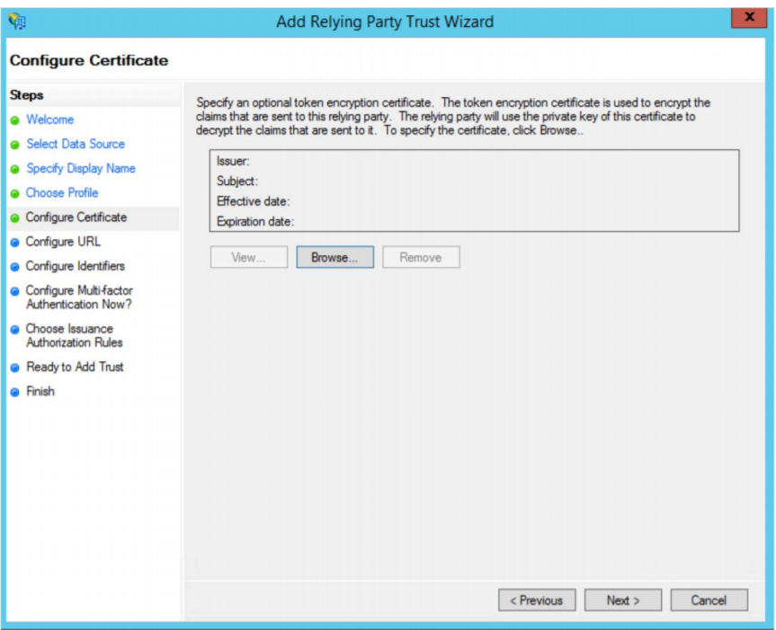
- On the Configure URL dialog, select Enable support for the SAML 2.0 Web SSO protocol and enter the relying party SAML 2.0 SSO service URL:
- US (North America): https://www-us.api.concursolutions.com/sso/saml2/V1/acs/
- EMEA: https://www-emea.api.concursolutions.com/sso/saml2/V1/acs/
- China: https://www-cn.api.concursolutions.com/sso/saml2/V1/acs/
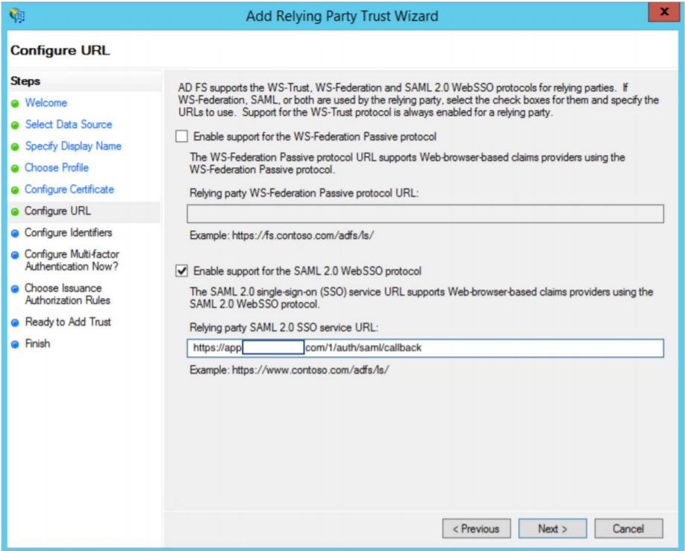
- On the Configure Identifiers dialog, add the Relying party trust identifier:
- US (North America): https://us.api.concursolutions.com/saml2
- EMEA: https://emea.api.concursolutions.com/saml2
- China: https://cn.api.concursolutions.com/saml2
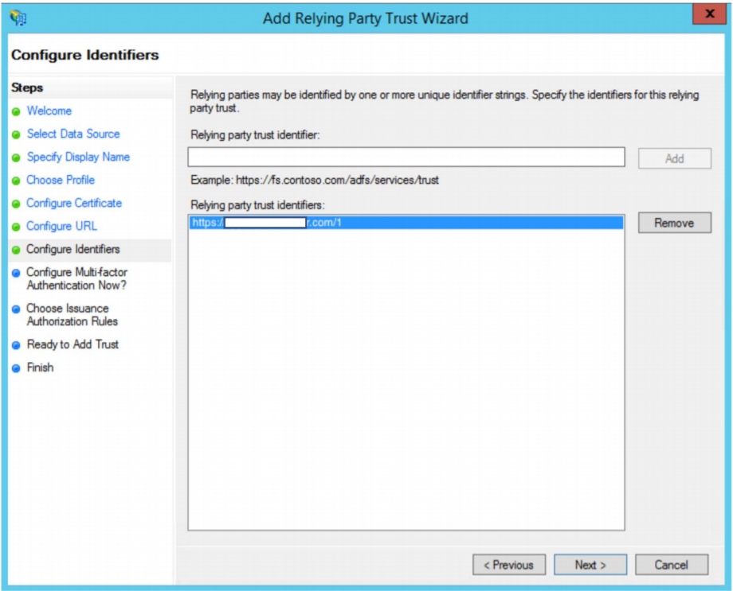
- Select the I do not want to configure multi-factor authentication settings for this relying party trust at this time option and then click Next.
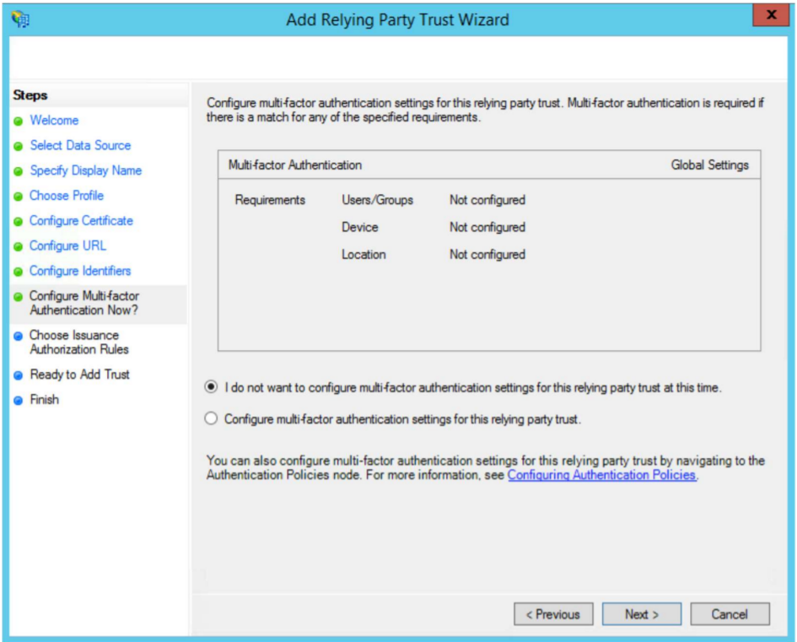
- In the Choose Issuance Authorization Rules dialog, select the Permit all users to access this relying party option and then click Next.
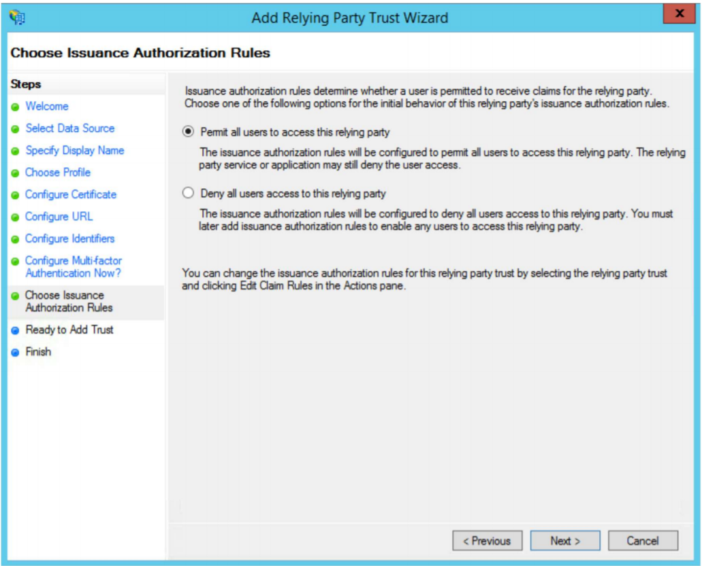
- Review the newly configured relying part trust if required. If you haven’t updated the metadata already, on the Ready to Add Trust dialog click the Signature tab, add the SAP Concur metadata and then click Next.
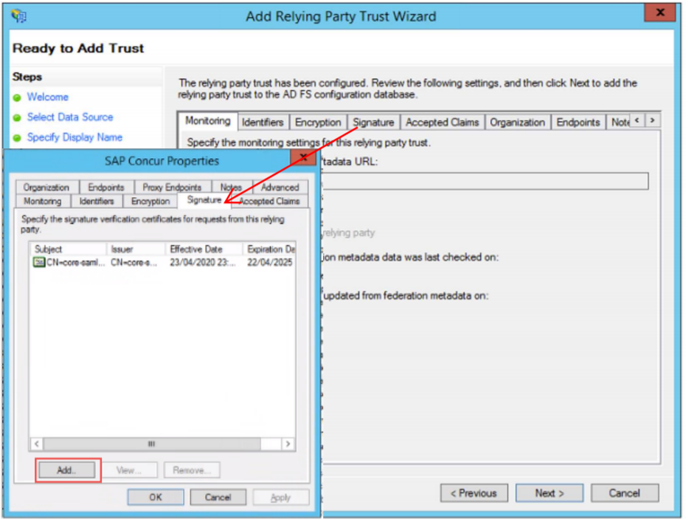
- On the Finish dialog, select the Open the Edit Claim Rules dialog for this relying party trust when the wizard closes option and then click Close.
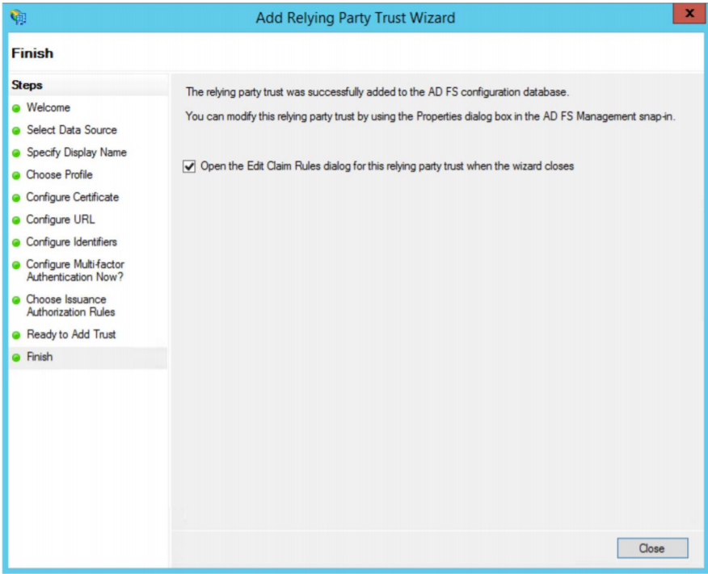
The Add Transform Claim Rule Wizard appears automatically.
- Create the following two rules:
Rule 1:
- Set claim rule template as "Send LDAP Attributes in Claim".
- Click Next.
- Add Claim rule name and set your Attribute store. This will normally be “Active Directory”.
- LDAP Attribute = E-Mail Addresses
- Outgoing Claim Type = E-Mail Address
- Click Finish.
Rule 2:
- Set claim rule template as “Transform an incoming claim”.
- Add Claim Rule Name.
- Incoming Claim Type = Email Address
- Outgoing Claim Type = NameID
- Outgoing Name ID format = Email
- Make sure “Pass through all claim values” is selected.
- Click Finish.
For the Name ID value that is passed in the assertion when a user authenticates, this value must match the user’s SAP Concur login ID. Most SAP Concur customers use email addresses as their login IDs therefore, by default, this is how the claim rule should be set up.
However, if your company uses a different format for your SAP Concur login IDs, for example, employeeID@companydomain.com, then you must customize this rule so that the LDAP Attribute sends the employeeid and companydomain.com. Any other custom roles created will need to make sure the Name ID format is sent as “email address”, as this is a requirement for SP-Initiated logins.

Configure Your SAP Concur Site
To complete the configuration, save a copy of the ADFS metadata file to your local machine.
To enter the ADFS metadata into SAP Concur:
- Sign into SAP Concur.
- Access the Manage Single Sign-On page.
- Click Add in the IdP Metadata section.
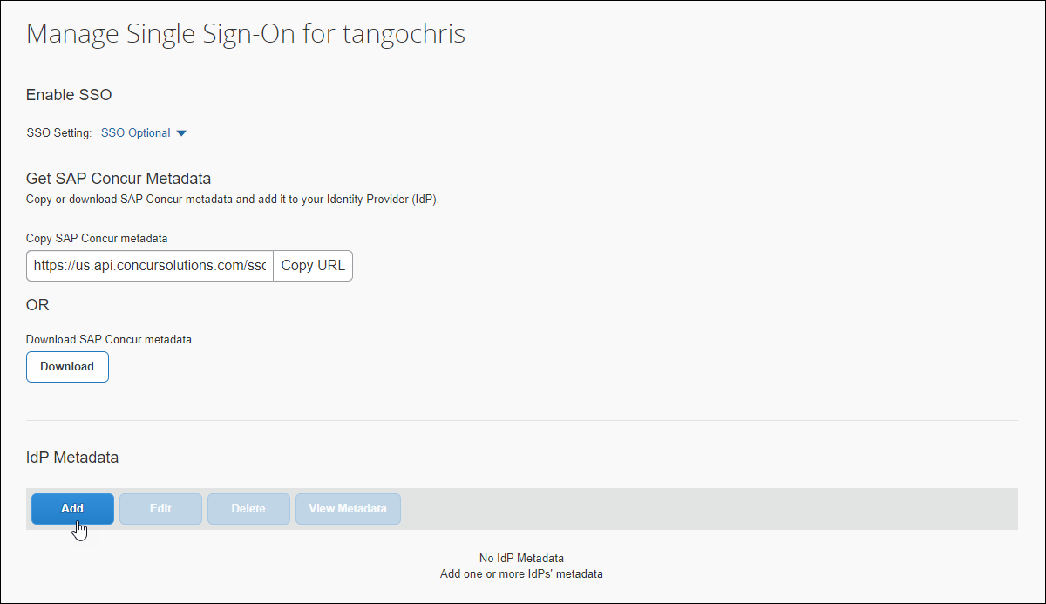
The Add IdP Metadata window appears.
- In the Add IdP Metadata window, Upload your IdP's metadata section, click Upload XML File and upload the ADFS metadata file.
- To hide the sign-in option from users on mobile and signing in through concursolutions.com, select the checkbox Hide this SSO option from users signing in to Concur on web or mobile.
By default, the option is available to users when they begin an SP-initiated sign-in through concursolutions.com or the mobile app. The option can be hidden in those cases that require users to sign-in through an IdP-initiated flow.
- Click Add Metadata.
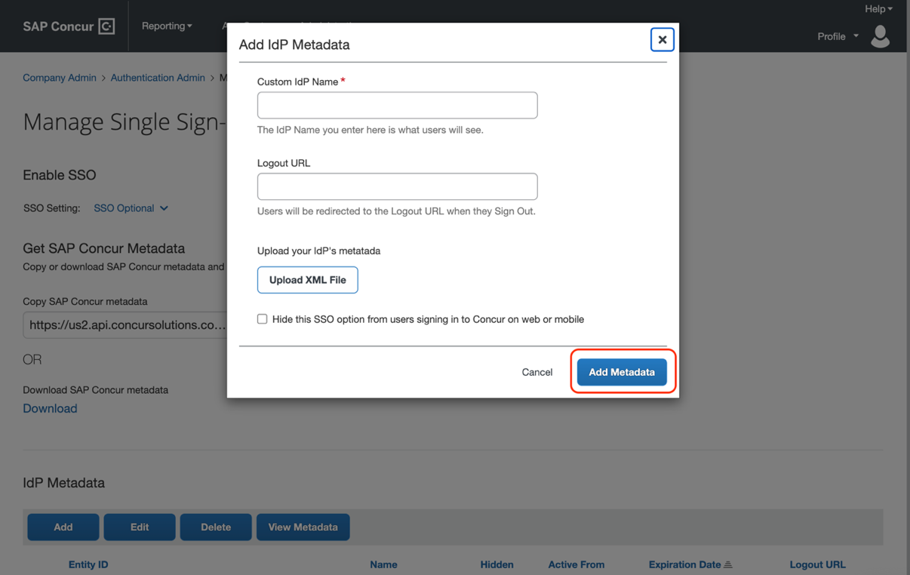

Test SSO Login

Testing IdP-Initiated SSO
To test your IdP-Initiated SSO login, make sure you’ve assigned the new application in ADFS to the users and groups who will test this. Use the ADFS URL that looks like this:
https://[Federation Service Identifier domain]/adfs/ls/idpinitiatedsignon.aspx?loginToRp= [Relying party trust identifier]
If correct, this URL should prompt you for your ADFS credentials and then redirect you to the already logged in SAP Concur home page.

Test SP-initiated SSO
To test the SP-initiated SSO:
- Open the SAP Concur login page according to the environment you want to test.
- US DC Prod: https://www.concursolutions.com/
- US DC Test: https://implementation.concursolutions.com/
- EMEA DC Prod: https://eu1.concursolutions.com/
- EMEA DC Test: https://eu1imp.concursolutions.com/
- CN DC Prod: https://www.concurcdc.cn/
- On the login page, you can add your username, verified e-mail address or SSO code to proceed. Once you click Next, you should see an option for your recently created SSO configuration. Click to proceed with authenticating your identity provider account which should redirect you to SAP Concur.
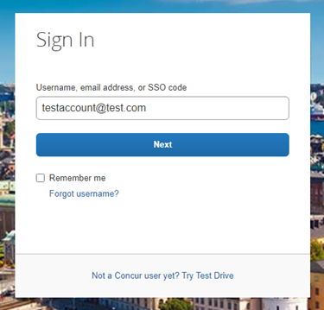
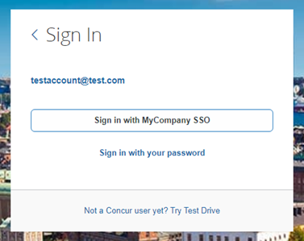
After adding your ADFS credentials, if you receive an error message in ADFS, this could be a sign that the onfiguration is not completed. If the error message is on the SAP Concur side, this could be a matter of unmatching credentials, an invalid certificate or a missing setting. If the IdP-Initiated login is working but the SP-Initiated is not, this is probably happening because the Name ID on the ADFS side is not being sent with the correct format. This is described in the Configure Your ADFS Application section.
If you’re still having issues, please copy the error ID you received and contact SAP Concur support for assistance.

Mobile Single Sign-On (SSO)
For SSO configurations created on our SAMLv2 platform, the Mobile SSO should be enabled automatically as soon as the metadata is saved. However, for this option to work, the SP-Initiated flow needs to be functioning. This can be validated using the previous Test SSO Login section.
The automatic enabling of Mobile SSO is only visible on the app version 9.86 or higher and if the user is opting for the new sign in experience. Users on older versions or opting for the earlier sign in experience will not see this option automatically.
If you have any issues in authenticating with SSO on the mobile app, please open a ticket with the SAP Concur support team and provide any error IDs and/or messages received with screenshots.

E-mail Notifications
The configuration of e-mail reminders to reflect your SSO URL are changes that need to be completed by SAP Concur support. To proceed, please open a ticket with the SAP Concur support team, providing the IDP URL from the application created on the IDP side so they can adjust the redirect URL for e-mail reminders. For more information on how to obtain the URL, see the Test SSO login > Testing IdP-Initiated SSO section of this appendix.

Rollout
After testing your new SSO configuration, you can then plan your rollout by assigning your new Azure AD application to all your users and groups who’ll need this access.
The Manage SSO page also offers the option for you to enforce this new SSO connection by changing the SSO Setting from SSO Optional to SSO Required. If you change it, users will be redirected to SAP Concur by providing their Username via the SP-initiated flow.
If you need to enforce Mobile SSO only, please contact SAP Concur support.
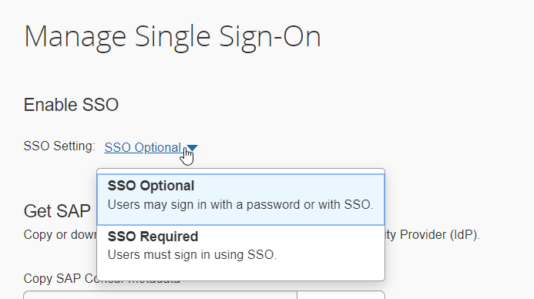

Appendix - Microsoft Azure AD Setup
Per the appendix instructions in this section, as content is sourced from the third-party provider, SAP Concur cannot guarantee its accuracy. If you encounter issues, it is recommended that you contact the third-party provider’s support resources.

Getting Started
Before you start the configuration process, ensure that:
- Your users exist in both Azure AD and SAP Concur. Auto user provisioning is not currently supported by SAP Concur, so you need to add users separately in there.
- The attribute you are sending from Azure AD matches the Login ID (Username / CTE Login Name) field for each employee in SAP Concur.
- You have the Company Administrator (Travel permission) assigned to your SAP Concur account. Once you have the permission, you can access the Manage SSO page by using one of the following paths, depending on your SAP Concur edition.
For SAP Concur Standard edition:
- Go to Administration > Expense Settings.
- Under Access to Concur section, click Show 1 Advanced Setting.
- Click Manage Single Sign-On to access the Manage SSO page.
For the SAP Concur Professional edition:
- Go to Administration > Company > Authentication Admin.
- Click Manage Single Sign-On to access the Manage SSO page.
Alternatively, users can access the page using one of the following URLs:
- US DC Prod: https://www.concursolutions.com/nui/authadmin/ssoadmin
- US DC Test: https://implementation.concursolutions.com/nui/authadmin/ssoadmin
- EMEA DC Prod: https://eu1.concursolutions.com/nui/authadmin/ssoadmin
- EMEA DC Test: https://eu1imp.concursolutions.com/nui/authadmin/ssoadmin
- CN DC Prod: https://www.concurcdc.cn/nui/authadmin/ssoadmin
If you don’t have that permission and cannot have this assigned to your profile, please ask an authorized support contact at your company to open a case with SAP Concur support.

Configure Your Azure AD Application
Please see the Microsoft Azure AD Guide as an additional reference for this section.

Step 1: Create Gallery Application
- Go to Home > Enterprise applications and then click New Application.
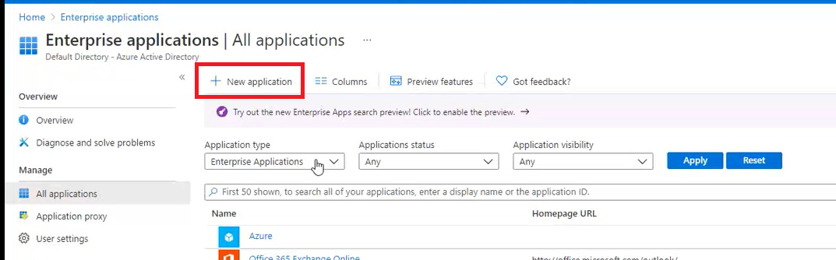
- Search for Concur.
- Select the SAP Concur Travel and Expense option. Do not use the SAP Concur option with the black icon as this is used for the Legacy SSO platform and not the recommended SAML2 SSO platform.
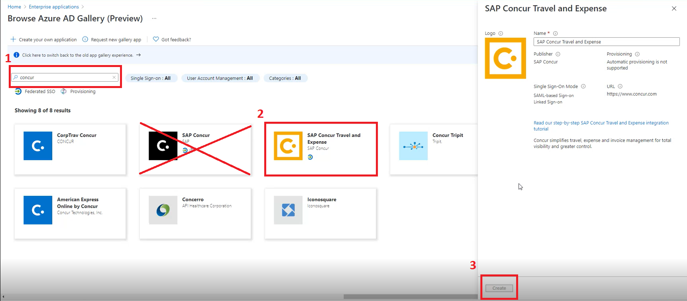
- Click Create.
- Click Set up Single sign on and then click on SAML.
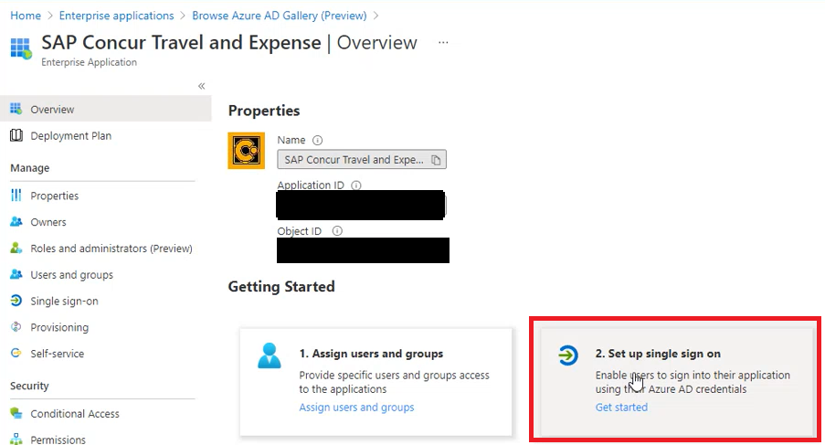
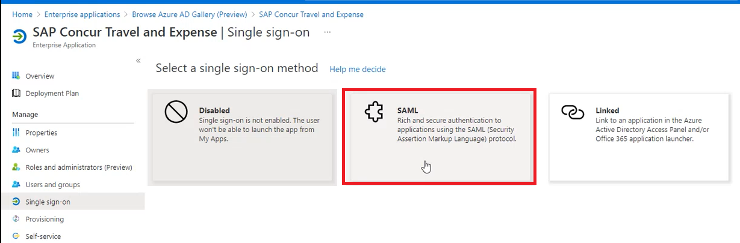

Step 2: Provide Azure ID with Identifier and Reply URL
- Upload the SAP Concur Metadata by clicking the “upload metadata file”.
OR
- Click Edit for the Basic: SAML Configuration option and remove the Identifiers (Entity IDs) and Reply URLs (Assertion Consumer Service URLs) that are not relevant for the datacenter your SAP Concur entity is on.
For SAP Concur Test Entities you will always need to upload the SAP Concur Metadata to get the correct Identifiers (Entity IDs) and Reply URLs (Assertion Consumer Service URLs).
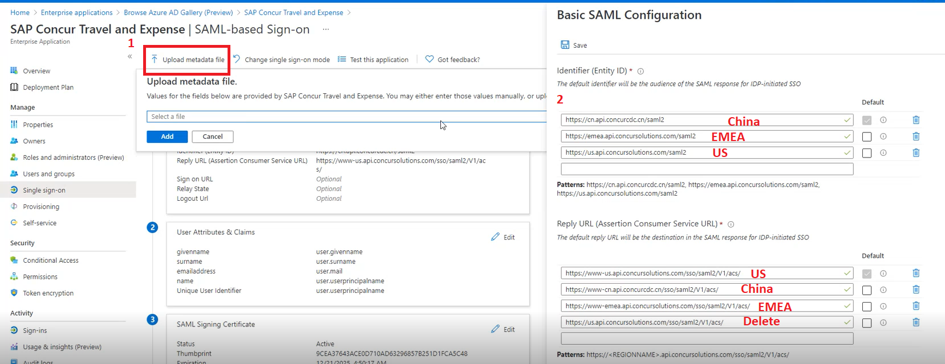
- To obtain the SAP Concur metadata on the Manage SSO page, you can either click Copy URL and then paste the URL in a new browser tab or click Download and open the downloaded file.
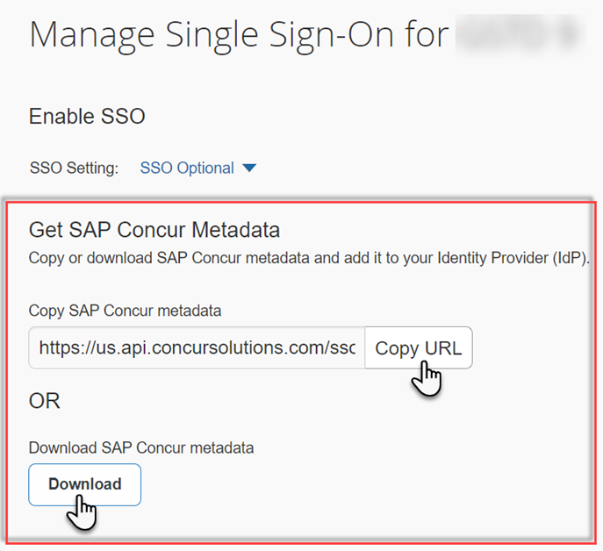

Step 3: Change Unique User Identifier
The default Unique User Identifier is user.userprincipalname. In SAP Concur, the Unique User Identifier must use the email address format.
- Click the pencil icon to edit this field under the User Attributes & Claims section.
- Change the user.userprincipalname to "user.mail". After you make this change, it should look like the following screenshot.
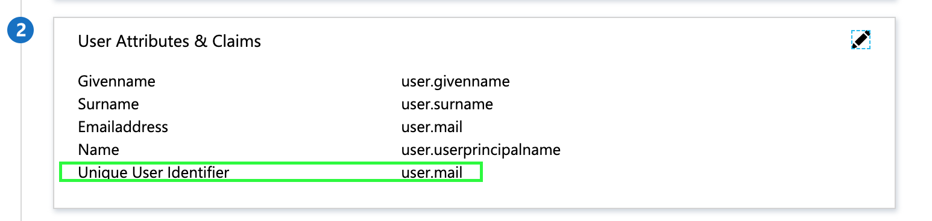
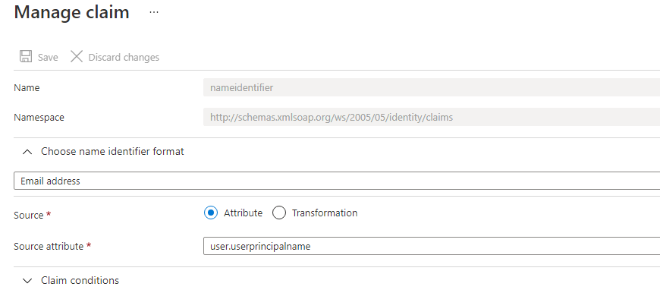
If your login IDs in SAP Concur do not match email address, you can still build customizations on the unique user identifier, so it sends a different value to SAP Concur. However, for any transformation rule please ensure you still send it with the email address format. Different formats would affect the logins made on the mobile app and/or via concursolutions.com.

Step 5: Download the Azure AD Metadata File
Click Download to download the “Federation Metadata XML” and save the metadata to your local computer or click on the paper icon to copy the “App Federation Metadata Url”.
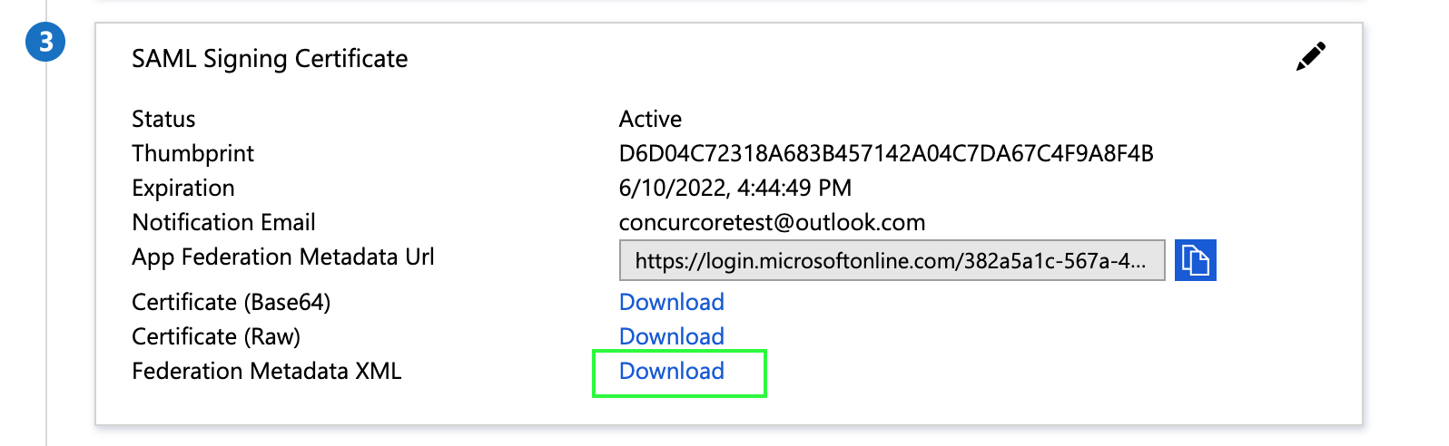
Before you upload your metadata file to SAP Concur, please make sure the User assignment required? setting via Manage > Properties is set accordingly. If set to the recommended setting of Yes, then you’ll need to add users under Users and groups.
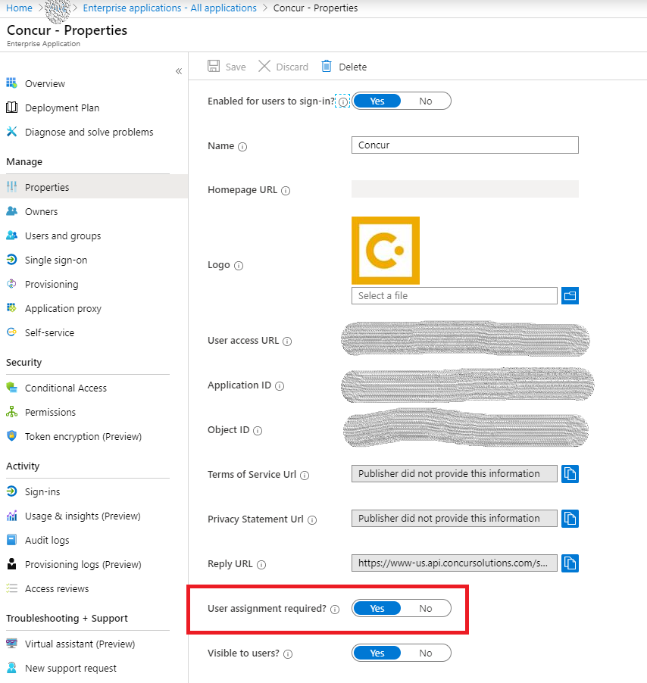

Configure Your SAP Concur Site
- Go to the Manage SSO page by following the steps provided in the Overview section.
- Click Add from the IdP Metadata section.
The Add IdP Metadata window appears.
- Enter an appropriate name in the IdP connection and enter it in the Custom IdP Name field.
If you decide to use the SP-initiated flow (through SAP Concur’s public site: https://www.concursolutions.com/nui/signin), the Custom IdP Name will display on the Sign In page right after you provide the Username and click Next. For example, if your Custom IdP Name is "Azure", then you will see the Sign in with Azure option.
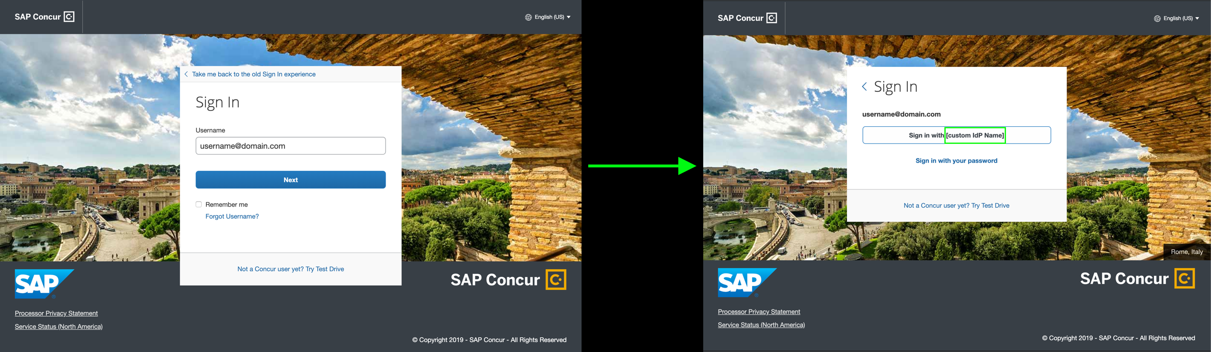
- Provide a Logout URL (optional) for users to get redirected to a different place when they log out. By default, if no URL is entered, users will be redirected to where they started the authentication process.
- In the Upload your IdP's metadata section, click Upload XML File and upload the metadata file from the IdP which was previously saved locally.
- To hide the sign-in option from users on mobile and signing in through concursolutions.com, select the checkbox Hide this SSO option from users signing in to Concur on web or mobile.
By default, the option is available to users when they begin an SP-initiated sign-in through concursolutions.com or the mobile app. The option can be hidden in those cases that require users to sign-in through an IdP-initiated flow.
- Click Add Metadata.
- A successfully added confirmation or a something went wrong message displays. For the latter, please contact SAP Concur support and provide the Correlation ID.
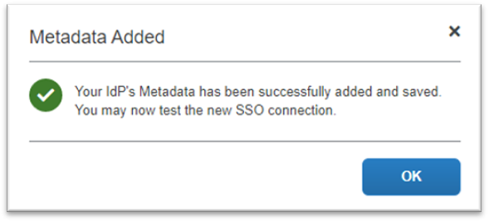
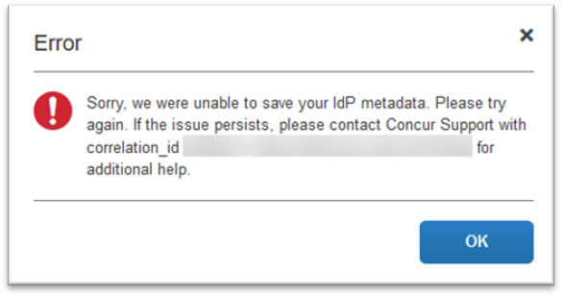

Test SSO Login
You can start testing SSO after you’ve successfully uploaded the IdP metadata to SAP Concur from the previous steps. In this section, you can test the IdP-Initiated (initiated on the identity provider side) and SP-Initiated (initiated on the service provider side) flows.

Test IdP-initiated SSO
(Option 1) To test IdP-initiated SSO with Test button:
- If the same account with the same email address at Azure AD exists in SAP Concur, you can click Test in Azure to do a test login for the IDP-initiated flow. You will still need to test the SP-Initiated flow, as it will be important for Mobile SSO tests.
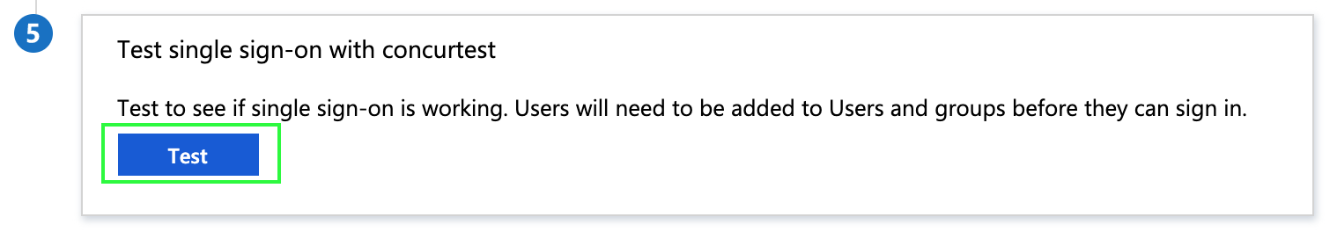
Before you test SSO, add additional users from Azure AD to this test application you just configured. To do so, click Users and groups and + Add user.
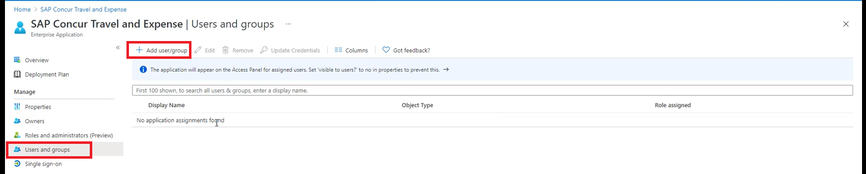
(Option 2) To test IdP-initiated SSO with User Access URL:
- Go to Manage > Properties and then copy the User access URL. Give this URL to your test users and ask them to copy paste this URL in the browser. They will see a Microsoft login page first. After that, they will be authenticated to SAP Concur directly without any other action.
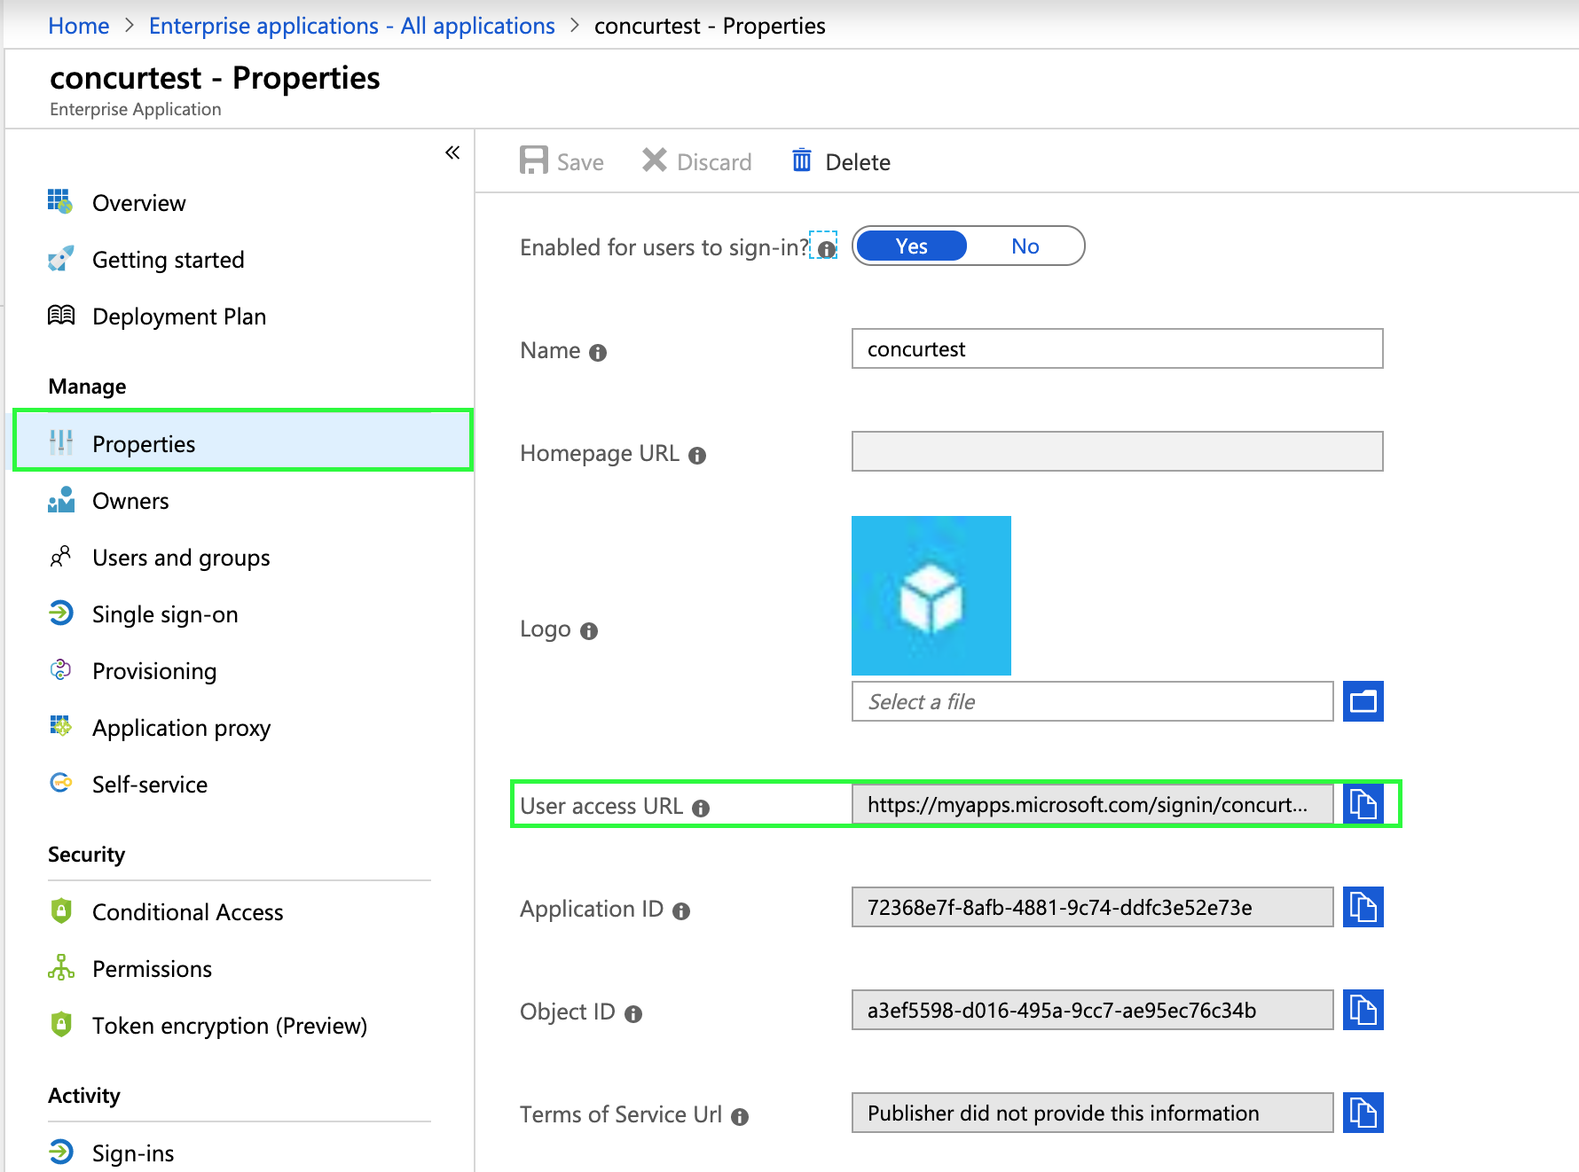
(Option 3) To test IdP-initiated SSO with Microsoft 365:
- After you assign the application to a few test users, they will see a new application appear on their Microsoft 365 portal. The user can click on the new application and then they should be authenticated directly to SAP Concur. The URL behind the SAP Concur application icon is the same as User access URL from the first test option.

Test SP-initiated SSO
To test the SP-initiated SSO:
- Open the SAP Concur login page according to the environment you want to test.
- US DC Prod: https://www.concursolutions.com/
- US DC Test: https://implementation.concursolutions.com/
- EMEA DC Prod: https://eu1.concursolutions.com/
- EMEA DC Test: https://eu1imp.concursolutions.com/
- CN DC Prod: https://www.concurcdc.cn/
- On the login page, you can add your username, verified e-mail address or SSO code to proceed. Once you click Next, you should see an option for your recently created SSO configuration. Click to proceed with authenticating your identity provider account which should redirect you to SAP Concur.
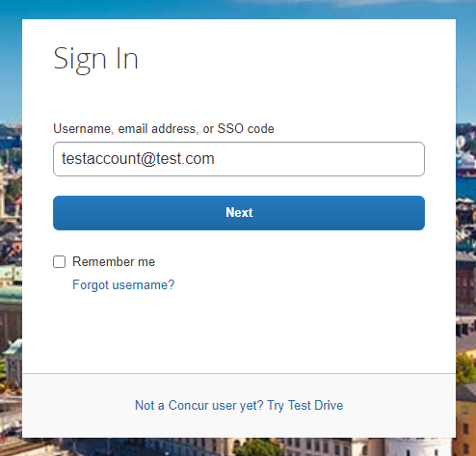
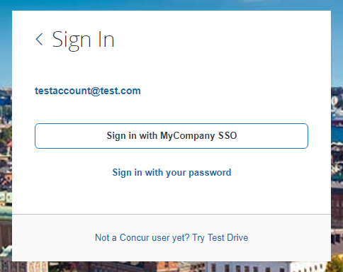

Mobile Single Sign-On (SSO)
For SSO configurations created on our SAMLv2 platform, the Mobile SSO should be enabled automatically as soon as the metadata is saved. However, for this option to work, the SP-Initiated flow needs to be functioning. This can be validated using the previous Test SSO login section.
The automatic enabling of Mobile SSO is only visible on the app version 9.86 or higher and if the user is opting for the new sign in experience. Users on older versions or opting for the earlier sign in experience will not see this option automatically. In that case, to guarantee that users are also able to log in with SSO on their mobile devices, please open a ticket with the SAP Concur support team providing the User Access URL from the application built on the Azure side so they can enable Mobile SSO for the legacy app versions. You can obtain this URL via Manage > Properties on your Azure admin account
If you have any issues in authenticating with SSO on the mobile app, please open a ticket with the SAP Concur support team and provide any error IDs and/or messages received with screenshots.

E-mail Notifications
The configuration of e-mail reminders to reflect your SSO URL are changes that need to be completed by SAP Concur support. To proceed, please open a ticket with the SAP Concur support team, providing the IDP URL from the application created on the IDP side so they can adjust the redirect URL for e-mail reminders. For more information on how to obtain the URL, see the Test SSO login > Testing IdP-Initiated SSO section of this appendix.

Rollout
After testing your new SSO configuration, you can then plan your rollout by assigning your new Azure AD application to all your users and groups who’ll need this access.
The Manage SSO page also offers the option for you to enforce this new SSO connection by changing the SSO Setting from SSO Optional to SSO Required. If you change it, users will be redirected to SAP Concur by providing their username via the SP-initiated flow.
If you need to enforce Mobile SSO only, please contact SAP Concur support.

Appendix – Google Workspace Setup

Overview
Before you start the configuration process, make sure that:
- You have admin access to the identity provider (Google Workspace). This will be needed so you can complete the application configuration on the Google Workspace side.
- Your users exist in both Google Workspace and SAP Concur. Auto user provisioning is not currently supported by Concur, so you need to add users separately in there.
- The attribute you are sending from Google Workspace matches the Login ID (Username / CTE Login Name) field for each employee in SAP Concur.
- You have the Company Administrator (Travel permission) assigned to your SAP Concur account. Once you have the permission, you can access the Manage SSO page by following one of the below paths, depending on your SAP Concur edition.

SAP Concur Professional edition:
- Go to Administration > Company > Authentication Admin.
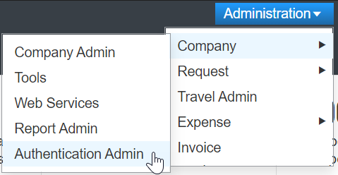
- Hit Manage Single Sign-On to access the Manage SSO page.
Alternatively, users can access the page using one of the following URLs:
- US DC Prod: https://www.concursolutions.com/nui/authadmin/ssoadmin
- US DC Test: https://implementation.concursolutions.com/nui/authadmin/ssoadmin
- EMEA DC Prod: https://eu1.concursolutions.com/nui/authadmin/ssoadmin
- EMEA DC Test: https://eu1imp.concursolutions.com/nui/authadmin/ssoadmin
- CN DC Prod: https://www.concurcdc.cn/nui/authadmin/ssoadmin
If you don’t have that permission and cannot have this assigned to your profile, please ask an Authorized Support Contact at your company to open a case with SAP Concur Support.

SAP Concur Standard edition:
- Go to Administration > Expense Settings.
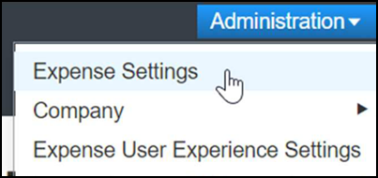
- Under Access to Concur click Show 1 Advanced Setting.
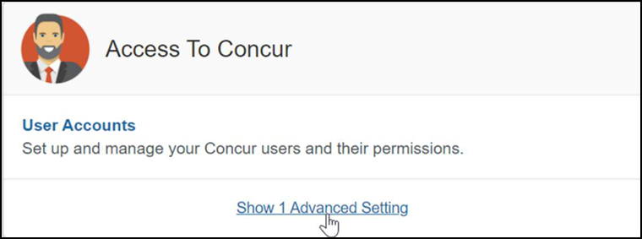
- Click Manage Single Sign-On to access the Manage SSO page.
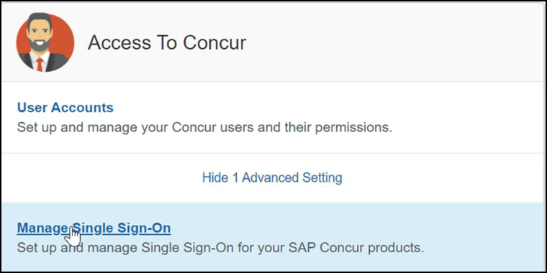

Configure Your Google Workspace (IDP) APP

Step 1: Get the SAP Concur metadata
To complete this you will need to follow the instructions on the Preparation section earlier in this guide login to your SAP Concur account and access the Manage SSO section. To obtain the SAP Concur Metadata on the Manage SSO page, you can either click on "Copy URL" and then paste the URL in a new browser tab or click Download and open the downloaded file.
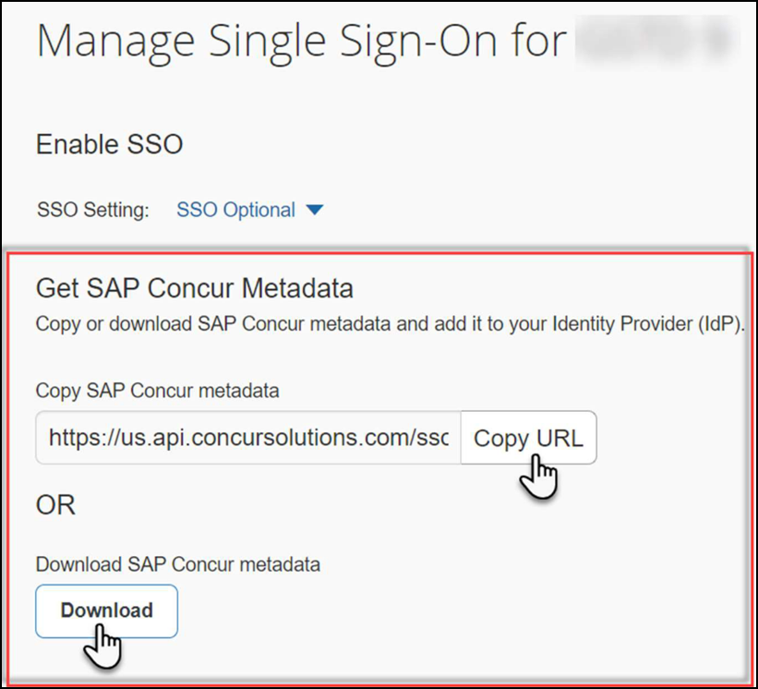

Step 2: Set up your own custom SAP Concur SAML app
- Sign into your Google Admin console.
(Sign in using an account with super administrator privileges (does not end in @gmail.com or similar)).
- From the Admin console Home page, go to Apps Web and mobile apps.
- Click Add App to add custom SAML app.
- On the App Details page:
- Custom app name
Enter the name of the custom app, for example, 'SAP Concur'
- (Optional) Upload an app icon
The app icon appears on the Web and mobile apps list, on the app settings page, and in the app launcher. If you don't upload an icon, an icon is created using the first two letters of the app name
- Click Continue.
- On the Google Identity Provider details page, get the setup information needed by the service provider using the Download the IDP metadata option.
- (Optional) In a separate browser tab or window, sign into your service provider and copy the information you entered in Step 4 into the appropriate SSO configuration page, then return to the Admin console.
- Click Continue.
- In the Service Provider Details window, enter the following ACS URL and Entity ID for your app.
ACS URL
- US (North America): https://www-us.api.concursolutions.com/sso/saml2/V1/ acs/
- EMEA: https://www-emea.api.concursolutions.com/sso/saml2/ V1/acs/
- China: https://www-cn.api.concurcdc.cn/ sso/saml2/V1/acs/
Entity ID
- US (North America): https://us.api.concursolutions.com/saml2
- EMEA: https://emea.api.concursolutions.com/saml2
- China: https://cn.api.concurcdc.cn/saml2
- The default Name ID is the primary email - multi-value input is not supported.
- Click Finish.

Step 3: Turn on your SAML app
- Sign into your Google Admin console.
(Sign in using an account with super administrator privileges (does not end in @gmail.com or similar)).
- From the Admin console Home page, go to AppsWeb and mobile apps. +.
- Select your SAML app.
- Click User access.
- To toggle availability of a service for your organization, click On for everyone or Off for everyone, and then click Save.
- (Optional) To turn a service on or off for an organizational unit:
- At the left, select the organizational unit.
- To change the Service status, select On or Off.
- Choose one:
- If the Service status is set to Inherited and you want to keep the updated setting, even if the parent setting changes click Override.
- If the Service status is set to Overridden, either click Inherit to revert to the same setting as its parent, or click Save to keep the new setting, even if the parent setting changes.
- To turn on a service for a set of users across or within organizational units, select an access group. For details, go to Provide access to user groups in this document.
- Ensure that the email addresses your users use to sign in to the SAML app match the email addresses they use to sign into your Google domain. Changes typically take effect in minutes but can take up to 24 hours.
Google Workspace doesn't support encryption of assertion currently. Please reach out to the IDP support if you need more information around this.

Step 4: Configure Your SAP Concur Site
- Go to the Manage SSO page again by following the steps provided on the Preparation section.
- Click on Add under IdP Metadata section. The Add IdP Metadata window appears.
- Give your IdP connection a friendly name and enter it in the Custom IdP Name field.
- Provide a Logout URL (optional), so the users get redirected to a different place when signing out.
By default, if no URL is entered, users will be redirected to where they started the authentication process. The logout endpoint for Google Workspace can be found on Applications & Resources > Tenant Settings > Identity Provider Settings > Single Logout Endpoint.
Single Logout (SLO) is not officially supported by SAP Concur, so the logout process with the SLO endpoint may not work as expected regarding disconnecting the user from the IDP in addition to Concur. In that case, the user may be logged out from SAP Concur but not from Google Workspace entirely.
- In the Upload your IdP's metadata section, click Upload XML File and upload the metadata file from the IdP, which was previously saved locally.
- To hide the sign-in option from users on mobile and signing in through concursolutions.com, select the Hide this SSO option from users signing in to Concur on web or mobile checkbox.
By default, the option is available to users when they begin an SP-initiated sign-in through concursolutions.com or the mobile app. The option can be hidden in those cases that require users to sign-in through an IdP-initiated flow
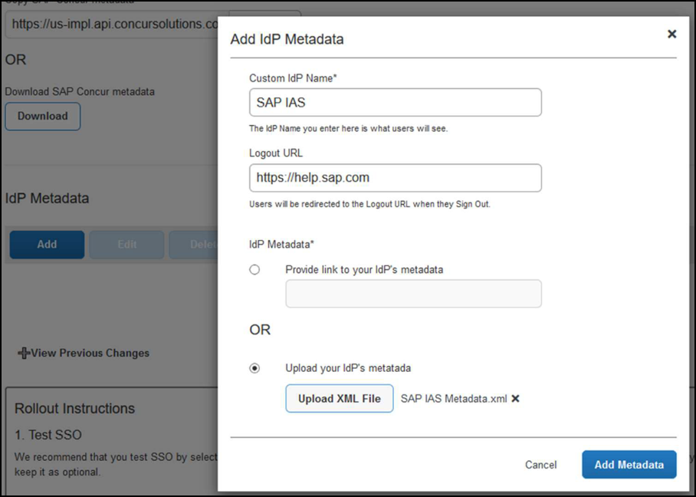
- Click Add Metadata.
- A successfully added or something went wrong message displays.
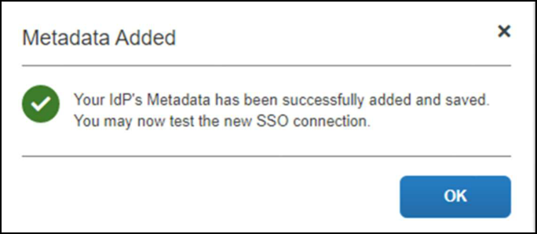
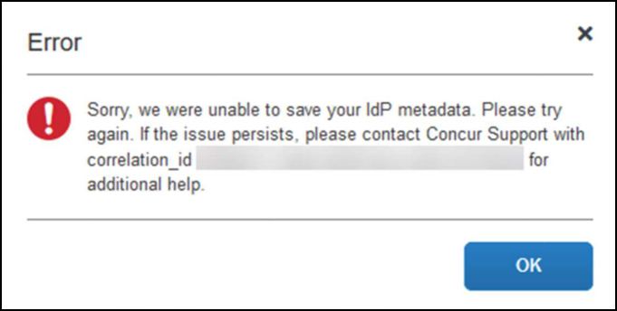
For help with the second one (above) please reach out to SAP Concur Support and provide the correlation id.
For step 3 above, if you decide to use the SP-initiated flow (through SAP Concur’s public site: https://www.concursolutions.com/nui/signin), the Custom IdP Name will be displayed on the Sign In page right after a user provides their Username and hits Next (see below image). For example, if your "Custom IdP Name" is "google SSO", then all users will see the option "Sign in with google SSO " as shown in the following:
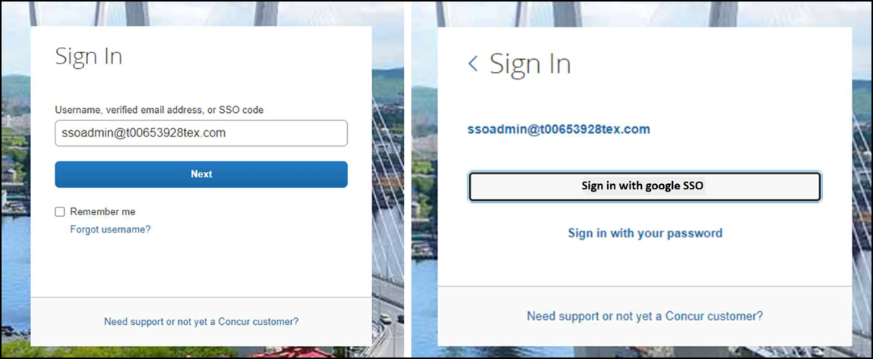

Test SSO Login
You can start testing SSO after you’ve successfully uploaded the IdP metadata to SAP Concur from the previous step. We’ll test the IdP-Initiated (initiated on the identity provider side) and SP-Initiated (initiated on the service provider side) flows.

1. Testing IdP-Initiated SSO
In the IdP-Initiated flow we start the login process on the identity provider. To test it, we can append parameters from the application we built to the SSO endpoint from Google Workspace.
An example of IdP-Initiated URL is:
Format: https://accounts.google.com/o/saml2/
initsso?idpid=CLIENT_IDP_ID&spid=SERVICE_PROVIDER_ID&forceauthn=false
Example: https://accounts.google.com/o/saml2/ initsso?idpid=C03fj4v82&spid=710982774547&forceauthn=false
You must fill CLIENT_IDP_ID and SERVICE_PROVIDER_ID with values from Google Workspace and it's something you can get by copying the URL from the Test SAML login button on the application

2. Testing SP-Initiated SSO
In order to test the SP-initiated flow, you will need to open the SAP Concur login page.
- US DC Prod: https://www.concursolutions.com/
- US DC Test: https://implementation.concursolutions.com/
- EMEA DC Prod: https://eu1.concursolutions.com/
- EMEA DC Test: https://eu1imp.concursolutions.com/
- CN DC Prod: https://www.concurcdc.cn/
On the login page, you can add your username, verified e-mail address or SSO code to proceed. Once you click on Next, you should see an option for your recently created SSO configuration. You can click on that and proceed with authenticating to your Google account which should redirect you back to SAP Concur after that.

Mobile Single Sign-On (SSO)
For SSO configurations created on our SAMLv2 platform, the Mobile SSO should be enabled automatically as soon as the metadata is saved. However, for this option to work, the SP-Initiated flow needs to be functioning. This can be validated on the ‘Test SSO login’ section on this guide.
If you have issues to authenticate with SSO on the mobile app, please open a ticket to the SAP Concur support team providing any error IDs and/or messages received.
It’s important to note that if you were using another IdP and you were already using Mobile SSO, you’ll probably see 2 options when trying to sign-in as follows:
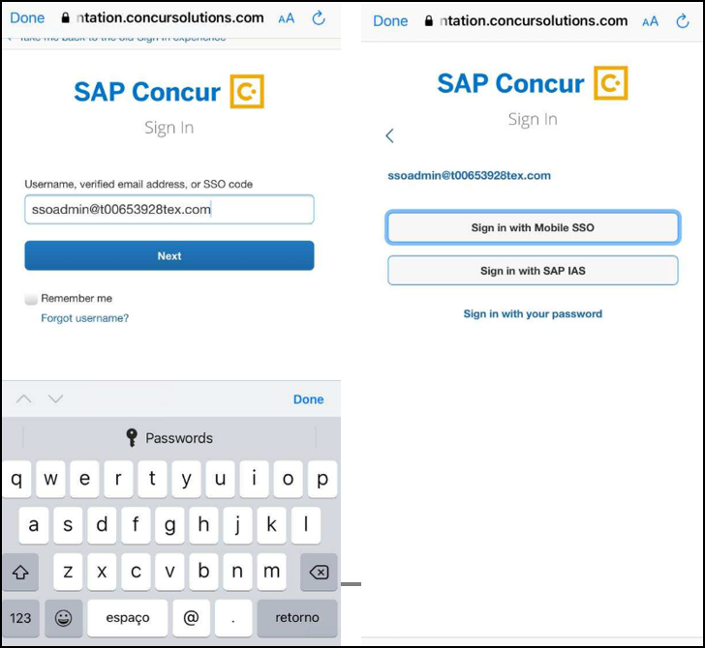
The Sign in with Mobile SSO option will have your old IdP link embedded, so it will redirect users to your old SSO connection.
For both cases, please open a ticket to the SAP Concur support team providing them the following information.
- If the users plan to use an older (legacy) version, provide the IdP-Initiated URL from the application built on the Google Workspace side so Support can enable Mobile SSO for the legacy app versions. More information about how to get the URL can be found on the ‘Test SSO login > Testing IdP-Initiated SSO’ section on this guide.
- If you want to remove the ‘Sign in with Mobile SSO’ option so it doesn’t confuse your users, please inform that to the support team.
If you have any issues to authenticate with SSO on the mobile app, please open a ticket to the SAP Concur Support team providing any error IDs and/or messages received with screenshots.

E-Mail Notifications
The configuration of e-mail reminders to reflect your SSO URL are changes that need to be completed by SAP Concur support. To proceed, please open a ticket to the SAP Concur support team providing the IDP URL from the application built on the IDP side so they can adjust the redirect URL for E-Mail reminders. More information about how to get the URL can be found on the Test SSO login > Testing IdP-Initiated SSO section on this guide.
- The URL will appear embedded on the View Report button
- This change will only be reflected in emails generated after the change - all emails prior to that will keep using the previous URL.
- This change will take effect up to 4 hours after the update.
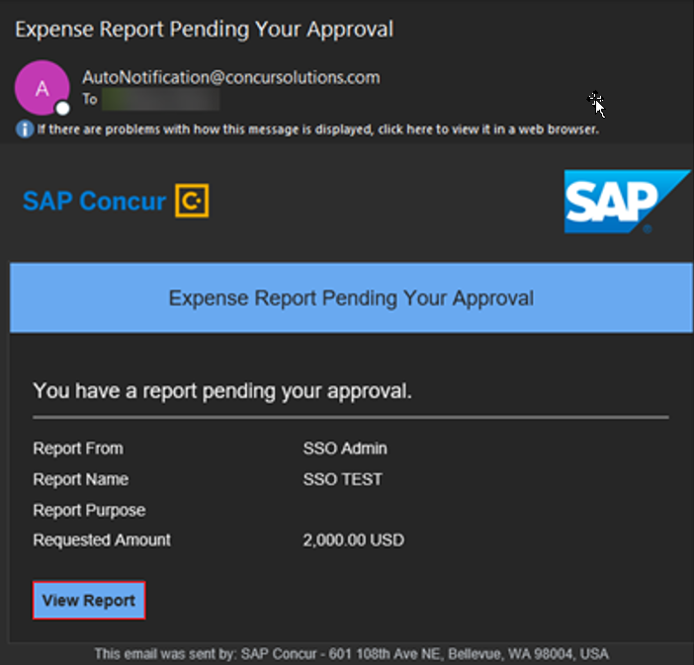
If you hover the cursor over the View Report button you will see what’s the URL currently embedded. The URL should appear between “ctedeepurl=” and “&hpo=” terms.

Rollout
After testing your new SSO configuration, you can then plan your rollout by assigning your Google Workspace application to all your users and groups who’ll need this access.
The Manage SSO page also offers the option for you to enforce this new SSO connection by changing SSO Setting from SSO Optional to SSO Required. If you change it, users will be redirected to Concur by just providing their Username via SP-initiated flow.
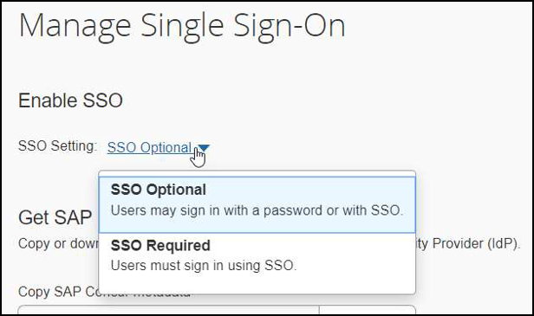

View Previous Changes
This featured was developed to help admins to keep track of all changes completed under the Manage SSO page. To view changes to the SSO configuration that have been made over time, click on the View Previous Changes button.
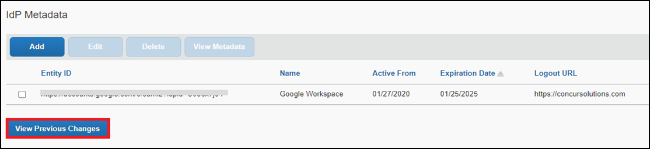
A table listing previous changes appears and is sorted in descending order by date and time.
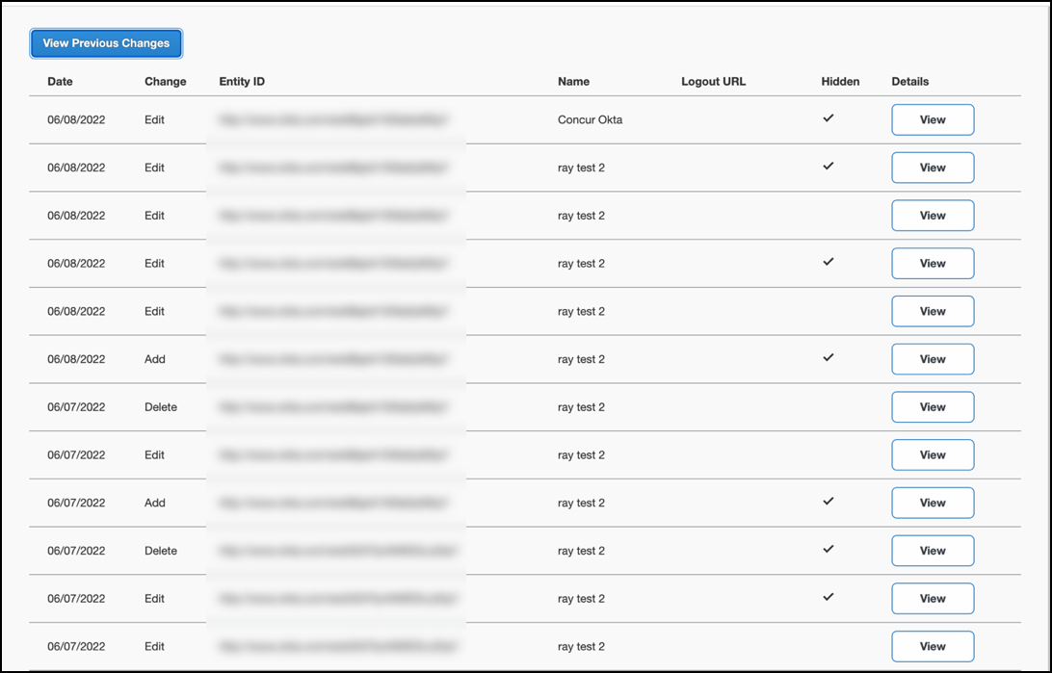
The table can display the last 100 changes. Changes that are listed in the table include:
- Add a configuration
- Delete a configuration
- Edit Custom IdP Name, Logout URL, or Hidden fields
To view more detailed information about a specific change listed in the table, click the View link for the desired list item.
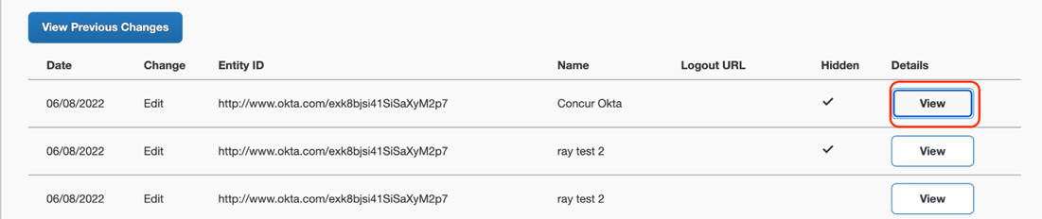
Inside each log, you'll see the field Company and Change by in the format [first name last name] [(UUID code)], which will mean who has performed such action. In case you don't recognize that user, you can always reach out to support requesting further details about it.
For deleted configurations, View Previous Changes includes a Revert button so you can reinstate the deleted configuration. After the configuration is reinstated, it will be available to users during the sign-in process.
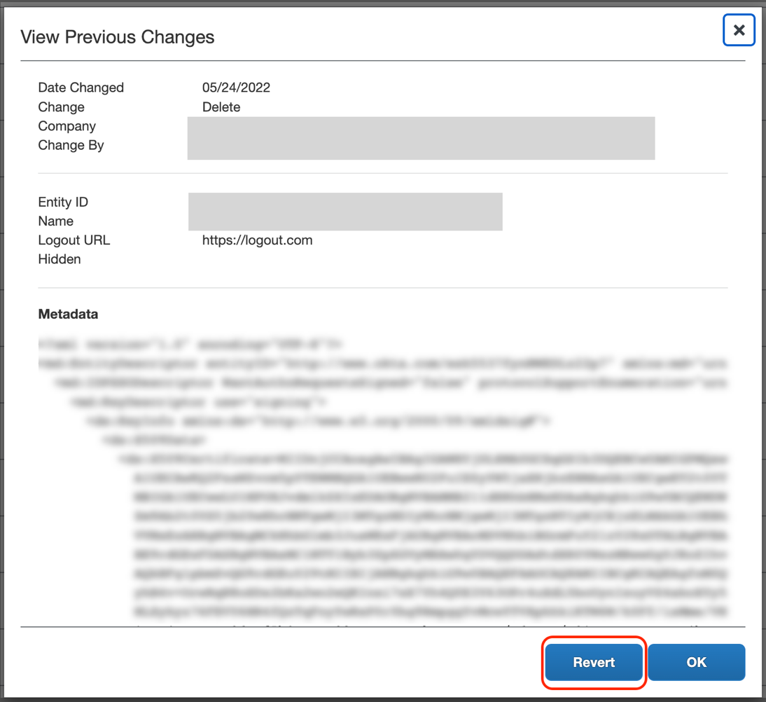
- For more info, please refer to the following documentation resources:
- SAP Concur - SSO Overview Guide
- SAP Help Portal - SAP Single Sign-On

Appendix - Idaptive Setup
Per the appendix instructions in this section, as content is sourced from the third-party provider, SAP Concur cannot guarantee its accuracy. If you encounter issues, it is recommended that you contact the third-party provider’s support resources.

Getting Started
Before you start the configuration process, ensure that:
- Your users exist in both Idaptive and SAP Concur. Auto user provisioning is not currently supported by SAP Concur, so you need to add users separately in there.
- The attribute you are sending from Idaptive matches the Login ID (Username / CTE Login Name) field for each employee in SAP Concur.
- You have the Company Administrator (Travel permission) assigned to your SAP Concur account. Once you have the permission, you can access the Manage SSO page by using one of the following paths, depending on your SAP Concur edition.
For SAP Concur Standard edition:
- Go to Administration > Expense Settings.
- Under Access to Concur section, click Show 1 Advanced Setting.
- Click Manage Single Sign-On to access the Manage SSO page.
For the SAP Concur Professional edition:
- Go to Administration > Company > Authentication Admin.
- Click Manage Single Sign-On to access the Manage SSO page.
Alternatively, users can access the page using one of the following URLs:
- US DC Prod: https://www.concursolutions.com/nui/authadmin/ssoadmin
- US DC Test: https://implementation.concursolutions.com/nui/authadmin/ssoadmin
- EMEA DC Prod: https://eu1.concursolutions.com/nui/authadmin/ssoadmin
- EMEA DC Test: https://eu1imp.concursolutions.com/nui/authadmin/ssoadmin
- CN DC Prod: https://www.concurcdc.cn/nui/authadmin/ssoadmin

If you don’t have that permission and cannot have this assigned to your profile, please ask an authorized support contact at your company to open a case with SAP Concur support.

Configure Your Idaptive Application

Step 1: Create the Idaptive app
- From the Idaptive Admin Home page, click Web Apps.
- Click Add Web Apps.
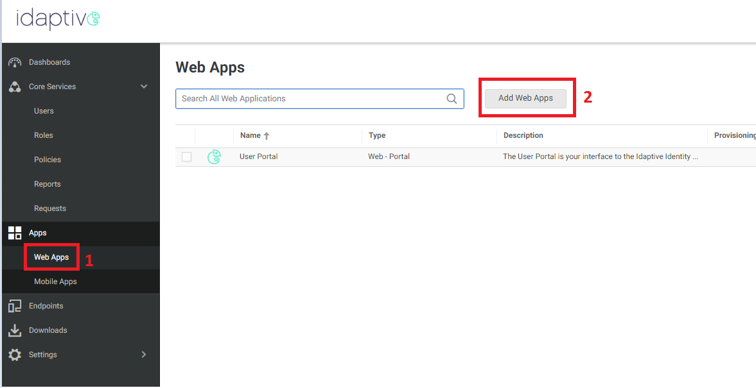
- Search for Concur.
- By the SAML + Provisioning option, click Add. Close the popup when it appears.
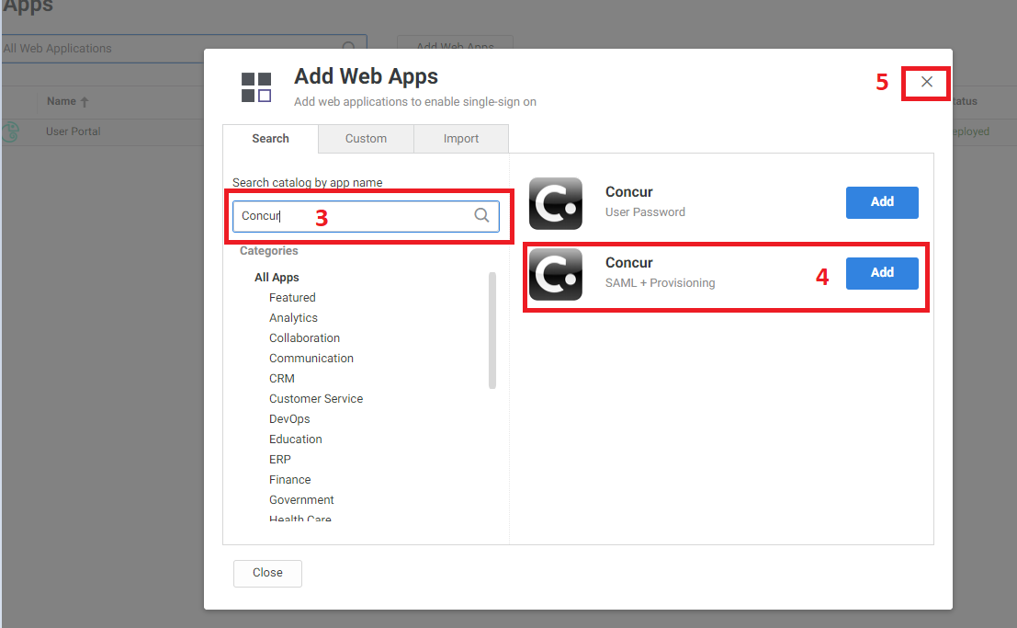
- In the Concur app configuration, click Trust.
- Select the Metadata option.
- Click Download Metadata File (for later use when uploading your metadata to SAP Concur).
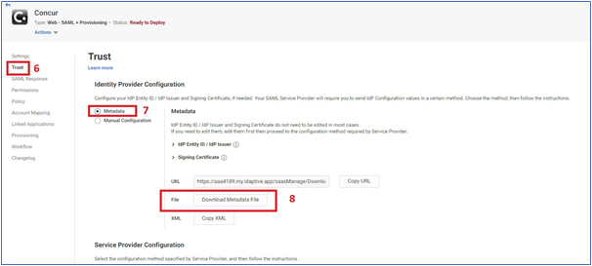
- Scroll down to the Service Provider Configuration section.
- Open the SAP Concur metadata, copy the Entity ID value and paste it to the SP Entity ID / SP Issuer / Audience field.
- Copy the Location value from the metadata and paste it to the Assertion Consumer Service (ACS) URL.
- Ensure that the Same as ACS URL option is selected for the Recipient.
- For the NameID Format field, this must match your SAP Concur Login IDs. Select emailAddress if your SAP Concur login IDs are in the same format as your email addresses or choose a different option according to the format of your SAP Concur login IDs (e.g., employeeid@companydomain.com). Even though the format of your login IDs may be different than email address, the Name ID format on the SAML Response must be in an email address format.
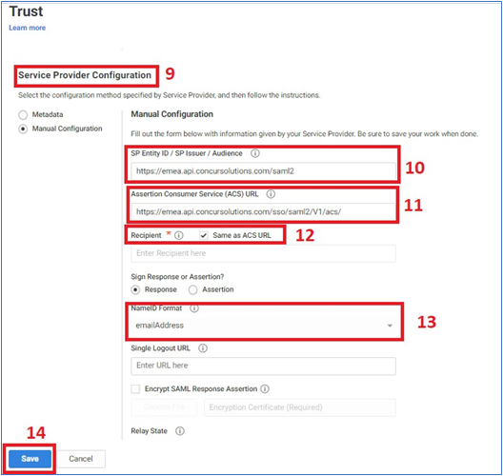
- Click Save.
- Click Permissions.
- Add the groups/users that need to access the SAP Concur app and click Save.
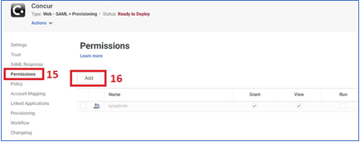

Configure Your SAP Concur Site
- Go to the Manage SSO page by following the steps provided in the Overview section.
- Click Add from the IdP Metadata section. The Add IdP Metadata window appears.
- Enter an appropriate name in the IdP connection and enter it in the Custom IdP Name field.
If you decide to use the SP-initiated flow (through SAP Concur’s public site: https://www.concursolutions.com/nui/signin), the Custom IdP Name will display on the Sign In page right after a user provides their Username and clicks Next.
- In the Upload your IdP's metadata section, click Upload XML File and upload the metadata file from the IdP.
- To hide the sign-in option from users on mobile and signing in through concursolutions.com, select the checkbox Hide this SSO option from users signing in to Concur on web or mobile.
By default, the option is available to users when they begin an SP-initiated sign-in through concursolutions.com or the mobile app. The option can be hidden in those cases that require users to sign-in through an IdP-initiated flow.
- Click Add Metadata.
- You should see either a successfully added confirmation or a something went wrong message. For the latter, please contact SAP Concur support and provide the Correlation ID.

Test SSO Login

Test IdP-initiated SSO
To test your SSO login from Idaptive, you’ll need to make sure you’ve assigned the new application configured in Idaptive to the users and groups who will test this.
Once this is completed, you can login to your account in Idaptive and look for the SAP Concur application. This application should redirect you to your account on SAP Concur, already logged in.

Test SP-initiated SSO
To test the SP-initiated SSO:
- Open the SAP Concur login page according to the environment you want to test.
- US DC Prod: https://www.concursolutions.com/
- US DC Test: https://implementation.concursolutions.com/
- EMEA DC Prod: https://eu1.concursolutions.com/
- EMEA DC Test: https://eu1imp.concursolutions.com/
- CN DC Prod: https://www.concurcdc.cn/
- On the login page, you can add your username, verified e-mail address or SSO code to proceed. Once you click Next, you should see an option for your recently created SSO configuration according to the note in Configure Your SAP Concur Site. Click to proceed with authenticating your identity provider account which should redirect you to SAP Concur.
If after adding your SSO credentials you receive an error message, this is a sign that your configuration is possibly not completed. If the error message is on the SAP Concur side. It may be an issue of unmatching credentials, an invalid certificate, or a missing setting. If the IdP-Initiated login is working but the SP-Initiated is not, this could be sure to the Name ID on the Idaptive side not sent with the correct format (email address).
If you’re still having issues, please contact SAP Concur Support for assistance providing any error IDs you receive.

Mobile Single Sign-On (SSO)
For SSO configurations created on our SAMLv2 platform, the Mobile SSO should be enabled automatically as soon as the metadata is saved. However, for this option to work, the SP-Initiated flow needs to be functioning. This can be validated using the previous Test SSO login section.
The automatic enabling of Mobile SSO is only visible on the app version 9.86 or higher and if the user is opting for the new sign in experience. Users on older versions or opting for the earlier sign in experience will not see this option automatically.
The Sign in with Mobile SSO option will have your earlier IdP link embedded, so it will redirect users to your old SSO connection.
For both cases, please open a ticket with the SAP Concur support team, providing them the following information.
- If the users plan to use an older version, please provide SAP Concur support with the IdP-Initiated URL from the application created on the Idaptive side so they can enable Mobile SSO for the legacy app versions. For more information on how to obtain the URL see Test SSO login > Testing IdP-Initiated SSO section on this guide.
- If you want to remove the Sign in with Mobile SSO option to eliminate potential confusion, please inform the support team.
If you have any issues in authenticating with SSO on the mobile app, please open a ticket with the SAP Concur support team and provide any error IDs and/or messages received with screenshots.

E-mail Notifications
The configuration of e-mail reminders to reflect your SSO URL are changes that need to be completed by SAP Concur support. To proceed, please open a ticket with the SAP Concur support team, providing the IDP URL from the application created on the IDP side so they can adjust the redirect URL for e-mail reminders. For more information on how to obtain the URL, see the Test SSO login > Testing IdP-Initiated SSO section of this appendix.

Rollout
After testing your new SSO configuration, you can then plan your rollout by assigning your new Idaptive application to all your users and groups who’ll need this access.
The Manage SSO page also offers the option for you to enforce this new SSO connection by changing the SSO Setting from SSO Optional to SSO Required. If you change it, users will be redirected to SAP Concur by providing their Username via the SP-initiated flow.
If you need to enforce Mobile SSO only, please contact SAP Concur support.

Appendix - Okta Setup
Per the appendix instructions in this section, as content is sourced from the third-party provider, SAP Concur cannot guarantee its accuracy. If you encounter issues, it is recommended that you contact the third-party provider’s support resources.

Getting Started
Before you start the configuration process, ensure that:
- You have admin access to the identity provider (Okta). This will be needed so you can complete the application configuration on the Okta side.
- Your users exist in both Okta and SAP Concur. Auto user provisioning is not currently supported by SAP Concur, so you need to add users separately in there.
- The attribute you are sending from Okta matches the Login ID (Username / CTE Login Name) field for each employee in SAP Concur.
- You have the Company Administrator (Travel permission) assigned to your SAP Concur account. Once you have the permission, you can access the Manage SSO page by using one of the following paths, depending on your SAP Concur edition.
For SAP Concur Standard edition:
- Go to Administration > Expense Settings.
- Under Access to Concur section, click Show 1 Advanced Setting.
- Click Manage Single Sign-On to access the Manage SSO page.
For the SAP Concur Professional edition:
- Go to Administration > Company > Authentication Admin.
- Click Manage Single Sign-On to access the Manage SSO page.
Alternatively, users can access the page using one of the following URLs:
- US DC Prod: https://www.concursolutions.com/nui/authadmin/ssoadmin
- US DC Test: https://implementation.concursolutions.com/nui/authadmin/ssoadmin
- EMEA DC Prod: https://eu1.concursolutions.com/nui/authadmin/ssoadmin
- EMEA DC Test: https://eu1imp.concursolutions.com/nui/authadmin/ssoadmin
- CN DC Prod: https://www.concurcdc.cn/nui/authadmin/ssoadmin
If you don’t have that permission and cannot have this assigned to your profile, please ask an authorized support contact at your company to open a case with SAP Concur support.

Configure Your Okta Application

Step 1: Get the SAP Concur metadata
To configure:
- Get the SAP Concur metadata. To complete this, follow the instructions in the Overview section to log in to your SAP Concur account and access the Manage SSO section. To obtain the SAP Concur metadata on the Manage SSO page, you can either click Copy URL and then paste it in a new browser tab or click Download and open the downloaded file.
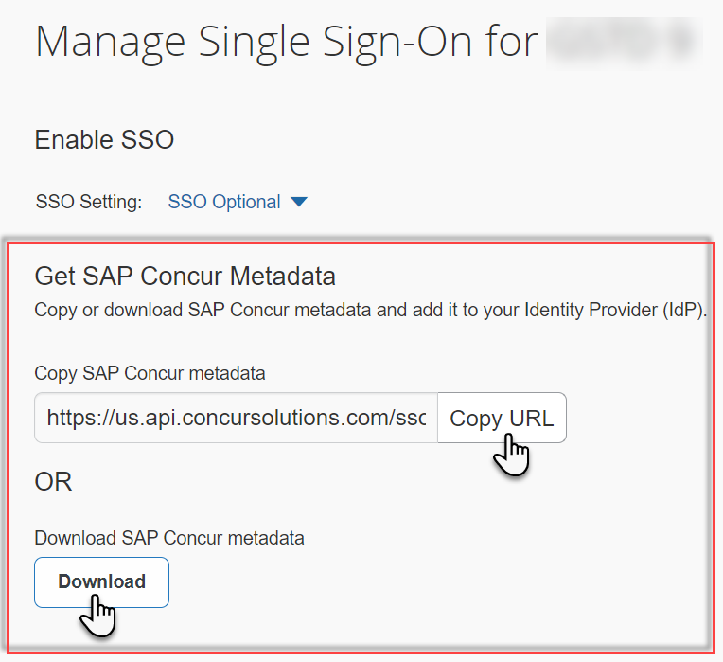

Step 2: Create an application on Okta
- First, log in with an administrator account in Okta to complete the following.
- Click Applications at the top to start creating your new application. Do not use the default SAP Concur application in Okta, as the default SAP Concur applications in the gallery may point you to the incorrect endpoint.
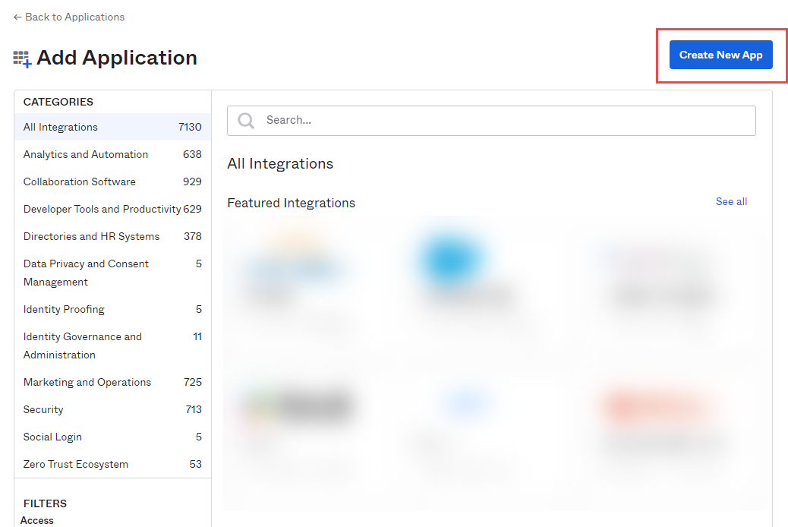
- Select SAML 2.0.
- Enter a name for the configuration and then click Create.
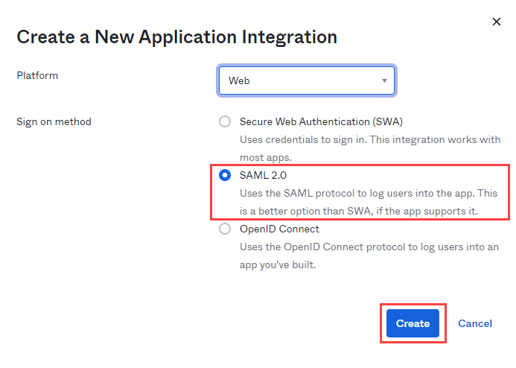
- Enter an App Name, select a logo (optional), and then click Next.
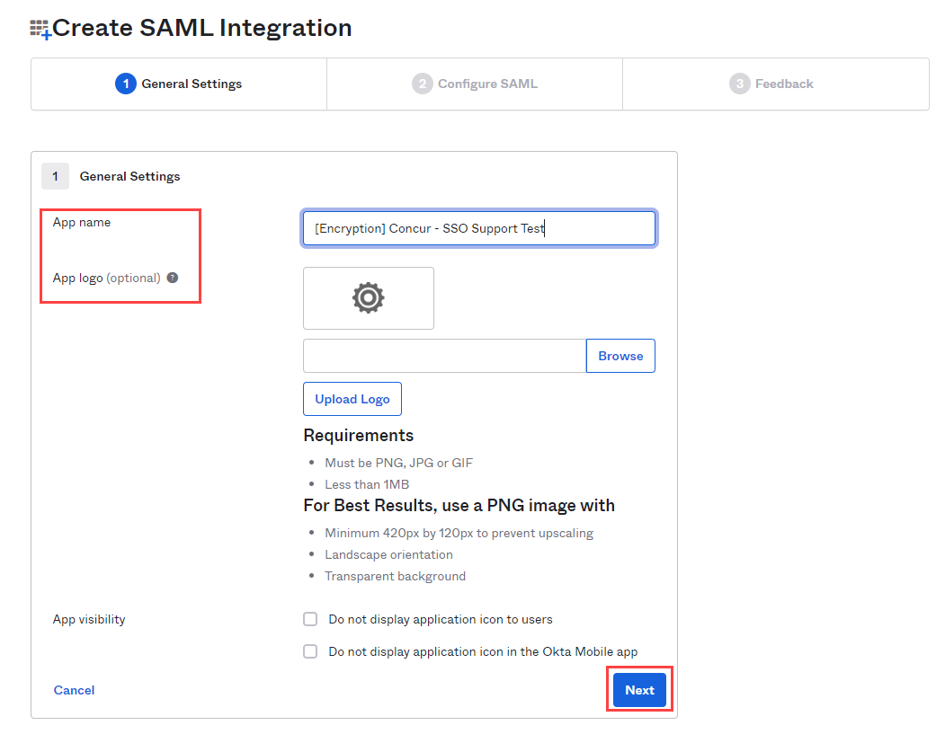
- Open the SAP Concur metadata, scroll down and locate Location=. Copy the URL value and paste it into the Single sign on URL field in the Okta application.
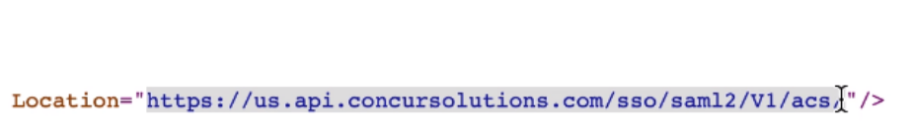
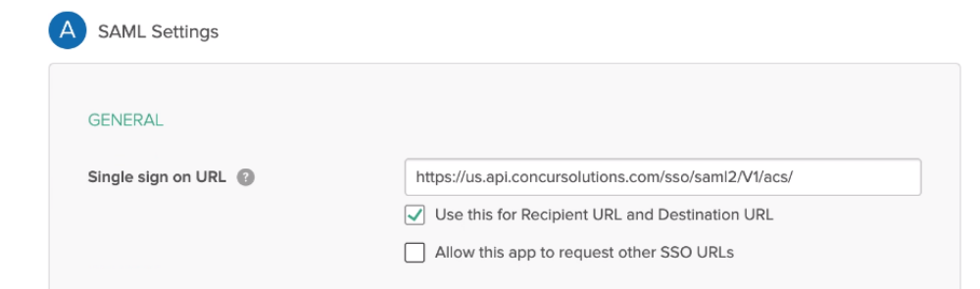
- Return to SAP Concur metadata and, at the top, locate entityID=. Copy the URL and paste it into the Audience URI (SP Entity ID) field on your Okta application.

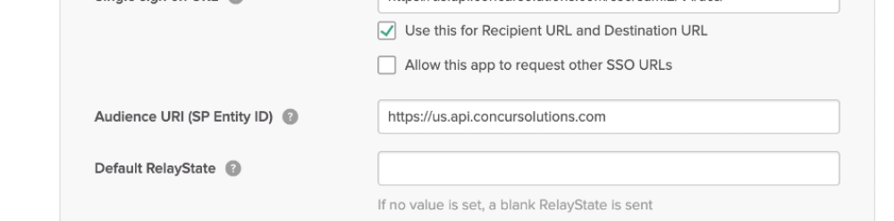

Step 3: Name ID configuration
During the application configuration, you will need to configure the Name ID. The Name ID must match the Login ID (CTE Login Name) registered for your employees in SAP Concur. We strongly recommend you set the Name ID format to EmailAddress.
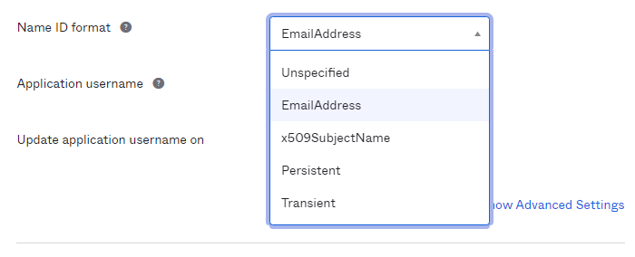
This is required by SAP Concur for the SP-Initiated logins, starting from concursolutions.com or from the mobile app.
In some cases, the available Application username may not match the usernames in SAP Concur. If this is the case, you can run employee imports in SAP Concur to make sure they match the attribute you send. Alternatively, you can reach out to product support for Okta for further help with Name ID configurations.
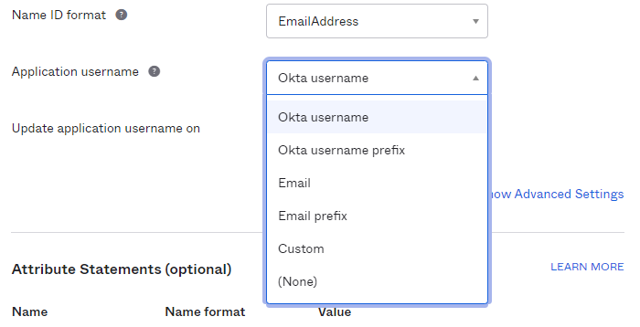
If you want to encrypt your SAML assertion, please follow Step 4 instructions. If this is not needed, please proceed to Step 5.

Step 4: (Optional) Encrypting the application
- Return to SAP Concur metadata, scroll down and locate the tag use=”Encryption”. Copy the X509 certificate and paste it into a text file (e.g., Notepad), between two BEGIN/END CERTIFICATE rows as shown here:
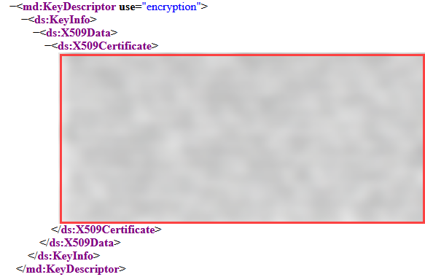
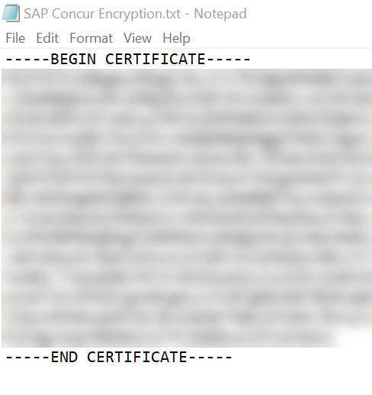
- Save this file in .crt format.

- In the Okta application, click the hyperlink Show Advanced Settings.
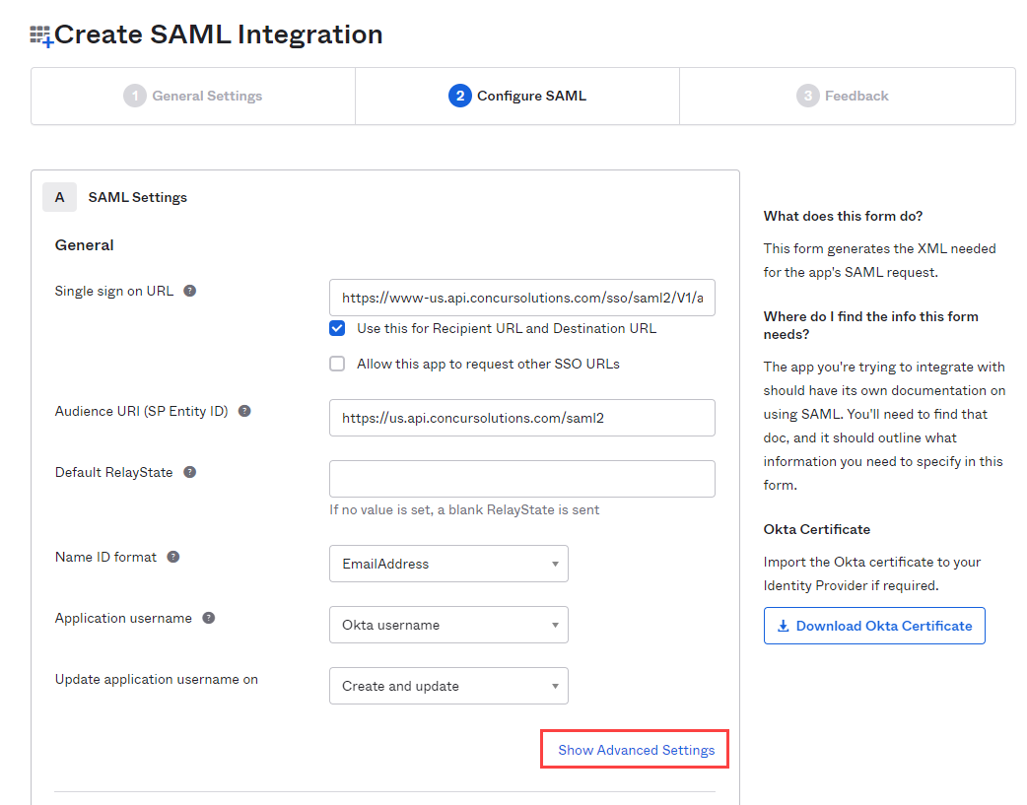
- Change the Assertion Encryption to Encrypted and browse to the encryption certificate file you saved.
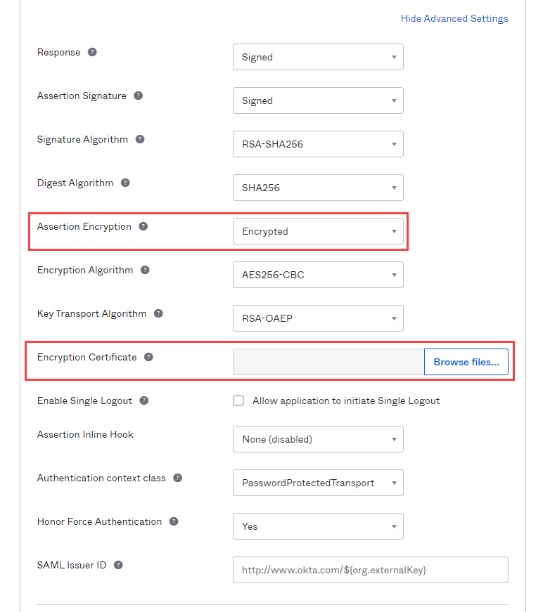
- Once this file has been uploaded, you will see the following information under Encryption Certificate:
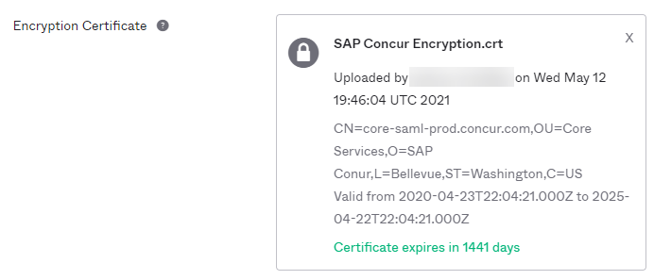

Step 5: Finish the Configuration
- In the Help Okta Support feedback section, choose I’m an Okta customer adding an internal app.
- Scroll to the bottom and click Finish.
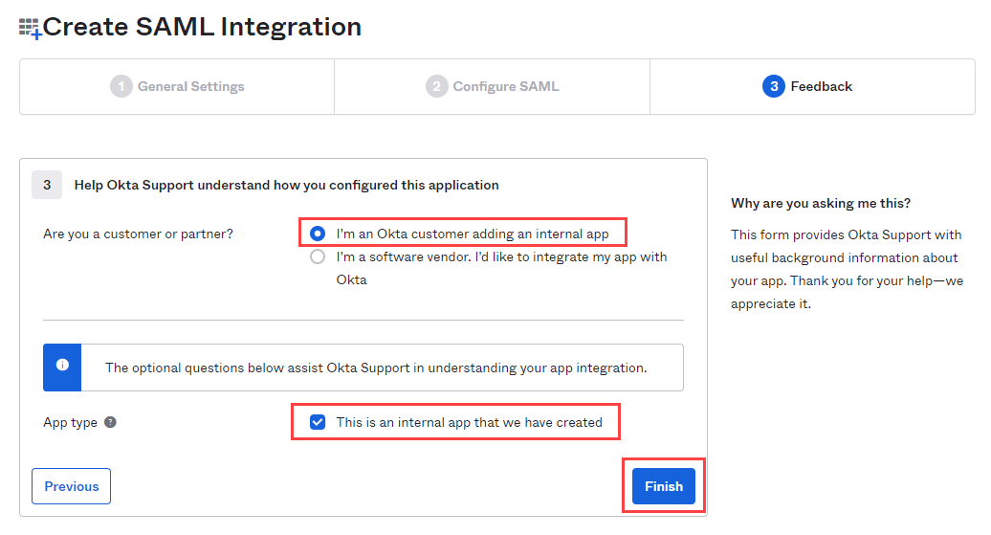

Step 6: Download the Metadata File
To finish the configuration on the SAP Concur side, upload the metadata file extracted from your application in Okta.
- On the Sign On settings page, click the Identity Provider metadata close to View Setup Instructions.
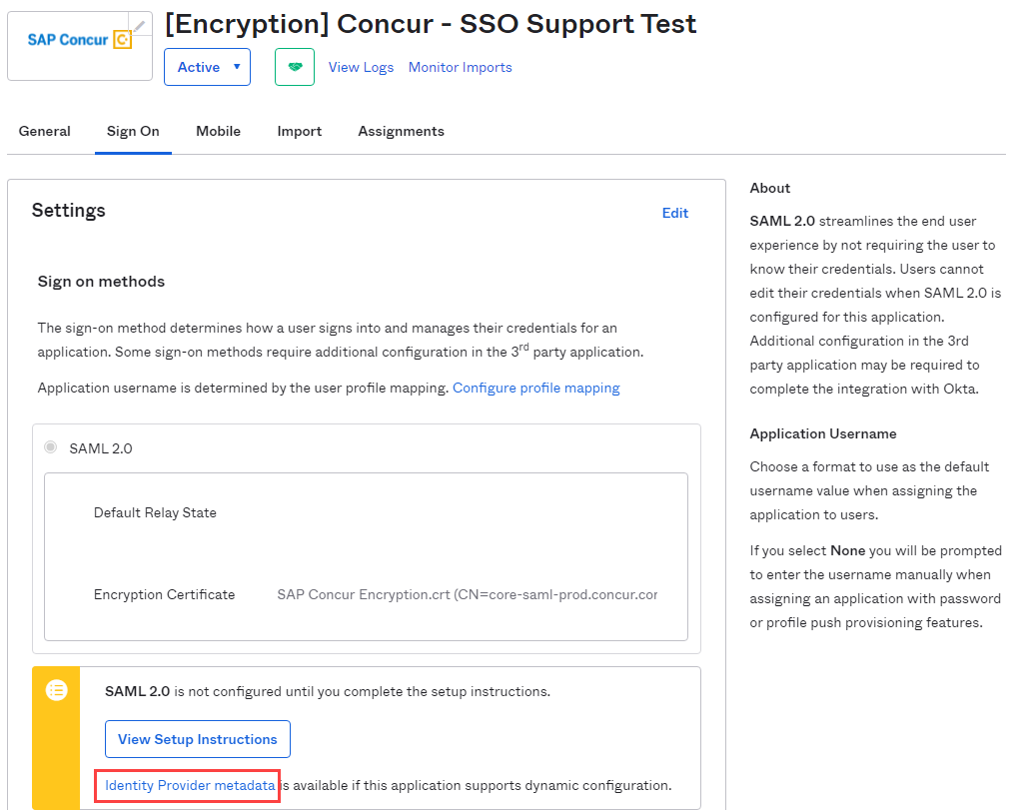
- If your browser does not download the metadata xml automatically, please right click the tab with the metadata and save it as .xml.


Configure Your SAP Concur Site
- Go to the Manage SSO page by following the steps provided in the Overview section.
- Click Add from the IdP Metadata section.
- Enter an appropriate name in the IdP connection and enter it in the Custom IdP Name field.
If you decide to use the SP-initiated flow (through SAP Concur’s public site: https://www.concursolutions.com/nui/signin), the Custom IdP Name will display on the Sign In page right after a user provides their Username and clicks Next. For example, if your Custom IdP Name is " Okta SSO [Encrypted]", then all users will see the option "Sign in with Okta SSO [Encrypted]".
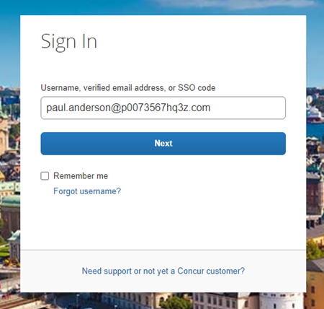
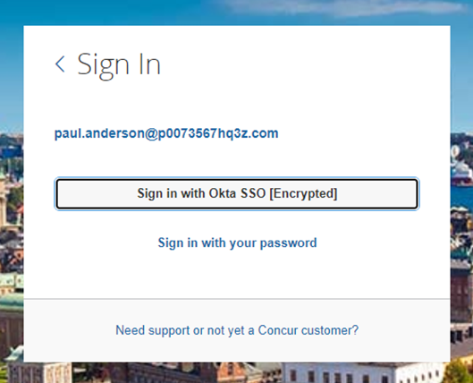
- Provide a Logout URL (optional) for users to get redirected to a different place when they log out. By default, if no URL is entered, users will be redirected to where they started the authentication process. The logout endpoint for Okta can be found on Local Provider > Identity Provider Settings > Single Log-Out Service (SLO) > Endpoint URL.
Single Logout (SLO) is not officially supported by SAP Concur, so the logout process with the SLO endpoint may not work as expected regarding disconnecting the user from the IDP in addition to SAP Concur. In that case, the user may be logged out from SAP Concur but not from Okta entirely.
- In the Upload your IdP's metadata section, click Upload XML File and upload the metadata file from the IdP, which was previously saved locally.
- To hide the sign-in option from users on mobile and signing in through concursolutions.com, select the checkbox Hide this SSO option from users signing in to Concur on web or mobile.
By default, the option is available to users when they begin an SP-initiated sign-in through concursolutions.com or the mobile app. The option can be hidden in those cases that require users to sign-in through an IdP-initiated flow.
- Click Add Metadata.
- You should see either a successfully added confirmation or a something went wrong message. For the latter, please contact SAP Concur support and provide the Correlation ID.

Test SSO Login
You can start testing SSO after you’ve successfully uploaded the IdP metadata to SAP Concur from the previous steps. In this section, you can test the IdP-Initiated (initiated on the identity provider side) and SP-Initiated (initiated on the service provider side) flows.

Test IdP-initiated SSO
To test IdP-initiated SSO:
- In the IdP-Initiated flow, start the login process on the identity provider side. To test it, log in to your Okta account, go to your applications and search for the tile referencing the new SAP Concur app you just configured. Click the tile and check whether you’re redirected to your SAP Concur profile directly.
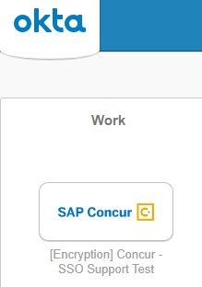
You can also go to the SSO tab on your application and test with the Embedded URL field. It should look like this:
https://companydomain.okta.com/home/concur/xxxxxxxxxx/xxx.

Test SP-initiated SSO
To test the SP-initiated SSO:
- Open the SAP Concur login page according to the environment you want to test.
- US DC Prod: https://www.concursolutions.com/
- US DC Test: https://implementation.concursolutions.com/
- EMEA DC Prod: https://eu1.concursolutions.com/
- EMEA DC Test: https://eu1imp.concursolutions.com/
- CN DC Prod: https://www.concurcdc.cn/
- On the login page, you can add your username, verified e-mail address or SSO code to proceed. Once you click Next, you should see an option for your recently created SSO configuration according to the note in Configure Your SAP Concur Site. Click to proceed with authenticating your identity provider account which should redirect you to SAP Concur.

Mobile Single Sign-On (SSO)
For SSO configurations created on our SAMLv2 platform, the Mobile SSO should be enabled automatically as soon as the metadata is saved. However, for this option to work, the SP-Initiated flow needs to be functioning. This can be validated using the previous Test SSO login section.
The automatic enabling of Mobile SSO is only visible on the app version 9.86 or higher and if the user is opting for the new sign in experience. Users on older versions or opting for the earlier sign in experience will not see this option automatically. However, if you were using another IdP and already using Mobile SSO, you may see two options when trying to sign-in as follows: 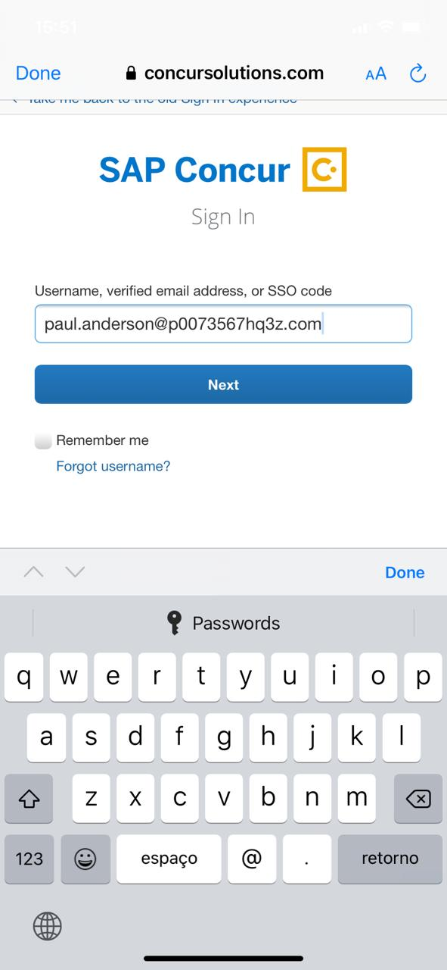 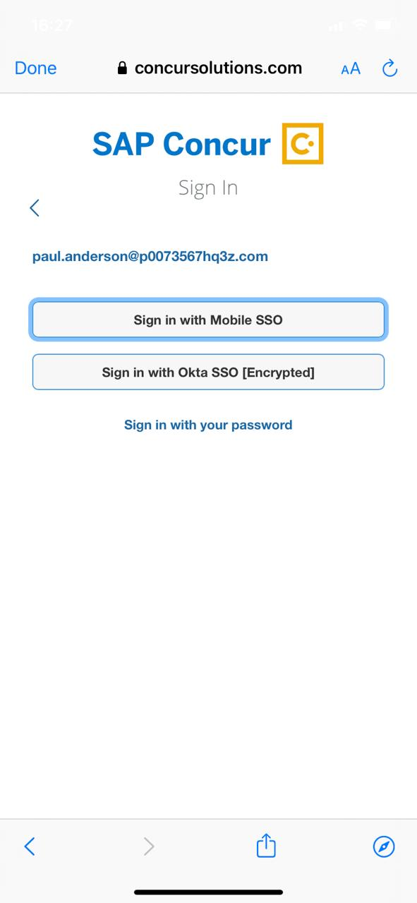
The Sign in with Mobile SSO option will have your earlier IdP link embedded, so it will redirect users to your old SSO connection.
For both cases, please open a ticket with the SAP Concur support team, providing them the following information.
- If the users plan to use an older version, please provide SAP Concur support with the IdP-Initiated URL from the application created on the Okta side so they can enable Mobile SSO for the legacy app versions. For more information on how to obtain the URL see Test SSO login > Testing IdP-Initiated SSO section on this guide.
- If you want to remove the Sign in with Mobile SSO option to eliminate potential confusion, please inform the support team.
If you have any issues in authenticating with SSO on the mobile app, please open a ticket with the SAP Concur support team and provide any error IDs and/or messages received with screenshots.

E-mail Notifications
The configuration of e-mail reminders to reflect your SSO URL are changes that need to be completed by SAP Concur support. To proceed, please open a ticket with the SAP Concur support team, providing the IDP URL from the application created on the IDP side so they can adjust the redirect URL for e-mail reminders. For more information on how to obtain the URL, see the Test SSO login > Testing IdP-Initiated SSO section of this appendix.
The URL will appear embedded on the View Report button.
This change will only be reflected in emails generated after the change. All emails prior to that will keep using the previous URL.
This change will take effect up to 4 hours after the update. 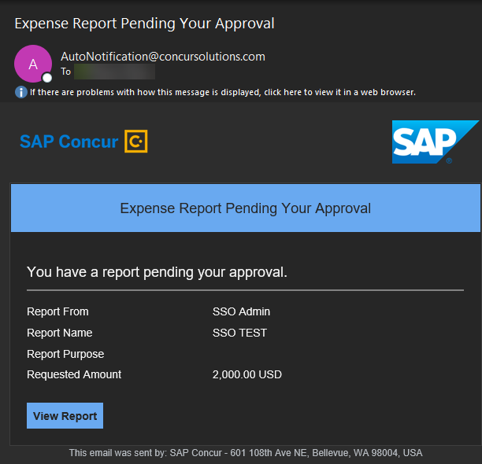
If you hover the cursor over the View Report button, you will see the currently embedded URL. The URL should appear between ctedeepurl= and &hpo= terms.
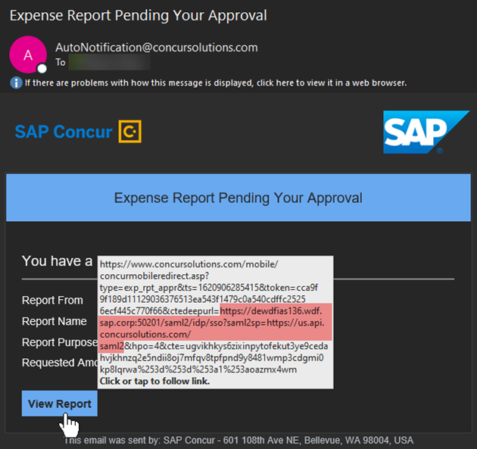

Rollout
After testing your new SSO configuration, you can then plan your rollout by assigning your new Okta application to all your users and groups who’ll need this access.
The Manage SSO page also offers the option for you to enforce this new SSO connection by changing the SSO Setting from SSO Optional to SSO Required. If you change it, users will be redirected to SAP Concur by providing their Username via the SP-initiated flow.

View Previous Changes
This featured was developed to help admins keep track of all changes completed under the Manage SSO page.
To view changes to the SSO configuration that have been made over time, click View Previous Changes.
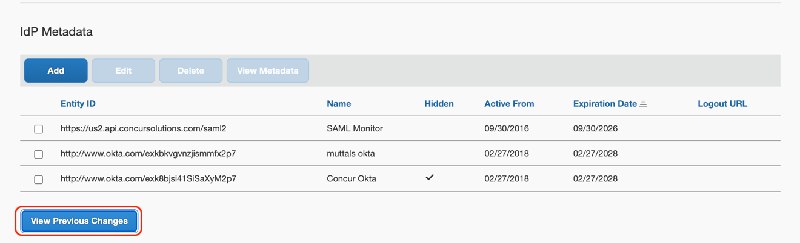
A table listing previous changes appears and it is sorted in descending order by date and time.
The table can display the last 100 changes. Changes that are listed in the table include:
- Add a configuration
- Delete a configuration
- Edit Custom IdP Name, Logout URL, or Hidden fields
To view more detailed information about a specific change listed in the table, click the View link for the desired list item.
Inside each log, you'll see the Company and ChangeBy fields in the format [first_name last_name] [(UUID code)]; this refers to the user who performed the action. In case you don't recognize that user, you can contact support to request further details about it.

Appendix - PingOne Setup
Per the appendix instructions in this section, as content is sourced from the third-party provider, SAP Concur cannot guarantee its accuracy. If you encounter issues, it is recommended that you contact the third-party provider’s support resources.

Getting Started
This appendix shows how to create a new application in PingOne and then upload this new configuration to your SAP Concur site on the new SAMLv2 platform.
Before you start the configuration process, ensure that:
- Your users exist in both PingOne and SAP Concur.
- The attribute you are sending from PingOne matches the Login ID (CTE Login Name) field for each employee in SAP Concur.
- You have the Company Administrator (companyadmin; a Travel permission) assigned to your SAP Concur account. Once you have the permission, you can access the Manage SSO page by using one of the following paths, depending on your SAP Concur edition.
For SAP Concur Standard edition:
- Go to Administration > Expense Settings.
- Under Access to Concur section, click Show 1 Advanced Setting.
- Click Manage Single Sign-On to access the Manage SSO page.
For the SAP Concur Professional edition:
- Go to Administration > Company > Authentication Admin.
- Click Manage Single Sign-On to access the Manage SSO page.
Alternatively, users can access the page using one of the following URLs:
- US DC Prod: https://www.concursolutions.com/nui/authadmin/ssoadmin
- US DC Test: https://implementation.concursolutions.com/nui/authadmin/ssoadmin
- EMEA DC Prod: https://eu1.concursolutions.com/nui/authadmin/ssoadmin
- EMEA DC Test: https://eu1imp.concursolutions.com/nui/authadmin/ssoadmin
- CN DC Prod: https://www.concurcdc.cn/nui/authadmin/ssoadmin

If you don’t have that permission and cannot have this assigned to your profile, please ask an authorized support contact at your company to open a case with SAP Concur support.

Configure Your PingOne Application

Step 1: Create a non-gallery SAML application
To configure:
- Log in to your PingOne admin account and go to the Applications tab.
- Click Add Application > New SAML Application.
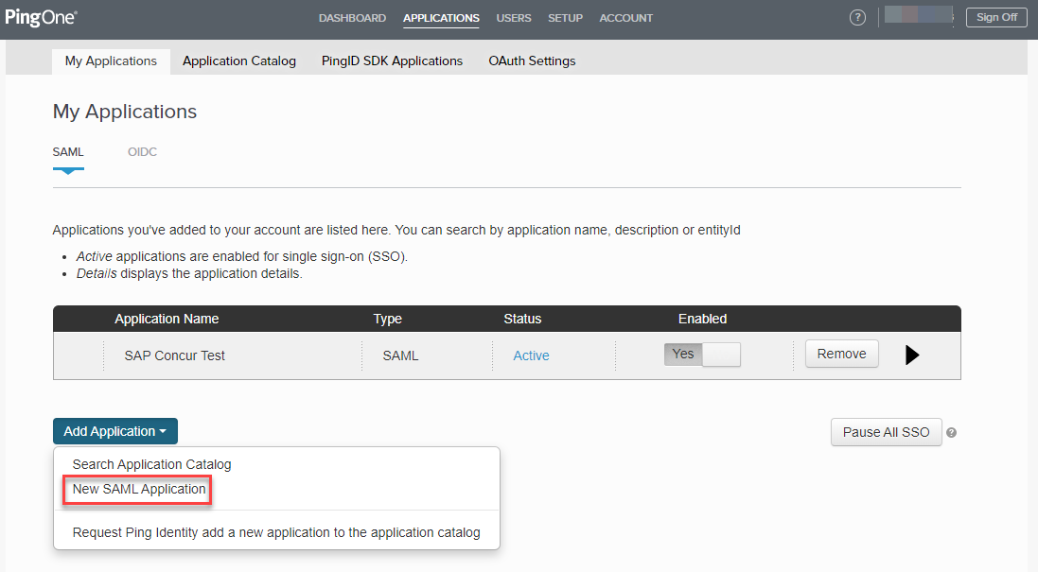

Step 2: Application details
- Fill in the application details as needed and then click Continue to Next Step.
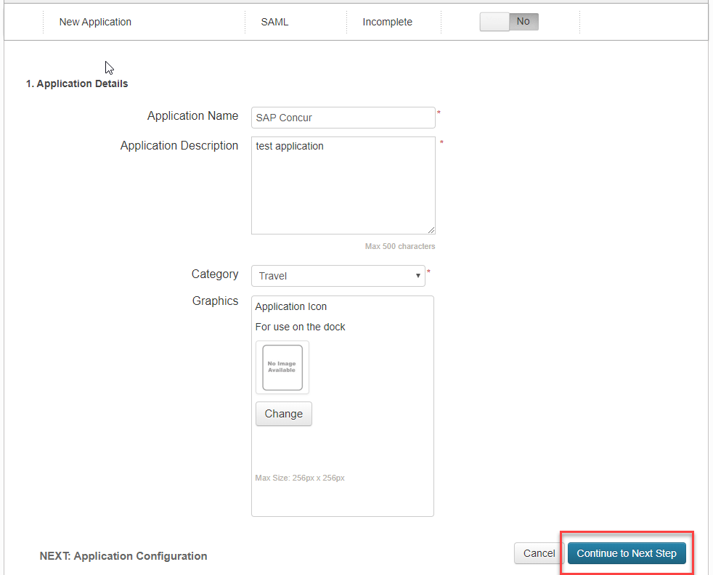

Step 3: Application configuration
To complete this step, log in to your SAP Concur account and access the Manage SSO section using the links in the Overview.
- Once you’ve accessed Manage SSO, you can obtain SAP Concur metadata by clicking Copy URL (to get the metadata URL) or Download (to download the metadata XML file).
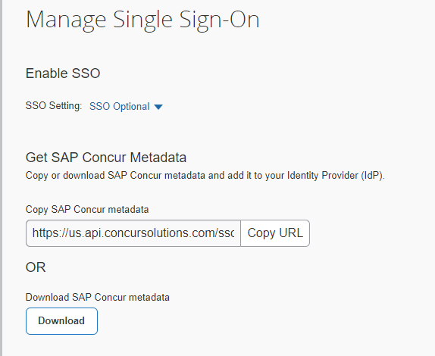
- Use your browser to open the metadata URL or XML file. PingOne supports metadata files upload, so you can go to Upload Metadata and load the xml file. You can also click Or use URL and add the metadata URL.
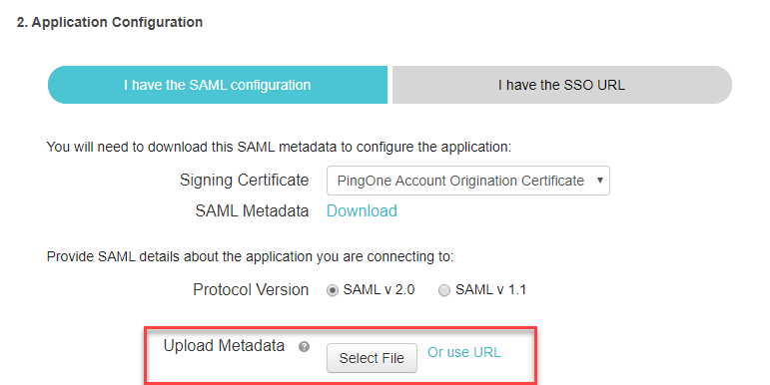
Once the metadata is loaded through the XML file or the URL, these fields should be automatically filled in:
- Assertion Customer Service (ACS)
- Entity ID
- Primary Verification Certificate
- Encrypt Assertion checkbox
- Encryption Algorithm
- Encryption Certificate
- Transport Algorithm
- Signing (from Sign Assertion to Sign Response)
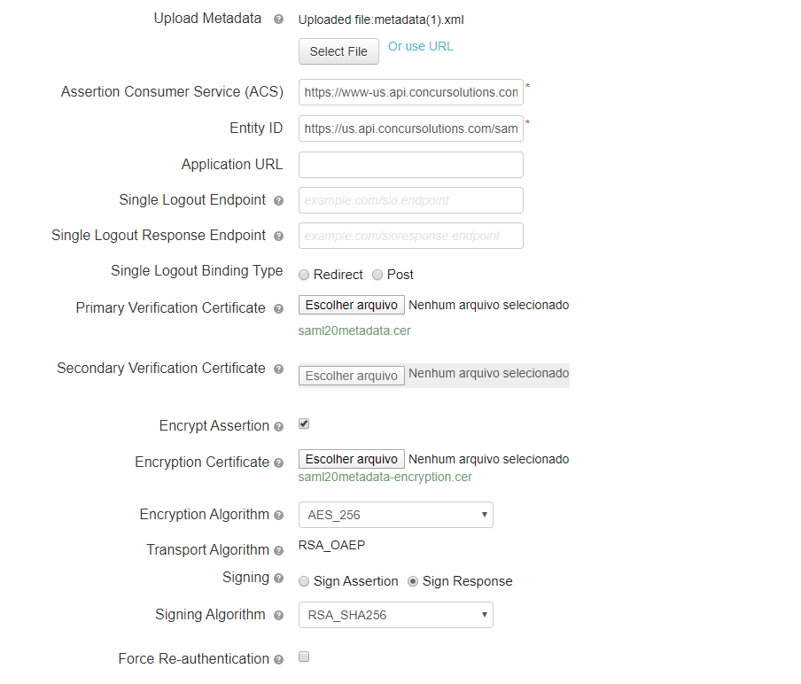
- Encrypt Assertion is an optional setting. If you prefer to track your SAML assertions for troubleshooting purposes, you may deselect this checkbox and then click Continue to the Next Step.

Step 4: Attribute Mapping
Once you get to the attribute mapping section, you need to build the attribute that will be sent to SAP Concur for validation. This attribute must match the employee’s Login ID field in SAP Concur.
- To add a new attribute, click Add new attribute.
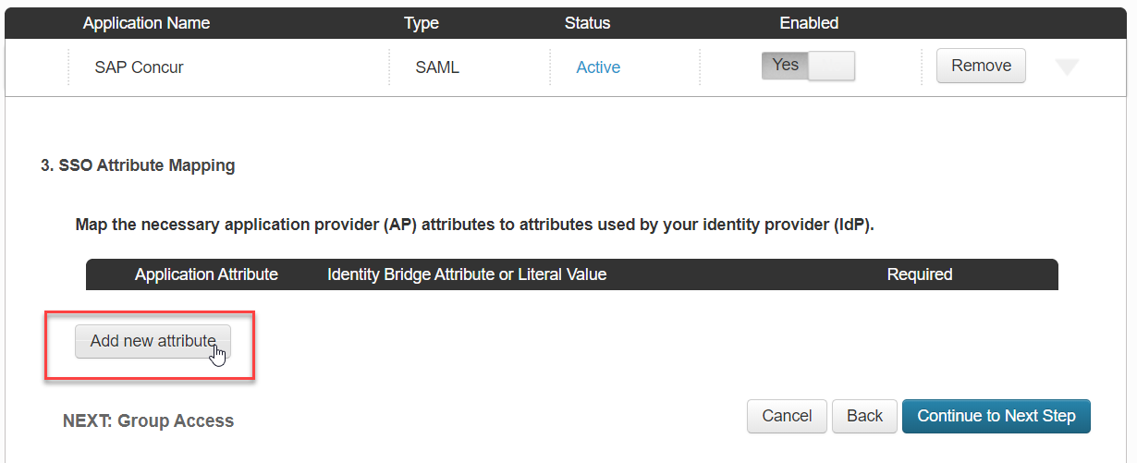
If your Ping e-mail address matches the Login ID field in SAP Concur, you can build an attribute like the following:
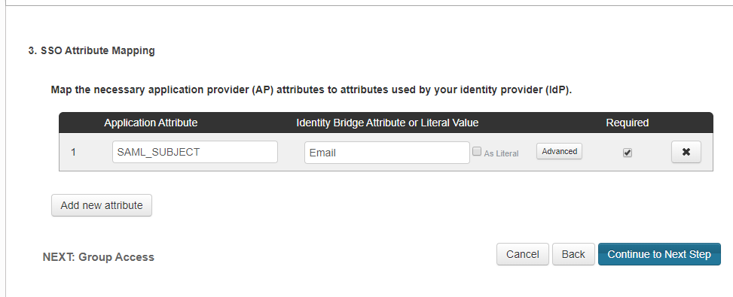
If your Login IDs in SAP Concur have a different structure, you’ll need to open the Advanced settings in SSO Attribute Mapping and configure a custom attribute. Ping has written an article in their community that can help you with this customization.

Step 5: Provide access to user groups
You’ll be prompted with a screen for Group Access. Add your user groups to this application. Please ensure all of your SAP Concur employees are included and click Continue to Next Step.
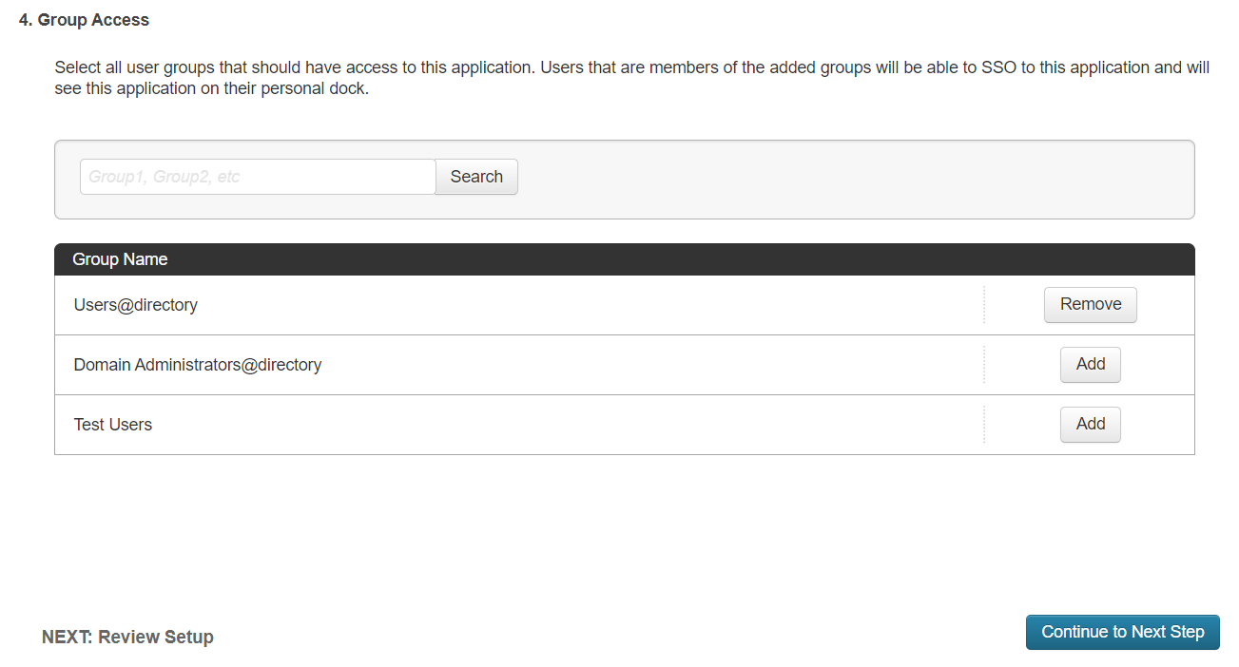

Step 6: Review and finish
Review your application configuration. Then download the SAML metadata from your configuration so you can upload it to SAP Concur later.
Finish your configuration by clicking Finish.
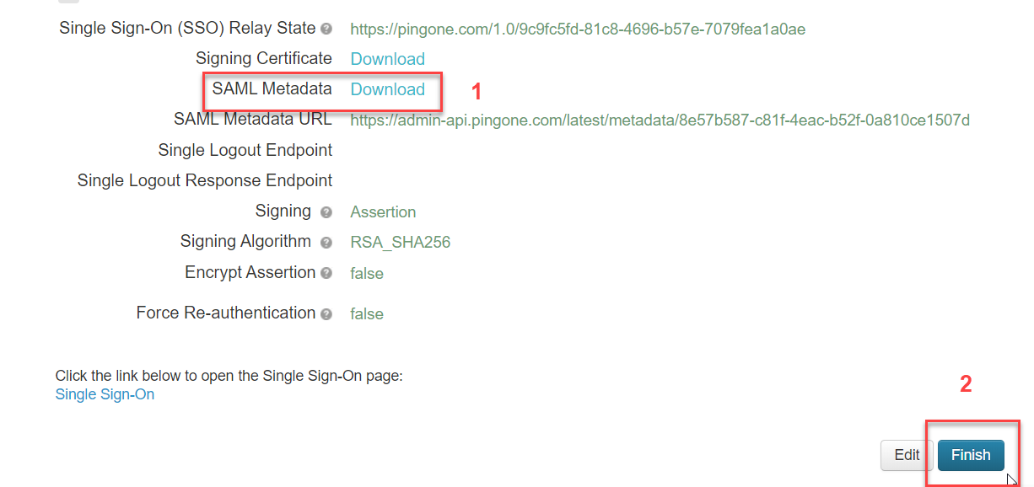

Configure Your SAP Concur Site
- Go to the Manage SSO page by following the steps provided in the Overview section.
- Click Add from the IdP Metadata section. The Add IdP Metadata window appears.
- Enter an appropriate name in the IdP connection and enter it in the Custom IdP Name field.
For SP-initiated SSO, the Custom IdP Name will display on the Sign In page right after a user provides their Username and clicks Next.
- In the Upload your IdP's metadata section, click Upload XML File and upload the metadata file from the IdP.
- To hide the sign-in option from users on mobile and signing in through concursolutions.com, select the checkbox Hide this SSO option from users signing in to Concur on web or mobile.
By default, the option is available to users when they begin an SP-initiated sign-in through concursolutions.com or the mobile app. The option can be hidden in those cases that require users to sign-in through an IdP-initiated flow.
- Click Add Metadata.
Once the metadata is successfully added, you can start testing your new configuration.

Test SSO Login
You can start testing SSO after you’ve successfully uploaded the IdP metadata to SAP Concur from the previous steps. In this section, you can test the IdP-Initiated (initiated on the identity provider side) and SP-Initiated (initiated on the service provider side) flows.

Testing IdP-initiated SSO
To test IdP-initiated SSO:
- Open your recently created application. The Initiate Single Sign-On (SSO) URL and Single Sign-On link open the Single Sign-On page.
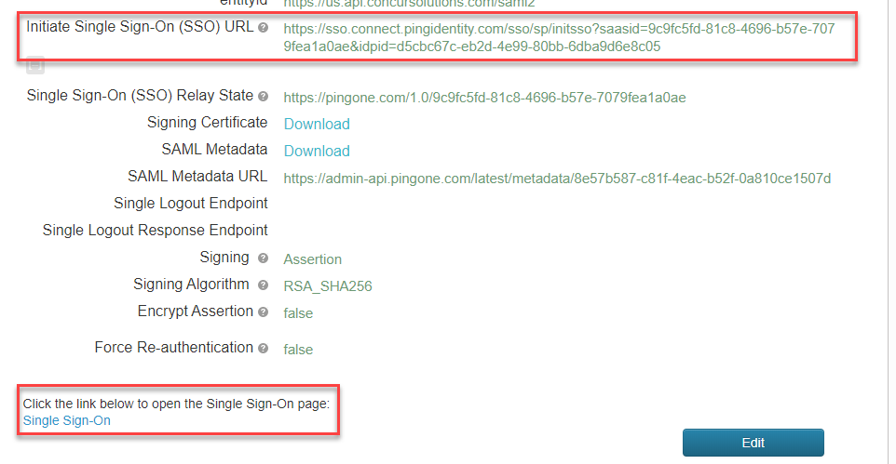

Testing SP-initiated SSO
To test the SP-initiated SSO:
- Open the SAP Concur login page according to the environment you want to test.
- US DC Prod: https://www.concursolutions.com/
- US DC Test: https://implementation.concursolutions.com/
- EMEA DC Prod: https://eu1.concursolutions.com/
- EMEA DC Test: https://eu1imp.concursolutions.com/
- CN DC Prod: https://www.concurcdc.cn/
- On the login page, you can add your username, verified e-mail address or SSO code to proceed. Once you click Next, you should see an option for your recently created SSO configuration. Click the SSO authentication option to proceed with authenticating your PingOne credentials which should redirect to your profile on SAP Concur.
If after adding your PingOne credentials you receive a PingOne error message, your configuration may be incomplete or is missing something. If the IdP-Initiated SSO login is working but the SP-Initiated is not, this is most likely an issue with the name ID format. To make sure the Name ID format is correct, please confirm if SAML_SUBJECT is set to Email as described in the attribute mapping step of Create Your PingOne Application.

Mobile Single Sign-On (SSO)
For SSO configurations created on our SAMLv2 platform, the Mobile SSO should be enabled automatically as soon as the metadata is saved. However, for this option to work, the SP-Initiated flow needs to be functioning. This can be validated using the previous Test SSO login section.
The automatic enabling of Mobile SSO is only visible on the app version 9.86 or higher and if the user is opting for the new sign in experience. Users on older versions or opting for the earlier sign in experience will not see this option automatically.
If you have any issues in authenticating with SSO on the mobile app, please open a ticket with the SAP Concur support team and provide any error IDs and/or messages received with screenshots.

E-mail Notifications
The configuration of e-mail reminders to reflect your SSO URL are changes that need to be completed by SAP Concur support. To proceed, please open a ticket wih the SAP Concur support team, providing the IDP URL from the application created on the IDP side so they can adjust the redirect URL for e-mail reminders. For more information on how to obtain the URL, see the Test SSO login > Testing IdP-Initiated SSO section of this appendix.

Rollout
After testing your new SSO configuration, you can then plan your rollout by assigning your new application to all your users and groups who’ll need this access.
The Manage SSO page also offers the option for you to enforce this new SSO connection by changing the SSO Setting from SSO Optional to SSO Required. If you change it, users will be redirected to SAP Concur by providing their Username via the SP-initiated flow.
If you need to enforce Mobile SSO only, please contact SAP Concur support.

Log examples:
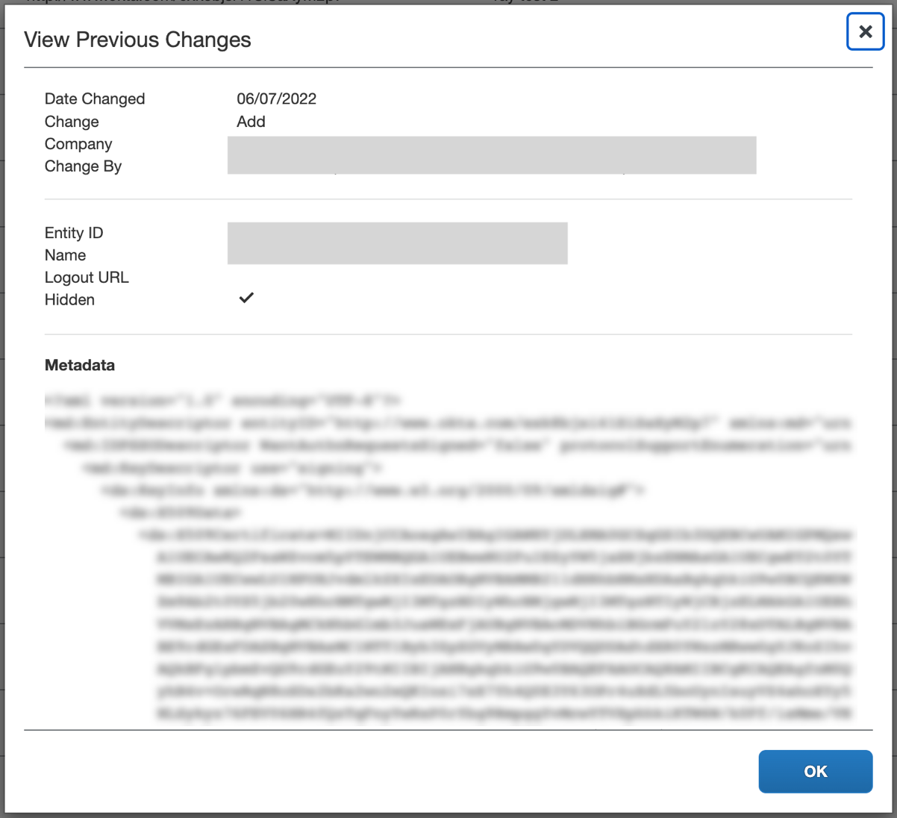
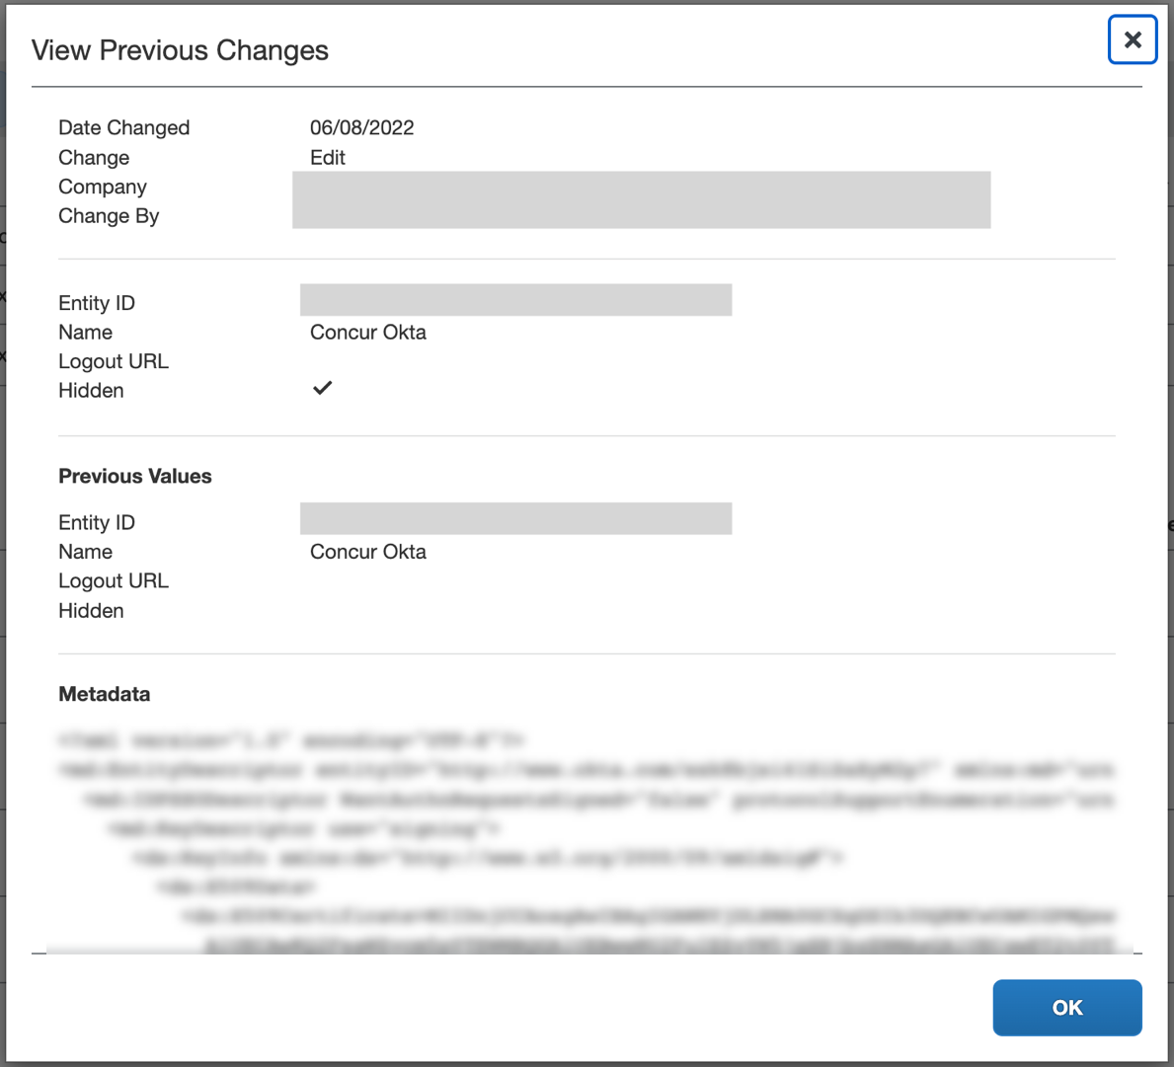
For deleted configurations, the View Previous Changes page includes a Revert button that enables you to reinstate the deleted configuration. After the configuration is reinstated, it will be available to users during the sign-in process.
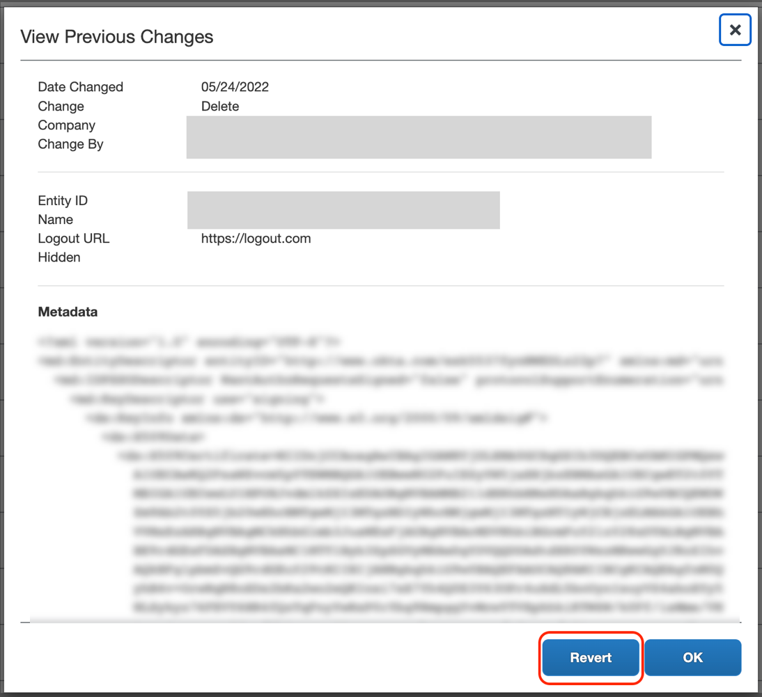

Appendix - SAP Cloud Identity Services - Identity Authentication Service (SAP IAS) Setup

Getting Started
Before you start the configuration process, ensure that:
- You have admin access to the identity provider (SAP IAS) so that you can complete the application configuration on the SAP IAS side. In the Viewing Assigned Tenants and Administrators documentation you can see how to find the tenants that your company owns and who the administrators are.
- Your users exist in both SAP IAS and SAP Concur. For user integration, SAP Concur supports flat file imports and APIs. For integration with SAP products, SAP offers automated user provisioning based on SAP Cloud Identity Service Identity Provisioning.
- For more information, refer to SAP Concur Integration Scenario on the SAP Help portal.
- The attribute you are sending as Subject Name Identifier from SAP IAS matches the Login ID (Username / CTE Login Name) field for each employee in SAP Concur.
- You have the Company Administrator (Travel permission) assigned to your SAP Concur account. Once you have the permission, you can access the Manage SSO page by using one of the following paths, depending on your SAP Concur edition.
For SAP Concur Standard edition:
- Go to Administration > Expense Settings.
- Under Access to Concur section, click Show 1 Advanced Setting.
- Click Manage Single Sign-On to access the Manage SSO page.
For the SAP Concur Professional edition:
- Go to Administration > Company > Authentication Admin.
- Click Manage Single Sign-On to access the Manage SSO page.
Alternatively, users can access the page using one of the following URLs:
- US DC Prod: https://www.concursolutions.com/nui/authadmin/ssoadmin
- US DC Test: https://implementation.concursolutions.com/nui/authadmin/ssoadmin
- EMEA DC Prod: https://eu1.concursolutions.com/nui/authadmin/ssoadmin
- EMEA DC Test: https://eu1imp.concursolutions.com/nui/authadmin/ssoadmin
- CN DC Prod: https://www.concurcdc.cn/nui/authadmin/ssoadmin

If you don’t have that permission and cannot have this assigned to your profile, please ask an authorized support contact at your company to open a case with SAP Concur support.

Configure Your SAP IAS Application

Step 1: Get the SAP Concur metadata
To configure:
- Get the SAP Concur metadata. To complete this, follow the instructions in the previous Overview section to log in to your SAP Concur account and access the Manage SSO section. To obtain the SAP Concur metadata on the Manage SSO page, you can either click Copy URL and then paste it in a new browser tab or click Download and open the downloaded file.

Step 2: Create an Application on SAP IAS
- Create an application in SAP IAS. After logging in to SAP IAS, you will need to access Applications & Resources > Applications.
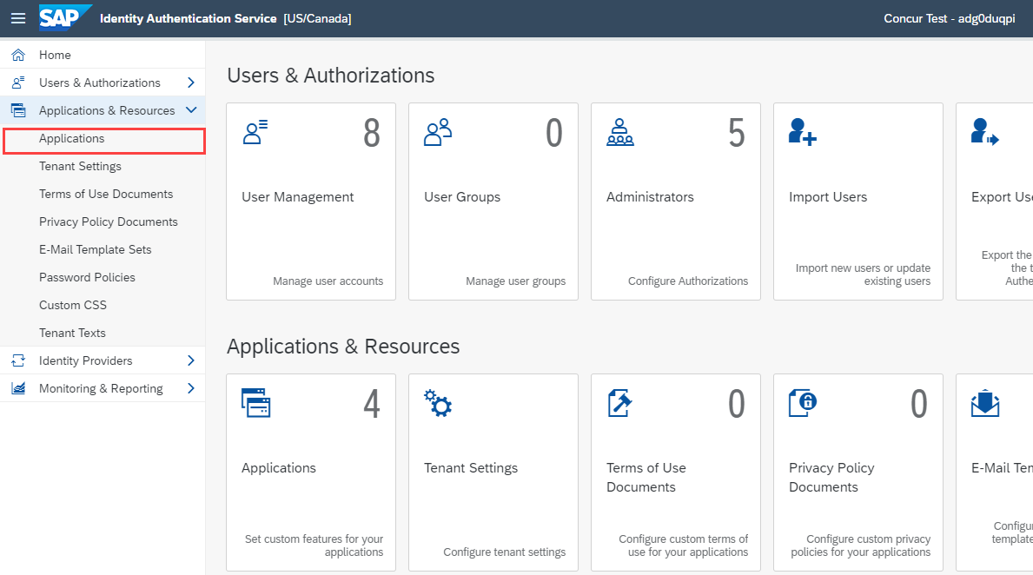
- This will list all applications created. Click +Add to add a new application.
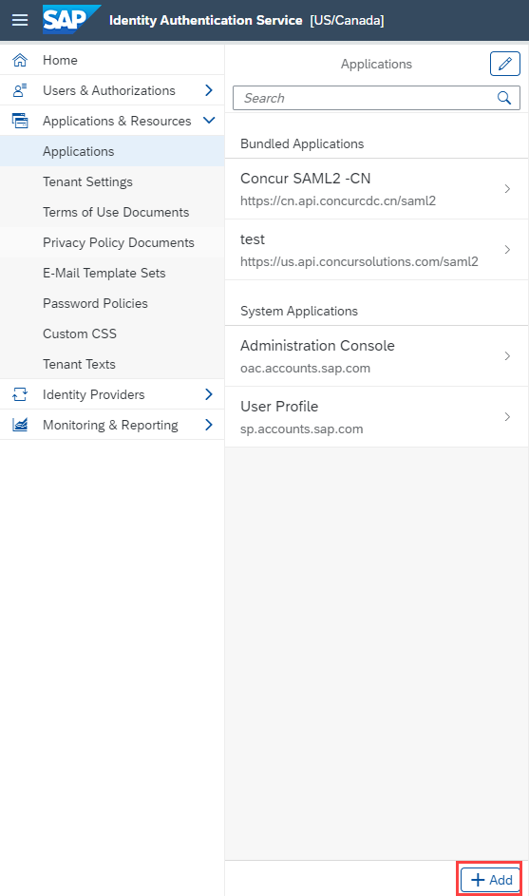
- Enter a name and click Save.
- This will be a SAML (Security Assertion Markup Language) configuration, so you will need to access SAML 2.0 Configuration.
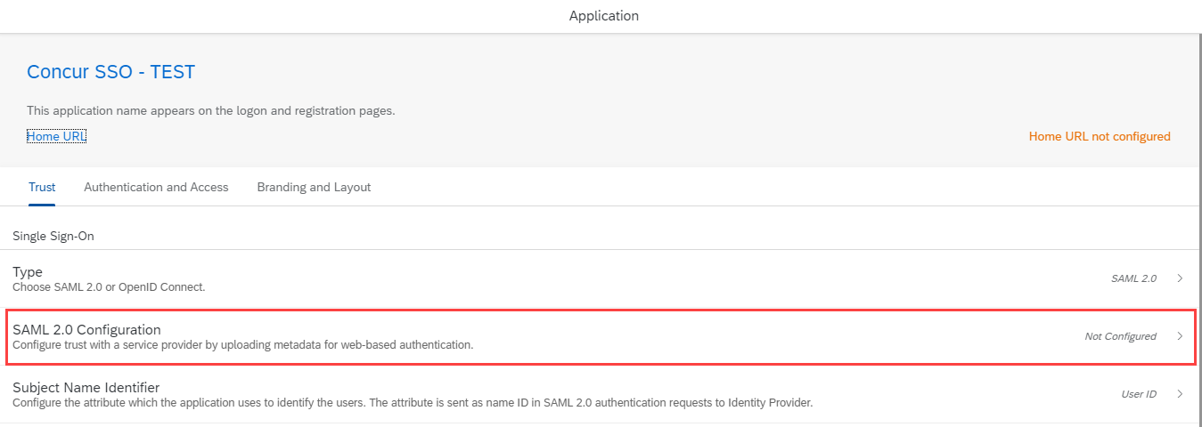
- As you already downloaded the SAP Concur metadata file, or copied the URL from a previous step, you can click Browse to upload the file via Metadata File input, or enter the URL in Metadata URL.
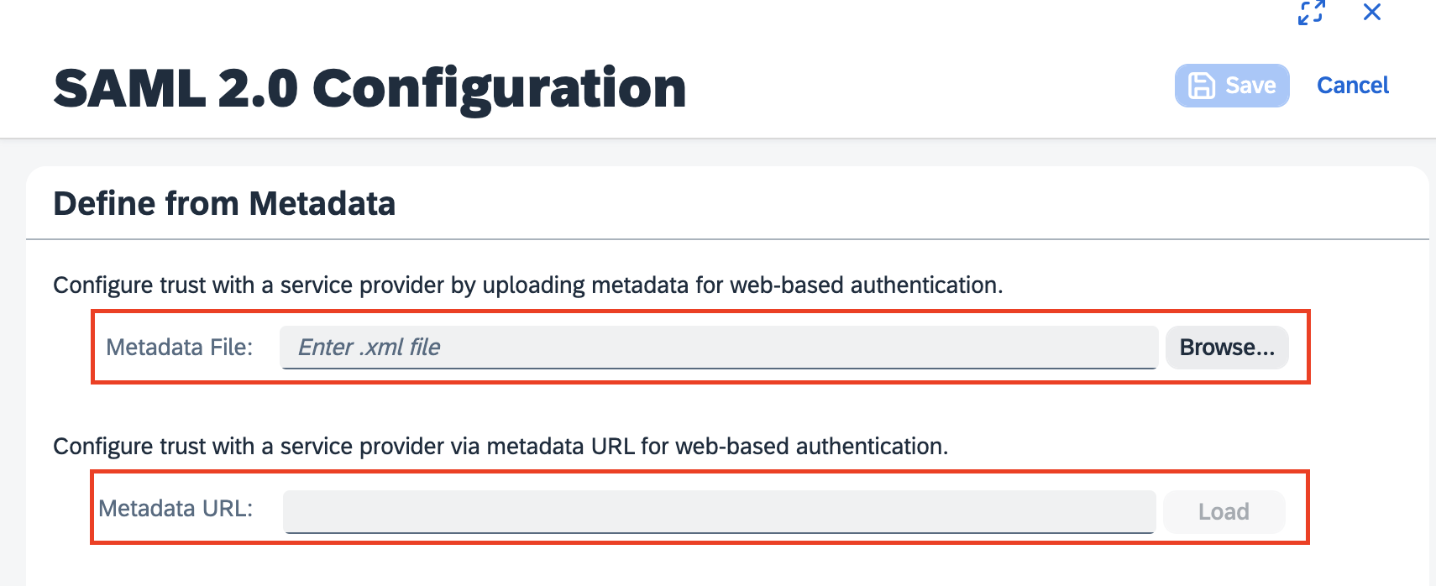
- After uploading the file, the SAP IAS should fill in fields accordingly by taking all values from the metadata. Then, click Save.
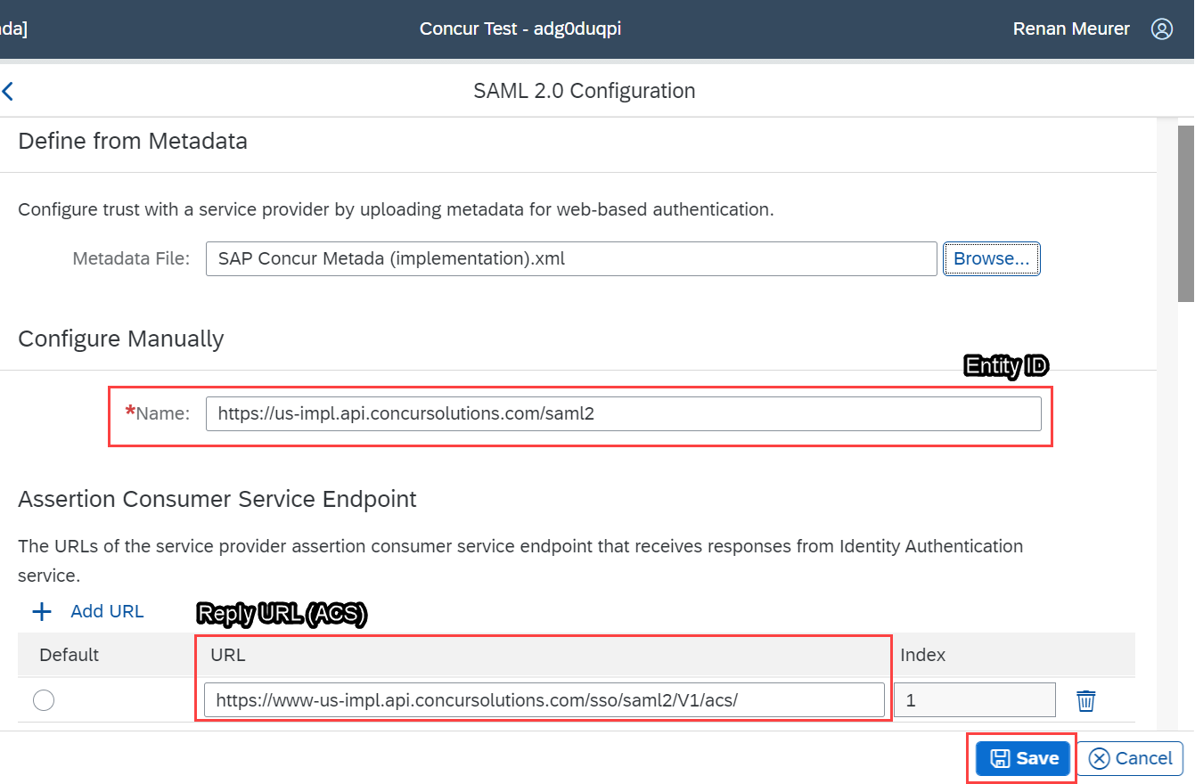

Step 3: Change Subject Name Identifier
The default Subject Name Identifier is User ID.
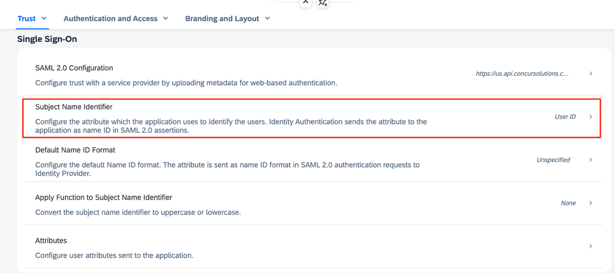
This should be updated based on the Login IDs (Usernames / CTE Login Names) of your users in SAP Concur:
- If the email addresses of your users are used as Logon IDs in SAP Concur, then in the Basic Configuration section you should configure Email in the Select a basic attribute drop-down.
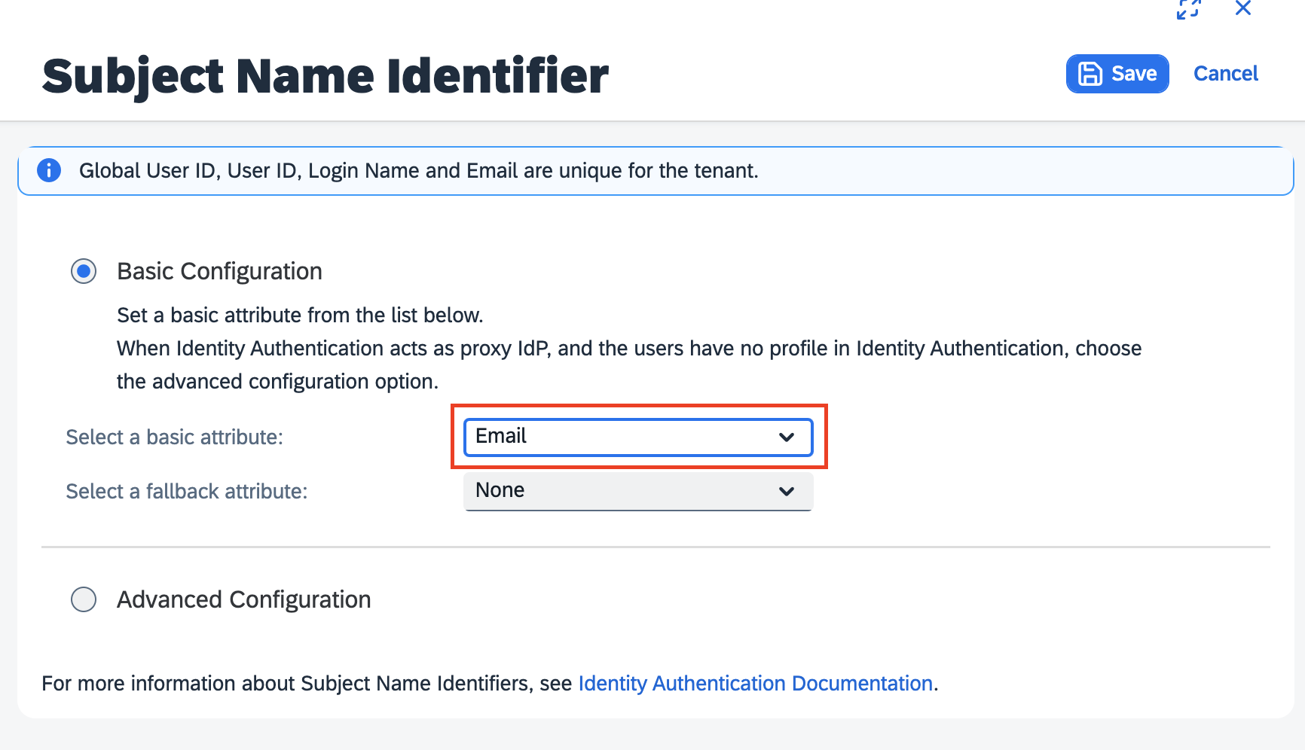
- if the login names (usernames) of your users are with email format and are used as Logon IDs in Concur, then in the Basic Configuration section you should configure Login Name in the Select a basic attribute drop-down.
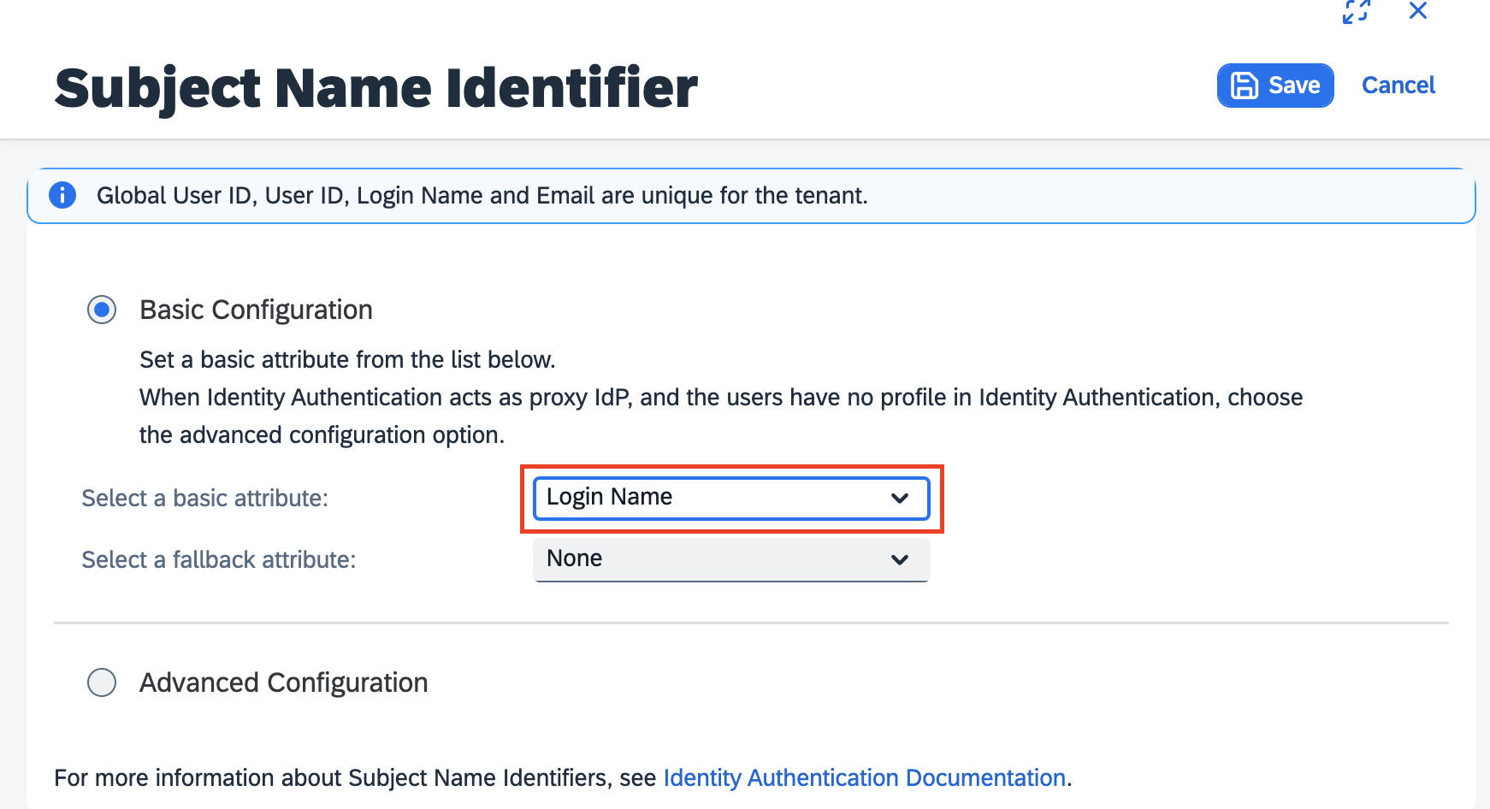
- If your login IDs in SAP Concur do not match any user attribute but are constructed based on some user attribute with a static domain as suffix, then you can use Advanced Configuration to construct a value from that user attribute following the procedures Configure the Subject Name Identifier Sent to the Application procedure.
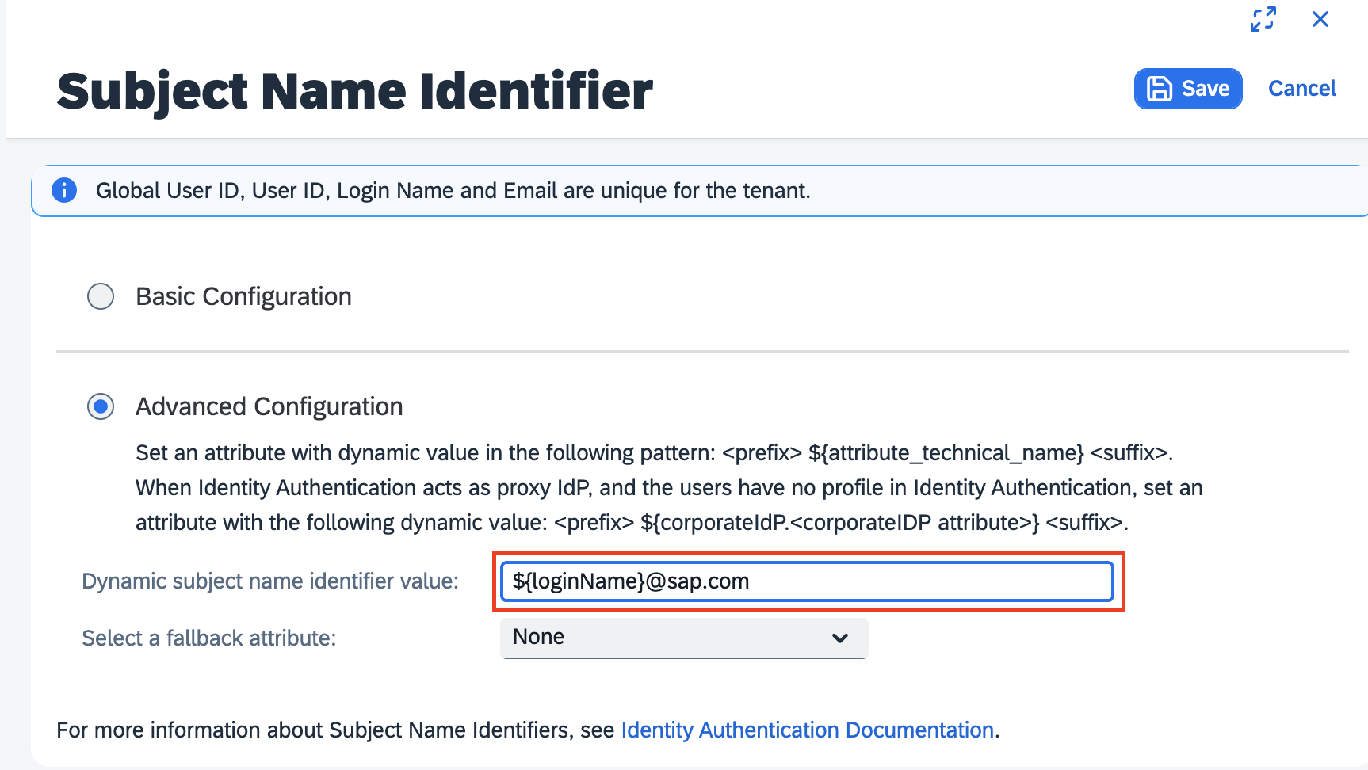

Step 4: Change Default Name ID Format
After finishing the application configuration, you will need to configure the Name ID. The Name ID must match the Login ID (CTE Login Name) registered for your employees in Concur. We also strongly recommend you set the Name ID format to Email address. This is required by SAP Concur for the SP-Initiated logins, starting from concursolutions.com or from the mobile app. The default Name ID Format is “Unspecified”, so click Default Name ID Format to change it.
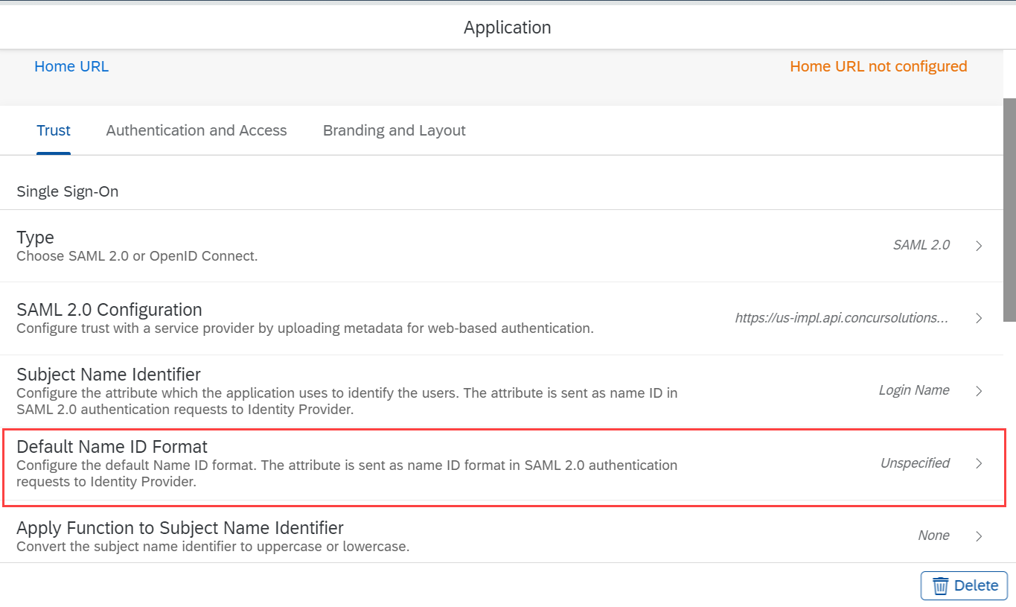
After you select the email, click Save.
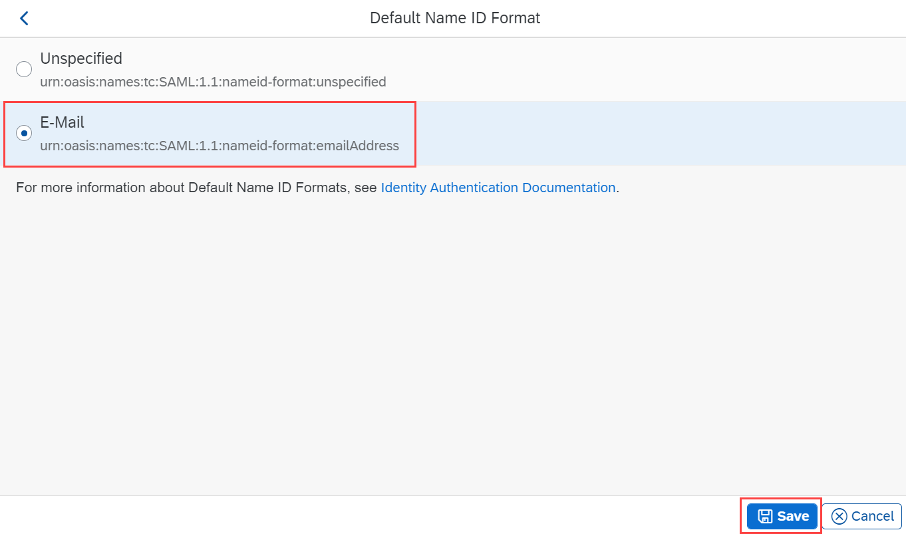
In some cases, this may not match the usernames in SAP Concur. If this is the case, you can run employee imports in SAP Concur to make sure they match the attribute you send. Alternatively, you can reach out to product support for SAP IAS for further help with Name ID configurations.

Step 5: Download the metadata
To complete the configuration on the SAP Concur side, upload the metadata file extracted from your application in SAP IAS. To do so, go to Applications & Resources > Tenant Settings > SAML 2.0 Configuration.
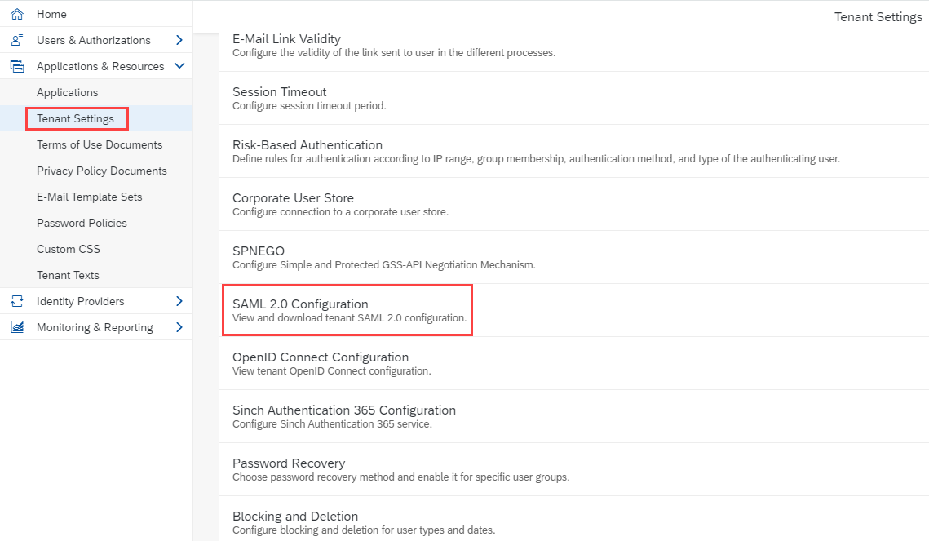
This displays the Identity Provider Settings screen where you can review your configuration and choose to Download Metadata File.
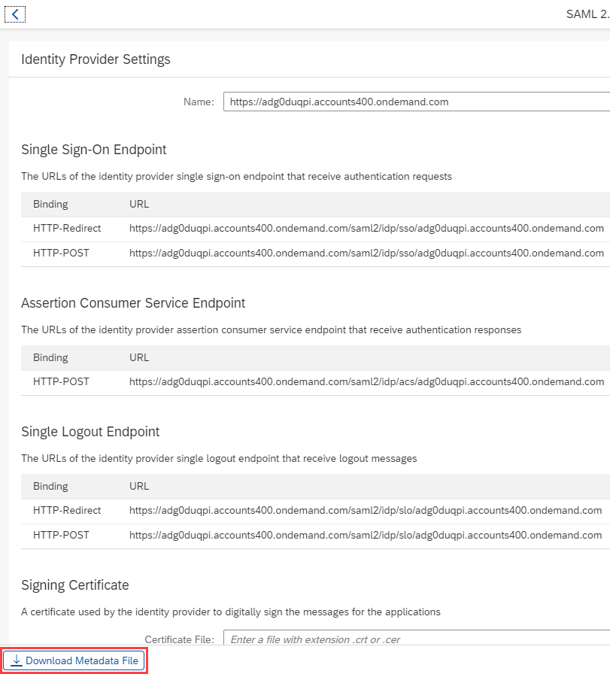
You are now ready to upload your metadata file to SAP Concur.

Configure Your SAP Concur Site
- Go to the Manage SSO page by following the steps provided in the Overview section.
- Click Add from the IdP Metadata section. The Add IdP Metadata window appears.
- Enter an appropriate name in the IdP connection and enter it in the Custom IdP Name field.
If you decide to use the SP-initiated flow (through SAP Concur’s public site: https://www.concursolutions.com/nui/signin), the Custom IdP Name will display on the Sign In page right after a user provides their Username and clicks Next. For example, if your Custom IdP Name is "SAP IAS", then all users will see the option "Sign in with SAP IAS".
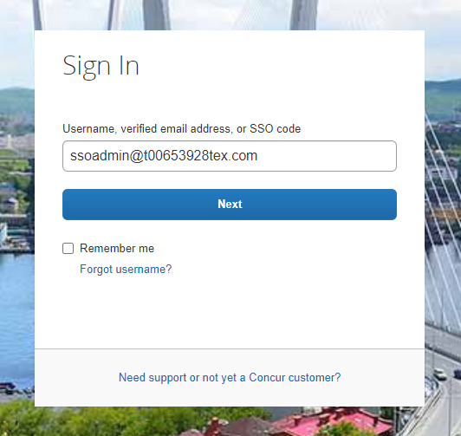
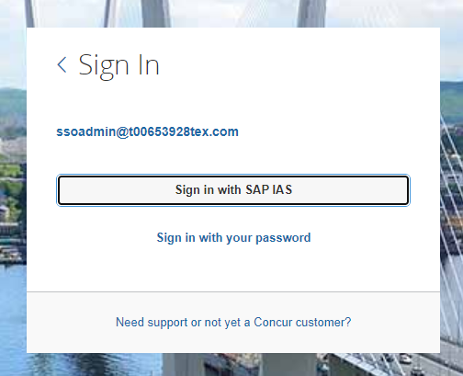
- Provide a Logout URL (optional) for users to get redirected to a different place when they log out. By default, if no URL is entered, users will be redirected to where they started the authentication process. The logout endpoint for SAP IAS can be found in Applications & Resources > Tenant Settings > Identity Provider Settings > Single Logout Endpoint. Please note that Single Logout (SLO) is not officially supported by SAP Concur, so the logout process with the SLO endpoint may not work as expected regarding disconnecting the user from the IDP in addition to SAP Concur. In that case, the user may be logged out from SAP Concur but not from SAP IAS entirely.
- In the Upload your IdP's metadata section, click Upload XML File and upload the metadata file from the IdP.
- To hide the sign-in option from users on mobile and signing in through concursolutions.com, select the checkbox Hide this SSO option from users signing in to Concur on web or mobile.
- By default, the option is available to users when they begin an SP-initiated sign-in through concursolutions.com or the mobile app. The option can be hidden in those cases that require users to sign-in through an IdP-initiated flow.
- Click Add Metadata.
- You should see either a successfully added confirmation or a something went wrong message. For the latter, please contact SAP Concur support and provide the Correlation ID.

Test SSO Login
You can start testing SSO after you’ve successfully uploaded the IdP metadata to SAP Concur from the previous steps. In this section, you can test the IdP-Initiated (initiated on the identity provider side) and SP-Initiated (initiated on the service provider side) flows.

Testing IdP-initiated SSO
To test IdP-initiated SSO:
- In the IdP-Initiated flow, start the login process on the identity provider side. To test, append the parameters from the application you just created to the SSO endpoint from SAP IAS. A format example of IdP-Initiated URL would be:
Format: [tenantName*]?saml2sp=[SP Identifier**]
Example: https://adg0duqpi.accounts400.ondemand.com/saml2/idp/sso?sp=https://us-impl.api.concursolutions.com/saml2
*TenantName: Go to Applications & Resources > Tenant Settings.
**SP Identifier: You can obtain it from the SAP Concur metadata. It will be the same as Entity ID or Audience.
SAP IAS has 5 different landscapes, but only one – the PROD environment (*.accounts.ondemand.com) – is relevant for customers.
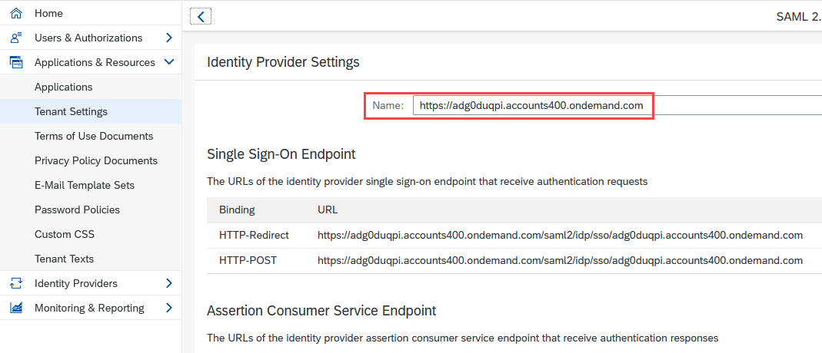
This URL should redirect you to a login page on the SAP IAS side. Once you login with your credentials, you should be redirected to the SAP Concur homepage.

Testing SP-initiated SSO
To test the SP-initiated SSO:
- Open the SAP Concur login page according to the environment you want to test.
- US DC Prod: https://www.concursolutions.com/
- US DC Test: https://implementation.concursolutions.com/
- EMEA DC Prod: https://eu1.concursolutions.com/
- EMEA DC Test: https://eu1imp.concursolutions.com/
- CN DC Prod: https://www.concurcdc.cn/
- On the login page, you can add your username, verified e-mail address or SSO code to proceed. Once you click Next, you should see an option for your recently created SSO configuration according to the note in Configure Your SAP Concur Site. Click to proceed with authenticating your identity provider account which should redirect you to SAP Concur.

Mobile Single Sign-On (SSO)
For SSO configurations created on our SAMLv2 platform, the Mobile SSO should be enabled automatically as soon as the metadata is saved. However, for this option to work, the SP-Initiated flow needs to be functioning. This can be validated using the previous Test SSO login section.
The automatic enabling of Mobile SSO is only visible on the app version 9.86 or higher and if the user is opting for the new sign in experience. Users on older versions or opting for the earlier sign in experience will not see this option automatically. However, if you were using another IdP and already using Mobile SSO, you may see two options when trying to sign-in as follows: 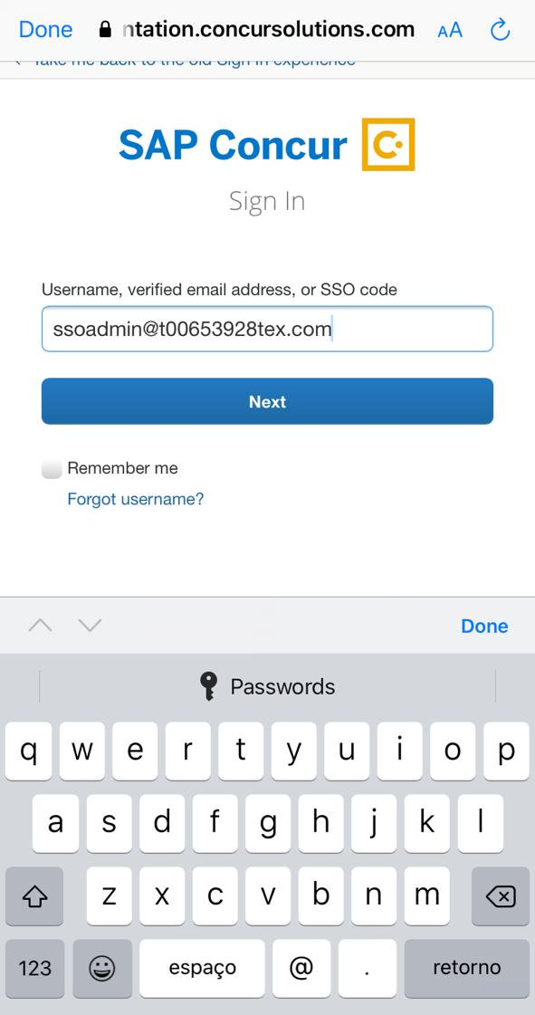 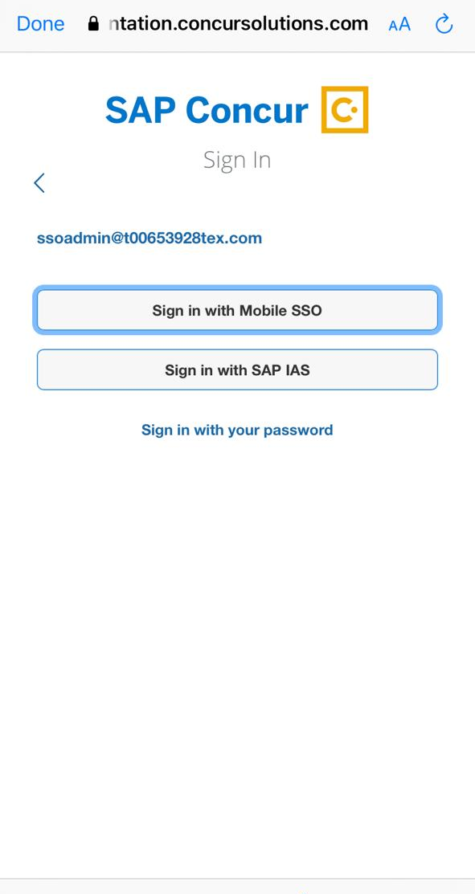
The Sign in with Mobile SSO option will have your earlier IdP link embedded, so it will redirect users to your old SSO connection.
For both cases, please open a ticket with the SAP Concur support team, providing them the following information.
- If the users plan to use an older version, please provide SAP Concur support with the IdP-Initiated URL from the application created on the SAP NetWeaver side so they can enable Mobile SSO for the legacy app versions. For more information on how to obtain the URL see Test SSO login > Testing IdP-Initiated SSO section on this guide.
- If you want to remove the Sign in with Mobile SSO option to eliminate potential confusion, please inform the support team.
If you have any issues in authenticating with SSO on the mobile app, please open a ticket with the SAP Concur Support team and provide any error IDs and/or messages received with screenshots.

E-mail Notifications
The configuration of e-mail reminders to reflect your SSO URL are changes that need to be completed by SAP Concur support. To proceed, please open a ticket wih the SAP Concur support team, providing the IDP URL from the application created on the IDP side so they can adjust the redirect URL for e-mail reminders. For more information on how to obtain the URL, see the Test SSO login > Testing IdP-Initiated SSO section of this appendix.
The URL will appear embedded on the View Report button.
This change will only be reflected in emails generated after the change. All emails prior to that will keep using the previous URL.
This change will take effect up to 4 hours after the update.
If you hover the cursor over the View Report button, you will see the currently embedded URL. The URL should appear between ctedeepurl= and &hpo= terms.

Rollout
After testing your new SSO configuration, you can then plan your rollout by assigning your new SAP IAS application to all your users and groups who’ll need this access.
The Manage SSO page also offers the option for you to enforce this new SSO connection by changing the SSO Setting from SSO Optional to SSO Required. If you change it, users will be redirected to SAP Concur by providing their Username via the SP-initiated flow.

View Previous Changes
This featured was developed to help admins keep track of all changes completed under the Manage SSO page.
To view changes to the SSO configuration that have been made over time, click View Previous Changes.
A table listing previous changes appears and it is sorted in descending order by date and time.
The table can display the last 100 changes. Changes that are listed in the table include:
- Add a configuration
- Delete a configuration
- Edit Custom IdP Name, Logout URL, or Hidden fields
To view more detailed information about a specific change listed in the table, click the View link for the desired list item.
Inside each log, you'll see the Company and ChangeBy fields in the format [first_name last_name] [(UUID code)]; this refers to the user who performed the action. In case you don't recognize that user, you can contact support to request further details about it.
Log examples:
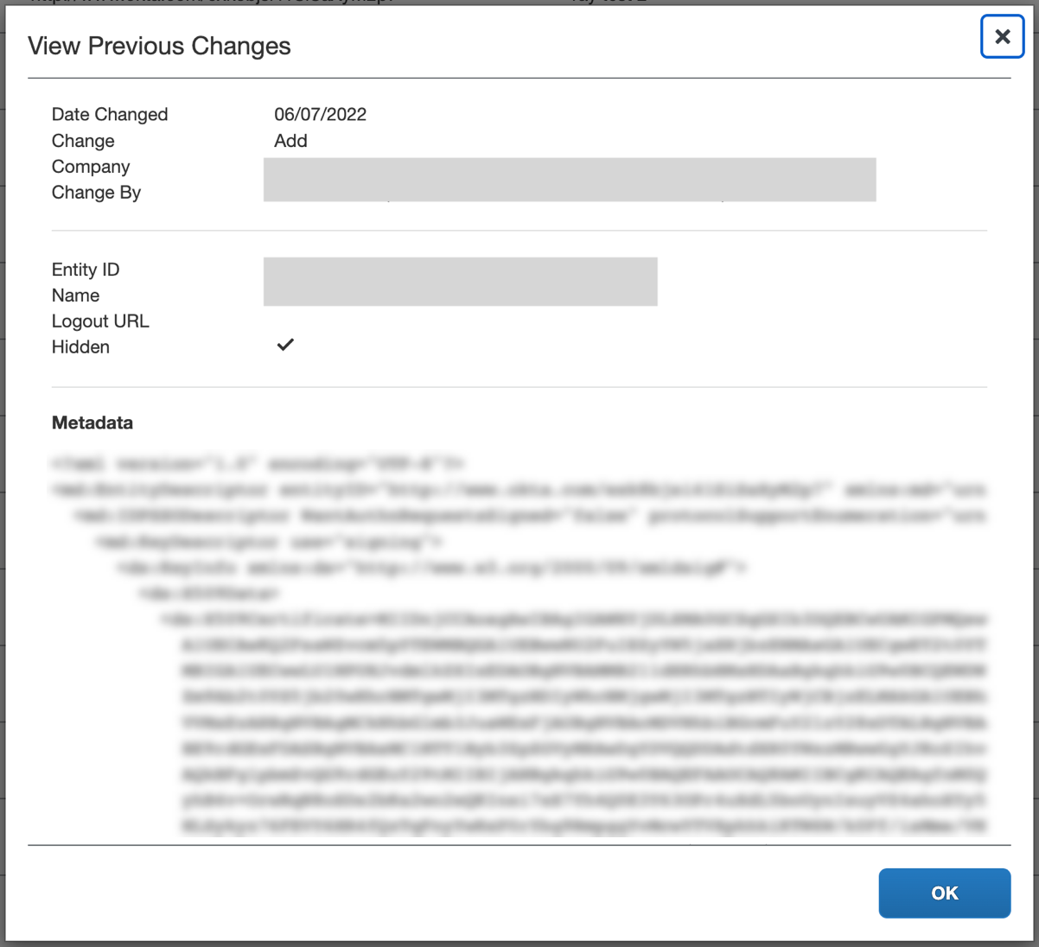
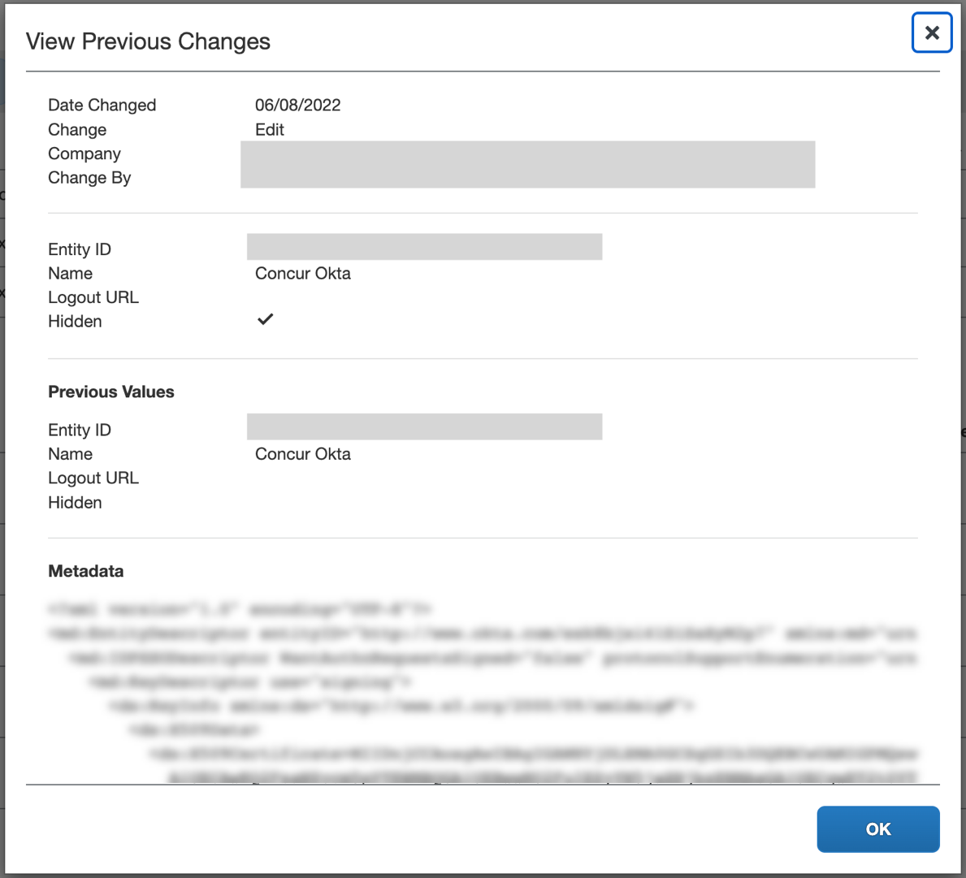
For configurations that are deleted, the View Previous Changes page includes a Revert button that enables you to reinstate the deleted configuration. After the configuration is reinstated, it will be available to users during the sign-in process.
- For more info, please refer to the following documentation resources:
- SAP Concur - SSO Overview Guide
- SAP Help Portal - SAP Cloud Identity Services - Identity Authentication
- SAP KBA - 2701851 - SAP Cloud Platform Identity Authentication Service (IAS) - Guided Answers

Appendix - SAP NetWeaver Setup

Overview
Before you start the configuration process, ensure that:
- You have admin access to the identity provider (SAP NetWeaver). This will be needed so you can complete the application configuration on the SAP NetWeaver side.
- Your users exist in both SAP NetWeaver and SAP Concur. Auto user provisioning is not currently supported by SAP Concur, so you need to add users separately in there.
- The attribute you are sending from SAP NetWeaver matches the Login ID (Username / CTE Login Name) field for each employee in SAP Concur.
- You have the Company Administrator (Travel permission) assigned to your SAP Concur account. Once you have the permission, you can access the Manage SSO page by using one of the following paths, depending on your SAP Concur edition.
For SAP Concur Standard edition:
- Go to Administration > Expense Settings.
- Under Access to Concur section, click Show 1 Advanced Setting.
- Click Manage Single Sign-On to access the Manage SSO page.
For the SAP Concur Professional edition:
- Go to Administration > Company > Authentication Admin.
- Click Manage Single Sign-On to access the Manage SSO page.
Alternatively, users can access the page using one of the following URLs:
- US DC Prod: https://www.concursolutions.com/nui/authadmin/ssoadmin
- US DC Test: https://implementation.concursolutions.com/nui/authadmin/ssoadmin
- EMEA DC Prod: https://eu1.concursolutions.com/nui/authadmin/ssoadmin
- EMEA DC Test: https://eu1imp.concursolutions.com/nui/authadmin/ssoadmin
- CN DC Prod: https://www.concurcdc.cn/nui/authadmin/ssoadmin
If you don’t have that permission and cannot have this assigned to your profile, please ask an authorized support contact at your company to open a case with SAP Concur support.

Configure Your SAP Netweaver Application

Step 1: Get the SAP Concur metadata
To configure:
- Get the SAP Concur metadata. To complete this, follow the instructions in the Overview section to log in to your SAP Concur account and access the Manage SSO section. To obtain the SAP Concur metadata on the Manage SSO page, you can either click Copy URL and then paste it in a new browser tab or click Download and open the downloaded file.

Step 2: Create an application on SAP Netweaver
- Create an application in SAP Netweaver. After logging in to SAP NetWeaver, you will need to access the Configuration tab.
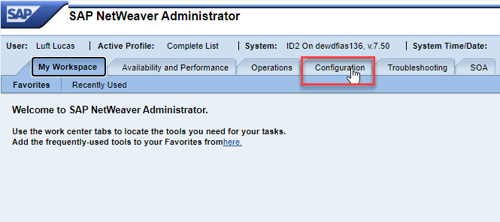
- On the Configuration tab, click Authentication and Single Sign-On.
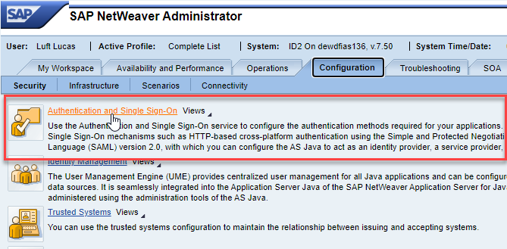
- This will be a SAML (Security Assertion Markup Language) configuration. Click the SAML 2.0 tab.
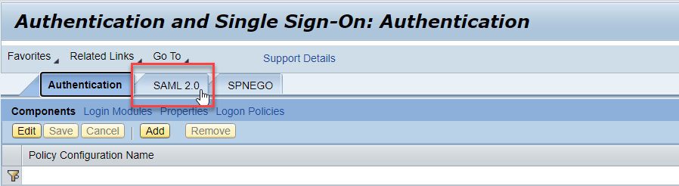
- To start creating the SAP Concur application, click Trusted Providers.
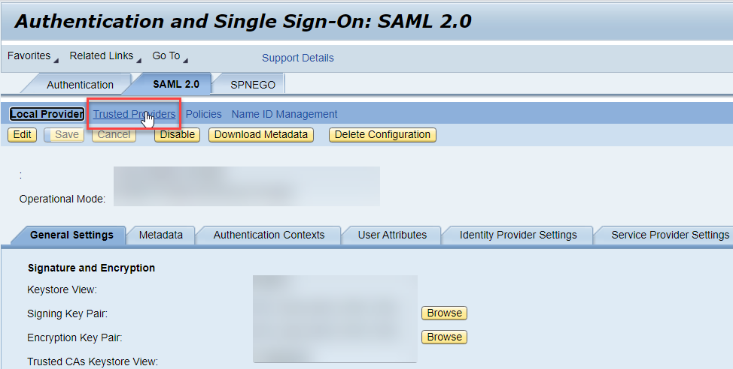
- The Trusted Providers section should show all existing service providers connected to your SAP NetWeaver tenant. To add a new application, click Add. Since you have already downloaded the SAP Concur metadata file in the first step, choose the Uploading Metadata File option.
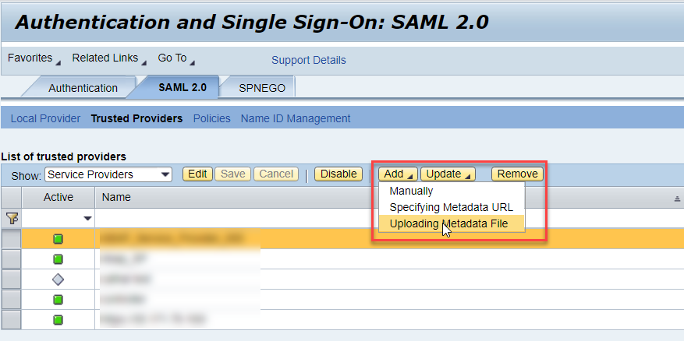
- Click Browse to look for the metadata file on your computer and then click Next.
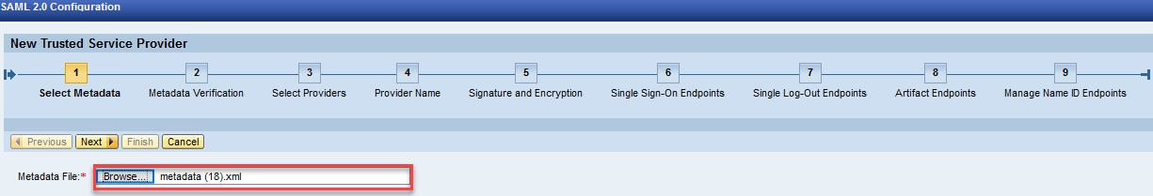
- After that you should see steps 2 (Metadata Verification) and 3 (Select Providers) greyed out and skipped automatically. You can also click Next to skip step 4 (Provider Name) since it will be automatically filled with the proper identifier (also called Entity ID) from the metadata.
For step 5 (Signature and Encryption) you can also click Next without making any changes. However, if you want to encrypt the assertion and/or the NameID request and response, you will need to adjust the Encrypt Elements field so this is enabled. Then, click Next again.
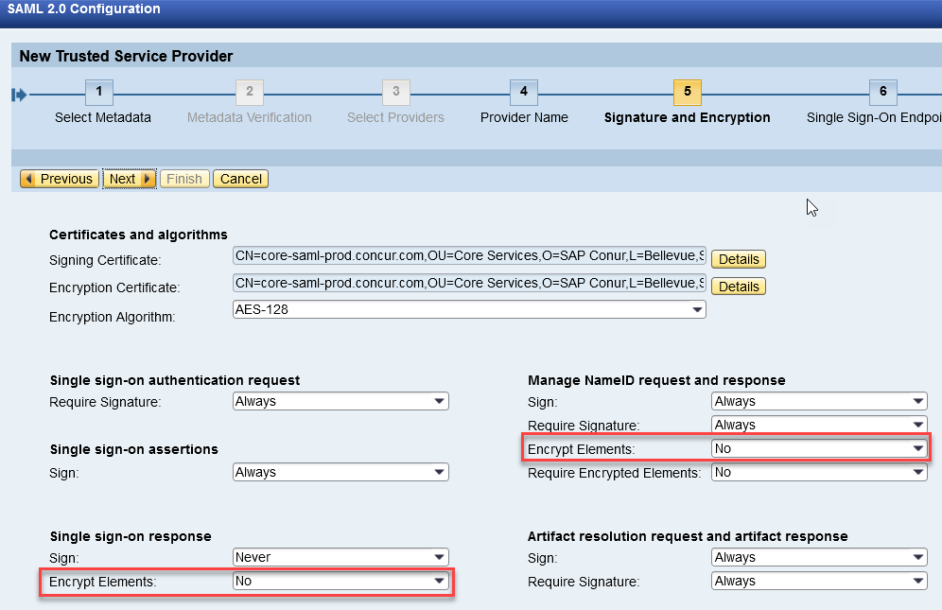
Step 6 (Single Sign-On Endpoints) will be filled automatically with the proper ACS URL taken from the metadata xml, so you can skip it. You can do the same for steps 7 (Single Log-Out Endpoints), 8 (Artifact Endpoints) and 9 (Manage Name ID Endpoints) until you are able to click Finish.
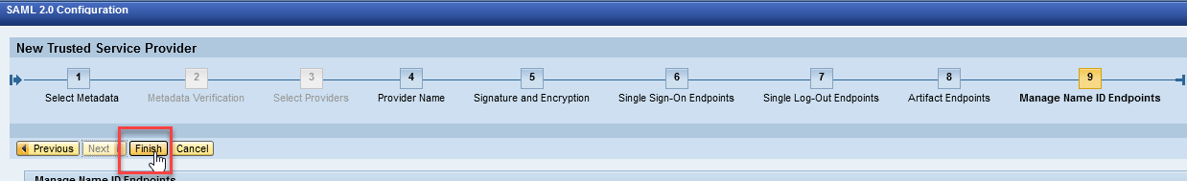

Step 3: Name ID configuration
After finishing the application configuration, you need to configure the Name ID. The Name ID must match the Login ID (CTE Login Name) registered for your employees in SAP Concur. We also strongly recommend that you set the Name ID format to Email address. This is required by SAP Concur for the SP-Initiated logins, starting from concursolutions.com or from the mobile app.
- To set the Name ID format, search for your new application, click it and then click Edit.
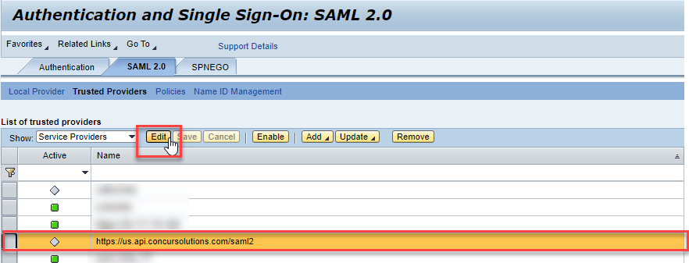
- On the Name ID Format popup, make sure you select E-mail. Fill in Source Name with the attribute matching your employees’ Login ID in SAP Concur.
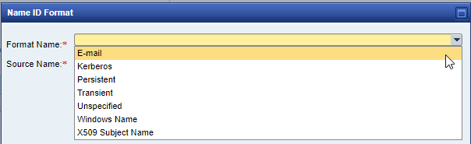
- In some cases, the available Source Name may not match the usernames in SAP Concur. If this is the case, you can run employee imports in SAP Concur to make sure they match the attribute you send. Alternatively, you can reach out to product support for SAP NetWeaver for further help with Name ID configurations.

Step 4: Enabling the application
With the Name ID configured you should be able to go back to the SAML 2.0 tab, select the new application and click Enable. This should change the Active column icon to a green square, confirming the application is active.
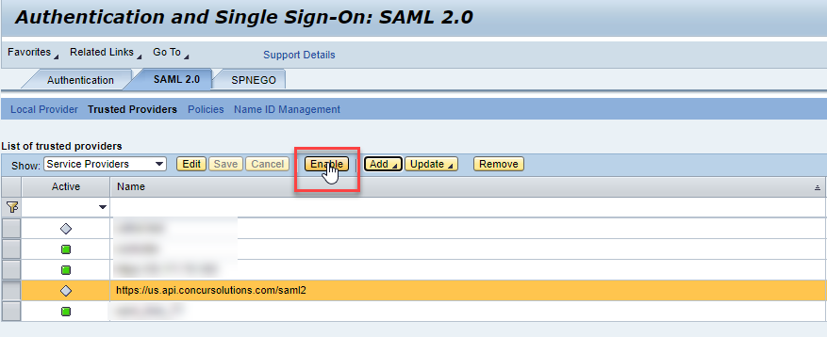

Step 5: Download the Metadata File
To finish the configuration on the SAP Concur side, upload the Metadata file extracted from your application in SAP Netweaver. On the SAML 2.0 tab, go to Local Provider and click Download Metadata to download the metadata xml.
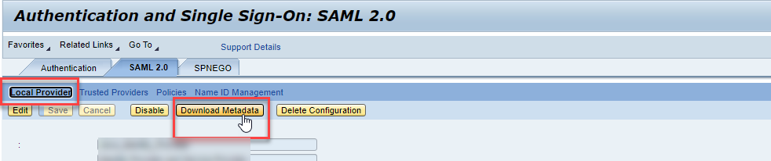

Configure Your SAP Concur Site
- Go to the Manage SSO page by following the steps provided in the Overview section.
- Click Add from the IdP Metadata section. The Add IdP Metadata window appears.
- Enter an appropriate name in the IdP connection and enter it in the Custom IdP Name field.
If you decide to use the SP-initiated flow (through SAP Concur’s public site: https://www.concursolutions.com/nui/signin), the Custom IdP Name will display on the Sign In page right after a user provides their Username and clicks Next. For example, if your Custom IdP Name is "SAP NW", then all users will see the option "Sign in with SAP NW".
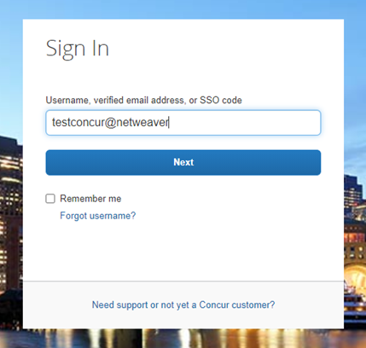

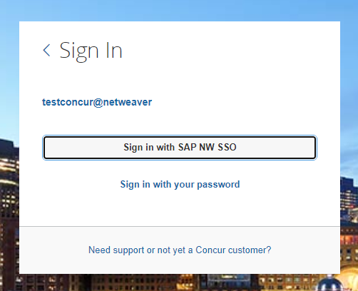
- Provide a Logout URL (optional) for users to get redirected to a different place when they log out. By default, if no URL is entered, users will be redirected to where they started the authentication process. The logout endpoint for SAP NetWeaver can be found on Local Provider > Identity Provider Settings > Single Log-Out Service (SLO) > Endpoint URL. Please note that Single Logout (SLO) is not officially supported by SAP Concur, so the logout process with the SLO endpoint may not work as expected regarding disconnecting the user from the IDP in addition to SAP Concur. In that case, the user may be logged out from SAP Concur but not from SAP NetWeaver entirely.
- In the Upload your IdP's metadata section, click Upload XML File and upload the metadata file from the IdP, which was previously saved locally.
- To hide the sign-in option from users on mobile and signing in through concursolutions.com, select the checkbox Hide this SSO option from users signing in to Concur on web or mobile.
By default, the option is available to users when they begin an SP-initiated sign-in through concursolutions.com or the mobile app. The option can be hidden in those cases that require users to sign-in through an IdP-initiated flow.
- Click Add Metadata.
- You should see either a successfully added confirmation or a something went wrong message. For the latter, please contact SAP Concur support and provide the Correlation ID.

Test SSO Login
You can start testing SSO after you’ve successfully uploaded the IdP metadata to SAP Concur from the previous steps. In this section, you can test the IdP-Initiated (initiated on the identity provider side) and SP-Initiated (initiated on the service provider side) flows.

Test IdP-initiated SSO
To test IdP-initiated SSO:
- In the IdP-Initiated flow, start the login process on the identity provider side. To test that, append the parameters from the application you just created to the SSO endpoint from SAP NetWeaver. A format example of IdP-Initiated URL would be:
Format: [SSO Endpoint URL*]?saml2sp=[SP Identifier**]
Example: https://idp.example.com:50001/saml2/idp/sso?saml2sp=https://us.api.concursolutions.com/saml2
**SP Identifier: You can obtain this value from the SAP Concur metadata. It will be the same as Entity ID or Audience.
*SSO Endpoint URL: You can obtain this value by following this path: SAML 2.0 > Local Provider > Identity Provider Settings > Single Sign-On Service (SSO) > Endpoint URL.
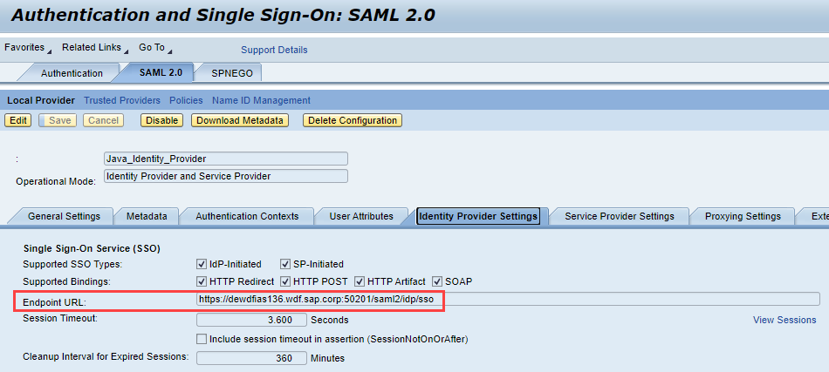
This URL should redirect to a login page on the SAP NetWeaver side. Once you login with your credentials, you should be redirected to the SAP Concur homepage.

Test SP-initiated SSO
To test the SP-initiated SSO:
- Open the SAP Concur login page according to the environment you want to test.
- US DC Prod: https://www.concursolutions.com/
- US DC Test: https://implementation.concursolutions.com/
- EMEA DC Prod: https://eu1.concursolutions.com/
- EMEA DC Test: https://eu1imp.concursolutions.com/
- CN DC Prod: https://www.concurcdc.cn/
- On the login page, you can add your username, verified e-mail address or SSO code to proceed. Once you click Next, you should see an option for your recently created SSO configuration according to the note in Configure Your SAP Concur Site. Click to proceed with authenticating your identity provider account which should redirect you to SAP Concur.

Mobile Single Sign-On (SSO)
For SSO configurations created on our SAMLv2 platform, the Mobile SSO should be enabled automatically as soon as the metadata is saved. However, for this option to work, the SP-Initiated flow needs to be functioning. This can be validated using the previous Test SSO login section.
The automatic enabling of Mobile SSO is only visible on the app version 9.86 or higher and if the user is opting for the new sign in experience. Users on older versions or opting for the earlier sign in experience will not see this option automatically. However, if you were using another IdP and already using Mobile SSO, you may see two options when trying to sign-in as follows: 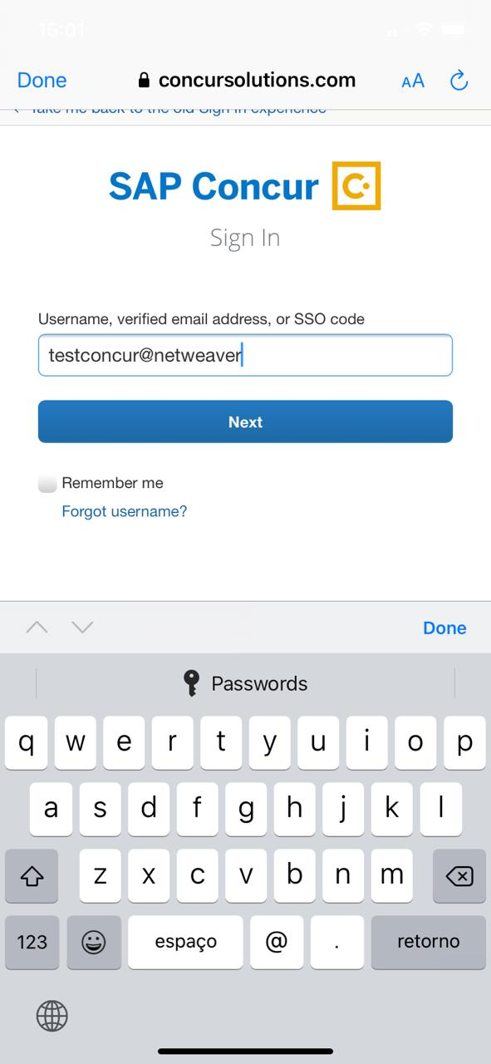 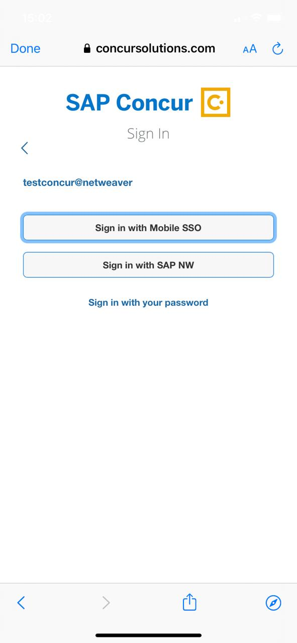
The Sign in with Mobile SSO option will have your earlier IdP link embedded, so it will redirect users to your old SSO connection.
For both cases, please open a ticket with the SAP Concur support team, providing them the following information.
- If the users plan to use an older version, please provide SAP Concur support with the IdP-Initiated URL from the application created on the SAP NetWeaver side so they can enable Mobile SSO for the legacy app versions. For more information on how to obtain the URL see Test SSO login > Testing IdP-Initiated SSO section on this guide.
- If you want to remove the Sign in with Mobile SSO option to eliminate potential confusion, please inform the support team.
If you have any issues in authenticating with SSO on the mobile app, please open a ticket with the SAP Concur support team and provide any error IDs and/or messages received with screenshots.

E-mail Notifications
The configuration of e-mail reminders to reflect your SSO URL are changes that need to be completed by SAP Concur support. To proceed, please open a ticket with the SAP Concur support team, providing the IDP URL from the application created on the IDP side so they can adjust the redirect URL for e-mail reminders. For more information on how to obtain the URL, see the Test SSO login > Testing IdP-Initiated SSO section of this appendix.
The URL will appear embedded on the View Report button.
This change will only be reflected in emails generated after the change. All emails prior to that will keep using the previous URL.
This change will take effect up to 4 hours after the update.
If you hover the cursor over the View Report button, you will see the currently embedded URL. The URL should appear between ctedeepurl= and &hpo= terms.

Rollout
After testing your new SSO configuration, you can then plan your rollout by assigning your new SAP NetWeaver application to all your users and groups who’ll need this access.
The Manage SSO page also offers the option for you to enforce this new SSO connection by changing the SSO Setting from SSO Optional to SSO Required. If you change it, users will be redirected to SAP Concur by providing their Username via the SP-initiated flow.

View Previous Changes
This featured was developed to help admins keep track of all changes completed under the Manage SSO page.
To view changes to the SSO configuration that have been made over time, click View Previous Changes.
A table listing previous changes appears and it is sorted in descending order by date and time.
The table can display the last 100 changes. Changes that are listed in the table include:
- Add a configuration
- Delete a configuration
- Edit Custom IdP Name, Logout URL, or Hidden fields
To view more detailed information about a specific change listed in the table, click the View link for the desired list item.
Inside each log, you'll see the Company and ChangeBy fields in the format [first_name last_name] [(UUID code)]; this refers to the user who performed the action. In case you don't recognize that user, you can contact support to request further details about it.
Log examples:
For deleted configurations, the View Previous Changes page includes a Revert button that enables you to reinstate the deleted configuration. After the configuration is reinstated, it will be available to users during the sign-in process.
- For more info, please refer to the following documentation resources:
- SAP Concur - SSO Overview Guide
- SAP Help Portal - SAP Single Sign-On
- SAP Help Portal - Configuring AS Java as a Service Provider
- SAP Help Portal - Identity Provider Implementation Guide (HTML)

Appendix – Google Workspace Setup

Overview
Before you start the configuration process, make sure that:
- You have admin access to the identity provider (Google Workspace). This will be needed so you can complete the application configuration on the Google Workspace side.
- Your users exist in both Google Workspace and SAP Concur. Auto user provisioning is not currently supported by Concur, so you need to add users separately in there.
- The attribute you are sending from Google Workspace matches the Login ID (Username / CTE Login Name) field for each employee in SAP Concur.
- You have the Company Administrator (Travel permission) assigned to your SAP Concur account. Once you have the permission, you can access the Manage SSO page by following one of the below paths, depending on your SAP Concur edition.

SAP Concur Professional edition:
- Go to Administration > Company > Authentication Admin.
- Hit Manage Single Sign-On to access the Manage SSO page.
Alternatively, users can access the page using one of the following URLs:
- US DC Prod: https://www.concursolutions.com/nui/authadmin/ssoadmin
- US DC Test: https://implementation.concursolutions.com/nui/authadmin/ssoadmin
- EMEA DC Prod: https://eu1.concursolutions.com/nui/authadmin/ssoadmin
- EMEA DC Test: https://eu1imp.concursolutions.com/nui/authadmin/ssoadmin
- CN DC Prod: https://www.concurcdc.cn/nui/authadmin/ssoadmin
If you don’t have that permission and cannot have this assigned to your profile, please ask an Authorized Support Contact at your company to open a case with SAP Concur Support.

SAP Concur Standard edition:
- Go to Administration > Expense Settings.
- Under Access to Concur click Show 1 Advanced Setting.
- Click Manage Single Sign-On to access the Manage SSO page.

Configure Your Google Workspace (IDP) APP

Step 1: Get the SAP Concur metadata
To complete this you will need to follow the instructions on the Preparation section earlier in this guide login to your SAP Concur account and access the Manage SSO section. To obtain the SAP Concur Metadata on the Manage SSO page, you can either click on "Copy URL" and then paste the URL in a new browser tab or click Download and open the downloaded file.

Step 2: Set up your own custom SAP Concur SAML app
- Sign into your Google Admin console.
(Sign in using an account with super administrator privileges (does not end in @gmail.com or similar)).
- From the Admin console Home page, go to Apps Web and mobile apps.
- Click Add App to add custom SAML app.
- On the App Details page:
- Custom app name
Enter the name of the custom app, for example, 'SAP Concur'
- (Optional) Upload an app icon
The app icon appears on the Web and mobile apps list, on the app settings page, and in the app launcher. If you don't upload an icon, an icon is created using the first two letters of the app name
- Click Continue.
- On the Google Identity Provider details page, get the setup information needed by the service provider using the Download the IDP metadata option.
- (Optional) In a separate browser tab or window, sign into your service provider and copy the information you entered in Step 4 into the appropriate SSO configuration page, then return to the Admin console.
- Click Continue.
- In the Service Provider Details window, enter the following ACS URL and Entity ID for your app.
ACS URL
- US (North America): https://www-us.api.concursolutions.com/sso/saml2/V1/ acs/
- EMEA: https://www-emea.api.concursolutions.com/sso/saml2/ V1/acs/
- China: https://www-cn.api.concurcdc.cn/ sso/saml2/V1/acs/
Entity ID
- US (North America): https://us.api.concursolutions.com/saml2
- EMEA: https://emea.api.concursolutions.com/saml2
- China: https://cn.api.concurcdc.cn/saml2
- The default Name ID is the primary email - multi-value input is not supported.
- Click Finish.

Step 3: Turn on your SAML app
- Sign into your Google Admin console.
(Sign in using an account with super administrator privileges (does not end in @gmail.com or similar)).
- From the Admin console Home page, go to AppsWeb and mobile apps. +.
- Select your SAML app.
- Click User access.
- To toggle availability of a service for your organization, click On for everyone or Off for everyone, and then click Save.
- (Optional) To turn a service on or off for an organizational unit:
- At the left, select the organizational unit.
- To change the Service status, select On or Off.
- Choose one:
- If the Service status is set to Inherited and you want to keep the updated setting, even if the parent setting changes click Override.
- If the Service status is set to Overridden, either click Inherit to revert to the same setting as its parent, or click Save to keep the new setting, even if the parent setting changes.
- To turn on a service for a set of users across or within organizational units, select an access group. For details, go to Provide access to user groups in this document.
- Ensure that the email addresses your users use to sign in to the SAML app match the email addresses they use to sign into your Google domain. Changes typically take effect in minutes but can take up to 24 hours.
Google Workspace doesn't support encryption of assertion currently. Please reach out to the IDP support if you need more information around this.

Step 4: Configure Your SAP Concur Site
- Go to the Manage SSO page again by following the steps provided on the Preparation section.
Click on Add under IdP Metadata section. The Add IdP Metadata window appears.
- Give your IdP connection a friendly name and enter it in the Custom IdP Name field.
- Provide a Logout URL (optional), so the users get redirected to a different place when signing out.
By default, if no URL is entered, users will be redirected to where they started the authentication process. The logout endpoint for Google Workspace can be found on Applications & Resources > Tenant Settings > Identity Provider Settings > Single Logout Endpoint.
Single Logout (SLO) is not officially supported by SAP Concur, so the logout process with the SLO endpoint may not work as expected regarding disconnecting the user from the IDP in addition to Concur. In that case, the user may be logged out from SAP Concur but not from Google Workspace entirely.
- In the Upload your IdP's metadata section, click Upload XML File and upload the metadata file from the IdP, which was previously saved locally.
- To hide the sign-in option from users on mobile and signing in through concursolutions.com, select the checkbox Hide this SSO option from users signing in to Concur on web or mobile.
By default, the option is available to users when they begin an SP-initiated sign-in through concursolutions.com or the mobile app. The option can be hidden in those cases that require users to sign-in through an IdP-initiated flow.
- Click Add Metadata.
- You should see one of following prompts on your screen saying it was successfully added or saying something went wrong while adding it.
For help with the latter, please contact SAP Concur Support and provide the correlation ID.
For step 3 above, if you decide to use the SP-initiated flow (through SAP Concur’s public site: https://www.concursolutions.com/nui/signin), the Custom IdP Name will be displayed on the Sign In page right after a user provides their Username and hits Next (see below image). For example, if your "Custom IdP Name" is "google SSO", then all users will see the option "Sign in with google SSO " as shown in the following:

Test SSO Login
You can start testing SSO after you’ve successfully uploaded the IdP metadata to SAP Concur from the previous step. We’ll test the IdP-Initiated (initiated on the identity provider side) and SP-Initiated (initiated on the service provider side) flows.

1. Testing IdP-Initiated SSO
In the IdP-Initiated flow we start the login process on the identity provider. To test it, we can append parameters from the application we built to the SSO endpoint from Google Workspace.
An example of IdP-Initiated URL is:
Format: https://accounts.google.com/o/saml2/
initsso?idpid=CLIENT_IDP_ID&spid=SERVICE_PROVIDER_ID&forceauthn=false
Example: https://accounts.google.com/o/saml2/ initsso?idpid=C03fj4v82&spid=710982774547&forceauthn=false
You must fill CLIENT_IDP_ID and SERVICE_PROVIDER_ID with values from Google Workspace and it's something you can get by copying the URL from the Test SAML login button on the application

2. Testing SP-Initiated SSO
In order to test the SP-initiated flow, you will need to open the SAP Concur login page.
- US DC Prod: https://www.concursolutions.com/
- US DC Test: https://implementation.concursolutions.com/
- EMEA DC Prod: https://eu1.concursolutions.com/
- EMEA DC Test: https://eu1imp.concursolutions.com/
- CN DC Prod: https://www.concurcdc.cn/
On the login page, you can add your username, verified e-mail address or SSO code to proceed. Once you click on Next, you should see an option for your recently created SSO configuration. You can click on that and proceed with authenticating to your Google account which should redirect you back to SAP Concur after that.

Mobile Single Sign-On (SSO)
For SSO configurations created on our SAMLv2 platform, the Mobile SSO should be enabled automatically as soon as the metadata is saved. However, for this option to work, the SP-Initiated flow needs to be functioning. This can be validated on the ‘Test SSO login’ section on this guide.
If you have issues to authenticate with SSO on the mobile app, please open a ticket to the SAP Concur support team providing any error IDs and/or messages received.
It’s important to note that if you were using another IdP and you were already using Mobile SSO, you’ll probably see 2 options when trying to sign-in as follows:
The Sign in with Mobile SSO option will have your old IdP link embedded, so it will redirect users to your old SSO connection.
For both cases, please open a ticket to the SAP Concur support team providing them the following information.
- If the users plan to use an older (legacy) version, provide the IdP-Initiated URL from the application built on the Google Workspace side so Support can enable Mobile SSO for the legacy app versions. More information about how to get the URL can be found on the ‘Test SSO login > Testing IdP-Initiated SSO’ section on this guide.
- If you want to remove the ‘Sign in with Mobile SSO’ option so it doesn’t confuse your users, please inform that to the support team.
If you have any issues to authenticate with SSO on the mobile app, please open a ticket to the SAP Concur Support team providing any error IDs and/or messages received with screenshots.

E-Mail Notifications
The configuration of e-mail reminders to reflect your SSO URL are changes that need to be completed by SAP Concur support. To proceed, please open a ticket to the SAP Concur support team providing the IDP URL from the application built on the IDP side so they can adjust the redirect URL for E-Mail reminders. More information about how to get the URL can be found on the Test SSO login > Testing IdP-Initiated SSO section on this guide.
- The URL will appear embedded on the View Report button
- This change will only be reflected in emails generated after the change - all emails prior to that will keep using the previous URL.
- This change will take effect up to 4 hours after the update.
If you hover the cursor over the View Report button you will see what’s the URL currently embedded. The URL should appear between “ctedeepurl=” and “&hpo=” terms.

Rollout
After testing your new SSO configuration, you can then plan your rollout by assigning your Google Workspace application to all your users and groups who’ll need this access.
The Manage SSO page also offers the option for you to enforce this new SSO connection by changing SSO Setting from SSO Optional to SSO Required. If you change it, users will be redirected to Concur by just providing their Username via SP-initiated flow.

View Previous Changes
This featured was developed to help admins to keep track of all changes completed under the Manage SSO page. To view changes to the SSO configuration that have been made over time, click on the View Previous Changes button.
A table listing previous changes appears and is sorted in descending order by date and time. The table can display the last 100 changes. Changes that are listed in the table include:
- Add a configuration
- Delete a configuration
- Edit Custom IdP Name, Logout URL, or Hidden fields
To view more detailed information about a specific change listed in the table, click the View link for the desired list item.
Inside each log, you'll see the field Company and Change by in the format [first name last name] [(UUID code)], which will mean who has performed such action. In case you don't recognize that user, you can always reach out to support requesting further details about it.
For deleted configurations, View Previous Changes includes a Revert button so you can reinstate the deleted configuration. After the configuration is reinstated, it will be available to users during the sign-in process.
- For more info, please refer to the following documentation resources:
- SAP Concur - SSO Overview Guide
- SAP Help Portal - SAP Single Sign-On

☼

