
Concur Request:
Workflow – Cost Object Approval
Setup Guide
Last Revised: October 1, 2022
Applies to these SAP Concur solutions:
 Expense
 Professional/Premium edition
 Standard edition
 Travel
 Professional/Premium edition
 Standard edition
 Invoice
 Professional/Premium edition
 Standard edition
 Request
 Professional/Premium edition
 Standard edition

Table of Contents
Section 1: Permissions 1
Section 2: Workflow Guides 1
Section 3: Overview 1
Benefits of Using Cost Object Approval 2
Level-Based Approvals and Limit-Based Approvals 2
Example of Level-Based Approval 3
Example of Limit-Based Approval 3
Section 4: How Level-Based Cost Object Approvals Work 4
Approver Action – Approved 4
Approver Action – Return to the Employee 5
Approver Action – Changes that DO NOT Affect the Cost Object, the Cost Object Amount, or the Request Total 5
Approver Action – Changes that Affect the Cost Object, the Cost Object Amount, or the Request Total 5
Example 6
Section 5: How Limit-Based Cost Object Approvals Work 7
Approver Action – Approved (NOT Using Cost Object Direct Approval) 7
Approver Action – Approved (Using Cost Object Direct Approval) 8
Approver Action – Return to the Employee 8
Approver Action – Changes that DO NOT Affect the Cost Object, the Cost Object Amount, or the Request Total 8
Approver Action – Changes that Affect the Cost Object, the Cost Object Amount, or the Request Total (NOT Using Cost Object Direct Approval) 9
Section 6: Important Allocation Considerations 9
Section 7: Employee Experience 10
Section 8: Approver Experience 13
Information Displayed 13
Section 9: Additional Scenarios and Conditions 14
Delegates 14
Automatic Approval and COW Exception if Approver is Request Originator 14
Request Recall 14
Additional Approver and Workflow Situations 14
Additional Error Handling 17
Section 10: Configuration 18
Step 1: Define the Cost Object Approver Hierarchy 19
Step 2: Activate the Feature 20
Step 3: Edit the Workflow Steps 21
Step 4: Assign the Proper Rights to Users 22
Employee Import 22
User Administration 22
Authorized Approvers Tab in Workflows 23
Step 5: Control the Information that Appears to the Cost Object Approver 25

Revision History
Date | Notes / Comments / Changes
October 1, 2022 | Updated screenshots and edited content for the new user experience.
January 21, 2022 | Updated the copyright year; no other changes; cover date not updated
March 29, 2021 | Updated the copyright year; no other changes; cover date not updated
July 20, 2020 | Removed the Request/Authorization Request/Concur Request section to align with Concur Request product branding.
June 5, 2020 | Changed "Authorization Request" to "Concur Request" in Request guide references to align with Concur Request product branding.
June 3, 2020 | Changed "Authorization Request" to "Concur Request" in guide title to align with Concur Request product branding.
April 22, 2020 | Renamed the Authorization Request check box to Request on the guide’s title page; cover date not updated
January 10, 2020 | Updated the copyright; no other changes; cover date not updated
January 17, 2019 | Changed copyright and added note to the SELFAPPR exception code description in the Additional Error Handling section.
April 12, 2018 | Changed the check boxes on the front cover; no other changes; cover date not updated
February 8 2018 | Updated guide name in reference to the Shared: Employee Import Specification guide.
February 15 2017 | Updated guide to clarify that:  - An approver acting as a delegate will see the report they submit auto-approved and a COW exception generated  - Best practice is to set single approver for each Cost Object level
December 14 2016 | Changed copyright and cover; no other content changes.
October 20 2016 | Updated the Permissions section and guide content to new corporate style; no content changes.
January 25 2016 | Changed references to the import/extract guide; no other changes
August 14 2015 | Updated the screen shots to the enhanced UI; no other content changes
September 19 2014 | Added information about two user interfaces; no other content changes.
February 7 2014 | Blocking exceptions that will not prevent approval of a report under COA when the Can exit step with blocking exceptions options is selected (enabled) are now listed under Additional Error Handling.
January 20 2014 | Cover and copyright changes; no other content changes
July 5 2013 | Added a note about time-out actions: Regardless of the time-out action selected, the only action that will occur within the cost object step is that the cost object moves to the next approver within the cost object approval step.
February 27 2013 | Added the following:  - Name change from "Travel Request" to "Request"  - Information about the Filter expenses to those that are applicable to Cost Object option in Workflow settings  - Main Destination Country in the hierarchy
December 28 2012 | Made rebranding and/or copyright changes; no content changes
December 13 2012 | Initial publication

Workflow – Cost Object Approval
NOTE: Multiple SAP Concur product versions and UI themes are available, so this content might contain images or procedures that do not precisely match your implementation. For example, when SAP Fiori UI themes are implemented, home page navigation is consolidated under the SAP Concur Home menu.

Permissions
A company administrator may or may not have the correct permissions to use this feature. The administrator may have limited permissions, for example, they can affect only certain groups and/or use only certain options (view but not create or edit).
If a company administrator needs to use this feature and does not have the proper permissions, they should contact the company's SAP Concur administrator.
Also, the administrator should be aware that some of the tasks described in this guide can be completed only by SAP Concur staff. In this case, the client must initiate a service request with SAP Concur support.

Workflow Guides
Refer to these guides when configuring and maintaining Concur Request workflows.
Setup Guide | Description
Concur Request: Workflow - General Information | Read this guide for general information about request workflows.
Concur Request: Workflow - Authorized Approvals | Read this guide if the company uses authorized approvers but only after reading the Concur Request: Workflow - General Information Setup Guide.
Concur Request: Workflow - Cost Object Approvals | Read this guide if the company uses cost object approvals but only after reading the Concur Request: Workflow - General Information Setup Guide.

Overview
The Cost Object Approval feature allows clients to define a special, more granular workflow step for its accounting-related data.
Assume that a client tracks costs by cost centers. Further assume that the client's configuration includes the use of request allocation fields, and those allocation fields are populated by the client's cost centers. Using the Cost Object Approval feature, the cost objects – the portion of the request allocated to each cost center – are routed for review and approval to each cost center simultaneously.
For example, if a request is allocated 50% to Sales and 50% to Training and if the client is using the Cost Object Approval feature, the submitted request is sent to approvers for the Training department and the approvers for the Sales department at the same time.

Benefits of Using Cost Object Approval
The benefits of using cost object approval include:
- Budget ownership: The approval process specifically aligns with the affected budget. In the example described above, Sales and Training have the opportunity to review the entire request and then either approve or reject the portion of the request allocated to its budget.
- Parallel processing: Each affected cost center (again, in this case, Sales and Training) is reviewing the request at the same time. This can save a tremendous amount of time, resulting in faster processing for the employee.
Certain changes made by any of the approvers (described in detail later in this guide) cause the request workflow process to stop immediately and then the request must go through the approval process again. This way, all approvers can review any changes – ensuring control, compliance, and visibility.

Level-Based Approvals and Limit-Based Approvals
A cost object approval step can be based on either:
- Level: This type of approval is defined by each approver's sequential position in the approval process. The cost object starts with the first approver and then moves from one level to the next to the next – all the way to the end of the process. For example, it moves from a junior manager to a senior manager to the company’s Chief Financial Officer.
- Limit: This type of approval is based on the amount that an approver is authorized to approve (commonly known as signing authority). The cost object starts with the first approver, moving from one level to the next. It stops when it reaches an approver who has an approval limit equal to or greater than the cost object amount.
There is a second limit-related option: Cost Object Direct Approval. Using this option, the cost object might not start at the first approver and might not go to the end – instead, it goes directly to the approver with the correct approval limit. In other words, the cost object's first and only stop is with the approver who has the correct limit.

Example of Level-Based Approval
Simple level-based cost object approval step:
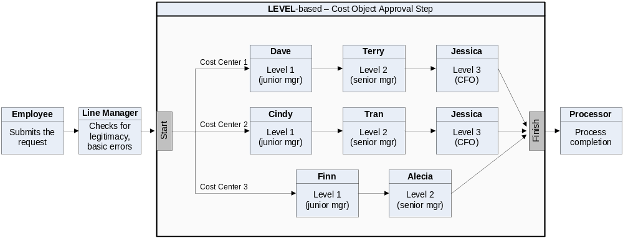
This example shows a simple workflow – from employee to the line manager to the cost object approval step to the processor.
Note the following:
- A client can have only one cost object approval step in a workflow.
- The number and placement of steps before and after the cost object approval step are client configurable.
- The levels within the cost object approval step, which can even differ by cost center (in this example, Cost Center 1 and 2 have three levels of approvals; Cost Center 3 has two), is client configurable.
- The processor step is optional.

Example of Limit-Based Approval
Simple limit-based cost object approval step:
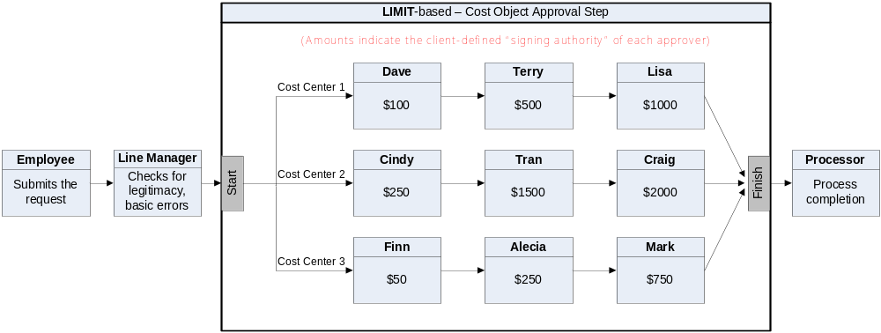
In this example, all the cost centers have three approvers. Just like level-based approvals:
- There can be only one cost object approval step.
- The steps before and after are client configurable.
- The limits and number of approvers within the cost object approval step are client configurable.
- The processor step is optional.

How Level-Based Cost Object Approvals Work
The following set of examples is based on this level-based cost object approval step.
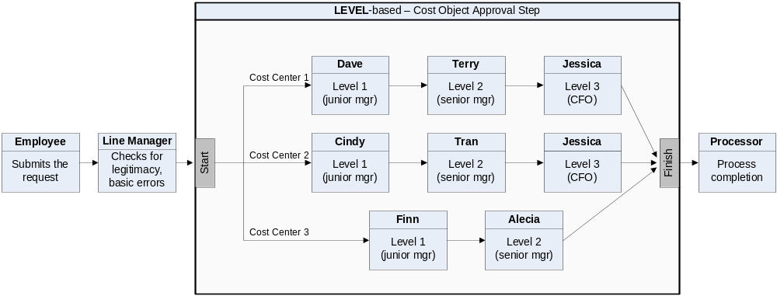

Approver Action – Approved
In this example, assume that the request is allocated between three cost centers.
The last column in the table below shows the flow through the cost object approval step if all approvers approve the cost object without changes:
Cost Center | Total allocated to  this cost center | Flow in the cost object approval step...  if all approvers approve without changes
1 | 1000 | Dave  Terry  Jessica  finish
2 | 500 | Cindy  Tran  Jessica  finish
3 | 500 | Finn  Alecia  finish
Remember, for level-based cost object approvals, the amount does not matter; the cost object starts at the first level and stops at every level until it reaches the end.

Approver Action – Return to the Employee
If any of the approvers return the request to the employee, then:
- All workflow instances are terminated (even though the other cost centers may not actually be affected).
- The approver who initiated the action is required to provide a comment, which is visible to all other approvers.
- The action is logged in the Audit Trail.
- The request is returned to the employee.
- The process starts again – starting with the employee. The employee can make changes, resubmit, cancel, etc. – whichever applies.

Approver Action – Changes that DO NOT Affect the Cost Object, the Cost Object Amount, or the Request Total
If any of the approvers make any other changes to the request but those changes do not affect the cost object, the cost object amount, or the request total – like adding a comment to the header – and then the approver clicks Approve, the request moves to the next step in the process (same as Approver Action – Approved).

Approver Action – Changes that Affect the Cost Object, the Cost Object Amount, or the Request Total
The cost object approval step is restarted if any of the cost object approvers make any changes that affect the cost object, the cost object amount, or the request total.
This sample assumes that the client configuration allows the approver to change amounts and/or allocations. In some configurations, approvers cannot change this type of information.
For example, assume that one of the approvers changes the percentage of the allocation assign to their cost center. Then:
- All workflow instances are terminated, even though the other cost centers may not actually be affected.
- The approver who initiated the action is required to provide a comment, which is visible to all other approvers.
- The action is logged in the Audit Trail.
- The system recalculates the request total, if necessary.
- The request returns to the start of the cost object step.
- The cost object approval step starts again.
If an approver makes a change that causes the cost object approval step to terminate and if that approver is the first in the list of approvers, when the cost object approval step starts again, that approver is bypassed – unless additional changes were made by other approvers.

Example
Assume that we started with these cost centers, approvers, amounts, and a $1000 request:
Cost Center | Amount allocated to  this cost center | Approvers in order by level
1 | 600 | Dave, Terry, Jessica
2 | 200 | Cindy, Tran, Jessica
3 | 200 | Finn, Alecia
Then, Dave (first approver in Cost Center 1) changed the allocation of Cost Center 1. The cost object step approval starts over. The new cost object approval step would look like this:
Cost Center | NEW Amount allocated to  this cost center | NEW flow in the cost object approval step...  if Dave changes the allocation
1 | 400 | Terry  Jessica  finish  (Dave is bypassed this time because he initiated the change, and he is the first approver in the list of approvers. For audit purposes, Dave still appears on the Approval Flow page.)
2 | 200 | Cindy  Tran  Jessica  finish
3 | 200 | Finn  Alecia  finish
This example also assumes:
- No other approver made changes.
- It is not required that the allocations total 100%.

How Limit-Based Cost Object Approvals Work
The following set of examples is based on this limit-based cost object approval step.
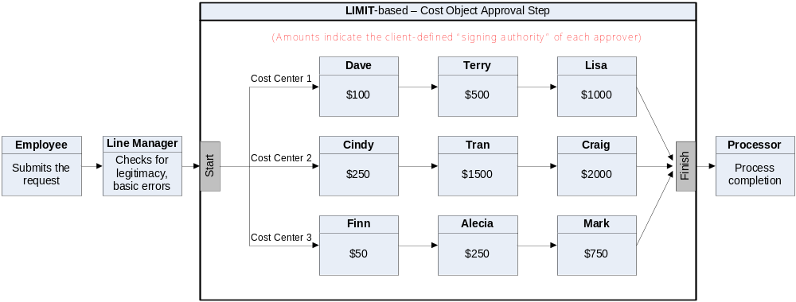

Approver Action – Approved (NOT Using Cost Object Direct Approval)
Using the cost object approval steps shown above, the last column in the following table describes the flow through the cost object approval step if all approvers approve the request without changes:
Cost Center | Amount allocated to  this cost center | Flow in the cost object approval step...  if all approvers approve without changes
1 | 600 | Dave  Terry  Lisa  finish
2 | 200 | Cindy  finish  (Tran and Craig are bypassed; Cindy has the proper limit.)
3 | 200 | Finn  Alecia  finish  (Mark is bypassed; Finn has the proper limit.)
Remember, when not using the Cost Object Direct Approval option, the cost object stops at each approver in the list until it reaches the approver with the correct limit.

Approver Action – Approved (Using Cost Object Direct Approval)
Remember, with Cost Object Direct Approval, the cost object's first and only – stop is with the approver who has the correct limit.
Assume that we started with these cost centers, approvers, amounts, and a $1000 request:
Cost Center | Amount allocated to  this cost center | Approvers and limits
1 | 600 | Dave (100) Terry (500) Lisa (1000)
2 | 200 | Cindy (250) Tran (1500) Craig (2000)
3 | 200 | Finn (50) Alecia (250) Mark (750)
The last column in the table below describes the flow through the cost object approval step if all approvers approve the request without changes and if the Cost Object Direct Approval option is configured:
Cost Center | Amount allocated to  this cost center | Flow in the cost object approval step...  if all approvers approve without changes
1 | 600 | Lisa  finish  (Dave and Terry are bypassed; Lisa has the correct limit)
2 | 200 | Cindy  finish  (Tran and Craig are bypassed; Cindy has the correct limit)
3 | 200 | Alecia  finish  (Finn and Mark are bypassed; Alecia has the correct limit)

Approver Action – Return to the Employee
The result is the same as for the level-based approval. Refer to that section of this guide.

Approver Action – Changes that DO NOT Affect the Cost Object, the Cost Object Amount, or the Request Total
The result is the same as for the level-based approval. Refer to that section of this guide.

Approver Action – Changes that Affect the Cost Object, the Cost Object Amount, or the Request Total (NOT Using Cost Object Direct Approval)
Assume that we started with these cost centers, approvers, amounts, and a $1000 request:
Cost Center | Amount allocated to  this cost center | Approvers and limits
1 | 600 | Dave (100) Terry (500) Lisa (1000)
2 | 200 | Cindy (250) Tran (1500) Craig (2000)
3 | 200 | Finn (50) Alecia (250) Mark (750)
Then, Lisa (final approver in Cost Center 1) changes the allocation but does not affect the other cost centers (assuming the 100% allocation is not required). The cost object step approval starts over. The new cost object approval step would look like this:
Cost Center | NEW Amount allocated to  this cost center | NEW flow in the cost object approval step...  if Lisa changes the allocation
1 | 400 | Dave  Terry  finish  (Lisa is bypassed; Terry has the correct limit)
2 | 200 | Cindy  finish  (Tran and Craig are bypassed; Cindy has the correct limit)
3 | 200 | Finn  Alecia  finish  (Mark is bypassed; Alecia has the correct limit)
Remember, when not using the Cost Object Direct Approval option, the cost object stops at each approver in the list until it reaches the approver with the correct limit.

Important Allocation Considerations
When dealing with allocations, an approver should consider simply returning the request to the user for corrections. For example, the approver may be able to change the percentage, but problems could arise if the configuration requires that the request is 100% allocated. The approver then must change the percentages or one or more other cost centers to reach 100%.

Employee Experience
On the Manage Requests page, users will see the Pending Cost Object Approval status for submitted requests. The name of the specific approver does not appear. The user can gather more information by clicking on the request tile to open it.
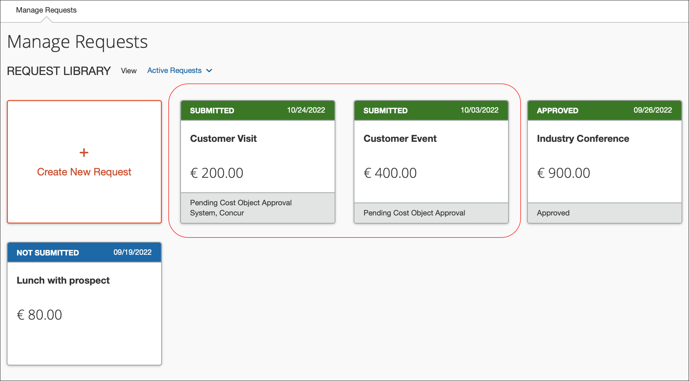
Once the request is open, users can click the Request Details menu and then click Request Timeline to view the approval workflow and comments on the Request Timeline page.
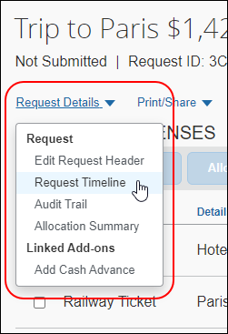
The Request Timeline page displays the approval workflow for the request, a summary of the approval activity for the request, and any comments added to the request.
The following image is the Request Timeline page for an unsubmitted request.
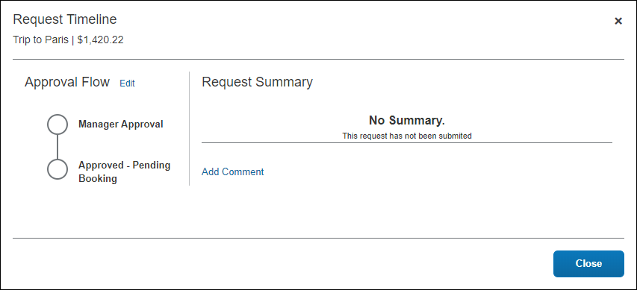
The following image is the Request Timeline page for a submitted and approved request.
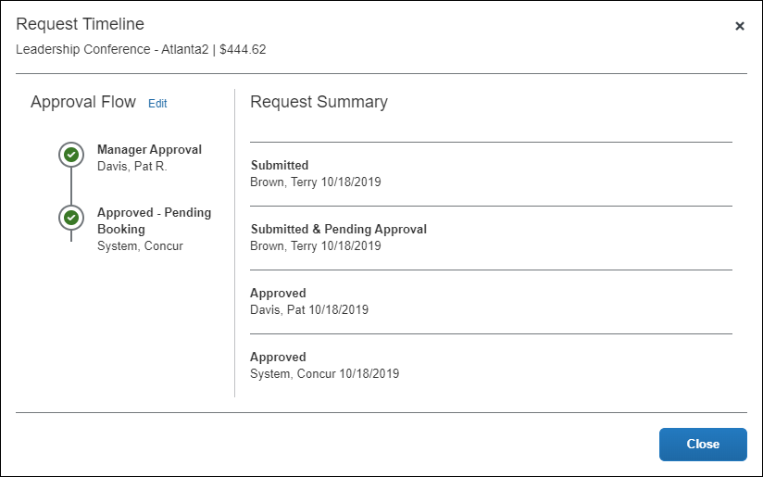
If the user does not have a request approver assigned or have permissions to change the request approver, the user can click the Edit link on the Request Timeline page to add or edit the request approver.
Clicking the Edit link opens the Edit Approval Flow dialog.
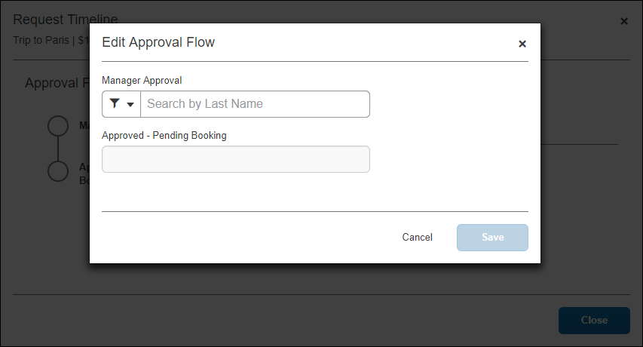
Users can add comments to the request by clicking the Add Comment link on the Request Timeline page. Clicking the Add Comment link opens the Add Comment dialog where a comment can be entered and saved.
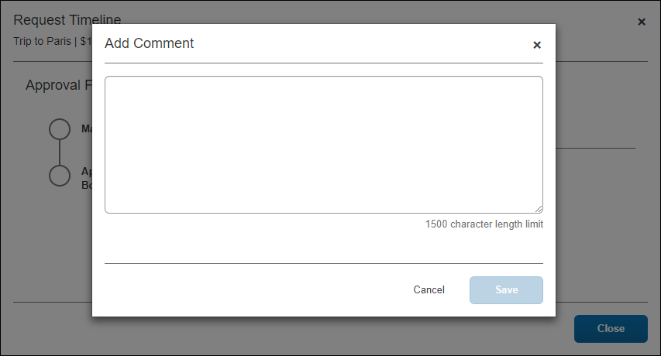
Saved comments display in the Request Summary section of the Request Timeline page.
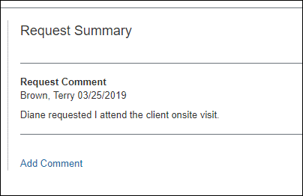

Approver Experience
On the Approvals page, approvers will see the cost object icon display for requests with allocations.
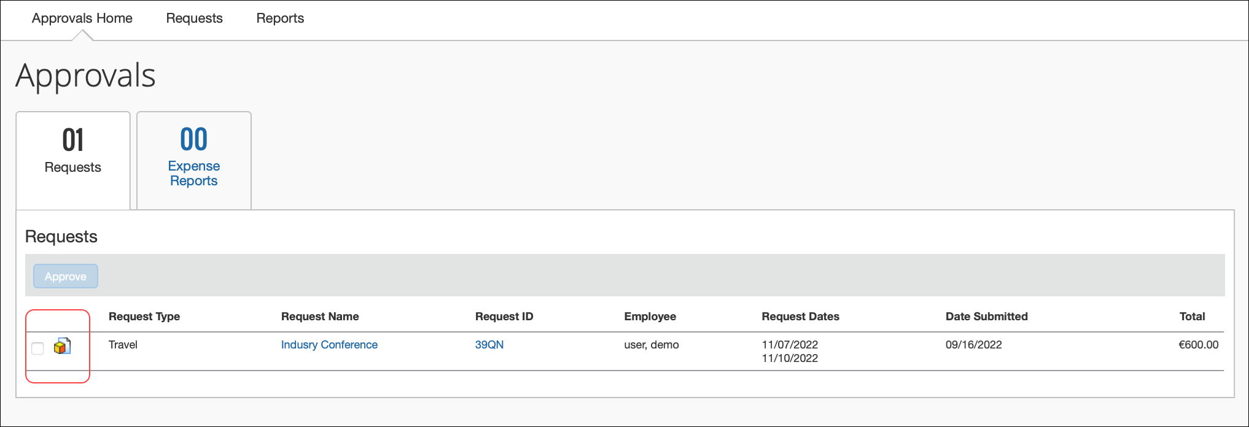

Information Displayed
By default, the entire request displays; however, only the entries with the icon must be reviewed by the current cost object approver. The remaining entries appear for information only.
There is a workflow setting that, when selected, hides information intended for other cost object approvers, as described in the configuration information in this guide.

Additional Scenarios and Conditions

Delegates
The delegate approver acting on behalf of the assigned approver will use the level or limit rights assigned to the original approver rather than their own values.

Automatic Approval and COW Exception if Approver is Request Originator
If a cost object approver submits a request while acting as a delegate of an employee, the request will be automatically approved in the cost object workflow step for that approver since Concur does not ever permit the request originator to share approval privileges for that same request. However, the cost object workflow will create and log the COW exception code whenever it encounters a cost object and level associated with an approver who also submitted the request.
- Refer to the section Additional Error Handling in this document for more information about exceptions.

System Choice Login When Multiple Approvers Exist
Note that if there are multiple cost object approvers configured for the identical cost object and level, there is no guarantee the system will differentiate and then select an approver based on the fact they created and submitted the request.

Request Recall
The request recall feature works per usual. The cost object approval feature has no impact on request recall.

Additional Approver and Workflow Situations
Note the following:
- Any settings configured at the workflow level (email notifications, etc.) apply for the entire workflow, including the cost object approval step.
- However, if approval time-out is ON – regardless of the action selected – the only action that will occur within the cost object step is that the cost object moves to the next approver within the cost object approval step.
- If users are allowed to add ad-hoc approval steps, they will be able to do so within the cost object approval step once the request enters that step. The workflows for each cost object are not created until that point, so are not visible for additions.
- The prompt for approver setting has no affect within the cost object approval step.
- Email notifications and reminders work per usual.
- If a request is fully allocated (100%) to one cost object, the process still applies but there is only one path within the cost object approval step. For example, if the request is 100% allocated to Cost Center 2, the workflow would look like this:
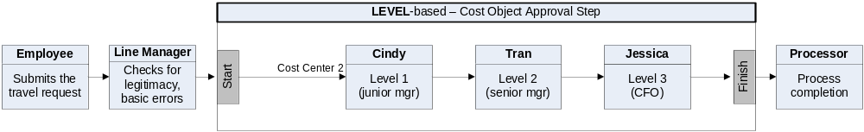
- On the Request Timeline page, each cost object can be expanded to show the approver.
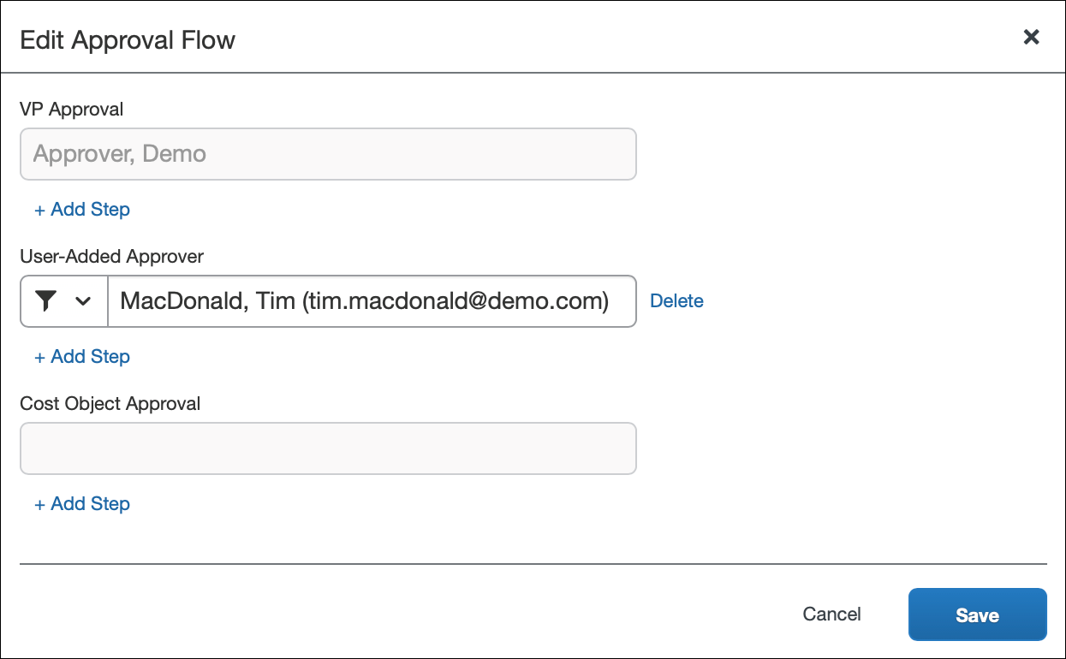
- If a cost object field (for example, Cost Center) is not required and is left blank by the employee, then this object moves through the workflow as if there was no cost object approval step.
- If there are multiple approvers with the same approval limit/levels in the approver definition, Concur uses the first approver found.
- For limit-based approvals, if the highest approver limit within the cost object approval step cannot achieve limit approval for the object, then Concur will add additional approver steps by "walking up" the hierarchy to find the next available approver with a limit higher than the previous approver.
If the next level up has approvers but none have adequate limits, then Concur continues up until it finds an approver with the required limit.
Row | Approver | Limit | Department | Division | Cost Center
1 | A | 100 | R&D | DEV | EXP
2 | B | 900 | R&D | DEV | EXP
3 | C | 500 | R&D | DEV
4 | D | 750 | R&D | DEV
5 | E | 1000 | R&D
6 | F | 5000 | R&D
Example #1 – Cost object of $1000 with Cost Object R&D-DEV-EXP:
- Concur first looks at the R&D-DEV-EXP node. It finds two approvers (A and B) and uses them.
- When all available approvers in that node have been used and the object is still not approved, Concur moves up to the next node. No approvers at R&D-DEV (C and D) have a limit higher than our last approver (B in R&D-DEV-EXP has $900), so Concur does not use any approvers from this node.
- The object is not approved, so Concur moves up to the next node. The first approver found (approver E) for $1000 is used. Since Concur is now able to get the object approved, Concur does not add any more approvers from this node.
- Summary: Concur uses these approvers:
A ($100)
B ($900)
E ($1000)
Example #2 – Cost object of $4000 with Cost Object R&D-DEV-EXP:
- Concur first looks at the R&D-DEV-EXP node. It finds two approvers (A and B) and uses them.
- When all available approvers in that node have been used and the object is still not approved, Concur moves up to the next node. No approvers at R&D-DEV (C and D) have a limit higher than our last approver (B in R&D-DEV-EXP has $900), so Concur does not use any approvers from this node.
- The object is not approved, so Concur moves up to the next node. The first approver found (approver E) for $1000 is used. Since the object is not yet approved, Concur uses the next approver (approver E). Now the object is approved so we do not add further steps.
- Summary: Concur uses these approvers:
A ($100)
B ($900)
E ($1000)
F ($5000)

Additional Error Handling
Note the following:
- Blocking exception prevents approval of report: When the workflow setting Can exit step with blocking exceptions is selected (enabled) the system will allow approval of the report for the following exception code scenarios:
- COW: One or more cost objects could not be approved by the right authority (%costObjects%). The expense report has been moved to the next workflow step.
- CONOAPPR: No approvers were found for cost object %costObjects%.
- BOW: One or more Budget objects could not be approved by the right authority (%costObjects%). The expense report has been moved to the next workflow step.
- APPRVTO: This report has been pending approval longer than allowed by policy. The report owner should contact their approver for instructions before resubmitting. If you are not the owner but have been forwarded the report, follow the approval steps according to your policy - this may involve approving the report or assigning it to another Approver for further review.
- NOAPPR: The previous step was skipped because the selected approver no longer has the approver role. Select another approver or contact the system administrator.
- SELFAPPR: The previous step was skipped because the selected approver would be self-approving the report.
The SELFAPPR exception code is only generated for the Change Approver workflow step action rule. The Change Approver action rule cannot be used with a cost object workflow step, so the SELFAPPR exception code will never be generated for a cost object approval workflow step. For cost object approval workflow steps, a COW exception code will be generated instead.
- Invalid approver: If an approver is designated for a step at workflow creation, it is possible that approver is no longer an appropriate choice when the request reaches that step. If the approver is no longer a valid approver at that point and if approver time-out is ON, the request will eventually time out.
Regardless of the time-out action selected, the only action that will occur within the cost object step is that the cost object moves to the next approver within the cost object approval step.
- Approver limit has changed: If the limit (signing authority) of an approver changes, the request is marked as limit-approved based on the current limit in effect when the request is approved by that approver. The workflow step is not modified dynamically to find a different approver for the step.
- Level approvers are not sequential: If any gaps in the numerical level sequence for approvers at a specific cost object are found, an exception is created that a level has been skipped.
- Example #1: Approvers are found with levels 1, 3, 4. Since the level 2 approver was not found, an exception is generated.
- Example #2: For cost object A, approvers for levels 1, 2 and 3 exist. For cost object B, approvers for levels 1, 2, 3 and 4 exist. No exception is generated for either of these as there are no gaps in the sequence.
- No approver found for level: If no approver exists for a level in the hierarchy, there will be no step created in the cost object approval step for that level.
- No approvers found for cost object: If no approvers at all are found for a cost object, then no cost object approval step is created for that cost object and an exception is generated.
- Cost object not approved: If, for any reason, a cost object does not achieve approved status at the conclusion of the cost object approval workflow, a system exception is created during the termination step for cost object approval. This exception lists each cost object that did not meet approval requirements.
- Limits: The exception is generated if, at the conclusion of the cost object workflow, the request has not been approved by any approver with limit authority.
- Levels: The exception is generated if any level in the cost object approval step has been skipped due to time-out, missing approver, or any other reason.

Configuration
Each client can have only one cost object approval step in a request workflow and only one request workflow in a policy. The steps to configure the cost object approval feature are shown below - with a full description on the following pages.
# | Step
1 | Define the Request Cost Object Approver hierarchy:  - Set up the hierarchy.  - Create a connected (multi-level) list of the hierarchy levels.
2 | Activate the Cost Object Approver feature.
3 | Edit workflow steps if desired.
4 | Assign the proper rights to users using the employee import, User Administration, or the Cost Object Approver List (in Workflows).
5 | Control the information that appears to the cost object approver, if desired.

Step 1: Define the Cost Object Approver Hierarchy
Define the Request Cost Object Approver hierarchy in Administration > Request > Feature Hierarchies, just like any other hierarchy, which may include importing a list.
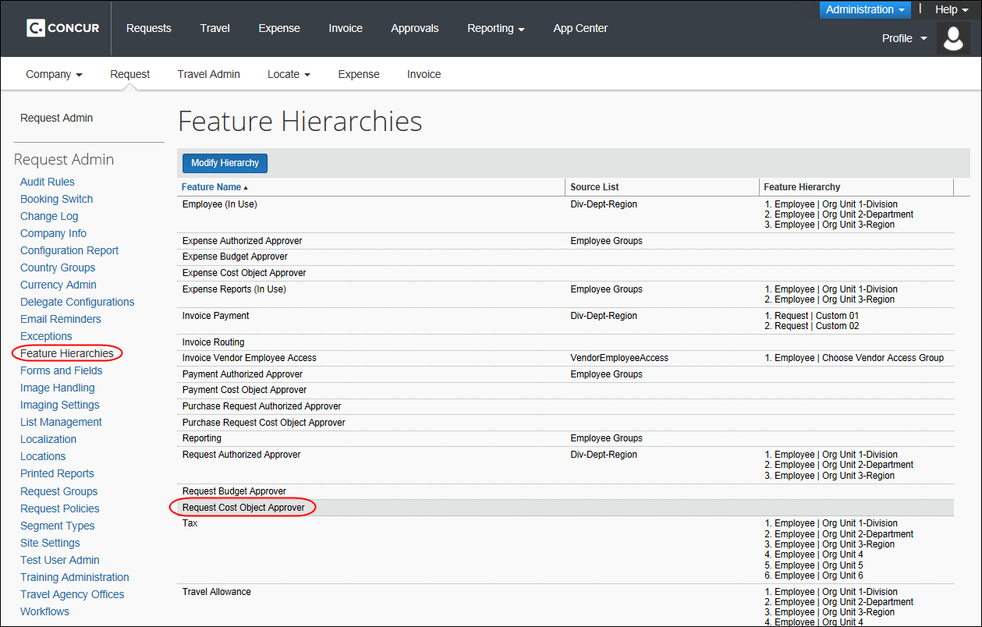
When defining the Request Cost Object Approver hierarchy, you can use any of these fields:
- Request (header)
- Approval status
- Currency
- Custom fields (1 to 20)
- Limit Approved
- Main Destination Country
- Request Policy
- Request Allocation (CT_AR_ALLOCATION)
- Custom fields (1 to 20)
- For more information about the hierarchy, refer to the Shared: Feature Hierarchies Setup Guide. For more information about lists, refer to the Shared: List Management Setup Guide.

Step 2: Activate the Feature
To activate the feature:
- Click Administration > Request.
- Click Workflows (left menu).
- To modify a workflow, on the Workflows tab, either:
- Click the desired workflow and click Modify.
– or –
- Double-click the desired workflow.
The General page appears.
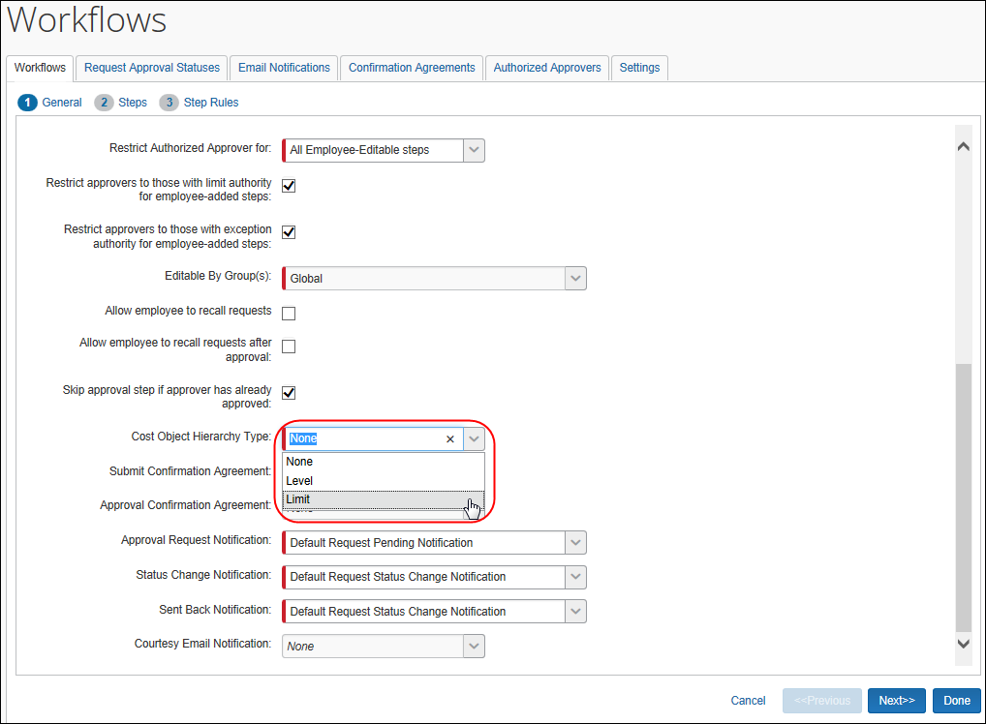
- In the Cost Object Hierarchy Type field, click the desired type: Level or Limit.
- If you click Limit, the Cost Object Direct Approval check box appears. Select (enable) this check box to route the cost object directly to that approver with the required approval limit amount.
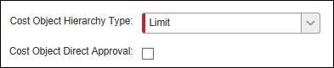
- Click Next. The Steps page appears.

Step 3: Edit the Workflow Steps
When you activate the feature, Concur adds the new workflow step (on the Steps page) just prior to the processor step. You can reorder the steps if necessary.
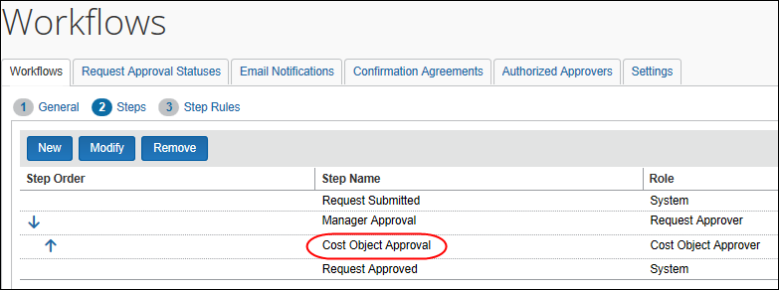
To make changes to the step:
- Either:
- Click the cost object approval step and click Modify.
– or –
- Double-click the cost object approval step.
- Make the desired changes.
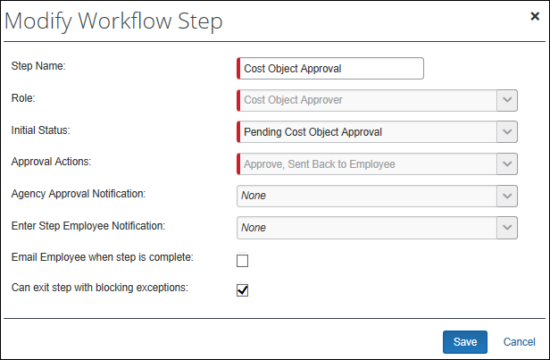
- For more information about editing workflows, refer to the Concur Request: Workflow - General Information Setup Guide.
- Click Save.
- Click Done.

Step 4: Assign the Proper Rights to Users
The company adds the proper permissions rights to users using the employee import or the Cost Object Approver List tab in Workflows.

Employee Import
- For information about the employee import, the Shared: Employee Import Specification.

User Administration
When the Cost Object Approver feature is activated, the Authorized Approval Limits link appears in the Request Settings section in User Administration.
To assign the proper rights:
- In the Request Settings section of User Administration, click the Authorized Approval Limits link. The Authorized Approval Limits window appears.
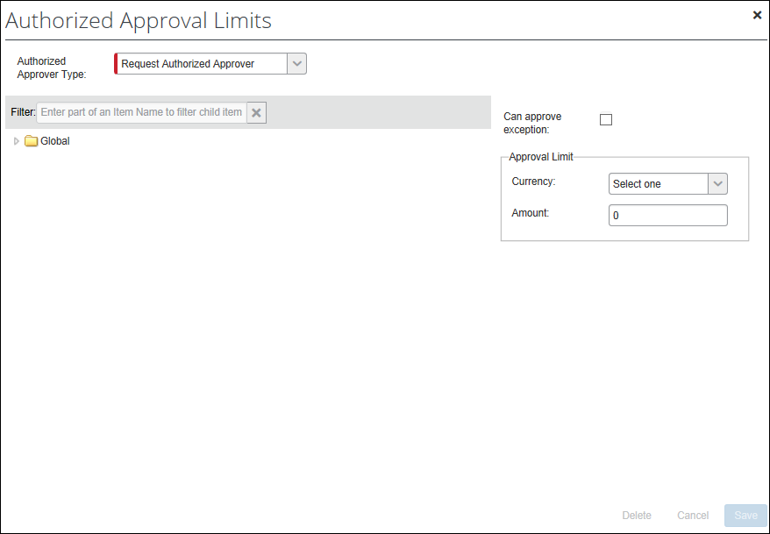
- On the left side, click the appropriate level in the hierarchy.
- On the right side:
- For limit-based cost object approval, select a currency and enter an amount.
- For level-based cost object approval, select a level.
The cost object configuration defines the type – either limit or level. If you complete both areas in this window – the Approval Limit area and the Level field – Concur Expense will use the one that applies to your configuration and ignore the other.

Authorized Approvers Tab in Workflows
To use the Cost Object Approver List tab:
- Click Administration > Request.
- Click Workflows (left menu).
- Click the Authorized Approvers tab.
- Click the Cost Object Approver List tab.
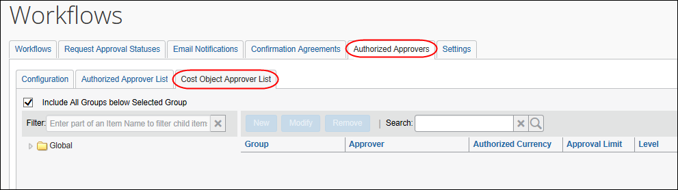
- On the left side, expand the hierarchy.
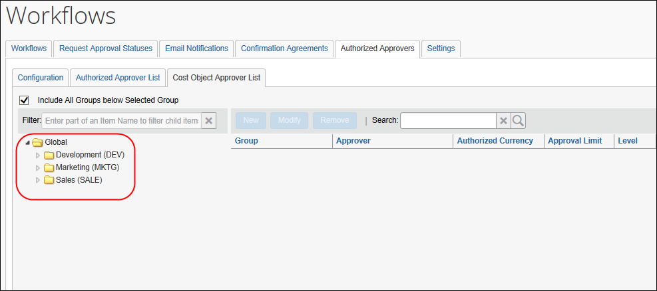
- Click the desired level in the hierarchy.
- On the right side, click New. The New Cost Object Approver window appears.
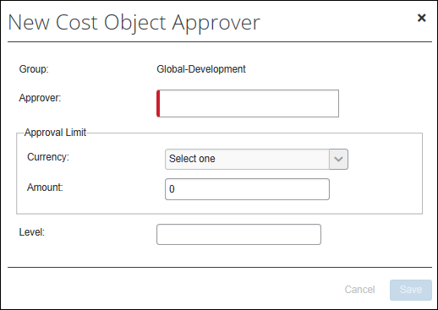
- Search for and select an approver.
Only current Request approvers will be available for selection.
- Then:
- For limit-based cost object approval, select a currency and enter an amount.
- For level-based cost object approval, enter a level.
The cost object configuration defines the type – either limit or level. If you complete both areas in this window – the Approval Limit area and the Level field – Concur will use the one that applies to your configuration and ignore the other.

Step 5: Control the Information that Appears to the Cost Object Approver
By default, when a cost object approver reviews a request, that approver can see the cost objects that belong to all other cost object approvers. If you use the Filter expenses to those that are applicable to Cost Object setting, when the cost object approver opens the request, only the cost objects that apply to that approver are visible. This setting is not designed to fully hide the other cost object information. It simply filters it out of the display, making it easier for a cost object approver to focus on the items that apply to them. In fact, if the cost object approver wants to see the entire request, the approver can use the print feature to see the printed report, which displays all the detail.
To configure:
- Click Administration > Request.
- Click Workflows (left menu).
- Click the Settings tab.
- Select (enable) the Filter expenses to those that are applicable to Cost Object check box.
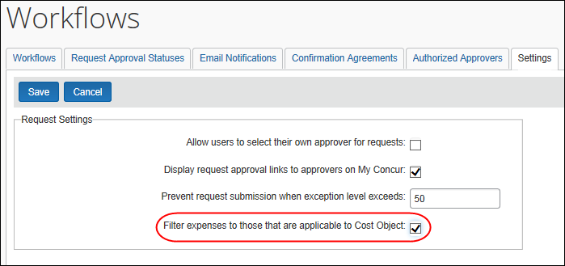
- Click Save.

☼

