
Concur Invoice:
Peppol Integration
Setup Guide
Last Revised: november 11, 2023
Applies to these SAP Concur solutions:
 Concur Expense
 Professional/Premium edition
 Standard edition
 Concur Travel
 Professional/Premium edition
 Standard edition
 Concur Invoice
 Professional/Premium edition
 Standard edition
 Concur Request
 Professional/Premium edition
 Standard edition
Table of Contents
Section 1: Permissions 1
Section 2: Overview 1
Supported Markets 2
Requirements 2
Standard Edition 2
Prerequisites 2
Feature Activation 2
Peppol Exchange Concepts 2
Section 3: Administrator Configurations 3
Section 4: Managing Peppol Integration for SAP Document and Reporting Compliance, Cloud Edition 4
Onboarding to SAP Document and Reporting Compliance, Cloud Edition 4
Setting Up a Global Account 4
Completing Initial Setup 4
Connecting to SAP Document and Reporting Compliance, Cloud Edition 4
Registering Peppol Participants to Receive Electronic Documents 7
Section 5: Managing Peppol Integration for Concur Invoice 8
Accessing Peppol Configuration 8
Professional Edition 8
Standard Edition 9
Configuring Peppol Integration 10
Modifying Peppol Integration Configuration 13
Deactivating Peppol Integration 13
Managing Invoice Notifications 13
Monitoring Invoices in the SAP Document and Reporting Compliance, Cloud Edition, Message Monitor 13
Receiving Exception Email Notifications from Concur Invoice 14
Section 6: End-User Experience 15
PO Invoices 16
Downloading the Peppol Attachment 16
Approver and Processor Experience 17
Section 7: Storing Peppol Documents for Compliance 17
Japan 17
Australia and New Zealand 17
Section 8: Appendix 18
Field Mapping 18
Error Messages 23

Revision History
Date | Notes/Comments/Changes
November 11, 2023 | Updated to include availability for Australia and New Zealand.
June 17, 2023 | Initial guide publication.

Peppol Integration
NOTE: Multiple SAP Concur product versions and UI themes are available, so this content might contain images or procedures that do not precisely match your implementation. For example, when SAP Fiori UI themes are implemented, home page navigation is consolidated under the SAP Concur Home menu.

Permissions
A company administrator may or may not have the correct permissions to use this feature. The administrator may have limited permissions, for example, they can affect only certain groups and/or use only certain options (view but not create or edit).
If a company administrator needs to use this feature and does not have the proper permissions, they should contact the company's Concur administrator.
In addition, the administrator should be aware that some of the tasks described in this guide can be completed only by SAP Concur staff. In this case, the client must initiate a service request with SAP Concur support.

Overview
Peppol Integration provides clients with an e-invoicing solution for exchange of electronic documents among business partners registered in the Peppol Exchange service for the cloud edition of SAP Document and Reporting Compliance. It allows Concur Invoice users to receive supplier e-invoices via SAP Document and Reporting Compliance, cloud edition certified access point. Both the supplier and buyer need to be registered as Peppol Exchange participants to send and receive documents through the network.
Peppol Integration provides the following benefits:
- Meets the global demand for digitalization of tax documents while adhering to document compliance for e-invoices
- Increases efficiency for businesses who want to exchange electronic invoices in a business to business (B2B) environment while complying with country mandates and regulations
- Reduces manual effort for users because the invoice received from Peppol pre-populates invoice creation in Concur Invoice
- Provides the original XML file in an attachment to the invoice report, which can be used for audit and tax purposes
The invoices received from the Peppol Exchange are approved and processed like any other invoice submitted for approval and payment processing.

Supported Markets
The Peppol Integration business solution for receiving invoices from the Peppol Exchange is currently only compliant to the rules published in Japan, Australia, and New Zealand.
This feature is available to new and existing clients who do business in Japan, Australia, and New Zealand (and those who have employees or configurations in Japan, Australia, and New Zealand). Additional countries may be included in a future release.

Requirements
Peppol Integration for Concur Invoice has the following requirements:
- An enterprise global account on SAP Business and Technology Platform (SAP BTP)
- A valid SAP Document and Reporting Compliance, cloud edition service license is required as an access point to the Peppol Exchange
- Refer to the Onboarding and Connecting to SAP Document and Reporting Compliance, Cloud Edition section in this guide.

Standard Edition
Clients using Concur Invoice for Standard Edition must be using a Japan or Australia country pack.

Prerequisites
Verify that suppliers sending electronic invoices are registered as Peppol Exchange participants.

Feature Activation
The Peppol Integration feature for Concur Invoice must be enabled by SAP Concur staff. Clients must initiate a service request with SAP Concur support.

Peppol Exchange Concepts
For Peppol Exchange concepts that are used in the SAP Document and Reporting Compliance, cloud edition, refer to Concepts | SAP Help Portal.

Administrator Configurations
To use the Peppol Integration feature, client administrators must complete the following:
- Onboard to the SAP Document and Reporting Compliance, cloud edition service
- Connect the Concur Invoice system with the SAP Doc and Reporting Compliance application in the SAP Concur App Center
- Register Peppol Participants in the Peppol Exchange of the SAP Document and Reporting Compliance, cloud edition service
- Configure the Peppol Integration feature in Concur Invoice
- Refer to the Managing Peppol Integration for SAP Document and Reporting Compliance, Cloud Edition and Managing Peppol Integration for Concur Invoice sections in this guide.
Customer onboarding to the SAP Document and Reporting Compliance, cloud edition service is a one-time manual activity.
The following figure illustrates the configurations client administrators need to perform to use the Peppol Integration feature.
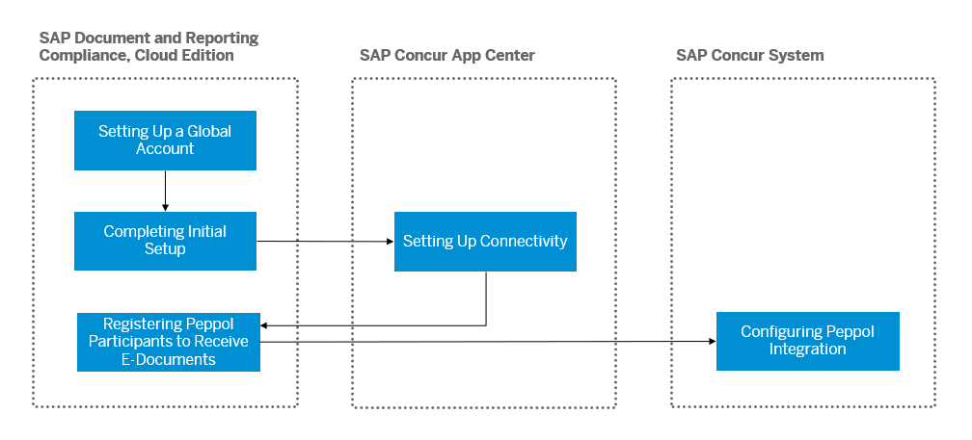

Managing Peppol Integration for SAP Document and Reporting Compliance, Cloud Edition

Onboarding to SAP Document and Reporting Compliance, Cloud Edition
Client administrators perform the following configurations to onboard users to SAP Document and Reporting Compliance, cloud edition:
- Set Up a Global Account
- Complete Initial Setup

Setting Up a Global Account
Client administrators must first set up a global account for the SAP Business Technology Platform (SAP BTP) to use the SAP Document and Reporting Compliance, cloud edition service. The global account is the primary account for SAP BTP.
- For more information, refer to Getting a Global Account | SAP Help Portal.

Completing Initial Setup
Client administrators must perform several tasks on SAP BTP to use SAP Document and Reporting Compliance, cloud edition with SAP Concur applications. Clients can either use the booster to perform the tasks automatically or perform all the steps manually.
- For more information, refer to Initial Setup | SAP Help Portal.

Connecting to SAP Document and Reporting Compliance, Cloud Edition
Communication between SAP Document and Reporting Compliance, cloud edition and Concur Invoice will be secured for each participating client using authentication.
Client administrators must connect their Concur Invoice account with SAP Document and Reporting Compliance, cloud edition using the SAP Doc and Reporting Compliance application available in the SAP Concur App Center.
To connect Concur Invoice with SAP Document and Reporting Compliance, cloud edition:
- On the Concur Invoice home page, click the App Center tab on the top navigation bar.
- On the App Center page, search for SAP Doc and Reporting Compliance in the search bar.
- Click the SAP Doc and Reporting Compliance tile.
- On the SAP Doc and Reporting Compliance page, click Connect.
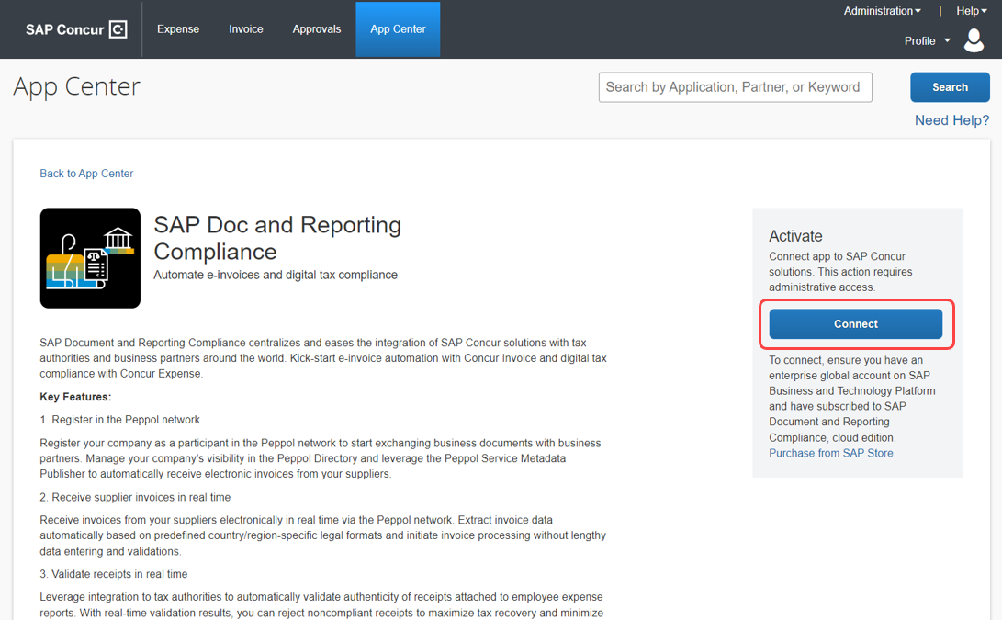
- On the Terms & Conditions window, review and accept the SAP Concur terms and conditions.
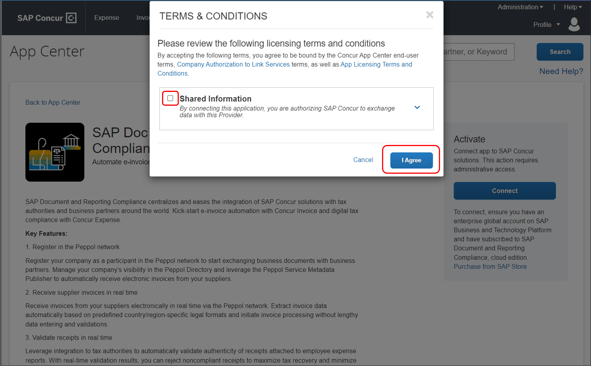
- Enter the subdomain of SAP BTP subaccount from which you subscribed for the cloud edition application and click Connect.
To find the subdomain ID for the SAP BTP account, refer to Creating a Subaccount | SAP Help Portal.
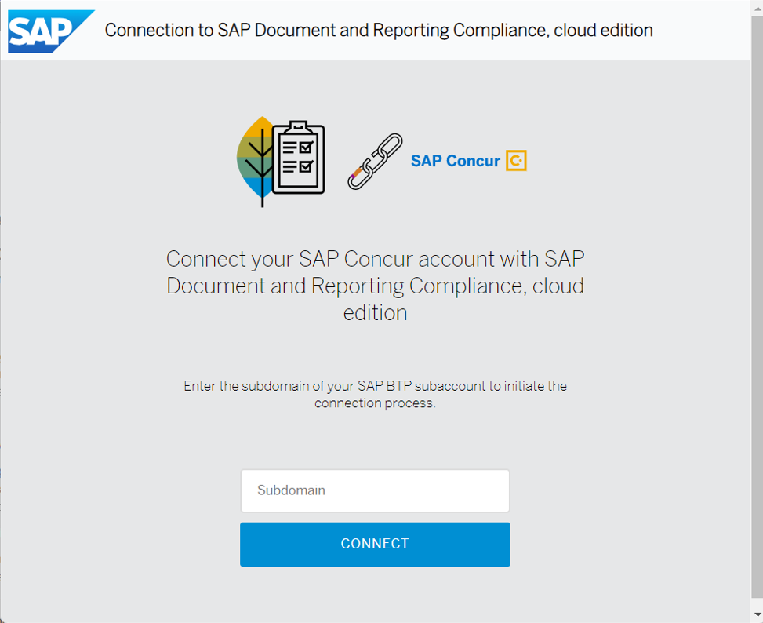
Once connected, the Success window appears.
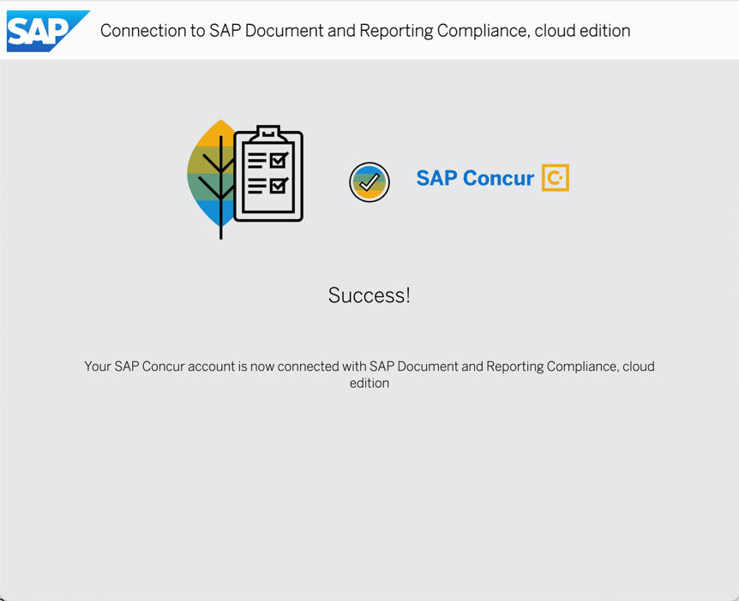
Your SAP Concur account is now connected to Document and Reporting Compliance, cloud edition service.

Registering Peppol Participants to Receive Electronic Documents
Concur Invoice cannot receive electronic documents from participants in the Peppol Exchange until the client administrator has created a participant ID for the company.
Only participants registered with the Service Metadata Publisher (SMP) can receive electronic documents from other participants in the Peppol Exchange. Client administrators can control whether the company receives electronic documents from other participants.
- For more information, refer to Registering Your Company to Receive Electronic Documents in the Peppol Network | SAP Help Portal

Managing Peppol Integration for Concur Invoice

Accessing Peppol Configuration

Professional Edition
To access the Peppol Configuration page:
- Navigate to Administration > Invoice > Invoice Processing Admin > Peppol Configuration.
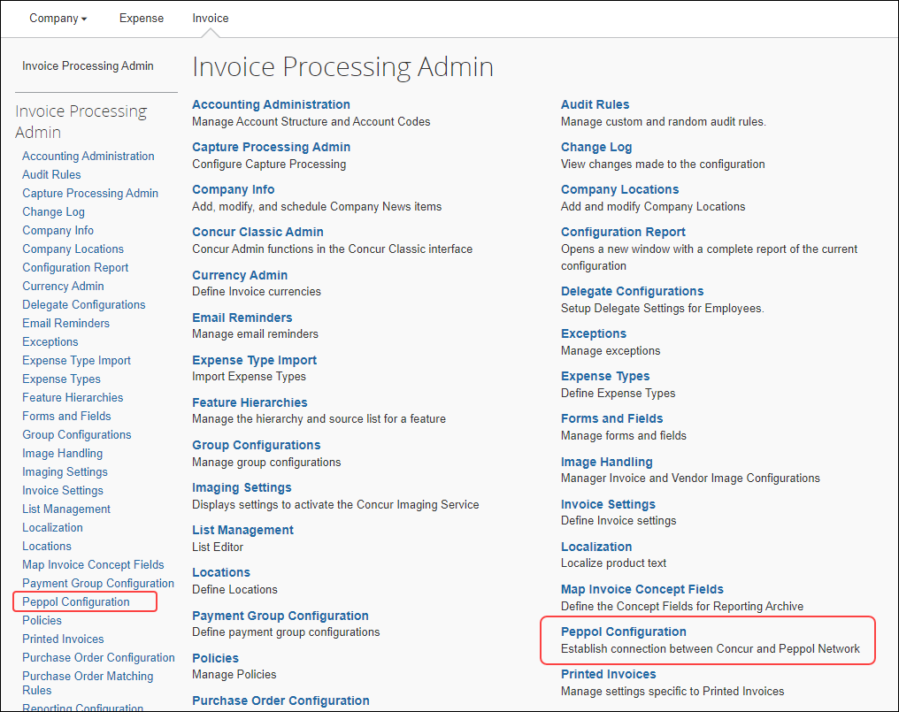
The Peppol Configuration page appears.
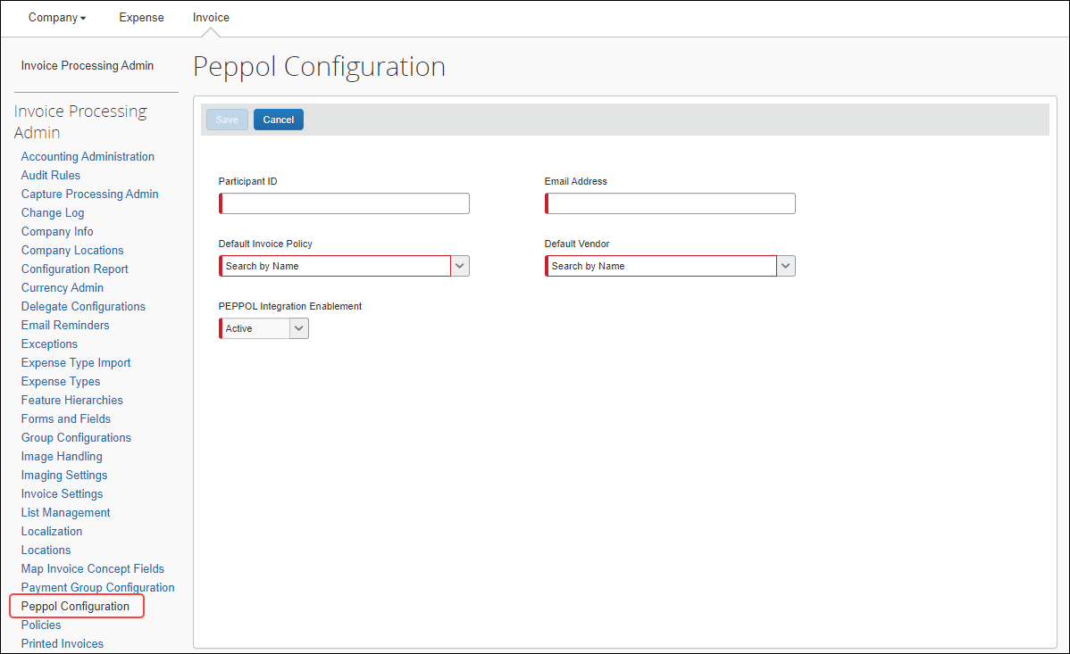

Standard Edition
To access the Peppol Configuration page:
- Navigate to Administration > Invoice Settings or Expense & Invoice Settings.
- In the Product list, select Invoice.
- Click the View Advanced Settings link.
- In the Connections section, on the Peppol Configuration tile, click Edit.
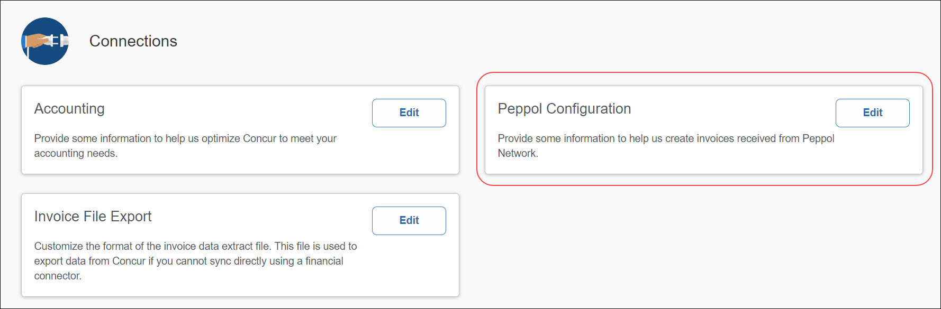
The Peppol Configuration page appears.
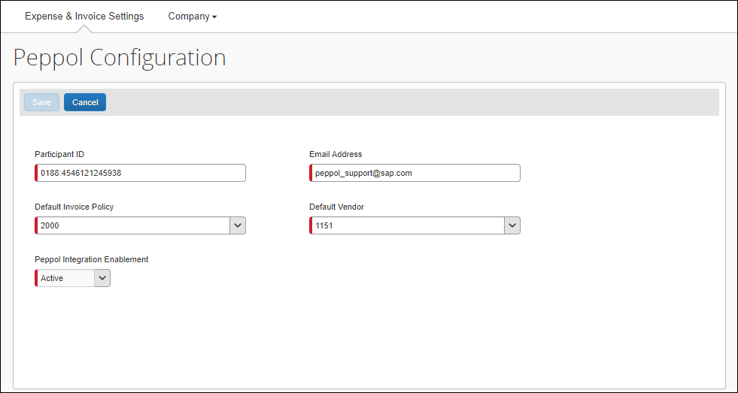

Configuring Peppol Integration
To establish a connection to the Peppol Exchange, client administrators need to configure Peppol Integration in Concur Invoice. Once configured, Concur Invoice can receive incoming supplier invoices from the service and validate the required fields entered during invoice creation.
Client administrators complete configuration on the Peppol Configuration page. Client administrators must configure the required fields necessary for accessing the Peppol Exchange. Once configuration is complete, client administrators can activate the integration for the company.
- Refer to the Accessing Peppol Configuration section in this guide.
To configure Peppol Integration:
- Access the Peppol Configuration page.
- Complete the required fields.
Field Name | Description/Action
Partcipant ID | Enter the unique participant ID for Peppol Integration.  This is the participant ID registered in the SAP Document and Reporting Compliance, cloud edition service for receiving incoming invoices at SAP Concur.  The Participant ID format is <scheme Identifier>: <Receiver or Customer Participant Identification Number>.  - For more details, refer to: https://docs.peppol.eu/poacc/billing/3.0/syntax/ubl-invoice/cac-AccountingSupplierParty/cac-Party/cac-PartyIdentification/cbc-ID/
Email Address | Enter the email address for whom exception emails will be managed.  NOTE: If invoice creation fails in Concur Invoice, an email regarding the failure will be sent to the email address maintained here.
Default Invoice Policy | Select the default policy used for Peppol Integration.  - Non-PO: This field defaults to NONPOPolicy.  - PO Invoices: If a matching PO number exists in Concur Invoice, then the policy associated with that PO is populated as the default policy.  If a matching PO number does not exist in the system, the default PO policy is used during invoice creation. Once the PO is available in the system, then PO matching is performed based on Concur Invoice configuration.  The default policy maintained here is used for all incoming invoices from the Peppol Exchange and is used for invoice creation in the system. The copy down of forms and fields and relevant values that are maintained in the policy configuration will be used.  NOTE: The default policy can be edited manually once invoice creation occurs in the system.  NOTE: For Concur Invoice for Standard Edition, the policy is associated with the country pack.
Default Vendor | Select the vendor for the invoice. Approved vendors with format <Vendor Code>-<Vendor Address Code> can be selected from the list.  - If a vendor with a Vendor Tax ID is not found in the system, the invoice will be routed to a default vendor.  - If the Vendor Tax ID has multiple vendors, the invoice will be routed to the default vendor.  NOTE: For Standard Edition, this field is the default vendor.  NOTE: The vendor can be manually changed after the invoice is created.
Active | This field activates Peppol Integration in the system. Once active, invoices will start flowing from the Peppol Exchange via SAP Document and Reporting Compliance to Concur Invoice for invoice creation.  This field defaults to Active.  Select Inactive to deactivate Peppol Integration.
- Click Save to save the configuration and activate it for your company.
A message confirming that the configuration is saved appears at the bottom of the screen.

If you leave the Peppol Configuration page without saving, a Save Changes? message appears to confirm whether you want to leave the page without saving the configuration.
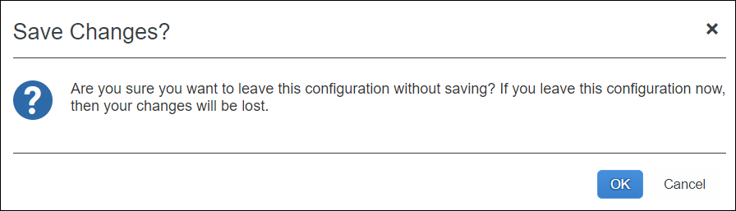
- Click the OK to leave the page and lose any field configuration.
- Click Cancel to remain on the page to complete and save the configuration.

Modifying Peppol Integration Configuration
Client administrators can edit Peppol Integration configuration.
To modify Peppol Integration configuration:
- Navigate to the Peppol Configuration page.
- Click Edit.
- Make any necessary edits.
- Click Save.

Deactivating Peppol Integration
Client administrators can turn off or deactivate Peppol Integration. When Peppol Integration has an Inactive status, the system will no longer receive supplier invoices from the Peppol Exchange.
To deactivate the Peppol Integration service:
- Navigate to the Peppol Configuration page.
- Click Edit.
- In the Peppol Integration Enablement field, select Inactive to deactivate the integration.
- Click Save.
To reactivate the integration, select Active, then click Save.

Managing Invoice Notifications

Monitoring Invoices in the SAP Document and Reporting Compliance, Cloud Edition, Message Monitor
Once SAP Document and Reporting Compliance, cloud edition sends the XML document, Concur Invoice sends a notification back to SAP Document and Reporting Compliance, cloud edition that the invoice was validated and received.
If the Concur Invoice service is not available, the SAP Document and Reporting Compliance, cloud edition message monitor provides automatic reprocessing once Concur Invoice service is restored.
If Concur Invoice rejects an incoming invoice, then Concur Invoice sends a rejection notification to the SAP Document and Reporting Compliance, cloud edition. These messages are sent before invoice creation in Concur Invoice. Client administrators can access the SAP Document and Reporting Compliance, cloud edition message monitor to identify and resolve the issue.
For cases where configuration needs to be completed in Concur Invoice, resolution and reprocessing is manually done within the SAP Document and Reporting Compliance, cloud edition message monitor once the issue is resolved. For example, sometimes the invoice cannot be created due to missing mandatory fields or an undefined participant. The administrator must first complete configuration correctly in Concur Invoice, then reprocess the invoice manually in the SAP Document and Reporting Compliance, cloud edition message monitor.
- For more information, refer to Viewing Documents | SAP Help Portal and Reprocessing Documents | SAP Help Portal.

Receiving Exception Email Notifications from Concur Invoice
A supplier invoice may fail invoice creation in Concur Invoice. If this occurs, the system sends an email notification to the address specified during configuration in the Invoice Processing Admin > Peppol Configuration page. The specific exceptions are listed in the body of the email.
When an exception email notification is received, the client administrator must correct configuration in Concur Invoice. Exceptions may include the following: a missing country postal code, the wrong currency or unit of measure, an invalid vendor, or other missing mandatory configuration as per the policy set.
- For a complete list of error messages and error codes to reference, refer to the Error Messages section in the Appendix in this guide.

End-User Experience
Invoices sent to Concur Invoice from the Peppol Exchange automatically create a new invoice report in the system.
On the Unassigned Invoices page, users can identify invoices received from Peppol in the Invoice Name column. The invoice name begins with “PEP_” followed by the invoice number.
Invoice Owners who are already assigned invoices by vendor will automatically be assigned invoices received from the Peppol Exchange and locate them on their All My Invoices page.
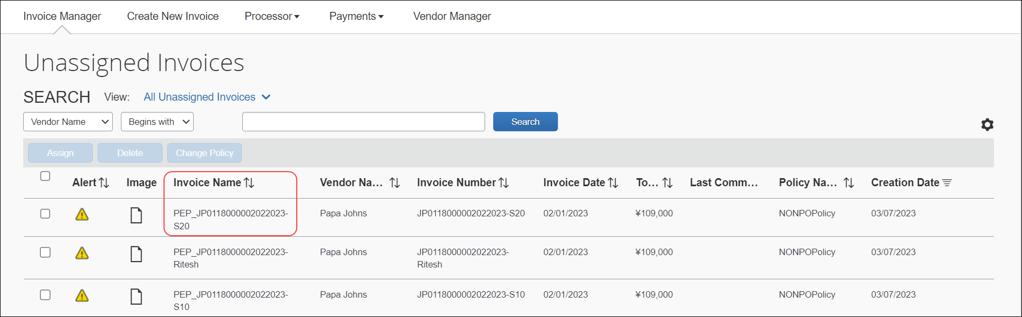
When a user opens the invoice, they will see it pre-populated with data in the Invoice Details section and can see line item detail in the Itemization Summary section. The Origin Source field is pre-populated with PEP.
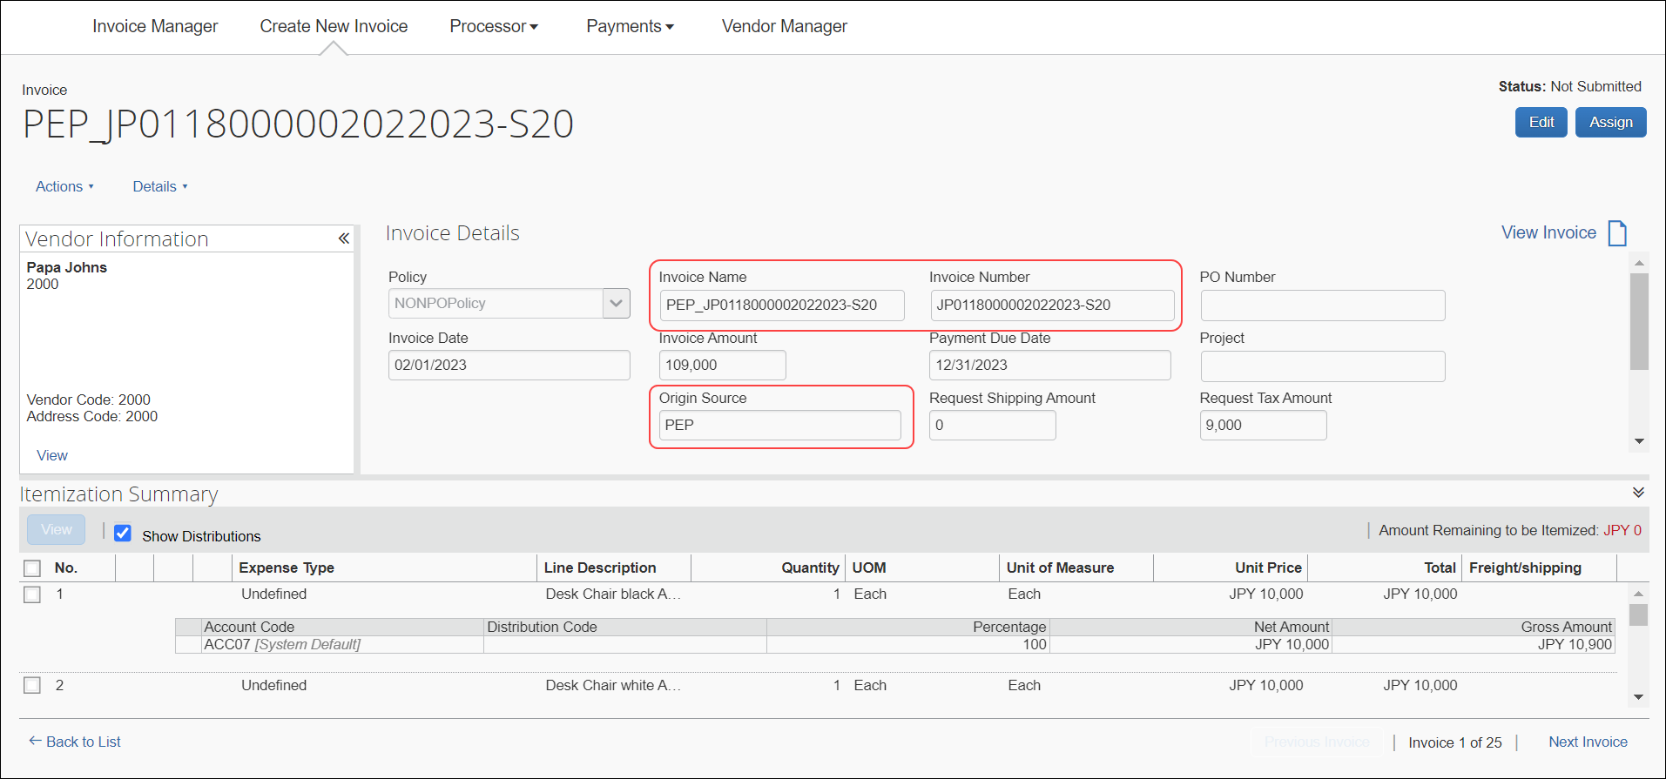

PO Invoices
Users can see the PO Number field is populated and view the multiple line items associated with the invoice in the Itemization Summary section.
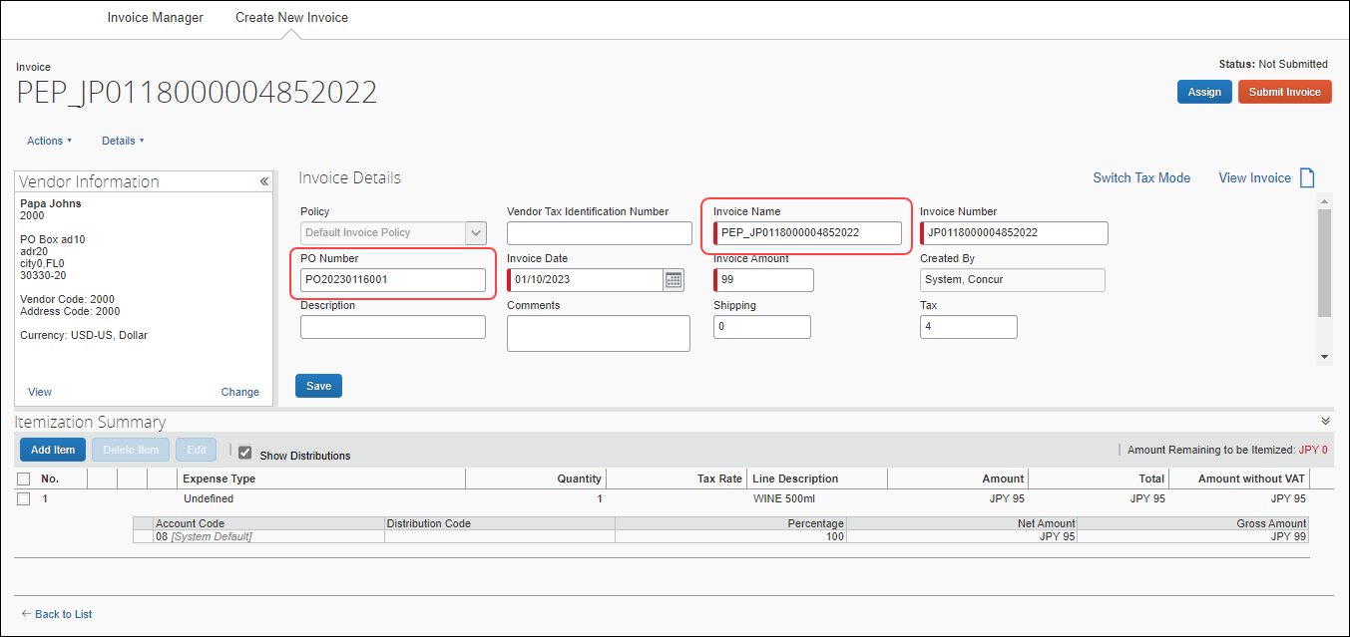

Downloading the Peppol Attachment
On the Actions menu, users can click Peppol Attachment > Download XML to download a copy of the XML file. The attachment file is a PDF file that cannot be edited or deleted.
A downloaded copy of the attachment can be used for auditing purposes.
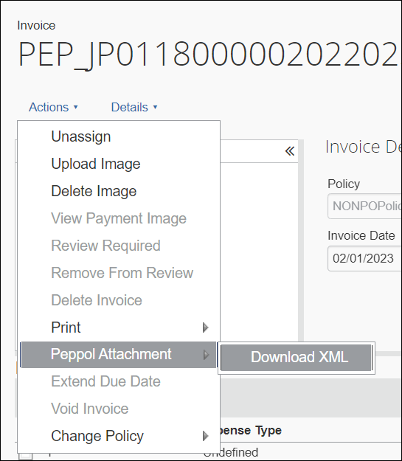
To download the Peppol Attachment file:
- Open the invoice.
- On the Actions menu, click Peppol Attachment > Download XML.

Approver and Processor Experience
Invoices received from the Peppol Exchange are approved and processed like any other invoice submitted for approval and payment processing.

Storing Peppol Documents for Compliance
Clients using the Peppol Integration feature must follow their country’s compliance requirements for Peppol Exchange document storage.

Japan
Clients must store a copy of documents received from the Peppol Exchange for a minimum of seven years to adhere to Japan compliance regulations.
- For more information, refer to the National Tax Agency web site for Japan.

Australia and New Zealand
Businesses in Australia and New Zealand can determine how long to store invoices based on the tax and auditing needs of their company.
- For more information, refer to the following tax web sites:
- Australia: https://www.ato.gov.au/business/einvoicing/peppol/
- New Zealand: https://www.einvoicing.govt.nz/

Appendix

Field Mapping
The following table contains information for mapping Peppol fields with Concur Invoice fields and provides field descriptions. The field mapping table is applicable for both Concur Invoice Professional and Standard Editions.

Peppol Fields | Concur Invoice Fields from SAP DRC | Concur Invoice Fields | Description
cbc:Amount | amount | AmountWithoutVat | The net amount of the invoice (excluding VAT).
cbc:AccountingCost | buyerAccountingReference | BuyerCostCenter | The company defined center responsible for the invoice.
cbc:PaymentID | remittanceInformation | CheckNumber | Check number of the payment made to the vendor.
cac:PostalAddress |  | CompanyBillToAddressCode | The code which identifies the company location to which the vendor billed the invoice.
cbc:PostalZone | buyer/postCode | CompanyShipToAddressCode | The code which identifies the company location to which the vendor shipped items listed in the invoice.
cbc:IdentificationCode | buyer/countryCode | CountryCode | Required. The country code.
cbc:DocumentCurrencyCode | invoiceCurrencyCode | CurrencyCode | The 3-letter ISO 4217 currency code for the invoice currency.  Examples:  USD - US dollars  BRL - Brazilian real  CAD - Canadian dollar  CHF - Swiss franc  EUR – Euro  GBO - Pound sterling  HKD - Hong Kong dollar  INR - Indian rupee  MXN - Mexican peso  NOK - Norwegian krone  SEK - Swedish krona
ORIGIN SOURCE = PEP |  | DataSource = 'PEP' | A code that indicates the method used to create the invoice. Use GET /invoice/localizeddata to translate the code into text.
cac:ReceiptDocumentReference | receivingAdviceReference | DeliverySlipNumber | The delivery slip number associated with receiving receipt.
 |  | Description | User-entered description of the invoice.
cbc:MultiplierFactorNumeric | percentage | DiscountPercentage | The discount from the supplier if the discount terms are met.
cbc:AllowanceChargeReason | reason | DiscountTerms | The NET discount terms with a supplier when discounts apply.
cbc:ElectronicMail | contactEmailAddress | EmployeeEmailAddress // EmployeeId | The email address of the employee to whom the invoice should be assigned.  Not evaluated if EmployeeLoginId or EmployeeId match an employee. This value is required if none of the following are provided:  LedgerCode  EmployeeLoginId  EmployeeId  PurchaseOrderNumber  ExternalPolicyId
cbc:CompanyID | vatIdentifier | EmployeeId | The company ID of the employee to whom the invoice should be assigned. Has precedence over EmployeeEmail; not evaluated if EmployeeLoginId matches an employee.  This value is required if none of the following are provided:  LedgerCode  EmployeeLoginId  EmployeeEmail  PurchaseOrderNumber  ExternalPolicyId
cbc:Name | contactPoint | EmployeeLoginId // EmployeeId | The login ID of the employee to whom the invoice should be assigned. Has precedence over EmployeeId and EmployeeEmail.  This value is required if none of the following are provided:  LedgerCode  EmployeeId  EmployeeEmail  PurchaseOrderNumber  ExternalPolicyId
cbc:ID | purchaseOrderReference | ExternalPolicyId // EmployeeId | The external policy ID of the Invoice. This value is required if none of the following are provided:  LedgerCode  EmployeeLoginId  EmployeeId  EmployeeEmail  PurchaseOrderNumber
cbc:IssueDate | invoiceIssueDate | InvoiceDate | The date the vendor issued the invoice.
cbc:ID | invoiceNumber | InvoiceNumber // venInvoiceNumber | The invoice number from the vendor for the invoice
cbc:TaxPointDate | valueAddedTaxPointDate | InvoiceReceivedDate | The date on which the invoice was received.
cac:InvoiceLine | invoiceLine | LineItems // multiple variables | The details of the Core Payment Request Line Item Identity Fields.
cbc:PayableAmount | amountDueForPayment | PaymentAmount | Represents the amount of the payment that will be/has been made for the invoice.
cbc:DueDate | paymentDueDate | PaymentDueDate | The date the vendor needs to be paid.
cac:PaymentTerms | terms | PaymentTermsDays | This number, along with type of payment terms (example: NET), determine when the invoice is expected to be paid.
cbc:CompanyID | vatIdentifier | VendorTaxId | The Vendor Tax ID.
cbc:ID | purchaseOrderReference | PurchaseOrderNumber // poNumber | The ID of the purchase order to which the invoice should be matched. This value is required if none of the following are provided:  LedgerCode  EmployeeLoginId  EmployeeId  EmployeeEmail  ExternalPolicyId
cac:AllowanceCharge | documentLevelAllowancesAndCharges | ShippingAmount // shipping | The value for the Shipping Amount header field.
cbc:TaxAmount | invoiceTotalVatAmount | TaxAmount // tax | The value for the Tax Amount header field.
cbc:TaxAmount | categoryTaxAmount | VatAmountOne | The amount of VAT included in the invoice total (first of two VAT amount fields available).
cbc:Percent | categoryRate | VatRateOne | The VAT rate applied to the net invoice total (should relate to the first VAT amount field).
cbc:IdentificationCode | countryCode | VendorShipFromAddressCode //vendorAddress2 | The code which identifies the location from which the vendor shipped items listed in the invoice.
cbc:Amount | amount | AmountWithoutVat | The net amount of the line item (excluding VAT).
cbc:Description |  | Description | Brief overview of the good or service ordered.
cbc:AllowanceChargeReasonCode | reasonCode | ExpenseTypeCode // | A code which indicates the expense type for the line item.
cbc:ID | sellerIdentification | ItemCode // LineItemPetCode | Represents the item code (the unique code a vendor assigns to a good, or code a vendor assigns to a good or service to identify it).
cac:OrderReference | purchaseOrderReference | MatchedPurchaseOrderReceipts // | The details of the Matched Purchase Order Receipts Identity fields (if any).
cbc:LineID | referencedPurchaseOrderLineReference | PurchaseOrderNumber // poNumber | Purchase order that is associated to the line item.
cbc:InvoicedQuantity | invoicedQuantity | Quantity // LineItemQuantity | Total number of goods or services ordered.
cbc:PostalZone | postCode | ShipFromPostalCode // vendorAddress1 | The postal code the good or service was shipped from.
cbc:PostalZone | postCode | ShipToPostalCode // companyAddress1 | The postal code the good or service will be shipped to.
cac:Item | itemInformation | SupplierPartId // | The unique identifier provided by the supplier that is associated with the good or service.
cbc:BaseAmount | itemGrossPrice | TotalPrice // total | The total amount of the line item.
@unitCode | itemPriceBaseQuantityUnitOfMeasureCode | UnitOfMeasure // | The code for the measurement unit used to quantify the good or service. Use GET /invoice/localizeddata to look up codes and descriptions.
cac:Price | itemNetPrice | UnitPrice // lineItemUnitPrice | The cost for a single unit of the line item good or service.
cbc:Percent | vatRate | VatRate // calculatedTaxRate | The VAT rate applied to the net line item total.

Error Messages
When a supplier invoice fails invoice creation in Concur Invoice, refer to the following table to locate the error messages, error codes, and reasons for the error message as needed.
- For more information, refer to the Receiving Exception Email Notifications section in this guide.

Error Messages | Error Codes | Reason
There was no vendor found for the supplied Vendor Code and Vendor Address Code. | 2000 | N/A (Vendor Code supplied in input is not present in the database).
The Currency Code is missing or invalid. | 3000 | Currency Code provided is not present in database.
There was no policy found matching the supplied External ID. | 4000 | N/A (External Policy ID ).
The policy does not support purchase orders. | 4001
Policy may not be changed for this purchase order. | 4002
The purchase order does not contain any line items. | 5000
The line item must contain either Expense Type or Account Code, but not both. | 5001
The line item expense type is not valid. | 5002
The line item account code is not valid. | 5003
The line item tax and unit price must both match positive or negative. | 5004
The line item Unit Of Measure code is not valid. | 5005
The line item Is Receipt Required must be either Y or N. | 5006
A line item contains distributions, but no distribution form is defined. | 5500
The line item distributions exceed the line item amount. | 5501
The distribution amounts for a line item must match the line item amount positive or negative. | 5502
The distribution amounts for a line item cannot be zero. | 5503
The maximum number of distributions for a line item is 20. | 5504
The purchase order status code is invalid, CLSD or TRAN or blank are the valid input for import. | 5504
The external id for the line item is not unique across the purchase order. | 5600
Tax and Unit Price sign mismatch. | 5601
Cannot enter tax for both line items and header. Only one is allowed. | 5602
Tax Mode not supported. Remove the tax values and send the request again. | 5603
The Ship To Address is missing or invalid. | 6000 | Shipping address not in database.
The Bill To Address is missing or invalid. | 6001
The submitted request has errors and cannot be saved. | 7999
The required field is missing. | 8000 | Mandatory fields are missing.
The value exceeds the maximum length allowed for the field. | 8001
The value is the wrong data type for the field. | 8002
The value is an invalid list item. | 8003
The value is an invalid connected list item or the parent element does not have a value. | 8004
The Country Code is missing or invalid. | 8005 | Country code not added.
The field is not part of the form. | 8006
The date format is invalid. The date should be formatted like YYYY-MM-DD. | 8007 | Date Format (YYYY-MM-DD).
The shipping method code is invalid. | 8008 | Not found.
The shipping term code is invalid. | 8009 | Not found.
No policy found for the supplied PO Number. | 8010 | Not found.
Invalid Discount Terms. | 8011
Invalid Discount Percentage. | 8011
No valid employee found. | 8012
Cannot unassign an assigned request. No valid employee found. | 8012
The supplied employee has a status mismatch. Might be a test user. | 8013
Valid External Policy and Ledger Code required when no employee information is sent. | 8014 | N/A (External Policy is added).
Valid External Policy and Ledger Code required when no employee information is sent. | 8015 | N/A (External Policy is added).
The employee does not have a ledger configured, send in a default ledger code. | 8016 | N/A (Sending Default).
The supplied address code is invalid. | 8017 | Shipping address not added in database.
The value does not meet the validation constraints on this field. | 8018 | Validation error in fields.
The supplied user does not have access to the provided vendor. | 8019 | Shipping address not added in database.
No matching request for the supplied request id or the supplied request id is blank. | 8020
The provided employee does not have access to the policy. | 8021
This request has already been submitted and can no longer be modified. | 8012 | Validation error in fields+C46.
Value must be either true or false. | 9997 | For Boolean values if anything other than true or false.
Invoice Global Group is not configured. | 9998
An unexpected error occurred. | 9999
Invalid pet code. | 7000 | If PetCode present and Expense type not set.
Invalid Unit of measure. | 7001 | Line item unit of measure not added in database.
No matching line item for the supplied line item id or the supplied line item id is blank. | 7003 | Line item Id is blank.
This field requires a non-negative numeric value. | 8021 | DiscountPercentage, Percentage, VatRate, VatRateOne, VatRateTwo, CalculatedTaxRate, VatRateThree, VatRateFour.  In Lineitem has -ve value.
Invalid percentage for allocation. | 9000 | Allocation percentage >100
Percentage is a required fields for allocation. | 9001 | Allocation percentage is null.
This field requires a valid percentage. | 9015 | Percentage field is not numeric.

☼

