
Concur Invoice: Image
Handling – Scan Configuration
Setup Guide
Last Revised: March 13 2015
Applies to these SAP Concur solutions:
 Concur Expense
 Professional/Premium edition
 Standard edition
 Concur Travel
 Professional/Premium edition
 Standard edition
 Concur Invoice
 Professional/Premium edition
 Standard edition
 Concur Request
 Professional/Premium edition
 Standard edition
Table of Contents
Section 1: Permissions 1
Section 2: Overview 1
Scan Configuration Settings 1
Scan Configuration and the Invoice Image Processor Role 2
Section 3: Invoice Image Processor Experience 3
Section 4: Administrator Experience 4
Section 5: Configure the Scan Configuration Feature 9
The Basic Process 9
Configuration/Activation 9
Step 1: Add a Scan Configuration 10
Step 2: Assign the Scan Configuration to a Policy 12
Step 3: (Optional) Select (Enable) the Required Hardcopy Receipt setting 14
Managing Scan Configurations 16

Revision History
Date | Notes/Comments/Changes
September 21, 2022 | Minor edits; cover date not updated
January 21, 2022 | Updated the copyright year; no other changes; cover date not updated
February 17, 2021 | Updated the copyright year; no other changes; cover date not updated
April 17, 2020 | Renamed the Authorization Request check box to Request on the guide’s title page; cover date not updated
January 6, 2020 | Updated the copyright; no other changes; cover date not updated
February 9, 2019 | Changed the term "Concur" to "SAP Concur" and the term "payment request" to "invoice" where applicable; no other content changes.
January 29, 2019 | Updated the copyright; no other changes; cover date not updated
April 6, 2018 | Changed the check boxes on the front cover; no other changes; cover date not updated
January 10 2018 | Updated the copyright; no other changes; cover date not updated
December 14 2016 | Changed copyright and cover; no other content changes.
December 5 2016 | Updated the Permissions section and guide content to new corporate style; no content changes.
March 13 2015 | New document.

Image Handling – Scan Configuration
NOTE: Multiple SAP Concur product versions and UI themes are available, so this content might contain images or procedures that do not precisely match your implementation. For example, when SAP Fiori UI themes are implemented, home page navigation is consolidated under the SAP Concur Home menu.

Permissions
A company administrator may or may not have the correct permissions to use this feature. The administrator may have limited permissions, for example, they can affect only certain groups and/or use only certain options (view but not create or edit).
If a company administrator needs to use this feature and does not have the proper permissions, they should contact the company's Concur administrator.
In addition, the administrator should be aware that some of the tasks described in this guide can be completed only by SAP Concur staff. In this case, the client must initiate a service request with SAP Concur support.

Overview
In Concur Invoice, clients can match a physical image with an invoice. To do this, an administrator adds a scan configuration, associates it with a policy, and then adds a workflow step that checks if there is a match between the scanned image and the invoice (hard copy check).
Clients can create scan configurations without enabling hard copy checks of images and workflow steps if they, for example, have internal policies that differ from policies in another country where they have a presence.
The scan configuration defines the parameters and records management that the invoice image processor uses. After the admin has added a scan configuration, the invoice image processor uses the Invoice Image Processor tool to update the Image Received information associated with an invoice.
The Invoice Image Processor tool is not a required component of Concur Invoice. If the tool is not required within your company, it is not necessary to perform any of the following configuration processes. In addition, if the admin has not assigned the role of invoice image processor to an employee, no link to the Invoice Image Processor tool will appear in Concur Invoice.

Scan Configuration Settings
Scan configuration settings are not based on groups; they are assigned to specific policies enabling alerts and conditions to be configured for each policy. Therefore, any group assigned to a policy can use a scan configuration. An administrator can set up multiple scan configurations; however, only one scan configuration can be used per policy.

Scan Configuration and the Invoice Image Processor Role
The Employee administrator can assign the Invoice Image Processor role to any employee within a group to which the scan configuration applies, allowing the assigned employee to access the Invoice Image Processor tool. Admins assign roles on the User Permissions page.
To access the User Permissions page, click Administration > Company > Company Admin, and then click User Permissions (left menu).
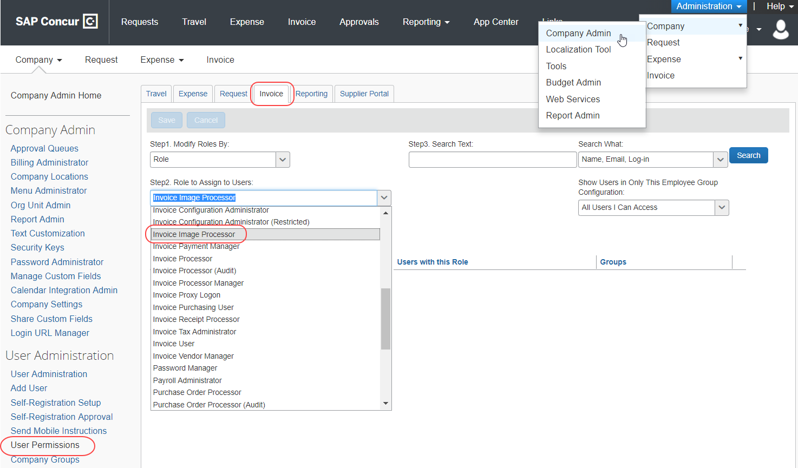
When the Configuration admin has added a scan configuration, an employee assigned the Invoice Image Processor role updates the Image Received information associated with an invoice. The invoice image processor may update the Image Received information in one of the following two ways:
- By using a scanner to read the barcode
- By entering the information manually from the invoice into the Request ID field on the Image Received page
After the employee has entered the data, the system updates the invoice appropriately, based on the policy and the scan configuration of the invoice.
- For information about the Invoice Image Processor tool, refer to the Concur Invoice: Process Images User Guide.

Invoice Image Processor Experience
The invoice image processor can access two pages, Image Received and Attach Images & View, from the Process Request Documents menu option in the Processor tool.
Image Received page:
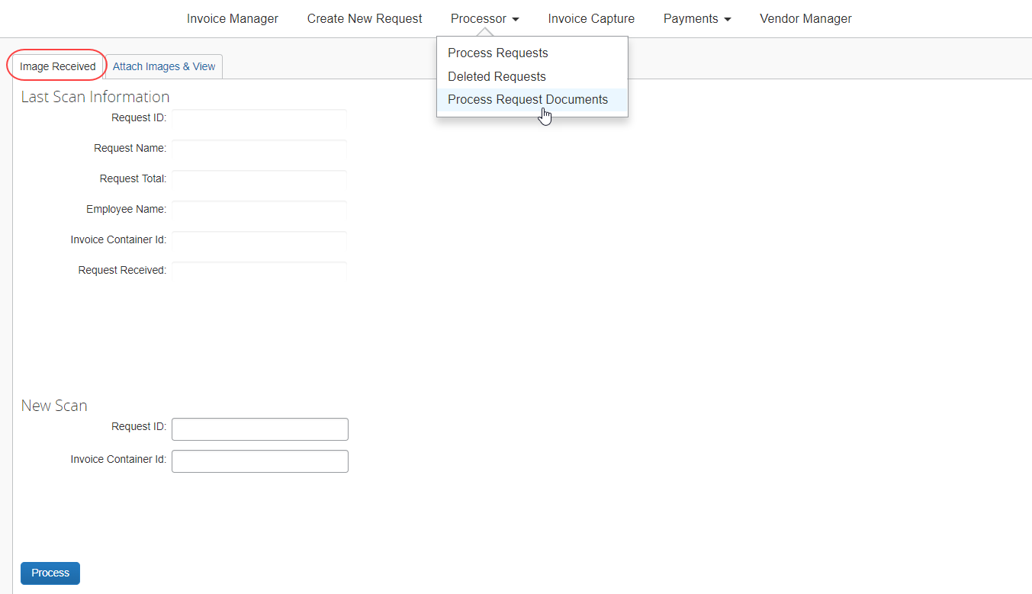
Attach Images & View page:
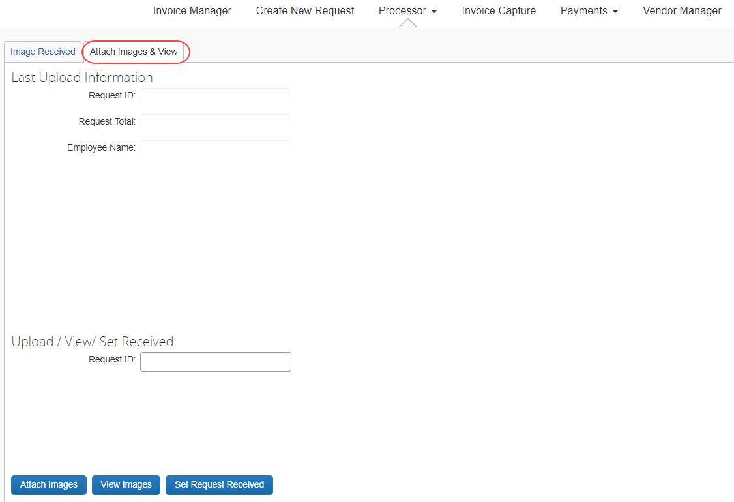

Administrator Experience
The Configuration administrator will see the following pages in Invoice Administrator related to image handling configuration:
- Image Handling
- Policies
- Workflows
On the Image Handling page, admins will see the Scan Configurations tab.
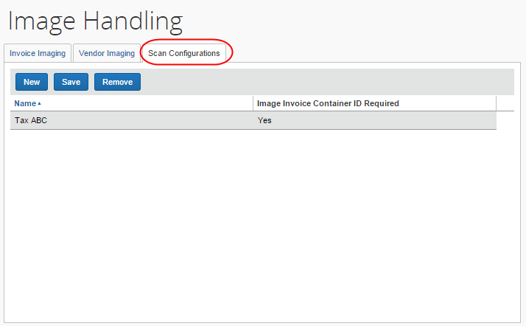
On the Policies page, admin will see the Scan Configuration list.
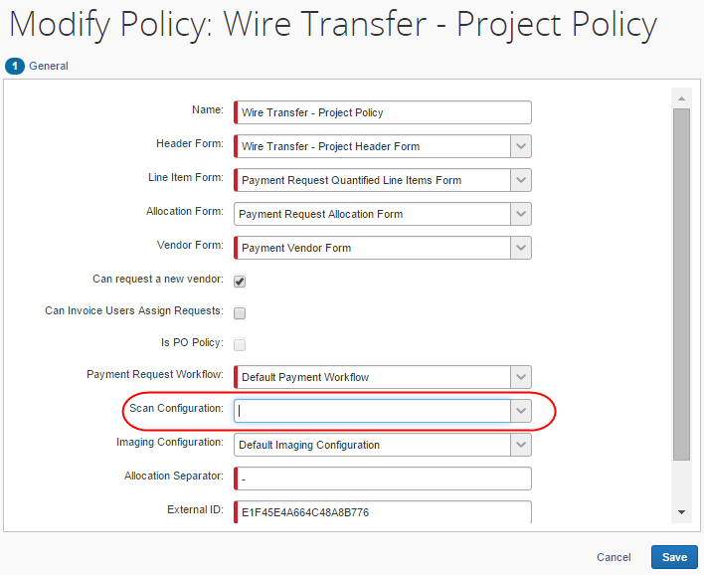
On the Workflow page, admin will see the Require Hardcopy Receipts option.
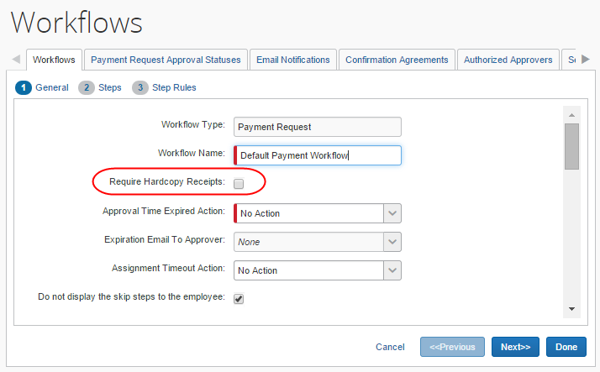
When the the admin selects (enables) the Require Hardcopy Receipts option on the Workflows page, they will be able to see the Hold for Invoice Hard Copy step on the Steps page.
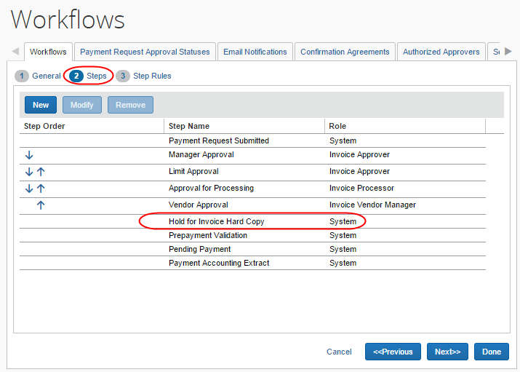
In addition, the admin will see the Hold for Invoice Hard Copy step on the Step Rules page.
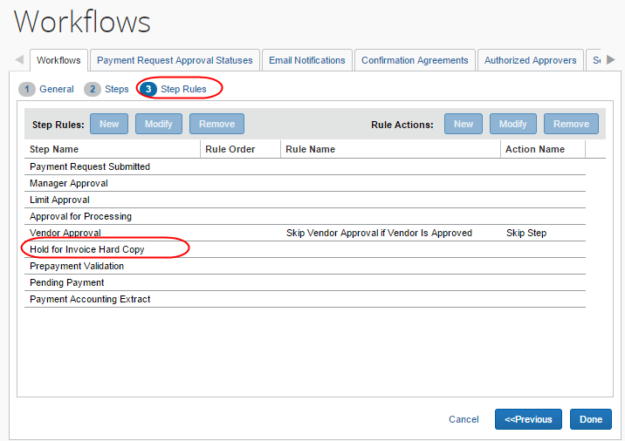

Configure the Scan Configuration Feature
Use this section to enable and configure the Scan Configuration feature.

The Basic Process
To start using this feature, the administrator must perform the following actions:
- Add a scan configuration
- Assign the scan configuration to a policy
- (Optional) Select (enable) the hardcopy receipt workflow setting

Configuration/Activation
To enable and configure this feature, you must first add a scan configuration. Once you have added a scan configuration, you must assign it to a policy. One configuration can be used by multiple policies; however, each policy can only use a single scan configuration. Finally, you may want to add a workflow setting that will check if the policy of the created invoice was associated to a scan configuration. This check happens after final approval, but before extract.

Step 1: Add a Scan Configuration
To add a scan configuration:
- Click Administration > Invoice.
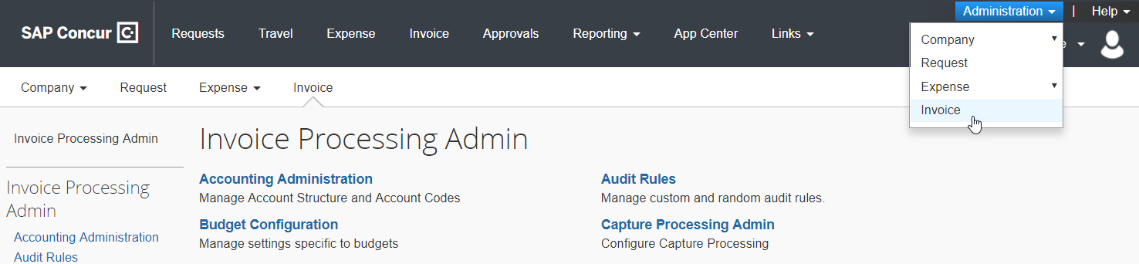
- Click Image Handling (left menu). The Image Handling page appears.
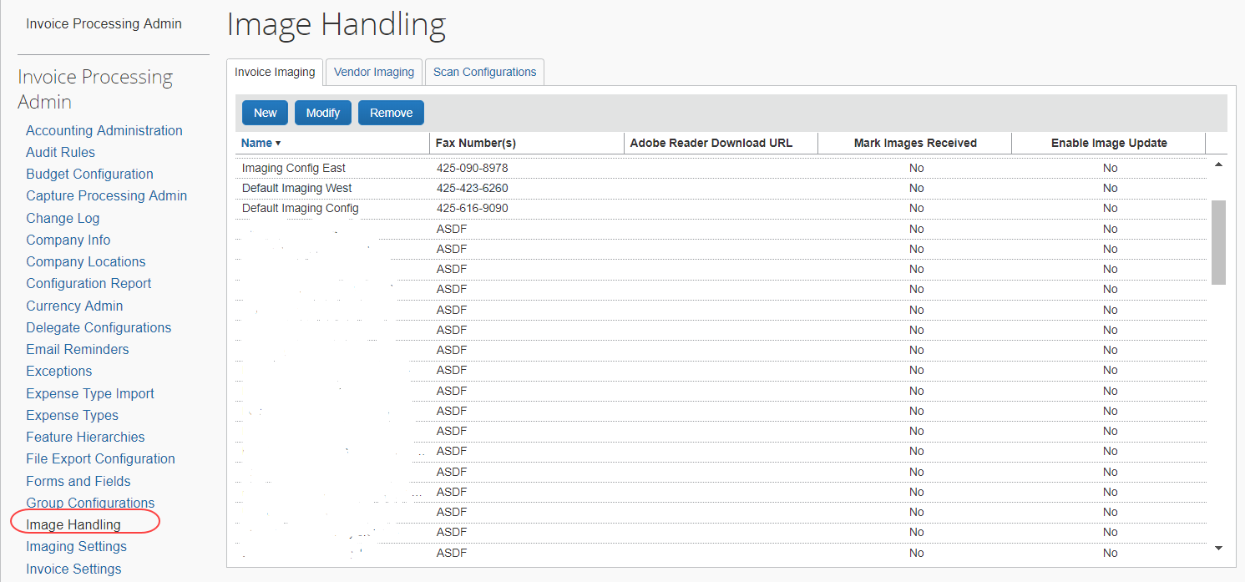
- Click the Scan Configurations tab.
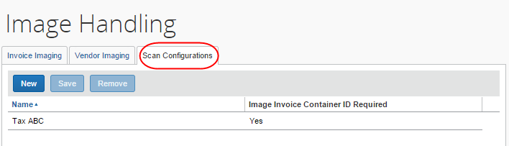
- Click New.
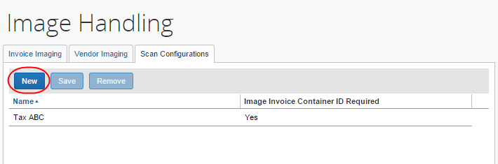
A new row appears ready for input.
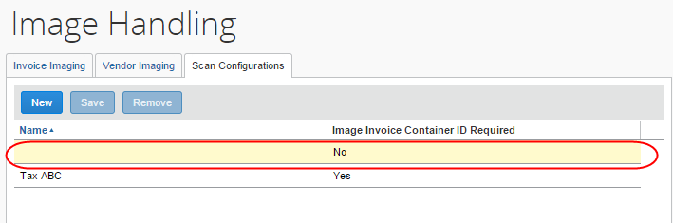
- Enter the required information based on the information in the table below.
Field | Description/Action
Configuration Name | This is the name of the scan configuration. The name does not need to be unique for each configuration; however, SAP Concur recommends that you use names that are easy to understand and to recognize in the list.
Image Invoice Container ID Required | Select Yes or No in the list.  If Yes, the invoice image processor must enter a Receipt Container ID value into the Image Invoice Container ID field for each invoice scanned.  If Yes, the invoice image processor must populate the Image Invoice Container ID field for invoices associated with this scan configuration on the Process Images page.
- Click Save. The new configuration appears on the page.
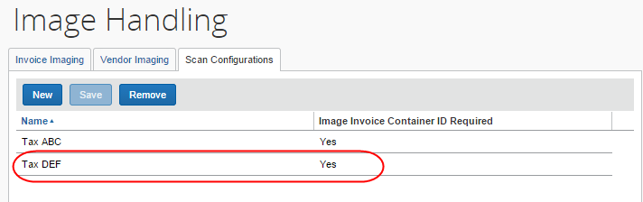

Step 2: Assign the Scan Configuration to a Policy
Once you have created a scan configuration, you must it assign it to a policy. One configuration can be used by multiple policies; however, each policy can only use a single scan configuration.
To assign the scan configuration to a policy:
- Click Administration > Invoice.
- Click Policies (left menu). The Policies page appears.
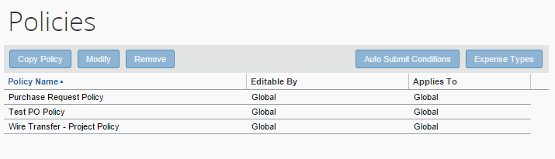
- Select the desired policy.
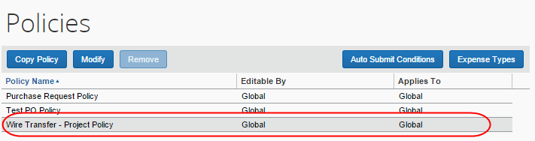
- Click Modify. The Modify Policy page appears.
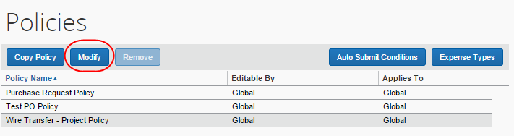
- Select the appropriate scan configuration name from the Scan Configuration list. This is the name that you created on the Scan Configuration page in Image Handling.
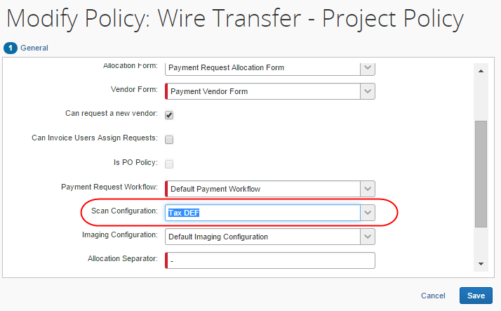
- For more information about policies, refer to the Concur Invoice: Policies Setup Guide.

Step 3: (Optional) Select (Enable) the Required Hardcopy Receipt setting
This procedure is optional. Select (enable) this setting if you would like Concur Invoice to match a physical image with an invoice and add a workflow step that will check for this match. If there is a match, the invoice will continue through the workflow. If there is not a match, the client cannot extract the invoice.
To select (enable) the Required Hardcopy Receipt option:
- Click Administration > Invoice.
- Click Workflows (left menu). The Workflows page appears.
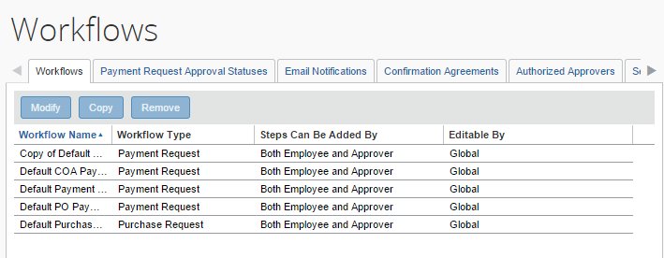
- Select the desired workflow.
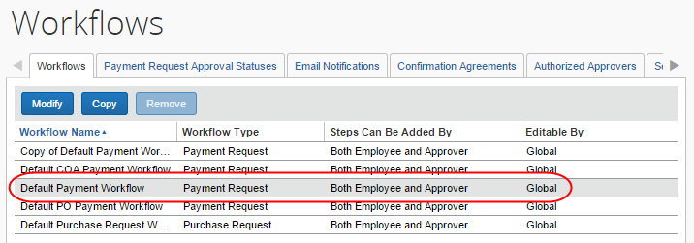
- Click Modify.
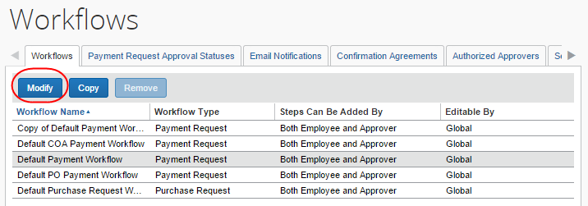
- Select (enable) the Require Hardcopy Receipts option.
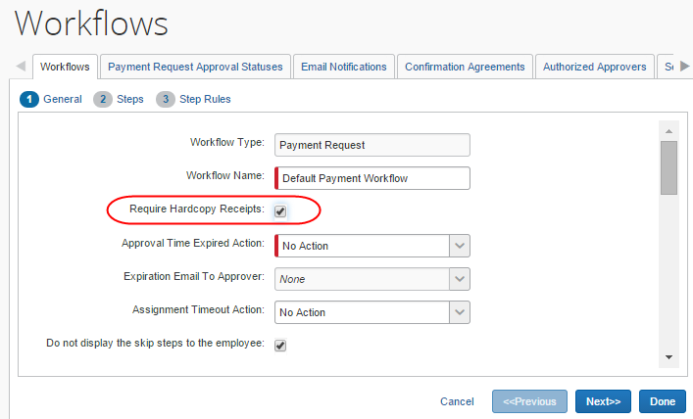
- Click Done.
- For more information about workflows, refer to the Concur Invoice: Workflows – General Information Setup Guide.

Managing Scan Configurations
If you need to modify or delete a scan configuration, use the following procedures.
To modify a scan configuration:
- On the Image Handling page, click Scan Configurations.
- Click on the desired scan configuration to edit it.
- Click Save.
To delete a scan configuration:
- On the Image Handling page, click Scan Configurations.
- Click on the desired scan configuration, and then click Delete.
☼

