
Concur Invoice: Capture Processing (Client-Managed)
Setup Guide
Last Revised: January 3, 2023

Applies to these SAP Concur solutions:
 Concur Expense
 Professional/Premium edition
 Standard edition
 Concur Travel
 Professional/Premium edition
 Standard edition
 Concur Invoice
 Professional/Premium edition
 Standard edition
 Concur Request
 Professional/Premium edition
 Standard edition
Table of Contents
Section 1: Exclusions 1
Section 2: Permissions 1
Section 3: Overview 1
Choosing a Capture Processing Method 2
Dual Support – Using Both Capture Processing Methods 2
Comparison: Classic and Current Client-Managed Capture Offerings 2
Required Roles 4
Terminology and Concepts 5
Terminology Used for Batch/Document/Page Structure 5
Supported Image File Types 6
Email Notifications Used in Capture Processing 6
Success Email Sent to the Supplier 7
Exception Email Sent to the Administrator 7
Routing Options: Auto-Assigning the Invoice 8
Ownership Assignment - Order of Assignment 8
Filter Vendors Based on Email Address Used by Vendor 9
Custom Routing Field 9
Section 4: Activating Capture Processing (Client-Managed) 11
Enabling Invoice Capture Processing 11
Section 5: Using the Capture Processing Admin Tool 12
Accessing Capture Processing Admin 13
Working With Options on the Forms and Fields Tab 13
Configuring Forms and Fields in Capture Processing 14
Use Invoice for Field Preparation of Capture Processing Fields 18
Procedure: Confirm the Form Configuration 20
Working With Options on the Task Definitions Tab 21
Configuring: Exception Email Address and Instruction Text Options 25
Working with Options on the Email Administration Tab 27
Adding an Email Alias 27
Adding an Email Address 29
Specifying an Email Alias and Capture Type 31
Filtering Vendors by Assigned Email Address 31
Working with Options in the Supplier Email Administration Tab 31
Setting The Email Acknowledgement to Act By Email or Globally 32
Working with Options on the Other Settings Tab 32
Configuring: Options in the Other Settings Tab 33
Section 6: Additional Information 34
Section 7: Appendix 35
Enabling CFDi Attachments for Reporting to Mexican Tax Authorities 35
Using the Email Address to Filter Vendor Availability 36
How It Works 37
What the Capture Processing Admin Sees 38
Configuration/Feature Activation 38
Additional Information About This Feature 42

Revision History
Date | Notes/Comments/Changes
January 3, 2023 | Removed the note in the Overview regarding the Invoice Capture paper invoice processing service retirement that occurred on December 31, 2022.
August 20, 2022 | Minor edit; no cover date change.
July 28, 2022 | Clarified the note to the Overview to address the pending retirement of the paper invoice processing service of Invoice Capture on December 31, 2022.
July 16, 2022 | Added a note to the Overview to address the pending retirement of the paper invoice processing service of Invoice Capture on December 31, 2022. Minor edits throughout.
January 31, 2022 | Minor style update and edits; cover date not updated.
January 4, 2022 | Removed reference to Internet Explorer. IE is no longer supported.
January 2, 2022 | Updated the copyright year; no other changes; cover date not updated.
September 20, 2021 | Updated step one of the “configure email recipient” procedure on page 26 to reflect that multiple addresses are supported.
February 20, 2021 | Added information about the Instruction Text option on the Verification page.
January 27, 2021 | Updated the copyright year; Updated the definition for Supplier Email Administration tab.
April 17, 2020 | Renamed the Authorization Request check box to Request on the guide’s title page; cover date not updated.
January 6, 2020 | Updated the copyright; no other changes; cover date not updated.
April 19, 2019 | Changed the term "payment request" to "invoice" as part of the new user experience for Concur Invoice.
January 29, 2019 | Updated the copyright; no other changes; cover date not updated.
April 6, 2018 | Changed the check boxes on the front cover; no other changes; cover date not updated.
January 29 2018 | Remove selected task definitions that are no longer used by the admin.
January 3 2018 | Clarify the routing options in the Ownership Assignment – Order of Assignment section.
September 16 2017 | Support for automatic attachment of CFDi tax documents for reporting to the Mexican tax authorities.
July 29 2017 | Updated with information that Chinese is now a value for Additional OCR Language field.
June 21 2017 | Updated with information about using an email alias to apply an attribute that automatically assigns the invoices to the user who emailed them.
June 3 2017 | The Capture Processing tool now calculates VAT based on field placement, and no longer uses the Policies tool to set the field's calculation behavior.
May 15 2017 | Support for the Winmail.dat file type is removed from the Supported Image File Types section.
April 22 2017 | Updated with information about:  - Automatic assignment of Vendor Owner to the Assign Request To field if a vendor is matched to an employee using the Vendor Mapping List options  - Support for calculations at the line item level for the VAT Amount 2-4 fields is included with this release
March 18 2017 | Added VAT information.
December 14 2016 | Changed copyright and cover; no other content changes.
December 5 2016 | Updated the guide content to new corporate style; no content changes.
November 4 2016 | Updated with information about rearranging fields on the Payment Request Line Item Details form by dragging and dropping the field to a new location.
June 17 2016 | Updated with information about associating an email alias to a default policy and language.
May 13 2016 | Updated with information about:  - VAT Amount 1 – 4 field usage  - Support for the Multiple PO feature available in the Invoice product
February 19 2016 | The PO Number field can now be added to the line item form.
November 20 2015 | Updated with information about:  - Options on the Supplier Email Administration tab are now available to the Verifier.  - Supplier email acknowledgments can now be handled globally, for all emails, or individually at the single email level.
October 30 2015 | Updated with information about audit trail created when tax and VAT changes occur.
July 10 2015 | Updated with information about:  - Dual support for both Client and Concur Managed versions is available  - Options supporting dual support are added to various parts of the user interface as explained in the document
June 12 2015 | Addition of the Supplier Email Administration tab in the Capture Processing Admin tool
May 15 2015 | The Instruction Text and Capture Attention To task settings are moved to the Task Definitions tab, under the Verification task definition.
April 10 2015 | Removed references to the current UI; made general updates to the content.
 | Older revision history has been removed.

Capture Processing (Client-Managed) Setup Guide
NOTE: Multiple SAP Concur product versions and UI themes are available, so this content might contain images or procedures that do not precisely match your implementation. For example, when SAP Fiori UI themes are implemented, home page navigation is consolidated under the SAP Concur Home menu.

Exclusions
Please note the following exclusions when working with Capture Processing:
- Multiple file upload is supported using Chrome, Safari, FireFox, or Microsoft Edge.
- A currency format that includes a decimal is enforced for capturing amount fields (Shipping; Tax). This means the amount data must be in the format "1.23" for successful capture to these fields.
- Currently the only exception email that can be sent for a selected batch that has failed conversion is the Attachment Format Not Supported email in the Batch List page. Additional exceptions will be added in upcoming releases.

Permissions
The Capture Processing functionality is available to selected users based on their role assignments. For example, those users with the AP User role in Concur Invoice can access the Capture Processing page. However, certain admin tools, such as those that activate Capture Processing, are limited to SAP Concur staff. In addition, managing emails (batches), documents, and associated pages requires the Client Managed Capture Verifier role, which should only be assigned to back-office personnel or your AP staff.
For this reason, the client may need to submit a service request to SAP Concur support to activate and configure some areas of the Capture Processing product.

Overview
The Capture Processing features of Invoice Management support capture and validation of invoice data using Optical Character Recognition (OCR). The features apply to two different methods:
- Invoice Capture Service: Managed, fee-based service where SAP Concur staff performs the verification of OCR results on behalf of the client.
- Client-Managed Capture: Free, client-managed feature of Invoice Management that lets the client self-manage the verification of OCR results
For both methods, the client provides suppliers with a unique SAP Concur-issued email to which invoices can be sent. Alternatively, the invoices can be mailed, scanned, and uploaded. From there, OCR is performed by the system. Either the client or SAP Concur staff performs verification of OCR results, after which each invoice is saved and advanced to the beginning of the workflow process.

Choosing a Capture Processing Method
Capture Processing may be configured at a client's site for Client-Managed, SAP Concur Managed (Service), or for both management types simultaneously. Options to work with both types of capture are available in the user interface, which is designed to allow easy identification and access of either capture type.

Dual Support – Using Both Capture Processing Methods
Dual Support lets a client process their emailed or uploaded batches using either capture method. When this feature is enabled, additional options appear that let the admin assign a capture type to one or more batches.

More Information
Clients will need to contact SAP Concur to activate this feature. There may be a fee for this service. Contact your SAP Concur account manager or SAP Concur support for more information.
- For more information about this feature, refer to Concur Invoice: Capture Processing – Dual Support User Guide.

About this Document
Included in this document are instructions on how to set up and configure this feature and key client considerations for optimal capture efficiency and visibility.
- This guide applies to the client-managed capture method only. For details on the Invoice Capture Service method, refer to the Concur Invoice: Capture Processing Dual Support User Guide.

Comparison: Classic and Current Client-Managed Capture Offerings
Some clients use a previous version of client-managed capture called Intelligent Capture. The following table describes the differences between the Classic Intelligent Capture and the Current implementation that replaces it:
Area of Product | Classic Implementation | Current Implementation
User Experience and Administration (Roles and Permissions) | Third-party OCR provider, requiring separate login and different look and feel. Requires separate OCR-provider administrator roles and associated permissions. | All functions are within Concur Invoice. Same login, user experience, and look and feel. Use the User Permissions tool to assign the AP User and Client Managed Capture Verifier roles; use the Invoice Admin tool for other configuration tasks.
Capture "Learning" Through User Feedback | Required: Concepts such as fingerprinting and templates, and functions, such as Wrong Vendor Selected, Highlighting Invoice Area, Dynamic Details (line item population) must be performed. The Verifier user needed to interact with the system to "teach" for improved recognition. | Not required: Capture Processing automatically performs these actions. Fingerprints, templates and other "learning" mechanisms are not used and are not relevant.  The Client Managed Capture Verifier role does not need to interact with the system to "teach" for improved recognition.
Payment Request Import | Required: Payment Request import must be set up and configured. | Not required: Immediate capture means the Payment Request Import is no longer needed; no import setup or subsequent job monitoring is required.
Format Choices | Must specify each format. | Date format, decimal separator, currency etc. are automatically determined by system attributes such as country and currency.
Image Types | Limited support for types. | More types supported.  - For more information, refer to the Supported Image File Types section in this document.
File Type Discovery | Must set file type for the system manually. | System automatically deduces file types.
Overall Usability (No. of Required Clicks) and Speed | Requires Stop, Hold, and Continue actions for successful resolution. | Increased load speed, fewer overall clicks for successful resolution.
OCR Technology | Template based. | Non-template based.
Email Attributes | No capability to capture email elements. | Email elements captured as metadata from the To:, From:, and invoice file name data values.
Monitor Status | Batch Queue and Job Monitor. | Capture Processing Batch List screen queue.

Note to Clients using Classic Intelligent Capture
- Can use both Classic Intelligent Capture and the Current Implementation simultaneously. They can continue using Classic for daily processing, while getting started learning and phasing in on Current. This means an easier transition at a pace that works for the client.
- Do not have to deal with any upgrade, data migration, or other transition of data or roles from Classic to Current. As noted above, fingerprints are not a relevant concept in Current, so there is no need to transfer fingerprint data from Classic.
Consult your Concur Invoice representative or SAP Concur support for additional details.

Required Roles
The following roles are used to activate, configure, and use the Capture Processing features.
- Invoice Configuration administrator (Unrestricted): To use Invoice Admin tools, such as Capture Processing Admin, Routing Configuration and Forms & Fields
- Invoice AP User: To access, with read-only privileges, the supplier emails on the Batch List tab
- Client Managed Capture Verifier: To access and work with document separation and verification, vendor selection, and final rejection or submission using options in the Document Separation and Verification tabs
- For more information about assigning roles to your users, refer to the Shared: User Admin User Guide.

Activating Invoice Capture Processing
SAP Concur support and Implementation will use the Concur Admin and Concur Consultant roles to activate the product in Hosted Management Console (HMC) and configure those activation tools to which the client does not have access.

Configuring Invoice Capture Processing
The Invoice Configuration administrator (Unrestricted) and User Admin roles are used to work with additional tools to which the client may not have access, for example, the Capture Processing Admin tool and the User Administration (permissions) tool.

Working within Invoice Capture Processing
The Invoice Capture Processing user will use the Client Managed Capture Verifier and Invoice AP User roles to access and use the Capture Processing page and its options.
TIP: Depending on the company size, you may have the option of dividing the tasks of reviewing supplier emails (AP User) with those that include the separation, verification, and submission of invoices (Client Managed Capture Verifier). This division of tasks can prevent possible fraud and ensure security at the client organization.
- For more information about assigning roles to your users using the User Permissions tool, refer to the Shared: User Admin User Guide.

Terminology and Concepts
The following terms are used throughout this document:
Batch: One or more invoice attachments either emailed or uploaded into the Capture Processing system.
Email: A Batch that has been emailed to the client’s view via their dedicated email address provided to the supplier for this purpose.
Upload: A Batch that was added to the list using the Upload button.
Locked, Unlocked: The state of a batch when the Verifier is working with a batch and it is unavailable to anyone else. This is because only a single person may have a session with a batch at one time.
Classic versus Current: There is a legacy Intelligent Capture product that is referred to as classic (DataCap), while the current iterations, both Client-Managed and SAP Concur service managed, are referred to as current (Capture Processing).
Document Separation: A step in the preparation process where the Client Managed Capture Verifier role reviews the batch for file and page grouping. To do this, they add or remove pages within files to create a single invoice, check and correct orientation in anticipation of the next step, process via OCR to generate the invoice.
Verification: A step where the Client Managed Capture Verifier role reviews the post-processing capture results, noting incorrect field capture and manually coding additional custom fields added onto the form by the client.

Terminology Used for Batch/Document/Page Structure
Batch: A collection of one or more Documents each with one or more Pages sent by the supplier. Taken together, each document’s pages form an invoice whose data will be processed into an invoice.
Document: A file of one or more pages. The file is converted by the system into PDF format and displays in a hierarchy above its associated pages (invoices).
NOTE: A document is referred to as an "attachment" in the user interface. For example, you rename and select pages for an attachment when using Processing.
Page: A single Page (invoice) within a Document represents all or part of an invoice, and after processing results in an invoice.
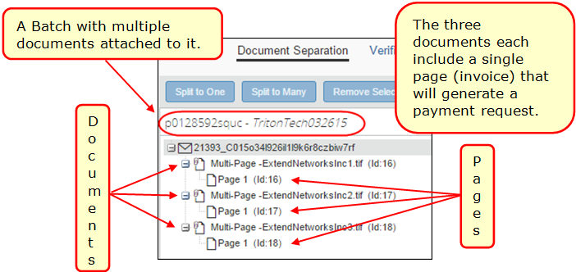
Split: To move an invoice from one document to a new document, either as the single invoice (Split to Many command), or one of several within the batch (Split to One command).

Supported Image File Types
The following file and image types are supported when uploading or emailing invoices:
- TIF, TIFF
- JPEG, JPG
- PNG
- PDF (with XFA; with embedded fonts)
- Word file (DOC; DOCX)
- Excel file (XLS; XLSX – not supported: XLTS)
- EML (File saved using Microsoft Outlook)
- CSV

Email Notifications Used in Capture Processing
Capture Processing processes and confirms the format and nature of all attachments included with incoming email from the supplier. After processing, the system sends email notifications automatically under the following circumstances:
- To the supplier, on successful receipt and processing of invoice attachments
- To the Processing administrator if an exception was encountered
These emails cannot be modified. They are generated by the system without intervention by the Invoice Capture Processing administrator.

Success Email Sent to the Supplier
The system auto-sends a non-modifiable email notification directly to the supplier’s originating address on successful receipt and processing of the supplier’s original email. The email looks similar to the following image.
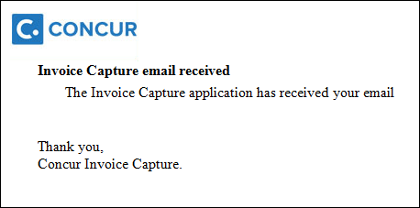

Exception Email Sent to the Administrator
A supplier email and its attachments may fail to process. The reason for a rejected email may be the inclusion of attachments whose format is not supported, a locked file, or attachments that are not invoices, such as dunning notices, statements, or emails lacking an attachment.
This email, along with the failed attachment(s), are sent to the address specified during configuration using options in the Invoice Admin > Capture Processing Admin > Other Settings tab. The specific exception and the files that failed processing are listed in the body of the email:
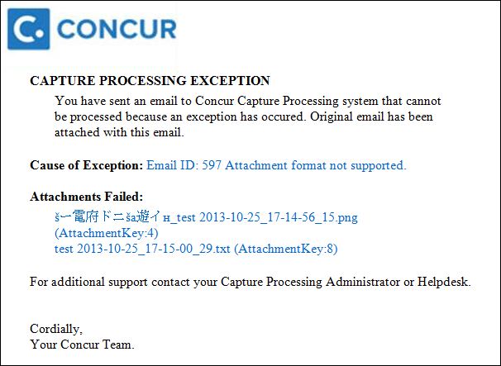
TIP: Instead of a single recipient, create a dedicated email alias that includes all relevant AP department/Verifiers, so that the email is received by more than one person who can act on it.
- For information about setting up the email address to which the exception emails are sent, refer to the Configuring: Exception Email Address and Instruction Text Options section in this document.

Routing Options: Auto-Assigning the Invoice
Overall, there are two different types of routing; user defined and system-based assignment logic. In operation, the user defined logic has precedence over the system-based assignment logic.

Ownership Assignment - Order of Assignment
- Purchase Request Owner (Invoice Settings)
- The ability to have invoices auto-assign to the Purchase Request Owner is available by selecting Assign Invoice to Purchase Request Owner check box in Invoice Settings
- User defined and highest priority
- Routing Configuration
- Based on feature hierarchy and hierarchy mapping list
- User defined and only used if the Purchase Request Owner is either not activated or not found
- Use Email Alias Address to Route Emailed Invoice to Invoice Owner
- Supports those clients who want the user who originally created and submitted an invoice to handle the processing and completion of the invoice. Create an email alias and set the Owner Assignment to "Sender", all emails associated with the alias are routed directly to the sender. The system identifies the "From" email of the sender and will route the invoice to the user associated with the email
- User defined and takes effect if the steps detailed above are not activated
- Assignment at the Invoice Level (Applies to both Capture Processing Client Managed and Invoice Capture Service)
- The user can supersede any assignment at the Batch level by assigning or changing the owner. The Capture Attention To feature must be activated for Capture Processing for this to work. Assign Invoice to will default to the Batch owner or the owner listed on the invoice and can be overridden.
- System based assignment logic
- Assignment at the Batch Level (Applies to Capture Processing Client Managed only)
- The user inputs the owner into the Batch Invoice Owner field for uploaded batches and then assigns the entire batch to that owner during the Verification step.
- System based assignment logic
- Assignment via Vendor by Associated Invoice Owner's Employee ID
- Assignments can be made in the Approved Vendor Import 200 record, or through the UI in Vendor Manager
- System based assignment logic
- Unassigned Queue
- An invoice that is not assigned will fall into the Assign Invoice queue

Assigning Invoices – Special Cases When Assigning Invoices
When the AP user opens an unassigned request type in the Assign Invoices queue, they see a message reminding them that the invoice is being assigned to them. However, this is a "soft assignment," so copy downs are not performed (e.g., Employee to Request Header values will not copy down).
Additionally, if the AP user is the Invoice Owner for the invoice, they will need to select themselves as the Invoice Owner and accept the new owner's copy down values for the invoice.

Filter Vendors Based on Email Address Used by Vendor
You can decide to filter the vendors that can be assigned to an invoice, thus increasing the accuracy of the vendor by reducing the number of available selections. By associating email addresses to a single email alias, then assigning the alias to a group of vendors, only those vendors are available during the OCR step, and when changing vendors manually during the verification step.
- For more information, refer to the Appendix: Using the Email Address to Filter Vendor Availability section in this document.

Custom Routing Field
The Routing Configuration feature allows clients to maintain a list of values mapped to Invoice Owners. When combining this feature with the inclusion of the relevant Custom field (Store Number, etc.) on the Verification form, an auto-assignment or "straight-through processing" affect can be achieved.
Typical values might be Store Numbers, Project Numbers, Account Numbers, or other list values that have a one-to-one relationship with an Invoice Owner. Other desired attributes are:
- Consistently included by suppliers on invoices
- AND -
- Is clearly labeled (including common variants, such as Account Number, Acct #, or Account No.)
- OR -
- Has a pattern which the client, self-managing this process, can identify without a label
Information on how to configure a custom field for inclusion in Capture Processing is detailed below.
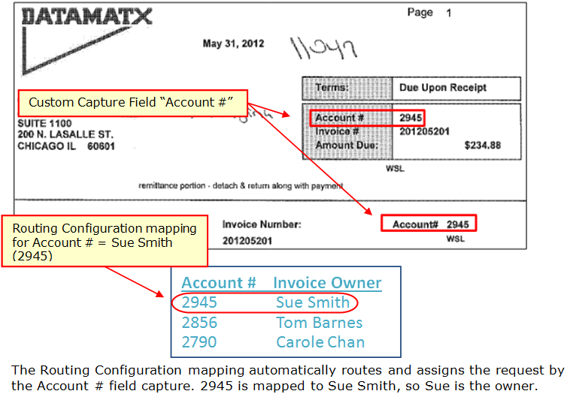
- For more information, refer to the Concur Invoice: Routing Configuration User Guide.

Activating Capture Processing (Client-Managed)
SAP Concur staff Capture Processing (client-managed) using options in Hosted Management Console (HMC). As this tool is not available to the client, a Service Request should be submitted to SAP Concur support to have Capture Processing activated for their company.

Enabling Invoice Capture Processing
Enable an entity for the Capture Processing feature by first identifying the client entity in HMC, and then using the Features Wizard option to activate it.
Enable the feature in HMC:
- In HMC, click Company Entity Management, search for the entity using the available options, then click Manage Entities.
- In Feature Activation, click Features Wizard.
- Scroll down to Intelligent Capture (IC) Type to view all options for Capture Processing.
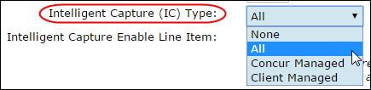
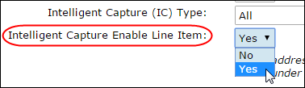
Select a setting as needed.
Field | Description
Intelligent Capture (IC) Type | Select a capture type:  - None: Feature is deactivated  - All: Both capture types  - Concur Managed: Service-based implementation of capture processing  - Client Managed: Client-based implementation of capture processing
Intelligent Capture Enable Line Item | Select Yes to collect line item data for the client.  NOTE: Select No if line-item data is not used for any reason, including coding or reporting.
Intelligent Capture Email | NOTE: This setting has been moved to the Email Administration tab of the Invoice Admin > Capture Processing Admin tool.  - For more information, refer to Working with Options on the Email Administration Tab in this document.
- Click Next and in the Jobs to Add List review the jobs and remove or add as required (none are required for this feature but be sure not to add any here).
- Click Next > Next > Skip, then Start Process.
- Click Exit to return to the Company Entity List page.
- Click Console Central, then Entity List.
- Under Cache, click Flush. This step must be completed to see changes to the entity user interface.
- Exit HMC.

Using the Capture Processing Admin Tool
When Capture Processing (client-managed) is activated several links appear to the administrator, including a link to the Capture Processing Admin tool. This tool is used by the Invoice Configuration administrator (Unrestricted) role to prepare Capture Processing.
The tool includes options available on several tabs on the page:
- Forms and Fields: Configure the processing-specific forms on this tab, adding default (supported capture) fields and other fields, as required
- Task Definition: Specify the forms (if required) for the verification task and configure separation and extraction tasks.
- Email Administration: Create one or more email addresses, each assigned to an alias and a capture type, for batch emails sent by the supplier. Use an email alias to set attributes, such as auto-assign to sender, for all emails associated with the alias.
- Supplier Email Administration: You can configure how Concur Invoice responds to supplier emails using the options on this tab. For example, you can configure Concur Invoice to block or not respond to supplier emails.
- Other Settings: Additional settings for configuration of Capture Processing
- It is critical that these settings be configured prior to use. For example, the Client Managed Verification option for the Task Processor field must be selected, or the admin will not see either the Verification or Document Separation options.

Accessing Capture Processing Admin
The Invoice Configuration administrator (Unrestricted) role navigates to Administration > Invoice > Capture Processing Admin to open the page.
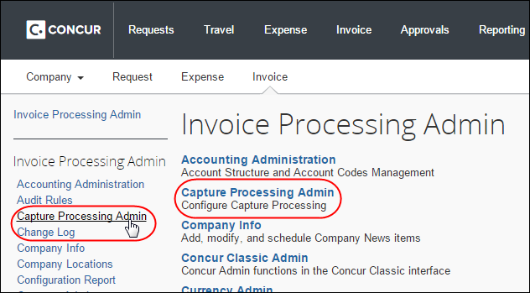
The page opens to the Capture Processing view of the Forms and Fields tab.
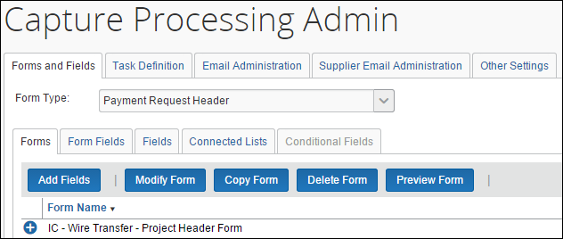

Working With Options on the Forms and Fields Tab
The Forms and Fields tab lets the admin verify the form and field setup for Capture Processing and, if necessary, customize forms by adding and removing fields as required for the verification and coding process. Note that some fields required by the company on invoice creation, such as a Coding field or similar, may not make sense for Capture Processing as not all vendors provide this information.
For this reason the client should consult with SAP Concur staff, if necessary, to refine the field set as needed. Note also that only specific fields will be automatically captured by OCR (refer to table below). Remaining fields added to the form save time by combining verification and coding into one step, but will require manual entry by the Verifier role.

Configuring Forms and Fields in Capture Processing
The client will copy one or more default forms and rename them, after which each copied form is available for selection in the Task Definitions tab. The admin can verify what form is currently being used by accessing the Task Definitions tab and opening the task (Verification in the figure below) to identify the forms in use.
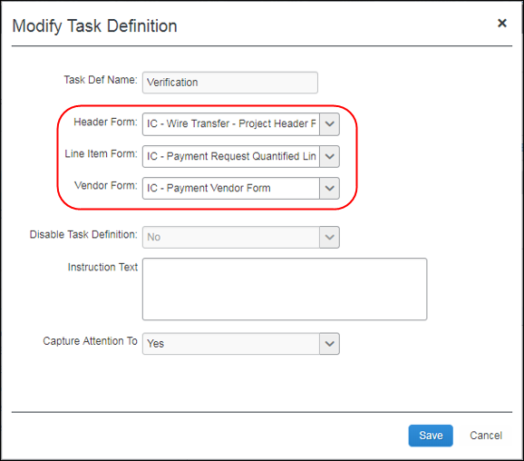

Default and Optional Form Fields: General
Each form configured for Capture Processing employs a set of default fields that the Capture Processing system looks for and populates automatically. These include the fields shown in the table below:
Fields Supported for Capture for Client-Managed Capture Processing
Header Fields
Vendor Name | Invoice Date | Invoice Number
Currency | Total Amount | Shipping
Tax | PO Number | Invoice Owner is configured
Vat 1 (Australia GST, US Tax, VAT UK/Japan) * | Vat Amount 1 - 4
Line-Item Fields
Part Number | Description | Total (calculated)
Quantity | Unit Price | PO Number
Vat 1 (Australia GST, US Tax, VAT UK/Japan) * | Vat Amount 2 - 4
NOTE: Fields may be added to the form but will require manual entry and coding by the Client-Managed Capture Verifier role.
* On screen calculation behavior for these fields is dependent upon which form, the Header or Line Item, the VAT field is placed on. Once a VAT field is added, calculations are performed based on the location as follows:
- Request Total = Header Shipping + Header Tax (or line tax) + (Header VAT total (if exists and has non-zero value)) + Line item Total
- OR -
Line VAT total (if exists and has non-zero value)
- Amount Remaining to be itemized = Invoice Amount - (Header Shipping + Header Tax (or line tax) + (Header VAT total (if exists and has non-zero value)) - Line item Total
- OR -
Line VAT total (if exists and has non-zero value)
Each form can also be configured to match the client’s verification process. For example, some optional (not on the form by default) fields may be required. This means a company would want to add the optional Tax and Shipping fields (as examples) to capture these values. Additionally, other fields may need to be renamed to provide clarity and match the client’s specific process.
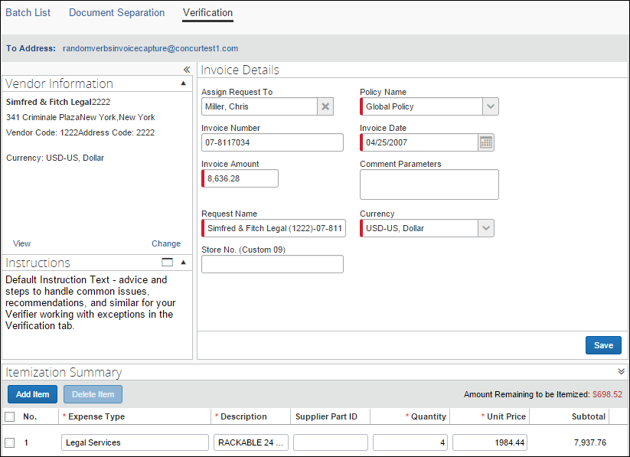

Default and Optional Form Fields: Vendor Form
The Capture Processing vendor form features a single field, Vendor Code, which is the only field that will be identified and captured when processing. Adding fields will not result in data in these fields being captured by the system.

Capturing Tax Data
For clients interested in capturing tax when using Capture Processing, multiple options are available to meet the needs of their business.
- Header Form Capture: When the existing tax field is activated for use in the Verification header form, the system will extract, and populate this field with Sales tax/VAT/GST (when the invoice contains VAT.)
SAP Concur recommends a custom field when manually capturing additional tax amounts. The Verifier will need to update the Total Amount value manually as well.
- Allocation Form Capture: If the client wishes to itemize tax in a single row in the Itemization section, they can do so in multiple ways:
- Manually enter one or more line items (if more than one tax type) for the total tax on an invoice
OR
- To capture tax specific to each line item row, do so by creating a Custom field for that tax value, then manually populate the tax amount in that field for each row. This will require the end user to calculate the total amount for each row manually. (Client-Managed only.)
Tax and VAT field data may change based on assigned owner, vendor, policy, or expense type assignment; an audit trail entry is created when this happens detailing the change from old to new amounts.

Configuring and Capturing VAT Data
Capture Processing specifies how VAT is calculated based on the actual placement of the VAT field on the form. Fields are added to a form using the Administration > Invoice > Capture Processing Admin tool, either on the Header or Line Item form.
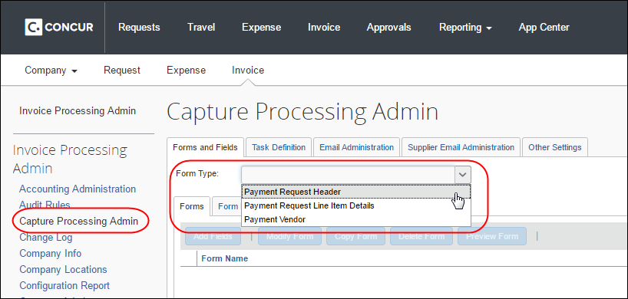
Once a VAT field is added, calculations are performed based on the location as follows:
- Request Total = Header Shipping + Header Tax (or line tax) + (Header VAT total (if exists and has non-zero value)) + Line item Total
- OR -
Line VAT total (if exists and has non-zero value)
- Amount Remaining to be itemized = Invoice Amount - (Header Shipping + Header Tax (or line tax) + (Header VAT total (if exists and has non-zero value)) - Line item Total
- OR -
Line VAT total (if exists and has non-zero value)
Please note the following when using the VAT feature:
- If both the header and line item VAT fields have non-zero values, then the line item VAT placement has precedence and that will be considered for calculation, (header VAT values will be ignored in that case).
- Tooltips are now added on the field Amount remaining to be itemized. This will help the user by providing the calculation details and the values for each field involved in that calculation.

Use Invoice for Field Preparation of Capture Processing Fields
Fields are configured using the Invoice Admin > Forms and Fields tool (that is, not using options on the Forms and Fields tab in Capture Processing). Fields configured using the Concur Invoice tool are made available "one-way" to the Capture Processing forms and fields module for additions to that feature’s forms. There, the administrator will find limited functionality similar to Concur Invoice, and can use these options to fine-tune some fields by, as an example, renaming them.

Example: Configuring the Field in Invoice for use In Processing
Assume a Custom-type field must be employed to allow the Verifier to capture (manually) the supplier’s store number. This example field, Store No (Custom09), is configured in the Concur Invoice Forms and Fields tool, and is made available in both Concur Invoice and Capture Processing for fine-tuning and addition to forms.
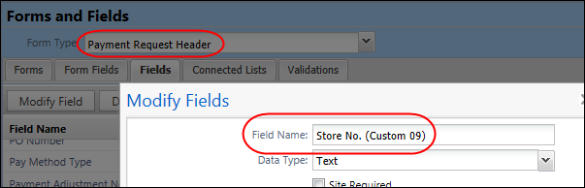
The admin opens this field in Capture Processing by clicking Fields and then selecting and opening the field. Note the limited access to options; these are reserved for Concur Invoice, while Processing-specific options are available for configuration here (such as the Access Rights for the Client-Managed Capture Verifier role, an option logically not available in Concur Invoice).
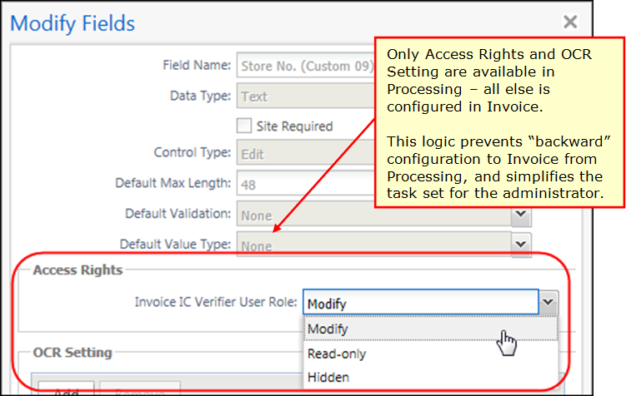
TIP: A field label (50-character limit) can convey information to the Client Managed Capture Verifier role since the configuration you are performing is reserved only for Capture Processing and will not appear in Concur Invoice. As an example, renaming the Invoice Number (fieldlabeltext) field to Invoice Number (Ven Code, Location) reminds the Verifier that the value for this field must be coded as the invoice number, the vendor’s code, and the specific vendor location.
- For more information, refer to the Concur Invoice: Forms and Fields Setup Guide.

Optional: Adding and Using Routing Configuration Fields
The Routing Configuration feature lets you tell the system to automatically route an invoice directly to an invoice owner without intervention by a user. Using the Invoice Routing Configuration tool, a Custom field is configured so that, dependent on value, the invoice is routed (assigned) to the correct owner’s invoice queue.
For example, in a Project field, entering a value of 123 auto-assigns the invoice to Terry Brown. Or, for a connected list field set, the selection of Company > Division > Department where the last value is 123 again assigns to Terry.
- For more information, refer to the Concur Invoice: Routing Configuration User Guide.

Procedure: Confirm the Form Configuration
In this step, the admin opens each form they will use and confirms the form name and field set.
To open the form and confirm the fields:
- In Capture Processing, select a form from Form Type and then click the Forms tab.
- Click the "+" to open the form and note the field set.
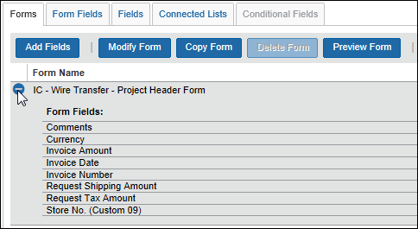
- Click the form name, then any of the following buttons to configure the form:
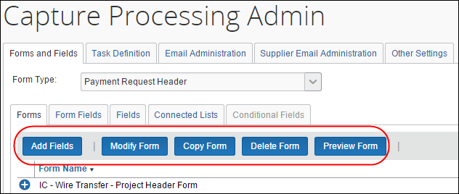
- Add Fields: Click to select one or more fields, then click Add Fields
- Modify Form: You are limited to renaming the form with this step
- Copy Form: Copy the existing form to create a new one, renamed as needed
- Delete Form: Unavailable if this is the default form; only copied forms may be deleted
- Preview Form: Click to view a representative display of the form and fields
- Continue through each form you intend to use in Capture Processing.

Working With Options on the Task Definitions Tab
Task definitions allow the Invoice Configuration administrator role to change task behavior to match a client’s capture needs. In most situations, the administrator should accept the default settings as they support full use of the feature. However, if a site wishes to change the separation task from manual to automatic, selected definitions must be configured to do so.
When working with definitions, note that not all definitions incorporate the same set of options, and not all definitions can be modified. As an example, the verification task includes options to specify the correct forms that appear, while the separation tasks work in tandem by requiring that both separation definitions be modified to change the functionality of the separation overall.
To work with task definitions:
- In Capture Processing, click the Task Definitions tab.
- Select the definition and click Edit.
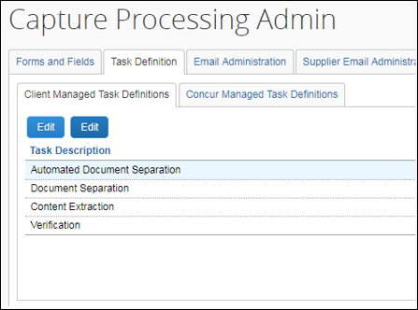
- In the Modify Task Definition window, select options as detailed in the table below.

Task Name | Description
Verification | Controls the display and use of options on the Verification tab of Capture Processing.  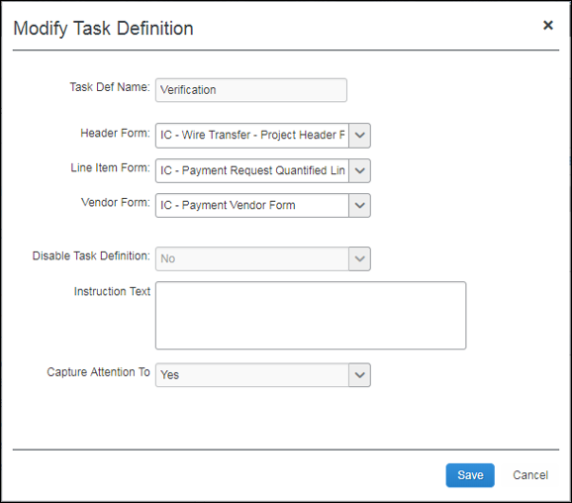  - Task Def Name: The name of the task.  - Forms (appear in Verification tab)  - Header: Specify the header form to use  - Line Item: Specify the line item form to use  - Vendor: Specify the vendor form to use  NOTE: Fields for these forms are configured using options in the Forms and Fields tab.  - For more information, refer to the Configuring Forms and Fields in Capture Processing section in this document.  - Disable Task Definition: No (enabled) by default; select Yes (disabled) to disable verification.  - Instruction Text: For more information, refer to Configuring: Exception Email Address and Instruction Text Options in this document.  - Capture Attention To: For more information, refer to Configuring: Exception Email Address and Instruction Text Options in this document.
Content Extraction | Controls the method of extracting the data from the invoice to create the invoice in Capture Processing.  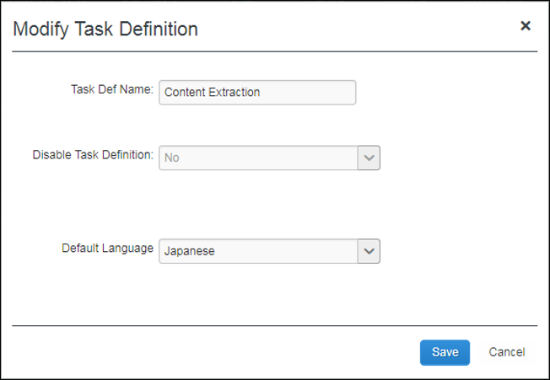  Task Def Name: The name of the task.  Disable Task Definition: No (enabled) by default; select Yes (disabled) to disable content extraction.  Default Language: Set the default language used on extraction.
Document Separation | Controls the method used for document separation, and in tandem with the Automated Document Separation task, allows the client to switch between manual document separation and the automated capture in Capture Processing.  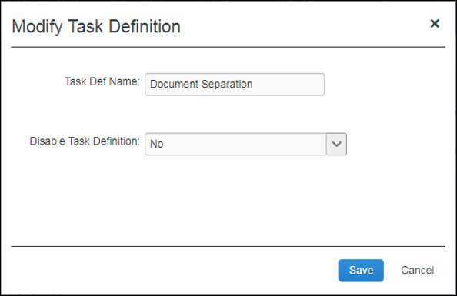  Task Def Name: The name of the task.  Disable Task Definition: No (enabled) by default; select Yes (disabled) in conjunction with selecting No in the Automated Document Separation definition to have the system perform automated (not manual) separation of document pages to processing-ready state.
Automated Document Separation | Controls the method used for document separation, and in tandem with the Document Separation task, allows the client to switch between manual document separation and the automated capture in Capture Processing that requires the use of separator pages between invoices.  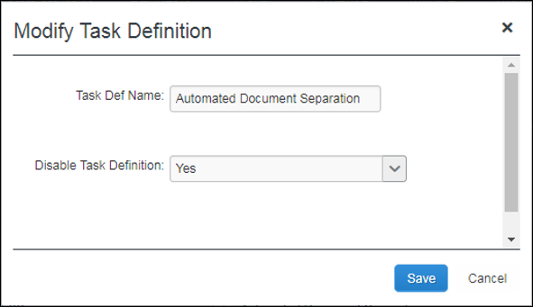  Task Def Name: Name of the task.  Disable Task Definition: Yes (disabled) by default; select No (enabled) in conjunction with selecting Yes in the Document Separation definition to have the system perform automated (not manual) separation of document pages to processing-ready state.

Configuring: Exception Email Address and Instruction Text Options

Exception Email Address
All supplier emails received for processing are viewed and handled by the system, including those that cannot be processed. When the system encounters an email that cannot be processed (unsupported document type; credit memos), the original email is formatted into a single PDF document that is sent as an attachment in the exception email notification to the recipient specified in Exception Email Address.
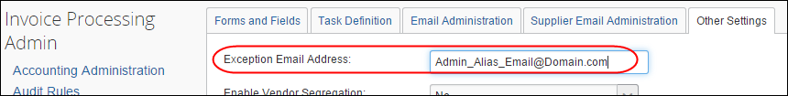
The recipient of the exception email is provided both the type of exception that was generated and a list of the files that were rejected by Capture Processing.
- For more information, refer to the Email Notifications Use in Capture Processing section in this document.

The Client Managed Capture Verifier role may need guidance when handling credit memos or other attachments. The Instruction Text option is used to provide special instructions under these circumstances. When populated, the text appears under Instructions in the Verification tab. When you click on the Instruction Text option, a separate window is opened with the instructions that you can move and resize so that the instructions are easily available next to the invoice you are processing.
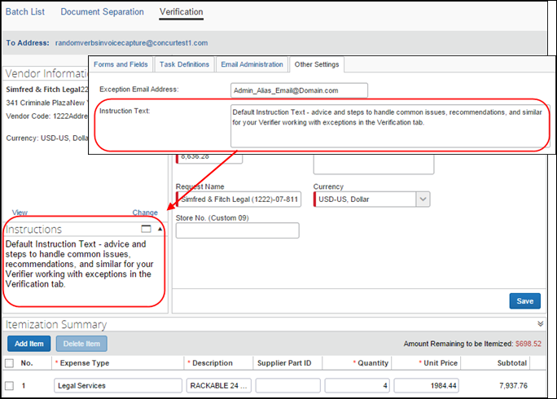
To configure the email recipient and instructional text:
- On the Other Settings tab, type an email address in Exception Email Address. To add multiple email addresses, separate the additional email addresses using a semi-colon. For example:
AP1@company.com; AP2@company.com
TIP: Create a dedicated email alias (email distribution list) that includes all AP department/Verifiers.
- Under Instructional Text, type instructions about how the Verifiers should handle special situations they may encounter.
- Click Save (or press Enter).

Capture Attention To
Capture Processing can identify the Attention field in its various forms (Attn, Attention, etc.) and pull the employee’s name from this field for routing purposes. By setting this option to Yes (default is No), Capture Processing will attempt to capture the name and route accordingly.
The Capture Attention To option adds the optional Assign Invoice To field to the Invoice Details section of the Verification tab, which is useful whenever you need to manually search for and assign the invoice to the invoice owner or let Concur Invoice assign a vendor owner automatically.

Assignment When Vendor has a Vendor Owner
The Assign Invoice To field is automatically populated with a Vendor Owner name if the Vendor Manager has configured both the Capture Attention To feature in Task Definitions, and the mapping of employee to vendor using options in the Vendor Manager > Vendor Mapping List page.
TIP: If the client is using the auto-routing features available using the Routing Configuration tool, the Capture Attention To option is not required and in fact should be disabled (No). The Routing Configuration takes precedence, and when enabled is usually considered the more accurate and easily maintainable assignment option.

Working with Options on the Email Administration Tab
The Email Administration tab includes options that let the admin add email addresses and associate these email addresses to an email alias. The purpose of this is to apply attributes to the email address so the system will automatically know what group, invoice assignment, and capture type attributes to apply based on the email address used to send invoices.
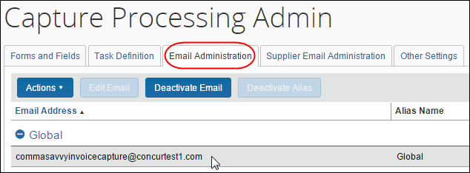

Adding an Email Alias
An email alias can be used to apply attributes to a group of email addresses associated with the alias. For example, the admin can set the policy, OCR language, and assignment of invoices on receipt. These options are available in the Manage Email Alias page.
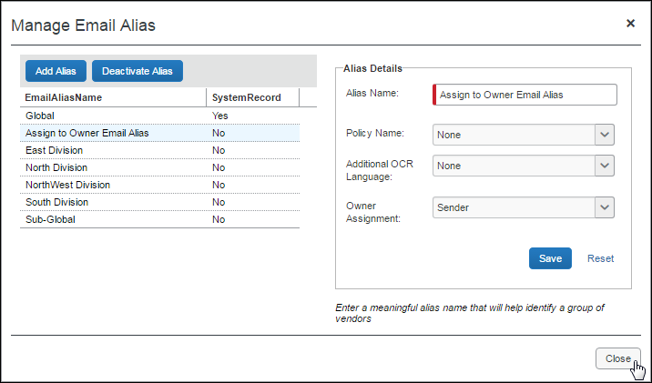

Adding an Email Alias and Setting Attributes
Add an email alias whenever you want to apply similar attributes to a group of email addresses.
To add an email alias:
- Click Administration > Invoice > Capture Processing Admin > Email Administration tab.
- Click Actions > Manage Email Alias > Add Alias.
- Type the name in Alias Name, and set the following optional attributes:
- Policy Name: Select the policy that will be associated to invoices included in any batch emailed using this alias
- Additional OCR Language - Select an option:
- None: Latin-based character set
- Japanese: Japanese character set, then Latin-based character set
- Chinese: Chinese character set, then Latin-based character set
The None setting is superseded if a language is configured in Modify Task Definition > Default Language.
- Owner Assignment: Select Sender to have the system automatically assign the invoice to the user sending the invoices via their "From" email address

Working with the Owner Assignment Option
Any employee who creates and sends invoices to Capture Processing can be automatically assigned these invoices on receipt by the system. This is useful for those clients whose invoice handling workflow requires that the invoice creator also be responsible for all processing steps, from scan and email, to coding, and finally to successful submission of the invoice.
To set auto-assignment of invoices to the email sender:
- Navigate to the Manage Email Alias window.
- Under Owner Assignment, choose Sender.
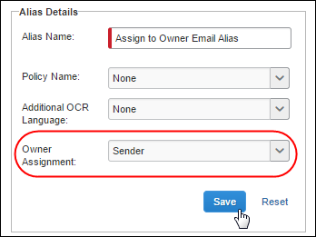
- Click Save, then click Close.
By selecting Sender for this email alias, all "To Concur" emails associated with the alias are detected and routing set to assign the emailed invoices directly to the sender. This is done by identifying the "From" email address of the sender and noting which employee is systematically associated with the email. The system is instructed to assign to sender via the "To" email and is provided with the employee’s name through their "From" email address.

Adding an Email Address
The Add Email window includes all options to configure and activate the email.
Type an email address, with a suffix of "concursolutions.com" in the text box (see Examples of Acceptable Email Formats below for required format of email).
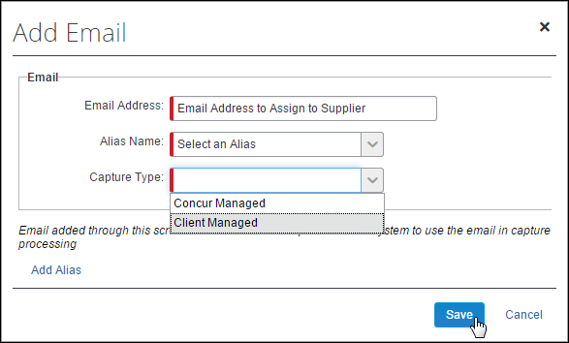
This email address is added to the Concur Solutions domain and is used as a unique identifier to route all supplier emails directly to the client entity being configured.
- WARNING At this time, send a minimum of one batch to the email address configured for the client to expose the email address in the Email Administration tab of the Capture Processing Admin tool.
Examples of Acceptable Email Formats
FORMAT:
The email requires the following format, with no spaces:
CompanyName + InvoiceCapture + @concursolutions.com
- OR -
Domain + InvoiceCapture + @concursolutions.com
The email appears as the following:
CompanyNameInvoiceCapture@concursolutions.com
CompanyName_InvoiceCapture@concursolutions.com
- OR -
CompanyDomainInvoiceCapture@concursolutions.com
CompanyDomain_InvoiceCapture@concursolutions.com

EXAMPLES:
Assume a company called Financial Advisors Inc. with a domain of FAI.com:
Acceptable email formats for this company can appear as the following:
- FinancialAdvisorsIncInvoiceCapture@concursolutions.com
- FinancialAdvisorsInc_InvoiceCapture@concursolutions.com
- FAIInvoiceCapture@concursolutions.com
- FAI_InvoiceCapture@concursolutions.com

Specifying an Email Alias and Capture Type
If an email address is assigned an email alias and capture type, these attributes are assigned to every emailed batch sent using that email. Now, group-based attributes and those attributes associated with the capture type are automatically applied to each emailed batch. These can include selected (filtered) vendors as explained below.

Filtering Vendors by Assigned Email Address
The list of vendors available for assignment to an invoice can be filtered based on the email used by the supplier when sending the invoice either by email or by using the Upload button. This means that the "To" email address provided to the supplier, or the alias chosen during upload, can filter the list of vendors that the admin or system can work with, resulting in more accurate vendor assignment.
- For more information, refer to the Using the Email Address to Filter Vendor Availability section in the Appendix of this guide.

Working with Options in the Supplier Email Administration Tab
The Verifier can prevent receipt and display of batches, based on an email address, as well as prevent the default email acknowledgement to be sent. Admins can use these options to temporarily disable selected emails, archive, and accept a different email address from a supplier changing location or domain, block spam, and adjust acknowledgement emails to match their preference.
The admin searches for the email by its address, and then clicks Edit Email to open the Edit Email window.
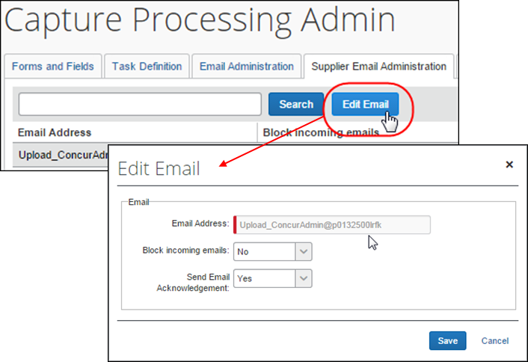
The following options are available:
- Block Incoming Emails: (Default = No) Capture Processing will prevent a supplier email from being received or displayed based on the email address associated with that supplier.
- Send Email Acknowledgement: (Default = No) Capture Processing will send an acknowledgement to the supplier on receipt of their email unless the admin selects No to prevent this email from being generated and sent.

Setting The Email Acknowledgement to Act By Email or Globally
The Global Email Acknowledgment feature tells the system to act globally or by each email to disable or enable the ability to send acknowledgement emails. The feature includes two options:
- Turn Off: Prevent the sending of email acknowledgment for each batch of invoices for every supplier email (globally disabled).
- By Email: (Default) Prevent the sending of email acknowledgment for each batch of invoices at the supplier email level for each address (discreetly disabled).
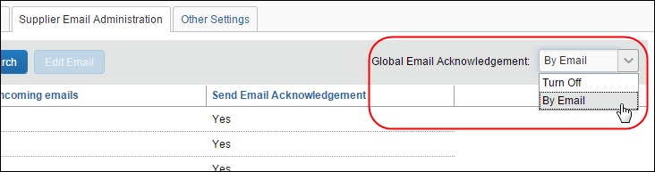

Working with Options on the Other Settings Tab
The options in the Other Settings tab are used to configure the exception alert email address, enable vendor segregation, and specify the default ledger and policy for each new invoice generated by Capture Processing. The Other Settings tab and its options are shown in the following figure.
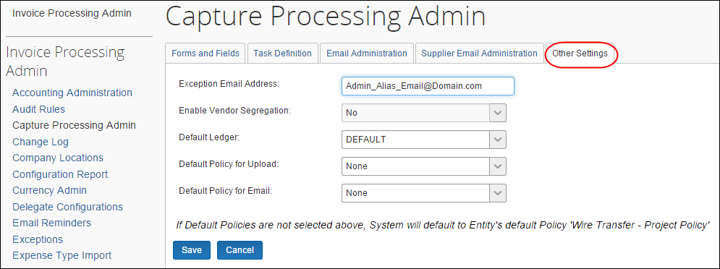

Configuring: Options in the Other Settings Tab
Several additional options are available as shown in the following figure, each setting reflecting its default value. The functionality of each setting is explained in the following sections.
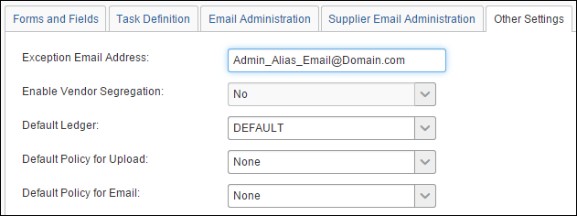

Exception Email Address
All supplier emails received for processing are viewed and handled by the system, including those that cannot be processed. When the system encounters an email that cannot be processed (unsupported document type; credit memos), the original email is formatted into a single PDF document that is sent as an attachment in the exception email notification to the recipient specified in Exception Email Address field.
The recipient of the exception email is provided both the type of exception that was generated and a list of the files that were rejected by Capture Processing.
- For more information, refer to the Email Notifications Used in Capture Processing section in this document.

Enable Vendor Segregation
You can decide to filter the vendors that can be assigned to an invoice, thus increasing the accuracy of the vendor by reducing the number of available selections. By associating email addresses to a single email alias, and then assigning the alias to a group of vendors, only those vendors are available during the OCR step, and when changing vendors manually during the verification step. You may also elect to set a policy and language attribute that will tell the system to use these by default.
To activate this feature, select Yes from the Enable Vendor Segregation list.
- For more information, refer to the Appendix: Using the Email Address to Filter Vendor Availability section in this guide.

Default Ledger
Clients using more than one ledger at their company can specify which ledger they want associated with the invoice output generated by Capture Processing. Doing this prevents incorrect account codes from being unintentionally associated with invoices created in Capture Processing.

Default Policy For Upload/Default Policy for Email
The default policy options let the administrator set a default policy under which each of the batches, based on the sending method (upload and email), will inherit their policy attributes. By setting the policy here, that same policy will populate the Policy field for emailed and uploaded batches in the Verification page.

Additional Information
For more information about this feature, refer to the Concur Invoice: Capture Processing (Client-Managed) User Guide. For example, the Appendix includes information about supported currencies, countries, getting your best results when processing, and other information.

Appendix
This section provides configuration details, in-depth descriptions, upcoming feature, and additional data that may be helpful to the user of Capture Processing.

Enabling CFDi Attachments for Reporting to Mexican Tax Authorities
Regulations in Mexico require that a CFDi document in XML format be attached to every submitted invoice. By enabling this feature in Capture Processing, a user may add this document to their invoice and the system will automatically image both documents and create an invoice that includes all relevant tax data for submission.
To enable this feature, the user must have the Invoice Configuration administrator role to work with the Group Configurations tool.
To enable the CFDi setting in Group Configurations:
- Click Administration > Invoice > Group Configurations.
- Select a group and click Modify.
- In the Configuration for Group page, select Allow users to upload CFDi attachments.
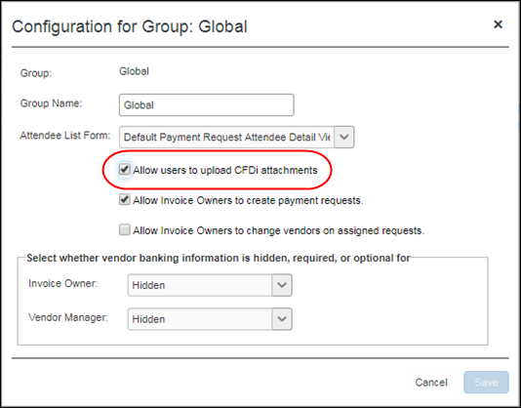
- Click Save.

Submitting the Paired Invoice and Attachment
A valid CFDi file in XML format must be detected by Capture Processing for the system to accept and pair the documents. An error message appears if an upload is attempted that does not follow these rules.
To upload or email the paired documents:
- Submit the invoice to Capture Processing, either by upload or by email, as a pair with no other invoice.

Using the Email Address to Filter Vendor Availability
The list of vendors available for assignment to an invoice can be filtered based on the email used by the supplier when sending the invoice either by email or by using the Upload button. This means that the "To" email address provided to the supplier, or the alias chosen during upload, can filter the list of vendors that the admin or system can work with, resulting in more accurate vendor assignment.

How It Works
This feature works by leveraging the Vendor Access Mapping feature used by clients to associate vendors to Invoice Owners and expense types. Using these same vendor groups, this feature extends the functionality by allowing association of these groups to email aliases made up of one or more email addresses.
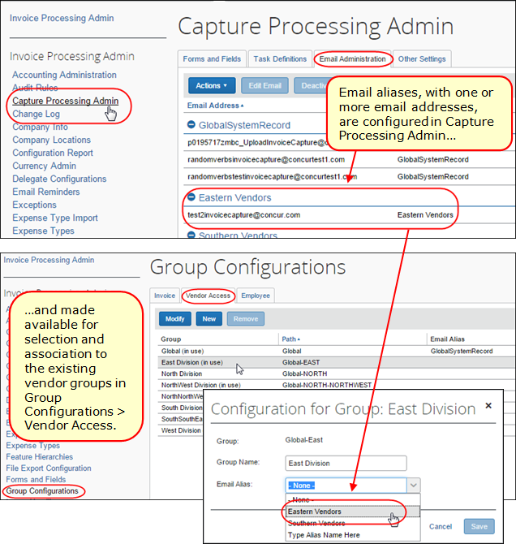
This means that, when the supplier is assigned a "To" email address, that email instructs the system to only display for selection those vendors within the assigned "vendor email" group. Similarly, when using the Upload function, the Verifier role chooses the email alias so that vendors associated with email addresses in that alias will direct what vendors are available.

What the Capture Processing Admin Sees
For the admin working in Capture Processing (Client-Managed), all vendors available for selection are based directly on the email address they provided to their supplier (by way of the alias the email address is assigned to). The system is also instructed to work only with these vendors, resulting in post-OCR vendor assignments aligned directly with the available vendor pool.
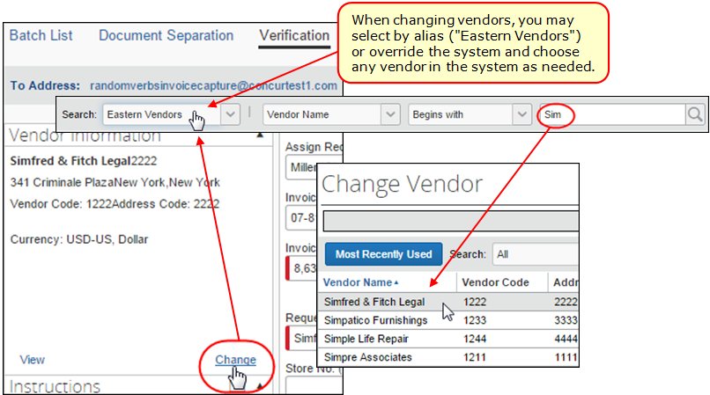
The vendors that display are based on the Capture Processing offering:
- Client Managed: Changing the vendor will display the vendors associated with the email alias. The search criteria can be changed to return other email aliases, to global to display all available vendors for selection.
- Concur Managed Service: Changing the vendor and searching on a name will display only those associated with the email alias.

Configuration/Feature Activation
The configuration steps are as follows, and assumes the client is using Vendor Import Access Mapping functionality to group their vendors:
- Step 1: Activate the Vendor Segregation feature (see procedure below) to expose the functionality in the user interface.
- Step 2: Create the Vendor Groups using the Vendor Import Access Mapping functionality of Group Configurations.
- For more information, refer to Concur Invoice: Vendor Access Mapping Import User Guide.
- Step 3: Create the email aliases and add the email addresses you want grouped within the alias (for example, assume Eastern Division alias, with Eastern-based supplier’s assigned email address of "eastern1invoicecapture@concur.com", "eastern2invoicecapture@concur.com", etc.).
- Step 4: Using Group Configurations > Vendor Access, assign a vendor group its email alias.
- Step 5: Distribute the email address to the supplier based on your preferred vendor list for that supplier.
The procedures below may require that the client submit a Service Request to SAP Concur support if they lack access to the configuration tool.
To activate the Vendor Segregation feature:
- Click Administration > Invoice > Capture Processing Admin > Other Settings.
- In the Enable Vendor Segregation list, click Yes.
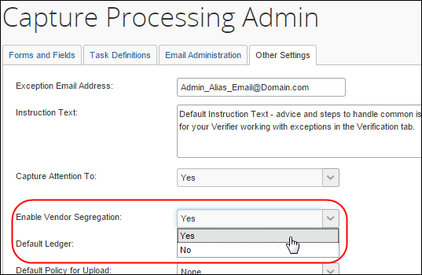
- Click Save.
Now, the functionality appears in Group Configuration > Vendor Access, and using the following procedure, both the parent alias and its child email addresses (one or more) may be configured.
To create an alias and add email addresses for Vendor Segregation:
- Click Administration > Invoice > Capture Processing Admin > Email Administration.
- Create an alias by clicking Actions > Manage Email Alias and, in the Manage Email Alias window, click Add Alias.
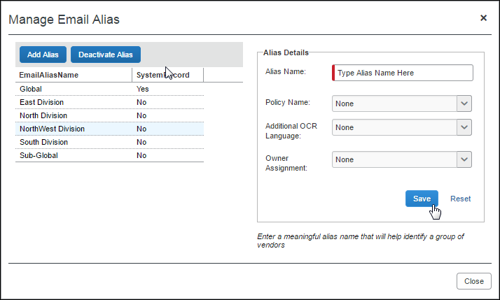
- Type the name of the alias in the Alias Name field.
- (Optional) Set the policy and language:
- Policy Name: Select the policy that will be associated to invoices included in any batch emailed using this alias
- Additional OCR Language - Select an option:
- None: Latin-based character set
- Japanese: Japanese character set, then Latin-based character set
- Chinese: Chinese character set, then Latin-based character set
The None setting is superseded if a language is configured in Modify Task Definition > Default Language.
- Owner Assignment: Select Sender to have the system automatically route the invoice to the user sending the invoices via their "From" email address
- Click Save, and then click OK in the confirmation message that appears.
(Optional): Continue adding additional aliases using the steps above.
- Click Close.
- Add email addresses by clicking Actions > Add Email.
- In the Add Email window, type the email address, and then select the alias from the Alias Name list.
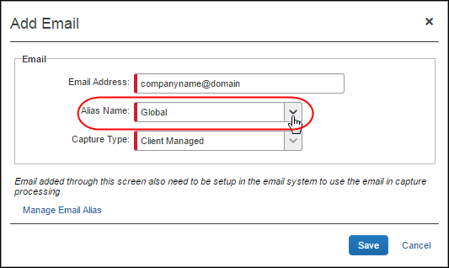
- Click Save.
- Important: Emails added using this procedure must also be registered by a SAP Concur Technical Consultant with Concur’s email system.
To associate (or edit) a vendor group with a registered email alias:
- Click Administration > Invoice > Group Configurations > Vendor Access tab.
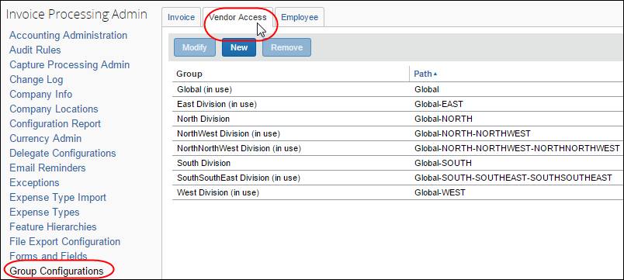
- In the Group list, select a vendor group, and then click Modify.
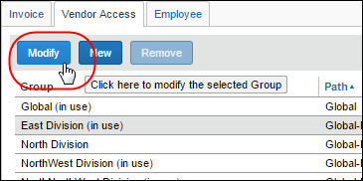
- In the Configuration for Group window, select the preferred email alias from the Email Alias list.
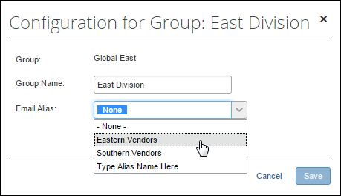
- Click Save.

Additional Information About This Feature
Please note the following when working with this feature:
- Hosted Management Console (HMC) Change: HMC now incorporates a single, dedicated system email associated with the Global group as a "backstop" so that all clients will have all vendors for selection under the Global group. This change means no additional (secondary) email is available following this release, only the single Intelligent Capture Email option.
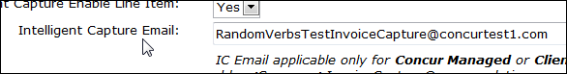
- A Read-Only, Single System-Based Email Is Enforced: As above, a single email associated with the Global group ensures all vendors are available to the client by default (absent of configuration of this feature). This is enforced by a read-only user interface when working with the GlobalSystemRecord email alias.
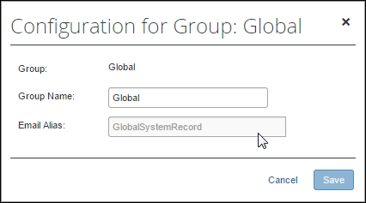
- Activating the "To" Emails for the Client: The SAP Concur Technical Consultant will need to activate the emails with the Concur email system by submitting an OPI on behalf of the client.
☼

