
Concur Expense: Workflow – Cost Object Approval
Setup Guide

Last Revised: August 25, 2023
Applies to these SAP Concur solutions:
 Expense
 Professional/Premium edition
 Standard edition
 Travel
 Professional/Premium edition
 Standard edition
 Invoice
 Professional/Premium edition
 Standard edition
 Request
 Professional/Premium edition
 Standard edition
Table of Contents
Section 1: Permissions 5
Section 2: Workflow Guides 5
Section 3: Overview 6
Benefits of Using Cost Object Approval 6
Level-Based Approvals and Limit-Based Approvals 6
Example of Level-Based Approval 7
Example of Limit-Based Approval 8
Section 4: How Level-Based Cost Object Approvals Work 8
Approver Action – Approved 9
Approver Action – Return to the Employee 9
Approver Action – Changes that DO NOT Affect the Cost Object, the Cost Object Amount, or the Report Total 10
Approver Action – Changes that Affect the Cost Object, the Cost Object Amount, or the Report Total 10
Example – Change in Amount 11
Example – Change in Cost Object 12
Section 5: How Limit-Based Cost Object Approvals Work 13
Approver Action – Approved (NOT Using Cost Object Direct Approval) 14
Approver Action – Approved (Using Cost Object Direct Approval) 14
Approver Action – Return to the Employee 15
Approver Action – Changes that DO NOT Affect the Cost Object, the Cost Object Amount, or the Report Total 15
Approver Action – Changes that Affect the Cost Object, the Cost Object Amount, or the Report Total 15
Example – Change in Amount 15
Example – Change in Cost Object 16
Section 6: Important! 16
Section 7: User Experience 17
Section 8: Approver Experience 17
Filtering the COA View for the Approver 19
Viewing the Cost Object Total for the Current Approver 20
Section 9: Processor Experience 21
Section 10: Additional Scenarios and Conditions 21
Cascading Copy Down 21
Delegates 21
Automatic Approval and COW Exception if Approver is Report Originator 21
Report Recall 22
Additional Approver and Workflow Situations 22
Additional Error Handling 26
Section 11: Configuration 27
Basic Steps 27
Step 1: Define the Cost Object Approver Hierarchy 28
Step 2: Activate the Feature 28
Step 3: Edit the Workflow Steps 30
Step 4: Assign the Proper Rights to Users 31
Employee Import 31
User Administration 31
Authorized Approvers Tab in Workflows 32

Revision History
Date | Notes / Comments / Changes
August 25, 2023 | Removed information and updated several sections about limit-based cost approvals.
June 9, 2023 | Added a note under the procedure in the Configuration section.
May 9, 2023 | Updated Additional Scenarios and Conditions section, Additional Approver and Workflow Situations topic, Additional Error Handling subtopic:  - Clarified Blocking exception prevents approval of report
September 17, 2022 | Removed pre-Next Gen UI screenshots
January 7, 2021 | Updated the copyright; added Concur to the cover page title; cover date not updated
April 9, 2020 | Renamed the Authorization Request check box to Request on the guide’s title page; cover date not updated
January 2, 2020 | Updated the copyright; no other changes; cover date not updated
January 2, 2018 | Added the following clarification note to the Approver Action – Changes that Affect the Cost Object, the Cost Object Amount, or the Report Total section: "To be clear, this is true for approver actions and is not true for updates made by validation rules as these do not update/reset the workflow."
July 24 2018 | Clarified that a limit must be set for an approver in order to be included, and not ignored, in a limit-based configuration
April 4 2018 | Changed the check boxes on the front cover; no other changes; cover date not updated
March 22, 2018 | Added the Cascading Copy Down topic to the Additional Scenarios and Conditions section.
February 20 2018 | Updated guide name in references to the Shared: Employee Import Specification guide.
January 9 2018 | Updated the copyright; no other changes; cover date not updated
September 19 2017 | Added the section: Limit Approval, Expense Processor.
July 26 2017 | Corrected reference (Approver E to Approver F) in third bullet of Example #2 – Cost object of $4000 with Cost Object R&D-DEV-EXP
March 27 2017 | Added a note: "For an unlimited approval amount, leave blank (NULL). To include an approver in the COA approval chain so they can see/approve a report, but not allow signing authority for any amount in the cost center, enter zero (0)."
February 15 2017 | Updated guide to clarify that:  - An approver acting as a delegate will see the report they submit auto-approved and a COW exception generated  - Best practice is to set single approver for each Cost Object level
December 14 2016 | Changed copyright and cover; no other content changes.
December 9 2016 | Updated the guide content to new corporate style; no content changes.
November 4 2016 | Clarified the Recall to Processor functionality when COA or Budget object (step) is included in the workflow.
July 8 2016 | Updated the graphic of the Settings tab to reflect that the settings Display expense report approval links to approvers on My Concur and Display cash advance approval links to approvers on My Concur have been relabeled Display Approve button on Approvals page.
August 14 2015 | Added information about the Approvals page.
July 10 2015 | Removed references to the current UI; made general updates to the content
September 24 2014 | Added information about two user interfaces; no other content changes.
August 8 2014 | Updated Level-Based Approvals and Limit-Based Approvals.
April 15 2014 | Changed copyright and cover; no other content changes
February 7 2014 | Blocking exceptions that will not prevent approval of a report under COA when the Can exit step with blocking exceptions options is selected (enabled) are now listed under Additional Error Handling.
March 22 2013 | Include notes reminding that a time-out action will always result in moving to the next step in COA workflow – there is no support any other action under time out.
February 22 2013 | A new setting is added to the Settings tab that filters out non-COA items to the COA user, letting them see only what items they are responsible for.
December 28 2012 | Made rebranding and/or copyright changes; no content changes
November 21 2012 | Removed information about NOT using the hierarchy  Added information about the Cost Object Approver List tab in Workflows
October 1 2012 | Clarification of the Cost Object Direct Approval feature
August 27 2012 | Limit-based Cost Object Workflow now supports direct routing to approver with correct limit amount for the cost object being approved
January 20 2012 | Added note that the ability to recall a report to the previous processor step in workflow is not available in cost object approval workflow
May 13 2016 | Updated instances of he/she to they.
February 25 2011 | Workflow configuration moved from the classic user interface to the current user interface in January and February
December 31 2010 | Updated the copyright and made rebranding changes; no content changes
February 19 2010 | Added section at end of document detailing differences in COA between the Expense and the Invoice products
December 2009 | Changed to stand-alone setup guide; no content change
September 18 2009 | Added note - Approver may receive several requests to approve Cost Objects within the same payment request.
August 14 2009 | Added a reminder that the cost object approval applies to the expense report workflow; it does not apply to authorization request or cash advance workflows
April 17 2009 | Initial publication

Permissions
A company administrator may or may not have the correct permissions to use this feature. The administrator may have limited permissions, for example, they can affect only certain groups and/or use only certain options (view but not create or edit).
If a company administrator needs to use this feature and does not have the proper permissions, they should contact the company's Concur administrator.
Also, the administrator should be aware that some of the tasks described in this guide can be completed only by Concur. In this case, the client must initiate a service request with Concur Client Support.

Workflow Guides
Refer to these guides when configuring and maintaining workflows.
Setup Guide | Description
Expense: Workflow - General Information | Read this guide for general information about expense and cash advance workflows.
Expense: Workflow - Authorized Approvers | Read this guide if the company uses authorized approvers but only after reading the Expense: Workflow - General Information Setup Guide.
Expense: Workflow - Cost Object Approvals | Read this guide if the company uses cost object approvals but only after reading the Expense: Workflow - General Information Setup Guide.  NOTE: Cost object approvals apply only to expense workflows – not cash advance workflows.

Overview
- IMPORTANT: Cost object approval applies to the expense report workflow. It does not apply to cash advance workflows.
The Cost Object Approval feature allows clients to define a special, more granular workflow step for its accounting-related data. For example, in the current environment, an expense report moves through a defined (generally hierarchical) workflow process. With the cost object approval feature, the report can move through separate client-defined workflows simultaneously.
For example, assume that the client defines cost object approval by cost center. Further assume that an expense report contains expenses that are assigned to two different cost centers – Sales and Training. When the report is submitted, it goes through a Training workflow and a Sales workflow at the same time.
The Split Report Approval functionality is not available to Cost Object Approvers.

Benefits of Using Cost Object Approval
The benefits of using the cost object approval feature include:
- Budget ownership: The approval process specifically aligns with the affected budget. In the example described above, each affected cost center has the opportunity to review the entire report and approve, partially approve, or reject the portion allocated to its budget.
- Parallel processing: Each affected cost center is reviewing the expense report at the same time. This can save a tremendous amount of time, resulting in faster reimbursement for the employee.
Certain changes made by any of the approvers (described in detail later in this document) cause the expense report to go through the approval process again. This way, all approvers can review any changes – ensuring control, compliance, and visibility for all affected cost centers.

Level-Based Approvals and Limit-Based Approvals
A cost object approval step can be based on either:
- Level: This type of approval is defined by each approver's sequential position in the approval process. The cost object moves from one level to the next to the next – all the way to the end of the process. For example, it moves from a junior manager to a senior manager to the company CFO.
- Limit: This type of approval is based on the amount that an approver is authorized to approve (also known as signing authority). The cost object starts with the first approver, moving from one level to the next. It stops when it reaches an approver who has an approval limit equal to or greater than the cost object amount. Note that a limit must be defined for the approver to allow them this functionality.
There is a second limit-related option: Cost Object Direct Approval. Using this option, the cost object might not start at the first approver and might not go to the end – instead, it goes directly to the approver with the correct approval limit. In other words, the cost object's first and only stop is with the approver who has the correct limit.
In some workflows, the Cost Object approver may have already approved the expense report as a manager. In this case, when the report reaches the Cost Object Approval step, it skips the step. The manager does not have to approve the same report twice.
In the examples on the following pages, assume that the Cost Center field has been defined by the client as the cost object.

Example of Level-Based Approval
Simple level-based cost object approval step:
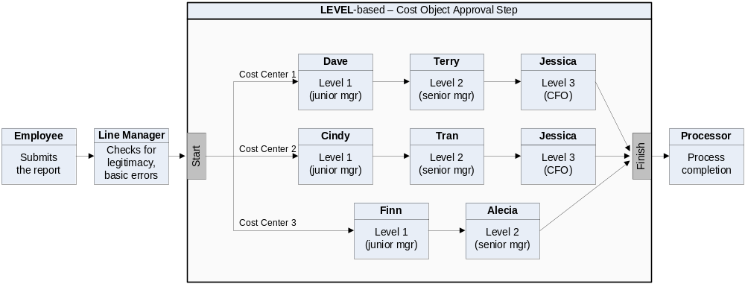
This example shows a simple workflow – from employee to the line manager to the cost object approval step to the processor.
A client can have only one cost object approval step in a workflow; however, the following are client-configurable:
- The number and placement of steps before and after the cost object approval step.
- The levels within the cost object approval step, which can even differ by cost center. In this example, Cost Center 1 and 2 have three levels of approvals; Cost Center 3 has two.

Example of Limit-Based Approval
Simple limit-based cost object approval step:
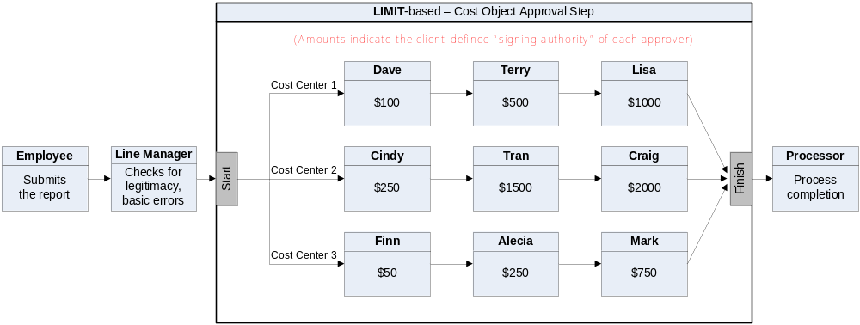
In this example, all of the cost centers have three approvers. Just like level-based approvals:
- There can be only one cost object approval step.
- The steps before and after are client-configurable.
- The limits and number of approvers within the cost object approval step are client-configurable.
- A limit must be defined, or the approver is ignored by the system.

How Level-Based Cost Object Approvals Work
The following set of examples is based on this level-based cost object approval step.
The table below lists the expenses on an expense report. The expenses are assigned to three cost centers.

Approver Action – Approved
The last column shows the flow through the cost object approval step if all approvers approve the expenses without changes.
Cost Center | Amount (USD) |  | Flow in the cost object approval step...
Cost Center | Expenses | Total | Flow in the cost object approval step...
1 | 75.00 | 975.00 | Dave  Terry  Jessica  finish
1 | 200.00 | 975.00 | Dave  Terry  Jessica  finish
1 | 700.00 | 975.00 | Dave  Terry  Jessica  finish
2 | 150.00 | 150.00 | Cindy  Tran  Jessica  finish
3 | 100.00 | 215.00 | Finn  Alecia  finish
3 | 115.00 | 215.00 | Finn  Alecia  finish
Remember, for level-based cost object approvals, the amount does not matter; the cost object starts at the first level and stops at every level until it reaches the end.

Approver Action – Return to the Employee
If any of the approvers return the report (Send Back to Employee), then:
- All workflow instances are terminated (even though the other cost centers may not actually be affected).
- The approver who initiated the action is required to provide a comment, which is visible to all other approvers.
- The action is logged in the Audit Trail.
- The report is returned to the employee.
- The process starts again – starting with the employee.

Approver Action – Changes that DO NOT Affect the Cost Object, the Cost Object Amount, or the Report Total
If any of the approvers make any other changes to the report but those changes do not affect the cost object, the cost object amount, or the report total and then the approver clicks Approve, the report moves to the next step in the process (same as Approver Action – Approved).

Approver Action – Changes that Affect the Cost Object, the Cost Object Amount, or the Report Total
The cost object approval step is restarted if any of the approvers:
- Change the cost object (for example, change the Cost Center field)
To be clear, this is true for approver actions and is not true for updates made by validation rules as these do not update/reset the workflow.
- Change the amount of any of the expenses that make up the cost object
- Reduce or reject an expense amount (even by marking any or all of an expense as personal), which affects the report total
This sample assumes that the client configuration allows the approver to change the cost object field and/or amounts. In some configurations, approvers cannot change this type of information; they can either approve the expense report "as is" or return it "as is" to the employee.
For example, assume that Terry (second approver in Cost Center 1) changed the cost center or amount. Then:
- All workflow instances are terminated (even though the other cost centers may not actually be affected).
- The approver who initiated the action is required to provide a comment, which is visible to all other approvers.
- The action is logged in the Audit Trail.
- The system recalculates the report totals if applicable.
- The report returns to the start of the cost object step.
- The cost object approval step starts again.
If the approver changes an amount, a cost object, or the report total, the report is not routed again to that approver, unless additional changes are made by other approvers.

Example – Change in Amount

Example #1
Assume that we started with these cost centers, amounts, and approvers:
Cost Center | Amount (USD) |  | Flow in the cost object approval step...
Cost Center | Expenses | Total | Flow in the cost object approval step...
1 | 75.00 | 975.00 | Dave  Terry  Jessica  finish
1 | 200.00 | 975.00 | Dave  Terry  Jessica  finish
1 | 700.00 | 975.00 | Dave  Terry  Jessica  finish
2 | 150.00 | 150.00 | Cindy  Tran  Jessica  finish
3 | 100.00 | 215.00 | Finn  Alecia  finish
3 | 115.00 | 215.00 | Finn  Alecia  finish
Then, Terry (second approver in Cost Center 1) reduced the 200.00 expense to 100.00. The cost object step approval starts over.
The new cost object approval step would look like this:
Cost Center | Amount (USD) |  | Flow in the cost object approval step...
Cost Center | Expenses | Total | Flow in the cost object approval step...
1 | 75.00 | 875.00 | Dave  Jessica  finish  (Terry is bypassed this time because she initiated the change. For audit purposes, Terry still appears on the Approval Flow page.)
1 | 100.00 | 875.00
1 | 700.00 | 875.00
2 | 150.00 | 150.00 | Cindy  Tran  Jessica  finish
3 | 100.00 | 215.00 | Finn  Alecia  finish
3 | 115.00 | 215.00 | Finn  Alecia  finish

Example #2
Assume that we started with these cost centers, amounts, and approvers:
Cost Center | Amount (USD) |  | Flow in the cost object approval step...
Cost Center | Expenses | Total | Flow in the cost object approval step...
1 | 75.00 | 975.00 | Dave  Terry  Jessica  finish
1 | 200.00 | 975.00 | Dave  Terry  Jessica  finish
1 | 700.00 | 975.00 | Dave  Terry  Jessica  finish
2 | 150.00 | 150.00 | Cindy  Tran  Jessica  finish
3 | 100.00 | 215.00 | Finn  Alecia  finish
3 | 115.00 | 215.00 | Finn  Alecia  finish
Then, Cindy (first approver in Cost Center 2) reduces the $150 expense to zero. The cost object step approval starts over.
The new cost object approval step would look like this:
Cost Center | Amount (USD) |  | Flow in the cost object approval step...
Cost Center | Expenses | Total | Flow in the cost object approval step...
1 | 75.00 | 975.00 | Dave  Terry  Jessica  finish
1 | 200.00 | 975.00 | Dave  Terry  Jessica  finish
1 | 700.00 | 975.00 | Dave  Terry  Jessica  finish
3 | 100.00 | 215.00 | Finn  Alecia  finish
3 | 115.00 | 215.00 | Finn  Alecia  finish

Example – Change in Cost Object
Assume that we started with these cost centers, amounts, and approvers:
Cost Center | Amount (USD) |  | Flow in the cost object approval step...
Cost Center | Expenses | Total | Flow in the cost object approval step...
1 | 75.00 | 975.00 | Dave  Terry  Jessica  finish
1 | 200.00 | 975.00 | Dave  Terry  Jessica  finish
1 | 700.00 | 975.00 | Dave  Terry  Jessica  finish
2 | 150.00 | 150.00 | Cindy  Tran  Jessica  finish
3 | 100.00 | 215.00 | Finn  Alecia  finish
3 | 115.00 | 215.00 | Finn  Alecia  finish
Then, Terry (second approver in Cost Center 1) changed the 200.00 expense by changing the cost center to Cost Center 3. The cost object step approval starts over.
The new cost object approval step would look like this:
Cost Center | Amount (USD) |  | Flow in the cost object approval step...
Cost Center | Expenses | Total | Flow in the cost object approval step...
1 | 75.00 | 775.00 | Dave  Jessica  finish  (Terry is bypassed because she initiated the change. For audit purposes, Terry still appears on the Approval Flow page.)
1 | 700.00 | 775.00
2 | 150.00 | 150.00 | Cindy  Tran  Jessica  finish
3 | 100.00 | 415.00 | Finn  Alecia  finish
3 | 115.00 | 415.00 | Finn  Alecia  finish
3 | 200.00 | 415.00 | Finn  Alecia  finish

How Limit-Based Cost Object Approvals Work
The following set of examples is based on this limit-based cost object approval step.
The table below lists the expenses on an expense report. The expenses are assigned to three cost centers.

Approver Action – Approved (NOT Using Cost Object Direct Approval)
The last column describes the flow through the cost object approval step if all approvers approve the expenses without changes. (Remember, when not using the Cost Object Direct Approval option, the cost object stops at each approver in the list until it reaches the approver with the correct limit.)
Cost Center | Amount (USD) |  | Flow in the cost object approval step...
Cost Center | Expenses | Total | Flow in the cost object approval step...
1 | 75.00 | 975.00 | Dave  Terry  Lisa  finish
1 | 200.00 | 975.00 | Dave  Terry  Lisa  finish
1 | 700.00 | 975.00 | Dave  Terry  Lisa  finish
2 | 150.00 | 150.00 | Cindy  finish (Tran and Craig are bypassed)
3 | 100.00 | 215.00 | Finn  Alecia  finish (Mark is bypassed)
3 | 115.00 | 215.00 | Finn  Alecia  finish (Mark is bypassed)
Remember, when not using the Cost Object Direct Approval option, the cost object stops at each approver in the list until it reaches the approver with the correct limit.

Approver Action – Approved (Using Cost Object Direct Approval)
The last column describes the flow through the cost object approval step if all approvers approve the expenses without changes and if the Cost Object Direct Approval option is configured. (Remember, with Cost Object Direct Approval, the cost object's first – and only – stop is with the approver who has the correct limit.)
Cost Center | Amount (USD) |  | Flow in the cost object approval step...
Cost Center | Expenses | Total | Flow in the cost object approval step...
1 | 75.00 | 975.00 | Lisa  finish (Dave and Terry are bypassed; Lisa has the correct limit so no other approvers are necessary)
1 | 200.00 | 975.00
1 | 700.00 | 975.00
2 | 150.00 | 150.00 | Cindy  finish (Tran and Craig are bypassed; Cindy has the correct limit so no other approvers are necessary)
3 | 100.00 | 215.00 | Alecia  finish (Finn and Mark are bypassed; Alecia has the correct limit so no other approvers are necessary)
3 | 115.00 | 215.00

Approver Action – Return to the Employee
The result is the same as for the level-based approval. Refer to that section of this guide.

Approver Action – Changes that DO NOT Affect the Cost Object, the Cost Object Amount, or the Report Total
The result is the same as for the level-based approval. Refer to that section of this guide.

Approver Action – Changes that Affect the Cost Object, the Cost Object Amount, or the Report Total

Example – Change in Amount
Assume that we started with these cost centers, amounts, and approvers:
Cost Center | Amount (USD) |  | Limits
Cost Center | Expenses | Total | Limits
1 | 75.00 | 975.00 | Dave (100) Terry (500) Lisa (1000)
1 | 200.00 | 975.00 | Dave (100) Terry (500) Lisa (1000)
1 | 700.00 | 975.00 | Dave (100) Terry (500) Lisa (1000)
2 | 150.00 | 150.00 | Cindy (250) Tran (1500) Craig (2000)
3 | 100.00 | 215.00 | Finn (50) Alecia (250) Mark (750)
3 | 115.00 | 215.00 | Finn (50) Alecia (250) Mark (750)
Then, Lisa (final approver in Cost Center 1) says the company will not reimburse the 200.00 and 700.00 expense and sets the approved amount to zero for these expenses. The cost object step approval starts over.
The new cost object approval step would look like this:
Cost Center | Amount (USD) |  | Flow in the cost object approval step...
Cost Center | Expenses | Total | Flow in the cost object approval step...
1 | 75.00 | 75.00 | Dave  finish (Terry and Lisa are bypassed)
1 | 0 | 75.00 | Dave  finish (Terry and Lisa are bypassed)
1 | 0 | 75.00 | Dave  finish (Terry and Lisa are bypassed)
2 | 150.00 | 150.00 | Cindy  finish (Tran and Craig are bypassed)
3 | 100.00 | 215.00 | Finn  Alecia  finish (Mark is bypassed)
3 | 115.00 | 215.00 | Finn  Alecia  finish (Mark is bypassed)

Example – Change in Cost Object
Assume that we started with these cost centers, amounts, and approvers:
Cost Center | Amount (USD) |  | Limits
Cost Center | Expenses | Total | Limits
1 | 75.00 | 975.00 | Dave (100) Terry (500) Lisa (1000)
1 | 200.00 | 975.00 | Dave (100) Terry (500) Lisa (1000)
1 | 700.00 | 975.00 | Dave (100) Terry (500) Lisa (1000)
2 | 150.00 | 150.00 | Cindy (250) Tran (1500) Craig (2000)
3 | 100.00 | 215.00 | Finn (50) Alecia (250) Mark (750)
3 | 115.00 | 215.00 | Finn (50) Alecia (250) Mark (750)
Then, Terry (second approver in Cost Center 1) changed the 200.00 expense by changing the cost center to Cost Center 3. The cost object step approval starts over.
The new cost object approval step would look like this:
Cost Center | Amount (USD) |  | Flow in the cost object approval step...
Cost Center | Expenses | Total | Flow in the cost object approval step...
1 | 75.00 | 775.00 | Dave  Lisa  finish  (Terry is bypassed because she initiated the change. For audit purposes, Terry still appears on the Approval Flow page.)
1 | 700.00 | 775.00
2 | 150.00 | 150.00 | Cindy  finish (Tran and Craig are bypassed)
3 | 100.00 | 415.00 | Finn  Alecia  Mark  finish  (Mark is now included because the amount was increased.)
3 | 115.00 | 415.00
3 | 200.00 | 415.00

Important!
If an expense is charged to the wrong cost center, an approver should consider the following when deciding when to return the report to an employee or to simply make the change (assuming the configuration allows the approver to make changes):
- If the approver knows the correct cost center, the approver can select the appropriate one. The expense report re-starts the cost object approval step again. The report is routed through the workflow of the affected cost center.
- If the approver does not know the correct cost center, the approver should return the expense report to the employee. The employee can make the appropriate changes and resubmit the report. The report will be routed through the workflow of the affected cost center.
- If the approver takes no action, the only time-out action that is supported within COA is to proceed to the next step.

User Experience
The user will see a new status in their list of expense reports. When the report is in the cost object approval step, the status Pending Cost Object Approval appears. The name of the specific approver does not appear.
The user can see the detailed information by opening the report and viewing the Approval Flow page.

Approver Experience
The cost object icon appears:
- On the Approvals page:
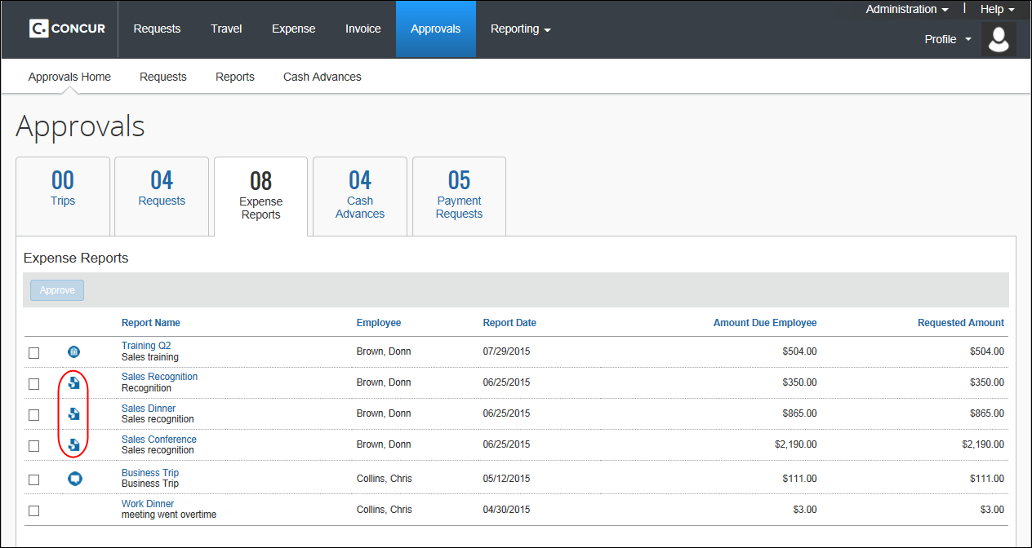
- In the Expense List section of the expense report:
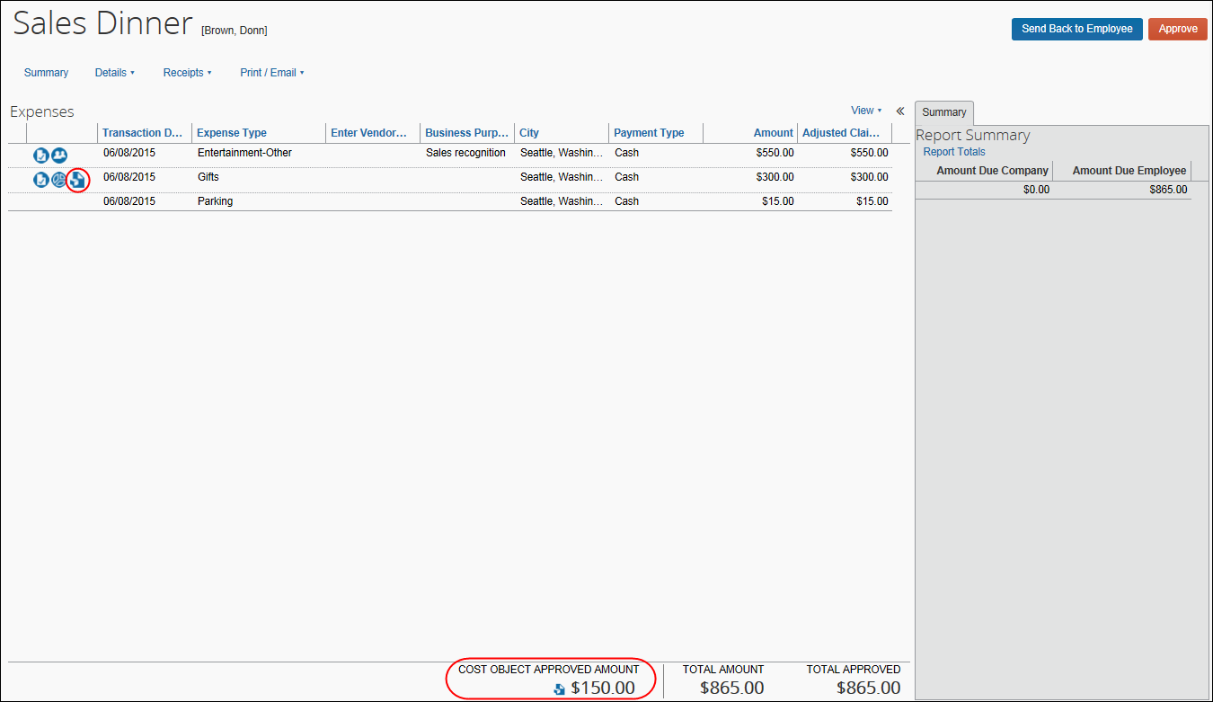
The entire report displays; however, only the entries with the icon must be reviewed by this approver. The remaining entries appear for information only.
- With the Filter expenses to those that are applicable to Cost Object setting filtering the view to only those objects the approver must approve (see Filtering the COA View for the Approver, next):
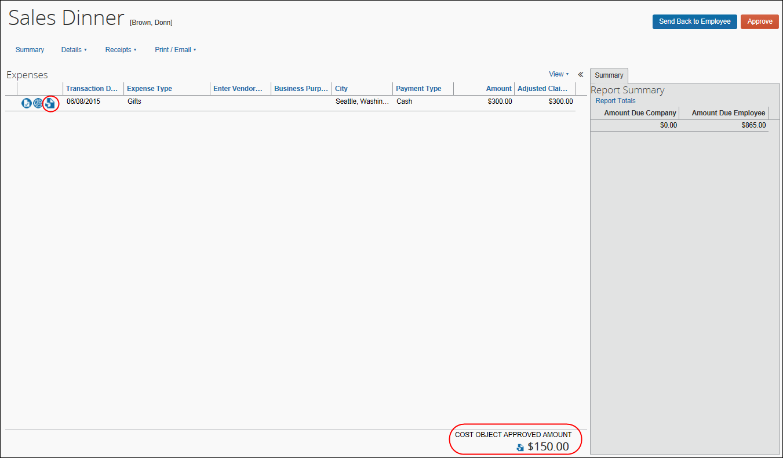

Filtering the COA View for the Approver
Using a setting on the Settings tab of Workflow, the administrator can focus the COA approver’s attention by filtering the view to only those objects they are responsible for, to show only relevant expenses on the expense list. This is done using the Filter expenses to those that are applicable to Cost Object setting.
- Refer to Expense: Workflow – General Information Setup Guide for more information.

Viewing the Cost Object Total for the Current Approver
The Expense List shows a total for the cost objects pending that current approver at the bottom of the list and next to the report total field.
The icon has a hover-over that lists each cost object and the total amount for that cost object.
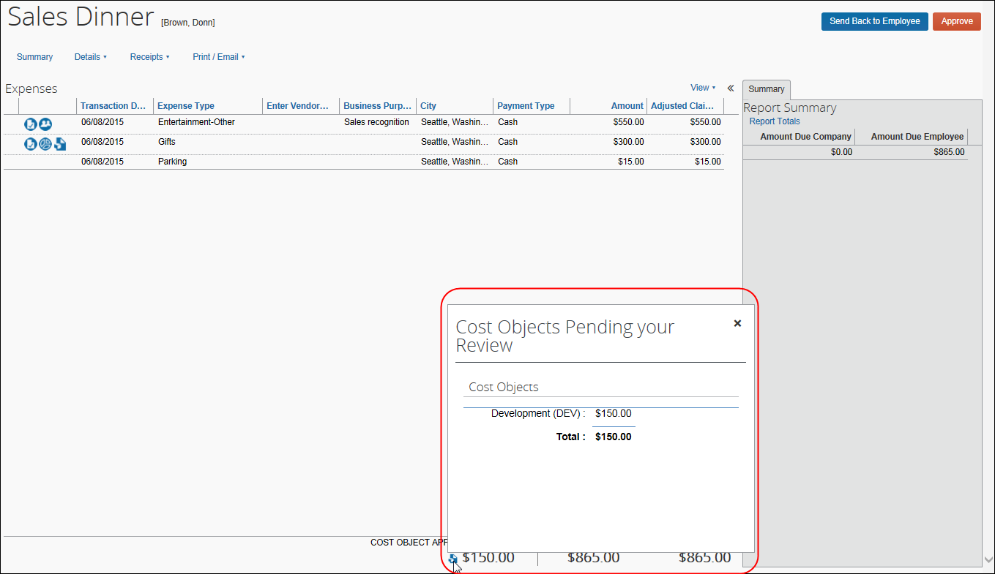

Processor Experience
A processor can see the individual approvers and can identify where the cost object is in the cost object workflow step.
While the cost objects are in the cost object workflow step, the only action the processor can take when the report is within the cost object workflow step is to approve "as is" or return it to the employee.
If the processor approves the report:
- All cost object workflows are terminated.
- The report is advanced to the next regular workflow step.
If the processor sends the report back to the employee:
- All cost object workflow instances are terminated.
- The report is returned to the employee.

Additional Scenarios and Conditions

Cascading Copy Down
Report Header → Expense Entry → Allocation Field (That is Part of CO Hierarchy)
Special handling is needed if the configuration copies down a value from the report header to the expense entry and then from the expense entry to the allocation, and that affected field in the allocation record is part of your cost object hierarchy. In this scenario, if the approver edits the field on the report header, the outcome of a changed field on the allocation record will not reset the cost object approval workflow.
SAP Concur recommends that report header fields not be editable by the approver. This best-practice configuration would require the approver to edit each individual expense entry or allocation record to make a change, but would result in proper handling of the cost object workflow.

Delegates
The delegate approver acting on behalf of the assigned approver will use the level or limit rights assigned to the original approver rather than their own values.

Automatic Approval and COW Exception if Approver is Report Originator
If a cost object approver submits a report while acting as a delegate of an employee, the report will be automatically approved in the cost object workflow step for that approver since Concur does not ever permit the report originator to share approval privileges for that same report. However, the cost object workflow will create and log the COW exception code whenever it encounters a cost object and level associated with an approver who also submitted the report.
- Refer to the section Additional Error Handling in this document for more information about exceptions.

System Choice Login When Multiple Approvers Exist
Note that if there are multiple cost object approvers configured for the identical cost object and level, there is no guarantee the system will differentiate and then select an approver based on the fact they created and submitted the report.

Report Recall
The recall to processor option (activated via Workflow > Settings) does not function if a COA or Budget object (step) is included in the workflow. Under this condition, the Recall to Processor link is unavailable to the processor.
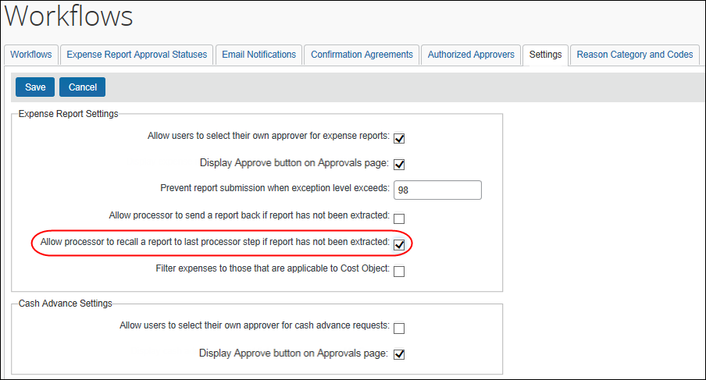

Additional Approver and Workflow Situations
Note the following:
- If an approver is responsible for approving more than one Cost Object in a expense report they may be prompted more than once, and at different times, to complete the overall approval of the report. An icon next to the Cost Object aids the approver in determining the object they are responsible for approving.
- Any settings configured at the workflow level apply for the entire workflow, so you have to make the same choices for approval time out, email notifications etc. when both a default workflow and cost object workflow is used
- If approval time-out is ON, then it applies to all steps within the workflow, including cost object approval steps (of which there may be many). In practice, if a COA step times out, the cost object always moves to the next step within the COA step – this is the only action COA supports.
- If users are allowed to add ad-hoc approval steps, they will be able to do so within the cost object approval step once the report enters that step. The workflows for each cost object are not created until that point, so are not visible for additions.
- The prompt for approver setting has no affect within the cost object approval step.
- Email notifications and reminders work per usual.
- The Approval Flow page shows a single cost object step followed by a line for each cost object on the report, showing the viewer:
- Who the report is currently pending (one or more employees)
- Who the report is scheduled to be routed to
When the cost object workflow is concluded, it shows the final approver for that workflow. Each cost object can be expanded to show the details of that child cost object workflow.
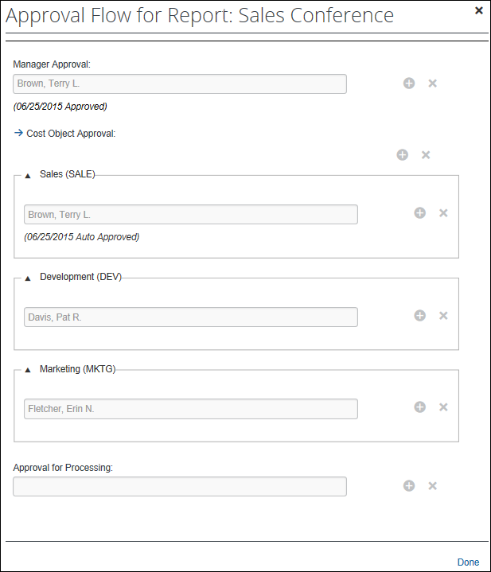
- If a cost object field (for example, Cost Center) is not required and is left blank by the employee, then this expense moves through the workflow as if there was no cost object approval step.
- If all of the expenses on a report are assigned to the same cost object, the process still applies but there is only one path within the cost object approval step. For example, if all expenses on a reports are assigned to Cost Center 2, the workflow would look like this:
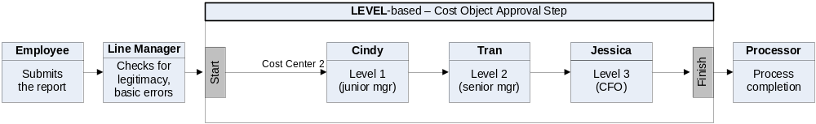
- Best practice is to assign a single approver for each cost object per level, but if multiple approvers with identical approval limit/levels are defined, Expense uses the first approver found in no particular order of search or otherwise.
- For limit-based approvals, if the highest approver limit within the cost object approval step cannot achieve limit approval for the object, then Expense will add additional approver steps by "walking up" the hierarchy to find the next available approver with a limit higher than the previous approver.
If the next level up has approvers but none have adequate limits, then Expense continues up until it finds an approver with the required limit.
Row | Approver | Limit | Department | Division | Cost Center
1 | A | 100 | R&D | DEV | EXP
2 | B | 900 | R&D | DEV | EXP
3 | C | 500 | R&D | DEV
4 | D | 750 | R&D | DEV
5 | E | 1000 | R&D
6 | F | 5000 | R&D
Example #1 – Cost object of $1000 with Cost Object R&D-DEV-EXP:
- Expense first looks at the R&D-DEV-EXP node. It finds two approvers (A and B) and uses them.
- When all available approvers in that node have been used and the object is still not approved, Expense moves up to the next node. No approvers at R&D-DEV (C and D) have a limit higher than our last approver (B in R&D-DEV-EXP has $900), so Expense does not use any approvers from this node.
- The object is not approved, so Expense moves up to the next node. The first approver found (approver E) for $1000 is used. Since Expense is now able to get the object approved, Expense does not add any more approvers from this node.
- Summary: Expense uses these approvers:
A ($100)
B ($900)
E ($1000)
Example #2 – Cost object of $4000 with Cost Object R&D-DEV-EXP:
- Expense first looks at the R&D-DEV-EXP node. It finds two approvers (A and B) and uses them.
- When all available approvers in that node have been used and the object is still not approved, Expense moves up to the next node. No approvers at R&D-DEV (C and D) have a limit higher than our last approver (B in R&D-DEV-EXP has $900), so Expense does not use any approvers from this node.
- The object is not approved, so Expense moves up to the next node. The first approver found (approver E) for $1000 is used. Since the object is not yet approved, Expense uses the next approver (approver F). Now the object is approved so we do not add further steps.
- Summary: Expense uses these approvers:
A ($100)
B ($900)
E ($1000)
F ($5000)

Additional Error Handling
Note the following:
- Blocking exception prevents approval of report: When the Workflow setting Can exit step with blocking exceptions is not selected (disabled) the system will allow approval of the report for the following exception code scenarios:
- COW - One or more Cost objects could not be approved by the right authority (%costObjects%). The expense report has been moved to the next workflow step.
- CONOAPPR - No approvers were found for cost object %costObjects%.
- BOW - One or more Budget objects could not be approved by the right authority (%costObjects%). The expense report has been moved to the next workflow step.
- APPRVTO - This report has been pending approval longer than allowed by policy. The report owner should contact their Approver for instructions before resubmitting. If you are not the owner but have been forwarded the report, follow the approval steps according to your policy - this may involve approving the report or assigning it to another Approver for further review.
- NOAPPR - The previous step was skipped because the selected approver no longer has the approver role. Select another approver or contact the system administrator.
- SELFAPPR - The previous step was skipped because the selected approver would be self-approving the report.
- Invalid approver: If an approver is designated for a step at workflow creation, it is possible that approver is no longer an appropriate choice when the report reaches that step. If the approver is no longer a valid approver at that point and if approver time-out is ON, the report will eventually time out and move to the next approver in the workflow (the only time-out action supported in COA).
- Approver limit has changed: If the limit (signing authority) of an approver changes, the report is marked as limit-approved based on the current limit in effect when the report is approved by that approver. The workflow step is not modified dynamically to find a different approver for the step.
- Level approvers are not sequential: If any gaps in the numerical level sequence for approvers at a specific cost object are found, an exception is created that a level has been skipped.
- Example #1: Approvers are found with levels 1, 3, 4. Since the level 2 approver was not found, an exception is generated.
- Example #2: For cost object A, approvers for levels 1, 2 and 3 exist. For cost object B, approvers for levels 1, 2, 3 and 4 exist. No exception is generated for either of these as there are no gaps in the sequence.
- No approver found for level: If no approver exists for a level in the hierarchy, there will be no step created in the cost object approval step for that level.
- No approvers found for cost object: If no approvers at all are found for a cost object, then no cost object approval step is created for that cost object and an exception is generated.
- Cost object not approved: If, for any reason, a cost object does not achieve approved status at the conclusion of the cost object approval workflow, a system exception is created during the termination step for cost object approval. This exception lists each cost object that did not meet approval requirements.
- Limits: The exception is generated if, at the conclusion of the cost object workflow, the report has not been approved by any approver with limit authority.
- Levels: The exception is generated if any level in the cost object approval step has been skipped due to time-out, missing approver, or any other reason.

Configuration
- IMPORTANT: Cost object approvals apply to expense report workflow. It does not apply to cash advance workflows.
Each client can have only one cost object approval step in an expense report workflow and only one expense report workflow in a policy.

Basic Steps
The basic steps for configuring are listed below and then described in detail on the following pages.
Step 1: Define the Expense Cost Object Approver hierarchy:
- Set up the hierarchy.
- Create a connected (multi-level) list of the hierarchy levels.
Step 2: Activate the Cost Object Approver feature.
Step 3: Edit workflow steps if desired.
Step 4: Assign the proper rights to users.

Step 1: Define the Cost Object Approver Hierarchy
This portion of the configuration requires permissions for the Feature Hierarchies section of Expense Admin.
Define the Cost Object Hierarchy (Administration > Expense > Feature Hierarchies) just like any other hierarchy, which may include importing a list.
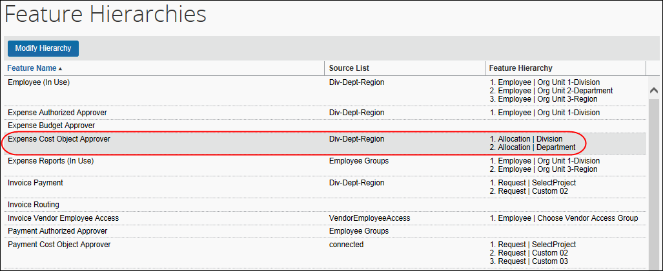
- For more information about the hierarchy, refer to the Shared: Feature Hierarchies Setup Guide. For more information about lists, refer to the Shared: List Management Setup Guide.

Step 2: Activate the Feature
To activate the feature:
- Click Administration > Expense > Workflows.
Users with the Expense Configuration Administrator (Restricted) role can access (view but not edit) the Workflow Configuration page in Concur Expense.
- To modify a workflow, on the Workflows tab, either:
- Select the desired workflow and click Modify.
– or –
- Double-click the desired workflow.
The General page appears.
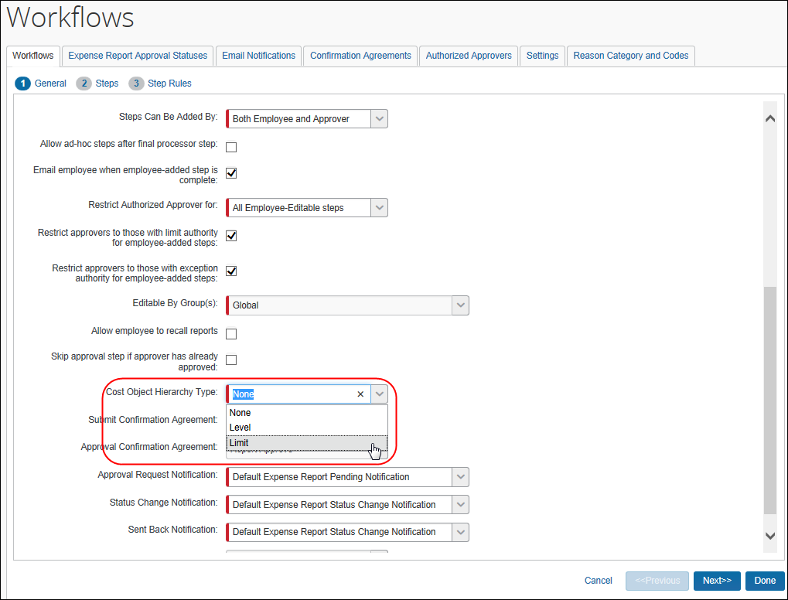
- In the Cost Object Hierarchy Type field, select the desired type: Level or Limit.
- If you select Limit, the Cost Object Direct Approval check box appears. Select this check box to route the cost object directly to that approver with the required approval limit amount.
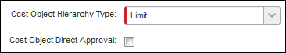
- Click Next. The Steps page appears (see next).

Step 3: Edit the Workflow Steps
When you activate the feature, Expense adds the new workflow step on the Steps page. You can reorder the steps, using the arrow icons, if necessary.
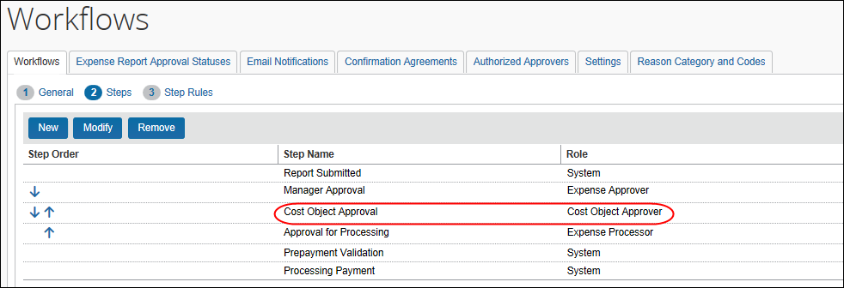
To make changes to the step:
- Either:
- Select the cost object approval step and click Modify.
– or –
- Double-click the cost object approval step.
- Make the desired changes.
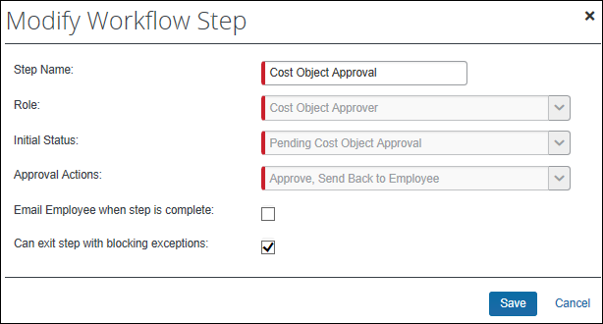
- For more information about editing workflows, refer to the Expense: Workflow - General Information Setup Guide.
- Click Save.
- Click Done.

Step 4: Assign the Proper Rights to Users
The company adds the proper authorized approver rights to users using:
- The employee import
- User Admin
– or –
- The Authorized Approvers tab in Workflows

Employee Import
- For information about the employee import, refer to the Shared: Employee Import Specification.

User Administration
When the Cost Object Approver feature is activated, the Authorized Approval Limits link appears in the Expense and Invoices Setting section in User Administration.
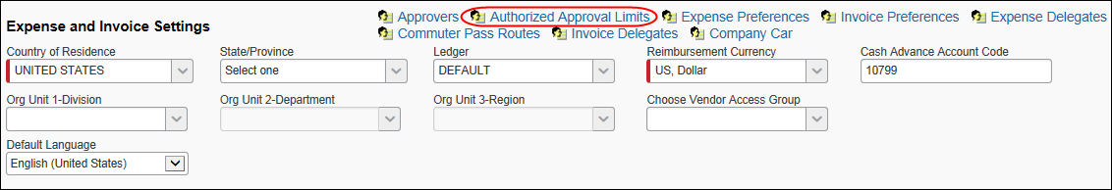
To assign the proper rights:
- In the Expense and Invoices Setting section of User Administration, click the Authorized Approval Limits link. The Authorized Approval Limits window appears.
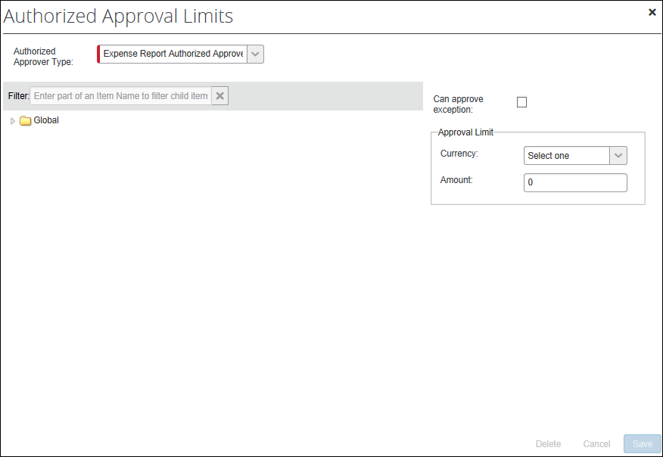
- On the left side, select the appropriate level in the hierarchy.
- On the right side:
- For limit-based cost object approval, select a currency and enter an amount.
When a currency is assigned with no limit (displayed as 0), the approver will receive the cost object; however, an exception will be generated upon approval to indicate the cost object has not been approved by the right authority or if available, the report will route to another cost object approver with higher authority. This does not apply when Cost Object Direct Approval is in use, in which case only a cost object approver with the lowest sufficient limit will receive the cost object.
- For level-based cost object approval, select a level.
The cost object configuration defines the type – either limit or level. If you complete both areas in this window – the Approval Limit area and the Level field – Expense will use the one that applies to your configuration and ignore the other.

Authorized Approvers Tab in Workflows
To use the Cost Object Approver List tab:
- Click Administration > Expense > Workflows (left menu).
- Select the Authorized Approvers tab.
- Select the Cost Object Approver List tab.
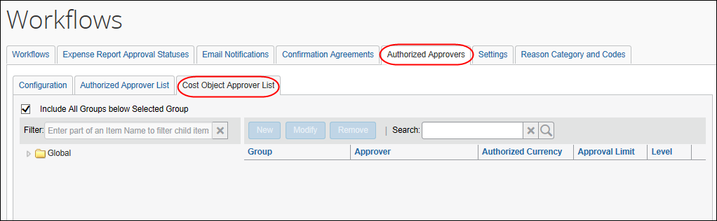
- On the left side, expand the hierarchy.
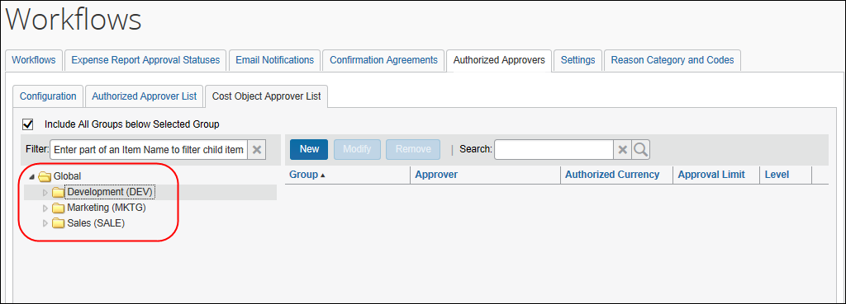
- Select the desired level in the hierarchy.
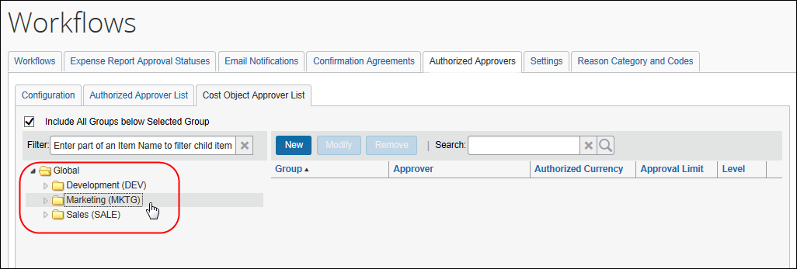
- On the right side, click New. The New Cost Object Approver window appears.
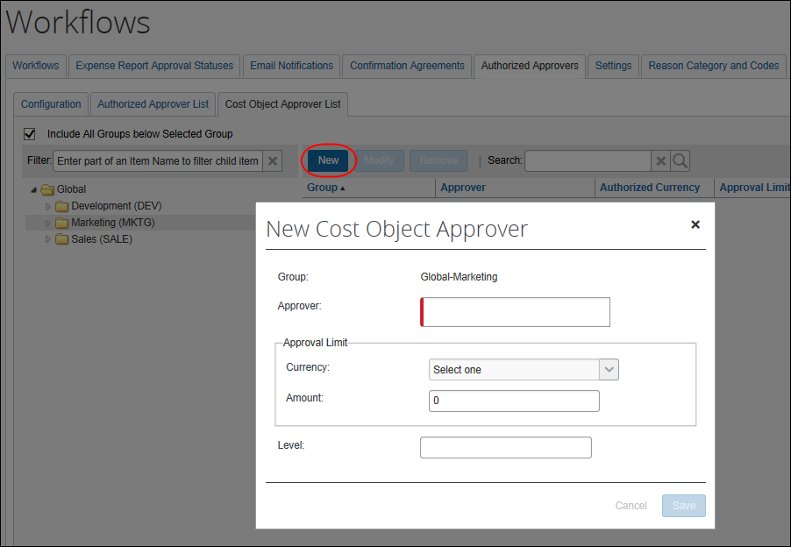
- Search for and select an approver.
Only current Expense approvers will be available for selection.
- Then:
- For limit-based cost object approval, select a currency and enter an amount.
NOTE: A limit must be assigned, or the approver will not be selected by the system for the cost object.
- For level-based cost object approval, enter a level.
The cost object configuration defines the type – either limit or level. If you complete both areas in this window – the Approval Limit area and the Level field – Concur will use the one that applies to your configuration and ignore the other.

☼

