
Concur Expense: Expense Types
Setup Guide

Last Revised: February 24, 2024
Applies to these SAP Concur solutions:
 Expense
 Professional/Premium edition
 Standard edition
 Travel
 Professional/Premium edition
 Standard edition
 Invoice
 Professional/Premium edition
 Standard edition
 Request
 Professional/Premium edition
 Standard edition
Table of Contents
Section 1: Permissions 1
Section 2: Overview 1
Definitions 1
Section 3: Expense Types Processes 3
Expense Types 4
Searching for an Expense Type 4
Creating a New Expense Type 6
Modifying an Expense Type 11
Deactivating an Expense Type 12
Expense Type Limits 13
Setting Limits on an Expense Type 13
Editing the Expense Type Limits 15
Removing an Expense Type Limit 15
Itemization Wizards 16
End-User Experience 16
Creating a New Itemization Wizard 18
Modifying an Itemization Wizard 23
Removing an Itemization Wizard 24
Section 4: Reference 24
Spend Categories 24
Amount Calculation Formulas 32
Variables 33
Basic Formulas 34
Conditional Formulas 35
Restrictions 36
End-User Experience 38

Revision History
Date | Notes / Comments / Changes
February 24, 2024 | Modified Searching for an Expense Type topic. Updated multiple images in Section 3: Expense Types Processes. The topic Removing an Expense Type is renamed and revised under Section 3. Updated the table in Section 4: Reference >Amount Calculation Formulas > Variable.
September 12, 2022 | Added note about the Transaction Amount calculation
January 21, 2022 | Updated the copyright year; no other changes; cover date not updated
January 7, 2021 | Updated the copyright; no other changes; cover date not updated
December 9, 2020 | Updated the description for the adjusted amount calculation in the Variables section.
July 31, 2020 | Updated the note for the Itemization field in the Creating A New Expense Type section.
July 1, 2020 | Added information about the existing UI and NextGen UI; made modifications throughout; cover revision date updated
June 26, 2020 | Updated the Itemization field with a note in the Creating A New Expense Type section.
April 9, 2020 | Renamed the Authorization Request check box to Request on the guide’s title page; cover date not updated
January 2, 2020 | Updated the copyright; no other changes; cover date not updated
January 4, 2019 | Updated the copyright; no other changes; cover date not updated
October 25, 2018 | Added information about the existing UI and NextGen UI; cover revision date updated
April 4, 2018 | Changed the check boxes on the front cover; no other changes; cover date not updated
February 10, 2018 | Removed Airline Fees and Goodwill spend categories.
January 4, 2018 | Added detail to the Variables section for transaction amount calculation and adjusted amount calculation for result.  Added a new point to the Restriction section that Transaction amount calculations may only be executed on an expense in an unsubmitted state.
December 27, 2017 | Updated the Restrictions section to include the following statement: "Calculation formulas should not reference a field that has been configured as a conditional field, because the value of that field may be null of the field is hidden."
December 11, 2017 | Added spend category code for Train.
December 9, 2017 | Updated the Spend Categories table for expense types in the Reference section of the guide.
July 18, 2017 | Clarified restriction for Cash Advance expense types using Update Cash Advance exchange rate on expense entries enabled in Group Settings.
December 14, 2016 | Changed copyright and cover; no other content changes.
December 9, 2016 | Updated the Permissions section and guide content to new corporate style; no content changes.
May 13, 2016 | Updated instances of he/she to they.
February 9, 2016 | Updated the Spend Category information.
June 12, 2015 | Updated the screen shots to the enhanced UI; no other content changes
September 24, 2014 | Added information about two user interfaces; no other content changes.
April 15, 2014 | Changed copyright and cover; no other content changes
April 3, 3012 | Removed all references to the legacy Authorization Request feature in Concur Expense  Changed any references to Concur's Travel Request service to Request, Concur Request, or Authorization Request, depending on the situation  No other content changes
December 28, 2012 | Made rebranding and/or copyright changes; no content changes
June 22, 2012 | Updated document to include Expense Types Limits functionality
January 20, 2012 | Updated document to include the Expense Categories functionality, now available in the current interface
September 23, 2011 | Updated information about Amount Calculation Formulas
December 31, 2010 | Updated the copyright and made rebranding changes; no content changes
July 16, 2010 | All attendee-related expense type options are now available in the current user interface
May 14, 2010 | Updated information about Amount Calculation Formulas
April 16, 2010 | Updated information about assigning Expense Categories, clarified Meal Spend Category visibility, and added information on using integers in calculations
March 19, 2010 | Added information on Amount Calculation Formulas
February 19, 2010 | Clarified use of Spend Categories
January 15, 2010 | Added information about custom itemization wizards, and itemization options for expense types
November 13, 2009 | Added Spend Category and Expense Category information
September 18, 2009 | Changed Add button to New
August 14, 2009 | New document

Expense Types
NOTE: Multiple SAP Concur product versions and UI themes are available, so this content might contain images or procedures that do not precisely match your implementation. For example, when SAP Fiori UI themes are implemented, home page navigation is consolidated under the SAP Concur Home menu.

Permissions
A company administrator may or may not have the correct permissions to use this feature. The administrator may have limited permissions, for example, they can affect only certain groups and/or use only certain options (view but not create or edit).
If a company administrator needs to use this feature and does not have the proper permissions, they should contact the company's SAP Concur administrator.
Also, the administrator should be aware that some of the tasks described in this guide can be completed only by SAP. In this case, the client must initiate a service request with support.

Overview
The Expense Types feature allows you to add, remove, and modify your expense types. The functionality includes a multi-step wizard to walk you through the process of adding or modifying expense types.
The Itemization Wizard feature allows you to create new itemization wizards to use with expense types. You can define the primary and secondary expense types, and whether they are required or personal.

Definitions
- Expense Types: Expense types are expenses that an employee can incur, such as airfare, lodging, breakfast, and so on. A list of expense types appears as an option when an employee first creates an expense entry. Each expense type has multiple unique fields that define the details of an expense. For example, Airfare could have ticket number and vendor attached to it, while Breakfast might only have vendor. These details are called fields.
- Expense Type Limits: Expense Type Limits set a warning or blocking amount limit on any expense type. When the warning limit is exceeded, the system will warn the user that they are over the limit. When the blocking limit is exceeded, the system will warn the user and prevent submission of the report, until the expense type amount is corrected in the report.
- Parent Expense Type: An expense that serves as a heading to expenses, such as Company Car (parent) which has Company Car Oil, Company Car Gas, and so on as children beneath it. An employee cannot select a parent expense type from the list of expenses when creating an expense report, only the items beneath it.
- Expense: An expense can be either a single expense that has no expense category, such as Airfare, or an expense that lies beneath the main expense and is related or linked to that expense and is listed under an expense category, such as Company Car Oil.
- Itemization: An itemization is an expense that is an itemization of a main or parent expense. For example, for a Lodging expense type, an employee may want to itemize the bill to include movie rental, room service, and so on. These itemizations have costs that add up to the main expense. You can define whether an expense type requires itemization, and create custom itemization wizards, using the Expense Types page.
- Spend Category: The Spend Category associated with each expense type determines which reporting category the expenses of that type fall under. When running reports that aggregate expenses by type, the Spend Category determines which type of spend the expense type will be associated with. Some spend categories are also associated with UI behavior, which determines whether the expense type has special presentation handling. Certain spend categories are used with Travel Allowance or mileage entries, which must collect and display the appropriate fields to the user.

Expense Types Processes
To access the Expense Types page:
Click Administration > Expense > Expense Types (left menu). The Expense Types page appears.
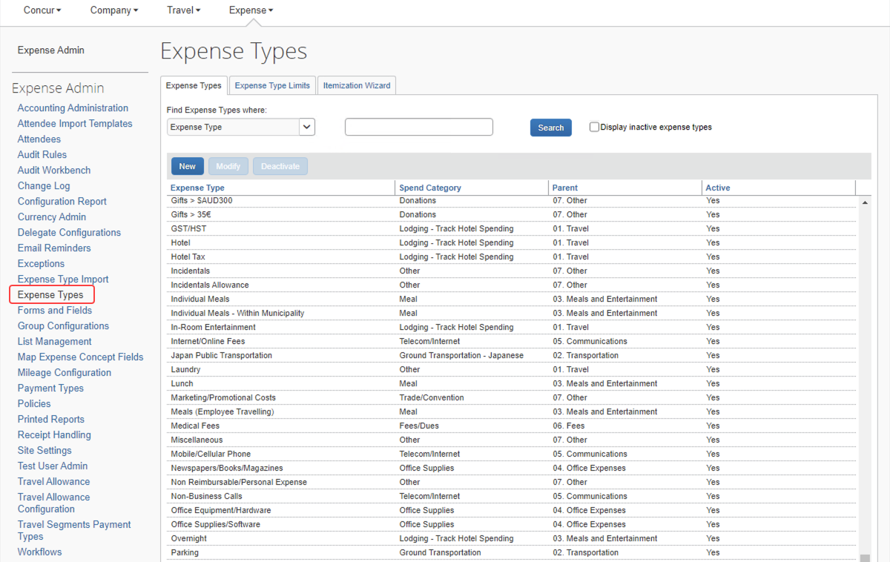

Expense Types

Searching for an Expense Type
To search for an expense type:
- On the Expense Types page, select a value in the Find Expense Types where: list.
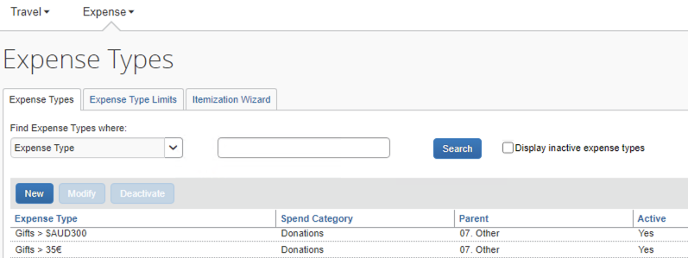
- Enter the desired search term in the search bar and click Search. The system will search for any expense types containing the letters entered. The list of matching expense types appears.
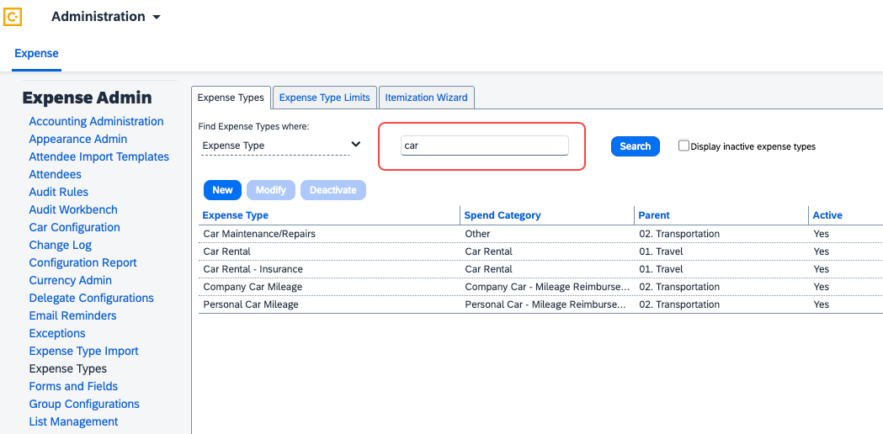
- You can also display expense types based on their active on inactive status. To display all the inactive expense types, select the Display inactive expense types checkbox.
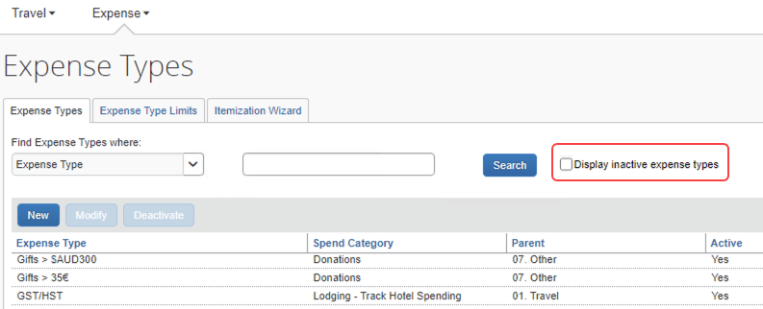
All active and inactive expense types displays on the screen.

Creating a New Expense Type
To create a new expense type:
- On the Expense Types page, click New. The General step of the New Expense Type wizard appears.
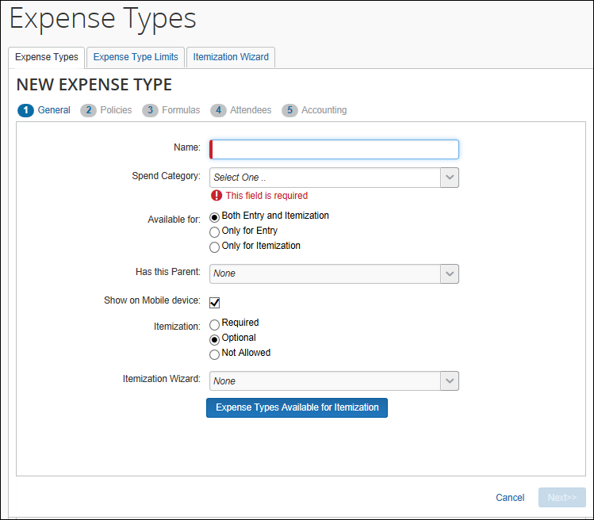
- Enter the desired values.
Field | Description
Name | The expense type's name
Spend Category | Allows you to define the overall category of spend that the expense type is associated with. This information is used in SAP Concur's reporting solutions. Certain spend categories are used with Travel Allowance or mileage entries to present the appropriate fields to the user.  - Refer to the Spend Categories section of this guide for more information.
Available for | The expense entry objects for which this expense type is visible
Has this Parent | The parent expense type of the new expense type. The parent groups similar expense types together for ease of selection by the end user.
Show on Mobile device | This determines whether the expense type will show as an available expense type on mobile devices.
Itemization | Select whether this expense type requires, allows or does not allow itemization.  NOTE: If the expense type is configured as Personal then itemization is not permitted and this field must be set as Not Allowed.
Itemization Wizard | Select the itemization wizard for this expense type.  - Refer to the Itemization Wizards section of this guide for more information.
Expense Types Available for Itemization | Click this to select the expense types that users can select from when entering itemizations manually.  NOTE: If the expense type also has an itemization wizard configured, the user will first see the itemization wizard and its associated expense type list. Any manual itemizations after that point will use the list defined in Expense Types Available for Itemization.
- Click Next. The Policies step appears.
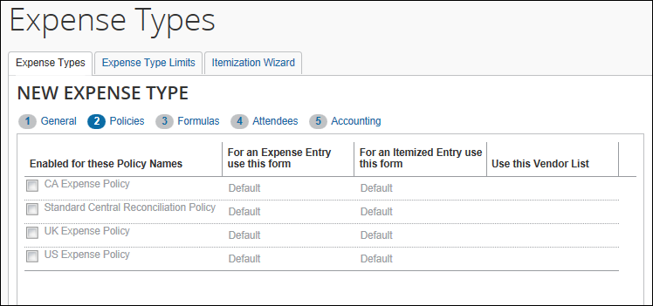
- Select the policies that use this expense type, then enter the desired values. Once you have selected a policy, the fields in the row become editable.
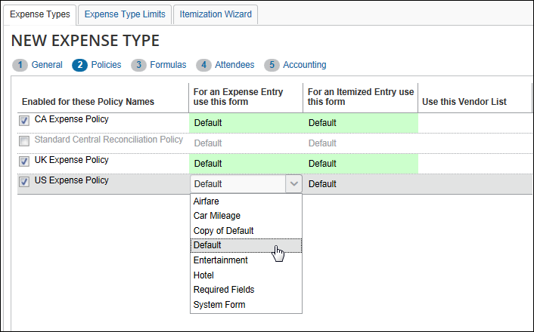
Field | Description
Enabled for these Policy Names | Select the expense policies this expense type should be available in.
For an Expense Entry use this form | Select the form to use with this expense type when it is used on an expense entry.
For an Itemized Entry use this form | Select the form to use with this expense type when it is used on an itemized entry.
Use this Vendor List | Select the vendor list associated with this expense entry. This field is necessary only if the selected forms include the Vendor List field.
- Click Next. The Formulas step appears. For each policy selected in the previous step, there will be an editable Amount Calculation Formula field. Enter the desired calculation for each policy.
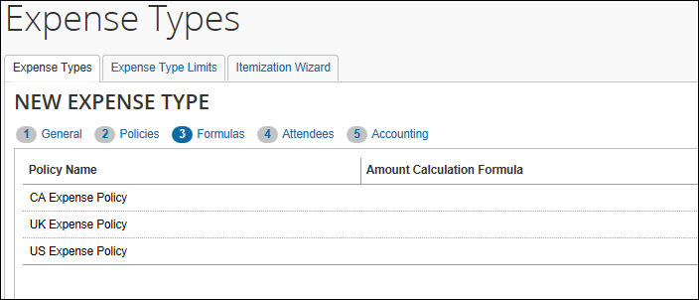
The Formulas tab will only appear if you have the correct user role. If the expense type is not eligible for a formula, the tab will appear grayed out.
- Refer to the Amount Calculation Formulas section of this guide for more information.
- Click Next. The Attendees step appears. For each policy selected in the Policies step, it will show a set of check boxes for selecting the appropriate attendee-related functions. These are necessary only for expense types that use the Attendee fields.
- Refer to the Concur Expense: Attendees Setup Guide for more information about these options.
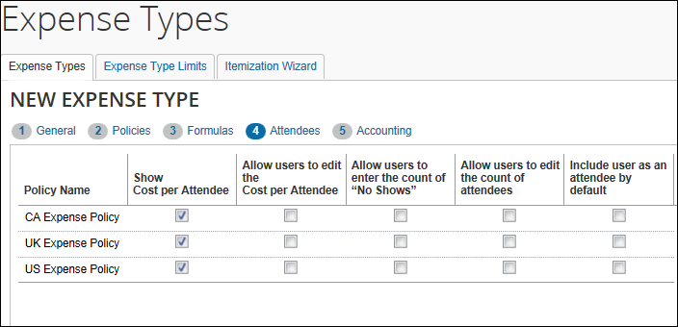
- Select the desired check boxes, per policy.
Field | Description
Show Cost per Attendee | Select this check box to allow users to view the amount of the expense allotted to each attendee.  If selected, the Amount column appears in the Attendees section of the New Expense/Expense tab.
Allow users to edit the Cost per Attendee | Select this check box to allow users to edit the amounts in the Amount column.
Allow users to enter the count of "No Shows" | Select this check box to allow users to account for no shows – attendees who were invited but did not attend.  If selected, the No Shows field appears in the Attendees section of the New Expense/Expense tab.
Allow users to edit the count of attendees | Select this check box to allow users to enter a count (number of unnamed attendees) for this expense type.  If selected, the Attendee Count column appears in the Attendee section of the New Expense/Expense tab.  IMPORTANT: This option is used in conjunction with the attendee type setting. Refer to the Concur Expense: Attendees Setup Guide.
Include user as an attendee by default | If this check box is selected, Concur Expense automatically adds the user as an attendee when the user accesses the attendees section the first time (when no attendees are assigned to the entry).  Once attendees are assigned or if the user removes their name from the attendee list, Concur Expense does not attempt to add the user again.
- Click Next. The Accounting step appears.
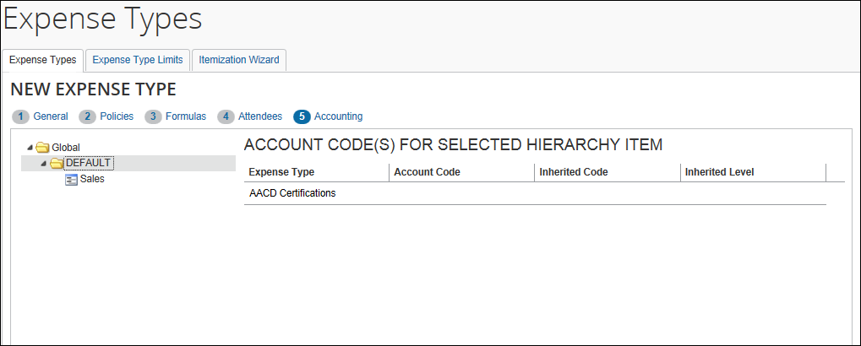
- The account code hierarchy is displayed in the left pane. The top level is Global. Level one is for Ledger. If there are levels set up for the Account Code Hierarchy for a Ledger, these appear as levels two though the number of levels set up. The right pane displays the account code fields for the new expense type for the level and value selected in the left pane.
- In the left pane, navigate to the place within the Account Code Hierarchy that you want to enter an account code.
- Enter the desired account code.
Field | Description
Expense Type | This read-only field displays the currently selected expense type name. Depending on the expense code there can be two rows:  - Lodging: One row for the regular case and one row for the overlimit case.  - Meals: One row for the regular case and one row for the overlimit case (used in travel allowances).  - Company Car: One row for Business Use case and one row for Personal Use case.  If the Taxability or Deductibility feature is enabled, there two rows:  - Taxability: One row for the Taxable case and one row for Not Taxable case  - Deductibility: One row for the Deductible case and one row for Not Deductible case  - Refer to the Spend Categories section of this guide for more information on expense codes.
Account Code | The account code for the expense type. If the Account Code field is left blank, this account code hierarchy value for this expense type will inherit its account code.
Inherited Code | If the Account Code is blank, this field displays the account code that this account code hierarchy value for this expense type will inherit.
Inherited Level | If the expense type is inheriting an account code, this field displays the account code hierarchy value that the account code was inherited from.
- Click Done.

Modifying an Expense Type
To modify an expense type:
- On the Expense Types tab, select the desired expense type.
- Click Modify.
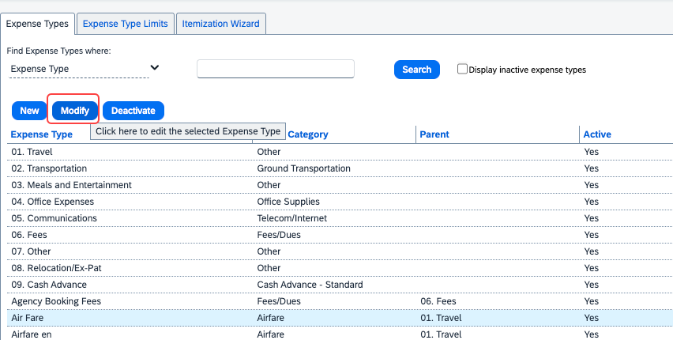
- Change fields as desired. Refer to the To add an expense type process for field information.
- Click Done.

Deactivating an Expense Type
You can deactivate an unused expense type. Deactivating an expense type allows you to retain it for future use. Much like active expense types, inactive expense types can also be modified and can even be set to active or be reactivated with a different name.
To deactivate an expense type:
- On the Expense Types page, select the desired expense type.
- Click Deactivate. The expense type is deactivated from the expense type list. It is now saved for future use and can be modified for use later.
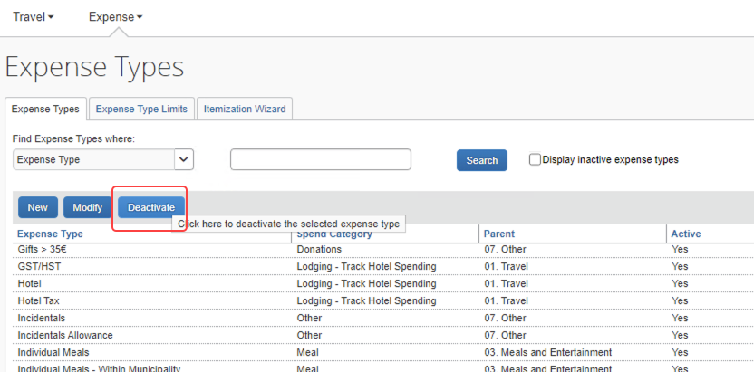
- A confirmation dialog pops up. Click Yes to proceed.
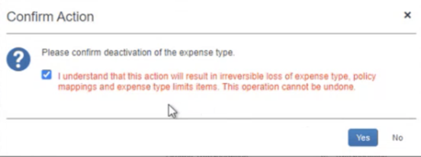
Deactivating an expense type always involves the loss of a certain amount of data. Please read the confirmation text carefully before proceeding.

Expense Type Limits
Expense Type Limits let the administrator set a warning or blocking amount limit on any expense type. When the warning limit is exceeded, the system will warn the user that they are over the limit. When the blocking limit is exceeded, the system will warn the user and prevent submission of the report, until the expense type amount is corrected in the report.

Setting Limits on an Expense Type
The limits that can be set apply to the selected policy by currency and allow a range within which the system first warns, then blocks, the report from submission via the expense type limits.
To set a limit on an expense type:
- Click the Expense Type Limits tab.
- Click New and select an expense type from the list under Expense Type.
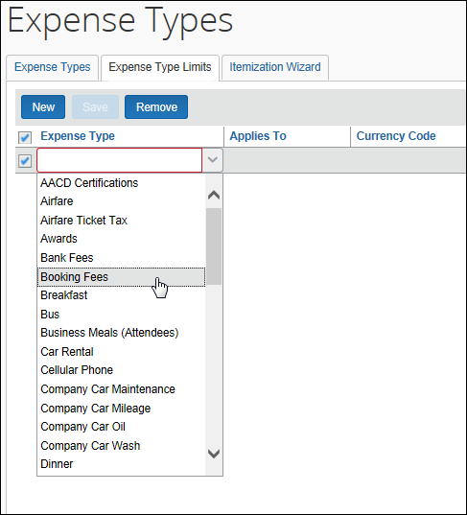
- Select the group this expense type limit will apply to under Applies to, and the currency under Currency Code.
- Set the amount range by configuring the following options:
- Warn Over This Amount: Set the amount over which the system will warn the user they have exceeded the lower maximum amount for this expense type.
- Block Over This Amount: Set the amount over which the system will block submission of the expense report.

- Click Save.
The expense type is now limit-configured, and the limits take effect immediately.

Editing the Expense Type Limits
To adjust the limits, click directly in any of the fields for the desired expense type and choose or type a new value.

Removing an Expense Type Limit
When you remove an expense type limit it takes effect immediately.
To remove an expense type limit:
- Select the row of the expense type limit you will delete.
- Click Remove.
- In the Remove Expense Type Limit dialog box, click Yes.
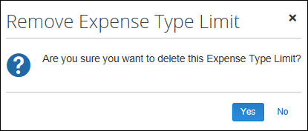
Additional information:
- Each expense type may use a single currency in conjunction with a specified Applies To Group. Clients wishing to set multiple rules for the same expense type and group in different currencies would need to use the more flexible audit rules functionality.
- If the client has multiple levels of expense hierarchy groups, the system will apply the first rule found for the expense type when searching first at the user's group and then walking up the hierarchy until a limit is found for the specified expense type. Any limits configured at higher levels in the hierarchy above that point where a limit is found will not be applied.
- These limits will not be applied to employees with the value of Never Audit (NVR) in the Expense Audit Required field on the employee profile record.

Itemization Wizards
Itemization wizards define the expense types that users see when itemizing an expense. The selected expense types can have the following properties set:
- Whether they are a Primary or Secondary expense type
- Whether they are Required
- Whether they default to being marked Personal
- Whether they are required to be marked Personal
This itemization option does not replace the existing lodging itemization wizard. The lodging wizard is specifically designed to address the recurring daily expenses of a hotel stay. The new itemization wizard option allows itemization of single occurrences of an expense type on the same date as the parent expense.

End-User Experience
The following example shows how the itemization wizard appears to the user while itemizing a car rental expense. The Car Rental expense type has been configured to use the Car Rental Itemization wizard.
The user enters the parent expense, then clicks Itemizations.
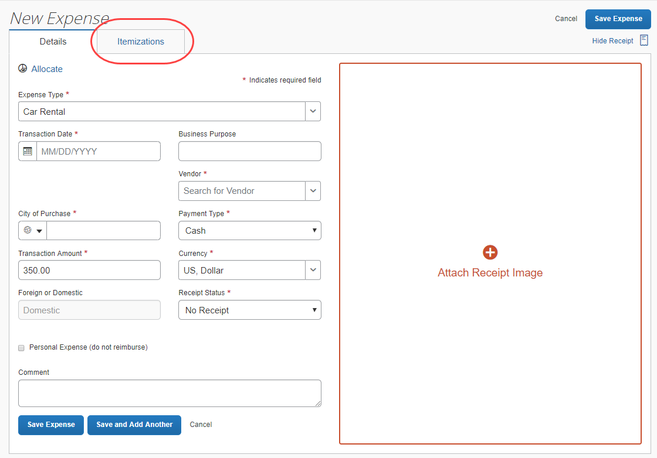
The user clicks Create Itemization and then enters the required details for each of the expense types required for an itemization.
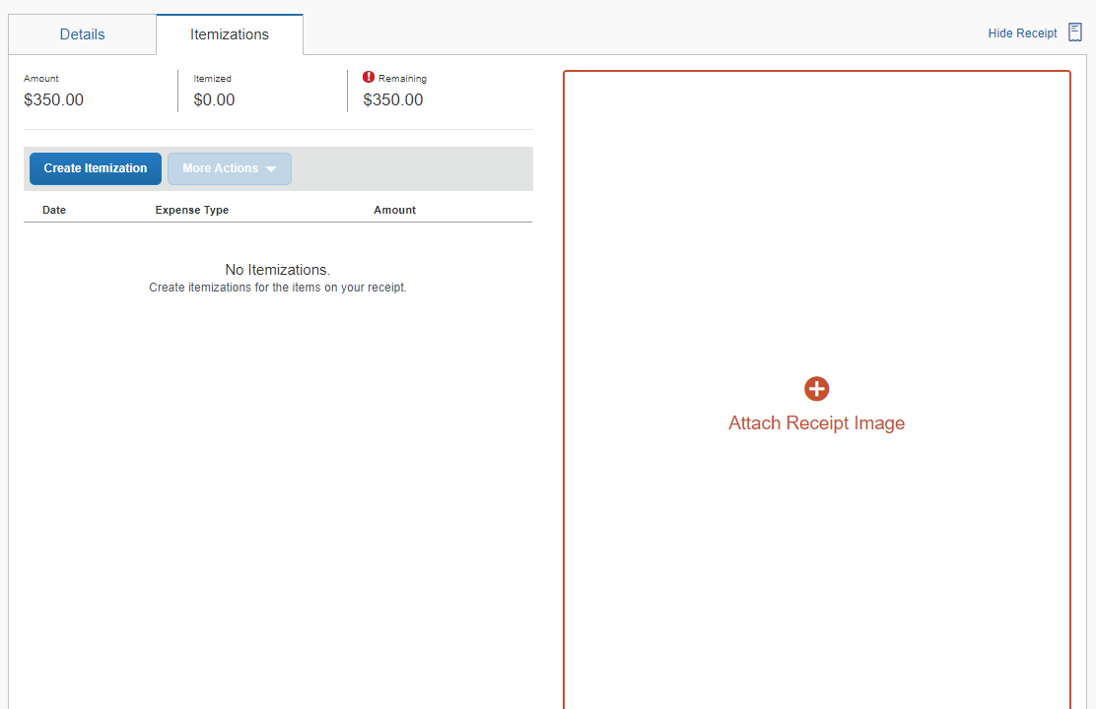
As with other itemization pages, the running totals of what has been accounted for and what amount remains shows at the top of the pane. Any amount not accounted for will be itemized using the parent expense type.
The user repeats these steps until the remaining amount becomes $0. When done, the user clicks Save Expense.
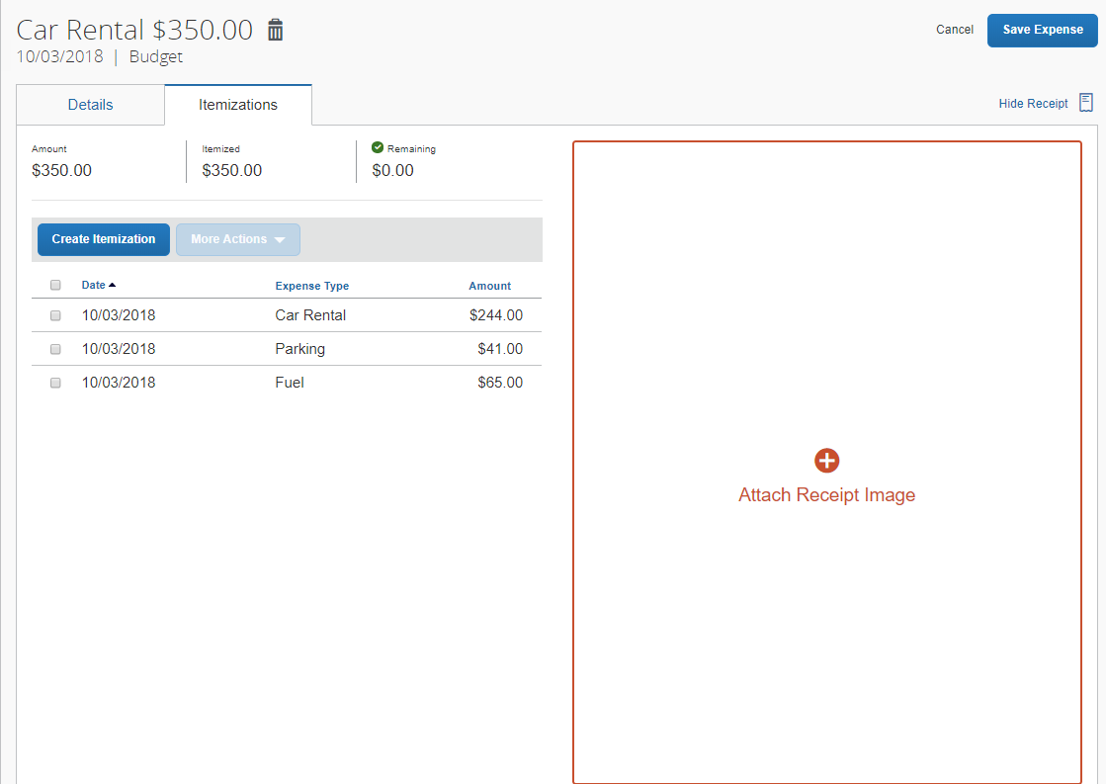

Creating a New Itemization Wizard
Itemization wizards can be created and edited on the Itemization Wizard tab of the Expense Types page.
To create a new itemization wizard:
- On the Expense Types page, select the Itemization Wizard tab. The Itemization Wizard page appears.
- Click New. The General step of the New Itemization Wizard page appears.
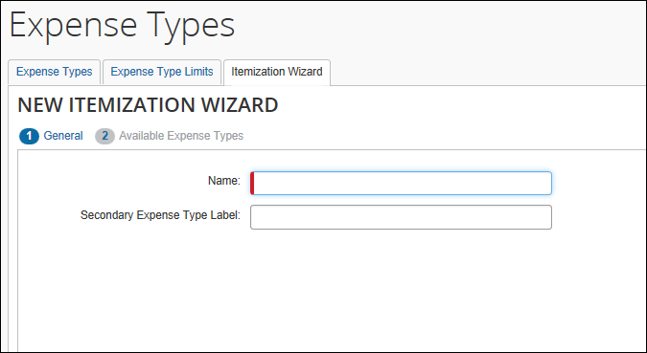
- Enter the desired values.
Field | Description
Name | This name appears on the itemization tab when users are filling in an expense type using this wizard, and in the list of itemization wizards on the expense type properties page.
Secondary Expense Type Label | This name appears to the end user as a label dividing the secondary expense types from the primary expense types. If this field is left blank, you will not be able to select any secondary expense types.
- Click Next. The Available Expense Types step of the New Itemization Wizard appears.
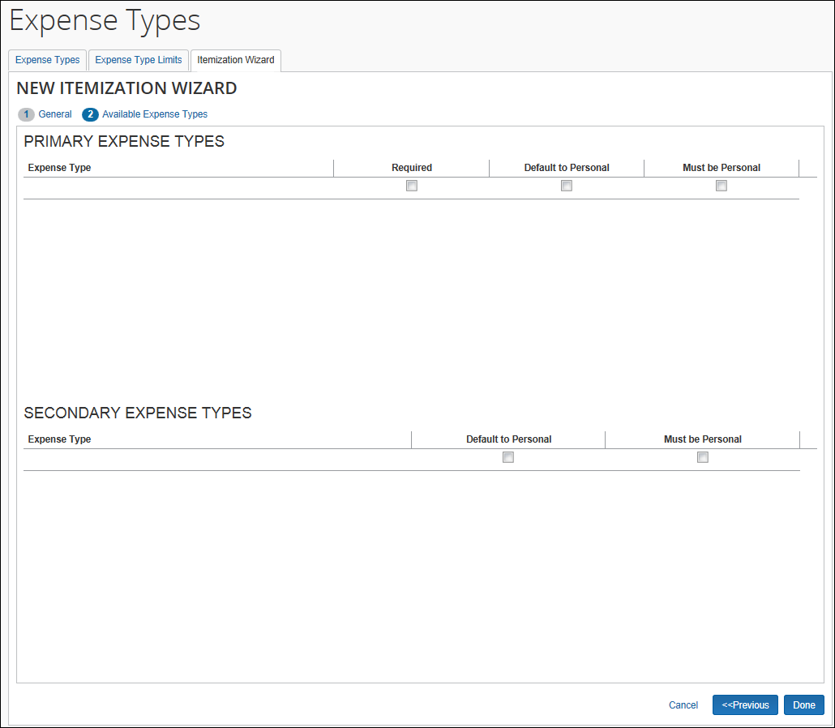
- Click in the Expense Types column to select an expense type.
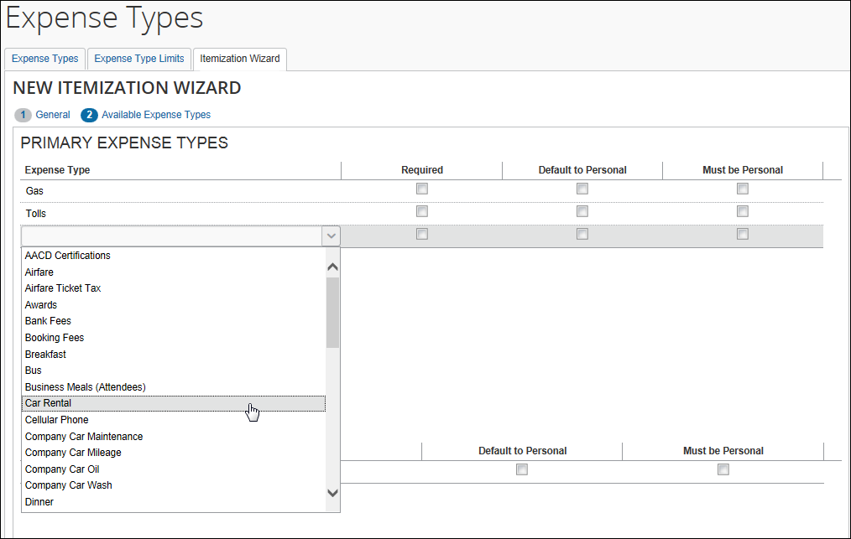
To remove an expense type, select the Remove value from the expense type list. The Remove value only appears after you have selected an expense type.
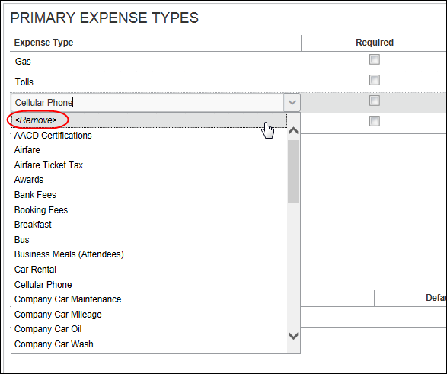
- Select the desired settings for each expense type.
Column | Description
Expense Type | Select the desired expense type.
Required | Select this box to require users to enter a value for this expense type.
Default to Personal | Select this box to set the Personal check box to selected by default for this expense type.
Must be Personal | Select this box to make the Personal check box selected and uneditable.
- Click Done.

Modifying an Itemization Wizard
To modify an itemization wizard:
- On the Itemization Wizard page, select the desired wizard.
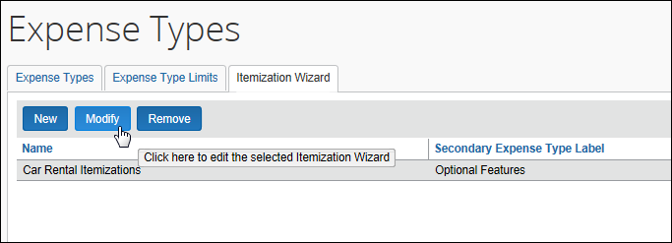
- Click Modify. The General step of the Modify Itemization Wizard page appears.
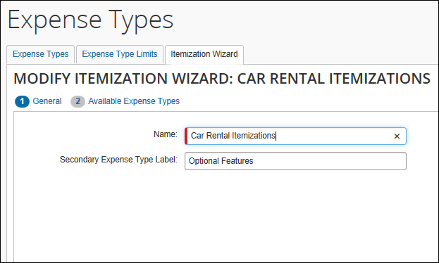
- Make any necessary changes.
- Click Next. The Available Expense Types step of the Modify Itemization Wizard page appears.
- Make any necessary changes.
- Click Done.

Removing an Itemization Wizard
To remove an itemization wizard:
- On the Itemization Wizard List page, select the desired wizard.
- Click Remove.
The Remove button is only available if the itemization wizard is not being used by any expense types.
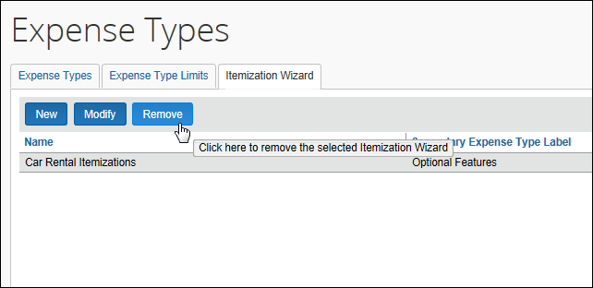

Reference

Spend Categories
The Spend Category associated with each expense type determines which reporting category the expenses of that type fall under. When running reports that aggregate expenses by type, the Spend Category determines which type of spend the expense type will be associated with. Some spend categories are also associated with UI behavior, which determines whether the expense type has special presentation handling. Certain spend categories are used with Travel Allowance or mileage entries, which must collect and display the appropriate fields to the user. Reporting Categories were used in older versions of reports in Cognos and are mapped to the Spend Categories to maintain the original expense type mapping.
The Spend Category Code column displays the spend category code associated with the spend category. The codes are used for the expense types import. The Recommended Use column indicates which product SAP recommends the spend category be used with.
The table of spend categories is below.
The list of spend categories is shared with Invoice.

Spend Category | Spend Category Code | Recommended Use | Description
Accounting | ACCNT | Invoice | Use this for account payable/receivable, accrued liabilities, and cash advance return.
Advertising/Marketing  Reporting Category: Advertising/Marketing  Special Handling: Standard | ADVTG | Invoice and Expense | Use this for marketing expense, promotional items, advertising, and promotions.
Agent/Booking Fees | ABFEE | Travel Expense | Use this for travel agent and booking fees other than airline fees.
Airfare  Reporting Category: Airfare  Special Handling: Standard | AIRFR | Invoice and Expense | Use this for airfare and airline fees.
Car Related | CARXX | Invoice | Use this for mileage, parking, tolls, car rental, company/personal car, and gasoline/fuel.
Car Rental  Reporting Category: Car Rental  Special Handling: Standard | CARRT | Expense | Use this for car rental.
Cash Advance - Not Partially Approvable  Reporting Category: Other  Special Handling: Other Not Partially Approvable | CASHA | Expense | Use this for any expense type where you do not want to allow approvers to partially approve. Cash Advance is the most common example.
Cash Advance – Standard  Reporting Category: Other  Special Handling: Standard | CASHN | Expense | Use this for standard cash advance.
Company Car - Fixed Expense  Reporting Category: Company Car  Special Handling: Standard | COCAR | Expense | Use this spend category for expense types where you want your users to enter a fixed expense amount in the user interface. The expense amount is independent of the distance.  NOTE: For Invoice users, SAP recommends using the Car Related spend category.
Company Car - Mileage Reimbursement  Reporting Category: Company Car  Special Handling: Company Car | COCRM | Expense | Use this spend category for expense types where you want your users to enter a distance in the user interface. The system calculates the expense amount using this distance.  NOTE: For Invoice users, SAP recommends using the Car Related spend category.
Computer  Reporting Category: Computer  Special Handling: Standard | COMPU | Invoice and Expense | Use this for IT services, software expenses, and computers.
Consulting Services | CONSL | Invoice | Use this for consultancy fees, consulting services, and consultants.
Donations | DONAT | Invoice and Expense | Use this for charitable contributions/events, charity, and goodwill.
Entertainment  Reporting Category: Entertainment  Special Handling: Standard | ENTER | Invoice and Expense | Use this for dinner/lunch/breakfast, business meals, and client/customer entertainment.
Facility | FACLT | Invoice | Use this for repairs/maintenance, maintenance equipment, and storage units.
Fees/Dues  Reporting Category: Fees/Dues  Special Handling: Standard | FEESD | Invoice and Expense | Use this for bank service charges, fines, penalties, membership dues, licenses, and permits.
Financial Services | FINAN | Invoice | Use this for accounting fees, audit fees, tax services, and financial services.
Fuel For Mileage | MFUEL | Expense | Use this for fuel for mileage.  NOTE: For Invoice users, SAP recommends using the Car Related spend category.
Gas  Reporting Category: Gas  Special Handling: Standard | GASXX | Expense | Use this for gas/fuel.  NOTE: For Invoice users, SAP recommends using the Car Related spend category.
Gifts | GIFTS | Invoice and Expense | Use this for gifts/awards for clients/customers and customer appreciation.
Ground Transportation  Reporting Category: Ground Transportation  Special Handling: Standard | GRTRN | Expense | Use this for bus, taxi, shuttle, and public transport.
Ground Transportation - Japanese | JGTRN | Expense | Use this for bus, taxi, shuttle, and public transport.  NOTE: This is specific for Japan.
Insurance | INSUR | Invoice and Expense | Use this for vehicle insurance, general insurance, and business insurance.
Janitorial | JANTR | Invoice and Expense | Use this for janitorial supplies and cleaning supplies.
Legal Services | LEGAL | Invoice | Use this for legal expenses and professional legal fees.
Lodging | LODGX | Expense | Use this for lodging.
Lodging - Do Not Track Room Rate Spending  Reporting Category: Lodging  Special Handling: Standard | LODGN | Expense | Use this spend category when you do not want to use the Hotel Wizard. Your users must manually itemize daily room rates and room taxes.  NOTE: This spend category will direct the user interface to not include the Travel Allowance related lodging field. Therefore, expense types using this spend category should not be used for Travel Allowance.  NOTE: For Invoice users, SAP recommends using the Lodging spend category.
Lodging - Track Room Rate Spending  Reporting Category: Lodging  Special Handling: Lodging | LODGA | Expense | Use this spend category when you want to use the Hotel Wizard. The wizard has entry fields for Daily Room Rate and Daily Room Tax. The wizard creates the itemizations for room rate and room tax.  NOTE: If you are using Travel Allowance for lodging, you must use this spend category for your Lodging expense types because this spend category will direct the user interface to include the Travel Allowance related lodging field.  NOTE: For Invoice users, SAP recommends using the Lodging spend category.
Lodging Tax | LODGT | Expense | Use this for lodging tax. Excluding local lodging tax is beneficial when negotiating prices with hotel chains.
Meal  Reporting Category: Dining  Special Handling: Standard | MEALS | Invoice and Expense | If you are not using Travel Allowance, use this spend category for your meals expense types.  NOTE: This category only appears for clients that do not use Travel Allowance.
Meal - Count in Daily Meal Allowance  Reporting Category: Dining  Special Handling: Meals | MEALA | Expense | Use this spend category when using Travel Allowance for all meals expense types you do want to count in the daily meal allowance. This typically also includes the Incidentals expense type. The user interface for these expense types will include the Travel Allowance related meals fields.  NOTE: This category only appears for clients using Travel Allowance.  NOTE: For Invoice users, SAP recommends using the Meal spend category.
Meal - Do Not Count in Daily Meal Allowance  Reporting Category: Dining  Special Handling: Standard | MEALN | Expense | Use this spend category when using Travel Allowance for all meals expense types you do not want to count in the daily meal allowance. The user interface for these expense types will not include the Travel Allowance related meals fields.  NOTE: This category only appears for clients using Travel Allowance.  NOTE: For Invoice users, SAP recommends using the Meal spend category.
Meetings  Reporting Category: Meetings  Special Handling: Standard | MEETG | Invoice and Expense | Use this for meetings.
Office Supplies  Reporting Category: Office  Special Handling: Standard | OFFIC | Invoice and Expense | Use this for office furniture and office stationery.
Other  Reporting Category: Other  Special Handling: Standard | OTHER | Invoice and Expense | Use this for tips/gratitude, undefined, sundry, miscellaneous, laundry, and incidentals.
Other Supplies | OSUPP | Invoice and Expense | Use this for inventory, technical supplies, warehouse supplies, tools, and lab supplies.
Personal Car - Fixed Expense  Reporting Category: Personal Car  Special Handling: Standard | PRCAR | Expense | Use this spend category for expense types where you want your users to enter a fixed expense amount in the user interface. The expense amount is independent of the distance.  NOTE: For Invoice users, SAP recommends using the Car Related spend category.
Personal Car - Mileage Reimbursement  Reporting Category: Personal Car  Special Handling: Personal Car | PRCRM | Expense | Use this spend category for expense types where you want your users to enter a distance in the user interface. The system calculates the expense amount using this distance.  NOTE: For Invoice users, SAP recommends using the Car Related spend category.
Personal Car – Parking Expense | PRKNG | Expense | Use this for personal parking.  NOTE: For Invoice users, SAP recommends using the Car Related spend category.
Printing/Reproduction | PRNTG | Expense | Use this for printing, duplicating, and photocopying.
Professional Services | PROFS | Invoice | Use this for professional subscriptions/dues, licensing, and outside services.
Rent | RENTL | Invoice | Use this for office/space/apartment rent, housing, and equipment rate/lease.
Shipping  Reporting Category: Shipping  Special Handling: Standard | SHIPG | Invoice and Expense | Use this for courier/shipping/freight, delivery and postage.
Staffing | STAFF | Invoice | Use this for employee award/recognition/benefits, commissions/bonus, and payroll/salaries.
Subscription/Publication  Reporting Category: Subscription/Publication  Special Handling: Standard | SUBSC | Invoice and Expense | Use this for dues, subscriptions and newspapers/books/magazines.
Telecom/Internet  Reporting Category: Telecom  Special Handling: Standard | TELEC | Invoice and Expense | Use this for cellular phone, internet services, and wireless devices.
Trade/Convention  Reporting Category: Trade/Convention  Special Handling: Standard | TRADE | Invoice and Expense | Use this for conferences, trade shows, and special events.
Train  Reporting Category: Rail  Special Handling: Standard | RAILX | Invoice and Expense | Use this for train or rail.
Training  Reporting Category:  Training  Special Handling: Standard | TRAIN | Standard | Use this for tuition/training reimbursement and seminar/learning.
Utilities | UTLTS | Invoice | Use this for electricity, gas, and waste disposal.

Amount Calculation Formulas
Amount calculation formulas are used to enforce policy level amount restrictions for expense types. The amount calculations are entered as simple formulas, using the addition (+), subtraction (-), multiplication (*) and division (/) operators. The calculations can also include simple if/then/else statements. Amount calculation formulas are used to modify the adjusted amount under certain circumstances. For transaction amounts, the formula calculates the amount for manual entries, and the user is not able to enter or modify the amount.
The Expense Configuration Administrator role, or a custom role including the Edit Expense Type Calculation Formulas task, is required to use this feature. Users without the appropriate role will not see the Formulas tab when adding or modifying expense types.

Variables
Certain report fields are available for use as variables in the calculations. These fields are:
Variable | Description
C1 to C40 | These variables refer to the custom fields 1-40.  Only custom fields defined with data types of Amount, Integer or Numeric can be used.  The C must be in upper case, followed by the desired number. Custom1 is referred to as C1, Custom2 as C2, and so on.
EX | This variable refers to the entry exchange rate. The variable name, EX, must be in upper case.  NOTE: You will always multiply the amount in the transaction currency by the exchange rate to get the amount in the base currency.
PA | This variable refers to the posted amount for the expense entry. The variable name, PA, must be in upper case.
result,  result_a,  result_t | The result variable indicates the final result of the calculations and is a required part of the formula definition.  The variable name must be in lower case. The result variable must be on the left side of the equation.  In basic formulas, there will be one result variable. In conditional formulas, there must be one result variable per condition.  Transaction Amount Calculation  The result_t variable will calculate the Entry Transaction Amount.  Transaction amount calculations may only be executed on an expense in an unsubmitted state. A formula that sets the expense amount (for example, result_T = <formula>) will not be executed for a submitted expense. The expense transaction amount may not be changed for a submitted expense.  Adjusted Amount Calculation  The result and result_a variables will update the Entry Adjusted Amount.  Adjusted amount calculations may only be executed on an expense in an unsubmitted state. A formula that sets the adjusted amount (for example, result_a=<formula>) will not be executed for a submitted expense. The expense adjusted amount may not be changed for a submitted expense.  NOTE: If an approver has permission to edit the expense, they may adjust the approved amount up to 100% of the claimed amount which will override the amount from the result of the calculation formula.  - Refer to the Basic Formulas and Conditional Formulas sections of this guide for more information.
R_C1 to R_C20 | These variables refer to the report level custom fields 1-20.  Only report custom fields defined with data types of Amount, Integer or Numeric can be used.  Report Custom1 is referred to as R_C1, Custom2 as R_C2, and so on.
TA | This variable refers to the Transaction Amount for the expense entry. The variable name, TA, must be in upper case.
T_MR, T_LR, T_IR | These variables refer to Travel Allowance rates for:  T_MR: Meals  T_LR: Lodging  T_IR: Incidentals  The rates are selected based on the location (city) and date of the expense entry, and the user's travel allowance configuration. The legacy Travel Allowance feature must be enabled and configured for the user to use this feature. If both company and government rates are found, the company rates will be used.  NOTE: These variables are not supported for rates from the travel allowance service feature.  - Refer to the Expense: Travel Allowance (Legacy) Setup Guide for more information.
V_A1 and V_A2 | These two variables refer to validation amounts 1 and 2. You must have a validation rule defined with a Calculation Formula action in order to use these fields in your calculations.  - Refer to the Expense: Audit Rules (Validation Rules) Setup Guide for more information.

Basic Formulas
Basic formulas include arithmetic operators and report data variables. All formulas must start with the result variable (lowercase), then define the equation:
result = equation
The formula to calculate the adjusted amount by subtracting the value in Custom4 from the posted amount is:
result = PA – C4
Numeric constants can be used in calculations. The formula to calculate the adjusted amount by reducing the posted amount to 75% of its original amount is:
result = PA * .75
Integer values must be entered with one decimal place specified. A possible formula to reduce the posted amount to ¼ of its original amount is:
result = PA*(1.0/4.0)
Parentheses can be used to separate sections of the formula. The calculations inside the parentheses will be worked first, then the calculations outside the parentheses will be worked with the result. The previous calculation can be enhanced to subtract the amount in Custom4 at the end:
result = (PA * .75) – C4
Exchange rates can be multiplied by amounts in foreign currency to get the amount in the user's reimbursement currency. The formula to convert Custom3 from foreign currency to reimbursement currency, then subtract it from the posted amount is:
result = PA – (C3 * EX)
Posted/transaction amounts are set using the result_t variable. The formula to set the entry transaction amount to 25 times the value in the entry custom 1 field is:
result_t = C1 *25.0
Validation rule amount values can be used in the calculations. The formula to set the transaction amount to the entry custom 1 amount multiplied by the validation amount 1 is:
result_t = C1 * (V_A1)
The report custom fields can be used in the calculations. The formula to set the approved amount to the value of the posted amount times the difference of the report custom 1 field and the report custom 5 field is:
result = PA * (R_C1 – R_C5)

Conditional Formulas
Conditional formulas are used when you need multiple possible calculations, depending on values involved. The formulas use the if, elif (elseif), and else conditional statements to define complex behavior. The lines containing the if/elif/else statements must end with a colon (:).
The lines following the conditional statements, that define the result calculation formula to use, must be indented. The indentation can be done by using either space(s) or a tab for indentation. It is not possible to enter tabs directly into the Amount Calculation Formula column. If tabs are desired, the formula should be entered into a text editor first, and then copied into the admin screen column.
The same indentation character must be used throughout the formula – you cannot use tab in one place and space in another.
In this example, you want to leave amounts below 20 alone, decrease amounts from 20-50 to 75%, and decrease amounts above 50 to 50%. The formula is:
if PA<20:
result = PA
elif PA<50:
result = (PA * 0.75)
else:
result = (PA * 0.5)

Accounting for Negative Amounts
It is possible for expense types to have a negative amount (credit) entered. The formulas can address the negative amounts by testing to see if the amount is more than zero before performing any other actions. In this example, negative amounts will be unchanged, while positive amounts will be reduced to 75% of the original value:
if PA<=0:
result = PA
elif PA > 0:
result = PA * .75

Restrictions
Transaction amount calculations may only be executed on an expense that is in an unsubmitted state. A formula that sets the expense amount (e.g. result_T = <formula>) will not be executed for a submitted expense. The expense transaction amount may not be changed for a submitted expense.
Any expense type marked as personal will not be subject to a transaction amount calculation.
The Formulas step is not available for the following expense types:
Fixed travel allowance expense types:
- Fixed Lodging expense type
- Fixed Meals (gross) expense type
- Fixed Meals expense type
- Overnight expense type
- Provided Meals expense type
- Taxable Meals expense type
Cash Advance expense types:
- Cash Advance Return expense type
- Currency Gain/Loss expense type
- Any expense type using the Cash Advance - Not Partially Approvable or Cash Advance – Standard spend categories
The exchange rate cannot be overwritten by the Cash Advance exchange rate for any expense that is partially approved or is a subordinate (child) expense even if Update Cash Advance exchange rate on expense entries is enabled in Group Settings.
Mileage expense types:
- Company Car Mileage expense type
- Personal Car Mileage expense type
- Any expense type using the Company Car - Mileage Reimbursement or Personal Car - Mileage Reimbursement spend categories
The Undefined expense type.
Itemized expense types have the following restrictions:
- Transaction amount calculations only apply to parent expense types of itemized entries.
- Adjusted amount calculations only apply to child itemization entries.
Calculation formulas should not reference a field that has been configured as a conditional field, because the value of that field may be null if the field is hidden.

End-User Experience

Adjusted Amount Calculation
Users creating expense entries will see the Requested amount column display the calculated amount after they save the entry.
Before the save:
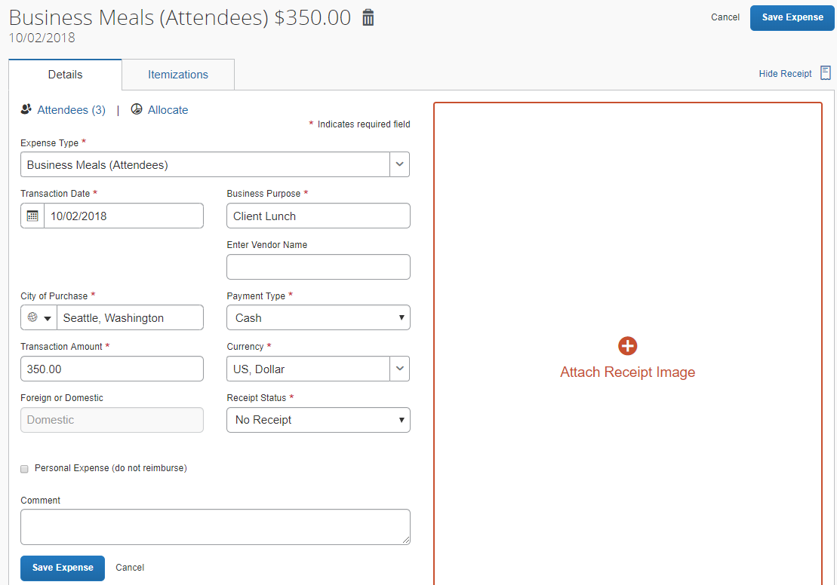
After saving, with the adjusted amount appearing in the Requested column:
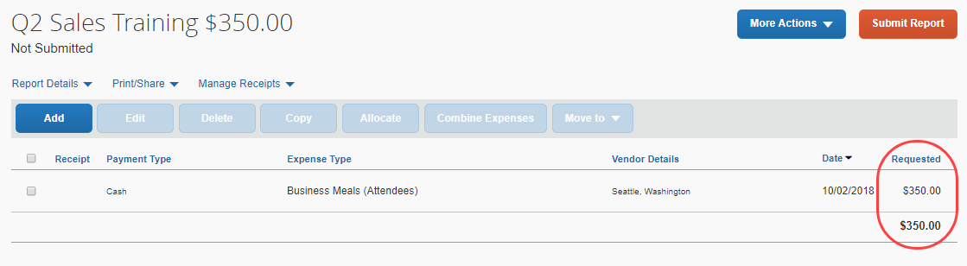
Entries with attendees will have the amount per attendee adjusted to match the calculated amount after the expense is saved.
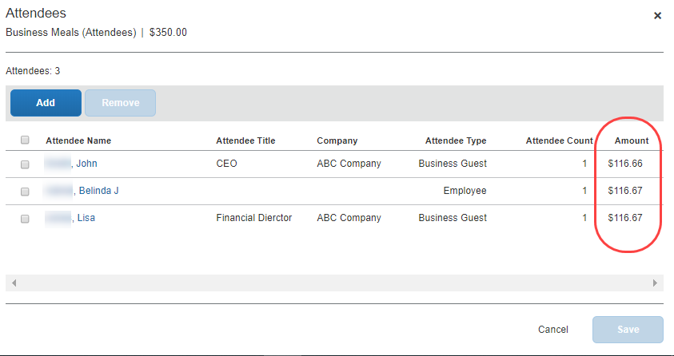
If the amount per attendee was previously adjusted by the user, a message will be displayed advising the user to review the new amounts.

Transaction Amount Calculation
Users creating expense entries will not be able to edit the Transaction Amount field and will see that it is not required. When the expense has been saved, the amount will be calculated and show in the expense list.

Important Note About User Edit and Default Behavior of the Currency Field
The change of the currency for the expense will not alter the amount calculated by the formula. The Currency field is typically not an editable field for expense types employing transaction amount calculations because the calculated amount will not be updated to reflect a change in currency.
With this limitation in mind, the Currency field may be configured to allow employee edit via the field access rights on the expense form definition. When user edit of the Currency field is permitted, the change of expense location would prompt the user to ask if the currency should be updated to match the new location. When user edit is not permitted, this prompt will not be offered to the user.
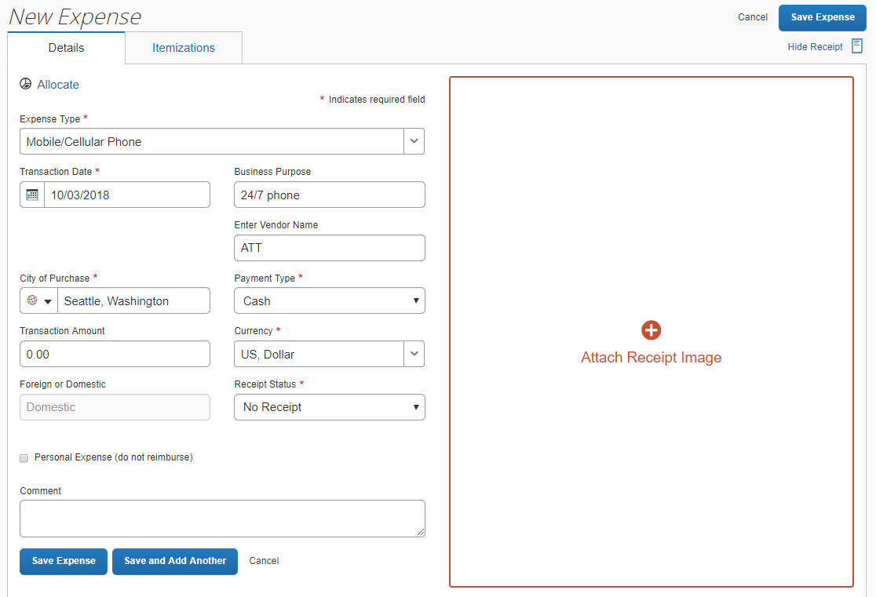
If the user opens the expense, the Transaction Amount field is read-only and cannot be edited:
☼

