
Expense: Custom Localization Service
Setup Guide
Last Revised: March 4, 2023
Applies to these SAP Concur solutions:
 Concur Expense
 Professional/Premium edition
 Standard edition
 Concur Travel
 Professional/Premium edition
 Standard edition
 Concur Invoice
 Professional/Premium edition
Standard edition
 Concur Request
 Professional/Premium edition
 Standard edition
Table of Contents
Section 1: Permissions 1
Section 2: Overview 1
Supported Services 2
Requirements 2
How It Works 2
Feature Activation 2
Section 3: Procedures for Configuration 3
Accessing the Custom Localization Page 3
Selecting the Target Language for the Translation 3
Viewing Category Text and Status for Localization 4
Using Search to locate the desired text 6
Using Filters to check the status of text 7
Section 4: Perform Translations on Text 8
Performing In-line Edits 8
Exporting Text for Translation 10
Understanding the localization.xls file 12
Importing a Translated File 13
Troubleshooting 14

Revision History
Date | Notes/Comments/Changes
October 14, 2023 | Initial guide publication.

Custom Localization Service
NOTE: Multiple SAP Concur product versions and UI themes are available, so this content might contain images or procedures that do not precisely match your implementation. For example, when SAP Fiori UI themes are implemented, home page navigation is consolidated under the SAP Concur Home menu.

Permissions
A company administrator may or may not have the correct permissions to use this feature. The administrator may have limited permissions, for example, they can affect only certain groups and/or use only certain options (view but not create or edit).
If a company administrator needs to use this feature and does not have the proper permissions, they should contact the company's Concur administrator.
In addition, the administrator should be aware that some of the tasks described in this guide can be completed only by SAP Concur staff. In this case, the client must initiate a service request with SAP Concur support.

Overview
Custom Localization allows administrators to localize custom text to relevant languages for their users. When a new custom text is added to a service that adopt custom localization feature within Concur Expense, the data in Custom Localization service is also updated with this new text for translation.
Custom Localization provides the following benefits:
- User-friendly in-line editing process.
- Higher data handling efficiency
- Reduced deployment cycle time.
- Easier text accessibility due to distinguished domains and category items
- Reduced export and import time due to centralized data storage.
- Enhanced searching and filtering capabilities along with support for partial text search
- Low error probability for domain services with minimal effort
It allows administrators to:
- Choose target language for translation.
- Check the last modified details of text.
- Export and import large sets of data.
- Perform in-line edits.
- View the status of imports and exports or related error messages.
- Search and check the status of a text.
- Filter search results.
Custom Localization is not an upgrade of the existing Localization feature, but a new service.
The list of languages available reflects the languages added to the system during the database initialization process. Use this guide to configure your localization settings only after Concur has added all the required language packs to your entity. If you request Concur to include additional language packs in the future, you should re-verify the configuration for localization, as described in this guide. Adding languages and locales affects existing language mapping.

Supported Services
Any service that adopts to the custom localization feature and require localization of text will use the Custom Localization service, while the remaining services continue to use the existing Localization service. All available services are displayed on the Custom Localization page.

Requirements
Administrators with the Shared Configuration Administrator or Shared Configuration Administrator (Restricted) role can access this feature.
- Refer to the Shared: User Administration User Guide.

How It Works
Administrators maintain customer-specific text relevant to their business processes. Whenever an administrator creates some configuration or adds a custom text to a service, the same text gets duplicated in the Custom Localization service as well. The administrator can then, use Custom Localization to localize the newly added custom text to a language that is relevant for their users.

Feature Activation
No feature activation is required to use this functionality. It is automatically available for clients with the right permissions.

Procedures for Configuration

Accessing the Custom Localization Page
To access the Custom Localization page:
- Click Administration > Expense.
- Click Custom Localization.
The localization page appears.
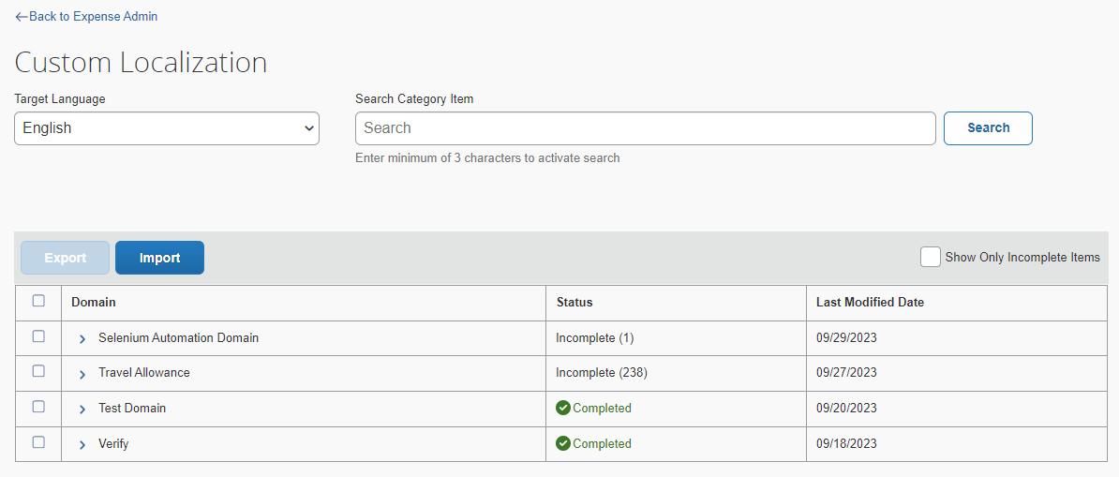

Selecting the Target Language for the Translation
Administrators can choose a language for text translation from the Target Language list. By default, the language is set to the locale of the administrator.
To select a language for translation:
- On the Custom Localization page, click the Target Language drop-down button, and select a language from the list.
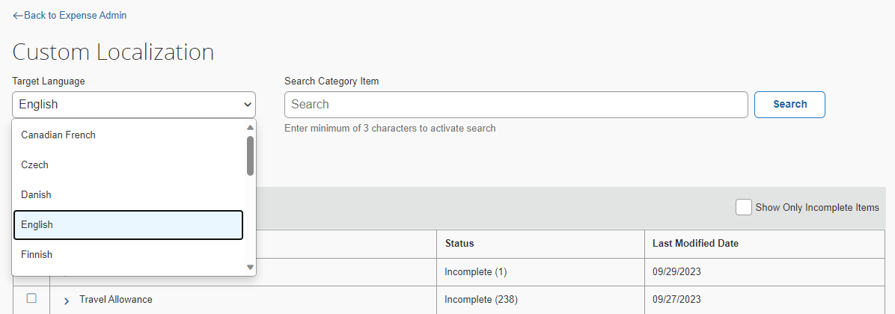
Administrators can only see those languages in the list that are supported by their Concur entity.

Viewing Category Text and Status for Localization
Administrators can easily view and locate the text that needs translation. For any chosen target language, the text, along with the translation status and last modified dates, are displayed in a tabular format.
To view text in a domain or category:
- On the Custom Localization page, choose a target language.
All the domains are displayed in a tabular view.
- Expand the desired domain name.
All the categories are displayed.
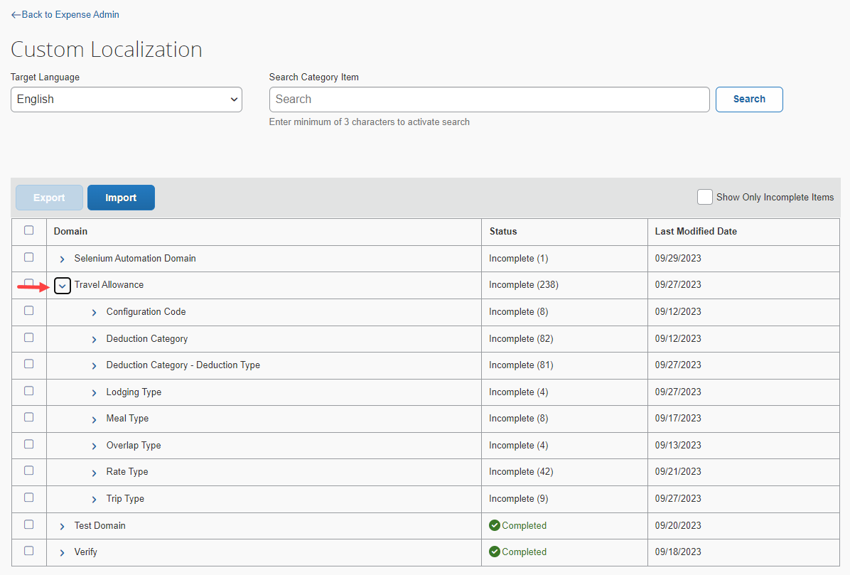
- Expand the desired category.
All the text of the selected category are displayed as a link.
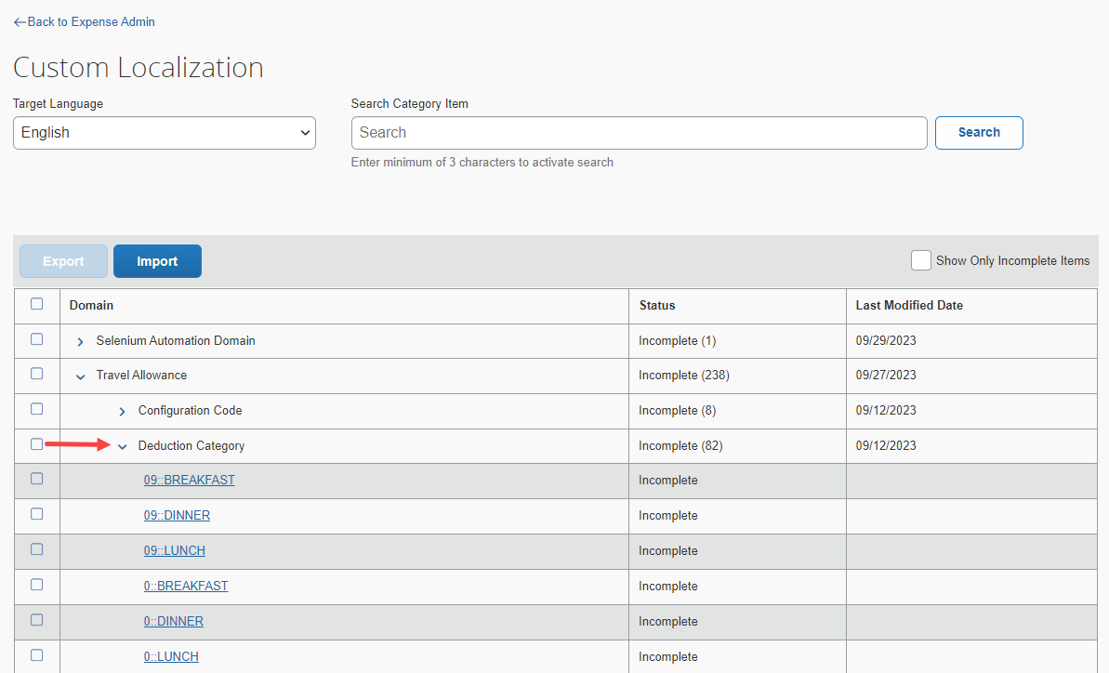

Using Search to locate the desired text
Administrators can search for the text for translation. The length of the search text should be larger than or equal to three characters.
Using search to locate the desired text:
- Enter the desired text in the Search Category Item field and click Search. The page refreshes, listing all text links that include the search text.
The Search button is disabled if the search text has less than three characters.
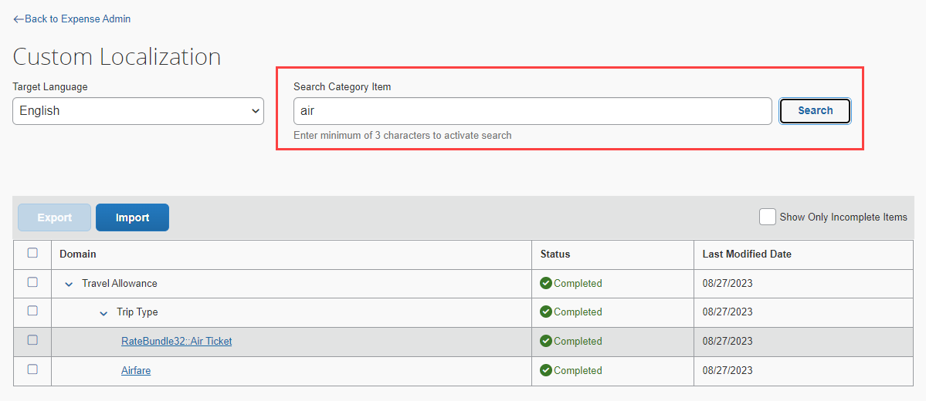

Using Filters to check the status of text
Administrators can filter search results to locate the text for translation.
Using filters to check the status of text:
- In the search result tabular view, select the Show Only Incomplete Items checkbox.
The table refreshes listing all the text with Incomplete status.
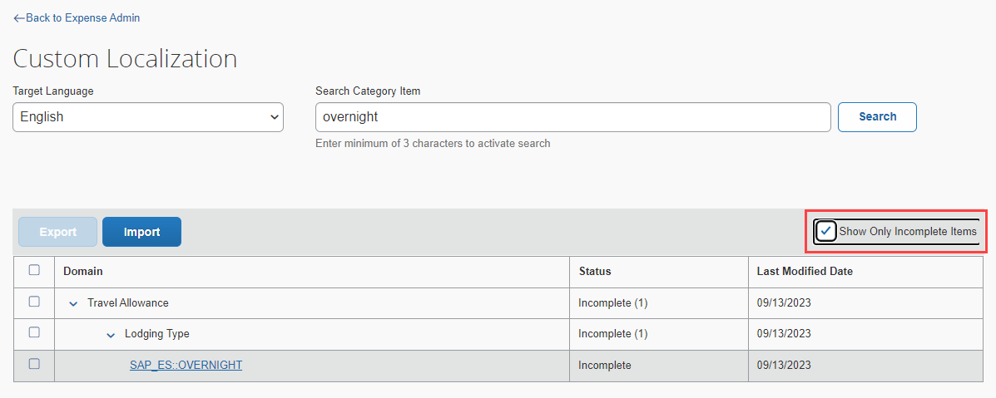
If any text in a language is not translated, its status is set to Incomplete.

Perform Translations on Text
Administrators can perform text translation in one of the following ways:
- Translate individual text manually, with the help of the in-line edit functionality.
- Export all or selected text and then import the translated file to Concur Expense.

Performing In-line Edits
To perform in-line translations on text:
- On the Custom Localization page, choose the Target Language for translation.
- From the tabular view, expand the desired domain name and category name.
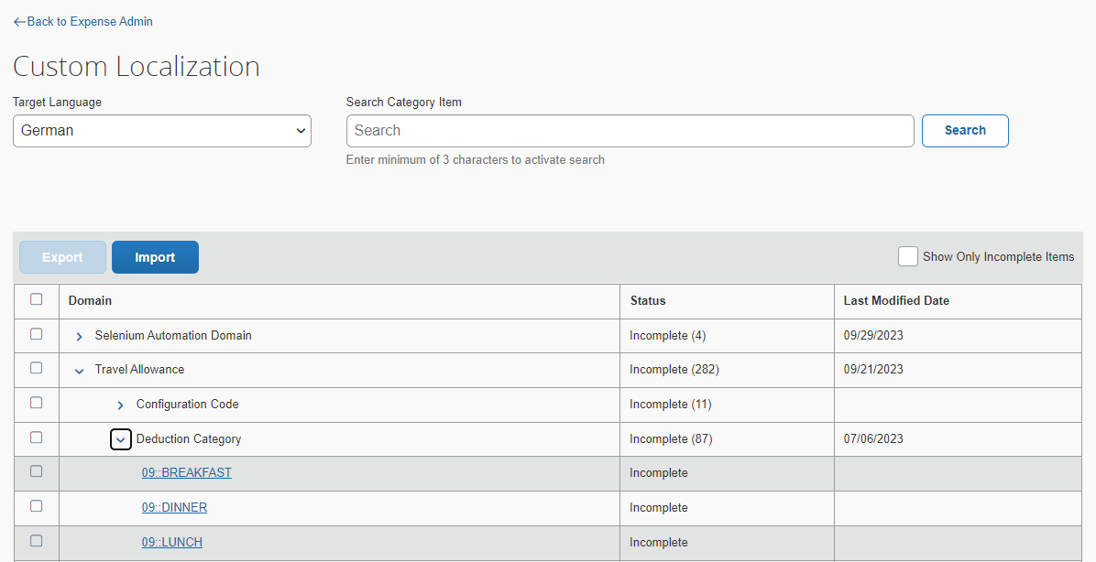
- Select the desired text link from the selected category.
A panel is displayed on the right.

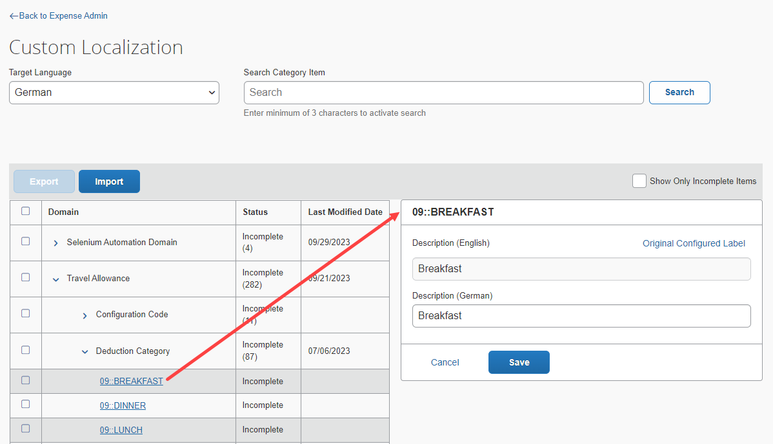
You can click on the Original Configured Label link to view the text as it was originally configured.
- Write the translated custom text in the target language Description field and click Save.
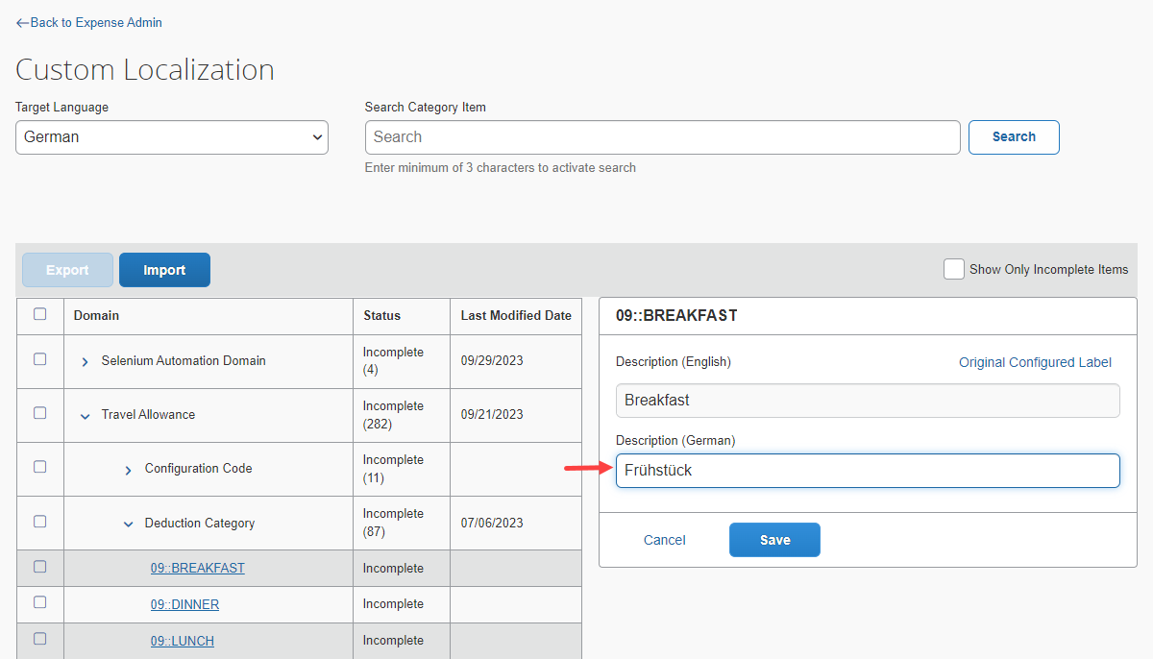

The status of the translated text changes to Completed and the Last Modified Date details are recorded.
The description of a text with the Completed status can be updated later.

Exporting Text for Translation
Administrators can use the export process to create an Excel (.xls) file that contains all the text of a selected domain or category that should be translated/localized. This file can include any number of texts regardless of its status. However, it typically contains text with incomplete status that still require localization. Once the file is created and stored in a directory, it can be sent to an external localized vendor for translation, as needed.
To perform text translations using export:
- On the Custom Localization page, choose the Target Language for the translation.
- From the tabular view, expand the desired domain name and category name.
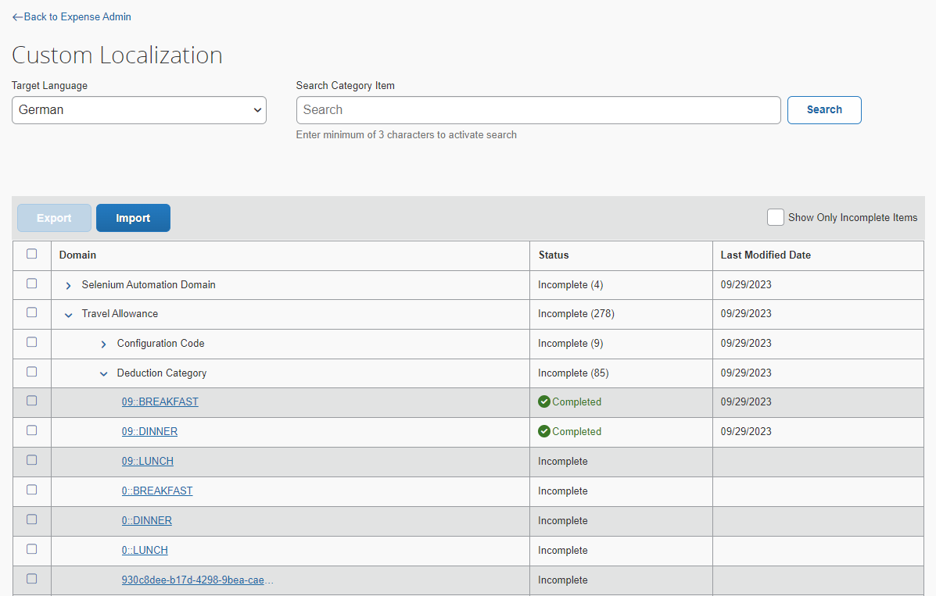
- Select the text links that are to be exported.
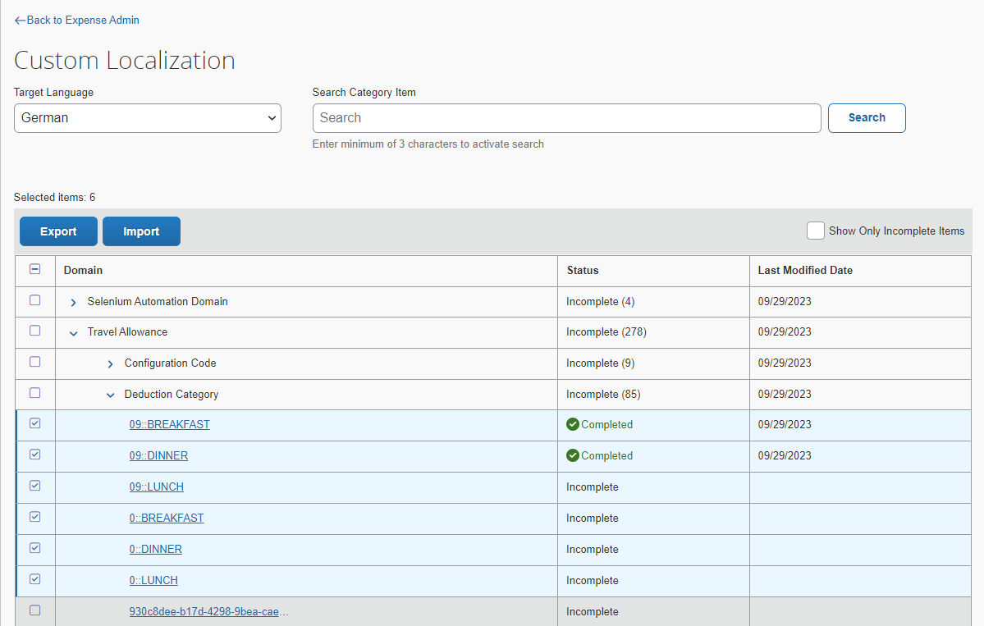
Note the following:
- You can select individual checkboxes next to each of the text link that are to be exported.
- You can select checkboxes next to each category name to export all the text links of the selected category.
- You can select checkboxes next to each domain name to export all text links of the selected domain.
- You can select the first checkbox, in the first row, to select all the text links across the domains.
- You can select the Show Only Incomplete Items checkbox to export only the text links that have not been translated in the selected sections.
- Click Export.
A .xls file is downloaded to your local drive and a success message is displayed.
The file is downloaded with its default name. You can change it later if required.

Understanding the localization.xls file
The file created during the export process contains all the text that need to be translated. The file lists both the source and target locale; however, the content of the file is listed in the target locale.
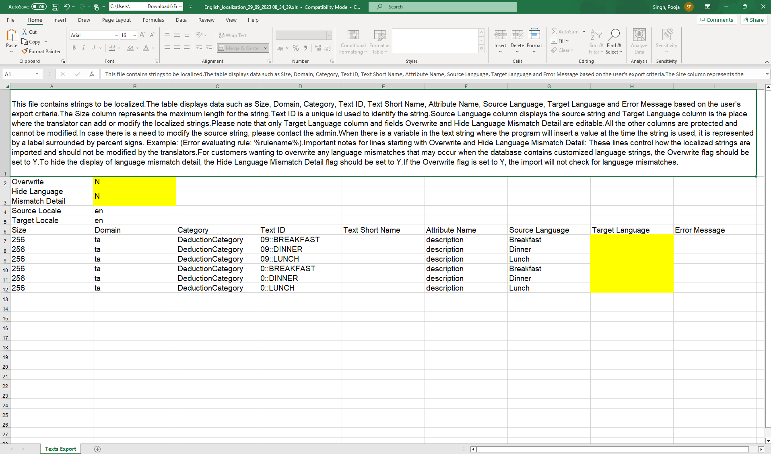
The file contains data, such as size, domain, category, and so on, based on the export criteria.
Note the following:
- When you translate this file, modify the Target Language column and save the file. Only the Target Language column as well as the Overwrite and Hide Language Mismatch Detail fields are editable. All the other columns are password protected and cannot be modified. In case you need to modify the source text, please contact SAP Concur support.
- If there is a variable in the text string, where the program is to insert a value at the time the string is used, it is represented by a label surrounded by percent signs. For example, Error evaluating rule: %rulename%.
- The Size column represents the maximum length of the text, which should be less than or equal to 256 characters. Anything more than the specified length causes an error to be displayed on the screen. However, the import process will not fail.
There are two parameters in the exported file that help minimize potential errors. These parameters control how the translated text are imported and should not be modified by the translators.

Parameter | Description
Overwrite | Consider that a few texts in this file are changed by a localization vendor and that there are different text for the same field in the product (i.e., a mismatch). By default, the text in the database remains and the text in the localization.xls file is not used for respective field when you try to import the localization.xls file.  If you want to overwrite the text in the database with the ones in this file, then change the value to Y.  Often, the database contains customizations, so you may not want to override them.
Hide Language Mismatch Detail | If a localized text in the database does not match the localized string in the import file, a mismatch occurs. A message about the mismatch is displayed on the Import page once the import is performed.  Sometimes, the count of mismatches can be high. To hide the details of the mismatches from this page, you can change the parameter to Y.  NOTE: If the Overwrite parameter is set to Y, the import does not check for language mismatches.

Importing a Translated File
Once the exported file is translated, either internally or by an external localization vendor, administrators should import the information back into the system. After the import is complete, any employee with the browser language settings configured for the translated language can see the changes.
To perform an import:
- On the Custom Localization page, click the Import button.
- In the Import popup, click Select a file button.
- Browse for the translated file that needs to be imported and click Open. The path is automatically inserted into the File name field.
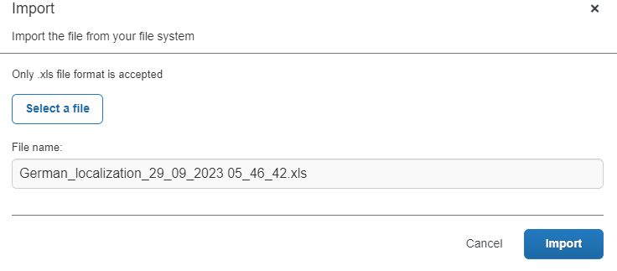
The file location may also be typed directly into the File name field; however, it should be entered with the complete directory structure and file name. For example, the user can enter C:\Concur\Localization\Import\localization.xls.
- Click Import. The import process runs, and the page refreshes to show the result.
WARNING: Do not exit the browser window during the import process, the process terminates. In such cases, only changes that have already occurred within the system remain.

Troubleshooting
If an error occurs while importing, a message strip gets displayed on top of the Custom Localization screen. Administrators can expand the message strip to know more about the error along with its line number.


