Applies to these SAP Concur solutions:
Expense
Professional/Premium edition
Standard edition
Travel
Professional/Premium edition
Standard edition
Invoice
Professional/Premium edition
Standard edition
Request
Professional/Premium edition
Standard edition

Concur TripLink
User Guide

Last Revised: February 28, 2024
Table of Contents
Section 1: Overview 1
Section 2: Getting Started with Concur TripLink 2
Section 3: Features 3
Booking Directly on Partner Websites and Mobile Apps 3
Concur TripLink Admin Control of Partners & Policy Messaging 5
Inactivating a Supplier 5
Trip Sync in Concur Travel & Expense 6
Itinerary Forwarding 6
Duplicate Emails 6
Manually Add Trip Segments to a New or Existing Itinerary 7
Cancellations and updates to Concur TripLink Bookings 9
Concur Expense (For Expense and Travel & Expense clients only) 9
Smart Expense Matching 9
E-Receipts 10
Travel Arranger 11
Email Notifications of Travel Policy Violations 11
Manager 11
User 12
Reporting 12
Integration with Duty of Care Providers 14
TripIt 14
Section 4: Configuration 15
Administrator 15
Travel Policy 15
Concur TripLink Discount Codes 16
Admin Control of Suppliers & Policy Messaging 16
Administrator – Professional Edition 16
User Roles 16
Expense Audit Rules 22
Administrator – Standard Edition 23
Terminating a Concur TripLink User 26
Supplier Configuration & Policy Messaging – For Administrator (Professional) 27
Supplier Configuration & Policy Messaging – For Administrator (Standard) 28
Concur TripLink Messaging Preference History 28
User 30
Connecting to Concur TripLink Partners 30
Manage Verified Email Address and Travel Arranger 33
Enable E-Receipts 34
Section 5: Concur TripLink Supplier Discount Code Information 35
American Airlines 36
Delta Airlines 37
Lufthansa 38
United Airlines 39
Marriott International 40
InterContinental Hotels Group (IHG) 40
Hyatt 41
Avis 41
Hertz 42
Sixt 42
Section 6: TripIt 43
Itinerary Forwarding 43
Travel Arranger 43
(TripIt Enabled Countries Only) Download TripIt Pro and Connect Concur Travel & Expense to TripIt Pro 44
Section 7: Frequently Asked Questions (FAQs) and Additional Resources 44

Revision History
Date |  | Notes / Comments / Changes
 | February 28, 2024 | Updated TripIt help page hyperlinks.  Updated Terminating a Concur TripLink User section.
 | January 16, 2024 | Several changes throughout the document to introduce Concur TripLink hub. Removed Admin Controls Policy and Messaging changes in Travel Partner Integrations and SAP Concur App Center and British Airways sections.
August 15, 2022 |  | Updated Integration with Duty of Care Providers section.
June 17, 2022 |  | Updated Overview section.
April 4, 2022 |  | Under TripIt section:  - Removed TripIt for Teams section due to decommission  - Added Spanish language support
January 21, 2022 |  | Updated the copyright year; no other changes; cover date not updated.
December 3, 2021 |  | Added note on upcoming decommission of TripIt for Teams in the TripIt section.
October 25, 2021 |  | Updated Features, Configuration, and TripLink Supplier Discount Code Information sections.
October 15, 2021 |  | Several changes throughout including:  - Replacing My Travel Network with Travel Partner Integrations.  - Replacing the term “supplier” with “partner” where applicable. In some cases the terms are interchangeable.  - Updating screenshots.
July 21, 2021 |  | Updated various sections regarding plans@concur.com retirement.
May 26, 2021 |  | Added information on Concur TripLink Admin Controls in the Features, Configuration, and FAQ sections.
May 18, 2021 |  | Added upcoming retirement note for plans@concur.com in various sections.
March 12, 2021 |  | Updated Features section.
January 27, 2021 |  | Updated Avis AWD code description.
January 11, 2021 |  | Updated Overview, Features, and TripLink Supplier Discount Code Information sections.
October 26, 2020 |  | Several revisions throughout User Guide.
May 7, 2020 |  | Renamed the Authorization Request check box to Request on the guide’s title page; cover date not updated.
Previous history removed for brevity

Concur TripLink

Overview
Concur TripLink brings outside bookings back into a client’s travel and expense program through SAP Concur’s Global Network of connected Partners and TripIt Pro, an award-winning, comprehensive trip management app. Complimentary subscription to TripIt Pro is provided for Concur TripLink Users. Concur TripLink is currently available for US and EMEA datacenters.
Clients can gain visibility, apply policy, and realize negotiated rates on bookings made with Concur TripLink connected partners - the only program of its kind. When travelers use TripIt Pro for bookings made with non-TripLink partners, their itineraries will become available in Concur Travel & Expense.
Concur TripLink represents the next generation of business travel by extending the value of corporate travel programs and integrated travel and expense to all travel, capturing the travel reservations, no matter where they are booked.
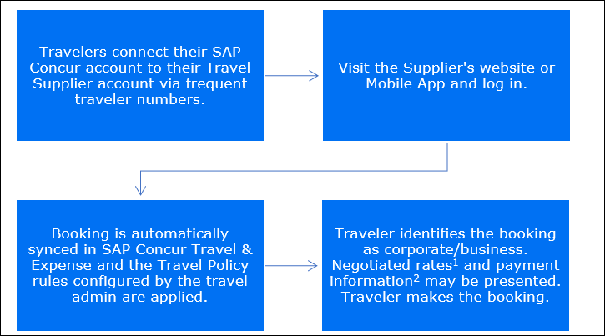
To ensure negotiated rates are applied, a Travel Admin must obtain their company’s unique discount code from partners and configure them in Concur Travel & Expense.
The feature for pre-population of payment information is available for select partners only.
Concur TripLink has many benefits to companies and their travelers:
- Allows the capture of corporate travel bookings made directly on partner sites and apps, helping you benefit from corporate discounts and avoid partner distribution fees.
- Offers the flexibility to control how partnered travel services are presented to your travelers, promoting policy compliance and better management of direct bookings.
- Enhances safety and visibility by applying audit rules and policies to all bookings, even those made directly with partnered services.
- Receipts can be posted directly by most of Concur TripLink partners, and for those that don't, our system offers an easy way to create expenses from itinerary events, helped by SAP Concur’s Smart Expense matching system.
- Concur TripLink includes a complimentary subscription to the award-winning app, TripIt Pro, which sends notifications about flight statuses, changes, and departure times to optimize productivity.
- Can be paired with Concur Travel, Concur Expense or both, and all travel details are easily accessible via the SAP Concur mobile app, Concur web application, or TripIt Pro.
- Simplify and enhance the travel and expense experience for all employees.
Please watch this video which explains the benefits of Concur TripLink:
https://www.youtube.com/watch?v=1l1M7CoVYBo
In this User Guide, the word TripLink Partner is used interchangeably with TripLink Supplier.

Getting Started with Concur TripLink
Follow the steps outlined below to experience the benefits of Concur TripLink:
- Implement Concur TripLink – Concur TripLink needs to be turned on and configured for your company. Your Implementation Manager can do that for you.
- Apply your Policy – Apply your policies and audit rules to direct bookings by setting up your Travel Policy, Policy Messaging, and Expense Audit Rules. For a quick step-by-step guide to set up your Concur TripLink policy, visit here.
Please refer the following sections of the User Guide for more information:
- Configure Travel Policy for Concur Travel Professional Edition
- Configure Travel Policy for Concur Travel Standard Edition
- Apply Negotiated Rates – Ensure your negotiated rates are being applied to bookings with participating travel partners. To do so, contact travel partners to obtain your company's unique discount codes. Then, add the discount codes to your Concur Travel & Expense configuration for your discounts to be applied to your travelers' bookings. For step-by-step instructions on how to add your travel partner discount codes, view here.
Please visit the Concur TripLink Partners page for additional information on how to obtain discount codes for Concur TripLink partners.
Even if your company does not have a contract with the partner, corporate travel booked by your travelers on the partner website or app will be automatically synced into Concur Travel & Expense, thereby capturing invisible spend and ensuring policy adherence.
- Introduce Concur TripLink to your employees – Educate travelers about the features and benefits and how to use Concur TripLink.
- Travelers should connect their frequent traveler accounts to their SAP Concur account by going to the Concur TripLink page through the main navigation after signing in to SAP Concur solutions. This can also be done from the travel partner’s page in the SAP Concur App Center or from Frequent Traveler Programs in Profile settings. Please refer to the Connecting to Concur TripLink Partners section of the User Guide for more details about this configuration for travelers.
- Travelers need to link their SAP Concur account to TripIt. In the Concur TripLink hub (found in the main navigation), they can either create and connect to a new TripIt account or connect to an existing TripIt account.

Features
Please note the following about the Concur TripLink product:
- Concur TripLink can be used with the Travel Arranger feature
- Concur TripLink cannot be used with the Guest Traveler feature

Booking Directly on Partner Websites and Mobile Apps
Participating travel partners offer business travelers a way to book corporate travel directly on their consumer websites with the extra benefit of providing many features of a fully managed travel program. For a full list of partners in the Concur TripLink network, please reference Concur TripLink Partners page.
For bookings made with a travel company that is currently not part of the Concur TripLink network, travelers can forward their itineraries to TripIt for synchronization. Please see Itinerary Forwarding for more information about this feature.
Travel admins can also reach out to their partner contact to request onboarding to the TripLink network.
To start using Concur TripLink, travelers must connect their loyalty accounts with their SAP Concur account. The primary way of doing this is by accessing the Concur TripLink hub, found in the main navigation of SAP Concur solutions. It can also be done through the partner’s listing in the SAP Concur App Center or from the Frequent Travel Programs section of the Profile.
Please see the Connecting to Concur TripLink Partners Configuration section for more details.
If your company has purchased Concur TripLink and your configuration is set up on the SAP Concur US or EMEA data center, then your travelers, regardless of where they are located, will have access to the features of Concur TripLink. Please note, users may experience some restrictions due to limits on travel partner integrations partners and TripIt Pro availability.
Travel partner coverage varies based on the partner’s unique integration on their website and mobile app.
The table below provides each Partner’s availability
Air
Sr. No | Partner | Integration Availability | Languages Supported |  | Supported on Web | Supported on Partner Mobile App
1 | American Airlines | United States, Canada |  | English | Yes | Yes
2 | Delta Airlines | Globally |  | EN, FR, DE, JP | Yes | Yes
3 | Lufthansa | Globally |  | EN, FR, DE, JP | Yes | Yes
4 | United Airlines | Globally |  | EN, FR, DE, JP | Yes | Yes
Hotels
Sr. No | Partner | Integration Availability | Languages Supported | Supported on Web | Supported on Partner Mobile App
1 | Booking.com | Globally | EN, FR, DE, JP | Yes | No
2 | Marriott International | Globally | EN, FR, DE, JP | Yes | No
3 | InterContinental Hotels Group (IHG) | Globally | EN, FR, DE, JP | Yes | Yes
4 | HRS Corporate Booking Portal | Globally | EN, FR, DE, JP | Yes | Yes
5 | Hyatt Hotels Corporation | Globally | EN, FR, DE, JP | Yes | Yes
Car Rental
Sr. No | Partner | Integration Availability | Languages Supported | Supported on Web | Supported on Partner Mobile App
1 | Avis | United States, Canada | English | Yes | Yes
2 | Hertz | Globally | EN, FR, DE, JP | Yes | Yes
3 | Sixt | Globally | EN, FR, DE, JP | Yes | Yes
Rail
Sr. No | Partner | Integration Availability | Languages Supported | Supported on Web | Supported on Partner Mobile App
1 | Trainline Europe | Globally | EN, FR, DE | Yes | Yes

Concur TripLink Admin Control of Partners & Policy Messaging
Admin controls in Concur TripLink provide travel admins the flexibility to manage the organization’s policy around partner-direct bookings and the messaging that travelers see, which helps to ensure the capturing of blind spend and policy compliance.
Different messaging options impact traveler communications in these ways:
- Supplier direct booking is allowed for all suppliers: Travelers are allowed to book directly with all integrated travel suppliers, and the travel suppliers will be available in the Concur TripLink hub and the SAP Concur App Center.
- Supplier direct booking is allowed only for suppliers you select below: Travelers are informed that they are allowed to book directly only with suppliers selected by the company, some of which can be designated as “preferred.” All suppliers will appear in the Concur TripLink hub and the SAP Concur App Center.
- Supplier direct booking is discouraged: Travelers will be encouraged to use the company’s preferred methods of booking, but they can still connect to suppliers in the Concur TripLink hub and the SAP Concur App Center.

Inactivating a Supplier
If necessary, you can request to inactivate an integrated travel supplier to remove it from the TripLink page and the SAP Concur App Center. We strongly discourage this as it will result in lost visibility into employee bookings made outside of your organization’s preferred methods, making it difficult to fulfill duty of care and reporting responsibilities.
Instead, we suggest that you discourage travel supplier direct bookings for non-preferred travel suppliers. You can do this by:
- Setting Concur TripLink Messaging Preferences to Supplier direct booking is allowed only for suppliers you select.
- Deselecting the suppliers you want to discourage.
If you would still like to set an integrated travel supplier to inactive, please create a customer support ticket with the subject line “Inactivate TripLink Supplier”.
Once a travel supplier is inactivated:
- The supplier app will be removed from the Concur TripLink hub and SAP Concur App Center.
- Your employees will no longer be able to connect to the supplier.
- Employees who are connected will be disconnected within 30 days.
- Upon disconnection, email notification will be sent to the disconnected employees.
For more details, please review the Supplier Configuration & Policy Messaging – For Administrator (Professional & Standard) section of this guide.

Trip Sync in Concur Travel & Expense
For travel partners in the Concur TripLink network, bookings made directly through these partner websites and mobile apps are automatically synced to Concur Travel & Expense.
Concur TripLink plans appear on the trip lists for Concur Travel users and in SAP Concur’s mobile application. Users can use the Itinerary Wizard page to add Concur TripLink bookings to existing Concur Travel itineraries or add new Concur Travel bookings to the itineraries created by Concur TripLink.

Itinerary Forwarding
In instances where bookings are made with a travel company that is not yet part of the Concur TripLink network, travelers can forward the confirmation email to plans@tripit.com. These bookings become part of a consolidated trip itinerary in TripIt and will sync back to the connected SAP Concur account, allowing visibility for duty of care and spend management.

Duplicate Emails
SAP Concur will avoid duplicating plans that are emailed to SAP Concur more than once or that are received by SAP Concur from multiple sources, such as from a Concur TripLink partner and an email forwarded by the traveler to plans@tripit.com.

Manually Add Trip Segments to a New or Existing Itinerary
If the company has Concur TripLink integrated with Concur Travel or Concur Travel & Expense, the user can click Add new itinerary manually from the Upcoming Trips tab on the Travel page:
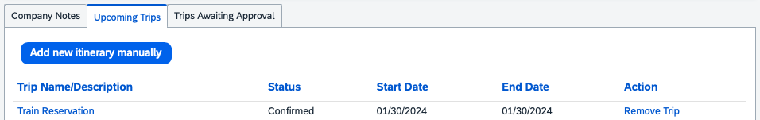
If the company has Concur TripLink integrated with Concur Expense only, the user can click on Enter Reservation from the New tab on the homepage.
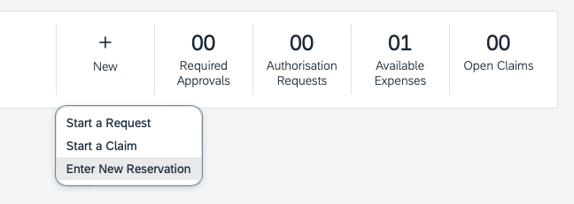
After clicking on either of those options, the Add New Reservation window will appear and the user can select one of the following from the Add Reservation to Trip list:
- Create New Trip
- The trip they wish to add the manual segment to; there will be a list of trips based on trip name.
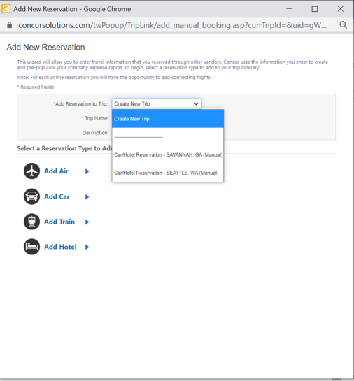
If the user selects Create New Trip, they are prompted to enter a trip name and description.
If the user selects an existing trip, they can proceed with adding the segment type they prefer.
After filling out the reservation form, the user has the option to Save and Close, or Save and Add Another:
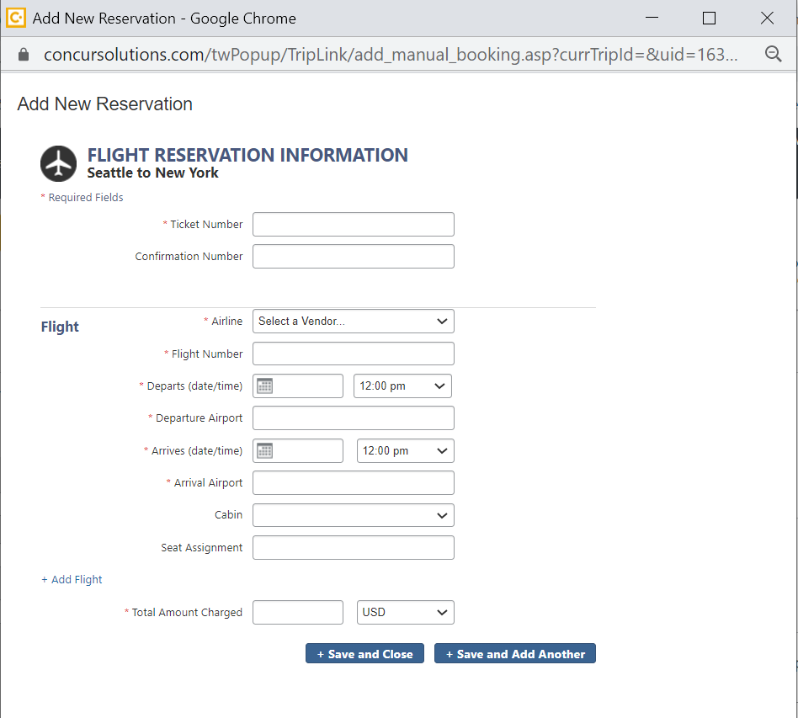

Cancellations and updates to Concur TripLink Bookings
Cancellations of Concur TripLink bookings cannot be done in Concur Travel. The traveler must go to the travel partner directly to cancel or change the Concur TripLink booking.
User initiated cancellations and updates to an itinerary made on the partner site or partner mobile app are automatically kept up to date when a traveler books a trip directly using a Concur TripLink connected partner.
Updates to bookings made with the travel partner, such as schedule changes by airlines, will also be updated in SAP Concur. Cancellations and updates made through the travel partner site or mobile apps that result in an update or refund will result in an update or removal of the corresponding expense.
Receipts that are posted by the partner will not be removed from a user’s expense report, but new receipts will be posted that reflect the most recent state of the user’s transaction history.
For cancellations of bookings that are subsequently emailed or added manually, the traveler must first cancel the booking with the travel company before removing it from the trip library within SAP Concur.
Removing a Concur TripLink booking manually only removes the record of the booking from Concur Travel & Expense. It does not cancel the booking.

Concur Expense (For Expense and Travel & Expense clients only)
Clients with Concur Expense will see their Concur TripLink segments included in the Available Expenses area.

Smart Expense Matching
Smart Expense matching is a feature that compares the information from a travel segment to expense data to determine if that segment matches an existing expense in Concur Travel & Expense. The data is scored depending on how close the match is, if the score is above a certain threshold, the expense is placed automatically into the same entry in the Available Expenses area, eliminating duplicate expenses.
Concur TripLink segments are included in the Smart Expense matching for clients with Concur Expense. Trip Segments posted to Concur using TripLink can match with the following types of transactions:
- Credit Card
- E-Receipt
- Expense Entry (Web)
- Expense Entry (Mobile)
- ExpenseIt Entry
How to use Smart Expense Matching
- The Expense user logs in, creates an expense report and fills out header information. On the Expense Report page, the Available Expenses section appears, including all the Concur TripLink segments, Travel itinerary items (if the client uses Concur Travel), e-receipts, and any imported corporate card transactions.
- If the user saves and re-enters the expense report, the user can re-open the Available Expenses section by clicking Import Expenses.
Users at companies that have enabled the personal card import feature instead click on Import Expenses > Available Expenses.
For more resources about configuration and tutorials for Expenses, please visit the below URL.
NetGen Expense UI: https://www.concurtraining.com/en-us/pr/nextgen/expense
Previous UI: https://www.concurtraining.com/en-us/pr/get-started

E-Receipts
The user must enroll in e-receipts to use this feature. Users that enroll in Travel Partner Integrations are automatically enrolled to receive E-Receipts.
E-Receipt Users can receive E-Receipts for Concur TripLink bookings.
This feature allows e-receipts direct from the partner to be received for Concur TripLink bookings. These e-receipts can be pulled into Expense and added to an Expense report. This applies to bookings sent to TripIt (plans@tripit.com) and those made through Concur TripLink Partner connections.
The plans@concur.com functionality was retired on July 22, 2021.
For a current list of E-receipt enabled partners please reference the E-Receipt Coverage Traveler Service Guide.
SAP Concur recommends that travelers connect their TripIt account with their SAP Concur Account and activate their TripIt Pro subscription. Afterwards, travelers can forward travel confirmation emails from travel partners to plans@tripit.com.
For more information, refer to the Enable E-Receipts Configuration section.

Travel Arranger
Because Concur TripLink direct bookings require a user to link their own Travel Partner account to SAP Concur and only book for themselves, Travel Arranger’s need to forward bookings made for others to plans@tripit.com using a verified email address. The travel arranger is a role within Concur Travel. A travel arranger may email plans to plans@tripit.com on behalf of a traveler. The arranger must include one of the traveler’s registered email addresses in the subject line of the email. The plans will be placed in the traveler’s Trip Library. The emailed plans can be used with the One-Click feature to generate and pre-populate trip details into an expense report.
The arranger must verify their email address in the Email Addresses section of Profile.
Please refer Travel Arranger topic under the TripIt section of this guide for more details.
Please refer to the Manage Verified Email Address and Travel Arranger section of this guide for detailed steps.

Email Notifications of Travel Policy Violations
Travel Policy rules configured by the Travel Admin are applied after the booking made on the partner website / mobile app is posted to Concur Travel & Expense.
Admins can setup notification preferences for Travel Policy Violations during the Travel Policy configuration step.
This section explains the types of email notifications that different roles within Concur Travel may receive based on specific conditions or situations to alert or inform.

Manager
If the Travel Policy rule violation is set to Notify Manager and a user creates a Concur TripLink itinerary that violates a rule set up in the new TripLink section of Travel Policy, then the manager will receive an email notification. This email will contain the following information:
- Alert that trip is out of policy
- Who the trip is for
- Who booked the trip
- The rule(s) that was violated
- Copy of the itinerary

User
If the rule violation is set to Notify Manager and a user creates a Concur TripLink itinerary that violates a rule set up in the TripLink section of Travel Policy, then the user/arranger will receive an email notification. This email will contain the following information:
- Alert that trip is out of policy and the manager has been notified
- Who the trip is for
- Who booked the trip
- The rule(s) that were violated
- Copy of the itinerary
If the rule violation is set to Log for Reports and a user creates a Concur TripLink itinerary that violates a rule set up in the TripLink section of Travel Policy, then the rule violation will be logged for reporting purposes.
Cancellations of Concur TripLink bookings are not supported in Concur Travel. The traveler must use the booking source directly to cancel or update the Concur TripLink booking.

Reporting
For clients with Concur Intelligence, reporting is available in Concur Intelligence.
The following reports are available in the TripLink folder:
Report Name | Description
Invisible Spend Details | This report tracks invisible spend at the employee level. Invisible spend represents the expensed amounts that are not matched to a trip, with one exception — any charges from TMC direct bookings are considered visible spend and will be excluded from this report.  Like the Invisible Spend Trend Analysis report, this report filters on spend categories. If the client has not mapped the expense types to the spend categories, then no data is returned on this report.
Invisible Spend Trend Analysis | Concur TripLink captures data from flights, hotels, and ground transportation – no matter where travel is booked. This report provides access to that data – giving companies of all sizes insight into travel expenditures before they happen and a more complete picture of spend outside the corporate travel system.  Invisible spend will go down over time as clients get visibility into travel spend before travel occurs through Concur TripLink. In addition, the information can also be used to meet "duty of care" requirements as well as track spend with specific partners, providing companies with information for better negotiations.  NOTE: SAP Concur looks at Concur Expense data where the expense is matched with a trip in order to determine visible spend. If SAP Concur finds credit card spend from TMC direct bookings, it is considered visible spend for this report; this provides the expensed amount. Then, Concur Travel provides the trip source information, like Concur Travel, Concur TripLink, etc.  Invisible spend represents the expensed amounts that are not matched to a trip.  As described below, the only expenses that are included in this process are those with expense types that are mapped to the four spend categories listed below.  The report also shows quarterly trends so the Travel Manager can see if invisible spend is increasing or decreasing over time. The report shows the current quarter and the previous 4 quarters based on the Sent for Payment Date.  The client has the option to set up spend categories and then map expense types to those categories, in this case, to "group" data for reporting reasons. The new Invisible Spend Trend Analysis report filters on spend categories. If the client has not mapped the expense types to the spend categories, then no data is returned on this report.
TripLink Air Partner Summary | This report lists air trips (booking total, ticket count, and segment count).
TripLink Car Rental Partner Summary | This report lists car rentals (# of rentals, # of days, and booking total).
TripLink Details by Traveler | This report provides trip-level and segment-level details by employee. The report includes the employee ID and expense type, as well as itinerary, ticket, and booking information.
TripLink Hotel Property Partner Summary | This report lists hotel properties (# of nights, # of rooms, and booking total).
TripLink Spend Summary by Traveler | This report lists spend by traveler (air tickets and total amount, rental car days and total amount, hotel days and total amount, and the summary amount).
In the Vendor folder of Intelligence, additional reports can be sorted by the itinerary source to view Concur TripLink vendor information. The reports are:

Report Name | Description
Airfare Details | This report provides the level of detail that is captured and available to report against for air travel. The flight detail report lists all flights during a specified timeframe. There are additional choices for selecting airline, number of days in advance (range: 1-6, 7-13, 14-20, 21+), and booking source (Travel vs. agent). Once the report is generated, managers can click on a record locator to see additional details about that trip, which includes associated hotel and car reservations.
Car Rental Details | This report provides a detailed description of car rental expenditures during a specified timeframe, enabling an organization to:  - Learn with whom the company is spending the most money and who is providing the most competitive rates for car rentals  NOTE: Companies can leverage this information to negotiate service commitments.  - Understand how much the company or individuals are spending on rental cars
Hotel Details | This report provides hotel spending amounts during a specified timeframe  With this report, an organization can better position itself for partner negotiations by analyzing which vendors and markets are providing the most competitive prices.
Concur TripLink also contains select reports within the Reporting > Travel Reports area of Concur Travel & Expense.
The Itinerary Source for a booking is how SAP Concur received the booking. The Booking Source for a booking is where the booking originated, and is usually a GDS or travel partner name.
For more details, please see the Concur Intelligence documentation.

Integration with Duty of Care Providers
Concur Locate and Active Monitoring including Risk Messaging, has been retired effective September 1, 2021.
For more information about Duty of Care Providers and retirement of Concur Locate, please see the Evolution of Duty of Care FAQ.
SAP Concur provides portfolio of duty of care providers within the SAP Concur App Center. These providers are all leaders in the duty of care space and their services are enabled by the comprehensive traveler location information from Concur Travel and Concur TripLink. For more details about the currently available providers, please see Duty of Care Partners.

TripIt
Travelers who connect their Concur TripLink accounts to the award-winning TripIt app will get a complimentary subscription to the premium offering of TripIt Pro.
TripIt organizes travel plans no matter where they are booked. Simply forward your confirmation emails to plans@tripit.com and TripIt will create a comprehensive itinerary for every trip.
Corporate bookings forwarded to TripIt will be available immediately in Concur Travel & Expense provided that the users SAP Concur and TripIt accounts are connected.
TripIt Pro also provides travelers with real-time flight alerts, location guidance, helpful reminders throughout their trip, and other features for stress-free travel
For more details about TripIt Pro, please see the TripIt section of the User Guide.

Configuration

Administrator
Contact SAP Concur to purchase Concur TripLink. SAP Concur will then activate Concur TripLink for all users at your company.
There are two assignable Concur TripLink related roles:
- Report User – This role gives the user access to the TripLink reports.
- TripLink Travel Policy Admin – This role gives the user access to the Travel Policy page (to set travel policy, rules, and corporate discounts).

Travel Policy
SAP Concur’s extensive set of travel policy rules can also be applied to your travelers’ Concur TripLink reservations.
Travel Policy Admin contains a section that will apply only to Concur TripLink itineraries. This includes itineraries sent into TripIt (plans@tripit.com), added manually, or received via a web service from the TMC or a participating supplier.
This feature allows a customer to apply their corporate policy, regardless of where the trip was booked. For example, if the policy says bookings with non-preferred suppliers are out of policy, then this can apply to Concur TripLink as well. The same could apply for rates. If the policy states that hotel rooms greater than $200 are out of policy, this can apply to Concur TripLink itineraries.
Concur TripLink itineraries are already confirmed by the time they are synchronized into Concur Travel & Expense, so the two options we offer for rules are:
- Log for Reports: Rule violations will be logged to the TripLink – Travel Policy Exceptions report.
- Notify Manager: Rule violations will be logged to the TripLink – Travel Policy Exceptions report AND an email notification is sent to the user and the user’s manager, defined in the profile or by the travel class.
The rule parts available apply to all trips, all segment types (air, rail, car, hotel) and include a rule part called Booking Source. If this rule part is used, you can define policy specific to a booking source, such as United.com or Marriott.com.
- BEST PRACTICE: Where possible, maintain a consistent travel policy for all bookings. It is not recommended to have more stringent or less stringent policy rules for Concur TripLink bookings than for bookings made via Concur Travel or the TMC.

Concur TripLink Discount Codes
For most suppliers, the Concur TripLink discount code is different than the discount code stored in the GDS systems.
Administrators can enter their company’s supplier discount codes in the Manage Company Discounts page, so these can be passed to the supplier for application on TripLink trips.
When users connect their SAP Concur accounts to the Concur TripLink supplier, they authorize SAP Concur to share their travel profile information with the supplier, including their company’s corporate discount codes. The supplier can use this information to apply the corporate discount code to the user’s booking.
For Concur Expense only users, for car rental E-receipts, the relevant rental company discount code must be entered so travelers can receive e-receipts.
- BEST PRACTICE: Enter your company’s corporate discount codes for all Concur TripLink suppliers. This will help to ensure that your travelers obtain your negotiated rates when they book directly with the supplier. If you are not aware whether your company has a corporate discount with a specific supplier, ask the individual within the organization who manages the travel program. If neither you, nor the travel program manager/administrator knows what corporate discount code to use for a specific supplier, contact the supplier’s sales or account management department directly.

Admin Control of Suppliers & Policy Messaging
All users with the TripLink Travel Policy Admin permission will be able to access and adjust the admin controls on the Manage TripLink Settings page in SAP Concur solutions as part of their Concur TripLink offering.
Concur TripLink admin controls provides the options to:
- Select their preferred integrated travel suppliers.
- Provide clear messaging to employees if travel supplier direct bookings are allowed or discouraged.
- Inactivate integrated travel suppliers by request.

Administrator – Professional Edition

User Roles
To assign the TripLink Admin User Roles:
- Click Administration > Company > Company Admin.
- Click User Permissions (left menu).
- Click the Travel tab. You can modify the permissions by Groups, Rule Classes, or Users.
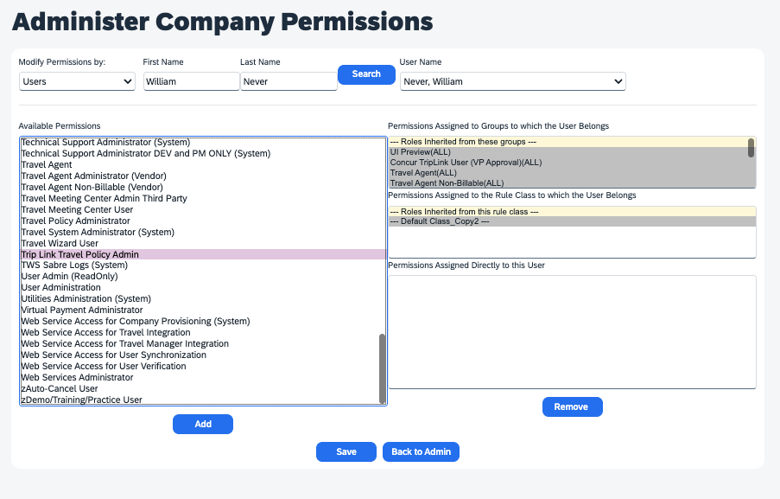
- For users that need access to the Concur TripLink reports, select the Report User role.
- For users that need access to the Travel Policy page, select the Trip Link Travel Policy Admin role.
- Click Add for the desired groups/rule classes/ users.
- Click Save.

Clients with Concur Travel and Concur Triplink
To configure the travel policy
To access this page, the user must have the TripLink Travel Policy Admin user permission.
- Click Administration > Travel > Travel Admin.
- Click Travel Rule Builder (left menu).
- Under Select Rule Template Category, select Concur TripLink and click OK.
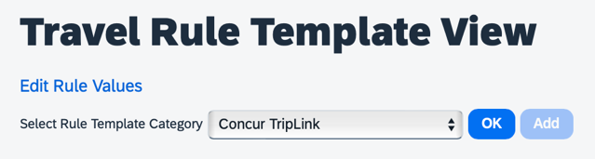
- Click Add.
- Enable desired rule(s) around Concur TripLink compliance. For example, create a rule that says “Carrier is not preferred.” You select the rule parts needed, name the rule, assign the violation code, and click Save.
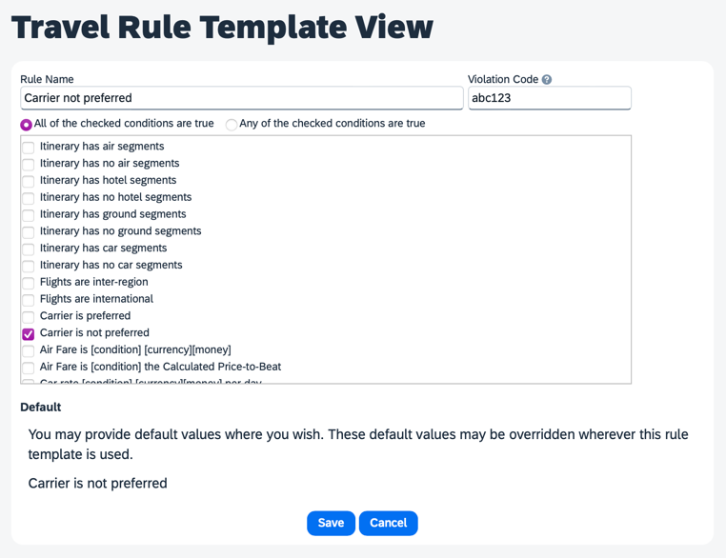
- Click Edit Rule Values.
- Choose the rule class you want to add this new rule to.
- Scroll down to the Concur TripLink section and click Edit.
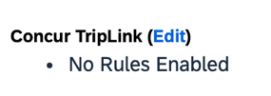
- Select the box to the left of the rule to enable and choose which violation option you prefer:
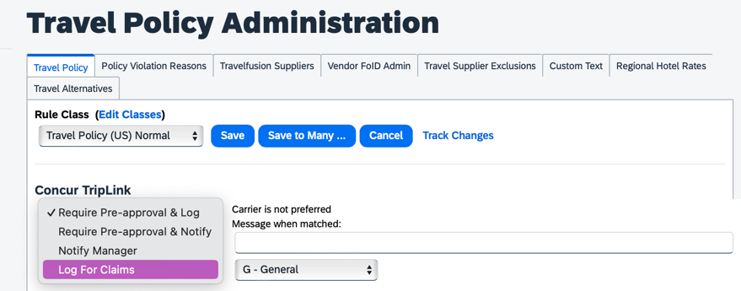
The reason code dropdown does not apply to the TripLink section rules. Anything added or selected here will be ignored.
- Save your changes.

Clients with concur expense only and Concur triplink
To configure the travel policy
To access this page, the user must have the TripLink Travel Policy Admin user permission.
- Click Administration > Company > Company Admin.
- Click TripLink Rules Configuration.
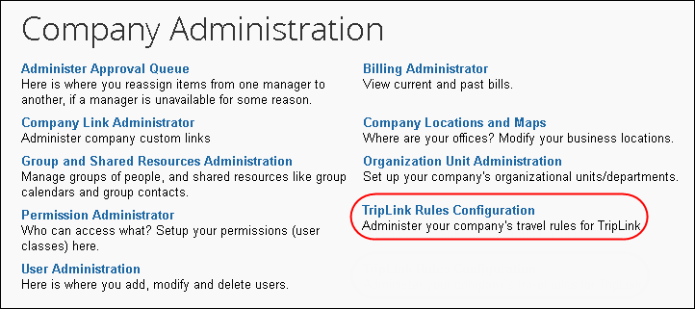
- Select the travel class to update.
- Select Log for Reports or Notify Manager for the desired rules, entering additional settings if necessary.
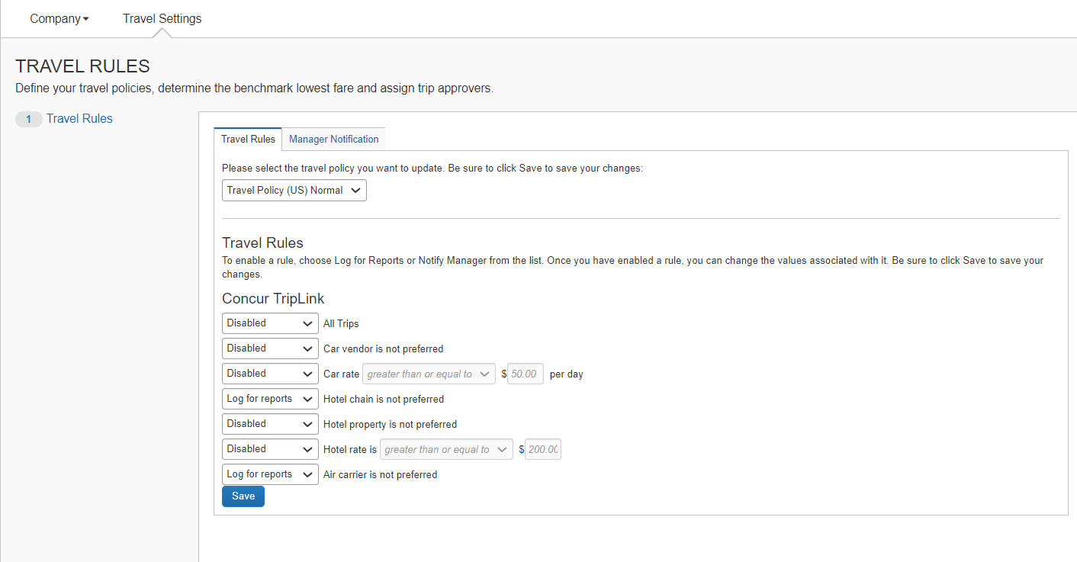
- Click Save.
- Click Manager Notification.
- Select the desired travel policy.
- Enter your manager notification settings.
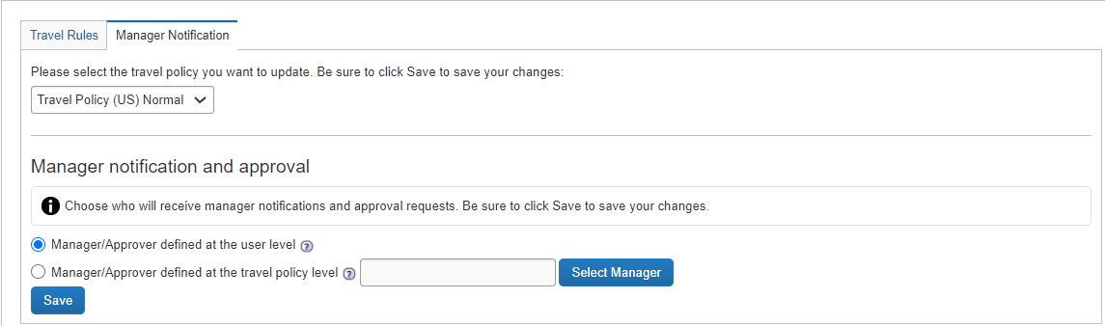
A manager can be the user’s manager, or using this screen, the administrator can designate an individual specific to the rule class to receive all notifications of rule violations.
- Click Save.
To set a Concur TripLink discount code
Contact suppliers to obtain your company’s unique discount codes. Then, add them to your Concur Travel & Expense configuration and your discounts will be applied to your travelers’ bookings.
To access this page, the user must have the Trip Link Travel Policy Admin user permission.
1. Click Administration > Company > Company Admin.
Depending on your permissions, the page may appear immediately after you click Administration.
2. From the left menu Travel Admin section, click Manage Corporate Discounts. The TripLink Discount Code column displays for each discount.
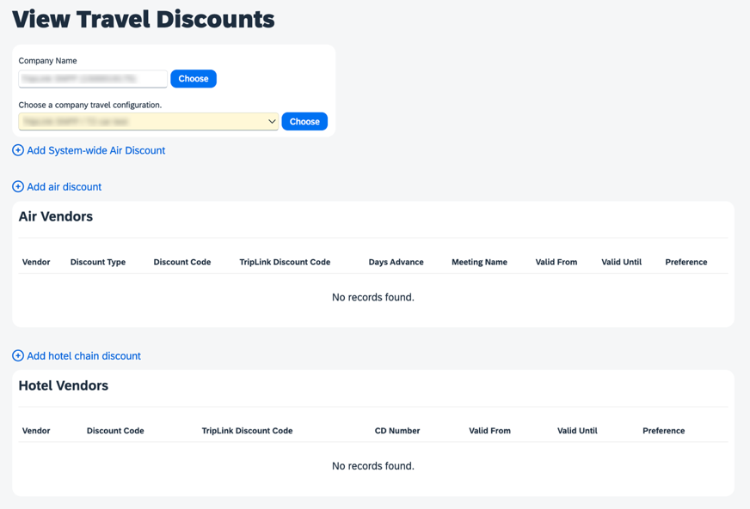
3. Edit an existing discount entry or add a new discount entry to set the TripLink Discount Code value.
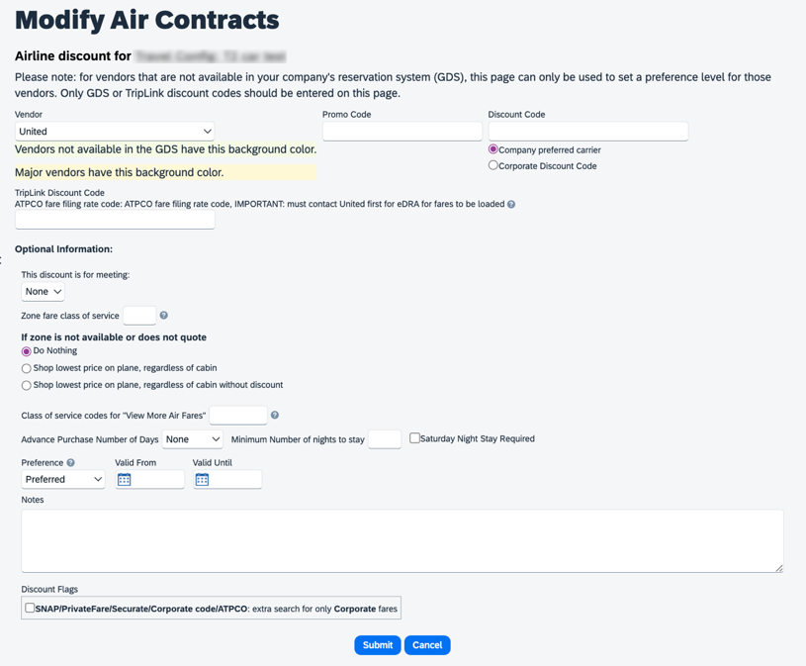
4. Click the Help icon to open the Quick Help window.
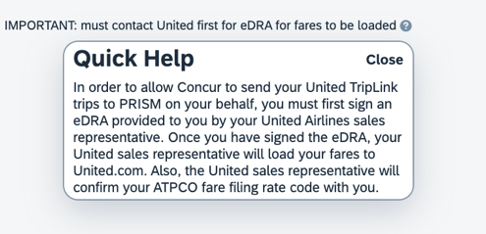
The Quick Help window provides information on how to locate your supplier discount codes.
Concur TripLink supplier discount code format and coverage vary by supplier. Please reference Concur TripLink Suppliers page for additional information on how to determine the correct discount code for TripLink suppliers.

Expense Audit Rules
Clients with the Concur Expense – Professional Edition product can create audit rules in Expense that apply to expense reports with itinerary items from Concur TripLink. The administrator can use the Entry > Booking Origin data object to identify the TripLink items.
For more information, refer to the Expense: Audit Rules Setup Guide.

Administrator – Standard Edition
To assign the Concur TripLink user roles
- Click Administration > Setup.
- If the company has Expense or Expense and Travel, click Expense > Users.
- If the user needs access to the Concur TripLink reports, select the Report user check box.
- If the user needs access to the Travel Policy page (to set travel policy, rules, and corporate discounts), select the TripLink Travel Policy Admin check box.
- Click Save.
To configure the Travel Policy
To access this page, the user must have the TripLink Travel Policy Admin user permission.
- Click Administration > Travel Settings.
- Click Travel Rules (option 2).
- Scroll down to the Concur TripLink section.
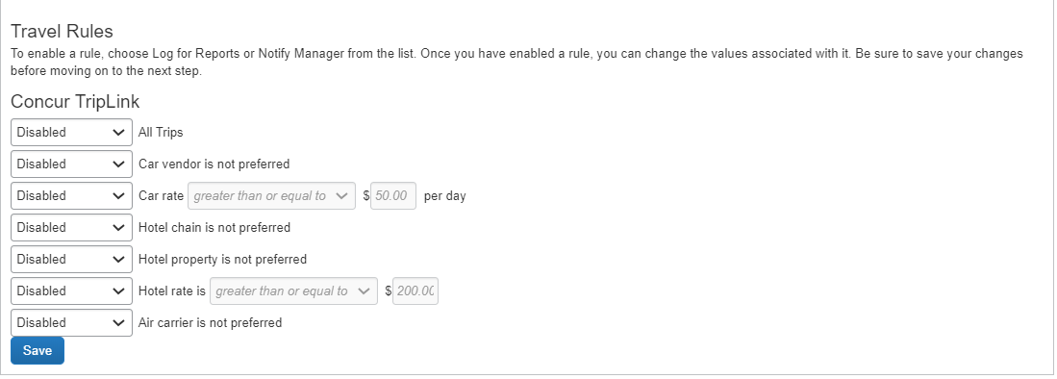
- Enable the desired rules around Concur TripLink compliance. These rules are disabled by default.
- To enable, choose Notify Manager or Log for Reports from the list.
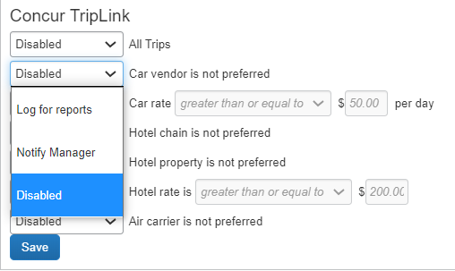
- If there is a value, for example if the car rate is greater than $50, then the fields will become editable once you select something other than Disabled.
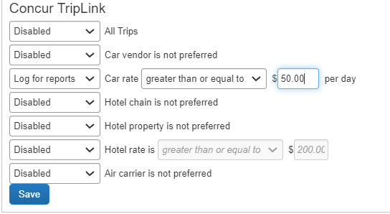
- Click Save.
To enter Concur TripLink supplier discount codes
Contact suppliers to obtain your company's unique discount codes. Then, add them to you Concur Travel & Expense configuration and your discounts will be applied to your travelers' bookings.
To access this page, the user must have the TripLink Travel Policy Admin user permission.
- Click Administration > Travel Settings.
- Click Travel Discounts (option 3)
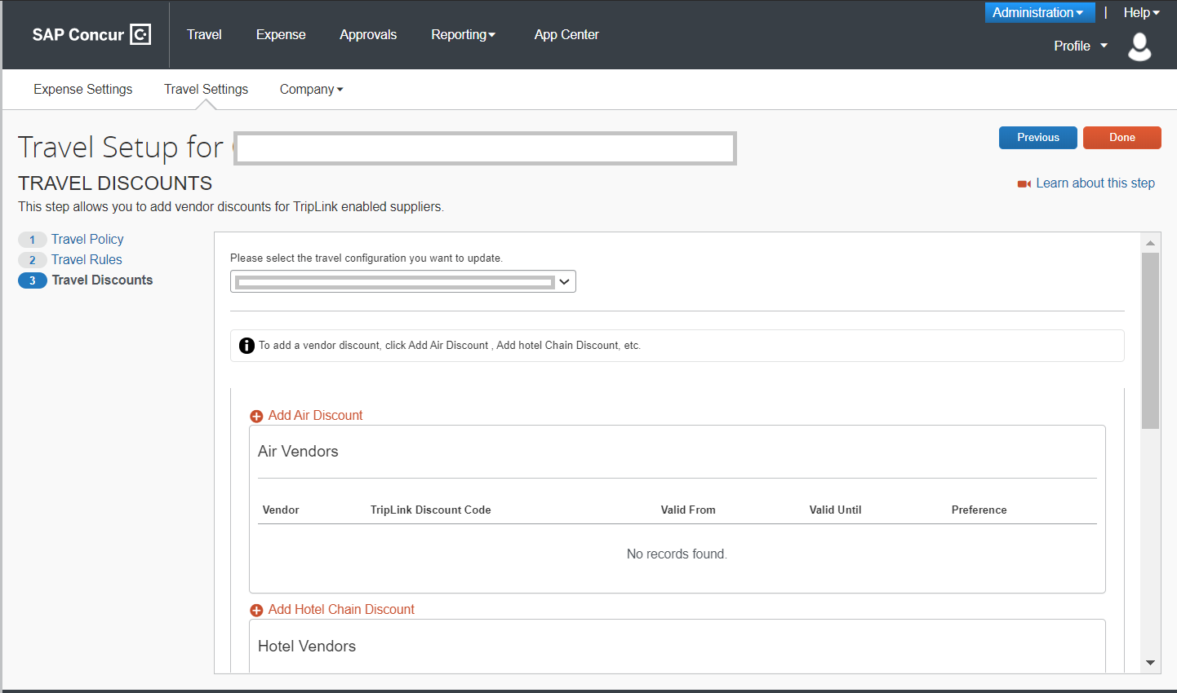
- Click Add <vendortype> discount for the desired supplier type.
- Fill in these fields:

Field | Description
Vendor | Select the desired Supplier.
TripLink Discount Code | Enter the discount code for the Supplier.
Preference | Dropdown list with fields: Most Preferred, Preferred, Less Preferred, Not Preferred
Valid From | The start date for the discount code.
Valid Until | The expiration date for the discount code.
- Click the Help icon to open the Quick Help window.
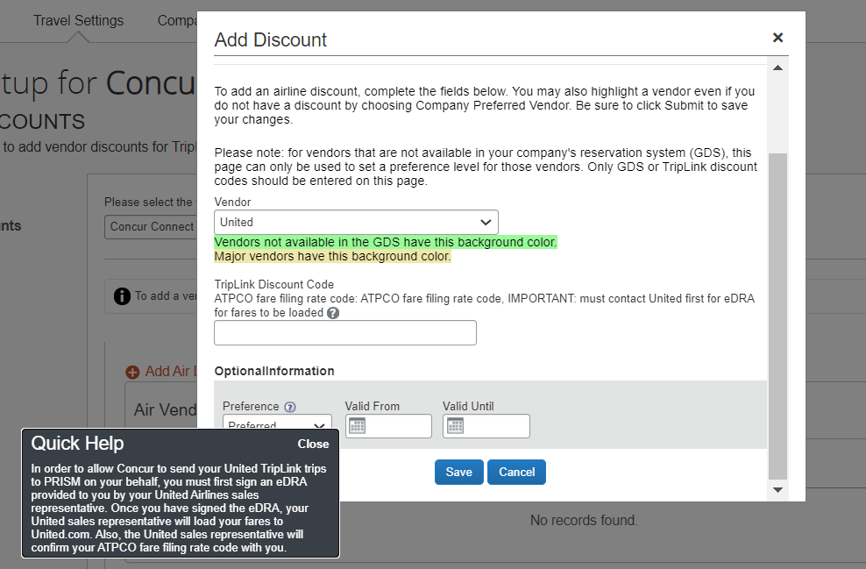
The Quick Help window provides instructions on how to locate your supplier discount code.
- Click Save.
- (Optional) Repeat for each supplier.
Concur TripLink supplier discount code format and coverage vary by supplier. Please view the Concur TripLink Suppliers page for additional information on how to determine the correct discount code for TripLink suppliers.

Terminating a Concur TripLink User
When a user with Concur TripLink is terminated, itineraries from the connected suppliers in Travel Partner Integrations, and itineraries from TripIt will stop flowing into Concur Travel & Expense.
In Professional Edition, the user is terminated when the Termination Activation Date set in User Administration has passed.
It is the responsibility of the Travel Admin to terminate a Concur TripLink User who is no longer a part of their organization. Failure to do so can result in the user’s itineraries from connected suppliers to continue synchronization into Concur Travel & Expense.
For more information, refer to the Shared: User Administration User Guide.
In Standard Edition, to have a user disconnected, the Active box must be cleared and a termination date must be added to the Account Termination Date box.
For more information, refer to the Shared: Users Setup Guide for Concur Travel & Expense Standard Edition.

Supplier Configuration & Policy Messaging – For Administrator (Professional)
Travel Admins can set Concur TripLink Messaging Preferences.
To do so
- Click Administration > Company > Company Admin.
- Under Travel Administration, click Manage TripLink Settings.
- Select the company name from the Company Name dropdown and then choose a company travel configuration from the next dropdown.
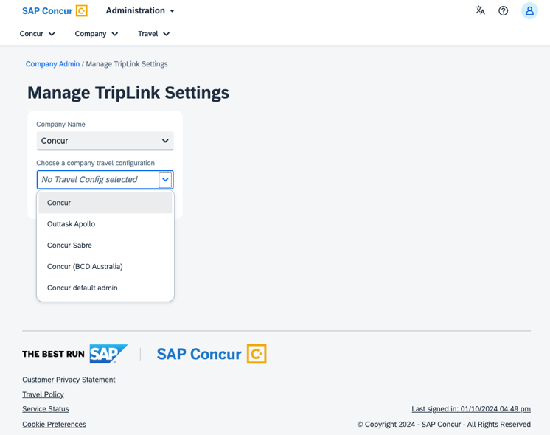
- Set the TripLink Messaging and Supplier Preferences.
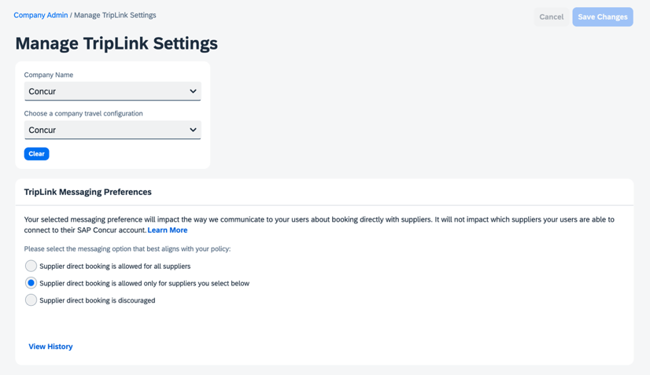
- Click Save Changes.
NOTE: The company travel configuration list will contain active and inactive travel configurations. Make sure you are choosing the correct active configuration.

Supplier Configuration & Policy Messaging – For Administrator (Standard)
Travel Admins can set TripLink Messaging Preferences.
To do so
- Click Administration > Company > Manage TripLink Settings.
- Select the company name from the Company Name dropdown and then choose a company travel configuration from the next dropdown.
- Set the TripLink Messaging and Supplier Preferences.

Concur TripLink Messaging Preference History
Administrators can access messaging preference history through the View History option.
To do so
- Select the Company Name and Company Travel Configuration under Manage TripLink Settings.
- Click View History.
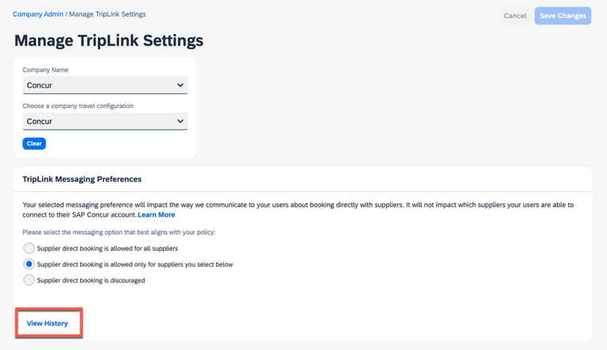
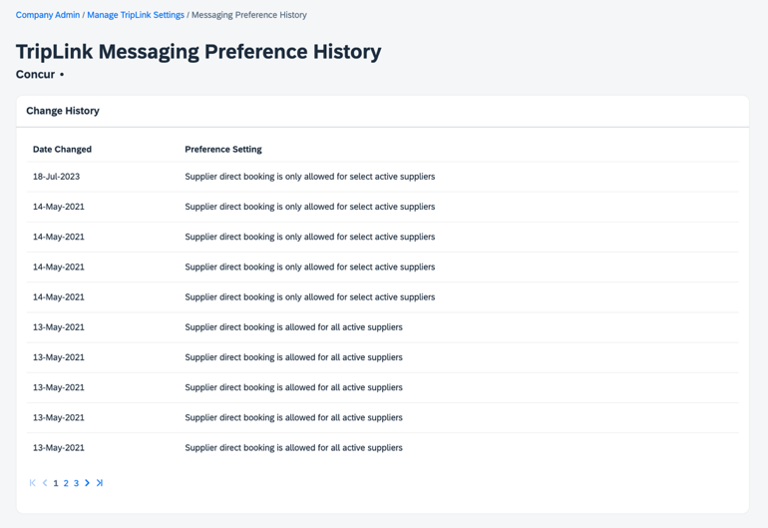
The company travel configuration list will contain active and inactive travel configurations. Make sure you are choosing the correct active configuration.

User

Connecting to Concur TripLink Partners
For travelers to start using Concur TripLink, they must connect their frequent traveler accounts with SAP Concur. The primary way to do this is by accessing the Concur TripLink hub, found in the main navigation. Users can also connect their travel partner accounts by adding their frequent traveler numbers through the partner’s page in the SAP Concur App Center, or in their SAP Concur Profile settings.

Concur TripLink Hub
In SAP Concur solutions, users can navigate to the Concur TripLink hub by selecting “TripLink” in the main navigation.
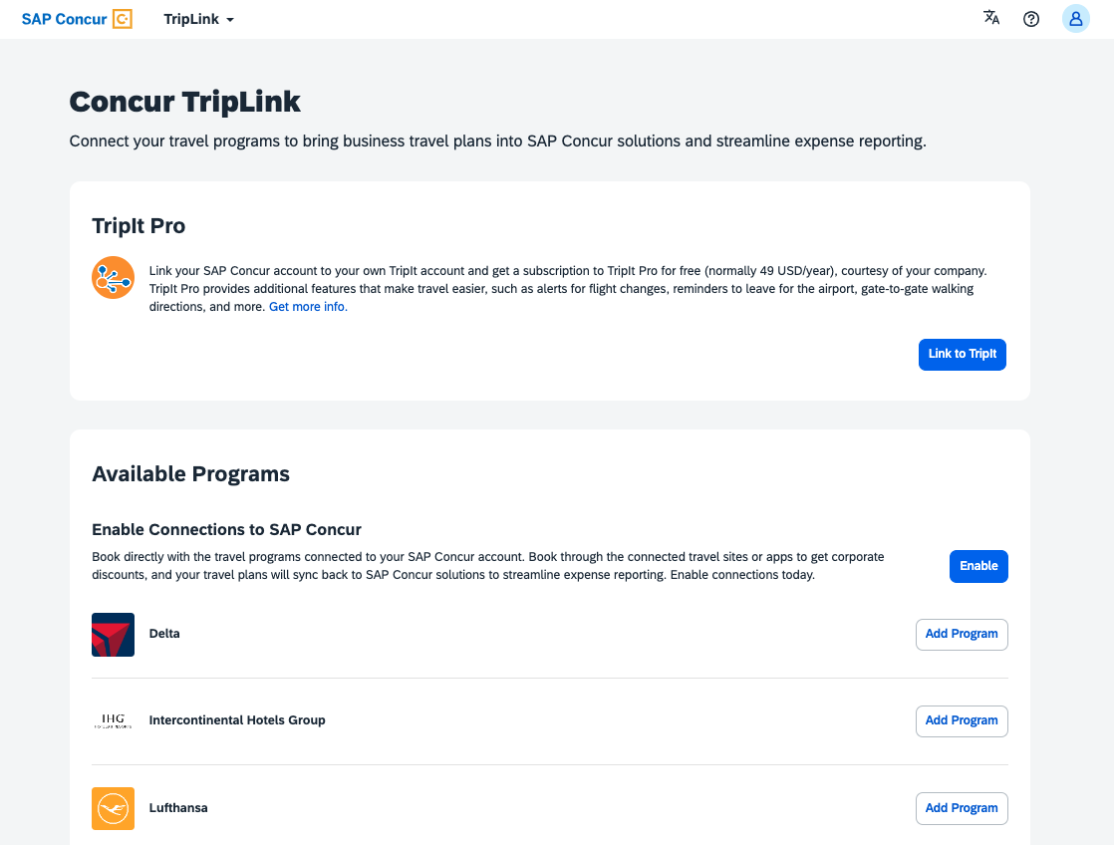
To initiate a connection with Concur TripLink Partners, users must first enable Travel Partner Integrations by simply clicking Enable. By clicking I Agree the user is agreeing to the terms and conditions for the connection and for sharing data between Concur TripLink partners and SAP Concur.
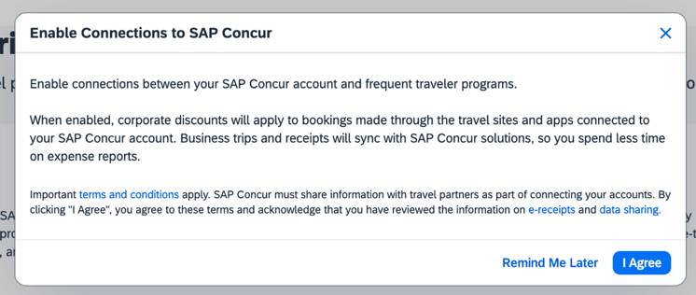
For users already enrolled in travel partner integrations, they can connect to partners by clicking Add Program and entering their frequent traveler number.
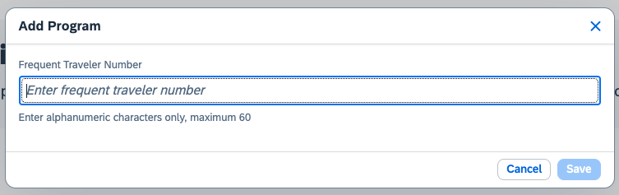
After adding the frequent traveler number, the program will be listed under Manage Connections. The connection status will be pending until the connection with the travel partner is established (this may take up to 24 hours). Upon connection, the status will show as connected and the traveler will receive a confirmation email. .
If a connection is not successful, the user should verify that their name and frequent traveler numbers match between their SAP Concur and partner accounts.
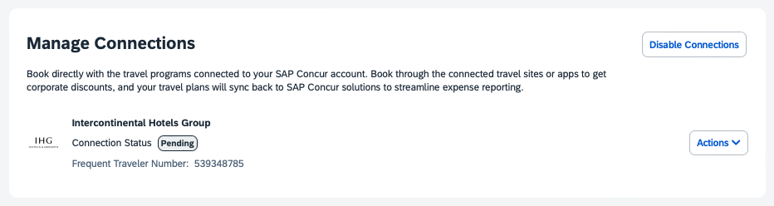
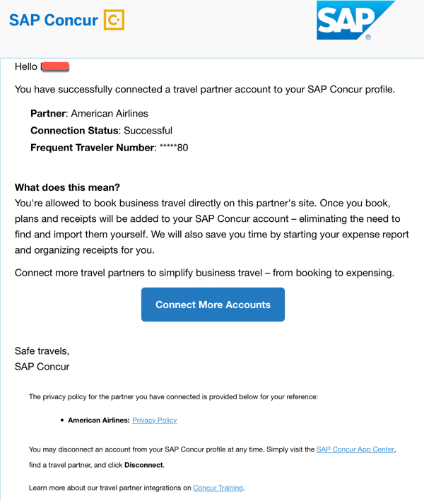
After the traveler has successfully connected their SAP Concur account with the travel partner account, they will have the option of making a corporate/business or personal/leisure booking when they sign in to the partner’s website or mobile app. Any negotiated rates will be applied to corporate searches and bookings. Corporate bookings will be shared with SAP Concur. Bookings identified as personal or leisureare not shared with SAP Concur and negotiated rates (if applicable) are not applied.
Travelers also have the option to Disable Connections. When connections are disabled, the user will no longer be able to book directly with these programs and get corporate discounts, synced itineraries, and e-receipts. All existing integrations will be disconnected.
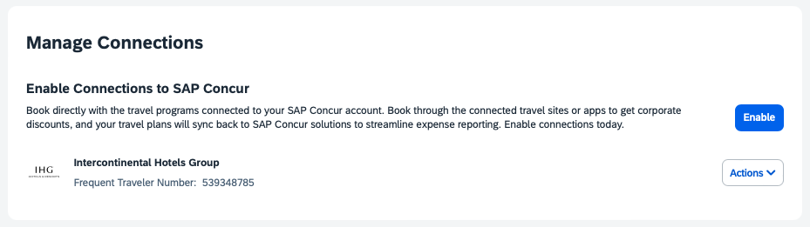

Travel Partner Integrations
A traveler can enroll in travel partner integrations from four places:
- Within the Concur TripLink hub by enabling connections to SAP Concur
- Within the SAP Concur App Center through the Travel Partner Integrations listing.
- From their Profile (Frequent Traveler Programs section).
- From an in-product prompt displayed to select users upon sign in to Concur Travel & Expense.

Travel Partner Integrations Enrollment from SAP Concur App Center or In-Product Prompt
Any frequent traveler accounts that the user has entered in the Travel Preferences section of their Profile for available (or soon to be available) Concur TripLink partners will be displayed in the Travel Partner Integrations enrollment screen. If the user enrolls in Travel Partner Integrations and later adds a frequent traveler account in Travel Preferences for a Concur TripLink available partner, the user will then be connected to that partner.
For all methods of enrolling in travel partner integrations, the connection status for each partner will be shown on the TripLink page (may take up to 24 hours).

Partner’s listing in the SAP Concur App Center
Users can connect to any Concur TripLink partner via the SAP Concur App Center, necessary for partners who don't offer frequent traveler numbers. Partners usually provide an easy way to join their rewards program and link the account in one step, accessible only through the SAP Concur App Center.
Upon clicking Connect and accepting the Access Authorization on the partner's Concur TripLink app in the App Center, users are redirected to the partner’s website to login or signup. The user's SAP Concur account then connects with their partner account, enabling immediate booking confirmation and e-receipts reception. Existing members of a partner's reward program can also link their accounts by entering their frequent traveler number (if not already in their profile). The SAP Concur App Center also allows disconnection from a partner.

Manage Verified Email Address and Travel Arranger
Once the Concur Travel & Expense administrator has enabled Concur TripLink for a user account, each user must perform the following steps to activate the itinerary forwarding functionality. If the user has already verified an email address for use with emailed receipts, they will not need to complete these steps. Concur TripLink and the emailed receipts functionality use the same verified email addresses.
To verify one or more email addresses
- Click Profile > Profile Settings.
- Click Email Addresses.
- Click Add an Email Address.
- Enter an email address that will be sending itineraries to SAP Concur (plans@tripit.com).
- Select whether you want this email to be included in travel notifications and click OK. You will then see the email address added with a verification status of Not Verified and a link to Verify.
- Click Verify to generate an email to the address.
- Open the email, then return to the Profile.
- In the Email Addresses area, enter the code from the email.
- Click OK. The process is complete. The email Verification Status shows Verified.
The plans@concur.com functionality was retired on July 22, 2021.
Once the travel arranger has verified their email address in the Email Addresses section of the profile, they may start emailing plans to plans@tripit.com on behalf of the traveler.

Enable E-Receipts
To allow partners to post receipts on their behalf, the user must enable e-receipts. The easiest way to do so is by enrolling in travel partner integrations which will activate e-receipts automatically.
If the user is not enrolled in travel partner integrations, they can also enable e-receipts independently in Profile.
To enable e-receipts
- Click Profile > Profile Settings.
- Click E-Receipt Activation.
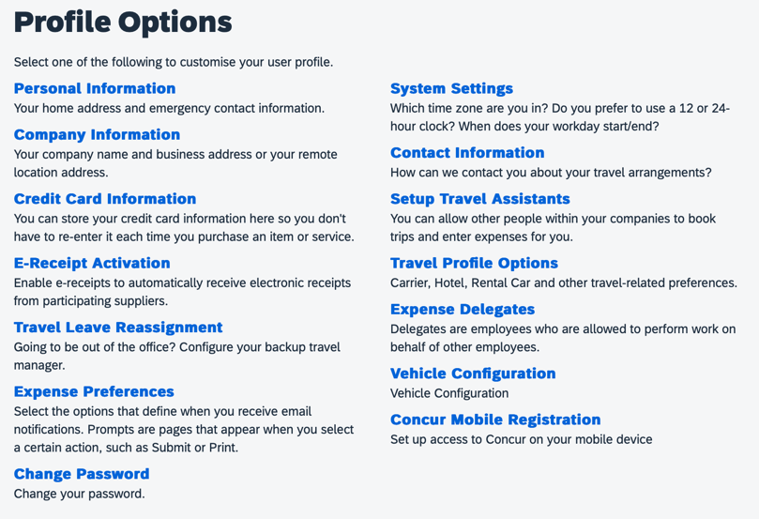
- Click the E-Receipt Activation link to enroll to receive E-Receipts from participating partners.
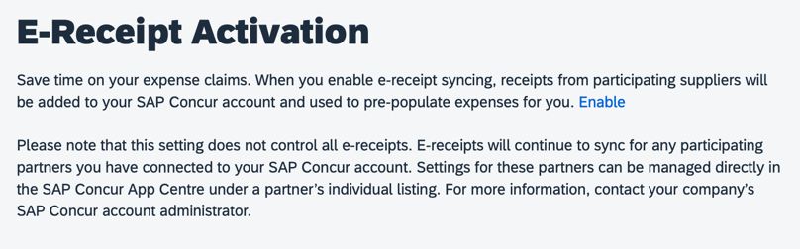
To ensure e-receipts delivery for Concur TripLink hotel partners IHG and Marriott, the user should also ensure the credit card they use to check out at the hotel is entered in their SAP Concur Travel Profile.

Concur TripLink Supplier Discount Code Information
Concur TripLink supplier discount code format and coverage vary by supplier. The following tables provide additional information on how to determine the correct discount code for TripLink suppliers.

American Airlines

Supplier Name for Discount Code | What does the code look like and where can a customer find it? | Supplier contact for support if the code cannot be identified.
Corporate Contract Number (Tour code) / Discount Code | A Concur TripLink Discount Code is different from a discount code that you might have on file for American with a travel agency or in GDS systems. Your Concur TripLink Discount Code, provided by American, is alphanumeric and specific to the region where contracted rates are available, along with where a customer is based. | If you do not know your American Airlines Concur TripLink Discount Code(s), ask the individual within your organization who manages your travel program or send an email to your American Airlines Account Manager including “Concur TripLink Discount Code” in the subject line.  To begin using Concur TripLink, please submit a new PRISM eDRA form. An eDRA (electronic Data Release Authorization) is an agreement with which a corporation directs a travel agency to send booking data to PRISM and authorizes PRISM to share data with an airline to facilitate corporate reporting.  For more information, including how to set up an eDRA form for Concur TripLink, refer to:  https://www.concurtraining.com/en-us/triplink/suppliers/americanairlines

Delta Airlines
eCredits and gift cards can be used on delta.com for business bookings. A business traveler who previously cancelled a Delta Airlines business flight and was issued an eCredit by Delta Airlines may now apply the eCredit to a new business flight.These eCredits can be used with another eCredits, credit cards or with gift cards.
Supplier Name for Discount Code | What does the code look like and where can a customer find it? | Supplier contact for support if the code cannot be identified.
Delta Corporate Ticket Designator | A Delta Air Lines Concur TripLink Discount Code is different from a discount code that you might have on file for Delta with a travel agency or in GDS systems. | If you do not know your Delta Air Lines Corporate Ticket Designator, ask the individual within your organization who manages your travel program or send an email to your Delta Air Lines Sales Account Executive and include “Delta Air Lines Concur TripLink Discount Code” in the subject line.  Setup for central form of payment (Corporate Ghost Card) –  SAP Concur added a new permission to Corporate Ghost Card setup, called, “Allow Form of Payment API Access.” This is defaulted to off (unchecked) for all existing and new cards.  In order to show the user only one mandatory form of payment, ensure “Allow Form of Payment API Access” is checked. When the field is unchecked, Delta shows the user all the cards from their Concur Travel & Expense profile as well as any cards in their Delta SkyMiles profile. If there are duplicates, they only show one card

Lufthansa

Supplier Name for Discount Code | What does the code look like and where can a customer find it? | Supplier contact for support if the code cannot be identified.
Concur TripLink Discount Code number (combined CLID and CUG) | Your Lufthansa ConcurTripLink Discount Code is not the same as the Lufthansa GDS code. The Concur TripLink Discount Code is a combination of your CLID (Client Identifier) and CUG (Closed User Group). The conditions of your corporate contract are stored within the 6 to 12-digit (alphanumeric) CUG. The Client Identifier is 13-digits (alphanumeric). Your Concur TripLink discount code is the CLID, plus the CUG with no spaces in between the two numbers. Your code could be between 19 and 25 digits. It is important that the codes be entered in exactly that order, CLID + CUG to avoid any problems with the discount code entry. | Lufthansa Group requires consent from Concur TripLink travel managers before making corporate fares available to travelers on LH.com. If consent is granted, Travel Managers will need to add the Lufthansa Client Identifier (CLID) and the Closed User Group (CUG) code to the Concur Travel & Expense configuration.  Email your Lufthansa Group Account Manager and copy triplink@lufthansa-group.com to request CLID and CUG, subject line for the email ‘Concur Triplink Discount Code Request’, confirming acceptance that corporate fares are available and bookable on LH.com.  If in agreement, the Concur TripLink Discount Code number (combined CLID and CUG) will be provided by your Lufthansa Group Account Manager within approximately two weeks.  PRISM eDRA for US-based Customers and Lufthansa Group Global Customers  Lufthansa will send PRISM data directly. To allow Lufthansa Group to send your Concur TripLink trips to PRISM on your behalf, you must first process an eDRA provided to you by your Lufthansa Group Account Manager.

United Airlines

Supplier Name for Discount Code | What does the code look like and where can a customer find it? | Supplier contact for support if the code cannot be identified.
ATPCO fare filing rate code | You must contact your United sales representative to acquire your ATPCO fare filing rate code before entering it into the Concur TripLink Discount Code field. Even if you already know your ATPCO fare filing rate code, you must sign an eDRA with United and United has to file your fares on United.com. | Process the United Airlines Prism eDRA  Contact your United sales manager who will email you an eDRA to process for PRISM reporting.  Setup for central form of payment (Corporate Ghost Card) –  SAP Concur added a new permission to Corporate Ghost Card setup, called, “Allow Form of Payment API Access.” This is defaulted to off (unchecked) for all existing and new cards.  In order to show the user only one mandatory form of payment, ensure “Allow Form of Payment API Access” is checked. When the field is unchecked, United shows the user all the cards from their Concur Travel & Expense profile as well as any cards in their United MileagePlus profile. If there are duplicates, they only show one card

Marriott International

Supplier Name for Discount Code | What does the code look like and where can a customer find it? | Supplier contact for support if the code cannot be identified.
Marriott Corporate Rate Code | The three letter Marriott rate access code that you enter into the Concur TripLink Discount Code field is the same as the rate access code that is entered in the GDS translation tables. | - Customers using a TMC:  To find the Marriott GDS rate access code, ask the individual within the organization who manages the hotel/travel program. For those customers setting up a SAP Concur account and using a Travel Management Company/Travel Agency to implement Concur TripLink, the Travel Management Company/Travel Agency can contact Marriott’s GDS Help Desk at 1-800-831-3100, option #2 for assistance with these codes.‎  - Customers not using a TMC:  To find the 3-character code Marriott corporate rate code, ask the individual within the organization who manages the hotel/travel program. If this person is not available or unaware if such a program exists, please contact the Marriott Business Travel Center at 402-390-3640 or businesstravelcenter@marriott.com.

InterContinental Hotels Group (IHG)

Supplier Name for Discount Code | What does the code look like and where can a customer find it? | Supplier contact for support if the code cannot be identified.
IHG Corporate ID Number (CorpID) | The Corporate ID number is 9-digits and numeric and it is not the same number that you use for GDS bookings.  NOTE: If the code obtained is not 9-digits, insert zeros in front of the number to make it 9-digits. | If your company doesn’t have negotiated rates with IHG but would like to learn more, or if you are a TMC and your client would like to set up negotiated rates, please email channels@ihg.com and ask for the IHG Corporate ID number. Be sure to include the company name in the request.

Hyatt

Supplier Name for Discount Code | What does the code look like and where can a customer find it? | Supplier contact for support if the code cannot be identified.
Hyatt Corporate ID number | The Hyatt Corporate ID number is a 5-7-digit numeric number. | If you do not know your Hyatt Corporate ID number, ask the individual within your organization who manages the hotel/travel program, or email your Hyatt account manager, and ask them to resend the Corporate ID number.

Avis

Supplier Name for Discount Code | What does the code look like and where can a customer find it? | Supplier contact for support if the code cannot be identified.
AWD  (Avis Worldwide Discount) Number | An AWD number is a total of seven characters, beginning with one alpha character and followed by six numeric characters. Example: A001100  In case an incorrect or no AWD number has been stored in SAP Concur, Avis will use a default AWD number for Concur TripLink users. | If you do not know your company’s AWD number, contact your Avis account manager. If your company doesn’t have negotiated rates with Avis, but would like to learn more, please visit www.avis.com/corpaccount for info on the Avis corporate account, and visit www.Avis.com/smallbiz for info on an Avis small business account.  If you need help identifying your account manager, contact Customer Service via phone  • In the US & Canada: 1-800-352-7900  • Or visit: www.avis.com/concur

Hertz

Supplier Name for Discount Code | What does the code look like and where can a customer find it? | Supplier contact for support if the code cannot be identified.
CDP (Corporate Discount Program) Code | The Hertz Corporate Discount Program number, also referred to as the Counter Discount Program (CDP) number, can be from one to seven digits long (no alpha characters). The CDP is the same number that you would use in the GDS. | If you do not have a CDP, and would like to get one, visit the Hertz Small Business Rewards page, if you're a small business with national rental car needs. If you are interested in a global car program, please email the Business Rewards Sales Team at businessrewardssalesteam@hertz.com or call 888-777-3807.

Sixt

Supplier Name for Discount Code | What does the code look like and where can a customer find it? | Supplier contact for support if the code cannot be identified.
CD Code (Corporate Discount Code) | A Sixt CD code is a 5-7 digit numeric code numerically identical to the Sixt GDS code. However, GDS integrations require a « SX » in front of the actual CD numeric code (e.g. CD code 9860588 needs to be entered as SX9860588 in the GDS). When entering the Sixt CD code into the TripLink Discount Code field, do not insert, “SX,” in front of the CD Code number. Use only the CD Code number. | If you do not know your company’s Sixt CD Code, contact your Sixt account manager. If your company doesn’t have negotiated rates with Sixt, but would like to learn more, visit Sixt Rent a Car.  Sixt country-specific hotlines can also be contacted for CD Code inquiries:  USA | German | France

TripIt
TripIt is a trip management service that helps travelers organize and share their travel plans, no matter where they book. TripIt gives travelers the tools to combine all their travel plans – whether booked within or outside their managed travel program – into consolidated itineraries that can be accessed via Concur Travel and Expense, on the web or on mobile apps.
Concur TripLink users have a complimentary subscription to TripIt Pro (US and EMEA Data Centers only).
TripIt Pro is available in English (US), English (UK), French, German, Spanish, Latin American Spanish, and Japanese. Users must have their language settings set to one of those languages in order to connect to TripIt.
TripIt for Teams was decommissioned on January 31, 2022.
- Concur TripLink users need to connect their TripIt account with their SAP Concur account. They can either connect their existing account or create a new account. This can be done in the Concur TripLink hub, found in the main navigation of SAP Concur solutions. The detailed steps for the TripIt Configuration and TripIt Pro Activation can be found at SAP Concur Customers – TripIt Help Center.

Itinerary Forwarding
For travel providers that are not yet part of the Concur TripLink network, travelers can share the itinerary with SAP Concur allowing visibility for duty of care and reservation management.
After they have connected their SAP Concur and TripIt accounts, travelers can forward travel confirmation emails from travel partners to plans@tripit.com. SAP Concur will automatically merge those segments with Concur Travel or TMC booked segments and create a consolidated itinerary. The data from these itineraries will also flow through to the expense report and to the management information reporting available to your company.

Travel Arranger
A travel arranger designated in Concur can add travel plans to their authorized traveler's TripIt account via plans@tripit.com.
Detailed set-up instructions can be found on the TripIt website.
Both the Concur Travel Arranger and traveler must be TripIt users.
The Concur Travel Arranger must be designated as such in the Assistants/Travel Arrangers section of their Concur Travel profile settings.
The email address used for both the travel arranger and traveler must be verified in the Email Addresses section of their Concur Travel profile settings.

(TripIt Enabled Countries Only) Download TripIt Pro and Connect Concur Travel & Expense to TripIt Pro
To download TripIt App
- iPhone/iPad: Go to the App Store and search for TripIt.
- Android: Go to Google Play and search for TripIt.
To link TripIt Pro to Concur Travel & Expense
Once the company has purchased TripIt, the user can link TripIt Pro to Concur Travel & Expense in the following ways:
- In the Concur TripLink hub, found in the main navigation of SAP Concur solutions
- TripIt App in the SAP Concur App Center.
- From an in-product prompt displayed to select users upon sign-in to Concur Travel & Expense.
- Through Banners and Inline messages on the Home and Travel pages.
During this setup process, users will have the option to make all SAP Concur trips public (default) or private in TripIt. Private trips are not shared with any connections, groups, or integrated applications that the user has previously established in TripIt.
More assistance for TripIt can be found using the TripIt help system.

Frequently Asked Questions (FAQs) and Additional Resources
Q. Why can’t I find My Travel Network (MTN) in the SAP Concur App Center?
A. My Travel Network is now called travel partner integrations. Users can enroll in travel partner integrations from the Concur TripLink hub or the SAP Concur App Center. Travel partner integrations will continue to have all functionality of My Travel Network.
Q. Why are negotiated rates not displayed when I access the Concur TripLink partner’s website/app?
A. To see your company rates in any Concur TripLink Partner site/app:
- Check if the correct frequent traveler number is setup under your profile.
- Make sure you are enrolled in Travel Partner Integrations.
- Check with your Travel Administrator that the Concur TripLink Discount Code is setup for your company.
- To see your company rates, configuration of Concur TripLink Discount Code is a requirement. Travel Admins should follow these steps to see Concur TripLink Discount Code.
- Click Administration > Company > Company Admin
- Click Manage Corporate Discounts under Travel Admin (left menu)
Q. Which report can I run to see a list of users, who have linked their SAP Concur and TripIt account?
A. The following Travel Reports will provide the users who have connected their SAP Concur and TripIt accounts:
- TripIt Connected Users Detail
- TripIt Connected Users Summary
To access these reports please use the following steps:
- Log in to Concur Travel & Expense.
- Click on Reporting > Travel Reports.
- Click the Report Name.
Q. What should I do if I do not have an existing frequent traveler number?
A. If the user does not have an existing frequent traveler number, they can select, Click here to create a new account in the Partner’s app listing in SAP Concur App Center. They are redirected to the partner site to create their frequent traveler number account. Where possible, the partners pre-fill the frequent traveler enrollment form with relevant information from the SAP Concur profile to save the user's time.
When the user completes their enrollment, their SAP Concur account is automatically linked with the travel partner, and the travel partner adds the new frequent traveler number into the user’s profile.
For partner’s that do not have this feature in Concur Travel & Expense, visit the partner’s website for more information on how to enroll in their loyalty programs. Once the user has a frequent traveler number, the user can either connect to the partner by adding the frequent traveler number in the Concur TripLink hub. Users can also add the frequent traveler number in partner’s App Center listing, or in their Travel Profile, if they are enrolled in Travel Partner Integrations.
Q. How do I disconnect a partner?
A. The traveler can visit the Concur TripLink hub to disconnect a Partner.
Q. Why did a personal trip show up under my Trip Library?
A. The user may have inadvertently identified the booking as a business trip on the connected partner’s website or mobile app when they made the booking. If your company allows bookings or expenses to be removed, the user can remove the booking in Concur Travel & Expense. This will NOT result in a cancellation of the booking on the partner site.
The itinerary was sent to plans@tripit.com and the user has their SAP Concur account linked to TripIt, so the itinerary synced to the user’s SP Concur Travel & Expense Trip Library.
User has auto-import feature turned on in TripIt.
Q. Why are the changes to my trip not updating in Concur Travel & Expense?
A. Changes to the trips made in one of our Concur TripLink Partners should sync automatically into Concur Travel & Expense.
The change will not sync if the trip is already expensed.
Q. What happens when you release a new Concur TripLink supplier connection?
A. There is outreach prior to the launch of each new Concur TripLink integrated travel partner, including e-mails and in-product announcements in SAP Concur solutions. Please also watch the external roadmap, available through the SAP Roadmap Explorer, for upcoming supplier and feature launches and recent innovations with Concur TripLink.
You can access and adjust Concur TripLink Messaging Preferences for all integrated travel partners that are currently live or coming soon. When a new partner integration is announced, it will also be available in your messaging preferences to adjust.
Q. Do I have an option to remove a supplier from appearing in Travel Partner Integrations and the SAP Concur App Center? How do I inactivate a supplier?
A. If necessary, you can request to inactivate an integrated travel supplier to remove it from the SAP Concur App Center and Travel Partner Integrations. We strongly discourage this as it will result in a loss in visibility that you have into employee bookings made outside of your organization preferred methods. This makes it difficult to fulfill your duty of care and reporting responsibilities.
Instead, we suggest that you discourage travel supplier direct bookings for non-preferred travel partners. You can do this by:
- Setting Concur TripLink Messaging Preferences to Supplier direct booking is allowed only for suppliers you select below.
- Deselecting the suppliers you want to discourage.
If you would still like to set an integrated travel supplier to inactive, please create a customer support ticket with the subject line “Inactivate TripLink Supplier”.
Q. What happens when a Concur TripLink Supplier is inactivated?
A. When a Concur TripLink Supplier is inactivated:
- The supplier app will be removed from the Concur TripLink hub and SAP Concur App Center.
- Your employees will no longer be able to connect to the supplier.
- Employees who are connected will be disconnected within 30 days.
Q. If I take no action, what will my Concur TripLink admin controls messaging preference be set to?
A. By default, your messaging preference is set to supplier direct booking is allowed for all suppliers. Travelers will be allowed to book directly with all integrated travel partners, and the travel partners will appear in the Concur TripLink hub and the SAP Concur App Center.
Q. Why do I see more travel configurations than I currently use?
A. The system cannot sort which configurations are active only, and all travel configurations will display, active and inactive. Choose the active configuration you want to update. Please note that not all inactive configurations will be labeled as inactive, old, or deactivated.
Refer to the Concur TripLink Admin FAQ for more resources on Concur TripLink Admin.
Refer to the Travel Partner Integrations and TripIt FAQ for more resources on Travel Partner Integrations and TripIt.
Refer to the Concur TripLink Admin Controls FAQ for more resources on TripLink Admin Controls of Suppliers and Policy Messaging

