

Applies to these SAP Concur solutions:

⮽ Expense  
⮽ Professional/Premium edition  
⮽ Standard edition

⮽ Travel   
⮽ Professional/Premium edition   
⮽ Standard edition

□ Invoice  
□ Professional/Premium edition   
□ Standard edition

□ Request  
□ Professional/Premium edition  
□ Standard edition

**Corporate Booking Portal Integrations for Concur TripLink Setup Guide**

Last Revised: October 20, 2022

Table of Contents

Section 1: Overview 1

Section 2: COBT Integrations 1

Corporate Rates Club (CRC) 1

End User Experience 1

Configuration / Feature Activation 2

ehotel 4

End User Experience 5

Configuration / Feature Activation 6

DERHOTEL 10

End User Experience 11

Configuration / Feature Activation 12

BlueSky by TravelSky 16

End User Experience 17

Configuration / Feature Activation 19

Revision History

| Date | Notes / Comments / Changes |
| --- | --- |
| October 20, 2022 | Added *BlueSky by TravelSky* Integration section |
| June 11, 2022 | Initial Post |
|  |  |
|  |  |

**NOTE:** Multiple SAP Concur product versions and UI themes are available, so this content might contain images or procedures that do not precisely match your implementation. For example, when SAP Fiori UI themes are implemented, home page navigation is consolidated under the SAP Concur Home menu.

# TripLink

## Overview

Concur® TripLink® brings outside bookings back into a client’s travel and expense program through SAP Concur’s global network of connected Partners and TripIt Pro, an award-winning, comprehensive trip management app. Complimentary subscription to TripIt Pro is provided for TripLink Users. Concur TripLink is currently available for US and EMEA datacenters.

Concur TripLink helps you manage travel across booking channels by capturing itineraries and integrating them into your SAP Concur solution.

Clients can gain visibility, apply policy and realize negotiated rates on bookings made with Concur TripLink travel partner integrations - the only program of its kind. When travelers use TripIt Pro for bookings made with non-TripLink partners their itineraries will become available in Concur Travel & Expense.

Concur TripLink represents the next generation of business travel by extending the value of corporate travel programs and integrated travel and expense to all travel, capturing the travel reservations, no matter where they are booked.

A selection of corporate portals, such as ehotel®, CRC and DERHOTEL allow you to have broad visibility into spend and duty of care, while your employees enjoy flexibility and ease of use.

## COBT Integrations

### Corporate Rates Club (CRC)

sending trip itineraries and eReceipts to SAP Concur solutions. When a company enables CRC, they can search, book, or cancel hotel bookings in the CRC corporate portal.

In extending Concur TripLink’s value of capturing outside spend, customers can have more visibility into travel bookings provided by regional travel supplier portals to facilitate traveler benefits of integrated SAP Concur Travel and Expense. Customers can have a broader range to book travel and receive itineraries.

#### End User Experience

Once logged in via CRC, the user can search for corporate rates to book their hotel stays. They can also review or cancel a previous booking.

#### Configuration / Feature Activation

The configuration steps are:

* Part 1: Professional and Standard Editions – Establish a relationship with CRC.
* Part 2: Professional and Standard Editions – Enable the CRC enterprise app in the SAP Concur App Center.

##### PART 1: PROFESSIONAL AND STANDARD EDITIONS – ESTABLISH A RELATIONSHIP WITH CRC

The company establishes a relationship with CRC, indicating that they are interested in their employees booking through CRC.

##### PART 2: PROFESSIONAL AND STANDARD EDITIONS – ENABLE IN THE SAP CONCUR APP CENTER

###### Permissions

For this task, the user must have the Web Services Administrator role.

###### Enable the Enterprise Application

1. To enable the app for your company:
2. On the **CRC** page, click **Connect**.
3. If the **Connect** button is unavailable, then you do not have the Web Services Administrator role required to enable the app.

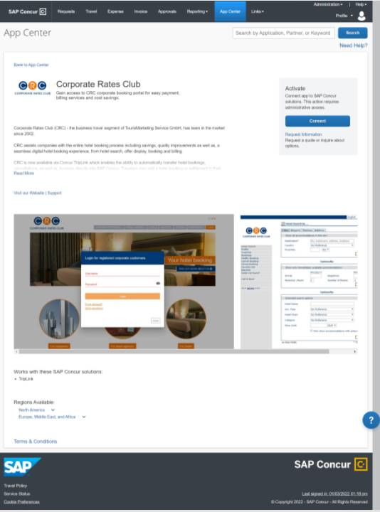

The **Terms & Conditions** page appears.

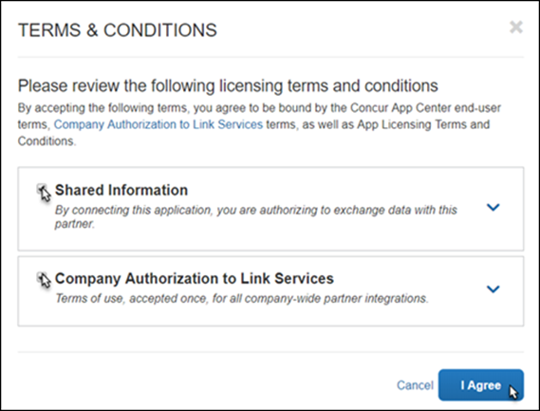

1. Click **Shared Information** and then click **I Agree**.
2. On the CRC page, you will be prompted to enter a verification code.
3. On the **Allow SAP Concur Connection** page, do the following:

* Enter the token/validation code in the **Verification code** field.
* Read and then select the **I have read the Terms & Conditions** checkbox.
* Read and then select the **I have read the Privacy Statement and consent to this agreement** checkbox.
* Click **Submit**.

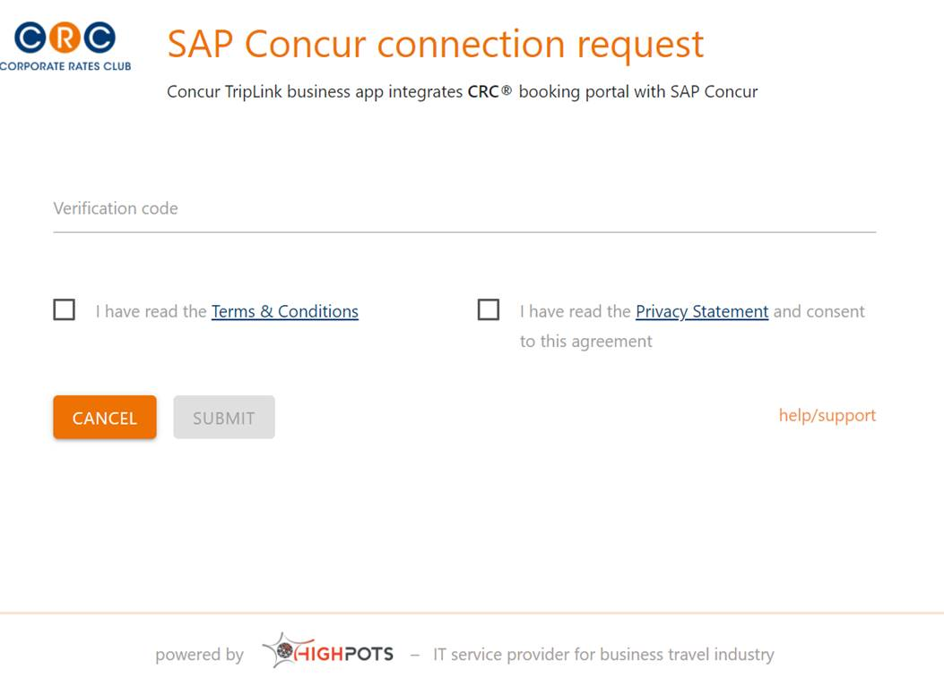

When the connection is successful, the confirmation page appears and the **Connect** button label changes to **Connected**.

### ehotel

**ehotel®** is an Online Booking Tool supplier which provides trip itineraries and eReceipts. When a company enables Concur TripLink and the ehotel integration, travelers can search, book, or cancel hotel bookings in the ehotel corporate portal.

In extending the Concur TripLink value of capturing outside spend, customers can have more visibility into travel bookings provided by regional travel supplier portals to facilitate traveler benefits of integrated SAP Concur Travel and Expense. Customers can have a broader range to book travel and receive itineraries.

#### End User Experience

Once logged in via ehotel, the user can search for corporate rates to book. They can also review or cancel a previous booking.

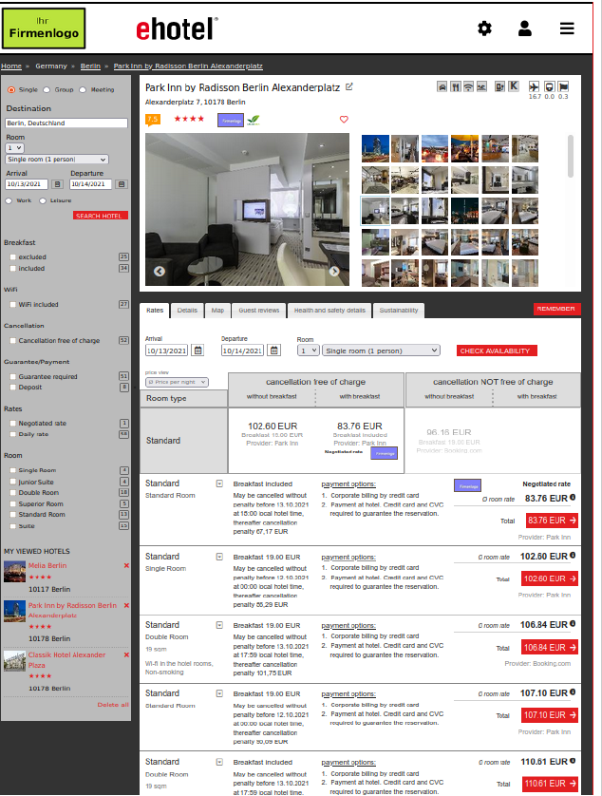

After the corporate rate is booked and confirmed, the itinerary is sent to **Concur Travel Itinerary**. Users can then review their ehotel confirmed itineraries in SAP Concur.

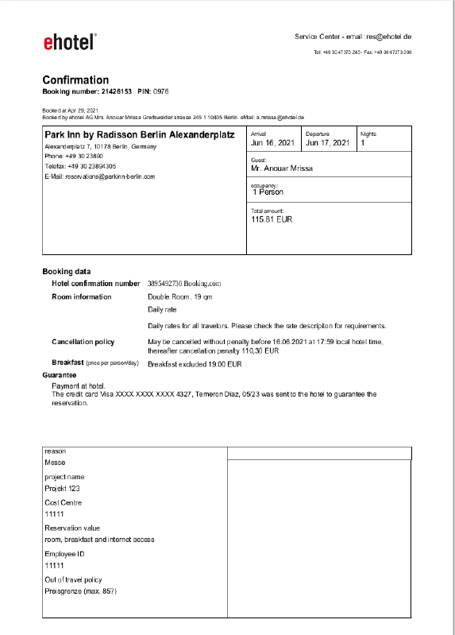

#### Configuration / Feature Activation

The configuration steps are:

* Part 1: Professional and Standard Editions – Establish a relationship with ehotel.
* Part 2: Professional and Standard Editions – Enable the ehotel enterprise app in the Concur App Center.

##### Part 1: Professional and Standard Editions – Establish a Relationship With ehotel

The company establishes a relationship with ehotel, indicating that they are interested in their employees booking through ehotel.

##### Part 2: Professional and Standard Editions – Enable in the App Center

###### Permissions

For this task, the user must have the Web Services Administrator role.

###### Enable the Enterprise Application

1. To enable the app for your company:
2. On the **ehotel** page, click **Connect**.
3. If the **Connect** button is unavailable, then you do not have the Web Services Administrator role required to enable the app.

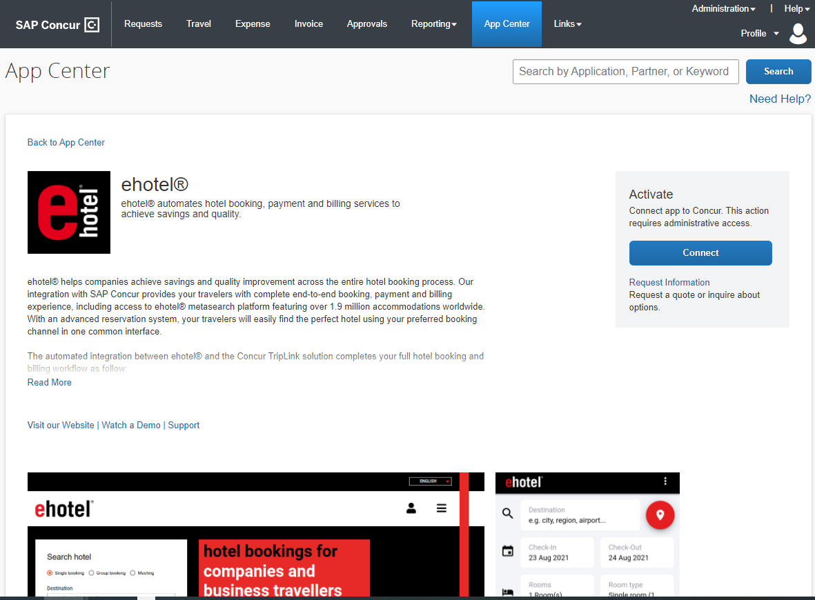

The **Terms & Conditions** page appears.

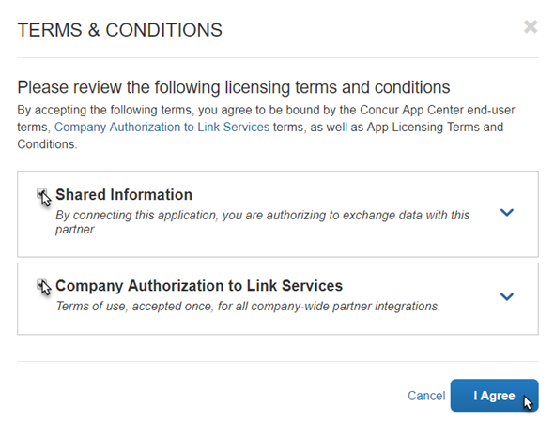

1. Click **Shared Information** and **I Agree**.
2. On the ehotel page, you will be prompted to enter a verification code.
3. On the **Allow SAP Concur Connection** page, do the following:

* Enter the token/validation code in the **Verification code** field.
* Read and then select the **I have read the Terms & Conditions** checkbox.
* Read and then select the **I have read the Privacy Statement and consent to this agreement** checkbox.
* Click **Submit**.

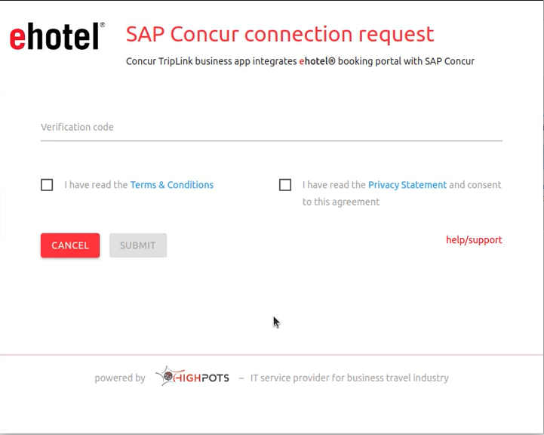

If the connection is successful, the following page appears and the **Connect** button label changes to **Connected**.

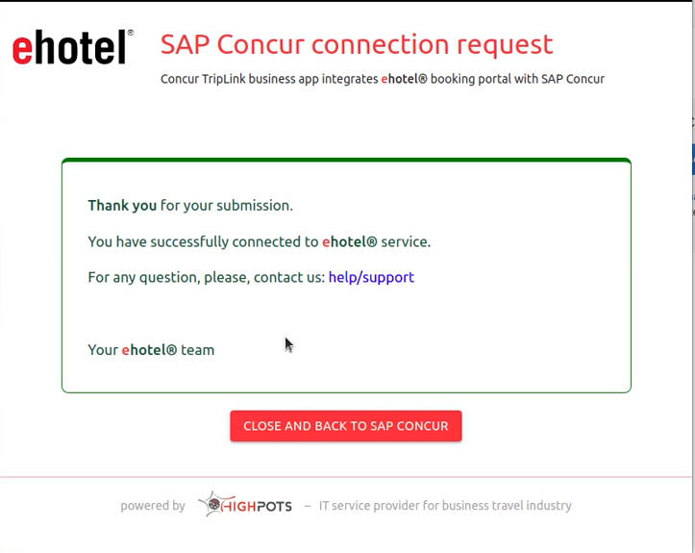

### DERHOTEL

DERHOTEL is an Online Booking Tool supplier which provides trip itineraries and eReceipts. When a company enables Concur TripLink and the DERHOTEL integration, travelers can search, book, or cancel hotel bookings in DER Corporate Services’ corporate portal.

In extending the Concur TripLink value of capturing outside spend, customers can have more visibility into travel bookings provided by regional travel supplier portals to facilitate traveler benefits of integrated SAP Concur Travel and Expense. With access to over 1 million hotels with DERHOTEL, customers can have a broader range to book travel and integrate itineraries and eReceipts with their SAP Concur solution.

#### End User Experience

Once logged in via DERHOTEL, the user can search for corporate rates to book. They can also review or cancel a previous booking.

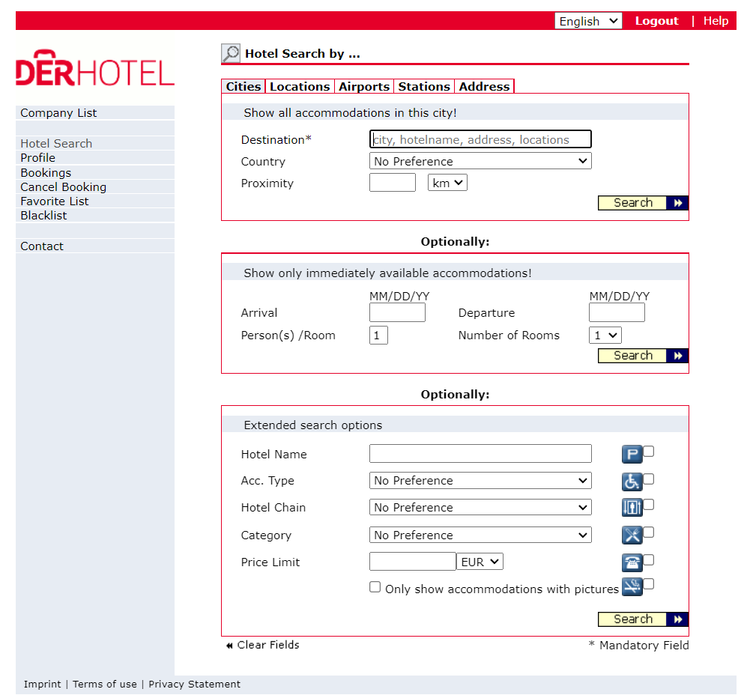

After the corporate rate is booked and confirmed, the itinerary is sent to **Concur Travel Itinerary**. Users can then review their DERHOTEL confirmed itineraries in SAP Concur.

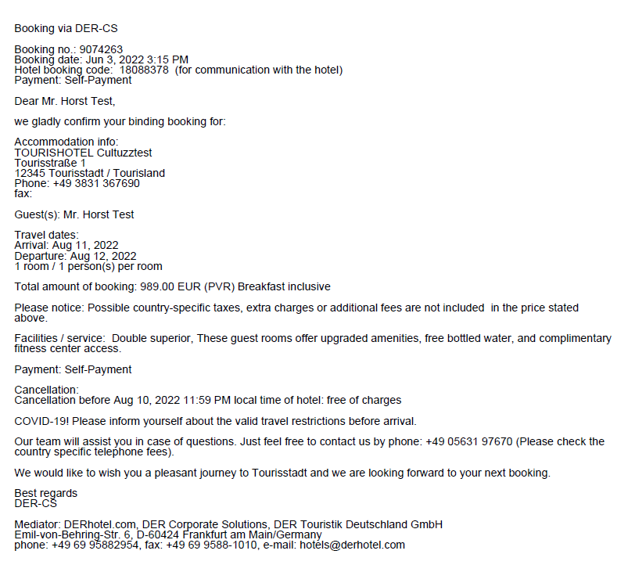

#### Configuration / Feature Activation

The configuration steps are:

* Part 1: Professional and Standard Editions – Establish a relationship with DERHOTEL.
* Part 2: Professional and Standard Editions – Enable the DERHOTEL enterprise app in the Concur App Center.

##### Part 1: Professional and Standard Editions – Establish a Relationship With DERHotel

The company establishes a relationship with DERHOTEL, indicating that they are interested in their employees booking through DERHOTEL.

##### Part 2: Professional and Standard Editions – Enable in the App Center

###### Permissions

For this task, the user must have the Web Services Administrator role.

###### Enable the Enterprise Application

1. To enable the app for your company:
2. On the **DERHOTEL** page, click **Connect**.
3. If the **Connect** button is unavailable, then you do not have the Web Services Administrator role required to enable the app.

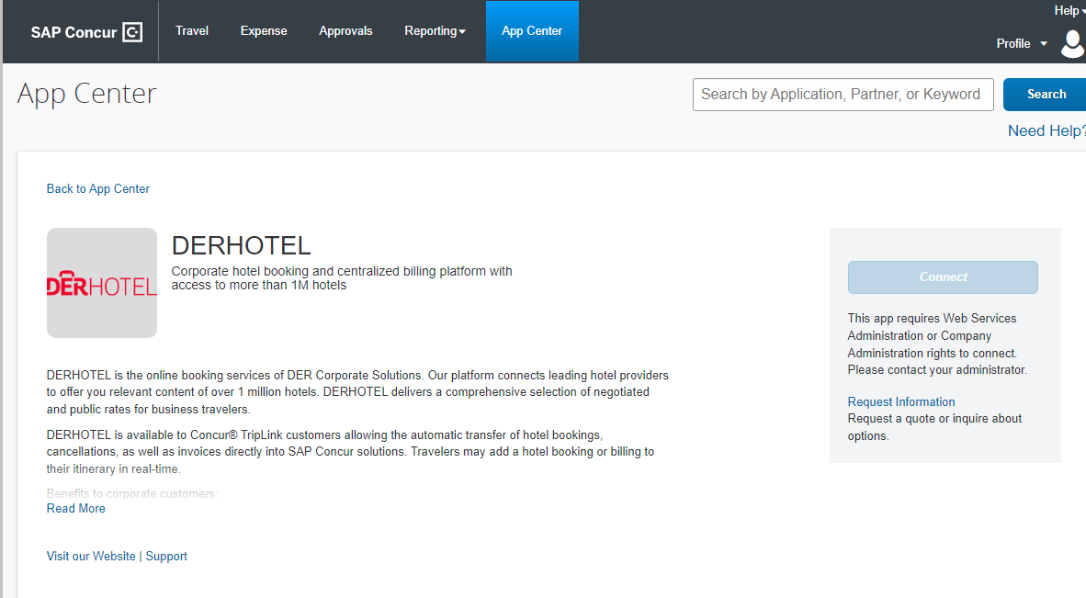

The **Terms & Conditions** page appears.



1. Click **Shared Information** and **I Agree**.
2. On the DERHOTEL page, you will be prompted to enter a verification code.
3. On the **Allow SAP Concur Connection** page, do the following:

* Enter the token/validation code in the **Verification code** field.
* Read and then select the **I have read the Terms & Conditions** checkbox.
* Read and then select the **I have read the Privacy Statement and consent to this agreement** checkbox.
* Click **Submit**.

If the connection is successful, the following page appears and the **Connect** button label changes to **Connected**.

### BlueSky by TravelSky

TravelSky is an online booking tool through which domestic airline bookings in China can be made. BlueSky is a Concur TripLink solution, powered by TravelSky, that once integrated allows for the online booking of flights and hotels in China.

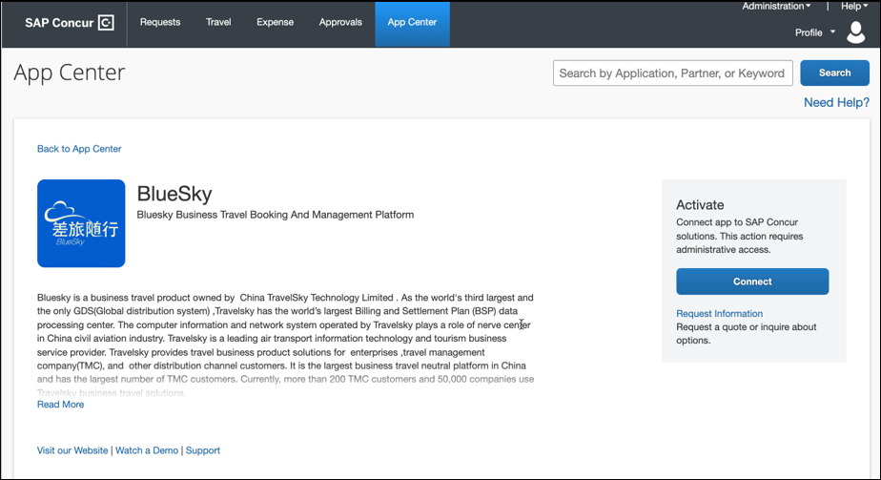

#### End User Experience

Once an organization establishes an integration with TravelSky, travelers can search BlueSky online booking tool for flights and hotels based on the approved booking criteria.

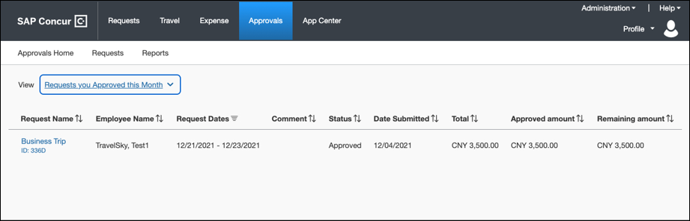

They can submit a booking request, and the approved travel request can be viewed in SAP Concur. Upon confirmation of their booking, customers can view trip itineraries in the Concur TripLink library.

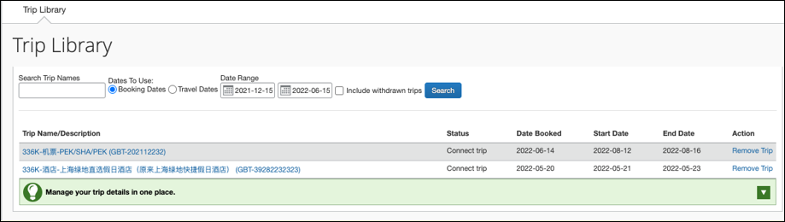

Flight ticket eReceipts and hotel eReceipts will be posted to the customer’s **Available Expenses** list.

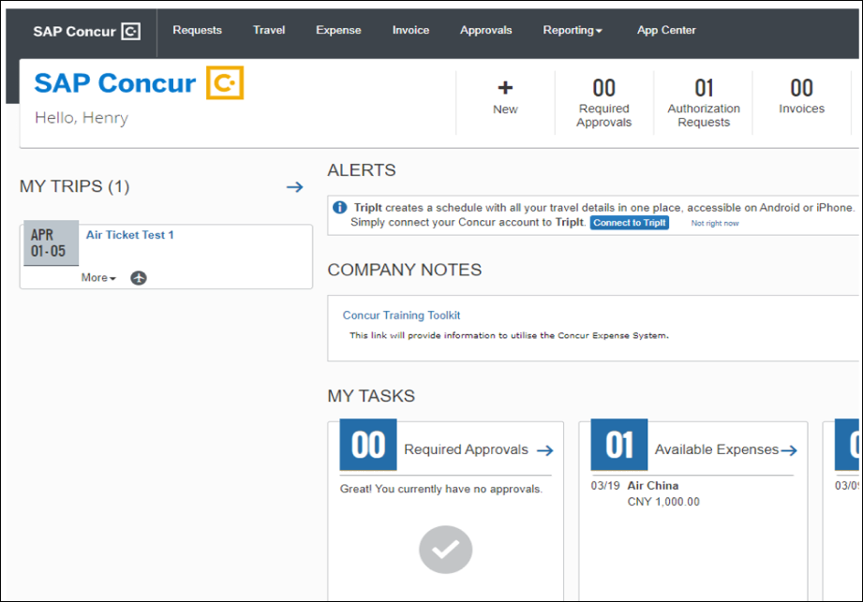

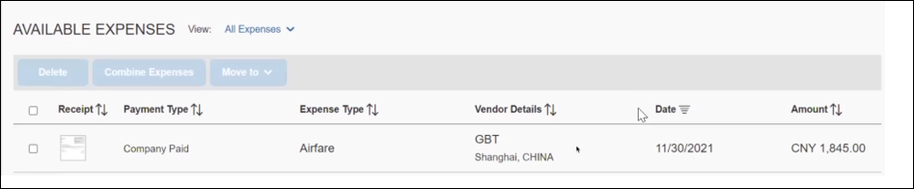

#### Configuration / Feature Activation

##### Part 1: Requirements for BlueSky

To be eligible for a BlueSky integration, the following solutions need to be purchased and implemented:

* Concur Expense (Professional Edition)
* Concur TripLink
* Concur Request
* Concur Implementation SKU: Implementation Service for Concur TripLink - Edition for TravelSky
* A TMC contract in China with a Concur/TravelSky certified TMC*: currently this includes FCM Travel and Amex GBT
* Please note TMCs may charge an additional set-up fee for the integration.
* An additional data sharing agreement completed with TravelSky

##### Part 2: Setup Steps

1. To begin, an inquiry form must first be completed. The form is available by visiting the BlueSky listing on the SAP Concur App Center and by clicking **Request information**. The TravelSky business development team will contact the person who submitted the inquiry form.
2. Once the above requirements are met, SAP Concur will configure the customer’s SAP Concur entity and test the integration together with the customer.
3. Once a BlueSky integration is established, the customer’s travelers can book their trips through their TMC’s platform technology, provided by BlueSky. Their trip data will populate within SAP Concur without any additional user setup.

**☼**