SAP Concur Release Notes
Concur TripLink and TripIt
Month | Audience
Release Date: January 22, 2022  Initial Post: Friday, January 21 | SAP Concur Client – FINAL

Contents
Release Notes 1
Concur TripLink 1
New Supplier: Corporate Rates Club (CRC) 1
TripIt 4
No Release Notes This Month 4
Planned Changes 5
Concur TripLink 5
No Planned Changes This Month 5
TripIt 5
CLQ 89393: ***Planned Changes***Decommissioning of TripIt for Teams (Jan 31) 5
Client Notifications 8
Accessibility 8
Accessibility Enhancements 8
Subprocessors 8
SAP Concur Non-Affiliated Subprocessors 8
Supported Browsers 8
Supported Browsers and Changes to Support 8
Additional Release Notes and Technical Documentation 9
Online Help 9
SAP Concur Support Portal – Selected Users 9
Cases 10
Steps for Getting a Status 10

Legal Disclaimer
The information in this presentation is confidential and proprietary to SAP SE or an SAP affiliate company and may not be disclosed without the permission of SAP SE or the respective SAP affiliate company. This presentation is not subject to your license agreement or any other service or subscription agreement with SAP SE or its affiliated companies. SAP SE and its affiliated companies have no obligation to pursue any course of business outlined in this document or any related presentation, or to develop or release any functionality mentioned therein. This document, or any related presentation and SAP SE or an SAP affiliate company’s strategy and possible future developments, products and or platforms directions and functionality are all subject to change and may be changed by SAP SE and its affiliated companies at any time for any reason without notice. The information in this document is not a commitment, promise or legal obligation to deliver any material, code or functionality. This document is provided without a warranty of any kind, either express or implied, including but not limited to, the implied warranties of merchantability, fitness for a particular purpose, or non-infringement. This document is for informational purposes and may not be incorporated into a contract. SAP SE and its affiliated companies assume no responsibility for errors or omissions in this document, except if such damages were caused by SAP SE or an SAP affiliate company’s willful misconduct or gross negligence.
All forward-looking statements are subject to various risks and uncertainties that could cause actual results to differ materially from expectations. Readers are cautioned not to place undue reliance on these forward-looking statements, which speak only as of their dates, and they should not be relied upon in making purchasing decisions.

Release Notes
Concur TripLink provides solutions to bring travel bookings from outside Concur Travel into SAP Concur solutions, and can be paired with Concur Expense, Travel, or both products. Its main features include the ability to capture itineraries through direct booking partners, capture of data from business reservations sent to TripIt, and the TripIt Pro features that are available to all travelers.

Concur TripLink

New Supplier: Corporate Rates Club (CRC)

Overview
As of January 4, 2022, Concur TripLink customers can see a new app in the App Center for CRC. CRC is a new Concur TripLink supplier which provides a connected hotel booking portal experience sending trip itineraries and eReceipts to SAP Concur solutions. When a company enables CRC, they can search, book, or cancel hotel bookings in the CRC corporate portal.

Business Purpose / Client Benefit
In extending Concur TripLink’s value of capturing outside spend, customers can have more visibility into travel bookings provided by regional travel supplier portals to facilitate traveler benefits of integrated SAP Concur Travel and Expense. Customers can have a broader range to book travel and receive itineraries.

What the User Sees
Once logged in via CRC, the user can search for corporate rates to book their hotel stays. They can also review or cancel a previous booking.

Configuration / Feature Activation
The configuration steps are:
- Part 1: Professional and Standard Editions – Establish a relationship with CRC.
- Part 2: Professional and Standard Editions – Enable the CRC enterprise app in the SAP Concur App Center.

PART 1: PROFESSIONAL AND STANDARD EDITIONS – ESTABLISH A RELATIONSHIP WITH CRC
The company establishes a relationship with CRC, indicating that they are interested in their employees booking through CRC.

PART 2: PROFESSIONAL AND STANDARD EDITIONS – ENABLE IN THE SAP CONCUR APP CENTER

Permissions
For this task, the user must have the Web Services Administrator role.

Enable the Enterprise Application
To enable the app for your company:
- On the CRC page, click Connect.
If the Connect button is unavailable, then you do not have the Web Services Administrator role required to enable the app.
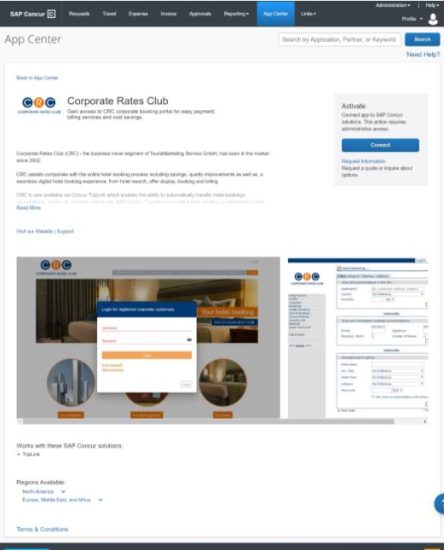
The Terms & Conditions page appears.
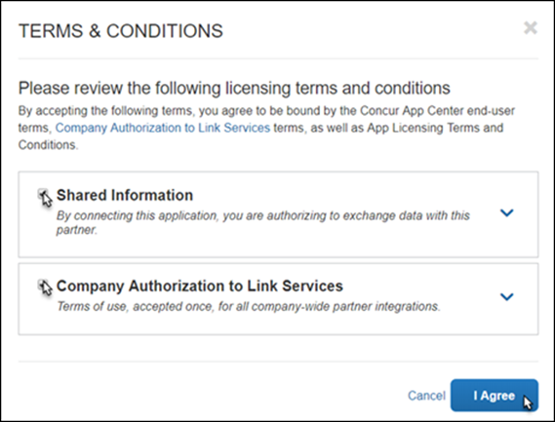
- Click Shared Information and then click I Agree.
- On the CRC page, you will be prompted to enter a verification code.
- On the Allow SAP Concur Connection page, do the following:
- Enter the token/validation code in the Verification code field.
- Read and then select the I have read the Terms & Conditions checkbox.
- Read and then select the I have read the Privacy Statement and consent to this agreement checkbox.
- Click Submit.
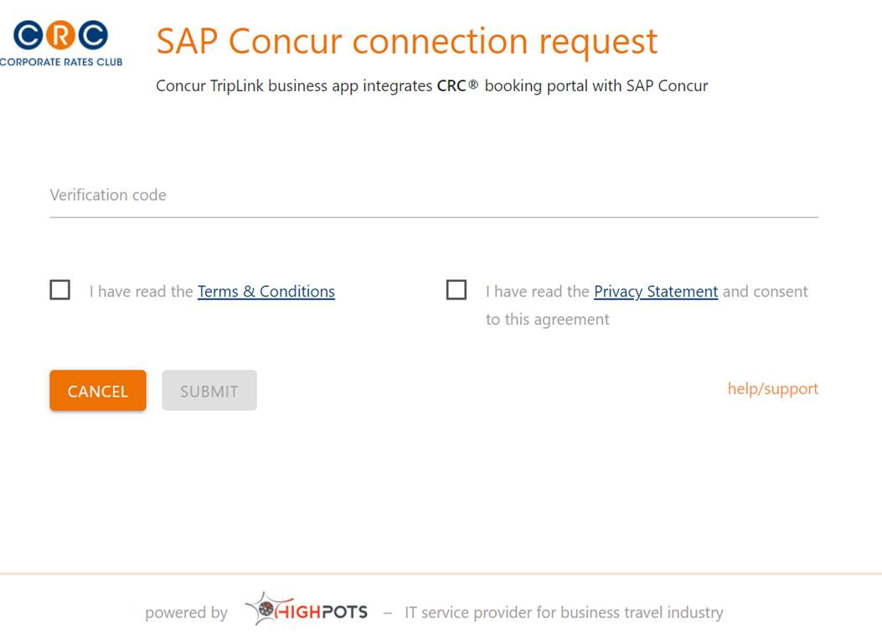
When the connection is successful, the confirmation page appears and the Connect button label changes to Connected.

TripIt

No Release Notes This Month

Planned Changes
The items in this section are targeted for future releases. SAP Concur reserves the right to postpone implementation of – or completely remove – any enhancement/change mentioned here.
IMPORTANT: These Planned Changes may not be all of the upcoming enhancements and modifications that affect this SAP Concur product or service. The Planned Changes that apply to multiple SAP Concur products and/or services are in a consolidated document. Please review the additional Planned Changes available in the Shared Planned Changes Release Notes.

Concur TripLink

No Planned Changes This Month

TripIt

CLQ 89393: ***Planned Changes***Decommissioning of TripIt for Teams (Jan 31)

Information First Published | Information Last Modified | Feature Target Release Date
November 5, 2021 | November 5, 2021 | January 31, 2022
Any changes since the previous monthly release are highlighted in yellow in this release note.

Overview
Targeted for January 31, 2022, TripIt will decommission TripIt for Teams for the mobile app and website. Users will no longer have access to the feature or be able to create Team trips. SAP Concur users who are part of a TripIt for Teams team can use it up until January 31, 2022. After January 31, 2022, users will not have access to TripIt for Teams. Users will have view and edit access for existing upcoming and past Team trips until July 1, 2022. After July 1, 2022, users will not have access to upcoming and past Team trips that they did not originally create. To retain plans shared via TripIt for Teams, users should contact the trip owner to invite them to the trip with the TripIt share function.

What the User Sees

Mobile App
In the TripIt mobile app, the TripIt for Teams section on the More tab will no longer appear. On the Trips tab, users can view and edit existing or upcoming Team trips or view past Team trips until July 1, 2022. After July 1, 2022, users will not have access to upcoming or past Team trips that they did not originally create. In order to retain plans shared via TripIt for Teams, users should contact the trip owner to invite them to the trip with TripIt’s share function.

Web
On the TripIt website, the TripIt for Teams tab will be removed. On the Trips tab, users will have view and edit access for existing upcoming and past Team trips until July 1, 2022. After July 1, 2022, users will not have access to upcoming and past Team trips that they did not originally create.

Configuration for Professional and Standard Travel
An assistant/travel arranger can still set up trips in TripIt for a user by linking to the Concur Travel arranger feature. After the accounts are linked, arrangers will have visibility into their travelers’ trips through a Concur Travel dashboard.
To link a user account to an assistant/travel arranger:
- Log in to Concur Travel and Expense.
- Click the Profile icon at the top right corner of the page.
- Click Profile Settings from the dropdown menu.
- In the left panel, click Assistants/Arrangers in the Travel Settings.
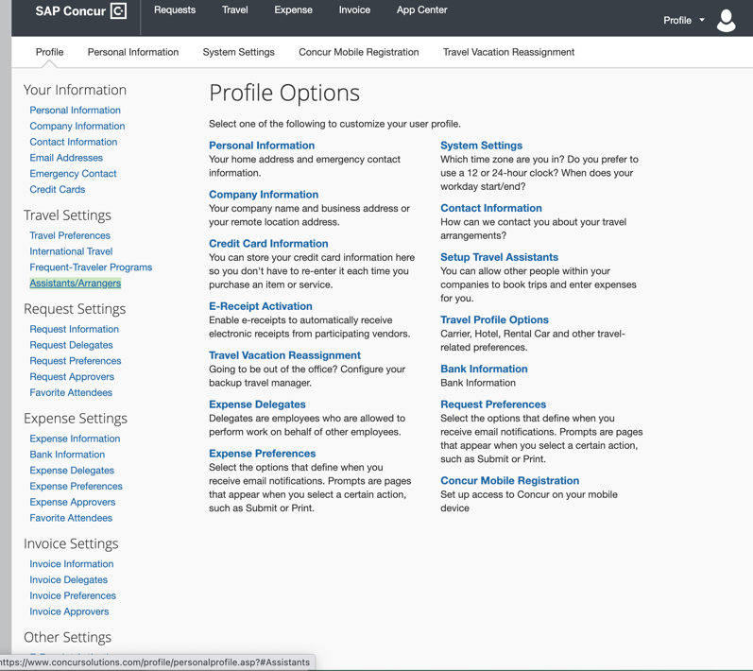
- In the Assistants and Travel Arrangers section of the page, click Add an Assistant.
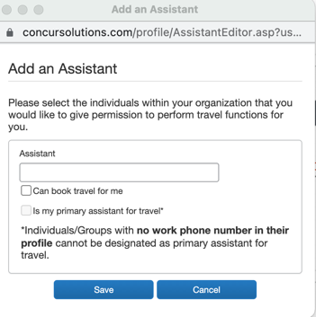
- Enter the name of the name of the Arranger/Assistant and select the Can book travel for me option.
- Click Save. The assistant/travel arranger is now linked to the user’s account and can help arrange travel.
- In order to arrange trips for users, the arranger can share a plan to plans@tripit.com and enter the user’s email address in the subject line. This creates a shared trip within TripIt for both arranger and the traveler. Also, arrangers can share plans or trips by directly inviting users to the trip with TripIt’s share function or via TripIt’s Inner Circle sharing feature.


Client Notifications

Accessibility

Accessibility Enhancements
SAP implements changes to better meet current Web Content Accessibility Guidelines (WCAG). Information about accessibility-related changes made to SAP Concur solutions is published on a quarterly basis. You can review the quarterly updates on the Accessibility Updates (English Only) page.

Subprocessors

SAP Concur Non-Affiliated Subprocessors
The list of non-affiliated subprocessors is available here: SAP Concur list of Subprocessors
If you have questions or comments, please reach out to: Privacy-Request@Concur.com

Supported Browsers

Supported Browsers and Changes to Support
For information about supported browsers and planned changes to supported browsers, refer to the Concur Travel & Expense Supported Configurations guide.
When changes to browser support are planned, information about those changes will also appear in the Shared Changes Release Notes.

Additional Release Notes and Technical Documentation

Online Help
Any user can access release notes, setup guides, user guides, admin summaries, monthly browser certifications, supported configurations, and other resources via online Help or directly on the SAP Help Portal.
Use the links in the Help menu in the app, or search for your SAP Concur product (Concur Expense, Concur Invoice, Concur Request, or Concur Travel) on the SAP Help Portal (https://help.sap.com) to view the full set of documentation for your product.

SAP Concur Support Portal – Selected Users
Access release notes, webinars, and other technical documentation on the SAP Concur support portal.
If you have the proper permissions, Contact Support appears on the Help menu. Click to access the SAP Concur support portal, then click Resources.
- Click Release/Tech Info for release notes, technical documents, etc.
- Click Webinars for recorded and live webinars.
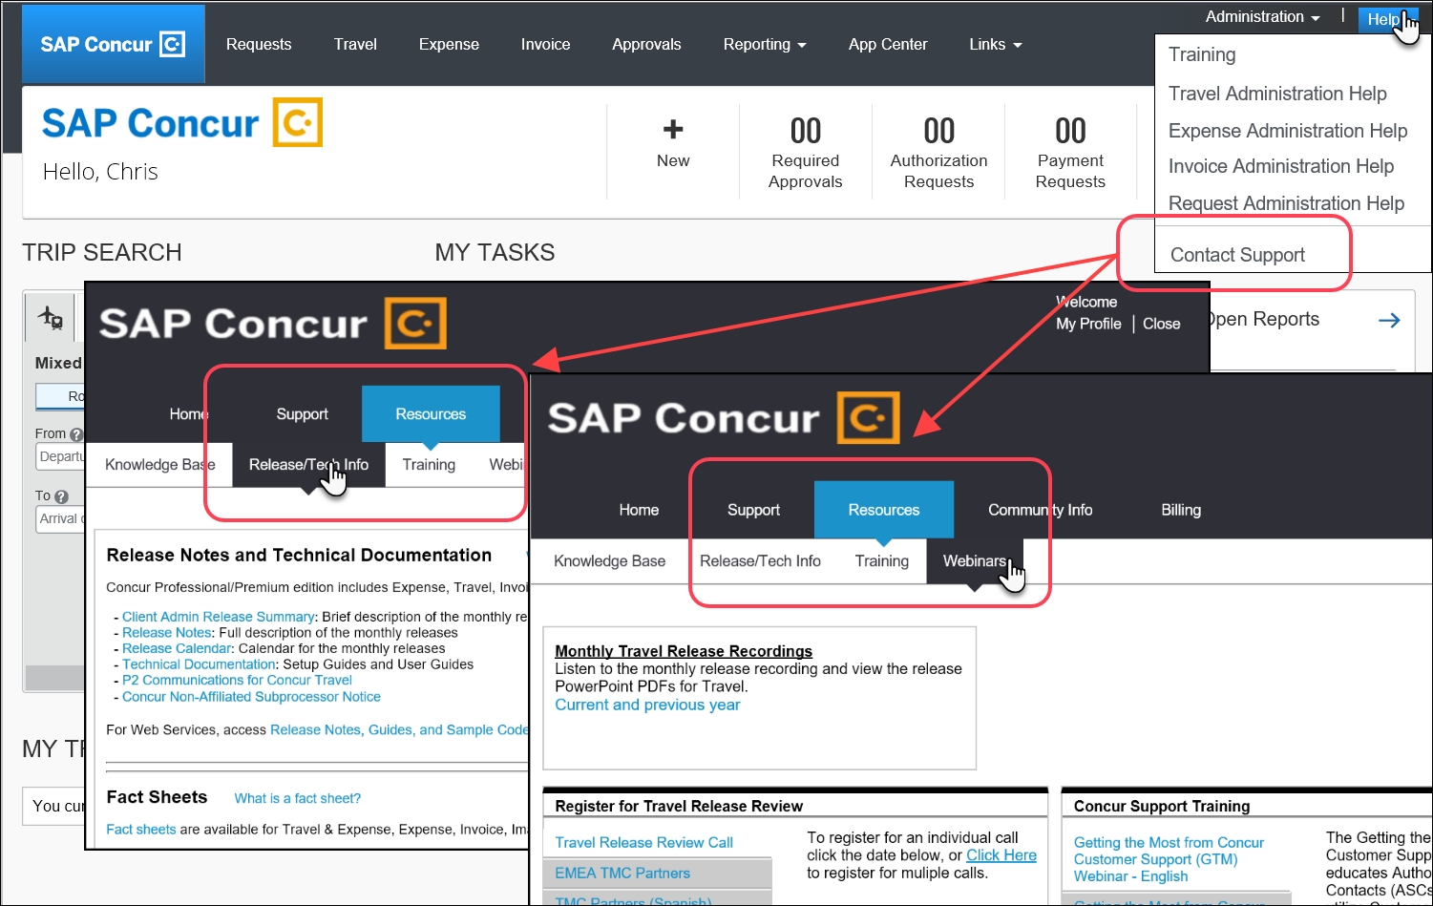

Cases

Steps for Getting a Status
Each service release contains case resolutions.
How to check the status of a submitted case
- Log on to https://concursolutions.com/portal.asp.
- Click Help > Contact Support.

If you do not have the option to contact SAP Concur support under the Help menu, then your company has chosen to support the SAP Concur service internally. Please contact your internal support desk for assistance.
- Click Support > View Cases.

- In the table, view the desired type of cases based on the View list selection. Search results are limited to each company's own cases.

© 2021 SAP SE or an SAP affiliate company. All rights reserved.
No part of this publication may be reproduced or transmitted in any form or for any purpose without the express permission of SAP SE or an SAP affiliate company.
SAP and other SAP products and services mentioned herein as well as their respective logos are trademarks or registered trademarks of SAP SE (or an SAP affiliate company) in Germany and other countries. Please see http://global12.sap.com/corporate-en/legal/copyright/index.epx for additional trademark information and notices.
Some software products marketed by SAP SE and its distributors contain proprietary software components of other software vendors.
National product specifications may vary.
These materials are provided by SAP SE or an SAP affiliate company for informational purposes only, without representation or warranty of any kind, and SAP SE or its affiliated companies shall not be liable for errors or omissions with respect to the materials. The only warranties for SAP SE or SAP affiliate company products and services are those that are set forth in the express warranty statements accompanying such products and services, if any. Nothing herein should be construed as constituting an additional warranty.
In particular, SAP SE or its affiliated companies have no obligation to pursue any course of business outlined in this document or any related presentation, or to develop or release any functionality mentioned therein. This document, or any related presentation, and SAP SE’s or its affiliated companies’ strategy and possible future developments, products, and/or platform directions and functionality are all subject to change and may be changed by SAP SE or its affiliated companies at any time for any reason without notice. The information in this document is not a commitment, promise, or legal obligation to deliver any material, code, or functionality. All forward-looking statements are subject to various risks and uncertainties that could cause actual results to differ materially from expectations. Readers are cautioned not to place undue reliance on these forward-looking statements, which speak only as of their dates, and they should not be relied upon in making purchasing decisions.

