AP Concur Release Notes
Concur Invoice Professional/Premium
Includes: Concur Invoice, Capture Processing, Invoice Pay, Purchase Requests and Purchase Orders
Month | Audience
Release: April 2024  Initial Post: April 19, 2024 | Client FINAL

Contents
Release Notes 1
Concur Invoice UX Evolution 1
**Ongoing** Updated User Interface (UI) for Concur Invoice End Users 1
Invoice Pay 6
New Currencies for ACH/EFT Payments 6
Vendor Management 8
SAP Business Partner Screening Solution Now Performs Automatic Online Screening 8
Planned Changes 14
Digital Invoices 14
**Planned Changes** New PDF Generation for Peppol E-Invoices (Japan) 14
Client Notifications 16
Accessibility 16
Accessibility Updates 16
Gender Diversity 16
Gender Diversity Planned Features and Changes 16
In-Product User Assistance 16
Client Customized Content 16
Subprocessors 17
SAP Concur Non-Affiliated Subprocessors 17
Supported Configurations 17
Supported Browsers and Changes to Support 17

SAP Concur Support Case Status 18
Check Support Case Status 18
Additional Release Notes and Other Technical Documentation 20
Online Help 20
SAP Concur Support Portal – Selected Users 20

Legal Disclaimer
The information in this presentation is confidential and proprietary to SAP SE or an SAP affiliate company and may not be disclosed without the permission of SAP SE or the respective SAP affiliate company. This presentation is not subject to your license agreement or any other service or subscription agreement with SAP SE or its affiliated companies. SAP SE and its affiliated companies have no obligation to pursue any course of business outlined in this document or any related presentation, or to develop or release any functionality mentioned therein. This document, or any related presentation and SAP SE or an SAP affiliate company’s strategy and possible future developments, products and or platforms directions and functionality are all subject to change and may be changed by SAP SE and its affiliated companies at any time for any reason without notice. The information in this document is not a commitment, promise or legal obligation to deliver any material, code or functionality. This document is provided without a warranty of any kind, either express or implied, including but not limited to, the implied warranties of merchantability, fitness for a particular purpose, or non-infringement. This document is for informational purposes and may not be incorporated into a contract. SAP SE and its affiliated companies assume no responsibility for errors or omissions in this document, except if such damages were caused by SAP SE or an SAP affiliate company’s willful misconduct or gross negligence.
All forward-looking statements are subject to various risks and uncertainties that could cause actual results to differ materially from expectations. Readers are cautioned not to place undue reliance on these forward-looking statements, which speak only as of their dates, and they should not be relied upon in making purchasing decisions.

Release Notes
This document contains the release notes for Concur Invoice for professional edition.
Features and changes that apply to SAP Concur site-wide or to multiple products/services are documented in the Shared Changes Release Notes. For information about site-wide or shared changes in this release that might impact your SAP Concur solutions, refer to the Shared Changes Release Notes.

Concur Invoice UX Evolution

**Ongoing** Updated User Interface (UI) for Concur Invoice End Users

Information First Published | Information Last Modified | Automatic Transition Date
July 14, 2023 | April 12, 2024 | To Be Determined
Any changes since the previous monthly release are highlighted in yellow in this release note.
This change is part of the Concur Invoice UX Evolution experience.

Overview
The continued evolution of the Concur Invoice solution user interface (UI) experience is the result of thoughtful design and research that provides a modern, intuitive, and streamlined experience for the invoice process.
Customers will have the ability to preview and then opt in to the new UI for Concur Invoice before the automatic transition date.

Business Purpose / Client Benefit
The result is the evolution of the Concur Invoice user interface designed to provide a modern, consistent, and streamlined user experience. The new UI focuses on consistency across SAP Concur Spend offerings, and includes several significant enhancements requested by clients. Focus areas include end-user efficiency when interacting with invoices, performance and stability, as well as accessibility compliance.

Products and Users Affected
To take advantage of these improvements, Concur Invoice customers will be required to transition to the new UI at a future date to be determined. The following sections provide information about the timeline and resources available to ensure this process is smooth and efficient for all users.
The new UI changes apply to:
- Concur Invoice (Professional/Premium and Standard) end users only

IMPORTANT: Timeline and Milestones
There are four important milestones for Concur Invoice customers as they transition from the current UI to the new UI.
- Early Adopter Care (EAC) Period: August 2023 – Ongoing in 2024
We are currently in the Early Adopter Care Period: During this time, the new UI is available to preview for customers participating in the Early Adopter Care Program. We encourage administrators and power users to use the Early Adopter Care Period to preview the refreshed interface, update internal training materials, and prepare the organization for the transition.
During the Early Adopter Care Period, not all planned features from the current UI will be available in new UI for Concur Invoice. New features and enhancements continue to be planned for future releases. The Early Adopter Care Period is intended to let customers get a head start on learning about the new UI and preparing for the transition.
If your organization is interesting in participating in the Early Adopter Care Program, please refer to the SAP Early Adopter Care page for more information.
- Opt-In Period: Targeted for Q2 2024
Following the Early Adopter Care Period there will be an open Opt-In Period. This milestone will be marked by the delivery of most planned features as well as further overall product quality and stability. The Opt-In Period will be available to all Concur Invoice customers.
Customers should use this period to plan their transition and move to the new UI for Concur Invoice when it is right for your business priorities. Some remaining features will become available throughout this period, so customers should plan their roll out accordingly.
- Active Move Period: To be determined
All customers will be required to move to the new UI. The first day of the Active Move Period is the first day of the 12-month notice period we committed to for customers to complete the transition at their own pace before the automatic transition date.
Customers are strongly encouraged to complete the tasks necessary to ensure a smooth transition for their organization and then transition during the Active Move Period.
- Automatic Transition Date: To be determined
All customers will be automatically transitioned to the new UI. This ensures that we continue to offer a consistent user experience for all customers and allows for superior product innovation and support.

Transition Information – Guides and Other Resources
We will provide guide updates, online help updates, release notes, and other resources to help in the transition.
Examples of where to find information about the new UI:
- Setup and user guides, FAQs, transition resources: During the transition from the current UI to the new UI, the Concur Invoice setup and user guides will be updated to include information about the new UI in addition to the current UI.
Along with the guide updates, there are other resources (such as an FAQ), and a list of features that are not yet available in the new UI. All these materials can be used to help customers prepare their users.
- SAP Help Portal: Concur Invoice topics will also be updated for the new UI in the Concur Invoice | SAP Help Portal. During the transition from the current UI to the new UI, the topics will include information about the current UI and the new UI.
- Release information: Release notes for enhancements associated with the new UI will be provided in the monthly Concur Invoice release notes. Release notes for the new UI will be clearly marked in the monthly release notes.

Get Started
Customers are encouraged to use the transition information described above and develop a plan for the transition.

More Information
Additional information will be available in future release notes.

Feature Availability
The Invoice UX Evolution user interface will be applied to specific Concur Invoice features in a phased approach during the Early Adopter and Opt-In milestones. There are some Concur Invoice features that the Invoice UX Evolution user interface will not be applied to during the Early Adopter or Opt-In milestones.
Use the following table to view which Concur Invoice features are currently updated with the Invoice UX Evolution user interface. The table also indicates whether a feature is a major or minor feature and which features will not be updated with the new user interface.
Clients using the major features listed in the Major Features section of the table should not move to the Invoice UX Evolution UI until the major features they are using are available in the Invoice UX Evolution UI.

Feature Availability for Invoice UX Evolution
Feature Name | Available? | Notes
Major Features

Attendees | No | Parity  Professional Only
Auto-Save | Early Adopter Care (EAC) Period | New  Professional | Standard
CFDI (Comprobantes Fiscal Digital por Internet) (Mexico) | No | Parity  Professional | Standard
Create/Edit Invoice | EAC | Parity – with the new create and edit invoice workflow  Professional | Standard
E-Bunsho | No | Parity  Professional | Standard
Editing Allocations | EAC | Parity  Professional | Standard
Expense Type Connected List | No | Parity  Professional Only
Greater than 15 Line Items can be added in the Itemization section on the Create New Invoices page | No | New  Professional | Standard
Line-Item Entry in the Itemization section on the Create New Invoices page | EAC | New  Professional | Standard
Multiple VAT Field Support (Canada) | No | Parity  Professional | Standard
PO Matching | EAC | Parity  Professional | Standard
Recurring Invoices | EAC | Parity  Professional | Standard
Tax Authority & Tax Validation Service | No | Parity  Professional | Standard
Minor Features

Approver navigation to invoices in new UI | No | Parity – with new workflow  Professional | Standard
Auto Resize – View Port | EAC | New  Professional | Standard
Cost Object Approval Filtering | No | Parity  Professional | Standard
Default Image In Line | EAC | Parity  Professional | Standard
Drag and Drop Images | EAC | New  Professional | Standard
Enhanced Comments | EAC | Parity  Professional | Standard
Enhanced Bulk Update Tools | No | New - Some Parity  Professional | Standard
Invoice Owner Improvements | EAC | Parity – with new workflow  Professional | Standard
Line-Item Entry Improvements – Custom Fields | EAC | Parity – with new workflow  Professional | Standard
Processor navigation to invoices in new UI | EAC | Parity – with new workflow  Professional | Standard
Switch Tax Mode Improvements | EAC | Parity – with new workflow  Professional | Standard
Submit/Assign Button Improvements | EAC | Parity – with new workflow  Professional | Standard
Unassigned Invoices List screen – Record Locking | EAC | New  Professional | Standard
VAT Tax Mode | EAC | Parity – with new workflow  Professional | Standard
Other Minor Parity Features | No | Parity  Professional | Standard
Features that will not have the Invoice UX Evolution User Interface

Concur Invoice Administration | No
Approvals Invoice List | No
Capture Processing | No
Invoice Pay | No
Processor Invoice List | No

Invoice Pay

New Currencies for ACH/EFT Payments

Overview
Concur Invoice clients contracted for Invoice Payment Manager and who have a Canadian Dollar (CAD), Euro (EUR), and/or British Pound (GBP) bank account are now able to make low-cost Electronic Funds Transfer (ETF) payments to vendors using the ACH payment method type.
Clients can set up their company’s CAD, EUR, and/or GBP bank account in Concur Invoice Payment Manager by creating a funding account with SAP Concur’s third-party ACH/EFT payment provider (Worldline) to facilitate invoice payments to their vendors.
Invoice payments are batched in Invoice Payment Manager for clients to review and manage before being sent to the payment provider to be processed. Using the Invoice Payment Confirmation extract or a financial connector application integrated with it, clients can post invoice payments to the ERP/accounting system.

Business Purpose / Client Benefit
This update provides Concur Invoice clients, who work with vendors located in Canada, Eurozone countries, and the United Kingdom, the ability to process low-cost EFT invoice payments using Invoice Payment Manager.

Prerequisites
Clients must have Concur Invoice and Invoice Payment Manager on their contract.
Clients must have a bank account in the supported countries and currencies and be able to register it with Worldline.

Supported ACH/EFT Payments
Currency | Country/Region | Payment System | Payment Cycle
Canada Dollar (CAD) | Canada | ACSS | 3 Bank Days
Euro (EUR) | Eurozone Countries and territories | SEPA | 4 Bank Days
Pound Sterling (GBP) | United Kingdom | BACS | 4 Bank Days
*US Dollar (USD)  *Existing functionality | United States and territories | ACH | 5 Bank Days
Cross-border and foreign exchange payments are not supported.

Roles
Users must have the Invoice Payment Manager role to configure ACH/EFT funding accounts and view payment batches.

How it Works
Once the funding account has been reviewed and verified by the payment provider, it can be activated in Concur and invoice payments can begin being batched for processing from it.
Banking information for vendors with a CAD, EUR, or GBP bank account, who are to be paid by EFT, can be added to the client’s Concur vendor profile by API, import file, or manual entry. The Pay Method Type in the vendor profile should be set to ACH for new invoices to default to be paid by EFT. A remittance email with payment and invoice details can be sent to email addresses populated in the Contact Email Address field.
In Concur Invoice, clients create, approve, and post to their ERP/accounting system invoices with the ACH pay method type the same way as invoices with other payment methods. After completing the approval workflow, approved ACH invoices are batched to be paid by EFT from the funding account in Invoice Payment Manager. Based on the invoice payment due date and batch settings configured in the funding account, the system automatically assigns the invoice to a batch schedule to be processed so the EFT payment credits the vendor’s bank account on the payment due date.
Clients can view and manage payment batches on the Monitor Payments page in Invoice Payment Manager. After a batch closes, the payments are sent to the payment provider to be processed and the remittance email is sent to the vendor contact.
Invoices are updated to a Paid payment status on the funding date of the batch when monies for the total batch amount are debited from the client’s bank account with which the Concur funding account is associated. Clients can then extract the invoice payments from Concur to post to their ERP/accounting system with the Invoice Payment Confirmation API or extract file.
The invoice, the funding account the payment debited from, and the vendor bank account the payment is credited to, must all be the same currency for a payment to be processed.

Configuration / Feature Activation
SAP Concur staff must enable the Invoice Pay settings for clients for them to be able to create funding accounts.
For more information about creating funding accounts, refer to the Concur Invoice Pay Setup Guide, Concur Invoice Pay User Guide, Concur Invoice: Vendor Import V3 (Current) Specification, and Concur Invoice: Vendor Banking Import User Guide.

Vendor Management

SAP Business Partner Screening Solution Now Performs Automatic Online Screening

Overview
SAP Concur now performs automatic online screening of vendors (suppliers) within Concur Invoice Vendor Management using the SAP Business Partner Screening (BPS) solution. Previously, SAP Concur performed offline screening of vendors (suppliers) within Concur Invoice Vendor Management using the SAP Business Partner Screening (BPS) solution.
For more information, refer to the Vendor Management | SAP Business Partner Screening Solution (August 11) release note published in the Concur Invoice Release Notes for August 2023.
The BPS solution is used to prevent prohibited vendors in embargoed countries or regions, or in sanctioned entities listed by the various applicable government agencies, from performing business activities with SAP products.
SAP policy prohibits the use of all SAP products and services in, from, or in support of, any business activities in locations where SAP products and services are not available. This list includes Cuba (CU), Iran (IR), North Korea (KP), Syria (SY), and regions of the Ukraine (Donestsk, Luhansk, and Crimea). This change also impacts the following currencies Cuba, Peso (CUC and CUP); North Korean Won (KPW); Syria, Pound (SYP); Iran, Rial (IRR).
When users try to submit an invoice for vendors that are identified as having a Sanctioned, Pending Review, or Invalid status during BPS screening, invoice submission will be blocked. Only invoices for vendors that passed BPS screening will be extracted to the financial system for payment.
With the release of the new automatic online screening update, this feature release also includes:
- Four new screening statuses in the Screening Status column on the Vendor Managers page
- A new Screening Status option in the Search list on the Manage Vendors page
- The ability to recall invoices for re-screening
- New alert messages for vendor invoice status during BPS screening
- Audit trail tracking of Export Trade Sanctions (ETS) categories, status codes, and screening statuses
- The ability to block submission of purchase requests (PR) and purchase orders (PO) for vendors with a Sanctioned or Invalid status during BPS Screening.

Business Purpose / Client Benefit
This change ensures clients follow local, national, and international laws governing embargoed countries and sanctioned individuals/entities and are systematically protected to the best ability from malicious actors and actions when working with SAP Concur products.

End User Experience

View Alert Messages
After invoice submission, users now see additional alerts displayed on the My Invoices page in Invoice Manager to track vendor invoices during BPS screening status.
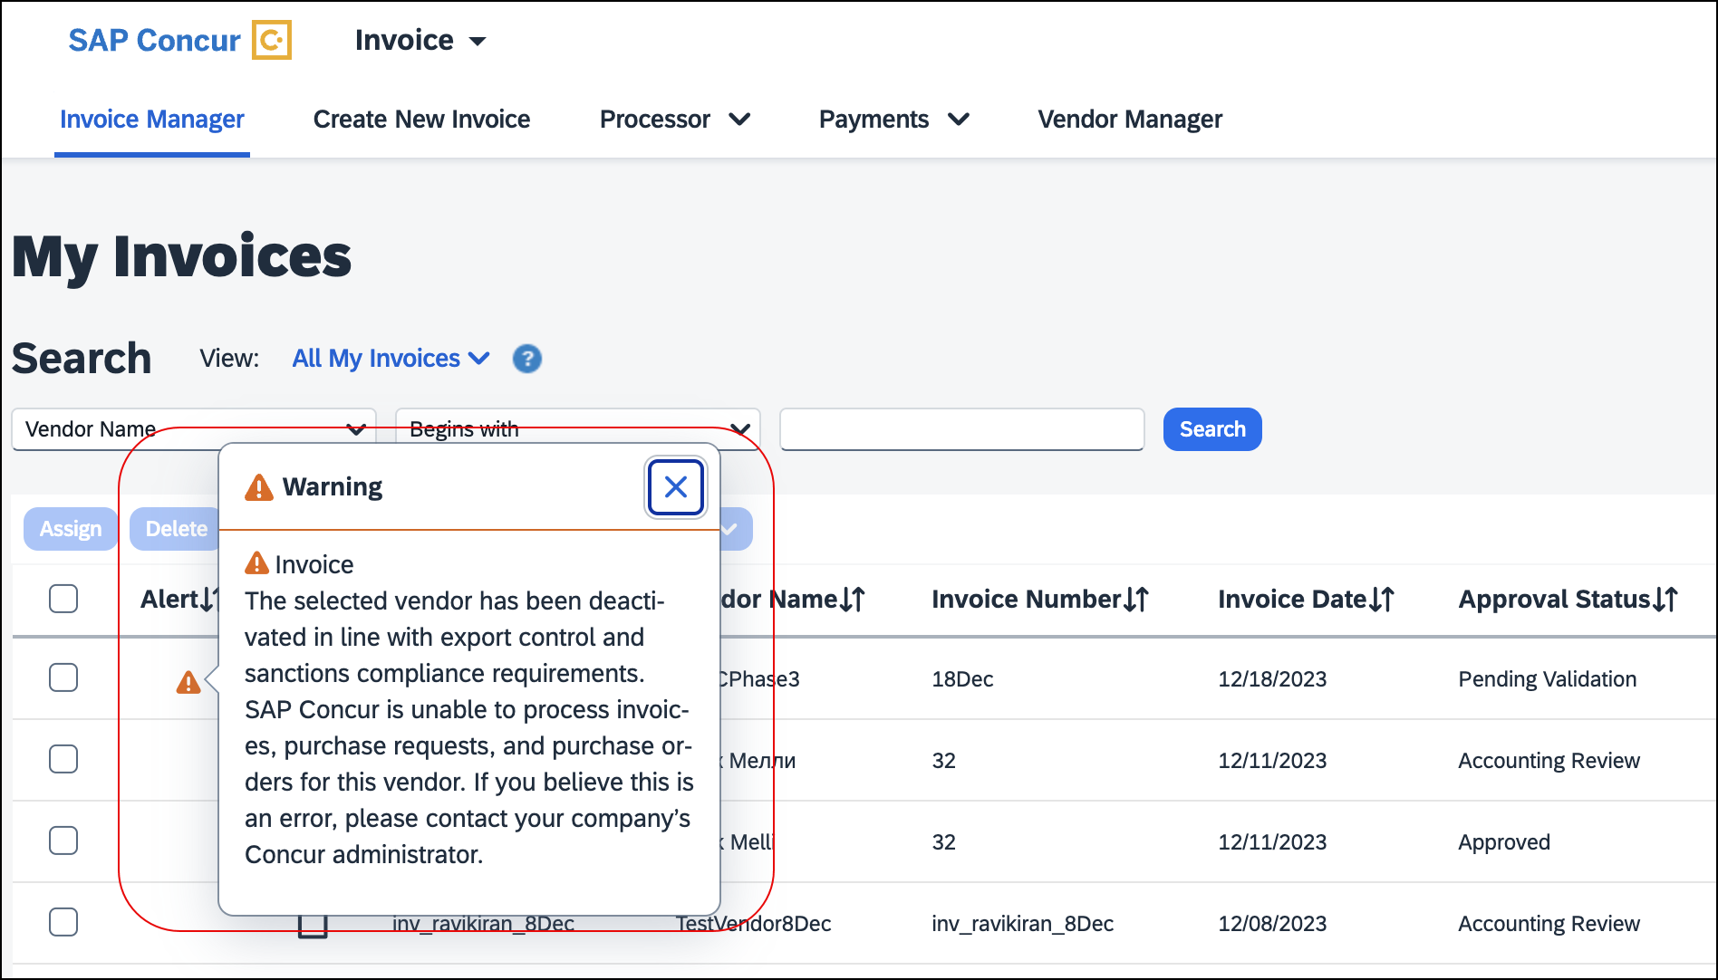
Alerts that may display include:
- Sanctioned: The selected vendor has been deactivated in line with SAP Export Control and Sanctions Compliance requirements. SAP Concur is unable to process invoices, purchase requests, and purchase orders for this vendor. If you believe this is an error, please contact your company’s Concur administrator.
- Pending Review: The selected vendor in this invoice is currently under review as part of SAP's Export Control and Sanctions Compliance policy. We appreciate your patience as we are processing your request as quickly as possible.
- System Pending: The selected vendor in this invoice is currently under review as part of SAP's Export Control and Sanctions Compliance policy. We appreciate your patience as we are processing your request as quickly as possible.
- Invalid: At this time, SAP Concur is unable to support the selected vendor as the information appears incomplete or inaccurate. Please ensure the full legal name of the company or individual and their full address (street, city, state (if applicable), and country/region) are complete and accurate in the vendor record.

Recall Invoices for Re-screening
In the unlikely event of a vendor not passing the BPS screening at the Prepayment Validation state, invoices with the vendor are placed on hold and an alert message displays for the invoice. Users can recall the invoice to the processor and approve it to initiate re-screening. If the vendor passes re-screening, invoices with the vendor will be extracted for payment. Otherwise, the invoices will continue to be placed in a hold status.
On the invoice record, users can click the Recall Invoice to Processor button to recall the invoice.
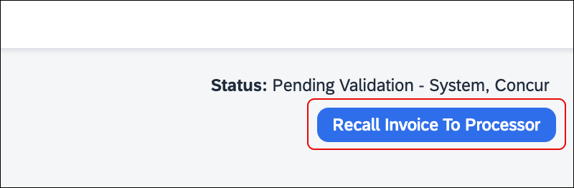
Users can then click the Approve button to re-submit the invoice for re-screening.
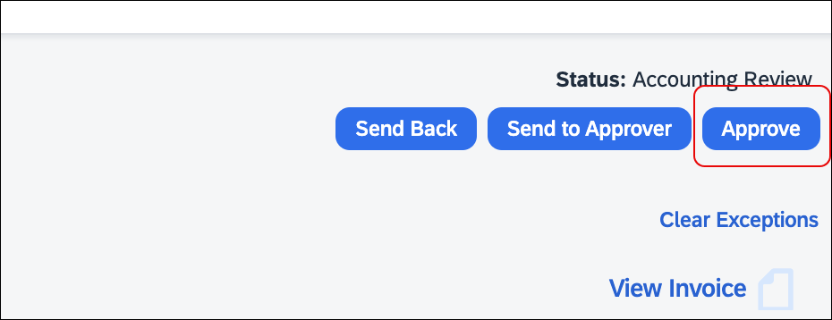

View the Audit Trail
When a vendor’s screening status is changed, this change is logged and documented in the audit trail with the Export Trade Sanctions (ETS) Category, status code, and the screening status. Users can reference the following table to understand the categories and codes documented in the audit trail.
ETS Category  (Available in Audit Trail) | Status Code  (Available in Audit Trail) | Screening Status  (Available statuses in the Screening Status column on the Manage Vendors Page)
ETS1 | 01 | Sanctioned
ETS3 | 01 | Sanctioned
ETS4 | 01 | Sanctioned
ETOK | 02 | Passed
ETS2 | 04 | Pending Review
EX30 | 30 | System Pending
EX31 | 31 | Invalid
EX32 | 32 | Translation in progress

Search for Vendors by Screening Status
Users can search for vendors by selecting Screening Status in the Search list on the Manage Vendors page.
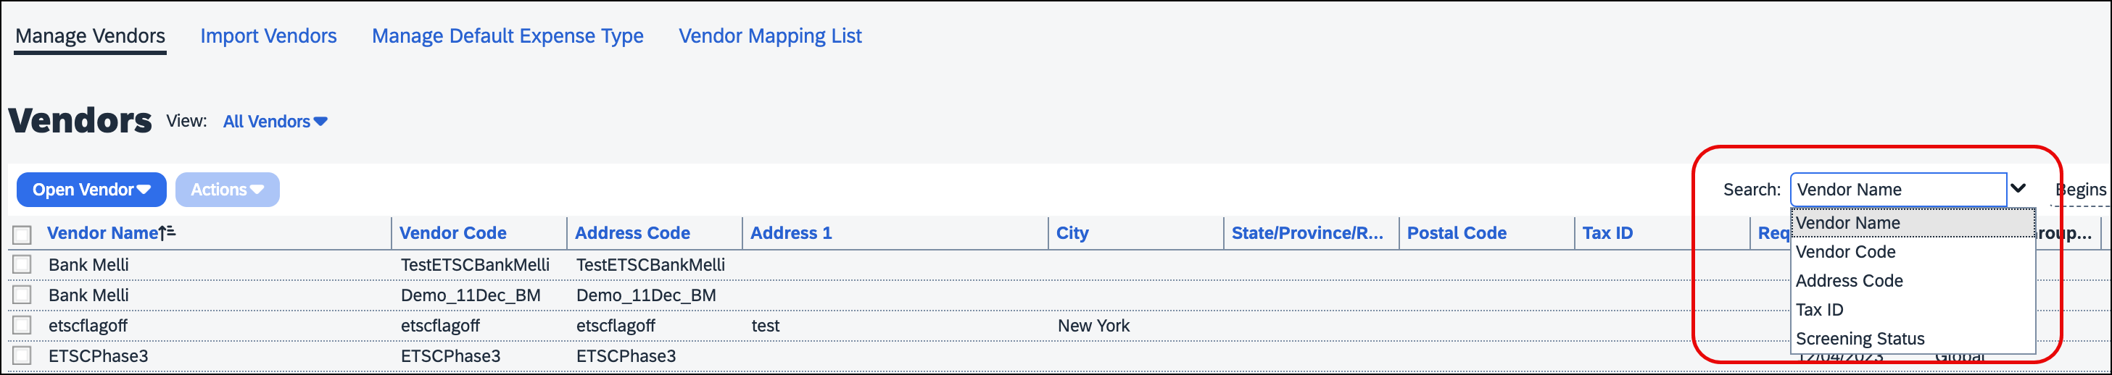

Submit Purchase Requests and Purchase Orders
When users submit a purchase request for vendors that are identified as having a Sanctioned, Pending Review, or Invalid status during BPS screening, purchase request submission is blocked.
When a user submits a purchase order created from a purchase request, and the purchase order for the vendor is identified as having a Sanctioned, Pending Review, or Invalid status during BPS screening, PO transmission is blocked.

APIs and Imports for PR/PO
When users create a purchase request using Purchase Request v4 API, and the purchase request is created for vendors that are identified as having a Sanctioned, Pending Review, or Invalid status during BPS screening, purchase request auto submission is blocked.
When users create a purchase order using Purchase Order v3 API or from the PO Import file for vendors that are identified as having a Sanctioned, Pending Review, or Invalid status during BPS screening, purchase order creation or import is blocked.
When user updates a purchase order using Purchase Order v3 API or the PO Import file for vendors that are identified as having a Sanctioned, Pending Review, or Invalid status during BPS screening, purchase order update is blocked.
The following image is an example of messages that display in the Import Run Details For: Purchase Order Import Run window when invoices are imported successfully, fail, or have errors.
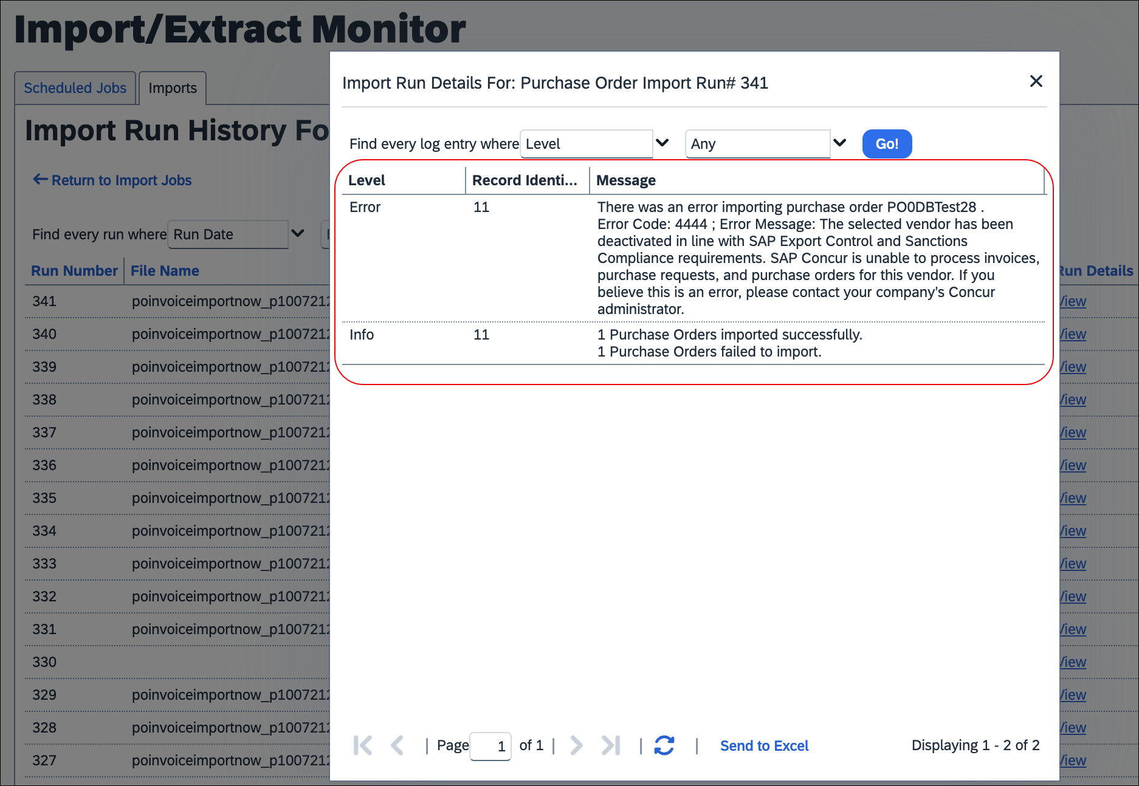

Vendor Manager Experience
Vendor Managers now see four new screening statuses display in the Screening Status column on the Manage Vendors page.
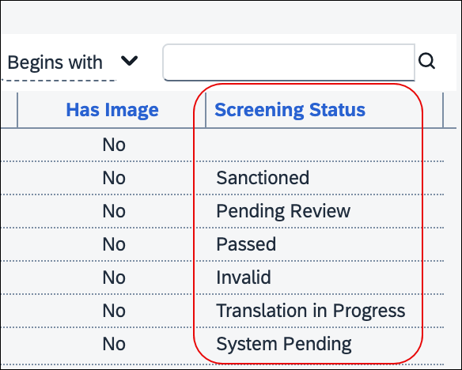
The Screening Status column displays four new status results based on BPS screening:
- Passed: Vendors that passed the BPS screening and can be used without restrictions.
- Pending Review: Vendors that require manual review by SAP Export Control Operations.
- System Pending: Vendors that are in the queue for BPS screening once the system is back online.
- Translation in Progress: Vendors that have non-Latin or special characters present and are currently being translated for BPS screening.

Configuration / Feature Activation
This change occurs automatically.
For more information, refer to Concur Invoice: Vendor Manager User Guide.

Planned Changes
The items in this section are targeted for future releases. SAP Concur reserves the right to postpone implementation of – or completely remove – any enhancement/change mentioned here.
The planned changes listed in this document are specific to this product. For information about planned site-wide or shared changes that might impact your SAP Concur solutions, refer to the Shared Changes Release Notes.

Digital Invoices

**Planned Changes** New PDF Generation for Peppol E-Invoices (Japan)

Information First Published | Information Last Modified | Feature Target Release Date
February 2024 | April 12, 2024 | May 2024
Any changes since the previous monthly release are highlighted in yellow in this release note.

Overview
Concur Invoice clients in Japan (or those who have employees or configurations in Japan) that are using the Peppol Integration solution will soon be able to view and download a readable PDF version of the Peppol XML file. The PDF will be automatically generated from the Peppol XML e-invoice document and will be accessible through the View Invoice option in the invoice.
The generated PDF provides the following benefits:
- Presents the invoice data in a better readable format.
- Allows Invoice Approvers and Processors to compare the invoice record created in Concur Invoice against the generated PDF to reduce instances of fraud.
- Allows all users to verify vendor names from the XML and compare the default vendor selected in the invoice record in Concur Invoice.
For more information on Concur Invoice Peppol Integration, refer to the Concur Invoice Release Notes for June 2023 and October 2023.

Business Purpose / Client Benefit
This update allows clients to have a human-readable PDFs of their invoicing files for auditing purposes. It also meets the Japanese market requirements by providing a readable PDF version of the XML e-invoice.

Configuration / Feature Activation
This update occurs automatically.

Client Notifications

Accessibility

Accessibility Updates
SAP implements changes to better meet current Web Content Accessibility Guidelines (WCAG). Information about accessibility-related changes made to SAP Concur solutions is published on a quarterly basis. You can review the quarterly updates on the Accessibility Updates page.

Gender Diversity

Gender Diversity Planned Features and Changes
SAP Concur is committed to supporting gender diversity. Over time we plan to implement product changes to help ensure that SAP Concur solutions support gender non-binary users. These changes will include but are not limited to support for preferred names, non-binary gender options in travel preferences, and non-binary titles.
These planned changes reflect SAP's commitment to supporting gender diversity and enable gender non-binary users to enter consistent information when making travel arrangements and entering personal information into SAP Concur solutions.
Timelines and details about these ongoing changes will be provided in the SAP Concur release notes.

In-Product User Assistance

Client Customized Content
If your company creates customized content for SAP Concur solutions through a user assistance tool such as SAP Enable Now or Concur User Assistant by WalkMe, the changes described in these release notes might affect your customized content. SAP Concur recommends reviewing the monthly release notes for all your SAP Concur solutions as well as the Shared Changes Release Notes to confirm whether any of the planned or released changes might impact your internal, customized content.
If any changes in a release impact your content, work with your internal teams to update your content accordingly.

Subprocessors

SAP Concur Non-Affiliated Subprocessors
The list of non-affiliated subprocessors is available from the SAP Sub-processors / Data Transfer Factsheets page.
To access the SAP Concur Sub-processors List:
- Click the following link to navigate to the SAP Sub-processors / Data Transfer Factsheets page:
SAP Sub-processors / Data Transfer Factsheets
- Sign in to the SAP Support Portal using your Support User ID (S-user) and password.
SAP customers must sign in to the SAP Support Portal using their Support User ID (S-user) and password. For information about S-User IDs, refer to Your New Support User ID (S-user) and to the Learn All About S-User IDs blog post.
- On the SAP Sub-processors / Data Transfer Factsheets page, type Concur in the Search field.
- In the Title column, click SAP Concur Sub-processors List.
If you have questions or comments, please reach out to: Privacy-Request@Concur.com

Supported Configurations

Supported Browsers and Changes to Support
For information about supported browsers and planned changes to supported browsers, refer to the Concur Travel & Expense Supported Configurations guide.
When changes to browser support are planned, information about those changes will also appear in the Shared Changes Release Notes..

SAP Concur Support Case Status
This release might resolve previously submitted support cases. You can check the status of a support case to confirm whether the case issue has been resolved.

Check Support Case Status
The steps in this procedure provide instructions for checking whether a case is resolved.
To check the status of a submitted case:
- Log on to https://concursolutions.com/portal.asp.
- Click Help > Contact Support.
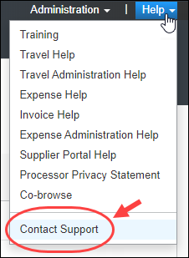
If you do not have the option to contact SAP Concur support in the Help menu, then your company has chosen to support the SAP Concur service internally. Please contact your internal support desk for assistance.
- Click Support > View Cases.
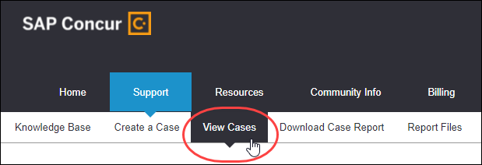
In the table, view the desired type of cases based on the View list selection. Search results are limited to each company's own cases.
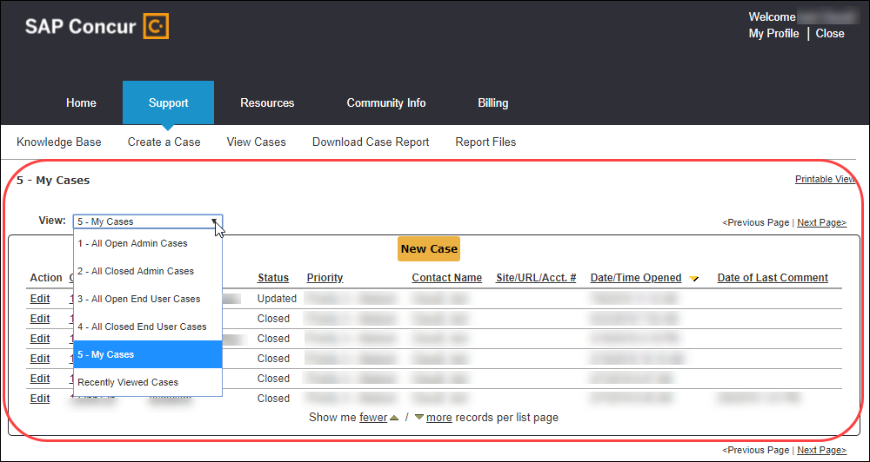

Additional Release Notes and Other Technical Documentation

Online Help
You can access release notes, setup guides, user guides, admin summaries, supported configurations, and other resources via the in-product Help menu or on the SAP Help Portal.
To access the full set of documentation for your product, use the links in the SAP Concur Help menu, or visit the SAP Concur solutions page.
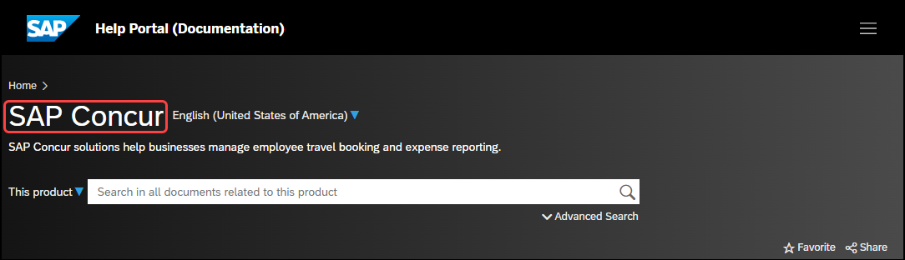

SAP Concur Support Portal – Selected Users
Access release notes, webinars, and other technical documentation on the SAP Concur support portal.
If you have the required permissions, Contact Support is available on the SAP Concur Help menu and in the SAP Concur page footer.
Click Contact Support to access the SAP Concur support portal, then click Resources.
- Click Release/Tech Info for release notes, technical documents, etc.
- Click Webinars for recorded and live webinars.

© 2024 SAP SE or an SAP affiliate company. All rights reserved.
No part of this publication may be reproduced or transmitted in any form or for any purpose without the express permission of SAP SE or an SAP affiliate company.
SAP and other SAP products and services mentioned herein as well as their respective logos are trademarks or registered trademarks of SAP SE (or an SAP affiliate company) in Germany and other countries. Please see http://global12.sap.com/corporate-en/legal/copyright/index.epx for additional trademark information and notices.
Some software products marketed by SAP SE and its distributors contain proprietary software components of other software vendors.
National product specifications may vary.
These materials are provided by SAP SE or an SAP affiliate company for informational purposes only, without representation or warranty of any kind, and SAP SE or its affiliated companies shall not be liable for errors or omissions with respect to the materials. The only warranties for SAP SE or SAP affiliate company products and services are those that are set forth in the express warranty statements accompanying such products and services, if any. Nothing herein should be construed as constituting an additional warranty.
In particular, SAP SE or its affiliated companies have no obligation to pursue any course of business outlined in this document or any related presentation, or to develop or release any functionality mentioned therein. This document, or any related presentation, and SAP SE’s or its affiliated companies’ strategy and possible future developments, products, and/or platform directions and functionality are all subject to change and may be changed by SAP SE or its affiliated companies at any time for any reason without notice. The information in this document is not a commitment, promise, or legal obligation to deliver any material, code, or functionality. All forward-looking statements are subject to various risks and uncertainties that could cause actual results to differ materially from expectations. Readers are cautioned not to place undue reliance on these forward-looking statements, which speak only as of their dates, and they should not be relied upon in making purchasing decisions.

