
Concur Invoice:
Administration
User Guide for Standard Edition
Last Revised: August 11, 2023
Applies to these SAP Concur solutions:
 Concur Expense
 Professional/Premium edition
 Standard edition
 Concur Travel
 Professional/Premium edition
 Standard edition
 Concur Invoice
 Professional/Premium edition
 Standard edition
 Concur Request
 Professional/Premium edition
 Standard edition

Table of Contents
Section 1: Overview 1
Clients Connected to Financial Systems 1
Section 2: Manage Unassigned and Assigned Invoices 1
Required Roles 2
Access the Unassigned Invoices Page from Invoice Manager 2
Customize Columns on the Unassigned Invoices Page 5
Search and Assign Management of Invoices 6
Search for Invoices 6
Search for Unassigned Invoices by Using the Search Functionality 7
Assign an Unassigned Invoice 7
Reassign an Assigned Invoice 8
Unassign an Assigned Invoice 10
Accept Auto-Assignment of an Invoice as the Invoice AP User 12
View Unsubmitted Purchase Order-Based Invoices 13
Invoice Navigation 13
Customize Columns on the My Invoices Page 14
Download Data to Excel 16
Create a Recurring Invoice 17
Make One Time Changes to the Details of a Recurring Invoice 20
Export Recurring Invoices 20
Work with Deleted Invoices 21
Filter Deleted Invoices Using the View Menu 21
Search for Deleted Invoices Using Search Criteria 22
Work with Images 24
Upload an Image for an Invoice 24
View an Image for an Invoice 25
Delete an Image from an Invoice 26
Section 3: Manage Vendors 27
Required Roles 28
Access the Vendor Manager Tool 28
Search for a Vendor 29
Include or Exclude Vendor in Capture Processing 30
Exclude a Vendor from Capture 30
View Vendor Information 32
Export Vendor Data to Excel 34
Add and Approve Vendors 35
Create and Approve Vendors Feature 35
Update Vendor Information 38
Review a Vendor's Audit Trail 41
Create Custom Fields for Vendor Pages 43
Add Vendor Banking Information to Vendor Form 45
Filter Vendors Without Banking Information 46
Deactivate and Reactivate a Vendor 47
Deactivate a Vendor 47
Filter for Deactivated Vendors 48
Reactivate Deactivated Vendors 49
Match a Vendor 50
Decline a Vendor Request 52
Assign a Default Expense Type to a Vendor 53
Benefits 54
Assign Default Expense Types to Vendors 54
Assign a Default Invoice Owner to a Vendor 56
Default Vendor Owner Assignment and Capture Processing 56
Manage Sanctioned or Invalid Vendors 58
Review Vendor Screening Status 58
Understand the End-User Experience 59
Import Vendors 59
Section 4: Process Invoices 60
Required Roles 60
Access the Invoice Manager Page 60
Access the Process Invoices Tool 62
Overview: Process an Invoice 62
Manage the Process Invoices View 63
Set the Invoices Ready for Processing Page Preferences 63
Manage the Invoices Ready for Processing Columns 63
Set the Processor General Preferences 64
Search for Invoices 65
Search for an Invoice 65
Use a Query to Search for an Invoice 66
Search for an Invoice Using a Preconfigured Query 67
Create a Custom Query 67
Edit a Saved Query 68
Delete a Query 69
Export Query Results 70
View and Modify Invoice Information 71
Open an Invoice 71
View When SAP Concur Received an Invoice 71
Mark Invoice (Image) Status for One or More Invoices 73
View and Upload Images 74
Clear Exceptions 76
Approve an Invoice 77
View and Manage Approval Workflows 78
Place an Invoice in Review 81
Delete an Invoice 83
Restore a Deleted Invoice 84
Void an Invoice 85
Manage Receipts and Receipt Images 86
View and Add Comments to an Invoice 86
Section 5: Payment Manager 88
About the Payment Manager Page 89
Invoice Pay Clients 89
Payment Manager Processes 90
Work with the GL Extract 90
User Experience 91
Run the GL Extract 91
Search for the Output File 92
View (Download) the Output File 92
Perform an On-Demand Payment Confirmation Extract 93
Run a Payment Confirmation Extract 94
Perform On-Demand Payment Confirmation Import 94
Overview 94
Section 6: Reporting 95
Access Analysis/Intelligence Documentation via Cognos 95
Section 7: Web Services 95
Section 8: Appendix 96
Switch Tax Mode 96
Use the Tax Field at Both the Invoice and Line Item Levels 97

Revision History
Date | Notes/Comments/Changes
November 11, 2023 | Minor edits; cover date not updated.
August 11, 2023 | Added the Manage Sanctioned and Invalid Vendors section.
May 20, 2023 | Minor edits: cover date not updated.
February 18, 2023 | Added an Export Recurring Invoices section to the Managing Recuring Invoices section. Added a Recurring Invoices bullet to the list in the Download Data to Excel section.
August 30, 2022 | Minor edits: cover date not updated
June 22, 2022 | Added a note about AP User and Process role access by vendor group in the Overview section. Added a note in the Create Custom Fields for Vendor Pages section.
May 21, 2022 | Added a Create Custom Fields for Vendor Pages section.
January 21, 2022 | Updated the copyright year; no other changes; cover date not updated
December 10, 2021 | Updated instructions for Product Settings page
March 4, 2021 | Updated the copyright year; no other changes; cover date not updated
October 17, 2020 | Removed reference to the Supplier Portal since it has been retired.
September 28, 2020 | Added information about duplicate invoices and removed in-product messaging information.
September 14, 2020 | Added information about customizing columns in the All My Invoices list view.
July 24, 2020 | Updated information about the Download as Excel feature.
July 8, 2020 | Added information about the Download as Excel feature.
March 14, 2020 | Added information about customizing columns in the Unsubmitted Invoices and Unsubmitted Purchase Order list views.
January 8, 2020 | Updated the copyright; no other changes; cover date not updated
December 16, 2019 | Added info about customizing columns on the Unassigned Invoices page.
August 5, 2019 | Added information about the Invoice Navigation window.
July 9, 2019 | Updated style applied to portions of the title. No revision date change.
June 27, 2019 | Added the “Access the Invoice Manager Page” section to Section 4.
June 17, 2019 | Added information about disabling the Create and Approve Vendors feature.
June 8, 2019 | Added the “View Unsubmitted Purchase Order-Based Invoices” section.
May 24, 2019 | Updated section 2 to reflect new Invoice UI terms and labels and Assign Invoice changes.
April 22, 2019 | Updated sections 3, 5, and 7 to reflect new Invoice UI terms and labels.
April 13, 2019 | Added information about the Payment Confirmation Extract.  Updated Section 4 to reflect changes related to the new Invoice UI for the Invoice Processor. Section 2 to be updated at a future date.
February 22, 2019 | Added info about new audit trail feature for Vendor Management. Updated 'Concur' to 'SAP Concur'.
January 30, 2019 | Updated the copyright; no other changes; cover date not updated
January 12, 2019 | Replaced 'payment request' with 'invoice' except UI elements. Added Create and Approve vendor information. Replaced old screenshots and updated text here and there.
June 16, 2018 | Removed information about QuickBooks Connector and Financial Integration, as content is now consolidated in the Shared: QuickBooks Connector Setup Guide and Shared: QuickBooks Integration Using Concur Financial Integration Service Setup Guide.
April 11, 2018 | Changed the check boxes on the front cover; no other changes; cover date not updated
December 9, 2017 | Added note about the Tax ID.
August 19, 2017 | Updated the Request New Vendor and the Vendor Information windows to show the Pay Method Type list. No content changes.
July 29, 2017 | Added information about the search functionality on the All Unassigned Requests page.
July 8, 2017 | Performed the following updates:  - Removed references to double-clicking to open an invoice, since users only need to single-click to open invoices  - Added information about filtering on vendors without banking information
April 22, 2017 | Updated with information about automatic assignment of Vendor Owner to the Assign Request To field in Capture Processing if a vendor is matched to an employee using the Vendor Mapping List options.
January 20, 2017 | Added information about the following:  - Adding comments to paid invoices  - Viewing exact time when Concur received invoice
December 13, 2016 | Changed copyright and cover; no other content changes.
December 5, 2016 | Updated the guide content to new corporate style; no content changes.
November 4, 2016 | Added information about the following:  - Processor page now displaying all invoices that need to be processed for new clients  - The Concur Receiving feature
 | Older revision history has been removed.

Concur Invoice Administration

Overview
Concur Invoice Standard Administration includes the following activities:
- Managing unassigned and assigned invoices that have not been submitted
- Viewing and managing vendor information using the Vendor Manager tool
- Processing invoices, such as searching for invoices, changing invoice approval statuses, reassigning invoices, and deleting invoices
- Managing batches of invoices and running, searching for, and downloading imports and extracts using the Payment Manager tool
- Producing reports using the Reporting tool
- Managing partner applications for the SAP Concur Connect platform using Web Services

Clients Connected to Financial Systems
If you have connected SAP Concur to your financial system, some fields on these pages might display different labels or pre-populated values based on your connected financial system.
- For more information, refer to the SAP Concur setup guide for your financial system.

Manage Unassigned and Assigned Invoices
This section describes how to use options on the Unassigned Invoices page to manage unassigned invoices that have not yet been submitted. Using these options, the Invoice AP user or Invoice Processor can search for both assigned and unassigned invoices by their assignment date. Once a list is returned by Concur Invoice, the user can then assign and unassign invoices singly, or in bulk, to a new invoice user. This is useful for organizations that use the centralized Accounts Payable (AP) back-office model, where a single employee may be responsible for assigning and monitoring invoices across an organization.

Required Roles
The Unassigned Invoices page and all its options are available to the following Invoice roles only:
- Invoice Processor
- Invoice AP User
Users with both the AP User and Processor roles can access the Unassigned Invoices page, based on their vendor group access. This ensures they will only view invoices relevant for their role.

Access the Unassigned Invoices Page from Invoice Manager
AP users who want to work with unassigned invoices can access the Unassigned Invoices page from the Invoice Manager page by clicking the Unassigned Invoices link in the Active Invoices or Back Office section.
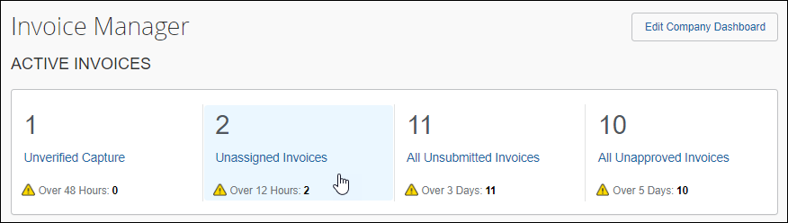
The Unassigned Invoices page appears with a list of unassigned invoices.
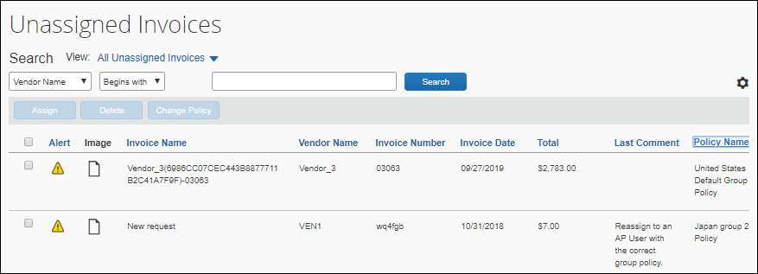
In the View list, the AP user can select to view all unassigned invoices, unassigned invoices they created, or all assigned invoices.
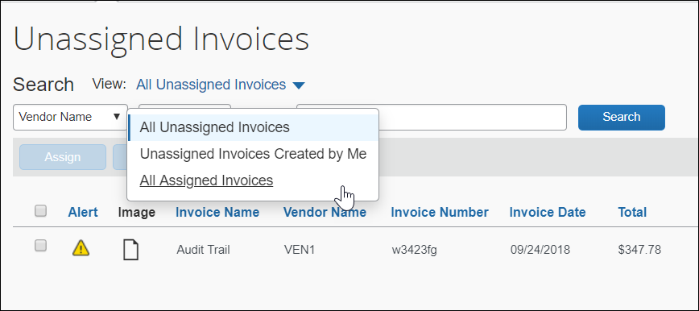
An AP user can open and view an unassigned invoice by clicking the name of the invoice in the Invoice Name column on the Unassigned Invoices page.
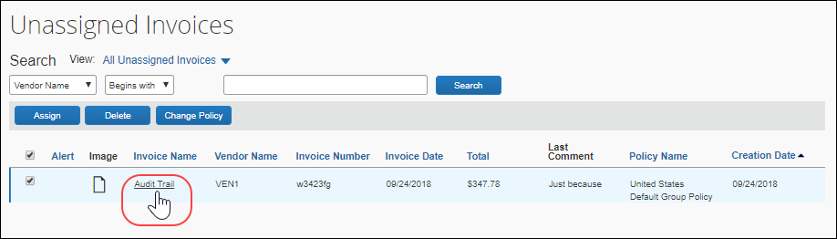
To edit an unassigned invoice, the AP user opens the invoice and then clicks Edit.
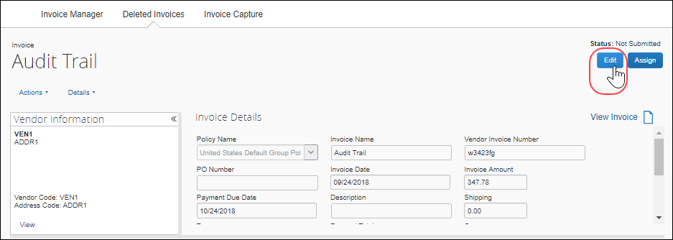
When the AP User clicks Edit, the Auto Assign message appears and they must either click OK to accept assignment of the invoice in order to edit the invoice.
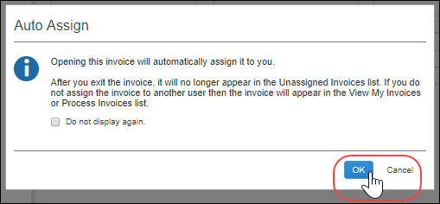
For more information about the Auto Assign message, refer to the Accept Auto-Assignment of an Invoice as the Invoice AP User section of this document.
When the edits are complete, the AP user clicks Save, and then clicks Assign to assign the invoice to an employee.
When they click Assign, the Assign Invoices window appears.
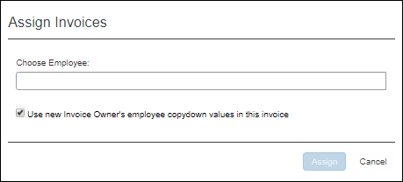
The AP User enters the name of the employee they want to assign the invoice to and then clicks Assign to assign the invoice to the employee. The invoice closes automatically, and the AP User is returned to the list of unassigned invoices. The edited invoice no longer appears in the list.
AP users will be able to see duplicate invoices on the Unassigned Invoices page before they open an invoice and they will also see a duplicate message immediately after they open an invoice.

Customize Columns on the Unassigned Invoices Page
AP users can manage and customize columns from the Unassigned Invoices list pages.
To customize columns:
- Click on the gear icon to access the Manage Columns window.
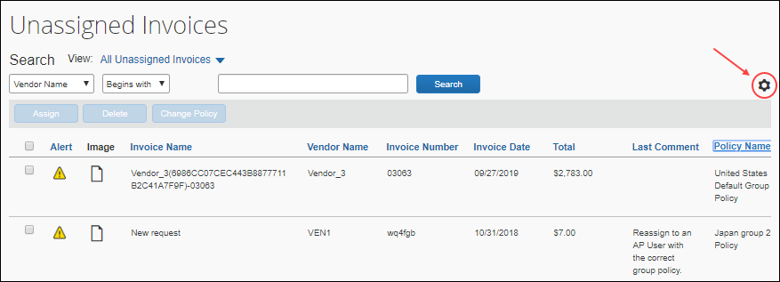
- In the Manage Columns window that appears, drag and drop fields between the Hidden and the Visible lists depending on what you want to see on the Unassigned Invoices page.
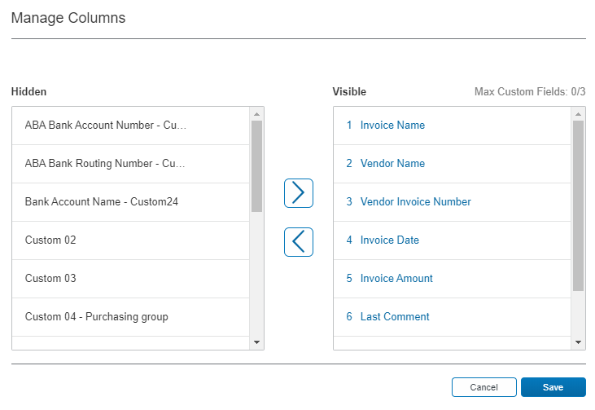
- Click Save.
Some of the columns cannot be removed (hidden). If you attempt to remove (hide) a required column, a warning message appears.
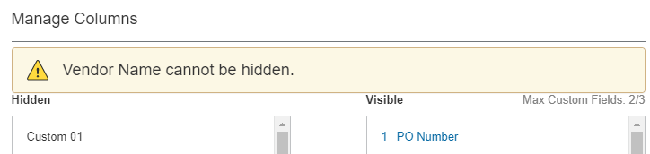
A maximum of three custom fields can be placed in the Visible list.

Search and Assign Management of Invoices
By using options on the Unassigned Invoices page, you can perform the following actions:
- Search for unassigned invoices
- Delete an invoice (might require change to settings)
- Change the policy associated with an invoice (might require change to settings)

Search for Invoices
By default, the system displays all unassigned invoices when you open the Unassigned Invoices page. You can search for all unassigned invoices, unassigned invoices that you created, and all assigned invoices.
To search for invoices
On the Unassigned Invoices page, click View, and then select All Unassigned Invoices, Unassigned Invoices Created by Me, or All Assigned Invoices.

Search for Unassigned Invoices by Using the Search Functionality
You can search for specific unassigned invoices by using the search functionality on the Unassigned Invoices page.
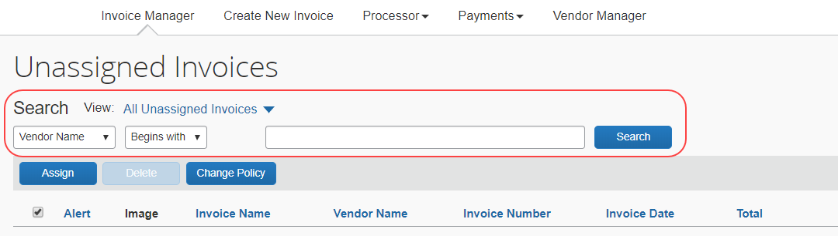
The search options include vendor name, invoice number, total, policy name, and invoice name.
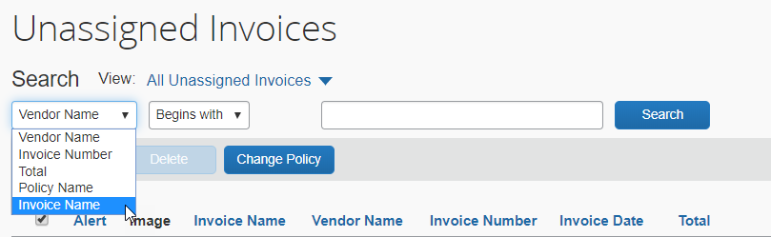

Assign an Unassigned Invoice
An unassigned invoice can be assigned to an employee using the procedure below. However, it is also possible to reassign an invoice to a different employee. See the procedure below for information on reassigning an invoice.
To assign an unassigned invoice to an employee:
- On the Unassigned Invoices page, search for the unassigned invoice(s) you want to assign, and then select the invoice(s) to be assigned by clicking the check box to the left of the row.
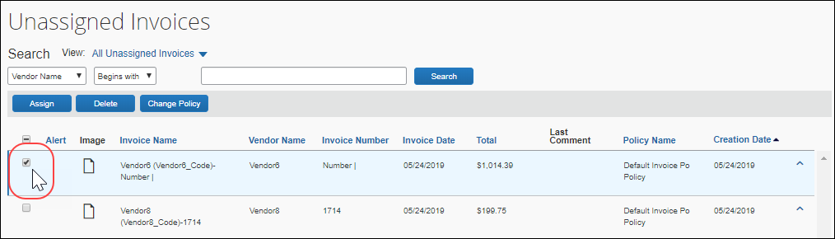
- Click Assign.
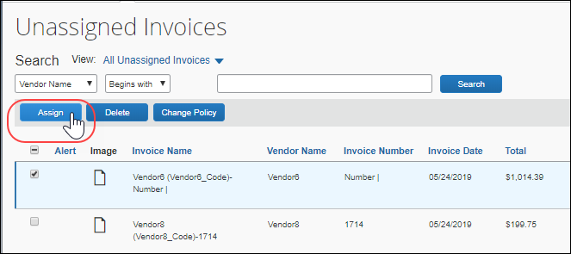
- In the Assign Invoices window, type the first three characters of the employee for whom you want to assign the invoice.
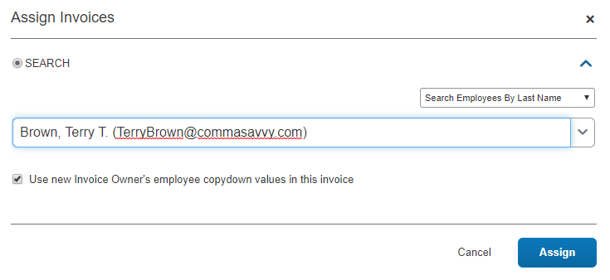
- (Optional) Select (enable) or clear (disable) the Use new Invoice Owner's employee values in this invoice to include the employee's information as pre-populated information on the invoice on assignment.
- Click Assign to assign the invoice to the employee. The Unassigned Invoices page appears.

Reassign an Assigned Invoice
An invoice that is assigned to an employee can be reassigned to another employee. You can also select multiple invoices to be reassigned at one time, but they must all be reassigned to the same user. Optionally, the AP User can direct an Invoice User to assign an invoice to another Invoice User. It is assigned with all ownership attributes transferred to the new owner.
To reassign an assigned invoice:
- On the Unassigned Invoices page, use the View menu options to search for the invoice(s) you want to reassign.
- Select one or more invoices using the check box to the left of the row.
- Click Assign.
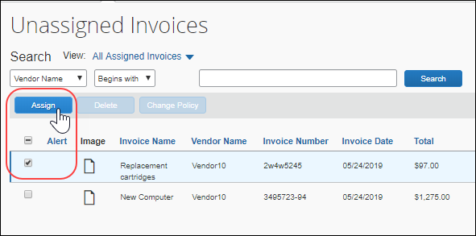
- In the Assign Invoices window, type the first three characters of the employee for whom you want to assign the invoice.
- (Optional) Select (enable) or clear (disable) the Use new Request Owner's employee copydown values in this request setting to include or exclude the employee's information as pre-populated information on the invoice on assignment.
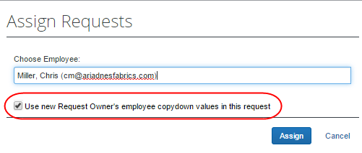
- (Optional) Select (enable) or clear (disable) the Use new Invoice Owner's employee values in this invoice to include the employee's information as pre-populated information on the invoice on assignment.
- Click Assign to assign the invoice to the employee. The Unassigned Invoices page appears.

Unassign an Assigned Invoice
An invoice can be unassigned from the current owner of an invoice. This action is restricted to a single invoice at a time since the invoice must be opened to access the Unassign menu item and only a single invoice can be opened at one time.
To unassign an invoice:
- On the Invoice Manager page, click All Unsubmitted Invoices.
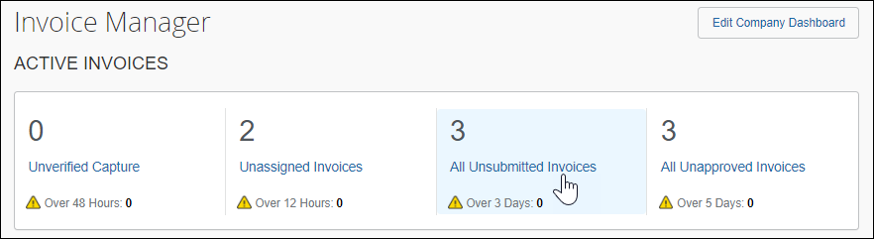
The My Invoices page appears showing the Unsubmitted Invoices view.
- Open the invoice you want to unassign. The Invoice for <name> page appears.
- In the Actions menu, click Unassign.
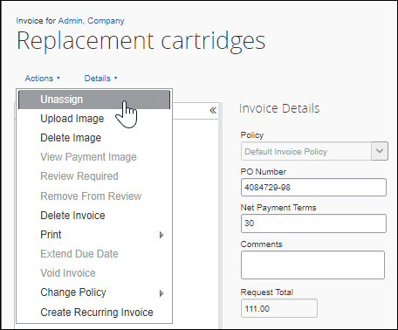
- In the Unassign Invoice window, provide a comment as to why the invoice was unassigned.
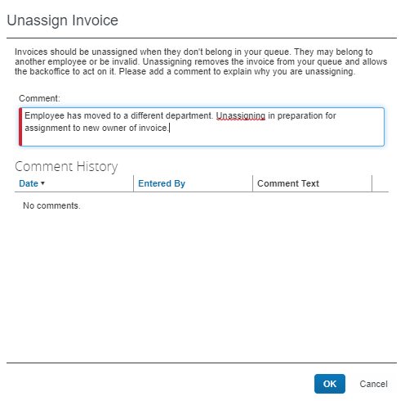
- Click OK.

Accept Auto-Assignment of an Invoice as the Invoice AP User
When the Invoice AP User opens an unassigned invoice, the Invoice AP User is prompted to accept the assignment of the invoice. This prompt only appears when the Invoice AP User opens an unassigned invoice.
To accept auto-assignment of an invoice:
- On the Invoice Manager page, click Unassigned Invoices.
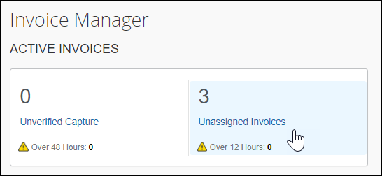
- On the Unassigned Invoices page, open the relevant invoice by clicking on the invoice name, and then click Edit.
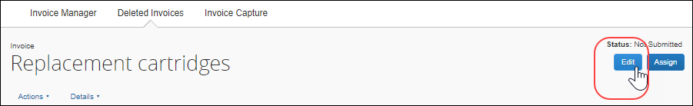
The Auto Assign window appears.
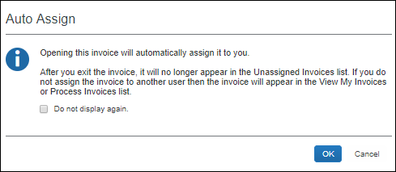
- (Optional) Select (enable) the Do not display again check box to prevent the Auto Assign dialogue from appearing when you open unassigned invoices in the future. If you enable this option, when you open an unassigned invoice in the future, the prompt will no longer appear, and the invoice will be assigned to you automatically.
- To assign the invoice to yourself, click OK. The invoice is now editable and can be updated, assigned to another employee, or unassigned.

View Unsubmitted Purchase Order-Based Invoices
AP users can view unsubmitted purchase order-based invoices on the My Invoices page by selecting the Unsubmitted Purchase Order Invoices option in the View list.
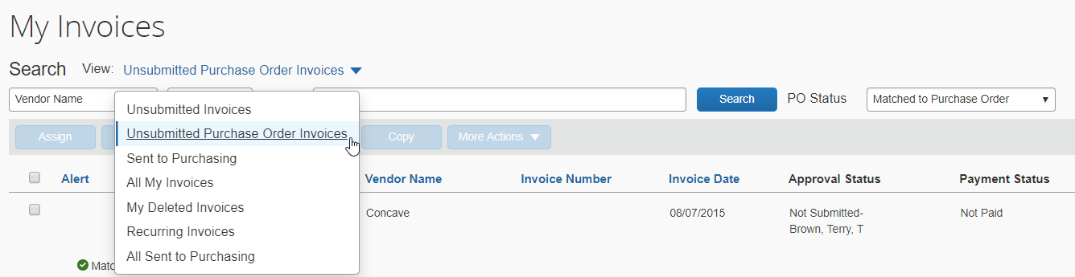
To filter on purchase order status, AP users can select an option in the PO Status list. The following options are available:
- All Invoices
- Does Not Match Purchase Order
- Matched to Purchase Order
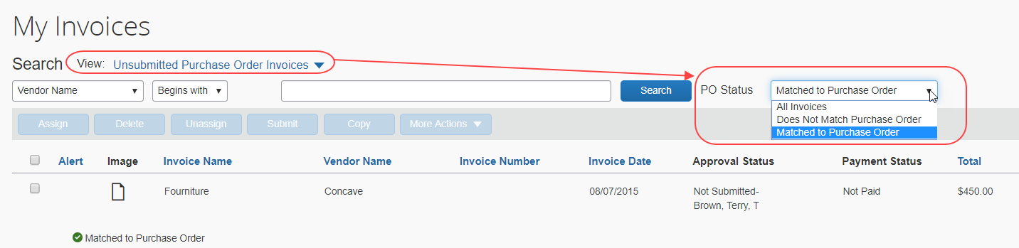

Invoice Navigation
Once you have opened an invoice, you can decide if you want to go to your next invoice directly by clicking the Next Invoice link instead of going back to the invoice list on the My Invoices page. The Previous Invoice will take you back to the previous invoice in your list.
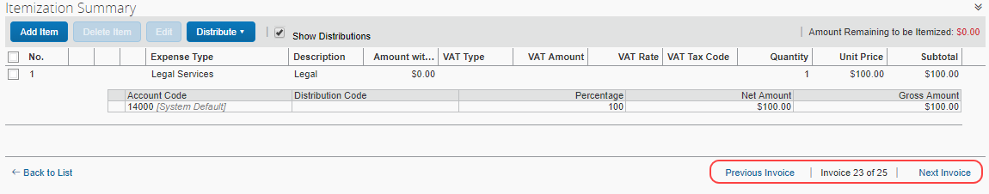
In addition, when you select an action (for example, assign) on a list page and select to whom to route the invoice, you can then choose if you want to go back to the invoice list or go to your next invoice directly by selecting either Open Next Invoice or Back to List in the Invoice Navigation window that appears.
The Invoice Navigation window only appears when users are working on the list pages.
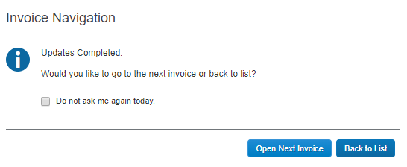
In addition, users can save their setting for 24 hours by selecting the Do not ask me again today option before clicking any of the buttons. This selection means that users will be directed to the next invoice automatically for the next 24 hours.

Customize Columns on the My Invoices Page
AP users can manage and customize columns from the following list views:
- Unsubmitted Invoices
- Unsubmitted Purchase Orders
- All My Invoices
To customize columns:
- Click on the gear icon to access the Manage Columns window.
- The image shows the Unsubmitted Invoices list view.
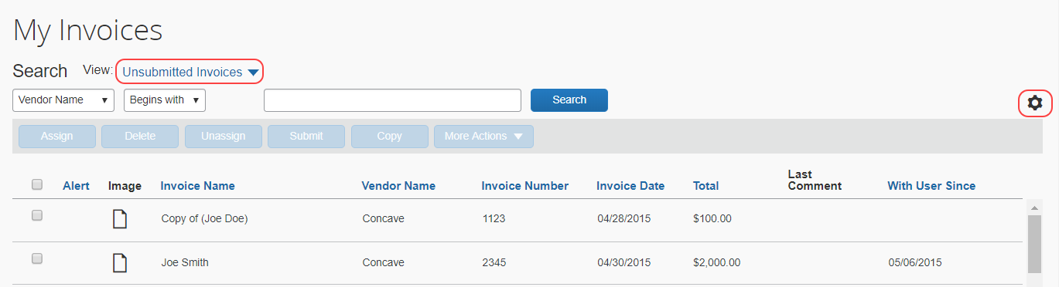
- In the Manage Columns window that appears, drag and drop fields between the Hidden and the Visible lists depending on what you want to see on the Unassigned Invoices page.
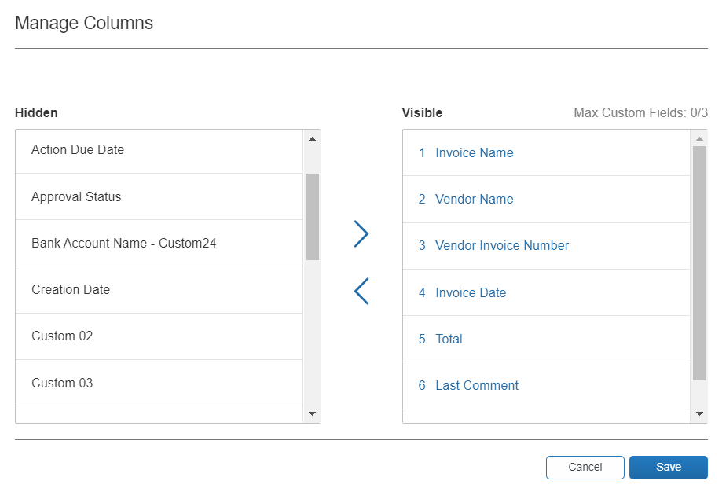
- Click Save.
The Vendor Name, Invoice Number, and Invoice Date fields cannot be removed (hidden). If you attempt to remove (hide) a required column, a warning message appears.
Default Columns:
- Invoice Name
- Vendor Name
- Invoice Number
- Invoice Date
- Total
- Last Comment
- With User Since
Additional Columns That Can Be Added/Removed
- Action Due Date
- Payment Status
- Approval Status
- Custom 1-20
- PO Number
- Policy Name
- Is Emergency Check Run
- Invoice Received Date
- Payment Terms
- Payment Due Date (not applicable to the All My Invoices list view)
- Payment Method
- Description
- Org Unit 1-6
Searchable columns:
- Vendor Name
- Title
- PO Match Status (not applicable to the All My Invoices list view)
- Total
- Vendor Invoice Number
- PO Number (not applicable to the All My Invoices list view)
Any changes to columns in the Manage Columns window will be applied to the Unsubmitted Invoices, Unsubmitted Purchase Orders, and All My Invoices list views.
A maximum of three custom fields can be placed in the Visible list.
In addition, if you customize columns while acting as a proxy for another user, you are customizing the view for yourself only, not the user for whom you are acting as a proxy.

Download Data to Excel
You can download data to Excel from several list views on the My Invoices page. The Download as Excel link is available from the following list views:
- Unsubmitted Invoices
- Unsubmitted Purchase Orders
- All Unassigned Invoices
- Unassigned Invoices Created by Me
- All Assigned Invoices
- My Deleted Invoices
- All My Invoices
- Recurring Invoices
The maximum number of invoices that can be exported from the All My Invoices list view is 12,500. The other list views do not have this limit, but the export process might take some time if there are many items to be exported.
Example – Download as Excel From All My Invoices List View
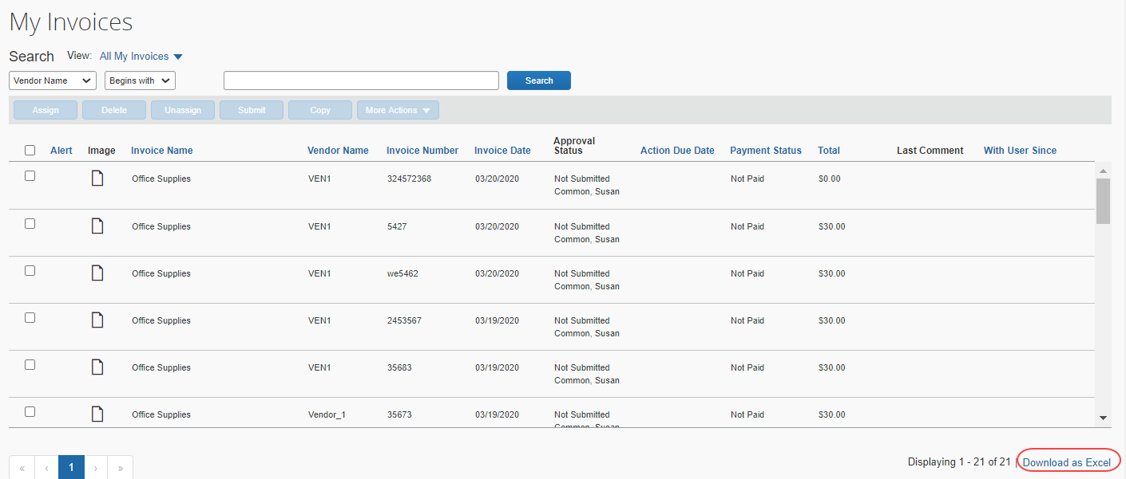
If the client leaves the My Invoices page while the export process is in progress, the export will be canceled. However, clients will be able to open an invoice on the My Invoices page while the export is running.

Create a Recurring Invoice
An Invoice User can specify that an invoice is recurring. When a recurring invoice is configured, the system generates the invoice on a designated schedule and moves the invoice to workflow and payment automatically.
Recurring invoices appear on the My Invoices page when you select Recurring Invoices from the View menu. The Recurring Invoices option only appears on the View menu when one or more recurring invoices are configured.
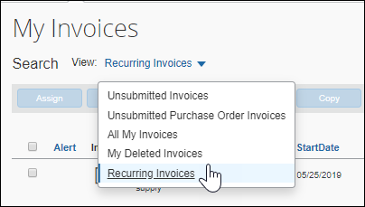
By default, the recurring invoice is generated 14 days before the scheduled payment date.
By marking an existing invoice as recurring, the system handles the creation and submission of the invoice automatically without user intervention.
This feature does not apply to purchase orders (a PO invoice); the command is unavailable if the invoice is a PO invoice.
To create a recurring invoice:
- Locate and open the invoice from which you would like to create a recurring invoice.
- Click Actions > Create Recurring Invoice.
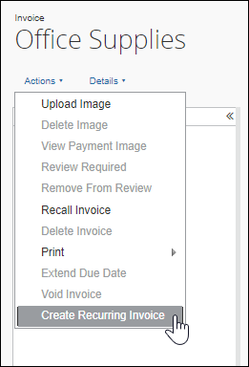
The Recurring Invoice Details window appears.
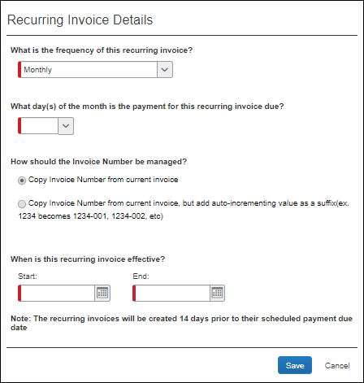
- Complete the following fields:
Field | Description
What is the frequency of this recurring invoice? | In this list, you select how often the system should create a recurring invoice. Select one of the following:  - Monthly  - Twice Per Month  - Quarterly
What day(s) of the month is the payment for this recurring invoice due? | In this list, you select what day of each month the payment for this recurring invoice should be due.
How should the Invoice Number be managed | Copy Invoice Number from current payment request: This is the default option.  Copy Invoice Number from current request, but add auto-incrementing value as a suffix: SAP Concur maintains the invoice number, and then adds a hyphen and number to the end of the invoice number to make it unique. For example, if the invoice number is 1234, then the recurring invoice numbers that are created from that template will be 1234-01, 1234-02, and so on.
When is this recurring invoice effective? | Select the dates between which the recurring invoice should be in effect.
- Click Save.
You can also configure a recurring invoice by clicking Actions > Create Recurring Invoice from the Invoice Details page of an open invoice.

Make One Time Changes to the Details of a Recurring Invoice
If the Invoice User must make a one-time change to a recurring invoice, they can open the submitted invoice, select Recall Invoice from the Actions menu, make the change, and then save and re-submit the invoice with the required change.
The next invoice that the system generates will not reflect the one-time change. The system does not retain a one-time change in the template.

Export Recurring Invoices
The Recurring Invoices list page has a Download as Excel link that works the same as the Download as Excel link on the My Invoices page, but only exports recurring invoices.
Once Invoice Owners with the AP User role click the Download as Excel link, all recurring invoices are selected and exported to an Excel spreadsheet. The export file will be named, invoices_<date or time stamp>.xml. The spreadsheet will contain the same fields as displayed on the Recurring Invoices list page.
Reviewing the exported recurring invoices spreadsheet, helps users identify any that require adjustments made to recurring invoice templates.
- For more information, refer to the Download Data to Excel section in this guide.
To download recurring invoices to an Excel spreadsheet:
On the Recurring Invoices list page, click the Download as Excel link in the lower right corner of the page.

Work with Deleted Invoices
Invoice Owners and Invoice AP Users can view their own deleted invoices by choosing My Deleted Requests from the View menu on the My Invoices page.
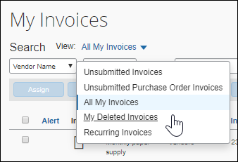
Invoice Processors can view all deleted requests by clicking on Deleted Invoices in the Processor menu.
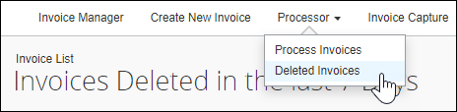

Filter Deleted Invoices Using the View Menu
On the Deleted Invoices page, Invoice AP Users and Invoice Processors can also filter deleted requests by choosing from the options on the View menu or entering search criteria into the Search fields.
By default, the list of deleted invoices that appears on the Deleted Invoices page includes invoices that were deleted within the last seven days. The user or processor can change this view by clicking View and selecting another option:
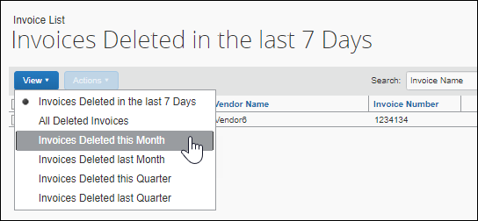

Search for Deleted Invoices Using Search Criteria
The AP user or processor can search for specific invoices by selecting search criteria from the available menus and entering search criteria into the Search field.
To search for deleted invoices:
- Navigate to the Deleted Invoices page.
- Search for the invoice by selecting search criteria such as by vendor name or by the invoice total.
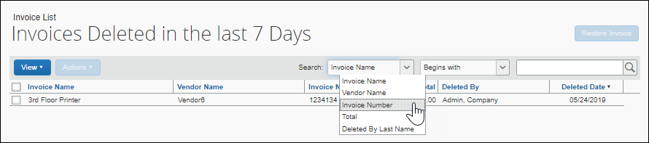
- Once you find the invoice, open the invoice by clicking it directly, or by selecting the invoice and then clicking Open Invoice on the Actions menu.
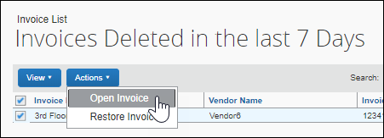
- Review the deleted invoice. The following options are available to the user:
- Restore: After selecting the invoice(s) on the Deleted Invoices page, click Actions, and then click Restore Invoice or click the Restore Invoice button to return the invoice(s) to your queue.
An AP user or processsor can also restore a deleted invoice by opening the request and then clicking the Restore Invoice button.
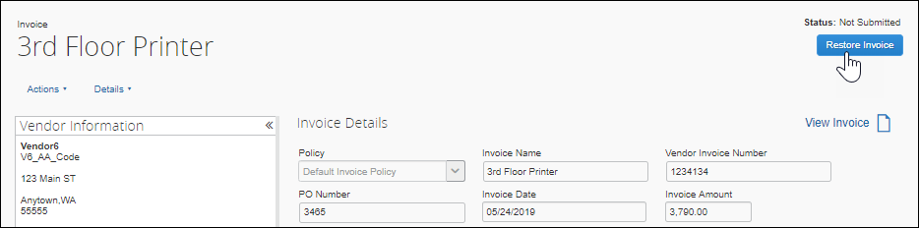
- Print: Open the invoice, click Actions, point to Print, and then choose a print format. The default print format is Invoice; however, your administrator might have enabled or configured other formats.
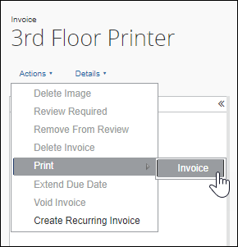
- View Comments: Open the invoice, click Details, and then click Comments.
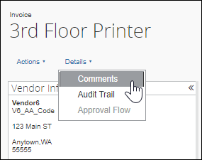
- View Audit Trail: Open the invoice, click Details, and then click Audit Trail.
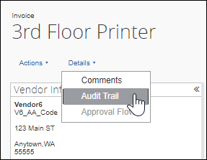
- View Uploaded Invoice Images: Open the invoice, click View Invoice. The Imaging service displays any associated images in a window of the same name.
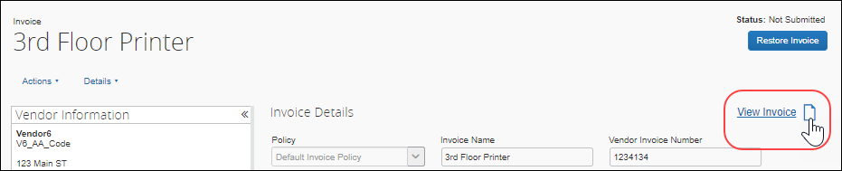

Work with Images
This section describes how to upload, change, and delete images associated with an invoice.

Upload an Image for an Invoice
You can upload an image, such as an invoice or W-9 form, for a specified invoice. This action is restricted to a single invoice at a time since you must open the invoice to access the Upload Image menu item.
To upload an image:
- Open the invoice you want to associate an image with.
- In the Actions menu, click Upload Image.
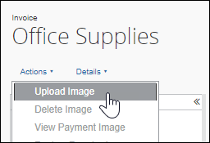
- In the Upload Image window, click Browse and navigate to the folder that contains the image(s).
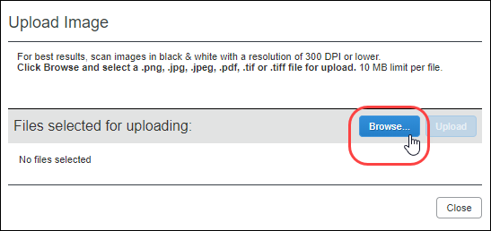
- Select the image file(s) and click Open. Invoice adds the file to a list under Files selected for uploading.
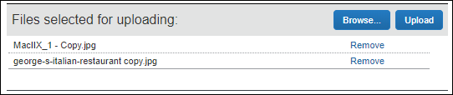
- Click Upload to upload the files.
- Click Close.
The process may take a few minutes. The amount of time required to upload the images depends both on the size of each file and the connection speed.

View an Image for an Invoice
You can view images associated with an invoice from the My Invoices page or from within the invoice details.
To view an image from the My Invoices page:
- Select the invoice whose image you want to view.
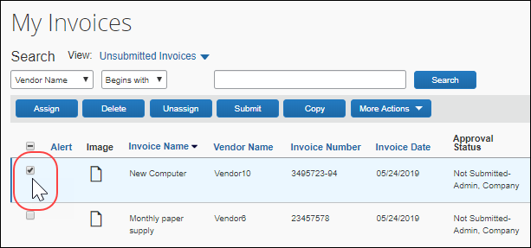
- Click on the image icon.
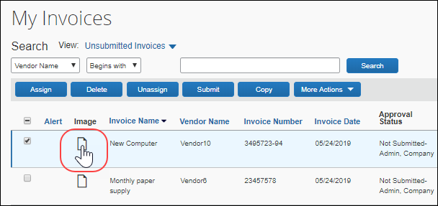
- The image appears in a separate window. When finished viewing the image, close the window.
To view an image associated with an open invoice:
- Open then invoice whose image you want to view.
- Click View Invoice.
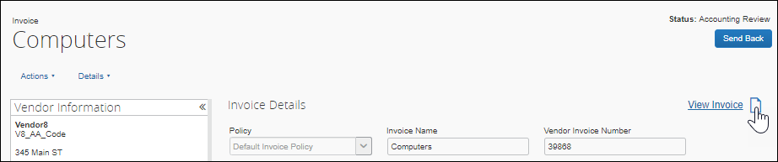
- The image appears in a separate window. When finished viewing the image, close the window.

Delete an Image from an Invoice
This action is restricted to a single invoice at a time since you must have the invoice open to access the Delete Image menu item.
- For information about disabling the ability to delete an image from an invoice, refer to the Concur Invoice: Invoice Settings Setup Guide.
To delete an image associated with an invoice:
- Open the invoice whose image you want to delete.
- In the Actions menu, click Delete Image.
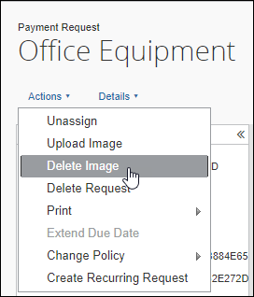
- In the Please Confirm window, click Yes to delete the image.
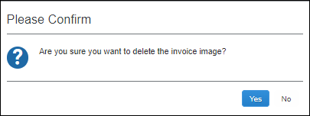

Manage Vendors
The Vendor Manager tool is used to view and manage vendor information, help maintain the integrity of the client’s Vendor Master List and streamline the new vendor request process to keep invoice cycle time low. The tool can be used to evaluate new, unapproved vendor requests and maintain an approved vendor list that is free of duplicate and invalid vendors.
A user with the Invoice Vendor Manager role can use the Vendor Manager tool to perform the following actions:
- Evaluate vendors with a status of Unapproved: Newly added vendor requests have a status of Unapproved until their validity can be determined. It is the responsibility of the Invoice Vendor Manager to evaluate each vendor and take appropriate action. Vendor requests fall into one of three categories: valid, invalid, or duplicate of an existing, approved vendor. This document explains how to process vendor requests in each of these categories.
- Maintain the Approved Vendor List: Vendor details can be viewed, W-9 images can be attached or appended, and the number of invoices attached to the vendor can be determined.
- Import Vendors: An on-demand vendor import is available for importing vendors into the system.
- Map Vendors to Defaults: To automate the assignment of vendors, both expense types and specific Invoice Users can be mapped by default to a specified vendor.
- Approve and Update Vendors: By default, the Create and Approve Vendors feature is enabled, and the Invoice Vendor Manager can approve new vendors and update the information for approved vendors.
If the Create and Approve Vendors feature is disabled, vendors can only be approved and updated through the Import Vendors feature.
- Review changes made to vendor information: Changes made to a vendor's information can be reviewed by checking the vendor information audit trail.
- Manage Sanctioned and Invalid Vendors: Manage invoices for vendors that are identified as having a Sanctioned or Invalid status during BPS screening.

Required Roles
The Vendor Manager tool is available to users with the Invoice Vendor Manager role.

Access the Vendor Manager Tool
You can manage vendors through the Vendor Manager feature.
To access the Vendor Manager tool:
- Click Invoice > Vendor Manager.
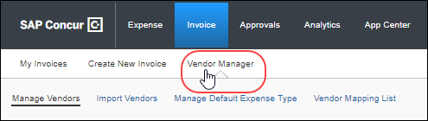
The Manage Vendors page appears.
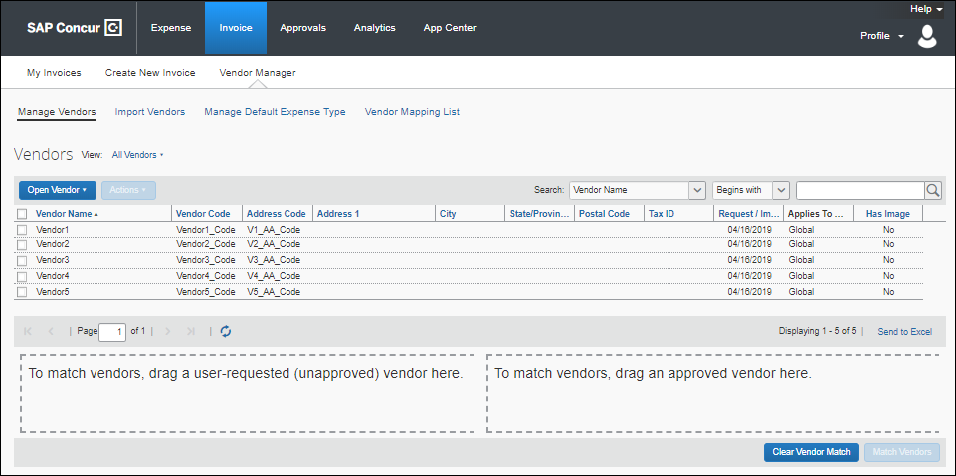

Search for a Vendor
You can search for specific vendors by combining vendor attributes, a search operator, and keywords.
To search for a vendor:
- Click Invoice > Vendor Manager. The Search fields appear in the upper left corner above the vendors list.
- Select the vendor attribute to search by:
Vendor Attribute | Description
Vendor Name (Default) | All or a part of the vendor's name
Vendor Code | All or part of the vendor's code identifier
Address Code | All of part of the vendor's address code identifier
Tax ID | All or part of the vendor's unique tax identification number  NOTE: The Tax ID will not be encrypted in the database.
- Select the operator attribute:
Operator Attribute | Description
Begins with (Default) | Return vendors that begin with vendor query attribute.
Contains | Return vendors that include all of the search criteria in the order provided.
Ends With | Return vendors that end with vendor query attribute.
Equals | Return vendors that match the search criteria exactly.
- Type the search string query in the box provided in the Search area.
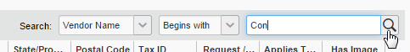
- Click (or press Enter).
The system returns a list of the vendors that match the search criteria.
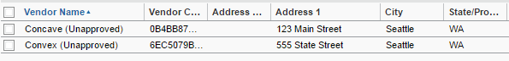

Include or Exclude Vendor in Capture Processing
As a Vendor Manager, you can prevent selected vendors from being included in invoices processed through Capture Processing. This option is only available to companies using Capture Processing and does not appear if the Capture Processing feature has not been enabled.
The Capture Processing feature is enabled by SAP Concur through an internal tool.
Preventing selected vendors from being included in invoices processed through Capture Processing can be useful when there is cross-department billing within a company and clients have set themselves up as vendors. By filtering these vendors out of the OCR engine, the capture process becomes more accurate at finding the correct vendor for the invoice.

Exclude a Vendor from Capture
All vendors are available for capture by default. Use this procedure to exclude one or more vendors from inclusion in the processed invoice generated by the Capture Processing tool.
To exclude a vendor from capture:
- Navigate to the Manage Vendors page.
- Search for the vendor that you would like to exclude from capture.
- In the Actions menu, select Exclude from Capture.
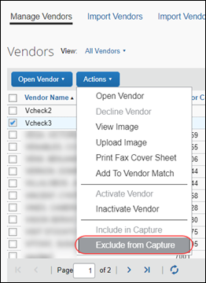
All of the vendors that you have excluded from capture are prevented from being used with the capture service. However, you can manually select an excluded vendor during the verify process.

Use the Vendor Import to Include or Exclude Vendors
If you import vendors by using the Vendor Import template that is available for download from the Import Vendors tab, you can enter Y or N in the Vendor Visible For Content Extraction column to specify whether to include or exclude the vendor.
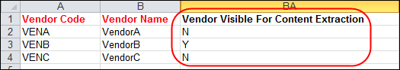

List Capture Processing Enabled and Disabled Vendors
If you would like to filter the list of vendors to either capture enabled vendors or capture disabled vendors, select Capture Enabled Vendors or Capture Disabled Vendors from the View menu.
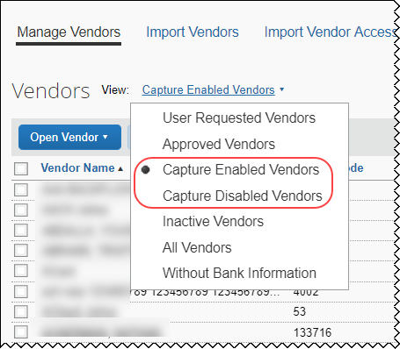

View Vendor Information
Details about a vendor—such as the vendor's name, address, and account number—are available on the Vendor Information page.
To view information about a vendor:
- Click Vendor Manager.
- On the Vendor Manager tab, search for the vendor:
- Use the View menu: Select a filtering option from the list.
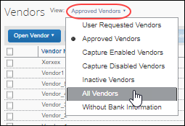
- Use the Search fields: Search using options in the Search fields (refer to the Searching for a Vendor section in this document for more information).
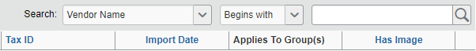
- Select the vendor.
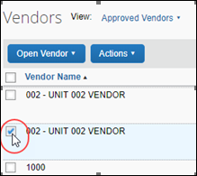
- Click Actions, and then click Open Vendor. You can also open the vendor information by double-clicking the vendor row in the list of vendors.
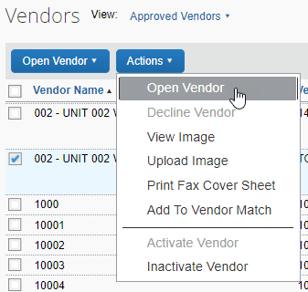
By default, a page similar to the following appears.
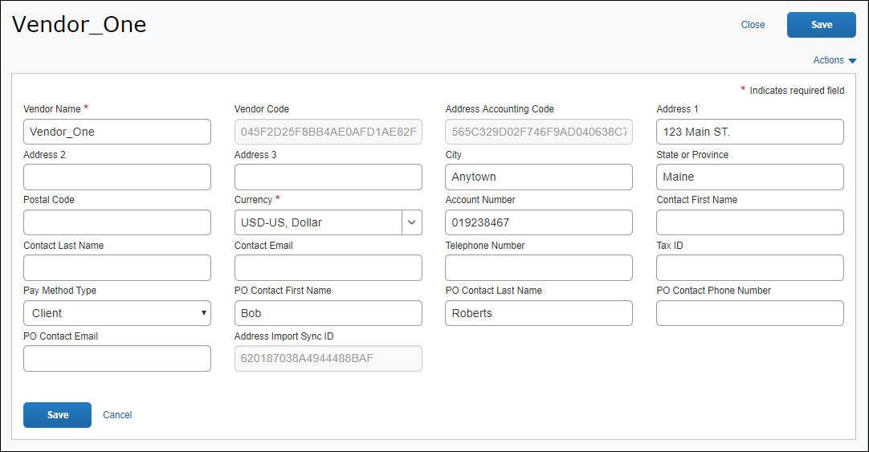
If the Create and Approve Vendors feature is disabled, a page similar to the following appears.
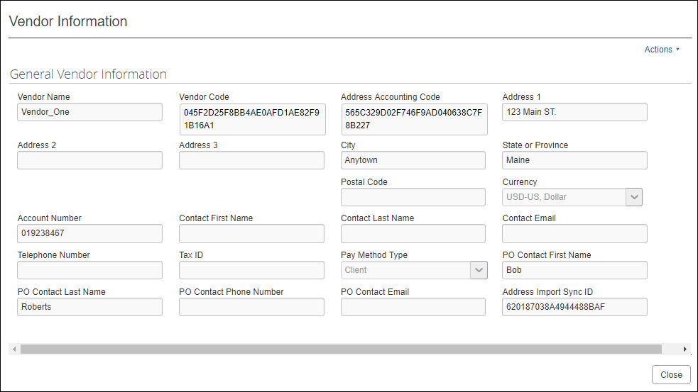

Export Vendor Data to Excel
The Vendor Manager can export vendor information for unapproved vendors, approved vendors, inactive vendors, or all vendors to an Excel spreadsheet. The format of the spreadsheet includes the rows and column headings.
- Only vendors that are visible on the page are included in the output
- A limit of 12,500 rows is enforced; if the exported list is greater than this, the system displays a message asking if the export should continue
To export vendor data to Excel:
- Click Invoice > Vendor Manager.
- On the Manage Vendors page, search for the vendors whose information you want to export.
- Click the Send to Excel link.
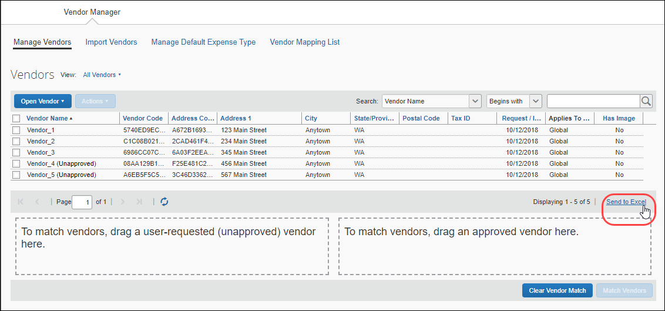
The vendor information is saved to an Excel spreadsheet and downloaded to the local system.
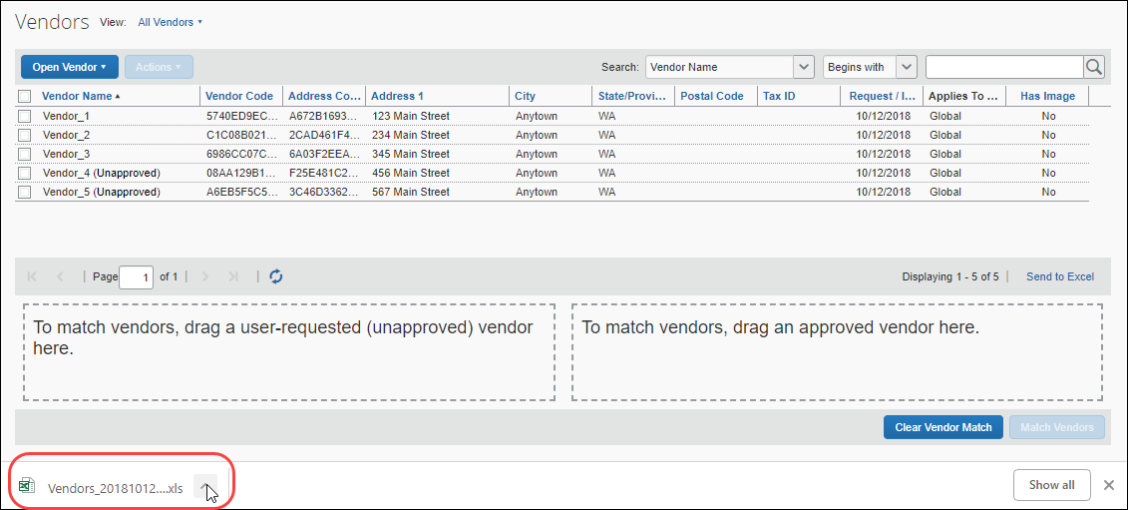
The Excel file contains columns for all fields that appear on the Vendor Information page regardless of whether the fields contain information.
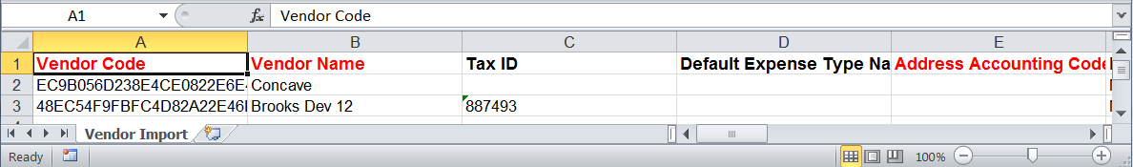

Add and Approve Vendors
By default, the Vendor Manager can add and approve new vendors. This feature can be disabled by the Invoice Admin.

Create and Approve Vendors Feature
The Create and Approve Vendors feature enables Vendor Managers to approve vendors. This feature is enabled by default and can be disabled by a user with the Invoice Admin role.
To disable the Create and Approve Vendors feature:
- (Invoice Admin only) Click Expense Settings or Expense & Invoice Settings or Invoice Settings.
- In the Product list, click Invoice.
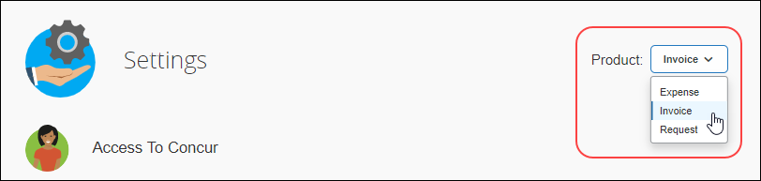
- In the Policy section, on the Invoice Approvals tab, click Edit.
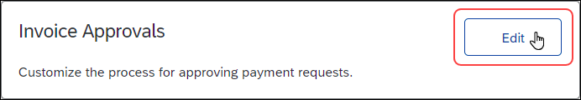
The Approval Routing page appears.
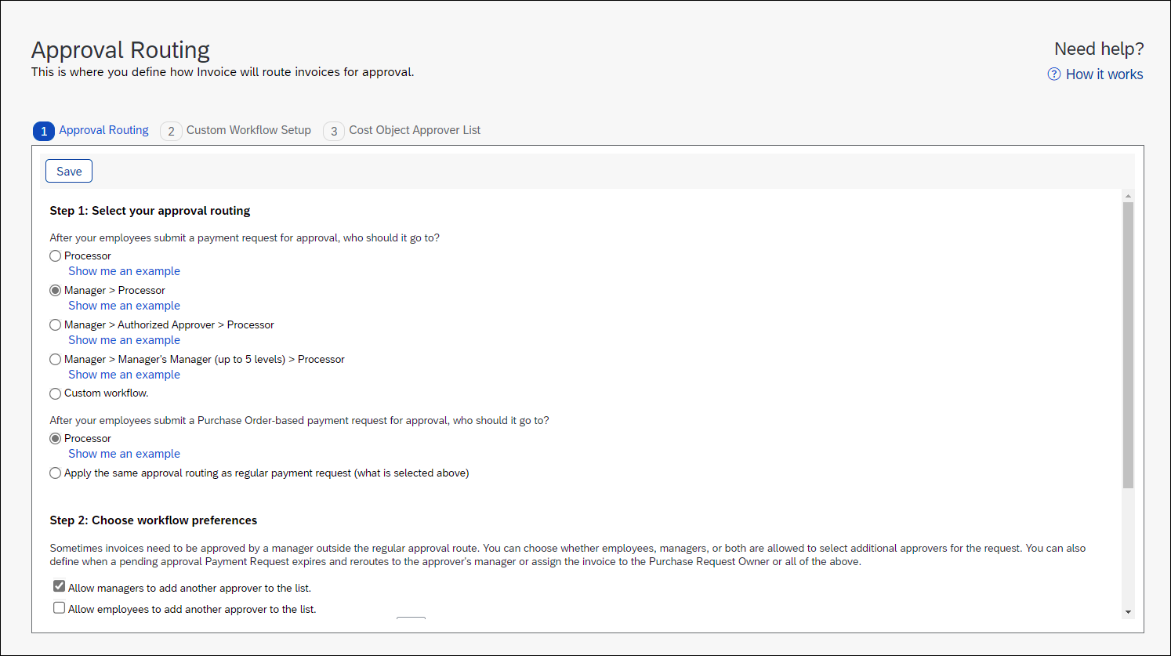
- In the Step 2: Choose workflow preferences section, uncheck (disable) Enable Create and approval for Invoice Vendor.
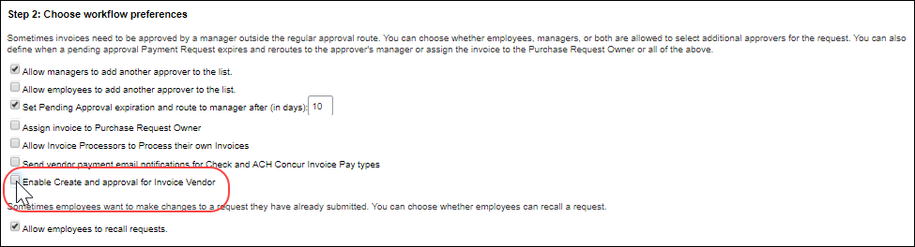
If the Create and Approve Vendors feature is disabled, vendors must be imported to be approved. Refer to the Import Vendors section of this document for more information.
To add a new vendor:
- On the Manage Vendors page, click Open Vendor > Request New Vendor. The New Vendor page appears.
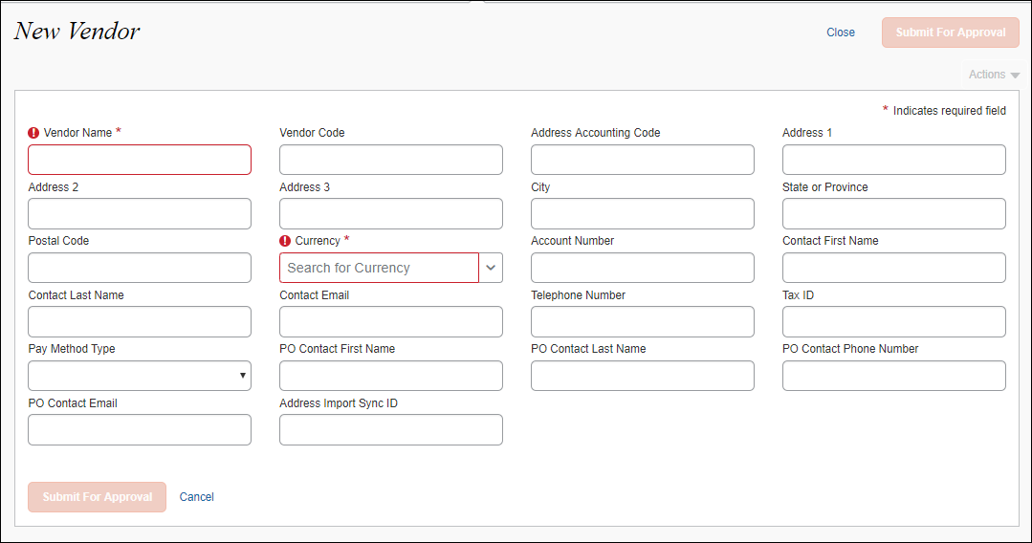
- Fill in the desired fields. If any of the fields are required, you must fill in those fields before submitting the form.
- Click Submit For Approval. The new vendor appears in the vendor list with a status of Unapproved.
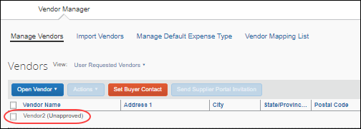
To approve an unapproved vendor:
- Select the vendor you want to approve.
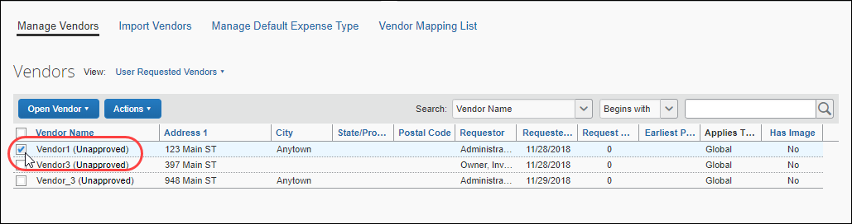
- On the Actions menu, click Open Vendor.
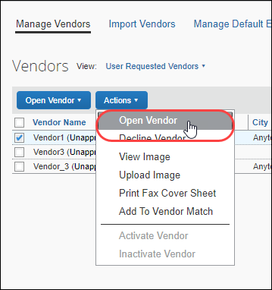
- Review the vendor information and then click Save and Approve.
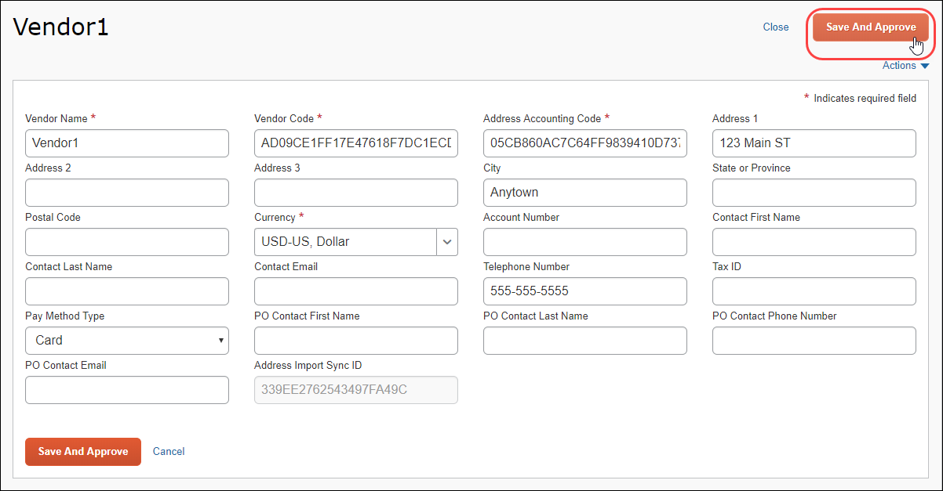

Update Vendor Information
By default, the Vendor Manager can update vendor information for unapproved and approved vendors. If the Vendor Manager updates vendor information for an unapproved vendor, the vendor will be approved when the vendor information is saved.
If the Create and Approve Vendors feature is disabled, the Vendor Manager can only update unapproved vendors and the vendor is not approved upon saving the information. When Create and Approve Vendors is disabled, vendor information for approved vendors can only be updated by importing updated vendor data.
To update vendor information for an unapproved vendor:
- Select the vendor whose information you want to update.
- On the Actions menu, click Open Vendor.
- Update the information as needed.
- Click Save and Approve.
If you do not want to approve the vendor, click Close. The vendor information will not be updated.
To update vendor information for an approved vendor:
- Find the vendor whose information you want to update by filtering the vendor list by approved vendors or by using the search fields to filter the vendor list.
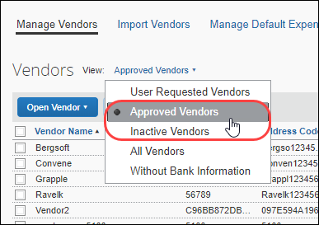
- Select the vendor whose information you want to update.
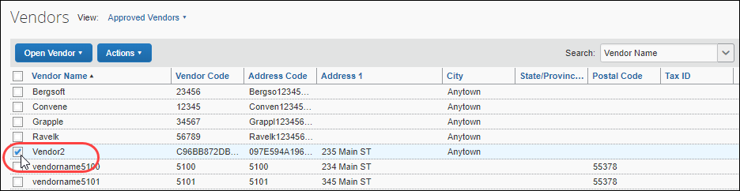
- On the Actions menu, click Open Vendor.
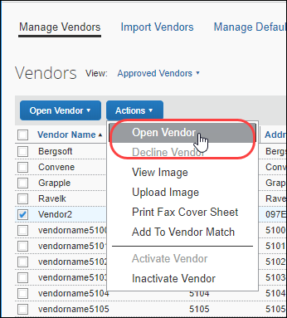
- Update the information as needed.
- Click Save.
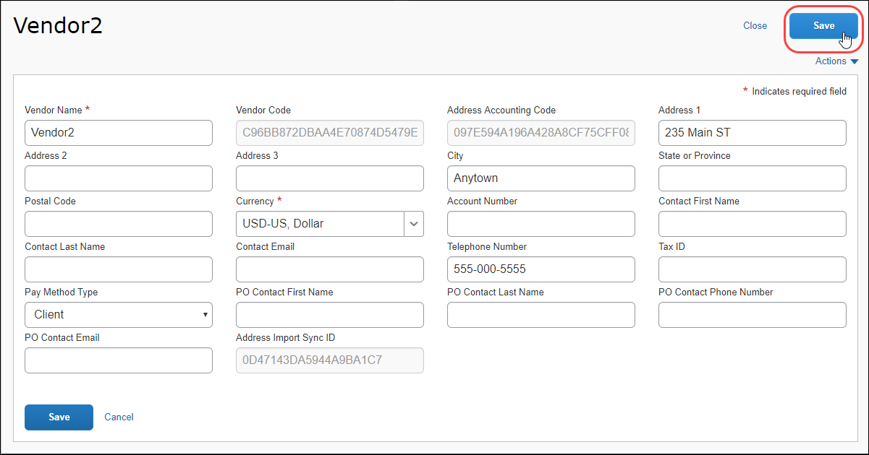

Review a Vendor's Audit Trail
Clients with the Create and Approve Vendors feature enabled can track any changes made to a vendor record by reviewing the Audit Trail page within the vendor's information page. For example, when a vendor is approved or updated by the Vendor Manager, the actions are added to the vendor information audit trail.
To view the vendor information audit trail:
- On the Manage Vendors page, select the vendor whose audit trail you want to view, and then select Open Vendor on the Actions menu.
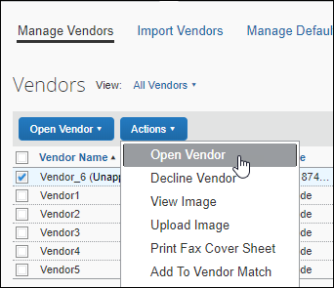
- On the vendor information page, select View Audit Trail on the Actions menu.
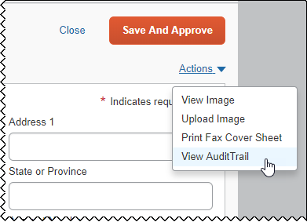
The audit trail for the selected vendor appears.
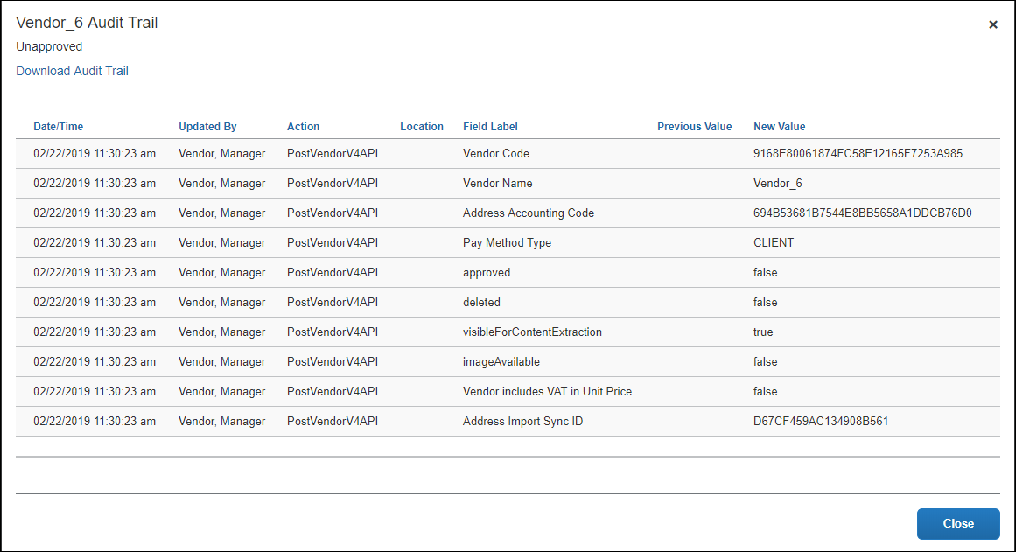
- (Optional) Download the audit trail to a comma-separated (.csv) file by clicking the Download Audit Trail link.
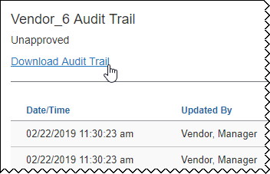

Create Custom Fields for Vendor Pages
Custom fields can be added to Concur Invoice vendor pages. Custom fields are created on the Custom Fields page in Product Settings and display on the New Vendor and Vendor pages in Concur Invoice.
When creating a custom field, admins can specify the copy-down sources for the custom fields on invoices, enabling them to choose whether custom fields should copy from the user profile to the Invoice Header or from the vendor record to the Invoice Header.
When an admin adds a custom field through the Custom Fields page in Product Settings, the field is added to the New Vendor page when a vendor manager or end user creates new vendors, and on the vendor information page for existing vendors.
Existing custom fields will not automatically be added to the vendor page. The admin must first visit the Administration > Invoice Settings > Custom Fields page. Visiting the Custom Fields page prompts the system to add the preexisting custom fields to the vendor page.
- For more information about creating custom fields, refer to Shared: Custom Fields Setup Guide for Concur Standard Edition.
To view custom fields on the New Vendor page:
- Click Invoice > Vendor Manager.
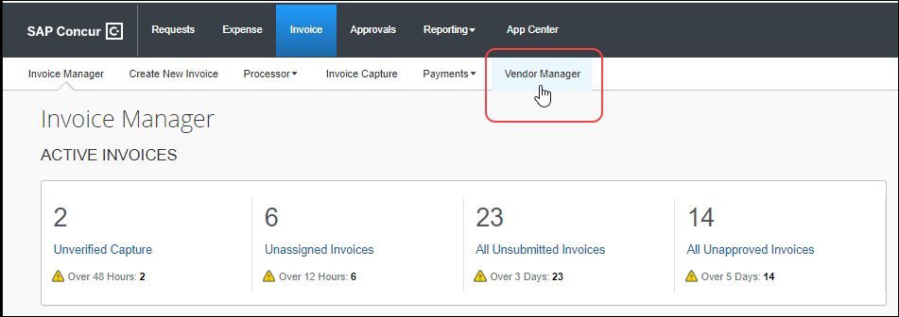
- Click Open Vendor > Request New Vendor.
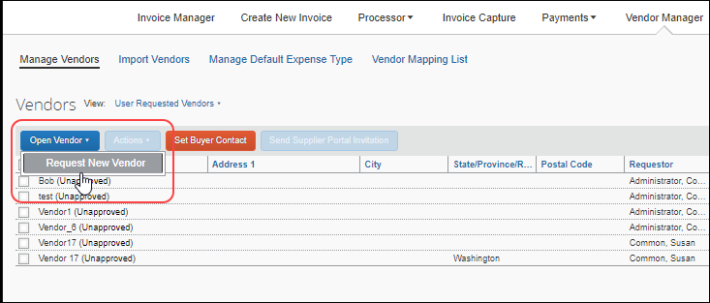
The custom field is included on the New Vendor page.
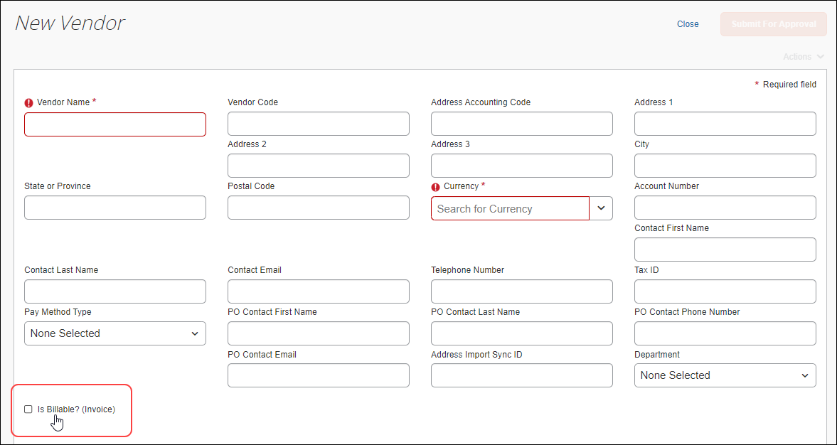
The custom field is also included on the page for existing vendors.
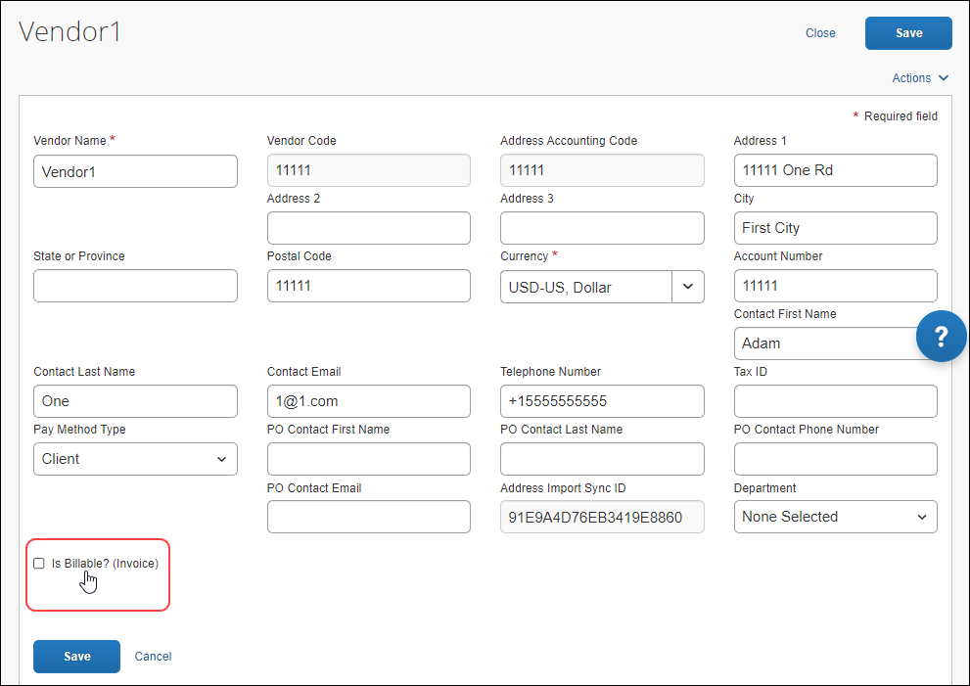

Add Vendor Banking Information to Vendor Form
The Invoice Admin can configure the New Vendor form to display the Vendor Banking Information section. The visibility of the Vendor Banking Information section can be configured for Invoice Owners only, Vendor Managers only, or both Invoice Owners and Vendor Managers. This section can be added to the form for all Invoice Owners or Vendor Managers, or the visibility can be based on which Invoice Policy Group the Invoice Owners or Vendor Managers are assigned to.
- For information about the Vendor Form Configuration option that adds this capability, refer to the Shared: Policy Groups Setup Guide for Concur Standard Edition.
How It Works
The Vendor Banking Information option can be set to one of the following:
- Hidden: The Vendor Banking Information section does not appear on the form.
- Required: The Vendor Banking Information section appears at the bottom of the form, and all the fields that are marked with a red asterisk (required fields) must be filled out before the form can be submitted for approval.
- Optional: The Vendor Banking Information section appears at the bottom of the form but entering banking information is optional and the form can be submitted for approval without banking information.
If the Invoice Admin configures vendor banking information to be visible, the banking information fields appear at the bottom of the New Vendor .
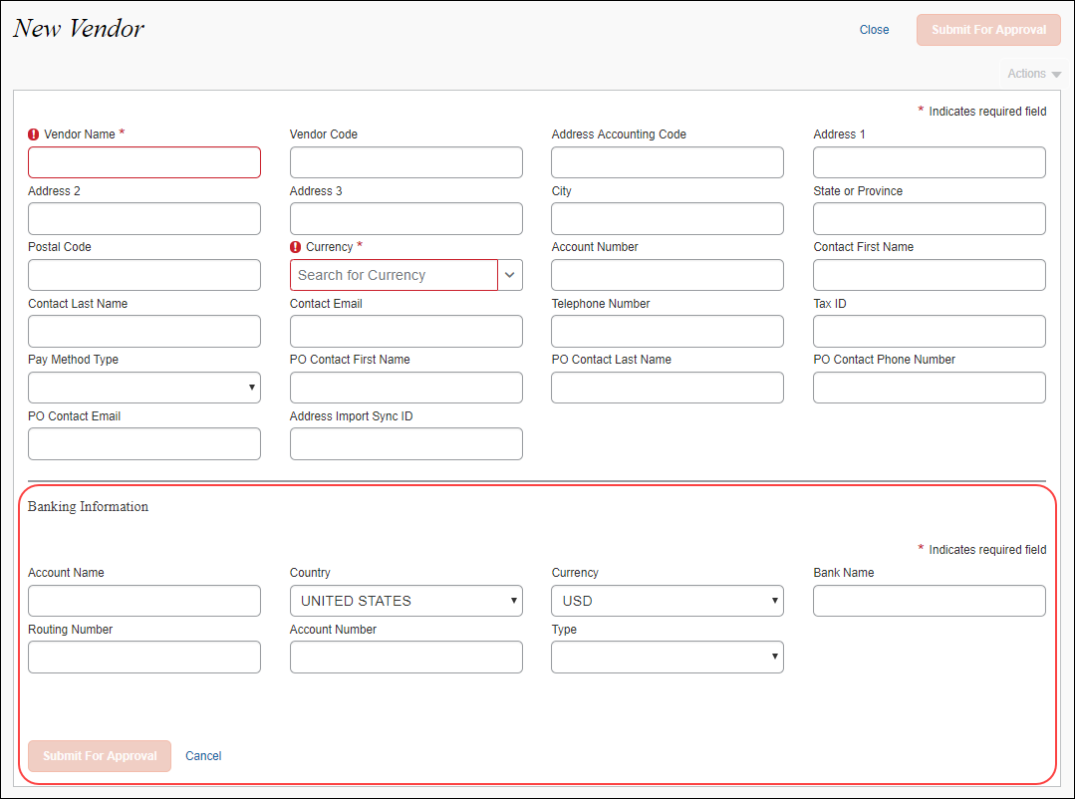

Filter Vendors Without Banking Information
You can filter the list of vendors so that only vendors without banking information are displayed. This feature makes is easier for the Vendor Manager to identify and update vendor forms that do not have banking information.
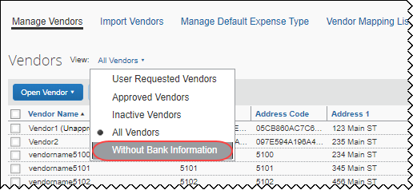

Deactivate and Reactivate a Vendor
Vendors can be deactivated and reactivated. Deactivating a vendor prevents the vendor from being associated with new invoices. For example, the Vendor Manager might want to deactivate a vendor that is no longer in business, has merged with another vendor, or when issues arise with financial transactions. Deactivating a vendor does not delete the vendor from the system, and a deactivated vendor can be reactivated.
Only an approved vendor can be deactivated and reactivated; unapproved vendors cannot be deactivated.
When the Vendor Manager deactivates a vendor:
- The vendor is marked with the status Inactive in the vendors list on the Manage Vendors page.
- The deactivated vendor can no longer be selected when creating a new invoice.
- The vendor no longer appears when filtering the vendor list by choosing Approved Vendor on the View menu.
- All invoices currently associated with the deactivated vendor require a new or different vendor; the system will prompt the user to select a vendor.
- The vendor can be reactivated.

Deactivate a Vendor
The Vendor Manager can deactivate one or more vendors.
To deactivate an approved vendor:
- On the Vendor Manager page, click Manage Vendors.
- Perform a search to return the vendor(s) you want to deactivate.
- Check the box next to the vendor(s) you want to deactivate.
- On the Actions menu, click Inactivate Vendor.
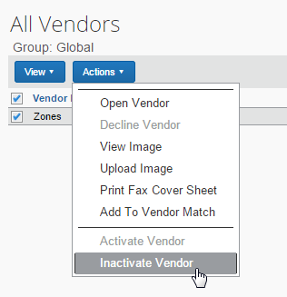
The vendor is marked Inactive and cannot be selected when creating new invoices.
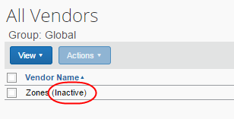

Filter for Deactivated Vendors
You can filter the vendor list so that only deactivated vendors appear.
To filter for inactive vendors:
- On the Vendor Manager page, click the Manage Vendors tab.
- On the View menu, click Inactive Vendors.
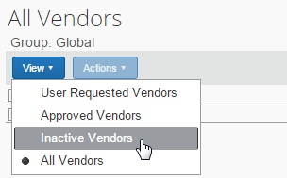
The system returns a list of vendors who have been inactivated.

Reactivate Deactivated Vendors
To reactivate a vendor:
- On the Vendor Manager page, click Manage Vendors.
- Perform a search to return the vendor(s) you want to reactivate.
- Select the vendor(s) to reactivate.
- On the Actions menu, click Activate Vendor.
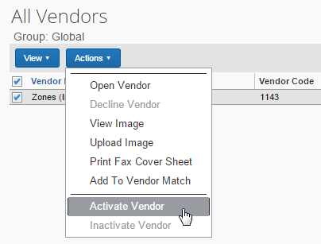
The vendor appears in the list when All Vendors or Approved Vendors is selected in the View menu, and the vendor can be selected when a new invoice is created.

Match a Vendor
When new vendors are requested, the Vendor Manager evaluates the request to ensure it is valid. If an unapproved (requested) vendor is found to be a duplicate of an existing approved vendor, the Vendor Manager can match the two vendors.
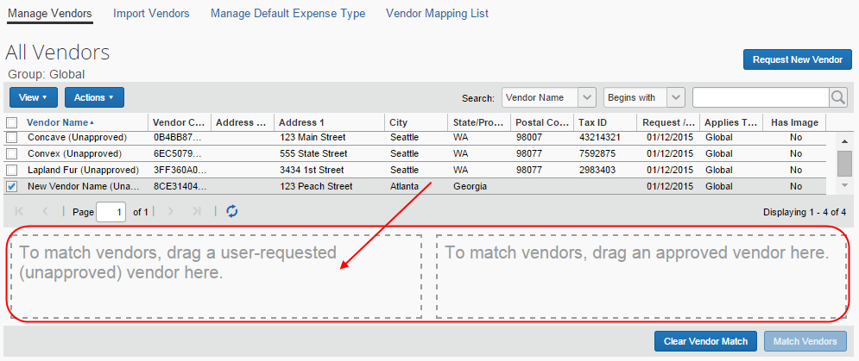
- IMPORTANT: An incorrect matching of vendors cannot be unmatched.
To match an unapproved vendor to an existing approved vendor:
- On the Vendor Manager page, click Manage Vendors.
- On the View menu, click All Vendors so that both approved and unapproved vendors appear in the list.
- To match the vendors:
- New unapproved vendor: Drag the unapproved vendor row to the "user-requested" (left side) box at the bottom of the Manage Vendors page.
You can also select the vendor request and click Add to Vendor Match from the Actions menu. The vendor request is directed to the correct box.
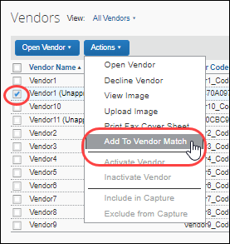
- Existing, approved vendor: Drag the approved vendor row to the "approved vendor" (right side) box at the bottom of the Manage Vendors page.
You can also select the vendor request and click Add to Vendor Match from the Actions menu. The vendor request is directed to the correct box.
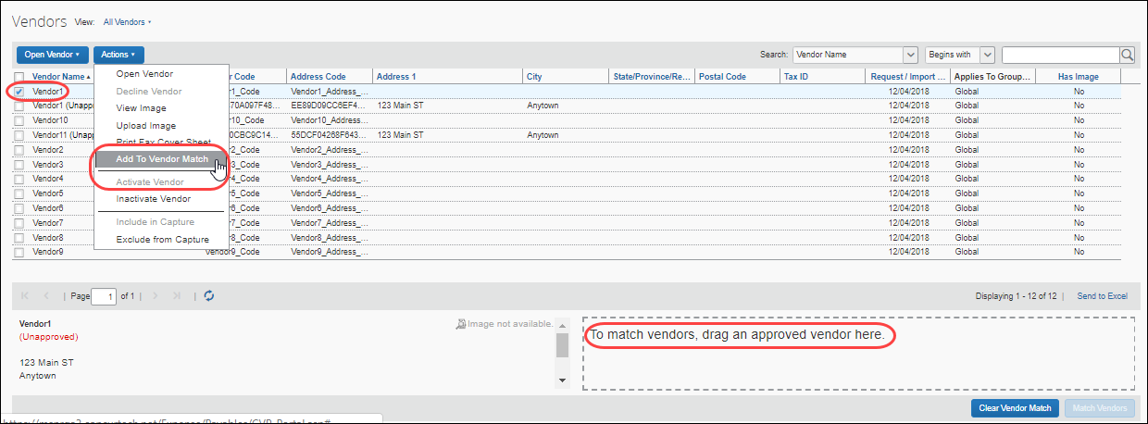
- (Optional) If the match is incorrect, click Clear Vendor Match.
- Click Match Vendors.
Matching the unapproved vendor request to the existing, approved vendor updates the system so all invoices that previously referenced the unapproved vendor are updated to reference the existing, approved vendor and the unapproved duplicate vendor request is deleted.

Decline a Vendor Request
The Vendor Manager can decline unapproved vendor requests. If a vendor request is declined, any invoices associated with the declined vendor are sent back to the invoice owner who submitted them.
To decline a vendor:
- On the Vendor Manager page, click Manage Vendors.
- Locate the vendor using one of the following methods:
- Select User Requested Vendors from the View menu.
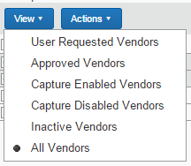
- Search by using options in the Search area
- Refer to the Searching for a Vendor section in this document for more information.
- Select (enable) the check box next to the vendor you want to decline.
- In the Actions menu, click Decline Vendor.
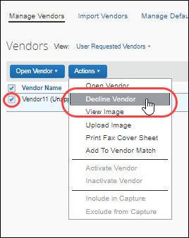
Invoice removes the vendor record from the Vendor Master list. If invoice(s) are associated with the declined vendor, the Vendor Manager is prompted for a comment to guide the originator/submitter to choose a valid vendor.
If an invoice has been submitted and the vendor request associated with the invoice has been declined, the invoice is returned to the owner to be updated with a valid vendor.
The returned invoice appears in the invoice owner's list of unsubmitted invoices. If the invoice owner attempts to resubmit the invoice without updating the vendor, the Submit Status message appears. Click OK to select another vendor.
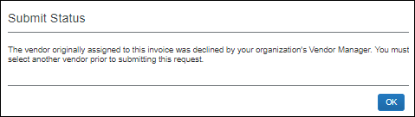

Assign a Default Expense Type to a Vendor
An approved vendor can be associated with a default expense type so that, when an invoice is received from the vendor, the designated expense type is automatically assigned to the invoice.
Only approved vendors can be assigned a default expense type.

Benefits
In most cases, a single vendor has a routinely associated account code choice. For example, Vendor1 provides office supplies to Company A. As such, invoices from Vendor1 are routinely assigned the Office Supplies expense type.
By assigning a default expense type to Vendor1, Company A ensures that the correct expense type is always assigned to Vendor1 invoices and makes invoice processing more efficient by reducing the number of steps required to process Vendor1 invoices.

Assign Default Expense Types to Vendors
There are two ways to assign default expense types to vendors:
- The Vendor Manager can assign default expense types to one or more approved vendors through the Manage Default Expense Type page.
- The default expense type can be included in the Vendor Import file so that it is added to Concur Invoice when the vendors are imported.
- For more information, refer to the Concur Invoice: Invoice Vendor Import (On-Demand) User Guide.
To assign default expense types through the Manage Default Expense Type page:
- On the Vendor Manager page, click Manage Default Expense Type.
- Select (enable) the check box for the vendor for whom you want to assign a default a default expense type.
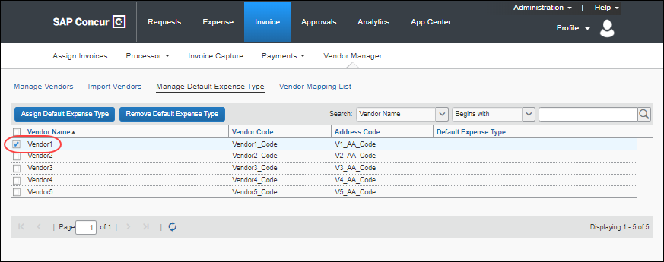
- Click Assign Default Expense Type.
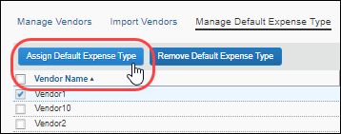
- In the Expense Type Helper, select an expense type from the list and then click Assign.
You can also filter the list of expense types by entering the first few letters of the expense type name in the Starts With field.
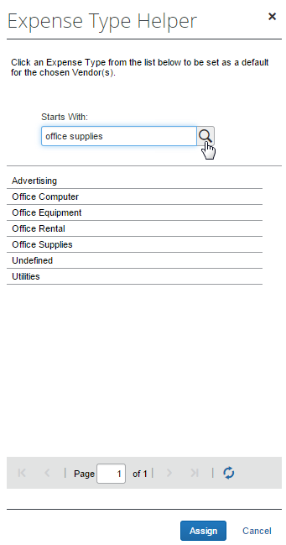
The assigned expense type appears in the Default Expense Type column on the Manage Default Expense Type page.
A default expense type can also be assigned to a vendor or vendors during vendor import by adding the desired expense type to the Default Expense Type Name column in the Vendor Import template. The expense type name must match an existing expense type in Concur Invoice.
- For more informatin, refer to the Concur Invoice: Invoice Vendor Import (On-Demand) User Guide for Concur Standard Edition.

Assign a Default Invoice Owner to a Vendor
A vendor can be associated with a default Invoice Owner so that an invoice is routed to the specified employee automatically. This ensures that an association is made if one is not specified through import or another method.

Default Vendor Owner Assignment and Capture Processing
When you map an employee to a vendor, invoices for that vendor are automatically assigned to the employee when the invoice is created on extraction in Capture Processing.
- For more information refer to the Capture Attention To section of Configuring: Exception Email Address and Instruction Text Options section in the Concur Invoice: Capture Processing Internal (Client-Managed) Setup Guide.
This association may be superseded by system rules or other assignment configurations - for example detection of an invoice owner through the login ID, email, employee ID, or invoice owner fields in the invoice import.
To associate a default invoice owner to a vendor:
- With the Vendor Mapping List tab open, search for the vendor or vendors to associate to an invoice owner.
- Vendor Name or Code: The unique code assigned to the vendor, or the name of the vendor, matched to all or part of the name or code (Begins With, Contains, etc.)
- Employee First or Last Name: The name, first or last, of the currently assigned Invoice Owner, matched to all or part of the name (Begins With, Contains, etc.) This lets you re-assign to a new owner.
User-requested and deleted vendors do not appear for matching.
- Click the magnifying glass () icon to begin the search.
- Select one or more vendors that you want to assign (or re-assign) to an Invoice Owner.
If a vendor is already assigned a default owner and you assign a different owner to the vendor, the previous owner is removed from assignment to the vendor.
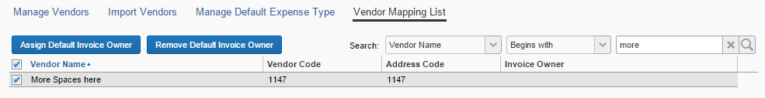
- Click Assign Default Invoice Owner. The Employee Helper window opens. Enter the search criteria based on the selection in Search Field (Last Name, First Name, Email Address, or Logon ID).
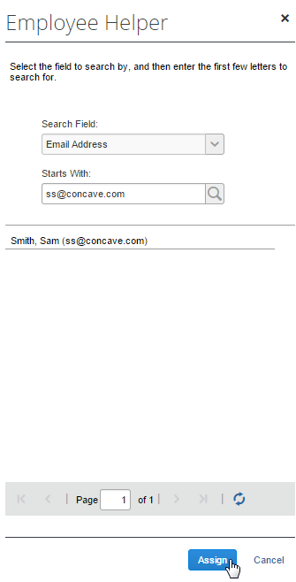
- To assign the new Invoice Owner to the vendor, click Assign. This association now appears in the Invoice Owner column in the list table of vendors.

Manage Sanctioned or Invalid Vendors
SAP Concur performs offline screening of vendors (suppliers) within Concur Invoice Vendor Management using the SAP Business Partner Screening (BPS) solution. The BPS solution is used to prevent prohibited vendors in embargoed countries or regions, or in sanctioned entities listed by the various applicable government agencies, from performing business activities with SAP products.
The SAP Export Control and Sanctions Compliance policy prohibits the use of all SAP products and services in, from, or in support of, any business activities in locations where SAP products and services are not available. Review the policy for a list of affected countries/regions and currencies.

Review Vendor Screening Status
On the Manage Vendors page in the Screening Status column, Vendor Managers can monitor the screening status for vendors.
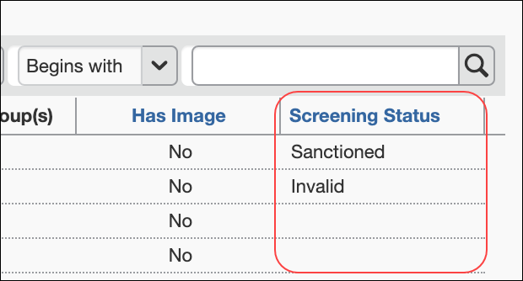
The Screening Status column displays three status results based on BPS screening:
- Sanctioned: Vendors that are identified during screening with ETS1 (individual/entity located in an embargoed country or region) or ETS4 (sanctioned individual/entity).
A Sanctioned status for a vendor record cannot be changed by the client. Only an authorized Concur Admin can modify a Sanctioned status for a vendor record.
- Invalid: Vendors that have incorrect or insufficient vendor data.
If a vendor has an Invalid status, the vendor record needs to be reviewed and updated. Once the vendor record has been updated for proper BPS screening, the status will change from Invalid to blank and users will be able to submit invoices for this vendor.
- Blank: Vendors that currently do not meet the criteria for Sanctioned or Invalid statuses. Users can submit invoices for vendors with a blank status.
A Sanctioned status for a vendor record cannot be changed by the client. Only an authorized Concur Admin can modify a Sanctioned status for a vendor record.
When a vendor’s screening status is changed, this change will be logged and documented in the audit trail.

Understand the End-User Experience
When users try to submit an invoice for vendors that are identified as having a Sanctioned or Invalid status during BPS screening, invoice submission will be blocked.

Sanctioned Vendors
When users try to submit an invoice for a vendor with a Sanctioned status, users will see the following message display:
The selected vendor contains a country/region or an entity in which SAP does not support. For additional information, please review the SAP Export Control and Sanctions Compliance policy statement on our website.

Invalid Vendors
When users try to submit an invoice for a vendor with an Invalid status, users will see the following message display:
At this time, SAP is unable to support the selected vendor as the registration information is not complete and accurate. Please ensure complete and accurate information for the selected vendor is provided.
Users should reach out to their Vendor Managers to ensure the vendor record is updated for required fields including Country, Currency, and State/Province, if applicable. Once the vendor record has been updated for proper BPS screening, the status will change from Invalid to blank. When the vendor record is updated to a blank status, users will be able to submit invoices for this vendor.

Import Vendors
The Vendor Import feature allows a user to import one or more vendors using the Import Vendors page. Options on this page allow the user to download an Excel spreadsheet, populate it with data, then upload and import the vendor data into Invoice.
- For more information, refer to the Concur Invoice: Vendor Import (On-Demand) User Guide.

Process Invoices
A user with the Invoice Processor role uses the Invoice Processor tool to confirm the accuracy of invoices submitted by employees using Concur Invoice. The Invoice Processor's role is typically the final signoff prior to authorizing payment to the vendor designated in the invoice. The Invoice Processor tool does not handle payment disbursement.

Required Roles
A user with the Invoice Processor role can perform the following tasks:
- Search for invoices by using existing or custom queries
- View unsubmitted invoices (required activation of payment setting)
- Change the approval status of invoices
- Mark the invoice received on invoices
- Clear exceptions on invoices
- Delete invoices
- Reassign invoices
- Customize the view of invoices by column

Access the Invoice Manager Page
The Invoice Processor can access the Invoice Manager page from the Invoice menu.
To access the Invoice Manager page:
Click Invoice. The Invoice Manager page appears.
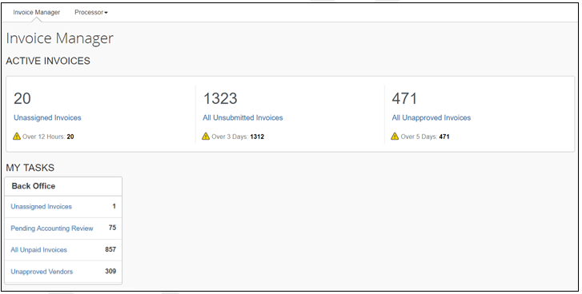
The Invoice Processor sees active invoices and their invoice tasks on the Invoice Manager page. Concur Invoice provides useful queries for invoice processors which they can access through links on the Invoice Manager page. These queries include unpaid invoices, unsubmitted invoices, unapproved invoices, and invoices pending accounting review.
To see some of the links on the Invoice Manager page, users might need additional permission roles. For example, if an Invoice Processor also has the Vendor Manager role, an Unapproved Vendors link displays in the Back Office section. Clicking this link will take the user to the Unapproved Vendors page in Vendor Manager.
The Invoice Manager page is divided into two sections: Active Invoices and My Tasks. The goal of the Active Invoices section is to raise awareness of invoices that are aging more than expected, and therefore might need Invoice Processor attention. An alert (yellow triangle) gives client visibility into the age of an invoice. For Capture Processing, the age is based on the Received date and for all other invoice counts, the age is based on the Invoice Created date.
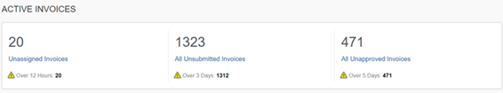
The My Tasks provides invoice processors access points to their daily tasks, for example, checking all unpaid invoices or invoices pending accounting review.
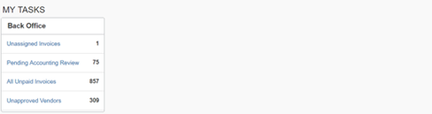

Access the Process Invoices Tool
Invoices can be processed on the Invoices Ready For Processing page.
To access the Invoices Ready For Processing page:
Click Invoice > Processor > Process Invoices.
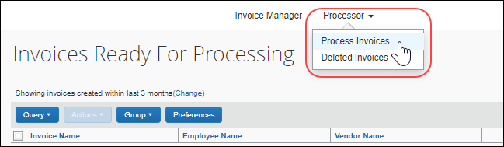

Overview: Process an Invoice
The following are the general steps required to process an invoice:
- Find an invoice and view its entries.
- Verify that Images have been uploaded (if required).
- Make any necessary modifications to the invoice and any backup documentation. Then:
- Delete the invoice if it is a duplicate.
- Upload or delete a receipt image.
- Send the invoice back to the creator to be updated or corrected.
- Set or remove the Review Required status on the invoice.
- Add steps to the approval workflow.
- Unassign the invoice.
- Approve the invoice. The following table shows available approval choices for the Invoice Processor.
Approval Status | Description
Accounting Review | States that the invoice is under review and allows minimal edits to occur within an invoice
Approved | States that the invoice has been approved
Sent Back to Employee | States that the invoice has been sent back to the submitter for modifications

Manage the Process Invoices View
The Invoice Processor can customize the Invoices Ready For Processing page by selecting column labels and setting other options on the Preferences page.
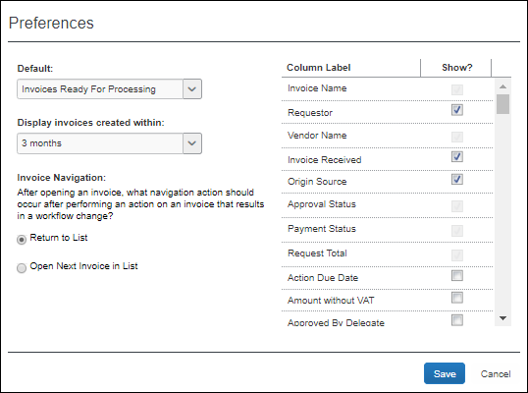

Set the Invoices Ready for Processing Page Preferences
Using the Preferences feature, you can add and remove columns and set how you want Concur Invoice to display the next invoice you want to process.

Manage the Invoices Ready for Processing Columns
To add or remove the invoice columns:
- On the Invoices Ready For Processing page, click Preferences.
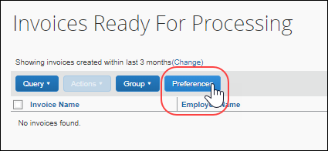
- Select (enable) the check boxes for the columns you want to add.
- Clear (disable) the check boxes for the columns to remove.
- Click Save.
To rearrange the invoice columns:
- On the Invoices Ready For Processing page, click and hold column header for the desired column.
- Drag and drop the column in the new location.
Arrows will appear to indicate where the column will be moved, and the page displays the new column order.

Set the Processor General Preferences
The Invoice Processor can specify whether the Invoices Ready For Processing page or a custom query is displayed when they click Invoice > Process > Process Invoices. They can also specify that only invoices created within a particular time frame be displayed and whether the list of invoices or the next invoice should be displayed after an invoice is processed.
To set the default landing page:
- On the processor page, click Preferences.
- In the Default list, select the home page preference.
The Default list contains the Invoices Ready For Processing page and any custom queries that have been configured. For more information about custom queries, refer to the Create a Custom Query section in this document.
- Click Save.
To set the time frame for displaying invoices:
- On the processor page, click Preferences.
- In the Display invoices created within list, select 3 months, 6 months, or 1 year to set the time frame for displaying invoices.
- Click Save.
To set the navigation sequence:
- On the processor page, click Preferences.
- Under Invoice Navigation, select how Concur Invoice should act after you approve an invoice:
- Return to List: Open the processor page
- Open Next Invoice in List: Open the next invoice according to the current order under the Invoice Name column
- Click Save.

Search for Invoices
Existing invoices are located either by entering search criteria or by running a preconfigured or custom query.

Search for an Invoice
To search for an existing invoice, you can enter specific criteria by which the results should be narrowed. You can do this by using the Search functionality.
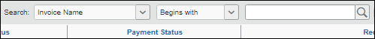
To search for invoices by using search criteria:
- Select and enter the appropriate search criteria to find the desired invoices. The following table outlines the available criteria:
Name | Available Operators | Text Entry
Invoice Name | Begins with, Contains, Ends with, Equals | Enter part or all of name
Request Key | Equals, Less Than, Less Than or Equal, Greater Than, Greater Than or Equal
Transaction ID | Begins with, Contains, Ends with, Equals
Employee Last Name | Begins with, Contains, Ends with, Equals | Enter part or all of name
Employee First Name | Begins with, Contains, Ends with, Equals | Enter part or all of name
Employee ID | Begins with, Contains, Ends with, Equals | Enter part or all of ID
Invoice ID | Begins with, Contains, Ends with, Equals | Enter part or all of ID
Check Number | Begins with, Contains, Ends with, Equals | Enter an amount
Latest Submit Date | Equals, Less Than, Less Than or Equal, Greater Than, Greater Than or Equal | Enter part or all of date
Approval Status | Begins with, Contains, Ends with, Equals | Enter part or all of name
Payment Status | Begins with, Contains, Ends with, Equals | Enter part or all of name
Invoice Received | Is True, Is False | Not Applicable
Invoice Image Available | Is True, Is False | Not Applicable
Request Total | Equals, Less Than, Less Than or Equal, Greater Than, Greater Than or Equal | Enter an amount
Vendor Name | Begins with, Contains, Ends with, Equals | Enter part or all of name
Vendor Invoice Number | Begins with, Contains, Ends with, Equals
Vendor Code | Begins with, Contains, Ends with, Equals
Pending Processor Since | Equals, Before, After
- Click the magnifying glass () to initiate the search.

Use a Query to Search for an Invoice
You can also search for an invoice by selecting a preconfigured query or a custom, condition-based query from the Query menu.
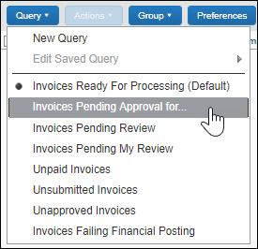

Search for an Invoice Using a Preconfigured Query
You can find invoices by selecting a preconfigured query by clicking Query and then selecting the desired query from the list. For example, you can search for all invoices that are pending approval by a specified invoice approver.

Create a Custom Query
You can create a custom query that will appear on the Query menu. Queries you create cannot be viewed, edited, deleted, or used by anyone else. Although custom queries cannot be shared with other processors, default queries are available to all processors.
To create a custom query:
- Click Query > New Query.
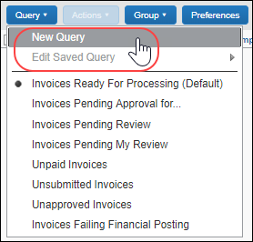
- In the Query Builder window, select the conditions for the query.
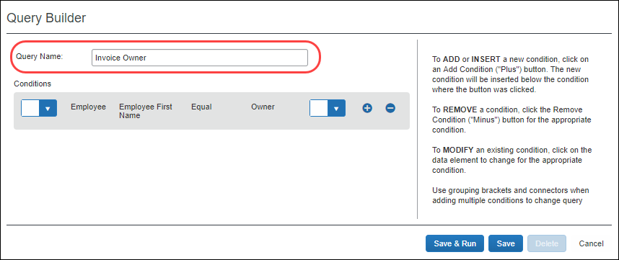
- Click:
- Save & Run: Saves the query in the Query menu, and runs it immediately, returning the results.
- Save: Saves the query for use in the Query menu.
The name entered in the Query Name field will appear on the Query menu after the new query is saved.
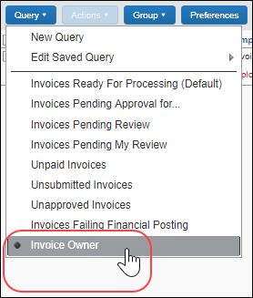

Edit a Saved Query
You can edit the custom queries that you create. Default queries are available to all users with the Invoice Processor roll and are not editable.
To edit your custom queries:
- Click Queries > Edit Saved Query and select the query you want to edit.
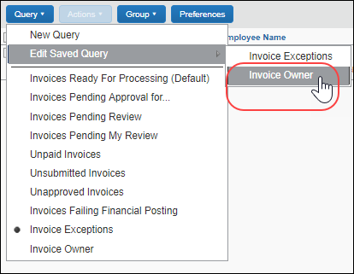
- Refer to Creating a Custom Query in this document for steps to edit your query.
- Click:
- Save & Run: Saves the query in the Query menu, and runs it immediately, returning the results.
- Save: Saves the query for use in the Query menu.

Delete a Query
You can delete your custom queries. Standard queries cannot be deleted.
To delete a custom query:
- Click Queries > Edit Saved Query and click the query you want to delete.
- Click Delete.
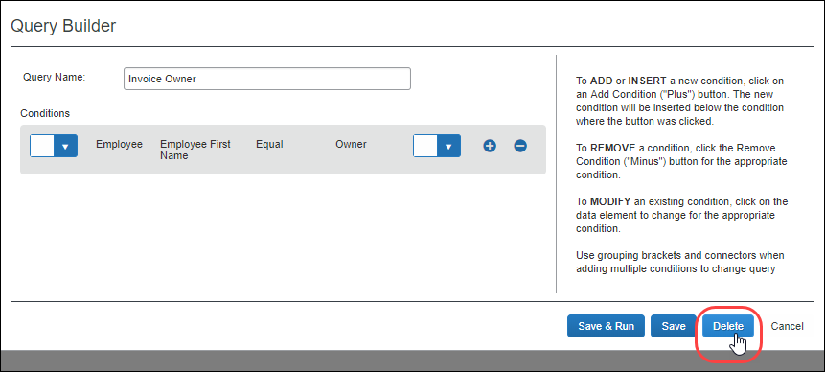
- Click Yes to confirm you want to delete the query.
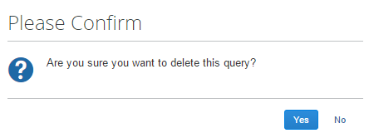
The query no longer appears on the Query menu.

Export Query Results
You can export the results of running a query to an Excel file.
To export the results of your query:
- Run the query for the results you are seeking.
- Click Send to Excel in the lower-right corner of the page.
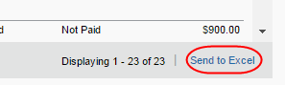
The Excel file is downloaded to the default download location on the local machine. (On Windows machines this is typically the user's Downloads folder). The file contains the column headers and data for all of the columns and rows displayed on the query results page including columns added through the Preferences page.

View and Modify Invoice Information
The following section details how to work with invoices that require processing.

Open an Invoice
To open an invoice:
- On the processor page:
- Click the row for the invoice you want to open.
-OR-
- Select the invoice and then, on the Actions menu, click Open Invoice.
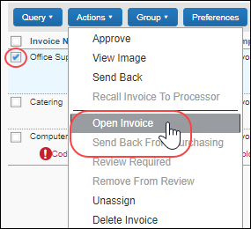
The invoice opens with all information displayed in the Summary view.
- To return to the processor page view, click Processor > Process Invoices or Back to List.

View When SAP Concur Received an Invoice
You can see the exact time when SAP Concur received an invoice in the System Received Date field. This timestamp is carried over from client-managed Capture Processing to Concur Invoice and is a read-only field.
Clients who create invoices manually will see the full date stamp in the Created Date field in Concur Invoice.
The System Received Date column is available in the Column Label list on the Preferences page.
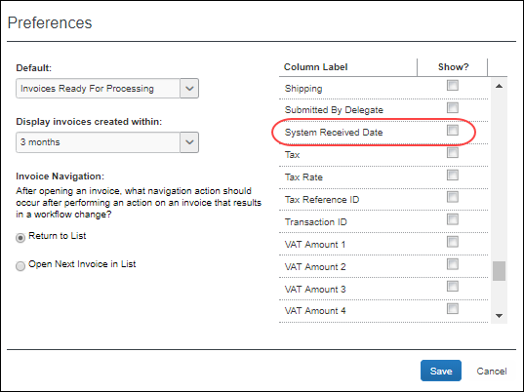
You can also use the System Received Date field to create queries in the Query Builder.
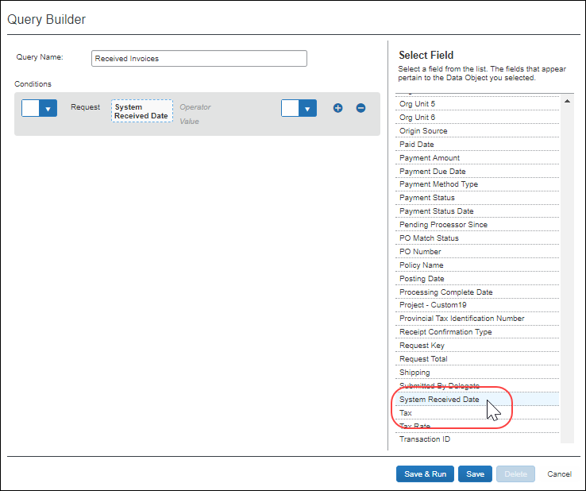

Mark Invoice (Image) Status for One or More Invoices
Depending on your company's configuration, employees can use the Imaging service to submit invoices. The Invoice Processor can view the invoices online by using the View Image command or button within the Invoice Processor tool.
To mark an invoice received or not received:
- On the Invoices Ready For Processing page, select one or more invoices, click the uppermost check box to select all invoices.
- In the Actions menu, click either Mark Invoice Received or Mark Invoice Not Received.
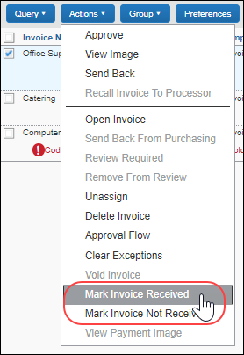
The status of the Invoice Received column changes to reflect the new status.
When you click Invoice Received or Invoice Not Received, all invoices in a multi-selected selection will be updated. Invoices can have differing statuses; for example, awaiting manager approval or pending processing. All can be updated simultaneously with certain restrictions.

View and Upload Images
The processor can view the existing images and attach additional new ones to the invoice.
To view images for an invoice:
- On the Invoices Ready For Processing page, select an invoice by selecting (enabling) its check box.
- Click Actions > View Image or click the View Image button.
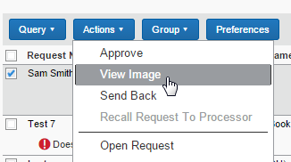
The system displays the image in a separate window. The Processor may print, save, or otherwise work with the image as required.
To upload images for an invoice:
- On the Invoices Ready For Processing page, select an invoice by selecting (enabling) its check box.
- Open it in summary view by clicking Actions > Open Invoice.
- Click Actions > Upload Image.
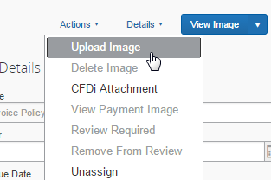
- In the Upload Image window, click Browse to locate the file to upload.
- Click Open to add the file to the Files Selection for Uploading list.
- (Optional) Repeat for as many images as you will add to the invoice.
- Click Upload to upload the file(s).
- Click Close to exit the Upload Image window.
If the file cannot be uploaded, an error message appears explaining why (size; wrong file type). Resolve the issue and try again or contact your Concur Invoice administrator for more information.

Clear Exceptions
Invoice exceptions can be cleared. If you clear exceptions from an invoice, all exceptions are cleared. You cannot choose to clear only some exceptions.
Exceptions are displayed on the Process Invoices page within the row for the affected invoice. The icon displayed for an exception differs depending on the level of exception.
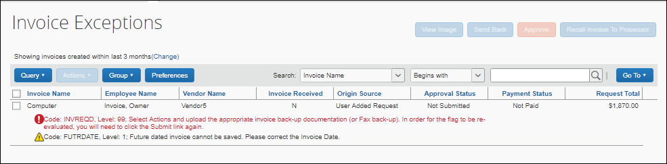
Exceptions are also displayed within the invoice details for the affected invoice.
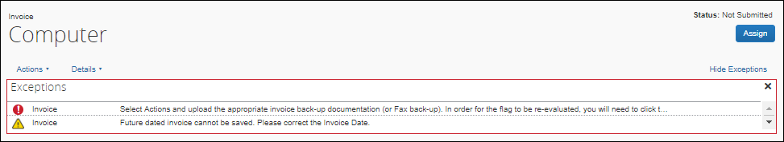
When an exception is cleared, it continues to display but the icon changes to an informational icon and the exception becomes inactive.
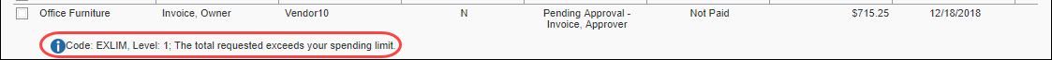
In addition, a message indicating that the exception was cleared is added to the audit trail for the invoice.
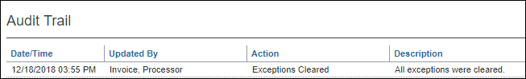
To clear invoice exceptions:
- Click Invoice > Processor > Process Invoices and then select the relevant invoice(s).
- Click Actions > Clear Exceptions. All exceptions are cleared.
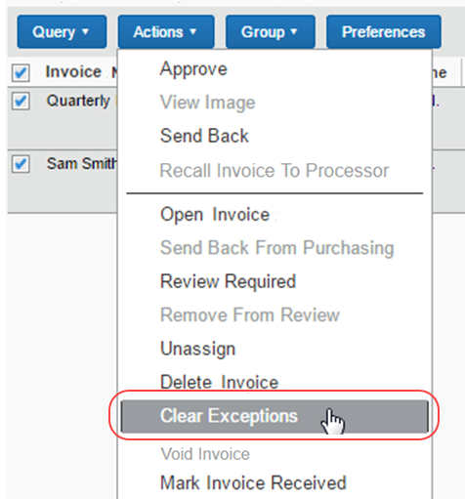
Certain exceptions may require the processor return the invoice to the user, and then have the user resubmit the invoice to clear the exception.
You can also clear exception from within an invoice by clicking the Clear Exceptions link.
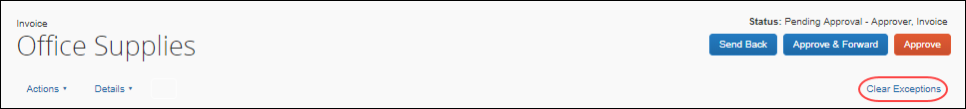

Approve an Invoice
Once the Processor is satisfied that the invoice can be approved, they can do this on the Invoices Ready For Processing page.
To approve an invoice:
- On the Invoices Ready For Processing page, search for the invoices that are to be approved.
- Click Actions > Approve or click the Approve button.
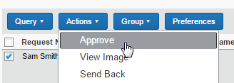
The invoice is approved and now ready for extract.
You do not receive a confirmation that the invoice is approved.

View and Manage Approval Workflows
Invoice Processors may view and add approvers to the workflow process. If approvers are added to the workflow, the invoice will go to those approvers based on the overall workflow of the invoice.
An approver might be added when an approver returns an invoice to an employee for resubmission and an additional manager needs to see the invoice. Alternatively, if an exception is in question, the Invoice Processor might want another party to view the exception prior to clearing it from the invoice.
To review the approval workflow for an invoice:
- With the invoice in summary view, on the Details menu, click Approval Flow.
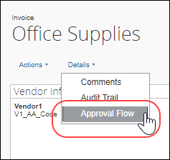
The Approval Flow for Invoice window appears.
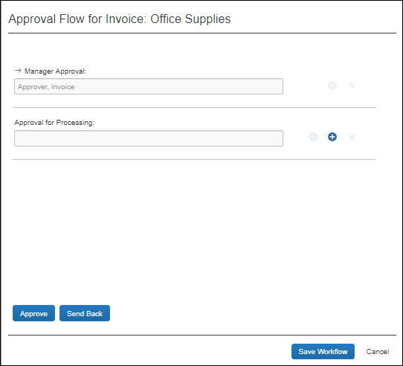
- Review the workflow details, and then click Cancel to close the window. Approvers may be added to the workflow by using the options in this window. If approvers are added to the workflow, the invoice will go to those approvers based on the overall workflow of the invoice.
The Processor can elect to use the Approve and Send Back buttons in the Approval Flow for Invoice window to reduce time processing invoices.
The processor can send an invoice, which is pending the processor, to an additional approver and then have the invoice sent back to the processor review step.
To send an invoice to an additional approver:
- With the invoice in summary view, click the Send to Approver button.

The Send Invoice to Approver window appears.
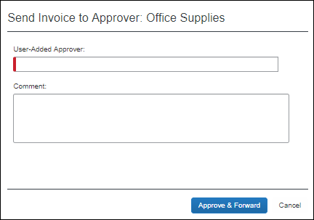
- Add an approver in the User-Added Approver step, and then click Approve. You can now go to the Approval Flow window (Details > Approval Flow) and see the two workflow steps that have been added, one for an approver and one for a processor.
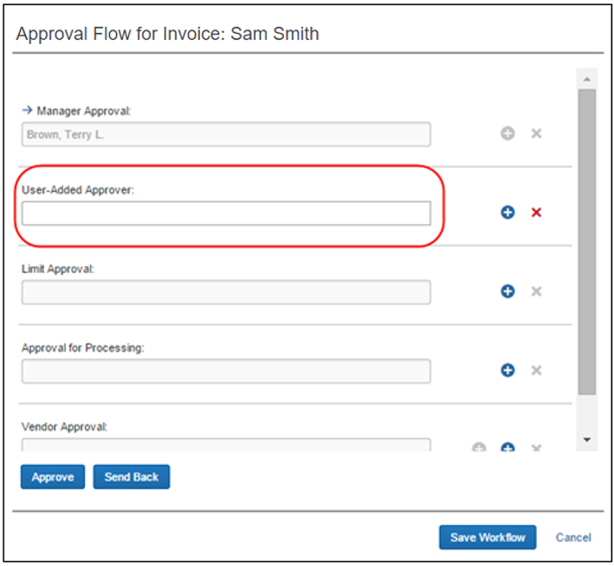

Place an Invoice in Review
The Invoice Processor can assign a status of Review in Progress on one or more invoices pending their approval. Doing this does not prevent another processor from moving the invoice through workflow; it simply alerts other processors that the invoice is under review, who placed it in that status, and the date this was done.
To place an invoice in review:
- On the Invoices Ready For Processing page, search for the invoice(s) to be placed under review.
- Select (enable) the check box next to each invoice to be placed in review, then click Actions > Review Required.
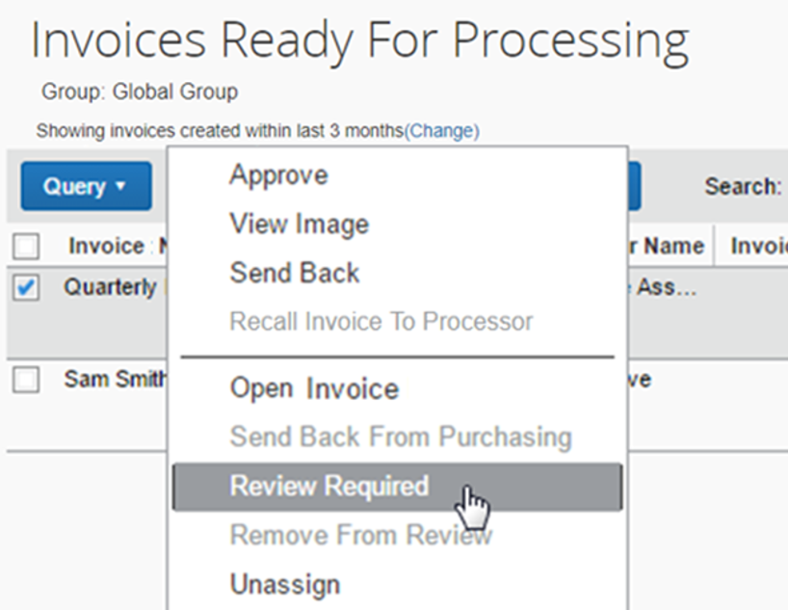
- In the Review Required window, provide a comment to explain why a review is required.
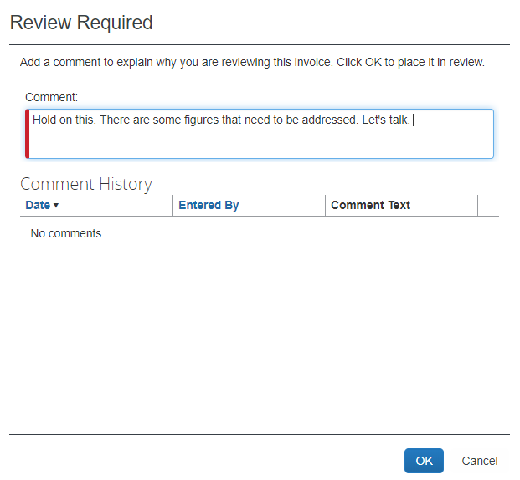
- Review any comments in Comment History that may affect your actions.
- Click OK.
A Review In Progress status is assigned and can be seen in the Approval Status column. If you hover the cursor over the review icon (a blue circle with a white "i"), you can view the comment directly within the page.
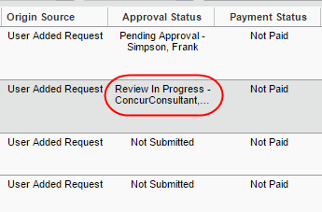
If the invoice is ever sent back, the review status is removed from the invoice and this event is recorded in the audit trail.

Delete an Invoice
The Invoice Processor Manager can delete invoices. This action is only available when the invoice has already been submitted and has not yet been extracted for payment.
To delete an invoice:
- On the Invoices Ready For Processing page, search for the invoices that you want to delete.
- Select (enable) the check boxes next to the desired invoices.
- In the Actions menu, click Delete Invoice.
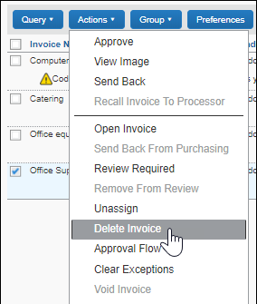
- Invoice prompts you to confirm your action in the Please Confirm window.
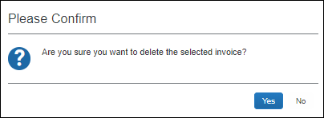
- Click Yes to delete the invoice.

Restore a Deleted Invoice
The Invoice Processor Manager can restore (undelete) one or more invoices. The invoice is returned to active status in an unassigned state and appears in the Deleted Requests page.
To restore a deleted invoice:
- In the Processor menu, click Deleted Invoices.
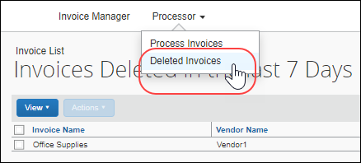
- Perform a search if the default query return does not show the invoice you want to restore.
- Select the invoice(s) to restore.
- Click Actions > Restore Invoice or click Restore Invoice.
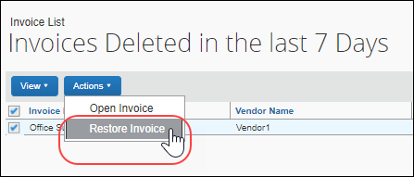
- In the Restore Invoice page, enter a comment about why you are restoring the invoice.
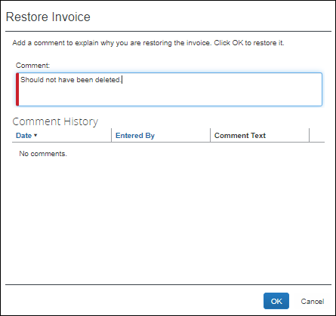
The invoice is returned to a status of Active, assigned to the original invoice owner, and appears in their queue. The audit log is updated with the date and name of the user who deleted the invoice.
The audit log is updated with the date and name of those users who deleted or restored any invoices.

Void an Invoice
If the financial system will not pay an invoice, or the invoice is deemed invalid, the Invoice Processor Manager role may change the invoice's Payment Status to Voided. This is useful where an invoice is rejected or cancelled in the client's financial system and the client wishes to apply this status to the invoice within Concur Invoice as well. When an invoice is voided, a record of the invoice remains in the system, but the invoice is not included in any listing or extract of general invoices. However, voided invoices can be included in search result lists by filtering the search where Payment Status is equal to Voided.
The invoice can be voided in batches, at the Invoices Ready For Processing page level, or at the invoice level by opening the invoice directly in summary view. The procedure below explains how to do this at the Invoices Ready For Processing page level.
For an invoice to be voided, it must first be extracted.
To void an invoice:
- On the Invoices Ready For Processing page, select the invoice you want to void by selecting (enabling) its check box.
- In the Actions menu, click Void Invoice.
The invoice is now assigned a Payment Status of Voided. The audit log is updated with the date and name of the user who voided the invoice.

Manage Receipts and Receipt Images
Invoice Processors who work with the Receiving feature, can add, edit, delete receipts and receipt images of the transmitted purchase order in the Purchase Order tab.
- For more information, refer to the Concur Receiving section of the Concur Invoice: Purchase Order Matching User Guide.

View and Add Comments to an Invoice
The Invoice Processor can view comments related to an invoice, which the person who created the invoice added.
Processors may also add comments to an invoice that has been extracted or is in a paid state.
To view comments of an invoice:
- Open the desired invoice.
- Click Details > Comments.
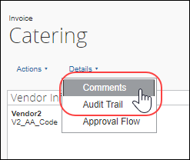
- In the Comment History window, review the comments and then click Close.
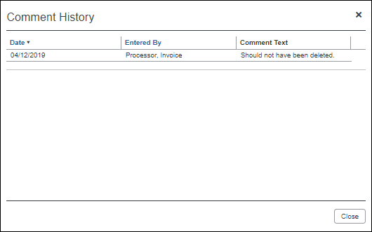
To add comments to an invoice:
- Open the desired invoice.
- Click Details > Comments.
The Comment History window appears.
- Add your comment in the Comments field.
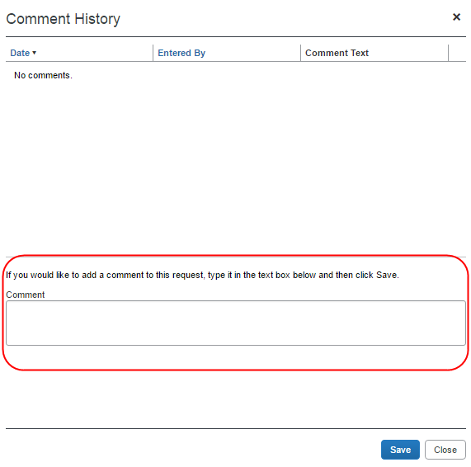
- Click Save.

Payment Manager
The Payment Manager page allows an administrator to view and manage batches of invoices that are ready for reimbursement. Each batch stays open until an administrator chooses to close it. Any invoices approved for payment will be listed in the currently open batch. An administrator can view the list of all the invoices in the batch from the Payment Manager page. Once a batch is closed, a transaction file listing the payments can be downloaded. This file can be imported into a financial system.

About the Payment Manager Page
The Payment Manager page allows you to run, search for, and download both import and extracts. By default, the Payment Confirmation Import link appears to all users. If the Download Extract feature is enabled, the GL Extract link appears in the Extract navigation menu as well. Finally, if both Invoice Pay and the Extract Download features are enabled, all options appear.
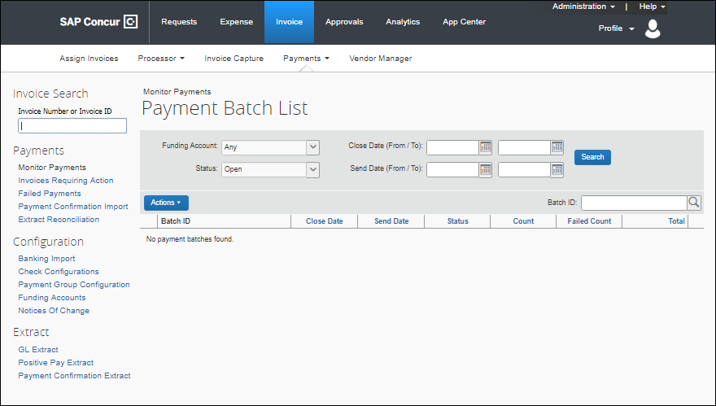
Depending on the options you enable with the help of SAP Concur, and those features you select in Product Settings, you may have one or more of the following transaction files available to you for your extract:
- A .CSV file
- A QuickBooks formatted (.IIF) file
- Extract and import feed files

Invoice Pay Clients
If you are interested in using Invoice Pay, or if you are currently using this add-on product to pay vendors, consult your Concur Invoice administrator for additional information about getting started with Invoice Pay.
- For more information about purchasing and using this product, refer to the Concur Invoice: Invoice Pay User Guide.

Payment Manager Processes
Use the procedures below to work with Payment Manager.
To access Payment Manager:
- Click Invoice > Payments > Payment Manager.
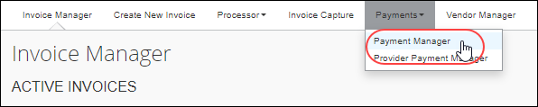
The the Payment Batch List page appears.
- In the Extract section, click GL Extract (left menu.)
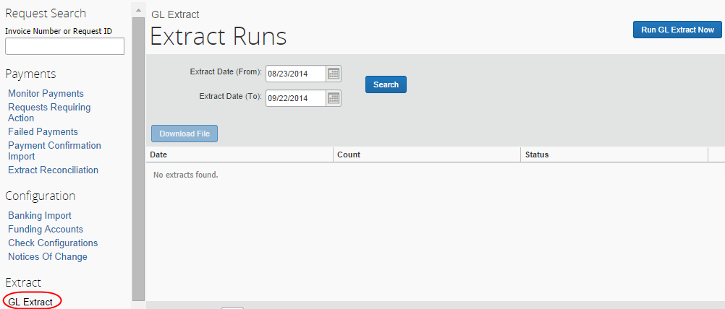

Work with the GL Extract
The GL Extract page is used to perform an overnight General Ledger (GL) extract on an on-demand schedule. The schedule is based on your choices during initial setup, where you were asked the schedule you would like to follow (Daily, Weekly, etc.). As a best practice, Invoice Pay users should coordinate the schedule of the extract with SAP Concur by consulting your Concur Invoice representative.
The page has two functions:
- Run the GL Extract: Perform the data extract from the client financial system for analysis as required.
- Search for and Download the Results File: Each extract run creates a file that can be searched for and analyzed for data, such as a failed row.

User Experience
When the Invoice Admin clicks GL Extract, the GL Extract page appears.
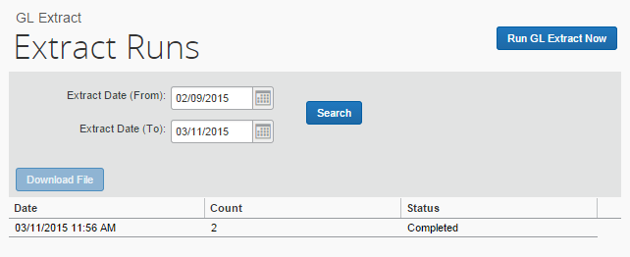

Run the GL Extract
The Invoice Admin role is required to run the extract.
To run the extract, click Run GL Extract Now.
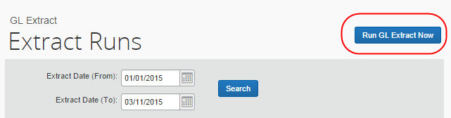
Depending on the job queue, the job may require time to process after preceding jobs in the job queue before the system can run the extract and generate the output file.

Search for the Output File
Once the extract run is finished, you can open an output file for review.
To search for the extract output file:
- Choose a date in Extract Date (From) by:
- Typing the date in mm/dd/yyyy format
- Selecting the date from the calendar
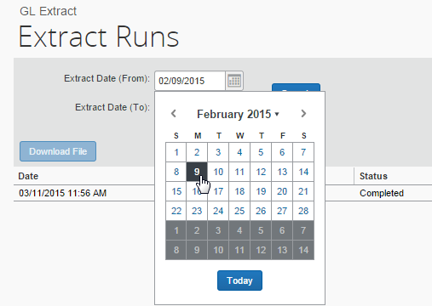
- Click Search to return the set of extracts found within the specified date range.

View (Download) the Output File
You can review the output file for a selected extract run by downloading the file.
To download the output file for an extract:
- Select a row containing the extract output file you want to review. Use the paging arrows if multiple rows prevent you from viewing the row.
- Click Download File.
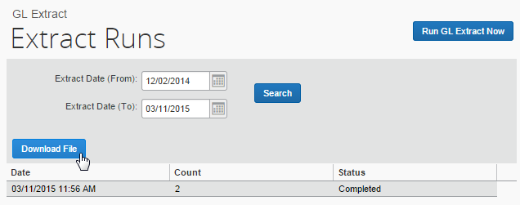
- Choose a local location to save the file, and then click Save.

Perform an On-Demand Payment Confirmation Extract
The on-demand Payment Confirmation Extract extracts invoice data from Concur Invoice to the client's financial system. This is helpful for Concur Invoice provider pay users, so that they can export provider payment information together with SAP Concur payment data.
To access the extract, click Invoice > Payments > Payment Manager, and then click the Payment Confirmation Extract link.
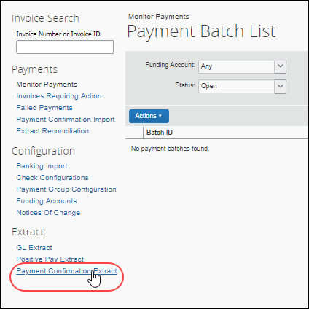

Run a Payment Confirmation Extract
To run a Payment Confirmation Extract:
- Select the dates from which you want to run the extract.
- Click Search and then click Run Payment Confirmation Extract Now.
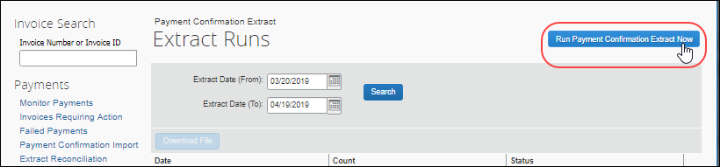
- For more information, refer to the Concur Invoice: Invoice Payment Request Confirmation Extract for Standard Edition.

Perform On-Demand Payment Confirmation Import
The on-demand Payment Confirmation imports invoice data from the client’s financial system making disbursements to the vendor. This data is imported into Concur Invoice and updates the payment status of invoices.
- For more information, refer to the Concur Invoice: Payment Request Confirmation Import User Guide.

Overview
The Invoice Admin begins by navigating to Invoice > Payment Manager, and then clicking the Payment Confirmation Import link to open the Import Payment Confirmations page.
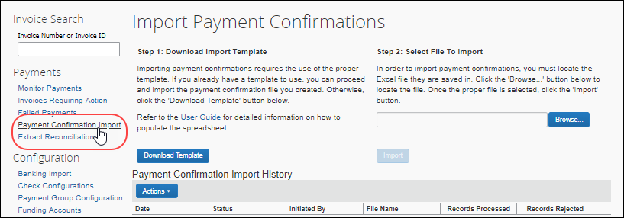
The administrator then:
- Downloads the template (or optionally provides their own)
- Populates the spreadsheet with invoice confirmation data
- Uploads and imports the template data
- Reviews the import details for any issues

Reporting
SAP Concur has partnered with Cognos to deliver a strong reporting platform for SAP Concur clients. The Reporting tab appears for users who have been granted the Reporting roles on the Users page. SAP Concur specific reporting documentation can be accessed from the Reporting tab.

Access Analysis/Intelligence Documentation via Cognos
To access Analysis/Intelligence (formerly Concur Insight) documentation from within Cognos, click Launch > Help – Report Catalog.
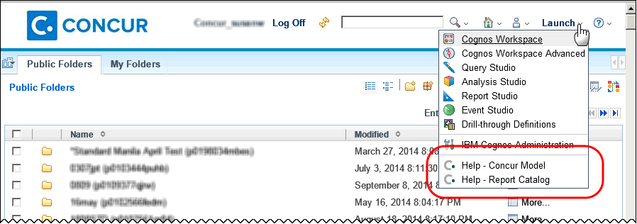

Web Services
Administrators use the Web Services page under Administration to manage partner applications for the SAP Concur Connect platform. You can use the links on this page to register a partner application with SAP Concur or enable a partner application to access your SAP Concur data.
The SAP Concur Connect infrastructure consists of:
- A user interface to register partner applications for partners that will be using the web services
- A user interface to enable the partner applications for each company
- A common authentication and authorization model that will determine the application’s level of access
Some web services are only available with the SAP Concur Professional product.
- For detailed documentation about the Web Services page and the available web services, refer to http://developer.concur.com.

Appendix
Special procedures and cases are documented in this section.

Switch Tax Mode
The Tax field allows the Invoice User to enter tax at both the invoice and the line item levels, or just one of them. This field can handle different tax rates within a single invoice, such as Sales and Use tax rates in the U.S., and the Value Added Tax in other countries. This line-item Tax field is available in the Payment Request import, the Standard Accounting Extract, and for use in the Audit Rules and Processor Queries as well.

Use the Tax Field at Both the Invoice and Line Item Levels
Some clients will only need to enter tax at the header level, while others will only enter at the line item level. Clients who need to use both should consider adding both the header Tax field and the line item Tax field. If a client configuration includes tax fields added at both header and line item levels, a Switch Tax Mode button appears on the Invoice page, and end-users can click it to switch between the header and line item "tax edit modes."
The invoice user can only use one Tax field, either at the header or line item level, per invoice.
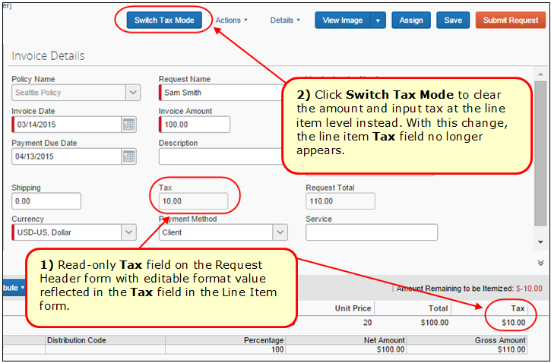
The figures below assume that Tax field configuration has been added at both header and line item levels; therefore the Switch Tax Mode button is displayed.
Example 1: Header Tax Edit Mode
Focus switched to header "tax edit" mode.
In this mode, you can edit the header field and the line item field is not displayed.
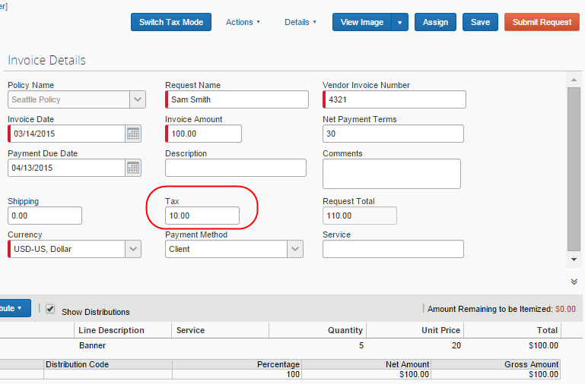
Example 2: Line Item Tax Edit Mode
Focus switched to line item "tax edit" mode.
In this mode, the header field is read-only, and you can edit the line item fields.



