
Shared: QuickBooks Integration Using Concur Financial Integration Service
Setup Guide for Concur Standard Edition
Last Revised: August 19, 2023
Applies to these SAP Concur solutions:
 Expense
 Professional/Premium edition
 Standard edition
 Travel
 Professional/Premium edition
 Standard edition
 Invoice
 Professional/Premium edition
 Standard edition
 Request
 Professional/Premium edition
 Standard edition

Table of Contents
Section 1: Overview 1
Important Timing Considerations 2
Connecting to/Disconnecting From QuickBooks 2
Sending Expense/Invoice Data to QuickBooks 2
Changing Accounting Information in QuickBooks 2
Features 3
Supported Editions of QuickBooks 4
Prerequisites to Using the Concur Financial Integration with QuickBooks 4
QuickBooks Online 4
Definitions 4
Master Data 5
Employee 5
Cost Object 5
Financial Posting 5
Supported QuickBooks Account Types 6
Section 2: End-User Experience 7
Expense Report Audit Trail 7
Process Reports Page 7
Financial Posting Failed Query 10
Section 3: Invoice User Experience 10
Invoice Audit Trail 11
Process Invoices Page 11
Invoices Failing Financial Posting Query 13
Section 4: Configure the QuickBooks Financial Integration 13
Step 1: Accounting 14
QuickBooks Online - Connect to QuickBooks 14
Financial Integration Items 17
Including Receipt or Invoice Images When Posting to QuickBooks Online 18
ERP Liability Account Code (Invoice Only) 19
Step 2: Custom Fields 20
Custom Fields 20
View List Items 20
Step 3: Expense Types 21
Account Codes 21
Mapping Expense Types to QuickBooks Items 22
Step 4: Taxation 24
Invoice 24
Expense 24
Step 5: Employee Reimbursements (Expense Only) 26
Entering Account Codes for Reimbursement Methods 27
Step 6: Payment Types (Expense Only) 28
Consolidated Vendor Handling 30
Step 7: File Export Configuration (Invoice Only) 31
Step 8: Payment Manager (Invoice Pay Only) 31
(Optional) Configure Liability Accounts 31
Step 9: Synchronize Vendors From QuickBooks (Invoice Only) 32
Section 5: Managing the Integration 34
Updating Employees (Vendor) Records 34
Updating the Synchronized Data 34
Updating the QuickBooks Online Authorization 34
Disconnecting the Integration 34

Revision History
Date | Notes/Comments/Changes
August 19, 2023 | Added an ERP Liability Account Code section in the Step: 1 Accounting section. Updated the Step 7: and updated the File Export Configuration (Invoice Only) section. Minor edits throughout.
January 21, 2022 | Updated the copyright year; no other changes; cover date not updated
December 15, 2021 | Updated instructions for Product Settings page
October 22, 2021 | Updated the ADP Payroll reimbursement method note
September 29, 2021 | Added a note about mapping a user's data after connecting to the ERP.
September 22, 2021 | Added text in section 4 step 1 that Items aren’t supported in Concur Invoice.
May 13, 2021 | Added support for QuickBooks integration in AU.
April 15, 2021 | Updated the copyright year; no other changes; cover date not updated
March 22, 2021 | Replaced "Company Card" with "Payment Types" to reflect the new module name.
February 20, 2021 | The “Other Current Liabilities” QuickBooks account type is now supported.
November 25, 2020 | Updated the list of included account types on page 20.
November 14, 2020 | Updated the images on pages 15 and 33 to reflect the new “Connect to Quickbooks” button design.
August 19, 2020 | Added information about the new feature to include receipts and images.
August 11, 2020 | Fixed a typo; cover page not updated.
July 7, 2020 | Updated pages 5, 6, and 18 to reflect changes to the Custom Fields page.
June 16, 2020 | Added a note on page 20.
April 27, 2020 | Renamed the Authorization Request check box to Request on the guide’s title page; cover date not updated.
January 15, 2020 | Updated the copyright; no other changes; cover date not updated.
November 26, 2019 | Added a note to the overview and sync sections regarding 30-day purge of data.
October 31, 2019 | Updated the “What the Invoice User Sees” section.
August 17, 2019 | Updated to reflect changes to the File Export > Select Format page.
June 8, 2019 | Updated text and images throughout to reflect UI name change from "Cost Tracking" to "Custom Fields".
May 17, 2019 | Updated these sections:  - What the Invoice User Sees > Process Invoices Page  - Step 5: Employee Reimbursements (Expense Only)  - Step 6: Company Card (Expense Only)  - Step 9: Synchronize Vendors from QuickBooks (Invoice Only)
February 26, 2019 | Updated the Step 2: Cost Tracking section for changes to list management.
November 19, 2018 | Added new section:  - Updating the QuickBooks Online Authorization
September 22, 2018 | Updated screenshot of My QuickBooks Data page. September 2018 release moved from September 15 to September 22.
September 4, 2018 | Updated these sections:  - Supported QuickBooks Account Types  - Step 4: Employee Reimbursements (Expense Only) > Entering Account Codes for Reimbursement Methods
August 18, 2018 | Added the following section:  - Important Timing Considerations > Connecting to/Disconnecting From QuickBooks  Updated the following sections:  - Configure QuickBooks Financial Integration > Step 1: Accounting > QuickBooks Online – Connect to QuickBooks  - Managing the Integration > Disconnecting the Integration
July 27, 2018 | Updated the Configure QuickBooks Financial Integration > Step 2: Cost Tracking > Data Entry Details section with new list functionality.
May 23, 2018 | Added information about Invoice tax codes in the Step 4: Taxation section
May 12, 2018 | Added the Supported QuickBooks Account Types section and updated the Step 2: Cost Tracking > Data Entry Details section.
April 16, 2018 | Changed the check boxes on the front cover; no other changes; cover date not updated
April 14, 2018 | Added the Step 9: Synchronize Vendors from QuickBooks (Invoice) section.
February 10, 2018 | Added step by step instructions for the Configuration tasks, and added several new sections, including:  - Important Timing Considerations  - Prerequisites to Using Concur's Financial Integration with QuickBooks  - Consolidated Vendor Handling  - Managing the Integration
January 25, 2018 | Reformatted the Configuration information, divided What the User Sees into Expense and Invoice,
November 4, 2017 | Added the Supported Editions of QuickBooks and Prerequisites to Using Concur’s Financial Integration with QuickBooks Online sections, and updated guide to include new Product Settings page, which replaces the Setup Wizard.
October 14, 2017 | Updated Overview section, added Taxation (Expense Only) section.
February 10, 2017 | New document.

NOTE: Multiple SAP Concur product versions and UI themes are available, so this content might contain images or procedures that do not precisely match your implementation. For example, when SAP Fiori UI themes are implemented, home page navigation is consolidated under the SAP Concur Home menu.

QuickBooks Integration Using Concur Financial Integration Service

Overview
SAP Concur and Intuit have partnered to make accounting for expenses in QuickBooks easier. The Standard Edition of Concur lets you import QuickBooks accounting data (master data) into your Concur configuration. This data allows you to utilize your unique accounting data when entering expenses and/or invoices and is updated in Concur regularly. The master data export loads employee (vendor), class, location, and customer cost objects and invoice vendors from QuickBooks to Concur during the implementation.
Data transmitted through QuickBooks integration during implementation and during subsequent synchronizations, is purged from Concur after 30-days. As a result, after 30 days, you can no longer view the details of successfully transmitted data by clicking the View Details link in Payment Manager.
The QuickBooks integration replaces the send data (Expense) and Send to QuickBooks (Invoice) links for batches in Payment Manager. The financial posting process sends expense reports and invoices that are ready to be posted from Concur to QuickBooks, utilizing APIs from the SAP Concur platform. Concur sends the expense data as a bill or credit card charge or sends the invoice data. The integration manages the transmission of expense and invoice data from Concur to QuickBooks, and the transmission of status information back to Concur. The financial posting happens as soon as the report or invoice is approved for payment, without waiting for a batch schedule. When the financial posting occurs, Concur also synchronizes the master data with the latest information in QuickBooks. The client will see financial posting status information in the audit trail of the expense report or invoice. The expense or invoice processor can view problems with the posting, allowing them to correct errors and re-send the information quickly.
- IMPORTANT: Account codes and vendor ID’s will need to be mapped after connecting to the ERP. Any existing account code and vendor ID mappings will be deleted.
The QuickBooks Financial Integration with Concur solutions can synchronize the following types of information between Concur and QuickBooks:
- Expense Reports: Concur → QuickBooks
- Cost Object Data: QuickBooks → Concur
- Expense Report Posting Status: QuickBooks → Concur
- Employee (Vendor) Data: QuickBooks → Concur
- Vendor Master Data: QuickBooks → Concur
- (UK and AU only) Invoices with tax: Concur → QuickBooks
The following functionality is also supported by the integration:
- Expense Pay
- Invoice Pay (Only Check and ACH)
- Client Remittance of IBCP
The following functionality is not supported by the QuickBooks Financial Integration with Concur Solutions:
- Payment Types with Offsets: Company Paid, IBCP with Offsets, CBCP with Offsets
If you would like to enable QuickBooks Financial Integration for your company, contact SAP Concur support for more information.

Important Timing Considerations

Connecting to/Disconnecting From QuickBooks
When connecting to or disconnecting from QuickBooks, you must first verify that your users have no in-flight expense reports or invoices. In-flight refers to reports or invoices that are:
- Created and unsubmitted
- Submitted but not fully through the approval workflow
If you attempt to connect or disconnect while you have reports or invoices in-flight, you will receive an error message and will not be able to connect/disconnect.

Sending Expense/Invoice Data to QuickBooks
The QuickBooks Connector sends the approved reports/invoices to QuickBooks when they are approved for payment. Once the data has been posted to QuickBooks, the reports/invoices cannot be modified in Concur.

Changing Accounting Information in QuickBooks
The QuickBooks Connector synchronizes accounting data from QuickBooks to Concur whenever an approved report or invoice is send to QuickBooks for payment.
In Concur, the QuickBooks related data for expenses and invoices is stored in the report or invoice when it is submitted for approval. Any changes to the QuickBooks related data that happen in Concur after the report or invoice is submitted are not reflected in the submitted reports or invoices. This preserves the record of the data as it was at the time of submission.
Because of this, you should manage the timing of changes in QuickBooks carefully. When making changes to any data in QuickBooks that would impact Concur, you should verify that there are no submitted and unpaid reports or invoices. If the report/invoice is sent to QuickBooks while it contains data that is no longer valid, it will cause an error and fail to post. To correct this error, the processor must send the report or invoice back to the employee, who can re-submit it with the latest QuickBooks information.
The following changes in QuickBooks should be managed carefully:
- Removing a list item from a customer or class list
- Removing or renaming a cost object
- Removing or modifying account codes
Prior to making these change, the administrator should notify users to stop submitting expense reports and invoices and wait for all submitted reports to finish the approval/sync process. Then the administrator can make the change in QuickBooks and update the synchronized data in Concur.
The administrator can review which reports are submitted and not yet sent to QuickBooks using the Expense Processor and Invoice Processor tools.
- For more information, refer to the Managing the Integration section of this guide.

Features
The integration resolves a common issue with the payment batch files- the inability to change reports or invoices once the batch has been closed. The payment batch process locks reports and invoices when it extracts them, making it impossible to make corrections in Concur after the batch closes. The integration provides a more responsive system, adding the financial posting to the report and invoice workflow. The report or invoice is posted to the financial system but remains open in Concur until posting is confirmed. Any problems with posting appear in Concur, where they can be identified and corrected. Once the data is corrected, the reports and invoices can be posted successfully to QuickBooks.
The integration works with Concur Expense (Standard Edition) and Concur Invoice (Standard Edition). The integration allows clients to:
- Send employee data from QuickBooks to Concur, keeping Concur up to date with the latest employee information.
- Send cost object data (Customer, Class, and Location) from QuickBooks to Concur, keeping Concur up to date with the latest information.
- Pay expense reports and invoices using their QuickBooks financial system, without needing to send a batch file to QuickBooks.
- Send data from Concur to QuickBooks and receive feedback from QuickBooks.
- View QuickBooks posting status in Concur, including posting document numbers and, if a posting failed, a description of why that posting failed. This information appears in the audit trail of the expense report or invoice.

Supported Editions of QuickBooks
- Plus (online) – Full transaction and list (class, customer, and location) integration
- Essentials (online) – Transaction integration only

Prerequisites to Using the Concur Financial Integration with QuickBooks

QuickBooks Online
The following prerequisites will prepare you to successfully connect your existing QuickBooks online service with your Concur service.
- QuickBooks credentials: Providing an administrative-level Intuit User ID and Password enables your Concur system to access your QuickBooks data from the Intuit cloud.
- Employees set up as vendors: By design, QuickBooks sends employee specific expense information to Concur using vendor settings. Employees must be set up as vendors in QuickBooks with a first name, last name, and email – all three of these fields are required by Concur.
- Company file: This single QuickBooks company file connects to your Concur system.

Definitions
Financial Documents: Concur expense reports and invoices are converted into financial documents, which are then posted to the QuickBooks financial system. A financial document corresponds to an Accounts Payable (AP) entry, a voucher, or a transaction. Each financial document is assigned a Document Identifier (ID), which is used to identify the document in the QuickBooks financial system and returned in the QuickBooks feedback to Concur.
One expense report or invoice generally is represented by one financial document. Some circumstances may cause the integration to create mutiple financial documents for a single report or invoice (new GL, intercompany process).
Master Data: The Master Data includes employee, cost object and vendor information. The employee master data includes user and employee information stored in QuickBooks, combined with the employee information stored in Concur.

Master Data
The master data export using the QuickBooks Integration with Concur Solutions sends the Employee (vendor) and Cost Object data from QuickBooks to Concur.

Employee
During the implementation of the integration, the QuickBooks employee (vendor) data is sent to Concur. After the implementation, the employee data is updated continuously. The employee data is always sent from QuickBooks to Concur. New users should always be added in QuickBooks with first name, last name, and email.

Cost Object
The QuickBooks Financial Integration with Concur solutions automatically creates and integrates Concur fields with the Customer, Class, and Location cost objects in QuickBooks, using the Custom Fields page in Product Settings. The integration creates the following cost object fields in Concur:
- The Department cost object, mapped to the QuickBooks Class field.
- The Customer:Job cost object, mapped to the QuickBooks Customer field.
- (QuickBooks Online Only) The Location cost object, mapped to the QuickBooks Location field.

Financial Posting
Once the financial posting is enabled, expense and invoice information is sent from Concur to QuickBooks, then posting feedback is sent from QuickBooks to Concur.
When expense reports or invoices reach the status of Approved for Payment, they are converted to financial documents and added to the processing queue. This initiates the financial posting process and Concur sends all the financial documents in the processing queue. QuickBooks returns an acknowledgement if the documents were all received successfully.
After receiving the successful receipt of documents message, Concur marks the documents as sent and will not send them again. QuickBooks processes the financial postings and returns confirmations for each document. The confirmation includes success information or error codes for any financial documents that failed to post.
If the financial document failed to post, the expense report/invoice is updated with the error message and can be recalled by the processor. Failed reports can be found in processor using the failed report query. The processor can then modify the report/invoice to fix the issues, and mark it as Approved for Payment again. This allows the report/invoice to be sent to QuickBooks again.
All expense reports and invoices that posted successfully are updated in Concur with the success message and are set to the approval status of Paid (reports) or Posted to Financial ERP (invoices). The expense reports/invoices are not allowed to be recalled by the processor once they have been successfully posted by QuickBooks.

Supported QuickBooks Account Types
The QuickBooks Integration using Concur Financial Integration Service supports the following account types in QuickBooks:
- Expense
- Fixed Assets
- Cost of Goods Sold
- Other current Assets
- Credit Card
- Accounts Payable
- Current Assets
- Other Current Liabilities
The connector does not support integrating the following account types with the Is Billable field on the Custom Fields page:
- Fixed Assets
- Accounts Payable
- Credit Card
- For more information, refer to the Step 2: Custom Fields section of this guide.

End-User Experience
In Concur, the integration functionality will appear to the end user in multiple places:
- Expense report audit trail
- Process Reports page

Expense Report Audit Trail
The report audit trail includes the posting status once the posting feedback has been returned from QuickBooks. The user clicks Details > Audit Trail to view the audit trail.
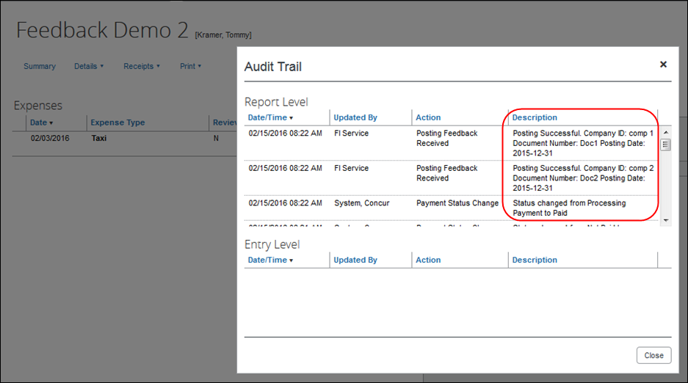

Process Reports Page
The Expense Processor approves the report for payment as usual. After approval, the expense report is placed in a financial posting queue for processing. The processing happens after the processor approves the report.
The financial integration does not put reports into batches- it sends them to QuickBooks immediately once they are approved by the processor. Make sure the reports are ready to be sent before approving them in Process Reports.
Once the financial posting is complete, the processor will see the posting feedback on the Process Reports page.
Reports that posted successfully will show the payment status Paid and show the details of the financial posting in the audit trail. The audit trail message includes the Company ID, the Document ID, and the Posting Date.
Reports that failed to post will show an exception and the payment status Financial Posting Failed.
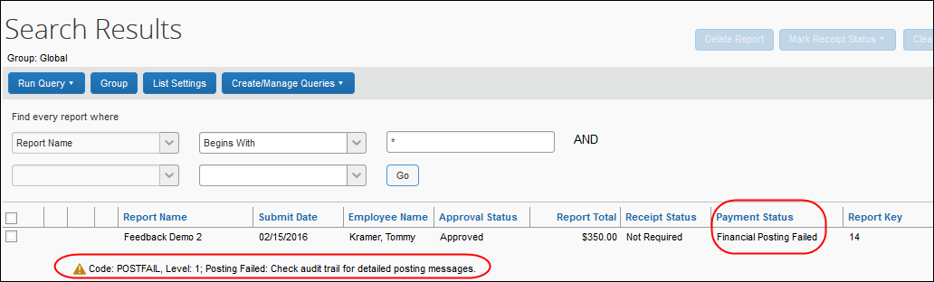
The processor can view the audit trail for the report to see the details of the posting failure. In this example, the report failed to post for two reasons. The audit trail message includes the Company ID, the Document ID, and the details of the failure.
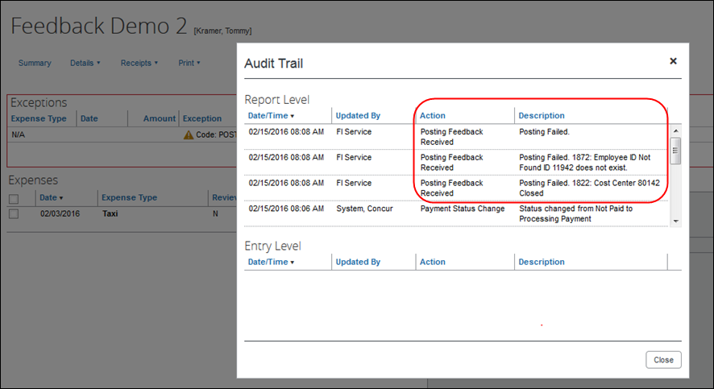
The processor recalls the report, in order to make changes to it.
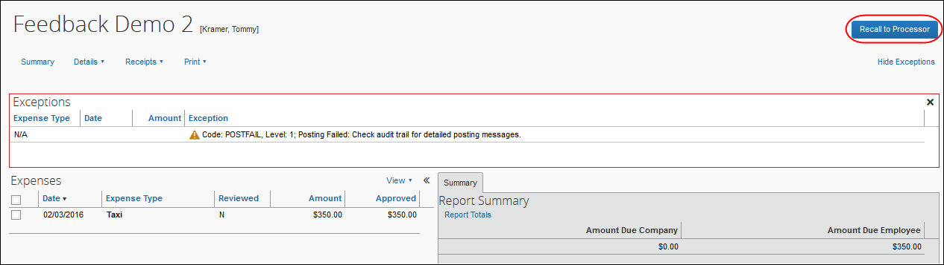
Then the processor works with the Concur and QuickBooks administrators to resolve the issues. In this example, the Concur administrator would update the user’s employee ID, while the QuickBooks administrator would confirm the correct cost center to select. Then the processor would select the correct Cost Center on the expense entry or report header. Once the processor has updated the report, they approve it for payment again.
When the report is successfully posted, the integration sets the report’s payment status to Paid.
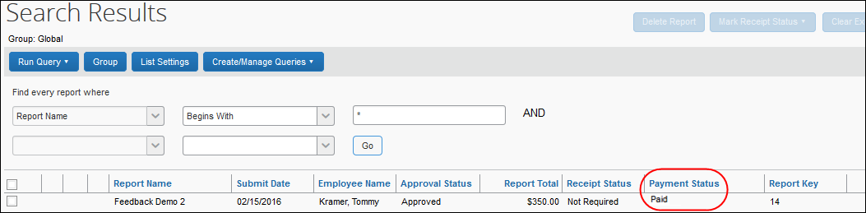

Financial Posting Failed Query
SAP Concur has added a query, Reports Financial Posting Failed, to the Process Reports page for clients with the integration. This query can be used by the processor to quickly locate all reports with the payment status of Financial Posting Failed.
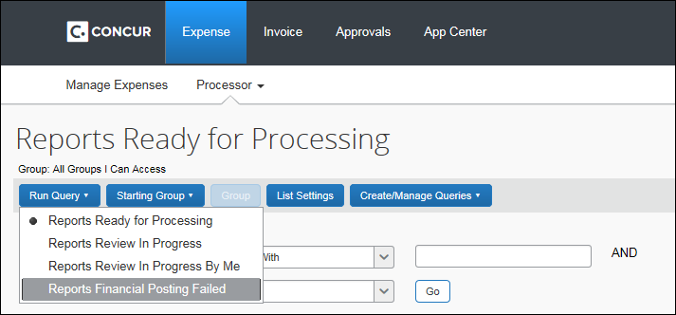

Invoice User Experience
In Concur, the integration functionality will appear to the end user in multiple places:
- Invoice audit trail
- Process Invoices pages

Invoice Audit Trail
The invoice audit trail includes the posting status once the posting feedback has been returned from QuickBooks. The user clicks Details > Audit Trail to view the audit trail.
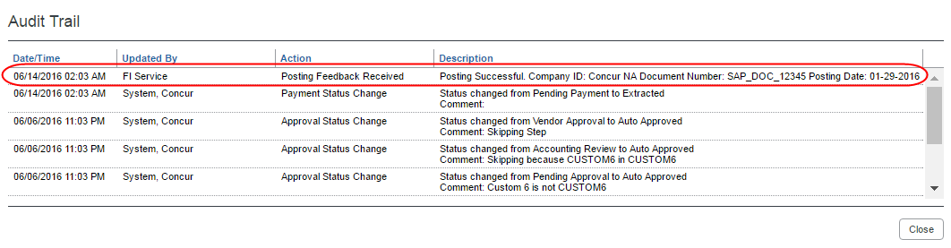

Process Invoices Page
The Invoice Processor approves the invoice for payment as usual. After approval, the invoice is placed in a financial posting queue for processing. The processing happens every time an invoice receives final processor approval.
The financial integration does not put invoices into batches—it sends them to QuickBooks immediately after they are approved by the processor. Make sure the invoices are ready to be sent before approving them in Process Invoices.
Once the financial posting is complete, the processor will see the posting feedback on the Process Invoices page.
If the process is successful, the invoice will show an Approval status of Extracted.
When the invoice is being sent to QuickBooks, it may show a status of Sent to Financial ERP. This status appears briefly.
If the posting fails, the invoice will show a status of Financial Posting Failed.
The invoice processor can recall the invoice by clicking Recall Invoice to Processor.
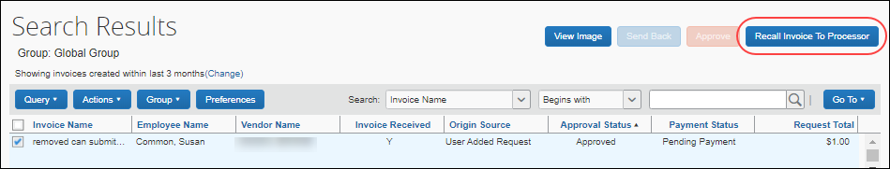
The invoice audit trail details the issue.
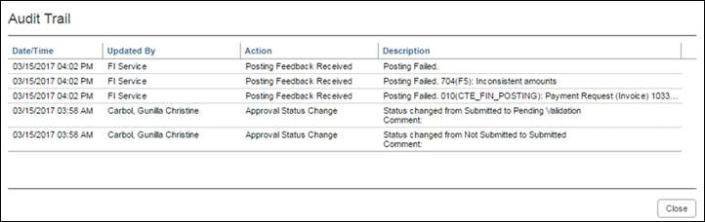
Once the invoice processor has corrected the information, the processor can re-send the invoice to QuickBooks by clearing the exception, and then clicking Approve again.
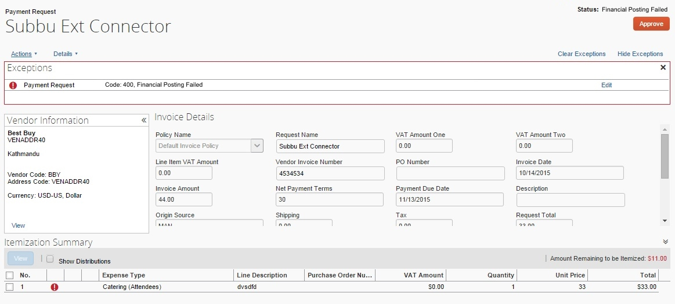

Invoices Failing Financial Posting Query
The processor can use the Invoices Failing Financial Posting query on the Process Invoices page to quickly locate all invoices with the Financial Posting Failed payment status.
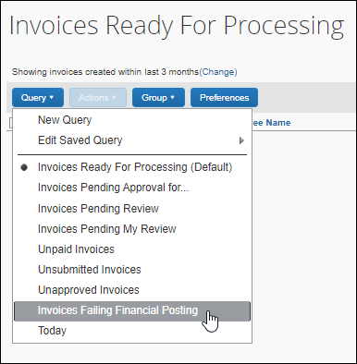

Configure the QuickBooks Financial Integration
SAP Concur Implementation must enable the QuickBooks Financial Integration for your company. Once it is enabled, you use the Product Settings pages to configure your QuickBooks integration.
SAP Concur Implementation brings select QuickBooks configuration data into your Concur company. You will configure QuickBooks-specific information on these pages of Product Settings:
- Accounting
- Custom Fields
- Expense Types
- Taxation
- Employee Reimbursements (Expense only)
- Payment Types (Expense only)
- File Export Configuration (Invoice only)
- Payment Manager (Invoice only)
- Vendor Manager (Invoice only)
This setup guide provides a high-level view of the QuickBooks-specific portions of Product Settings. For each page of Product Settings, detailed guides are provided. This document introduces those guides.
Once you have finished configuring QuickBooks using Product Settings and begin using Expense and/or Invoice, you will find QuickBooks-specific information in the Concur Expense: Payment Manager User Guide for Concur Standard Edition and the Concur Invoice Administration User Guide for Concur Standard Edition.

Step 1: Accounting
The QuickBooks Integration using Concur Financial Integration Service allows companies that use QuickBooks to integrate their Concur Expense and Concur Invoice company with QuickBooks. The integration manages the transmission of expense and invoice data from Concur to QuickBooks, and the transmission of status information back to Concur.
When connecting Concur to a QuickBooks company, the process of entering your accounting data is automated. This ensures that your users are accounting for their expenses correctly. This eliminates data entry and ensures the data is correct because we use what you have in QuickBooks.

QuickBooks Online - Connect to QuickBooks
You will not be able to connect to QuickBooks if you have any expense reports or invoices in-flight. Make sure your users complete any in-flight reports or invoices before attempting to connect your company to QuickBooks.
To connect Concur to your QuickBooks Online company:
- Click Administration > Expense Settings or Expense & Invoice Settings or Invoice Settings. The Product Settings page appears.
- In the Product list, select Invoice or Expense.
- In the Connections section, on the Accounting tab, click Edit.
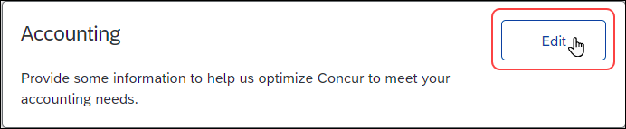
- On the Accounting page, click the Connect to QuickBooks button. This button only appears if Intuit Integration is enabled for your company.
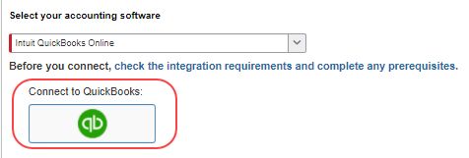
All inflight reports or invoices must be processed before the connection can be established. If there are any expense reports or invoice in-flight, a warning page similar to the following appears:
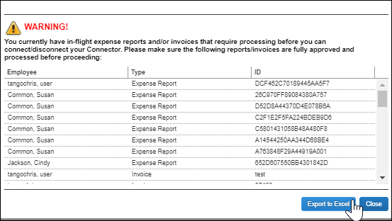
The warning page lists the inflight reports. The list can be exported to an Excel file by clicking the Export to Excel button.
- When prompted, enter your Intuit credentials to confirm your permissions and enable the QuickBooks data transfer.
- Select the relevant QuickBooks company file. If you administer more than one company in QuickBooks, select the company you want to connect to Concur.
- Authorize SAP Concur to give Concur permission to use select QuickBooks data. Once you are connected to QuickBooks, you can start to take advantage of easier transaction data transfer between Concur and QuickBooks.
- Once you are connected, the screen displays the My Intuit QuickBooks Online Data link.
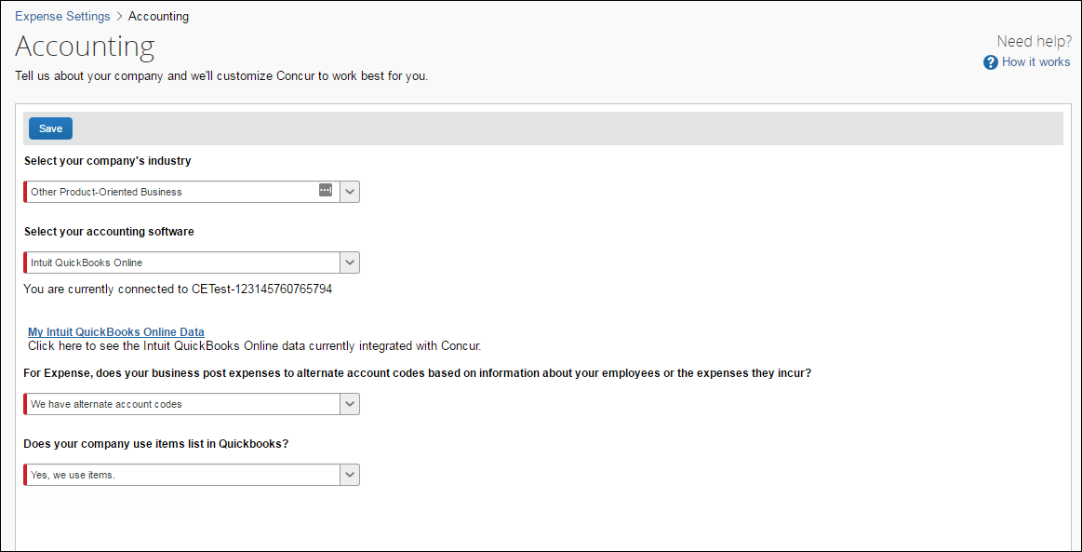
- Click on the My Intuit QuickBooks Online Data. The Intuit QuickBooks Online Company Details page appears. This page provides a summary view of the QuickBooks data that is now integrated with Concur, including GL Expense accounts, employee and vendor records, and customer and class list values.
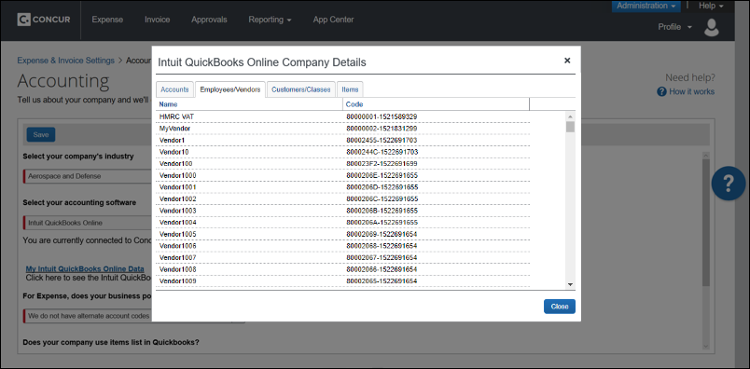

Financial Integration Items
Currently, Items is not supported for Concur Invoice. While you can map the item names to your Concur Invoice expense types, when approving invoices, you will receive an error “At least one expense type is missing an account code”.
In QuickBooks, items are used for tracking anything that a company buys, sells, or resells (billable and non-billable items) and these items are tied to an expense account and/or an income account.
In Concur Expense, if your company uses QuickBooks Online Financial Integration, you can map expense types to QuickBooks accounts or QuickBooks items.
The Does your company use items list in QuickBooks? list on the Accounting page determines whether expense types can be mapped to QuickBooks items.
The Does your company use items list in QuickBooks? list is only available on the Accounting page if the company is connected to a QuickBooks company using QuickBooks Online Financial Integration, and Intuit QuickBooks Online is selected from the Select your accounting software list on the Accounting page.
To define your QuickBooks item settings:
- On the Accounting page, select whether you want to map QuickBooks items to expense types.
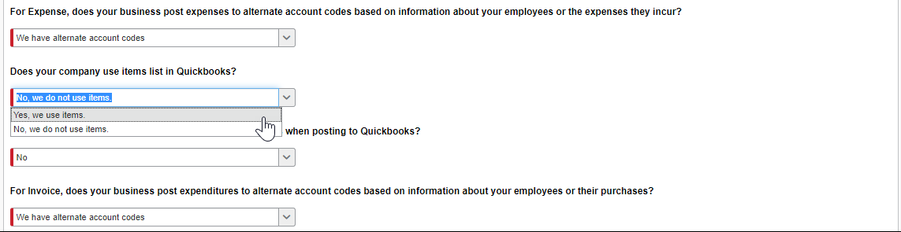
- In the Does your company use items list in QuickBooks list, choose one of the following options:
- Yes, we use items: This option enables the QuickBooks Item Name column on the Expense – Account Codes and Invoice – Account Codes pages so that you can map Concur expense types to QuickBooks items.
- No, we do not use items: The system will not display the QuickBooks Item Name column on the Expense – Account Codes or Invoice – Account Codes page.
- Click Save to save your choices.
If you choose Yes, we use items, expense types can be mapped to QuickBooks accounts or QuickBooks items on the Expense – Account Codes page.

Including Receipt or Invoice Images When Posting to QuickBooks Online
You can include expense receipts and invoice images when posting from Concur Expense or Concur Invoice to QuickBooks Online.
There is no limit to the number of images that can be attached when posting to QuickBooks Online, however the size of the upload cannot exceed 100 MB.
To include or exclude receipt or invoice images when posting to QuickBooks Online
- Click Administration > Expense Settings or Expense & Invoice Settings or Invoice Settings.
- In the Product list, select Invoice or Expense.
- In the Connections section, on the Accounting tab, click Edit. The Accounting page appears.
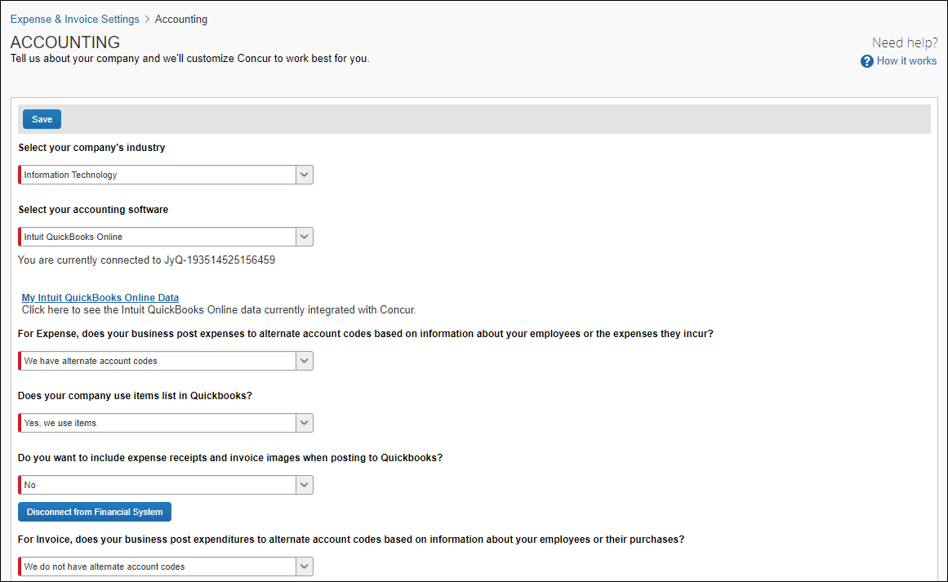
- In the Do you want to include expense receipts and invoice images when posting to QuickBooks list, click Yes to include receipts and images or click No to exclude receipts and images.
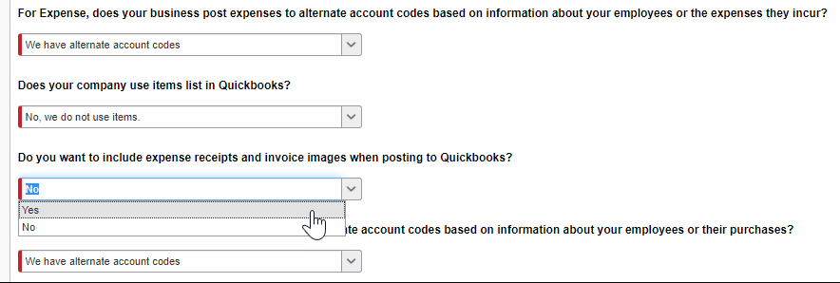

ERP Liability Account Code (Invoice Only)
For Concur Invoice clients, use the Invoice ERP Liability Account Code list on the Accounting page to map your company’s ERP liability account code to ensure invoices post directly to it. This required field ensures that the systems are mapped to avoid failures in invoice postings.
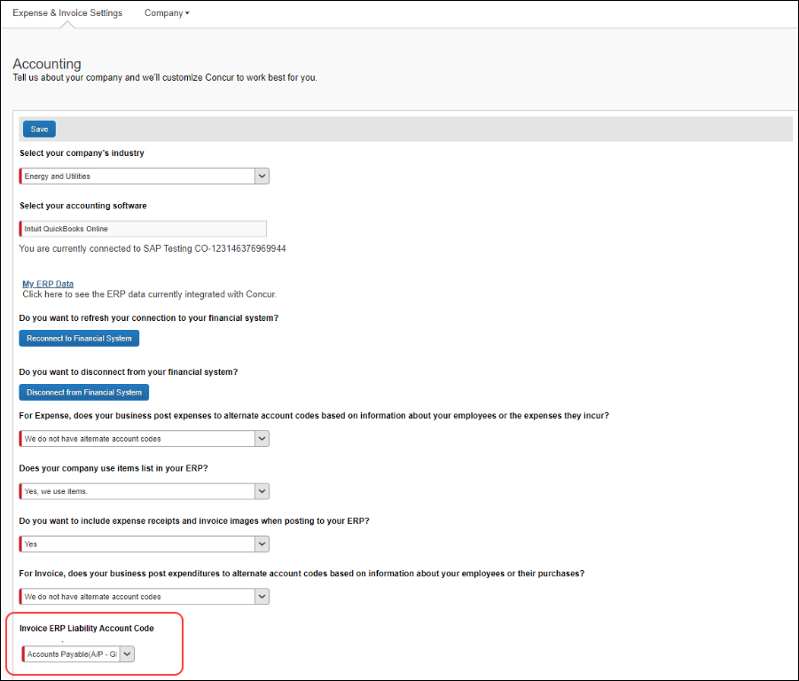
To enter your liability account code:
- On the Accounting page, in the ERP Liability Account Code list, enter your company’s ERP account code.
- Click Save.

Step 2: Custom Fields

Custom Fields
On the Custom Fields page in Product Settings, you will see your QuickBooks information in Concur. After you connect to QuickBooks, the integration adds the following fields to Concur:
- Department: This field is mapped to the QuickBooks Class field.
- Customer:Job: This field is mapped to the QuickBooks Customer field.
- Location: This field is mapped to the QuickBooks Location field.
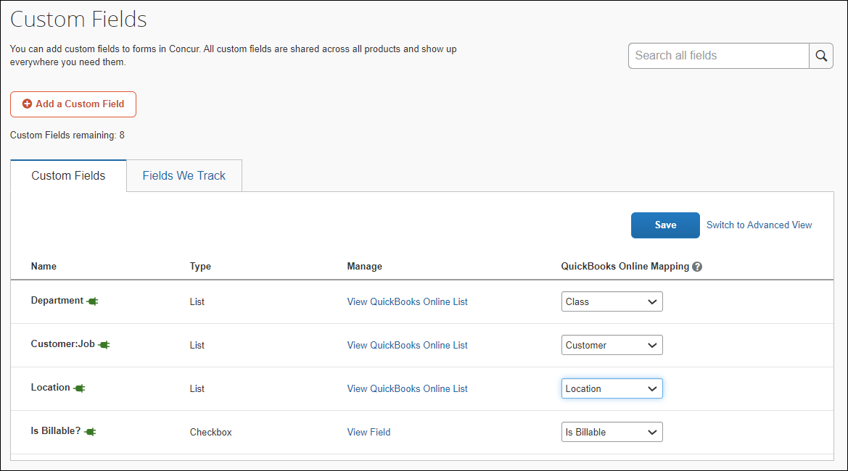
The Is Billable field is intended to work with a customer mapping. Ensure that if the Is Billable field is configured to integrate with QuickBooks, that a customer field is also configured to integrate with QuickBooks. The integration does not support integrating the following QuickBooks account types with the Is Billable field: Fixed Assets, Bank, Account Receivable, Accounts Payable, Credit Card, Other Current Liability, Long Term Liability, Equity, and Income.

View List Items
The admin can click the View List link on the Custom Fields page to view the list item details for a field. The list items for the Customer: Job (QuickBooks Customer), Department (QuickBooks Class) and Location (QuickBooks Location) fields are read-only.
- Moving from Custom Fields to View List will automatically populate the list values for the QuickBooks Customer, QuickBooks Class, and QuickBooks Location fields.
- The Import List, Add, Edit, and Delete options are not visible for integrated clients.
- For more information, refer to the Shared: Custom Fields Setup Guide for Concur Standard Edition.

Step 3: Expense Types
Your users select expense types when they create expenses or invoices in Concur and can only choose from the configured list. When the approved expense or invoice data is sent to QuickBooks, Concur automatically knows where to post those transactions. On the Account Codes tab of the Expense Types page of the Product Settings, you will configure your GL account codes.

Account Codes
You will map the accounts to expense types and invoices. Concur imports the GL account code names for you to use when accounting for expenses and invoices. The following account types are included:
- Expense
- Other Expense
- Fixed Assets
- Cost of Goods Sold
- Other Current Assets
- Other Current Liabilities

To enter your default account codes:
- For Concur Expense, click Administration > Expense Settings or Expense & Invoice Settings > Expense Types for Expenses > Account Codes.
For Concur Invoice, click Administration > Invoice Settings or Expense & Invoice Settings > Expense Types for Invoices > Account Codes.
- Click Account Codes (tab).
- Select the desired account code name in the QuickBooks Account Name or Number field.
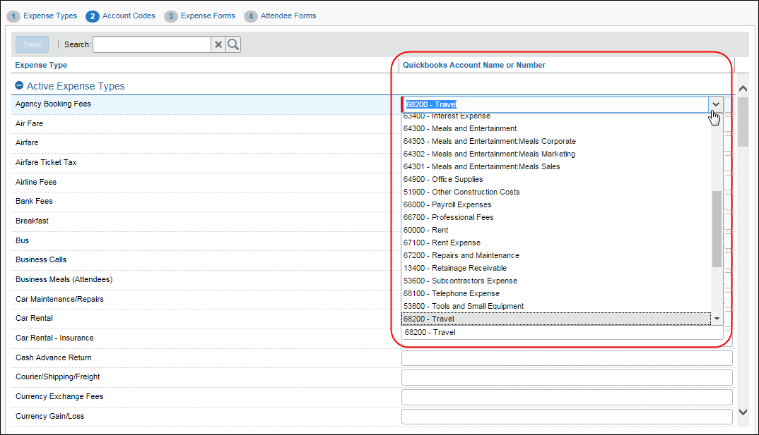
- Repeat for each expense type.
- Click Save.
- For information about entering alternate account codes, refer to the Concur Expense: Expense Types Setup Guide for Concur Standard Edition or Concur Invoice: Expense Types Setup Guide for Concur Standard Edition.
Account names are pulled in from QuickBooks Online. Concur does not pull in account numbers.

Mapping Expense Types to QuickBooks Items
If you selected Yes, we use items from the Does your company use items list in QuickBooks? list on the Accounting page, the QuickBooks Item Name column is displayed next to the QuickBooks Account Name or Number column.
This page allows you to select a QuickBooks account or QuickBooks item to associate with each expense type in Concur. The accounting and item information is used when Concur sends the expense/invoice data to QuickBooks.
An expense type can only be associated with either a QuickBooks account or a QuickBooks item, not both.
QuickBooks items can be mapped to expense types for alternate groups and alternate account codes.
(Invoice Only) The Vendor Name and Vendor Code in Concur Invoice and Vendor Display Name and Company Name in QuickBooks Desktop must be the same and must be 32 characters or less. The Invoice Expense Type Account Code must be 48 characters or less.
If you have created policy groups, you may configure different expense type to QuickBooks item mappings for the individual policy groups.
To map your expense types to items:
- For Concur Expense, click Administration > Expense Settings or Expense & Invoice Settings > Expense Types for Expenses > Account Codes.
For Concur Invoice, click Administration > Invoice Settings or Expense & Invoice Settings > Expense Types for Invoices > Account Codes.
- In the QuickBooks Item Name field, enter the QuickBooks item name.
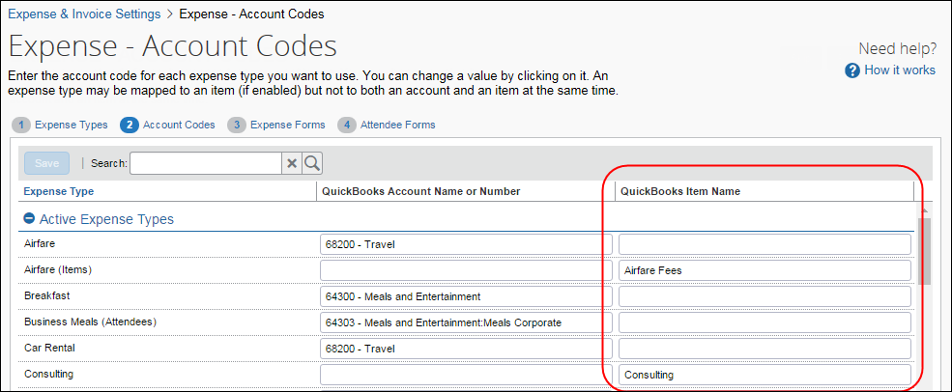
- Click Save.
- For more information about mapping expense types for Concur, refer to the Concur Expense: Expense Types Setup Guide for Concur Standard Edition or Concur Invoice: Expense Types Setup Guide for Concur Standard Edition.

Step 4: Taxation

Invoice
VAT/GST Tax rate mapping is only available to Concur Invoice clients using the Concur Invoice UK or AU country packs. The administrator imports the VAT/GST code mapping from QuickBooks Online Accounting once the Concur Invoice UK or AU country packs are enabled by SAP Concur staff.
To import the VAT code mapping:
- Click Administration > Invoice Settings or Expense & Invoice Settings.
- In the Product list, select Invoice.
- In the Capturing Spend section, on the VAT Tax Codes for Invoices tab, click Edit.
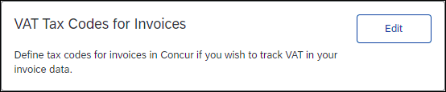
The Taxation page opens, triggering the import of the tax codes from QuickBooks Online Accounting.
- Click Save.

Expense
QuickBooks clients using Tax Authorities (for value-added tax) use the Taxation page of Product Settings to configure their ERP Tax Codes.
Once VAT tracking for a tax authority is activated, you can map VAT/GST tax codes for tax groups between QuickBooks and Concur.
- For information on activating VAT tracking, refer to the Concur Expense: Taxation Setup Guide for Concur Standard Edition.
When the QuickBooks tax codes are mapped, QuickBooks will calculate the tax amount based on the QuickBooks tax code, ensuring the correct transaction amounts are posted.
The VAT/GST tax rate mapping only accommodates VAT/GST that is collected at a single level, such as at the country level.
To map VAT/GST tax codes for tax groups (after activation):
- Click Administration > Expense Settings or Expense & Invoice Settings > VAT.
- On the Taxation tab, click View in the Tax Groups column for the activated tax authority. The Tax Groups page appears, showing the full configuration for the various expense type groups.
- Select the tax group and then click Modify. The Expense Types for Tax Group window appears.
- Click the Modify Reclaim Codes tab. The Tax Code column is displayed next to the Reclaim Tax Code column.
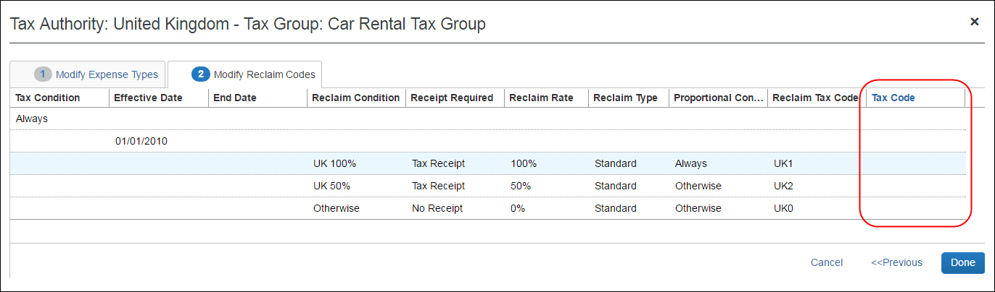
- In the Tax Code column, click the corresponding QuickBooks tax rate for the Concur reclaim tax code. The list in the Tax Code column is populated with the tax rates from QuickBooks.
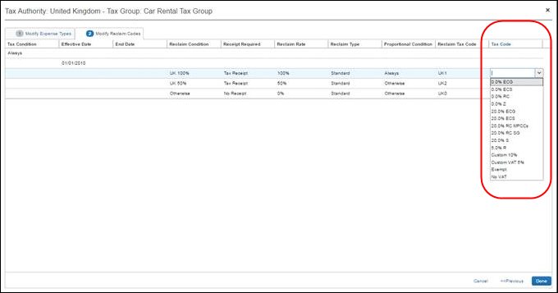
- When you are done mapping tax codes, click Done.

When a QuickBooks tax rate is mapped to a Concur reclaim tax code, on the Tax Groups for Tax Authority: [country name] page, _[2-digit QuickBooks tax code] is appended to the mapped Concur reclaim tax code in the Reclaim Code column.
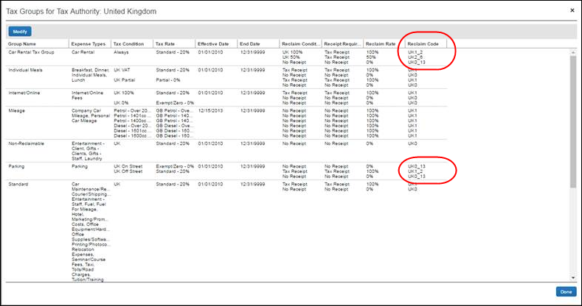
- If you are finished, click Done. You are taken back to the Taxation page.
- For more information, refer to the Concur Expense: Taxation Setup Guide for Concur Standard Edition.

Step 5: Employee Reimbursements (Expense Only)
On the Employee Reimbursements page of Product Settings, you will configure the QuickBooks Liability Account Code. You configure it on the Accounting tab from a read-only list and populate it with the relevant liability accounts from your General Ledger. Depending on the selection, the Cash Account Code field may display.
If you use the ADP Payroll reimbursement method, a .CSV file is not generated because the transaction information is sent directly to QuickBooks.
If ADP file with Financial Integration is enabled, payment batches generate an ADP EPIP file. ADP file with Financial Integration is enabled by SAP Concur internal staff. If you require an EPIP file, contact SAP Concur support for assistance.

Entering Account Codes for Reimbursement Methods
Once you have saved the employee reimbursement method, the Accounting tab appears.
To enter your account codes:
- Click Administration > Expense Settings or Expense & Invoice Settings > Employee Reimbursements.
- Create or edit the desired reimbursement method.
- On the Accounting tab, enter the codes in the fields:
Field | Description
How do you want our transactions to appear in QuickBooks? | This field defaults to Bill, which is the only option for posting employee reimbursements in QuickBooks.
QuickBooks Liability Account Code | This is the accounting code that appears in the accounting file "Payment Demand Company Liability Account Code" field for payment made with this reimbursement method. The Liability Account field may be used to record when expenses are incurred. Clients may use this field to capture a code that represents an offset account in the GL extract. This account code commonly represents the credit in the expense accounting entry.  NOTE: The QuickBooks Liability Account Code defaults to Accounts Payable, select a different Accounts Payable account if applicable.
Cash Account Code | This is the accounting code that appears in the accounting file Payment Demand Company Cash Account Code field for payments made with this reimbursement method. The Cash Account Code field may be used to record when expenses settle. Clients may use this field to capture offsets against transactions that directly impact the bank accounts. This account code commonly represents the credit in the payment accounting entry.  NOTE: This field is only used by customers who use an extract and not the QuickBooks integration.
- Click Save.
- For more information, refer to the Concur Expense: Employee Reimbursement Setup Guide for Concur Standard Edition.

Step 6: Payment Types (Expense Only)
The Concur client administrator configures the company card programs on the Payment Types page of Product Settings. For each card program, the Accounting tab allows you to configure your accounting code and transaction settings for each card program.
To enter your program settings:
- Click Administration > Expense Settings or Expense & Invoice Settings > Credit Cards.
- On the Payment Types page, create or edit the desired card program.
- On the Accounting tab, fill in the fields:
Field | Description
How do you want your transactions to appear in QuickBooks? | Select the desired setting. If you select Credit Card, the QuickBooks Credit Card Account field will auto-populate with a list of your card accounts in QuickBooks.
Use consolidated vendor handling? | Refer to the Consolidated Vendor Handling section below.
New credit card merchants will be consolidated in this Vendor record in QuickBooks | NOTE: This field only appears if you enable Consolidated Vendor Handling.  Enter the vendor record you would like to use in QuickBooks for the credit card transactions that don’t match an existing vendor.
How do you want us to handle charges that have already been entered in QuickBooks? | Select the desired option:  - Match expense data to the existing credit card charge in QuickBooks (Recommended Best Practice: If we detect that the transaction already exists in QuickBooks we will add the following information provided by the end user on the expense report to the existing entry in QuickBooks:  - Business Purpose  - Customer/Class value  - Billable/Non-Billable  - Concur Expense report ID  - Employee’s Last Name/First Name in the memo field for alpha sorting on the QuickBooks Reconcile Credit Card screen  - Use the expense data to create a new credit card charge in QuickBooks. Select this if you prefer that we post a new credit card charge and during reconciliation process you will determine which entry to keep and which entry you need to delete.  - Ignore the expense data if the transaction already appears in QuickBooks. Select this if you have what you need already and prefer that we do not create a new entry in QuickBooks if we see that it already exists in QuickBooks.
QuickBooks Credit Card Account | Select or enter the desired card account.
Clearing Account Code | Select the relevant clearing account codes. Concur imports the clearing account codes (Other current asset accounts) you use in QuickBooks to account for your card transactions that are marked as a “personal expense".
- Click Save.
- For more information, refer to the Concur Expense: Payment Types Setup Guide for Concur Standard Edition.

Consolidated Vendor Handling
The Use consolidated vendor handling? setting allows you to configure how Concur handles credit card transactions from vendors that don’t match existing vendors. Once you have enabled the setting, you can define a single vendor record to use for credit card transactions when an exact match is not found. This allows you to retain control over your vendor lists in QuickBooks and provides you with the capability to reduce the number of infrequent and/or one-time vendors that are added to your list during the posting process of the credit card transactions.
If you do not use Consolidated Vendor Handling, the transactions are posted to the vendor value contained in the expense report.
QuickBooks Online and QuickBooks Desktop handle the vendors slightly differently. Refer to the table below for the full details.
Using Consolidated Vendor Handling:
Vendor information in transaction | QuickBooks Online | QuickBooks Desktop
No Vendor | Applies to the vendor defined in the Consolidated Vendor Handling setting. | Applies to the vendor defined in the Consolidated Vendor Handling setting.
Existing Vendor | Applies to the existing vendor. | Applies to the existing vendor.
New Vendor | Applies to the vendor defined in the Consolidated Vendor Handling setting. | Applies to the vendor defined in the Consolidated Vendor Handling setting.
Inactive Vendor | Applies to the vendor defined in the Consolidated Vendor Handling setting. | Applies to the inactive vendor.
Not Using Consolidated Vendor Handling:
Vendor information in transaction | QuickBooks Online | QuickBooks Desktop
No Vendor | Applies to "Unknown Vendor.” | Applies to "Unknown Vendor.”
Existing Vendor | Applies to the existing vendor. | Applies to the existing vendor.
New Vendor | The vendor is created in QuickBooks Online. | The vendor is created in QuickBooks Desktop.
Inactive Vendor | Duplicate vendor is created in QuickBooks Online. | Applies to the inactive vendor.

Step 7: File Export Configuration (Invoice Only)
The File Export Configuration page of Product Settings is reduced to options in one tab, the others preset to generate the correct information for QuickBooks.
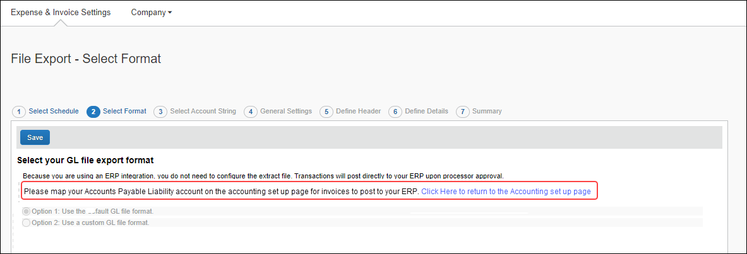
- For more information, refer to the Concur Invoice: File Export Configuration Setup Guide for Concur Standard Edition.

Step 8: Payment Manager (Invoice Pay Only)

(Optional) Configure Liability Accounts
Clients can pay invoices in Concur Invoice by using the Invoice Pay ACH or Check payment types and have the transaction data sent to QuickBooks. The invoice posts as a bill in QuickBooks, which the client manually closes out. Clients enter the liability account code in the Liability Account field of the Funding Account page in Payment Manager.
To update the Liability Account code:
- Click Invoice > Services > Payment Manager. The Monitor Payments page appears.
- Click Funding Accounts.
- Select the desired account and:
- Click Actions > Open Funding Account
- Double-click the funding account directly
- In the Liability Account field, enter the QuickBooks liability account code.
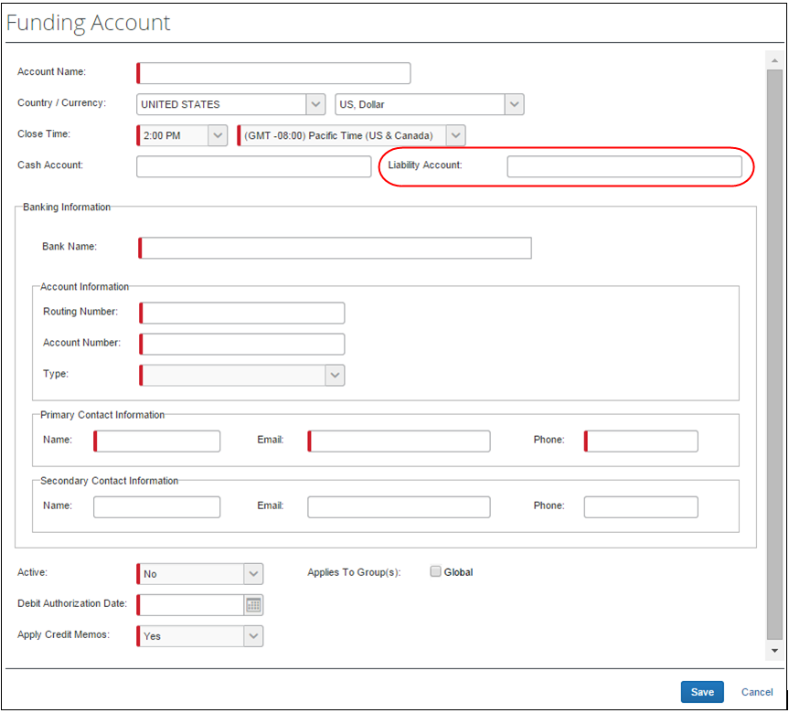
- Click Save.
- For more information, refer to the Concur Invoice: Invoice Pay User Guide.

Step 9: Synchronize Vendors From QuickBooks (Invoice Only)
QuickBooks Desktop and Online clients will be able to create vendors in QuickBooks and then synchronize this data with Invoice from the Vendor Manager page of Product Settings without having to use the vendor import functionality.
The vendor name, vendor code, and vendor display name in QuickBooks must be the same and must not exceed 32 characters.
To synchronize QuickBooks vendors with Concur Invoice:
- On the Vendor Manager page, select Open Vendor > Add Vendors from QuickBooks.
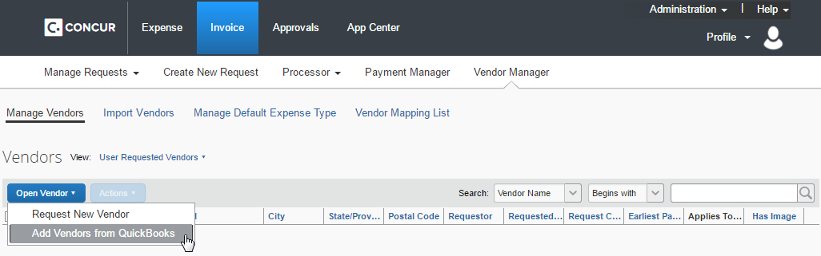
The Add Vendors from QuickBooks window appears.
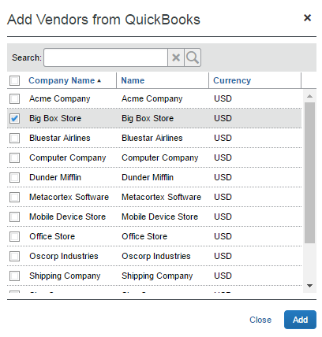
- Select the vendors to add from QuickBooks.
- Click Add. The vendors are added to Concur Invoice.

Managing the Integration

Updating Employees (Vendor) Records
The integration will automatically add your QuickBooks users to Concur, during implementation. It will update the employee and cost object information in Concur continuously, so no steps are necessary to update user data in Concur. New users should always be added in QuickBooks.
- For more information, refer to the Shared: Users Setup Guide for Concur Standard Edition.

Updating the Synchronized Data
The accounting data in QuickBooks is synchronized with Concur continuously. You do not need to run a manual sync update.
Data transmitted through QuickBooks integration during implementation and during subsequent synchronizations, is purged from Concur after 30-days. As a result, after 30 days, you can no longer view the details of successfully transmitted data by clicking the View Details link in Payment Manager.

Updating the QuickBooks Online Authorization
If the QuickBooks Online authorization process fails, SAP Concur will prompt the administrator to enter new QuickBooks Online credentials on the Accounting page of Product Settings.
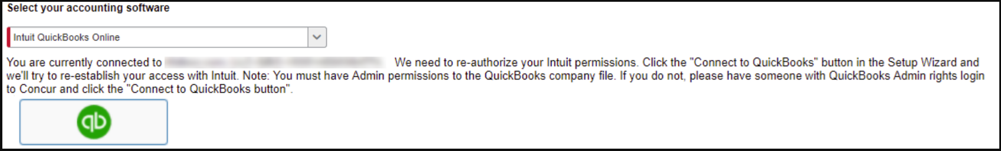
If this message appears, click the Connect to QuickBooks button to enter new authorization credentials.

Disconnecting the Integration
Clients who are ready to disconnect QuickBooks Online from Concur can do so on the Accounting page of Product Settings. If there are in-flight expense reports or invoices, the administrator will not be able to disconnect from QuickBooks.
SAP Concur has identified some situations where it is necessary to disconnect the integration despite in-flight reports or invoices. In those cases, clients should contact SAP Concur support for assistance.
To disconnect your QuickBooks company from Concur:
- Click Administration > Expense Settings or Expense & Invoice Settings > Accounting.
- Click Disconnect from Financial System.
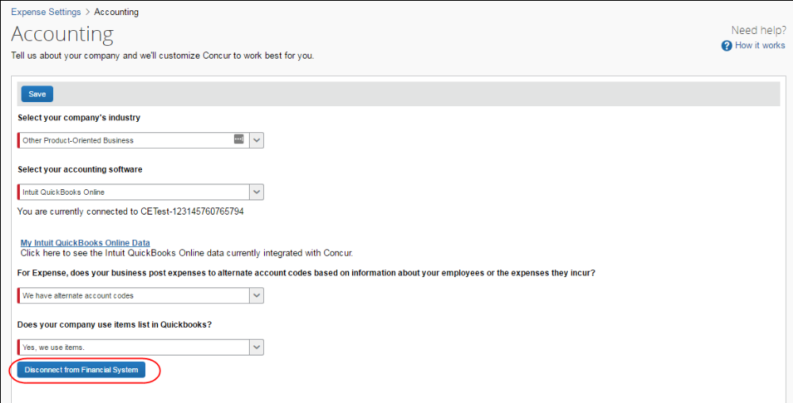
- Click Save.
☼

