
Shared:
Localization
Setup Guide for Concur Standard Edition
Last Revised: December 16, 2021
Applies to these SAP Concur solutions:
 Expense
 Professional/Premium edition
 Standard edition
 Travel
 Professional/Premium edition
 Standard edition
 Invoice
 Professional/Premium edition
 Standard edition
 Request
 Professional/Premium edition
 Standard edition

Table of Contents
Section 1: Overview 1
Section 2: Configure Expense Types/Invoice Expense Types 2
Access the Localize Page 2
Add a Localized Expense Type Label 3
Section 3: Configure Cost Objects 4
Access the Cost Objects Tab 4
Add a Localized Cost Object Label 5
Section 4: Configure Exceptions 6
Access the Exceptions Page 6
Add Localized Exception Text 7
Section 5: Configure Missing Receipt Affidavit 8
Access the Missing Receipts Affidavit Page 8
Localize Receipt Affidavit Items 9
Section 6: Configure List Items 10
Access the List Items Page 10
Localize List Items 11
Section 7: Configure Payment Types 12
Access the Payment Types Tab 12
Localize Payment Types 13

Revision History
Date | Notes/Comments/Changes
January 21, 2022 | Updated the copyright year; no other changes; cover date not updated
December 16, 2021 | Updated Product Settings page instructions
April 15, 2021 | Updated the copyright year; no other changes; cover date not updated
April 27, 2020 | Renamed the Authorization Request check box to Request on the guide’s title page; cover date not updated
January 15, 2020 | Updated the copyright; no other changes; cover date not updated
June 8, 2019 | Updated text and images throughout to reflect UI name change from "Cost Tracking" to "Custom Fields".
February 12, 2019 | Updated the copyright; no other changes; cover date not updated
April 16, 2018 | Changed the check boxes on the front cover; no other changes; cover date not updated
March 14 2018 | Updated the copyright; no other changes; cover date not updated
November 4 2017 | Updated guide to include new Product Settings page, which replaces the Setup Wizard.
March 18 2017 | Updated with menu option name change to access Setup Wizard.
December 15 2016 | Changed copyright and cover; no other content changes.
November 20 2015 | Updated graphics to reflect updated step names and instructional text where applicable.
October 16 2015 | Updated graphics to reflect newly styled step numbers.
February 6 2014 | Added Payment Types section  Removed information about two user interfaces
September 16 2014 | Added information about two user interfaces; no other content changes
May 16 2014 | New document. (This content originated from the Expense Setup Guide for Concur Standard.)

NOTE: Multiple SAP Concur product versions and UI themes are available, so this content might contain images or procedures that do not precisely match your implementation. For example, when SAP Fiori UI themes are implemented, home page navigation is consolidated under the SAP Concur Home menu.

Localization
This page of Product Settings is visible only when enabled by Concur.

Overview
The Localize page of Product Settings allows you to select a language (from the configured languages) and specify your own language-specific text for the following:
- Expense Types and Invoice Expense Types
- Cost Objects
- Exceptions
- Missing Receipt Affidavits
- List Items
- Payment Types
To do this, multiple tabs are used, which collect all the localized data.
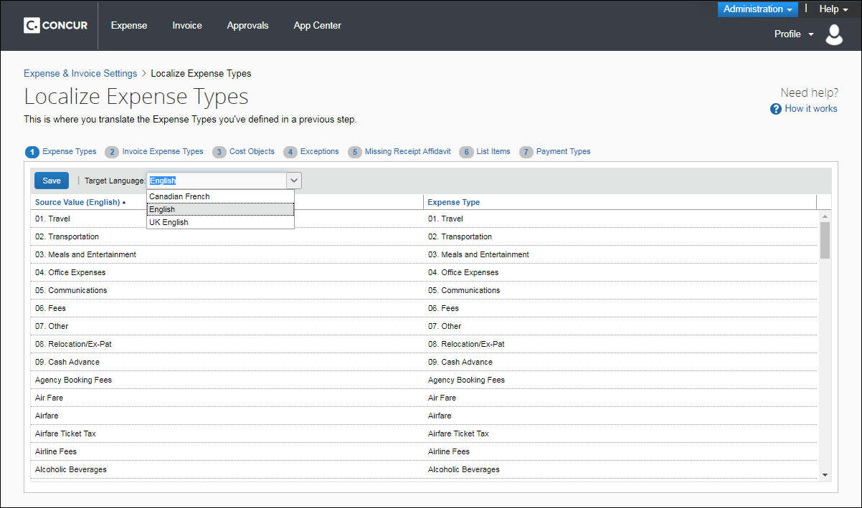
This page only appears if your company is configured by Concur for multiple languages. Tabs appear depending on your configuration.

Configure Expense Types/Invoice Expense Types
Use the Expense Types and Invoice Expense Types tabs to localize the expense type labels for your products, such as “Transportation”.
Example
You are a Canadian company and you have entered a custom expense type in United States. Use the Expense Types tab(s) to provide a Canadian French localized label.

Access the Localize Page
To access the Localize page:
- Click Administration > Expense Settings or Expense & Invoice Settings or Invoice Settings.
- In the Product list, click Expense or Invoice.
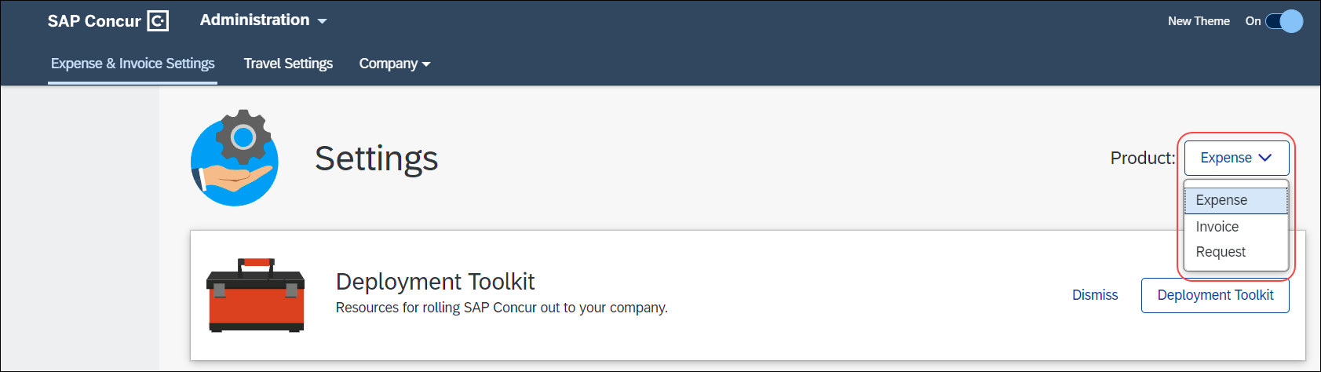
- In the Access to Concur section, on the Translations tab, click Edit.
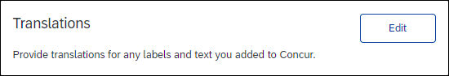
- The Expense Types tab of the Localize page appears.

Add a Localized Expense Type Label
To add a localized expense type label:
- On the Expense Types tab of the Localize page, click the desired target language.
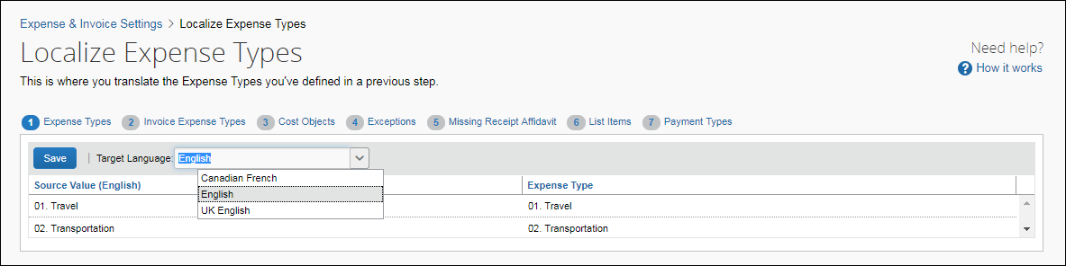
- Enter the localized text in the Expense Type column.
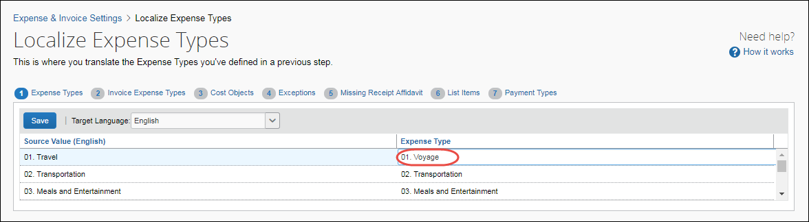
- Click Save.
- Click the Invoice Expense Types tab. Use the steps above to again select a language and edit the existing text to your preferences.
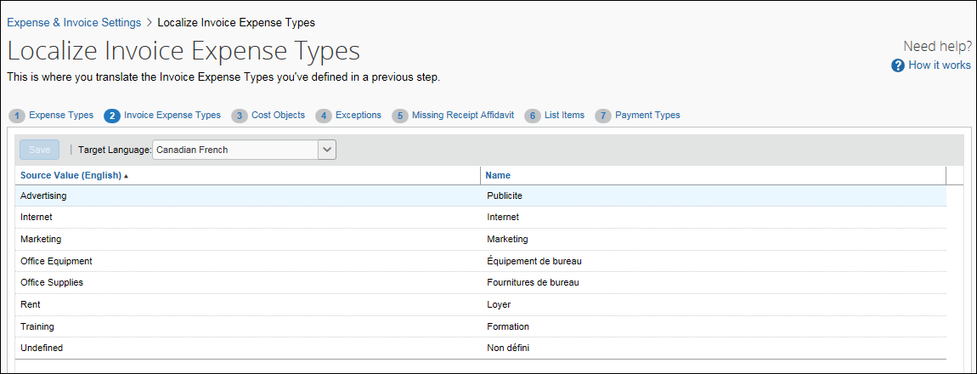
- Click Save or navigate to another tab to save your changes.

Configure Cost Objects
On the Cost Objects tab, you can enter localized labels for your cost objects.
Example
You added a custom cost object in English and you need to add a Canadian French localized label. You can choose Canadian French as your target language, and then enter Canadian French specific custom cost object labels in the Cost Objects column.

Access the Cost Objects Tab
To access the Cost Objects tab:
- Click Administration > Expense Settings or Expense & Invoice Settings or Invoice Settings.
- In the Product list, click Expense or Invoice.
- In the Access To Concur section, on the Translations tab, click Edit.
The Expense Types tab of the Localize page appears.
- Click Cost Objects (tab).
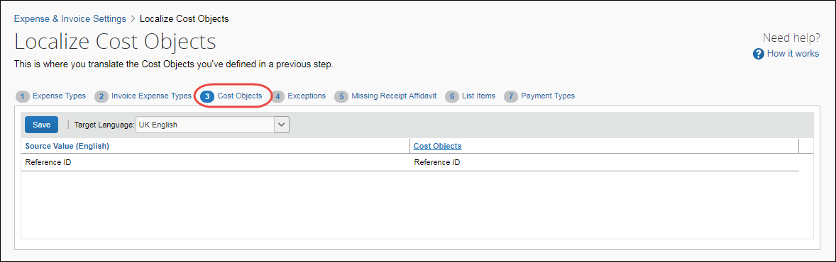

Add a Localized Cost Object Label
To add a localized cost object label:
- On the Cost Objects tab, select the desired target language.
- In the Cost Objects column, enter the localized text.
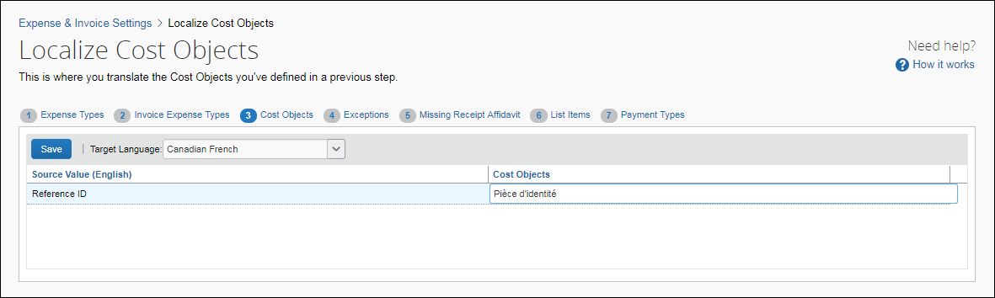
- Click Save to save your changes.
Only the custom cost objects that you created appear on this page. The standard cost objects are localized by Concur.

Configure Exceptions
On the Exceptions page, you can enter localized text for exceptions that users see.
Example
You would like to translate the exceptions that users see into Canadian French. You can choose Canadian French as your target language, and then enter the localized exception text in the Text column. Click Save to save your changes.

Access the Exceptions Page
To access the Exceptions page:
- Click Administration > Expense Settings or Expense & Invoice Settings or Invoice Settings.
- In the Product list, click Expense or Invoice.
- In the Access to Concur section, on the Translations tab, click Edit.
The Expense Types tab of the Localize page appears.
- Click Exceptions (tab).
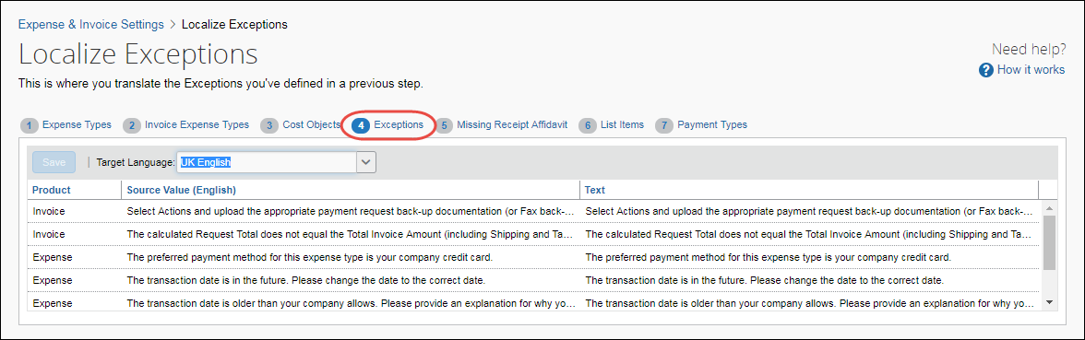

Add Localized Exception Text
To add localized exception text:
- On the Exceptions tab, select the desired target language.
- In the Text column for the exception, enter the localized text.
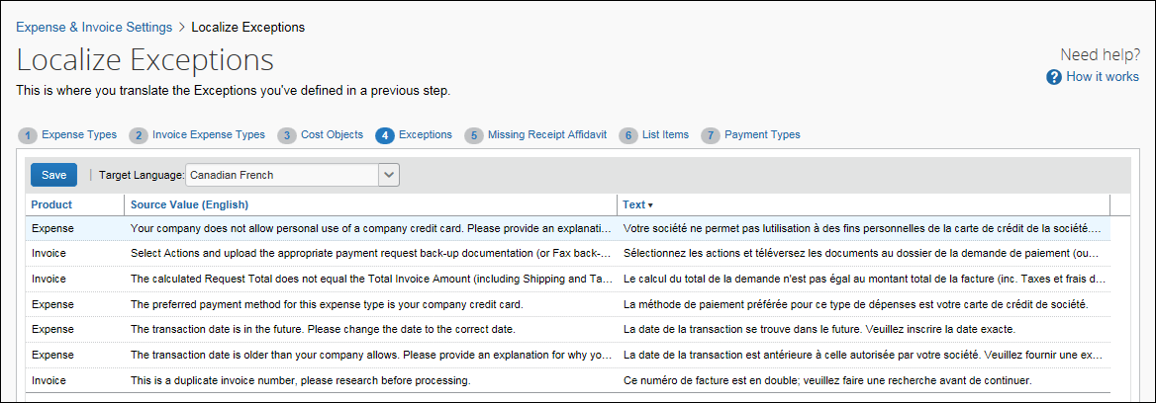
- Click Save to save your changes.

Configure Missing Receipt Affidavit
On the Missing Receipt Affidavit page, you can enter localized text for the receipt affidavit explanations and statements. Note that the Missing Receipt Affidavit tab only appears when you select (enable) the Missing Receipt Affidavit check box in the Compliance Controls page, and provide text for this option.
Example
You need to localize the text you provided for the missing receipt for your Canadian French division.

Access the Missing Receipts Affidavit Page
To access the Missing Receipts Affidavit page:
- Click Administration > Expense Settings or Expense & Invoice Settings or Invoice Settings.
- In the Product list, click Expense or Invoice.
- In the Access To Concur section, on the Translations tab, click Edit.
The Expense Types tab of the Localize page appears.
- Click Missing Receipts Affidavit (tab).
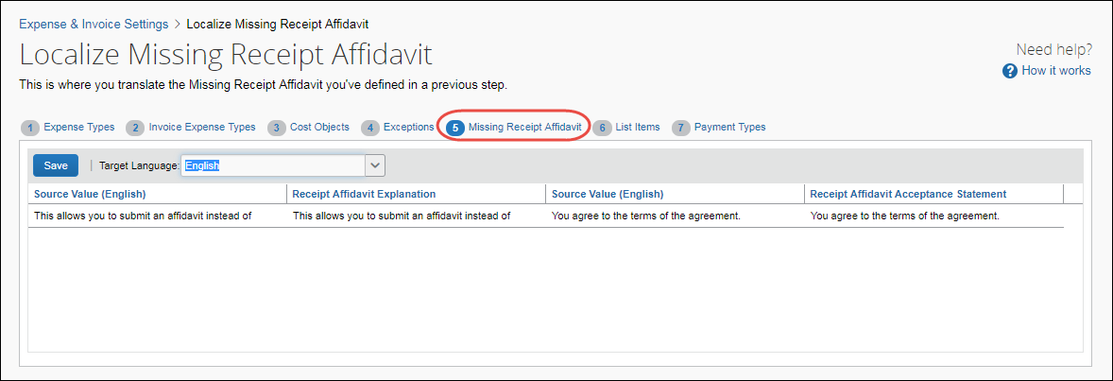

Localize Receipt Affidavit Items
To localize receipt affidavit items:
- On the Missing Receipts Affidavit tab, select the desired target language.
- In the Receipt Affidavit Explanation and Receipt Affidavit Acceptance Statement columns, enter the localized text.
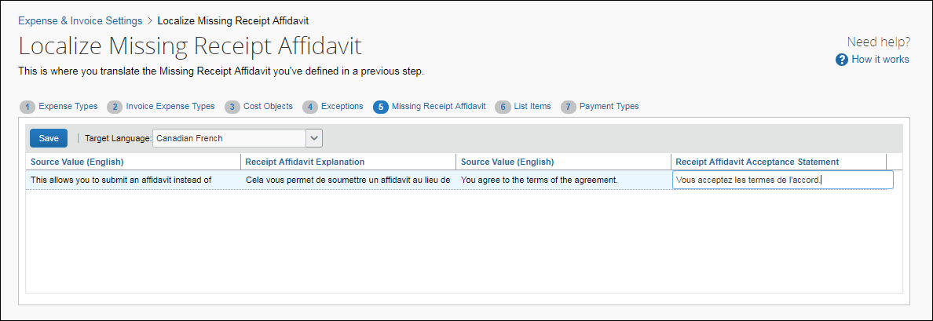
- Click Save to save your changes.

Configure List Items
On the List Items page, you can enter localized values for the list items that you have created.
Example
You would like your list items to display Canadian French-specific text to users that select that language. You can select Canadian French as your target language, and then enter localized text in the Value column. Click Save to save your changes.

Access the List Items Page
To access the List Items page:
- Click Administration > Expense Settings or Expense & Invoice Settings or Invoice Settings.
- In the Product list, click Expense or Invoice.
- In the Access To Concur section, on the Translations tab, click Edit.
The Expense Types tab of the Localize page appears.
- Click List Items (tab).
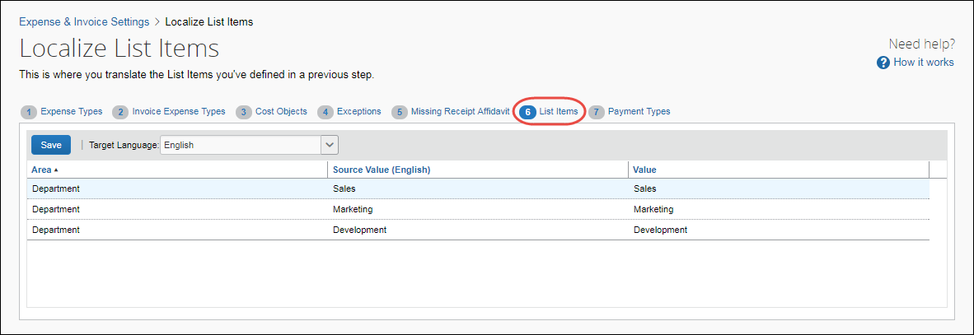

Localize List Items
To localize list items:
- On the List Items tab, select the desired target language.
- In the Value column for the list item, enter the localized text.
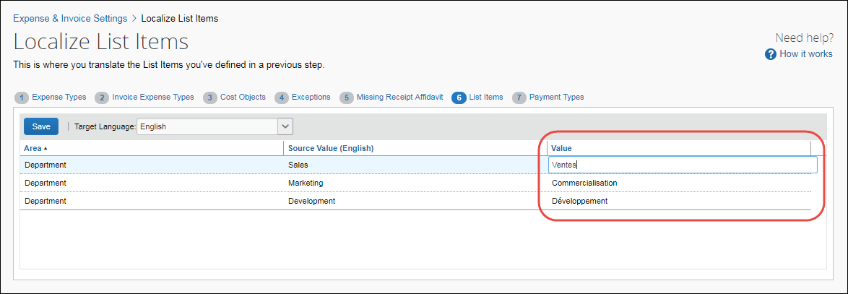
- Click Save to save your changes.

Configure Payment Types
On the Payment Types tab, you can enter localized values for the list items that you have created.
Example
You would like your list items to display UK English-specific text to users that select that language. You can select UK English as your target language, and then enter localized text in the Payment Types column. Click Save to save your changes.

Access the Payment Types Tab
To access the Payment Types tab:
- Click Administration > Expense Settings or Expense & Invoice Settings or Invoice Settings.
- In the Product list, click Expense or Invoice.
- In the Access To Concur section, on the Translations tab, click Edit.
The Expense Types tab of the Localize page appears.
- Click Payment Types (tab).
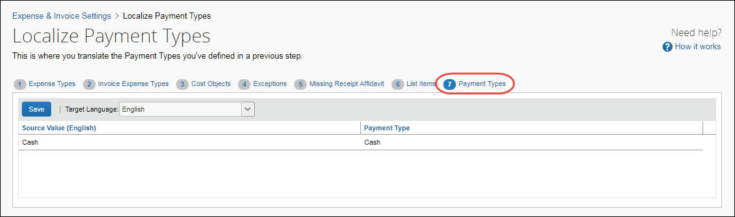

Localize Payment Types
To localize list items:
- On the Payment Types tab, select the desired target language.
- In the Payment Types column for the list item, enter the localized text.
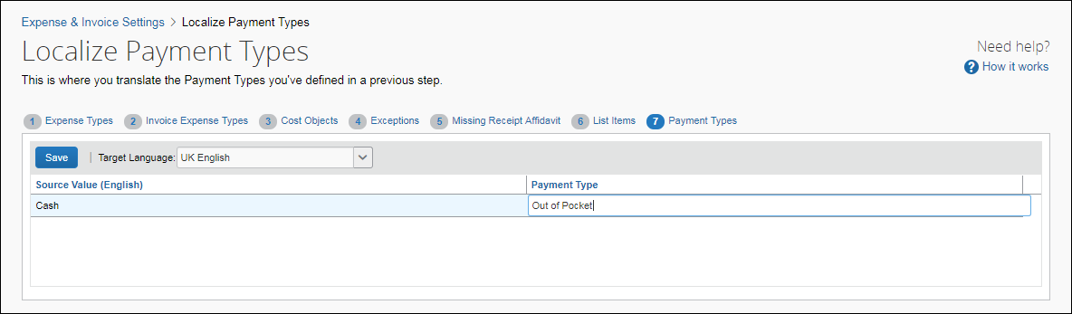
- Click Save to save your changes.
☼

