
Shared: Budget
Setup Guide for Standard Edition

Last Revised: June 17, 2023
Applies to these SAP Concur solutions:
 Expense
 Professional/Premium edition
 Standard edition
 Travel
 Professional/Premium edition
 Standard edition
 Invoice
 Professional/Premium edition
 Standard edition
 Request
 Professional/Premium edition
 Standard edition

Table of Contents
Section 1: Permissions 1
Section 2: Overview 1
Terminology 2
Budget Roles 4
Section 3: How It Works 5
Fiscal Calendars 5
Date Range Budgets 6
Budget Categories 6
Budget Tracking Fields 7
Budget Items 10
Date Range Budget Items 11
Budget Type 12
Budget Item Search and Filter 12
Change Logs 13
Budget Item Import 13
Budget Item Export 14
Bulk Export 14
Budget Details 17
Budget Tracking Fields (Optional) 17
Budget Adjustments 19
Manage Approvers (Optional) 21
Filter by Managers (Optional) 22
Manage Viewers (Optional) 25
Team Budgets 25
Budget Settings 31
Show Unsubmitted Expenses (Concur Expense Only) 35
Budget Audit Rules 36
Budget Workflows 37
Important to Note 38
General Budget Approval Rules 39
Budget Dashboards 39
Budget Overview 41
Budget Details 50
Spend Differences Between Purchase Requests and Invoices 67
Budget Consumption in Concur Expense 68
Budget Consumption in Concur Request 69
Section 4: What the User Sees 70
Section 5: What the Approver Sees 73
Section 6: Budget Configuration 78
Access Budget Configuration 79
Assign Budget Roles 80
Manage Fiscal Years 81
Add a Fiscal Year 81
Modify a Fiscal Year 84
Activate a Fiscal Year 86
Deactivate a Fiscal Year 87
Remove a Fiscal Year 88
Manage Fiscal Periods 88
Activate a Fiscal Period 88
Add a Fiscal Period to a Fiscal Year 90
Modify a Fiscal Period 94
Deactivate a Fiscal Period 97
Remove a Fiscal Period 99
Manage Budget Categories 101
Add a Budget Category 101
Modify a Budget Category 104
Remove a Budget Category 105
Configure Custom Fields for Budget Tracking 106
Field Behavior Settings 107
Enable the Budget Manager Hierarchy (Optional) 108
Manage Budget Items 109
Add a Budget Item 109
Modify a Budget Item 115
Remove a Budget Item 116
Add a New Team Budget 117
View the Audit Trail of a Budget Item 120
View Change Logs 121
Perform a Bulk Export 123
Add an Adjustment to a Budget Item 124
Manage Budget Settings 126
Set Alert Limit Percent 126
Set Control Limit Percent 126
Manage Alert Limit Notifications 126
Manage Control Limit Notifications 126
Restrict Notifications for Past Budgets 127
Select an Alternate Budget Manager 127
Show Unexpensed Expenses (Concur Expense Only) 127
Include the Pending Amount in the Calculated Remaining Amount 128
Enable Budget Capture for Concur Request 128
Enable Budget Capture for Concur Expense 129
Enable Budget Capture for Purchase Requests 129
Enable Budget Capture for Concur Invoice 129
Mark Requests as Spent After Approval 129
Mark Purchase Requests as Spent After Approval 130
Enable Use Expense Net Amount 130
Enable Use Invoice Net Amount 130
Enable Filtering by Budget Manager 130
Enable Date Range Budgets 131
Enable Budget Owner Adjustments 131
Configure Budget Workflows 131

Revision History
Date | Notes/Comments/Changes
June 17, 2023 | Minor correction in the Enable Use Expense Net Amount and Enable Use Invoice Net Amount sections.
January 21, 2022 | Updated the copyright year; no other changes; cover date not updated
December 16, 2021 | Updated the Products page screen shot in the Budget Roles section.
December 14, 2021 | Updated instructions for Product Settings page
September 10, 2021 | Added information about team budgets.
April 17, 2021 | Added more information about Filter by Manager option and several other minor updates.
February 20, 2021 | Added the Use invoice net amount budget setting.
October 20, 2020 | Removed information about the Budget Accrual Date field, since this is not applicable to the standard edition of Budget.
July 23, 2020 | Updated images to show new Users page redesign.
July 6, 2020 | Updated images to show budget approval routing option with processor.
June 20, 2020 | Updated information about the Bulk Export feature in Budget Items.
June 5, 2020 | Minor edit; no content changes.
May 29, 2020 | Updated information about custom fields.
May 21, 2020 | Added Bulk Export procedure.
May 16, 2020 | Added information about the following:  - Change logs for budget administrators  - Bulk exports for budget administrators  - Link to Concur Expense Approvals page in Pending Transaction
April 27, 2020 | Renamed the Authorization Request check box to Request on the guide’s title page; cover date not updated
April 9, 2020 | Updated images in the Budget Dashboard to capture clickable icon to select YTD View and Budget Details options.
March 14, 2020 | Added information about the following:  - Administrators only need the Budget Administrator role to access Budget Configuration  - Audit Trails for Budgets
February 21, 2020 | Added information about budget owners being able to add adjustments.
February 15, 2020 | Added information about when the admin selects the Include Budget Approver checkbox on the Approval Routing page.
January 18, 2020 | Added information about filter for fiscal year being honored when admins use the Send To Excel functionality in Budget Items.
January 9, 2020 | Updated the description of the Alert Limit Percent and Control Limit Percent options. Updated copyrights.
July 30, 2019 | In addition, updated text and images throughout to reflect UI name change from "Cost Tracking" to "Custom Fields".
June 8, 2019 | Added information about the following:  - Enable Budget Item Manager Tab option in Budget Settings renamed to Enable filtering by Budget Manager  - Message in Approval Flow window when budget approver step is skipped  - The Filter by Managers (optional) tab has been renamed to Filter by Managers (optional) in the Add Budget Item and Modify Budget Item windows in Budget Items  - Parent expense types being available when Concur Request is enabled
May 11, 2019 | Added information about the following:  - Updated images of Budget Items to reflect new Created and Last Modified columns  - Use expense net amount budget setting to consume expense reports with or without tax (Concur Expense only)  - Year-to-date budget spend
April 16, 2019 | Rearrange content about budget approvals. No other changes.
April 13, 2019 | Changed the term "payment request" to "invoice" as part of the new user experience for Concur Invoice.  Added information about the new Budget Workflow feature and performed minor updates.
March 16, 2019 | Added information about the budget item search and filter functionality.
February 22, 2019 | Changed the Request End Date to the Request Start Date in the Budget Consumption in Concur Request section.
February 9, 2019 | Added information about budget consumption against time.
January 12, 2019 | Added information about the Spending Category column in the Excel spreadsheet of the Export Data functionality.
January 7, 2019 | Updated to reflect new Cost Tracking page names. Abridged this table to two pages.
December 17, 2018 | Changed copyright; no other content changes.
December 8, 2018 | Added information about the following new features:  - New budget type in Budget Items  - Enhanced and new search filters on the Budget Dashboard  - Budget Overview page content on the Budget Dashboard can now be exported
November 17, 2018 | Vendor Name column has been added to the Export Data functionality in Budget Details. In addition, "Concur" was replaced with "SAP Concur" where applicable.
 | Older revision history has been removed.

Budget
NOTE: Multiple SAP Concur product versions and UI themes are available, so this content might contain images or procedures that do not precisely match your implementation. For example, when SAP Fiori UI themes are implemented, home page navigation is consolidated under the SAP Concur Home menu.

Permissions
A company administrator may or may not have the correct permissions to use this feature. The administrator may have limited permissions, for example, they can affect only certain groups and/or use only certain options (view but not create or edit).
If a company administrator needs to use this feature and does not have the proper permissions, they should contact the company's Concur administrator.
The administrator should be aware that some of the tasks described in this guide can be completed only by SAP Concur. In this case, the client must initiate a service request with SAP Concur support.

Overview
The Budget feature enables clients to set up all components of a budget; a fiscal year to determine the budget period, budget tracking fields to track spending on a cost center (profit center) level, budget categories to group expense types for budgets, which are the actual annual budgets, and budget items, which define the budget including fiscal year, budget owner, budget name, and budget display name.
When the admin has configured this feature, users will be able to access a Budget Dashboard to view and manage their budgets.
This feature makes budgets visible, actionable, and real-time for approvers and budget owners, leading to high-quality spending decisions for Concur Invoice (invoices and purchase requests), Concur Expense (expense reports) and Concur Request (authorization requests).
The Budget feature provides the following benefits:
- Enables clients to validate invoices, purchase requests, expense reports, and authorization requests against a budget
- Provides end users budget visibility before submitting an invoice, purchase request, expense report, or authorization request
- Provides approvers detailed insight into the budget while approving invoices, purchase requests, expense reports, and authorization requests
- Provides budget owners insight into budget spending
The Budget feature is a purchased service.

Terminology
This table describes the terminology used for the Budget feature.
Term | Description
Budget Category | This is a group of expense types from which to manage budgets.
Budget Currency | This is the currency of a budget item. Budget items are always displayed in their budget currency and take precedence over the currency setting in Profile Settings. Spending items are converted to the budget currency based on the submit date of the invoice, the expense date, or the request date. The actual invoices, purchase requests, expenses, and requests are not converted.
Budget Dashboard | The dashboard shows how much of a budget has been spent to date—including pre-approved spend—across an approver’s budget. Budget managers can view their budgets and make informed budget decisions.
Budget Item | This is the annual budget including fiscal year, budget owner, budget name, and budget display name.
Budget Period | This is part of the Budget Item. Depending on the period type of the Budget Item, the Budget Item has one or more budget periods. Each budget period is associated with a fiscal period and has a budget amount for that fiscal period and budget item.
Budget Tracking | Budget tracking fields are copies of the custom fields defined in Product Settings. If a new budget tracking field is needed, admins can add a custom field in Product Settings and then a budget tracking field is automatically added with the same name in Budget Configuration. These budget tracking fields appear in the Budget Tracking Fields (Optional) tab in Budget Items where admins can specify a value for the budget tracking field to be associated with a budget item. The budget tracking fields in the Standard editions are limited to the fields defined as custom fields.
Manager Hierarchy | A manager hierarchy consists of the managers to whom the users report to directly or indirectly. If a user or an admin has defined a budget manager for a budget item, spending items will be matched to the Budget Item if the submitter of the spending items reports to one of managers listed in the Filter by Managers (optional) tab of the Budget Item.  Managers listed in the Filter by Managers (optional) tab have the Budget Approver / Manager role.  NOTE: To see the Filter by Managers (optional) tab, the admin must have selected (enabled) this option in Budget Settings.  - For more information about where users and admins define the budget approver/manager, refer to the Filter by Managers (optional) section in this document.
Matching Criteria | Expense reports, invoices, purchase requests, and authorization requests can be matched to one or more budget items. The matching criteria are as follows:  - When an expense type of a line item or allocation matches a budget category of a budget item  - If a budget item does not have a budget category, any expense type is accepted for matching  - When the submitter of the invoice, purchase request, expense report, or authorization request reports to one of the budget approvers listed in a manager hierarchy of a budget item  - If a budget item does not have a manager hierarchy, items from any user are accepted regardless of the organizational structure  - When an Expense Report Transaction Date, Purchase Request Date, Invoice Date, or Authorization Request End Date fall into a fiscal period that is associated with a budget period  - If a fiscal period is marked as inactive, the spending item will be matched to the next active fiscal period  - If no future fiscal periods are active, the spending item will not be matched to a budget item  NOTE: If there are no budget categories or budget managers associated with a budget item, all spending items will match based on the fiscal period.
Period Type | Each budget item has a period type. The period type determines the level of control of a budget item. Admins can select yearly, quarterly, or monthly.  Example: If admins select monthly as period type, the Budget Item is controlled monthly and budget amounts for each monthly period must be entered. Budget items are displayed in the budget dashboards for each month, and the remaining budget uses the monthly budget amounts on a "use or lose" basis.
Spending Item | This is a specific item that consumes a portion of a budget, such as, an expense allocation, expense item, invoice allocation, invoice line item, purchase request allocation, purchase request line item, authorization request expected expense, or authorization request segment.  A spending item can reference one or more budget items.

Budget Roles
The administrator can assign four Budget roles on the Users page in Product Settings.
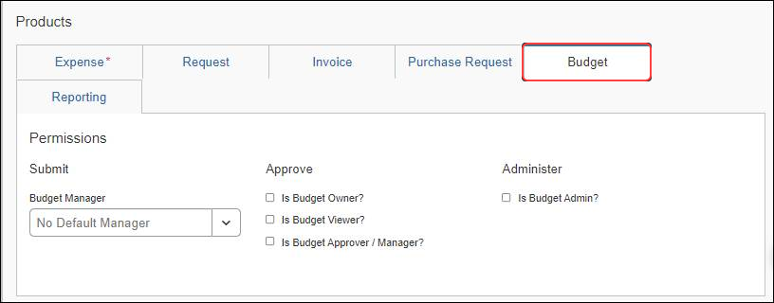
This table describes the different roles for the Budget feature.
Role | Description
Budget Admin | Configures the Fiscal Calendar, Budget Categories, Budget Tracking Fields, Budget Items, and Budget Settings. Budget Admins have access to all budget items within an entity. The Budget Admin can see the budget amounts as configured in Budget Items, but not the budget actuals as shown in the dashboards.  NOTE: If the Budget Administrator also has the Budget Viewer role, the admin will be able to see all configured budget items in the Shared Budgets section of the Budget Dashboard.
Budget Approver / Manager | Users with this role can be selected as budget approvers on specific budget items, which allows them to approve the budget in the approval step for spend items hitting that budget. They can also access the View Budget link while they approve spend items to see the specific impact of that spend on the budgets being approved.  NOTE: The Budget Approver / Manager does not have access to the budget configuration information.  In addition, users with this role are part of the default approver or Custom Manager Manager's Hierarchy to filter a Budget Item.  NOTE: Users with the Budget Approver / Manager role have the same access rights to spend item fields as regular approvers, if admins have configured these fields to be editable.
Budget Owner | Owns the budget and can view budgets in the dashboards. The Budget Owner does not have access to the budget configuration information.
Budget Viewer | Views budgets in the dashboards. Can be one or several budget viewers. The Budget Viewer does not have access to the budget configuration information.
Administrators only need to have the Budget Administrator role to access Budget Configuration. No additional role is required.
Administrators can import user roles by clicking the Import Users button on the Users page in Product Settings.

How It Works
This section describes how the Budget feature works including the Fiscal Calendar, Budget Category, Budget Tracking, Budget Items, Budget Settings, and Budget Dashboard functionality.

Fiscal Calendars
A fiscal calendar allows organizations to define their accounting periods independently of the standard calendar year. Many organizations define their own calendars to model their financial reporting to reflect seasons in their business, to compare results with direct competitors, and to avoid the busy year-end season in January.
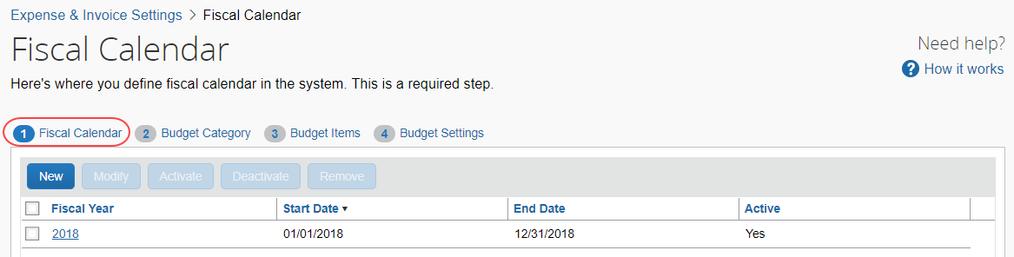
A fiscal calendar has one or more fiscal years, and fiscal years have one or more fiscal periods.
Fiscal years have a start date and an end date. Each year may have a different length to accommodate leap years and short years or long years. Organizations use short years and long years when they change the start date of their fiscal year. Fiscal years cannot overlap with prior fiscal years and no gaps can exist between fiscal years.
Fiscal periods can vary in length within a fiscal year; however, they typically represent months. In the background, for every three fiscal periods a fiscal quarter is generated and for the year a fiscal year period is generated. The fiscal quarters and the fiscal year period are used when budget items are maintained quarterly or yearly.
If a fiscal year or a fiscal period is not marked as active, Budget cannot match the spending items to the fiscal period and the system will try to map them to the next available active fiscal period. In addition, if Budget cannot map a spending item to an active fiscal period, the spending item cannot be associated to a budget. A fiscal year cannot be more than two years.

Date Range Budgets
Budget items can be associated with fiscal calendars and fiscal periods, or with date ranges. Date range budgets do not use the fiscal calendars, and only contain a single budget period that includes the entire date range of the budget.
- For more information, refer to the Date Range Budget Items section of this guide.

Budget Categories
Budget categories are groupings of expense types in Concur Invoice, Concur Expense, and Concur Request for managing budgets at a specific expense type group level. If an expense entry, invoice line item, purchase request line item, expected expense entry or segment has an expense type belonging to a budget category, the expense item, invoice line item, purchase request line item, expected expense entry or segment is associated to the budget having that budget category (if all other criteria are matched as well).
An expense type can belong to more than one budget category. This is useful, for example, where different departments may have slightly different definitions of certain expense types. Admins can create two categories for, for example, Concur Travel, with different sets of expense types for different departments.
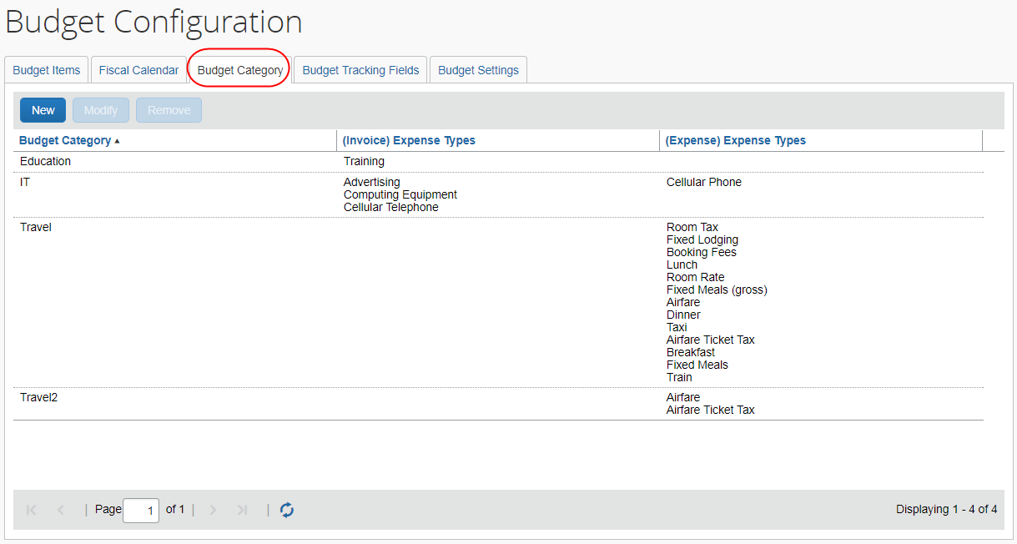
Budget categories are optional to use.
If clients do not use budget categories, Concur Invoice, Concur Expense, or Concur Request can, for example, match expense entries, invoice line items, purchase request line items, expected expense entries or segments based on the budget approver/manager manager hierarchy (defined in Budget Items).
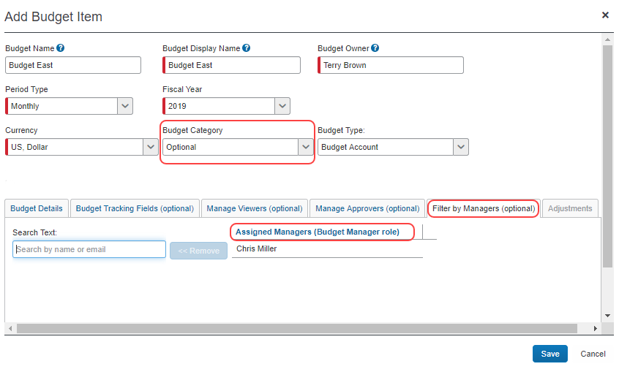

Budget Tracking Fields
Budget Tracking is optional, just like Budget Categories. If clients want to use budget tracking fields, they should configure them before creating or importing Budget Items.
Budget tracking fields provide a way to define budgets for, for example, a cost center, project, department, or a combination of these. Budget tracking fields can be configured for each budget item, if desired. Only spending items that match the budget tracking fields and values (and the other matching options like fiscal period) will be applied to the budget item.
The budget tracking fields are cost objects and/or organization units on a spending item. The values of these cost objects and organization units are entered or selected by the submitter of a spending item, then the value is compared to the budget tracking mapping for budget items to determine the correct budget.
The Field Type of the budget tracking field does not have to match the User Input type of a mapped field configured in Custom Fields. A field defined as a list field in Custom Fields can be mapped to a field defined as a free-form text field in Budget Tracking Fields.
When configuring budget tracking for multi-level lists, the admin can configure a budget tracking field to correspond to the final field of the multi-level list, without needing to map the entire set of connected list fields to budget tracking fields. If the admin would like to configure a budget tracking field to multiple levels of a connected list, the admin configures a Connected Budget Tracking field.
Fields that are configured as the Connected List Field Type in Budget Tracking can only be mapped to a single list value for each budget item. To map a field from a connected list to multiple values for a budget item, the admin must configure the associated budget tracking field as a free-form text field, then use the InValueList operator when mapping it to the specific values (comma separated) for a budget item.
- For more information, refer to the Add a Budget Item section of this guide.
To use budget tracking, admins configure custom fields in Product Settings as they normally would when they use custom fields in Concur Invoice, Concur Expense, and Concur Request.
- For more information, refer to the Shared: Custom Fields Setup Guide for Concur Standard Edition.
When the admin has configured the budget tracking fields in the Budget Tracking Fields tab, they need to go into Budget Items to activate the fields they want to use for a specific budget item, and define the field values to track.
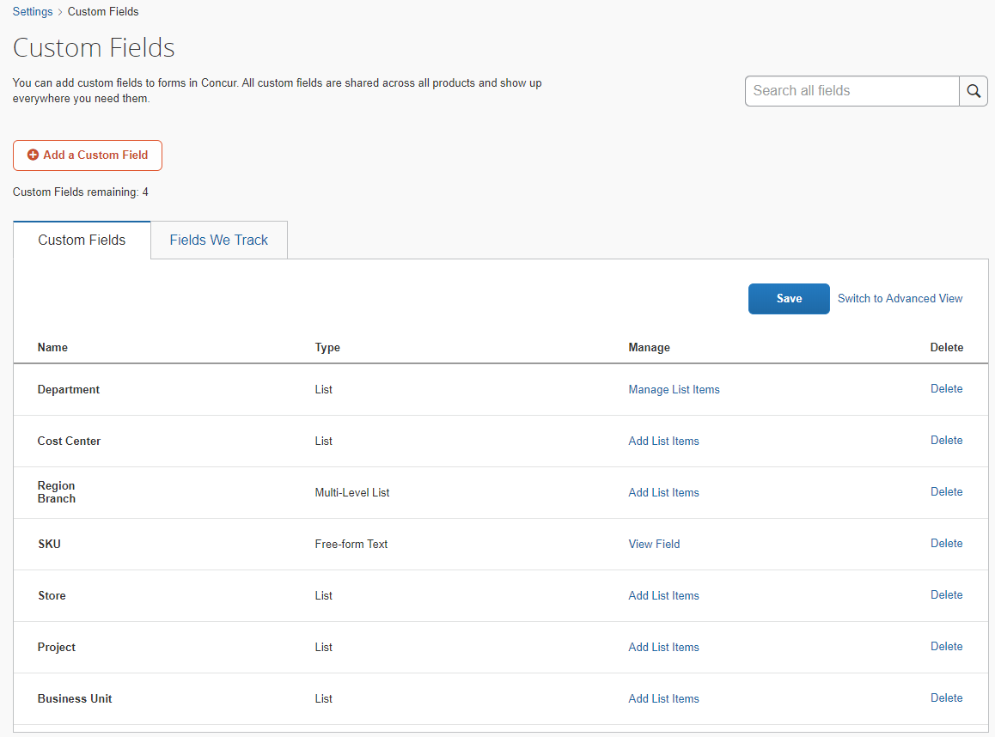
These custom fields then automatically become budget tracking fields once they are selected in Budget Items. Each custom field is available for each budget item. If a field is removed from custom fields, this same field is no longer available for budget tracking. The lists of the list fields and linked list fields in Custom Fields in Product Settings are synchronized with the budget tracking fields within Budget.
When the admin has configured the budget tracking fields in Custom Fields in Product Settings, they need to go into Budget Items to activate the fields they want to use for a specific budget item.
Admins can ensure budget items capture spending items using budget tracking field by:
- Setting up custom fields: The custom fields admins define in Custom Fields in Product Settings can be free form text, check boxes, lists, or multi-level (connected) lists.
If admins have already defined custom fields in Product Settings, but do not see them in Budget Items, go to the Custom Fields page and click the Save button, or click the Synchronize button in the Budget Tracking Fields (Optional) tab of the Add/Modify a Budget Item window, to synchronize the custom fields with the budget tracking fields.
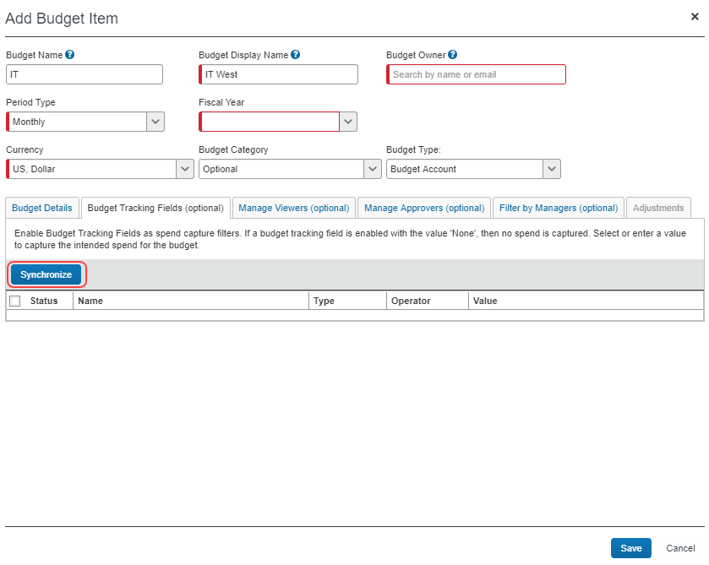
- For more information, refer to the Shared: Custom Fields Tracking Setup Guide for Concur Standard Edition.
- Assigning budget tracking fields to budget items: For budget tracking to function, clients need to associate a budget item to one or more budget tracking fields. Clients can define a budget for one specific tracking item or a combination of multiple tracking items. These tracking items can be directly linked, such as region and country, or unlinked, such as department and region. Budget items can be set up for each top level of a connected list. Clients can set up a budget for regions and within regions for each country.
- For more information, refer to the Budget Tracking Fields section in this guide.

Budget Items
When a client has set up a fiscal calendar and, optionally, budget categories, they can set up a budget item.
A budget item is a record of a budget and has three components—an amount (budget amount and budget currency), a purpose for the amount (Budget Category, Budget Type, Budget Owner, and Budget Manager), and a time restriction on the amount available (fiscal period or date range).
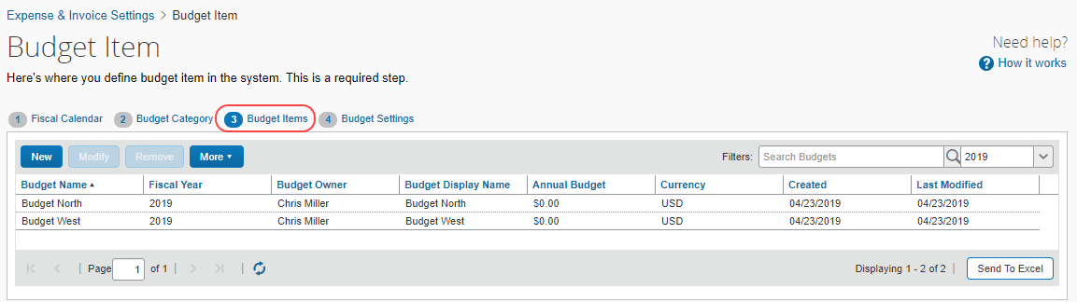
These components define the budget and give clients a way to associate a budget with a spending item, such as an expense report item, an invoice item, a purchase request item, an expected expense entry, or a segment.
Concur Invoice, Concur Expense, and Concur Request map these spending items through budget categories and a budget approver/manager manager hierarchy.
- For more details, refer to the Filter by Managers (Optional) section in this guide.
Budgets can have both budget categories and budget approvers/managers. However, budget categories and budget approvers/managers are optional.
Budget categories provide a link to the expense types of a spending item. Everyone who reports directly or indirectly to a budget approver/manager will have their spending items linked to the budget associated with the budget approver/manager.
If a budget has a budget category and budget approvers, the expense type of the spending item must match one of the expense types of the Budget Category and the submitter of the spending item must report to the budget approver/manager.
Budget owners are accountable for the budget and can view budget items in the My Budget section on the budget overview page of the Budget Dashboard. Budget owners are not automatically budget managers, because capture of spend through the Manager Hierarchy is optional and, in most cases, not needed. If applicable, assign a budget owner as a manager in the Filter by Managers (optional) tab.
The Filter by Managers (optional) tab only appears on the Budget Item page if the Budget administrator has enabled it on the Budget Settings page.

Date Range Budget Items
Date range budget items are configured with a Start Date and End Date, which define a single budget period. They are not associated with the fiscal calendars and fiscal periods defined on the Fiscal Calendar tab of Budget Configuration.
The admin must configure fiscal calendars, even if the company is only using date range budgets, as the Spending Trend chart in the Budget Dashboard requires fiscal calendars.
The date range budget items allow the Budget Administrator to configure flexible budget items to support project-, contract-, or semester-based budgets, which may not align with fiscal calendars, or personal budgets, which may align with an individual’s contract length, tenure dates, or other date ranges.
Date range budget items are enabled in Budget Settings. Once the feature is enabled:
- The Date Range option appears in the Period Type field on the Add Budget Item and Modify Budget Item pages.
- When the admin selects Date Range for a budget item, the Start Date and End Date fields appear on the Add Budget Item and Modify Budget Item pages.
- The Budget Item Import template displays the Start Date and End Date columns.
- The Budget Dashboards include a date range filter.
- The budget details page displays start and end dates for the budget periods
- The Spending Trend graph on the budget details page displays up to two years of information at a time.
If the feature is disabled after date range budgets are configured:
- The existing date range budgets are still supported
- The admin can’t create new date range budget items manually or through the Budget Item import
- The Budget Item import template no longer displays the Start Date and End Date columns.

Budget Type
The Budget Type field on the Add Budget Item / Modify Budget Item pages allows the Budget administrator to mark a budget as Personal Account, or as Budget Account (default), or Restricted Account.
The Personal Account budget type supports budgets that are associated to one person, for education, entitlements, or other benefits. The personal budgets are limited to Request and Expense spending items. The spending items will match the personal budget if the budget owner and spending item requestor are the same, and the other matching configured in Budget Items is met. Personal budgets do not use the manager hierarchy. The Budget Owner field defines the user whose spending items apply to the personal budget. The spending items go to the user's Request or Expense approver, then are applied to the personal budget (if they meet the other matching criteria defined in the budget item).
Examples of personal budgets are:
- Stipends for Higher Education
- Continuing Medical Education (CME) for Healthcare
- Entitlements
- Allowances
The Restricted Account budget type has the same functionality as the Budget Account budget type except that it is sorted and displayed separately from the Budget Account to make it easier for clients to distinguish between "regular budget accounts" and "restricted budget accounts".
In higher education and in the public sector, a restricted account is another name for a grant or a purpose-driven budget. An example of a restricted account is funding for a new research project. The organization has a $20,000 budget and a $10,000 grant. The grant needs to be spent in a specific period, so the organization wants to use the grant first; otherwise they might lose the grant due to time restrictions. The organization configures a restricted account and uses the date range for the time limitation. The rest of the budget ($20,000) will be configured as a regular budget account with a possible longer date range.
Budget types are available for selection in Audit Rules.
Clients who want to use budget audit rules should contact SAP Concur.
Once budget types are configured in Budget Items, they will appear on the budget cards on the budget overview and the budget details pages of the Budget Dashboard.

Budget Item Search and Filter
Companies who have many budget items will now be able to find and update these quicker with the new search and filter functionality in Budget Items. Admins can search and filter on budget name, budget description, owner name, and owner email.
In addition, there is a list of fiscal years which admins can use to filter and search for budget items. The list will show the current year as default.
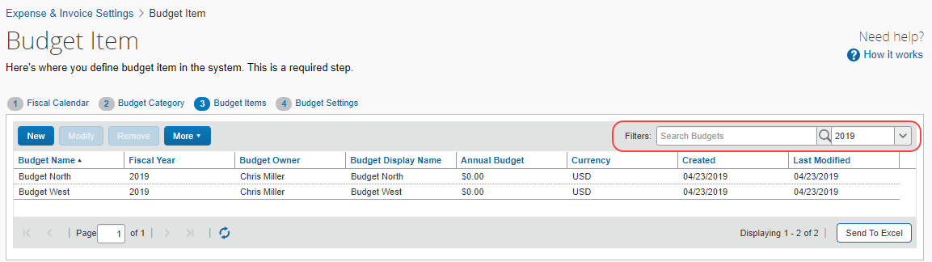
You can also search and filter and then export the filtered budget items that show on the Budget Items page.

Change Logs
Budget admins can search and view change logs of budgets and budget settings in Budget Items. This means that they can see who added, modified, or deleted budget records, and who changed company budget configuration settings. For budget item changes, admins can see more details about the changes made. They can click on the changed budget in the returned results, which is a hyperlink that will open the audit trail for that specific budget item.
- For more information about importing budget items, refer to the View Change Logs procedure in this guide.

Budget Item Import
Admins can import budget items to quickly set up budgets and avoid mistakes caused by entering them manually. Admins can also use the import function to update or remove existing records.
- For more information about importing budget items, refer to the Shared: Budget Item Import User Guide for Concur Standard Edition.

Budget Item Export
Admins can export budget data to an Excel spreadsheet by clicking Send To Excel on the Budget Items step. If the admin is using the filter for fiscal year, this filter will be honored so that only those budgets for the selected fiscal year are sent to excel instead of all budgets.
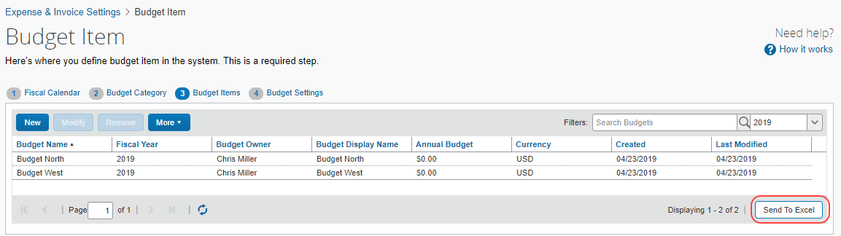
The exported spreadsheet is in the same format as the budget item import spreadsheet, so the admins can modify the data and use the same spreadsheet to import additional budget items. For larger amounts of data, budget admins can use the Bulk Export functionality in Budget Items.

Bulk Export
Budget admins can perform bulk exports of budget data by selecting the Bulk Exports option in the More menu in Budget Items.
To create an export, budget admins must first select one of the following types of data:
- Budget Configuration: The type of budget data that will be exported by selecting this option consists of all the budget item data visible on the Budget Items page similar to when the budget admin clicks on Send to Excel.
- Budget Balances: The type of budget data that will be exported by selecting this option is the equivalent of what is available in the tile view of the Budget Dashboard. Budget owners can export their own and shared budgets by using the Send to Excel functionality whereas budget admins will be able to export all budgets for a given year with their balances from the Bulk Export window.
- Budget Adjustments: The type of budget data that will be exported by selecting this option is the equivalent of what is available when budget admins export budget adjustment by clicking More > Adjustments Import and Export in Budget Items. This option will not change with the new Bulk Export feature.
- Spend Items: The type of budget data that will be exported by selecting this option is the equivalent to the data the Budget Owner selects by clicking the Export Data button in the Budget Dashboard. Spend items across all budgets will be exported when budget admins select this option.
After budget admins have selected the type of data they want to export, they need to select the fiscal year of the budgets they want to export. Then, budget admins can filter budgets they want to export by budget category; they can select a specific budget category or all budget categories. Finally, when budget admins have selected the file type for the export, they can select if they want to receive an email once the export is ready to download.
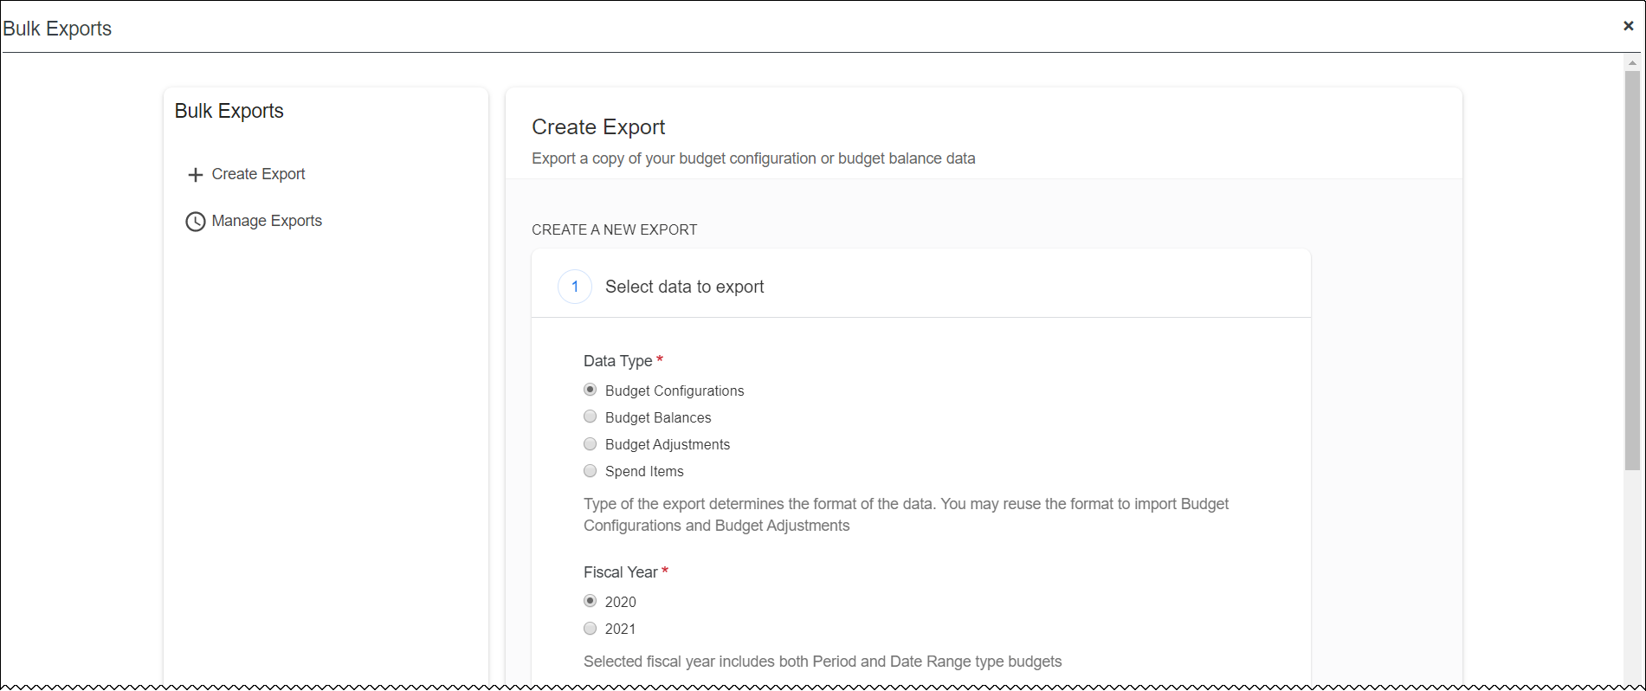
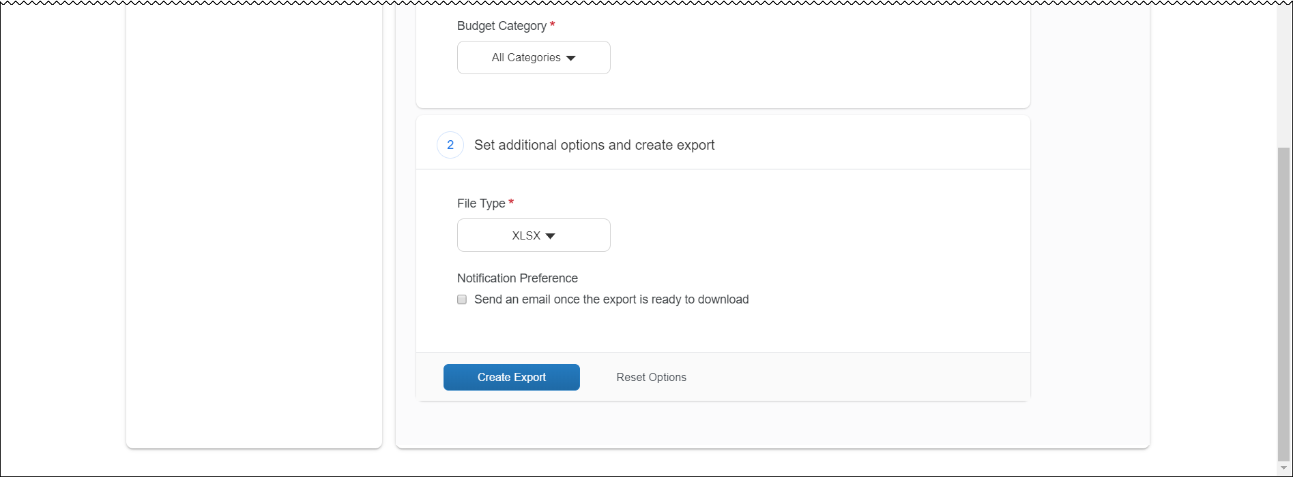
If budget admins select to receive an email when the export is ready to download, they will see a similar window to the one below.
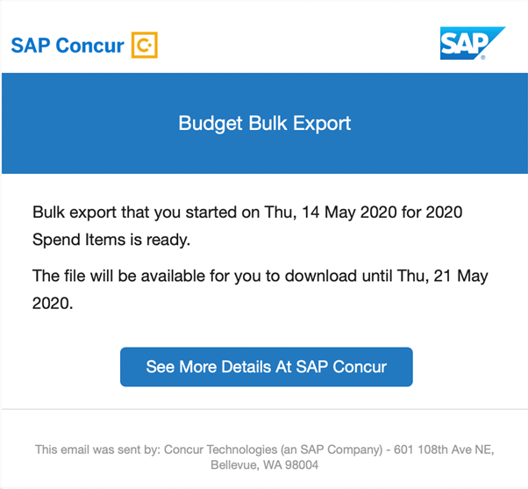
On the Manage Exports page, budget admins can see a list of requested exports in the last seven days including a link to download each export.
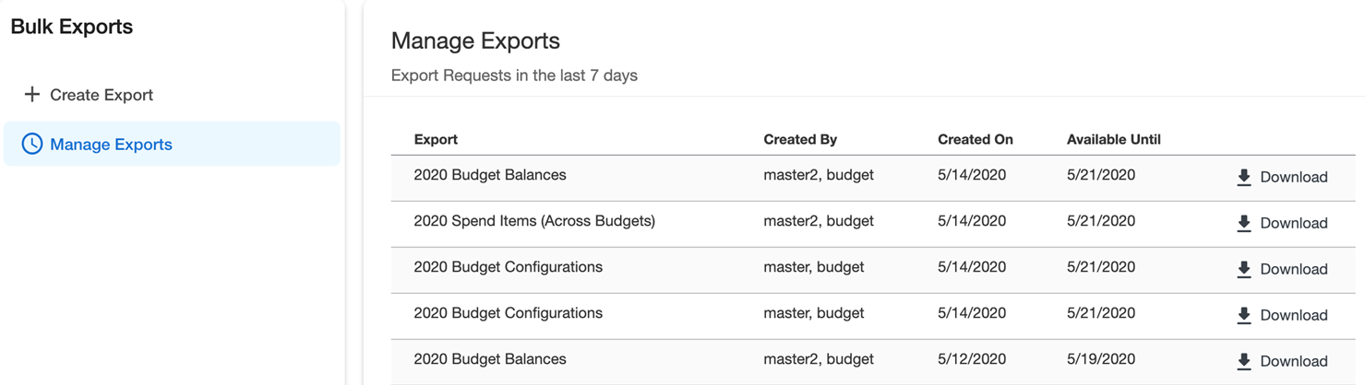

Budget Details
The Budget Details tab displays the fiscal periods and the budget amount for each period. In addition, it shows if a period is active (open) or not. The admin selects the type of period for which the budget will be applicable in the Period Type list. The budget period type can be monthly, quarterly, or yearly.
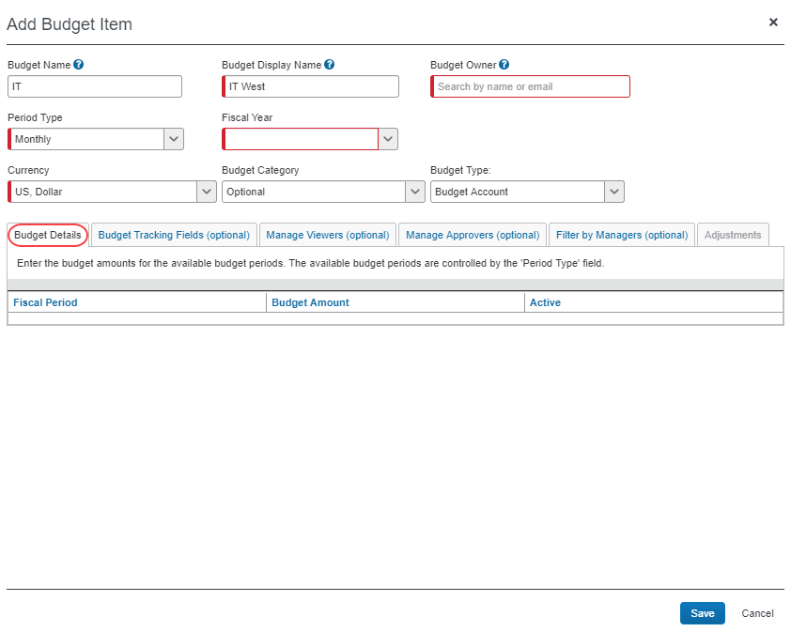

Budget Tracking Fields (Optional)
When the admin has configured the budget tracking fields, they need to associate these fields to a budget item. This is done by clicking the Budget Items step and then either clicking Add or selecting an existing budget item and clicking Modify.
In the Budget Tracking Fields (optional) tab of the window that appears, the admin can select which fields to associate to the budget item by selecting one of the check boxes.
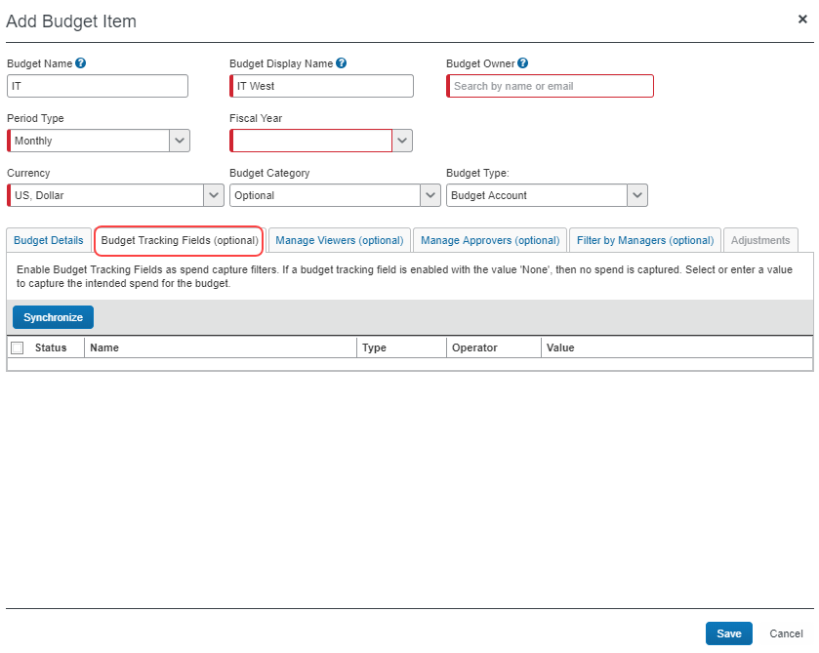
The columns in the Budget Tracking Fields (optional) tab contain information based on the Custom Fields configuration in Product Settings.
If you have already defined custom fields in Product Settings, but do not see them in Budget Items, go to the Custom Fields page and select the Save button, or click the Synchronize button in the Budget Tracking Fields tab of the Add/Modify a Budget Item window, to synchronize the custom fields with the budget tracking fields.

Budget Adjustments
Budget items may be adjusted by the Budget Administrator manually on the Adjustments tab of the Modify Budget Item page or on the Adjustment tab on the budget details page of the Budget Dashboard. In addition, budget items may be adjusted by importing a spreadsheet of adjustments. The adjustments can be made to the total budget amount, the spent amount, or the pending amount.
Adding Adjustments in Budget Items
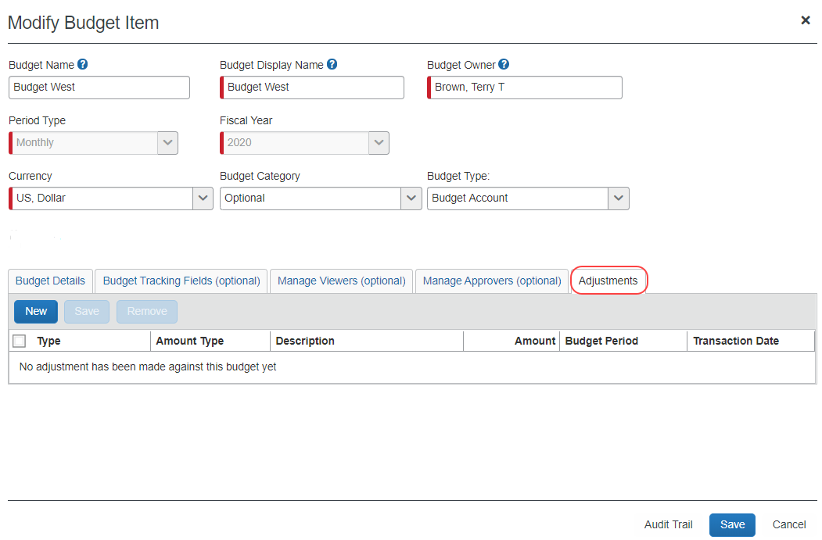
Adding Adjustments on the details page of the Budget Dashboard
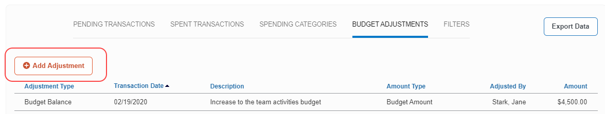
If the budget has any adjustments, they will appear on the budget details page, on the Budget Adjustments tab.
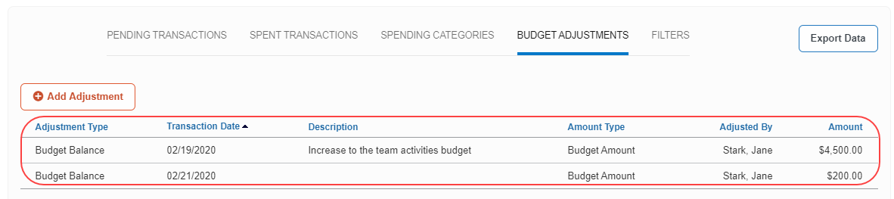
Budget Administrators can activate the Enable Budget Owner Adjustments option in Budget Settings to enable budget owners to add adjustments to their own budgets. For more information, refer to the Budget Adjustments for Budget Owners section in this guide.
Budget Adjustments Import & Export
Admins can import adjustments to existing budget items using the Budget Adjustments import, and export budget adjustments from the Budget Adjustments Import window.
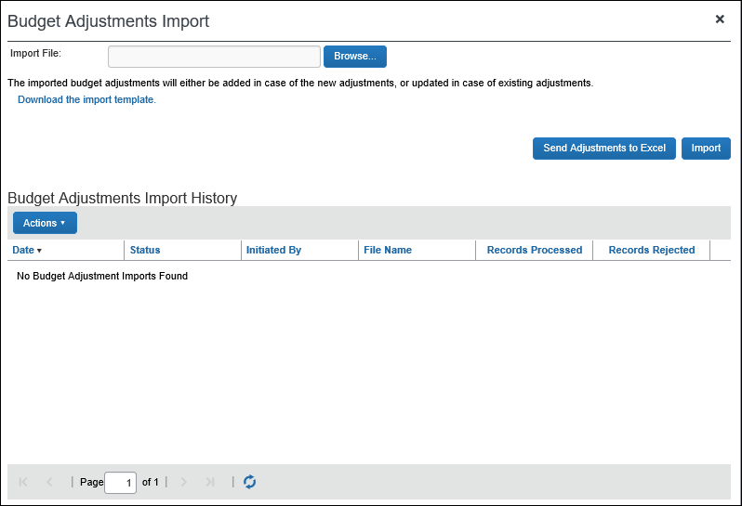
- For more information about importing budget items, refer to the Shared: Budget Item Adjustments Import User Guide.

Manage Approvers (Optional)
The Manage Approvers (optional) tab will display on the Add Budget Item and Modify Budget Item windows if Budget is enabled and budget approval is configured.
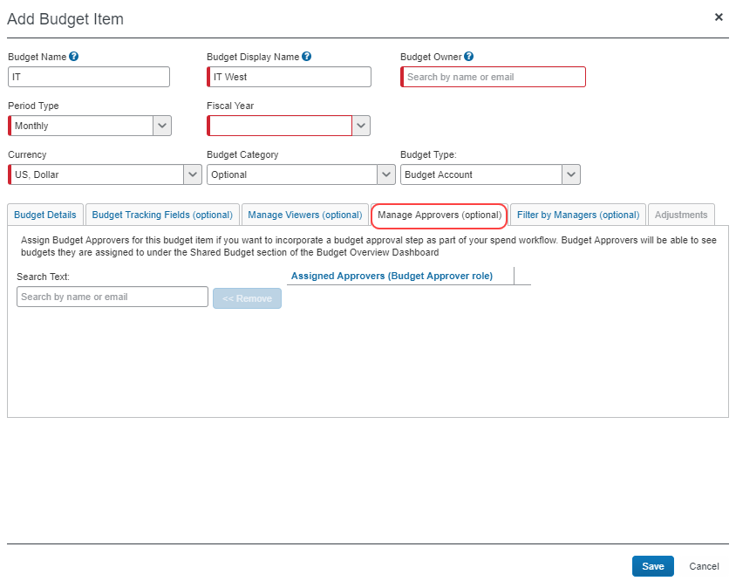
Admins can add up to five budget approvers per budget item. However, only one approval is needed per budget. For example, if there are five approvers, they will all be notified to approve the transaction but once one of them has approved, the other ones will be skipped. If a spending item matches multiple budgets and each budget has its own approver, one budget approval is required for each budget. If a budget approver is associated with multiple budgets, the budget approver only needs to approve the spending item once.
If admins try and add more than five approvers, a warning message displays at the bottom of the window on the Manage Approvers (optional) tab.

- For more information about budget approvals and budget workflows, refer to the Budget Workflows section in this document.

Filter by Managers (Optional)
The user with the Budget Approver / Manager role enables the budget manager hierarchy. There are two different ways of doing this, which are described below. Submissions of invoices, purchase requests, expense reports, or requests by direct and indirect employees are matched to budgets based on the manager hierarchy, that is, a manager who is a direct manager or any manager above this manager in the hierarchy.

Building a Custom Manager Hierarchy to Filter a Budget
- The budget setting Enable filtering by Budget Manager needs to be selected (enabled)
- The budget setting Alternate Budget Manager needs to be set to Budget Manager
- The users who will be budget managers will need the Budget Approver/Manager permission role
- Users will need to have Budget Manager added to their profile, which can be done in the following ways:
  - The admin can enter an approver manager in the Your budget manager field in Invoice Approvers, Expense Approvers, or Request Approvers
  - The admin can import budget approvers/managers in User Administration
  - The user can enter a budget approver in the Your budget manager field in Invoice Approver, Expense Approvers, or Request Approvers, which they can access by clicking Profile > Profile Settings > Invoice Approvers, Expense Approvers, or Request Approvers.
The Budget Manager in a user's profile in Concur Expense, Concur Invoice, and Concur Request is shared, which means, for example, that an approver entered for Concur Expense also applies to Concur Invoice and Concur Request.

Use a Default Approver Hierarchy to Filter a Budget
- The budget setting Enable filtering by Budget manager needs to be selected (enabled)
- The budget setting Alternate Budget Manager needs to be set to Expense Approver, Invoice Approver, or Travel Manager
- The default approvers who will be budget managers will need the Budget Approver/Manager permission role
- The default approver(s) will need to be added to the budget item on the Filter by Managers tab
You do not need to add a budget manager to users' profiles when you use a default approver. If you do not add a default approver to the budget item, the filter will not work.
Budget managers do not approve spend for budget approvers.
Examples:
When a manager has direct reports who are also managers
When Pat is listed on the Filter by Managers tab for the budget, Pat's spend plus all the managers who report to Pat and their direct reports will consume the budget.
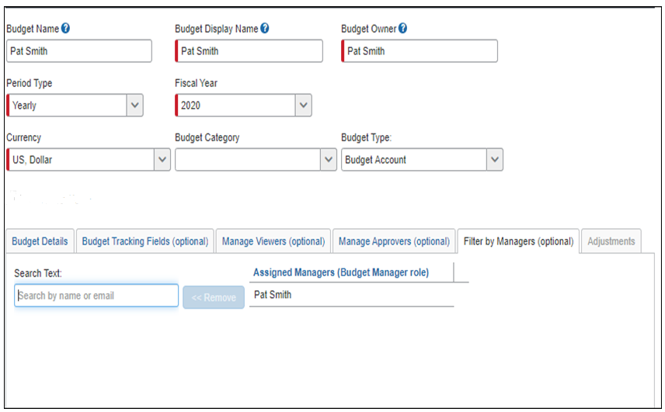

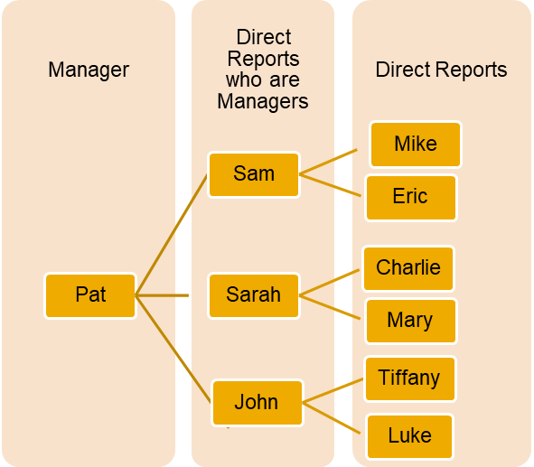
When a manager has direct reports only
When Pat is listed on the Filter by Managers tab for a budget, Pat's spend plus Sam, Sarah, and John spend will consume the budget. Other matching criteria, such as fiscal period and budget category will also apply.
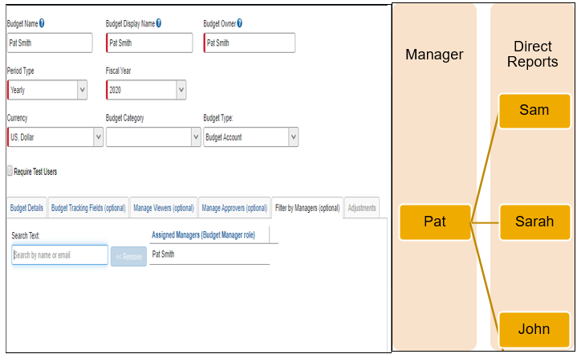
Budget managers who are not budget owners will be able to see shared budgets in the Shared Budget section on the budget overview page of the Budget Dashboard.

Manage Viewers (Optional)
Budget viewers are users who can view someone else’s budget without the permission to approve invoices, purchase requests, expense reports, or authorization/travel requests for that budget. A budget owner can always see their own budget and can have multiple budgets. A budget may have multiple budget viewers or none. Admins can assign one or more budget viewers to a budget to share visibility of a budget. Budget viewers will see the shared budgets in the Shared Budget section on the budget overview page of the Budget Dashboards.
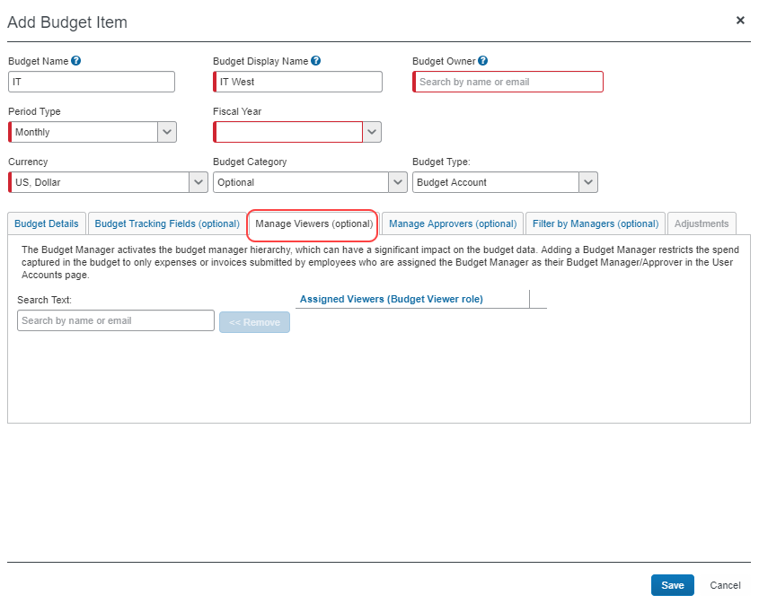

Team Budgets
Team budgets enable budget owners to create and self-manage budgets for their team(s). This is particularly useful for lower-level managers who might receive an informal budget amount from their direct manager without a good way to track the spend of their team(s) against a budget. With team budgets, they can easily create a team budget and track the spend of their team(s) against an amount over time. In addition, Team budgets eliminates dependency on budget admins.
There is no limit to how many team budgets a manager can create. However, they can only create team budgets for their own team(s). Admins will manage any change of a manager or budget type.
To create a team budget, budget owners click Add Team Budget in the Budget Dashboard.
In the Add Team Budget window that appears, budget owners enter the required information in the fields.
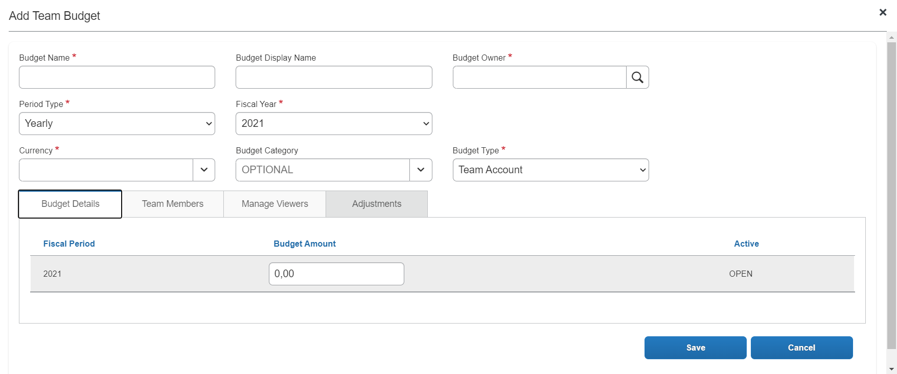
The information on this page is similar to the Add Budget Item window. The differences include the following:
- The Budget Type field is set as Team Account by default for budget owners.
- Budget does not support budget tracking fields, budget approvers, filter by managers, and import and export functionality. Some of this functionality will be available in the future.
- The Budget Owner field is always set to you being the manager and owner of the budget. Only budget admins can change this.
- The Team Members tab listing the members of the team. More information about this tab below.
Adjustments are not available until the budget is saved.
The Team Members tab shows all the employees for which the Budget Owner approves spend items. This information is pulled in automatically when a team budget is created. Budget owners can define how team members participate in the created team budget. To refresh the list of team members, the Budget Owner needs to open the relevant team budget and, if needed, define participation period for members who left or joined the team. Example of this is provided below.
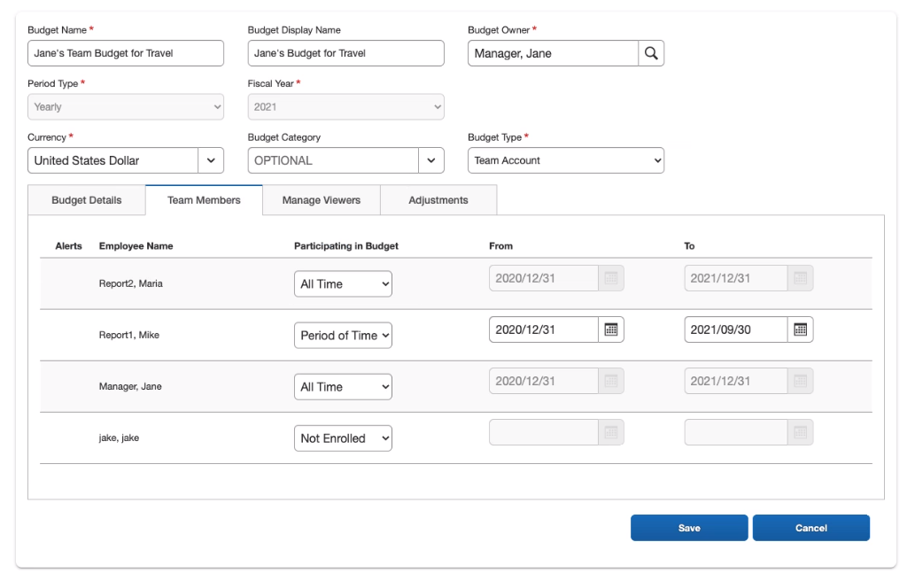
The following table describes the columns in the Team Members tab.
Column | Description
Alert | An alert is shown in the following scenarios:  - When a new employee has been added to a team after the team budget is created  - When an employee has left a team but is still shown as participating in a budget
Employee Name | This column lists the employees in a team.
Participating in Budget | This list shows how employees participates in a budget. The options are:  - All Time (participates in the team budget)  - Period of Time (participates in the team budget between the dates shown in the From and To columns.  - Not Enrolled (not participating in the team budget)
From | This field shows the start date of the employee participating in the budget.
To | This field shows the end date of the employee participating in the budget.

Examples of Managing Team Members and Team Budgets
This section lists a number of examples of how budget owners can manage team members and team budget participation.
Team Member Participating in a Team Budget for a Period of Time
Jane is a manager and has a direct, Mike, who she only wants to participate in the team budget for a period of time. To do this, Jane selects the Period of Time option in the Participating in Budget column next to Mike's name. Then she selects the dates that Mike should participate in the team budget in the From and To columns.
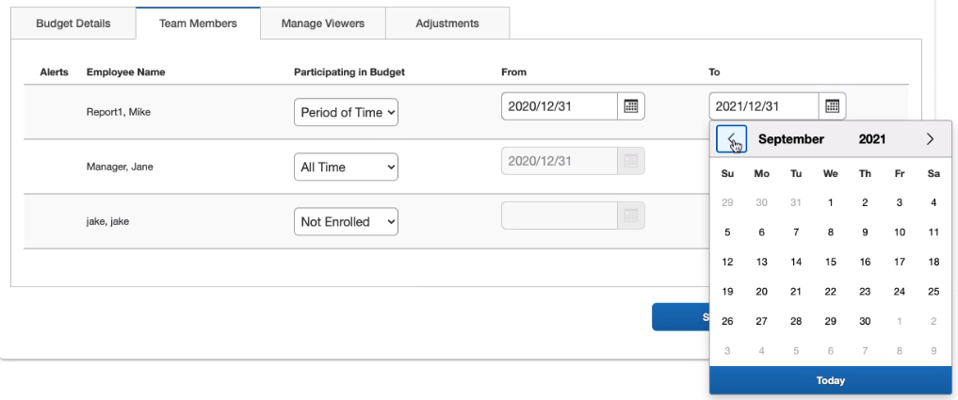
Team Member Not Participating in a Team Budget
Jane is a manager of a team and has a direct, Jake, who she does not want to participate in the team budget. To do this, Jane selects the Not Enrolled option in the Participating in Budget column next to Jake's name and clicks Save.
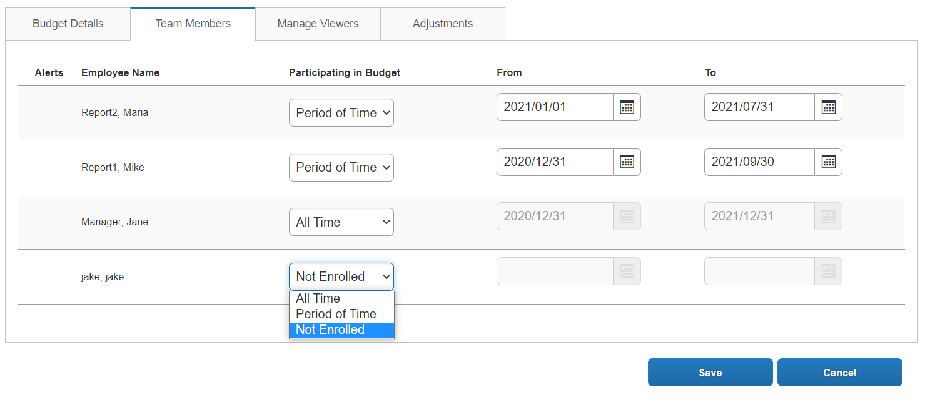
Team Member Joining a Team
Jane is a manager and a new employee, Mike, has joined the team. As can be seen in the image below, Mike has been added as an employee showing that he is participating in the budget for a period of time including the relevant dates. Jane can adjust the dates if needed and then click Save.
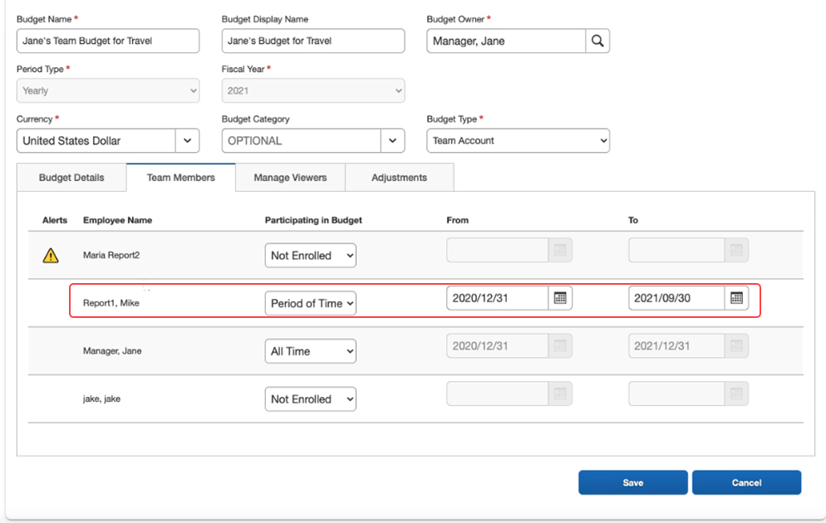
Team Member Leaving a Team
Jane is a manager and one of her directs, Maria, has left the team. As can be seen in the image below, Maria has been removed as an employee but is still enrolled in the team budget. Jane can see an alert about this in the Alerts column. To remove Maria from the team budget, Jane needs to select the Period of Time option in the Participating in Budget column, select Maria's exit date in the To column, and then click Save.
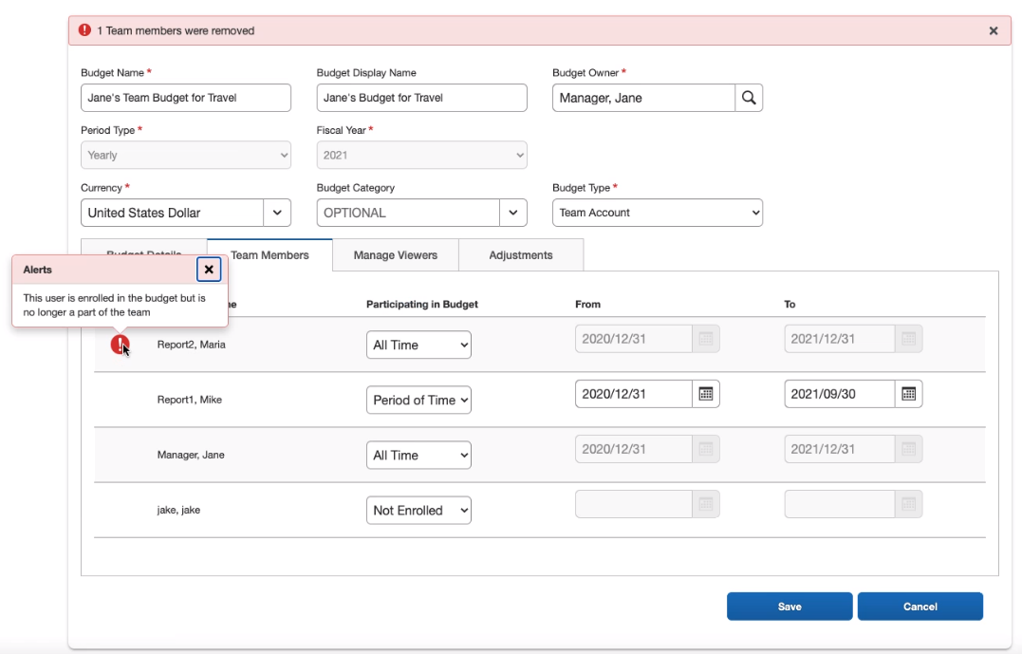
- For information about the other tabs in the Add Team Budget window, refer to the Budget Configuration section of this guide.

Budget Settings
The Budget Settings step is available for users with the Budget Admin role. In addition, users need to have the Invoice Admin or Can Administer role.
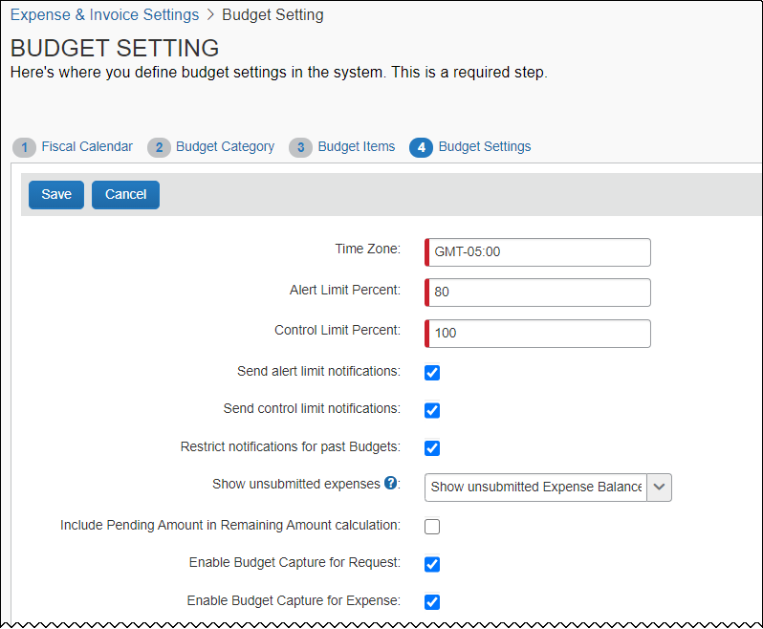
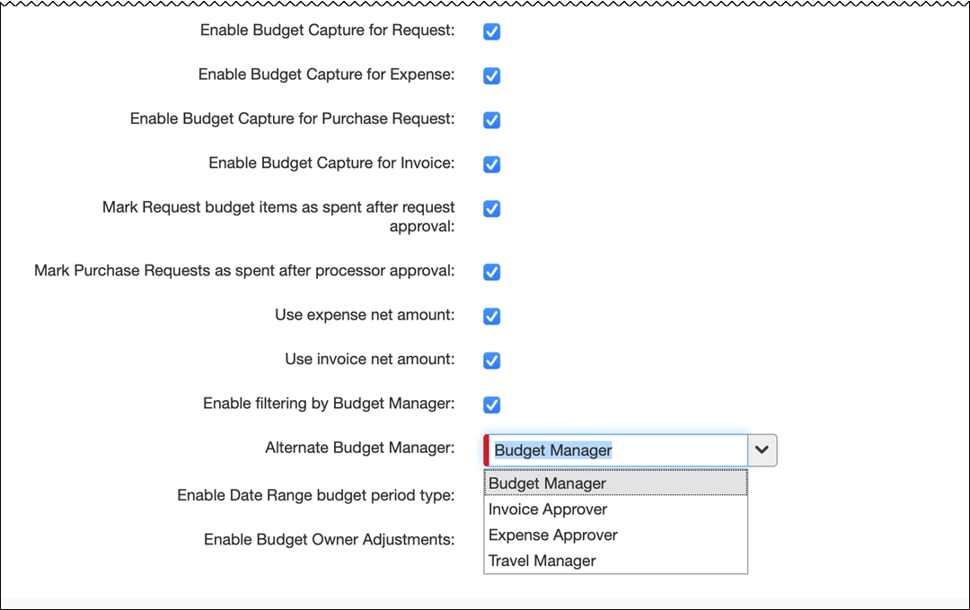
The following table describes the settings available on the Budget Settings page.
Setting | Description
Time Zone  (only appears for SAP Concur Internal users) | This setting determines exactly when the first day of the year starts and the last day of the year ends. When the first admin user creates a fiscal year, this will be registered, and this setting will show the time zone of where this user is located. Only SAP Concur can change this setting. Contact SAP Concur support to create a service request.
Alert Limit Percent | When a budget reaches a certain percent (80% by default), the owner or approver of the budget will see a yellow visual indicator when the budget is consumed beyond this percent.
Control Limit Percent | When a budget reaches a certain percent (100% by default), the owner or approver of the budget will see a red visual indicator when the budget is consumed beyond this percent.
Send alert limit notifications | When this option is selected (enabled), budget owners will receive an email alert when their budget exceeds the budget alert limit.
Send control limit notifications | When this option is selected (enabled), budget owners will receive an email alert when their budget exceeds the budget alert limit or control limit.
Restrict notifications for past Budgets | When this option is selected (enabled), budget owners will not receive email notifications for older data, only for the previous, current, and any future periods. This means that by selecting this option, fewer email notifications will be sent out to them.
Show unsubmitted expenses  (Expense only) | The admins can select (enable) one of the following options:  - Do not show unsubmitted Expense amounts  - Show unsubmitted Expense Amounts as Pending  - Show unsubmitted Expense Balance  Click on the question mark icon for quick information about the three options available.  - For more information about these options, refer to the Show Unsubmitted Expenses (Expense Only) section below this table.
Include Pending Amount in Remaining Amount calculation | Companies who want to include the pending amount in the calculated remaining amount should select (enable) this setting. This means that the pending amount will be subtracted from the remaining amount.  If the setting is selected (enabled), the remaining amount equals the budget amount minus the spent amount and the pending amount. In this scenario, clients typically want the remaining amount to reflect a realistic view of what remains to spend and estimate that most of the pending items will be approved.  If the setting is cleared (disabled), the remaining amount equals the budget amount minus the spent amount. In this scenario, clients typically want the remaining amount to reflect the amount they still have control over. Pending spending items can be rejected.  This setting is cleared (disabled) by default.
Enable Budget Capture for Request | The admin can select (enable) this check box to enable budget capture for Concur Request.
Enable Budget Capture for Expense | The admin can select (enable) this check box to enable budget capture for Concur Expense.
Enable Budget Capture for Purchase Request | The admin can select (enable) this check box to enable budget capture for purchase requests.
Enable Budget Capture for Invoice | The admin can select (enable) this check box to enable budget capture for Concur Invoice.
Mark Request budget items as spent after request approval (Request only) | The admin can select (enable) this check box so that request budget items are marked as spent when the request has been approved.
Mark Purchase Requests as spent after processor approval  (Purchase Request feature of Invoice only) | The admin can select (enable) this check box so that a purchase request is marked as spent when the processor approves it. The purchase request will remain marked as spent until it has been matched to an invoice. This means that the system acknowledges the pre-authorization approval as final approval.
Use invoice net amount (Concur Invoice only) | The admin can choose whether the net or gross amount of the invoice should be consumed. The option is selected by default. If the admin would like to include taxes and shipping costs, the option should be cleared (disabled).
Use expense net amount (Concur Expense only) | The admin can select (enable) this check box so that the reclaim amount will be subtracted from the gross amount, that is so that expense reports are consumed with tax. This is useful in countries where companies can reclaim taxes from expense reports, for example, countries who use VAT.
Enable filtering by Budget Manager | The admin can select (enable) this check box so that the Filter by Managers (Optional) tab appears in Budget Items.  When the admin selects this option, spend is captured based on the Manager Hierarchy if the budgets have filter by managers defined on them. This can be used in conjunction with other filtering options like budget categories and budget tracking fields.  This setting is cleared (disabled) by default.  NOTE: When you select this option, the Alternate Budget Manager option will display.
Alternate Budget Manager | The default is Budget Manager field in Invoice Approvers or Expense Approvers in a user's profile when using a custom "who reports to who". If you want to use an existing "who reports to who in a user's profile", you can choose a default approver (Travel, Invoice, or Expense approver) the user has not filled in an approver in the Your budget manager field in Invoice Approvers or Expense Approvers in Profiles Settings, the system will use the approver selected in the Alternate Budget Manager list. The following options are available:  - Budget Manager  - Travel Manager  - Invoice Approver  - Expense Approver  NOTE: To see the Alternate Budget Manager list, you must select (enable) the Enable filtering by Budget Manager option on the Budget Settings page.  - For more information, refer to the Filter by Managers section of this guide.
Enable Date Range Budget Period Type | The admin can select (enable) this check box to allow budget items based on date ranges instead of fiscal year and fiscal period.  When the admin selects this option, the Add Budget Item and Modify Budget Item pages display the Date Range value in the Period Type field. If the admin selects Date Range for the budget item, the page displays the Start Date and End Date fields. The Budget Item Import template displays the Start Date and End Date columns.  - For more information, refer to the Date Range Budget Items section of this guide.
Enable Budget Owner Adjustments | The admin can select (enable) this check box to allow budget owners to add adjustments to a budget.  When the admin selects this option, budget owners will see a new option, Add Adjustments, in the Budget Dashboard which enable them to add an adjustment to a budget.  NOTE: Budget administrators can also add adjustments on the details page of the Budget Dashboard.

Show Unsubmitted Expenses (Concur Expense Only)
The Show unsubmitted expenses setting in Budget Settings enables budget owners to view the balance of the expense items that have not been submitted yet and is a combination of unsubmitted expense reports and available expenses which are not attached to an expense report. The setting has three options, which control what budget owners can see in the Budget Dashboard and when they click the View Budget link in Concur Expense.
The following table describes the options available for the Show unsubmitted expenses setting.
Show unsubmitted expense setting | Description
Do not show unsubmitted Expense amounts | If the admin selects this option, unexpensed amounts do not appear in the Budget Dashboards.  This option is the default value.  Clients might want to select this option when they estimate that less than 80% of the available expenses and unsubmitted expense reports are matched correctly to a budget. Under this threshold, the unexpensed amount becomes less valuable and might be confusing for the individual budget owners.  NOTE: Available expenses might not have enough information to be matched correctly. Unsubmitted expense reports can be in various stages from created to fully updated and ready for submission.
Show unsubmitted Expense Amounts as Pending | If the admin selects this option, available expenses and unsubmitted expenses are included in the pending amount visible in the Budget Dashboards and in the in-transaction view (through the View Budget link).  Clients might want to select this option when they estimate that 95% or more of the available expenses and unsubmitted expense reports are matched correctly to a budget.  NOTE: Credit card transactions and billing statements will not show in the Pending budget bucket when the admin selects this option. Instead, these transactions will show in the Spent budget bucket.
Show unsubmitted Expense Balance | If the admin selects this option, expenses will show in the unexpensed amount visible in the Budget Dashboard and in the in-transaction view (through the View Budget link).  Clients might want to select this option when they estimate that 80-95% of the available expenses and unsubmitted expense reports are matched correctly to a budget.  NOTE: Credit card transactions and billing statements will not show in the Unexpensed budget bucket when the admin selects this option. Instead, these transactions will show in the Spent budget bucket.
If admins have selected the Show unsubmitted Expense Amounts as Pending and the Include Pending Amount in Remaining Amount calculation options, the remaining amount will have the pending amount and the unexpensed amount (unexpensed plus unsubmitted).
The second and third option in the table above give budget owners an indication of how they are really spending their budget(s) and what they need to do when planning their budget(s) going forward.
In addition, when the admin has selected the second or third of these options, an Employee column displays on the Budget Field Mapping tab in the Budget Tracking Fields step when clicking the Budget section in Product Settings.
- For more information, refer to the Map Budget Tracking Fields to Spending Items Fields section in this guide.

Budget Audit Rules
Budget audit rules help companies control budget spend during a budget year. For example, to ensure that a budget is not spent too early in the year when there might be important spending coming up later in that year. Budget audit rules are an add-on feature to Concur Expense, Concur Invoice, and Concur Request Standard Edition.
Clients who want to use budget audit rules should contact SAP Concur.

Budget Workflows
Workflows define how the system routes invoices, purchase requests, expense reports, and requests through approval and processing steps. The flexible workflow feature in SAP Concur allows companies to design Budget workflows specifically tailored to their unique needs.
Without budget review, budgets may become fully consumed well before the end of a period or year leaving an organization with limited options and budget owners with, for example, exceeded budgets. In addition, early spending means that more important spending will be declined because lesser important spending consumed the budget early on.
Combining budget review in the workflow adds value. Audit rules and workflow step rules can help organizations to add in controls when it makes sense to fine tune to an organization's specific needs.
Equally important is the determination when a spending item is regarded as committed toward a budget. In most organizations, the commit occurs when a spending item is paid; it went through most if not all approval steps. In other organizations, the commit occurs much earlier. As soon as a purchase request or an authorization request is approved it is regarded as committed.
Budget workflows are incorporated by adding a budget approval step in the already existing workflow functionality for Concur Expense and Concur Invoice (including purchase requests).
Budget workflows are not available for standard edition of Concur Request.
Apart from adding a budget approval step to the Workflow functionality, SAP Concur has also added a Manage Approvers (optional) tab in the Add Budget Item and Modify Budget Item windows of Budget Items.
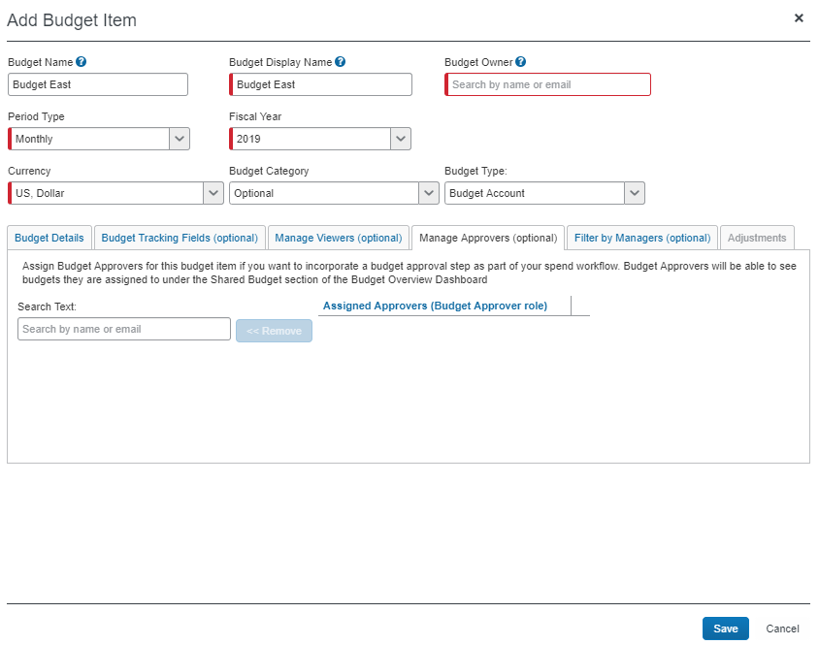
A user with the Budget Approver role in combination with the spend user permission will be able to access the Approval page to approve transactions. For example, if a budget approver is also an expense user or an expense approver, the budget approver can access the expense approvals menu and approve the expense report.
Budget approvers cannot be delegated.
- For more information about the Manage Approvers (optional) tab, refer to the Manage Approvers (Optional) section in this document.

Important to Note
Clients should note the following:
- If clients are using the old Concur Expense user interface, the budget approval step does not display the budget approver on the mobile app until after the step in the workflow. This also means that the budget approval step does not work if clients use the mobile app.
- Japanese clients who use e-Bunsho and China Data Center clients must use the old Concur Expense UI. Thus, SAP Concur recommends that these clients do not approve budgets on the mobile app.
- The approval flow windows on mobile available for Concur Invoice only, do not display the budget approver until after the budget approval step is completed. However, this does not prevent anyone from approving invoices for Budget.

General Budget Approval Rules
Ensure that you are familiar with the following budget approval rules:
- If the spend approval step comes before the budget approval step and the spend approver is also a budget approver, the budget approval step will be skipped for the budgets associated with that spend approver. However, if the budget approval step comes before the spend approval step, the transaction must be approved twice (for example for personal accounts) by the same approver; for the budget approval step and for the spend approval step.
- If a budget approver is the same as a cost object approver or processor and the budget approver step occurs after these in the workflow, they must all approve separately.
- If a submitter is also an approver of the same budget, the budget approval step will be skipped for that budget. If other budgets are affected, approval is still needed from other budget approvers.
- A workflow with a cost object approval step and a budget approval step will always require approval separately; the cost object approval will never be skipped.
- Budgets who do not have an approver will be skipped.
- If the Approval Time Expired action in a workflow is set to Send to the Approver's Approver, the spend will skip to the next step of the workflow.
- Only one approval is needed by a budget approver who is associated with multiple budgets. For example, if an expense report affects multiple budgets for one budget approver, the approver will see the expense report as a single line item on the Approvals page, and only need to approve the expense report once.
- Clients can have budget approvers without using Budget workflows. Budget approvers will have access to the Budget Dashboards and the in-transaction view. This means that spend approvers, who also have budget approver permission, can see the in-transaction view and the impact of the spend before they approve a transaction, whereas spend approvers with budget viewer permission cannot see the in-transaction view.

Budget Dashboards
Users will have access to a Budget Dashboard that contains both overview and detailed information about budgets. The dashboard shows how much has been spent to date – including pre-approved spend if enabled – across an approver’s budget. If a manager has multiple budgets, they can look at them while they approve spending items, and not later.
When clicking Reporting > Budget Dashboard, users will see a budget overview page that contains overview information about a user’s current budget(s), such as the following:
- Budget size (Budget)
- How much of the budget that has been spent (Spent)
- How much of the budget that is left (Remaining)
- How much of the budget that is pending approval (Pending)
- (Expense only) How much of the budget that is unexpensed (Unexpensed)
- A budget breakdown in percentage of Spent, Pending, and Remaining
- Budget consumption against time
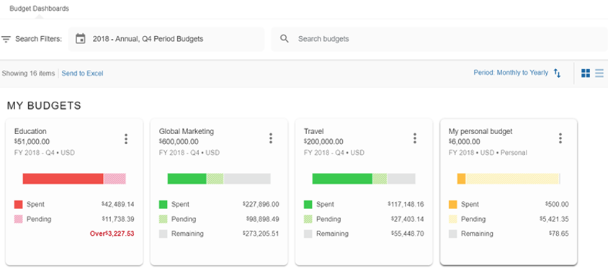
If the user has the right permission, other budgets (shared) might be available to view.
Clicking on a budget will take the user to a page that contains detailed information about a user’s specific budget. Apart from showing the same information about Budget, Spent, Remaining, and Pending that is available on the budget overview page, the page with budget details also contains a graphical budget breakdown in percentage of Spent, Pending, and Remaining and detailed information about the spent and pending budget of invoices, purchase requests, expense reports, and requests, and information about adjustments that have been made to the budget.
If budget types are configured in Budget Items, they will appear on the budget cards on the budget overview and the budget details pages of the Budget Dashboard. The budget types labels will display as Restricted or Personal. When no budget type label is displayed, it indicates a regular budget account.
- For more information about budget types, refer to the Budget Types section in this document.

Budget Overview
The budget overview allows users to quickly see their budgets and the spent, remaining, and pending amounts. Concur Expense users can also see the unexpensed amount. Unexpensed amounts enable budget owners to view the balance of the expense items that have not been submitted yet and are a combination of unsubmitted expense reports and available expenses which are not attached to an expense report. A budget owner, for example, might want to view their budgets to make budget spend decisions, or see how much is left of their budgets. They might also want to compare one budget year with another.
To view the budget overview page, a user must have the Budget Viewer, Budget Owner, or Budget Approver / Manager role.
A budget user can use filter and search functionality to find budgets.
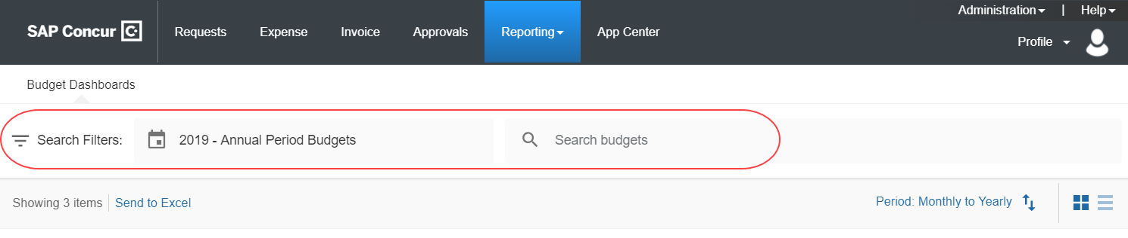
The period filter enables users to select a budget year (current budget year is set as default) and a budget period. When users click the period filter, a window appears where they can select the budget year and then period type (monthly, quarterly, and/or yearly). They can also select multiple quarters and months for the period budgets.
The period filter only shows information that is relevant to the user. For example, if a user does not have yearly or quarterly budgets in a fiscal year, those fiscal periods are not available in the list. This also applies to the fiscal years. Another example is if a company has defined fiscal years and budgets for five years, but a user only owns budgets in the current year. Then the user can only select the current year.
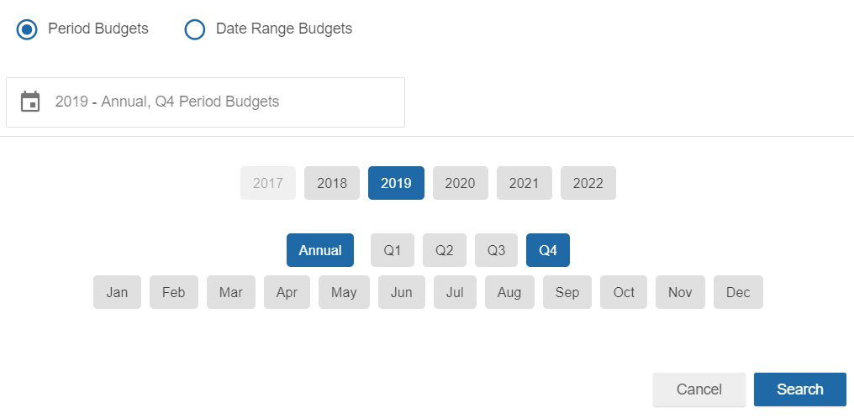
If users click the Date Range Budgets option, they can filter budget on year and date range by clicking the relevant buttons. They can also select multiple date ranges.
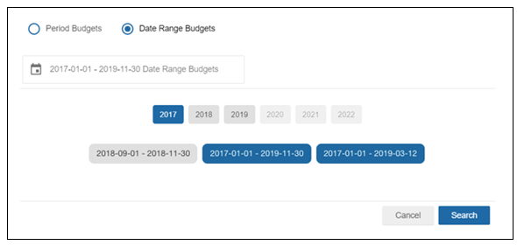
If users use the search filter functionality, they can start typing the name of the budget that they are looking for in the search field. When clients start typing, they will see that the search functionality is structured into relevant categories; Show Budgets, Show Budgets With Category, and Show Budgets Owned By for easier viewing.
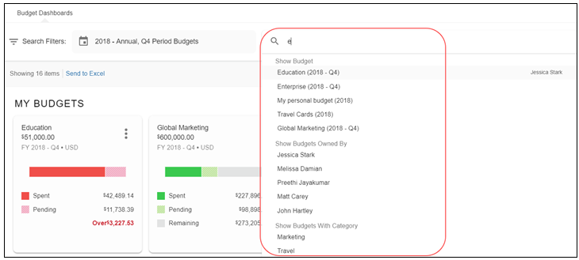
Users can also use search strings to search for budgets. The table below describes the available terms to use when creating a search string in the search field. These terms are pulled from Budget Items.
Search Category | Description
Name | This is the budget name. For example, to search for food expenses type name:(all food expenses).
Owner | This is the budget owner. For example, to search for budgets by owner type owner:johnsmith@brooksdev.com.
Category | This is the budget category. For example, to search for a budget category type category:(IT).
Description | This is the budget display name. For example, to search for a budget description type description:(budget west).
Budget | This is the budget amount. For example, to search for a budget with a specific budget amount type budget:(>1000). Some other examples include the following:  - Budget=1000  - Budget<1000  - Budget>=1000  - Budget<=1000
A budget user can view a specific budget to see how much of the budget has been spent (Spent), how much is awaiting approval (Pending), and how much is left to spend (Remaining). Concur Expense users can also see the unexpensed amount (Unexpensed) if the admin has activated the feature. The percentage shows how much of the budget is spent. Budget users can click the tile to view more details of a specific budget.
The bar graphs for each budget are color coded to make it easier to see how much of a budget is spent or pending (only if the Include Pending Amount in Remaining Amount calculation setting is selected (enabled) in Budget Settings). Budget admins can configure the percentage in the Alert Limit Percent and Control Limit Percent fields in Budget Settings. The color coding is mapped as follows:
- Green equals 80% or less of budget spent or pending
- Yellow equals 80-99% of budget spent or pending
- Red equals 100% or more of budget spent or pending
Users can select if they want to see the budget information in a tile view or a list view, using the view options.
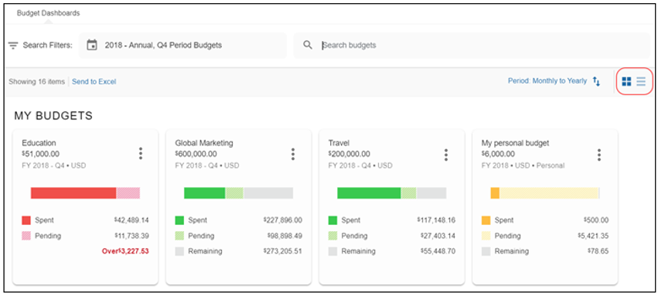
In addition, if users select to view budgets in the list view, they can click the arrow next to a budget to view how much of a budget is spent, pending, and remaining.
Unexpensed amount, if configured, is only available in Concur Expense.
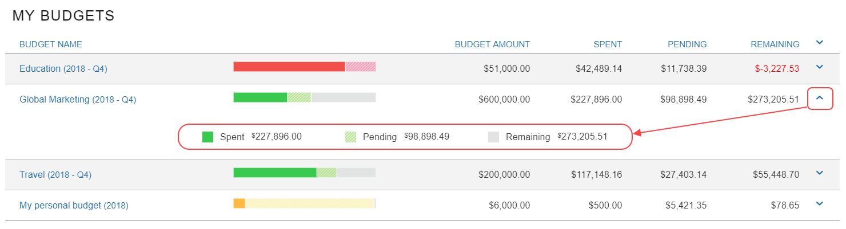
Users can also click the arrow at the top to close all the expanded budgets.
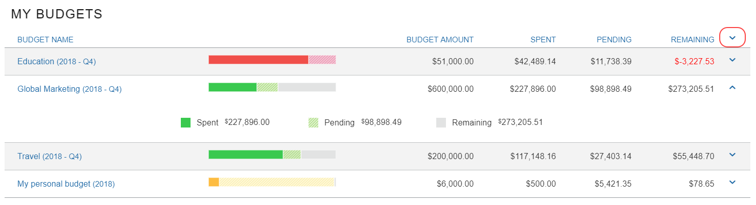

Year-to-Date Budget Spend
Budget owners can view year-to-date information about a budget. For monthly and quarterly budgets, the budget amount will be based on the budget amount of the current budget period plus prior budget periods of the current fiscal year.
The yearly and date range budget will not have a year-to-date view.
The year-to-date information is accessible through the Card and List view on the budget overview page.
For the Card view, users must right-click the budget tile and select YTD View.
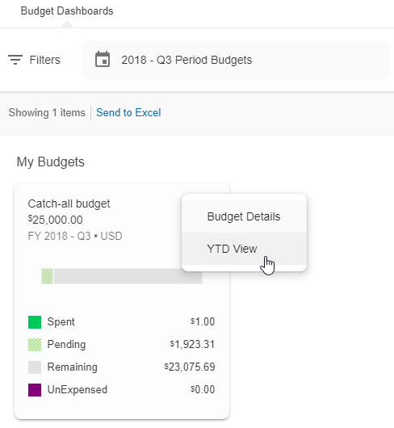
For the List view, users must expand the budget by clicking the blue expansion arrow to the right.
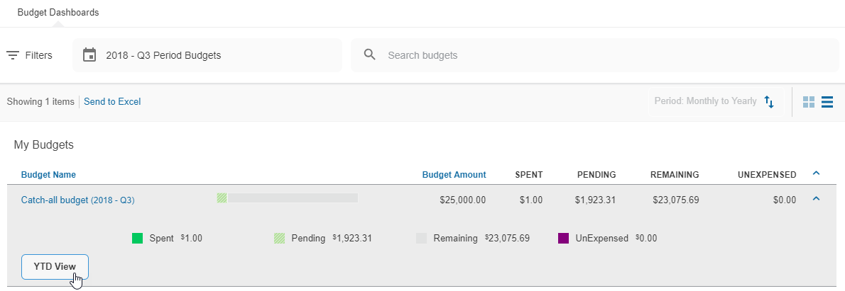
Once the budget owner clicks the YTD View button to open the year-to-date view, they will see the YTD View window showing how their budget spend is doing from the start of the fiscal year up until today.
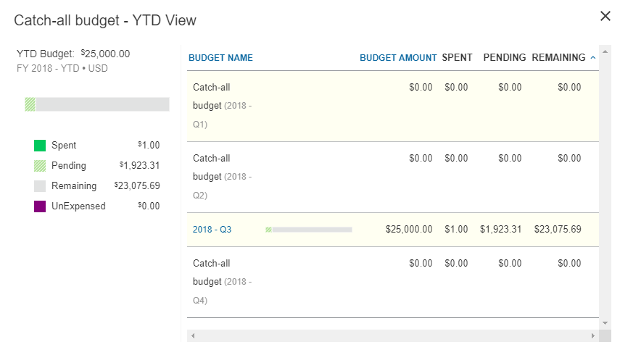

Compare Budget Consumption Against Time
Budget owners can view the consumption of their budget per budget period on a timeline on the bar charts of the Budget Dashboard. The timeline compares the budget consumption against time. If the budget consumption is equally spread on each day of the budget period, budget owners can see if consumption is ahead or behind schedule. The timeline helps budget owners keep track of their spent budget to ensure the budget is not overspent.
To see the timeline on the budget overview page, budget owners must hover the pointer over the tile of a budget.
This view shows a timeline of the budget period for January with the days of the month.
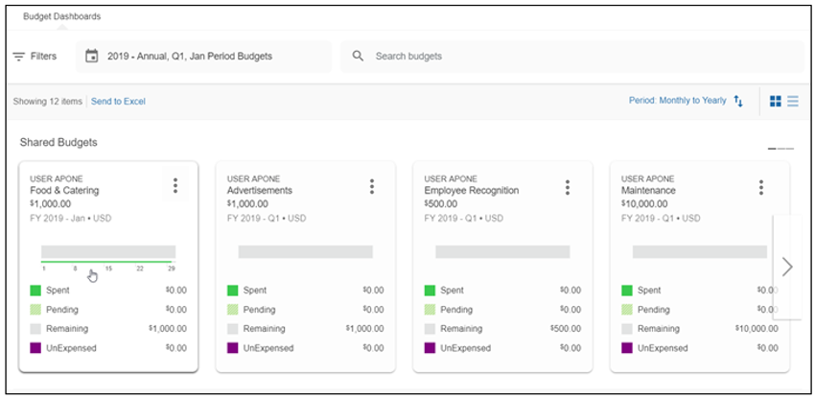
This view shows a timeline of the budget period for the first quarter of the year with January, February, and March.
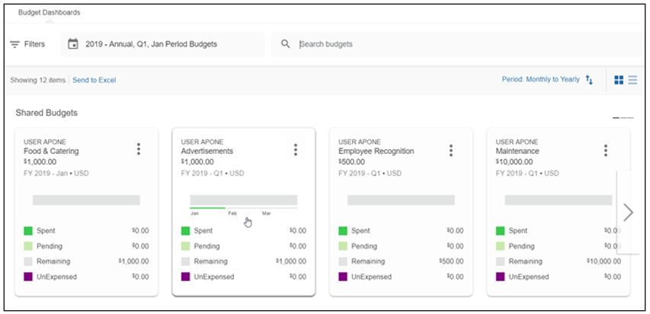

View Shared Budgets
Budget owners can view all their budgets in the My Budgets section at the top of the budget overview. If a user has the Budget Approver / Manager or Budget Viewer role, they will be able to view budgets that are shared with them by other budget owners in the Shared Budgets section of the budget overview. The shared budgets are prefixed with the budget owner’s name.
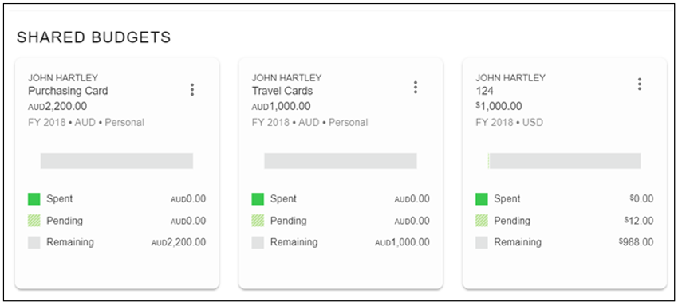

Create Team Budgets
Budget owners can create and self-manage team budgets in the Budget Dashboard.
To create a team budget, budget owners click Add Team Budget.
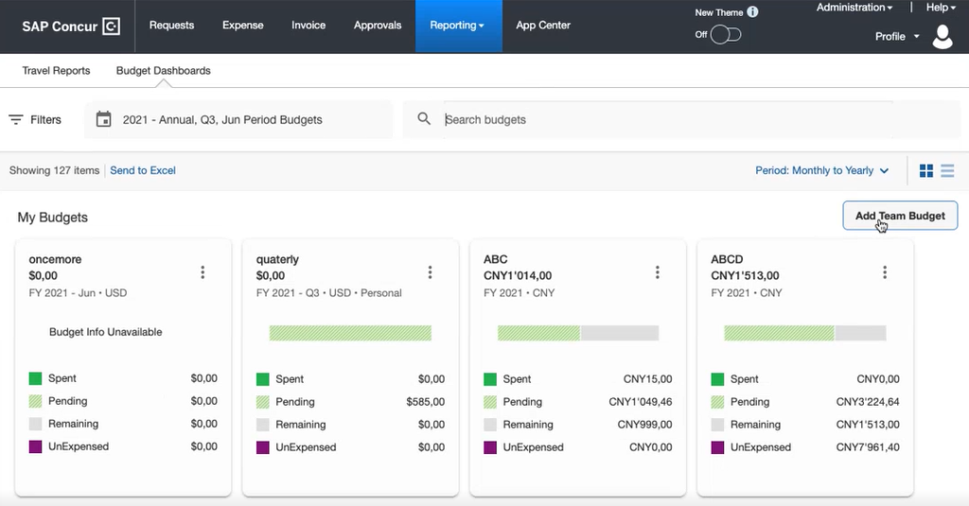
Budget owners can enter the required information on the page that appears and then click Save. For information about how to enter information on this page, refer to the Add a New Team Budget section in this guide which is similar for budget owners and budget admins.
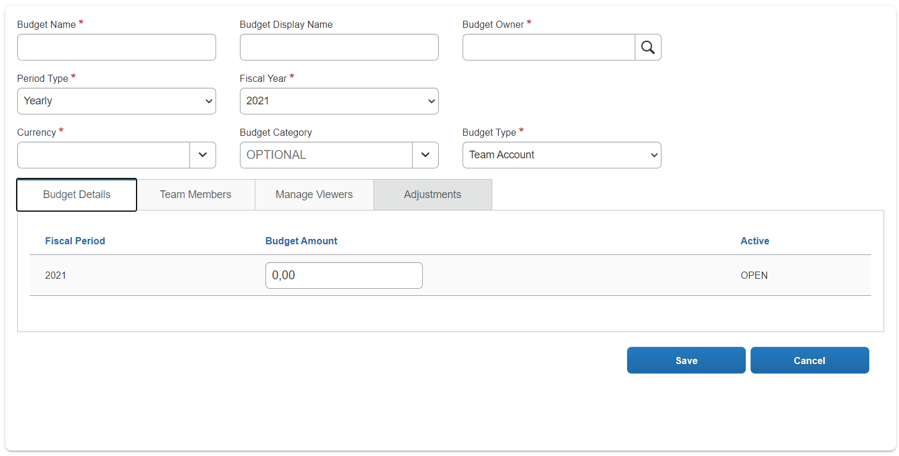
- For more information about team budgets, refer to the Team Budgets section in this guide.

Export Data on Budget Overview Page
Budget owners can share budget information with non-SAP Concur users. By clicking the Send to Excel link on the budget overview page, clients can export the same information that is available in the list view option of the Budget Dashboard including some additional fields into an Excel spreadsheet. The additional fields include the Original Budget Amount (the budget amount entered in a budget item without the adjustment), the Adjusted Budget Amount (the budget amount coming from Adjustment Imports and Exports in Budget Items), the Period Type, the Budget Category, and the Budget Type.
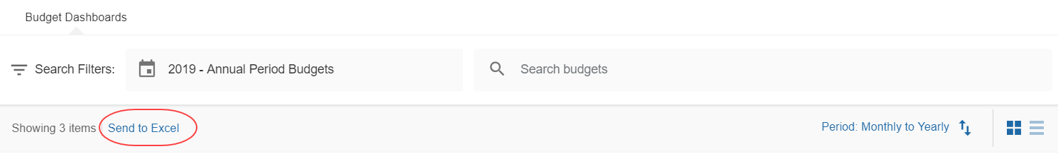

Budget Details
Budget users can view detailed information about a specific budget and use search filters to search for budgets. They will be able to see the same information as they did on the budget overview page, including a graphical budget breakdown in percentage of Spent, Pending, Remaining, and Over, budget consumption against time, a graph showing the amount spent per expense type, and a spending trend bar graph. The budget details page also includes tabs that provide insight into the Pending Transactions, Spent Transactions, Spending Categories, Budget Adjustments, and Filters.
Users can export budget data as transactions or summarized by expense type. They can apply filters to reduce the size of the export spreadsheet file. These filters are available for product category (Request, Expense, Invoice, Purchase Request, and Request) transaction status (Pending & Spent), and date range.
In addition, budget owners can view the audit trail of a budget item.
To view budget details, a user must have the Budget Viewer, Budget Owner, or Budget Approver / Manager role.
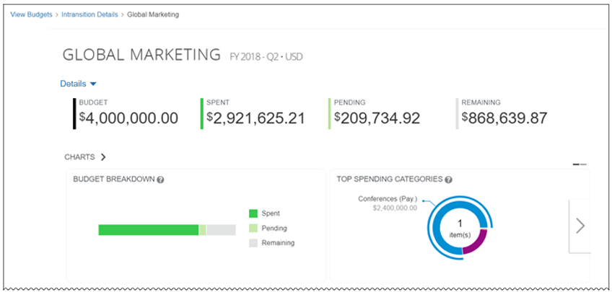
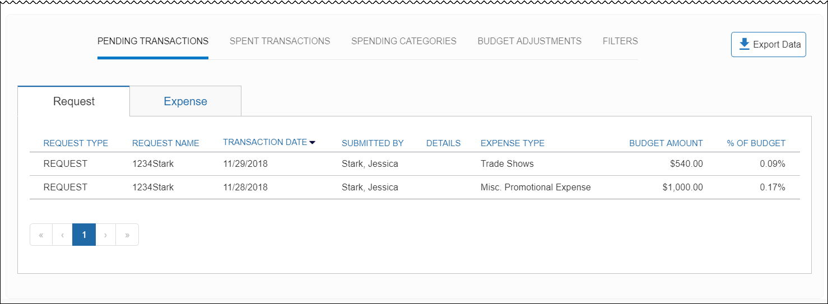

View Audit Trail for a Budget Item
Budget owners can view the audit trail of a budget item in an opened budget by clicking the Details menu and then selecting Audit Trail. Audit trails provides information about actions that the Budget Owner and the Budget Administrator have taken on a specific budget item.
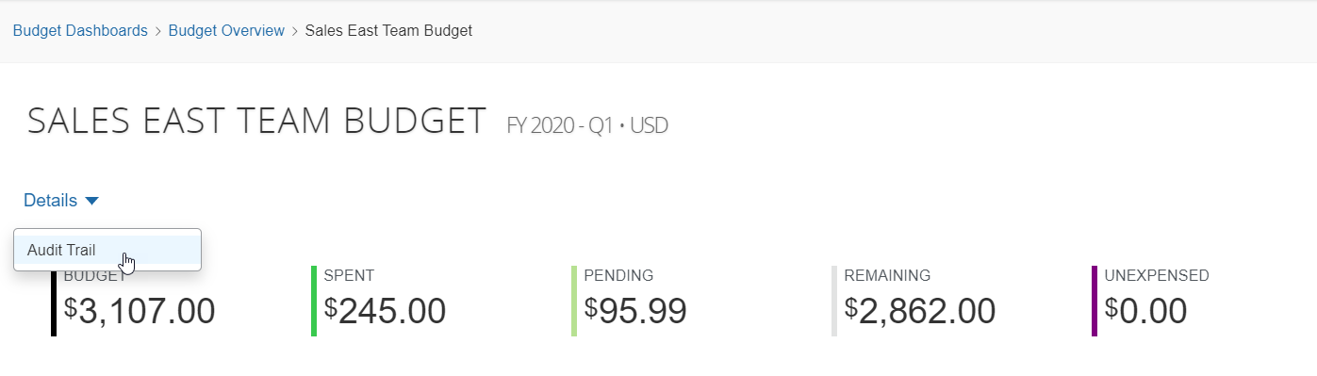
This opens the Audit Trail window with a Header, People, Filters, and Amount tab.
The Header tab shows changes that have been made to a budet item.
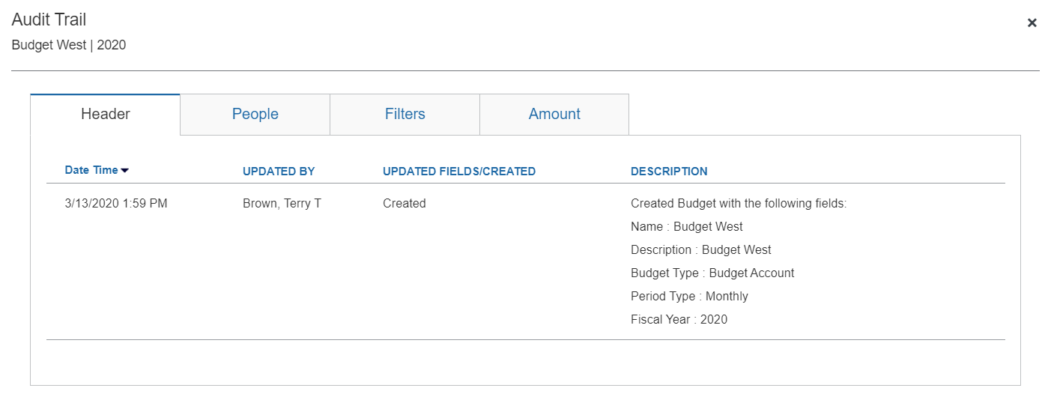
The People tab shows information about changes made by users such as budget viewers and budget approvers.
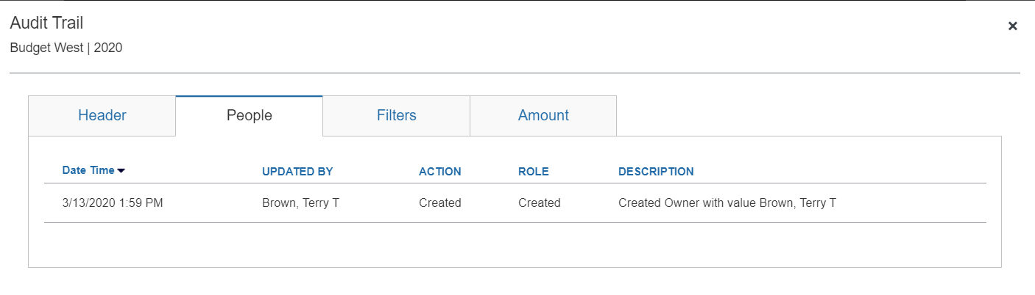
The Filters tab shows the filter changes that have been made to a budget in the Budget Dashboard.
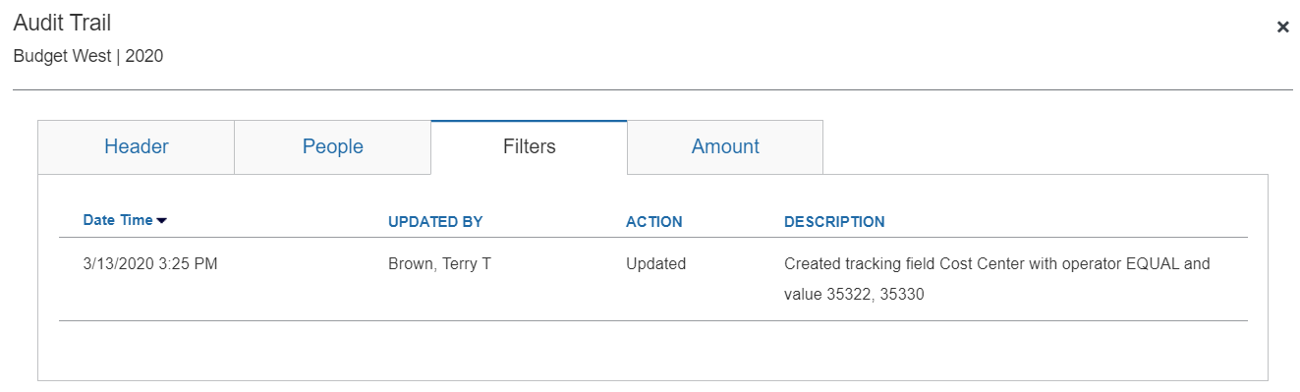
Amount tab
The Amount tab shows the changes that have been made to the budget item amount.

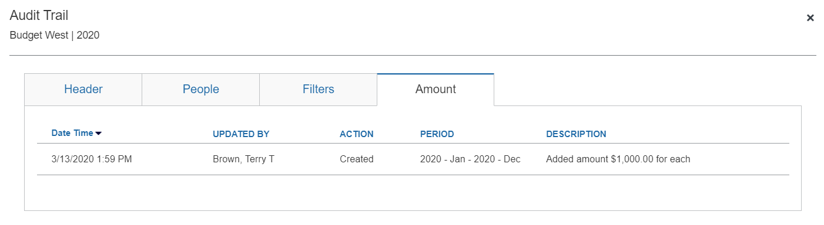

Compare Budget Consumption Against Time
Budget owners can view the consumption of their budget per budget period on a timeline on the bar charts of the Budget Dashboard. As mentioned above, on the Overview page, budget owners must hover the pointer over the tile to see the timeline. However, when budget owners navigate to the Details page, they see the timeline by default without having to hover the pointer over the tile.
This view shows a timeline of the budget period for January with the days of the month.
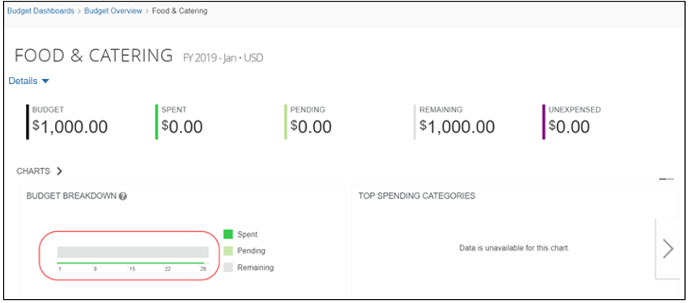
This view shows a timeline of the budget period for January with the days of the month.

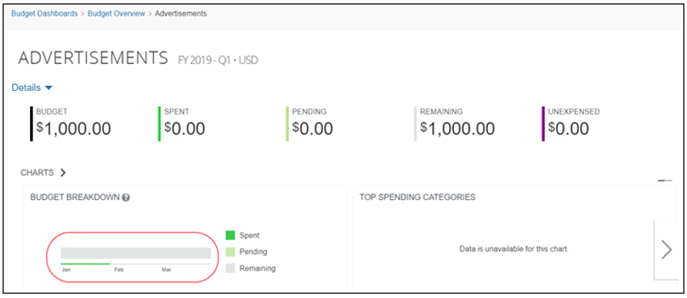

Pending and Spent Transactions
They can click Pending Transactions and Spent Transactions to see more details about spent and pending budget for invoices, purchase requests, expense reports, and requests.
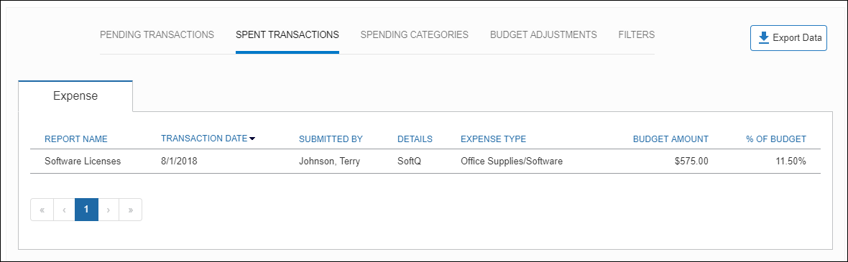
The following tables list and describe the columns that the users will see in each tab in the Pending Transactions and Spent Transactions areas.
Invoice Tab
Field | Description
Request Name | This column shows the identifier of the invoice entered by the submitter.
Invoice Number | This column shows the number of the invoice.
Employee Name | This column shows the employee who created the invoice.
Invoice Date | This column shows the date the invoice was submitted.
Line Description | This column shows a description of the invoice.
Expense Type | This column shows the expense type associated with the invoice.
Vendor Name | This column shows the name of the vendor.
Budget Amount | This column shows how much of the budget amount that is pending or spent.
% of Budget | This column shows the percent of the budget that is pending or spent.
Purchase Request Tab
Field | Description
Request Number | This column shows the number of the purchase request.  An approver can click the Review and Approve icon and be directed to the purchase request to approve it.
Requestor | This column shows the name of the employee who created the purchase request.
Submit Date | This column shows the date the purchase request was submitted.
Line Description | This column shows a description of the purchase request.
Expense Type | This column shows the expense type associated with the purchase request.
Vendor Name | This column shows the name of the vendor.
Budget Amount | This column shows how much of the budget amount that is pending or spent.
% of the Budget | This column shows the percent of the budget that is pending or spent.
Expense Tab
Field | Description
Report Name | This column shows the name of the report.
Transaction Date | This column shows the date of the transaction of the expense.
Submitted By | This column shows the name of the employee who submitted the expense report.
Details | This column shows details (such as, airline, city, and state) associated with the expense report.
Expense Type | This column shows the expense type associated with the expense.
Budget Amount | This column shows how much of the budget amount that is pending or spent.
% of Budget | This column shows the percent of the budget that is pending or spent.
Request Tab
Field | Description
Request Type | The type of request.
Request Name | The name of the request.
Submitted By | This column shows the name of the employee who submitted the request.
Details | This column shows details (such as, airline, city, and state) associated with the request.
Expense Type | This column shows the expense type associated with the request amount.
Budget Amount | This column shows how much of the budget amount is pending or spent.
% of Budget | This column shows what percent of the budget is pending or spent.
Link to Concur Expense Approvals Page in Pending Transactions (Concur Expense Only)
If a budget owner is also an approver, they can click a link to open the Approvals page for expenses directly from the Budget Dashboard expense list in Pending Transactions. This enables them to directly approve a record of spend on the Approvals page.
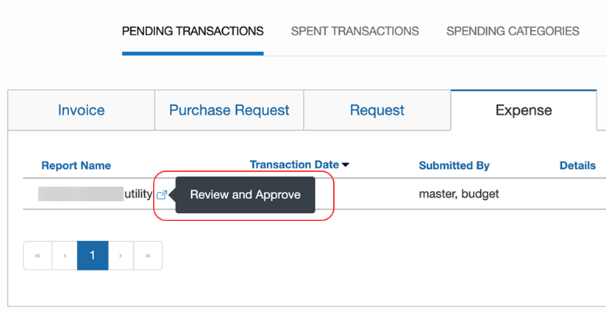
Credit Card Transactions (Concur Expense Only)
In Concur Expense, travel bookings and credit card feeds can represent a significant portion of a budget and employees cannot always submit their expense reports within the budget period. Therefore, it is useful for budget owners, who want to see employee-based spend, such as travel booking and credit card feeds when reviewing their budget, to be presented with a reasonable predictor for the spend during a budget period.
Since credit card transactions and billing statements (expense reports with credit card transactions) are counted as paid and spent, these transactions, even unsubmitted ones, will show in the Spent budget bucket in the Budget Dashboard. In addition, the credit card transactions will appear in a new Credit Card tab on the Spent Transactions tab on the budget details page.
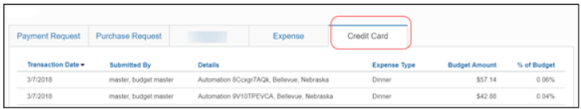
The following table lists and describes the columns that the users will see in the Credit Card tab of the Spent Transactions tab.
Field | Description
Transaction Date | This column shows the date of the transaction of the credit card.
Submitted By | This column shows the name of the employee who submitted the expense on the card.
Details | This column shows the description of the credit card transaction.
Expense Type | This column shows the expense type associated with the expense.
Budget Amount | This column shows how much of the budget amount is pending or spent.
% of Budget | This column shows the percent of the budget that is pending or spent.
Credit card feeds are transmitted once a day during a nightly run (US Pacific Time) and budget will process these feeds shortly after. Since credit card feeds are not provided in real-time, Budget cannot process them in real-time either. Budget processes all available expenses during that nightly run. Unsubmitted expense reports are processed in real-time the first time they are saved and within ten minutes after the second time they are saved.

Spend Categories
The Spend Categories tab displays the details for the spend categories that are used in the budget transactions.
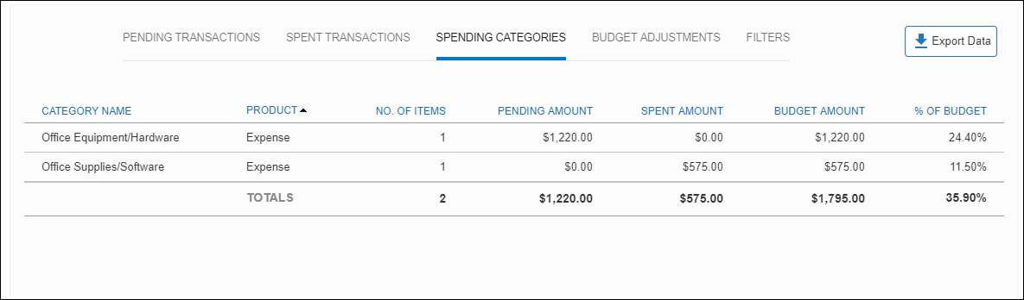

Budget Adjustments for Budget Owners
Budget owners can add adjustments to a budget provided the Budget Administrator has activated this feature for them. If so, budget owners will see an Add Adjustment button on the budget details page of the Budget Dashboard.
Budget administrators can also add adjustments on the details page of the Budget Dashboard. For additional information on adding adjustments for budget administrators, refer to the Budget Adjustments section in this guide.
When the Budget Owner clicks Add Adjustments, the Add Adjustment window appears.
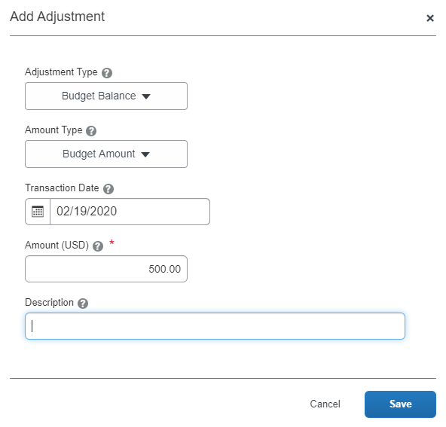
Budget owners can use the following table to fill in the details in the Add Adjustment window.
Field | Description
Adjustment Type | Select the type of balance you want to adjust. Choose one of the following:  - Budget Balance  - Fund Transfer  - Expense  - Invoice  - Purchase Request  - Request
Amount Type | Select where the adjustment amount should be applied. Choose one of the following:  - Budget Amount  - Spent Amount  - Pending Amount
Transaction Date | Select the date the adjustment was applied to the budget. This should be within the budget period for this budget.
Amount (USD) | Type in the adjusted amount. This can be a positive or negative value.
Description | Type the reason for or description of the adjustment.

Filters
The Filters tab displays the expense types, by SAP Concur product, that match the budget.
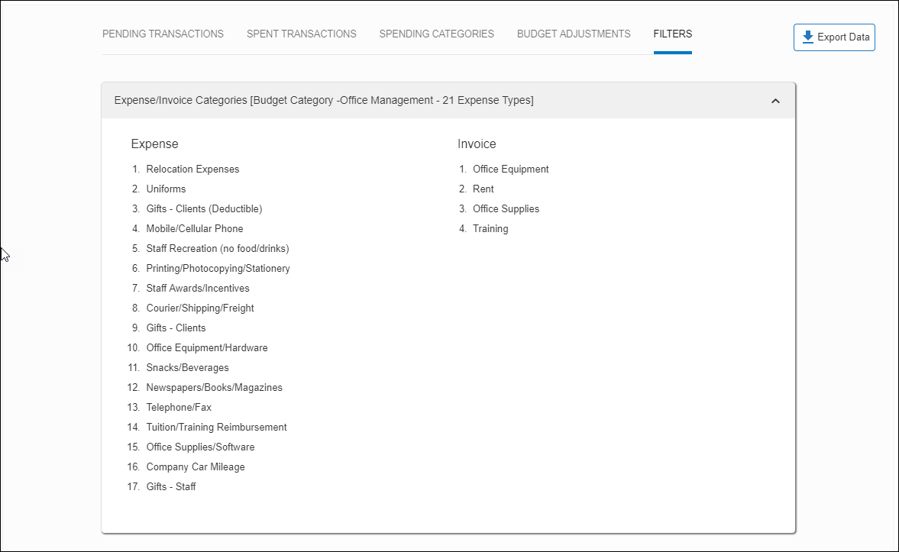

Include or Exclude Pending Amount in Remaining Budget
By default, the pending amount is not included in the remaining amount calculation as can be seen below.
The remaining amount equals the budget amount minus the spent amount. Clients may want to have control over the remaining amount in their budget. The pending amount may or may not be approved.
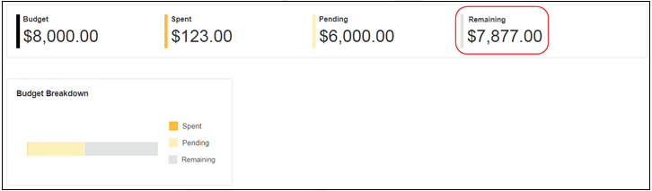
If users require to include the pending amount in the remaining amount calculation, they can do so by requesting that the admin selects (enables) the Include Pending Amount in Remaining Amount calculation option in their internal system. Here the remaining amount equals the budget amount minus the spent amount and the pending amount. Users may count on the pending amounts to be approved and therefore want the remaining amount to reflect a realistic view of what is still available to spend.
The image below shows the pending amount included in the remaining amount calculation.
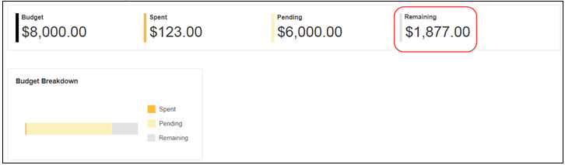

View Amount Spent per Expense Type
The details of a budget also display a graph showing the amount spent per expense type.
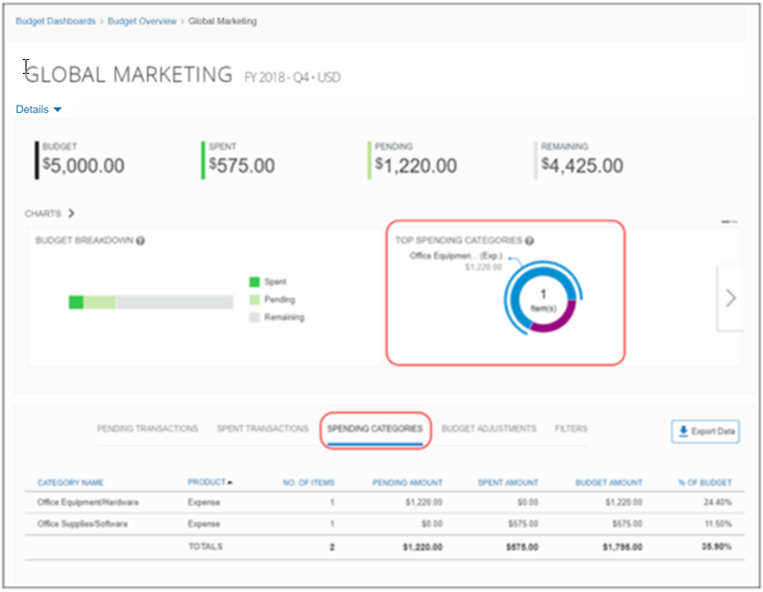
Users can view what has been spent or is pending per expense type when reviewing spending items. To do this, users can click on the Spending Categories tab. This view shows each expense type with its pending and spent amount per product with the total budget amount.
The Spending Categories tab is not sorted based on the amount per expense type graph.

View Spending Trend Per Year
The Spending Trend bar graph shows the status of a budget owner's budget periods over a year. Budget owners can view two bars for each budget period; the budget amount (bar in solid color) and the total spending amount (total spent amount equals part of bar in solid color, total pending amount equals part of bar in stripes) for a specific period in a quarterly or monthly view. The bar showing the total spending amount is composed of the total spent amount and the total pending amount.
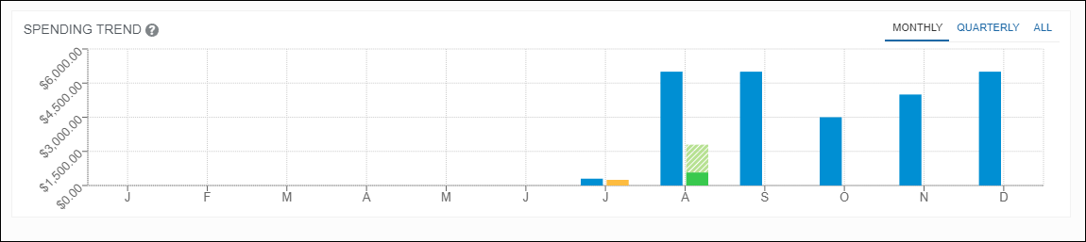
Budget owners can also hover over each bar to view budget details of a specific month.
If a budget is based on a full year, the monthly view shows the budget period amount divided by the number of fiscal periods (typically 12 months) to calculate the monthly budget amounts. For the quarterly view, the budget period amount is multiplied by three to calculate the quarterly budget amount in the chart. The budget consumption (spend and pending) is based on the monthly actuals even for yearly and quarterly budgets.
The table below describes the status of a budget period which budget owners will see if they hover over a bar in the Spending Trend bar graph.
Budget Status | Description
Spent | This shows the approved amount that has been spent.
Pending | This shows the amount pending approval.
Remaining | This shows the amount left to spend. The remaining amount is calculated as budget amount minus spent amount. If the admin has enabled the Include Pending Amount in Remaining Amount calculation option in Budget Settings, the remaining amount is calculated as budget amount minus spent amount minus pending amount.
Over | If the remaining amount becomes negative, the Remaining label is replaced by a red colored Over label which indicates how much has been consumed over the budget amount.
Unexpensed (Concur Expense only) | This shows the balance of the expense items that have not yet been submitted.  The unexpensed balance does not affect the bar graph, because it is not subtracted from the remaining balance, and, thus, unsubmitted expenses do not consume a budget.
The bar graph colors display in green, yellow, and red, which means the following:
- Green: The consumption of the budget is below the budget alert limit (default 80%)
- Yellow: The consumption of the budget is at or above the budget alert limit
- Red: The consumption is at or above the budget control limit (default 100%)
Budget owners that have monthly or quarterly budget periods can also see their spending year-to-date for the fiscal year. The All view of the Spending Trend graphs shows the year-to-date budget amount and budget consumption.
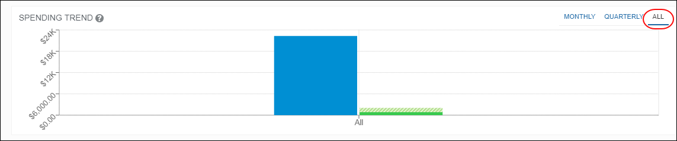

Export Budget Data
Budget owners can export budget data into an Excel spreadsheet, so that they can analyze spending details. Up to 12, 500 items can be exported at a time.
To export budget data, budget owners click Export Data on the budget details page.
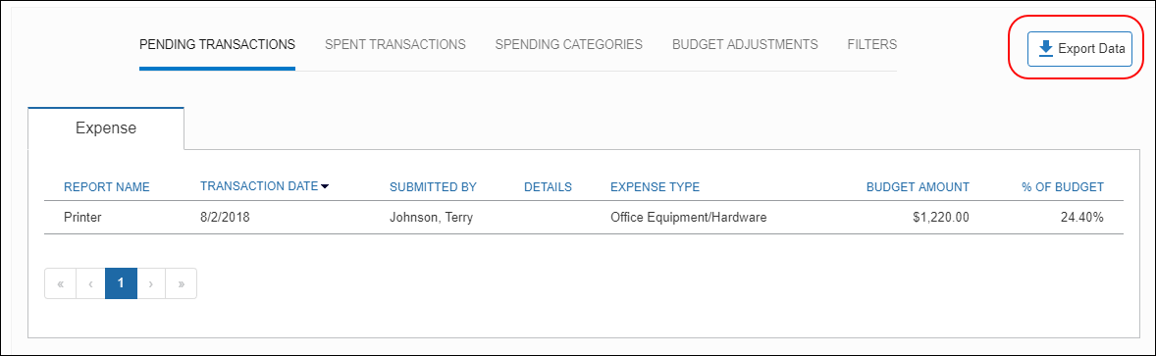
On the Export Spending Data window that appears, budget owners can select the following options in the:
- Data Type (Line Items Data or Spending Category data)
- Date Range
- Product Category (Expense, Invoice, Purchase Request, Request, Credit Card, or All Categories)
- Transaction Status (Pending & Spent, Spent, or Pending)
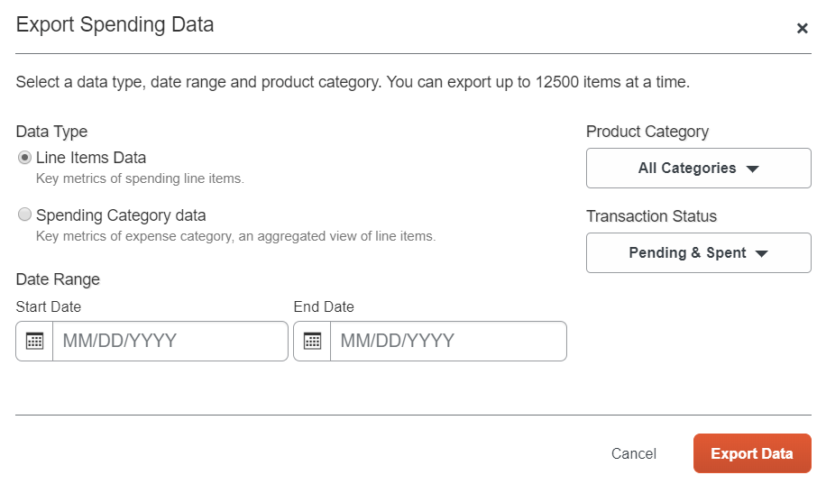
After the budget owner has selected their options, they click the Export Data button to export the budget data into a spreadsheet.
The spreadsheet contains the columns listed in the table below.
Column | Description
Status | This column shows the budget status of the expense report, invoice, purchase request, or authorization request. The status can be one of the following:  - Pending & Spent  - Pending  - Spent
Product Category | This column shows the product category whose budget data is exported. The product category can be one of the following:  - Expense  - Invoice  - Purchase Request  - Request  - Credit Card  - All Categories
Reference | This column shows the invoice number, purchase request ID, or expense report name or authorization request name of the spending item.
Date | This column shows the transaction date of the expense report, invoice, purchase request, or request.
Employee Name | This column shows the name of the Invoice Owner or the employee who submitted the expense report, invoice, purchase request, or authorization request.
Description/Detail | This column shows the address details of the submitter of the expense report, invoice or purchase request, or the description of the authorization request.
Spending Category | This column shows the spending category, such as Parking, Airfare, or Materials) of the expense report, invoice, purchase request, or authorization request. The Adjustment spending category indicates an adjusted transaction that affects the pending or spent balances.
Budget Tracking Fields | The budget tracking fields, if configured, will appear as individual columns in the data export. These columns are labeled with the field name and show the value for the field for each spending item. These columns only appear when exporting the Line Items Data data type.
Vendor Name | This column enables users to see how much is spent per vendor when they export spending line items of a budget.  NOTE: Applicable to Concur Expense, Concur Invoice, and Purchase Request.
Budget Amount (USD) | This column shows the budget amount of the expense report, invoice, purchase request, or authorization request.
% of Budget | This column shows the percentage of the total budget for the expense report, invoice, purchase request, or authorization request.

Spend Differences Between Purchase Requests and Invoices
The way a consumed budget is regarded in Concur Invoice differs between invoices and purchase requests.
For both invoices and purchase requests, the consumption of budget items starts with the submission of the purchase request or invoice.
Purchase requests use the submit date to determine the fiscal period. Based on the fiscal period and other matching criteria, each purchase request line item (or distribution) is matched to one or more budget items. As purchase requests move through the workflow, matching is verified every time a purchase request is approved or processed. If a purchase request is sent back, removed, or closed, the purchase request line items (and distributions) are removed from the budget consumption, freeing up budget balances.
Purchase requests remain in the "Pending" budget bucket throughout the workflow. When a purchase order is generated, received, and matched with an invoice, the purchase request is closed and removed from the budget in favor of the invoice.
Budget owners might want purchase request items to be consumed by budgets when they are most likely to be received. Since the Needed By field is the only system date on the purchase request item that can be used as an indicator for a future receipt, this field will be used as the transaction date when the Needed By field has a value. If the Needed By field does not have a value, the Submit Date field of the purchase request determines the budget consumption.
If a spend is pre-authorized for a budget period (Needed By date), the spend item should honor the original date when the purchase request moves to an invoice (provided the invoice is linked to the purchase request). The spend items should display the budget request date as well as the invoice date. For example, if a purchase request is submitted in November with one spend item having a Needed By date in December, the budget period is December. If an invoice for that purchase request spend item has an invoice date in January, the budget period for that spend item remains in December. However, if an invoice is entered with an invoice date in January without a reference to a purchase request item, the budget period is based on the invoice date which is January.
When an invoice is submitted, each invoice line item (or distribution) is matched to one or more budget items based on the matching criteria and the invoice or expense date which determines the fiscal period. If an invoice is submitted without being matched to a purchase order that is linked to a purchase request, the invoice appears in the "Pending" budget bucket. If the invoice is linked to a purchase request, it will still appear in the "Pending" budget bucket. The purchase request remains visible in the "Pending" budget bucket with a zero amount.
As invoices move through the workflow, the matching is verified every time an invoice is approved or processed. If an invoice is sent back or removed, the invoice line items (and distributions) are removed from the budget consumption, freeing up budget balances. Once an invoice is approved by the processor, the budget balance moves from the "Pending" budget bucket to the "Spent" budget bucket.

Budget Consumption in Concur Expense
For expense reports, the consumption of budget items starts with the submission of the expense report.
Expense reports use the transaction date of the expense item to determine the fiscal period. Based on the fiscal period and other matching criteria, each expense item or expense allocation is matched to one or more budget items. As expense reports move through the workflow, matching is verified every time an expense report is approved or processed. If an expense report is sent back or removed, the expense items (and allocations) are removed from the budget consumption, freeing up balances.
If a spend is pre-authorized for a budget period (Transaction Date), the expense report honors the budget period of the request. The spend items should display the budget request date as well as the transaction date. For example, if a request is submitted with an end date in December, the budget period is December. If the expense report item for the request item has a transaction date in January, the budget period for that item remains in December. However, if an expense report item has a transaction date in January without a reference to a request item, the budget period is based on the expense item transaction date which is January.
Once an expense report is approved by the processor, the budget balance moves from the "Pending" budget bucket to the "Spent" budget bucket.

Budget Consumption in Concur Request
For travel and authorization requests, the consumption of budget items starts with the submission of the request. Because requests are always for future spend, Budget uses the Request Start Date to determine the fiscal period. Budget does not include cash advance requests in spend calculations.
Based on the fiscal period and other matching criteria, each expected expense item, segment, or expected expense allocation is matched to one or more budget items. As requests move through the workflow, matching is verified every time a request is approved or processed. If a request is sent back or removed, the request expense items, segments, and allocations are removed from the budget consumption, freeing up balances.
If a request with budget items is associated with an expense report, the expense entry uses the budget period determined by the request. For example, if a request is submitted with an end date in December, the budget period is December. If the expense entry for the request item has a transaction date in January, the budget period for that item remains in December.
Once a request is approved by the processor, the budget balance moves from the "Pending" budget bucket to the "Spent" budget bucket.
Concur Request Integrated With Concur Expense
If clients have Concur Request integrated with Concur Expense, then the request amount may be associated with an expense report. When this happens, the budget details page updates the display of the budget spending item as follows:
- If the expense report includes the total amount from the request spending item, the Request tab on the budget details page will show a zero amount for the spending item. The zero amount remains visible until the request is closed.
- If the expense report includes a partial amount from the request spending item, the Request tab on the budget details page will show a reduced amount (request total – expense amount) for the spending item. The reduced amount remains until the rest of the request amount is associated with expenses, or the request is closed. When the rest of the spending item amount is associated with expenses, a zero amount appears in the Request tab on the budget details page for the spending item and remains until the request is closed.
- The Expense Report tab on the budget details page will include a new spending item representing the amount from the request. This item uses the Request End Date to determine which fiscal period the spending item applies to. This item inherits the Pending/Spent status from the request spending item.
Clients may configure Budget to mark request budget items as Spent once the request has reached final approval.
- For more information, refer to the Budget Settings section of this document.

What the User Sees
The user will see a menu option, Budget Dashboards, in the Reporting menu.
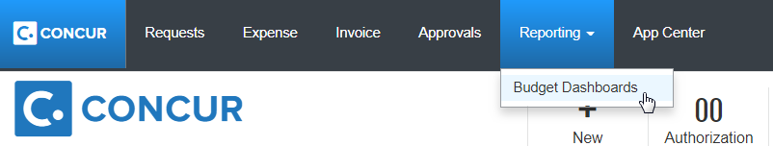
Once the user clicks the Budget Dashboard menu option, they will see a budget overview page.
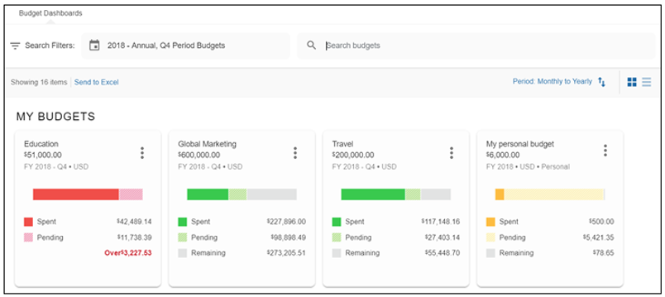
Clicking on one of the budgets will show details about that budget.
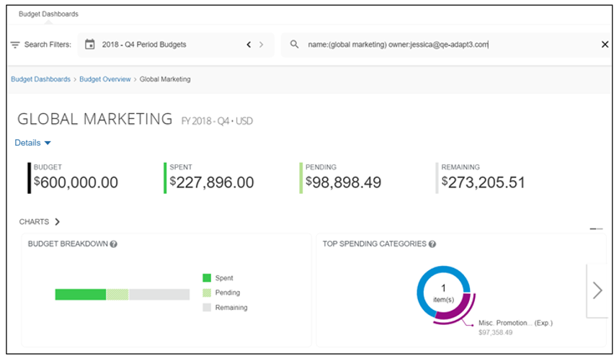
If the admin has enabled unexpensed amounts in Budget Settings, Concur Expense budget owners will see an Unexpensed value in the Budget Dashboard, both on the budget overview page and on the budget details page.
Budget Overview Page
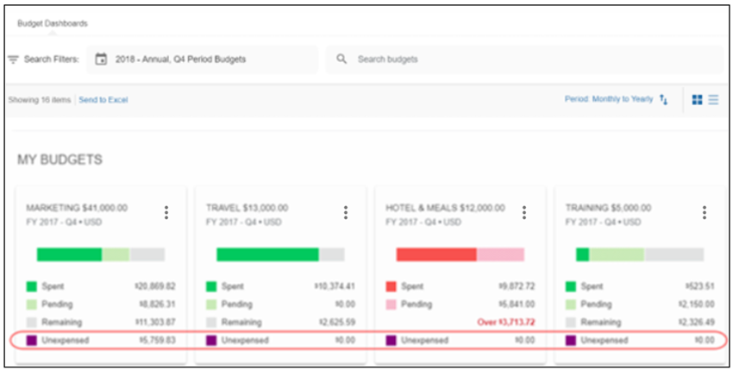
Budget Details Page
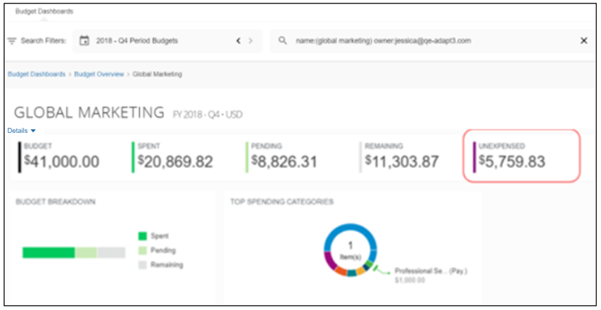
Users who have credit card transactions will see a Credit Card column in the export file generated when they have defined data to export by clicking the Export Data button on the budget details page.
In addition, on the Spent Transactions tab on the budget details page, these users will see a Credit Card tab.
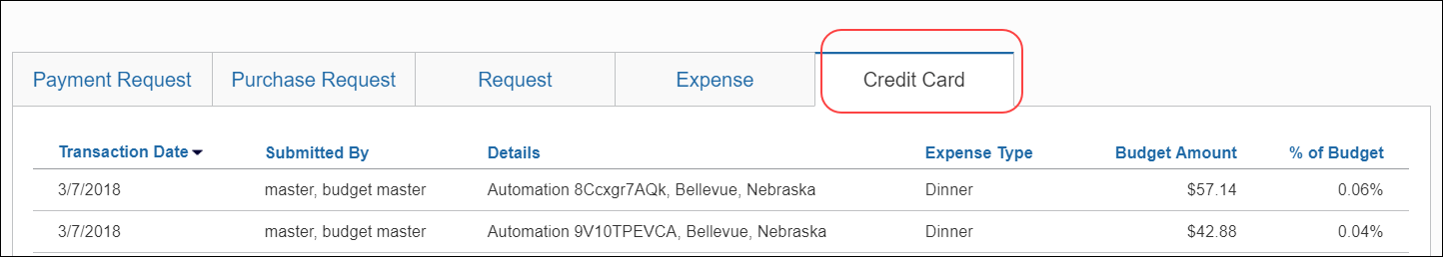

What the Approver Sees
The approver will see a View Budget link (Concur Invoice, Concur Expense) or a View Budget(s) button (Concur Request) on the Approvals page for expense reports, invoices, purchase requests, or authorization requests in the following three scenarios:
- For approvers who are listed in the Manage Approvers tab for a budget and where the client is using the Budget Approver step in their workflow.
- For approvers who are listed in the Manage Approvers tab for a budget and where they are already part of the approval process, even when the client is not using the Budget Approver step in their workflow.
- For approvers who are budget owners for a budget, and where they are already part of the approval process even when the client is not using the Budget Approver step in their workflow.
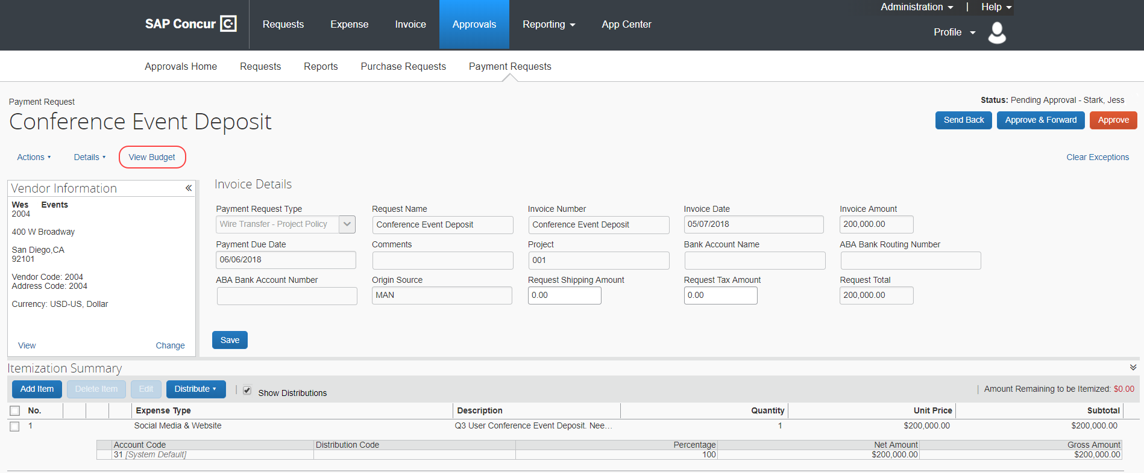
When approvers click the View Budget button, if there are multiple budgets impacted, they will see an overview page of the impacted budgets.
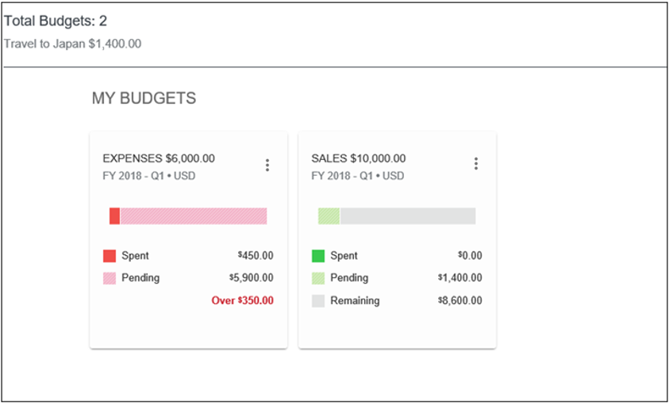
If there is a single budget impacted, or they select one of the impacted budgets, they will see the budget details of their purchase request, invoice, expense report, or request, such as percentage of budget used along with the total budget amount.
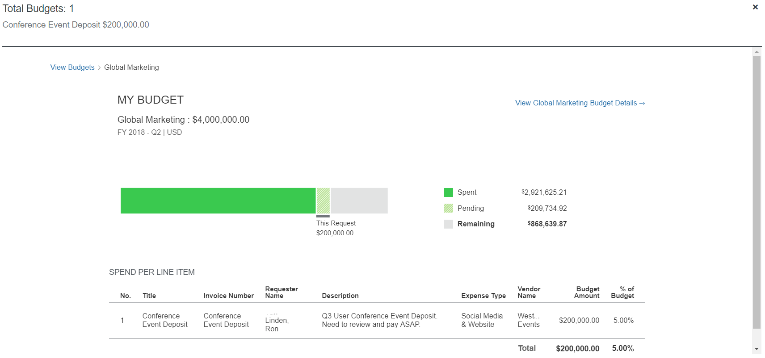
If the spending currency is different than the budget currency, two amount columns, Spending Amount and Budget Amount, appear in the Spend Per Line Item section. The budget amount is in the budget currency while the spending amount shows the amounts in the spending currency for reference purposes.
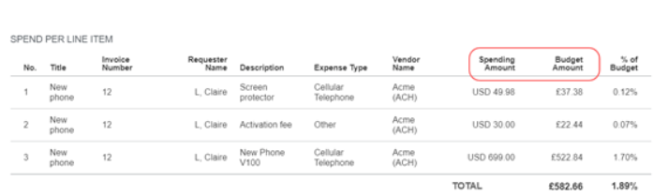
Clicking the View <Name> Budget Details link will take the approver to a detailed view of the total budget for which the purchase request, invoice, expense report, or request in question is a part of. The user sees similar information in Reporting > Budget Dashboards.
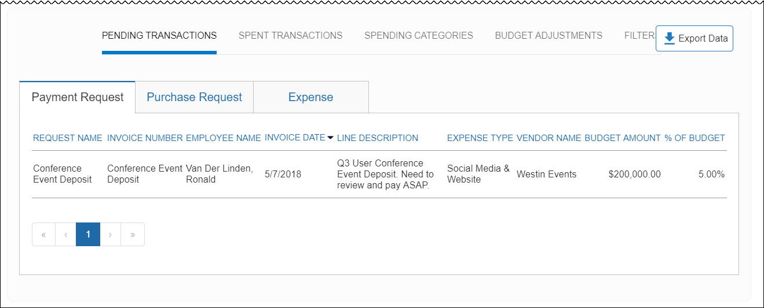
The approver can click the arrow or the breadcrumb menu to return to the previous view.
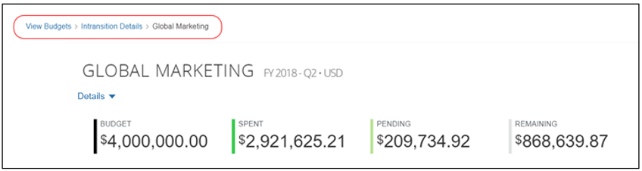
If the admin has enabled unexpensed amounts in Budget Settings, Expense approvers will see an Unexpensed value on the details page.
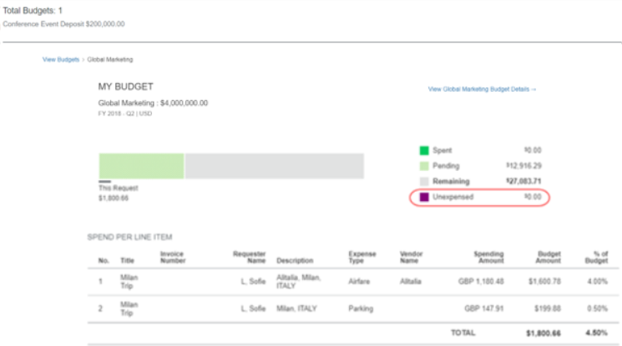
If clients use Budget Workflows, they will see the budget approvers in the Approval Flow window. The window displays budgets that are approved, auto approved, and not approved.
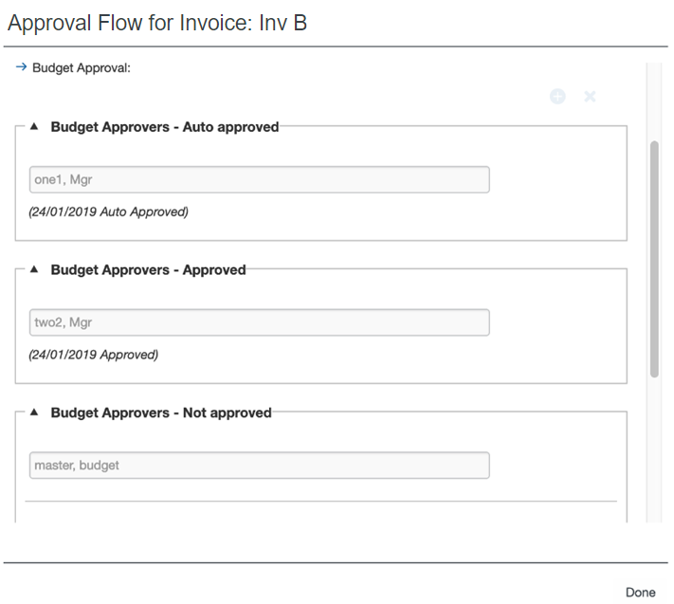
When a budget workflow step is skipped because the submitter or approver is also the budget approver or when no budgets or no budgets with approvers are matched, the Approval Flow window will display a message for why the budget approval step was skipped for the shown approver.
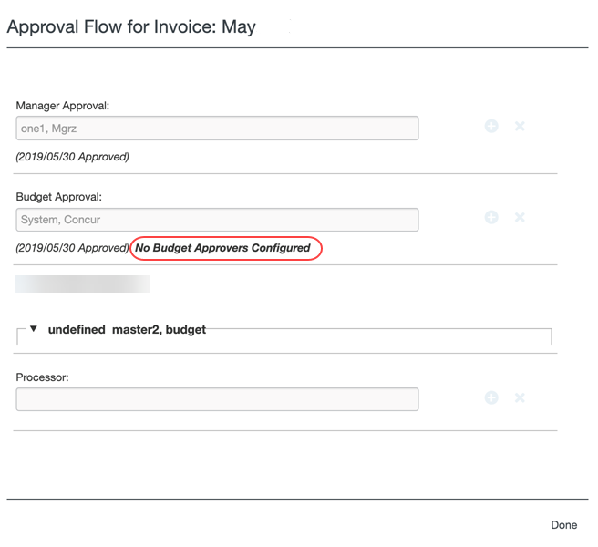

Budget Configuration
Once SAP Concur has activated the Budget feature, the budget admin needs to click the Budget link in Product Settings to configure the Budget feature.
The admin uses the following steps to configure Budget:
- Assign budget roles to users
- Set up a fiscal calendar to define the fiscal year and fiscal periods
- (Optional) Configure budget categories if you want budgets to be based on expense type association
- (Optional) Configure custom fields if you want to track certain costs within a budget
- (Optional) Enable the manager hierarchy
- Create budget items to associate a budget with, a fiscal year, budget owner, and currency

Access Budget Configuration
To access Budget Configuration:
- Click Administration > Invoice Settings or Expense & Invoice Settings.
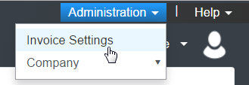
- In the Product list, select Invoice or Expense.
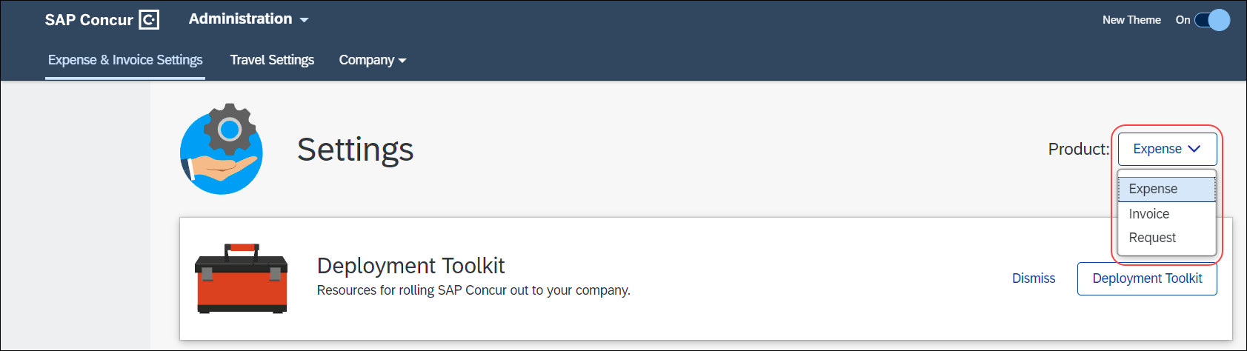
- In the Monitoring Spend section, on the Budget tab, click Edit.
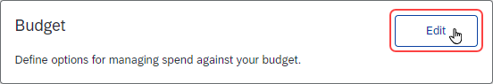
- The budget configuration information appears.
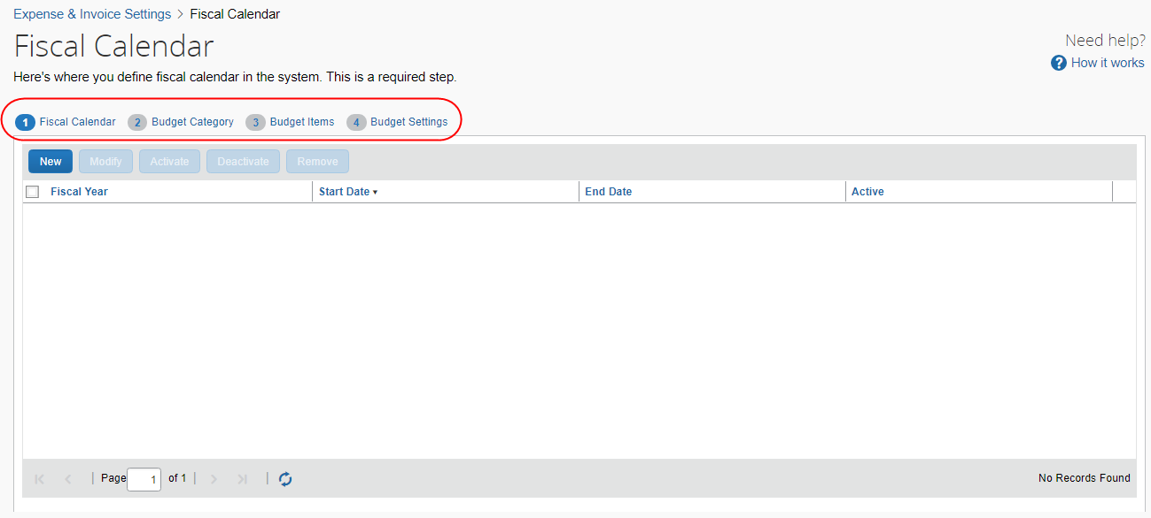

Assign Budget Roles
To assign budget roles:
- Click Administration > Invoice Settings or Expense & Invoice Settings.
- In the Product list, select Invoice or Expense.
- In the Access to Concur section, on the User Accounts tab, click Edit.
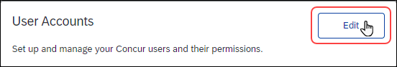
The Users page appears.
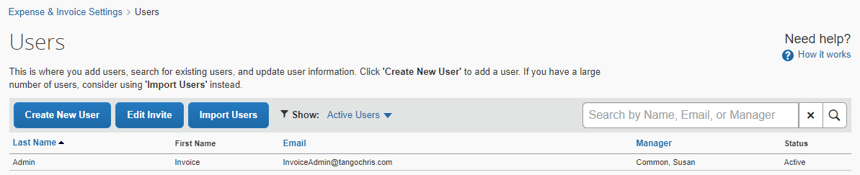
- Create a new user by clicking Create New User or double-click an existing user.
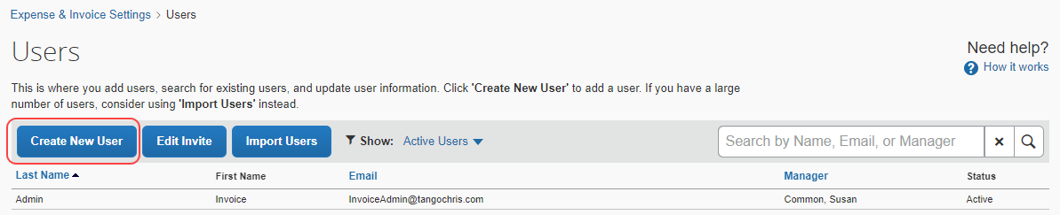
- In the User Permissions section, assign the relevant role for the user.
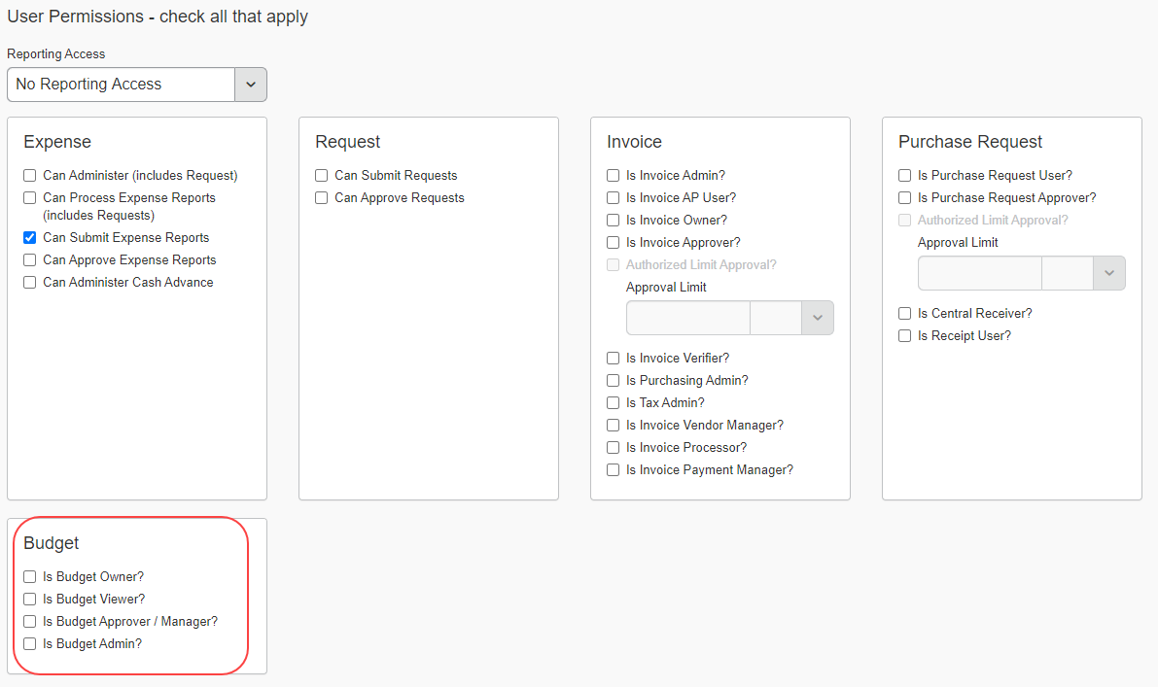
- Click Save.
- For more information about the roles, refer to the Budget Roles section in this guide.

Manage Fiscal Years

Add a Fiscal Year
You can add a fiscal year to define your company’s accounting periods. A fiscal year can have one or more periods. Date range budgets use fiscal years for the graphs on the Budget Dashboard, so it is necessary to configure fiscal years even if you are only using date range budgets.
Fiscal years cannot overlap with prior fiscal years and there cannot be any gaps between fiscal years.
To add a fiscal year:
- In the Fiscal Calendar step, click New.
The Add Fiscal Year window appears.
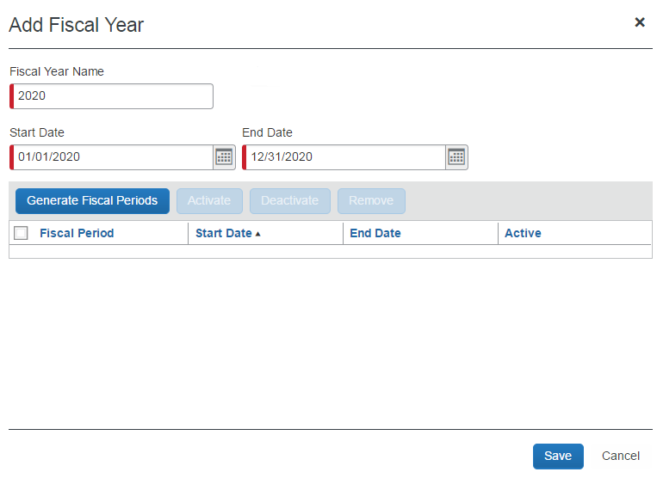
- Complete all required fields.
Field | Description/Action
Fiscal Year Name  (Required) | Enter the name of the fiscal year. This can be any combination of characters, but it must be unique. It is recommended to use the actual calendar year name. If two fiscal years comply within this rule (short year), use a post fix for the second year.  Concur Invoice, Concur Expense and Concur Request will default a fiscal year name based on the start date of the fiscal year. If the start date is before July 1, the year of the start date is defaulted as the fiscal year name. If the start date is July 1 or later, the year of the end date is defaulted as the fiscal year name.
Start Date  (Required) | Enter the start date of the fiscal year, which must be the day after the end date of the previous fiscal year. The first fiscal year can have any start date.  NOTE: The start date is based on the time zone of the entity, which is managed by SAP Concur.
End Date  (Required) | Enter the end date of the fiscal year, which can be any date after the start date. By default, it will be one year minus one day from the start date.  NOTE: The start date is based on the time zone of the entity, which is managed by SAP Concur.
- Click Generate Fiscal Periods to create all fiscal periods for the fiscal year.
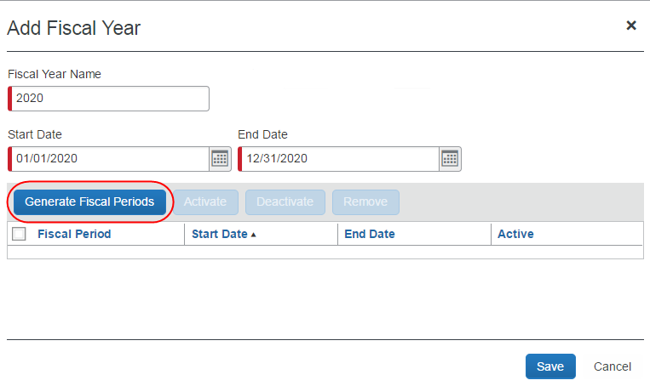
The generated fiscal periods appear on the page.
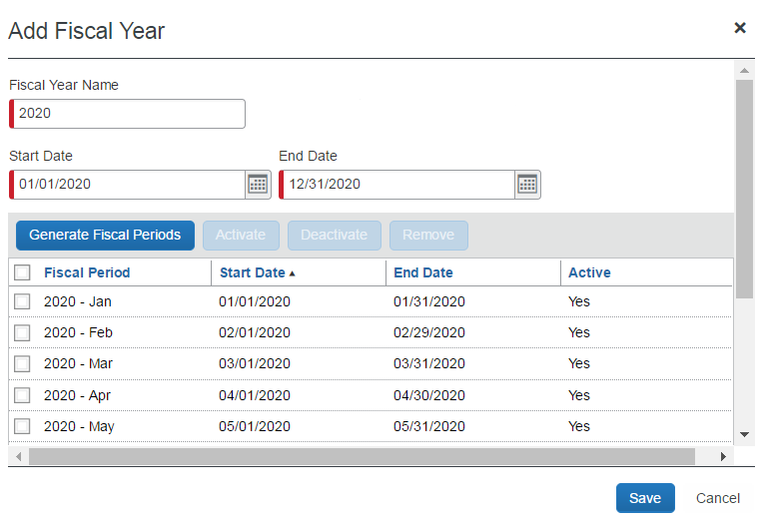
- Click Save. The fiscal year appears in the Fiscal Calendar step.
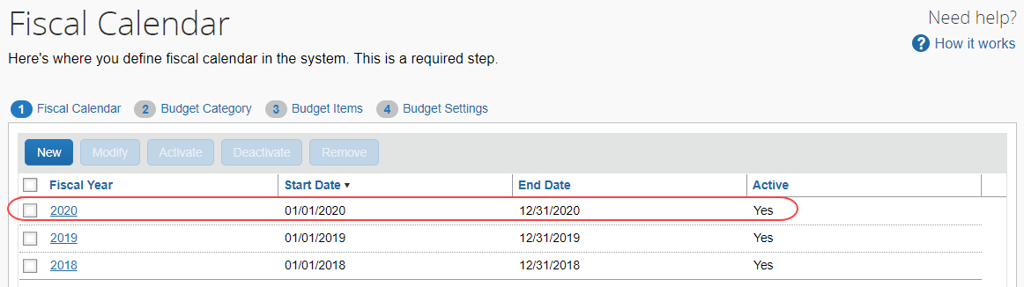
If a fiscal year or a fiscal period is not marked as active, spending items cannot be matched to the fiscal period and the system will try to map them to the next available active fiscal period. If spending items cannot be mapped to an active fiscal period, the spending items cannot be associated to a budget.

Modify a Fiscal Year
You can modify an existing fiscal year, for example, to correct mistakes or to reflect organizational changes, such as a merger or need to follow industry standards.
You cannot change the end date of the current month to today or any date before today, and you cannot change the start date of the current month. In addition, you cannot change any start or end date of past months this year or prior years.
To modify a fiscal year:
- In the Fiscal Calendar step, select a fiscal year and then click Modify, or double-click the year you would like to modify.
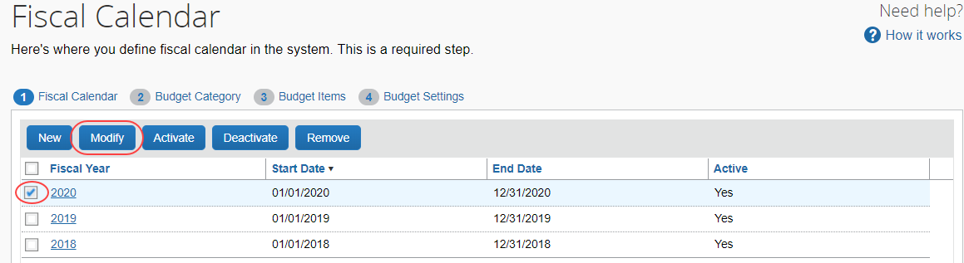
The Modify Fiscal Year window appears.
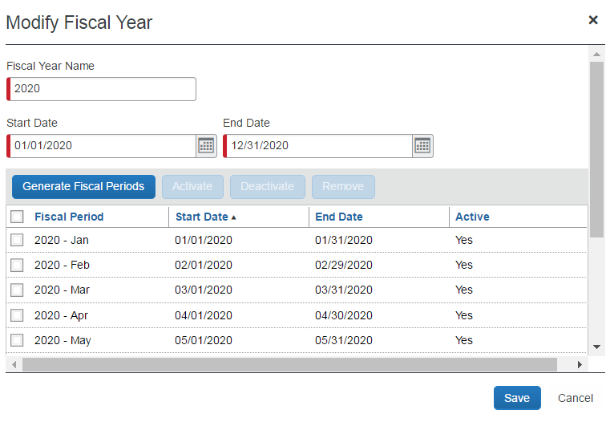
- Make the desired changes. For field information, refer to the To add a Fiscal Year procedure in this document. If you need a fiscal year to be shorter than 12 months or longer than 12 months, change the end date, but ensure fiscal years are not overlapping or have gaps.
- Click Generate Fiscal Periods.
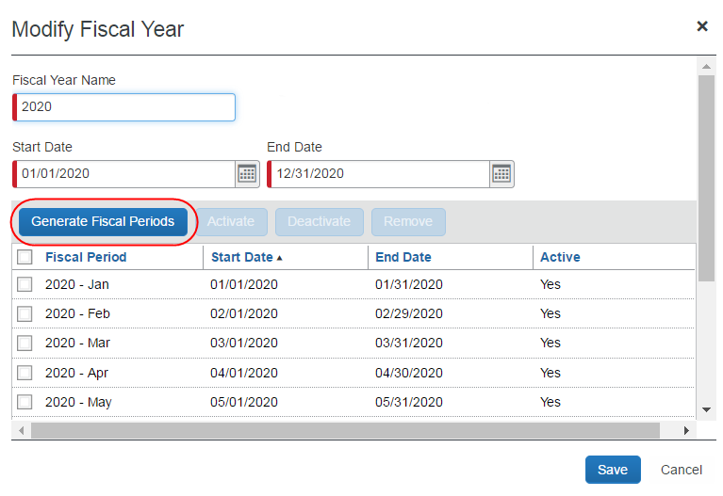
- Click Save.

Activate a Fiscal Year
You can activate a fiscal year to enable budgets for budget owners.
To activate a fiscal year:
- In the Fiscal Calendar tab, select a fiscal year and then click Activate.
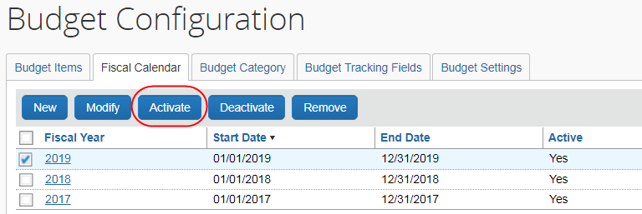
The Activate Fiscal Year window appears.
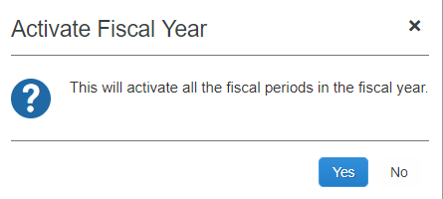
- Click Yes.

Deactivate a Fiscal Year
You can deactivate a fiscal year to disable budgets for budget owners. By deactivating the year any spend still in the process of being approved or submitted will get applied to the budgets of the next open period.
To deactivate a fiscal year:
- In the Fiscal Calendar tab, select a fiscal year and then click Deactivate.
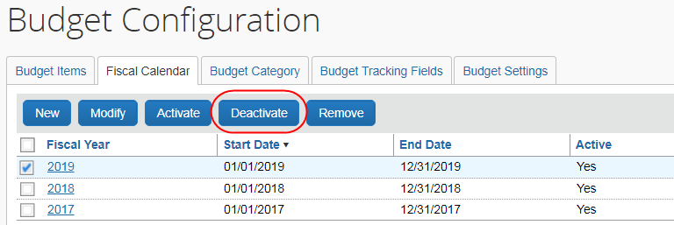
The Deactivate Fiscal Year window appears.
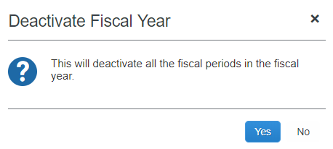
- Click Yes.

Remove a Fiscal Year
You can remove a fiscal year to clean up the list of available fiscal years to ensure old fiscal years cannot be re-activated.
You can only remove fiscal years if they are not associated with a budget.
To remove a fiscal calendar:
- In the Fiscal Calendar step, select a fiscal year and then click Remove.
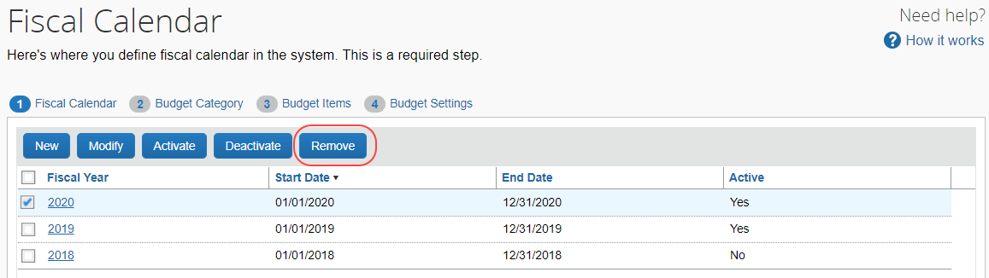
- In the Remove Fiscal Year window that appears, click Yes.
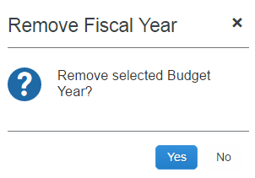
The fiscal years and budget items will be marked as deleted and will not be able to be retrieved by any user.

Manage Fiscal Periods

Activate a Fiscal Period
You can activate a fiscal period to enable budgets for budget owners.
To activate a fiscal period:
- In the Fiscal Calendar step, select a fiscal year and then click Modify, or double-click the year you would like to modify.
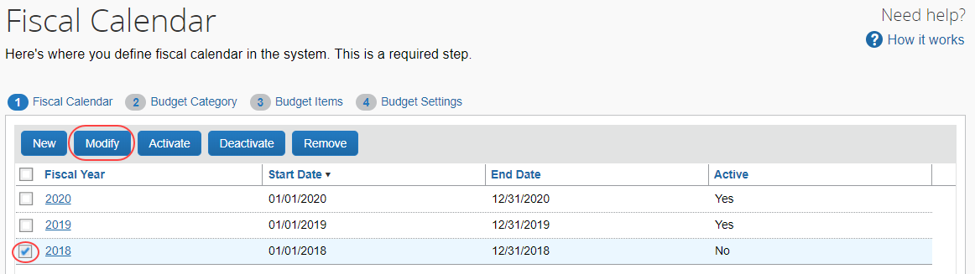
The Modify Fiscal Year window appears.
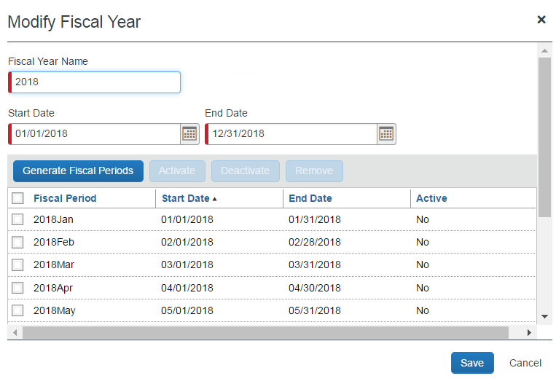
- Select a fiscal period and then click Activate.
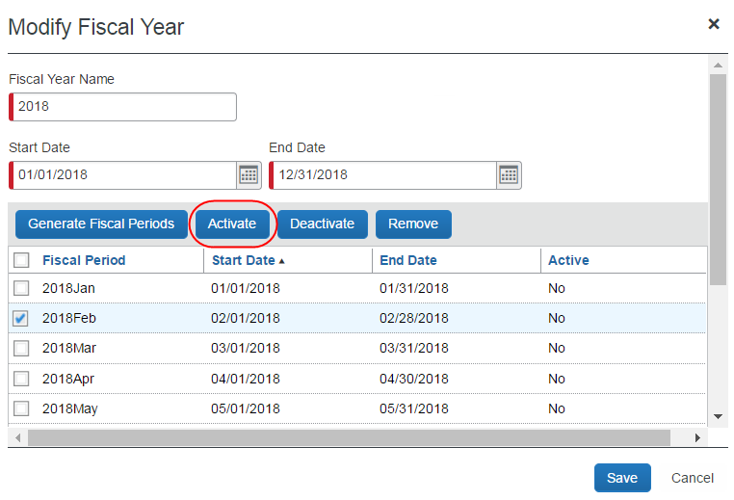
- Click Save.
You can activate a fiscal period of an inactive fiscal year. When you save the change, the fiscal year becomes active.

Add a Fiscal Period to a Fiscal Year
You can add a fiscal period to a fiscal year by extending the fiscal year. To add a fiscal period in the same calendar year, first extend the fiscal year beyond the calendar year, then modify the generated fiscal period dates until you have the correct number of fiscal periods in the calendar year, then delete extra fiscal periods. Refer to the Modify a Fiscal Period procedure for details.
To add a fiscal period to a fiscal year:
- In the Fiscal Calendar tab, select a fiscal year and then click Modify, or double-click the desired year.
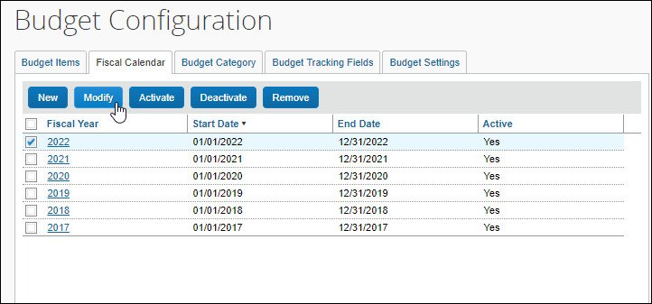
The Modify Fiscal Year window appears.
- Add a fiscal period by changing the end date of the fiscal year in the End Date field.
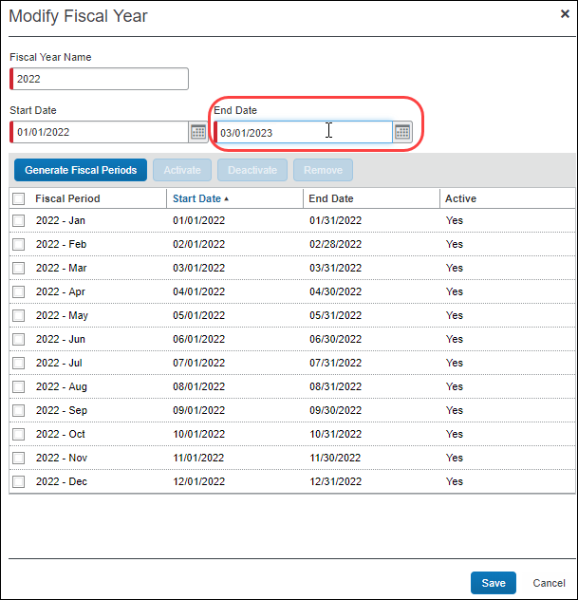
- Click Save.
- On the Alert window, click OK.
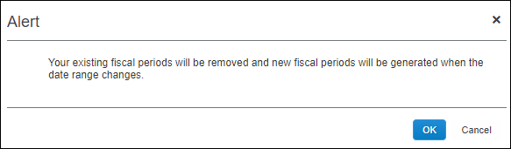
- If you created a fiscal year that is greater than a calendar year, on the Alert window click OK.
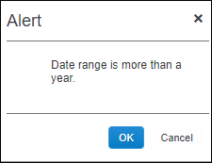
The new fiscal periods are automatically generated and activated.
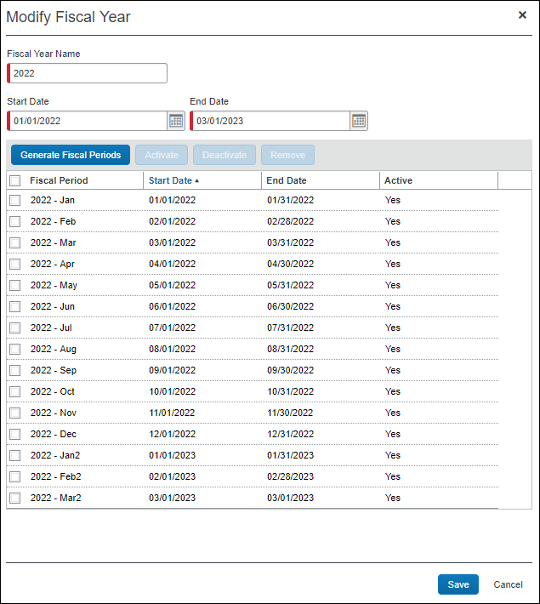
- Click Save.

Modify a Fiscal Period
You can modify a fiscal period if it is not associated with a budget item.
To modify a fiscal period:
- In the Fiscal Calendar tab, select a fiscal year and then click Modify, or double-click the desired year.
The Modify Fiscal Year window appears.
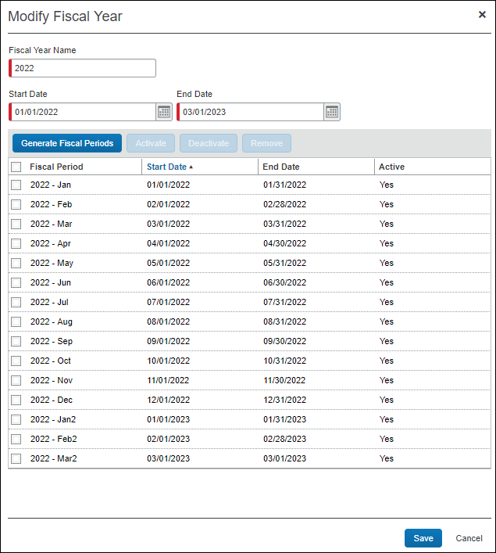
- Change the fiscal period date range by entering the new date(s) in the Start Date or End Date columns.
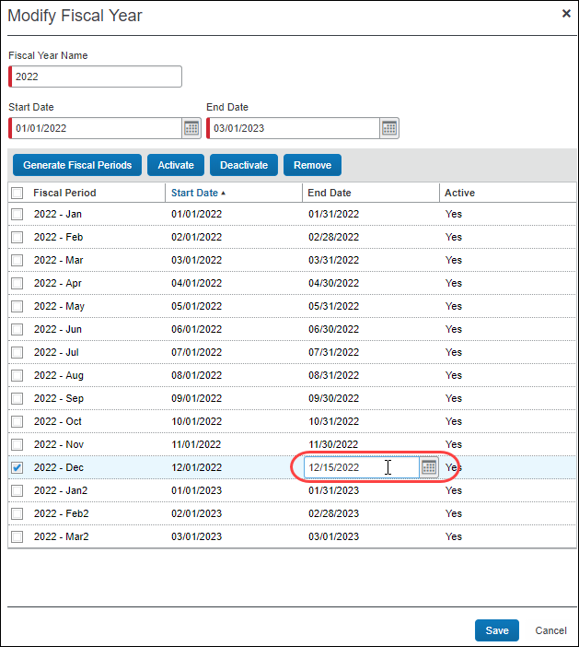
- Change the name of the fiscal period, by clicking in the Name column.
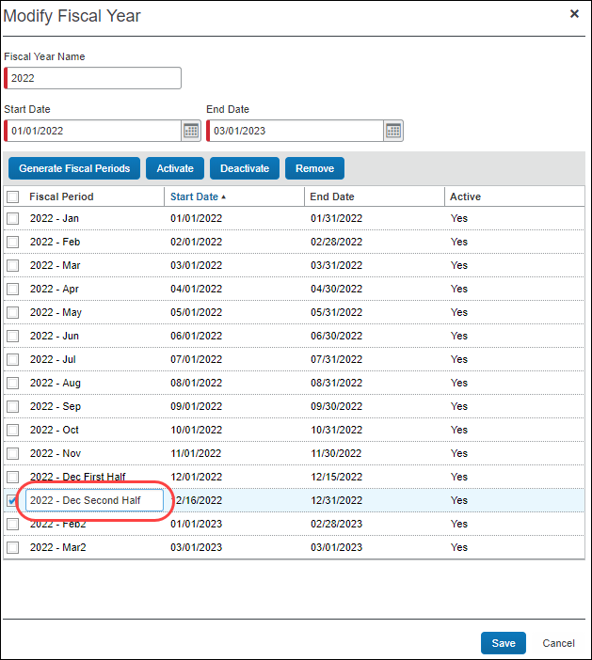
- Click Save.

Deactivate a Fiscal Period
You can deactivate a fiscal period to disable budgets for budget owners. You can deactivate a fiscal period anytime. All fiscal periods that belong to the fiscal year become inactive when the year is deactivated. If all fiscal periods that belong to the fiscal year are inactive then the year is deactivated.
To deactivate a fiscal period:
- In the Fiscal Calendar step, select a fiscal year and the click Modify.
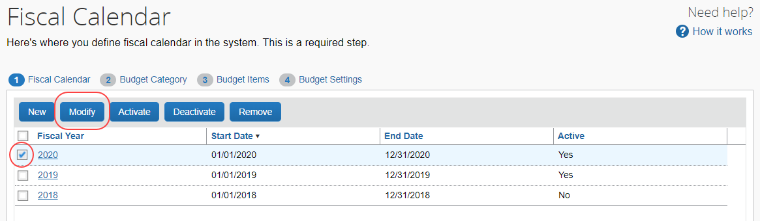
The Modify Fiscal Year window appears.
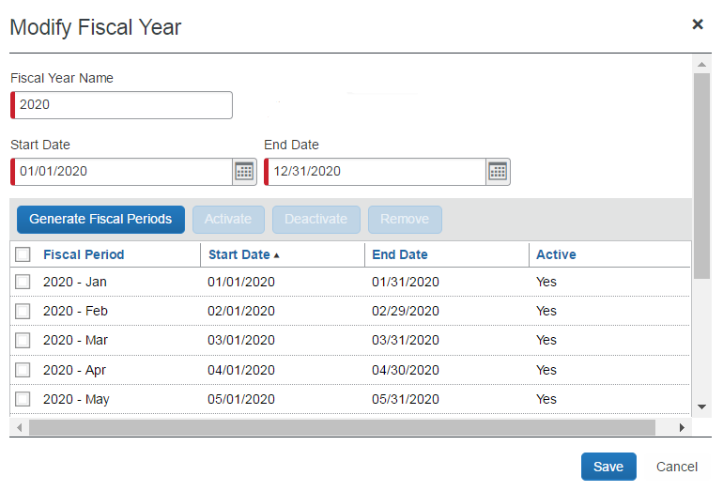
- Select a fiscal period and then click Deactivate.
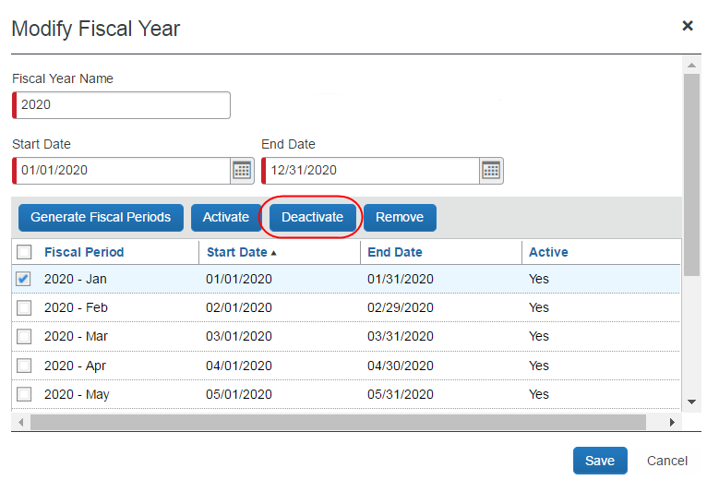
- Click Save.

Remove a Fiscal Period
You can remove a fiscal period to change the fiscal periods of a fiscal year. A fiscal period can be removed any time if it is not associated with a budget item.
The Fiscal Calendar will not show any fiscal periods marked as deleted.
To remove a fiscal period:
- In the Fiscal Calendar step, select a fiscal year and then click Modify.
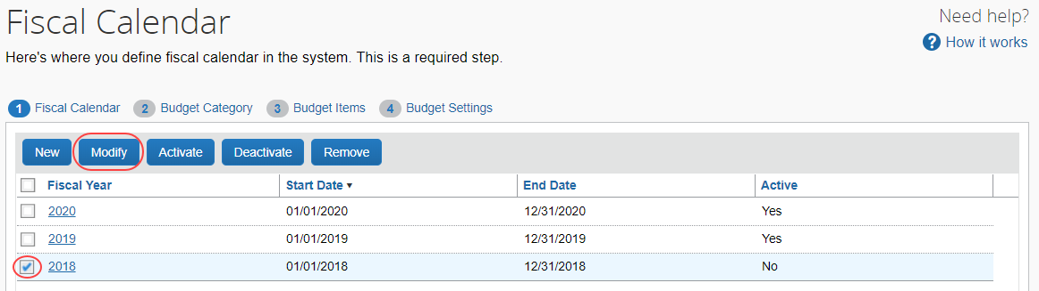
The Modify Fiscal Year window appears.
- Select a fiscal period and then click Remove.
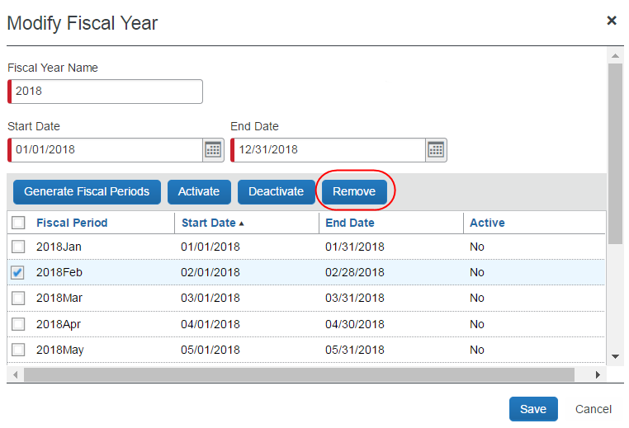
- Click Save.
The fiscal period is removed from the fiscal year.
The fiscal periods and budget items will be marked as deleted and will not be retrievable by any users. SAP Concur can decide to permanently remove any records marked as deleted.

Manage Budget Categories

Add a Budget Category
You can add a budget category to manage budgets at an expense type group level, which will provide a more detailed level of budgeting.
To add a budget category:
- In the Budget Category step, click New.
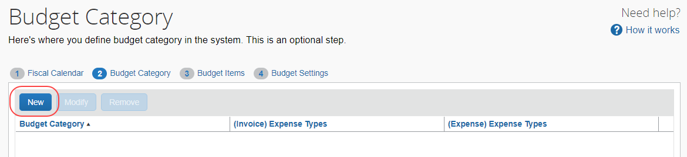
The Add Budget Category window appears.
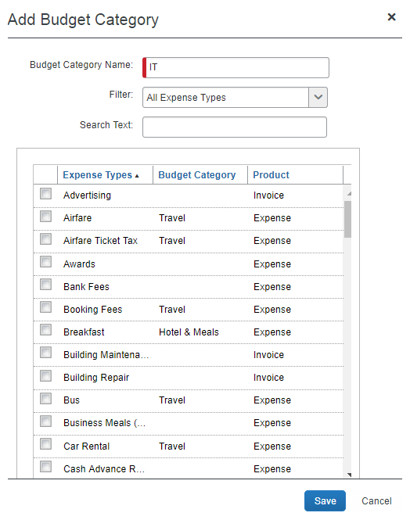
- Complete all the fields in the window by using the table below as guidance.
Field/List/Column | Description/Action
Budget Category Name | Enter a name for the collection of expense types that you are creating. Any combination of characters is allowed, but the name must be unique.
Filter | Select one of the following filters:  - All Expense Types (shows all expense and invoice expense types)  - All Expense – Expense Types (shows all expense report expense types)  - All Invoice – Expense Types (shows all invoice expense types)  NOTES:  - The expense types that are read-only are already used by other budget categories.  - Request expense types are shared with Concur Expense, so they appear labeled for the Concur Expense product.
Search Text | Use this field to search for expense types.
Expense Type | This column shows the expense types available for either Concur Invoice, Concur Expense, or Concur Request (included with Expense). Select one or more expense types. Expense types can be selected for multiple budget categories. All expense types are available, apart from the Undefined expense type, which is used by Capture Processing when no expense type can be identified during the Capture Processing process.
Budget Category | This column shows the Budget Category for which the expense type(s) applies.
Product | This column shows the product for which the expense type applies.
Concur Request clients can select parent expense types when Concur Request is enabled. This will make it easier when, for example, clients travel somewhere for a few days and do not know how many lunches and dinners they will eat. Instead of specifying several lunches and dinners, they can select the parent expense type (Meals).
- Click Save. The Budget Category will appear on the Budget Category page.
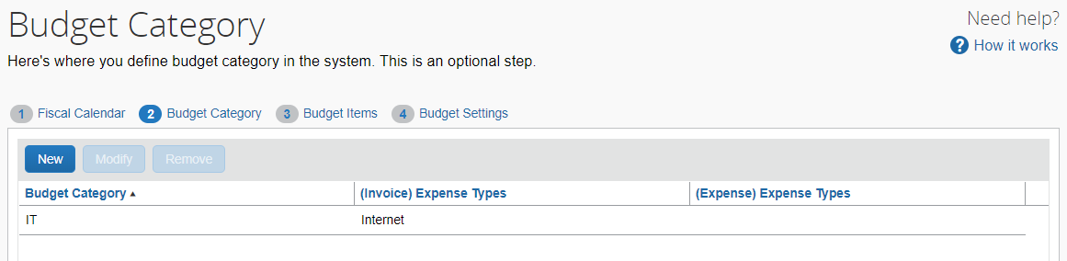

Modify a Budget Category
You can modify a budget category by adding or removing expense types or by changing the name of the Budget Category. You cannot remove an expense type from a budget category if it is associated with a budget.
To modify a budget category:
- In the Budget Category step, select a budget category and then click Modify.
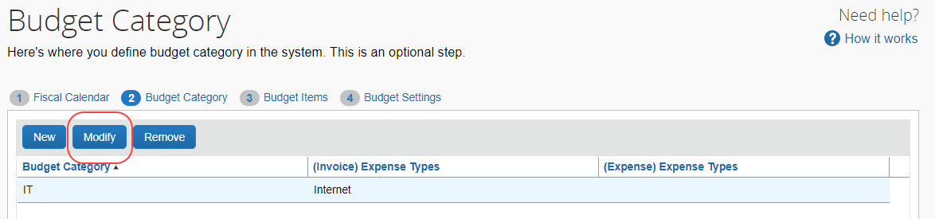
The Modify Budget Category window appears.
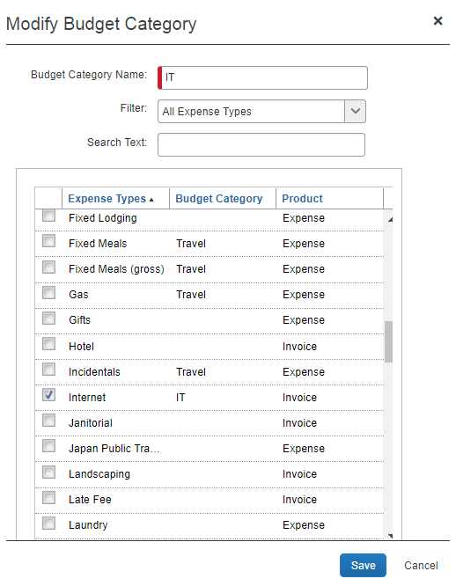
- Make the desired changes. For field information, refer to the To add a budget category procedure in this document.
- Click Save.
An expense type can only be used by one budget category.

Remove a Budget Category
You can remove a budget category that is no longer needed or was added by mistake. You can remove a budget category anytime, if it is not associated with a budget. Any expense type associated to the removed budget category becomes available to other budget categories.
To remove a budget category:
- In the Budget Category step, select a budget category and then click Remove.
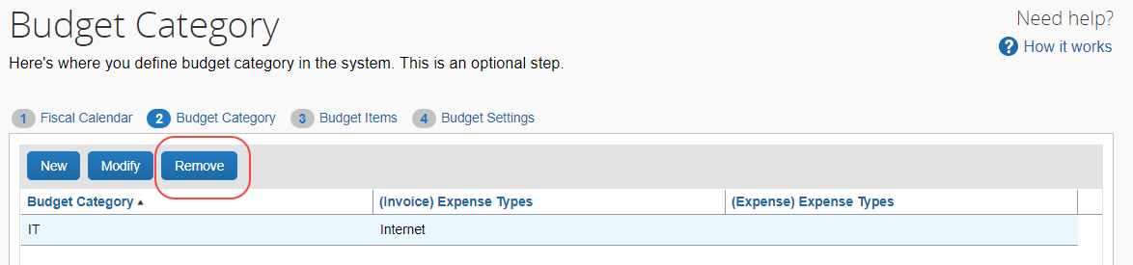
- In the Remove Budget Category window that appears, click Yes.
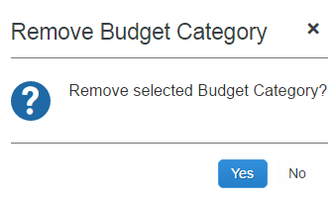
Spending items are not re-allocated when a budget category is removed. When a spending item changes workflow status or is changed, the spending item expense type is validated again, and, at that point, a spending item is associated with other budgets.

Configure Custom Fields for Budget Tracking
To use budget tracking, you configure custom fields in Product Settings as you normally would when you use custom fields in Concur Invoice, Concur Expense, or Concur Request.
If you have already defined custom fields in Product Settings, but do not see them in Budget Items, go to the Custom Fields page in Product Settings and select the Save button. Alternatively, click the Synchronize button in the Budget Tracking Fields tab of the Add/Modify a Budget Item window, to synchronize the custom fields with the budget tracking fields.
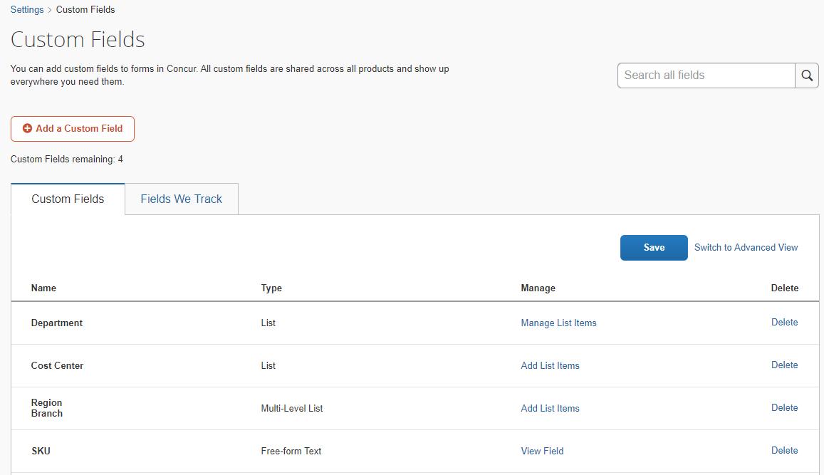
These custom fields then automatically become budget tracking fields and can be activated in Budget Items.

Field Behavior Settings
To use a custom field as a budget tracking field, the custom field must be visible on at least one Concur Expense or Invoice form. Setting a custom field to optional, required, or read-only for a form, makes the field visible to users when they view that form. If a custom field is set to be hidden from employees for a form, then users will not see the field on that form.
Setting the visibility of a field for a Concur Expense form does not make it available for tracking in Concur Invoice, and vice versa. To track a custom field in both Concur Expense and Invoice, you must set the visibility of the field to optional, required, or read-only for at least one Concur Expense and at least one Concur Invoice form.
Visibility of custom fields is configured by clicking Custom Fields > Switched to Advanced View > Manage Visibility in Product Settings. In the following example, the Department field is hidden from employees on all Concur Expense forms and visible as an optional field on the Invoice Header form.
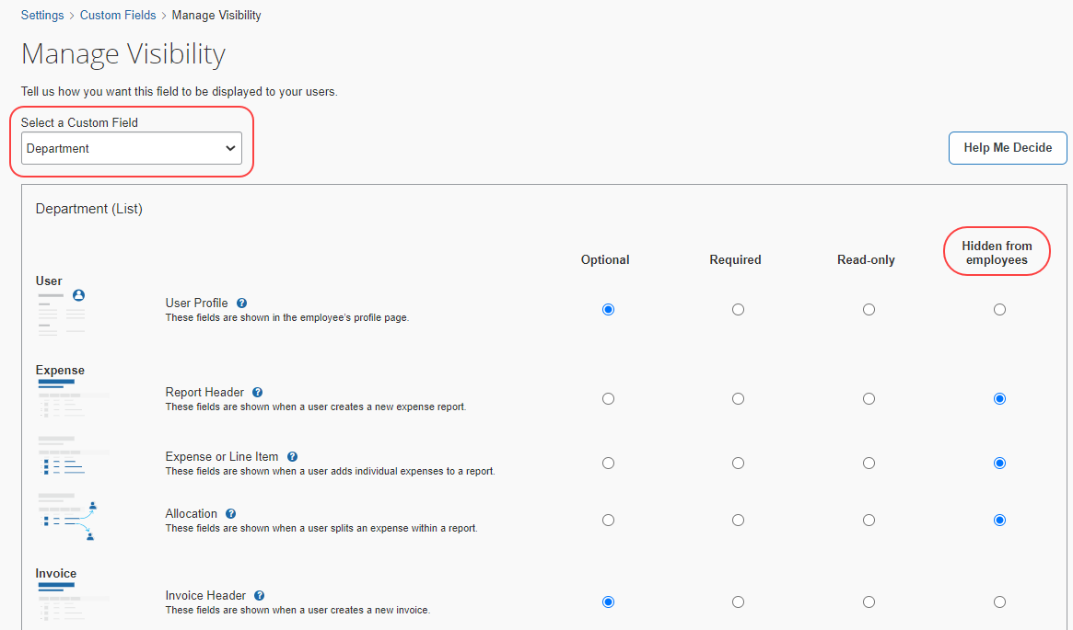
- For more information about custom fields, refer to the Shared: Custom Field Setup Guide for Concur Standard Edition.

Enable the Budget Manager Hierarchy (Optional)
If clients choose to use the Manager Hierarchy to match employees to the correct budgets, the admin must first confirm that the budget users have their manager selected in the Manager field of the Users page of Product Settings.
- For more information, refer to the Shared: Users Setup Guide for Concur Standard Edition, and the Shared: User Import Setup Guide for Concur Standard Edition.
After the admin has confirmed that all budget users have managers defined, they must select a manager on the Filter by Managers (optional) tab for each Budget Item.
To see the Filter by Managers (optional) tab, the admin must have selected (enabled) this option in Budget Settings.
Admins can let users enable the manager hierarchy by letting them define a budget approver/manager in Profile Settings. For more information on this, refer to the Filter by Managers (optional) section in this document.

Manage Budget Items

Add a Budget Item
You can add a budget item to define a budget, including fiscal year, budget owner, budget name, and budget display name.
To add a budget item:
- In the Budget Items tab, click New.
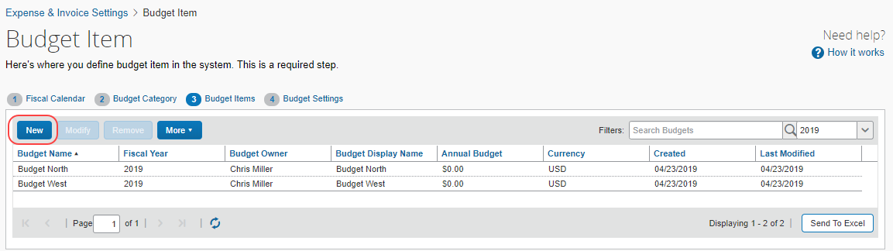
The Add Budget Item window appears.
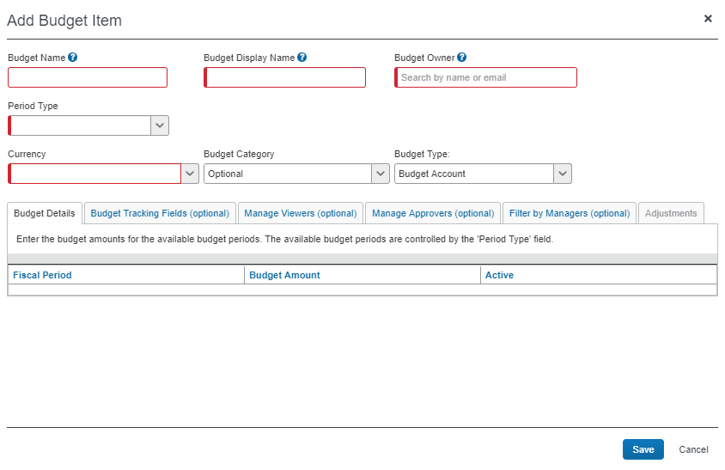
- Complete all required fields.
Field | Description/Action
Budget Name (Required) | Enter a budget name. The name can be any combination of characters but needs to be unique per fiscal year.  The budget name, fiscal year, and budget owner constitute the unique key of the budget record. The budget name is not displayed to users anywhere.
Budget Display Name (Required) | Enter a description of the budget item, which will be displayed on the budget dashboard, the in-transaction view, and on the Mobile app for budget owners, budget viewers, and budget managers. Maximum 50 characters.  NOTE: For Mobile users, the limit is 20 characters.
Budget Owner  (Required) | Type in the first three letters of the budget owner name to search for a budget owner. The result shows all users with the Budget Owner role.
Period Type  (Required) | Select one of the following options:  - Yearly  - Quarterly  - Monthly  - Date Range  Date Range budgets are defined by start and end dates rather than fiscal years and contain a single budget period.  - For more information, refer to the Date Range Budget Items section of this guide.  NOTE: Selecting a period type will re(generate) the budget periods with zero amounts.
Fiscal Year | Select the fiscal year associated to this Budget Item or leave blank for date range budget items.
Start Date | The start date of the budget item. Only appears if Date Range is selected in the Period Type field.
End Date | The end date of the budget item. Only appears if Date Range is selected in the Period Type field.
Currency  (Required) | Select the currency associated to this Budget Item.  NOTE: This Currency list is not editable if the budget is associated with a spending item.
Budget Category  (Optional) | Select the Budget Category associated to this Budget Item.
Budget Type | Select the type of budget, either Budget Account (default), Restricted Account, or Personal Account. Personal use budgets are budgets that are associated to one person, for education, entitlements, or other benefits. The spending items will match the personal budget if the budget owner and spending item requestor are the same, and the other matching configured in Budget Items is met. A restricted account is another name for a grant or a purpose-driven budget.  - For more information about budget types, refer to the Budget Types section in this document.
- In the Budget Details tab, in the Budget Amount column, enter the budget amounts for the available budget periods. The available budget periods are controlled by the Period Type field. The other columns are read-only fields.
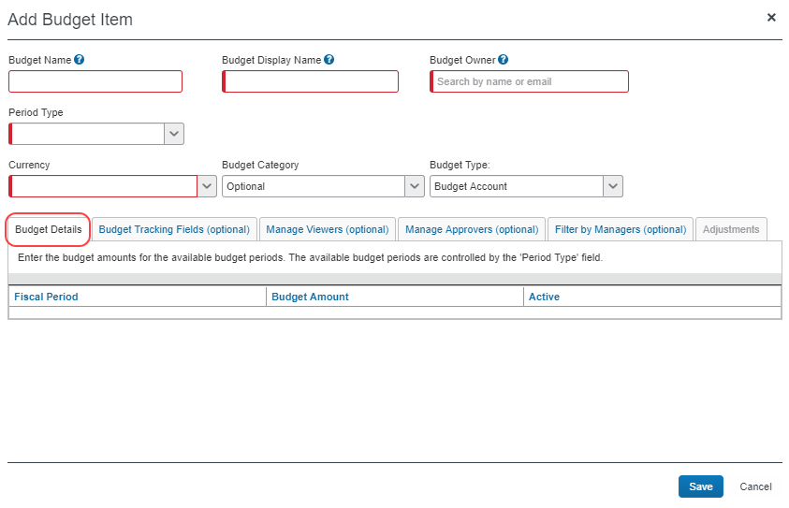
If a budget period amount is zero (or negative) and an employee submits an expense report, invoice, purchase request, or authorization request against that specific budget period, the system will not send out any notifications to budget owners that their budget has reached its limit or is over limit.
- In the Budget Tracking Fields (optional) tab, enable the budget tracking fields as spend capture filters by activating the fields and connected lists that you want to use.
If you do not see tracking fields that you have added in Custom Fields in Product Settings, go to the Data Entry Details step in Custom Fields and select the Save button. Alternatively, click the Synchronize button in the Budget Tracking Fields tab of the Add/Modify a Budget Item window, to synchronize the custom fields with the budget tracking fields.
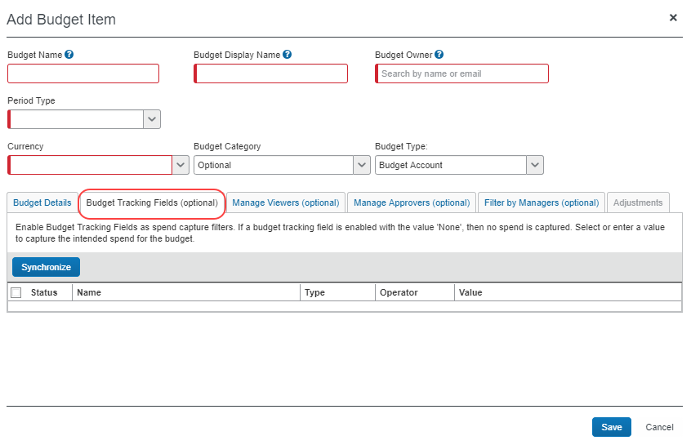
Column | Description/Action
Status | This indicates the Active or Inactive status of the budget tracking field. To activate a budget tracking field, select (enable) the check box for the budget tracking field you would like to activate.
Name | This is the name of the budget tracking field.
Type | This is the input type of the tracking field. The following types are available:  - List  - Connected List  - Free Form
Operator | The following operators are available:  - IsEqual – This is the default operator which will filter on a value in the Value column. If the None value is selected, the filtering will take place on any or all values in the list. The admin can change the operator if needed. For example, a departmental budget for the Finance department will have the following budget tracking field filter: Department IsEqual Finance.  - IsNotEqual – This operator is useful if you need all values apart from one, or when a field on the expense report or invoice is optional and may have blank values beside valid values. For example, if there is a separate budget for the Training department in your company, Training would have the IsEqual operator, and other departments would have the IsNotEqual operator.  - IsBlank – With this operator, budgets will be matched if the spending item has no value, and then the budget tracking field value is ignored. Mapping to budget will be performed and no searching or filtering will take place.  - IsNotBlank – With this operator, budgets will be matched if the spending item has a value, and then the budget tracking field value is considered. Mapping to budget will be performed and searching or filtering will take place.  - InValueList – This operator enables entry of a comma separated value list (not a maintained list or a connected list) which can be useful for, for example, a budget owner who owns multiple cost centers within one budget. They can then list the cost centers with a comma-separated value. This operator is only available for free form text fields.  NOTE: The InValueList value needs to be comma separated without any spaces in between. The values also need to be in list codes. For example, "FR" for "France".  - NotInValueList – Admins can use this negative operator to exclude certain values. This operator is only available for free form text fields.  - IsTrue – Admins can use this operator to filter on Boolean values. This operator is only available for free form text fields. For example, if admins select an Is Billable Boolean budget tracking field value together with the IsTrue operator, the system will only filter on expenses that are billable. The IsTrue operator only covers True.  - IsNotTrue - Admins can use this operator to filter on Boolean values. If a Boolean field does not have a default value and is not required, it is saved as Null (neither True or False). This operator covers both False and Null and is only available for free form text fields.  - IsFalse - Admins can use this operator to filter on Boolean values. This operator is only available for free form text fields. For example, if admins select an Is Billable Boolean budget tracking field value together with the IsFalse operator, the system will not filter on expenses that are billable. The IsFalse operator only covers False, not Null.  - IsNotFalse - Admins can use this operator to filter on Boolean values. This operator is only available for free form text fields. The IsNotFalse operator covers True and Null.
Value | This is the default value for the budget tracking field. For example, if the field name is Department, the default value might contain different company departments, such as Sales, IT, and Marketing.  NOTE: If a budget tracking field is enabled with the None value, spend is not captured. Select or enter a value to capture the intended spend for the budget.
- In the Filter by Managers (optional) tab, in the Search Text field, type the first three letters of the manager’s name, select the correct name in the list which is then added to the Assigned Managers (Budget Manager role) list.
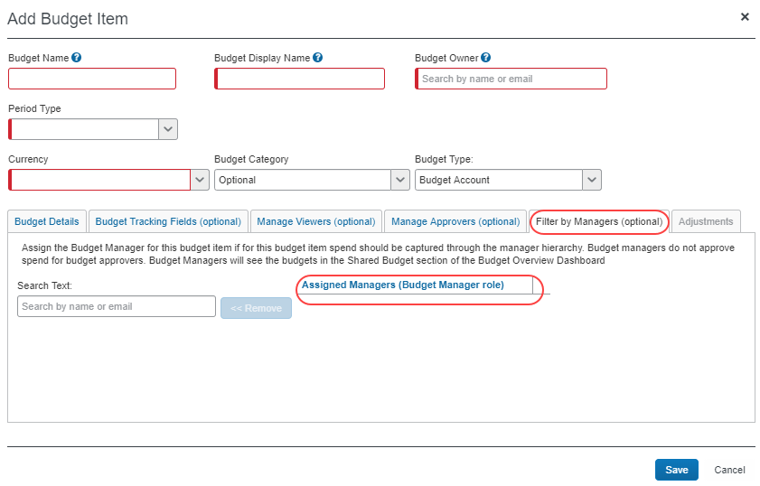
To see the Filter by Managers (optional) tab, the admin must have selected (enabled) this option in Budget Settings.
- In the Manage Viewers (optional) tab, type the first three letters of the viewer’s name, select the correct name in the list, which is then added to the Manage Viewers (optional) list.
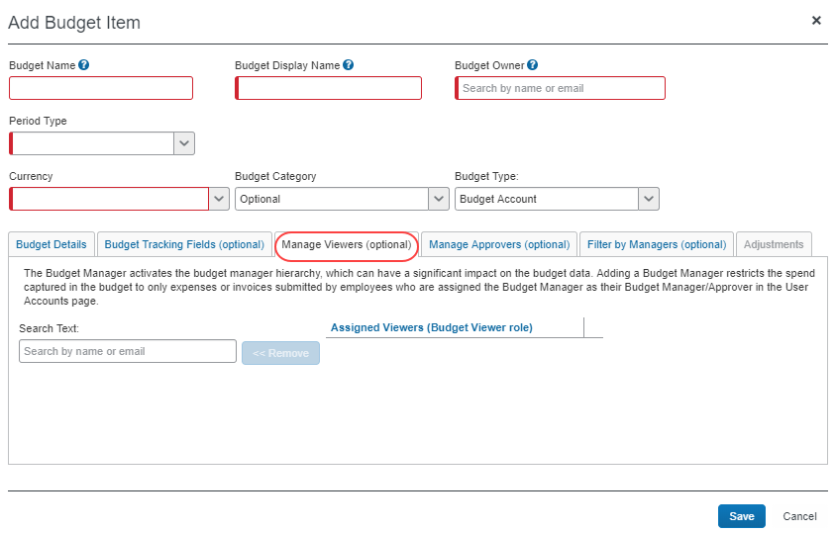
- Click Save.

Modify a Budget Item
You can modify an existing budget item to correct mistakes or to apply configuration changes.
To modify a budget item:
- In the Budget Items tab, select a budget item and then click Modify.
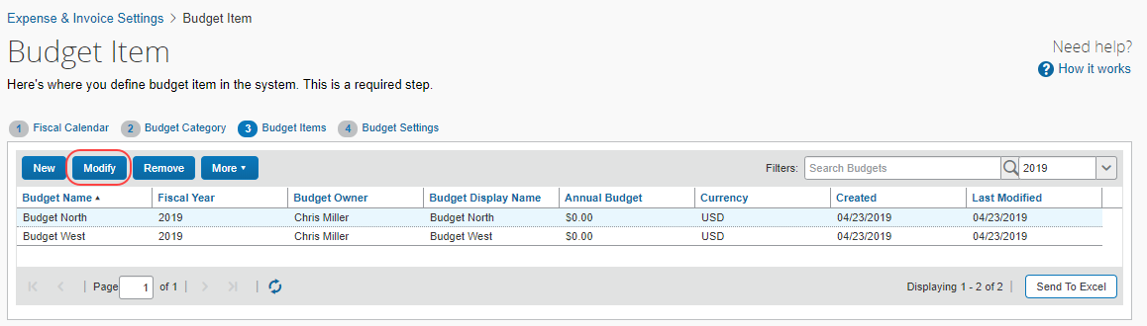
The Modify Budget Item window appears.
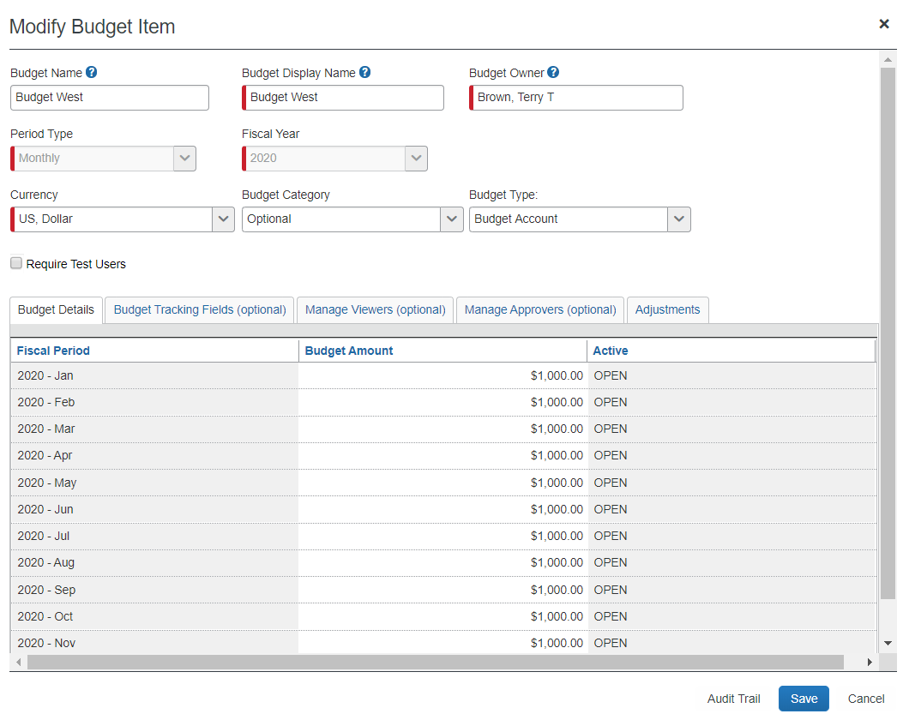
- Make the desired changes. For field information, refer to the To add a budget item procedure in this document.
If you change the fiscal year or the period type, the budget periods will regenerate with zero budget amount.
- Click Save.

Remove a Budget Item
You can remove a budget item that is no longer needed or was added or imported by mistake anytime. If you delete a budget item, all budget periods of that budget item will be deleted. In addition, you can remove a budget item if a spending item is associated with it.
To remove a budget item, in the Budget Items tab, select a budget item and then click Remove.
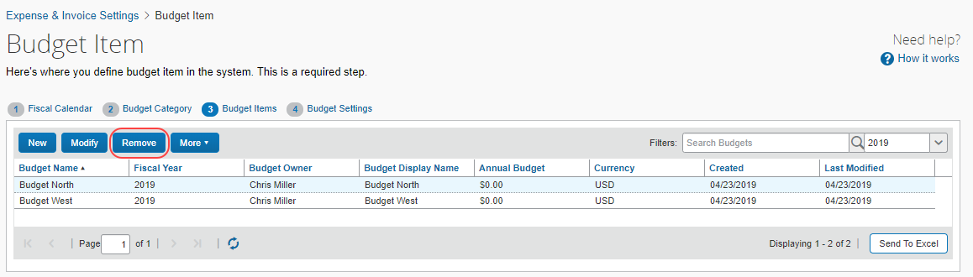
If you select more than one budget item, the Remove button will be grayed out (not available).
The Budget Item is removed from the list in the Budget Items tab.
The budget items will be marked as deleted and will not be retrievable by any user. SAP Concur can decide to permanently remove any records marked as deleted.
All spending items (within the budget, not the original spend items) associated with the marked as deleted budget items will be marked as deleted.

Add a New Team Budget
In addition to budget owners, budget admins can also add team budgets.
If you are a budget owner, you can add a team budget through the Budget Dashboard. Once you are in the Add Team Budget window, you can use the procedure below, starting at the second step, to enter information in the fields.
To add a team budget:
- In the Budget Items tab, click New Team Budget. The Add Team Budget window appears.
- Complete all required fields.
Field | Description/Action
Budget Name (Required) | Enter a budget name. The name can be any combination of characters but needs to be unique per fiscal year.  The budget name, fiscal year, and budget owner constitute the unique key of the budget record. The budget name is not displayed to users anywhere.
Budget Display Name | Enter a description of the budget item, which will be displayed on the budget dashboard, the in-transaction view, and on the Mobile app for budget owners, budget viewers, and budget managers. Maximum 50 characters.  NOTE: For Mobile users, the limit is 20 characters.
Budget Owner  (Required) | Type in the first three letters of the budget owner name to search for a budget owner. The result shows all users with the Budget Owner role. As a budget admin, you can select the Budget Owner in the list.  If you are a budget owner, this field is defaulted to the Budget Owner creating the team budget and they cannot change it.
Period Type  (Required) | Select one of the following options:  - Yearly  - Quarterly  - Monthly  - Date Range  Date Range budgets are defined by start and end dates rather than fiscal years and contain a single budget period.  - For more information, refer to the Date Range Budget Items section of this guide.  NOTE: Selecting a period type will re(generate) the budget periods with zero amounts.
Fiscal Year  (Required) | Select the fiscal year associated to this Budget Item or leave blank for date range budget items.
Start Date | The start date of the budget item. Only appears if Date Range is selected in the Period Type field.
End Date | The end date of the budget item. Only appears if Date Range is selected in the Period Type field.
Currency  (Required) | Select the currency associated to this Budget Item.  NOTE: This Currency list is not editable if the budget is associated with a spending item.
Budget Category  (Optional) | Select the Budget Category associated to this Budget Item.
Budget Type  (Required) | The Budget Type is set as Team Account by default.
- In the Budget Details tab, refer to the Add a Budget Item section in this guide.
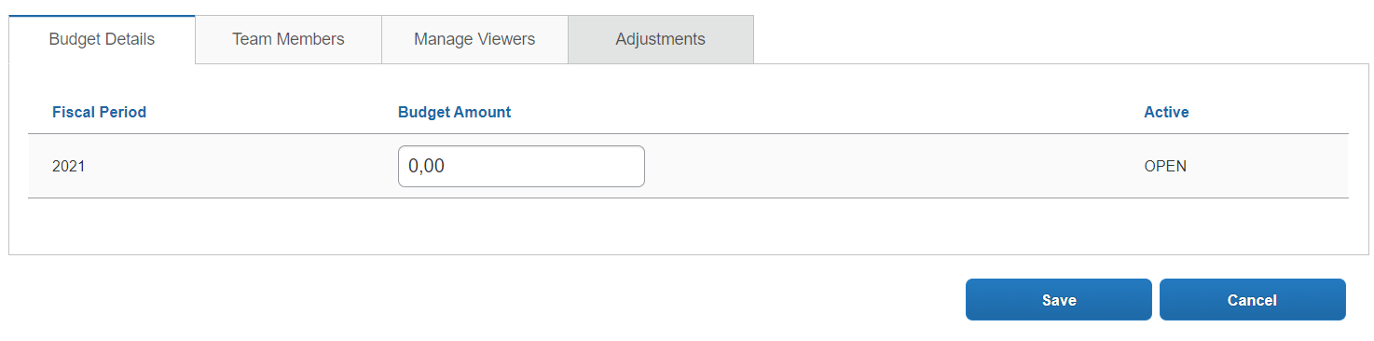
- In the Team Members tab, select how the team members participate in the budget (All Time, Period of Time, or Not Enrolled). If you select the Period of Time option, enter the dates when the team member participates in the budget. For more information about the Team Members tab, refer to the Team Budgets section in this guide.
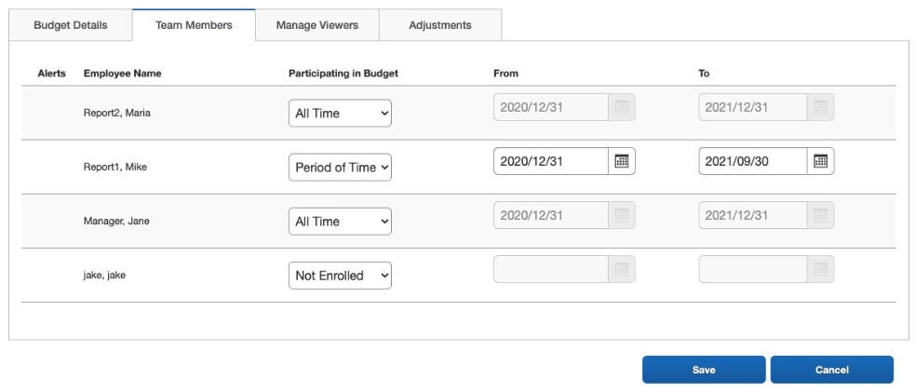
- To add viewers in the Manage Viewers tab, refer to the Manage Viewers (Optional) section in this guide.
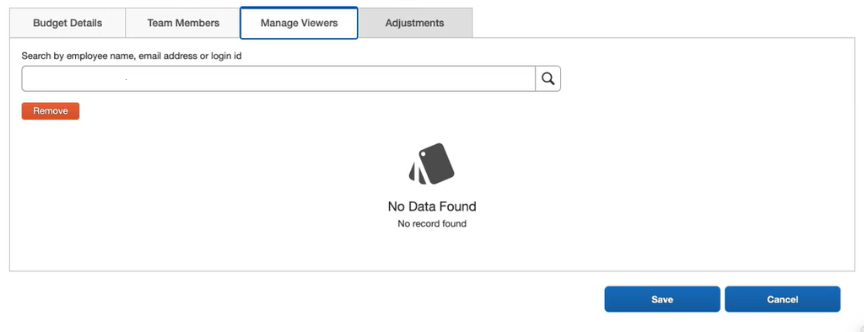
- To configure budget adjustments in the Adjustments tab, refer to the Budget Adjustment section in this guide.
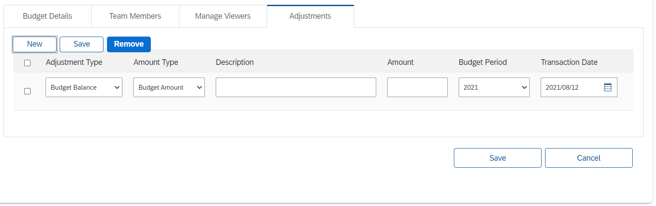
The Adjustment tab is not available until the budget is saved.

View the Audit Trail of a Budget Item
You can view the audit trail of a budget item in the Modify Budget Item window.
To add the audit trail of a budget item:
- In the Budget Items tab, select a budget item and then click Modify.
- In the Modify Budget Item window that appears, click Audit Trail.
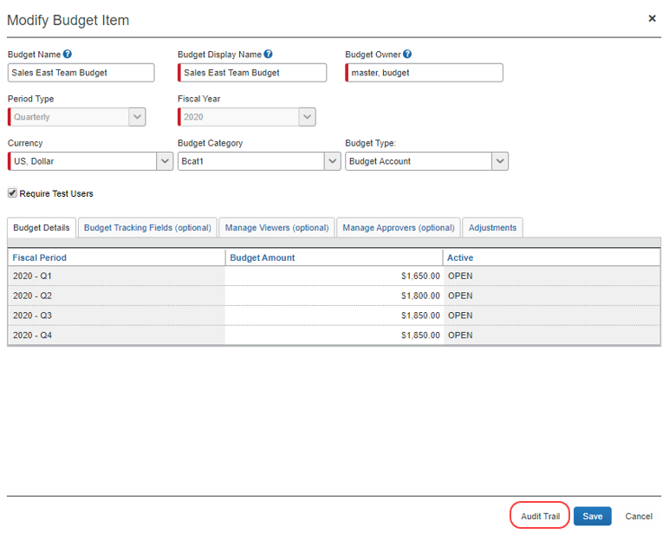
The Audit Trail window appears.

View Change Logs
You can search on and view change logs for budgets and budget settings.
To view change logs:
- In the Budget Items tab, click the More menu and select Change Logs.
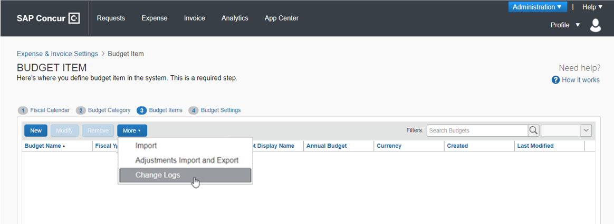
The Change Logs window appears.
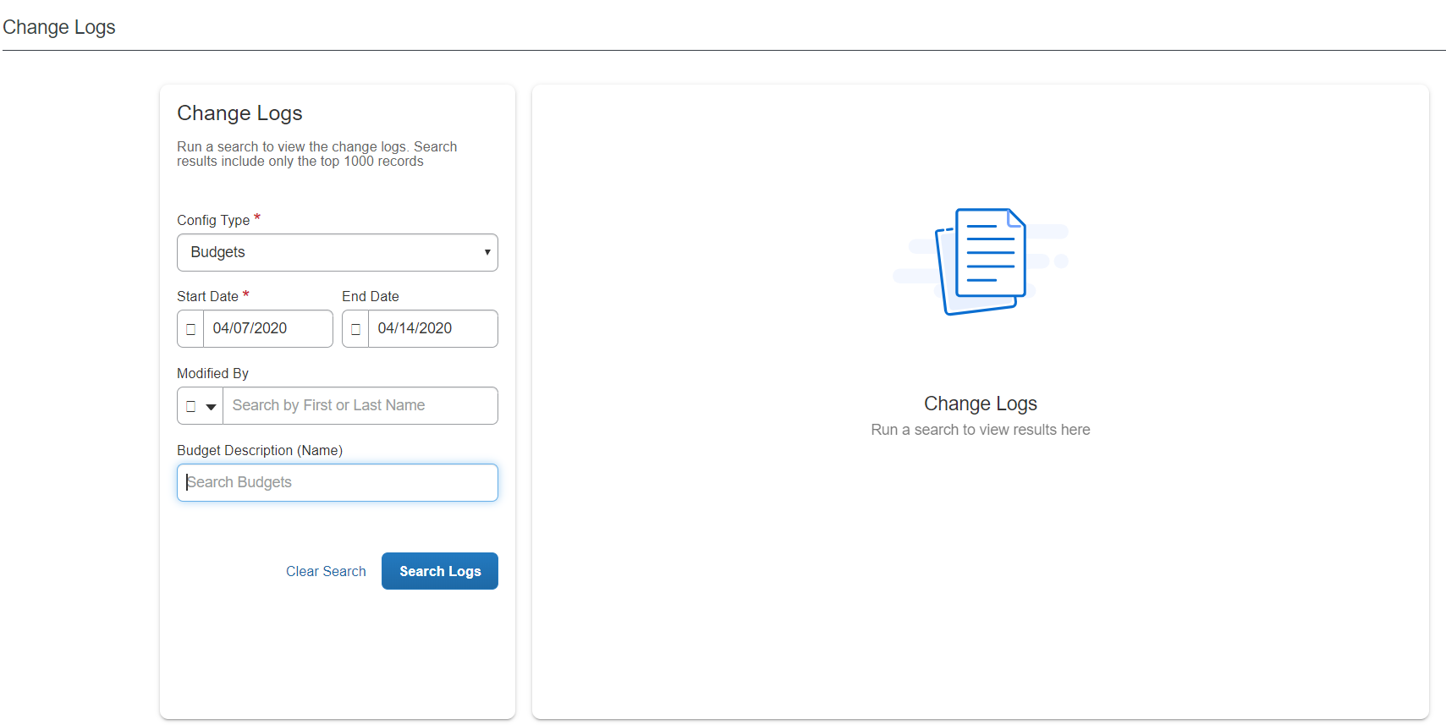
- Fill in the information in the Change Logs window by using the table below.
Field/List | Description/ Action
Config Type | Select Budgets if you want to search on overall budget changes or Settings if you want to search on changes in Budget Settings.
Start Date | Select the start date from which the search should be performed.
End Date | Select the end date from which the search should be performed.
Modified By | Select the user for whom you want to search modified budgets or budget settings.
Budget Description (Name) | Select the description of the budgets. This option is available when you have selected the Budgets config type.
Setting Description | Select the description of the budget setting. This option is available when you have selected the Settings config type.
- Click Search Logs.

Perform a Bulk Export
You can perform bulk exports of budget data in Budget Items.
To perform a bulk export:
- In the Budget Items tab, click the More menu and select Bulk Exports.
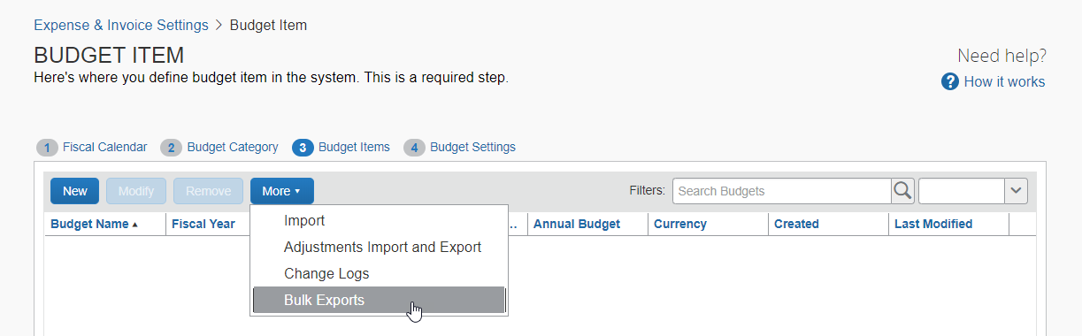
The Bulk Exports window appears.
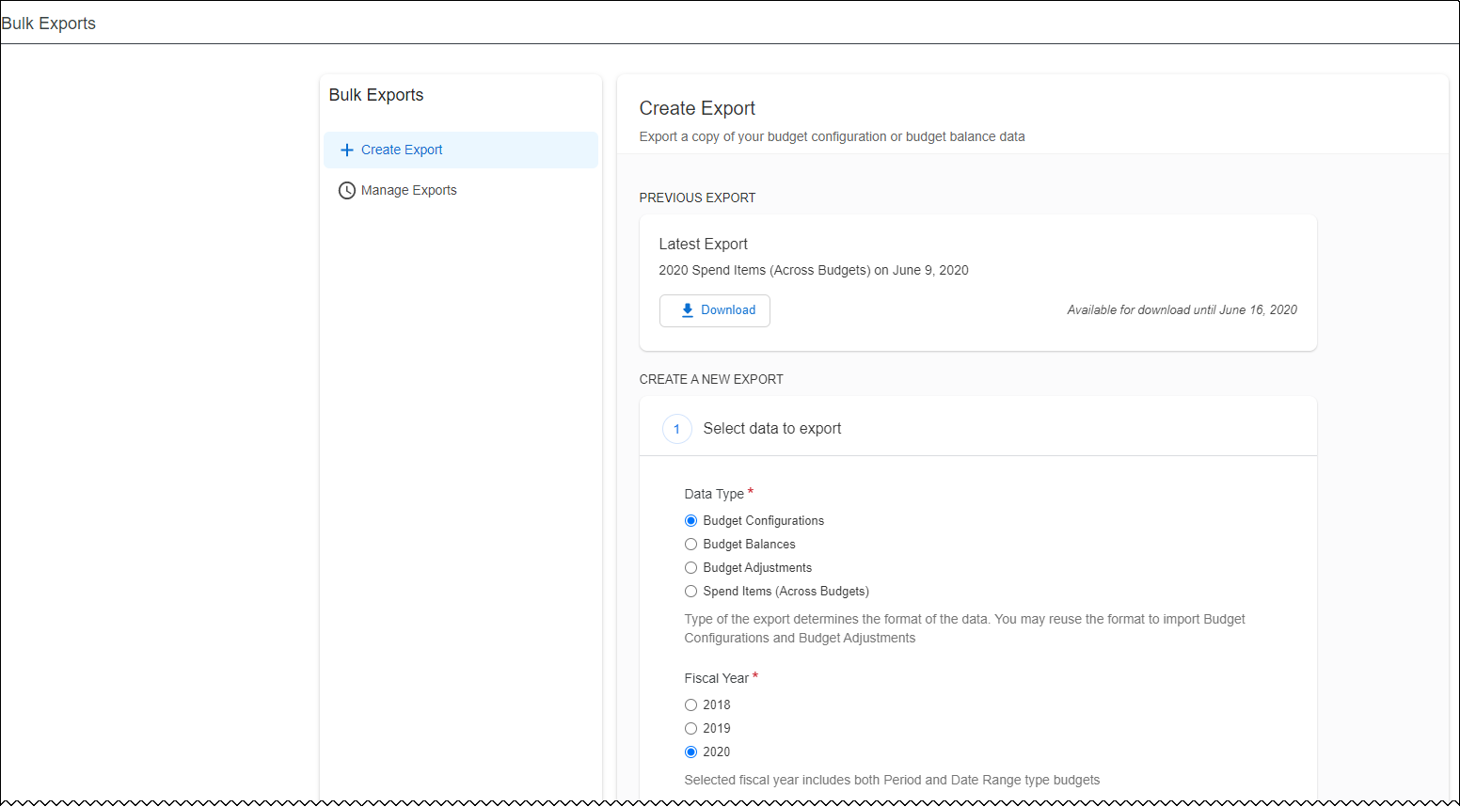
- Fill in the information in the Bulk Export window by using the table below.
Field/List | Description/ Action
Data Type | - Budget Configurations: All the budget item data visible on the Budget Items page similar to when the you click Send to Excel.  - Budget Balances: The equivalent of what is available in the tile view of the Budget Dashboard. You can export all budgets for a given year with their balances from the Bulk Export window.  - Budget Adjustments: The equivalent of what is available when you export budget adjustment by clicking More > Adjustments Import and Export in Budget Items.  - Spend Items (Across Budgets): Spend items across all budgets will be exported when you select this option.
Fiscal Year | Select the fiscal year of the budgets you want to export.
Budget Category | Select all budget categories or a specific budget category.
File Type | Select the file type for the export.
Notification Preference | Select (enable) the Send an email once the export is ready to download option if you want to receive information about when the export is ready to download.
- Click Create Export.

Add an Adjustment to a Budget Item
You can add adjustments to existing budget items to apply budget changes.
To add an adjustment to a budget item:
- In the Budget Items tab, select a budget item and then click Modify.
The Modify Budget Item window appears.
- Click Adjustments.
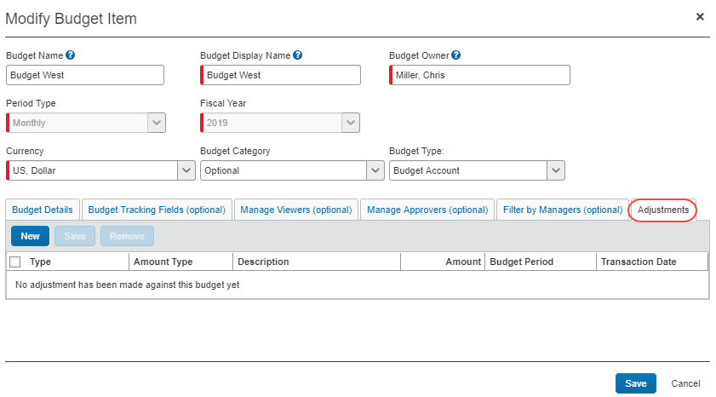
- Click New.
- Fill in the fields by using the table.
Field | Description/ Action
Type | The source of the budget adjustment. Values are Budget Balance, Fund Transfer, Expense, Invoice, Purchase Request, or Request.
Amount Type | Where the amount should be applied. Values are Budget Amount, Spent Amount, Pending Amount.
Description | The reason for or description of the adjustment.
Amount | The adjusted amount.
Budget Period | The budget period to apply the adjustment to.
Transaction Date | The date the adjustment is applied to the budget. Must be within the specified budget period.
- Click Save.

Manage Budget Settings

Set Alert Limit Percent
In Budget Settings, you can select (enable) the Alert Limit Percent option so that when a budget reaches a certain percent (80% by default), the owner or approver of the budget will see a yellow visual indicator when the budget is consumed beyond this percent.
To set alert limit percent:
- In the Budget Settings step, select (enable) the Alert Limit Percent check box.
- Click Save.

Set Control Limit Percent
In Budget Settings, you can select (enable) the Set Control Limit Percent option so that when a budget reaches a certain percent (100% by default), the owner or approver of the budget will see a red visual indicator when the budget is consumed beyond this percent.
To set control limit percent:
- In the Budget Settings step, select (enable) the Set Control Limit Percent check box.
- Click Save.

Manage Alert Limit Notifications
You can select (enable) the Send Alert Limit Notification option in Budget Settings, so that budget owners will receive an email alert when their budget exceeds the budget alert limit.
To send alert limit notifications:
- In the Budget Settings step, select (enable) the Send Alert Limit Notification check box.
- Click Save.

Manage Control Limit Notifications
You can select (enable) the Send Control Limit Notification option in Budget Settings, so that budget owners will receive an email alert when their budget exceeds the budget control limit.
To send control limit notifications:
- In the Budget Settings step, select (enable) the Send Control Limit Notifications check box.
- Click Save.

Restrict Notifications for Past Budgets
You can select (enable) the Restrict notifications for past Budgets option in Budget Settings, so that budget owners will not receive email notifications for older data, only for the previous, current, and future periods. This means that by selecting this option, fewer email notifications will be sent out to them.
To restrict notifications for past budgets:
- In the Budget Settings step, select (enable) the Restrict notifications for past Budgets check box.
- Click Save.

Select an Alternate Budget Manager
If the user has not filled in an approver in the Your budget manager field in Invoice Approvers or Expense Approvers in Profiles Settings, the system will use the approver selected in the Alternate Budget Manager list in Budget Settings.
To see the Alternate Budget Manager list, you must select (enable) the Enable filtering by Budget Manager option on the Budget Settings page.
To select an alternative manager:
- In the Budget Settings step, in the Alternate Budget Manager list, select (enable) one of the following options:
- Budget Manager
- Travel Manager
- Invoice Approver
- Expense Approver
- Click Save.

Show Unexpensed Expenses (Concur Expense Only)
You can select (enable) to show unexpensed amounts to enable budget owners to view the balance of the expense items that have not been submitted yet and is a combination of unsubmitted expense reports and available expenses which are not attached to an expense report.
To show unexpensed expenses:
- In the Budget Settings tab, in the Show unsubmitted expenses list, select one of the following options:
- Do not show unsubmitted Expense amounts
- Show unsubmitted Expense Amounts as Pending
- Show unsubmitted Expense Balance
- For more information about these options, refer to the Show Unsubmitted Expenses (Concur Expense Only) section in this guide.
- Click Save.

Include the Pending Amount in the Calculated Remaining Amount
You can include the pending amount in the calculated remaining amount in Budget Settings. This means that the pending amount will be subtracted from the remaining amount.
If the Include Pending Amount in Remaining Amount calculation option is selected (enabled), the remaining amount equals the budget amount minus the spent amount and the pending amount. In this scenario, clients typically want the available amount to reflect a realistic view of what remains to be spent and estimate that most of the pending items will be approved.
If the Include Pending Amount in Remaining Amount calculation option is cleared (disabled), the remaining amount equals the budget amount minus the spent amount. In this scenario, clients typically want the remaining amount to reflect the amount they still have control over. Pending spending items can be rejected.
To include the pending amount in the calculated remaining amount:
- In the Budget Settings step, select (enable) the Include Pending Amount in Remaining Amount calculation check box.
- Click Save.

Enable Budget Capture for Concur Request
You can select (enable) budget capture for Concur Request in Budget Settings.
To enable budget capture for Concur Request:
- In the Budget Settings tab, select (enable) the Enable Budget Capture for Request check box.
- Click Save.

Enable Budget Capture for Concur Expense
You can enable budget capture for Concur Expense in Budget Settings.
To enable budget capture for Concur Expense:
- In the Budget Settings step, select (enable) the Enable Budget Capture for Expense check box.
- Click Save.

Enable Budget Capture for Purchase Requests
You can enable budget capture for purchase requests in Budget Settings.
To enable budget capture for purchase requests:
- In the Budget Settings step, select (enable) the Enable Budget Capture for Purchase Request check box.
- Click Save.

Enable Budget Capture for Concur Invoice
You can enable budget capture for Concur Invoice in Budget Settings.
To enable budget capture for Concur Invoice:
- In the Budget Settings step, select the Enable Budget Capture for Invoice check box.
- Click Save.

Mark Requests as Spent After Approval
In Budget Settings, you can select (enable) an option to mark requests as spent when a processor approves them.
This option is only applicable to requests.
To mark request budget item as spent after request approval:
- In the Budget Settings tab, select (enable) the Mark Request budget items as spent after request approval check box.
- Click Save.

Mark Purchase Requests as Spent After Approval
In Budget Settings, you can select (enable) an option to mark purchase requests as spent when a processor approves them.
This option is only applicable to purchase requests.
To mark purchase requests as spent after approval:
- In the Budget Settings step, select (enable) the Mark Purchase Requests as spent after processor approval check box.
- Click Save.

Enable Use Expense Net Amount
In Budget Settings, you can clear (disable) the Use expense net amount check box if you want expense reports to be consumed with tax.
This option is only applicable to expense reports.
To enable the use expense net amount
- In the Budget Settings tab, clear (disable) the Use expense net amount check box.
- Click Save.

Enable Use Invoice Net Amount
In Budget Settings, you can select whether the net or gross amount of the invoice should be consumed. In other words, you can configure budgets to include invoice taxes and shipping charges or not. The Use invoice net amount check box is selected (enabled) by default. If you want to include invoice taxes and shipping charges, you need to clear (disable) the Use invoice net amount check box.
This option is only applicable to invoices.
To enable the use invoice net amount
- In the Budget Settings tab, clear (disable) the Use invoice net amount check box.
- Click Save.

Enable Filtering by Budget Manager
In Budget Settings, you can select (enable) an option to activate the Filter by Managers (optional) tab in Budget Items.
To enable filtering by budget manager:
- In the Budget Settings step, select (enable) the Enable filtering by Budget Manager check box.
- Click Save.

Enable Date Range Budgets
In Budget Settings, you can select (enable) an option to activate date range budget periods.
To enable date range budgets:
- In the Budget Settings step, select (enable) the Enable Date Range budget period type check box.
- Click Save.

Enable Budget Owner Adjustments
In Budget Settings, you can select (enable) an option to enable budget owner adjustments. This gives budget owners more control over their budgets and makes work more efficient for budget administrators.
To enable budget owner adjustments:
- In the Budget Settings step, select (enable) the Enable Budget Owner Adjustment check box.
- Click Save. An Add Adjustment button appears on the details page of the Budget Dashboard.
As a Budget Administrator, you can also add adjustments on the details page of the Budget Dashboard.

Configure Budget Workflows
The administrator must configure Budget approval routing in Approval Routing in Product Settings.
If clients are using custom workflows, they should contact SAP Concur for more information. Budget Approval workflow is not available for Concur Request approval routing and custom workflow in the Standard Edition.
To configure Concur Expense, Concur Invoice, or purchase requests for budget approval routing:
- Click Administration > Invoice Settings or Expense & Invoice Settings.
- In the Product list, click Invoice or Expense.
- In the Policy section, on the Invoice Approvals tab, Purchase Request Approvals tab, or Expense Approvals tab, click Edit.
The Approval Routing page appears.
- Select the Include Budget Approver check box. The image shows the Approval Routing page for Concur Invoice.
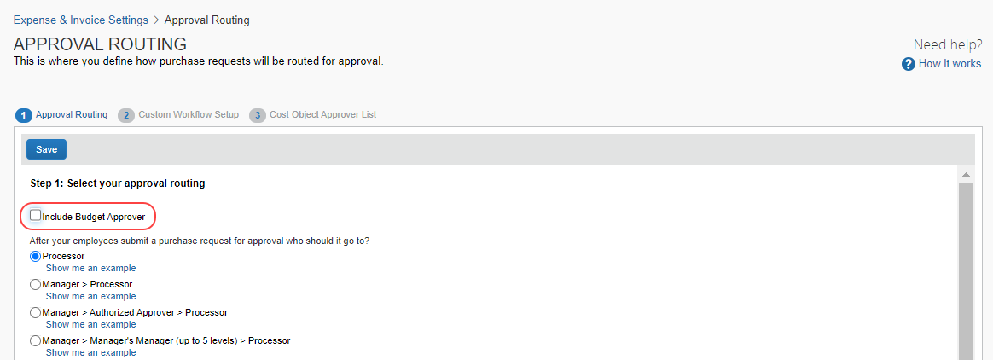
If you select the Include Budget Approver checkbox on the Approval Routing page, the budget approver step is skipped during the approval routing, but if the option is not selected, then the step is not skipped.
The Budget Approval step will be added before the Processor step. The image shows the Approval Routing page for Concur Invoice.
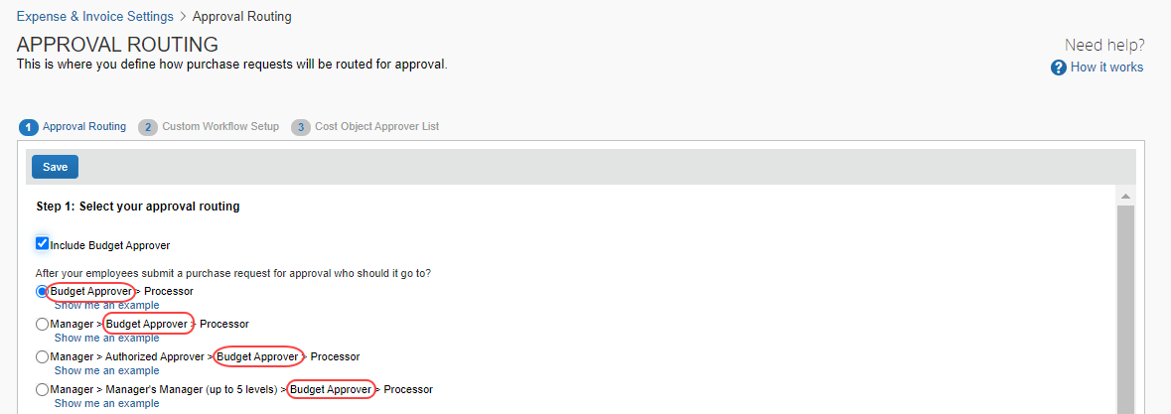
Admins can move the step order of the Budget Approval step.
- Click Save.

☼

