
Concur Invoice: Custom Audit Rules

Setup Guide for Standard Edition
Last Revised: March 23, 2024
Applies to these SAP Concur solutions:
 Concur Expense
 Professional/Premium edition
 Standard edition
 Concur Travel
 Professional/Premium edition
 Standard edition
 Concur Invoice
 Professional/Premium edition
 Standard edition
 Concur Request
 Professional/Premium edition
 Standard edition

Table of Contents
Section 1: Overview 1
Section 2: Custom Audit Rules 1
General Concepts about Audit Rules 2
Conditions ("if" portion of the "if/then" statement) 2
Events (Triggers) 4
Exceptions ("then" portion of the "if/then" statement) 5
Visibility 5
The Basic Process of How to Create Custom Audit Rules 6
Understanding Conditional Expressions 7
The Conditions Step 9
Configuration/Activation 19
Step 1: Enable Custom Audit Rules 19
Step 2: Access Custom Audit Rules 19
Step 3: Add a Custom Audit Rule 21
Manage Custom Audit Rules 27
Copy a Custom Audit Rule 27
Modify a Custom Audit Rule 28
Deactivate/Activate a Custom Audit Rule 28
Remove a Custom Audit Rule 28
Additional Samples of Custom Audits 29
Is Duplicate (for Invoices) 29
Account Code Rule for a Specific Invoice and Purchase Request 29
Quotes Required for Purchases (for Purchase Requests) 30
Budget Audit Rules 34
Budget Parameters for Audit Rule Notifications 37
Vendor Tax ID 38

Revision History
Date | Notes/Comments/Changes
March 23, 2024 | Added the Vendor Tax ID section in the Additional Samples of Custom Audit Rules section.
August 30, 2022 | Minor edits; cover date not updated
January 21, 2022 | Updated the copyright year; no other changes; cover date not updated
November 10, 2021 | Updated Product Settings page instructions.
March 4, 2021 | Updated the copyright year; no other changes; cover date not updated
April 22, 2020 | Renamed the Authorization Request check box to Request on the guide’s title page; cover date not updated the copyright; no other changes; cover date not updated
January 8, 2020 | Updated the copyright; no other changes; cover date not updated
June 8, 2019 | Updated text and images throughout to reflect UI name change from "Cost Tracking" to "Custom Fields".
May 23, 2019 | Changed "%First3Budgets%" to "%Top3Budgets%".
May 11, 2019 | Added information about budget parameters for audit rule notifications.
March 19, 2019 | Updated "payment request" to "invoice". Updated "Concur to SAP Concur". Updated out-of-date images.
March 16, 2019 | Added information about the following:  - New Payment Request Budget Submit event  - Budget Amount and Budget Remaining Amount audit rule options
January 29, 2019 | Updated the copyright; no other changes; cover date not updated
June 14, 2018 | Changed copy-down to copydown; no other changes; cover date not updated
April 11, 2018 | Changed the check boxes on the front cover; no other changes; cover date not updated
March 19, 2018 | Added information about Budget audit rules.
February 13, 2018 | Changed copyright and performed minor updates.
November 4, 2017 | Updated guide to include new Product Settings page, which replaces the Setup Wizard.
March 18, 2017 | Updated with menu option name change to access Setup Wizard.
December 13, 2016 | Changed copyright and cover; no other content changes.
December 5, 2016 | Updated the guide content to new corporate style; no content changes.
February 19, 2016 | Added Account Code rule for purchase requests.
November 20, 2015 | Updated graphics to reflect newly styled step numbers.
June 12, 2015 | Updated with purchase request and purchase order information. In addition, updated with images of the enhanced user interface.
December 12, 2014 | Added invoice status as an invoice duplication check
September 16, 2014 | Added information about two user interfaces; no other content changes
July 11, 2014 | Updated procedure and screenshot to reflect the move of the Concur Admin Settings.
June 13, 2014 | New document.

Custom Audit Rules
NOTE: Multiple SAP Concur product versions and UI themes are available, so this content might contain images or procedures that do not precisely match your implementation. For example, when SAP Fiori UI themes are implemented, home page navigation is consolidated under the SAP Concur Home menu.

Overview
The Compliance Controls page allows you to set up custom audit rules. When you create a custom audit rule, you specify the event that triggers the rule. When an event that has a custom audit rule associated with it occurs, the rule is triggered, and the system generates an exception.
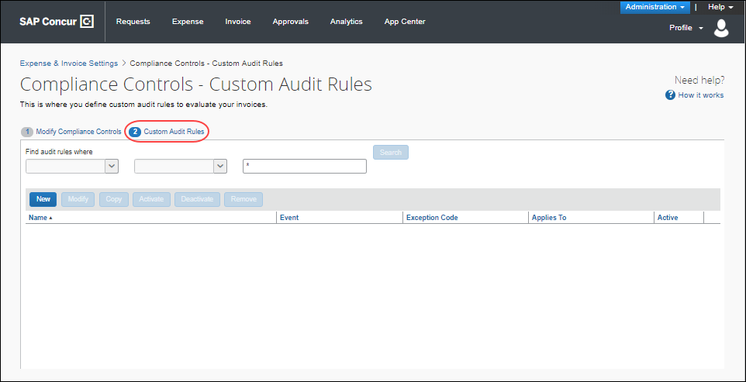
Only SAP Concur can enable the custom workflow functionality.

Custom Audit Rules
A custom audit rule is used to monitor information entered by users and is triggered by an event. For example, if an administrator creates a rule that specifies the use of certain preferred vendors and that the rule is triggered when the user saves an invoice or purchase request. Then, when the user saves an invoice or purchase request that lists a vendor other than the preferred vendor, the system generates an exception.
The client administrator uses custom audit rules to monitor the activity of users, for example, to monitor requests for a specified currency or for unapproved vendors.

General Concepts about Audit Rules
Custom audit rules are if/then statements; if the defined conditions are met, then an exception is generated.

Conditions ("if" portion of the "if/then" statement)
When you create or edit a custom audit rule, you define the conditional expression(s), the if portion of the rule. The expression can contain one or more conditions separated by and or or.
Example
Assume that you want to monitor all office supply purchases made from a vendor other than the company's preferred vendor, which is Staples. The condition (if statement) for "office supply purchases from a vendor other than Staples" is:
(Expense Type equals Office Supplies) and
(Vendor is not equal to Staples)
In the Conditions step, the fields are configured as follows:
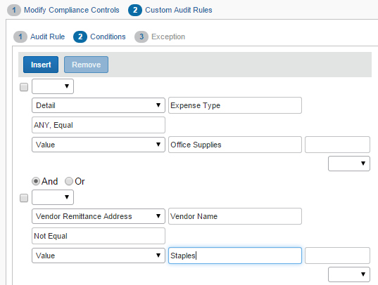
Example
Assume the administrator wants to ensure that invoices or purchase requests for office supplies of more than $2,000 include a comment for the approver. The condition for "include a comment for office supplies of more than $2,000" is:
(Expense Type equals Office Supplies) and
(Total is greater than 2,000.00 USD)
In the Conditions step, it displays as:
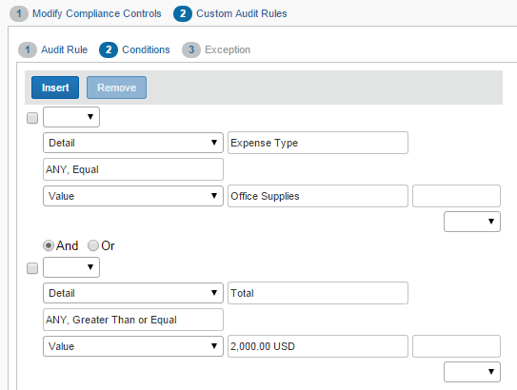
Example
Assume the administrator wants to monitor all invoices or purchase requests submitted by one employee. The condition for "review all invoices or purchase requests submitted by Chris Smith" (whose employee ID is 10799) is:
(Employee ID equals 10799)
In the Conditions step, it displays as:
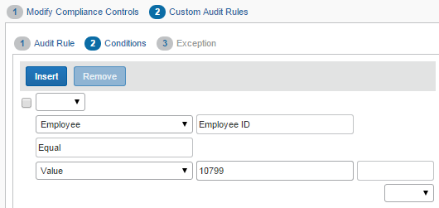
- For more information about conditional expressions and the tool used to create and edit conditional expressions, refer to the Understanding Conditional Expressions section of this guide.

Events (Triggers)
When you create or edit a custom audit rule, you specify the event that triggers the rule.
For invoices:
- Payment Request Allocation Save: This rule is triggered as each individual allocation "line item" is saved. (Though this type of rule is triggered when the allocation is saved, the exception icon and message appear within the request or on the processor list page.)
- Payment Post Request Submit: The rule is triggered immediately after a request enters the first step of workflow. Any exceptions generated will not prevent the request from being submitted.
- Payment Request Manual Assign: The rule is triggered immediately after a invoice is manually assigned to the Invoice Owner.
- Payment Request Save: The rule is triggered immediately after the request header information is saved whether by the employee, approver, or processor.
- Payment Request Submit: The rule is triggered when the request is submitted. If there are exceptions generated that are above the exception level limit (that is prevents request submission; described in Exceptions in this guide), then the request cannot be submitted and is prevented from entering the first step of a workflow.
- Payment Request Import Assign: The rule is triggered immediately after an invoice is assigned by import to the Invoice Owner.
- Payment Request Details Save: The rule is triggered when the details are saved, whether by the employee, approver, or processor. If a rule that is triggered at Payment Request Details Save contains a request field in its condition, then the rule is also triggered at Payment Request Save.
- Payment Request Details Submit: The rule is triggered when the details are submitted.
For purchase requests:
- Purchase Request Distribution Save: This rule is triggered as each individual distribution is saved. (Though this type of rule is triggered when the distribution is saved, the exception icon and message appear within the purchase request or on the processor list page.)
- Purchase Request Items Save: The rule is triggered immediately after the purchase request line item information is saved whether by the employee, approver, or processor.
- Purchase Request Save: The rule is triggered immediately after the purchase request header information is saved whether by the employee, approver, or processor.
- Purchase Request Submit: The rule is triggered when the purchase request is submitted. If there are exceptions generated that are above the exception level limit (that is prevents purchase request submission; described in Exceptions in this guide), then the purchase request cannot be submitted and is prevented from entering the first step of a workflow.

Exceptions ("then" portion of the "if/then" statement)
When you create or edit a custom audit rule, you assign an exception—the then portion of the if/then statement. All exceptions contain the following:
- Exception code: This is the SAP Concur- or client-defined code for the exception, up to eight alphanumeric characters, all uppercase.
- Exception level: There are two options to choose from, Warn or Block. The warning appears for the user if an audit rule is triggered. Blocking prevents the user from advancing to the next level.
- Exception text: This is the actual message that displays, such as "This is not the preferred vendor for this expense type. Please include a comment for your approver explaining why you used this vendor."

Visibility
When you create or edit a rule, you define who sees the exception text.
For invoices:
- Invoice User, Invoice Approver, and Invoice Processor: The exception text is visible to the user, approver, and processor
- Invoice Approver and Invoice Processor: The user does not see the exception text and, hence, does not know an exception was generated
- Invoice Processor: The user and approver do not see the exception text and, hence, do not know an exception was generated
For purchase requests:
- Purchase Requester, Approver, Purchase Request Processor: The exception text is visible to the user, approver, and processor
- Approver and Purchase Request Processor: The user does not see the exception text and, hence, does not know an exception was generated
- Purchase Request Processor: The user and approver do not see the exception text and, hence, do not know an exception was generated
The exception message appears along with:
- A red icon for exceptions that prevent submission of the invoice or purchase request
- A yellow icon for exceptions that do not prevent submission of the invoice or purchase request
- A blue icon if the Invoice processor or the purchasing admin, who processes purchase requests, has cleared the exception

The Basic Process of How to Create Custom Audit Rules
To summarize, when you complete the if portion of the custom audit rule, you:
- Name the rule
- Identify the event that triggers the rule
- Define the conditions by using the Conditions step
When you complete the then portion of the custom audit rule, you:
- Define who sees the exception text:
- Invoice User, Invoice Approver, and Invoice Processor/Purchase Request User, Approver, and Purchase Request Processor (Purchasing Admin)
- Invoice Approver and Invoice Processor/Approver and Purchase Request Processor (Purchasing Admin)
- Invoice Processor/Purchase Request Processor (Purchasing Admin)
- Select (or create) the appropriate exception, which includes:
- Exception code
- Exception level (warn or block)
- Exception text

Understanding Conditional Expressions
When you create or edit conditional expressions, you should consider the following:
There is no limit to the number of conditions that comprise a total expression. The condition for "office supply purchases from a vendor other than Staples" is:
It is comprised of two conditions, separated by the Boolean separator of and.
- Most conditions are comprised of a field then an operator then a value. For example:
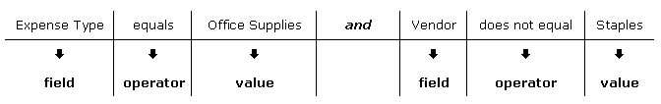
  - A field consists of a data object (essentially a database table), and a field in the data object (essentially a database column). The field selected defines the data type of the condition (number, text, date, and so on).
  - An operator is one of several pre-defined comparison operators (equals, not equals, is greater than, and so on). The list of operators changes depending on the type of data being compared.
  - A value is a constant, and like the field, can be of any data type. The data type of the value must match the data type of the field.
  - If a second field is used in the condition, its data type must match that of the first field.
- When a conditional expression is composed of multiple conditions, each condition is separated by either and or or.
- Parentheses are optional and are used to define the order of operation for and/or operators. If the parentheses are omitted, and/or operations are carried out left to right. There is no precedence of and over or—the evaluation of the expression is simply left to right.
- If a conditional expression contains parentheses, the count of left parentheses must match the count of right parentheses. There can be up to three parentheses for both left and right sides.
Example of correct placement of parentheses and total left/right count:
(Condition 1) and (Condition 2)
Examples of incorrect parentheses even though the total left/right count matches:
Condition1 ) And ( Condition2
Condition1 ) And ( Condition2 ) Or ( Condition3
( Condition1 )) And ( Condition2

The Conditions Step
The Conditions step in Custom Audit Rules has several parameters that you can configure, such as Data Object, Field/Value, and Operator.
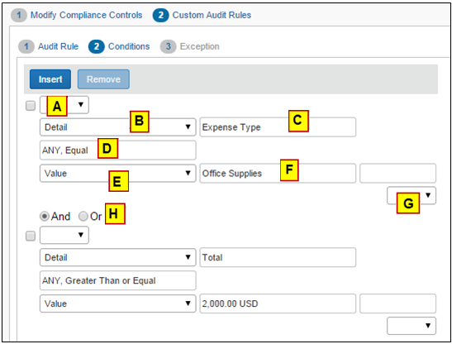
The table below describes the fields and lists in the Conditions step.
Field | Description
A: Left Parenthesis | Select zero to three parentheses, depending on the complexity of the condition.
B: Data Object | The choices that appear in this list are based on the event that triggers the rule.  For invoices:  - Budget: Budget consumption and control and alert limits  - Detail: Detail-level fields  - Detail Allocation: An allocation  - Employee: Employee-level fields  - Request: Request-level fields  - Request Exception: Request exceptions  - Vendor Remittance: Vendor remittance fields  - Vendor Ship From Address: Vendor ship from fields  For purchase requests:  - Budget: Budget consumption and control and alert limits  - Employee: Employee-level fields  - Purchase Request: Request-level fields  - Purchase Request Distribution: A distribution  - Purchase Request Exception: Request exceptions  - Purchase Request Item: Requests on the line item level  - Vendor Remittance Address: Vendor remittance address
C: Field/Value | Select an item from the helper pane that appears. The information that appears in this pane is based upon the selection the administrator made in the Data Object list.  See the table below.
D: Operator | Select an item from the helper pane that appears. The information that appears in this pane is based upon your previous choices.  NOTE: If you use the In or Not In operators for expense types, you can select multiple check boxes to include as many expense types as are required.
E: Data Object | The system provides the option that best suits the previous choices. Change it if necessary.
F: Field/Value | Select an item from the helper pane that appears. The information that appears in this pane is based upon the selection the administrator made in the Data Object list.  See the table below.
G: Right Parenthesis | Select zero to three parentheses, depending on the complexity of the condition.
H: And/Or | Select either option to join the current condition to the next condition.
The table below describes the data objects and associated choices in the Conditions step for invoices.
Selection from the Data Object list | Choices Displayed for Field/Value
Budget | - Actual Spent Consumption Percent  - Alert Limit  - Committed Pending Consumption Percent  - Committed Spent Consumption Percent  - Control Limit  - HasBudget  - Pending Consumption Percent  - Spent Consumption Percent  - Total Consumption Percent
Detail | - Allocation State  - Approved Amount  - Custom 01 – 20  - Description  - Expense Type  - Has Exceptions  - Item Code  - Quantity  - Request Line Item Key  - Supplier Part ID  - Tax  - Total  - Unit Price
Detail Allocation | - Account Code  - Allocation Key  - Custom 01 - 20  - Percentage  - Request Line Item Key
Employee | - Active  - Country of residence  - Custom 22  - Email Address  - Employee First Name  - Employee ID  - Employee Last Name  - Ledger  - Locale  - Logon ID  - Middle Initial  - Number of Requests Pending for Employee  - Password Changed Date  - Reimbursement Currency  - State/Province  - Sum of Totals for Requests Pending for Employee  NOTE: Employee data changes over time and may change between the time when an entry is created and when an entry is edited. Given that, consider not creating conditions against employee fields. Instead, it is strongly recommended that you use the copydown functionality to copy the employee data to the request or detail level and then write the condition against the copieddown field to ensure consistent data.
Request | - Accounting Extract Date  - Action Due Date  - Amount Remaining  - Approval Status  - Approved Amount  - Approved By Delegate  - Assigned by Another User  - Certificate Number  - Check Number  - Country  - Create Date  - Created By  - Currency  - Custom 01 – 24  - Description  - First Approval Date  - First Submit Date  - Group  - Has CFD Attachment  - Has Cleared Exceptions  - Has Comments  - Has Exceptions  - Has Processor Tracked Change  - Has Tracked Change  - Has Unapproved Vendor Address  - Invoice Amount  - Invoice Date  - Invoice Image Available  - Invoice Received
Request  (Cont'd) | - Invoice Received Date  - Is Assigned  - Is Duplicate  - Is Emergency Check Run  - Is Exception Approved  - Is Fully Allocated?  - Is Limit Approved  - Last Assigned Date  - Latest Submit Date  - Ledger  - Net Payment Terms  - Notes to Approvers  - Notes to Vendor  - Number of Line Items  - Origin Source  - Paid Date  - Payment Amount  - Payment Due Date  - Payment Method Type  - Payment Status  - Payment Status Date  - Pending Processor Since  - Policy Name  - Processing Complete Date  - Receipt Confirmation Type  - Request ID  - Request Key  - Request Name  - Request Total  - Shipping  - Submitted By Delegate  - Tax  - Transaction ID  - Vendor Invoice Number  - Workflow Was Modified?
Request Exception | - Exception Code  - Exception Level
Vendor Remittance Address | - Account Number  - Address 1-3  - Address Accounting Code  - City  - Contact Email  - Contact First Name  - Contact Last Name  - Country  - Currency  - Image Avail  - Image Received  - Is Approved  - Net Payment Terms  - Postal Code  - State or Province  - Tax ID  - Telephone Number  - Vendor Code  - Vendor Name
Vendor Ship From Address | - Address 1 - 3  - Address Accounting Code  - City  - Contact Email  - Contact First Name  - Contact Last Name  - Country  - Currency  - Image Avail  - Image Received  - Is Approved  - Net Payment Terms  - Postal Code  - State or Province  - Telephone Number
The table below describes the data objects and associated choices in the Conditions step for purchase requests.
Selection from the Data Object list | Choices Displayed for Field/Value
Employee | - Active  - Cost Center  - Country of residence  - Custom 22  - Email Address  - Employee First Name  - Employee ID  - Employee Last Name  - Is a Test User?  - Ledger  - Locale  - Logon ID  - Middle Initial  - Number of Requests Pending for Employee  - Password Changed Date  - Reimbursement Currency  - State/Province  - Sum of Totals for Requests Pending for Employee  NOTE: Employee data changes over time and may change between the time when an entry is created and when an entry is edited. Given that, consider not creating conditions against employee fields. Instead, it is strongly recommended that you use the copy down functionality to copy the employee data to the purchase request or detail level and then write the condition against the copied down field to ensure consistent data.
Purchase Request | - Amount without VAT  - Approval Status  - Cost Center  - Currency  - Custom 01 – 24  - Description  - First Submit Date  - Group  - Has Unapproved Vendor Address  - Image Available  - Is Exception Approved  - Is Limit Approved  - Notes To Supplier  - Policy Name  - Provincial Tax Identification Number  - Shipping  - Submit Date  - Tax  - Total  - VAT Amount One  - VAT Amount Two  - VAT Rate One  - VAT Rate Two  - Vendor Tax Identification Number
Purchase Request Distribution | - Account Code  - Custom 1-22  - Percentage
Request Exception | - Exception Code  - Exception Level
Purchase Request Item | - Amount without VAT  - Currency  - Custom 1-20  - Description  - Discount Percentage  - Discount Terms  - Expense Type  - Item Number  - Needed By  - Net Payment Terms  - Purchase Type  - Quantity  - Shipping  - Shipping Method  - Shipping Terms  - Tax  - Total  - Unit of Measure  - Unit Price  - VAT Amount  - VAT Rate
Vendor Remittance Address | - Account Number  - Address 1 - 3  - Address Accounting Code  - City  - Contact Email  - Contact First Name  - Contact Last Name  - Country  - Currency  - Custom 1-20  - Discount Percentage  - Discount Terms  - Image Avail  - Image Received  - Is Approved  - Net Payment Terms  - PO Contact Email  - PO Contact First Name  - PO Contact Last Name  - PO Contact Phone Number  - Postal Code  - Provincial Tax Identification Number  - Shipping Method  - Shipping Terms  - State or Province  - Tax ID  - Tax Type  - Telephone Number  - Vendor Code  - Vendor Name

Configuration/Activation
The following steps describe how to enable and configure custom audit rules for invoices and purchase requests.

Step 1: Enable Custom Audit Rules
The SAP Concur admin enables custom audit rules in an SAP Concur internal-only tool. Once SAP Concur has enabled the feature, the Custom Audit Rules tab appears on the Compliance Controls page of Product Settings for both invoices and purchase requests.

Step 2: Access Custom Audit Rules
To access custom audit rules:
- Click Administration > Invoice Settings or Expense & Invoice Settings.
- In the Product list, click Invoice.
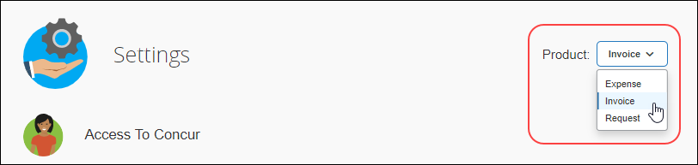
- Do one of the following:
- For invoices, on the Invoice Compliance tile, click Edit.
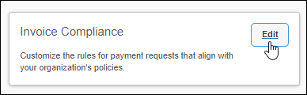
- For purchase requests, on the Purchase Request Compliance tile, click Edit.
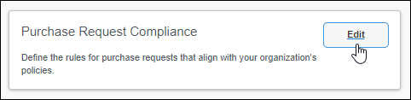
The Modify Compliance Controls page appears.
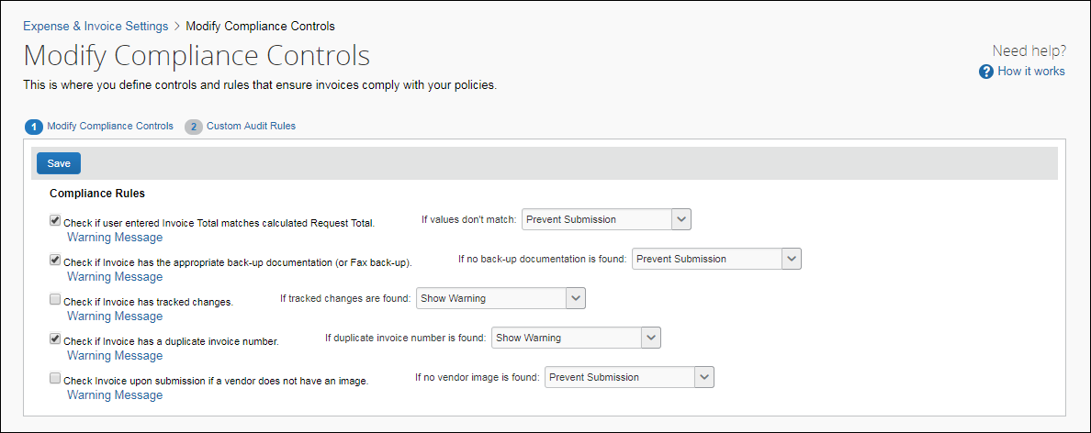
- Click Custom Audit Rules. The Compliance Controls – Custom Audit Rules page appears.
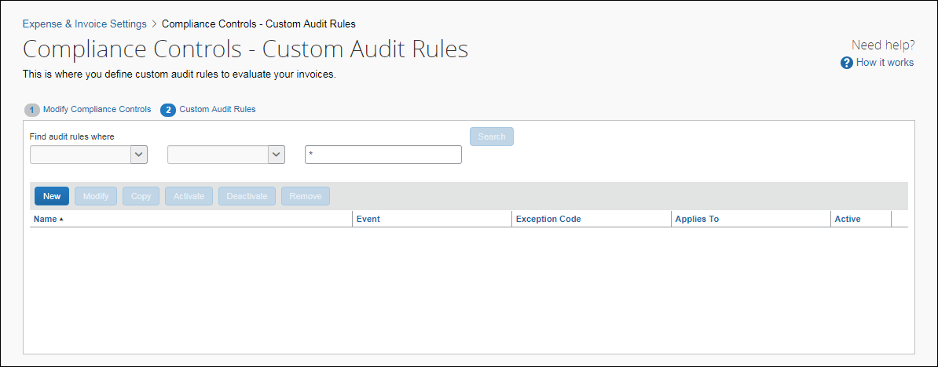

Step 3: Add a Custom Audit Rule
The following procedures describe how to create custom audit rules.
To add a custom audit rule:
- In the Custom Audit Rules step of the Compliance Controls page, click New. The Audit Rule step appears.
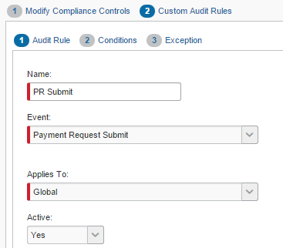
- Complete the appropriate fields.
Field | Description
Name | Type a unique name.
Event | Select the event that triggers the rule.  For invoices:  - Payment Post Request Submit  - Payment Request Allocation Save  - Payment Request Details Save  - Payment Request Details Submit  - Payment Request Import Assign  - Payment Request Manual Assign  - Payment Request Save  - Payment Request Submit  For purchase requests:  - Purchase Request Distribution Save  - Purchase Request Items Save  - Purchase Request Save  - Purchase Request Submit  - For a definition of each of the events, refer to the Events (Triggers) section in this guide.
Applies To | Select the appropriate group(s). The groups that you see here are the groups that you added in the Policy Groups step.
Active | Select Yes to activate the rule upon completion.
- Click Next. The Conditions step appears.
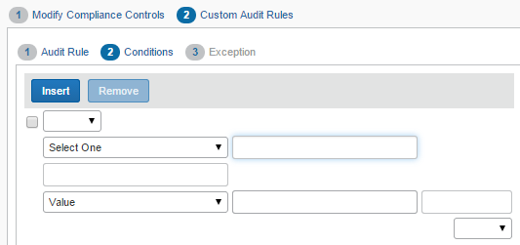
- Complete the appropriate fields, making selections from the helper pane.
- For a description of this page, refer to the Understanding Conditional Expressions section in this guide.
- Complete all conditions by using these same steps, using Insert to add conditions and selecting the check box for condition, and then clicking Remove to delete conditions.
- If you simply click Insert, the new condition is added at the bottom.
- To insert the new condition between existing conditions, select the condition that will be below the new condition.
Concur Invoice image:
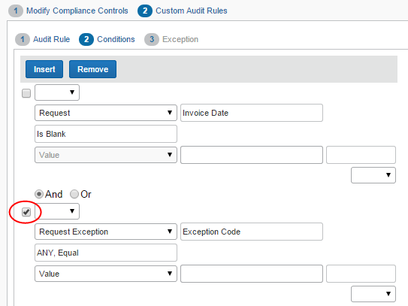
Click Insert. A new blank row appears.
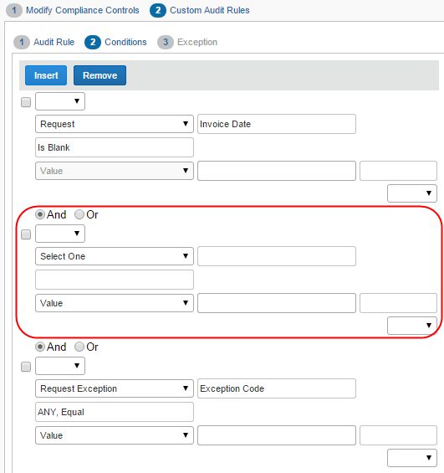
- When you have added all conditions, click Next. The Exception step appears.
For invoices:
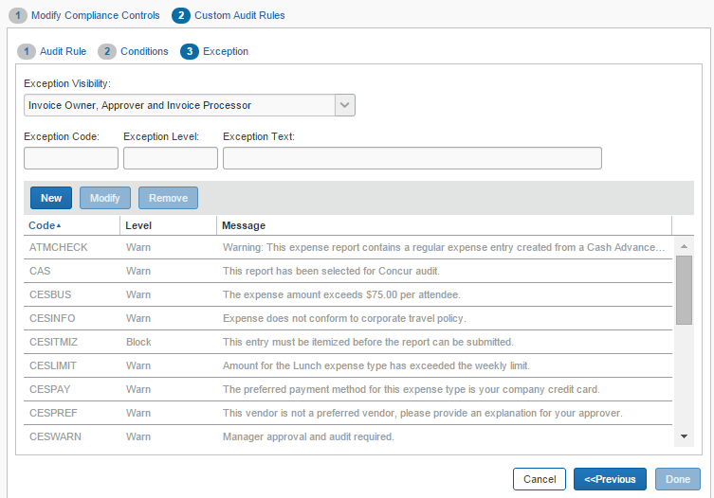
For purchase requests:
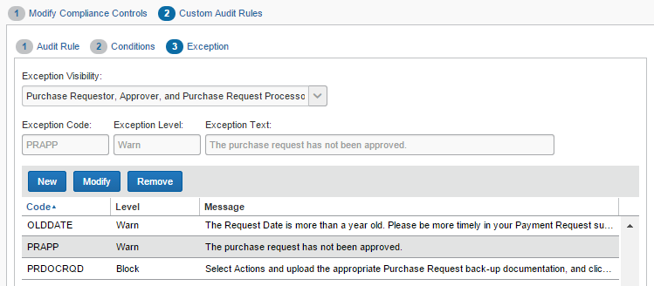
- From the Exception Visibility list, select the users who are able to see the exception message.
For invoices:
- Invoice Owner, Approver, and Invoice Processor
- Approver and Invoice Processor
- Invoice Processor
For purchase requests:
- Purchase Requester, Approver, and Purchase Request Processor
- Approver and Purchase Request Processor
- Purchase Request Processor
- For the exception, you can:
- Use an existing exception.
To use an existing exception, click the desired exception. It appears in the Exception Code, Exception Level, and Exception Text fields at the top of the page.
- Create a new exception.
Click New. The New Exception window appears.
For invoices:
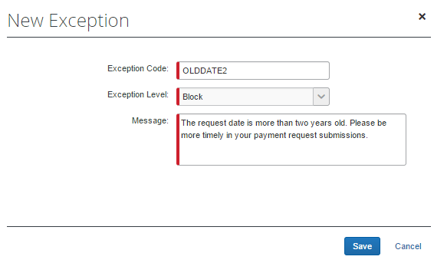
For purchase requests:
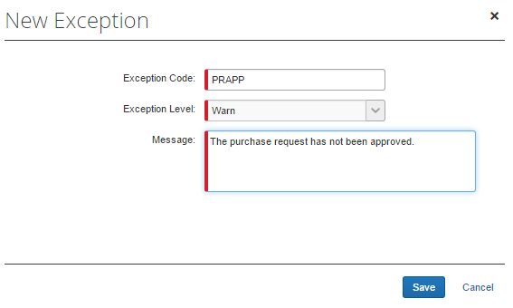
Complete the three fields and then click Save.
- For audit rule notifications for Budget, refer to the Budget Audit Rules section in this document.
- Click Done.

Manage Custom Audit Rules

Copy a Custom Audit Rule
Instead of creating all rules, you can save time by copying a custom audit rule and then editing the copy. For example, assume you want three rules for preferred vendors for three different expense types. You can create the first one (for example, by using the expense type of Office Supplies and the vendor name of Staples) and then copy it. Edit the copy by changing the expense type and vendor name. Repeat the same process for the third rule.
- For detailed information about the fields on this page, refer to the Adding a Custom Audit Rule section in this guide.
To copy a custom audit rule:
- On the Custom Audit Rules page, select the rule you want to copy.
- Click Copy. The Audit Rule step appears.
- Make any desired changes.
- Click Next. The Conditions step appears.
- Edit the condition(s) as required.
- Click Next. The Exception step appears.
- Make the desired changes.
- Click Done.

Modify a Custom Audit Rule
To modify a custom audit rule:
- On the Custom Audit Rules page, select the rule you want to edit
- Click Modify. The Audit Rule step appears.
- Make any desired changes.
- Click Next. The Conditions step appears.
- Edit the condition(s) as required.
- Click Next. The Exception step appears.
- Make the desired changes.
- Click Done.

Deactivate/Activate a Custom Audit Rule
Activate a rule when you are ready to use it.
Instead of deleting a rule, you can deactivate it. This way, the rule is still available if you want to use it in the future.
To deactivate/activate a custom audit rule:
- On the Custom Audit Rules page, select the rule you want to deactivate/activate.
- Click Deactivate or Activate.

Remove a Custom Audit Rule
To remove a custom audit rule:
- On the Custom Audit Rule page, select the audit rule that you would like to remove.
- Click Remove.

Additional Samples of Custom Audits
Here are some other examples of custom audits.

Is Duplicate (for Invoices)
Use the Is Duplicate check option to create audit rules that allow the system to alert you when two or more invoices may be identical. The check performs three tasks:
- Is the vendor the same for the invoices (Invoice checks this by comparing the parent vendor record.)
- Are the invoice numbers identical for the invoices
- Are the invoice statuses (Canceled, Deleted, or Voided) identical for the invoices
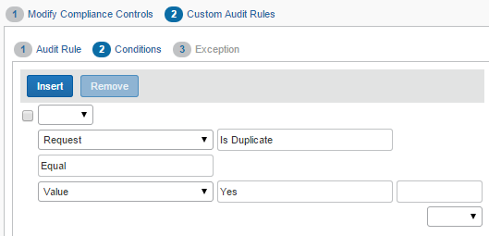
If the result of these checks is True, an exception is generated and appears in both the payment header and on the Requests Ready For Processing page.

Account Code Rule for a Specific Invoice and Purchase Request
Administrators may create audit rules for purchase request line items based on account code, so that they can use the same audit rules for the purchase request and invoice. The account code for a purchase request is applicable for the item, but displayed and available at the distribution level. As the account code is derived from the expense type selected for an item, the same account code will be applied across all distributions for that item.
To configure the Account Code audit rule for purchase requests:
- Click Administration > Invoice Settings or Expense & Invoice Settings.
- In the Product list, click Invoice.
- On the Purchase Request Compliance tile, click Edit.
The Modify Compliance Controls page appears.
- On the Modify Compliance Controls page, click Custom Audit Rules.
- On the second step of the three-step wizard, select Purchase Request Distribution, and then Account Code.
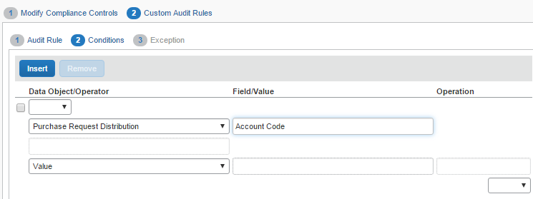
- Complete the audit rule steps, and then click Done.

Quotes Required for Purchases (for Purchase Requests)
In situations where your company requires a quote for a purchase, it might be useful to apply an audit rule to warn the user. To do so, the admin can use a custom field to create an audit rule that allows the system to alert the purchase requestor when no quote has been attached to a purchase request.
The procedure below shows how to set up an audit rule so that a purchase requester receives a warning if they have not provided a quote for the purchase.
To create an audit rule that requires a quote for a purchase:
- In Product Settings, on the Purchase Request Compliance tile, click Edit.
- On the Modify Compliance Controls page, click the Custom Audit Rules.
- On the Compliance Controls – Custom Audit Rules page, click New.
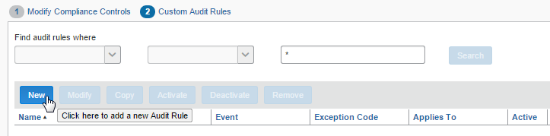
- In the Audit Rule step, type in the required information, and then click Next.
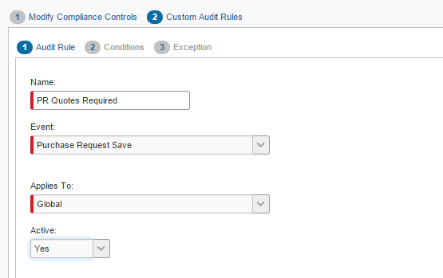
- In the Conditions step, type in the rule, and then click Next.
To use custom fields, you must have configured these on the Custom Fields page of Product Settings.
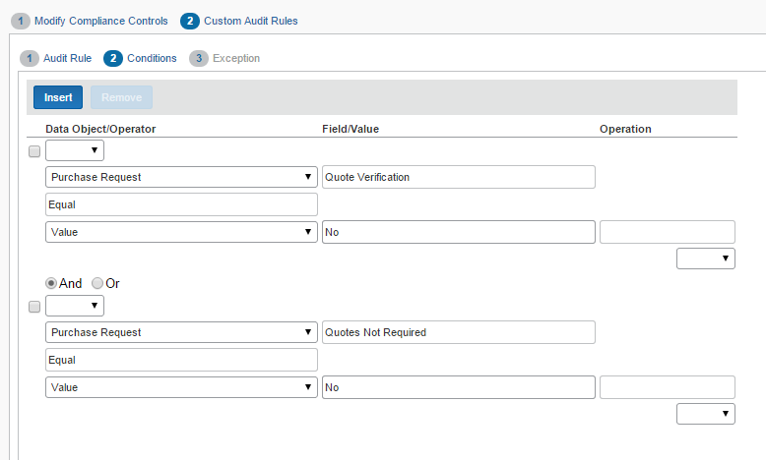
- In the Exception step, select to whom this exception will be visible by choosing an option in the Exception Visibility list.
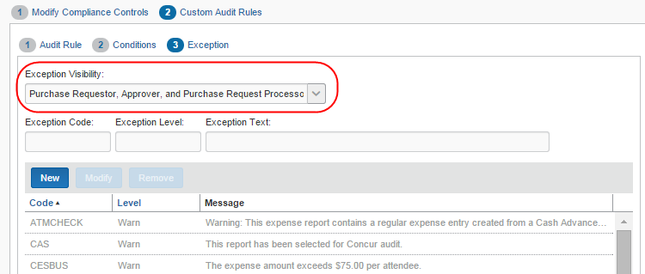
- Click New to create the exception.
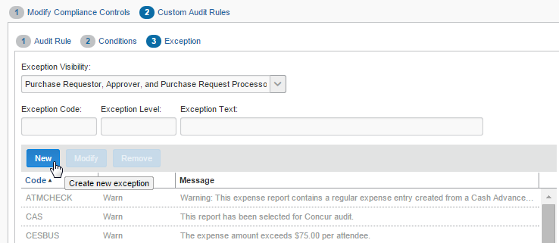
- In the New Exception window, type in the exception details and message that the user will see and then click Save.
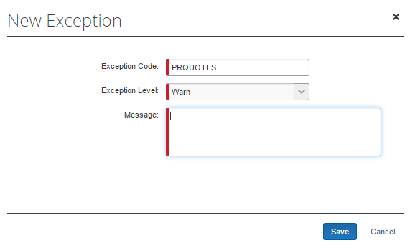
The exception appears in the the audit rule list.
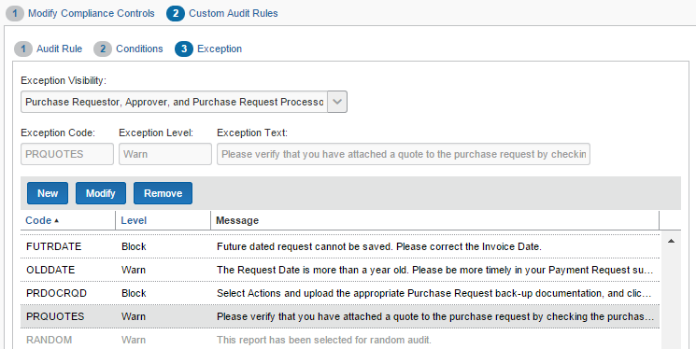
- Click Done. If the result of this check is true, the system generates an exception which appears in both the Purchase Request Header form and on the Requests Pending Processor Review page.

Budget Audit Rules
Budget audit rules help companies control budget spend during a budget year. For example, to ensure that a budget is not spent too early in the year when there might be important spending coming up later in that year.
Budget has its own Payment Request Budget Submit event.
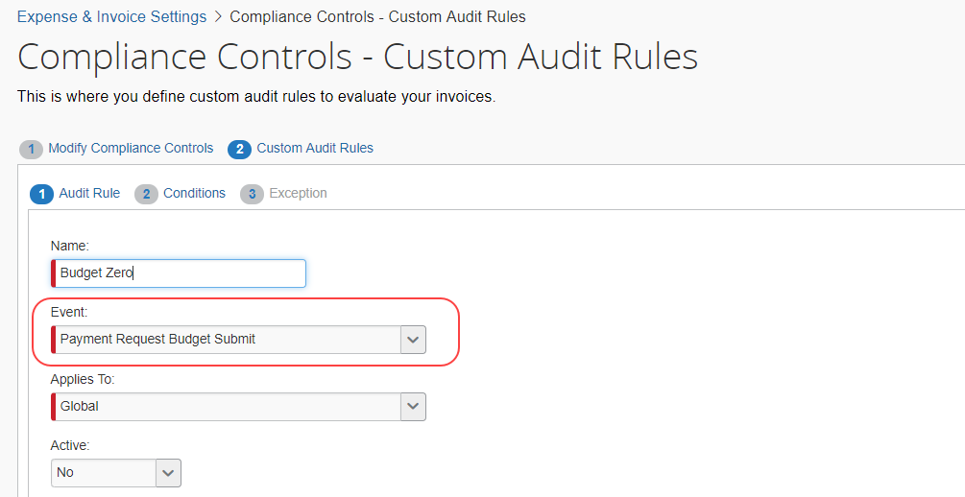
This following image shows the available audit rules in the Conditions step in Custom Audit Rules.
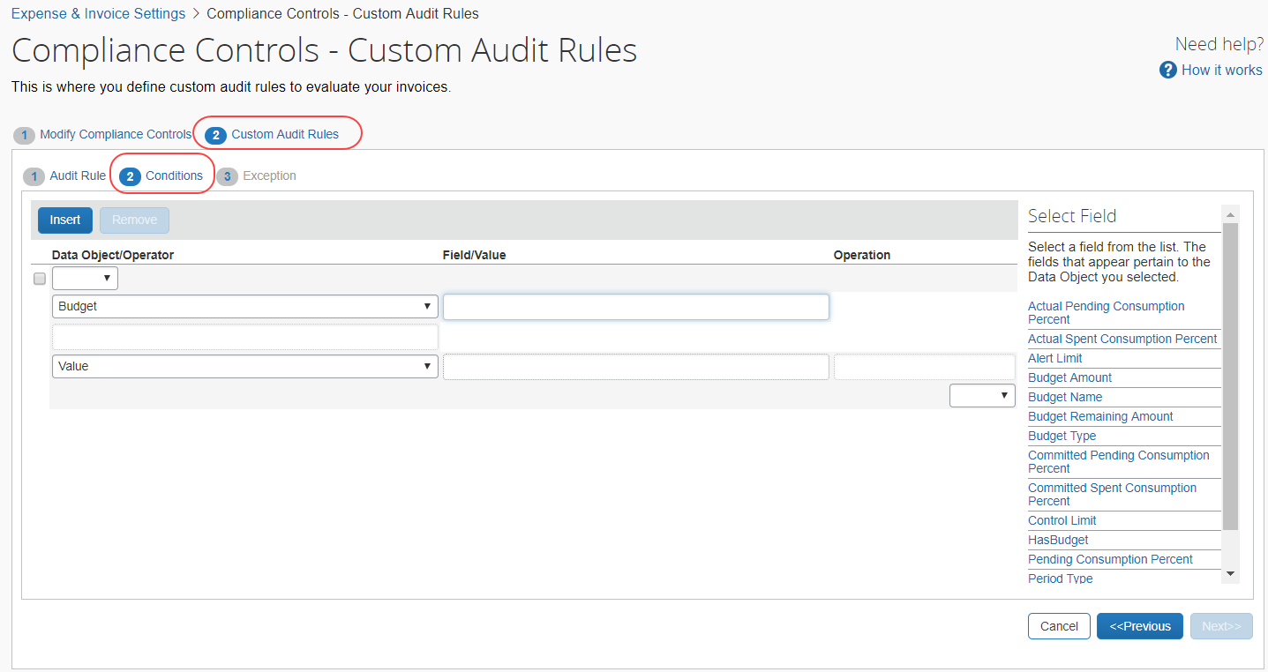
The following table lists the budget audit rules and when they are used.
Budget Audit Rule | Description
Actual Pending Consumption Percent | Use this audit rule to check how a certain percentage compares to the total of pending expense reports and invoices of a budget.  NOTE: This rule applies to submitted unapproved expense reports and invoices, and not to purchase requests.
Actual Spent Consumption Percent | Use this audit rule to check how a certain percentage compares to the total of spent expense reports and invoices of a budget.  NOTE: This rule applies to approved expense reports and invoices, and not to purchase requests.
Alert Limit | This audit rule is based on the Alert Limit Percent setting defined on the Budget Settings tab in Budget Configuration and is intended for notifications and exceptions.
Budget Amount | Use this audit rule to check budgets by budget amount. Admins can use this option to ensure the audit rule does not run against budgets with a zero amount.  Example  Budget amount is not equal to 0 and total consumption percentage >110%.  This audit rule will ignore spend landing in zero-amount budgets, but still catch budgets with consumed percentage over 110%.
Budget Name | Use this audit rule to check budgets by budget name. This field is a case-sensitive free text field.
Budget Remaining Amount | Use this audit rule to check budgets by the amount that remains. The amount remaining is by default the budget amount minus the spent amount. If the admin has selected (enabled) the Include Pending Amount in Remaining Amount calculation option in Budget Setting, the amount remaining will be Budget Amount - (Spent Amount + Pending Amount).
Budget Type | Use this audit rule to check a certain type of budget. You can select one of the following:  - Budget Account  - Restricted Account  - Personal Account  - For more information about budget types, refer to the Shared: Budget Setup Guide for Standard Edition.
Committed Pending Consumption Percent | Use this audit rule to check if a certain percentage of the budget amount is committed and pending. This rule applies to submitted but unapproved purchase requests only.
Committed Spent Consumption Percent | Use this audit rule to check if a certain percentage of the budget amount is committed and spent.  This rule only applies to approved purchase requests.
Control Limit | This audit rule is based on the Control Limit Percent setting defined on the Budget Settings tab in Budget Configuration and is intended for notifications and exceptions.
HasBudget | Use this audit rule to check if the invoice or expense report is part of a budget for the fiscal year in question.
Pending Consumption Percent | Use this audit rule to check how a certain percentage compares to the total of pending expense reports, invoices, and purchase requests of a budget.  This applies to submitted but unapproved invoices, expense reports, and purchase requests.
Period Type | Use this audit rule field to check budgets per month, quarter, year, or date range.
Spent Consumption Percent | Use this audit rule to check how a certain percentage compares to the total of spent expense reports, invoices, and purchase requests of a budget.  This applies to approved invoices, expense reports, and purchase requests.
Total Consumption Percent | Use this audit rule to check the total consumption percentage of a budget.  This rule applies to invoices, expense reports, and purchase requests for submitted but unapproved spending.

Budget Parameters for Audit Rule Notifications
For clients to see which budget is matched with a spending item when an audit rule is triggered, SAP Concur now provides additional notifications to which clients can insert parameters for budgets. Clients can then receive messages on top of their screen notifying them that a budget with a certain description and owner is, for example, over the budget threshold.
The table below lists the available budget parameters.
Term | Description
%BudgetName% | The budget name of the first budget in response to the triggered audit rule.
%BudgetOwner% | The budget owner of the first matched budget item.
%Top3Budgets% | Shows budget names and budget owners of the first three budget items.
%BudgetCount% | Shows number of matched budget items.
%BudgetDescription% | The budget display name users see in the Budget Dashboard.
You can use these parameters in the Message field of the New Exception window on the Exception page in Audit Rules.
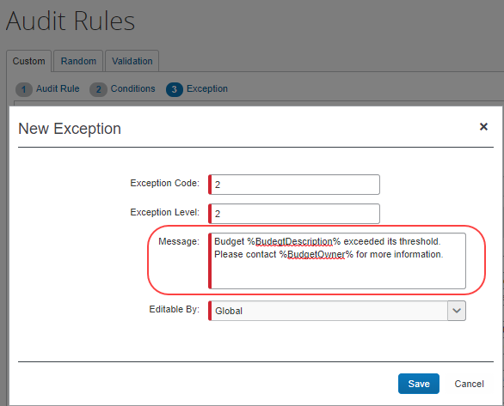

Vendor Tax ID
For invoice entries where the country is specified as Japan or a city within Japan, an audit rule can be created to validate the value of the Vendor Tax ID with the Japan National Tax Agency (NTA). You can create a rule to determine whether the Vendor Tax ID is valid, invalid, or whether the Vendor Tax ID could not be verified with the Japan NTA (unverified). The system will then allow the invoice to be saved, will show an exception as invalid and prevent saving the invoice, or generate a system exception requiring a resave of the entry respectively.
At this time, the validation of the Vendor Tax ID will only be performed for invoice entries where the country is set to Japan or a city within Japan – a future release will create support for other countries.
The audit rule checks for both invoice header and vendor information to read Vendor Tax ID value. So, the below conditions are valid:
- If the TaxID is in both the vendor information and the invoice header, then the audit rule checks TaxID in the invoice header. (It doesn’t check vendor information.)
- If the TaxID is only in vendor information, then the audit rule checks TaxID in vendor information.
- If the TaxID is only in invoice header, then the audit rule checks the TaxID in invoice header.

Initial Setup of the Invoice Entry Form
To use the Vendor Tax ID audit rule feature, the invoice entry form must include the following:
- The Vendor Tax ID form field
- AND-
- The country for the expense (that is, Japan)
The invoice entry form must have the Country/Region field or the City (Location) field so that the user can enter the country value, required for validation.

Rule Setup
An audit rule is configured to test the Vendor Tax ID value in the entry in three ways:
- Is Valid – The Vendor Tax ID is registered with the Japan government.
- Is Not Valid – The Vendor Tax ID is not registered with the Japan government.
- Not Verified – The Vendor Tax ID verification is not completed due to a temporary system issue. Users may need to re-run the audit rule if they want to verify the values.
The following image shows the configuration of the conditions for an audit rule to determine if the Vendor Tax ID is not valid.
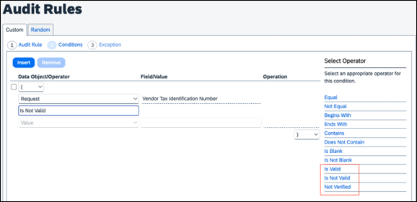
Per this rule, if the Vendor Tax ID is not valid, then an exception will be raised. The exception can be specified on the Exception pane. Depending on the level of the exception specified, the user may be blocked from submitting the invoice. The user can change the Vendor Tax ID and save the invoice again – this will execute the audit rule again, and validation of the revised Vendor Tax ID will again be performed with the Japan NTA.
If the Japan NTA API is unavailable, then a system exception will be attached to the invoice entry. In this case, the user will be directed to open and save the invoice to retry the validation.
In the event the internal service is unavailable or returns an error, the invoice returns as "Not Verified". A message may display if the client has configured it for the audit rule. SAP Concur recommends clients use the following message, "The Vendor Tax ID could not be validated against an external service. Please try again after some time to retry validation. If the error persists, please contact SAP Concur support or your Concur Administrator".

Disclaimer
This function is based on information fetched from Invoice-kohyo system Web API by Japan National Tax Agency (NTA-API). Japan NTA does not give any guarantee to the results of this function. Since NTA-API is provided by Japan NTA, SAP Concur cannot assure its service time. Users must know that system errors of NTA-API affect the function results.

☼

