
Concur Expense:
Taxation
Setup Guide for Standard Edition
Last Revised: July 15, 2022
Applies to these SAP Concur solutions:
 Expense
Professional/Premium edition
 Standard edition
 Travel
 Professional/Premium edition
 Standard edition
 Invoice
 Professional/Premium edition
 Standard edition
 Request
 Professional/Premium edition
 Standard edition

Table of Contents
Section 1: Overview 1
Fringe Benefits Tax 2
Section 2: Configuration 3
Configure Taxation 3
Access the Taxation – VAT Tracking Page 3
View VAT Configuration 4
Activate or Deactivate VAT Tracking 5
Modify VAT Configuration (After Activation) 5
Map VAT Tax Codes (For QBO, Sage Intacct, and Xero Accounting Clients Only) 8
Configure Fringe Benefits 10
Access the Fringe Benefits tab 10
Modify Fringe Benefits 12
Add Fringe Benefits 13
Remove Fringe Benefits 13
Section 3: Tax Related Features 13
VAT Basics 13
VAT Reclaim Calculation 15
VAT Fields in File Export Configuration 15
Standard Tax Groups 15
Special Cases 16
Single-Level VAT Country Calculation 17
Output File and Tax Information 17
Troubleshooting 18
Country-Specific Information 18
Canada 18
Travel Diary 34
Australia 34
Section 4: UK VAT Reclamation for Mileage Expenses 35
Fuel Expenses 35
Mileage Expenses 35
Valid Fuel Receipts 36
User Experience 36
Using Quick Expenses 37
User Experience on the Individual Expense 38
Additional Information 39

Revision History
Date | Notes/Comments/Changes
September 17, 2022 | Removed Section 2: Two User Interfaces for Concur Expense End Users.  Minor edits.
July 14, 2022 | Updated references to Sage to Sage Intacct.
April 21, 2022 | Removed content about Recaptured Input Tax Credit (RITC).
April 15, 2022 | Added information about the existing UI and NextGen UI; made modifications throughout; cover revision date updated
December 16, 2021 | Updated instructions for Product Settings page
January 21, 2021 | Updated the copyright; added Concur to the cover page title; cover date not updated
September 10, 2020 | Fixed a typo.
September 9, 2020 | Added references to Sage Intacct and Xero accounting to the procedure on page 8.
April 16, 2020 | Renamed the Authorization Request check box to Request on the guide’s title page; cover date not updated
January 3, 2020 | Updated the copyright; no other changes; cover date not updated
August 10, 2019 | Minor edits.
June 8, 2019 | Updated text and images throughout to reflect UI name change from "Cost Tracking" to "Custom Fields".
January 10, 2019 | Updated the copyright; no other changes; cover date not updated
April 6, 2018 | Changed the check boxes on the front cover; no other changes; cover date not updated
March 17, 2018 | Added UK VAT Reclamation for Mileage Expenses section. This information is clarification of the existing feature. The functionality has not changed.
November 4 2017 | Updated guide to include new Product Settings page, which replaces the Setup Wizard.
April 25 2017 | Added information about mapping VAT tax codes for QuickBooks Online clients.
March 18 2017 | Updated with menu option name change to access Setup Wizard.
January 10 2017 | Added a note to the section View VAT Configuration to clarify that a single expense can be influenced by a maximum of two tax authorities.
December 15 2016 | Changed copyright; no other content changes.
October 18 2016 | Updated Taxation – VAT Tracking graphics for Canada to show the new HST tax rates for Prince Edward Island.
July 8 2016 | Updated Taxation – VAT Tracking graphics for Canada to show the new HST tax rates for New Brunswick and Newfoundland and Labrador.
June 17 2016 | Updated Taxation – VAT Tracking graphic for the United Kingdom to reflect changes to the information displayed in the Tax Rate column.
March 18 2016 | Updated existing graphics to show new Canada XF Standard rate type.
December 2015 | Updated the Canadian section for activated tax groups to reflect the splitting of HST – NB NL into two new groups: NB and NL.
November 20 2015 | Updated graphics to reflect updated step names and instructional text where applicable.
March 13 2015 | Added details to the VAT Basics and Canada-specific sections
February 6 2015 | Updated the screen shots to the enhanced UI  Removed information about two user interfaces; no other content changes
September 16 2014 | Added information about two user interfaces; no other content changes
July 11 2014 | Removed the step for selecting and modifying the Effective Date for a tax group. This functionality is not available in Expense for Concur Standard Edition.
May 16 2014 | New document. (This content originated from the Expense Setup Guide for Concur Standard.)

NOTE: Multiple SAP Concur product versions and UI themes are available, so this content might contain images or procedures that do not precisely match your implementation. For example, when SAP Fiori UI themes are implemented, home page navigation is consolidated under the SAP Concur Home menu.

Taxation
This page of Product Settings is visible only when enabled by SAP.

Overview
The Taxation page of Product Settings allows you to activate (or deactivate) Value-Added Tax (VAT) and select which expense types to place in the standard tax groups in SAP Concur. Once activated, you can view the VAT configuration available for a selected country and modify the expense types. After which SAP Concur collects line item information about the tax and reclaim amounts. Fringe Benefits Tax configuration is also accomplished in this portion of Product Settings for those countries that require it. Taxation information is included in the transaction file from SAP Concur that can be used in your financial systems.
This page only appears if your company is implemented in a VAT collecting country.
In this product, the term "VAT" is used though most countries use terms other than VAT. For example, the French term is Taxe sur la Valeur Ajoutée (TVA), the German term is Mehrwertsteuer (MwST), and the Italian term is Imposta sul Valore Aggiunto (IVA), and so on. SAP Concur provides a standard VAT tracking configuration for the appropriate tax authorities for your country.
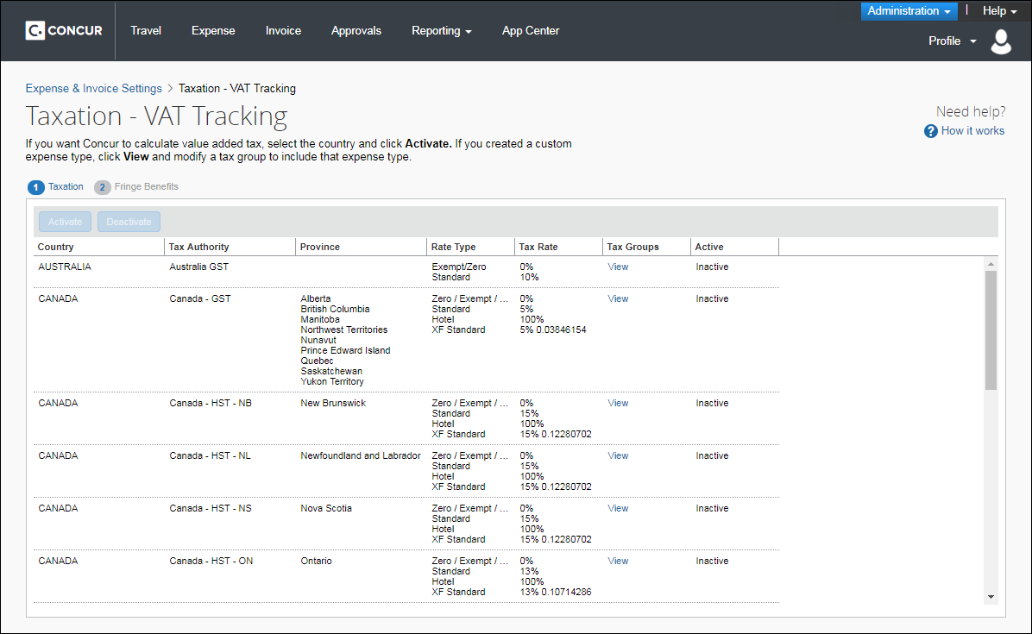

Example
Your country uses VAT and you need to track your employee's VAT amounts. Select the tax authority and click View to see the tax configuration information. The default expense types are organized into the available tax groups. Take a close look at these, as your company’s definition of the expense type might lead to different needs, and check with your tax advisor to ensure that your tax needs match with the tax groups. Once you have completed this review, select the tax authority and click Activate.
Once you have activated the tax authority you can click View under Tax Groups to move expense types from one tax group to another, and to add your custom expense types to the right tax group.

Fringe Benefits Tax
Countries that collect fringe benefits tax, such as Australia, also see the Fringe Benefits tab in Taxation. This page allows you to configure the fringe benefits for every expense type/attendee type combination. SAP Concur provides a best practice configuration that the administrator can modify to fit your business needs. The Fringe Benefits step becomes available after you have activated a VAT configuration.
The Fringe Benefits Tax (FBT) feature in SAP Concur Expense extracts the taxable portion of the expense from expense reports to the company's accounting system. The feature does not calculate the tax; rather it provides the necessary information to the accounting system so that the tax can be appropriately tracked and processed with all other FBT-taxable expenses.
FBT is calculated after the processor approves the report. At that time, the FBT configuration is applied to the report to split applicable expenses into the different amounts by attendee type as required.
Currently, Australia and New Zealand require that companies pay FBT on certain kinds of expenses that employees claim. For example, when an employee takes a business guest to lunch and expenses the meal, the meal becomes a fringe benefit to the employee and may be taxed.
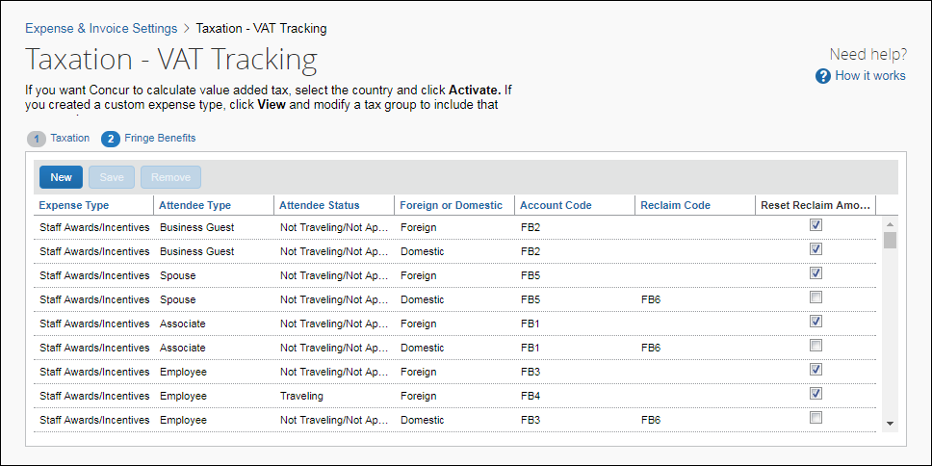

Configuration

Configure Taxation

Access the Taxation – VAT Tracking Page
To access the Taxation – VAT Tracking page:
- Click Administration > Expense Settings or Expense & Invoice Settings.
- In the Product list, click Expense.
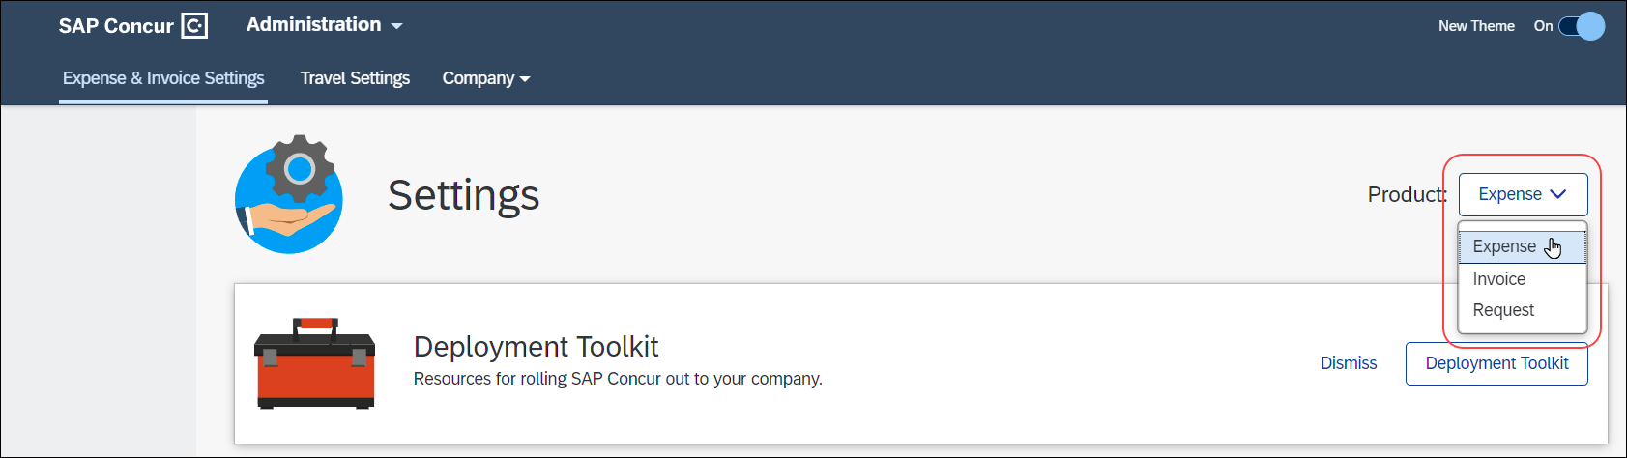
- In the Capture Spending section, on the VAT tab, click Edit.
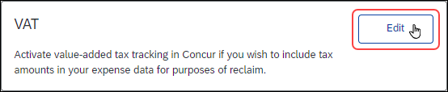
The Taxation – VAT Tracking page appears.
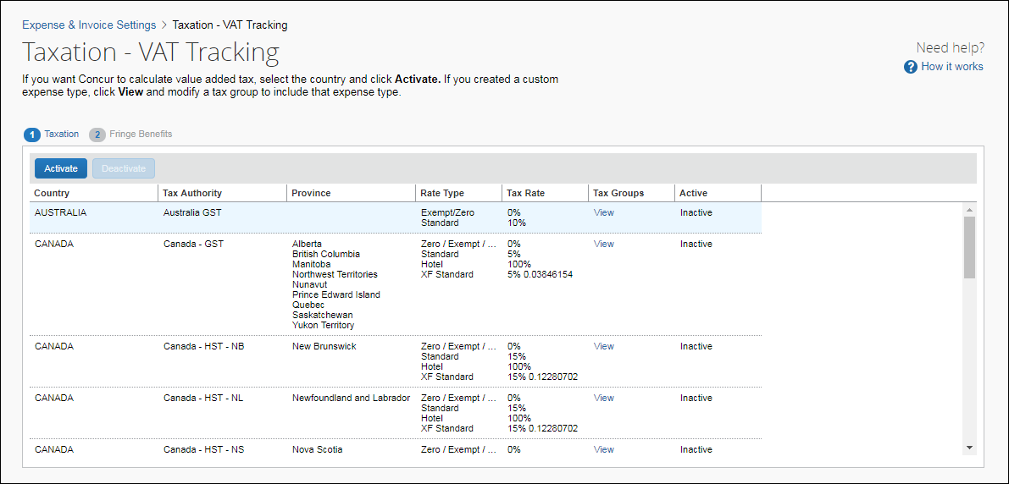

View VAT Configuration
To view the VAT configuration (prior to activation):
- On the Taxation tab, click View in the Tax Groups column for the desired tax authority. The Tax Groups for Tax Authority page appears, showing the full configuration for the various expense type groups.
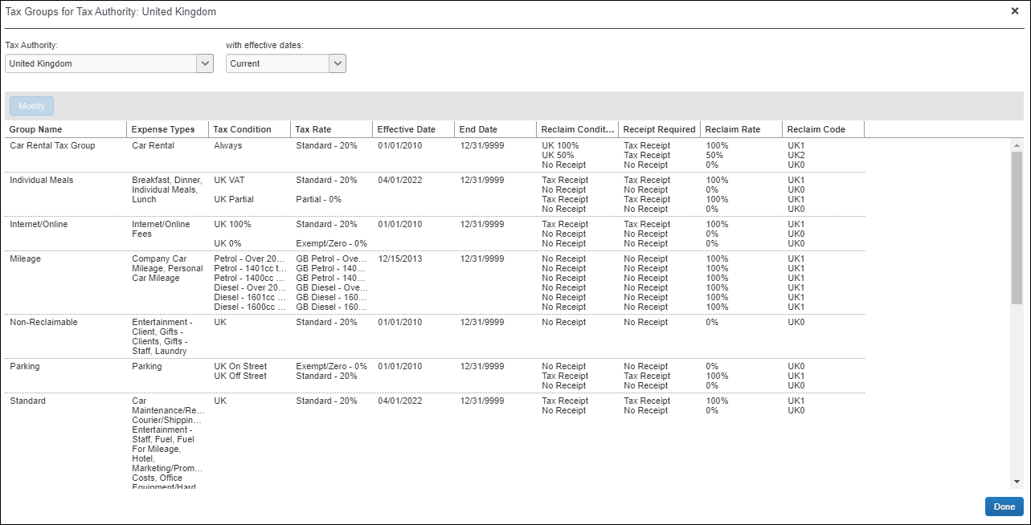
- Review this configuration carefully to make sure that the supplied tax groups match your company's value-added tax tracking. You can move the expense types to different groups once the tax authority is activated.
- A single expense can be influenced by a maximum of two tax authorities.

Activate or Deactivate VAT Tracking
To activate or deactivate VAT tracking:
On the Taxation tab, select the desired tax authority and click Activate or Deactivate.
- IMPORTANT: The calculation method chosen must be used consistently throughout the fiscal year.

Modify VAT Configuration (After Activation)
You can move expenses between groups to accomplish different tax and reclaim treatments if necessary, and to add a custom expense types to the correct tax and group.
To modify the VAT configuration (after activation):
This process should be completed whenever you add a new expense type to SAP Concur.
- On the Taxation tab, click View in the Tax Groups column for the activated tax authority. The Tax Groups page appears, showing the full configuration for the various expense type groups.
- Select the tax group and click Modify. The Expense Types for Tax Group window appears.
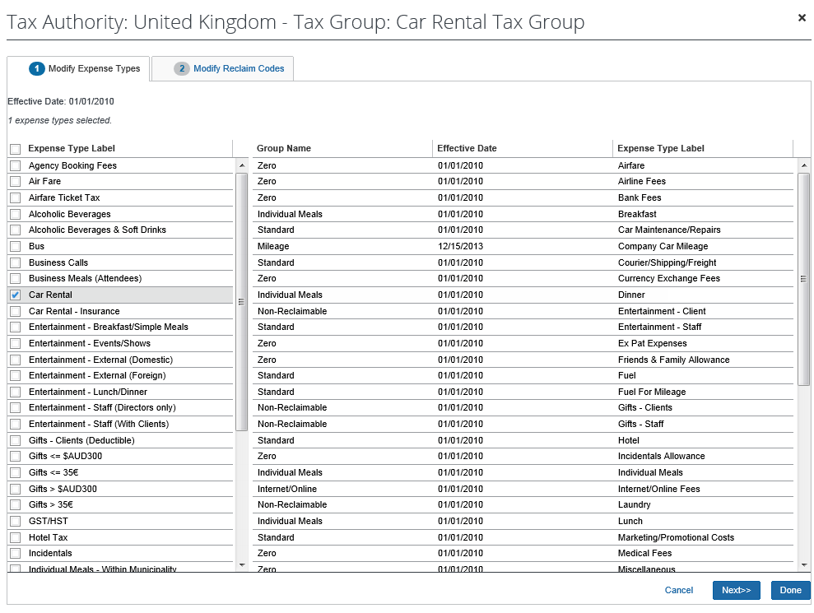
- Select or clear the check boxes for the desired expense types. If an expense type is already in use in another tax group, then it is unavailable for assignment and listed on the right side of the window.
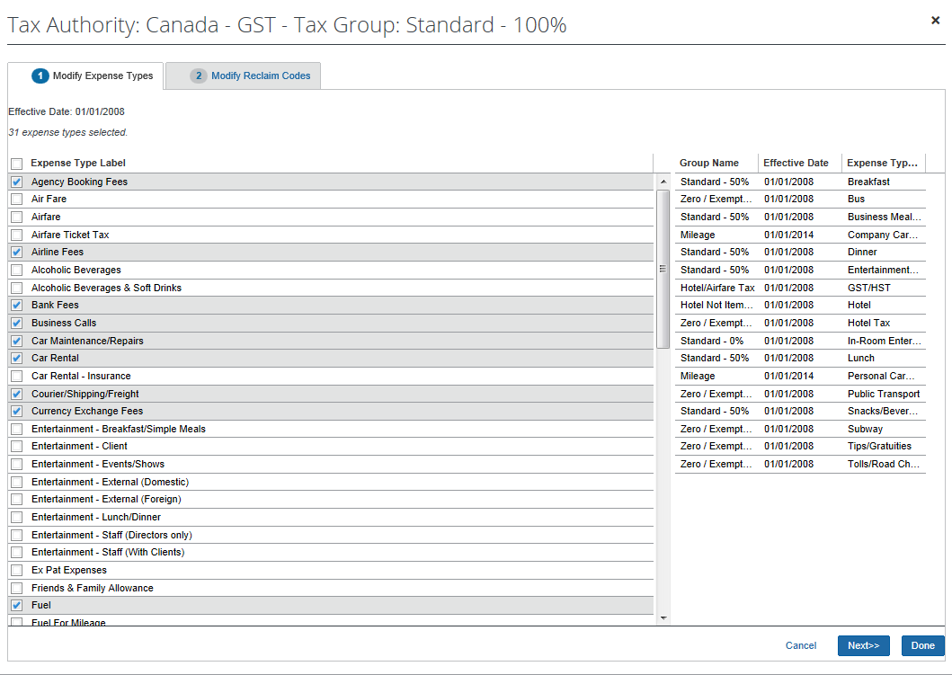
- Click the Modify Reclaim Codes tab.
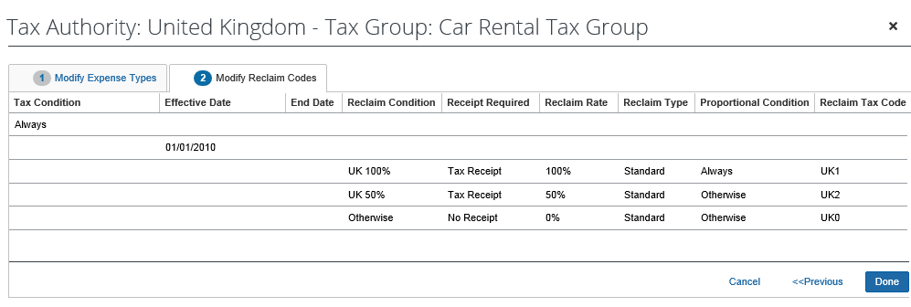
Use the information in the Reclaim Condition column to ensure that you are editing the intended row.
- (Optional) In the Reclaim Tax Code column, click on the desired reclaim tax code and make changes if necessary.
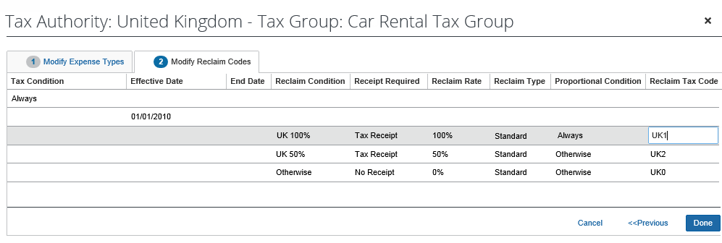
- Click Done.
- If you are finished, click Done again. You are taken back to the Taxation page.

Map VAT Tax Codes (For QBO, Sage Intacct, and Xero Accounting Clients Only)
For clients using QuickBooks Online (QBO), Sage Intacct, or Xero accounting integration, once VAT tracking for a tax authority is activated, you can map VAT tax codes for tax groups between your integrated accounting software and SAP Concur. When the accounting software tax codes are mapped, QBO, Sage Intacct, or Xero Accounting will calculate the tax amount based on their tax codes, ensuring the correct transaction amounts are posted.
The VAT tax rate mapping only accommodates VAT that is collected at a single level, such as at the country level.
So, while Canada and Australia can technically use the tax rate mapping, the tax rate mapping will not fit the needs for more complex tax structures where VAT is collected at multiple levels.
To map VAT tax codes for tax groups (after activation):
- On the Taxation tab, click View in the Tax Groups column for the activated tax authority. The Tax Groups page appears, showing the full configuration for the various expense type groups.
- Select the tax group and then click Modify. The Expense Types for Tax Group window appears.
- Click the Modify Reclaim Codes tab. For QBO, Sage Intacct, and Xero Accounting clients, the Tax Code column is displayed next to the Reclaim Tax Code column.
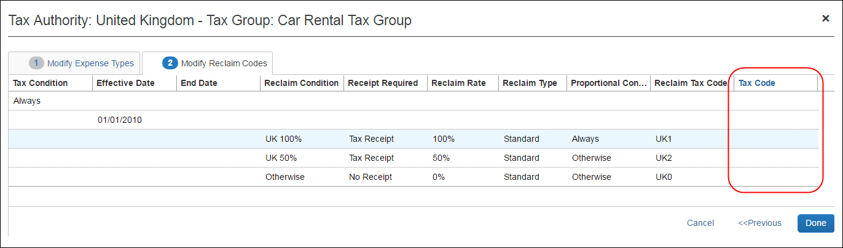
- In the Tax Code column, click the corresponding QBO, Sage Intacct, or Xero Accounting tax rate for the SAP Concur reclaim tax code. The list in the Tax Code column is populated with the tax rates from QBO, Sage Intacct, or Xero Accounting.
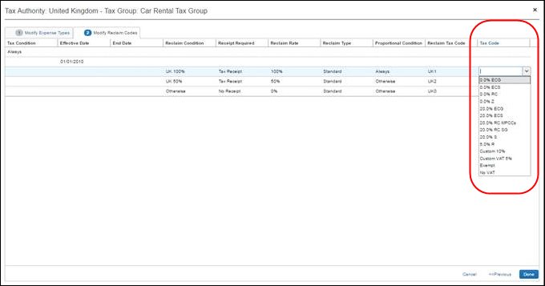
- When you are done mapping tax codes, click Done.
When an accounting software tax rate is mapped to an SAP Concur reclaim tax code, on the Tax Groups for Tax Authority: [country name] page, the 2-digit accounting software tax code is appended to the mapped SAP Concur reclaim tax code in the Reclaim Code column.
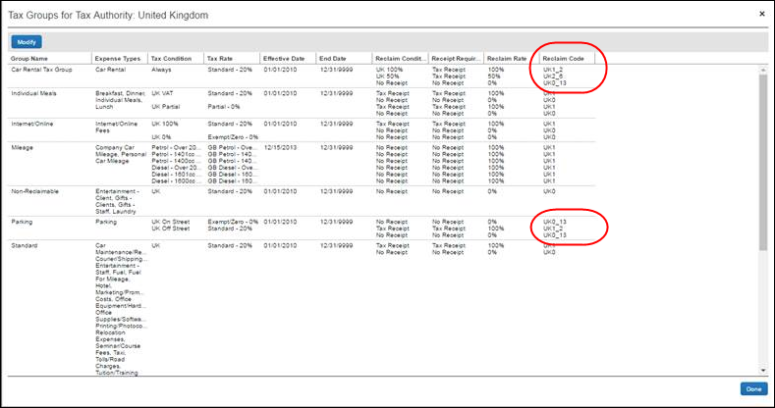
- If you are finished, click Done again. You are taken back to the Taxation page.

Configure Fringe Benefits
The Fringe Benefits tab of the Taxation – VAT Tracking page is only applicable to Australia.

Access the Fringe Benefits tab
To access the Fringe Benefits page:
- Click Administration > Expense Settings or Expense & Invoice Settings.
- In the Product list, click Expense.
- In the Capture Spending section, on the VAT tab, click Edit.
The Taxation – VAT Tracking page appears.
- Click Fringe Benefits (tab).
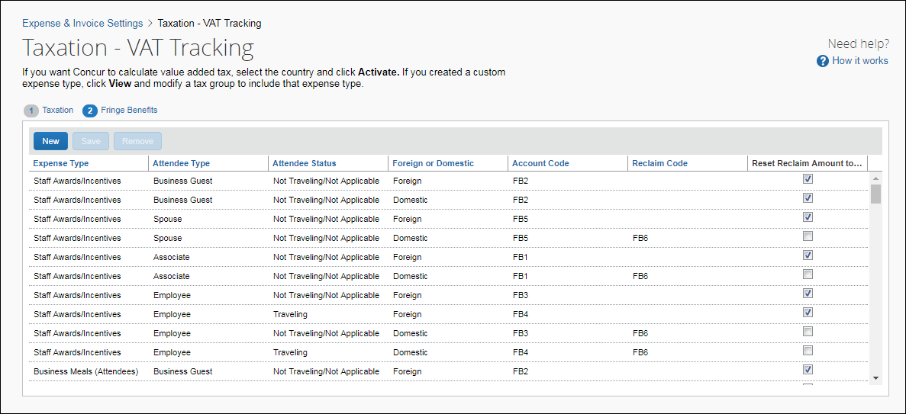

Modify Fringe Benefits
To modify the Fringe Benefit configuration:
- On the Fringe Benefits tab, select the row to modify.
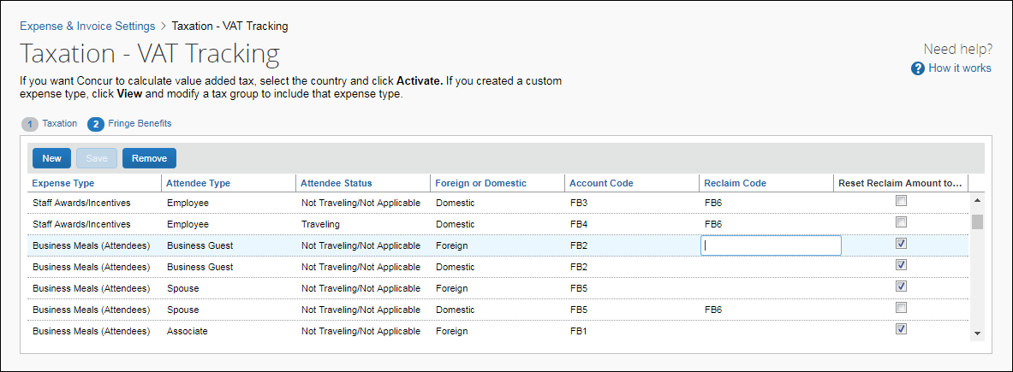
- Update the fields:
Field | Description
Expense Type | Select an expense type.
Attendee Type | Select the type of attendee for this configuration. Examples of attendee types are "Employee" or "Business Guest."
Attendee Status | Select the status of attendee for this configuration. Examples of attendee status is Not Traveling.
Foreign or Domestic | Specify whether the FBT configuration is for domestic or foreign expenses.
Account Code | Enter the account code to use for this expense type and attendee combination.  The account code is specified by the organization and defines what is involved in a transaction. The account code overrides the default value set on the Expense Types page.
Reclaim Code | Enter the reclaim code to use for this expense type and attendee combination if your organization's financial system requires it.  The reclaim code is similar to a tax code; it is a pass-through to some client financial systems. This reclaim code overrides the default value set in the Tax & Reclaim group configuration on the Taxation page.
Reset Reclaim Amount to Zero | Select the check box to set the tax reclaim amount to zero for this configuration.  This setting overrides any reclaim amount calculated by the Tax & Reclaim group configuration and resets it to zero.
- Click Save.

Add Fringe Benefits
To add an Fringe Benefits configuration:
- On the Fringe Benefits tab, click New.
- Select or enter data in the fields. Refer to the Modify process above for field details.
- Click Save.

Remove Fringe Benefits
To remove an Fringe Benefits configuration:
- On the Fringe Benefits tab, select the configuration you want to remove.
- Click Remove.

Tax Related Features

VAT Basics
Taxes are calculated at the time an expense is saved.
Concur Expense uses the following information to properly calculate the VAT:
VAT is recalculated when any of these fields are changed by the employee, approver, or processor. A user with the Process Reports role can modify calculated taxes in which case the system will not recalculate and overwrite the tax amounts.
- Expense type
- Date—the date the expense was incurred. Tax rates do change periodically.
- Expense amount—the gross amount of the transaction.
- Country and State/Province—these fields are present in the employee’s profile as Country of Residence, State/Province. This data copies down when a new expense entry is being manually entered, or is populated from the credit card data. The user will overwrite this if the expense was incurred elsewhere.
- Important: The data in these fields determines whether the tax will be calculated and which province’s tax is applicable. The employee profile information for country and province (for Canada) is essential to identify the domestic tax regime for that user. The system will calculate and track tax for domestic transactions.
When a new expense entry is being manually entered, Country and State/Province data is pre-populated based on the information you entered for the employee on the User page in Product Settings or from the credit card data. The user can overwrite as needed if the expense was incurred elsewhere.
- City—this is an optional field that can be set to Hidden on the expense forms. The location information that is necessary to calculate the tax is Country and in some countries such as Canada also Province. When the city field is used, the country and province are derived from the city that is selected. You may decide to educate your users to use the City field, or the Country and State/Province fields when an expense is incurred in a different location than the employee’s home/default location.
- Receipt—this field tracks whether or not the user has attached the image of the physical receipt.
Concur Expense calculates VAT based on country-specific tax regulations. Refer to the Taxation – Enable VAT Tracking page to see the country-specific tax groups. This section contains basic information about SAP Concur’s VAT features.
Example Calculation
The basis of the VAT calculations is that Concur Expense computes the net expense amount from the gross expense amount entered by the user and the various tax rates. The equation is derived as follows:
Gross = Net + SumOfTaxes
or
Net = Gross - SumOfTaxes
where
Tax1 = Net * TaxRate1
Tax2 = Net * TaxRate2
etc.
and
SumOfTaxes = Tax1 + Tax2 + . . .
SumOfTaxes = (Net * TaxRate1) + (Net * TaxRate2) + . . .
SumOfTaxes = Net * (SumOfTaxRates)
Therefore:
Net = Gross – (Net * SumOfTaxRates)
Net + (Net * SumOfTaxRates) = Gross
Net * (1 + SumOfTaxRates) = Gross
Net = Gross / ( 1 + SumOfTaxRates )
Once we have the Net, we can calculate each of the individual taxes. For most countries this is really a simple calculation, as VAT is levied only at the country level. For other countries, such as Canada, this calculation should still arrive at the correct amounts for the various levels of tax.

VAT Reclaim Calculation
The amount of the VAT that is reclaimable is published as a percentage of the VAT amount, so this is a simple calculation:
ReclaimAmount = Tax * ReclaimPercent

VAT Fields in File Export Configuration
Two tax related fields are available in the File Export Configuration page of Product Settings. These fields are used with VAT calculations, to identify the portion of the expense that are attributable to goods and services:
- Journal Net of Total Adjusted Reclaim Tax: This is calculated as Journal Amount minus the total adjusted reclaim amount. This calculation produces the allocated amount of goods and services which excludes the reclaimable tax portion.
- Journal Net of Total Adjusted Tax: This is calculated as Journal Amount minus the total adjusted tax. This calculation produces the allocated amount of goods and services which excludes the tax portion.

Standard Tax Groups
The following tax groups are created for all single-level VAT countries:
Rate Type | Tax Group | Tax Form | Tax Rate | Reclaim
Standard | Standard | None | Standard | 100%
Standard | Standard 50% Reclaim | None | Standard | 50%
Standard | Standard No Reclaim | None | Standard | 0%
Zero | Zero | None | Zero | 0%
Reduced | Reduced | None | Reduced | 100%
Reduced | Reduced No Reclaim | None | Reduced | 0%
Super Reduced | Super Reduced | None | Super Reduced | 100%
Super Reduced | Super Reduced No Reclaim | None | Super Reduced | 0%
Reduced 3 | Reduced 3 | None | Reduced 3 | 100%
All | All Rates | All Rates:  List containing all tax rates for a country e.g  Standard (19%)  Reduced (7%)  Zero (0%) | All Tax Rates | 100% for Non Zero Rates
All | All Rates Non Reclaimable | All Rates:  List containing all tax rates for a country e.g  Standard (19%)  Reduced (7%)  Zero (0%) | All Tax Rates | 0%
All | Domestic/International Reclaimable
All | Domestic/International Non Reclaimable
If there are no active rates for a tax group, and no expense types associated with the group, it will not appear on the Taxation page.

Special Cases
In some cases it is impossible to calculate the right tax amount for an itemized expense based on the information captured in SAP Concur and the information available to the user on the receipt or the data entry burden on the user to enter the information in exactly the manner needed for the calculation to work correctly is too great.

Explicit Tax Amount
SAP Concur allows configuration of an expense type and accompanying tax calculation to take 100% of that expense amount as the tax. This allows the user to enter in the tax amount as an itemization of the expense.
An example of where this may be appropriate is a country where the hotel folio states the nightly room charges with a line item each for room rate, VAT and other taxes. It would unreasonable to ask the user to total the room rate and VAT amounts so the system can correctly reverse-calculate the VAT amount. With this option, the user may simply enter the individual totals on the hotel wizard and the system will create a line item for each date’s VAT amount.

Single-Level VAT Country Calculation
This example calculation applies to all countries that collect VAT at a single level (most common).
Example Calculation
From the point of sale:
Net expense = 125.32 (pre-tax sales total)
VAT rate = 20%

VAT = 125.32 * 0.2 = 25.064 rounded to 25.06
Gross = Net + SumOfTaxes
Gross = 125.32 + 25.06
Gross = 150.38
The gross amount of the transaction is entered into SAP Concur either manually, captured via ExpenseIt, or imported from credit card data.
So, from the application:
Gross expense = 150.38
VAT rate = 20%
Net = Gross / (1 + SumOfTaxRates)
Net = 150.38 / (1 + 0.2)
Net = 150.38 / 1.2
Net = 125.31666 rounded to 125.32
Tax = Net * TaxRate
VAT = 125.32* 0.2 = 25.064 rounded to 25.06

Output File and Tax Information
There are many VAT-related data fields that may be exported out of Concur Expense as part of the standard accounting extract such as Report Entry Expense Type Name, Journal Account Code, and Net Adjusted Reclaim Amount.

Troubleshooting
If VAT is not calculated as expected, use the following steps.
The expense claim processor should:
- Verify that the province displays on the line item expense.
- Record the type of tax and the reclaim amount shown on this line item.
- Calculate the expected tax independent of what is displayed.
The administrator should use Expense Settings or Expense & Invoice Settings > Expense > Taxation to:
- Verify that the expense type belongs to the correct tax group.
- Verify that the expected tax authorities are applicable to the province in which the expense occurred.
If troubleshooting results in configuration changes to the user's information or to Product Settings, then have the user create and submit a new expense claim.

Country-Specific Information

Canada

Taxes and Credits
Canada levies VAT at two levels (country-wide and by province) and is managed using the following taxes and credits:
- GST: The federal Goods and Services Tax (GST).
- PST: The Provincial Sales Tax (PST).
Only in Quebec can PST be recovered or reclaimed.
- HST: GST and PST combined into a Harmonized Sales Tax (HST).
- ITC: Input Tax Credit (ITC) is appliable for all provinces where businesses registered for federal level of indirect taxes (GST/HST) can recover GST/HST paid on the purchases and expenses.
The type of expense and which province the expense occurs in are major factors in determining the percentage of tax that a company can reclaim.
- QST: The Quebec Sales Tax (QST) calculated on the sum of the expense amount and the GST amount.

Exact and Simplified (Administrative Factors) Tax Calculation Methods
Companies operating in Canada with SAP Concur have two choices for calculating input tax credits.
- SAP your tax advisors regarding your selection of a calculation method and when you might opt to change the method. The simplified method may not be an option for some companies, such as non-profits, municipalities, and schools.
Exact (Prescribed) Calculation Method—the amount reported to the government corresponds to what is on the Point of Sale (POS) receipt. This becomes very burdensome as tip amounts need to be taken into consideration and the actual taxes from receipts need to be reviewed.
A reason to select this method might be that you want to maximize the tax returned on large ticket items such as airline and hotel room expenses.
Simplified (Administrative Factors) Method—less intrusive, simpler application of mathematical factors which nets you less than the full amount of the potential VAT reclaims, but with considerably less tracking of evidentiary documentation and auditing by the government. Canadian clients will see the Extraction Factor Column in the Tax Groups for Tax Authority window. This method allows the calculation of the tax and ITC amount using special extraction factors which eliminate the need to detail tip and actual tax amounts.
A reason to select this method might be to minimize the administrative burden on your company to keep meticulous records.
More information about this option can be found at the Canada Revenue Agency site under Simplified Method (http://www.cra-arc.gc.ca/tx/bsnss/tpcs/gst-tps/bspsbch/itc-cti/hwt/smplfd-eng.html) and also Revenu Québec site under Simplified Method (http://www.revenuquebec.ca/en/centre-information/nf/archives/nf2006/in-136_74/calcul_simplifie_cti_rti.aspx).

Exact Method Example – Basic
For current percentages, click Administration > Expense Settings or Expense & Invoice Settings > Expense > Taxation > View.
Tax Amount
The tax amount calculation is as follows:
Tax = Net * TaxRate

From the point of sale:
Net expense = 569.37 (pre-tax sales total)
GST rate = 5%
PST rate = 7%

GST = 569.37 * 0.05 = 28.4685 rounded to 28.47
PST = 569.37 * 0.07 = 39.8559 rounded to 39.86

Gross = Net + SumOfTaxes
Gross = 569.37 + (28.47 + 39.86)
Gross = 637.70
The gross amount of the transaction is entered into SAP Concur either manually, captured via ExpenseIt, or imported from credit card data.
So, in Concur Expense:
Gross expense = 637.70
GST rate = 5%
PST rate = 7%
Net = Gross / (1 + SumOfTaxRates)
Net = 637.70 / (1 + 0.05 + 0.07)
Net = 637.70 / 1.12
Net = 569.375
Tax = Net * TaxRate
GST = 569.375 * 0.05 = 28.46875 rounded to 28.47
PST = 569.375 * 0.07 = 39.85625 rounded to 39.86
It is possible that the computed Net is not the same as the original sales Net expense. This means that the following validity check fails:
Gross = Net + SumOfTaxes
To minimize this, when calculating the Net amount for use in calculating the various Tax amounts, Concur Expense does not round the Net amount. Concur Expense uses the full calculated value for Net and then calculates the various Tax amounts. Each Tax amount must then be rounded to the number of decimal digits of the spend currency.
Later, when the VAT tables are populated, the Net amount is computed and stored based on the following (eliminating further rounding issues):
Net = Gross – SumOfTaxes
- Additional Exact Method examples are provided below.

Simplified Method Example – Basic
To view current percentages, click Administration > Expense Settings or Expense & Invoice Settings > Expense > Taxation > View.
The Canadian government allows the calculation of the tax and reclaim amount using special extraction factors that they publish.
Tax Amount
The basic calculation of the tax amount using extraction factors is very simple.
The tax amount calculation is as follows:
Tax = Gross * ExtractionFactor

Reclaim Amount
The basic calculation of the reclaim amount using extraction factors is very simple.
For the reclaim amount, the calculation is as follows:
Tax = Gross * ExtractionFactor * ReclaimPercent

From the point of sale:
Net expense = 569.37 (pre-tax sales total)
HST rate = 13% (Ontario)

HST = 569.37 * 0.13 = 74.0181 rounded to 74.02
Gross = Net + SumOfTaxes
Gross = 569.37 + (74.02)
Gross = 643.39
The gross amount of the transaction is entered into SAP Concur either manually, captured via ExpenseIt, or imported from credit card data. Reclaim or tax and reclaim may apply.
So, in Concur Expense:
Gross expense = 643.39
HST Extraction factor = 12/112 = 0.1071428 (Ontario)
Tax = Gross * ExtractionFactor
RECLAIM = Gross * ExtractionFactor* ReclaimPercent
HST Tax = 643.39 * 0.1071428 = 68.934606 rounded to 68.93
HST RECLAIM = 643.39 * 0.1071428 * 50% = 34.467303 rounded to 34.47
Provincial Sales Tax (PST)
The provincial sales tax (PST) is a tax levied at the provincial level. In the majority of provinces, you apply the country-level GST and a provincial level PST to each expense. This is a straightforward calculation as described in the example above.
Harmonized Sales Tax (HST)
The GST and PST rates are combined into a single Harmonized Sales Tax (HST) in the Canadian maritime provinces of Nova Scotia, New Brunswick, Newfoundland, Prince Edward Island, and Ontario. For these provinces, you must create and use a single total for HST in place of PST and GST.

Special Considerations: Air Travel, and Hotel Stays, and Tips
All expense types will automatically calculate taxes with the exception of air travel and hotel stays. By default these expenses use the Exact method for VAT calculations due to the complexity of accurately calculating the value-added taxes within the numerous additional taxes on these types of expenses. Concur Expense provides an itemization wizard which prompts the user to enter the required information.
Be sure to:
- Activate these expense types: GST/HST, QST/PST, and Air Fare.
- Configure Compliance Controls to require user to itemise all hotel expenses.
To use the Simplified method for VAT calculations of air travel, activate
the Airfare expense type and deactivate the Air Fare expense type. Review this change in Product Settings by clicking Administration > Expense Settings or Expense & Invoice Settings > Expense > Taxation > View.
For both the Exact and Simplified calculation methods, there is a tip field on the entry form for any expense types configured in the Meal or Entertainment Category. If you are using the Exact method, the tip amount is subtracted from the gross amount before calculating taxes. The Simplified method ignores any use of this field.

Subtleties
Concur Expense efficiently processes the many subtleties related to Canada VAT.
Examples are called out on the following graphic of the Canada – GST tax groups. To view the Canada – GST tax groups or any of the other Canada tax groups, click Administration > Expense Settings or Expense & Invoice Settings > Expense > Taxation > View.
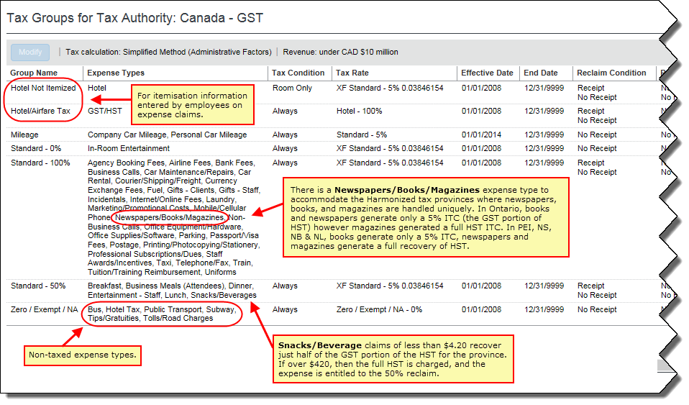

Expense Claim Entries and Tax Calculation/Recalculation
Receipt: For Canada, the ITC tax amount is populated only when the value is “Receipt.”
The receipt status field can also be set to default to a value at the configuration level, which avoids the end user having to change this for each line, if the receipt is in fact missing, the user or processor can change the receipt status to no receipt, in which case the ITC will not be calculated.
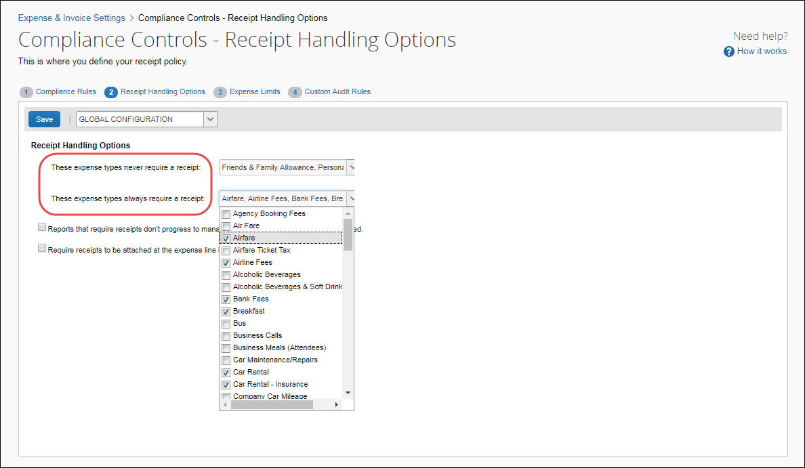
- Mileage: In order to calculate the ITC, the employees’ work province field must be populated. One mileage rate exists for North West Territories, Yukon, and Nunavut, while a second mileage rate exists for the balance of the provinces. Within each group is a rate for under 5,000km/year and a lower rate for over 5,000km/year.

Output File and Tax Information
For every expense entered into SAP Concur for Canada, there will be multiple ROWS of data that correspond to each expense. SAP Concur’s file format has a line for the expense and then a subsequent row for each type of tax. For example, an expense entered in Ontario, might have the expense row, the HST row. And for Alberta, the expense might have the expense row and a GST row.
- For more information, refer to the Concur Expense: Payment Manager Extract User Guide for Concur Standard Edition.

Simplified Method Example for Alberta – where GST is the only tax levied.
From Point of Sale (POS):
Price of good or service = $ 125.00
GST rate = 5%
GST=$125*.05
GST=$6.25
Gross Expense = Net expense + sum of taxes
= $125.00+$6.25
= $131.25
The gross amount of the transaction is entered into SAP Concur either manually, captured via ExpenseIt, or imported from credit card data.
SAP Concur calculates the factored GST as follows:
GROSS expense = $131.25
GST Extraction factor for Alberta (a GST only province) = 4/104 = 0.038461538
GST TAX = GROSS * Factor
= $131.25 * 0.038461538
= 5.04807 rounded to $5.05
The POS GST calculated is $6.25, but the factored GST amount is $5.05.
The Input tax credit for each type of expense is dictated by CRA.
SAP Concur calculates the ITC assuming 50% in this example:
ITC = GROSS * Factor * ITC Percent
ITC = $131.25 * 0.038461538 * .50
ITC= $2.53

Simplified Method Example for Quebec – where there is GST And QST
From Point of Sale (POS):
Price of good or service = $ 125.00
GST rate = 5%
GST=$6.25
QST rate=9.975%
PST=$12.46875 rounded to $12.47
Gross Expense = Net expense + sum of taxes
= $125.00+$6.25+12.47
= $143.72
The gross amount of the transaction is entered into SAP Concur either manually, captured via ExpenseIt, or imported from credit card data.
SAP Concur calculates the factored GST:
GROSS expense = $143.72
GST factor for Quebec is 4/104
GST TAX = GROSS * Factor
= $143.72 * 0.0384615
= $5.53
SAP Concur calculates the factored QST:
GROSS expense = $143.72
QST factor for Quebec is 9/109
GST TAX = GROSS * Factor
= $143.72 * 0.0825688
= $11.87
The POS GST calculated is 6.25, but the factored GST amount is 5.53.
The POS QST calculated is 12.47, but the factored QST is 11.87.
The Input tax credit for each type of expense is dictated by CRA. Assuming an ITC percentage of 50% for the item purchased in this example.
SAP Concur calculates the GST ITC:
ITC = GROSS * Factor * ITC Percent
ITC = $143.72 * 0.0384615 * .50
ITC = $2.75
SAP Concur calculates the QST ITC:
ITC = GROSS * Factor * ITC Percent
ITC = $143.72 * 0.0825688* .50
ITC = $5.90

Simplified Method Example for Ontario – where there is HST
From Point of Sale (POS):
Price of good or service = $ 125.00 + $20.00 tip
HST rate = 13%
HST=$125*.13
HST=$16.25
Gross Expense = Net expense + sum of taxes + tip
= $125.00+$16.25 + $20.00
= $161.25
The POS HST calculated is 16.25, of the HST, the GST portion is 5/13 and the provincial portion is 8/13.
The gross amount of the transaction is entered into SAP Concur either manually, captured via ExpenseIt, or imported from credit card data.
SAP Concur calculates the factored GST amount:
GROSS expense = $161.25
HST factor for Ontario = 12/112 = 0.107142857
HST TAX = GROSS * Factor
= $161.25 * 0.107142857
= $17.27678 rounded to $17.28
The POS HST calculated is $16.25, but the factored HST amount is $17.28. The Simplified method does not have to isolate tip amounts.
The Input tax credit for each type of expense is dictated by CRA. Assuming an ITC percentage of 50% for the item purchased in this example.
SAP Concur calculates the ITC:
ITC = GROSS * Extraction Factor * ITC Percent
= $161.25 * 0.107142857 * .50
= $8.64

Appendix B: Calculating GST and ITC using Exact Method
The gross amount of the transaction is entered into SAP Concur either manually, captured via ExpenseIt, or imported from credit card data.
The application will first calculate the net expense amount:
NET = GROSS / (1 + Sum Of Tax Rates)
The calculation of exact taxes must account for any amounts added to the total by the traveler such as tips. So in fact the end user may need to enter the Gross amount and any tips added to derive the correct net amount. If this is not done, then the taxes that SAP Concur calculates will not match the receipts.
NET = (GROSS – tips) / (1 + Sum Of Tax Rates)
Once the net amount is derived, the system can then calculate the individual tax amounts:
TAX = NET * Tax Rate
The calculation of the ITC amount using exact tax (either HST or GST) amounts is simply:
ITC = GST * ITC percent

Exact Method Example for Alberta – GST is the only tax levied.
From Point of Sale (POS):
Price of good or service = $ 125.00
GST rate = 5%
GST=$125*.05
GST=$6.25
Gross Expense = Net expense + sum of taxes+ tips
= $125.00+$6.25
= $131.25
The gross amount of the transaction is entered into SAP Concur either manually, captured via ExpenseIt, or imported from credit card data.
SAP Concur calculates the GST:
GROSS expense = $131.25
NET = (GROSS-TIPS) / (1 + sum of tax rates)
NET = $131.25 / (1+.05)
NET = $125.00
GST = NET * Tax Rate
GST =$ 125.00 * .05
GST = $6.25
The Input tax credit for each type of expense is dictated by CRA. Assuming an ITC percentage of 50% for the item purchased in this example.
SAP Concur calculates the ITC:
ITC = GST* ITC Percent
ITC = $6.25 * .50
ITC= 3.12

Exact Method Example for Quebec – where there is GST And PST
From Point of Sale (POS):
Price of good or service = $ 125.00
GST rate = 5%
GST=$6.25
PST rate=9.975%
PST=12.46875 rounded to 12.47
Gross Expense = Net expense + sum of taxes + tips
= $125.00+$6.25+12.47
= $143.72
The gross amount of the transaction is entered into SAP Concur either manually, captured via ExpenseIt, or imported from credit card data.
SAP Concur calculates the GST and QST:
GROSS expense = 143.72
NET= (GROSS-Tips) / (1+sum of taxes)
NET= $143.72 / (1+.05+.09975)
NET=$125.00
GST = NET * Tax Rate
GST =$ 125.00 * .05
GST = $6.25
QST=NET* Tax Rate
QST=$125*.09975
QST=$12.47
The Input tax credit for each type of expense is dictated by CRA. Assuming an ITC percentage of 50% for the item purchased in this example.
SAP Concur calculates the two ITC:
GST ITC = GST * ITC Percent
GST ITC = $6.25 * .50
GST ITC = $3.12
QST ITC = QST * ITC Percent
QST ITC = $12.47 * .50
QST ITC = $6.23

Exact Method Example for Ontario – where there is HST
From Point of Sale (POS):
Price of good or service = $ 125.00 + a $20.00 tip was left.
HST rate = 13%
HST=$125*.13
HST=$16.25
Gross Expense = Net expense + sum of taxes+ tips
= $125.00+$16.25+20
= $161.25
The POS HST calculated is 16.25, of the HST, the GST portion is 5/13 and the provincial portion is 8/13.
The gross amount of the transaction is entered into SAP Concur either manually, captured via ExpenseIt, or imported from credit card data.
SAP Concur calculates the HST amount:
GROSS expense = $161.25 and the tip is entered as $20.00
NET= (GROSS-Tips) / (1+sum of taxes)
NET= $141.25 / (1+.13)
NET=$125.00
HST = NET * Tax Rate
HST =$ 125.00 * .13
HST = $16.25
The Input tax credit for each type of expense is dictated by CRA. Assuming an ITC percentage of 50% for the item purchased in this example.
SAP Concur calculates the ITC:
ITC = HST * ITC Percent
= $16.25 * .50
= 8.12

Activated Tax Groups
Simplified Method and Annual Revenues > 10 Million CAD = NO
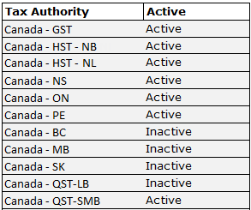
Simplified Method and Annual Revenues > 10 Million CAD = YES
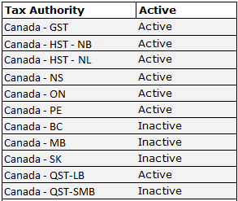
Exact Method and Annual Revenues > 10 Million CAD = NO
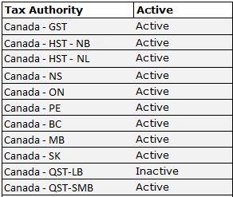
Exact Method and Annual Revenues > 10 Million CAD = YES
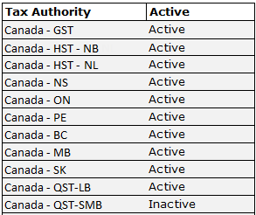

Travel Diary

Australia
A travel diary is required of Australian travelers in some circumstances to avoid taxation under the rules of the Fringe Benefits Tax. Under this governmental provision, the traveler must use a travel diary to identify where they traveled, the dates and times of travel for the entire duration of the trip, and finally the nature of the travel itself.
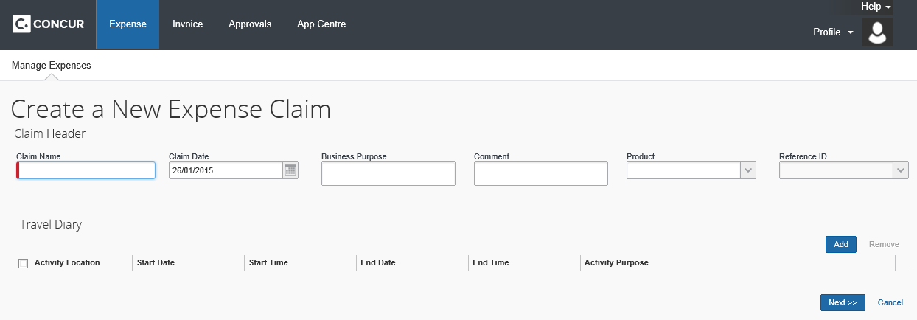
When Add is clicked, it opens a new entry line and the user adds their travel information. Date is chosen from a calendar, or by typing in a number and that becomes the date of the current month. Time is entered by typing a 24-hour time, such as 21, that resolves to 9:00PM, or type in a number - the system resolves the number within a current workday of 7am to 6pm (thus, the number 5 is 5:00PM; the number 11 is 11:00AM).

User Experience
Within the report header, the user sees the Travel Diary table when they enter data for their new expense report.
The travel diary shows the following information:
- Activity Location: Where the activity took place
- Activity Start Date/Time: The date and approximate time the activity started
- Activity End Date/Time: The date and approximate time the activity ended
- Activity Purpose: The description of the activity
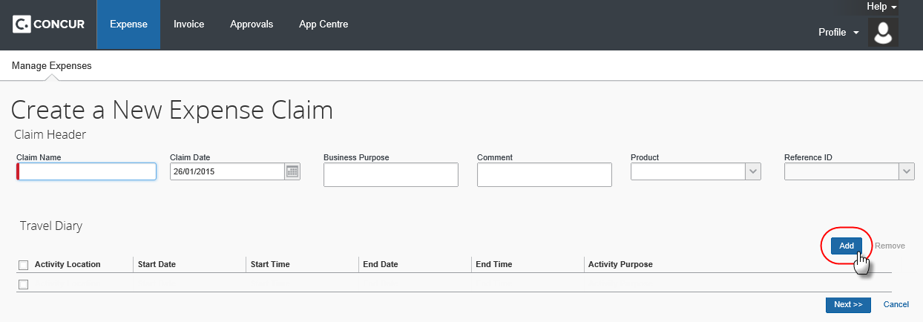

UK VAT Reclamation for Mileage Expenses
The feature for fuel VAT reclaim allows the company to track and reclaim the taxes for fuel and for mileage.
SAP designed this feature for the UK, but it can be used for other countries with similar needs.
The user records mileage expenses and fuel purchases on the same expense report (also known as a claim) to allow tracking of the reclaimable VAT paid on the fuel that will inevitably be used during mileage journeys. To accomplish this, a spend category called Fuel for Mileage is used.
Companies, who use reporting, may generate a report for missed VAT on mileage.

Fuel Expenses
Generally, a user claims mileage costs – not fuel costs – and never both. However, the tax on the fuel that will inevitably be used during mileage journeys can be subject reclaim. This feature allows the user to have mileage and fuel expenses on the same report, letting the company take advantage of the reclaim. The system reimburses the user for the mileage expenses as usual but not for the fuel expenses.
This section of this guide describes how to configure fuel expenses with a special spend category (Fuel for Mileage) as well as to be "personal" so the user is not reimbursed.

Mileage Expenses
This section of this guide describes how to configure complex mileage rates.

Valid Fuel Receipts
A valid fuel receipt is:
- a VAT receipt that is
- for the date of the mileage expense or earlier, and
- for the same fuel type as is used by the car in the mileage expense (e.g. petrol or diesel), and
- of a monetary value great enough to cover the potential VAT reclaim (users can use multiple receipts to achieve this)

User Experience
In SAP Concur, users must use the Fuel for Mileage expense type for VAT Reclamation because it has a special mapping to the Mileage expense. When SAP Concur sees Mileage entries in a report, SAP Concur is, in the background, adding up the potential VAT reclaim using the Advisory Fuel Rates. The system warns users as soon as a Mileage expense is created that has is potential VAT reclaim.
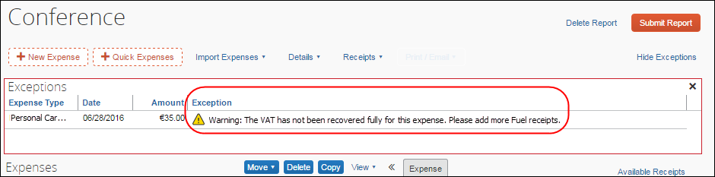
The user may enter the expenses by clicking either Quick Expenses, or New Expense.
Regardless of the method used to create the expenses, the following are important key concepts for users to understand and remember:
- Users cannot add any available fuel receipt. They must use a receipt that is valid in relation to the mileage entries in this report (amount, date, VAT receipt, and so on)
- Users must submit their Mileage entries and their Fuel for Mileage entries using the same report
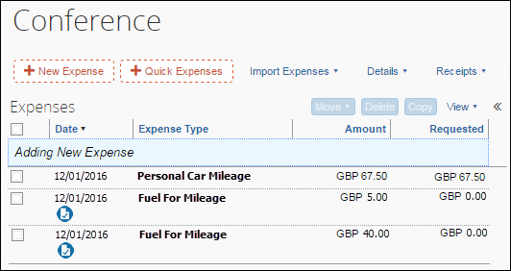
- Users must not use the Fuel expense type in this scenario because that is about reimbursement and nothing to do with VAT reclaim on driving

Using Quick Expenses
The user creates the report and then clicks Quick Expenses to enter his/her mileage-based expense entries and fuel purchases.
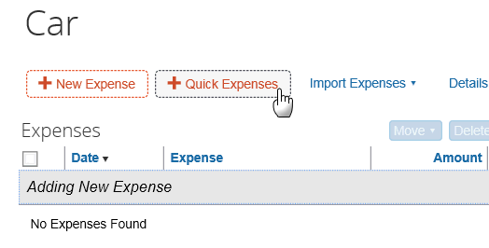
The Quick Expenses appears. The user clicks the Mileage Expenses tab.
- On the top portion of the window – Journey Details – the user chooses a vehicle and expense type, and then enters the trip information.
- On the bottom portion of the window – Receipt Details – the user to provides the receipt information and attaches receipts as necessary.
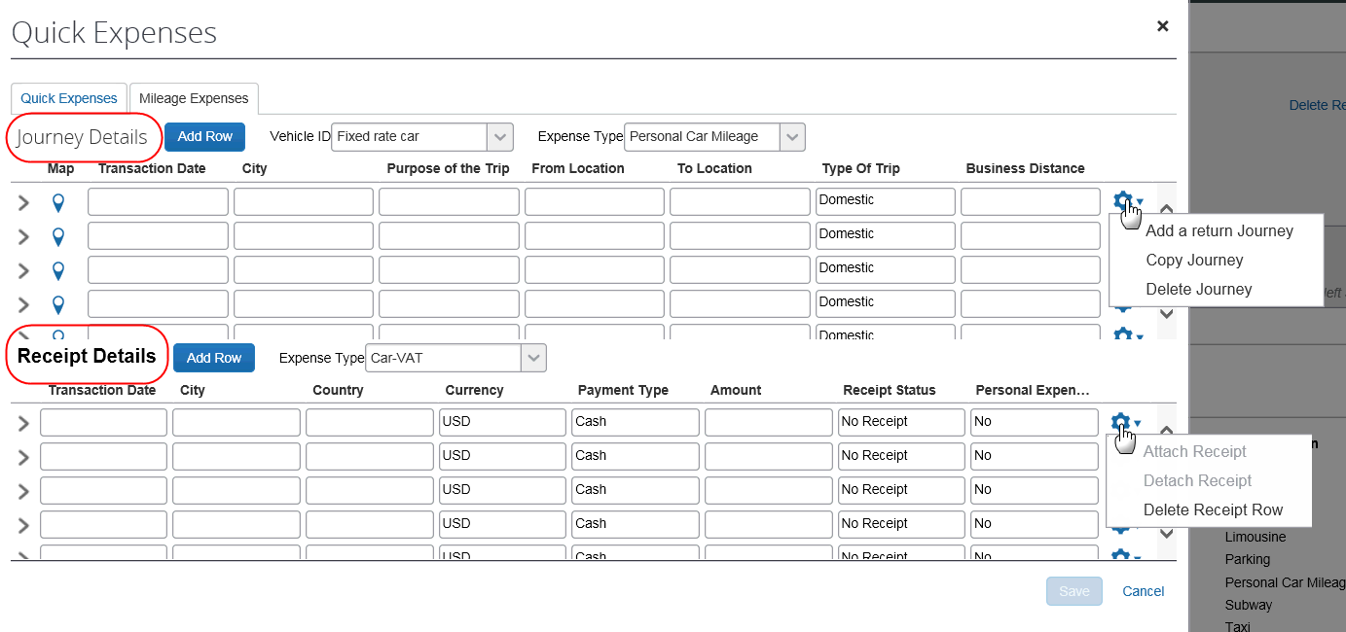
- IMPORTANT: The Receipt Details pane displays only if the client has an expense type assigned to the Fuel for Mileage spend category.
This Receipt Details panel provides additional information about the fuel receipt and transaction:
- Transaction Date: Date of the fuel transaction
- Country: Country in which the transaction occurred
- Payment Type: Method of payment (cash or credit)
- Currency: Currency used to pay for the fuel
- Amount: Amount paid for the fuel
- Receipt Status: If a receipt is available
- Fuel Type: The type of fuel purchased (this list requires additional configuration as described below)
The user must enter Fuel for Mileage expenses even if the company does not reimburse the expense, as this is mandatory justification for the VAT reclaimed for the mileage entries per the UK's HMRC.

User Experience on the Individual Expense
The Tax Amount field shows the maximum potentially reclaimable amount of tax allowed for the journey and is compared to tax paid on Fuel for Mileage receipts on the same report. The Reclaim Amount is adjusted up to the available and unused amount of tax paid that has not yet been used on other mileage expenses.

Additional Information
As with other types of expenses, the fuel receipt rows become individual expenses when the user saves the information.
- If there are multiple expense types configured to represent fuel for mileage, the user must select the appropriate expense type from the list above the table grid.
- The Send Back Expense should not be used on a Fuel for Mileage expense, as separating the expense from the corresponding mileage expenses will remove that amount of VAT from the available total for reclamation.

☼

