
Concur Expense:
Payment Types
Setup Guide for Concur Standard Edition
Last Revised: December 10, 2021
Applies to these SAP Concur solutions:
 Expense
 Professional/Premium edition
 Standard edition
 Travel
 Professional/Premium edition
 Standard edition
 Invoice
 Professional/Premium edition
 Standard edition
 Request
 Professional/Premium edition
 Standard edition

Table of Contents
Section 1: Overview 1
Section 2: About Card Programs 2
Selecting the Card Type 3
Card Program Details 4
Card Program Names 4
Create Multiple Card Programs for the Same Billing Recipient, Bill Payor, and Country 4
Card Registration 4
Rich Data Transactions 4
Section 3: Manage Company Card Programs 5
Access the Payment Types Page 5
Create Corporate Card Programs 6
Validate Credit Card Account Numbers 12
Create Business Card Programs 17
Create American Express Business Card Programs 22
Create Personal Card Programs 27
Filter Card Programs 30
Modify Card Programs 30
Edit Card Programs 30
Deactivate Business Card Programs 30
Configure Accounting Codes 32
Set Batch Schedules for Payments 34
Set Up Funding Accounts 36
Remittance Information Tab 37
Section 4: Manage System Payment Types 37
Change the Default Payment Type 38
Rename the Default Payment Type Label 39
Edit Payment Types 40
Deactivate Payment Types 40

Revision History
Date | Notes/Comments/Changes
January 21, 2022 | Updated the copyright year; no other changes; cover date not updated
December 10, 2021 | Updated instructions for Product Settings page
July 17, 2021 | Removed the Implementation Options section describing the temporary Welcome banner available during the deprecation of the Company Cards page.
March 30, 2021 | Minor edit. No cover date change.
March 25, 2021 | Clarified text in the Remittance Information Tab section.
March 20, 2021 | Setup guide created.

NOTE: Multiple SAP Concur product versions and UI themes are available, so this content might contain images or procedures that do not precisely match your implementation. For example, when SAP Fiori UI themes are implemented, home page navigation is consolidated under the SAP Concur Home menu.

Payment Types

Overview
The Payment Types page includes settings and configuration for management of credit card programs and payment types used to classify employee spending.
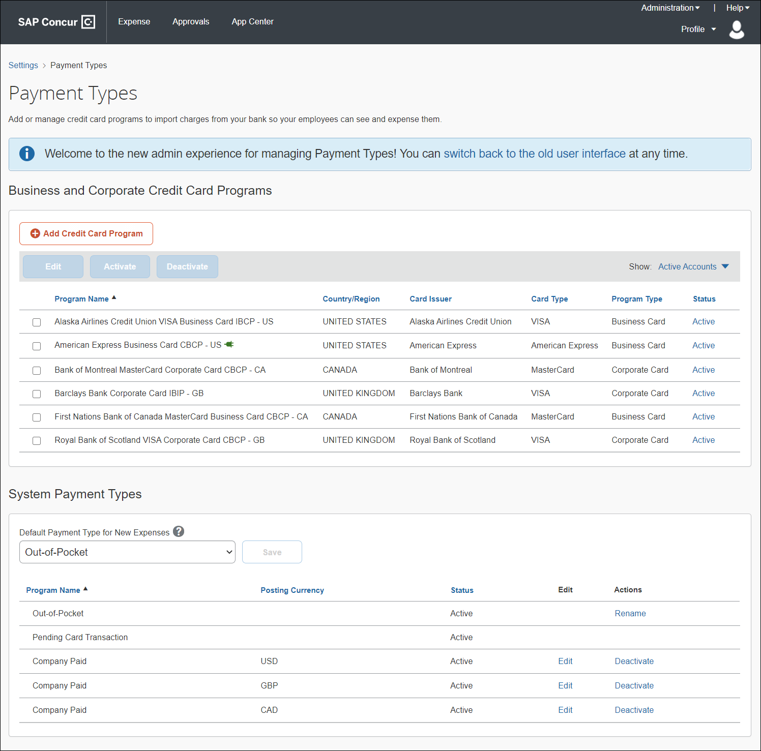
Existing clients migrating to the new Payment Types module will not see existing user-managed card program details display in the Business and Corporate Credit Card Programs section. The card program will be listed here, but all field data may not display for each column.
The Payment Types page allows you to:
- Add, edit, activate, and deactivate company card programs
- Create separate card programs for cards paid by employees and cards paid by the company
- Select the payment method for card programs
- Select the payment batch schedule and accounting information for each card program
- View, sort, and filter payment types
- Set a default payment type for new expenses
- Rename the default Out-of-Pocket payment type
- Edit payment types
- Deactivate payment types

About Card Programs
Before setting up card programs for your company, administrators first need to determine the type of card programs their company is using.
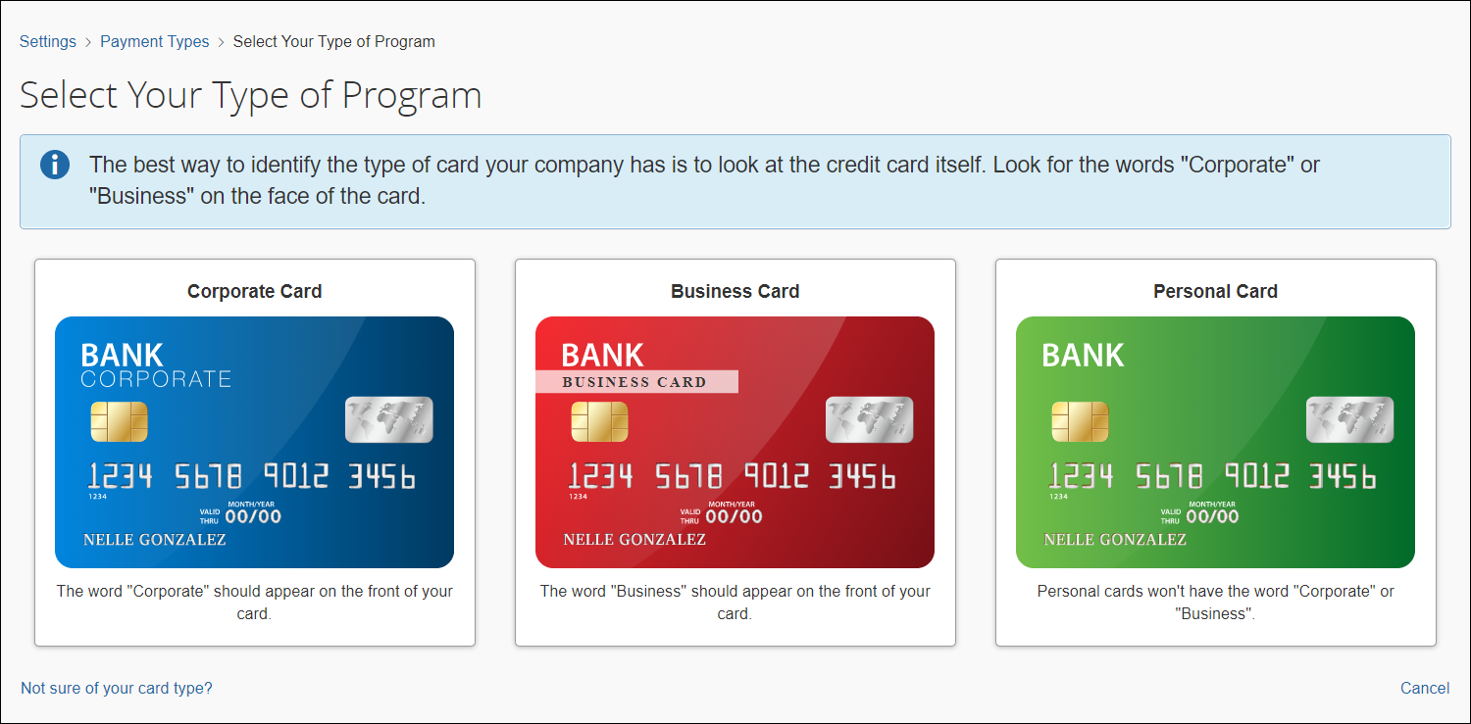
Three card programs are available:
- Corporate Card – Automated data feed from bank issuer for corporate cards configured by the administrator.
- Business Card – Automated data feed from bank issuer for users' business cards configured by the administrator and set up by the user. Users register business credit cards on their Profile page in Profile Settings. Users also manage the data import for their charges from the card provider or manually enter them.
- Personal Card – Automated data feed from a bank issuer for users' personal cards and set up by the user. Users register personal credit cards on their Profile page in Profile Settings. Users also manage the data import for their charges from the card provider or manually enter them.

Selecting the Card Type
To help determine the type of credit card your company has and the card program type, you first need to examine the credit card.
Review the front of the credit to determine the card type:
- Corporate credit cards should have the word "Corporate" printed on the front of the card.
- Business cards should have the word "Business" printed on the front of the card.
- Personal cards do not have "Corporate" or Business" printed on the front of the card.
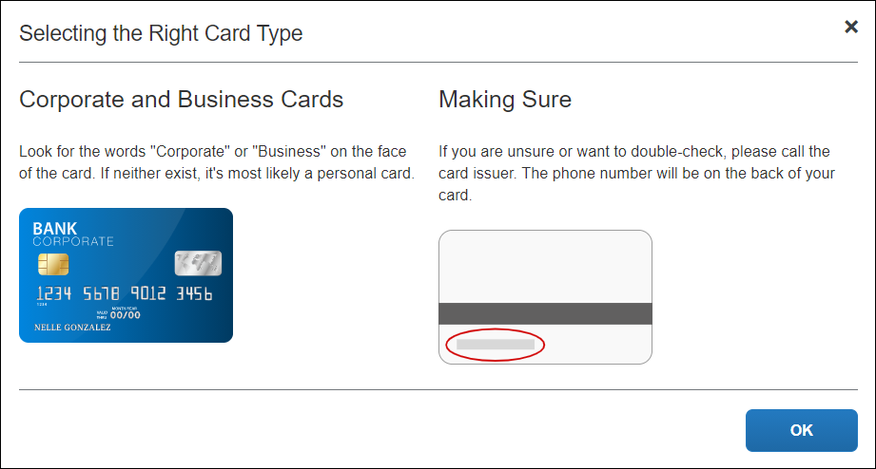
If the type of card is still uncertain, call the card issuer using the phone number printed on the back of the card.
To access the Select the Right Card Type page, click the Not sure of your card type? link in the lower left corner of the Select Your Type of Program page. Click OK to return to the Select Your Type of Program page.

Card Program Details

Card Program Names
Each card program name must be unique. Concur Expense provides a default name when the card program is created. If a card program is accidentally created with the same name as another program, an error message displays.
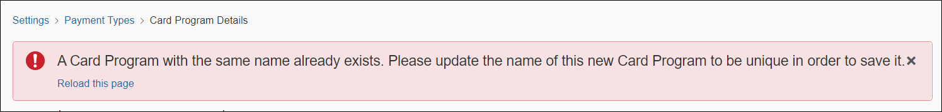
Edit the card program with a unique name and click Save. Or, click Reload this page to refresh the page and return to the Payment Types page to create a new card program.

Create Multiple Card Programs for the Same Billing Recipient, Bill Payor, and Country
If needed, you can create multiple card programs for a card issuer with the same billing recipient, bill payor, and country. Follow the same procedure for setting up the additional card program as you did for the first card program. However, each additional card program name must be unique.
For example, if the first card program is named Citibank VISA Corporate Card IBCP, we recommend including a unique identifier, such as a "2", in the additional card program's name, such as: Citibank VISA Corporate Card IBCP 2. This naming convention helps ensure a unique name for each card program.

Card Registration
Before users can register business and personal credit cards, administrators must create their user accounts in the system. To access the Users page, click User Accounts in the Access to Concur section in Product Settings.
Once users are added to the system, admins can invite users to register their business credit cards. Users register their business cards on their Profile page by clicking Expense Credit Cards under Expense Settings. Users must have an online account created with their card issuer before their credit cards can be registered in Concur Expense.
- For more information, refer to the Register a Credit Card help topic in the Concur Expense Standard Edition End User Help system.

Rich Data Transactions
When transactions with rich data are imported through the credit card feeds, the rich data can take the place of a required receipt. For countries that accept rich data, the presence of rich data fulfills the receipt requirement.
Example: On the Compliance Controls page in Product Settings, the company has set the Car Rental expense type to require a receipt. Chris Miller has a company card transaction for a car rental that includes rich data. Chris will be able to submit the expense report without adding a receipt image to the car rental expense entry, as the rich data counts as an attached receipt.
- For more information, refer to the Client Fact: Sheet Rich Data – Company Card Transactions as Receipts in Standard Edition.

Manage Company Card Programs

Access the Payment Types Page
To access the Payment Types page:
- Click Administration > Expense Settings or Expense & Invoice Settings.
- In the Product list, click Expense.
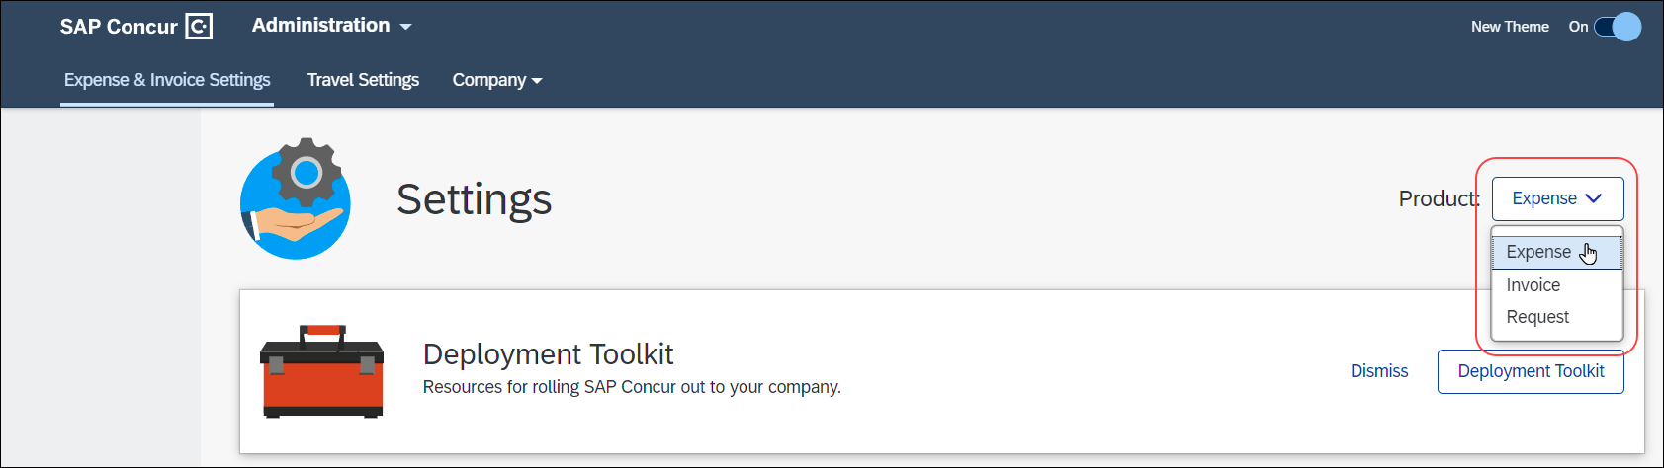
- In the Capturing Spend section, on the Payment Types tab, click Edit.
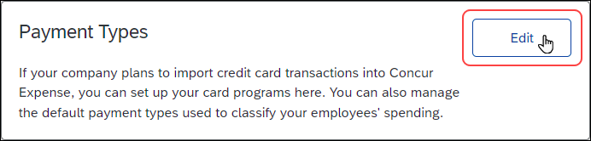
The Payment Types page appears.
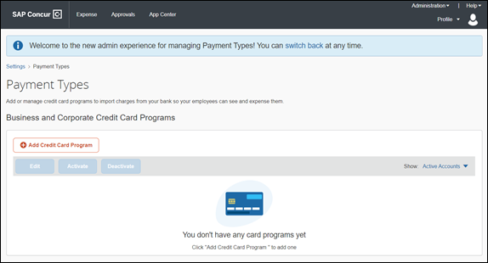

Create Corporate Card Programs
Corporate cards are credit cards are designed for larger businesses and tied to a corporate account.
Corporate cards have a different verification process than business cards, so it is important to know the type of credit card you have before creating card program for it. If you are uncertain, please call the bank issuer for verification.
To create a corporate card program:
- On the Payment Types page, click Add Credit Card Program. The Select Your Type of Program page displays.
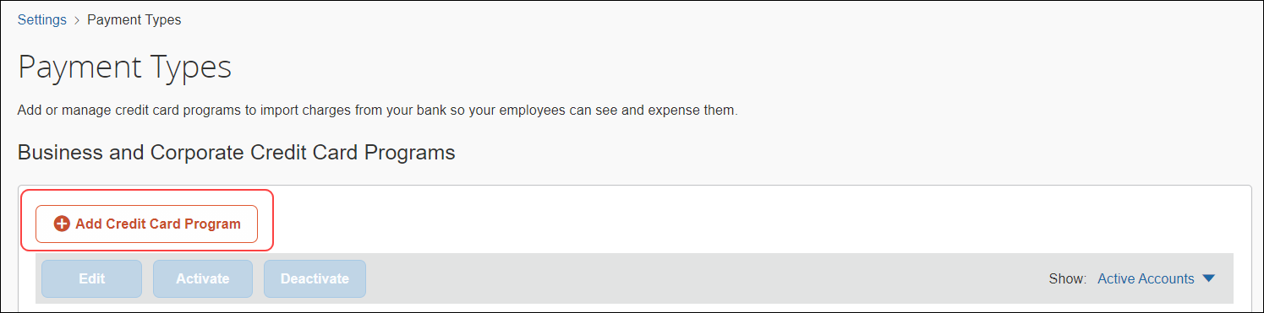
- On the Select Your Type of Program page, click Corporate Card. A Corporate Card Verification page appears.
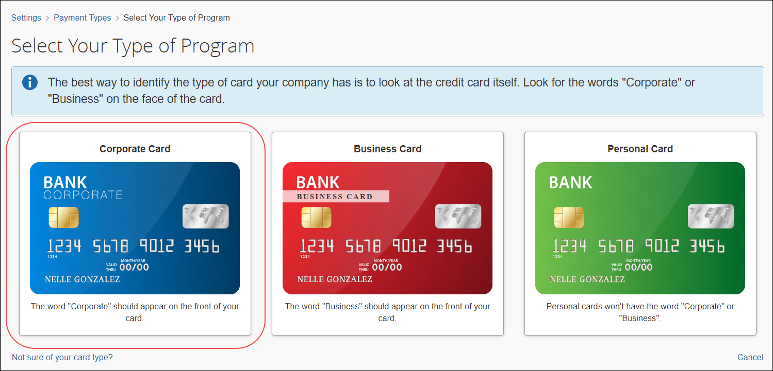
- On the Corporate Card Verification page, verify that the credit card is indeed a corporate card.
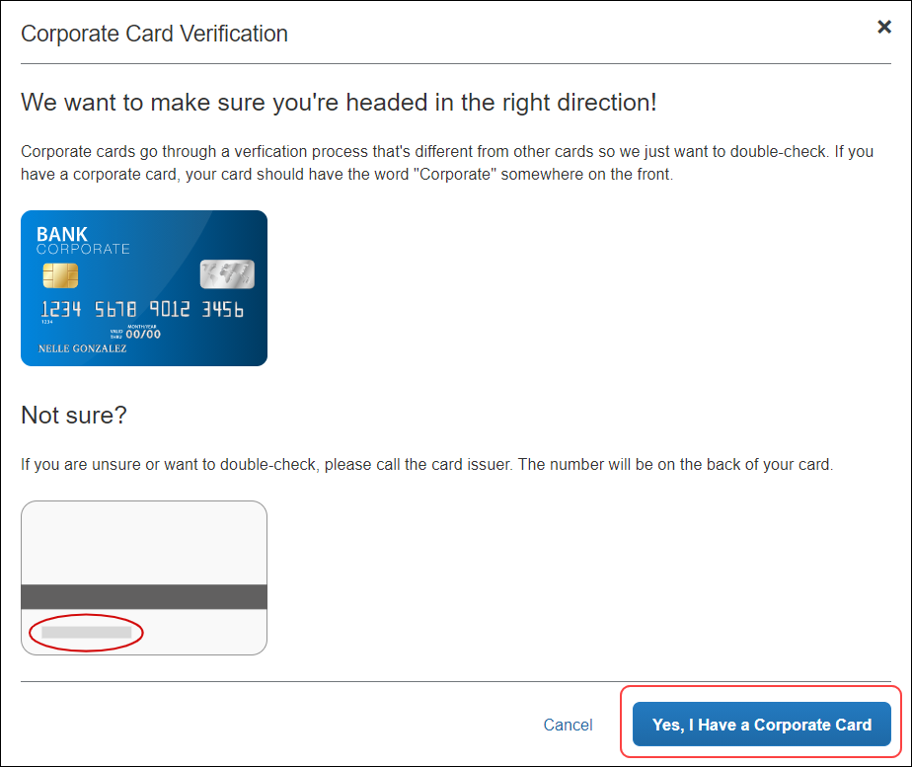
- Click Yes, I Have a Corporate Card to confirm the selection.
The Card Program Details page appears. In the Program Details section, a series of questions will appear to help guide administrators through card program configuration.
- In the From what country/region is the card issued? list, select the country of the card issuer.
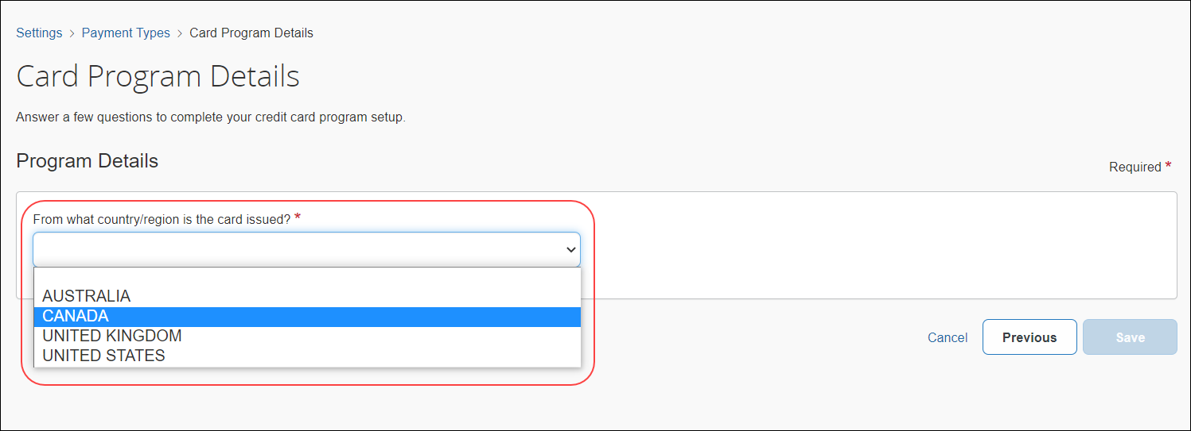
The list of available countries/regions that display is reflective of the Country Pack(s) that are enabled in the system for your company.
If a country or region has only one currency, it is automatically filled in the What is the billing or posting currency? list. If a country or region has more than one currency, select the appropriate billing or posting currency for the card issuer.
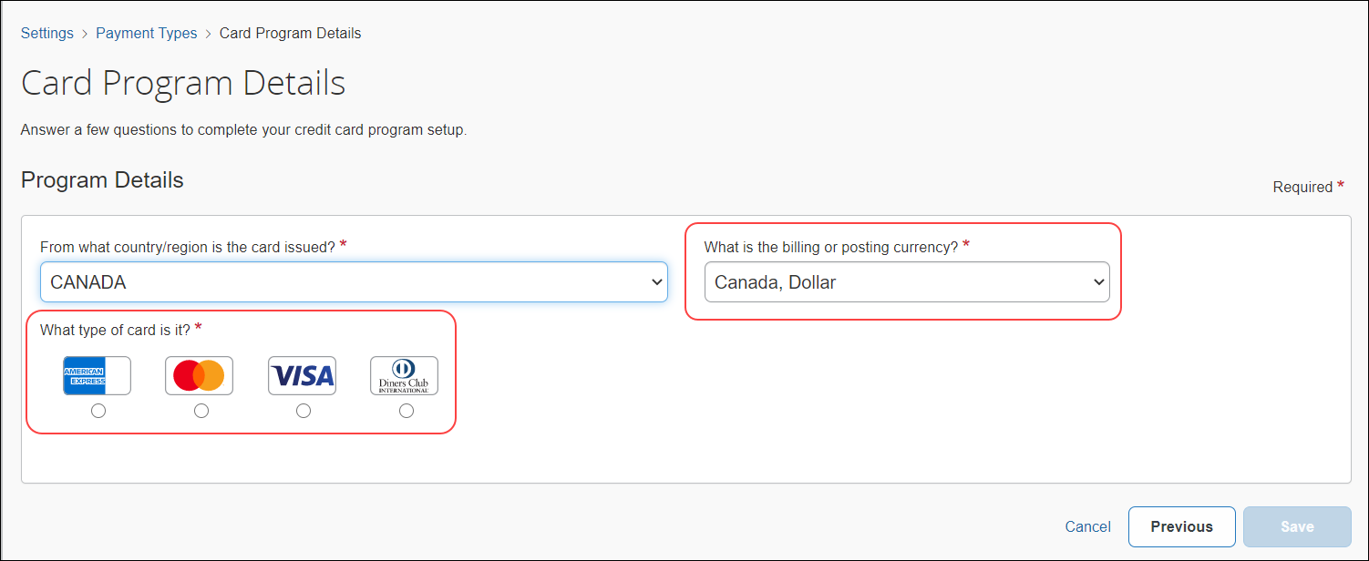
- In the What type of card is it? section, select the applicable card type.
- In the Who issues the card? list, select the card issuer.
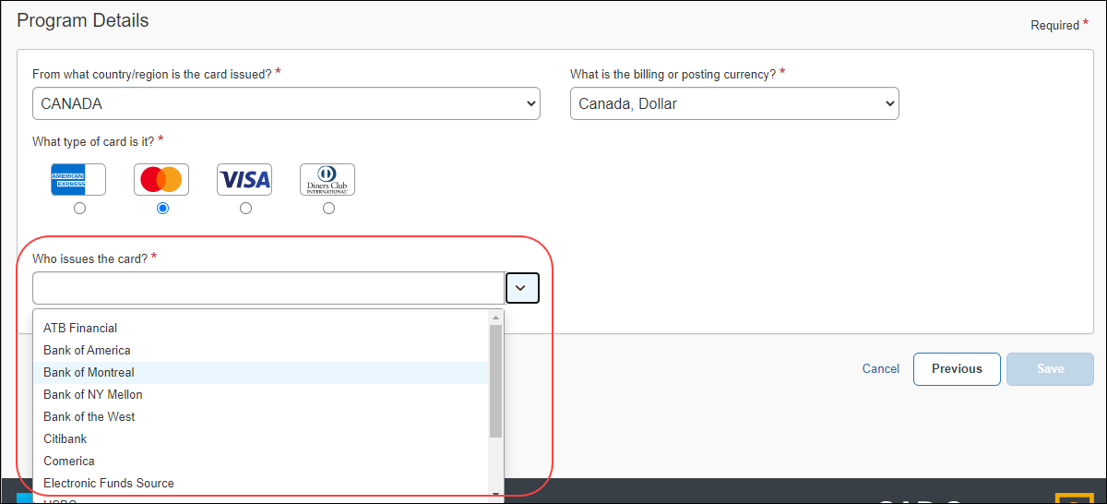
- In the What type of program is it? list, select the card program type: Corporate Card or Purchasing Card.
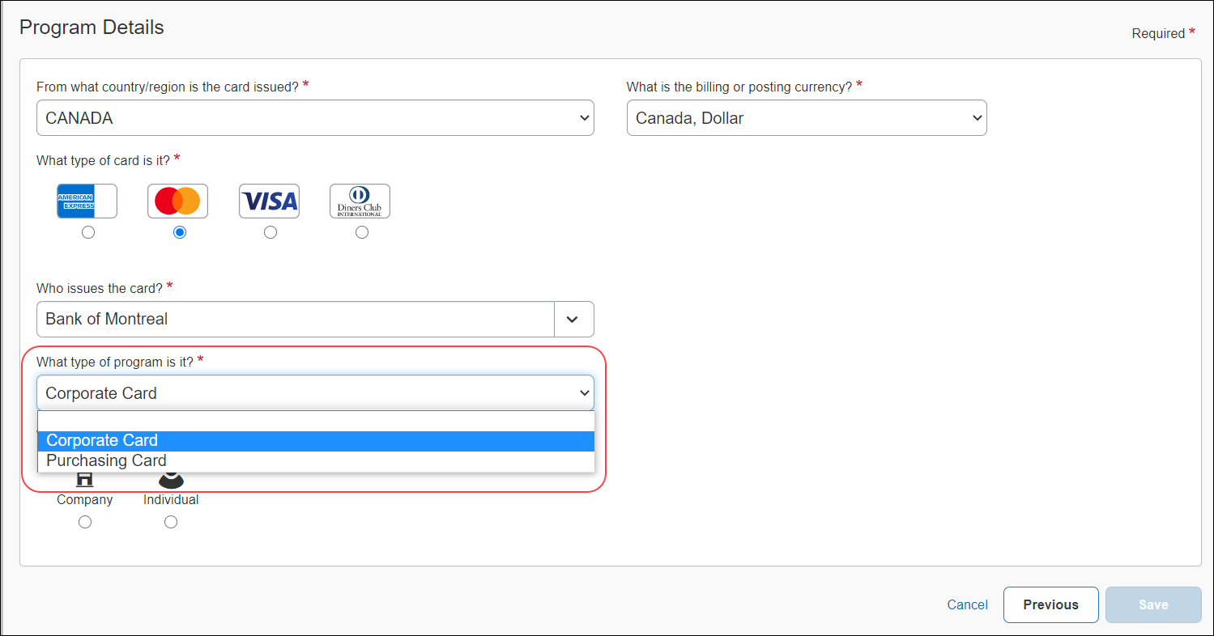
- In the Who receives the card statement? section, select Company or Individual.
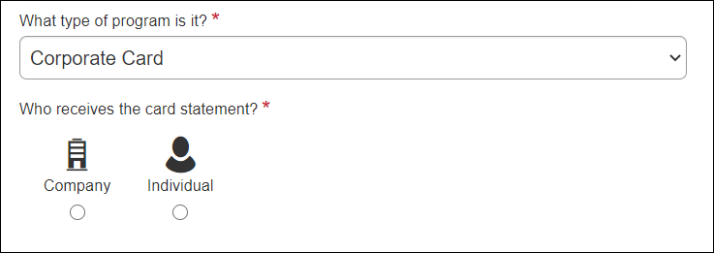
- In the Who pays the issuer of the card? section, select Company or Individual.
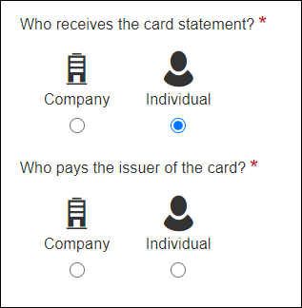
If Company is selected as the recipient of the card statement, the only option to select is Company.
If Individual is selected as the recipient of the card statement, both Company and Individual display as options.
- In the What do you want to name this card program? list, type or edit a name for the card program as needed. A default name automatically displays.
- In the How do you want to pay for this card program? list, select a payment option: Company Check (via Accounts Payable), Expense Pay by Concur, or Other Reimbursement Method.
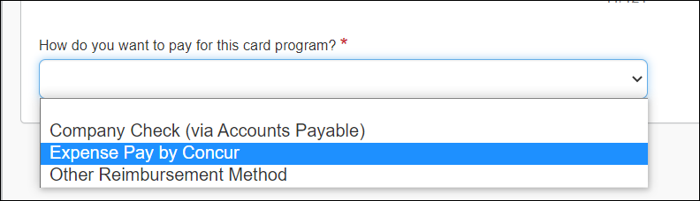
  - If your company uses Expense Pay to pay corporate credit cards, refer to the Validate Credit Card Account Numbers section in this guide.
- Verify whether the Prevent employees from manually entering credit card charges check box should be selected. The option is selected by default.
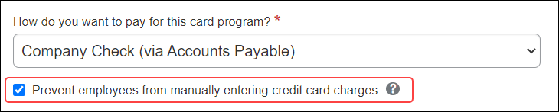
When this option is selected, employees will not be able to manually enter transactions on their expense reports and assign them to this card. Only transactions that come from the automatic card feed will use this payment type. This can be useful to prevent fraud or duplicate transactions.
- Scroll to the bottom of the page and click Save.
The Credit Card Program Added page displays confirming card program setup and outlining the next steps to take with your activation coach.
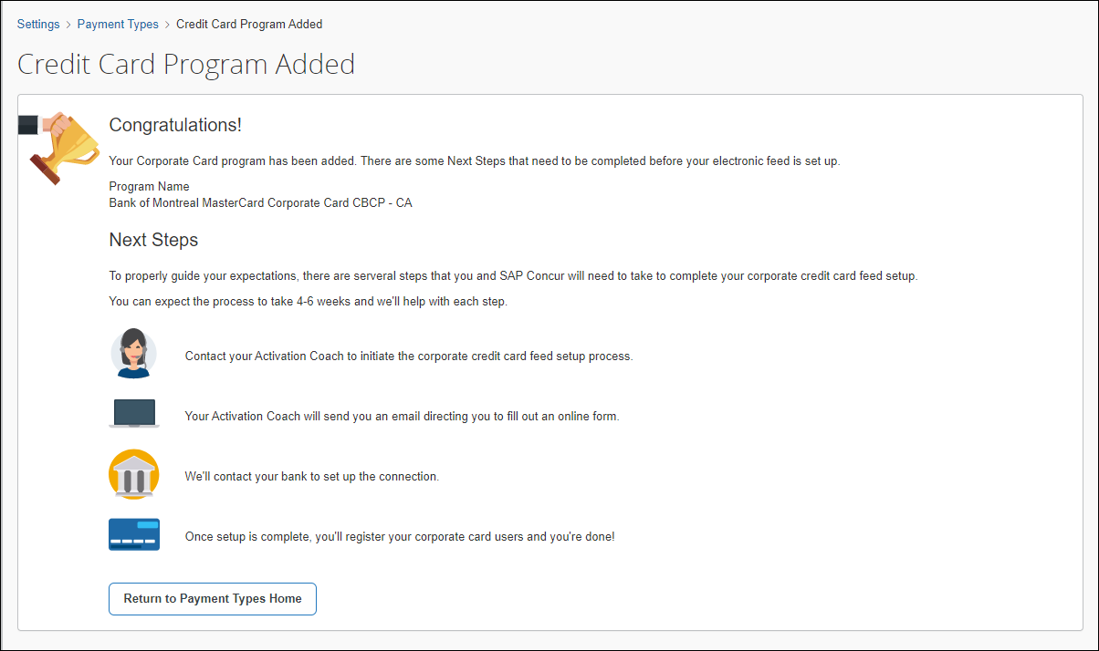
- Click Return to Payment Types Home.
The card program created now appears on the Payment Types page. This card program is automatically set to Active status.
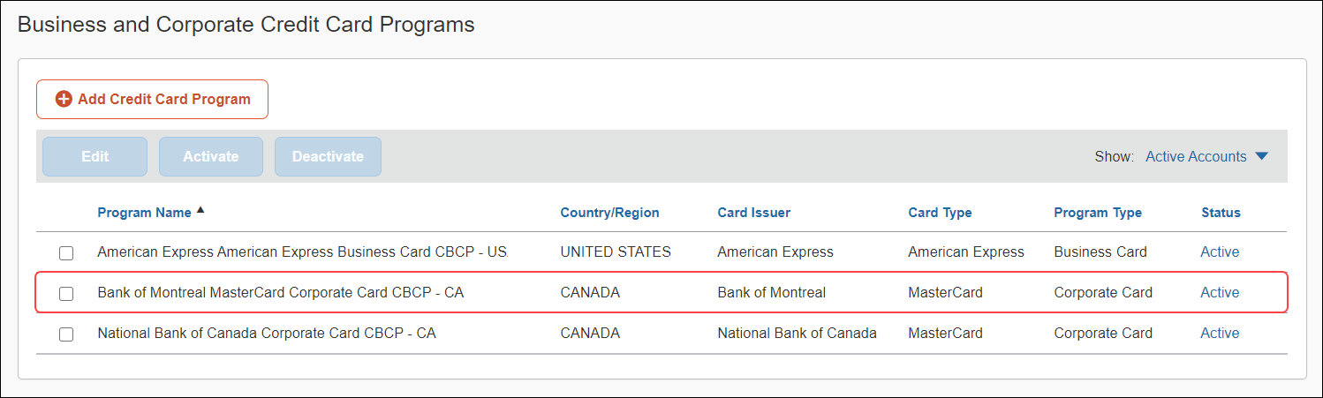
- On the Payment Types page, select the card program that was created and click Edit to review the card program summary, configure accounting codes, and set the payment batch schedule.

Validate Credit Card Account Numbers
Clients who use Expense Pay to pay their corporate card can verify their card's issuer identification number (IIN) to ensure Expense Pay supports payments to that card issuer.
Expense Pay is not supported for every card program.
To validate credit card account numbers for Expense Pay:
- On the Payment Types page, complete the steps to create a corporate card program.
- In the How do you want to pay for this card program? list, select Expense Pay by Concur.
- Click Expense Pay Verification to verify the issuer identification number (IIN) of the card program you are entering. This button only appears if you are using Expense Pay to pay the corporate card.
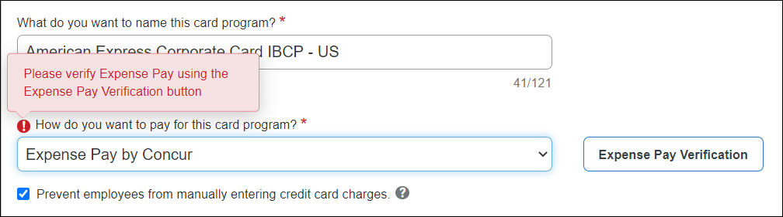
The Issuer Identification Number Verification page displays.
- In the Issuer Identification Number field, type the first six digits of the corporate card account number.
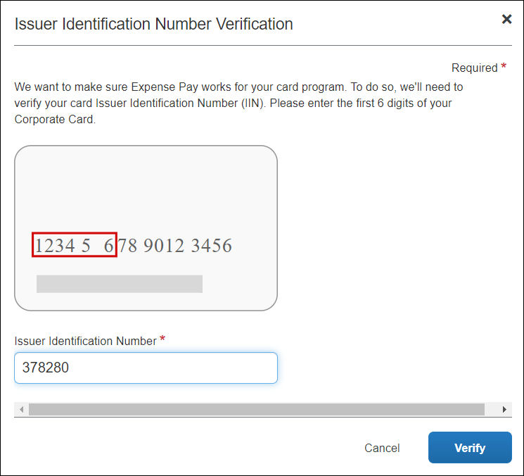
- Click Verify.
When the account number is verified as valid, a confirmation message appears, and you can complete the steps for creating a corporate card program.
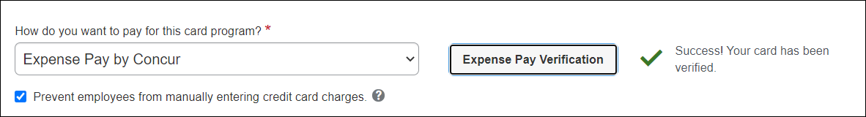
If the account number is not supported by Expense Pay, an error message appears.
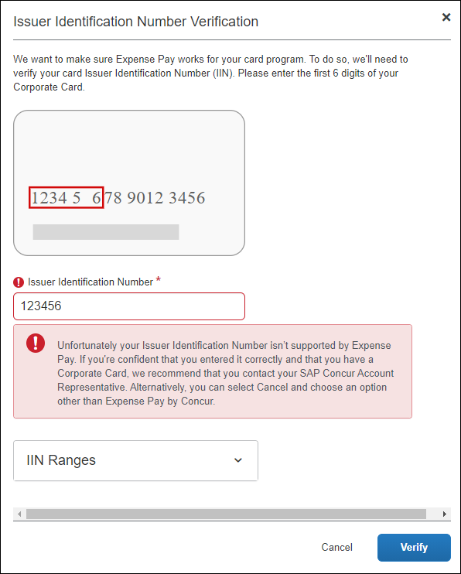
- Click the IIN Ranges list to view valid account number ranges for Expense Pay.
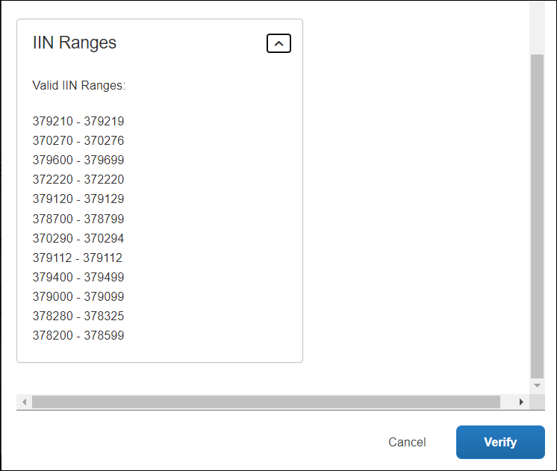
If you are certain you entered the numbers correctly, call your SAP Concur account representative.
- Click Cancel to close the page.
An error message appears on the page informing you that you can still set up the card program if you select another payment option other than Expense Pay by Concur.
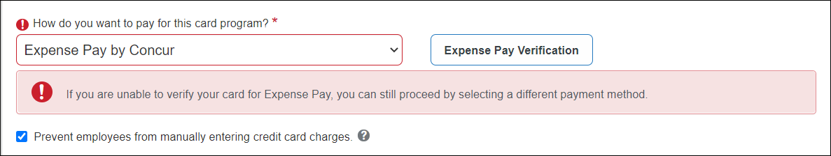
- Click Cancel or Previous to return to the Select Your Type of Program page.

Create Business Card Programs
Business cards are credit cards designed for smaller businesses that my not qualify for a corporate credit card program.
Business card integrations are not yet available for all countries/regions. If you cannot find a business card for your country/region, please contact your SAP Concur representative with any questions.
After program configuration is complete and users are added to the system, users can register business cards by clicking the Add a New Personal Card link on the Expense Credit Cards page in Profile settings.
- For more information, refer to the Card Registration section in this guide.

To create a business card program:
- On the Payment Types page, click Add Credit Card Program. The Select Your Type of Program page displays.
- On the Select Your Type of Program page, click Business Card.
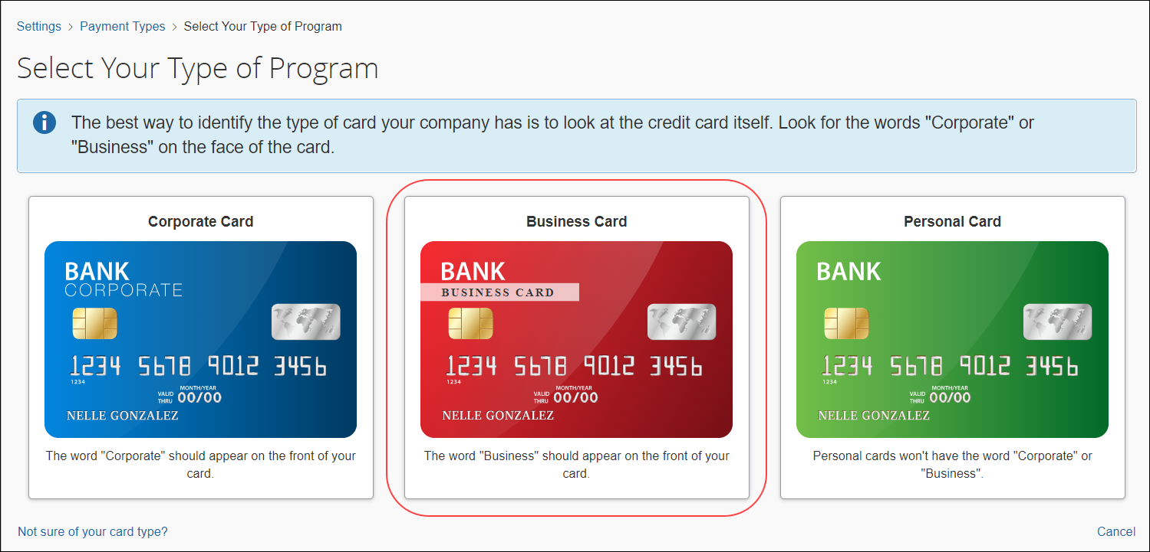
The Card Program Details page appears. In the Program Details section, a series of questions will appear to help guide administrators through card program configuration.
- In the From what country/region is the card issued? list, select the country of the card issuer.
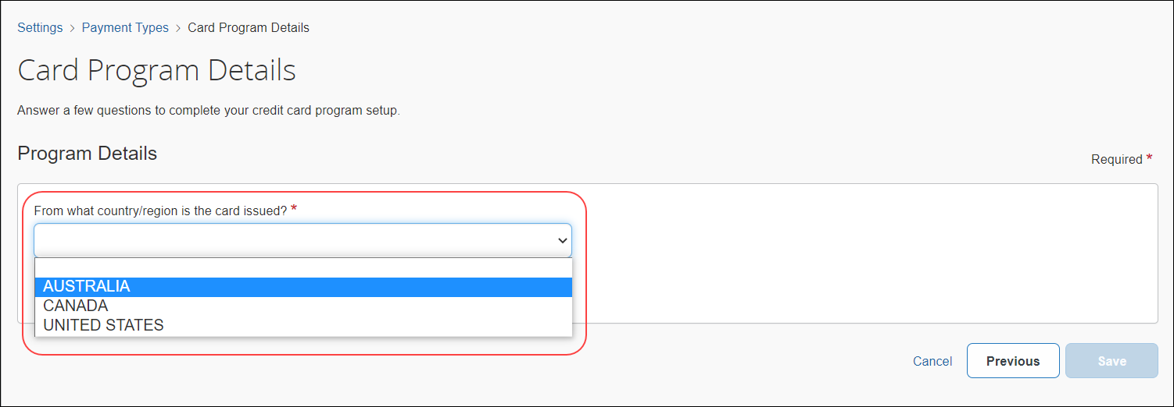
The list of available countries/regions that display is reflective of the Country Pack(s) that are enabled in the system for your company.
If a country or region has only one currency, it is automatically filled in the What is the billing or posting currency? list. If a country or region has more than one currency, select the appropriate billing or posting currency for the card issuer.
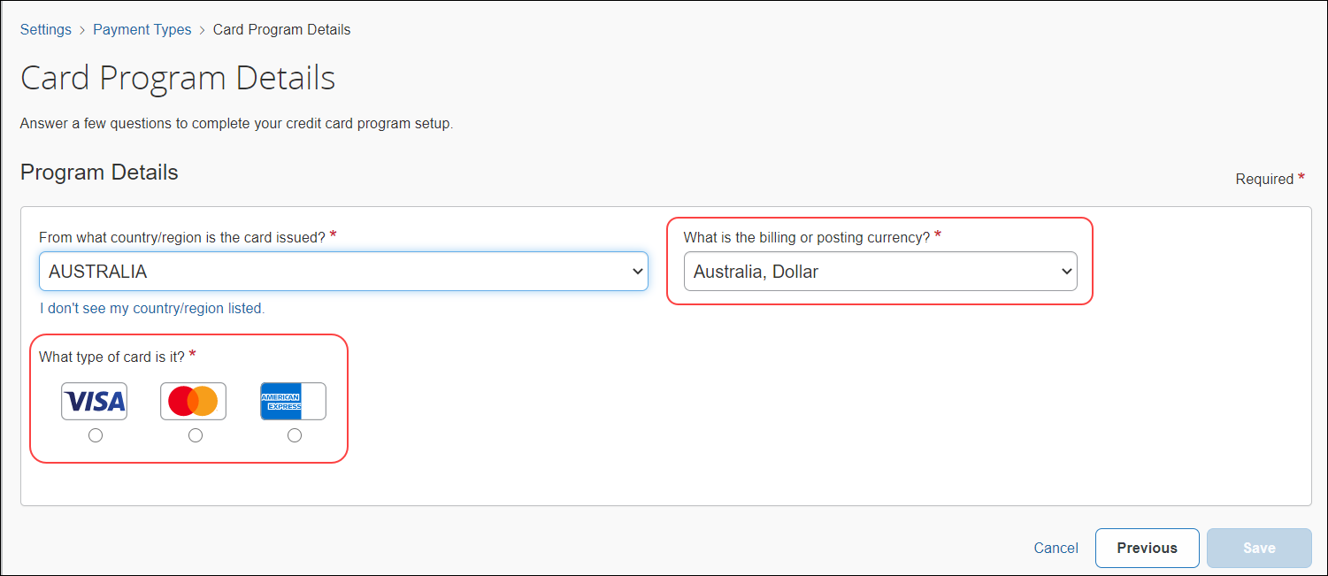
- In the What type of card is it? section, select the card type.
- In the Who issues the card? list, select the card issuer.
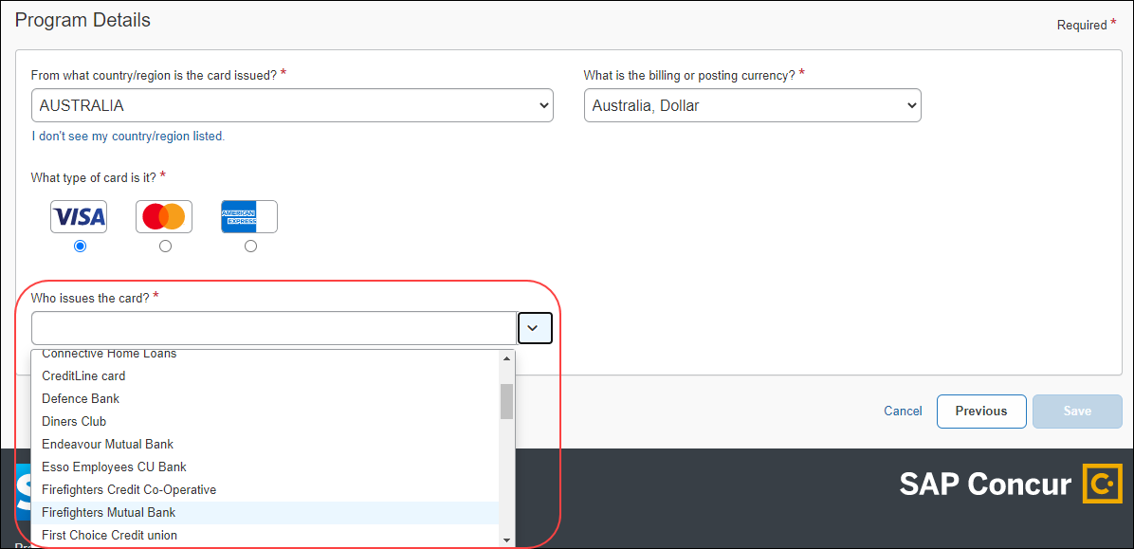
- The What type of program is it? list automatically defaults to Business Card.
- In the Who receives the card statement? section, select Company or Individual.
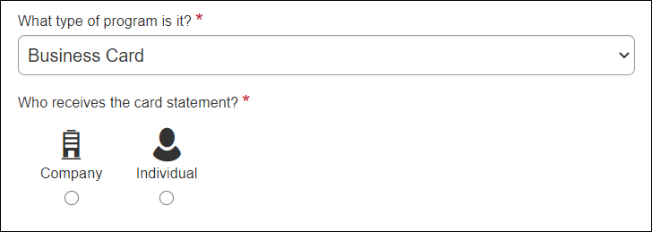
- In the Who pays the issuer of the card? section, select Company or Individual.
If Company is selected as the recipient of the card statement, the only option to select is Company.
If Individual is selected as the recipient of the card statement, both Company and Individual display as options.
- In the What do you want to name this card program? list, type or edit a name for the card program as needed. A default name automatically displays.
- In the How do you want to pay for this card program? list, select a payment option: Company Check (via Accounts Payable) or Other Reimbursement Method.
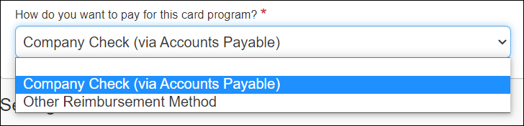
- Scroll to the bottom of the page and lick Save.
The Credit Card Program Added page displays confirming card program setup and outlines the next steps you need to take to ensure successful implementation.
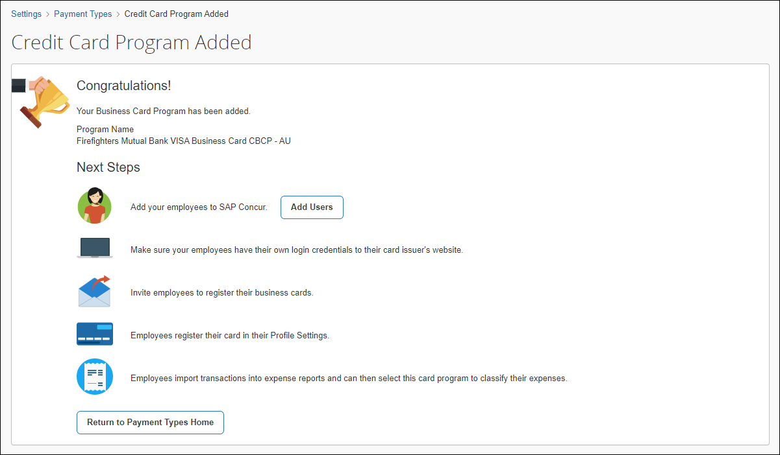
You can opt now to click Add Users to access the Users page and add employees to Concur Expense.
- Click Return to Payment Types Home.
The card program created now appears on the Payment Types page. This card program is automatically set to Active status.
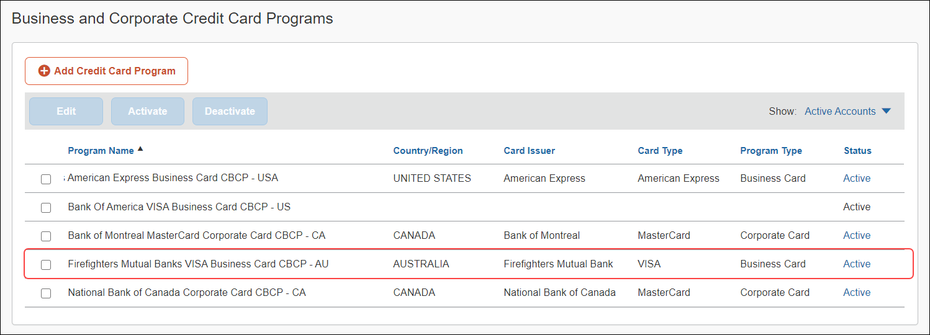
- On the Payment Types page, select the card program that was created and click Edit to review the card program summary, configure accounting codes, and set the payment batch schedule.

Create American Express Business Card Programs
SAP and American Express© have partnered to deliver a business card integration that allows you to sync American Express© business cards with Concur Expense.
Currently, this feature is only available to clients in the United States.
Please refer to the following table to ensure the American Express© Business Card integration is configured correctly. When configured correctly, the Turn on the American Express Business Card Integration activation setting will appear.
American Express Configuration table:
Field | Entry
From what country/region is the card issued? | United States
What is the billing or posting currency? | USD
What type of card is it? | American Express
Who issues the card? | American Express
What type of program is it? | Business Card
Who receives the card statement? | Company
Who pays the issuer of the card? | Company
What do you want to name this card program? | American Express Business Card
How do you want to pay for this card program? | Select Company Check (via Accounts Payable) or Other Reimbursement Method
After program configuration is complete and users are added to the system, users can register American Express© business cards by clicking the Add Amex Business Card link on the Expense Credit Cards page in Profile settings.
- For more information, refer to the Card Registration section in this guide.

To create an American Express business card program:
- On the Payment Types page, click Add Credit Card Program.
The Select Your Type of Program page displays.
- On the Select Your Type of Program page, click Business Card.
- In the From what country/region is the card issued? list, select United States.
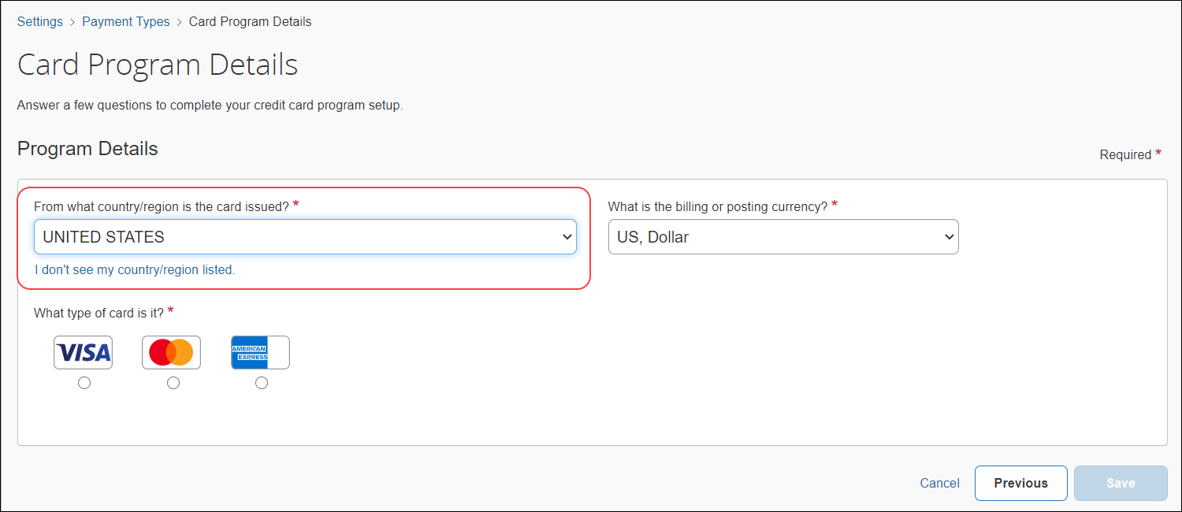
The What is the billing or posting currency? list is automatically filled in with US, Dollar.
- In the What type of card is it? section, select American Express.
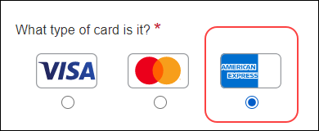
- In the Who issues the card? list, select American Express.
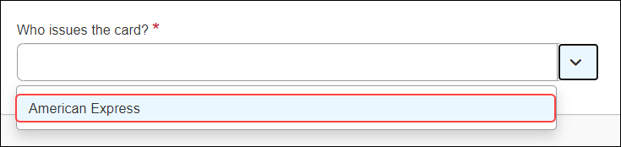
The What type of program is it? list is automatically filled with Business Card.
- In the Who receives the card statement? section, select Company.
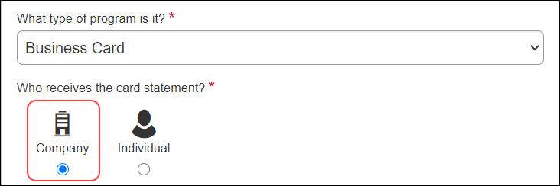
- In the Who pays the issuer of the card? section, select Company.
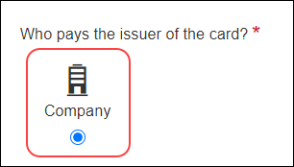
- In the What do you want to name this card program? list, type or edit a name for the card program as needed. A default name automatically displays.
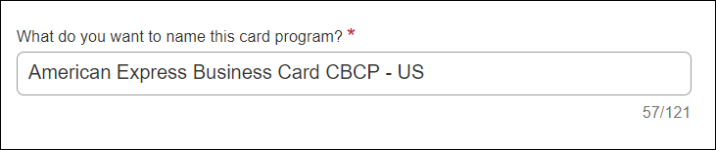
- In the How do you want to pay for this card program? list, select Company Check (via Accounts Payable) or Other Reimbursement Method.
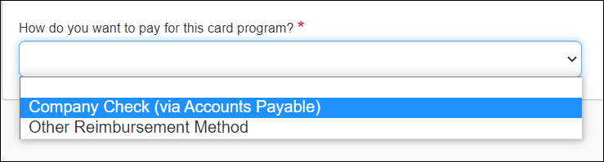
- Select (enable) the Turn on the American Express Business Card Integration check box to activate this feature for your company. This setting is disabled by default.
The card program activation setting only displays if it is configured for US American Express business cards and is set up as Company Bill Company Paid (CBCP).
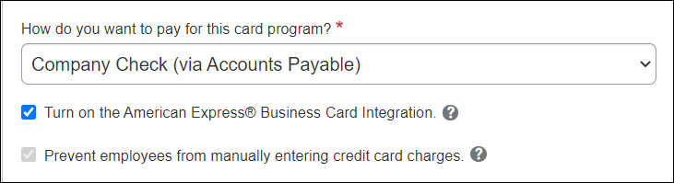
If the Turn on the American Express Business Card Integration check box is selected (enabled), the Prevent employees from manually entering credit card charges check box is automatically selected (enabled).
When the Prevent employees from manually entering credit card charges check box is selected (enabled), employees will not be able to manually enter transactions and assign them to this card. Only transactions that come from the automatic card feed will use this payment type. This can be useful to prevent fraud or duplicate transactions.
If your company is not ready to activate the American Express© business card program, you can leave the both check boxes clear (disabled), save the configuration, and return to enable the feature at a later time.
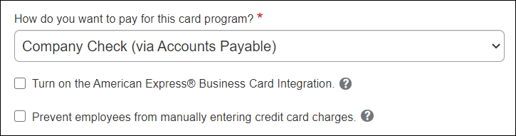
To turn off the American Express Business Card Integration feature, clear (disable) the Turn on the American Express Business Card Integration check box.
- Scroll to the bottom of the page and click Save.
The Credit Card Program Added page displays confirming card program setup and outlines the next steps you need to take to ensure successful implementation.
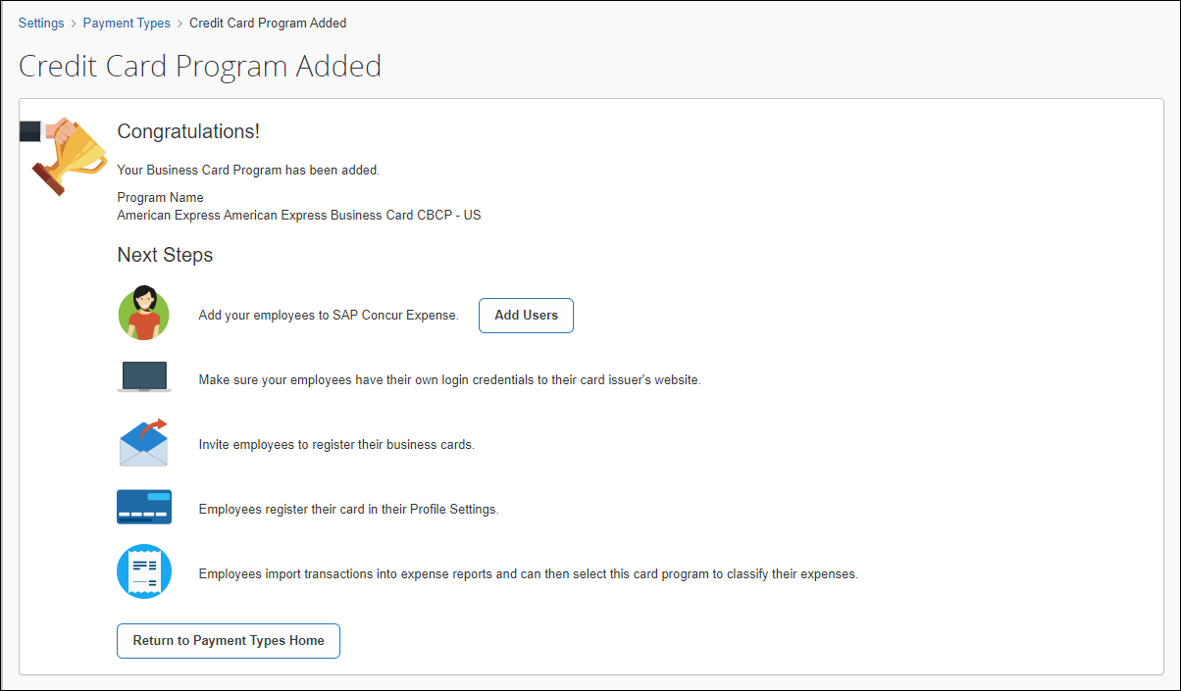
- Click Return to Payment Types Home.
The card program created now appears on the Payment Types page. This card program is automatically set to Active status. A connector icon displays next to the program name to indicate that the card feed has been activated.
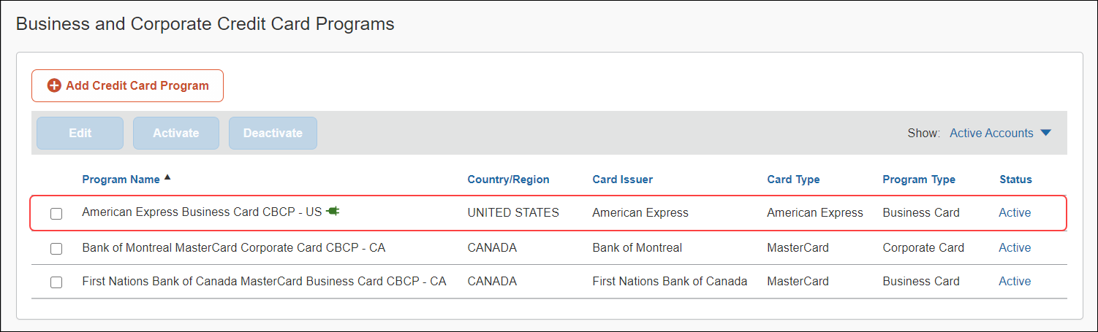
- On the Payment Types page, select the card program that was created and click Edit to review the card program summary, configure accounting codes, and set the payment batch schedule.
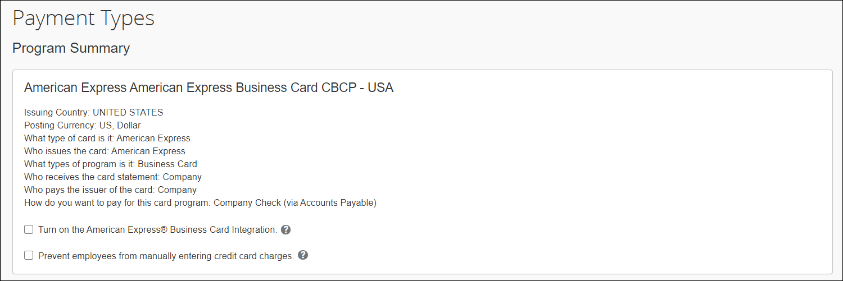

Create Personal Card Programs
Personal cards are personal credit cards issued directly to the employee for their own personal use and are sometimes used to pay for business expenses.
Personal card programs automatically default to an Out-of-Pocket payment type. Employees who import transactions into expense report will have the default payment type of Out-of-Pocket. This default setting will not affect expenses created by importing card transactions of trip segments.
After users are added to the system, users can register personal cards by clicking the Add a New Personal Card link on the Expense Credit Cards page in Profile settings.
- For more information, refer to the Card Registration section in this guide.

To create a personal card program:
- On the Payment Types page, click Add Credit Card Program. The Select Your Type of Program page displays.
- On the Select Your Type of Program page, click Personal Card.
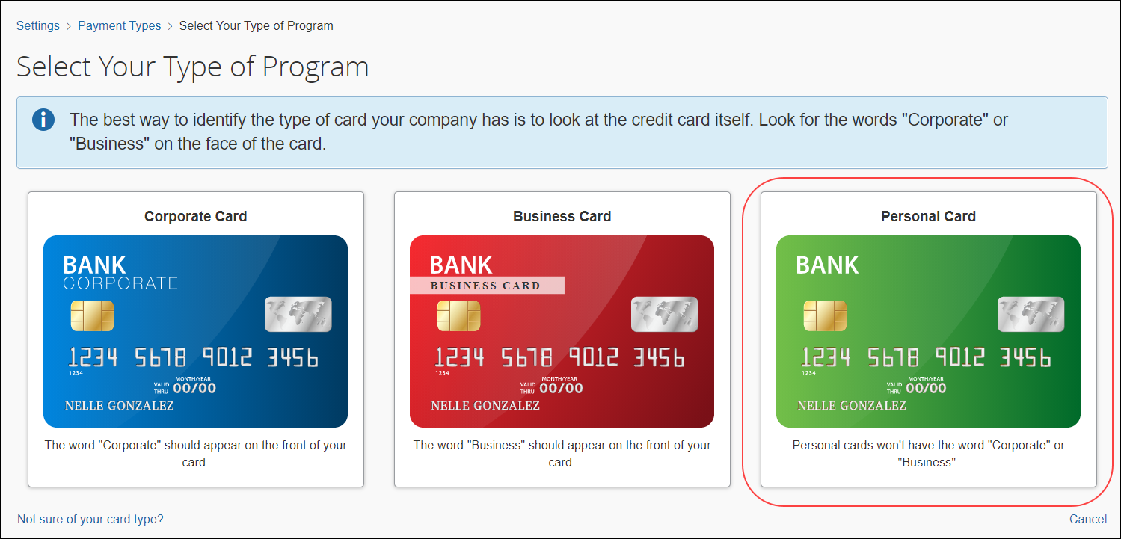
The Personal Cards Next Steps page appears.
- On the Personal Cards Next Steps page, review the action item steps that need to be completed for users to successfully register their personal credits cards in the system.
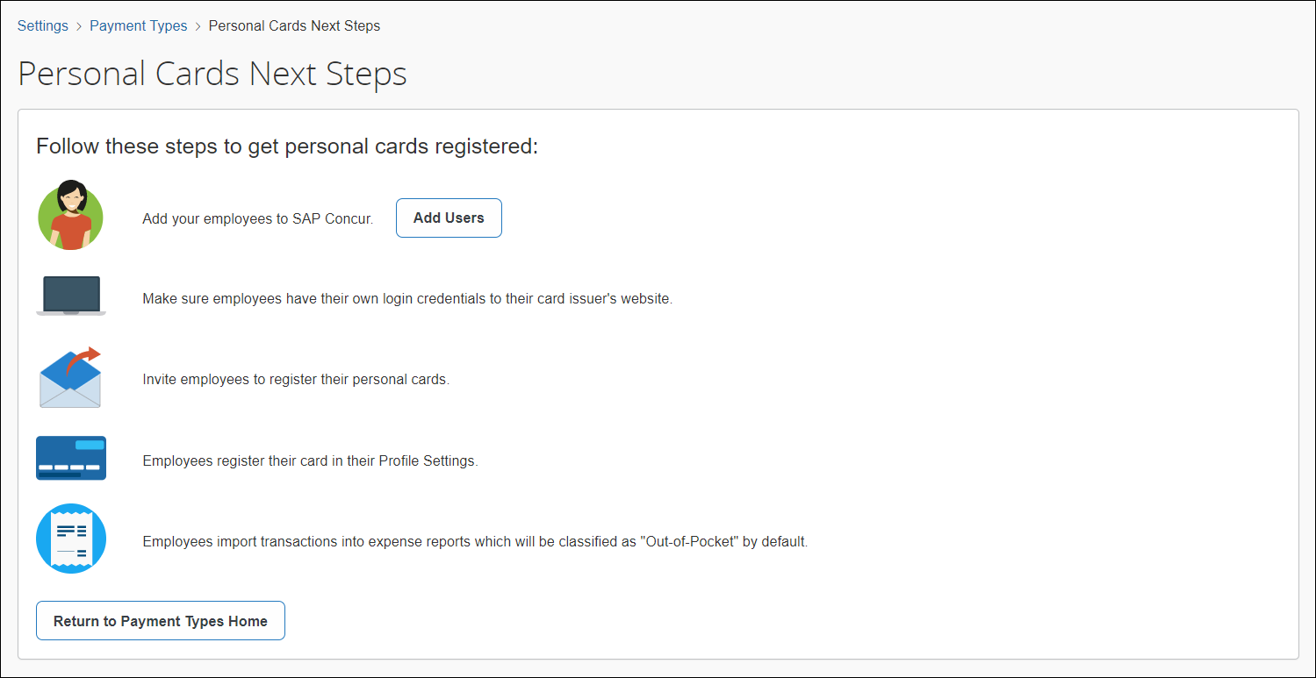
The Personal Cards Next Steps page outlines the following steps:
- Add employees to Concur Expense
- Ensure employees have login credentials to their card issuer's website
- Invite employees to register their personal cards
Once employees have registered their personal cards in the system, they can import transactions into expense reports which will be classified as Out-of-Pocket by default.
- Click Add Users to access the Users page and add users to the system.
- Click Return to Payment Types Home.

Filter Card Programs
Once card programs are created, you can filter card program display using the Show filter. This filter defaults to Active Accounts.
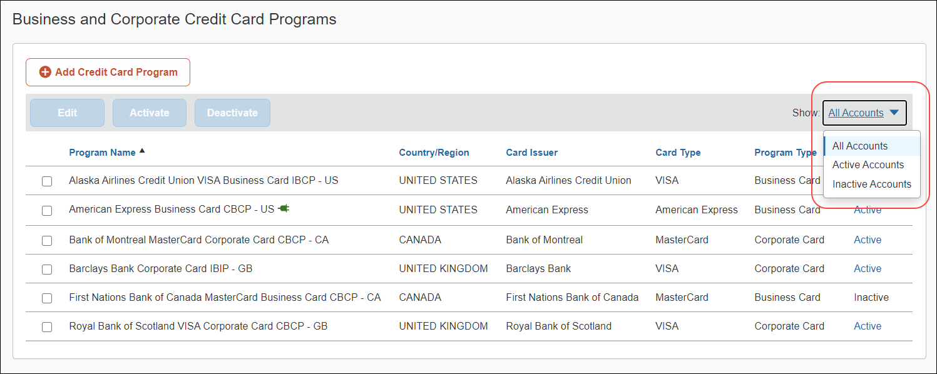
Click in the Show list to select: All Accounts, Active Accounts, or Inactive Accounts.

Modify Card Programs
You can edit, deactivate, and activate card programs.

Edit Card Programs
Once you have created a card program, you can only edit fields on tabs in the Settings section, such as modifying the batch schedule or editing an account code.
To edit card program information:
- Select the check box next to the card program you want to edit.
- Click Edit.
- Change fields as necessary on tabs in the Settings section.
- Click Save.

Deactivate Business Card Programs
You can only deactivate business card programs. Deactivating a business card program is useful when your company changes banks or credit cards issued by a bank. When this happens, you will want to deactivate the old card program to discontinue its use.
Also, if a card program is accidentally configured incorrectly, you can deactivate it and create a new card program with the correct configuration.
Corporate card programs can only be deactivated by an SAP Concur administrator. Contact SAP Concur support to request deactivation of a corporate card program.
Personal card programs are managed by the user in their Profile settings.
To deactivate a business card program:
- Select the card program that you want to deactivate.
- Click Deactivate.
A message appears confirming the successful deactivation of the card program.
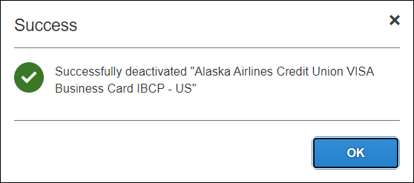
- Click OK.
The deactivated card program no longer displays in the card program list if the Show filter is set to Active Accounts.
To reactivate a business card program:
- In the Show list, select Inactive Accounts.
- Select the card program you want to reactivate and click Activate.
A message appears confirming the successful activation of the card program.
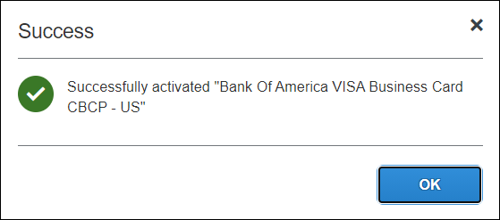
The card program now displays in the card program list when the Show filter is set to Active Accounts and All Accounts.

Configure Accounting Codes
The Accounting tab allows you to configure your accounting codes for each card program. The codes entered on this page are included in the accounting export file for the card program. We recommend completing this step with someone who is familiar with your company's accounting practices.
If you connect Concur Expense to your financial system using one of the SAP Concur financial integrations, you may see options on the Accounting tab specific to your financial system.
- Refer to the setup guide for your financial system integration for details.

To enter account codes:
- On the Payment Types page, select the card program for which you want to enter account codes.
- Click Edit.
- In the Settings section, click the Accounting tab.
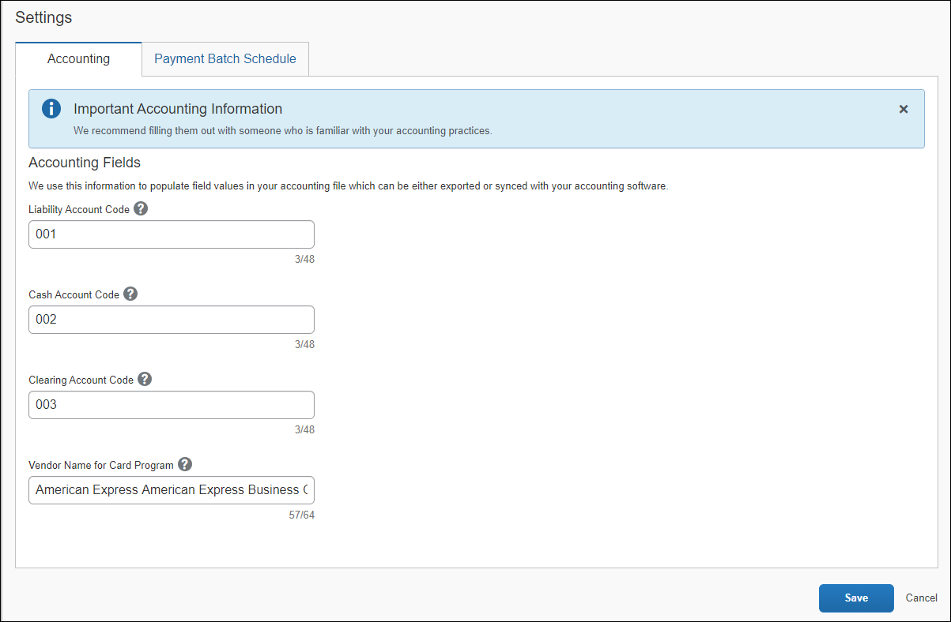
- Fill in the liability, cash, and clearing account codes.
Account Codes Reference table:
Field | Description
Liability Account Code | This is the accounting code that appears in the accounting file "Payment Demand Company Liability Account Code" field for payment made to this card program.  The Liability Account Code field may be used to record when expenses are incurred. Clients may use this field to capture a code that represents an offset account in the GL extract. This account code commonly represents the credit in the expense accounting entry.  NOTE: This field does not appear for QuickBooks clients.
Cash Account Code | This is the accounting code that appears in the accounting file "Payment Demand Company Cash Account Code" field for payments made to this card program.  The Cash Account Code field may be used to record when expenses settle. Clients may use this field to capture offsets against transactions that directly impact the bank accounts. This account code commonly represents the credit in the payment accounting entry.  NOTE: This field does not display for companies that use one of the SAP Concur financial integrations, such as QuickBooks, Xero, Sage, Intacct, etc.
Clearing Account Code | This is the accounting code that appears in the accounting file "Payment Demand Company Cash Account Code" field for payments made to this card program.  The Clearing Account Code field may be used to book amounts in the company’s ledger that the employee owes back to the company when they have charged amounts that are not going to be reimbursed on a company paid card.  NOTE: This field only displays if the payment type is Company Bill/Company Paid (CBCP).
Vendor Name for Company Credit Card Program | (Optional) This field allows clients to enter the Vendor ID value for the card issuer of your company-paid card program.  If clients choose to populate this field, the value is available for output into their accounting file. If they have multiple company paid card programs, they can set this value independently for each company paid card program they create in the system.
- Click Save.
Once accounting codes are entered, you can now set the payment batch schedule.

Set Batch Schedules for Payments
Batch scheduling is used to set the dates that a payment batch is closed (preventing any new payment demands from being entered) and processed.
Definitions table:
Term | Definition
Batch | A group of payment demands.
Payment Demand | The collection of all payment requests for a single payee (such as a card issuer) for a report. A report with five expenses would have a single payment demand for the total of the expenses.
The Payment Manager tool in Company > Tools allows administrators to view and manage batches of expense reports ready for reimbursement. The Payment Manager tool automatically closes the batches and creates the transaction file for the batch based on the schedule selected.
The batches close at the end of the day on the selected dates. If you are using Expense Pay, the batches are also sent to the payment engine on that day.
If you change the schedule once there is an open batch, the system waits until the current batch is completed (using the old schedule), then opens a new batch using the new schedule. Any reports that reach the Pending Payment status go into the current open batch.
- For more information, refer to Concur Expense: Payment Manager User Guide for Standard Edition.

To schedule the batch:
- On the Payment Types page, select the card program for which you want to set batch schedule.
- Click Edit.
- In the Settings section, click the Accounting tab.
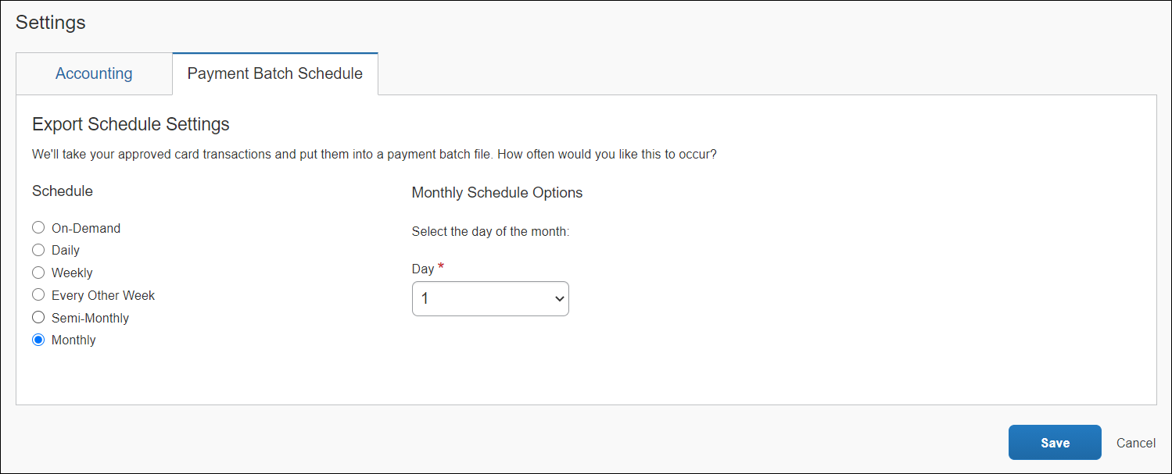
- Select the export schedule settings for the card program.
Batch Scheduling Settings table:
Schedule | Description
On-Demand | The batch will remain open until you manually close it in Payment Manager.
Daily | The batch closes daily at the end of the day.
Weekly | The batch closes at the end of the day on the selected day(s) of the week.
Every other week | The batch closes at the end of the day on the selected day of the week, every other week. The administrator selects the weekday, and the batch closes on the second occurrence of that day.  Example: On Monday, the administrator chooses the Every other week schedule and selects Thursday as the weekday. The next Thursday (3 days later) is the first occurrence of the weekday and marks the end of the first week. The Thursday after that is when the batch closes for the first time.
Semi-Monthly – Days of Month | The batch closes at the end of the day on the two selected days of the month.
Monthly | The batch closes at the end of the day on the selected day of the month.  NOTE: If you use Expense Pay, you can account for banking holidays by setting the Monthly option to six calendar days prior to your payment due date. These six calendar days will account for three banking days for processing plus three non-banking days for the weekend plus a bank holiday. If you set the day of the month six calendar days out, you may pay your card prior to the due date. If you choose this option, you will avoid the need to modify the batch close date around bank holidays.
- Click Save.
Now you can view and manage batches in Payment Manager. If you have not yet entered accounting codes, you can do so on the Accounting tab.

Set Up Funding Accounts
Funding accounts are the bank accounts that Expense Pay draws funds from to fund reimbursements paid to employees or card programs.
When Expense Pay by Concur is selected as the reimbursement method, the Funding Account tab appears in the Settings section of the Card Program Details page.
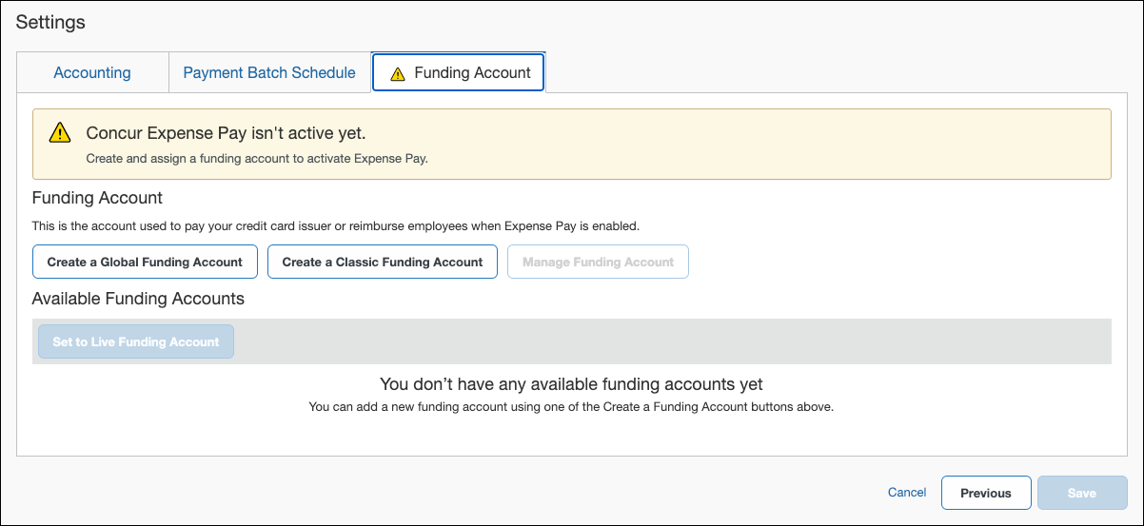
The Funding Account tab allows you to:
- Create a funding account to activate Expense Pay
- Manage the funding account
- Set the funding account to active
- For more information, refer to Concur Expense: Expense Pay User Guide for Concur Standard Edition or Concur Expense: Expense Pay Global User Guide for Concur Standard Edition.

Remittance Information Tab
Once a funding account is set up, the Remittance Information tab may appear for certain payment type methods. This functionality is only available with certain card issuers. The fields on this tab vary by card program.
The Remittance Information tab allows you to enter details required by your card issuer to ensure correct allocations of your payments. The fields on this tab will change depending on which card issuer you are using. Concur Expense will send the payment and payment allocations to your card issuer.
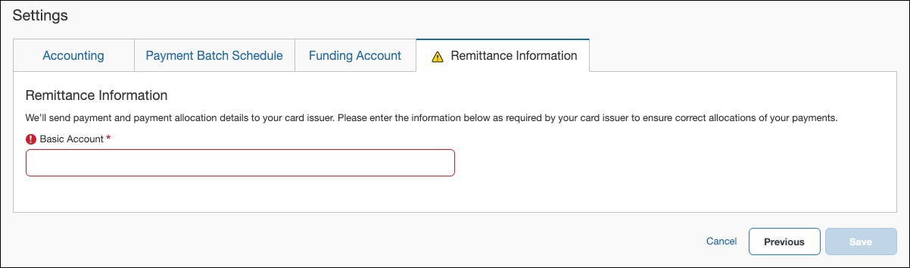
- For more information, refer to Concur Expense: Expense Pay User Guide for Concur Standard Edition.

Manage System Payment Types
The System Payment Types section of the Payment Types page provides an overview of the payment types your company uses to pay expenses. You can sort this list by clicking on the arrow next to each column header.
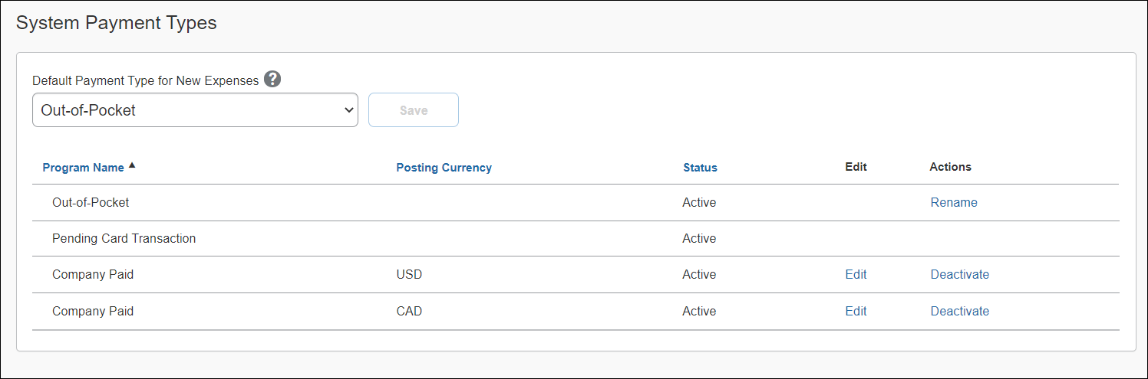
In the System Payment Types section, you can:
- Review all active and inactive payment types
- Sort the payment types list by column
- Change the default payment type for new expenses
- Rename the Out-of-Pocket payment type
- Edit the payment type
- Deactivate the payment type status

Change the Default Payment Type
There are three payment types that can be set as the default payment type:
- Company Paid
- Out-of-Pocket
- Pending Card Transaction
The default payment type is Out-of-Pocket. When a user creates a new expense, this will be the default payment type.
The default payment type setting will not affect expenses created by importing card transactions or trip segments.

To change the default payment type:
- In the Default Payment Type for New Expenses list, select an item as the new payment type.
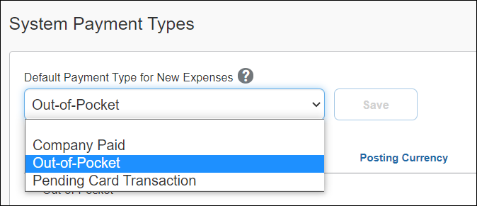
- Click Save.

Rename the Default Payment Type Label
If you intend to rename the label for the default payment type, please keep in mind that the name of this payment type should retain the original intent. For example, another common name for "Out-of-Pocket" is "Cash".
To rename the Out-of-Pocket payment type:
- In the payment types list, click Rename in the Actions column for the Out-of-Pocket payment type.
- In the Rename the Out-of-Pocket Payment Type field, type in a new name.
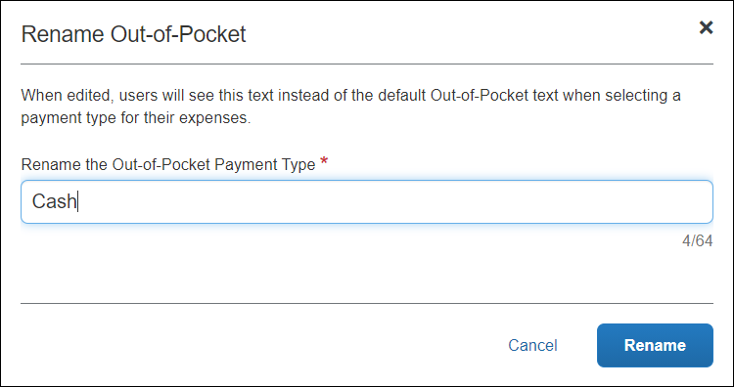
- Click Rename.
The new name displays as the default payment type.
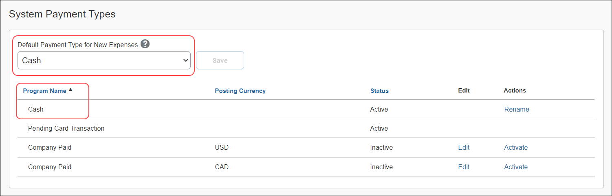

Edit Payment Types
Editing the payment type involves updating accounting fields for the card program.
To edit a payment type:
- In the Edit column, click Edit for the payment type you wish to modify.
- On the Accounting tab, edit the account codes or vendor name of the card program.
- Click Save.

Deactivate Payment Types
You can only deactivate the Company Paid payment type. The only reason to deactivate the Company Paid payment type is if your company does not want employees to use it.
To deactivate a payment type:
- In the Actions column for the payment type you want to deactivate.
- Click Deactivate.
The payment type now displays as Inactive in the Status column.
- To re-activate this payment type, click Activate.
☼

