Applies to these SAP Concur solutions:
Expense
Professional/Premium edition
Standard edition
Travel
Professional/Premium edition
Standard edition
Invoice
Professional/Premium edition
Standard edition
Request
Professional/Premium edition
Standard edition
Concur Expense: Payment Card Integration Service
Setup Guide for Standard Edition
Last Revised: October 13, 2023
Table of Contents
Payment Card Integration Service 1
Section 1: Permissions 1
Section 2: Overview 1
Required Roles 1
Section 3: Configuring Payment Card Integration 2
Login With the Correct Credentials 2
Confirm the Card Provider App Availability in Concur App Center 2
Configure the Payment Type for the Payment Card Service 4
Configure the Card Integration for the Payment Type 7
Authorize the Card Provider for Expense 9
Section 4: Appendix 11
Using Rule Types to Create Country-Specific Data Imports 11

Revision History
Date | Notes / Comments / Changes
October 13, 2023 | Various minor updates and remove the DRAFT watermark.
September 15, 2023 | Initial publication of this guide.

Payment Card Integration Service
NOTE: Multiple SAP Concur product versions and UI themes are available, so this content might contain images or procedures that do not precisely match your implementation. For example, when SAP Fiori UI themes are implemented, home page navigation is consolidated under the SAP Concur Home menu.

Permissions
A company administrator may or may not have the correct permissions to use this feature. The administrator may have limited permissions, for example, they can affect only certain groups and/or use only certain options (view but not create or edit).
If a company administrator needs to use this feature and does not have the proper permissions, they should contact the company's SAP Concur administrator.
Also, the administrator should be aware that some of the tasks described in this guide can be completed only by SAP Concur. In this case, the client must initiate a service request with SAP Concur Customer support.

Overview
The Payment Card Integration service uses a purpose-designed API-based enhanced data delivery service that allows card networks, issuing banks, and FinTech partners to directly deliver custom credit card data to SAP Concur. This offers the card partner a method to send data in near real-time while providing self-service card data onboarding to Concur clients.
This service allows clients working with participating financial institutions to use the SAP Concur App Center to link their corporate and business card types directly to the Concur Expense product’s Card functionality. The purpose of a service-driven solution is to reduce manual steps and delays in authorization in favor of a direct, authorized method increasingly endorsed by the banking community and in full control of the client.

Required Roles
The client will need the Can Administer role to perform the steps to successfully complete integrating Card data using the Payment Card Integration service.
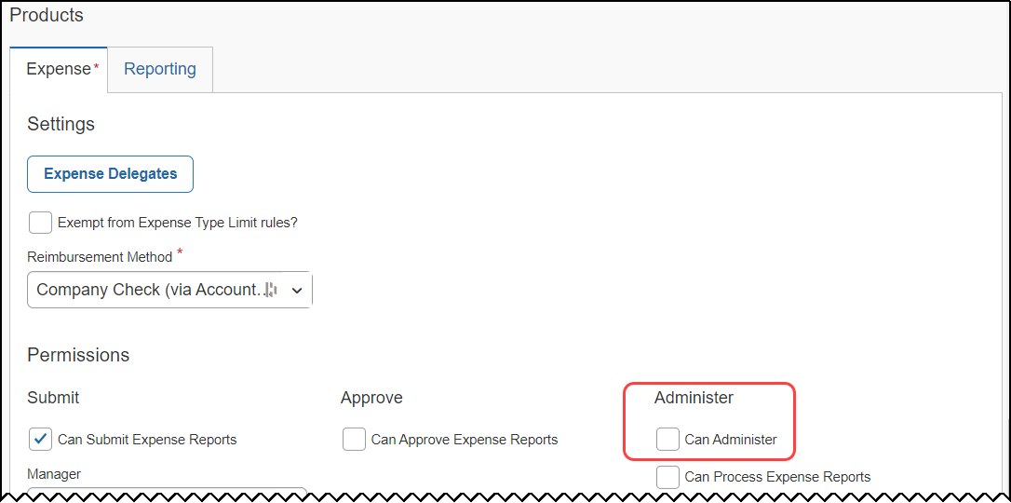
For more information, refer to the Shared: Users Setup Guide for Standard Edition.

Configuring Payment Card Integration
The procedures in this document allow the administrator to configure Expense to request API-based integration with card partners. This leverages the card vendor’s ability to push card data, using APIs, directly to Expense. The Concur App Center makes available the vendor apps required to perform this action. The client will use the following steps to successfully integrate Expense to the vendor:
- Login to Expense with the correct credentials
- Confirm the vendor app is available in the Concur App Center
- Configure the Payment type(s) and the Card type(s)
- Authorize the card vendor to send data directly to Expense
- (Optional) Create Rule Types for differing card data

Login With the Correct Credentials
To begin, ensure the administrator has both the Card Admin and the Web Services roles prior to login.
Roles are assigned using the Administration > Expense Settings > User Accounts option on the Settings page.

Confirm the Card Provider App Availability in Concur App Center
Before configuration, best practice is to search for and confirm the availability of the card vendor’s presence in the Concur App Center before proceeding.
To confirm the card vendor’s app availability:
- Navigate to and click App Center.
- In App Center, perform a search using the vendor’s name or similar identifying keywords, such as Archa or HyperCard.
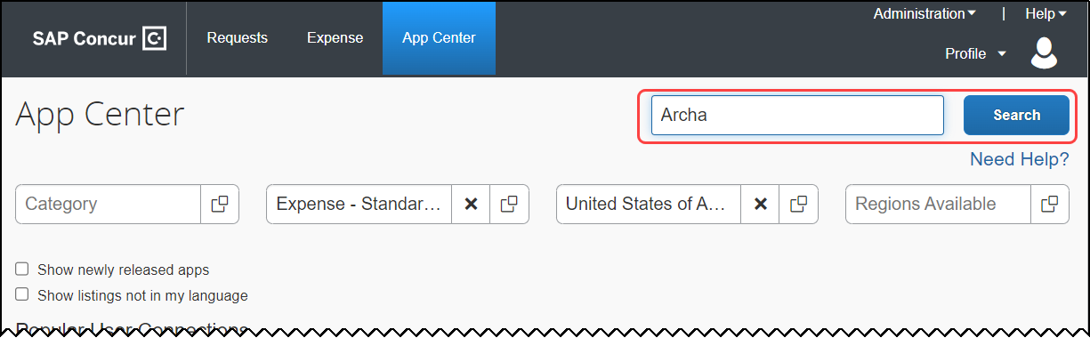
- Click Search.
- The App Center returns all applicable apps - confirm the vendor app appears.
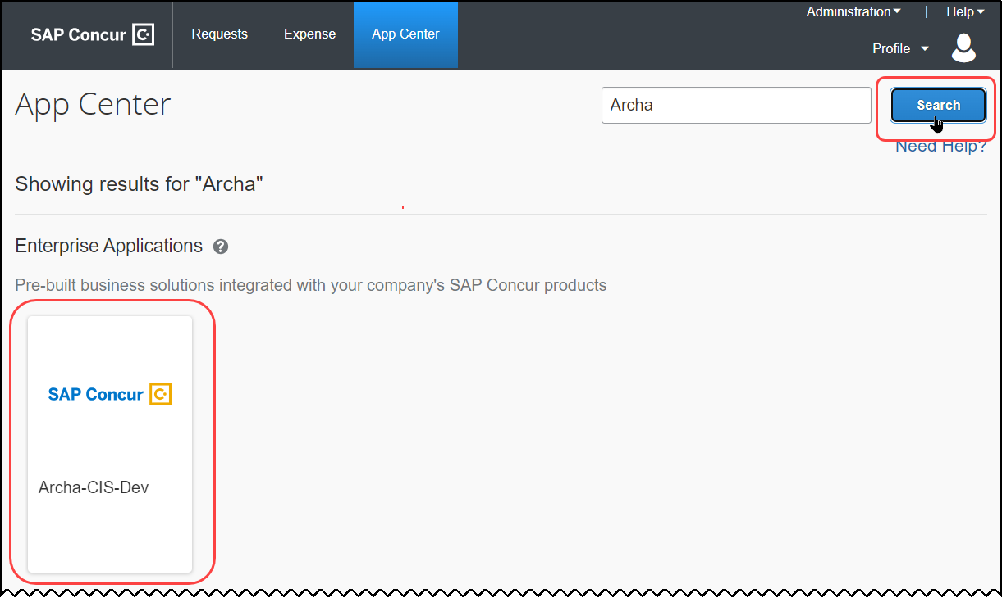
If the vendor is not found, contact Concur Support to determine availability and next steps.
- Click the tile directly to open the app, then confirm that the Connect button is active (see below) and is not inactive (grayed out).
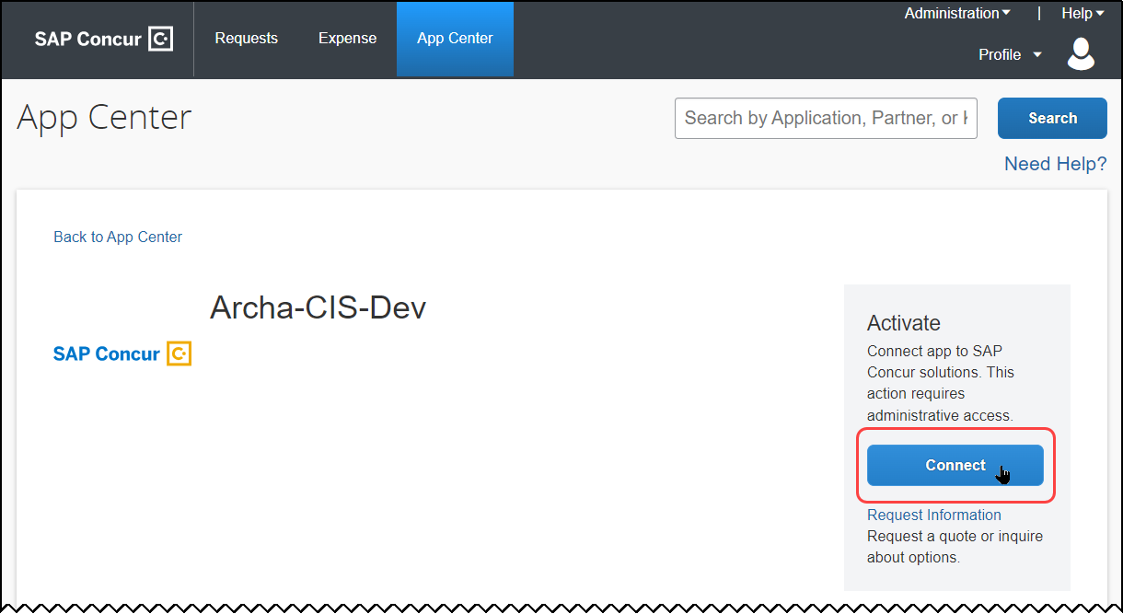
- Exit the App Center to return to the SAP Concur home page.

Configure the Payment Type for the Payment Card Service
The Payment Type Name and Card Program configuration is required to identify and assign the imported data using the Payment Card Integration service.
For more information, refer to the Concur Expense: Payment Types Setup Guide for Expense Standard.
To configure the payment type:
- Click Administration > Expense Settings.
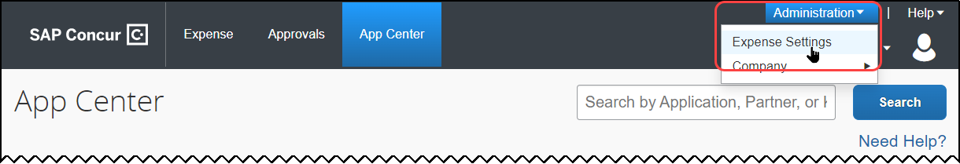
- On the Settings page, scroll down to Payment Types, then click Edit.
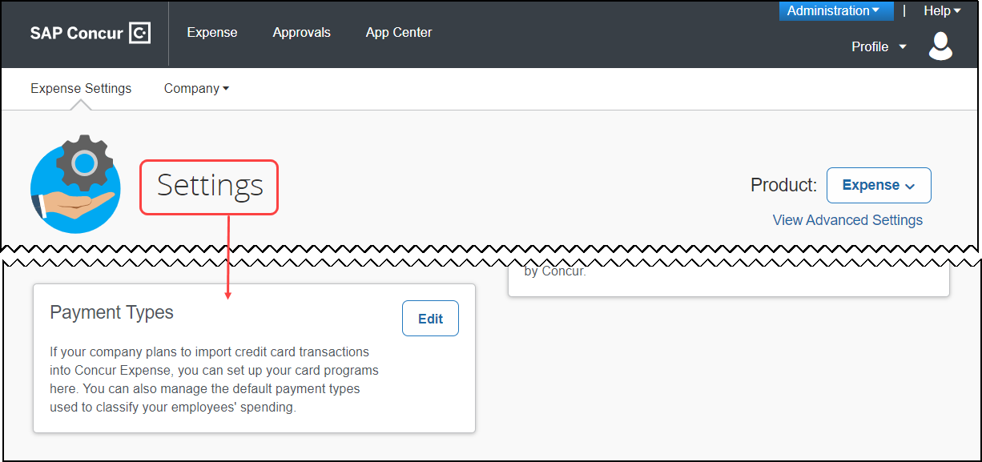
- On the Payment Types page, click Add Credit Card Program.
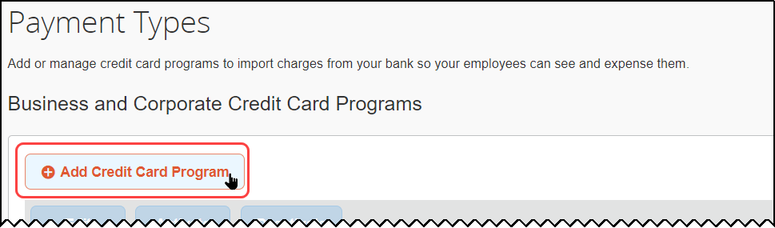
- On the Select Your Type of Program, click the Corporate Card tile.
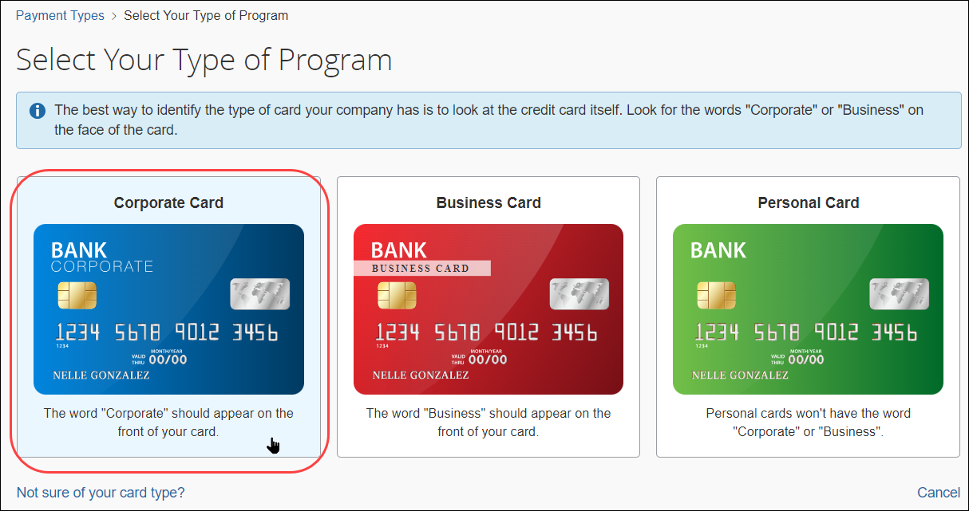
If you have validated that your card issuer is present in the App Center, click Corporate Card regardless of the wording on your credit card.
- Confirm the choice by clicking Yes, I Have a Corporate Card.
- In the Card Program Details page that appears, enter values for the following options:
- The country/region choice for the card issuer and the currency, if different from the default
- The card type and the card issuer
- The card program type
- The liability type (who receives the card statement) and the card payee (who pays the balance of the card statement)
- The name (retain the default or type a new name)
- Select how the card should be paid in reimbursement
- Permissions to allow or disallow employees from manually entering credit card data
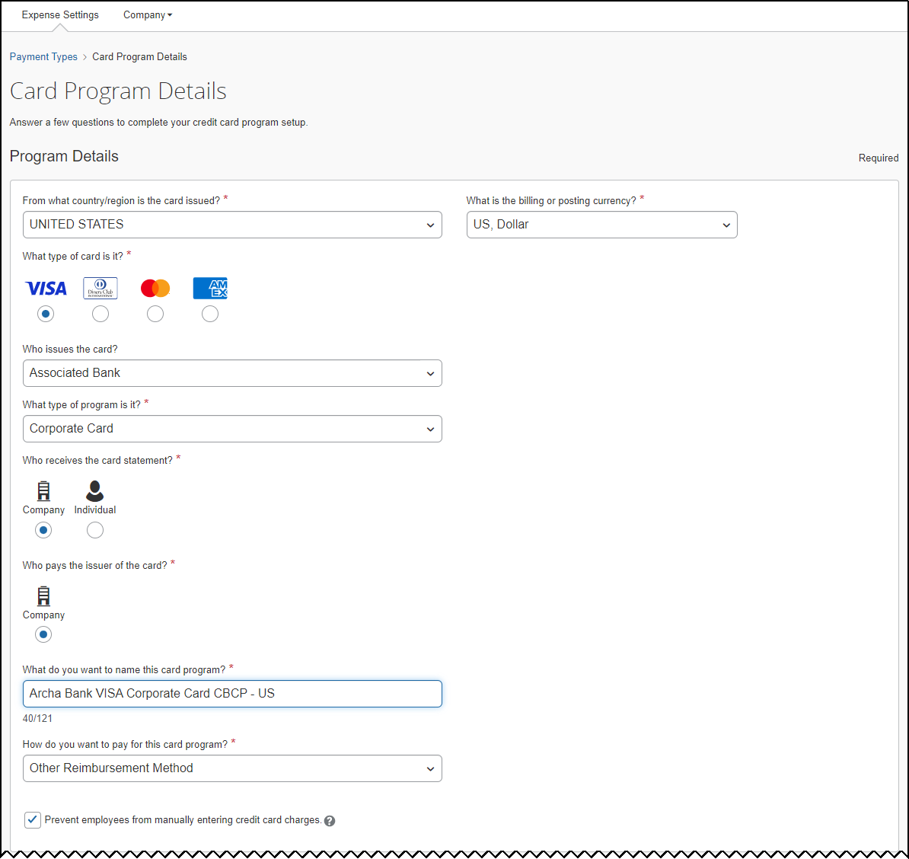
- Fill out all other fields as needed under Settings.
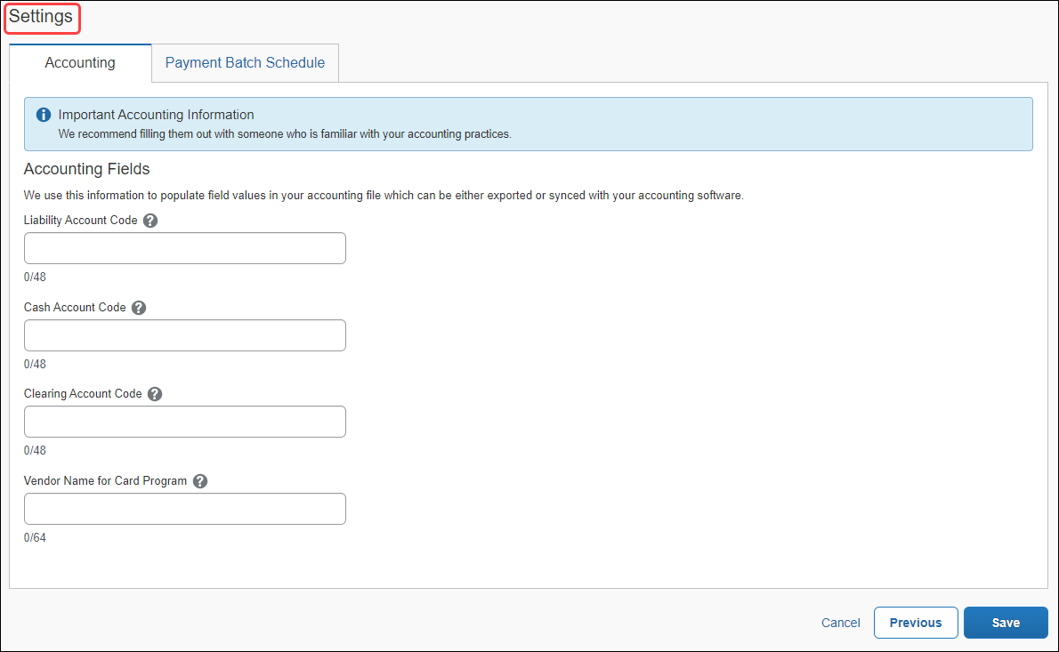
- Click Save.
The Credit Card Program Added page appears. You may disregard the Next Steps at this time and proceed directly to configure the card integration to use the newly created Payment Type Name configuration.
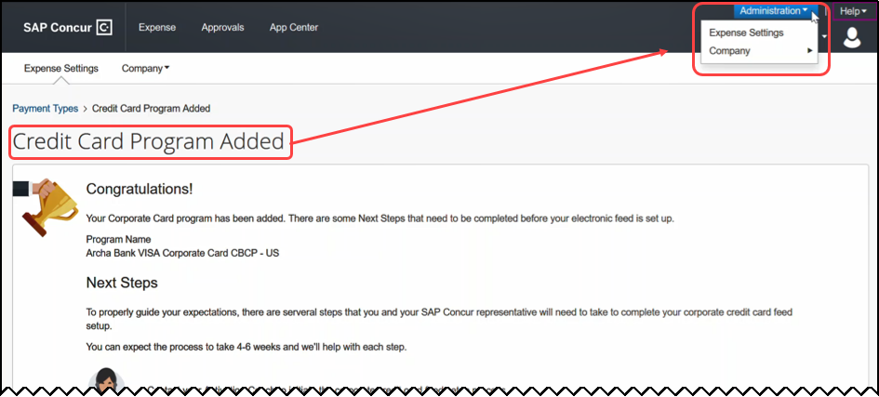

Configure the Card Integration for the Payment Type
The administrator now uses the Card Integration Admin tool to associate the payment type to a card integration.
To configure the card integration:
- Click Company > Tools, then Card Integration Admin.
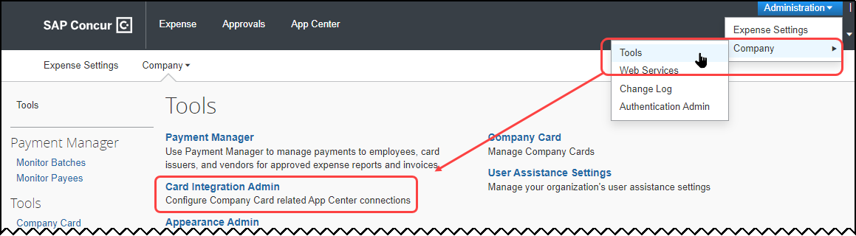
- Click Create Integration.
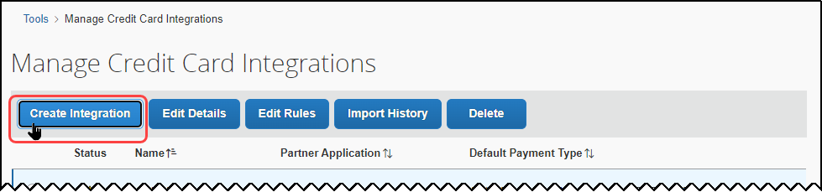
- In the Add a new configuration page, enter values for the following options:
- Type the name for this integration, such as “Archa Integration.”
- Type the partner name
- Select the new card program from Default Payment Type – this is the card program you created in the previous steps.
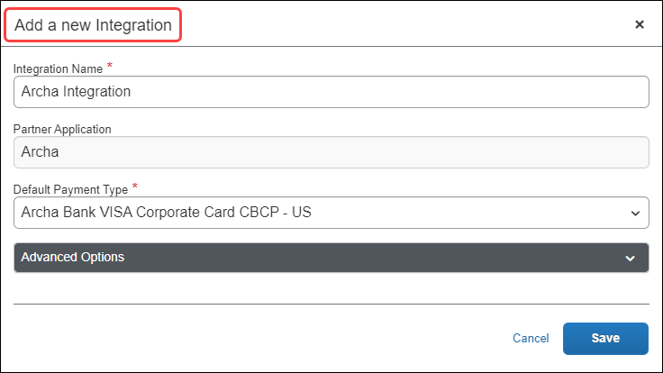
- Click Save. You may disregard the Status alert () at this time.

Authorize the Card Provider for Expense
This step authorizes the card provider to send data to Expense on behalf of the client, and are virtually identical to those described in this guide to confirm the presence of the vendor’s app.
To authorize the card provider to send data:
- Click the App Center tile, then use the Search function to return the card vendor’s app.
- Click the vendor tile, then click Connect.
- In the (SAP Concur) TERMS & CONDITIONS window, review the required terms and conditions, then agree to each.
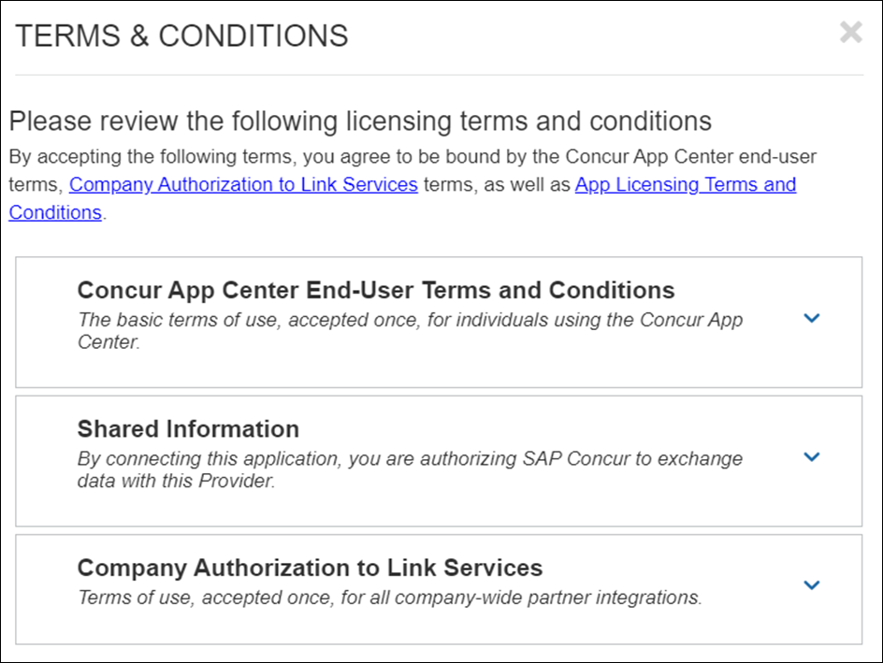
- Each individual card issuer will open a unique pop-up window, but the general steps are the same for all, in general:
- Agree to the card issuer’s terms and conditions, if required, and any authorization to link services on the client’s behalf
- Use the options provided to log in to your account
- Complete all card issuer steps, such as enablement, and then close the pop-up window
A sample of the vendor experience is shown below; your experience may differ depending on the vendor and what you may have already contracturally agreed to when signing up initially to their service.
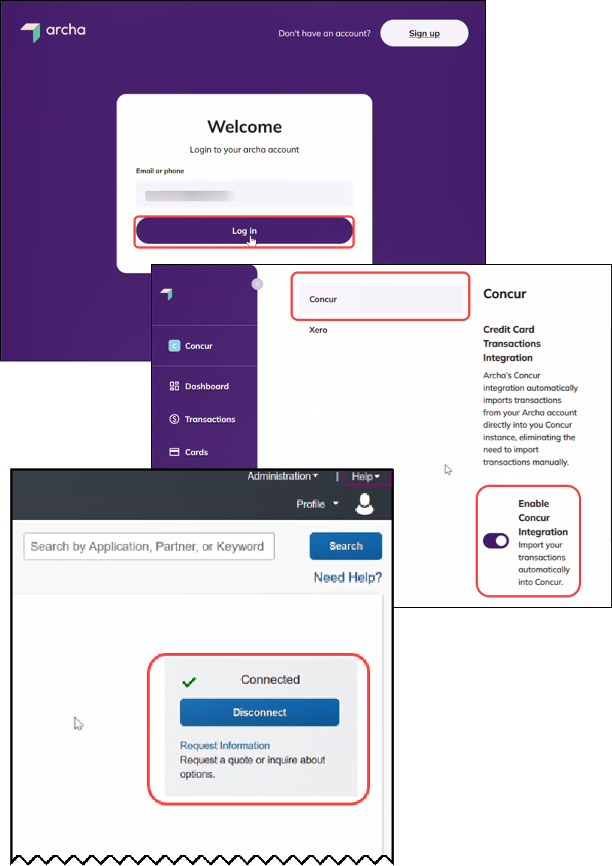
The integration is now complete, and the Connected value appears in the vendor tile on return to Expense. Accounts and transactions will now flow into Expense as the card issuer submits them, in near real-time.

Appendix

Using Rule Types to Create Country-Specific Data Imports
Some clients may require country-specific payment type data, for example, if they require banking data by country from their operations in the United States, Canada, and Germany. Since the data the bank sends is handled by the card integrations default payment type, the administrator can notify the bank(s) that country-specific data sent by the APIs should include a country-specific identifier.
Now, with an identifier, the administrator can create a rule in Expense that will recognize and gather data by country and apply the specified payment type to that country’s data. This is done using the Manage Credit Card Integrations tool, which allows for one or more rules to be configured for the card integration, each of which can match the desired payment type to be applied to the country. All other data that does not match a rule will be associated with the default payment type.
The card integration with the initial, default payment type.
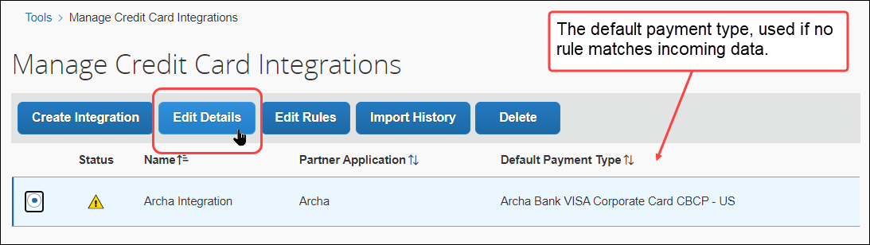
The Manage Rules page, where the rule is configured for each country type.
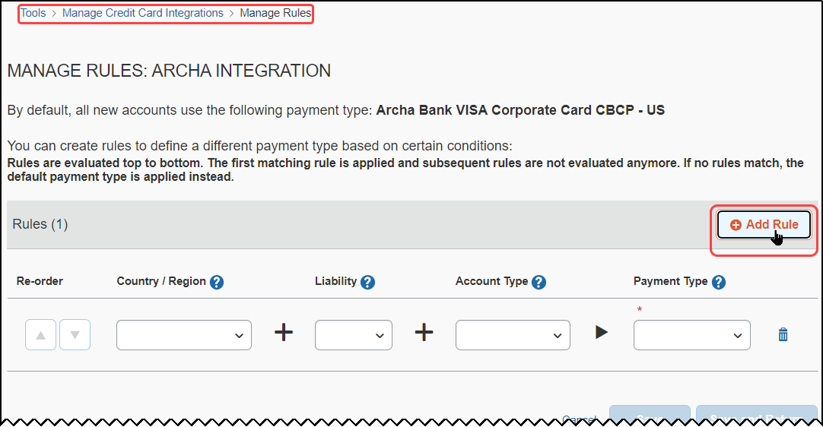
A sample set of rules configured for Canada, Germany, and the United States.
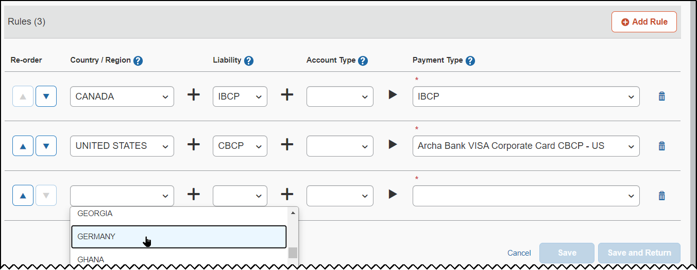
For more information, refer to the Concur Expense: Payment Types Setup Guide for Standard Edition.

