
Concur Expense: JPT on NextGen UI
Setup Guide for Standard Edition
Last Revised: August 26, 2022
Applies to these SAP Concur solutions:
 Expense
Professional/Premium edition
 Standard edition
 Travel
 Professional/Premium edition
 Standard edition
 Invoice
 Professional/Premium edition
 Standard edition
 Request
 Professional/Premium edition
 Standard edition
Table of Contents
Section 1: Overview 1
Who Should Use This Feature 1
Required Roles 1
Section 2: Accessing Japan Public Transport 1
Section 3: What the Employee Sees 2
Section 4: What the Approver Sees 32
Section 5: What the Administrator Sees 34
Section 6: Configuring Japan Public Transport 38
Configure JPT 38
Managing the Commuter Pass Routes 39
Searching for Commuter Pass Routes by User 39
Adding a Commuter Pass Route 39
Exporting Commuter Passes 41
Deleting a Commuter Pass Route 43
Configure the IC Card reader feature 44
About IC Cards 44
Configuration Process 44
How Expense Works With the IC Card 45
Associate an IC Card to an employee 45
Section 7: Audit Rules and Japan Public Transport 46

Revision History
Date | Notes / Comments / Changes
August 26, 2022 | Updated screenshots and path information for commuter pass screens.
April 23, 2022 | Added new section (section 7) for Audit Rules.
December 10, 2021 | Added several new sections to Section 3: What the User Sees that detail the new Favorites feature. New sections address how to add a favorite route, add a JPT expense from a favorite route, saving and adding another JPT expense, deleting a favorite route from both the Route Search and Favorite Routes tabs, adding an expense from a favorite route for the requested trip date and time, and adding a favorite via station.  Added a new Exporting Commuter Passes section to the Managing the Commuter Pass Routes section.
November 5, 2021 | Minor edits.
September 29, 2021 | Minor text edits.
September 23, 2021 | Removed reference to manual option for users typing in an entry in the Creating a JPT on NextGen UI Expense Report Using Route Search section.
September 14, 2021 | Added note regarding the future availability of JPT on NextGen UI in the China data center in the Overview section.
August 27, 2021 | Updated feature name from JPT 2.0 to JPT on NextGen UI.
June 30, 2021 | New guide.

Japan Public Transport on NextGen UI
NOTE: Multiple SAP Concur product versions and UI themes are available, so this content might contain images or procedures that do not precisely match your implementation. For example, when SAP Fiori UI themes are implemented, home page navigation is consolidated under the SAP Concur Home menu.
This page of Product Settings is visible only when enabled by SAP Concur support.

Overview
The typical businessperson in Japan can have multiple train rides per day that they will track and process for reimbursement. To answer the need to expense this type of travel, Concur designed and integrated the Japan Public Transport (JPT) 2.0 feature into the Expense product.
This feature allows users to quickly expense JPT in several ways:
- IC Card import using a network IC Card reader
- Route search (look up routes bases on a from/to station)

Who Should Use This Feature?
The Japan Public Transport feature is intended for use by multinational companies with employees located in Japan or with employees traveling in Japan. The rail content sourced is specific to the Japan marketplace. The feature cannot be used with any rail content outside of Japan.
Customers who have employees located in Japan can use this feature as an Add-On. Please contact to your Account Manager if you want to start using this feature.

Required Roles
There are no required roles to use the Japan Public Transport feature; you need only have the Can Submit Expense Reports role.
The SAP Concur administrator must enable this feature. When enabled, the Japan Public Transportation expense type is activated by default for the country of Japan. The Employee Administration Country for that user must be “Japan” if the multiple countries setting is activated for that Entity.

Accessing Japan Public Transport
Users access this feature by selecting the Japan Public Transportation expense type when creating an expense report.
For the country of Japan, the Japan Public Transportation expense type is activated by default. The Employee Administration Country for that user must be “Japan” if the multiple countries setting is activated for that Entity.

What the Employee Sees
The employee is granted access to the Japan Public Transport (JPT) feature and options in the following areas of Concur Expense:
- When Creating the Expense Report: The user selects the Japan Public Transportation expense type to expose options that let them add the routes they have traveled.
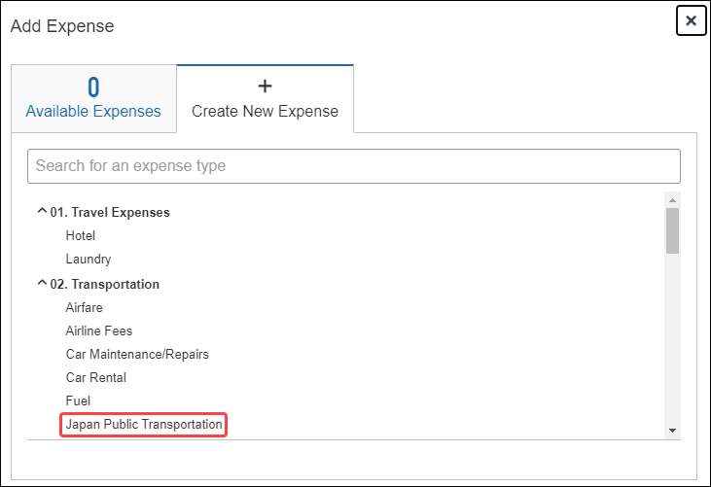
- My Profile: The user’s Profile page includes links that let them add or delete commuter pass routes they transit.
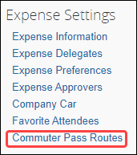
The JPT feature allows users to expense JPT using route searches to search for and select their applicable journeys for reimbursement, add a commuter pass to their profile.

Creating a JPT Expense Report Using Route Search
Users can create an expense report using the policy to which JPT expense type is activated when the client is configured with the JPT feature.
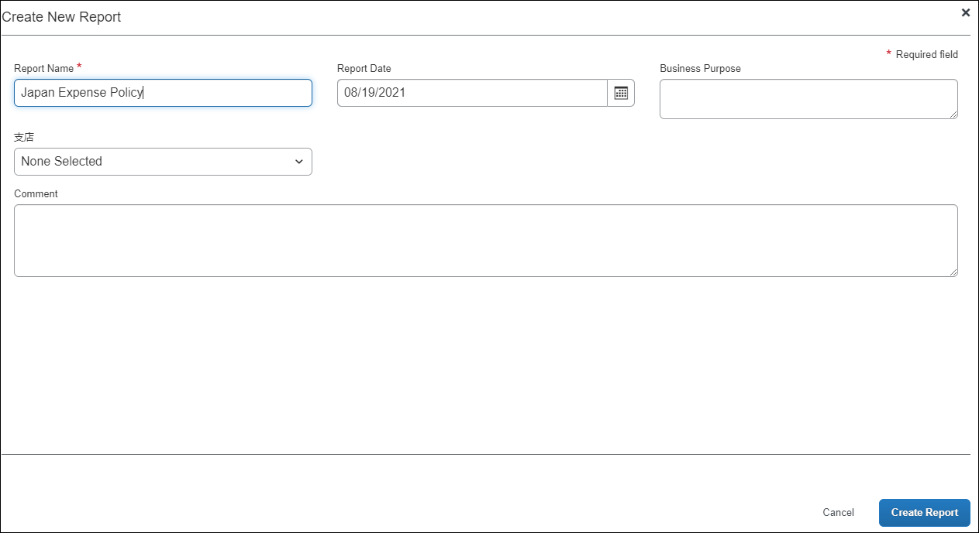
When the report is created, the report currency is displayed as configured for that user’s reimbursement currency.
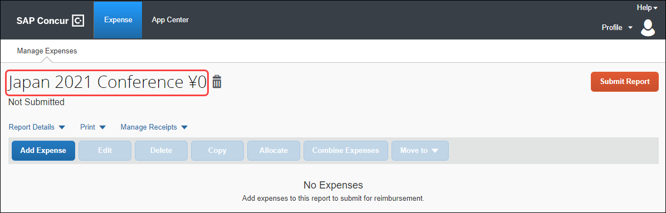
When a user creates a new JPT expense, they will select Japan Public Transportation.
Users will provide the required route search criteria:
- Trip Date: The date the trip occurred.
- Time: The time the trip occurred.
- Trip Type: The type of trip taken – One-way or Round Trip.
- Seat Type: The user has three options: Non-reserved, Reserved, or Green (first class)
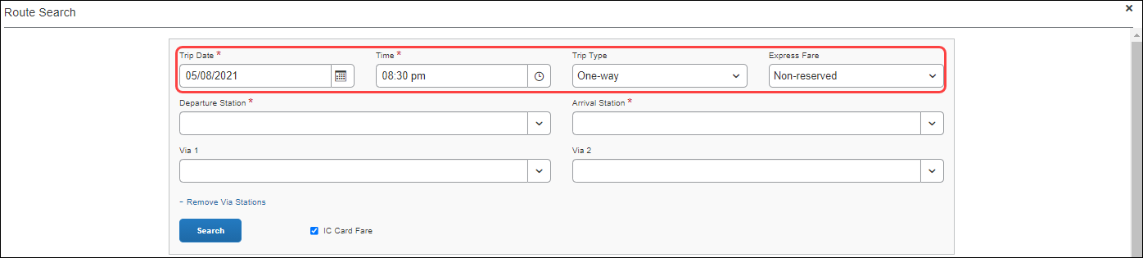
Users can perform a route search by searching for and selecting both a Departure Station and Arrival Station.
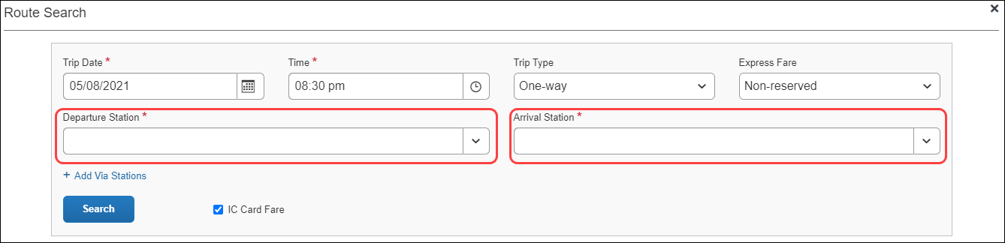
As the user types, Concur Expense deploys a search and filter list, allowing users to select the appropriate departure station and arrival station as it appears in the list.
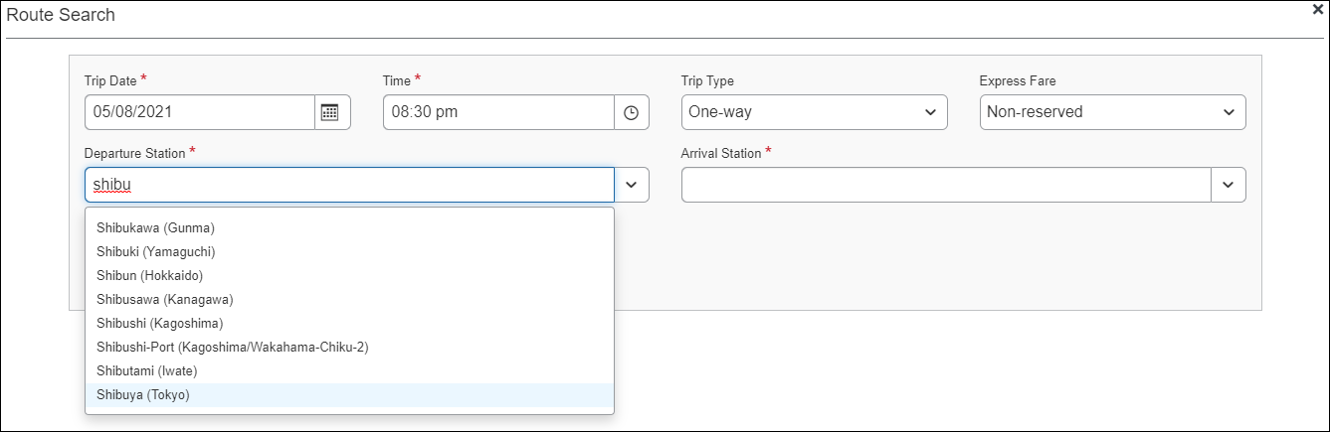
If necessary, users may add up to two via stations as part of their route search by clicking +Add Via Stations. As they type, users can use the search and filter list to select the appropriate via station(s) as they appear in the list.
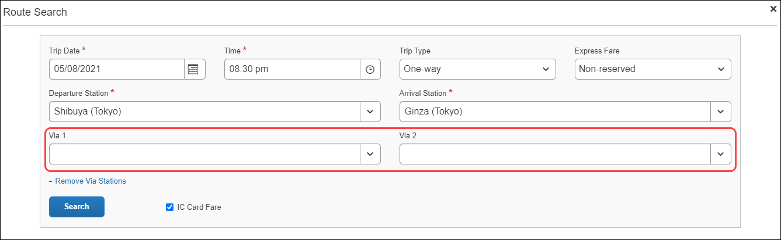

By default, the IC Card Fare checkbox is selected. Selecting IC Card Fare indicates whether the user ("traveler") paid for their ticket using their travel card or if the ticket was purchased from the ticket counter. The prices may differ based on the payment method used.
Most of the time, users will select the IC Card Fare option. Therefore, IC Card Fare is selected by default.
When the user clicks Search, Concur Expense returns a maximum of five route results. These routes ("journeys") will be classified as Fast, Easy, Cheap, or Commuter Pass OR none of the designations.
These designations are specified if a partner has provided that data to SAP Concur. Depending on the journey, the route can have multiple designations (for example, Fast and Cheap). A journey with a designation of Easy has the fewest number of stops.
These designations can also help approvers when they review a JPT expense by allowing them to see if the route complies with their organization's travel policy.
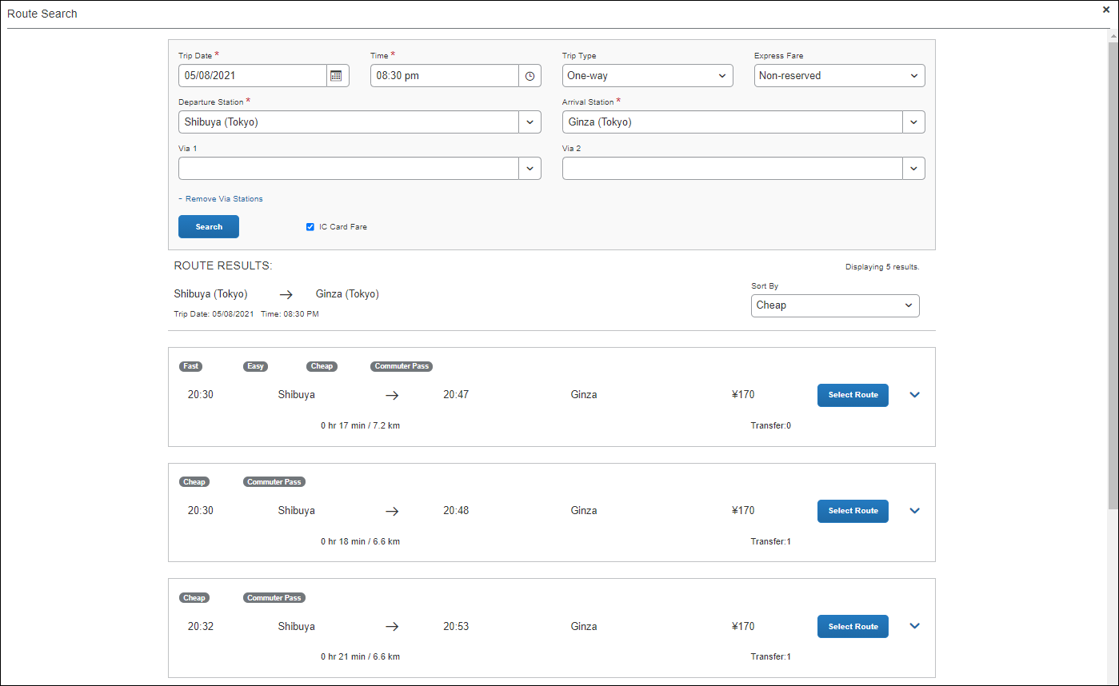
Users can sort the route results using the Sort By list, which offers three sorting options: Cheap, Easy, and Fast. A route can have multiple designations or none at all. Therefore, if sorting by Cheap, the route results displayed may have other designations.
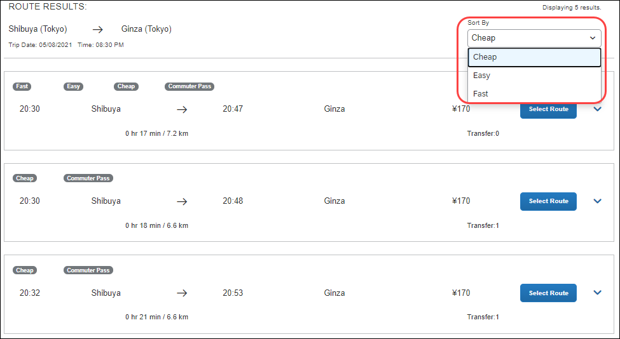
Users click expand icon to expand the route details and see if additional transportation is required to get to the designated arrival station in the selected route. Icons, such as a bus or a walking person, indicate whether the user needs to take a bus or walk to a stop in the selected route.
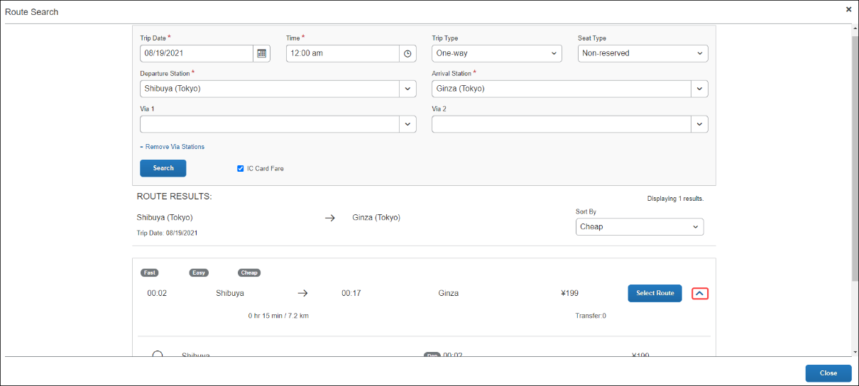
Once a user selects a route by clicking Select Route button, they will be able to save their JPT expense report by completing the required fields.
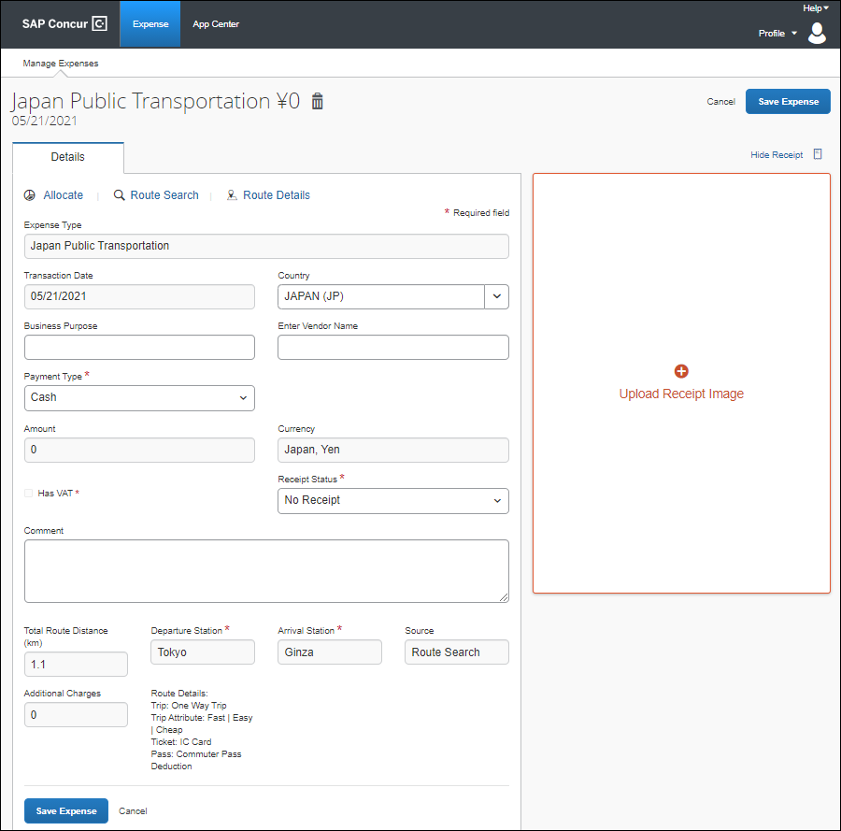
The Expense Type field will always be Japan Public Transportation; you cannot change it to another expense type. When you create an expense report and select Japan Public Transportation as the expense type, it is then hardcoded into the expense details.
For example, unlike other expense reports, you cannot change the Expense Type to another expense type such as Hotel or Dinner, when providing the details of the Japan Public Transportation expense.
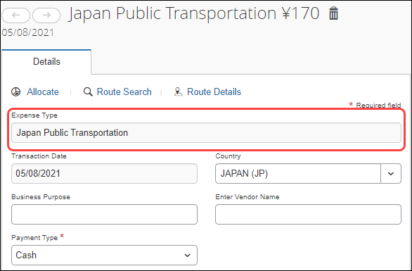
Additional information about JPT expense details page:
- Users cannot edit the Transaction Date field, as the date is extracted from the route search.
- The Country field always defaults to JAPAN (JP) given the travel will always occur in Japan.
- The Currency field will always default to the reimbursement currency configuration that is mapped to that user (in this case, you, the traveler).
- The source of the expense will either be Route Search or IC Card Fare (through e-receipt).
- Additional charges, such as those assisted with first-class fare, display in the Additional Charges fields, if applicable.
- The Route Details area display the type of trip (One Way Trip or Round Trip) and the type of ticket used (Paper or IC Card Fare).

Registering a Commuter Pass
Users can register a commuter pass. Once a commuter pass is registered, it can be used for JPT expense.
From the Profile Settings page, users can add a commuter pass if it is configured.
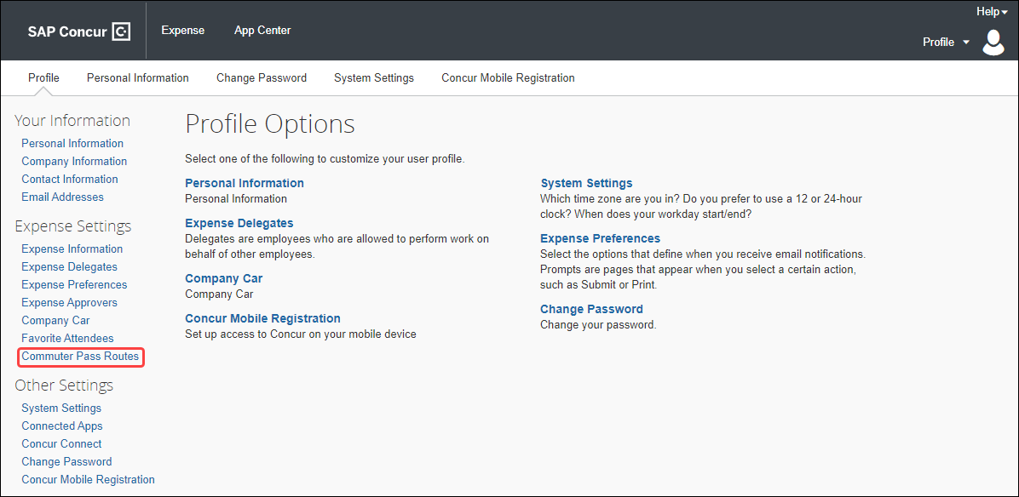
Users will only be able to store one commuter pass at a time.
Only one commuter pass is allowed in a date period; a user cannot use multiple commuter passes for the same period. For example, if they use one route on Monday, Wednesday, and Friday, but use another route on Tuesday and Thursday, they cannot use separate passes for the two unique routes.
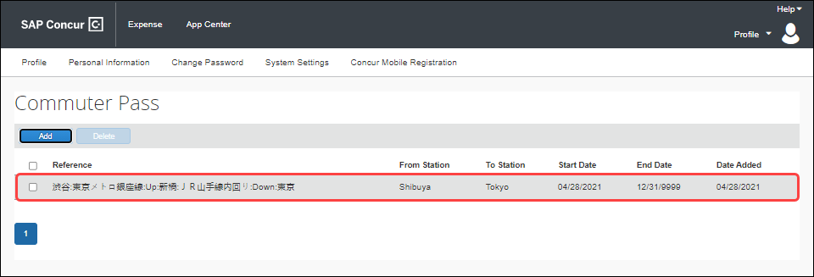

Adding a Favorite Route
Users can configure a route they regularly use (for example, from home to work) and add it to their favorites. When they create a future JPT expense, they can then select the route from the Favorite Routes tab.
Currently, there is no limit to the number of routes you can add to the Favorite Routes tab.
From the Route Search window, a user can create a route and mark it as a favorite from the Route Search tab.
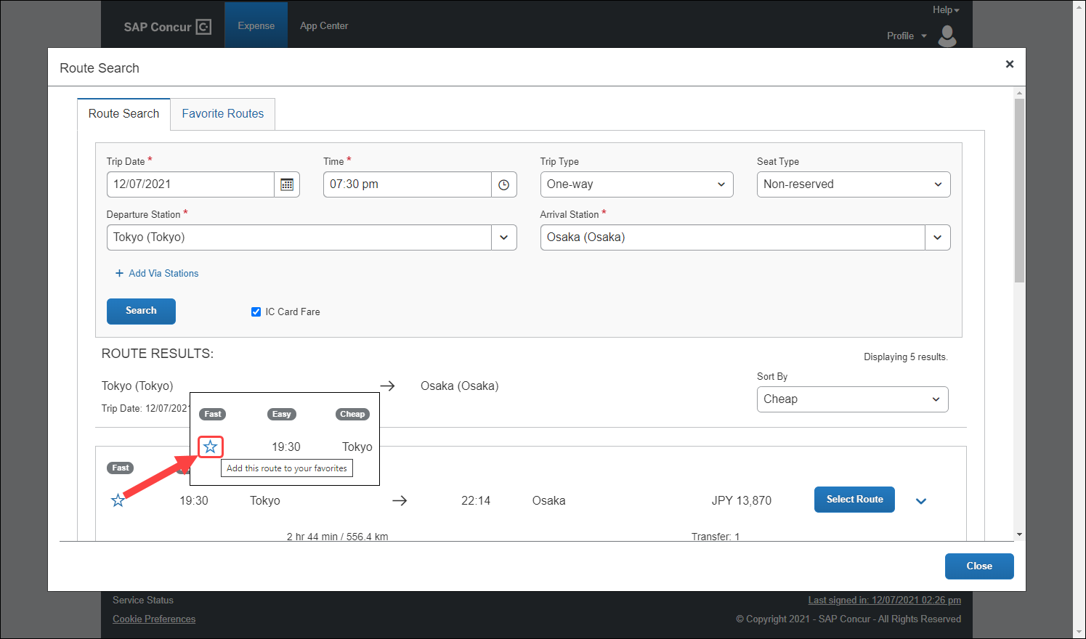
Once the user clicks the star icon, the route is favorited (the star changes from clear to blue) and added to the Favorite Routes tab.
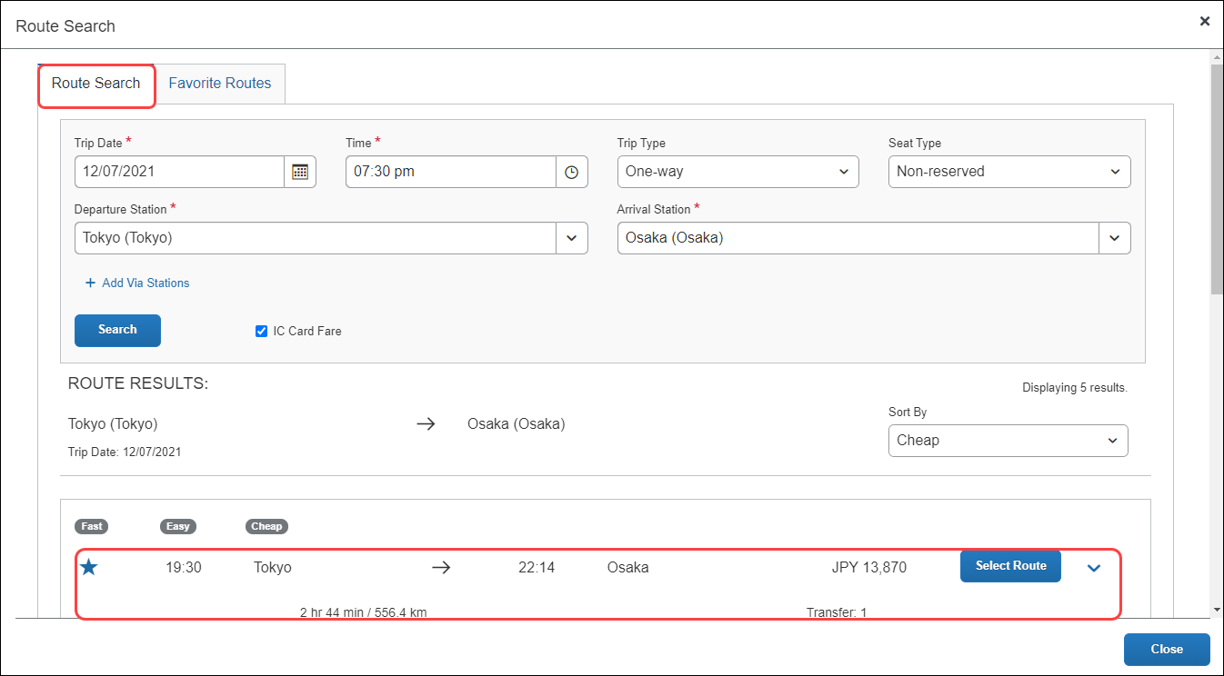
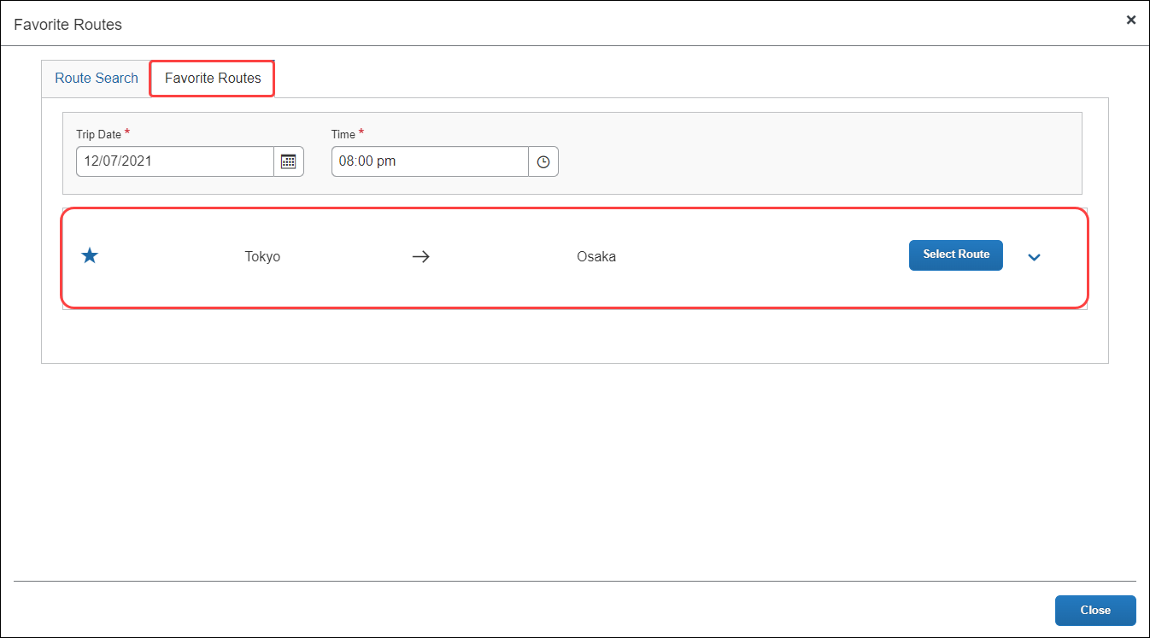
Users can click the Show Details toggle button to display the favorite route’s details.
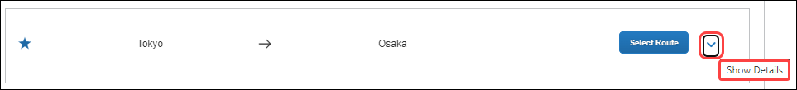
Users can then click the Hide Details toggle button to hide the favorite route’s details.
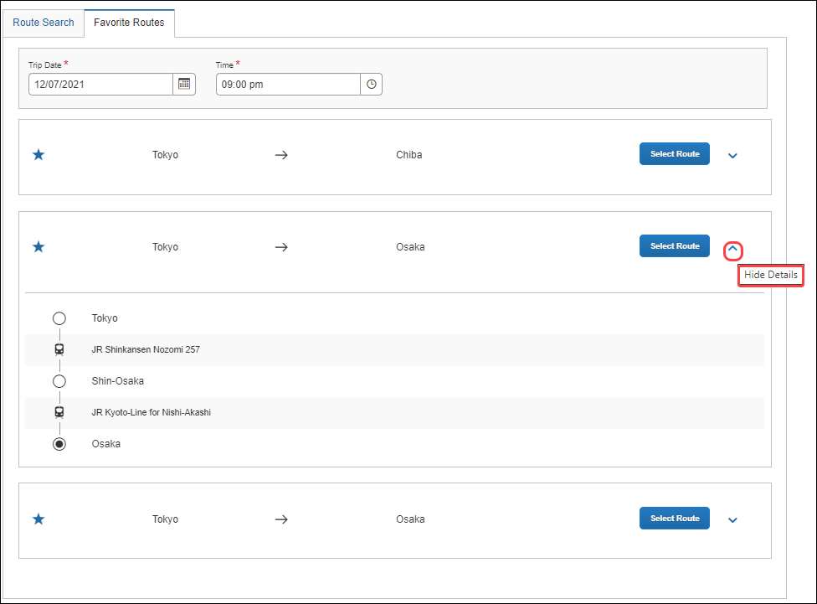

Adding a JPT Expense from a Favorite Route
Users can create a JPT expense and select a favorite route (noted by the star icon).
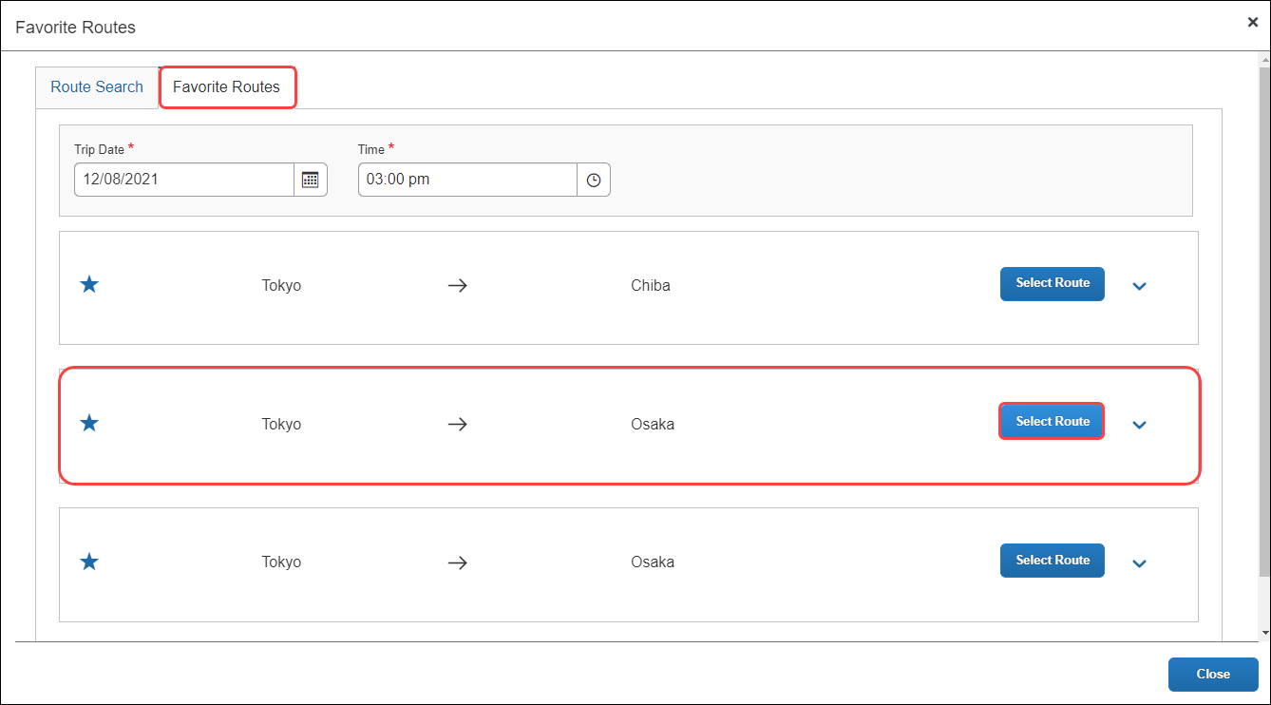
In the expense report, the departure station and arrival station will pre-populate with the data provided from the favorite route selected.
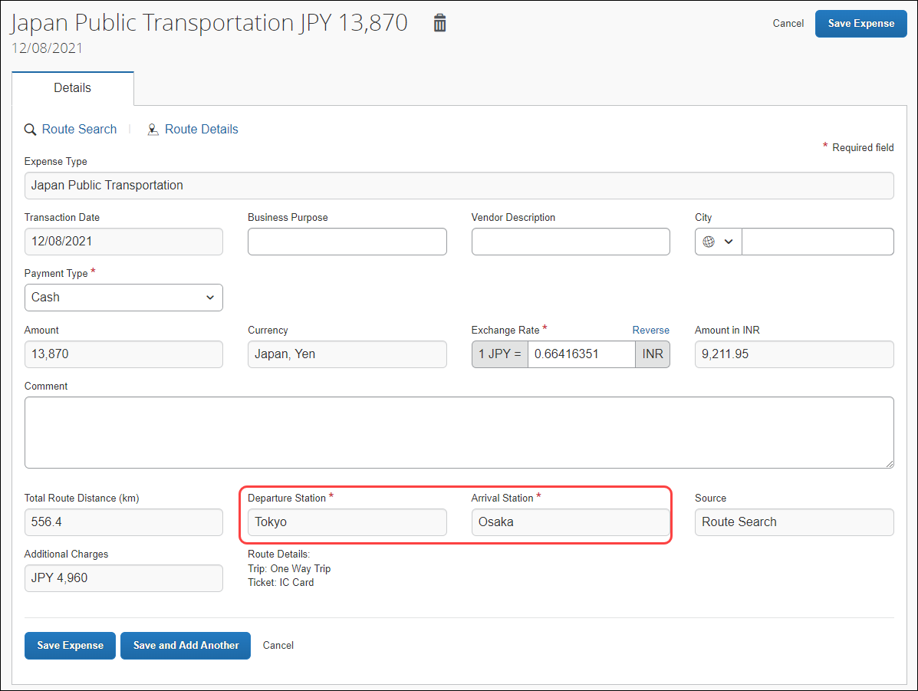
Users can then save the expense or save the current JPT expense and add another JPT expense.

Saving and Adding Another JPT Expense
Users can save a JPT expense and then add another JPT expense (to the same expense report) by clicking the Save and Add Another button.
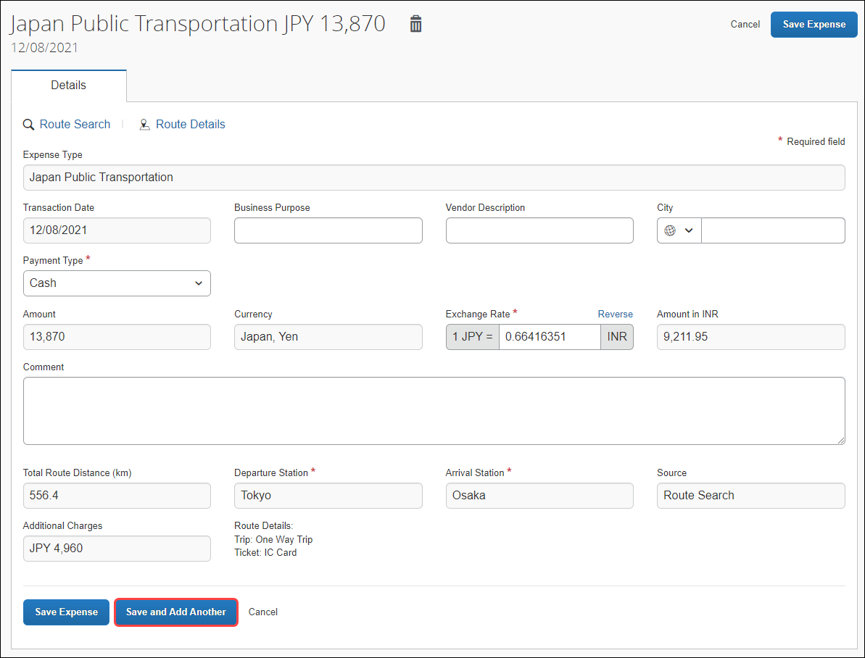
The JPT expense is saved, and the New Expense window will open.
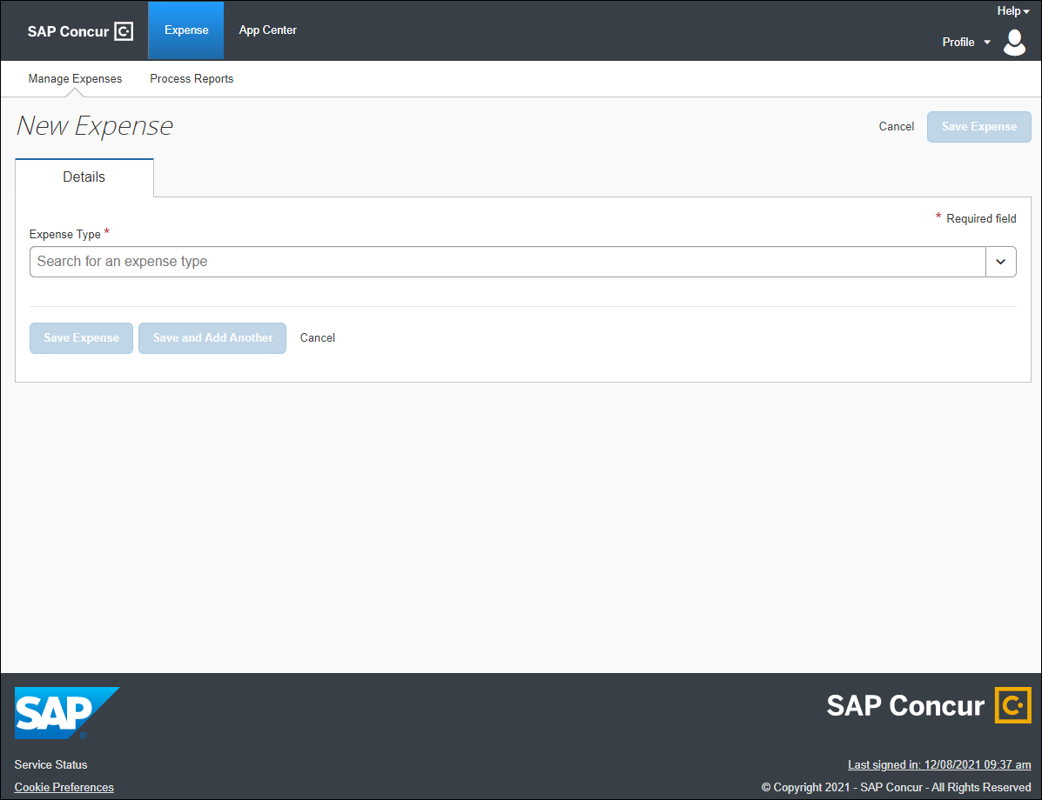
Users can select any expense, but in this case, they select Japan Public Transportation.
Users can select a route using a route search OR select a favorite route on the Favorite Routes tab.
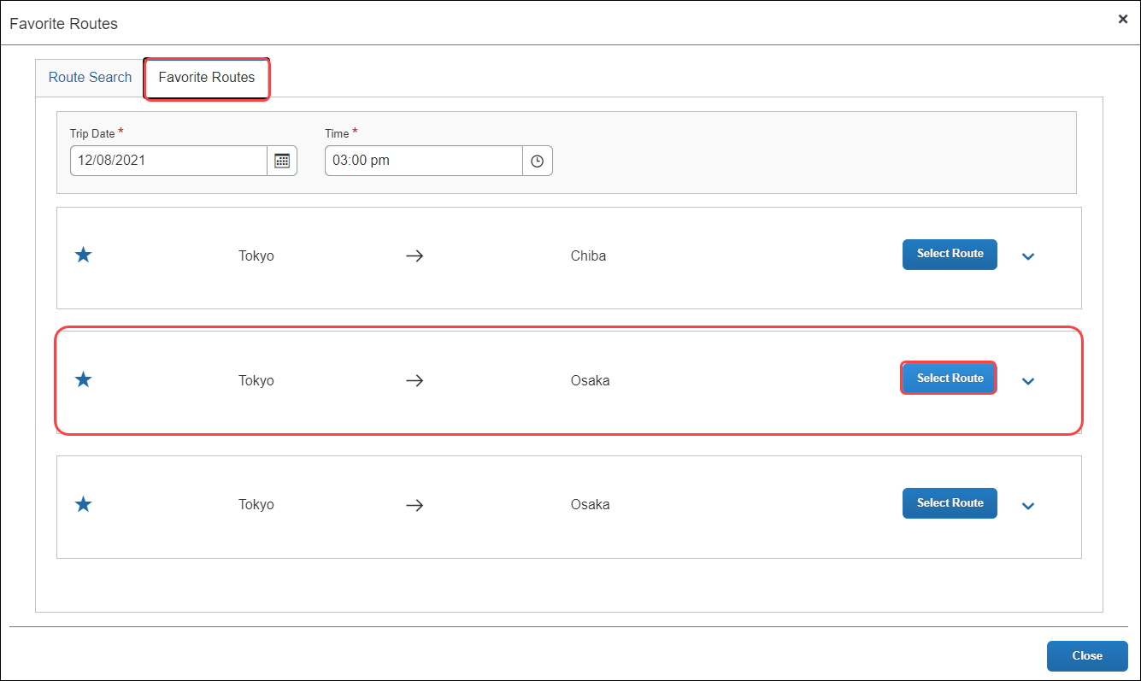
The JPT expense report reflects the newest JPT expense added using the Favorites Route tab.
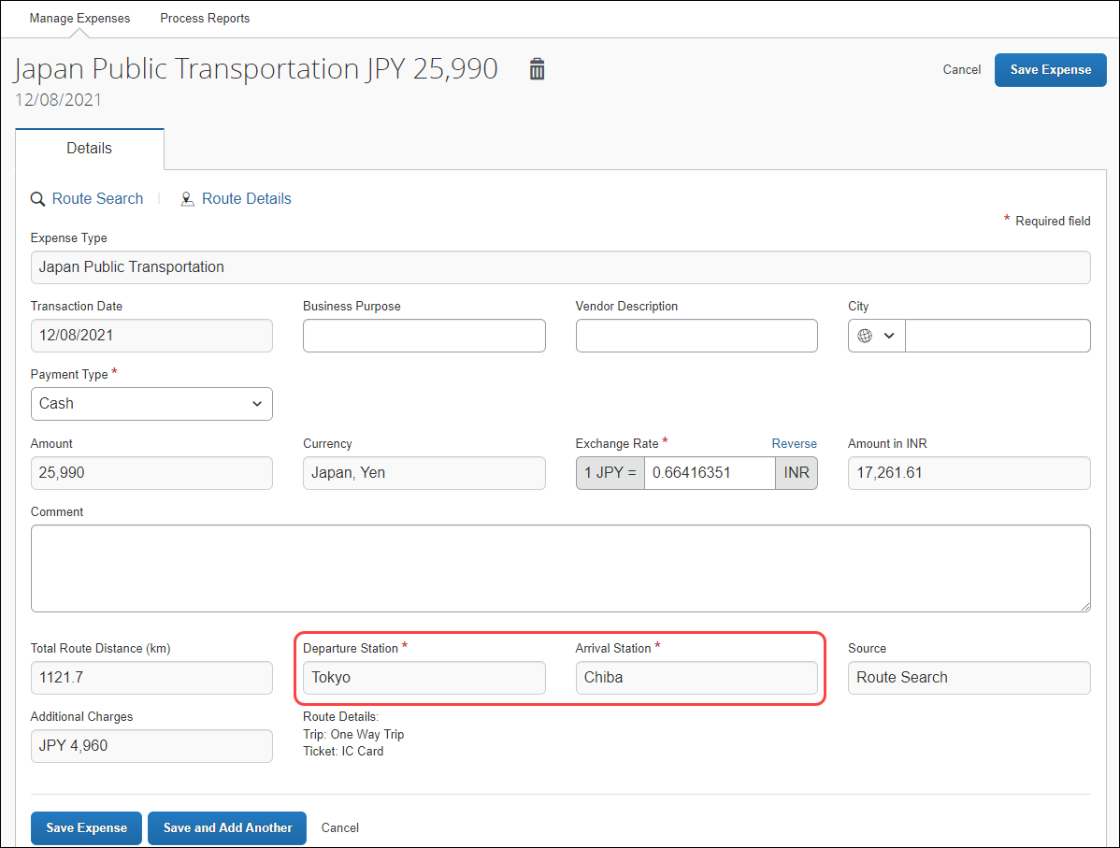
Users can choose (again) whether to save the JPT expense or clicking Save and Add Another to save another expense to the expense report.
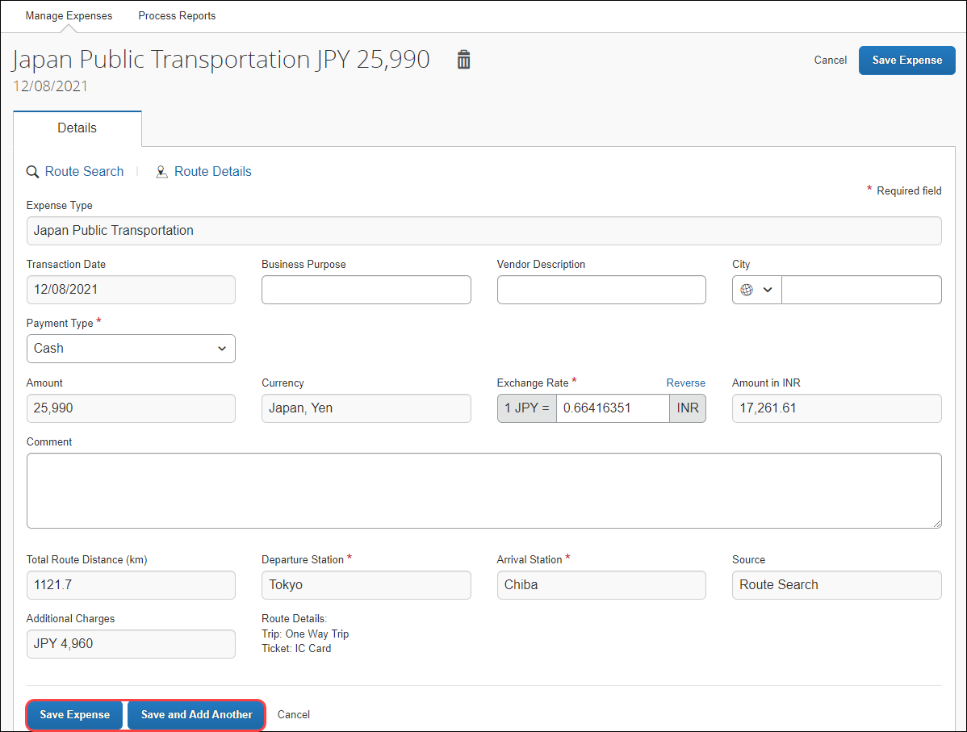

Deleting a Favorite Route From The Route Search
Users can delete a favorite route from the Route Search tab by clicking the star icon to remove it as a favorite.
The favorite route will also be deleted from the Favorite Routes tab.
Deleting a favorite route does NOT affect any previous JPT expenses submitted using a favorite route.
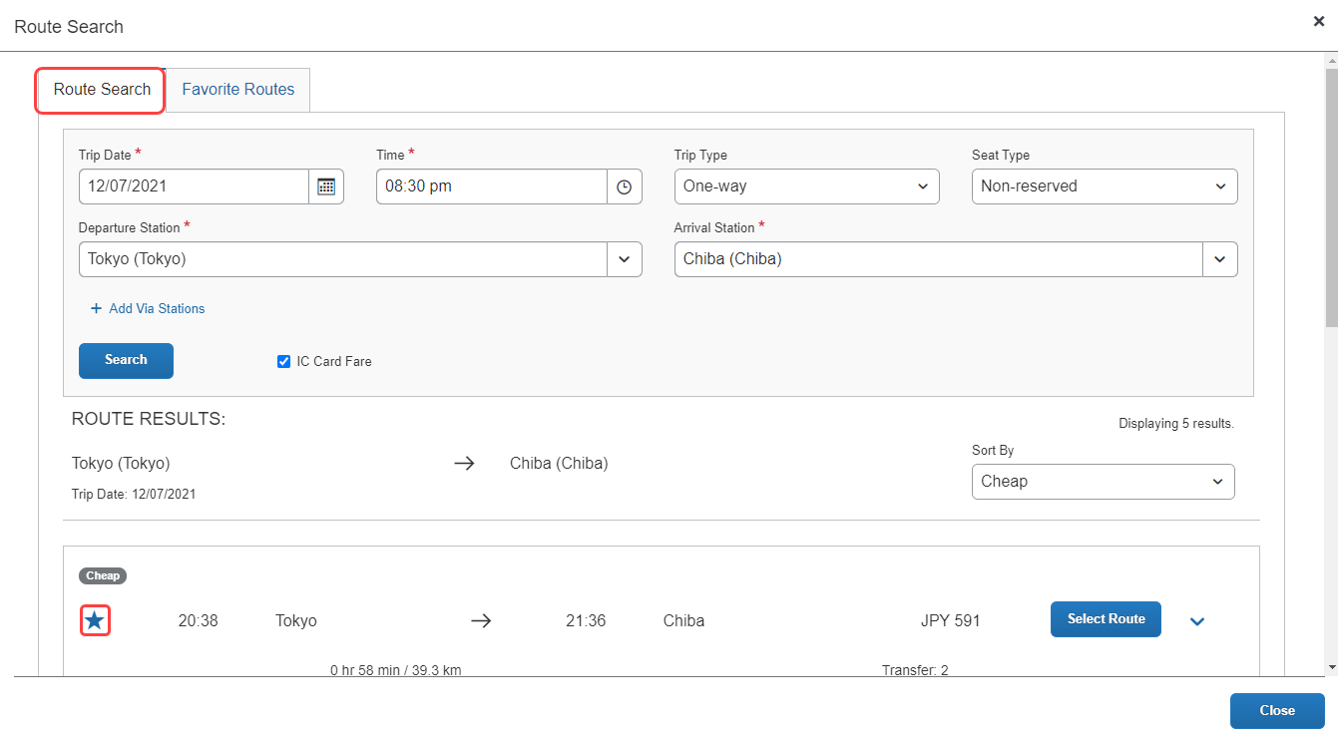

Deleting a Favorite Route From The Favorite Routes Tab
Users can delete a favorite route from the Favorite Routes tab by clicking the star icon to remove it as a favorite.
Deleting a favorite route does NOT affect any previous JPT expenses submitted using a favorite route.
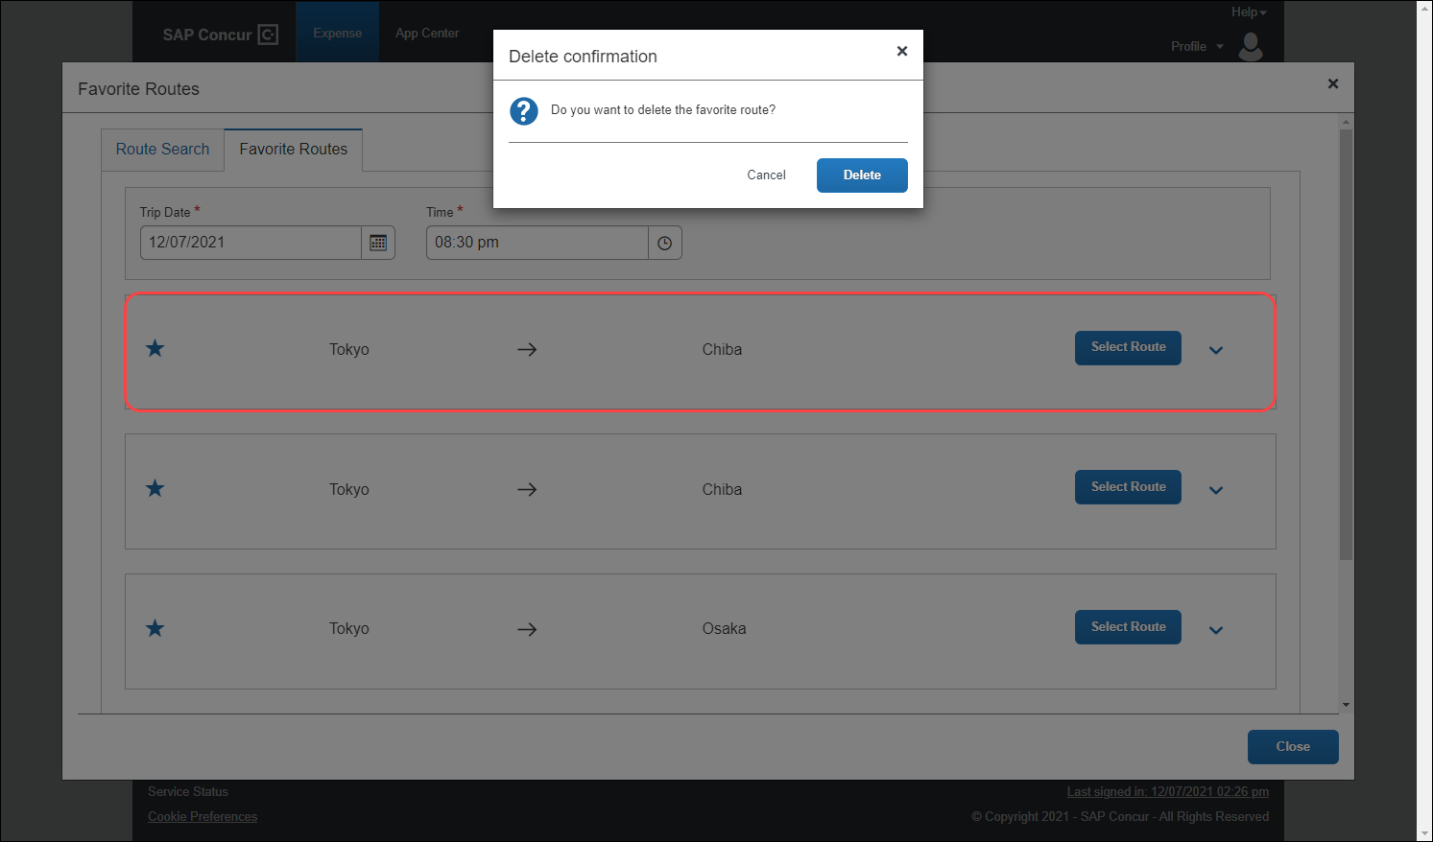
The route is removed, and the Favorite Routes list tab is updated.
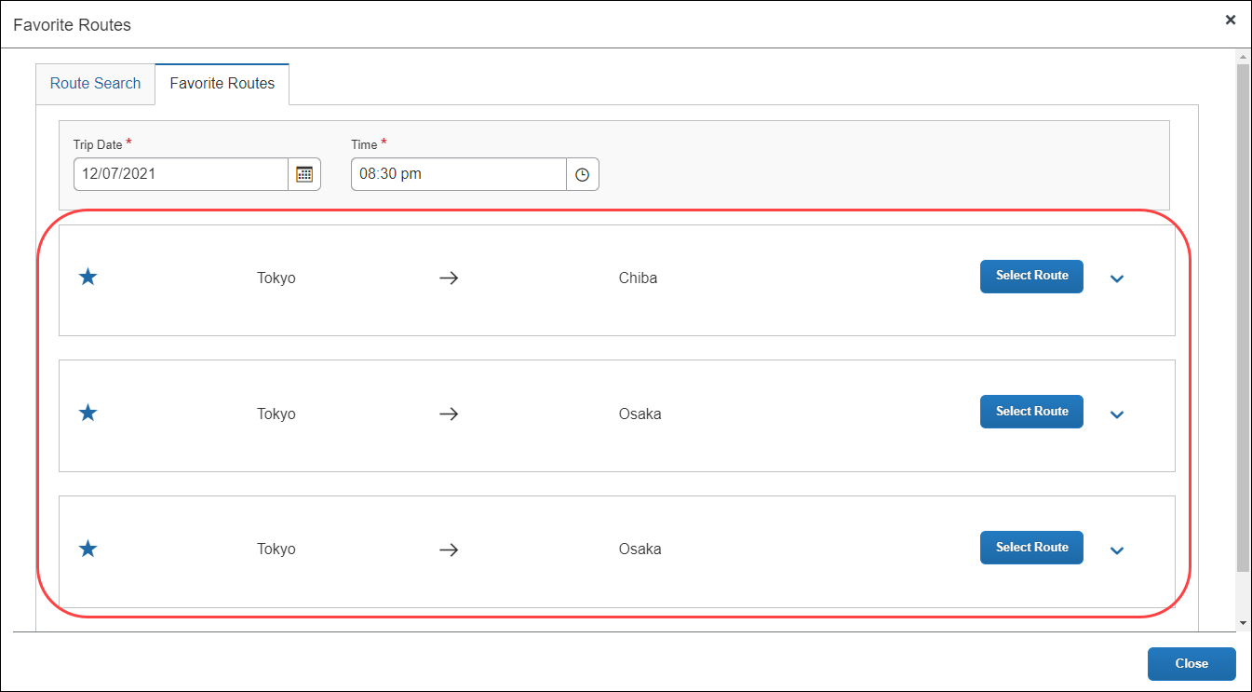

Deleting a Favorite Route From The Favorite Routes Tab
Users can delete a favorite route from the Favorite Routes tab by clicking the star icon to remove it as a favorite.
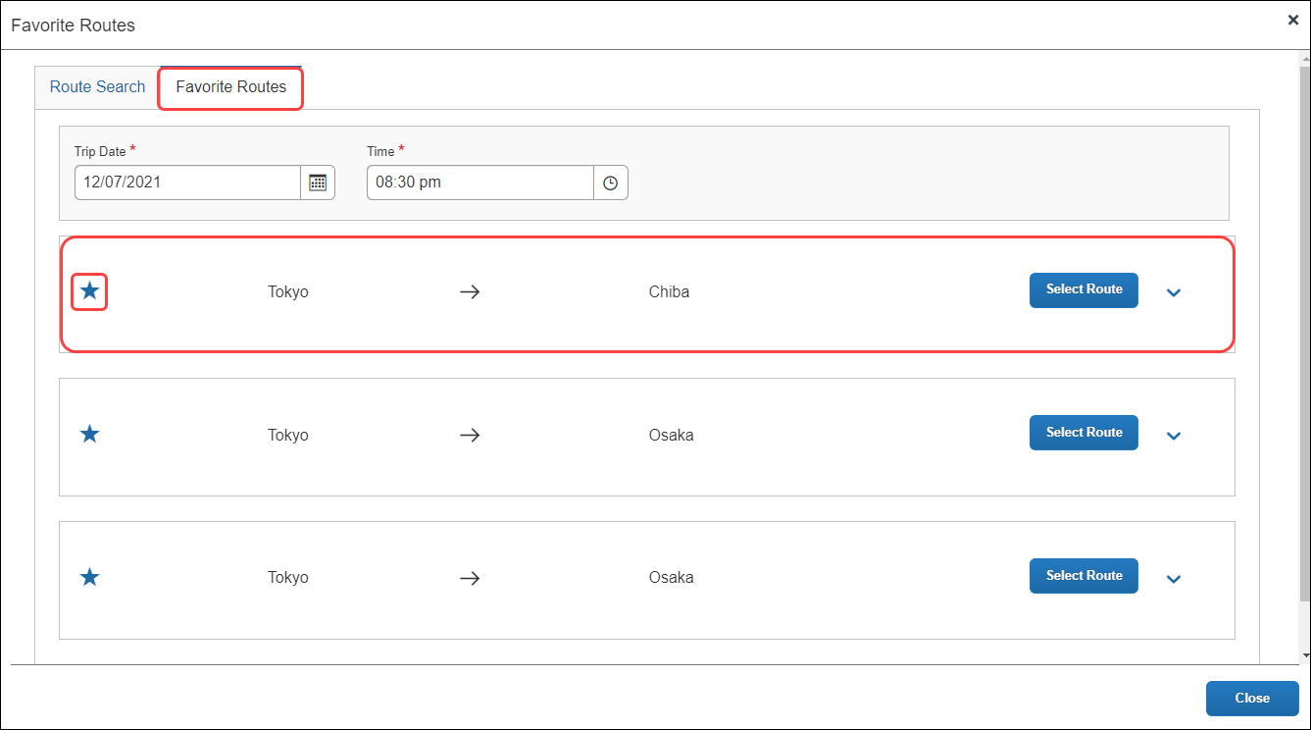
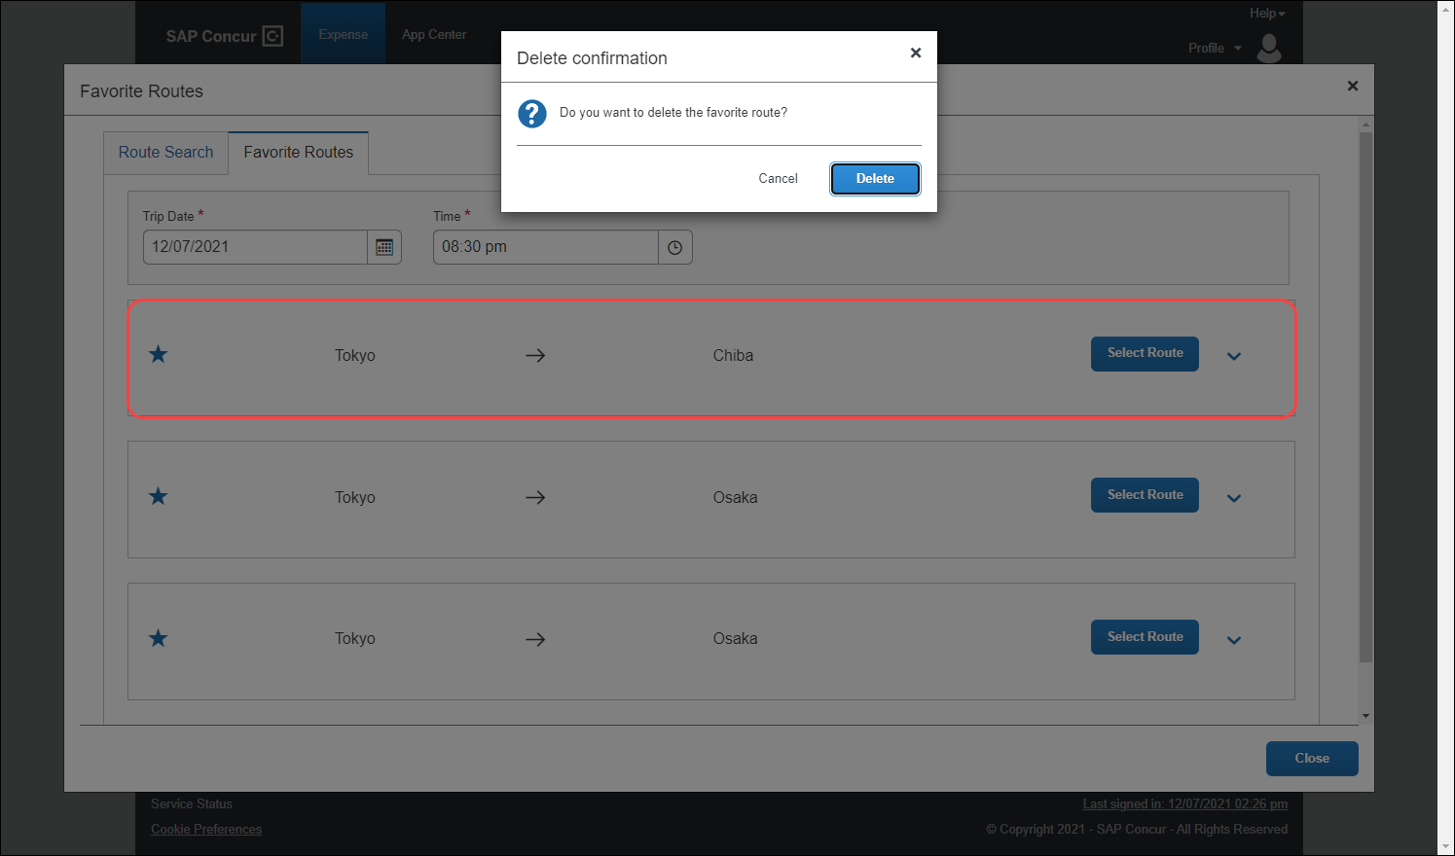
The Favorite Routes tab updates with the favorite route removed.
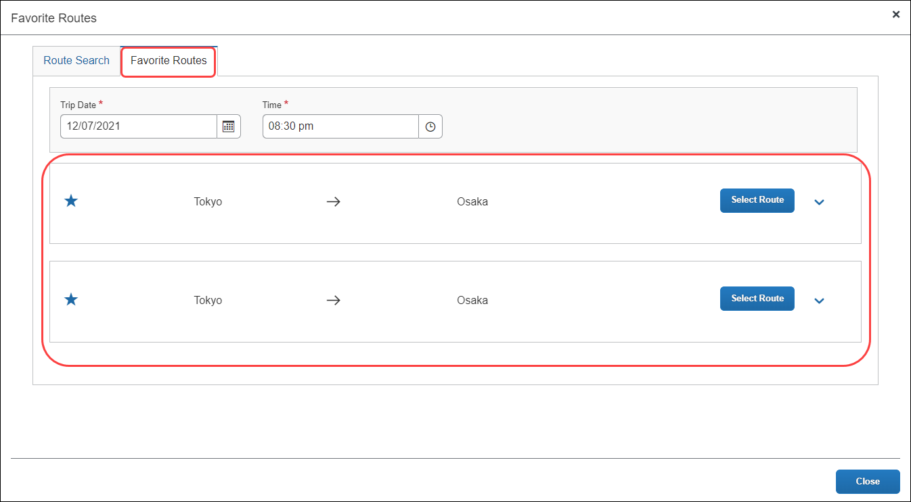

Adding An Expense From A Favorite Route For The Requested Trip Date and Time
Users can create a JPT expense using the same route, but the route’s date and time changes based on the date and time traveled. Users can save time by providing route stations and route search conditions (such as seat type), and then select the target route. They want to reuse these route search conditions and route (same departure and arrival stations and lines) to create a new JPT expense.
When providing the date and time, the user may not know the precise time of the departure or arrival, for example. However, when adding a JPT expense from a favorite route for the requested trip date and time, Concur Expense will automatically update the expense report using your favorite route’s adjusted date and time.
On the Favorite Routes tab, users can configure the trip date and time. In this example, the user selects the date.
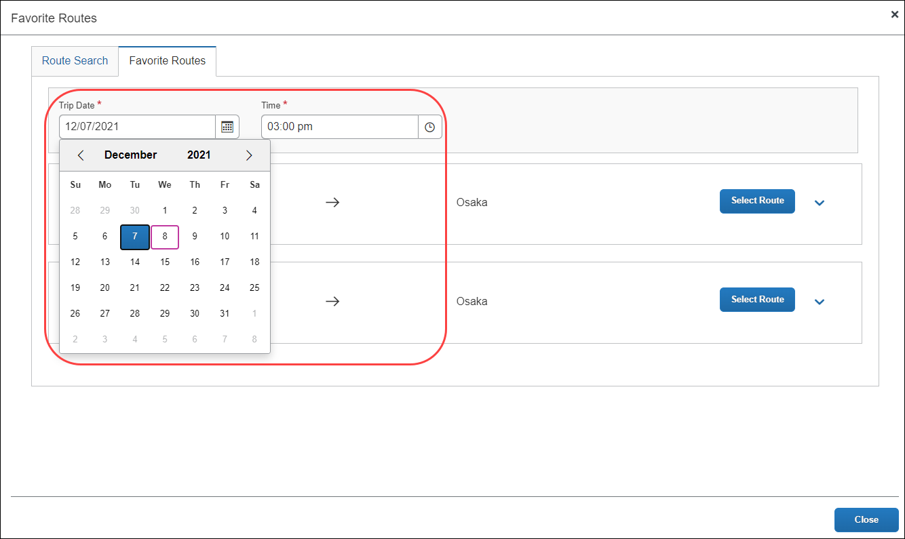
Once the user selects the date, they then provide an approximate time for when they think took the favorite route.
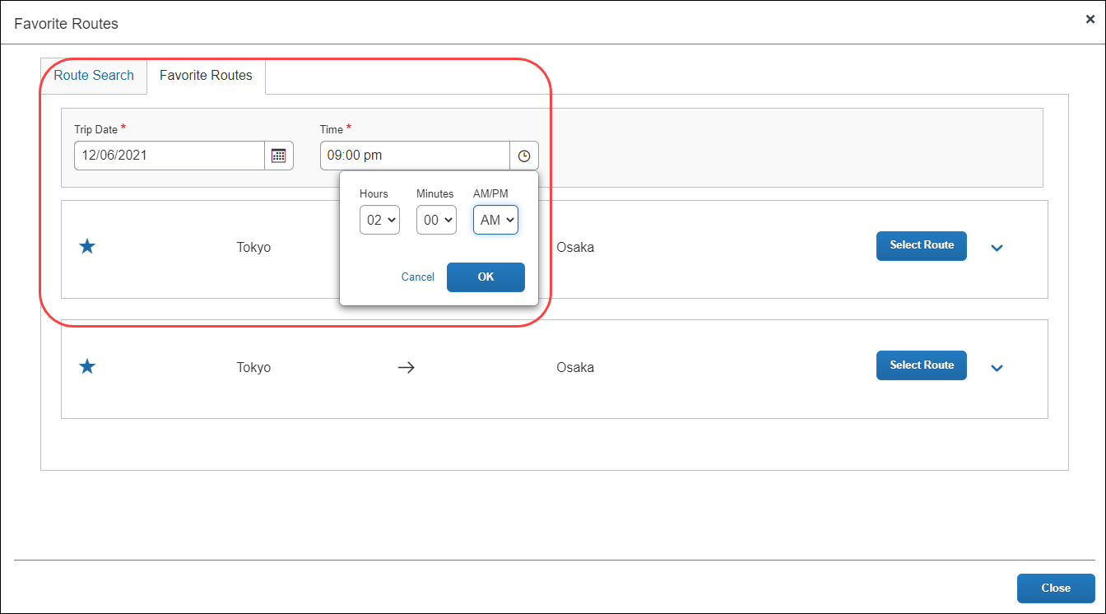
The user selects the route from the Favorite Routes tab, with the trip date and time (they provided) applied.
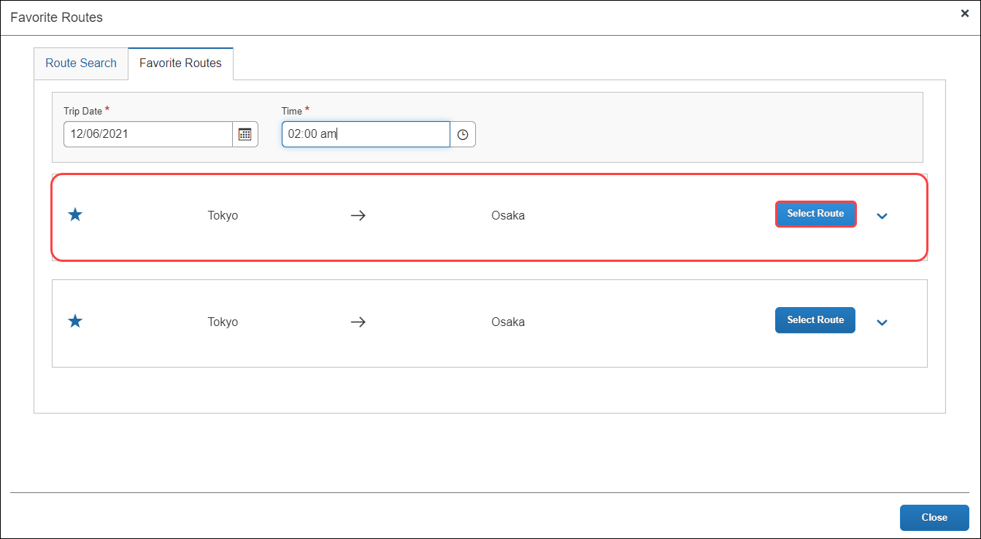
On the expense report page, the user can view the route details that have been pre-populated from the route search then click Route Details at the top of the report to view the selected route’s details.
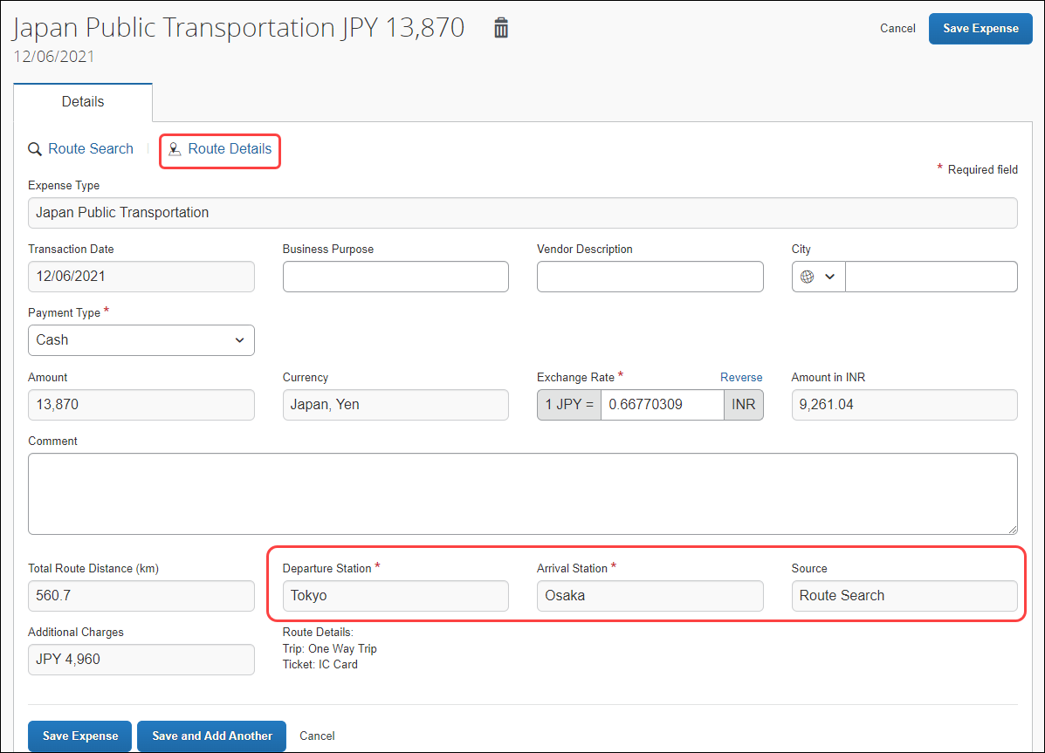
If the trip’s departure date and time are different than the favorite route’s date and time specified by the user, Concur Expense will automatically adjust the time in the Route Details window. In the previous example, the user had entered a 2:00 a.m. departure date, but Concur Expense updated the departure time to the correct time (of 4:55) from the actual route data.
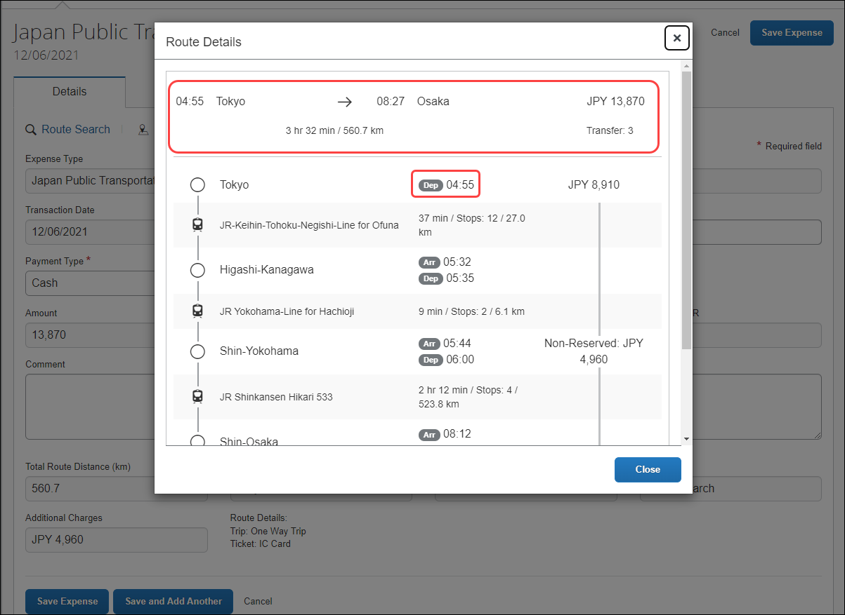
If the favorite route is associated with a commuter pass, you will see Commuter Pass Deduction for the Pass information.
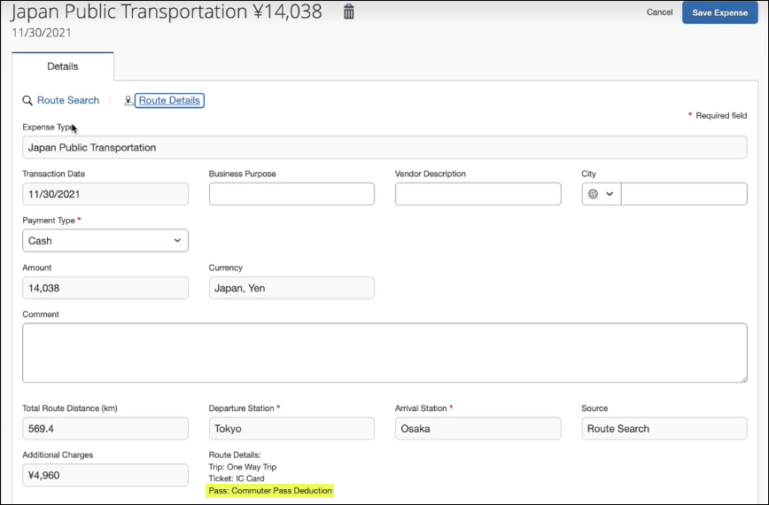

Adding a Favorite Via Station Route
Users can add a favorite via station route using the same method for adding a favorite route by clicking the star icon.
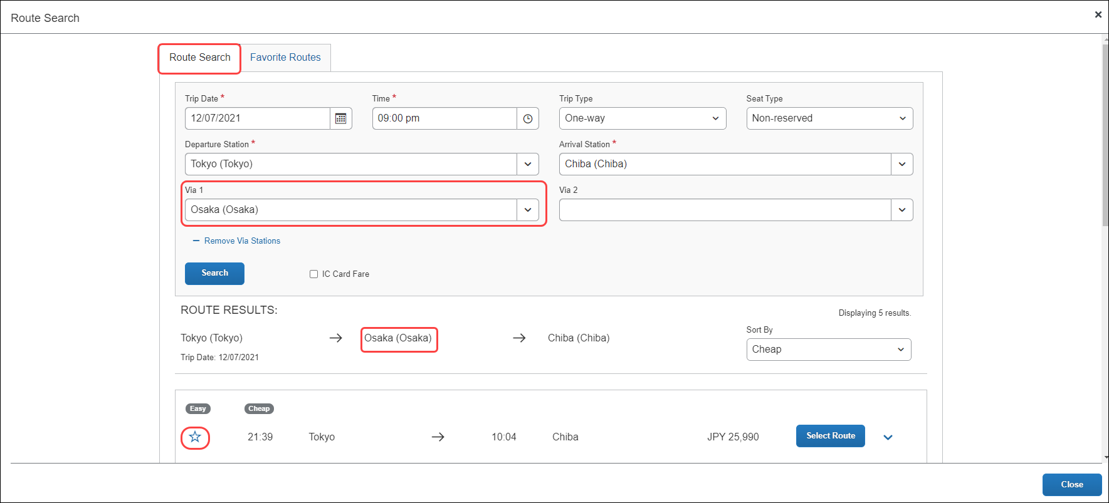
Once added, the favorite via station route will be added to the Favorite Routes tab. You can expand the route by clicking the Show Details button to display the route’s details, which contains the favorite via station.
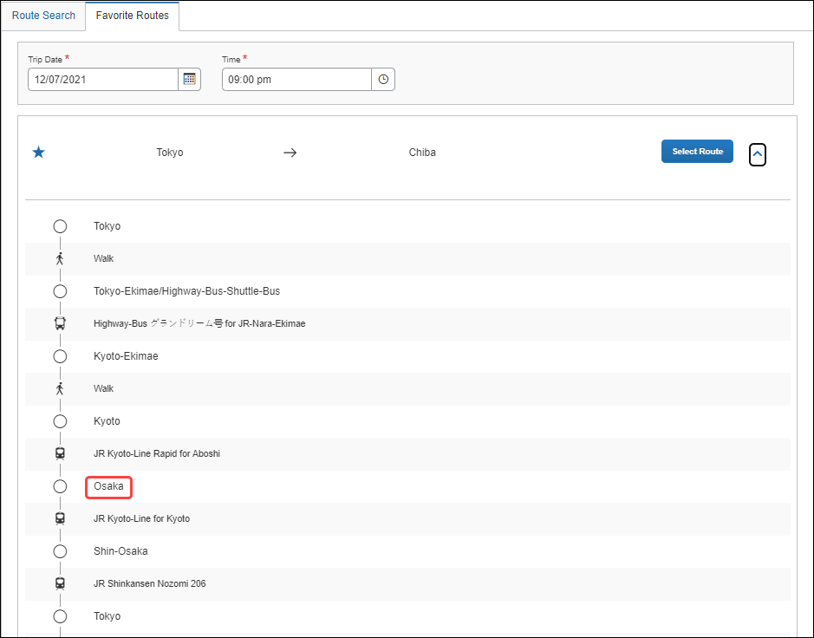

Adding a Commuter Pass
From Profile Settings > Commuter Pass Routes, users can add a commuter pass to their profile that can be applied to a favorite route for a JPT expense.
If the commuter pass is not valid, you will see this warning:
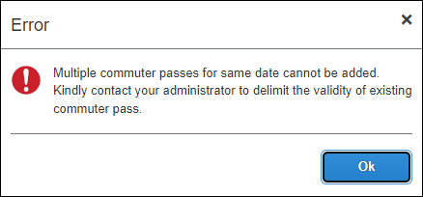

Registering a Commuter PASS Route Using Route Search
Users will be able to register a route (for example, from home to work) that they can use regularly when creating a JPT expense. In addition, if the user has a commuter pass registered to their profile, the route will be tied to that route.
The user pays upfront for the commuter pass at the station and will be reimbursed outside of SAP Concur. The expense process is typically facilitated through their HR system via reimbursement in their paycheck. For SAP Concur, this ensures the user is not double-reimbursed in SAP Concur.
On the Commuter Pass Routes page of Profile Settings, users may add a commuter pass route. If a user needs to change the end date of their commuter pass, they must contact Concur Admin to configure the end date of the commuter pass.
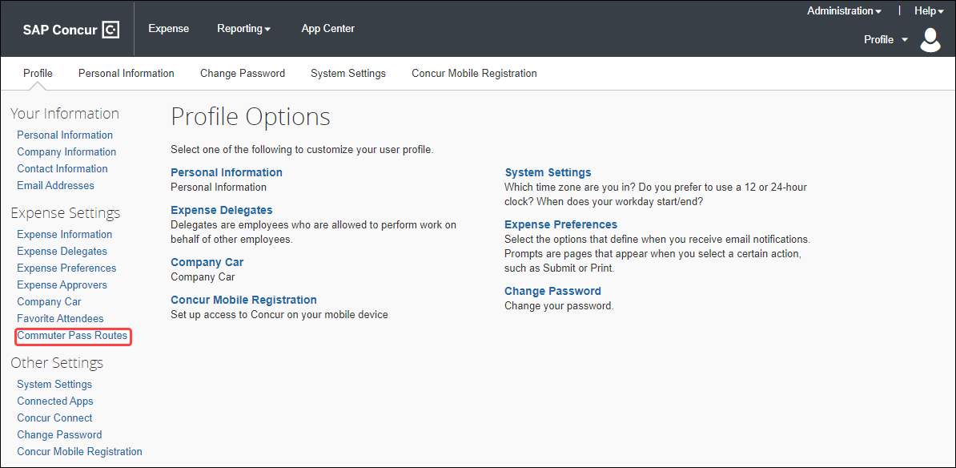
Users will search for and add the route. If necessary, they can also add four via stations.
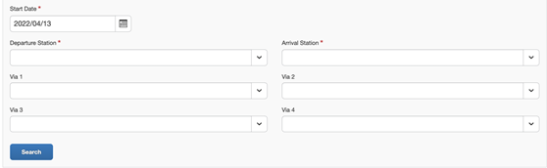
Once the route is selected, it is added to the user's Commuter Pass page.
Once a commuter pass route is added, the route search results will feature a Commuter Pass designation when the route meets the commuter pass route's criteria, including the precise transfer stops if applicable.
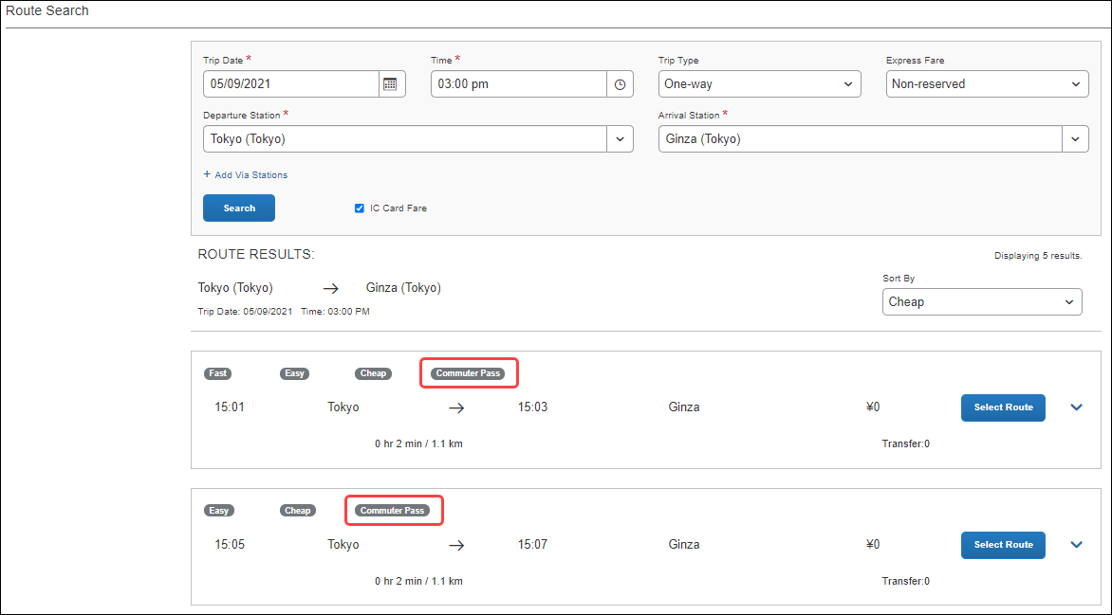
If a user selects a route not associated with their commuter pass, the Commuter Pass designation will not appear.
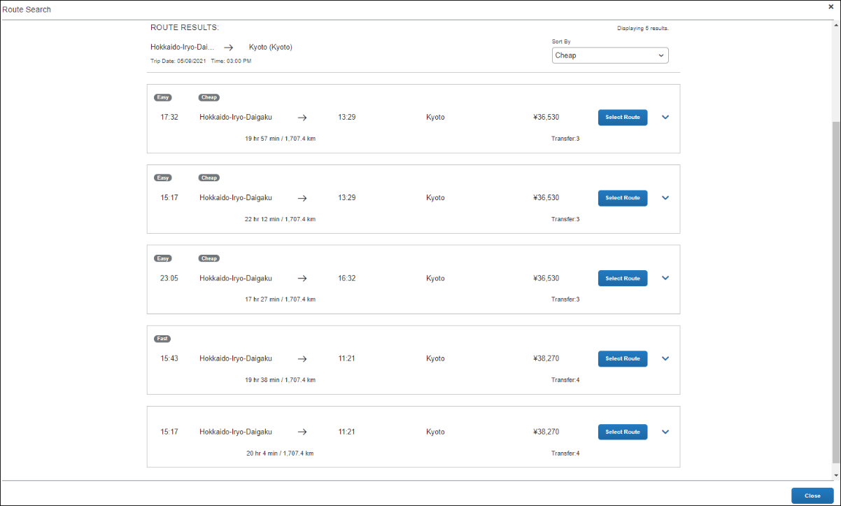
If the user selects a route that partially or entirely matches their registered commuter pass route, there will be a fare deduction. If the entire route matches their registered commuter pass, the total fare will be zero.
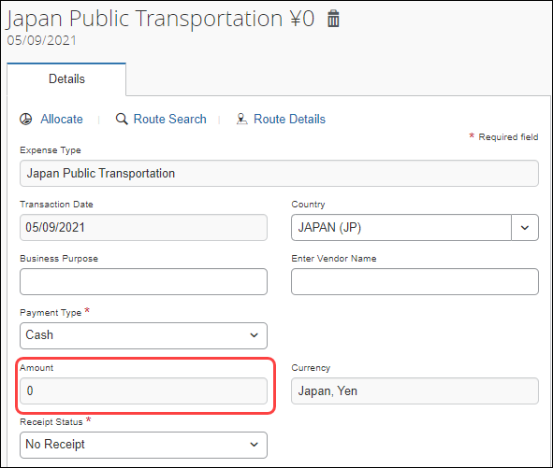

What the Approver Sees

Processing a Japan Public Transportation Route Search Expense
On the home page in the Required Approvals section of My Tasks, approvers can view and select a report which has JPT expense to review and approve. Approvers can view and select a report on the “Process Reports” screen.
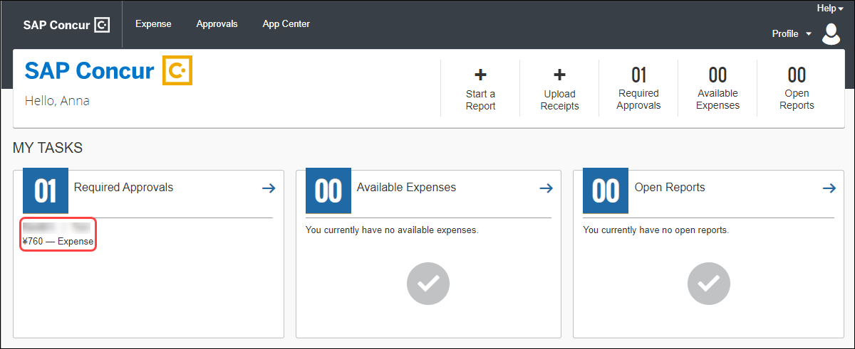
When the expense is selected, approvers can view the journey's route details; this gives them the opportunity to verify if the route complies with the organization's travel policy.
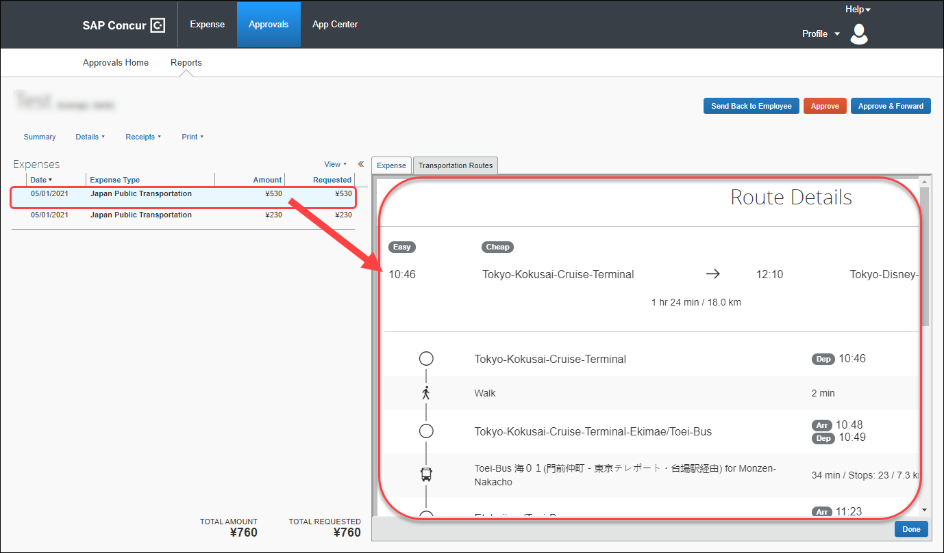

Adding a Commuter Pass
Approvers can also add a commuter pass but are restricted. If an approver or admin needs to change the end date of their commuter pass, they must contact Concur Admin to configure the end date of the commuter pass.
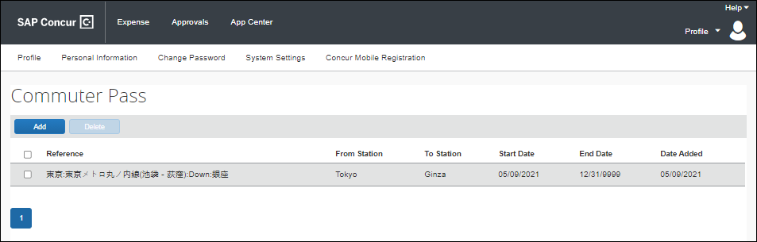

What the Administrator Sees
Admin can process JPT expenses as expected and can configure a commuter pass added by a user and manage commuter passes on behalf of users.

Processing a Japan Public Transportation Route Search Expense
From Expense > Process Reports page, Admin searches for the corresponding expense tied to a JPT expense.
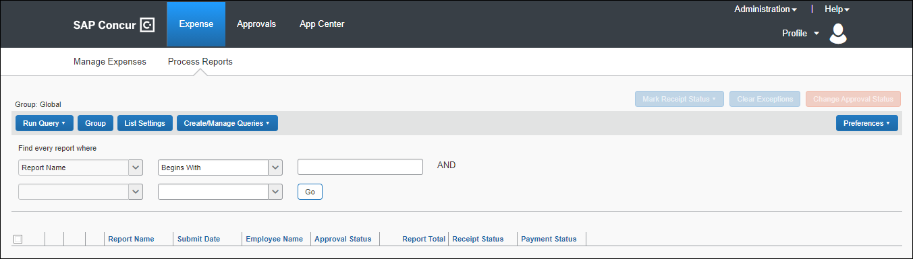

Example of Reports Ready for Processing Search Results
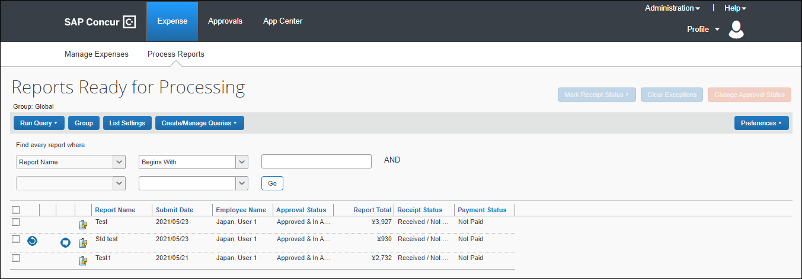
By default, once the expense report is selected, the route details of that JPT expense displays.
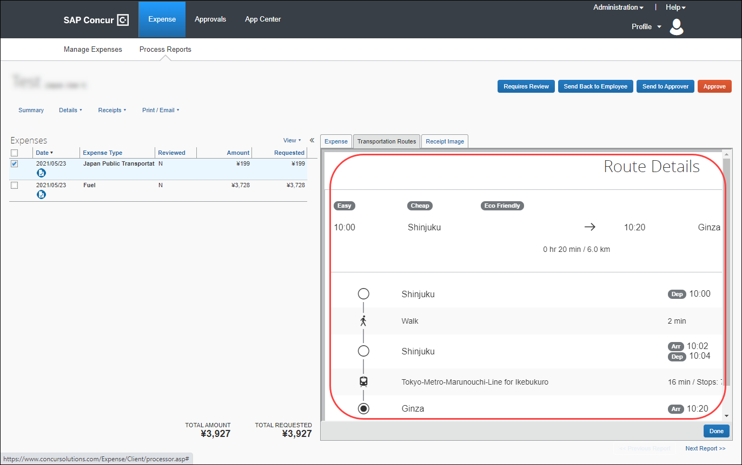
Admin then approves the expense report if no further actions are required (for example, Requires Review, Send Back to Employee, or Send to Approver).

Managing the Commuter Pass
Concur Admin can configure the settings of a user's commuter pass. For example, a user cannot configure the expiry date of their commuter pass, so they must contact their Concur Admin to change the end date for them. When Concur Admin adds an end date, the user can then add another commuter pass. Admin can export commuter pass information to Microsoft Excel. Prior to configuring the commuter pass, Concur Admin must update the Concur Admin settings to disable the Simple Setup Wizard for Expense option.
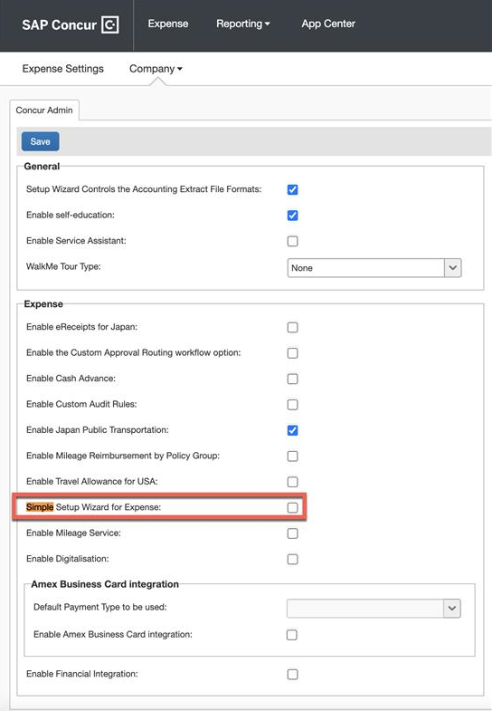
From the Commuter Pass Administrator page (Administration > Expense > Expense Settings > Capturing Spend > Commuter Passes), Concur Admin will be able to search and add commuter passes on behalf of the users.
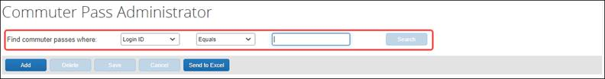

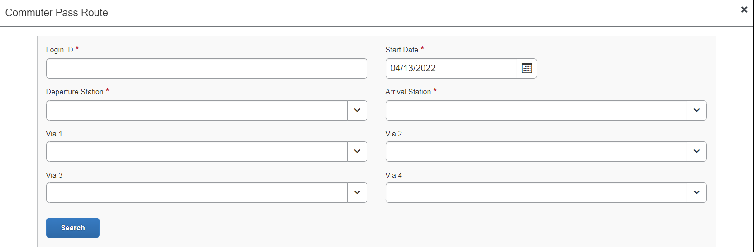
Concur Admin can also configure commuter pass settings that a user cannot configure. Using the Find commuter passes where fields, Concur Admin can search for and select a user whose commuter pass they want to modify.
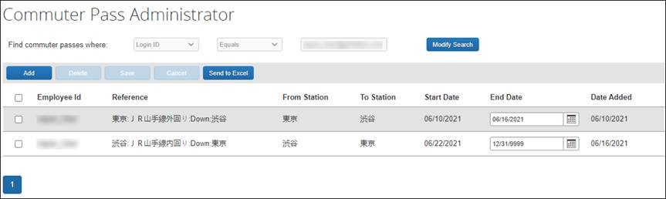
For example, a user cannot change the end date of their commuter pass. When a Concur Admin receives the user's request, Concur Admin can then add an end date, allowing the user to add another commuter pass.
Concur Admin can also delete commuter passes and export commuter pass information to Microsoft Excel.

Configuring Japan Public Transport
In Product Settings, the Manage Expense Types page displays the expense type, Japan Public Transportation.
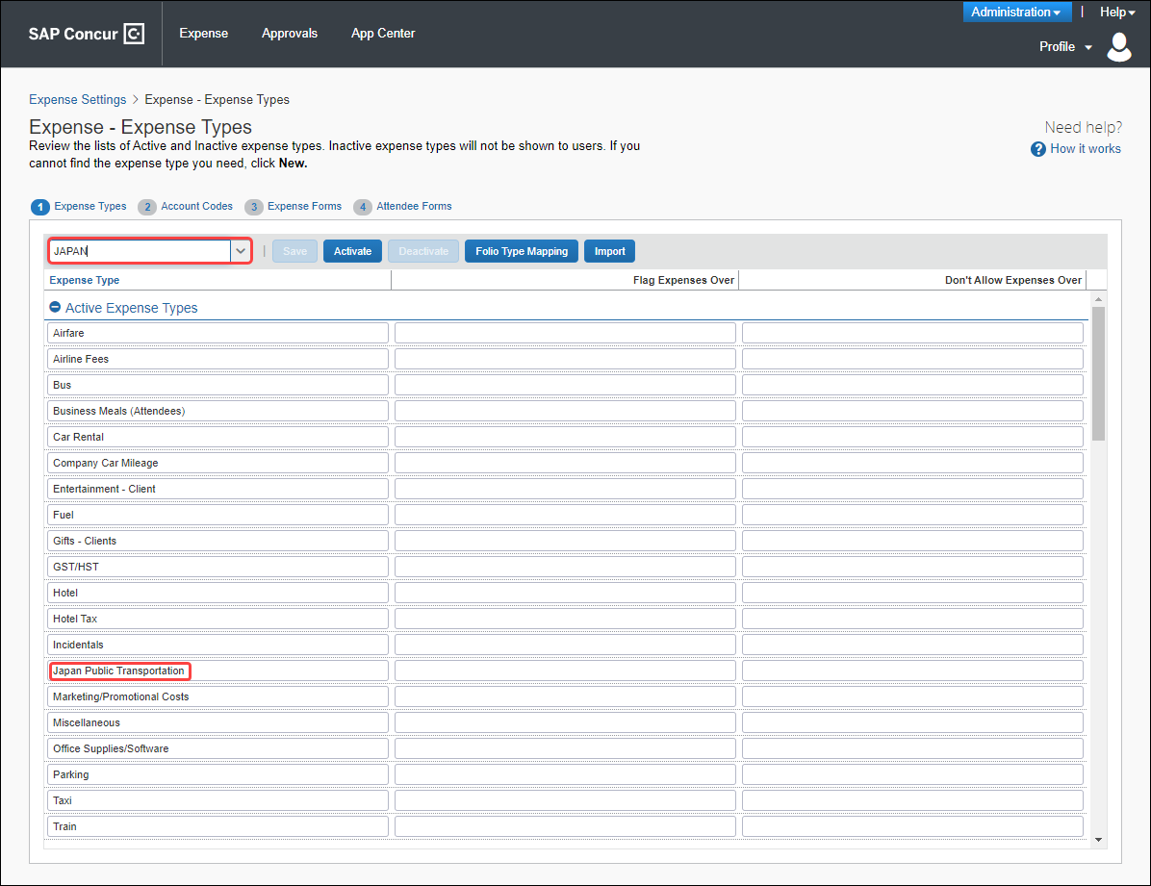

Configure JPT
The Japan Public Transportation expense type is activated by default for the country of Japan.
To configure the JPT feature for users in Japan:
- (Optional) In Product Settings, configure policy groups for the country of Japan.
- (Optional) By default, for all policy groups in Japan, on the Manage Expense Types page, the Japan Public Transportation expense type is active. Deactivate any groups that should not use this expense type on their expense reports.
- On the Manage Account Codes page, enter an account code for the Japan Public Transportation expense type and click Save.
- (Optional) Configure commuter pass routes for existing employees using the User Information page of Product Settings.

Managing the Commuter Pass Routes
The admin uses the Commuter Pass Admin page to:
- Add or remove commuter pass routes for an employee: By employee, add a route, or select and then delete the route.
- Manage the ending date of the employee’s commuter pass: The end date can be edited in the grid and does not appear to the employee.

Searching for Commuter Pass Routes by User
All Commuter pass routes in the Expense system can be accessed from the Commuter Pass Admin page. The Search criteria let the administrator search by login ID. Go to Commuter Pass Administrator page (Administration > Expense Settings > Capturing Spend > Commuter Passes).
A search is performed by selecting from the available criteria and entering the employee’s identification.
Concur Admin can also configure commuter pass settings that a user cannot configure. Using the Find commuter passes where fields, Concur Admin can search for and select a user whose commuter pass they want to modify or export.
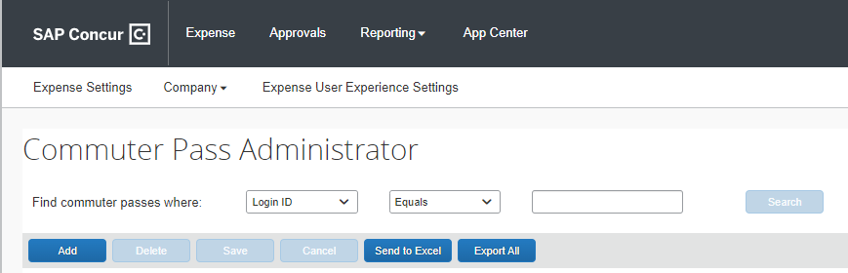
Concur Admin can also export commuter pass information to Microsoft Excel by pushing Send to Excel button after the commuter pass routes are displayed.

Adding a Commuter Pass Route
Concur Admin will be able to search and add commuter passes on behalf of the user.
To enter a route for an employee:
- On the Commuter Pass Administrator page, click Add.
- On the Commuter Pass Route page, provide the Login ID for the user you are creating the route for and complete the required fields.

- Login ID: Provide the Login ID of the user.
- Start Date: Select the date that is the starting date of the commuter pass validated period
- Departure Station: Enter the route by first specifying the starting station the user will travel.
- Arrival Station: Enter the route by first specifying the ending station the user will travel.
- (Optional) Via 1-4: You may optionally specify the station(s) through which the travel should route. You can add up to four Via stations.
- Click Search to return a list of routes validated by the Ekispert service.
If no route is returned, the service cannot find a route that matches the stations – try a different station.
- In the listed routes, click Select Route and then click Add Commuter Pass.
The route is added to the user’s list of commuter pass routes.
- (Optional): The administrator can now elect to define an end date for the commuter pass routes directly in the grid by clicking in End Date.
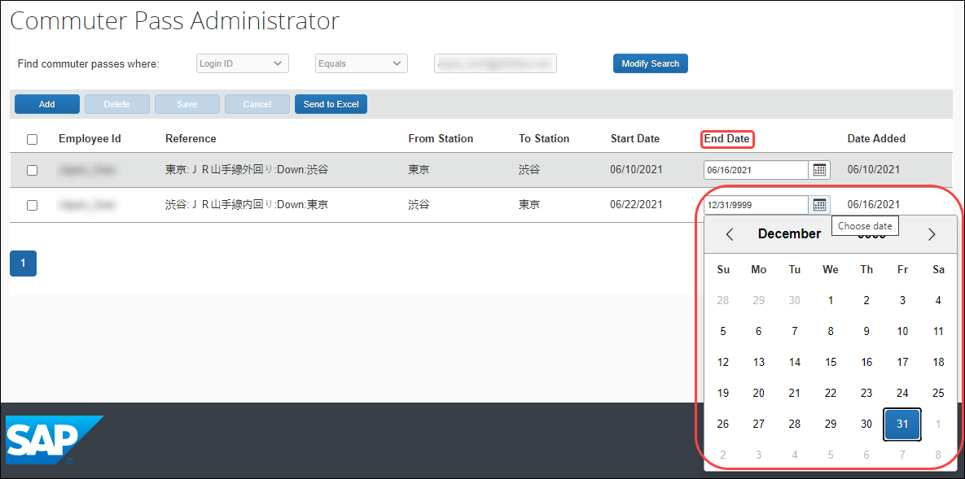

Exporting Commuter Passes
Concur Admin can export all commuter pass information Administration > Expense Settings > Capturing Spend > Commuter Passes. This allows the admin to see commuter passes registered in Concur Expense.

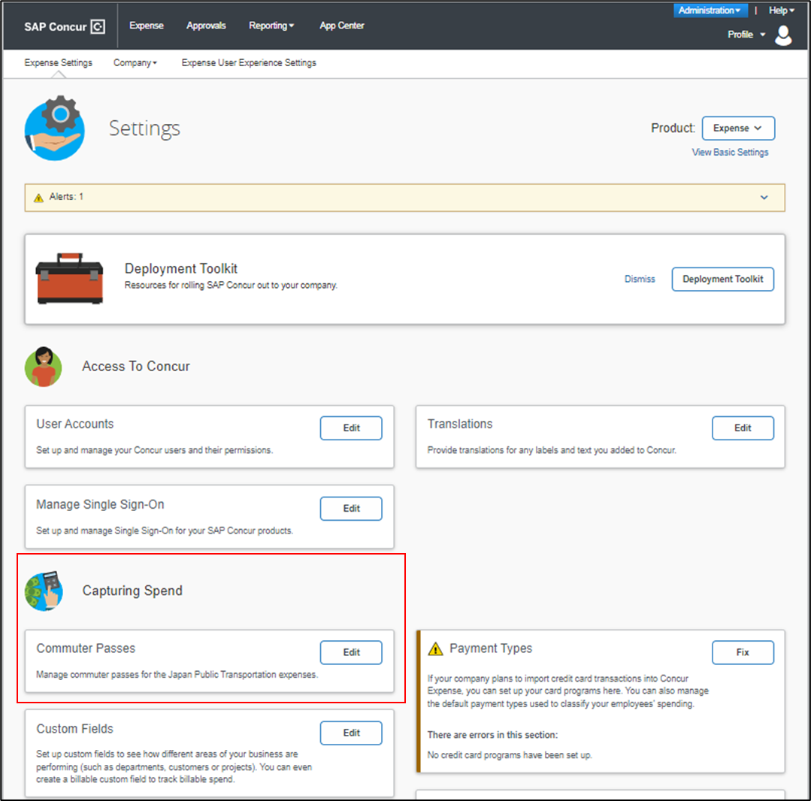

On the Commuter Pass Administrator page, Concur admin clicks the Export All button to export the commuter pass information to an Excel spreadsheet. All existing commuter passes of JPT on NextGen UI information will be exported and there will be no value sets on Find Commuter passes field.
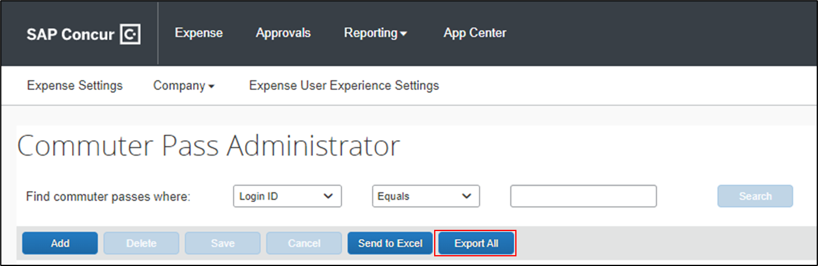
An Excel spreadsheet is downloaded to their default downloads location and then opens to show commuter pass information, such as the Employee ID, from and to station names, and so forth, for all users with a commuter pass.

Example
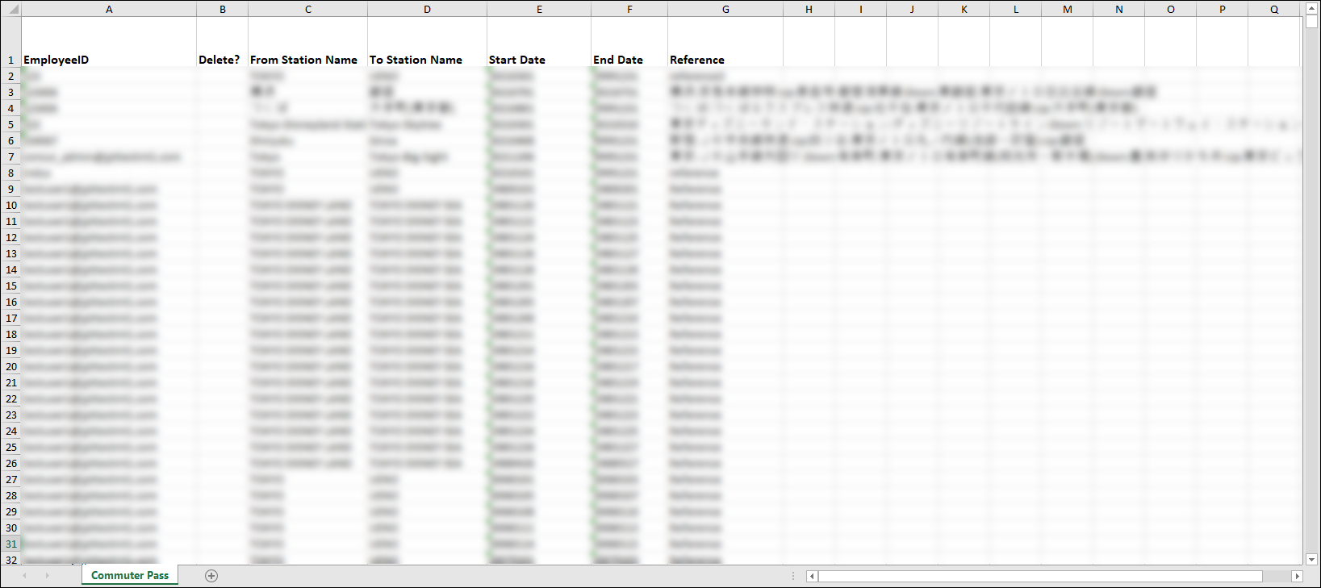

Deleting a Commuter Pass Route
To delete a commuter pass route:
- On the Commuter Pass Admin page, search for the Login ID of the user.
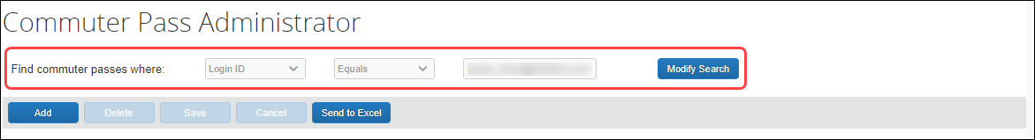
- In the list of returned routes, select the check box for one or more routes to remove.
- Click Delete.
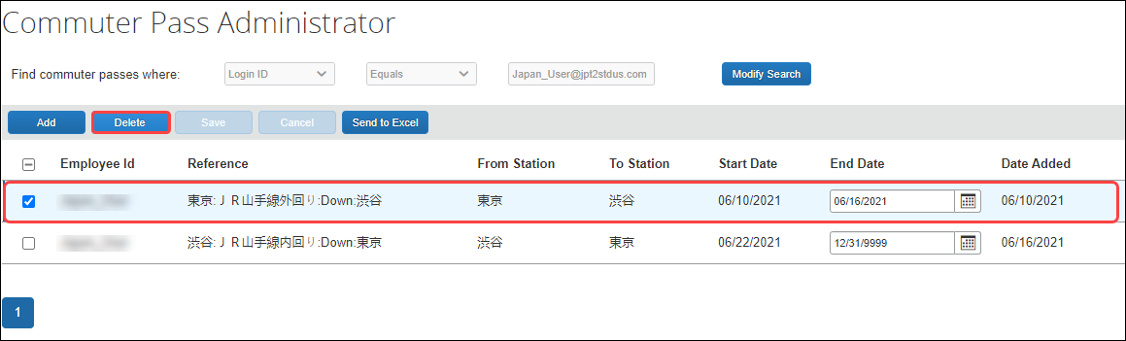
- Click Yes in the Delete message box to complete the deletion of the route.
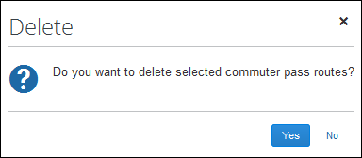
The route is removed from the user’s list of commuter pass routes.

Configure the IC Card reader feature
The easiest, quickest, and most error-free way to add routes to an expense report is to import them into Concur Expense from an employee IC Card. The network IC Card reader device enables users to import their IC Card data into Expense via the Internet. One device per office location is typical.
To use this feature, contact your Concur Expense implementation coach. This feature requires a small implementation project and the purchase and installation of IC Card readers from a specific manufacturer.

About IC Cards
An IC Card is a preloaded commuter card used to enter and exit the rail station gates, thereby capturing the time, date, and route information within the intelligent chip of the IC Card. There are roughly 16 different IC Cards in Japan, SUICA and PASMO being the most popular since they are primarily used by JR (Japan Rail Company) and within Tokyo by close to 40 million people. Each IC Card stores the last 20 transactions.

Configuration Process
The general steps for using this feature include the following:
- Contact your Concur Client Executive to confirm that you have the following prerequisites: 1) Concur JPT Service; 2) Concur Web Services; and 3) at least one proxy server with a static IP address.
- For Japanese clients, your Concur Client Executive will organize an implementation project. For global clients, your Concur Client Executive will contact an implementation partner from Fujisoft for the project. You must purchase at least one network IC Card reader device. You may choose to purchase a device for each of your office locations.
- Once the IC Card reader device is installed, your Implementation manager will complete set up for your company.
- The first time a user taps their IC Card on the network IC Card reader device located in their office, they will be prompted to enter their employee ID (not every time, just the first time). After entering their employee ID, their last 19 routes at maximum will be imported into Concur Expense.).

How Expense Works With the IC Card
A device should be installed in each Company location. An employee swipes the IC Card on the device. Routes stored on the IC Card are pulled into the Receipt Store and displayed in Available Expenses along with any other Smart Expenses.

Associate an IC Card to an employee
After the set up for the company is complete, users need to associate their IC Card to their SAP Concur account. The first-time users tap their IC Card on the network IC Card device, the screen below displays. Enter user’s employee ID.
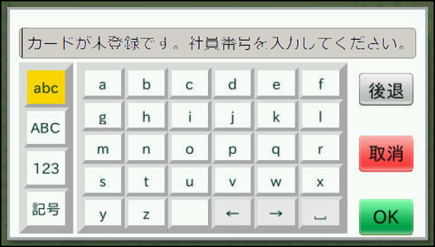

The IC Card and the user’s SAP Concur product account are associated.
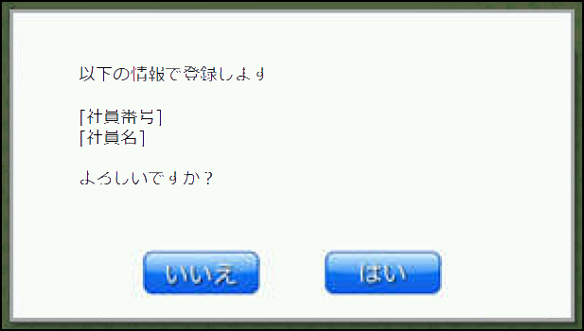

Audit Rules and Japan Public Transport
Audit Rules is a parity feature and can be used to flag the use of Japan Public Transport (JPT). For example, the administrator can generate exceptions based on the source used to enter the Transport route by the JPT traveler. This is used by companies whose specific policy rules restrict how an employee expenses a JPT transaction (which may require a receipt). By raising an exception, these criteria may be enforced at the company policy level.
For the itemized JPT expense audit rules to work both on JPT 1.0 and on JPT on NexGen UI, customer admins should modify audit rules before migrating. In the NextGen UI, only the event Entry Save is supported.
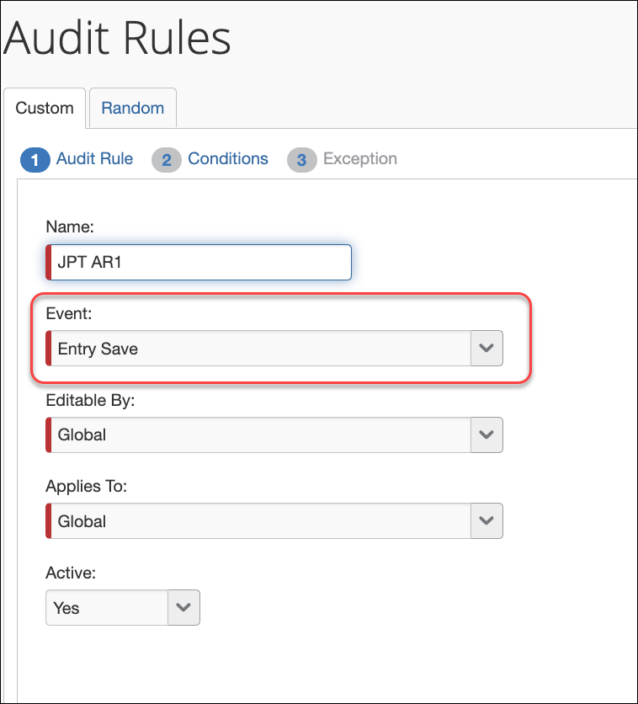
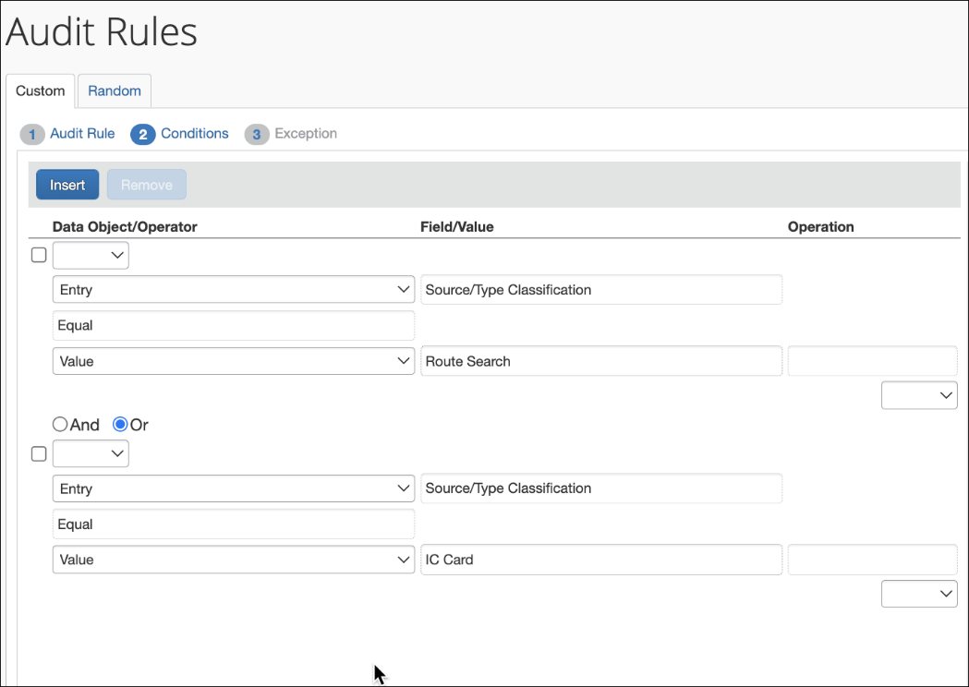
The admin can choose from JPT-specific fields display when the feature is enabled on the entity and the Entry object is selected. The choices are as follows:

Field Name | Available Selections for the Field
Source/Type Classification | Identifies the type of input based on the source of the route data used by the JPT traveler:  - CARD = (IC Card) Route data entered using IC Card  - RSRC = (Route Search) Route data entered by search

☼

