
Concur Expense:
Approval Routing
Setup Guide for Standard Edition
Last Revised: December 10, 2021
Applies to these SAP Concur solutions:
 Expense
Professional/Premium edition
 Standard edition
 Travel
 Professional/Premium edition
 Standard edition
 Invoice
 Professional/Premium edition
 Standard edition
 Request
 Professional/Premium edition
 Standard edition
Table of Contents
Section 1: Overview 1
Budget Workflow 2
Section 2: Types of Approval Routing 2
Processor Only 2
Requirements 2
Example – Employee to Processor Workflow 3
Manager to Processor 3
Requirements 3
Example – Manager > Processor Workflow 3
Manager to Authorized Approver to Processor 4
Requirements 4
Example – Manager > Authorized Approver > Processor Workflow 4
Manager to Second Approver to Processor 7
Requirements 7
Example – Manager > Second Approver > Processor Workflow 7
Manager to Manager’s Manager to Processor 8
Requirements 8
Example 1 – Manager > Manager's Manager (up to 5 levels) > Processor Workflow 8
Example 2 – Manager > Manager's Manager (up to 5 levels) > Processor Workflow 8
Example 3 – Manager > Manager's Manager (up to 5 levels) > Processor Workflow 8
Section 3: Configuration 10
Access the Approval Routing Page 10
Configure Your Approval Workflow 11
Approval Time Out 12
Workflow Conceptual Diagram 13
Section 4: Approval Email Notifications 18

Revision History
Date | Notes/Comments/Changes
January 21, 2022 | Updated the copyright year; no other changes; cover date not updated
December 10, 2021 | Updated instructions for Product Settings page
January 21, 2021 | Updated the copyright; added Concur to the cover page title; cover date not updated
June 20, 2020 | Updated Users page images.
April 16, 2020 | Renamed the Authorization Request check box to Request on the guide’s title page; cover date not updated
January 3, 2020 | Updated the copyright; no other changes; cover date not updated
December 16, 2019 | Added the new processor only workflow.
August 10, 2019 | Minor edits
June 8, 2019 | Updated text and images throughout to reflect UI name change from "Cost Tracking" to "Custom Fields".
April 13, 2019 | Added information about Budget Workflow
January 10, 2019 | Updated the copyright; no other changes; cover date not updated
April 14, 2018 | Updated the approval routing timeout duration to coincide with a renamed checkbox and new integer field. Updated screen shots to reflect changes in the UI. Updated flowchart to reflect the new timeout duration.
April 6, 2018 | Changed the check boxes on the front cover; no other changes; cover date not updated
March 13 2018 | Updated the copyright; no other changes; cover date not updated
November 4 2017 | Updated guide to include new Product Settings page, which replaces the Setup Wizard.
March 18 2017 | Updated with menu option name change to access Setup Wizard.
December 15 2016 | Changed copyright; no other content changes.
November 20 2015 | Updated graphics to reflect updated step names and instructional text where applicable.
February 6 2015 | Updated the screen shots to the enhanced UI  Removed information about two user interfaces; no other content changes
September 16 2014 | Added information about two user interfaces; no other content changes
August 22 2014 | Added section: Approval Time Out
July 11 2014 | Specified the 10-day timeframe after which the system will forward an unapproved report to the second approver (if a second approver is configured.)
May 16 2014 | New document. (This content originated from the Expense Setup Guide for Concur Standard.)

NOTE: Multiple SAP Concur product versions and UI themes are available, so this content might contain images or procedures that do not precisely match your implementation. For example, when SAP Fiori UI themes are implemented, home page navigation is consolidated under the SAP Concur Home menu.

Approval Routing
This page of Product Settings is visible only when enabled by SAP Concur support.

Overview
The Approval Routing page of Product Settings allows you to select the process that expense reports go through for approvals. There are five workflow options:
- Processor: This is the simplest option for routing expense reports directly to the processor and is the default setting.
- Manager > Processor: This option ensures that every expense report is approved by one manager, the employee's manager.
- Manager > Authorized Approver > Processor: This option ensures that approval limits are used.
- Manager > Second Approver > Processor: This option ensures that every expense report is approved by two managers prior to reaching a processor.
- Manager > Manager's Manager (up to 5 levels) > Processor: This option ensures that when handling large volumes of expense reports only those expense reports requiring the highest approval limits reach upper management.
Options 2 and 4 are role-based while options 3 and 5 are role-based and limit-based.
The administrator can also select whether managers and employees can add more approvers to the process. When the report is given the final approval, it is ready to be exported and paid.
If you select a manager approval step for your company's workflow, a message appears on the Approval Routing page notifying you that you now need to assign a user as the manager approver for each user record on the Users page.
The Approval Routing page is also where you configure whether employees will see a Recall button when viewing their submitted reports. This functionality is enabled by default. Once recalled, any errors or omissions can be corrected and the report resubmitted, or the report can simply be deleted.
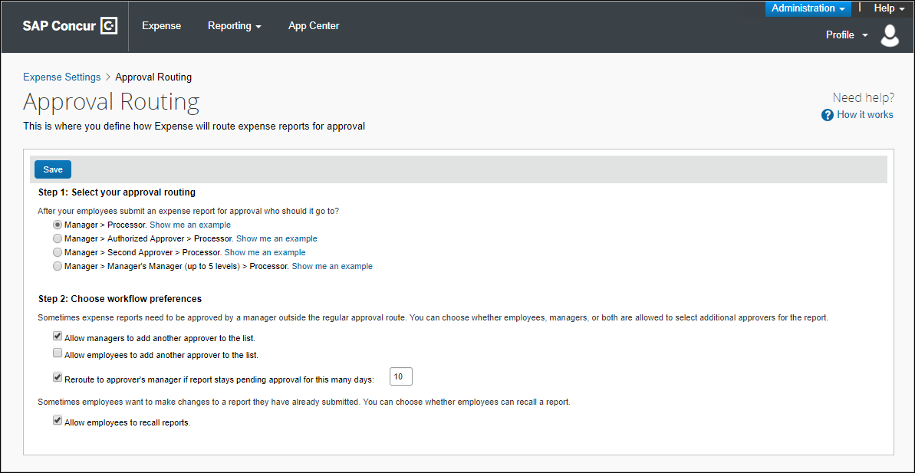

Budget Workflow
If your company has the Budget Workflow feature enabled, you can select to include a budget approval step on the Approval Routing page.
- For more information about budget approvals, refer to the Shared: Budget Setup Guide for Standard Edition.

Types of Approval Routing
This section describes approval routing options and workflow preferences.

Processor Only

Requirements
The processor only option is the default setting. This option simplifies the approval workflow process and eases initial user administration setup. For smaller businesses, this option may be preferred because it removes a duplicate approval process.
Clients can still opt to include a manager approval step in their company's workflow. If you select a manager approval step for your company's workflow, a message appears on the Approval Routing page notifying you that you now need to assign a user as the manager approver for each user record on the Users page.

Example – Employee to Processor Workflow
An employee clicks Submit Report for an expense report totaling $500. The expense report goes to the company's processor who is permitted to approve any amount, and who, after careful consideration, clicks Approve. The expense report status is set to Pending Payment.
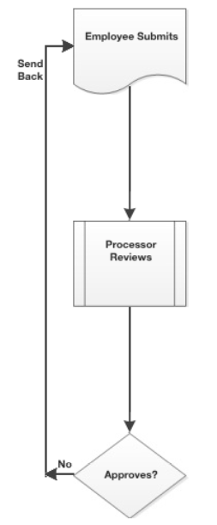

Manager to Processor

Requirements
Each employee must have a manager selected in the Manager field on the Users page.

Example – Manager > Processor Workflow
An employee clicks Submit Report for an expense report totaling $500. The expense report goes to their manager who is permitted to approve any amount, and who, after careful consideration, clicks Approve. The report goes to a processor who is permitted to approve any amount, and who, after careful consideration, clicks Approve. The expense report status is set to Pending Payment.
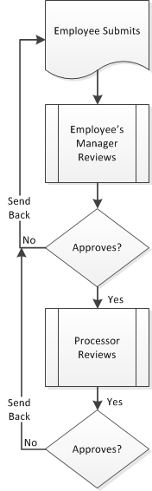

Manager to Authorized Approver to Processor

Requirements
- Each employee must have a manager selected in the Manager field on the Users page.
- Each manager must have an approval limit entered using the Can Limit Approve Reports field on the Users page.

Example – Manager > Authorized Approver > Processor Workflow
An employee clicks Submit Report for an expense report totaling $500. The expense report goes to their manager (Manager A) who has an approval limit of $300, and who, after careful consideration, clicks Approve. Manager A is prompted to make a selection from a list of managers within the company who are configured with an approval limit sufficient to cover this $500 expense report. Because Manager A's manager does not have a sufficient approval limit to cover this expense report, Manager A will select a different manager. The expense report goes to the selected authorized approver who has an approval limit of $5000, and who, after careful consideration, clicks Approve. The expense report goes to a processor who is permitted to approve any amount, and who, after careful consideration, clicks Approve. The expense report status is set to Pending Payment.
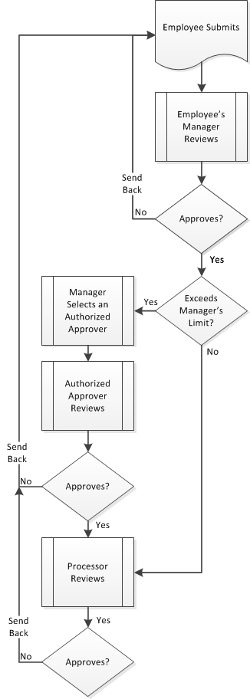

Manager to Second Approver to Processor

Requirements
- Each employee must have a manager selected in the Manager field on the Users page.
- Each employee should have a second approver designated using the Second Approver field on the Users page. If the employee has no second approver, their approved reports will go from their manager directly to the processor.

Example – Manager > Second Approver > Processor Workflow
An employee clicks Submit Report for an expense report totaling $500. The expense report goes to their manager who is permitted to approve any amount, and after careful consideration, clicks Approve. The report goes to the person who is this submitter's second approver. The second approver is permitted to approve any amount, and after careful consideration, clicks Approve. The expense report goes to a processor who is permitted to approve any amount, and who, after careful consideration, clicks Approve. The expense report status is set to Pending Payment.
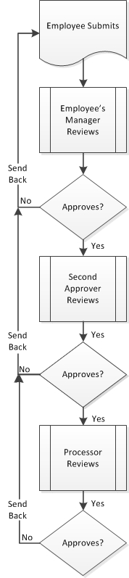

If a second approver exists, and the first approver does not handle an expense report within the configured number of days, then the system will automatically forward the expense report to the second approver.

Manager to Manager’s Manager to Processor

Requirements
- Each employee must have a manager selected using the Manager field on the Users page.
- Each manager must have an amount entered using the Can Limit Approve Reports field on the Users page.
Make sure that the final manager has a very high approval limit so that all reports can be successfully approved. Also make sure that at least one other manager has a very high approval limit so that reports submitted by the final manager can be successfully approved. Remember that no one can approve their own reports.

Example 1 – Manager > Manager's Manager (up to 5 levels) > Processor Workflow
An employee clicks Submit Report for an expense report totaling $5000. The expense report goes to their manager (Manager A) who has an approval limit of $100, and who, after careful consideration, clicks Approve. The expense report goes to the manager's manager (Manager B) who has an approval limit of $200, and who, after careful consideration, clicks Approve. The expense report goes to Manager B's manager (Manager C) who has an approval limit of $300, and who, after careful consideration, clicks Approve. The expense report goes to Manager C's manager (Manager D) who has an approval limit of $4000, and who, after careful consideration, clicks Approve. The expense report goes to Manager D's manager (Manager E) who has an approval limit of $5000, and who, after careful consideration, clicks Approve. The expense report goes to a processor who is permitted to approve any amount, and who, after careful consideration, clicks Approve. The expense report status is set to Pending Payment.

Example 2 – Manager > Manager's Manager (up to 5 levels) > Processor Workflow
An employee clicks Submit Report for an expense report totaling $500. The expense report goes to their manager (Manager A) who has an approval limit of $600, and who, after careful consideration, clicks Approve. The expense report goes to a processor who is permitted to approve any amount, and who, after careful consideration, clicks Approve. The expense report status is set to Pending Payment. While the approval routing was configured to accommodate additional approvers, they were not needed in this example.

Example 3 – Manager > Manager's Manager (up to 5 levels) > Processor Workflow
An employee clicks Submit Report for an expense report totaling $500. The expense report goes to their manager (Manager A) who has an approval limit of $400, and who, after careful consideration, clicks Approve. The expense report goes to the manager's manager (Manager B) who has an approval limit of $500, and who, after careful consideration, clicks Approve. The expense report goes to a processor who is permitted to approve any amount, and who, after careful consideration, clicks Approve. The expense report status is set to Pending Payment. While the approval routing was configured to accommodate additional approvers, they were not needed in this example.
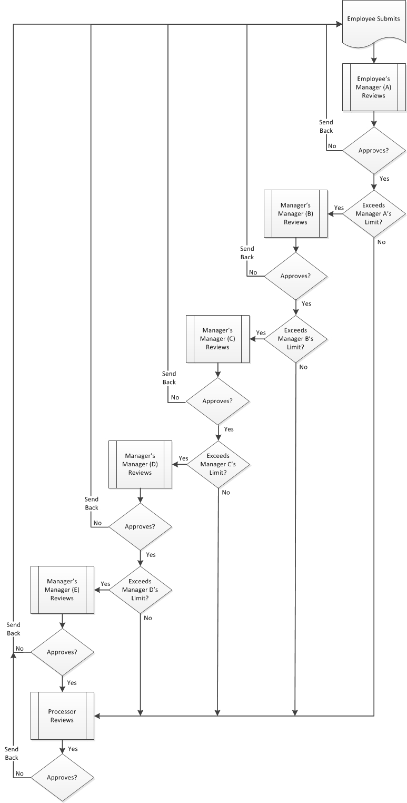

Configuration

Access the Approval Routing Page
To access the Approval Routing page:
- Click Administration > Expense Settings or Expense & Invoice Settings.
- In the Product list, click Expense.
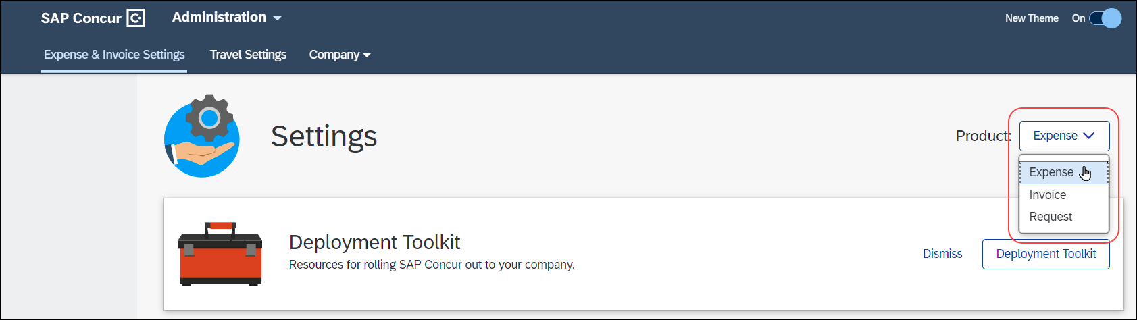
- In the Policy section, on the Expense Approvals tab, click Edit.
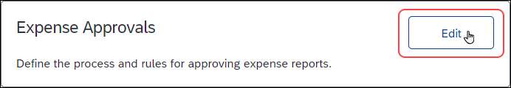
The Approval Routing page appears.
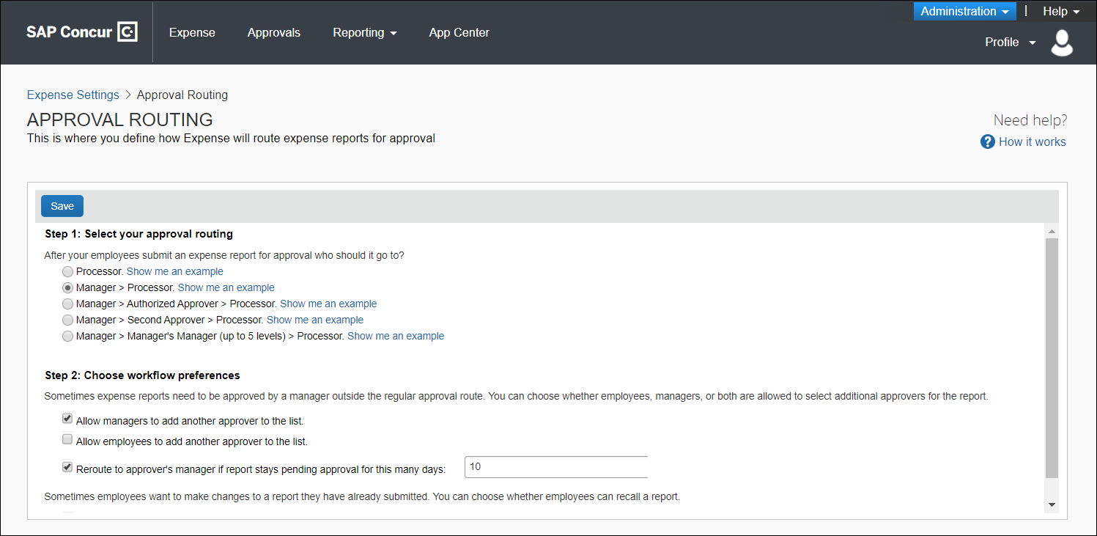

Configure Your Approval Workflow
To configure your workflow preferences:
- On the Approval Routing page, fill in the fields:
Field | Description
Choose whether to allow additional approvers | Choose whether managers and employees can add more approvers to the report approval route. If you select this option, the manager or employee sees a button after approving or submitting that lets them select another approver. The approver they select is added to the approval route after them, and then the report continues on the existing path. The additional approver does not replace the standard approvers.
Choose whether to turn off time outs | Choose whether to turn off approval time outs. This setting is enabled by default to keep expense reports moving through the workflow.  For more information, refer to the Approval Time Out section of this guide.
Choose whether to allow recalls | Choose whether employees can recall submitted expense reports. When allowed (default configuration), employees can edit and resubmit, or delete, expense reports. The expense reports are available for recall any time prior to reaching the Pending Payment status.
- Click Save to save your changes.

Approval Time Out
The Reroute to approver's manager if report stays pending for this many days setting is enabled by default. The default number is 10 calendar days. This field can be modified.
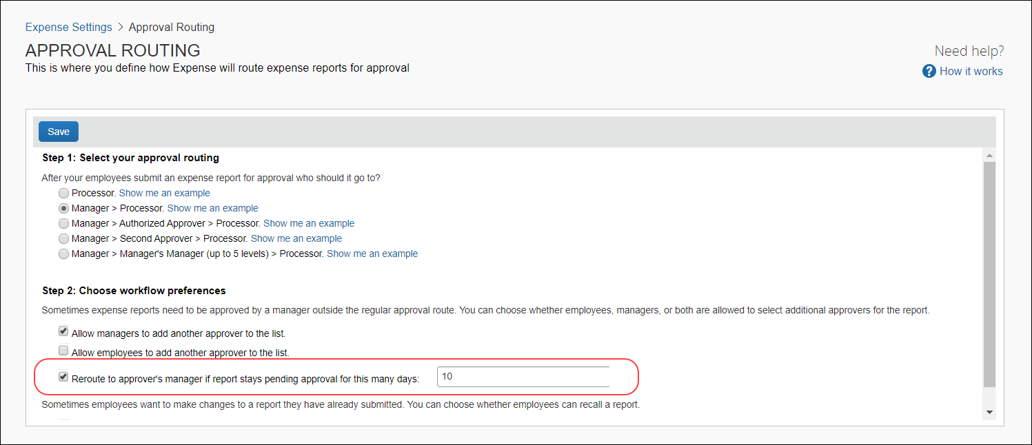
This setting allows the system to take these actions:
- The system times the approver. This begins when the expense report enters the pending approval workflow step for the approver.
- The system may automatically reassign an expense report. If the timer reaches the configured number of calendar days, the system escalates the expense report to the approver's manager and resets the timer. If the timer again reaches the configured number of calendar days, the system forwards the expense report to the next approver or to the processor.
When the system escalates an expense report, the system is including someone in the approval process that might not otherwise be involved. When the system forwards an expense report, the system is skipping an approver and assigning the report to the next person who would have eventually received it for approval.

Workflow Conceptual Diagram
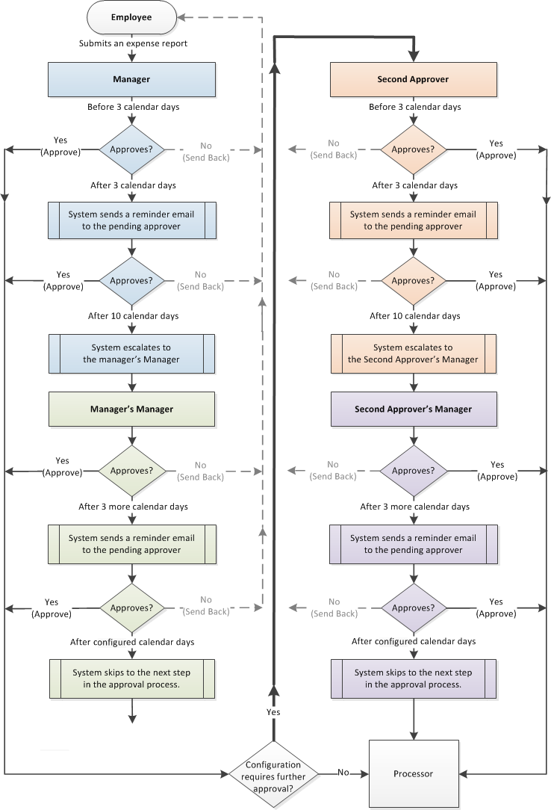

Example Time Outs

Submitter > Manager > Processor
This workflow is available on the Approval Routing page in Product Settings. The following section describes how this workflow option is impacted by the Approval Time Out setting.
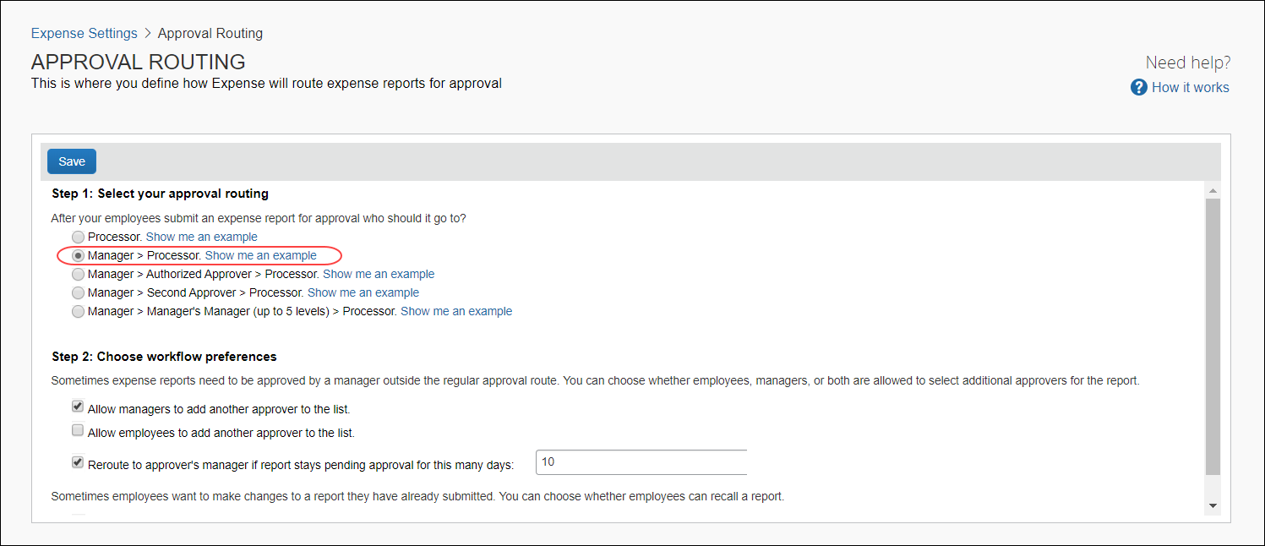
If the approver does not approve (or send back) the expense report after 3 calendar days, then the system automatically sends the approver a reminder email.
If the approver does not approve (or send back) the expense report after the configured number of calendar days, then the expense report is automatically escalated by the system to the approver's Manager, or if no Manager is configured, then to the processor.
An approver's Manager is configured using the Manager field on the approver's Create User or Edit User page:
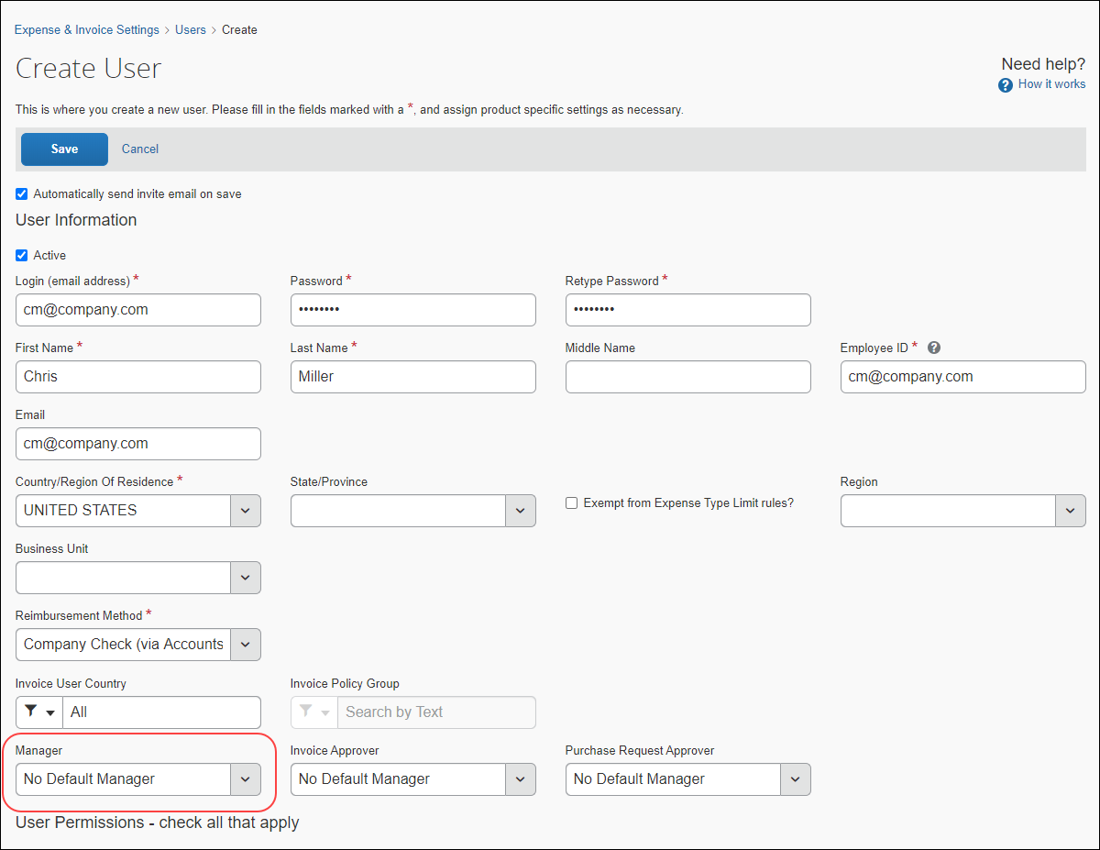
If the approver's Manager does not approve (or send back) the expense report in 3 days, then the system automatically sends the approver's Manager a reminder email.
If the approver's Manager does not approve (or send back) the expense report in the configured number of calendar days, then the expense report is automatically forwarded by the system to the processor.

Submitter > Manager > Second Approver > Processor
This workflow is available on the Approval Routing page in Product Settings. The following section describes how this workflow option is impacted by the Approval Time Out setting.
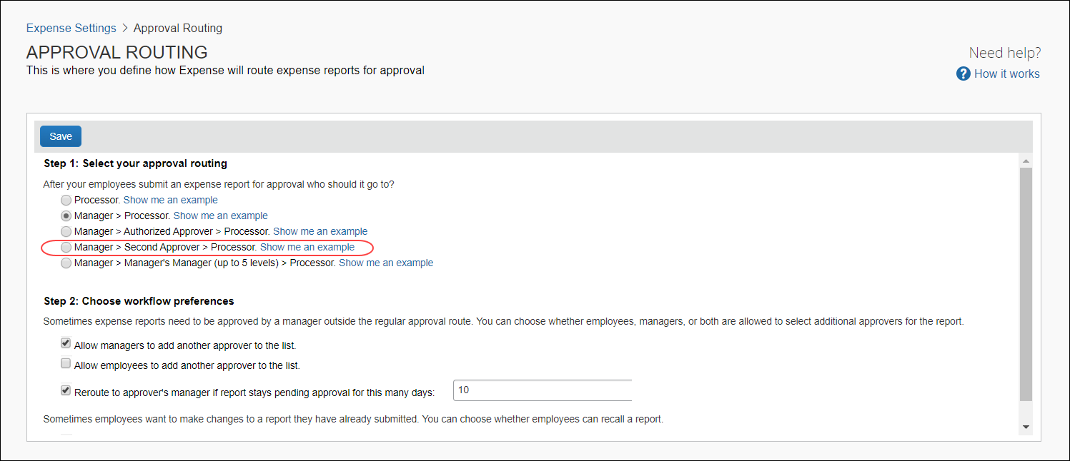
If the approver does not approve (or send back) the expense report after 3 calendar days, then the system automatically sends the approver a reminder email.
If the approver does not approve (or send back) the expense report after the configured number of calendar days, then the expense report is automatically escalated by the system to the approver's Manager.
An approver's Manager is configured using the Manager field on the approver's Create User or Edit User page. A Second Approver is configured using the Second Approver field on the approver's Create User or Edit User page.
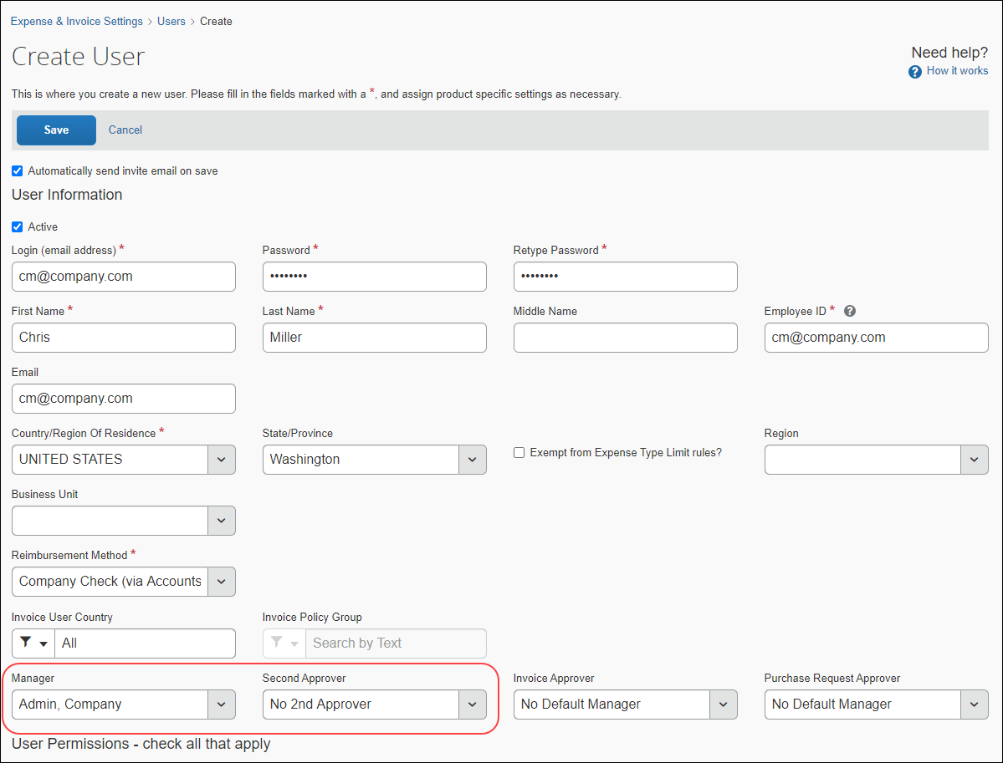
In the event that Manager and/or Second Approver are blank, those approvers are skipped by the system resulting in the expense report reaching the processor sooner.
If the approver's Manager does not approve (or send back) the expense report in 3 days, then the system automatically sends the approver's Manager a reminder email.
If the approver's Manager does not approve (or send back) the expense report in the configured number of calendar days, then the expense report is automatically escalated by the system to the submitter's Second Approver.
If the Second Approver does not approve (or send back) the expense report in 3 days, then the system automatically sends the Second Approver a reminder email.
If the Second Approver does not approve (or send back) the expense report in the configured number of calendar days, then the expense report is automatically forwarded by the system to the Second Approver's Manager.
If the Second Approver's Manager does not approve (or send back) the expense report in 3 days, then the system automatically sends the Second Approver's Manager a reminder email.
If the Second Approver's Manager does not approve (or send back) the expense report in the configured number of calendar days, then the expense report is automatically forwarded by the system to the processor.

Approval Email Notifications
When an expense report enters the approval queue for a user with the Can Approve Expense Reports role, the approver receives a notification email. After 3 calendar days, the approver receives a reminder email. After that, the approver receives daily reminders until they have approved the report.
Approvers can choose whether they receive email notifications when a report is submitted for their approval on the Expense Preferences page of Profile.
Users can choose whether they receive email notifications when their report status changes on the Expense Preferences page of Profile.



