SAP Concur Release Notes
Concur Expense Standard Edition
Month | Audience
Release Date: March 23, 2024  Update #1: March 26, 2024 | Client FINAL

Contents
Release Notes 1
Audit Rules 1
Check for Expense Date Within Leave of Absence Date Range 1
Expense Pay 3
Additional AMEX Corporate Card Programs Now Supported for Europe 3
Expense Types Redesign 5
**Ongoing** Updated User Interface (UI) for Expense Types 5
Verify 7
Audit Profile: Quick Start Profiles 7
Traveler Name Check Update 8
Planned Changes 10
Company Card 10
**Planned Changes** Enhancements to the Manage Transactions Screen 10
**Planned Changes** Updates to New Card Account Pending Assignment Email 12
Expense Types 14
**Planned Changes** Enhanced Expense Types Administration 14
Miscellaneous 24
**Planned Changes** Keyboard Shortcuts for Expense Screens 24
Reports 26
**Planned Changes** Preferred Name for Expense Submitter 26
Client Notifications 28
Accessibility 28
Accessibility Updates 28
Gender Diversity 28
Gender Diversity Planned Features and Changes 28
In-Product User Assistance 28
Client Customized Content 28
Subprocessors 29
SAP Concur Non-Affiliated Subprocessors 29
Supported Browsers 29
Supported Browsers and Changes to Support 29
Additional Release Notes and Other Technical Documentation 30
Online Help 30
SAP Concur Support Portal – Selected Users 30
Cases 31
Check Support Case Status 31

Legal Disclaimer
The information in this presentation is confidential and proprietary to SAP SE or an SAP affiliate company and may not be disclosed without the permission of SAP SE or the respective SAP affiliate company. This presentation is not subject to your license agreement or any other service or subscription agreement with SAP SE or its affiliated companies. SAP SE and its affiliated companies have no obligation to pursue any course of business outlined in this document or any related presentation, or to develop or release any functionality mentioned therein. This document, or any related presentation and SAP SE or an SAP affiliate company’s strategy and possible future developments, products and or platforms directions and functionality are all subject to change and may be changed by SAP SE and its affiliated companies at any time for any reason without notice. The information in this document is not a commitment, promise or legal obligation to deliver any material, code or functionality. This document is provided without a warranty of any kind, either express or implied, including but not limited to, the implied warranties of merchantability, fitness for a particular purpose, or non-infringement. This document is for informational purposes and may not be incorporated into a contract. SAP SE and its affiliated companies assume no responsibility for errors or omissions in this document, except if such damages were caused by SAP SE or an SAP affiliate company’s willful misconduct or gross negligence.
All forward-looking statements are subject to various risks and uncertainties that could cause actual results to differ materially from expectations. Readers are cautioned not to place undue reliance on these forward-looking statements, which speak only as of their dates, and they should not be relied upon in making purchasing decisions.

Release Notes
This document contains the release notes for Concur Expense Standard edition.
Features and changes that apply to SAP Concur site-wide or to multiple products/services are documented in the Shared Changes Release Notes. For information about site-wide or shared changes in this release that might impact your SAP Concur solutions, refer to the Shared Changes Release Notes.

Audit Rules

Check for Expense Date Within Leave of Absence Date Range

Overview
With this release, the Audit Rules administrator may now create conditions that compare a data object date field (for example, an expense entry transaction date) against a Leave Of Absence (LOA) date range provided from the user’s profile to determine if the date falls within a LOA period. Based on company policy, the resulting exception can prevent submission of the report or flag it for additional scrutiny during approval reviews.

Business Purpose / Client Benefit
This feature lets a company identify when the report’s dates or expense dates conflict with company policy about incurring expenses during a leave of absence.

What the Administrator Sees
The administrator uses audit rule conditions to create a rule that compares the report date and/or expense dates found in a report against the user’s LOA, by date range. The comparison is performed when the report is saved or submitted and can prevent the report from submission if the report and/or expense dates fall within the leave range and the absence type does not allow for expensing during the absence.

Types of LOA
Leave of Absence information that is recorded in the user profile is classified by type of absence:
- Voluntary: An employee chooses to take time off from an employer (i.e. for personal reasons)
- Mandatory: An employer is required to grant the employee time off from work (i.e. for maternity / paternity leave, or for mandatory military service)

How the Date Ranges are Handled
The administrator uses two new date Operators, Within Employee Mandatory Leave of Absence and Within Employee Voluntary Leave of Absence when configuring the date range condition.
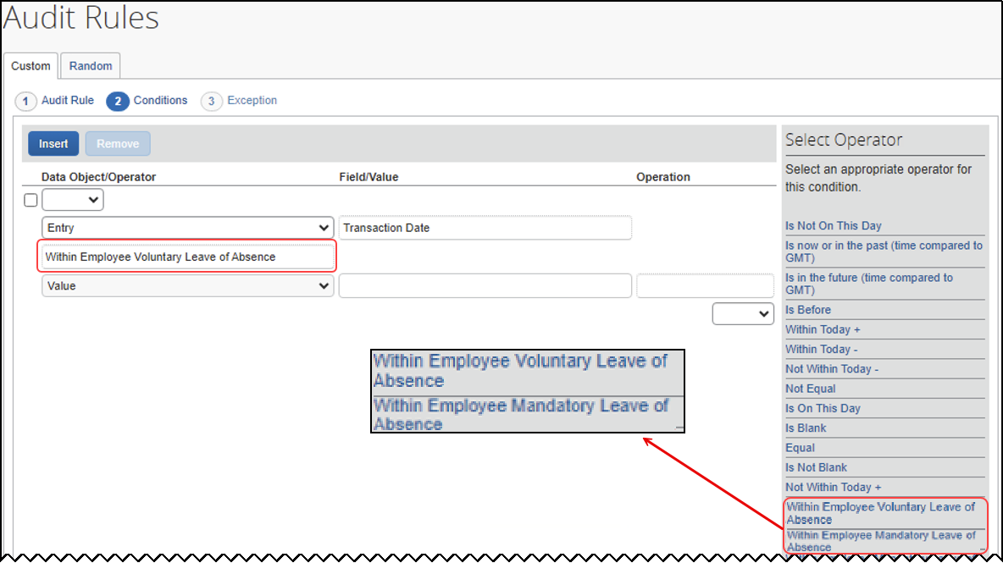
Note the following when using this feature:
- Both the LOA Start and End dates, and the absence type, Mandatory or Voluntary, are used
- If an employee has multiple historical LOAs, the rule will test the date as follows:
- Between a Start and End date of a single range, such as Range A
- Not between the Start date of Range A, and the End date of Range B
- A system exception appears if Expense cannot reach the user data from the user’s profile service

Configuration / Feature Activation
Companies wishing to use this new option must:
- Load LOA data into the user profile via the following API:
- User Provisioning service
- Identity v4.1
- Identity v4
- Create a custom audit rule employing these new conditions.
For more information, refer to the Concur Expense: Audit Rules Setup Guide.
For more information about loading LOA ranges into the user profile, refer to the User API at developer.concur.com.

Expense Pay

Additional AMEX Corporate Card Programs Now Supported for Europe

Overview
Expense Payment Manager now supports reimbursement for the following AMEX corporate credit card programs issued out of Europe:
- American Express – EMEA – Czechia (CZK)
- American Express – EMEA – Norway (NOK)
- American Express – EMEA – Poland (PLN)

Business Purpose / Client Benefit
This update allows end users to automate the reimbursement process for corporate AMEX cards in these countries/currencies and can expedite the processing of credit card expenses.

Administrator Experience
These additional credit card programs are available to reimbursement admins on the Manager > Configure Batches > Card Programs (tab) > Add New Card Program page.
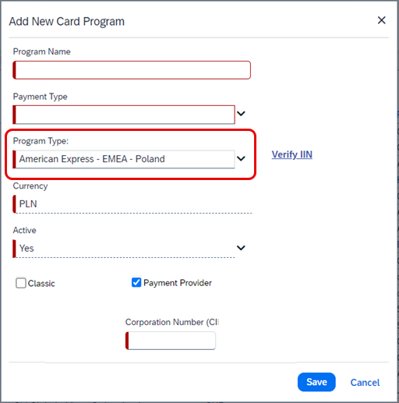

End-User Experience
You will have to setup the card program and configure a card batch in the Configure Batches area of Payment Manager. To complete setting up the card program, request the Corporation Number (CID) from your AMEX representative, to enter in the corresponding field when setting up the card program.

Configuration / Feature Activation
The change occurs automatically; there are no additional configuration steps.

Expense Types Redesign

**Ongoing** Updated User Interface (UI) for Expense Types

Information First Published | Information Last Modified | Feature Target Release Date
August 2023 | February 2024 | Q3 2023 – Q4 2024
Any changes since the previous monthly release are highlighted in yellow in this release note.

Overview
SAP Concur is redesigning the Concur Expense UI experience for Expense Types screens to give product admins a new user experience while creating and managing expense types. These changes will take place between Q3 2023 and throughout 2024.
The redesigned version of Expense Types will become the default version for Concur Expense customers from April 2024. Customers will still have the ability the use the legacy version if they wish to do so until it is no longer available.

Business Purpose / Client Benefit
The new design provides a modern, consistent, and streamlined user experience for Concur Expense admins.

Products and Users Affected
To take advantage of these improvements, Concur Expense customers will be encouraged to transition to the redesigned version of Expense Types in Concur Expense. The following provides information about the timeline and resources available to ensure this process is smooth and efficient for all users.
These UI changes apply to:
- Standard version of Concur Expense
- Admins; there are no changes for end users, approvers, or processors.

IMPORTANT: Timeline and Milestones
There are three important milestones for Concur Expense customers as they transition from the existing legacy UI for Expense Types to the redesigned version.
- Phase 1: October 2023
In October 2023, customers who had the basic configuration of Concur Expense were offered an Opt-In Period, to try out the redesigned Expense Types.
The redesigned version of Expense Types was not available for customers who had advanced features such as Policy Groups, Multiple Country Packs, and so on, enabled for their organization. If the customers with the basic configuration chose to enable advanced settings, then they automatically reverted to the legacy version.
Customers used this period to plan their transition and moved to the redesigned Expense Types when it was right for their business priorities.
During the Opt-In Period, not all Concur Expense features from the existing UI were available in the redesigned user interface.
During the first phase, only the Manage Expense Types screens was covered under the redesigned version.
Any decision to opt-in or opt-out was a company-wide decision and was applicable to all the admins in the company.
- Phase 2: April 2024
During this period, all customers will automatically default to the redesigned version of Expense Types, regardless of the configuration. They will still have the chance to access the legacy screens. These changes will be available from April 2024.
The features planned for this phase will include a First Run Experience for new customers, Policy Groups, Alternate Account Codes, Multiple Country Packs, and Item Code Mapping for financial integrations.
- Phase 3: TBD
During this period, all customers will be automatically transitioned to the redesigned UI and will not be able to access the legacy screens of Expense Types any longer.
This ensures that we continue to offer a consistent user experience for all customers and allows for superior product innovation and support. We have not yet set a date for these changes.

Transition Materials – Guides and Other Resources
Customers can use the Concur Expense: Expense Types Setup Guide to learn more about the changes happening in Expense Types. Along with the setup guide, we also offer release notes, and other resources to aid in the transition.
To help with training needs, customers can create custom training materials by using the setup guide "as is". They can cut, copy, paste, delete, or otherwise edit either guide at will.
- Setup guide: This guide compares the legacy user interface to the redesigned version for Concur Expense to help users become comfortable with the new experience. This guide will be updated as needed during the Opt-In Period as the redesigned UI is being enhanced. Admins should review the guide often.
The customer can cut, copy, paste, delete, or otherwise edit this guide at will.
- Release information: During the Opt-In Period, the release of enhancements will not be on the regular release schedule. Instead, SAP Concur will provide special release notes and information about features and enhancements that are nearing release.

Getting Started
Customers are encouraged to use the transition materials described above and develop a plan for the transition.
For more information on the exact changes, please refer to the Expense Types | **Planned Changes** Enhanced Expense Types Administration planned change in this document.

Verify

Audit Profile: Quick Start Profiles

Overview
Currently, users manually configure Checks when creating Audit Profiles. From March 22 to March 24, a new feature will be available. Users can select Add Essential Checks to expedite the creation of profiles. This change will also be applicable to existing profiles where previously no checks were added.

Business Purpose / Client Benefit
This feature is being introduced to streamline the profile creation process and to avoid inconsistencies in different user profiles.

Administrator Experience
Currently, when a profile is being created, a user must select Add Check and add each check to the profile individually. This new feature enhances efficiency by adding default checks to each profile. Existing profiles which currently have no checks included, can also have checks added by clicking Add Essential Checks.
Selecting Add Essential Checks automatically adds the following checks to the profile:
- Incorrect Date
- Incorrect Amount
- Illegible receipt
- Expense type
- Duplicate receipt
Example
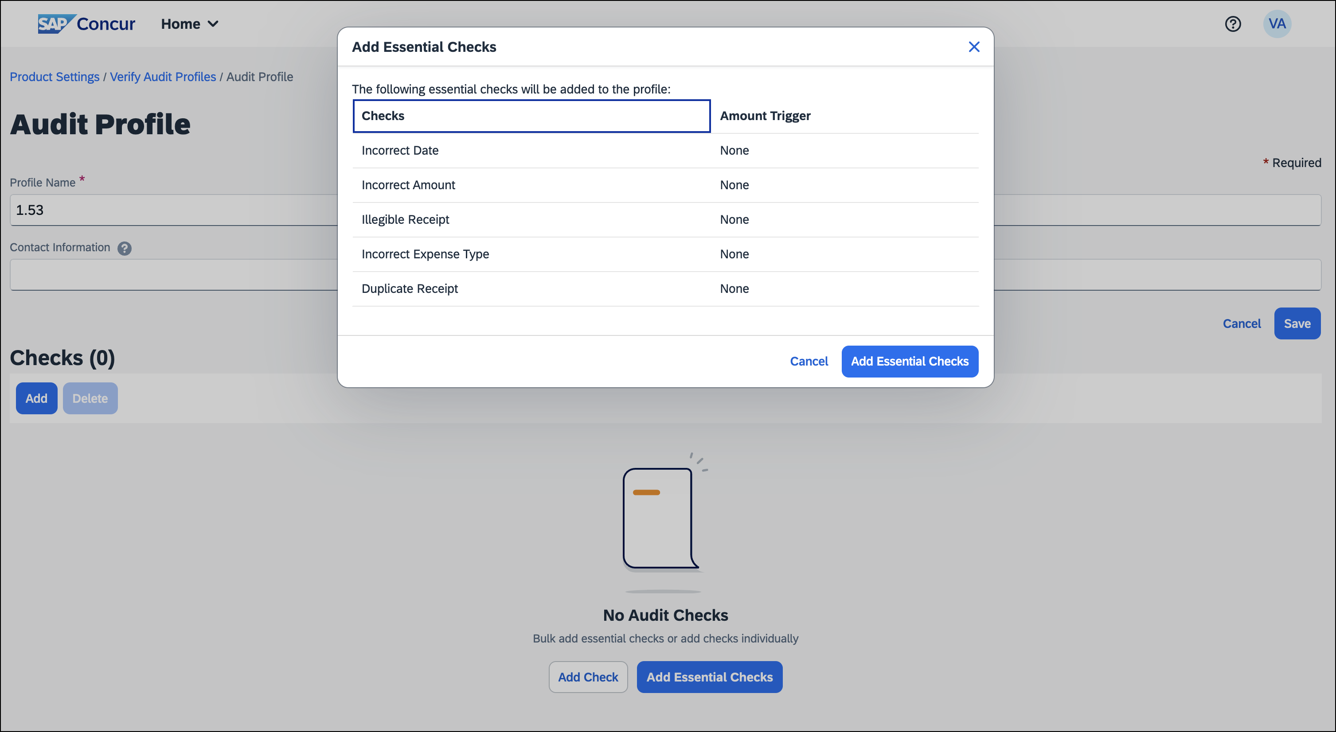
Check values can also be updated by the administrator at any time, after these essential checks are added.

Configuration / Feature Activation
The change occurs automatically; there are no additional configuration steps.

Traveler Name Check Update

Overview
Currently, the description of the traveler name check indicates that SAP Concur validates for an exact match of the traveler’s name on the receipt. However, the check only confirms the presence of a traveler name.
SAP Concur will update the descriptions to accurately represent the true function of this check.

Business Purpose / Client Benefit
This change is being made to align the description with the functionality of the check.

Administrator Experience
Between March 22 and March 24, SAP Concur will update the check description of Traveler Name check to better reflect its functionality. This ensures the information provided matches the actual validation of the check.
Previously, the description read “We review the receipt and attempt to determine the traveler name. We compare the name on the receipt to the name from the expense report and will raise an exception if we suspect they don't match.”
The updated description will read “We review the receipt and attempt to identify if a traveler name is present. We will raise an exception if a name is not present.”

Configuration / Feature Activation
The change occurs automatically; there are no additional configuration steps.

Planned Changes
The items in this section are targeted for future releases. SAP Concur reserves the right to postpone implementation of – or completely remove – any enhancement/change mentioned here.
The planned changes listed in this document are specific to this product. For information about planned site-wide or shared changes that might impact your SAP Concur solutions, refer to the Shared Changes Release Notes.

Company Card

**Planned Changes** Enhancements to the Manage Transactions Screen

Information First Published | Information Last Modified | Feature Target Release Date
March 2024 | -- | April 14, 2024
Any changes since the previous monthly release are highlighted in yellow in this release note.

Overview
On April 14th, enhancements to the Manage Transactions screen will be available to the Company Card administrator for evaluation. These changes will be visible by default and the administrator may work with the new user interface and then decide to revert to the earlier version or continue with the newer version which will become the default user interface in an upcoming release.
More feature information will be available in an upcoming release note.

Business Purpose / Client Benefit
This feature improves the company card experience by automatically displaying search results from the previous 30 days with the ability to perform a more complex search that displays hidden, visible, duplicate, and expensed transactions in a column order view familiar to administrators working in a financial statement format.

Administrator Experience
The Company Card administrator will see the simple search format of employee transactions of the previous 30 days. Transactions that are both hidden and visible to employees (including transactions that are already on an expense report) will be returned.
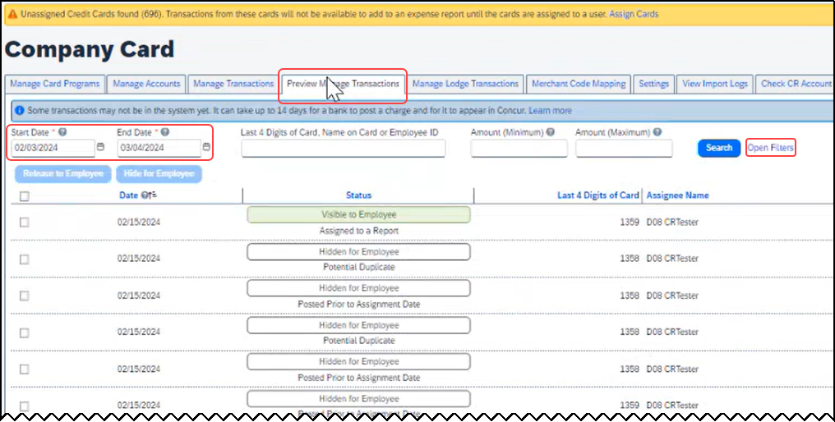
From this simple format, the administrator clicks Open Filters to refine the search:
The Last 4 Digits… search now combines the logic for all the potential typed values:
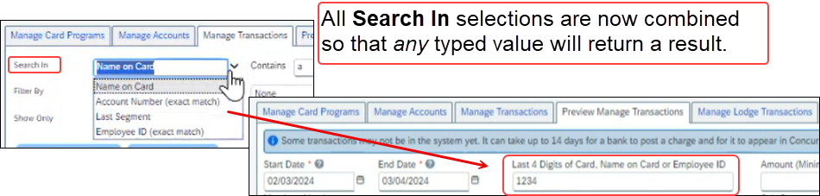
Duplicate transactions are displayed using the Potential Duplicate attribute, and the informational window includes a link to release the transaction to the employee:
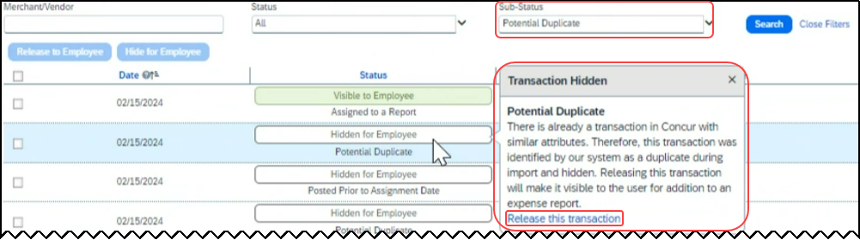
Transactions both already assigned to a report or posted prior to assignment date are clearly marked. For some status types, hovering a cursor opens an informational window describing the condition, action, and links to take action as needed:
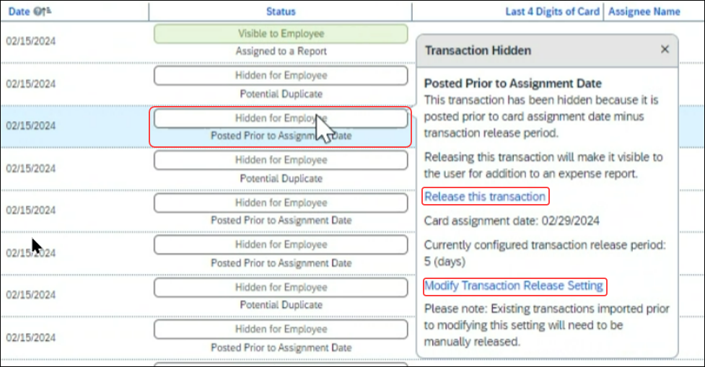

Moving Between the Two Manage Transactions Windows
In the figures above both the Manage Transactions and Preview Manage Transactions tabs are shown for clarity. Only a single tab will be displayed for the benefit of the administrator, who may move from the new user interface to the original interface using the Revert to prior experience link.

Configuration / Feature Activation
The change to the new user interface is visible by default and the administrator may revert to the original interface as needed. Note the new interface will display at any time the administrator moves from the screen and back again in a single session.

**Planned Changes** Updates to New Card Account Pending Assignment Email

Information First Published | Information Last Modified | Feature Target Release Date
March 2024 | -- | April 4, 2024
Any changes since the previous monthly release are highlighted in yellow in this release note.

Overview
On April 4th, the email notifying the client of unassigned card accounts that require assignment will be changed. At that time, the text will be modified and a link to assign the accounts will be provided directly in the body of the email.

Business Purpose / Client Benefit
This feature improves the company card experience by clearly describing the error, the required action, and directing the administrator to the page using a link.

Administrator Experience
The Company Card administrator will see a modified email detailing the results of the card import.
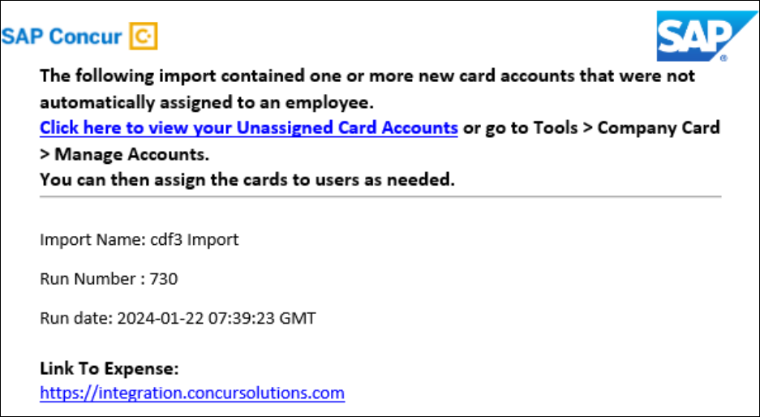
In that email, modified text explaining that the import has unassigned card accounts that require assignment will be seen and a link that opens the Manage Accounts page where the unassigned accounts are listed will be available.
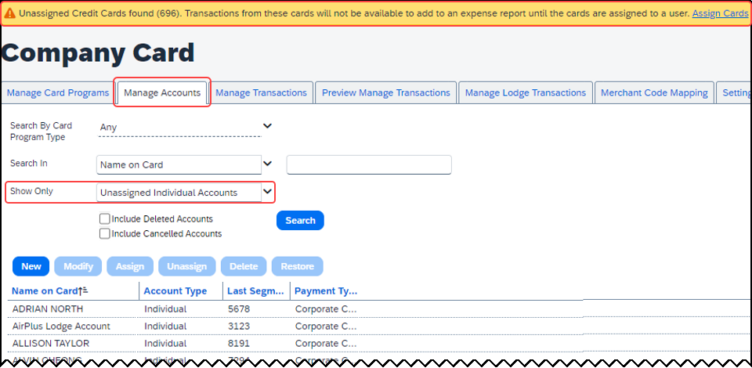
Clicking Assign Cards (upper-right corner) lets the administrator begin this task.

Configuration / Feature Activation
The change will occur automatically; there are no additional configuration steps.

Expense Types

**Planned Changes** Enhanced Expense Types Administration

Information First Published | Information Last Modified | Feature Target Release Date
February 9, 2024 | March 8, 2024 | April 16, 2024
Any changes since the previous monthly release are highlighted in yellow in this release note.

Overview
Over the next few months, SAP Concur will redesign the Concur Expense UI experience of the Manage Expense Types screens to give the product admins a modern, intuitive, and streamlined experience for creating and managing Expense Types.
The redesigned version of Expense Types will become the default version for Concur Expense customers from April 16th, 2024. Customers will still have the ability the use the legacy version if they wish to do so until it is no longer available.
Refer to the Expense Types Redesign | **Ongoing** Updated User Interface (UI) for Expense Types release note in this document.
Targeted for April 16th, 2024, SAP Concur will offer a First Run Experience to new customers setting up Concur Expense for the first time using the Activation Wizard. The First Run Experience is an intuitive, two-step process that will guide new customers in setting up their Expense Types. This experience will not be available to existing customers.
The enhanced features such as Alternate Account Codes, Policy Groups, Multiple Country Packs, and Item Code Mapping for Financial Integration will be offered in the redesigned user interface for all customers.

Business Purpose / Client Benefit
This update will facilitate better Expense Types configuration and will reduce complexity, time, and effort involved for administrators when setting up Expense Types.

Administrator Experience

First Run Experience for New Customers
For the first time set up process, navigate to Expense Types for Expense through the Configuration Wizard to view the Your Expense Types Setup welcome screen. Click Set Up Now to configure your Expense Types.
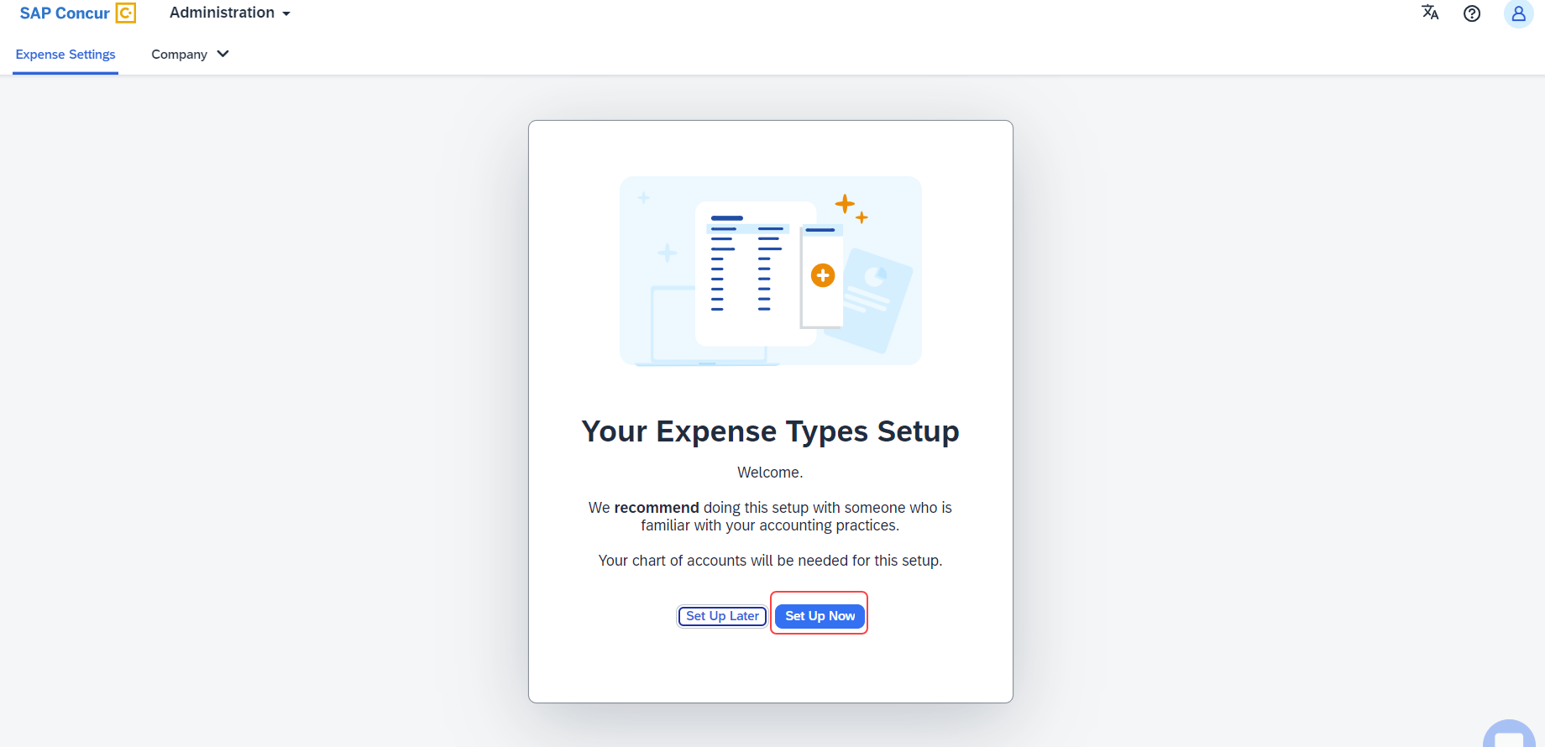
An introductory screen will display in the next screen. Proceed to click Select Expense Types to continue setting up the Expense Types.
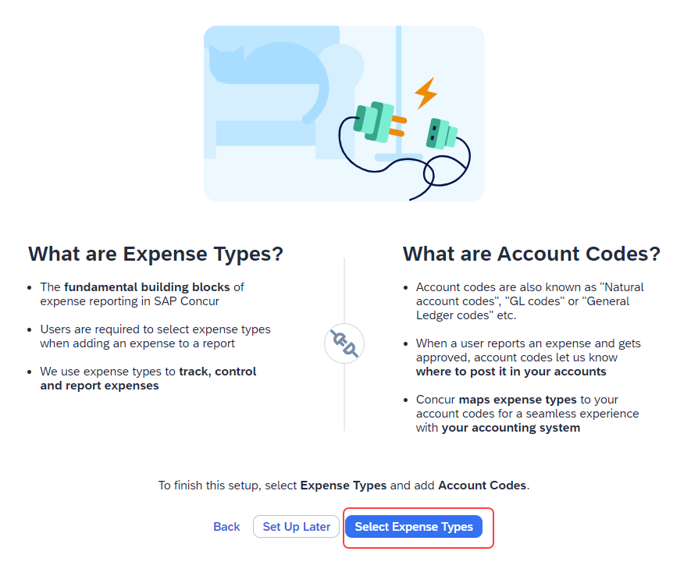
The Your Expense Types Setup screen will display. There are two steps in setting up your Expense Types. The step progress bar at the top of the screen will indicate the progress in the setup process.
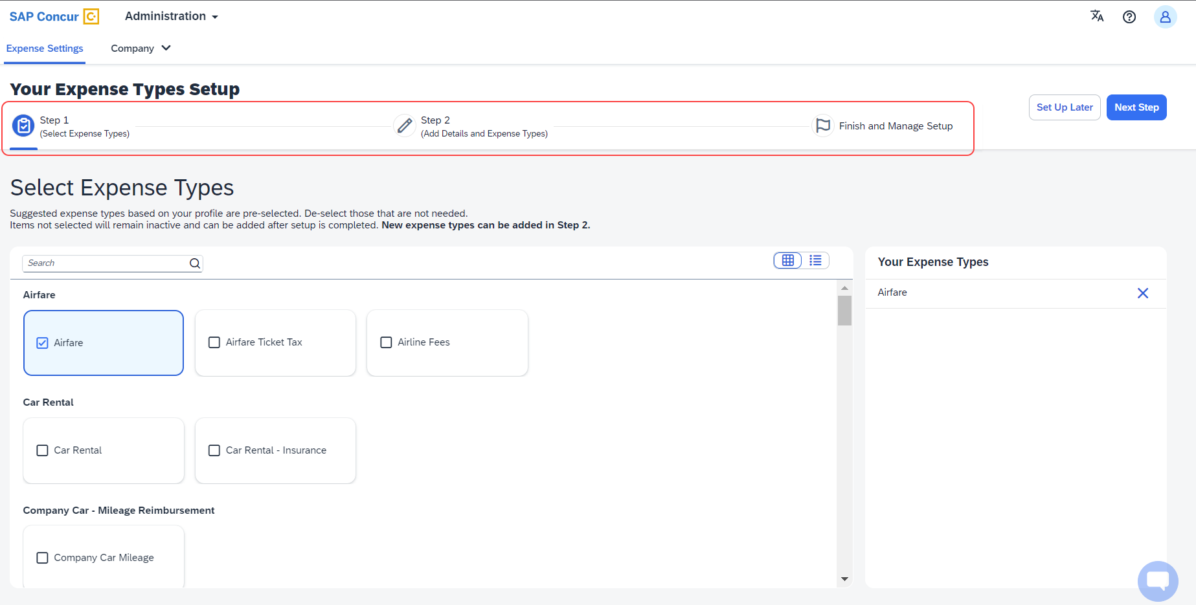
The first step of the First Run Experience will now display. In the Select Expense Types screen, you will check or uncheck the tiles to select your desired expense types.
Concur Expense will display the most used expense types as suggestions. Based on your selections, the Your Expense Types list on the right pane shows the selected expense types.
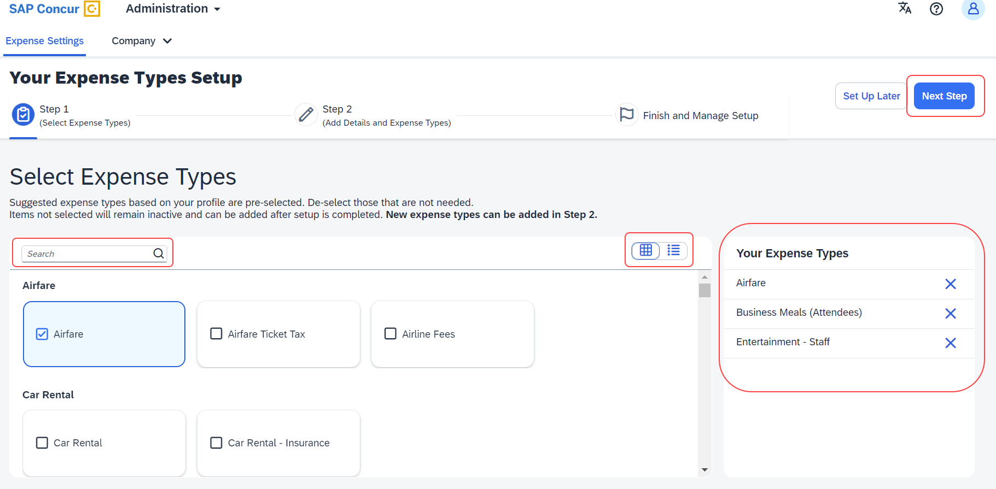
Toggle between card view and list view using the button. Use the search box to search for a specific expense type. When you have made your selections, click Next Step. Click Next to add details to your expense types.
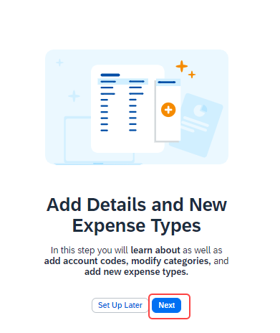
The second step of the First Run Experience will display next.
In the Add Details and Expense Types screen, you will add details to your expense types such as Account Codes, Category, Activation & Limits, and so on, or even create custom expense types.
The progress bar in the top right will display the number of expense types with complete details. The fully configured expense types will be indicated using a green check mark where it will be listed under Your Expense Types section. The red X mark indicates that the account codes are missing. Click Save and Next to save the changes.
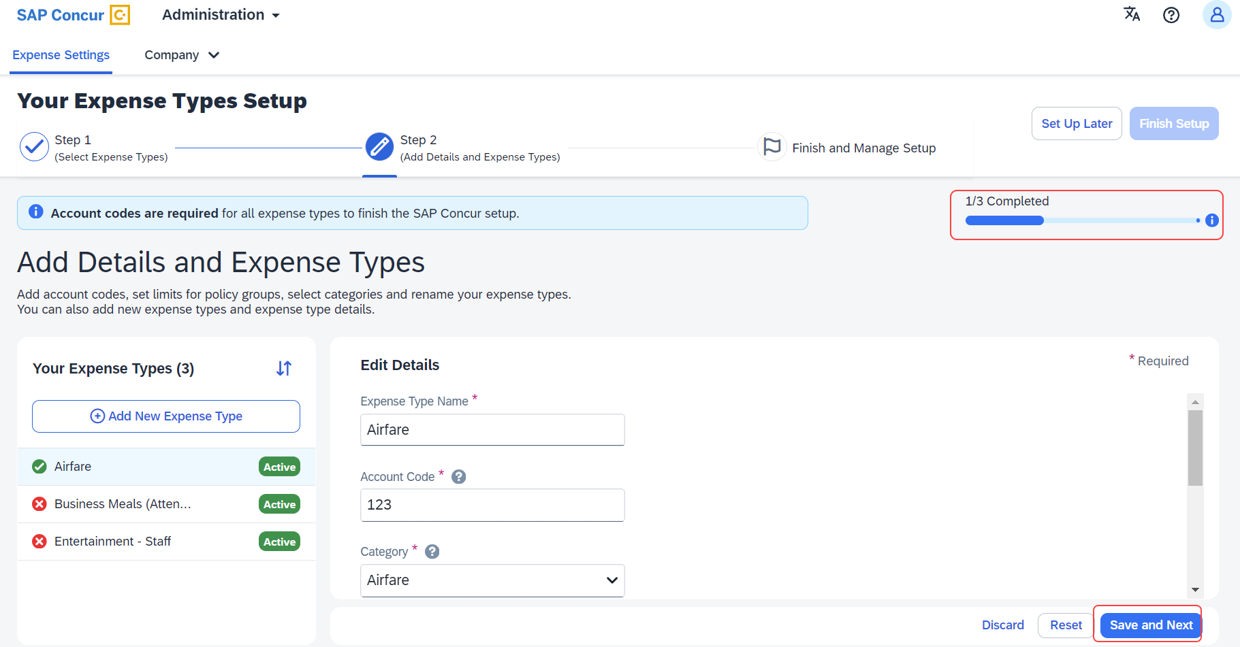
A success message will display when you complete setting up the Expense Types. The progress bar will reflect the completion status as well. Click Finish Setup to exit the screen.
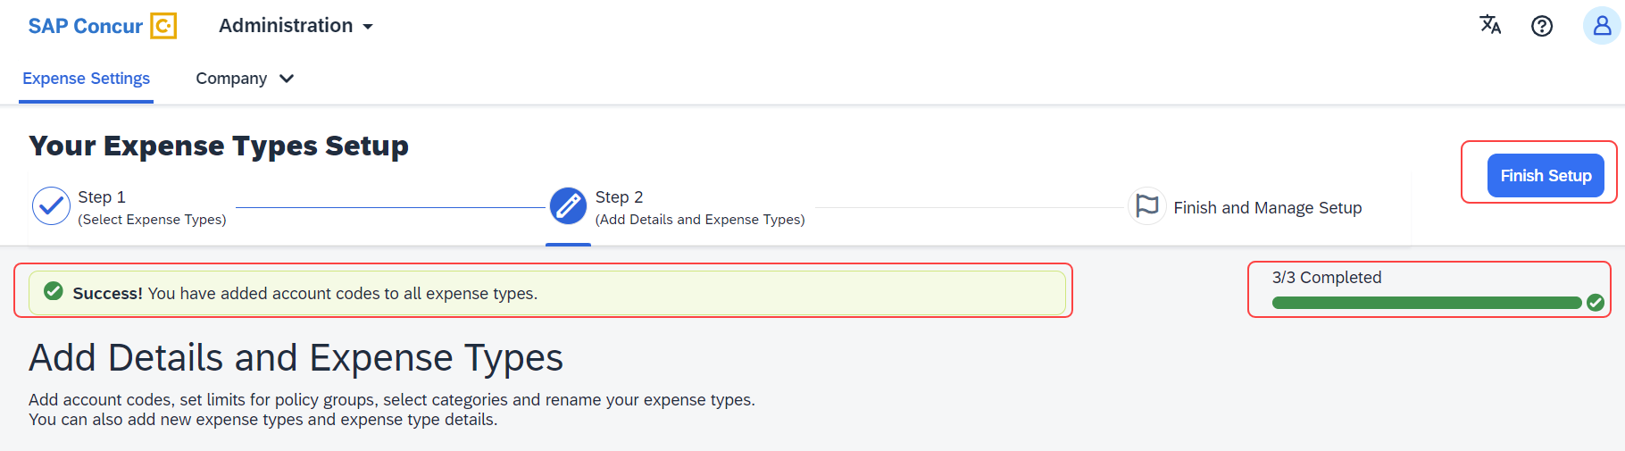
Next, click Take me to my Expense Types to be directed to the Manage Expense Types screen. The congratulatory banner will display indicating that the Expense Types are set up successfully. This will indicate the end of the First Run Experience.
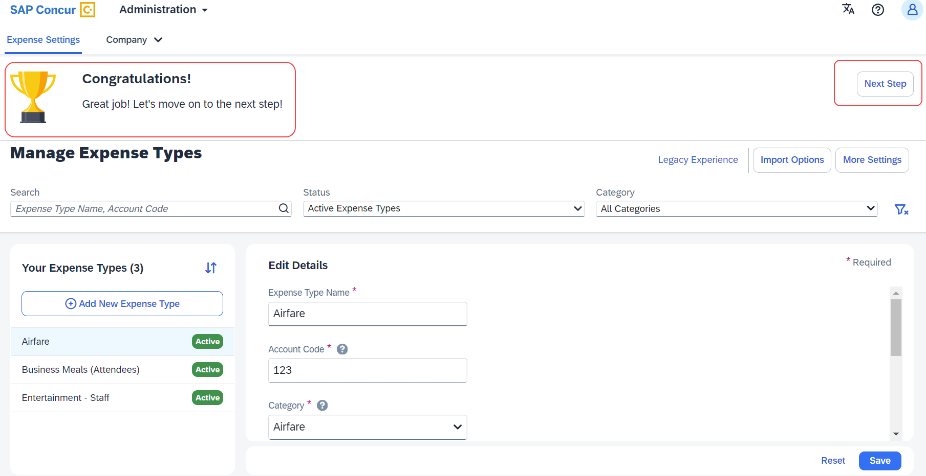
Click Next Step to navigate back to the Activation Wizard to complete setting up Concur Expense. You will also be able to postpone setting up your Expense Types if you select Set Up Later.

Existing UI: Policy Groups: Activation & limits
In the existing UI, you can select the preconfigured policy groups in the Expense Types screen from the dropdown menu where all the available policy groups for your entity are listed.
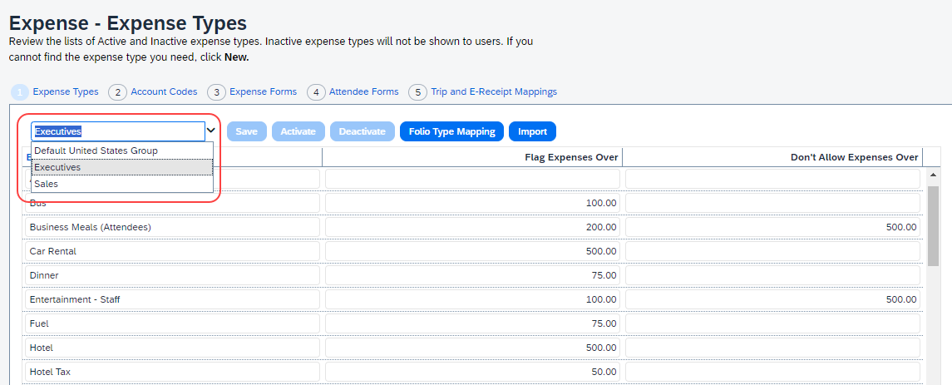

Redesigned UI: Policy Groups: Activation & limits
In the new experience, when there are multiple country packs, they will display on the Manage Expense Types screen, in the Edit Details > Policy Groups: Activation & Limits section.
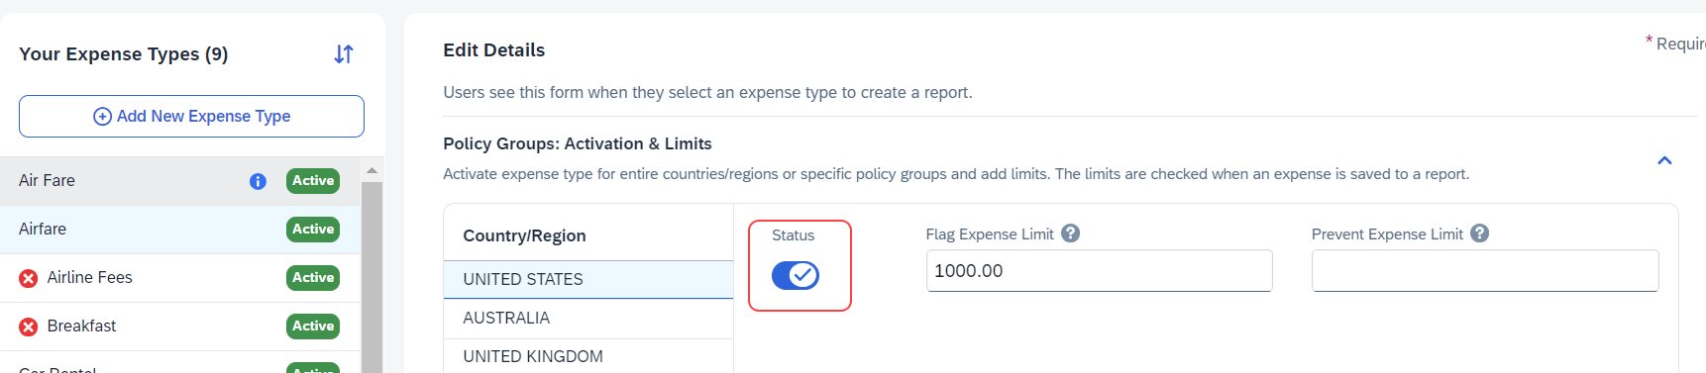
Use the Status toggle button to switch on or off the country pack for an entity. When there are Policy Groups configured for these countries, you will be able to make granular changes to these policy groups as show in the following image. You will be able to set limits, activate or deactivate expense types, and so on.
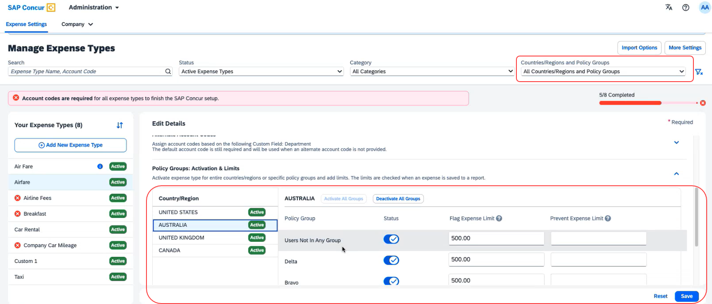
You will also be able to search using Countries/Regions and Policy Groups as a filter in the Manage Expense Types screen.

Existing UI: Alternate Account codes
If there are alternate account codes to be set up, you can set up the same in the Expenses – Expense Types > Account Codes tab. Select the list item from the account code driver list and configure them.
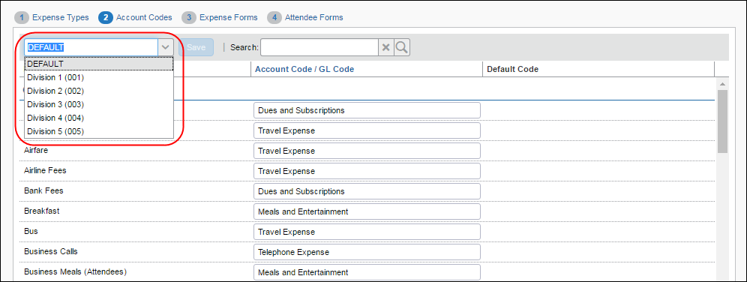

Redesigned UI: Alternate Account codes
In the redesigned UI, you will be able to set up alternate account codes in the Edit Details > Alternate Account Codes section.
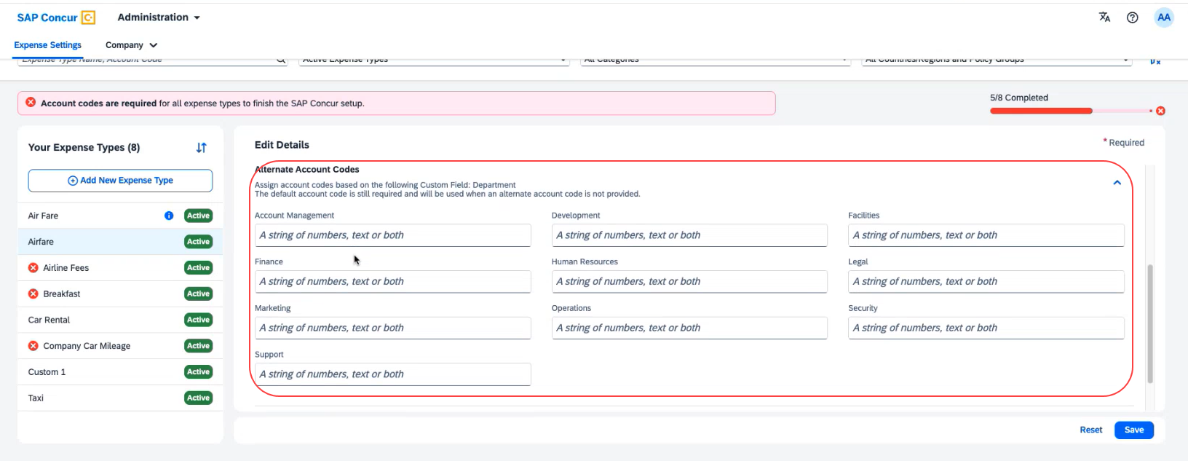

Existing UI: Item code mapping for financial integrations
If you connect Concur Expense to your financial system using one of SAP Concur's financial integrations, you may see options on the Expense – Account Codes page specific to your financial system in the legacy UI.
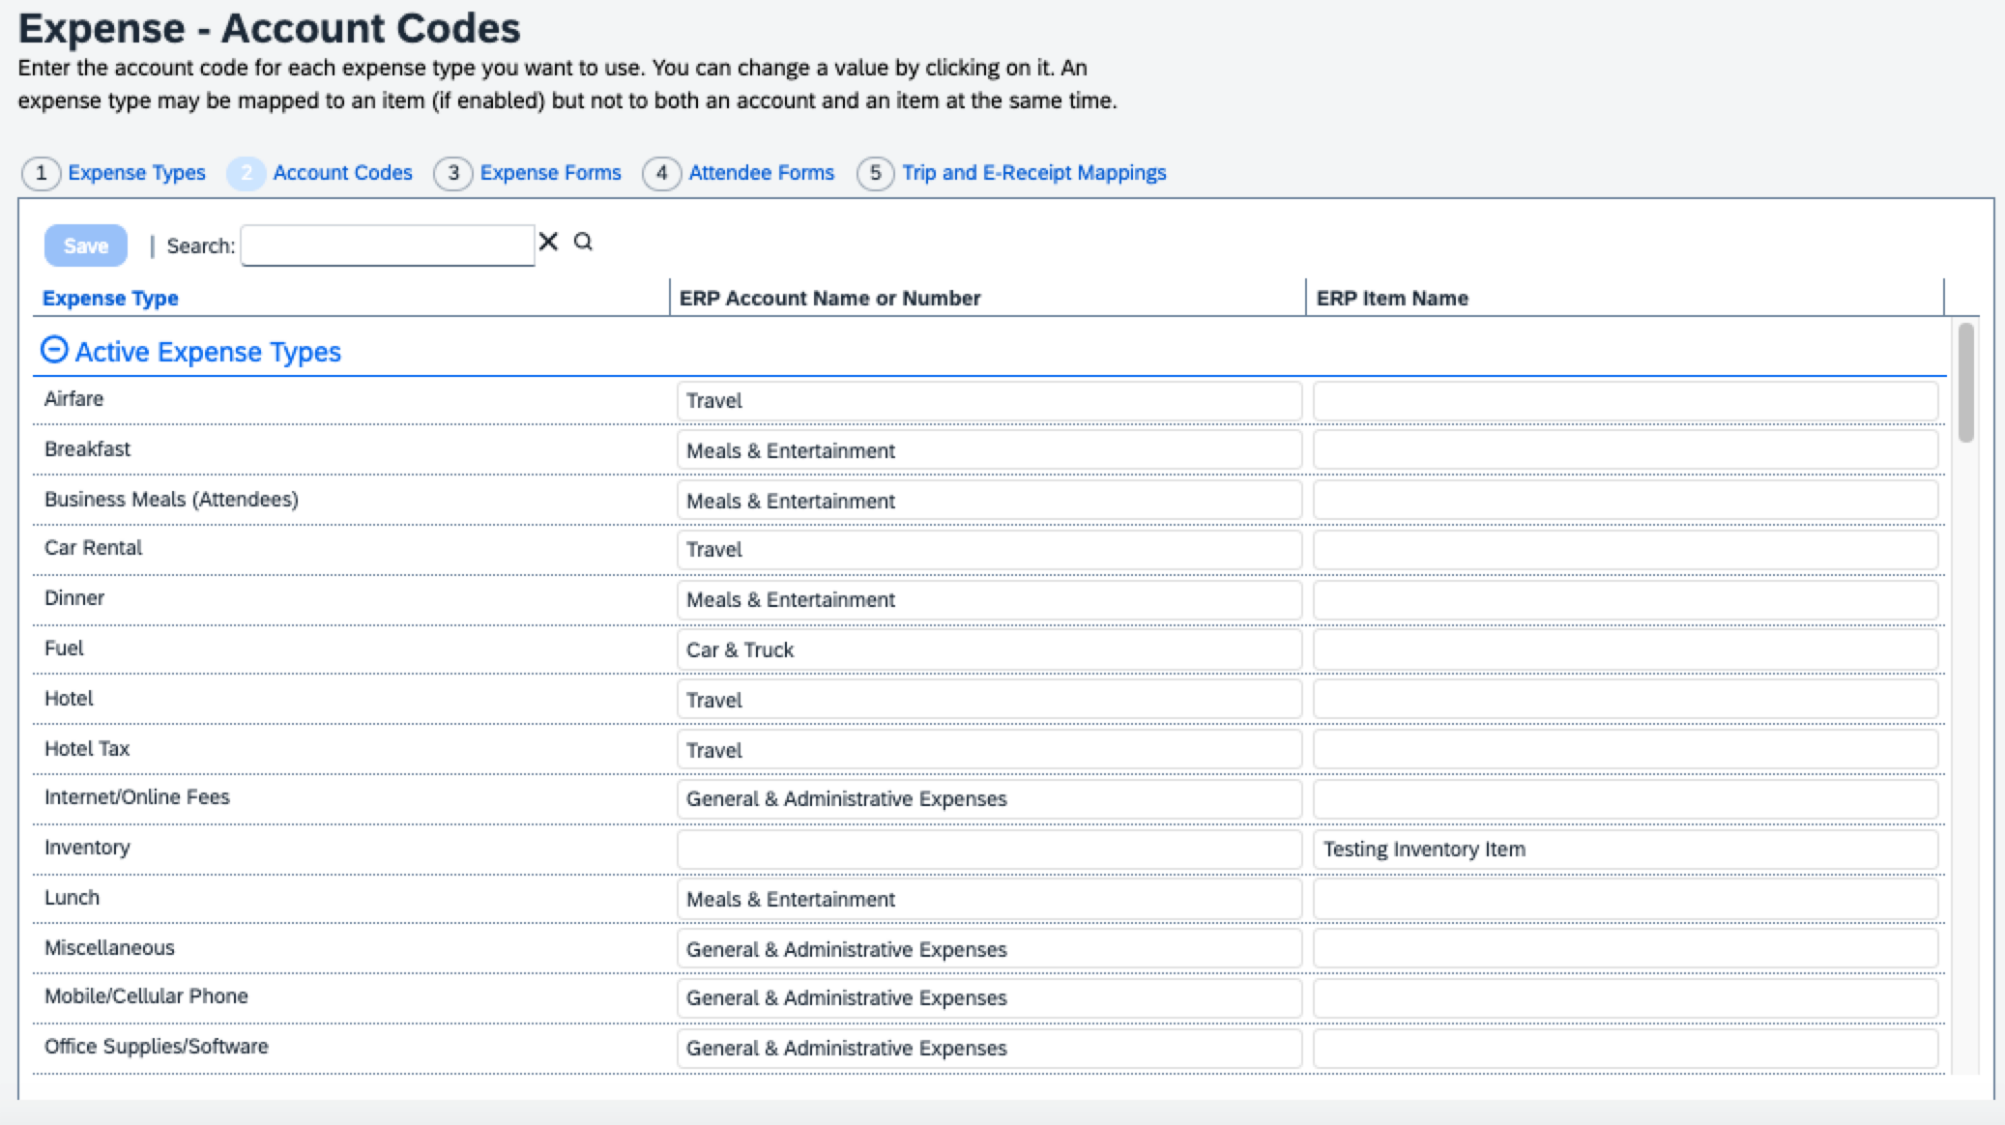

Redesigned UI: Item code mapping for financial integrations
In the redesigned UI, the Account Code field becomes Default Account Code with a dropdown menu for each Expense Type.
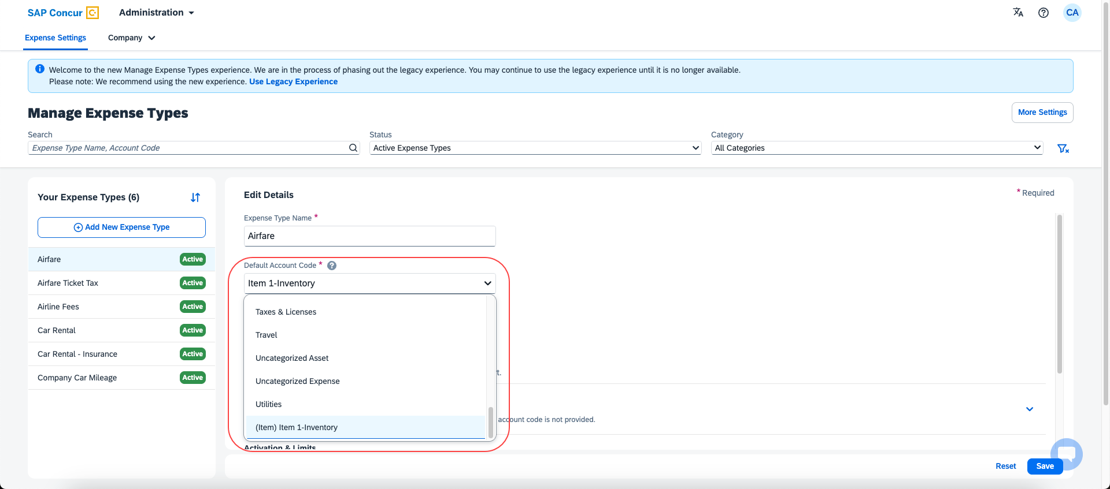

Configuration/Feature Activation
The new redesigned version will be automatically made the default version as of April 2024; there are no additional configuration steps.
If you wish to opt out of this experience, click Use Legacy Experience. Your view will return to the legacy screens.
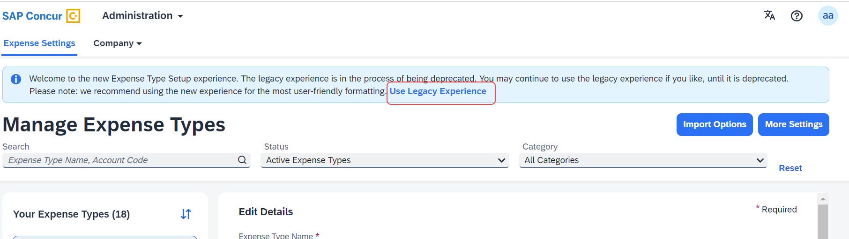
For more information on the exact changes, refer to the Expense Types Redesign| **Ongoing Changes** Updated User Interface (UI) for Expense Types release note in this document. For general information, refer to the Concur Expense: Expense Types Setup Guide.

Miscellaneous

**Planned Changes** Keyboard Shortcuts for Expense Screens
Information First Published | Information Last Modified | Feature Target Release Date
March 8, 2024 | -- | March 26, 2024
Any changes since the previous monthly release are highlighted in yellow in this release note.

Overview
Targeted for March 26th, 2024, SAP Concur will enable convenient keyboard shortcuts in selective Concur Expense screens such as Expense Home, Report Page, and Expense Entry Page.
This feature will currently be available in English only.

Business Purpose / Client Benefit
This update will offer users a more convenient way to navigate the expense application faster, ultimately improving productivity, efficiency, and user satisfaction.

End-User Experience
On selective Expense screens such as Expense Home, Report Page, and Expense Entry Page, press SHIFT + / to view the available shortcuts and to toggle the keyboard shortcuts ON or OFF.
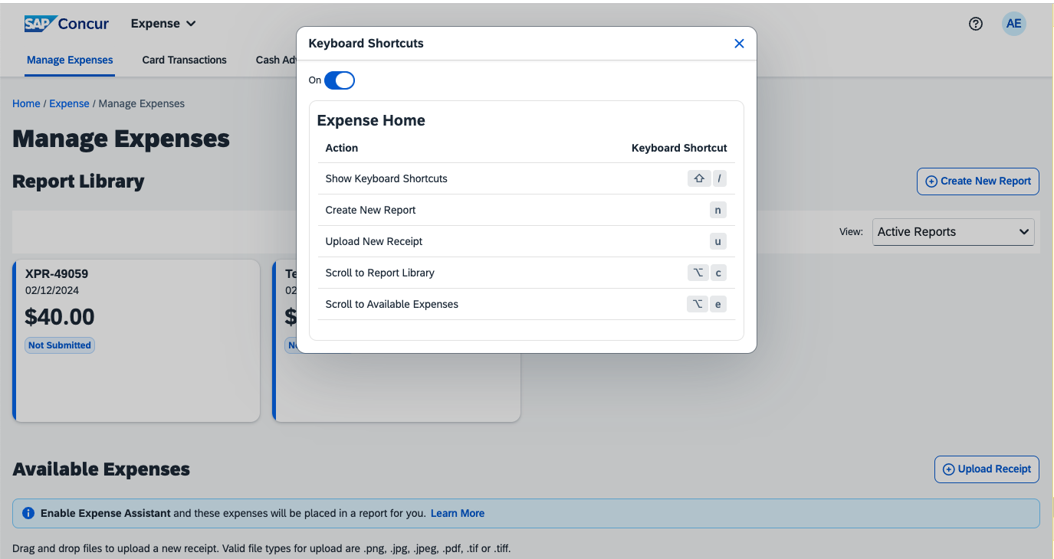
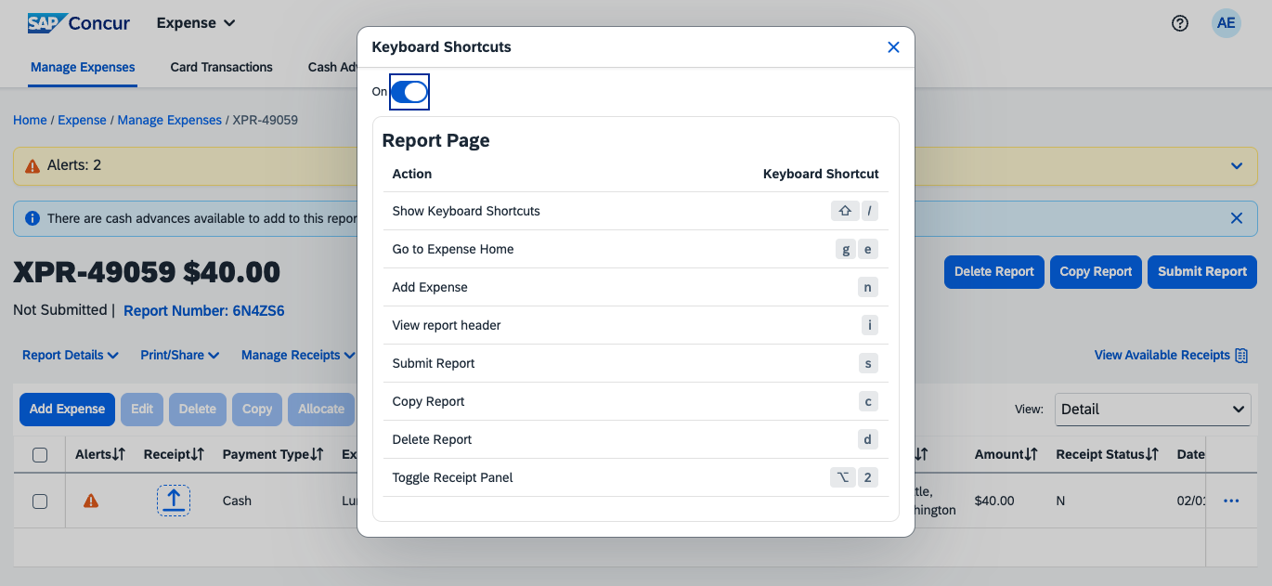
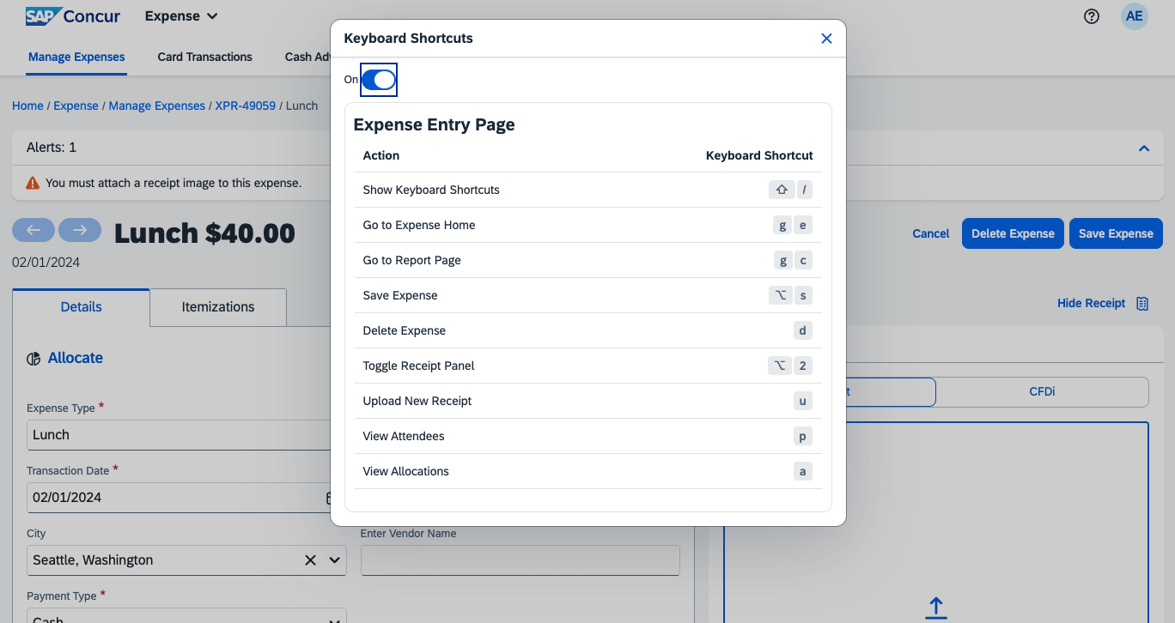

Configuration / Feature Activation
The change occurs automatically; there are no additional configuration steps.

Reports

**Planned Changes** Preferred Name for Expense Submitter
Information First Published | Information Last Modified | Feature Target Release Date
March 15, 2024 | -- | Q2, 2024
Any changes since the previous monthly release are highlighted in yellow in this release note.

Overview
Targeted for the second quarter of 2024, Concur Expense will support preferred names for users submitting expenses. The users will be able to view the preferred name that has been setup for approvers, company attendees, and other elements that display a name field, if the preferred name has been configured for the user.
Today, in Concur Expense, users can set a preferred name for themselves. In the second quarter of 2024, Concur will display the preferred name for approvers, company attendees, and other names that an expense submitter will see in the system.
For example, if a user with expense approver permissions has specified a preferred name, this preferred name will display to users submitting expenses, when selecting an approver, or when viewing the timeline for an expense report.
Similarly, if another user in the same company has specified a preferred name in Concur Expense, an expense submitter will see the preferred name when searching for an attendee, and when the user has been added as an attendee to an expense.

Benefit
This update will offer users the flexibility to set up their own preferred names at work, compared to using their given first names and improves user satisfaction.

End-User Experience
The user who is an expense submitter will see the preferred names that is configured for other employees that they interact with in the system, if their locale supports preferred name. This preferred name will appear in places where the users may have seen the given name of the employee previously.

Configuration / Feature Activation
The change occurs automatically; there are no additional configuration steps.

Client Notifications

Accessibility

Accessibility Updates
SAP implements changes to better meet current Web Content Accessibility Guidelines (WCAG). Information about accessibility-related changes made to SAP Concur solutions is published on a quarterly basis. You can review the quarterly updates on the Accessibility Updates page.

Gender Diversity

Gender Diversity Planned Features and Changes
SAP Concur is committed to supporting gender diversity. Over time we plan to implement product changes to help ensure that SAP Concur solutions support gender non-binary users. These changes will include but are not limited to support for preferred names, non-binary gender options in travel preferences, and non-binary titles.
These planned changes reflect SAP's commitment to supporting gender diversity and enable gender non-binary users to enter consistent information when making travel arrangements and entering personal information into SAP Concur solutions.
Timelines and details about these ongoing changes will be provided in the SAP Concur release notes.

In-Product User Assistance

Client Customized Content
If your company creates customized content for SAP Concur solutions through a user assistance tool such as SAP Enable Now or Concur User Assistant by WalkMe, the changes described in these release notes might affect your customized content. SAP Concur recommends reviewing the monthly release notes for all of your SAP Concur solutions as well as the Shared Changes Release Notes to confirm whether any of the planned or released changes might impact your internal, customized content.
If any changes in a release impact your content, work with your internal teams to update your content accordingly.

Subprocessors

SAP Concur Non-Affiliated Subprocessors
The list of non-affiliated subprocessors is available from the SAP Sub-processors / Data Transfer Factsheets page.
To access the SAP Concur Sub-processors List:
- Click the following link to navigate to the SAP Sub-processors / Data Transfer Factsheets page:
SAP Sub-processors / Data Transfer Factsheets
- Sign in to the SAP Support Portal using your Support User ID (S-user) and password.
SAP customers must sign in to the SAP Support Portal using their Support User ID (S-user) and password. For information about S-User IDs, refer to Your New Support User ID (S-user) and to the Learn All About S-User IDs blog post.
- On the SAP Sub-processors / Data Transfer Factsheets page, type "Concur" in the Search field.
- In the Title column, click SAP Concur Sub-processors List.
If you have questions or comments, please reach out to: Privacy-Request@Concur.com

Supported Browsers

Supported Browsers and Changes to Support
For information about supported browsers and planned changes to supported browsers, refer to the Concur Travel & Expense Supported Configurations guide.
When changes to browser support are planned, information about those changes will also appear in the Shared Changes Release Notes.

Additional Release Notes and Other Technical Documentation

Online Help
You can access release notes, setup guides, user guides, administrator summaries, supported configurations, and other resources via the in-product Help menu or directly on the SAP Help Portal.
To access the full set of documentation for your product, use the links in the SAP Concur Help menu, or visit the SAP Concur solutions page.
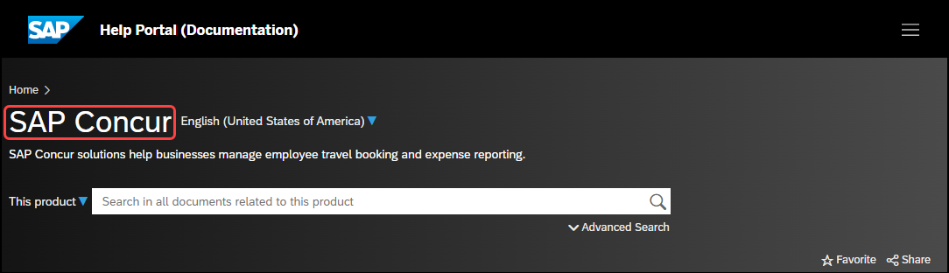

SAP Concur Support Portal – Selected Users
Access release notes, webinars, and other technical documentation on the SAP Concur support portal.
If you have the required permissions, Contact Support is available on the SAP Concur Help menu, and in the SAP Concur page footer.
Click Contact Support to access the SAP Concur support portal, then click Resources.
- Click Release/Tech Info for release notes, technical documents, etc.
- Click Webinars for recorded and live webinars.

Cases

Check Support Case Status
The steps in this procedure provide instructions for checking whether a case is resolved.
To check the status of a submitted case:
- Log on to https://concursolutions.com/portal.asp.
- Click Help > Contact Support.
If you do not have the option to contact SAP Concur support under the Help menu, then your company has chosen to support the SAP Concur service internally. Please contact your internal support desk for assistance.
- Click Support > View Cases.
- In the table, view the desired type of cases based on the View list selection. Search results are limited to each company's own cases.

© 2024 SAP SE or an SAP affiliate company. All rights reserved.
No part of this publication may be reproduced or transmitted in any form or for any purpose without the express permission of SAP SE or an SAP affiliate company.
SAP and other SAP products and services mentioned herein as well as their respective logos are trademarks or registered trademarks of SAP SE (or an SAP affiliate company) in Germany and other countries. Please see http://global12.sap.com/corporate-en/legal/copyright/index.epx for additional trademark information and notices.
Some software products marketed by SAP SE and its distributors contain proprietary software components of other software vendors.
National product specifications may vary.
These materials are provided by SAP SE or an SAP affiliate company for informational purposes only, without representation or warranty of any kind, and SAP SE or its affiliated companies shall not be liable for errors or omissions with respect to the materials. The only warranties for SAP SE or SAP affiliate company products and services are those that are set forth in the express warranty statements accompanying such products and services, if any. Nothing herein should be construed as constituting an additional warranty.
In particular, SAP SE or its affiliated companies have no obligation to pursue any course of business outlined in this document or any related presentation, or to develop or release any functionality mentioned therein. This document, or any related presentation, and SAP SE’s or its affiliated companies’ strategy and possible future developments, products, and/or platform directions and functionality are all subject to change and may be changed by SAP SE or its affiliated companies at any time for any reason without notice. The information in this document is not a commitment, promise, or legal obligation to deliver any material, code, or functionality. All forward-looking statements are subject to various risks and uncertainties that could cause actual results to differ materially from expectations. Readers are cautioned not to place undue reliance on these forward-looking statements, which speak only as of their dates, and they should not be relied upon in making purchasing decisions.

