|  |  |
| --- | --- |
| SAP Concur Release Notes  Concur Expense Standard Edition | |
| **Month** | **Audience** |
| Release Date: May 20, 2023  Initial Post: May 19, 2023 | Client ***FINAL*** |

Contents

Release Notes 1

Audit Rules 1

Audit Rule Check for an Invalid List Item in a Custom List 1

Cards 1

AMEX: Reauthorization of AMEX Business Cards Required Starting November 28th and Ending May 31st 1

Company Card Administrator Role May Now Assign and Unassign Accounts 5

Compliance Controls 6

Expense Standard Compliance Controls Updated 6

Concur Expense – Next Generation User Interface 8

Active Move Period Information Page No Longer Updated 8

Financial Integration Service 9

New Merchant Tax ID Field Added to Expense Report Financial Document 9

Planned Changes 10

Expense Pay Flex 10

**Planned Changes** Payment Processing Enhancements for HKD Currency (May to June 2023) 10

Mileage Service 10

**Planned Changes** Parity: Set Rates by Group Within a Country 10

Miscellaneous 11

**Planned Changes** In-Product Survey for Expense Approvers and Expense Processors 11

Receipts 13

**Planned Changes** Add Merchant Tax ID to Expense Entry Form 13

**Planned Changes** Mexico CFDI Validation with SAP Document and Reporting Compliance, Cloud Edition 14

Travel Allowance Service 14

**Planned Changes** New Country Pack for Austria for the NextGen UI (Q3 2023) 14

Client Notifications 16

Accessibility 16

Accessibility Updates 16

In-Product User Assistance 16

Client Customized Content 16

Subprocessors 16

SAP Concur Non-Affiliated Subprocessors 16

Supported Browsers 17

Supported Browsers and Changes to Support 17

Additional Release Notes and Other Technical Documentation 18

Online Help 18

SAP Concur Support Portal – Selected Users 18

Cases 19

Check Support Case Status 19

Legal Disclaimer

The information in this presentation is confidential and proprietary to SAP SE or an SAP affiliate company and may not be disclosed without the permission of SAP SE or the respective SAP affiliate company. This presentation is not subject to your license agreement or any other service or subscription agreement with SAP SE or its affiliated companies. SAP SE and its affiliated companies have no obligation to pursue any course of business outlined in this document or any related presentation, or to develop or release any functionality mentioned therein. This document, or any related presentation and SAP SE or an SAP affiliate company’s strategy and possible future developments, products and or platforms directions and functionality are all subject to change and may be changed by SAP SE and its affiliated companies at any time for any reason without notice. The information in this document is not a commitment, promise or legal obligation to deliver any material, code or functionality. This document is provided without a warranty of any kind, either express or implied, including but not limited to, the implied warranties of merchantability, fitness for a particular purpose, or non-infringement. This document is for informational purposes and may not be incorporated into a contract. SAP SE and its affiliated companies assume no responsibility for errors or omissions in this document, except if such damages were caused by SAP SE or an SAP affiliate company’s willful misconduct or gross negligence.

All forward-looking statements are subject to various risks and uncertainties that could cause actual results to differ materially from expectations. Readers are cautioned not to place undue reliance on these forward-looking statements, which speak only as of their dates, and they should not be relied upon in making purchasing decisions.

# Release Notes

This document contains the release notes for Concur Expense Standard edition.

1. Features and changes that apply to SAP Concur site-wide or to multiple products/services are documented in the *Shared Changes Release Notes*. For information about site-wide or shared changes in this release that might impact your SAP Concur solutions, refer to the [*Shared Changes Release Notes*](https://www.concurtraining.com/customers/tech_pubs/RN_shared_planned/_client_shared_RN_all.htm).

## Audit Rules

### Audit Rule Check for an Invalid List Item in a Custom List

#### Overview

Administrators can now configure an audit rule to check for an invalid list item in a custom list. An invalid list item may occur if a user creates and saves an expense with a particular list item in a custom field, but the list item is removed from the custom list prior to report submission.

##### Business Purpose / Client Benefit

Configuring audit rules to check for this field prevents expenses with invalid list items from being forwarded to financial systems that may depend on a valid list item value.

For more information, refer to the *Concur Expense: Audit Rules Setup guide*.

## Cards

### AMEX: Reauthorization of AMEX Business Cards Required Starting November 28th and Ending May 31st

#### Overview

AMEX has updated the Application Programming Interface (API) which affects the use of AMEX business cards for their customers. Specifically, this action replaces the existing APIs currently supporting, among other things, the import and use of transactions within the SAP Concur Expense product.

##### Business Purpose / Client Benefit

This update is required to ensure continued connectivity for AMEX business cards within Concur Expense, allowing Expense AMEX card users to enjoy the adoption of continued API services.

#### End-User Experience

For SAP Concur Expense users, once completed, this change provides continued connectivity when using the AMEX business cards. However, to ensure a seamless transition, selected clients using this business card *may* need to reauthorize their cards within Expense. This requirement is based on the date they originally authorized their card.

The following table shows which clients must reauthorize their card:

| Client Definition | Required Action Nov 28th, 2022 – Mar 31st, 2023 |
| --- | --- |
| Any user whose card was authorized *before* November 28th, 2022 | Reauthorize your AMEX business card within Expense within the dates specified in this release note. |
| Any client authorizing their card *after* November 28th, 2022 | No action is required. The updated APIs will be adopted by default for all cards authorized after this date. |

Failure to reauthorize the AMEX business card within the specified date range does not mean the card cannot be reauthorized following May 31, 2023.However, the client may experience a disruption in transaction activities following May 31, 2023, because American Express will be disabling connectivity via the older APIs after this date.

#### Administrator Experience

The admin responsible for use of AMEX business cards at their site should plan their actions, especially notification of all applicable users, based on this release note. If in doubt for any given card user, performing the reauthorization task itself will not result in adverse results and may benefit a client site seeking simplicity in messaging their users.

#### Configuration / Feature Activation

Please review the dates and need to reauthorize your AMEX Business card.

1. To Reauthorize your AMEX Business Card:
2. Open **Profile > Profile Settings**.
3. In **Expense Settings**, click **Expense Credit Cards**. The **Expense Credit Cards** page appears.

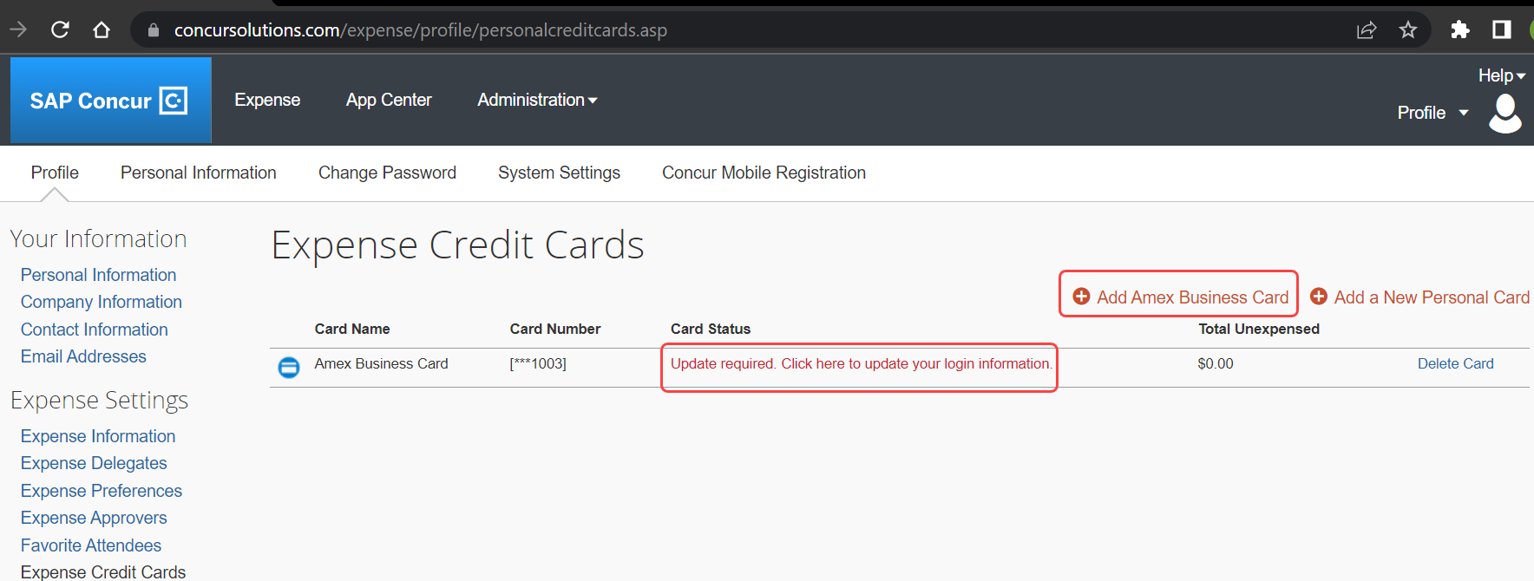

1. Click **Add Amex Business Card** to add a new Amex Card.
2. In case the card already exists on the **Expense Credit Cards** page and only needs to be reauthorized, below the **Card Status**, you will see **Update required. Click here to update your login information**. This hyperlink allows you to re-authorize your card.
3. In the **You are now leaving Concur** box, click **Continue**.

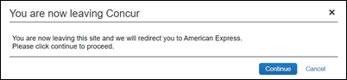

1. On the **Card Data Access User Agreement**, read the agreement and select the **I Accept the Terms and Conditions** check box, then click **Continue**.
2. On the **American Express** login page, type your login credentials, then click **Log In**.

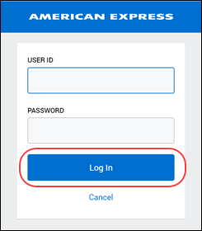

1. On the **Authorize access to Concur** disclaimer, read the information and then click **Continue**.

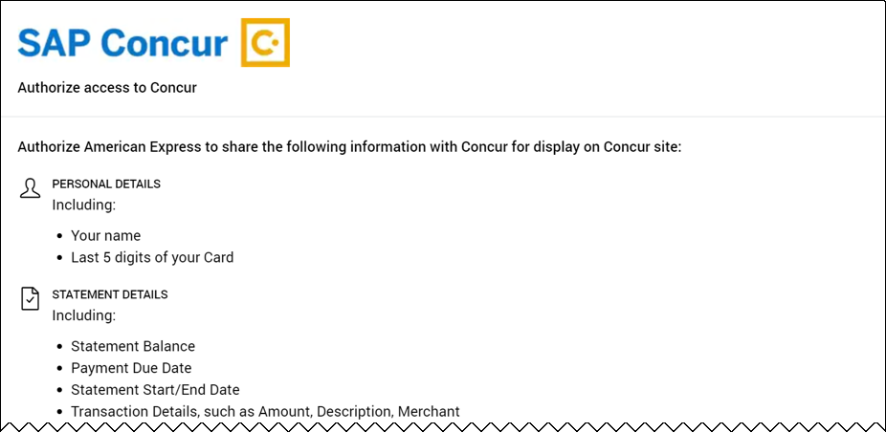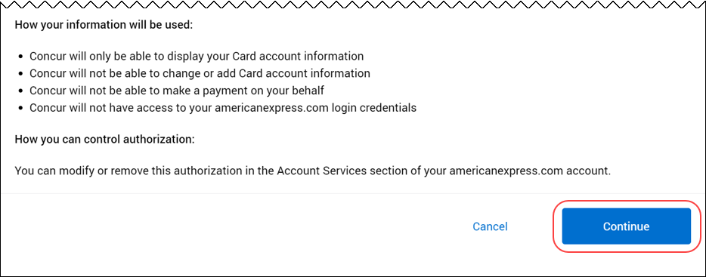

1. On the **American Express** authorization page, select the check box for each card you want to reauthorize.

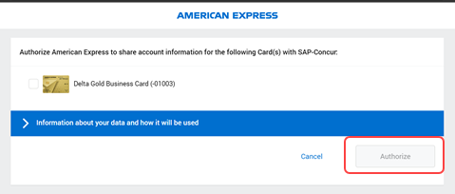

You can now see all business cards you have registered with American Express.

Supplemental cards will also display, but only if the corresponding basic card is not displayed here. For example, if you own both the basic and supplemental card, then only the basic card is shown.

Any other American Express corporate card or personal card will not appear here.

1. Click **Authorize** to synchronize cards.
2. Click the **Return to SAP-Concur** button. The AMEX card is now reauthorized.

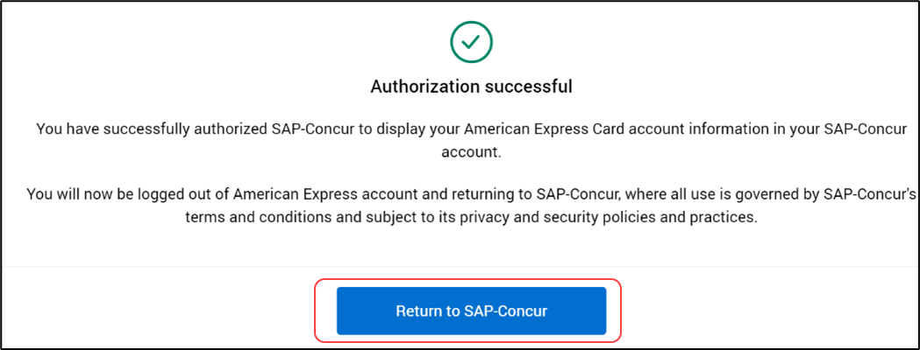

### Company Card Administrator Role May Now Assign and Unassign Accounts

#### Overview

With this release, the Expense Company Card administrator role will now be given permissions to manage their own card accounts by allowing them to unassign or assign these accounts. This ability is provided using a site setting switch that allows or prevents this capability for this role at the client site.

##### Business Purpose / Client Benefit

This update allows greater flexibility when working with card accounts and exposes a configuration area formerly not available to the administrator.

##### Changing the Setting at the Client Site

To support existing card configurations, all current clients will automatically have this capability turned on for Concur Expense. Conversely, new clients will *not* have this setting activated on deployment of the Concur Expense product at their client site.

The client may request that this setting be activated or deactivated by submitting a ticket to Support for this purpose.

#### Administrator Experience

The administrator changes an account assignment by searching for their card account using the available search options. The feature is active if they can find their account, and inactive if no account is returned for the search.

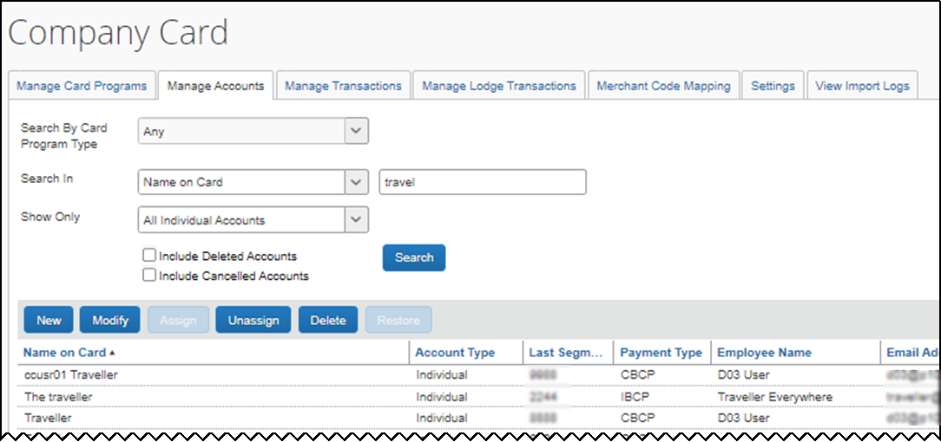

Orphaned accounts may be assigned to the card administrator at any time and this capability is not changed with the status of the site setting.

#### Feature Activation

The change occurs automatically; there are no additional configuration steps.

For more information, refer to the *Concur Expense: Company Card & Company Bill Administrator User guide*.

## Compliance Controls

### Expense Standard Compliance Controls Updated

|  |  |  |
| --- | --- | --- |
| Information First Published | Information Last Modified | Feature Target Release Date |
| April 14, 2023 | May 12, 2023 | May 18, 2023 |
| Any changes since the previous monthly release are highlighted in yellow in this release note. | | |

#### Overview

On May 18, 2023, SAP Concur plans to remove the following settings from the **Expense Settings** and **General Compliance** sections of the **Expense Compliance** **> Compliance Controls – Compliance Rules** page in Product Settings:

* **Rename the Out-of-Pocket payment type to:**
* **Set the default Payment Type for new expenses**

##### Business Purpose / Client Benefit

These settings are redundant to settings that are found on the **Payment Types** page in Product Settings.

#### Admin Experience

The admin will no longer see the redundant settings on the **Expense Compliance** **> Compliance Controls – Compliance Rules** page in Product Settings.

##### Settings to be Removed

* **Rename the Out-of-Pocket payment type to:**
* **Set the default Payment Type for new expenses**

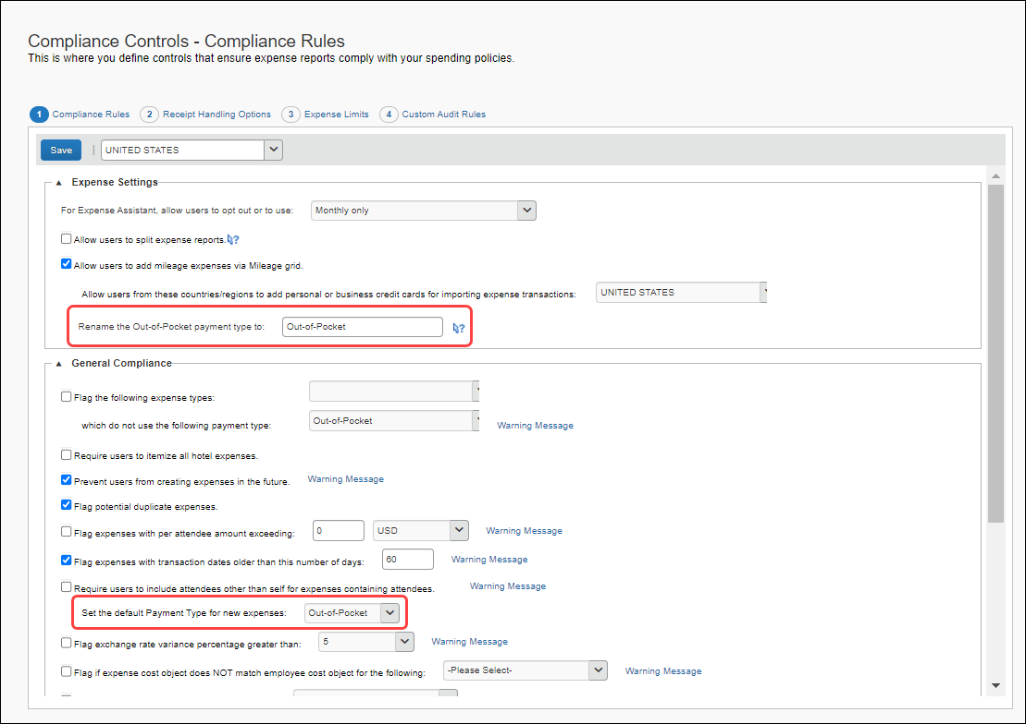

##### Settings on the Payment Types Page

* **Default Payment Type for New Expenses**
* **Program Name > Out of Pocket > Actions > Rename**

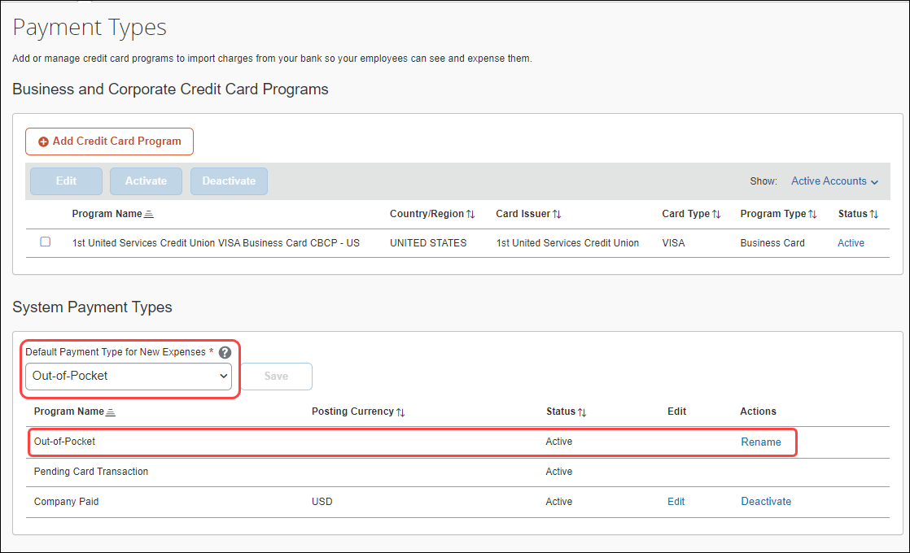

#### Configuration / Feature Activation

The redundant settings will be removed automatically.

## Concur Expense – Next Generation User Interface

### Active Move Period Information Page No Longer Updated

#### Overview

With the adoption of the NextGen User Interface for Concur Expense earlier this year, the Concur Expense edition’s [Active Move Period Information page](http://www.concurtraining.com/customers/tech_pubs/NextGenEXP/_RN_NextGenEXP_client_mid.htm) detailing NextGen UI updates for the benefit of clients transitioning from the now retired older user interface is no longer needed and will no longer be updated.

All feature updates and initiatives for Concur Expense may be seen in the regular release notes:

* [Concur Expense Professional release notes](https://www.concurtraining.com/customers/tech_pubs/Docs/_ReleaseNotes/_RN_CCC_CTE.htm)
* [Concur Expense Standard release notes](https://www.concurtraining.com/customers/tech_pubs/Docs/ConcurPremier/ReleaseNotes/ReleaseNotesCPS_CCC.htm)

##### Business Purpose / Client Benefit

This update creates a single access point for all feature communications.

#### Configuration / Feature Activation

The change occurs automatically; there are no additional configuration steps.

## Financial Integration Service

### New Merchant Tax ID Field Added to Expense Report Financial Document

#### Overview

SAP Concur has added the **Merchant Tax ID** field to the expense report financial document available through the Financial Integration Service/API. This field is now available in the API, however, it will only contain data once the field has been added to the product UI in a future release.

For more information about the FIS API fields, refer to the [Financial Integration API](https://developer.concur.com/api-reference/financial-integration/v4.financial-integration.html) documentation.

This field is available to customers with Concur Expense Professional or Standard Editions.

##### Business Purpose / Client Benefit

This change provides additional tax information for expense reports via the Financial Integration Service/FI API.

#### Configuration / Feature Activation

The feature is automatically available; there are no additional configuration or activation steps. The field will be populated with data when it is exposed on the Concur Expense product UI in a future release.

For more information, refer to the \**\*Planned Changes** Add Merchant Tax ID to Expense Entry Form* release note in this document.

# Planned Changes

The items in this section are targeted for future releases. SAP Concur reserves the right to postpone implementation of – or completely remove – any enhancement/change mentioned here.

1. The planned changes listed in this document are specific to this product. For information about planned site-wide or shared changes that might impact your SAP Concur solutions, refer to the [*Shared Changes Release Notes*](https://www.concurtraining.com/customers/tech_pubs/RN_shared_planned/_client_shared_RN_all.htm).

## Expense Pay Flex

### **Planned Changes** Payment Processing Enhancements for HKD Currency (May to June 2023)

|  |  |  |
| --- | --- | --- |
| **Information First Published** | **Information Last Modified** | **Feature Target Release Date** |
| April 21, 2023 | -- | May to June 2023 |
| Any changes since the previous monthly release are highlighted in yellow in this release note. | | |

#### Overview

Targeted for May, the HKD (Hong Kong Dollar) payment processing experience with Convera will be enhanced through automated returns, accurate estimated dates for payments on reports, real-time payment status, and access to the **View Funding** page for HKD batches. Additional existing currencies will include these enhancements throughout May and June.

##### Business Purpose / Client Benefit

Upcoming releases will support an enhanced payment processing experience.

#### Configuration / Feature Activation

Clients will need to click the **Upgrade Funding Account** button to take advantage of these improvements once they become available.

## Mileage Service

### **Planned Changes** Parity: Set Rates by Group Within a Country

|  |  |  |
| --- | --- | --- |
| **Information First Published** | **Information Last Modified** | **Feature Target Release Date** |
| May 11, 2023 | -- | Q3 2023 |
| Any changes since the previous monthly release are highlighted in yellow in this release note. | | |

#### Overview

In an upcoming release, clients using the Concur Expense Mileage service may assign car rates by a group of users within the same country. This feature brings functional parity to match the legacy and the service versions of mileage rates.

For clients, this update allows both automatic and manually adjusted rates to be used within a country by applying either one to an employee group as needed.

##### Business Purpose / Client Benefit

This update brings parity between the two mileage rate solutions in Concur Expense and allows greater flexibility when assigning a car rate to groups of travelers.

#### Configuration / Feature Activation

The change occurs automatically; there are no additional configuration steps.

More information will be available in an upcoming release note and updated guide for this feature.

## Miscellaneous

### **Planned Changes** In-Product Survey for Expense Approvers and Expense Processors

|  |  |  |
| --- | --- | --- |
| Information First Published | Information Last Modified | Feature Target Release Date |
| May 2023 | -- | June 2023 |
| Any changes since the previous monthly release are highlighted in yellow in this release note. | | |

#### Overview

Targeted for June, Concur Expense users who are Expense approvers and Expense processors will see a survey when approving and processing expense reports.

The short survey will appear intermittently, enabling the user to provide feedback on their experience with Concur Expense. Companies who are not participating in the in-product survey will not see the survey or user panel.

No survey information is shared outside of SAP Concur as per SAP policy.

##### Business Purpose / Client Benefit

This new survey will collect actionable feedback from the user that can be used by the SAP Concur product teams to prioritize and improve the features they deliver.

#### End-User Experience

After approving or processing an expense report, on an intermittent basis, the user will see the following message:

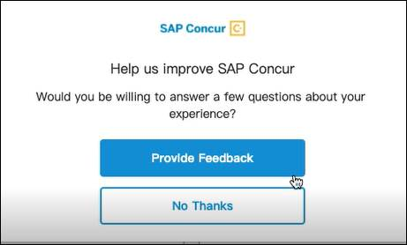

If the user clicks **Provide Feedback**, a short series of screens like the following image will appear, enabling the user to provide feedback about their experience.

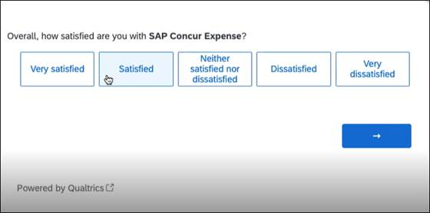

##### Declining Participation in the In-Product Survey

Customers can choose to opt-out of the user feedback mechanism. This can be done only at the entity level, not at a user level. To do so, submit a ticket to SAP Concur support requesting that this experience be turned off. To opt back in, submit a ticket to SAP Concur support requesting that this experience be turned on.

#### Configuration / Feature Activation

The feature is automatically available if the client is currently participating in the Concur Expense in-product survey.

## Receipts

### **Planned Changes** Add Merchant Tax ID to Expense Entry Form

|  |  |  |
| --- | --- | --- |
| Information First Published | Information Last Modified | Feature Target Release Date |
| March 2023 | -- | June 2023 |
| Any changes since the previous monthly release are highlighted in yellow in this release note. | | |

#### Overview

Increasingly, governments are mandating that merchants include a valid tax identifier on the receipts and invoices. This is being done to verify tax reclamation requests by the customer for the good or service provided by these vendors.

In anticipation of this, the Expense Standard’s Entry form will now include the **Merchant Tax ID** field that can transmit this data within an expense report. This feature is included in all Expense Standard edition non-U.S. country packs.

##### Business Purpose / Client Benefit

This change supports requirements to verify and display purchaser and supplier tax identifiers for clients working in, or adhering to, VAT and GST tax regulations.

#### End-User Experience

Any non-US Expense Standard Edition user who is creating an expense report will see the **Merchant Tax ID** field on their Expense Entry form whenever (and only if) the **Vendor** or **Vendor Description** field(s) are present as well.

The new field will be an optional, editable text field that is not a *Required* field type.

#### Approver and Processor Experience

Both the Approver and Processor will have read and write privileges for the **Merchant Tax ID** field when working with the expense report.

#### Configuration / Feature Activation

The feature is automatically available; there are no configuration or activation steps.

More information will be available in an upcoming release note.

### **Planned Changes** Mexico CFDI Validation with SAP Document and Reporting Compliance, Cloud Edition

|  |  |  |
| --- | --- | --- |
| **Information First Published** | **Information Last Modified** | **Feature Target Release Date** |
| April 21, 2023 | -- | May – July 2023 |
| Any changes since the previous monthly release are highlighted in yellow in this release note. | | |

#### Overview

In a future release, SAP Concur will enable validation of Mexico CFDI receipts through a native product of SAP, SAP Document and Reporting Compliance, Cloud edition.

To use SAP Document and Reporting Compliance, Cloud edition for validating CFDI receipts, the client must have:

* An Enterprise Global account type on the SAP Business Technology Platform (BTP).
* A subscription to SAP Document and Reporting Compliance, Cloud edition

##### Business Purpose / Client Benefit

This feature provides an improved user experience by introducing SAP Document and Reporting Compliance Cloud edition to SAP Concur users, which will automatically create the expense entry and pre-populate it with the CFDI for confirmation of validation and inclusion in an expense report.

More information will be available in an upcoming release note.

## Travel Allowance Service

### **Planned Changes** New Country Pack for Austria for the NextGen UI (Q3 2023)

|  |  |  |
| --- | --- | --- |
| Information First Published | Information Last Modified | Feature Target Release Date |
| May 2023 | -- | Q3 2023 |
| Any changes since the previous monthly release are highlighted in yellow in this release note. | | |

#### Overview

A new country pack for Austria will be available in Q3 2023.

The upcoming release will contain three new, self-updating statutory bundles pre-configured with the best practice content and country-specific calculations for Austria.

* **IMPORTANT:** The Travel Allowance Service (TAS) solution is only available to net new clients. The current "classic" TA solution remains in use and will be fully supported for existing clients and new clients who do not have a new TAS country-specific template yet.

This solution is *not* an upgrade of the existing "classic" TA feature, but a completely new solution that automatically updates to provide the correct annual statutory rates to the client.

##### Business Purpose / Client Benefit

The clients get best-practice content and annual rate updates managed by SAP Concur to conform to the travel allowance rules in Austria.

#### Configuration / Feature Activation

All users who access the **Expense Admin** page will see the **Travel Allowance Configuration** link.

More information will be available in an upcoming release note and in the Austria configuration guide available on release of this feature.

For Concur Request, refer to the [guides](https://www.concurtraining.com/customers/tech_pubs/_Docs_ReqHelp.htm#su) landing page.

# Client Notifications

## Accessibility

### Accessibility Updates

SAP implements changes to better meet current Web Content Accessibility Guidelines (WCAG). Information about accessibility-related changes made to SAP Concur solutions is published on a quarterly basis. You can review the quarterly updates on the [Accessibility Updates](https://help.sap.com/docs/SAP_CONCUR/caf7d7289796414a91e130a5169d8e71/84234e2c0e844ca09e7a91213e6c8646.html) page.

## In-Product User Assistance

### Client Customized Content

If your company creates customized content for SAP Concur solutions through a user assistance tool such as SAP Enable Now or Concur User Assistant by WalkMe, the changes described in these release notes might affect your customized content. SAP Concur recommends reviewing the monthly release notes for all of your SAP Concur solutions as well as the [Shared Changes Release Notes](https://www.concurtraining.com/customers/tech_pubs/RN_shared_planned/_client_shared_RN_all.htm) to confirm whether any of the planned or released changes might impact your internal, customized content.

If any changes in a release impact your content, work with your internal teams to update your content accordingly.

## Subprocessors

### SAP Concur Non-Affiliated Subprocessors

The list of non-affiliated subprocessors is available from the *SAP Sub-processors / Data Transfer Factsheets* page.

1. To access the SAP Concur Sub-processors List:
2. Click the following link to navigate to the *SAP Sub-processors / Data Transfer Factsheets* page:  
   [*SAP Sub-processors / Data Transfer Factsheets*](https://support.sap.com/en/my-support/trust-center/subprocessors.html)
3. Sign in to the SAP Support Portal using your Support User ID (S-user) and password.
4. SAP customers must sign in to the SAP Support Portal using their Support User ID (S-user) and password. For information about S-User IDs, refer to [*Your New Support User ID (S-user)*](https://support.sap.com/en/my-support/users/welcome.html) and to the [*Learn All About S-User IDs*](https://blogs.sap.com/2021/03/09/learn-all-about-s-user-ids/) blog post.
5. On the *SAP Sub-processors / Data Transfer Factsheets* page, type "Concur" in the **Search** field.
6. In the **Title** column, click **SAP Concur Sub-processors List**.

If you have questions or comments, please reach out to: [Privacy-Request@Concur.com](mailto:Privacy-Request@Concur.com)

## Supported Browsers

### Supported Browsers and Changes to Support

For information about supported browsers and planned changes to supported browsers, refer to the [*Concur Travel & Expense Supported Configurations*](http://www.concurtraining.com/customers/tech_pubs/Docs/Z_SuppConfig/Supported_Configurations_for_Concur_Travel_and_Expense.pdf) guide.

When changes to browser support are planned, information about those changes will also appear in the [*Shared Changes Release Notes*](https://www.concurtraining.com/customers/tech_pubs/RN_shared_planned/_client_shared_RN_all.htm).

# Additional Release Notes and Other Technical Documentation

## Online Help

You can access release notes, setup guides, user guides, admin summaries, supported configurations, and other resources via the in-product Help menu or directly on the SAP Help Portal.

To access the full set of documentation for your product, use the links in the SAP Concur **Help** menu, or visit the [SAP Concur solutions page](https://help.sap.com/docs/SAP_CONCUR).

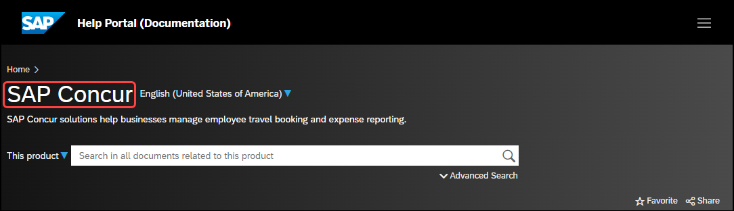

## SAP Concur Support Portal – Selected Users

Access release notes, webinars, and other technical documentation on the SAP Concur support portal.

If you have the required permissions, **Contact** **Support** is available on the SAP Concur **Help** menu and in the SAP Concur page footer.

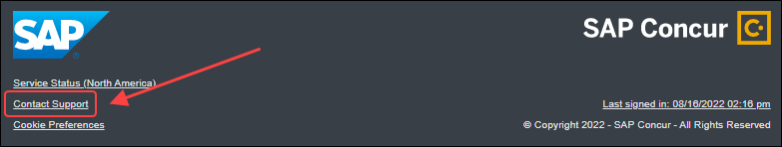

Click **Contact Support** to access the SAP Concur support portal, then click **Resources**.

* Click **Release/Tech Info** for release notes, technical documents, etc.
* Click **Webinars** for recorded and live webinars.

# Cases

## Check Support Case Status

The steps in this procedure provide instructions for checking whether a case is resolved.

1. To check the status of a submitted case:
2. Log on to <https://concursolutions.com/portal.asp>.
3. Click **Help** > **Contact** **Support**.
4. If you do not have the option to contact SAP Concur support under the **Help** menu, then your company has chosen to support the SAP Concur service internally. Please contact your internal support desk for assistance.
5. Click **Support > View Cases**.
6. In the table, view the desired type of cases based on the **View** list selection. Search results are limited to each company's own cases.

© 2023 SAP SE or an SAP affiliate company. All rights reserved.

No part of this publication may be reproduced or transmitted in any form or for any purpose without the express permission of SAP SE or an SAP affiliate company.

SAP and other SAP products and services mentioned herein as well as their respective logos are trademarks or registered trademarks of SAP SE (or an SAP affiliate company) in Germany and other countries. Please see http://global12.sap.com/corporate-en/legal/copyright/index.epx for additional trademark information and notices.

Some software products marketed by SAP SE and its distributors contain proprietary software components of other software vendors.

National product specifications may vary.

These materials are provided by SAP SE or an SAP affiliate company for informational purposes only, without representation or warranty of any kind, and SAP SE or its affiliated companies shall not be liable for errors or omissions with respect to the materials. The only warranties for SAP SE or SAP affiliate company products and services are those that are set forth in the express warranty statements accompanying such products and services, if any. Nothing herein should be construed as constituting an additional warranty.

In particular, SAP SE or its affiliated companies have no obligation to pursue any course of business outlined in this document or any related presentation, or to develop or release any functionality mentioned therein. This document, or any related presentation, and SAP SE’s or its affiliated companies’ strategy and possible future developments, products, and/or platform directions and functionality are all subject to change and may be changed by SAP SE or its affiliated companies at any time for any reason without notice. The information in this document is not a commitment, promise, or legal obligation to deliver any material, code, or functionality. All forward-looking statements are subject to various risks and uncertainties that could cause actual results to differ materially from expectations. Readers are cautioned not to place undue reliance on these forward-looking statements, which speak only as of their dates, and they should not be relied upon in making purchasing decisions.