SAP Concur Release Notes
Concur Expense Standard Edition
Month | Audience
Release Date: April 22, 2023  Initial Post: April 21, 2023 | Client FINAL
Contents
Release Notes 1
Delegates - Mobile 1
Android / iPhone / iPad Delegate Functionality is Updated 1
Expense Pay - Flex 2
Addition of Load Number and Source ID Fields for AMEX CAD Card Configuration Program 2
Expense Pay - Global 3
View Funding and Display of Returned Amount Record Details 3
Japan Public Transport (JPT) 3
Addition of Entry Submit and Report Submit Events in Audit Rules 3
Payment Types 4
Import Transactions for Business and Personal Card Types 4
Set Business Card Type as the Default Payment Type 6
User Interface Changes 7
Usability Changes to the User Interface 7
Value Added Tax (VAT) / Tax Administration 10
Reclaim Full VAT in Germany 10
Planned Changes 12
Compliance Controls 12
**Planned Changes** Expense Standard Compliance Controls Updated 12
Concur Expense – Next Generation User Interface 14
**Planned Change** Active Move Period Information Page Will No Longer Be Updated 14
Expense Pay Flex 14
**Planned Changes** Payment Processing Enhancements for HKD Currency (May to June 2023) 14
Receipts 15
**Planned Changes** Add Merchant Tax ID to Expense Entry Form 15
**Planned Changes** Mexico CFDI Validation with SAP Document and Reporting Compliance, Cloud Edition 16
Client Notifications 17
Accessibility 17
Accessibility Updates 17
Sub-processors 17
SAP Concur Non-Affiliated Sub-processors 17
Supported Browsers 18
Supported Browsers and Changes to Support 18
Additional Release Notes and Other Technical Documentation 19
Online Help 19
SAP Concur Support Portal – Selected Users 19
Cases 20
Check Support Case Status 20

Legal Disclaimer
The information in this presentation is confidential and proprietary to SAP SE or an SAP affiliate company and may not be disclosed without the permission of SAP SE or the respective SAP affiliate company. This presentation is not subject to your license agreement or any other service or subscription agreement with SAP SE or its affiliated companies. SAP SE and its affiliated companies have no obligation to pursue any course of business outlined in this document or any related presentation, or to develop or release any functionality mentioned therein. This document, or any related presentation and SAP SE or an SAP affiliate company’s strategy and possible future developments, products and or platforms directions and functionality are all subject to change and may be changed by SAP SE and its affiliated companies at any time for any reason without notice. The information in this document is not a commitment, promise or legal obligation to deliver any material, code or functionality. This document is provided without a warranty of any kind, either express or implied, including but not limited to, the implied warranties of merchantability, fitness for a particular purpose, or non-infringement. This document is for informational purposes and may not be incorporated into a contract. SAP SE and its affiliated companies assume no responsibility for errors or omissions in this document, except if such damages were caused by SAP SE or an SAP affiliate company’s willful misconduct or gross negligence.
All forward-looking statements are subject to various risks and uncertainties that could cause actual results to differ materially from expectations. Readers are cautioned not to place undue reliance on these forward-looking statements, which speak only as of their dates, and they should not be relied upon in making purchasing decisions.

Release Notes
This document contains the release notes for Concur Expense Standard edition.
Features and changes that apply to SAP Concur site-wide or to multiple products/services are documented in the Shared Changes Release Notes. For information about site-wide or shared changes in this release that might impact your SAP Concur solutions, refer to the Shared Changes Release Notes.

Delegates - Mobile

Android / iPhone / iPad Delegate Functionality is Updated

Overview
With this release, the SAP Concur Mobile app is extending the delegate function. Now, regular Expense users can create, edit, and delete manual expenses while acting on behalf of another user.
This new functionality includes:
- The ability to view a list of all delegators and select whom to act for
- Viewing list of all available expenses
- Manually create a new expense outside of a report
- Attach an image while manually creating an expense (from camera, gallery, or files)
- Edit an existing expense outside of a report
- Delete an existing expense outside of a report when no image is linked
GRDC users with ExpenseIt can still act on behalf of another user in ExpenseIt but will not be able to create, edit, or delete manual expenses.

Business Purpose / Client Benefit
This feature lets the user edit, create, and delete expenses while acting on behalf of another user. This enhances the mobile experience and provides further mobile and web parity.

Configuration / Feature Activation
The change occurs automatically; there are no additional configuration steps.
For more information, refer to the SAP Concur Release Notes – SAP Concur Mobile App release notes.

Expense Pay - Flex

Addition of Load Number and Source ID Fields for AMEX CAD Card Configuration Program

Overview
When setting up a new or updating an existing card program for AMEX using CAD currency, two new fields are required: Source ID and Load Number. This data is sent with the remittance for card vendor processing.
Load Number is a unique six-digit value. Source ID is a unique 10 alphanumeric value.
This change is intended for new clients. Existing clients can continue to use the existing remittance file format until they are provided their Load Number and Source ID from Amex Canada and the old format is deprecated.

Business Purpose / Client Benefit
To efficiently process AMEX Canada payments, a unique Load Number and Source ID are required per client to support a new AMEX CAD remittance file format. These fields support payment reconciliation and help prevent missing remittance requests due to timing issues.

End-User Experience
In the Add New Card Program dialog, when the Payment Provider option is enabled for the Amex card program, the Source ID and Load Number fields are enabled and required.

Configuration / Feature Activation
Once Amex Canada provides you with your company’s unique Source ID and Load Number, you must go to your card program configuration screen in SAP Concur and enter your IDs and then click Save. The next card batch opened will be sent using these new IDs with the new format.
This feature is automatically available; there are no configuration or activation steps.

Expense Pay - Global

View Funding and Display of Returned Amount Record Details

Overview
Previously, when an administrator tried to view details on a returned amount, all the day’s funding activity for the batch would display in addition to the returned payments, making it difficult to locate the returned records in the grid. This was especially difficult for larger payment batches. In this release, only returned payment lines display when the administrator clicks View Details on a row for a returned amount.

Business Purpose / Client Benefit
To efficiently reconcile returns for large batches, the user interface has been enhanced to show only returned records when the administrator wants to view details on returned amounts.

Payment Manager Experience
In the Monitor Batches > View Funding > Global Funding dialog, when the Payment Manager administrator clicks View Details on a returned amount record, only the activity for returned records displays.
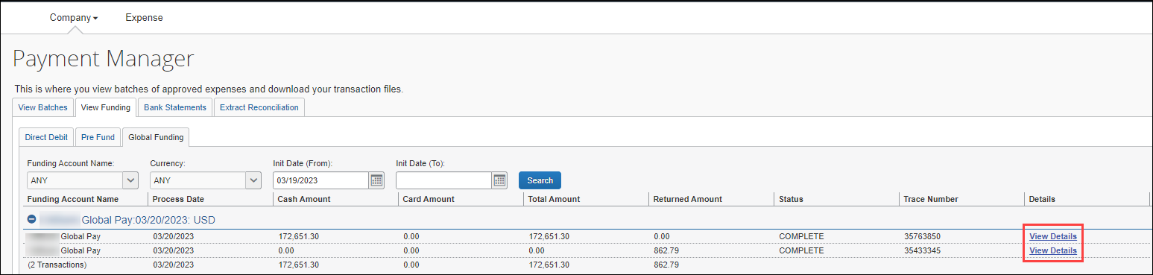

Configuration / Feature Activation
This feature is automatically available; there are no configuration or activation steps.

Japan Public Transport (JPT)

Addition of Entry Submit and Report Submit Events in Audit Rules

Overview
Entry Submit and Report Submit events are now supported for Japan Public Transport (JPT) on NextGen UI.

Business Purpose / Client Benefit
This update enables admins to configure audit rules and manage the way employees submit expenses.

Configuration / Feature Activation
The feature is automatically available; there are no additional configuration or activation steps.
For more information, refer to the Concur Expense: JPT on NextGen UI Setup Guide and the Expense: Audit Rules Setup Guide.

Payment Types

Import Transactions for Business and Personal Card Types

Overview
With this release, card users may now configure the import of expense transactions directly on the same screen they use to configure their cards, as part of the process. This is done using options on the Card Program Details (business) and the Enable Countries/Regions for Personal Cards (personal) screens.

Business Purpose / Client Benefit
This update makes it easier to add import functionality for expense transactions directly on the same screen used to add a new business or personal card.

Administrator Experience
The Expense Standard admin entering a new business card will now see new import options in the Card Program Details screen. The admin selects Yes to the request to import expense transactions, and this will apply to all employee card accounts for the given country or region.
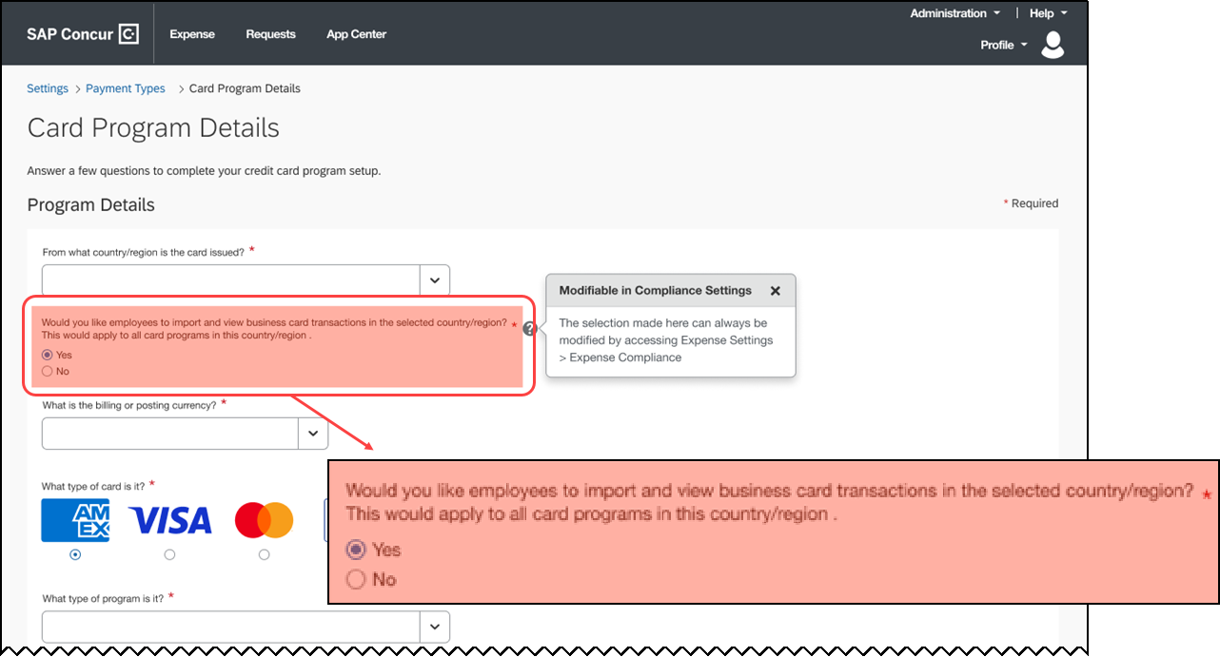
A different screen allows for the addition of a personal card for these imports.
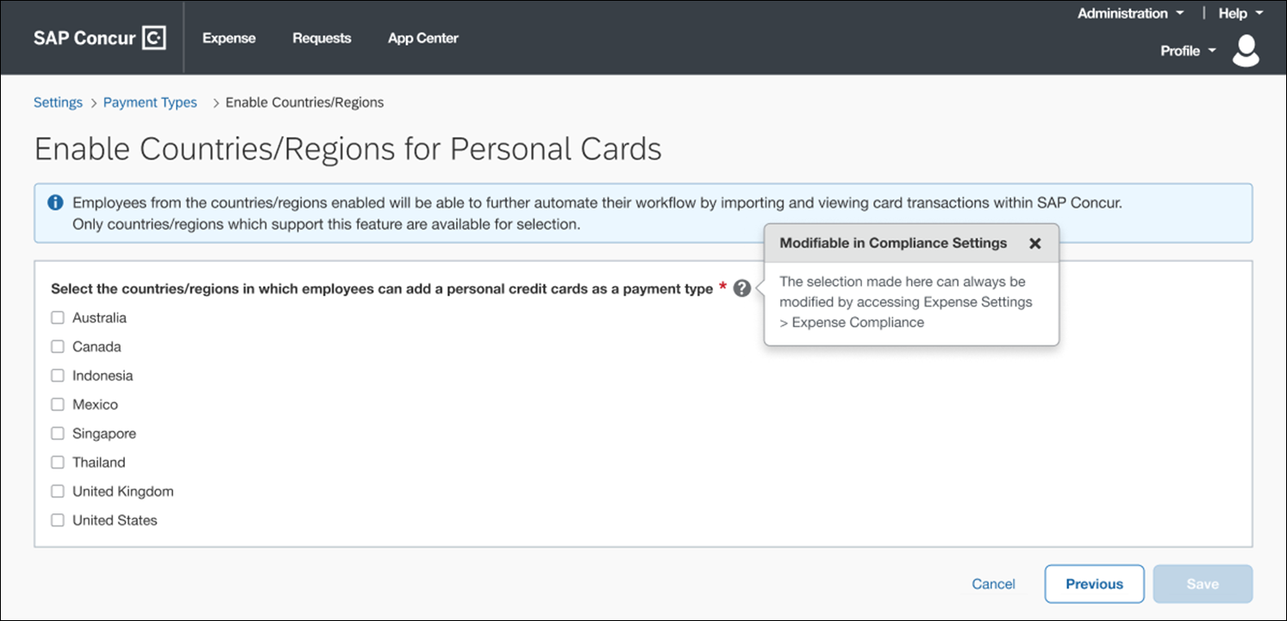

Changing the Behavior of the Import After Configuration
The admin may reconfigure these settings using options available today in the Expense Settings > Expense Compliance screen using the Allow users option.
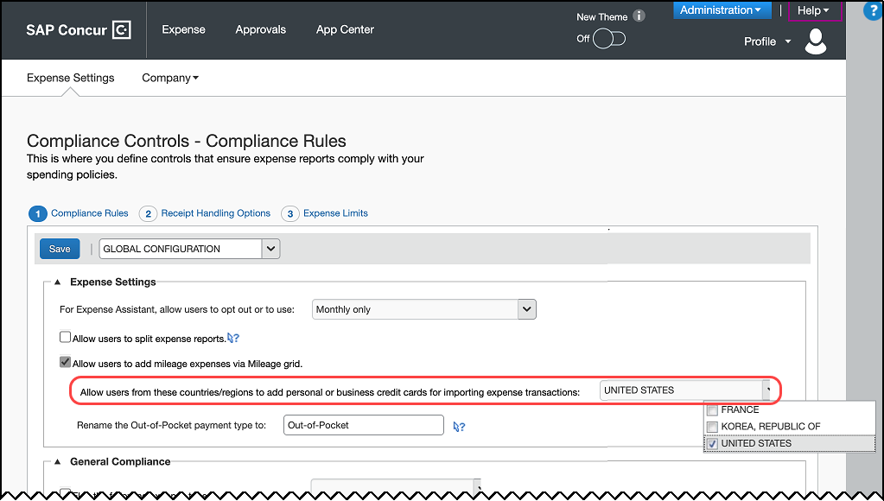

Configuration / Feature Activation
The change occurs automatically; there are no additional configuration steps.

Set Business Card Type as the Default Payment Type

Overview
With this release, new options will be added to the Expense Settings > Payment Types screen that will allow the choice of any business card program as the default payment type for employees using this card type.
Prior to this change the System Payment Type > Default Payment Type for New Expenses selection included several options (Company Paid; Pending Card Transaction). Now, each business card program added by the admin is available for selection as the default payment type.

Business Purpose / Client Benefit
This update supports business card programs as the default payment type.

Configuration / Feature Activation
The change occurs automatically; there are no additional configuration steps.

User Interface Changes

Usability Changes to the User Interface

Overview
The following usability changes are part of the ongoing continuous improvement process for the user experience. The changes shown below are available in this release.

Business Purpose / Client Benefit
These changes are part of the ongoing effort to improve the user experience when working with SAP Concur products.
- Report Library: The Create New Report button is available on the right top corner of the Report Library. This provides more screen space to display the existing expense reports.
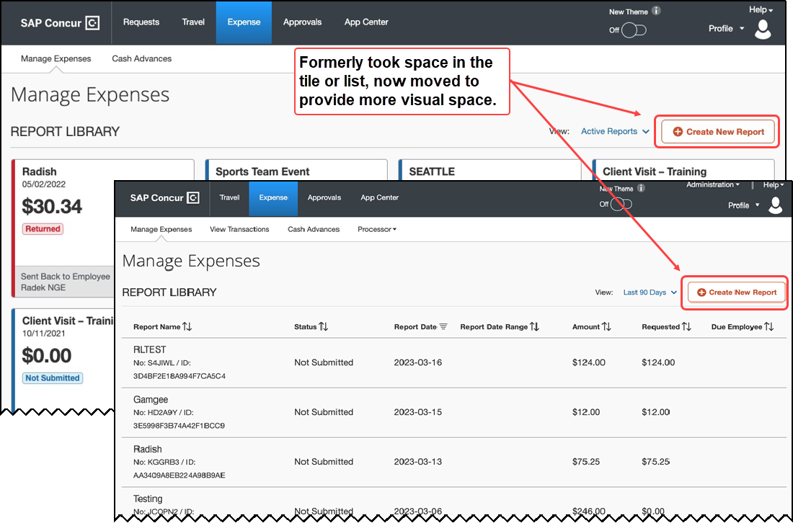
- Available Receipts: The Available Receipts button is available on the right top corner of the Available Receipts section of the screen. This provides more screen space to display the existing receipt tiles.
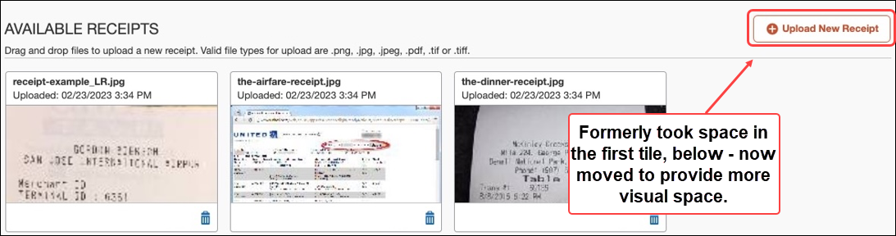
- Available Receipts Panel in Report Page: Toggling Available Receipts when a report is displayed in the Report page lets the user view and then drag and drop their receipts directly to an expense on the left side. Hide the entire Receipt Viewer panel by clicking Hide Receipt Panel.
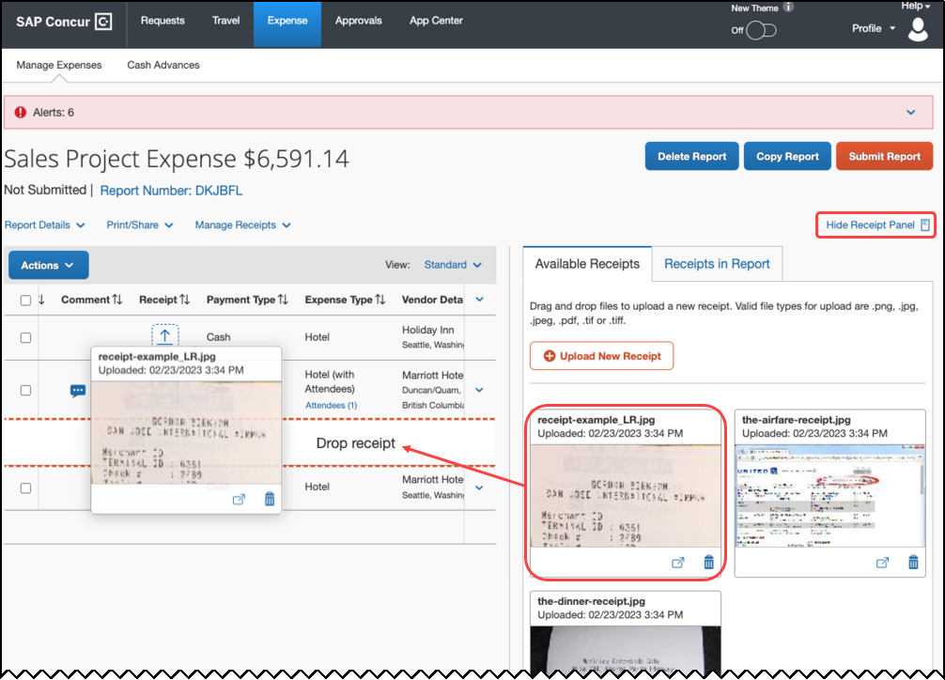
- Full Screen Experience: The user will see a full screen view of Expense – this includes all applicable pages (Home and Expense Detail screens shown below).
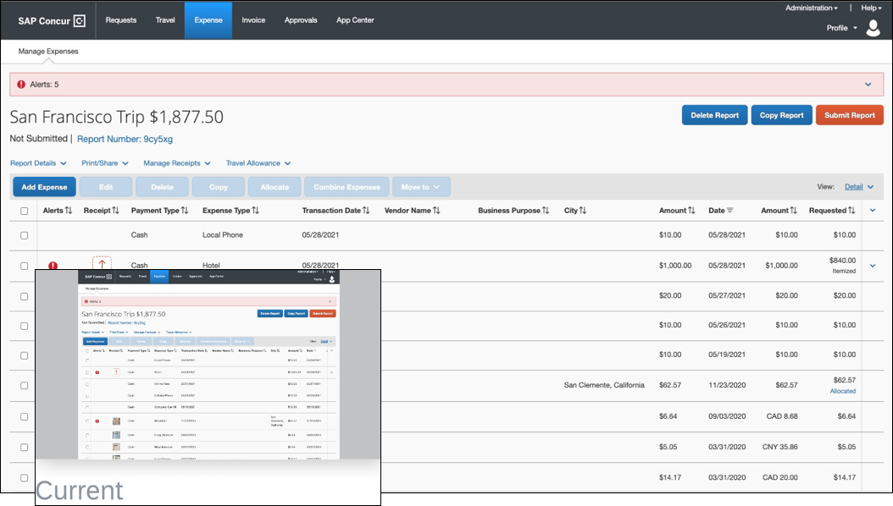
- Resizable and Draggable Pop-ups: Selected non-full screen pop-ups may be moved and resized so the user may set the screen as they prefer.
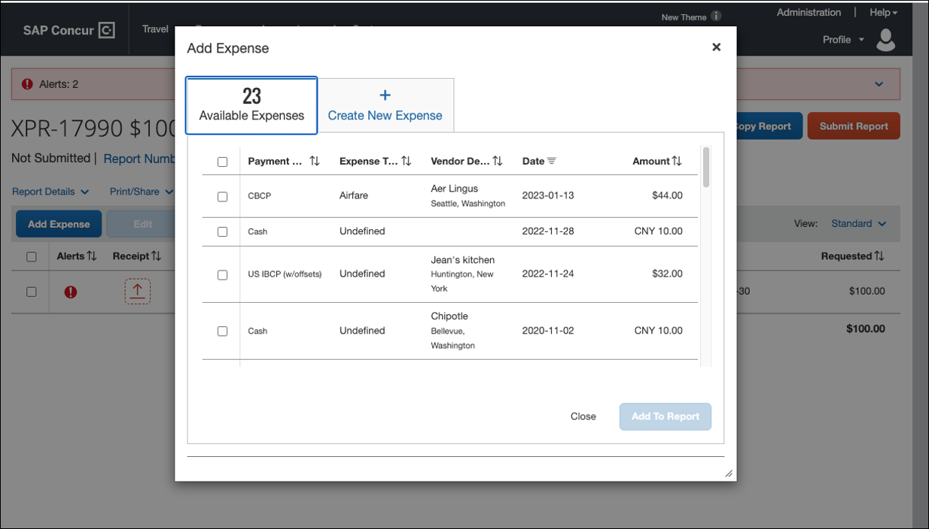

Configuration / Feature Activation
The feature is automatically available, there are no additional configuration or activation steps.

Value Added Tax (VAT) / Tax Administration

Reclaim Full VAT in Germany

Overview
SAP Concur now allows companies in Germany to reclaim full VAT amount deducted on reimbursement of domestic entertainment expenses incurred towards the client.
When an employee of a company in Germany claims an expense towards client entertainment within the country, the VAT deduction is applicable on the entire amount reimbursed to the employee. This enhancement now enables the company to reclaim the full VAT paid, instead of the VAT split based on the deductible amount which is 70% of the total amount.

Business Purpose / Client Benefit
This solution now allows the company to either reclaim the full VAT amount or only a partial VAT amount.

Administrator Experience
On the Taxability and Deductibility Configuration page, under Corporate Deductibility tab, choose the appropriate options:
- Managed By: CUSTOMER
- Country: DE - Germany
- Policy: Germany Expense Policy
- Expense Type: Entertainment – Client
The Add Deductibility Configuration window appears with a list of configuration options.
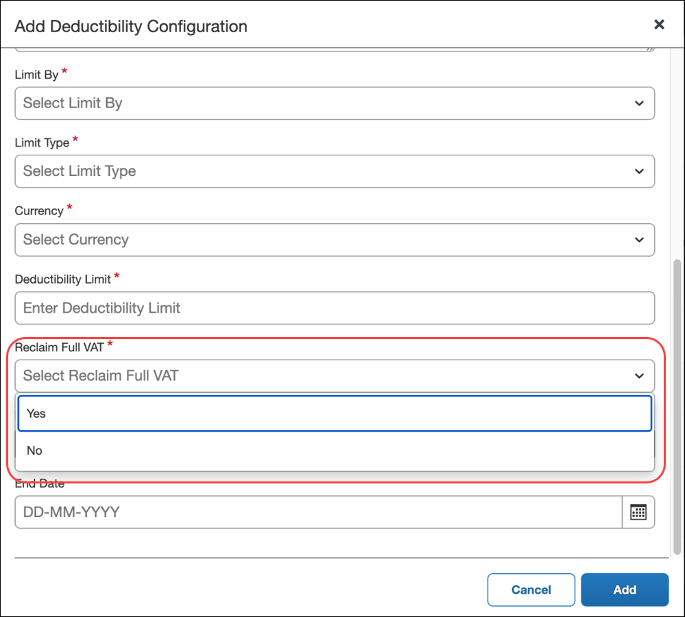
In order to reclaim the 100% VAT amount, select Yes from the Reclaim Full VAT configuration option. Alternatively, choose No to reclaim the partial VAT amount. In case of a No, the preconfigured reclaim VAT rate is picked as specified in Tax Administration > Tax & Reclaim Groups > Reclaim Rates. Currently, this rate is maintained at 70%.

Configuration / Feature Activation
The feature is automatically available; there are no additional configuration or activation steps.
For more information, refer to the Concur Expense: Value Added Tax (VAT) / Tax Administration Setup Guide.

Planned Changes
The items in this section are targeted for future releases. SAP Concur reserves the right to postpone implementation of – or completely remove – any enhancement/change mentioned here.
The planned changes listed in this document are specific to this product. For information about planned site-wide or shared changes that might impact your SAP Concur solutions, refer to the Shared Changes Release Notes.

Compliance Controls

**Planned Changes** Expense Standard Compliance Controls Updated

Information First Published | Information Last Modified | Feature Target Release Date
April 14, 2023 | -- | May 18, 2023
Any changes since the previous monthly release are highlighted in yellow in this release note.

Overview
Targeted for May 18, 2023, SAP Concur plans to remove the following settings from the Expense Settings and General Compliance sections of the Expense Compliance > Compliance Controls – Compliance Rules page in Product Settings:
- Rename the Out-of-Pocket payment type to
- Set the default Payment Type for new expenses

Business Purpose / Client Benefit
These settings are redundant to settings that are found on the Payment Types page in Product Settings.

Admin Experience
The admin will no longer see the redundant settings on the Expense Compliance > Compliance Controls – Compliance Rules page in Product Settings.

Settings to be Removed
- Rename the Out-of-Pocket payment type to
- Set the default Payment Type for new expenses
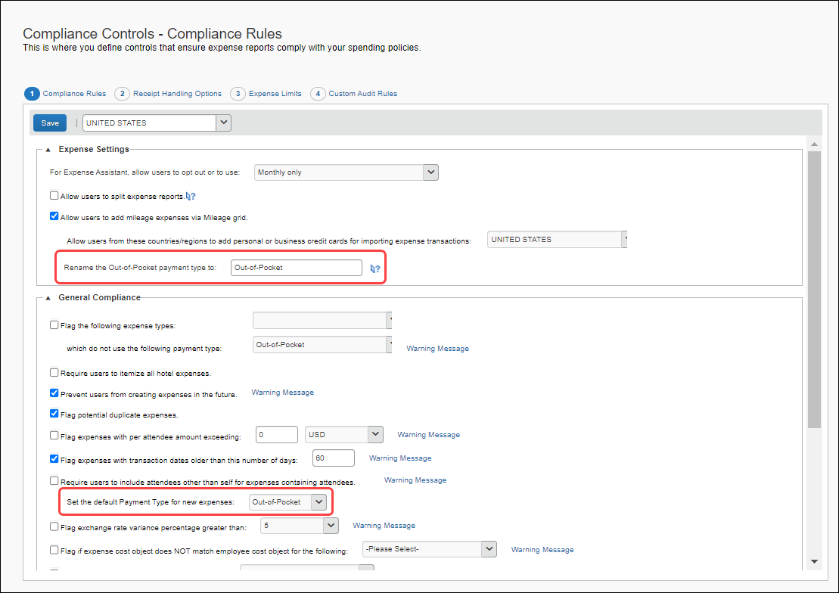

Settings on the Payment Types Page
- Default Payment Type for New Expenses
- Program Name > Out of Pocket > Actions > Rename
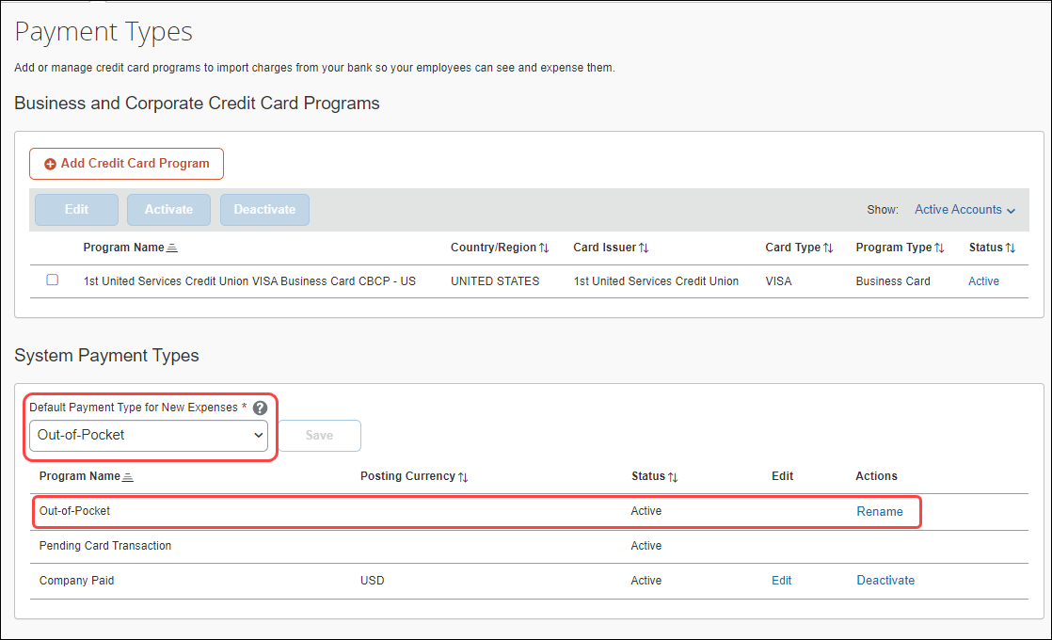

Configuration / Feature Activation
The redundant settings will be removed automatically.

Concur Expense – Next Generation User Interface

**Planned Change** Active Move Period Information Page Will No Longer Be Updated

Information First Published | Information Last Modified | Feature Target Release Date
April 21, 2023 | -- | May 2023
Any changes since the previous monthly release are highlighted in yellow in this release note.

Overview
With the adoption of the Next Generation Expense (NGE) user interface earlier this year, the Concur Expense Active Move Period Information page detailing NextGen UI updates for the benefit of clients transitioning from the now retired older user interface is no longer needed and will no longer be updated.
All feature updates and initiatives for the Concur Expense Professional/Premier and Expense Standard editions may be seen in the regular release notes:
- Concur Expense Professional release notes
- Concur Expense Standard release notes

Business Purpose / Client Benefit
This update creates a single access point for all feature communications.

Configuration / Feature Activation
The change occurs automatically; there are no additional configuration steps.

Expense Pay Flex

**Planned Changes** Payment Processing Enhancements for HKD Currency (May to June 2023)

Information First Published | Information Last Modified | Feature Target Release Date
April 21, 2023 | -- | May to June 2023
Any changes since the previous monthly release are highlighted in yellow in this release note.

Overview
Targeted for May, the HKD (Hong Kong Dollar) payment processing experience with Convera will be enhanced through: automated returns, accurate estimated dates for payments on reports, real-time payment status, and access to the View Funding page for HKD batches. Additional existing currencies will include these enhancements throughout May and June.

Business Purpose / Client Benefit
Upcoming releases will support an enhanced payment processing experience.

Configuration / Feature Activation
Clients will need to click the Upgrade Funding Account button to take advantage of these improvements once they become available.

Receipts

**Planned Changes** Add Merchant Tax ID to Expense Entry Form

Information First Published | Information Last Modified | Feature Target Release Date
March 2023 | -- | June 2023
Any changes since the previous monthly release are highlighted in yellow in this release note.

Overview
Increasingly, governments are mandating that merchants include a valid tax identifier on the receipts and invoices. This is being done to verify tax reclamation requests by the customer for the good or service provided by these vendors.
In anticipation of this, the Expense Standard’s Entry form will now include the Merchant Tax ID field that can transmit this data within an expense report. This feature is included in all Expense Standard edition non-U.S. country packs.

Business Purpose / Client Benefit
This change supports requirements to verify and display purchaser and supplier tax identifiers for clients working in, or adhering to, VAT and GST tax regulations.

End-User Experience
Any non-US Expense Standard Edition user who is creating an expense report will see the Merchant Tax ID field on their Expense Entry form whenever (and only if) the Vendor or Vendor Description field(s) are present as well.
The new field will be an optional, editable text field that is not a Required field type.

Approver and Processor Experience
Both the Approver and Processor will have read and write privileges for the Merchant Tax ID field when working with the expense report.

Configuration / Feature Activation
The feature is automatically available; there are no configuration or activation steps.
More information will be available in an upcoming release note.

**Planned Changes** Mexico CFDI Validation with SAP Document and Reporting Compliance, Cloud Edition

Information First Published | Information Last Modified | Feature Target Release Date
April 21, 2023 | -- | May – July 2023
Any changes since the previous monthly release are highlighted in yellow in this release note.

Overview
In a future release, SAP Concur will enable validation of Mexico CFDI receipts through a native product of SAP, SAP Document and Reporting Compliance, Cloud edition.
To use SAP Document and Reporting Compliance, Cloud edition for validating CFDI receipts, the client must have:
- An Enterprise Global account type on the SAP Business Technology Platform (BTP).
- A subscription to SAP Document and Reporting Compliance, Cloud edition

Business Purpose / Client Benefit
This feature provides an improved user experience by introducing SAP Document and Reporting Compliance Cloud edition to SAP Concur users, which will automatically create the expense entry and pre-populate it with the CFDI for confirmation of validation and inclusion in an expense report.
More information will be available in an upcoming release note.

Client Notifications

Accessibility

Accessibility Updates
SAP implements changes to better meet current Web Content Accessibility Guidelines (WCAG). Information about accessibility-related changes made to SAP Concur solutions is published on a quarterly basis. You can review the quarterly updates on the Accessibility Updates page.

Sub-processors

SAP Concur Non-Affiliated Sub-processors
The list of non-affiliated sub-processors is available from the SAP Sub-processors / Data Transfer Factsheets page.
To access the SAP Concur Sub-processors List:
- Click the following link to navigate to the SAP Sub-processors / Data Transfer Factsheets page:
SAP Sub-processors / Data Transfer Factsheets
- Sign in to the SAP Support Portal using your Support User ID (S-user) and password.
SAP customers must sign in to the SAP Support Portal using their Support User ID (S-user) and password. For information about S-User IDs, refer to Your New Support User ID (S-user) and to the Learn All About S-User IDs blog post.
- On the SAP Sub-processors / Data Transfer Factsheets page, type "Concur" in the Search field.
- In the Title column, click SAP Concur Sub-processors List.
If you have questions or comments, please reach out to: Privacy-Request@Concur.com

Supported Browsers

Supported Browsers and Changes to Support
For information about supported browsers and planned changes to supported browsers, refer to the Concur Travel & Expense Supported Configurations guide.
When changes to browser support are planned, information about those changes will also appear in the Shared Changes Release Notes.

Additional Release Notes and Other Technical Documentation

Online Help
You can access release notes, setup guides, user guides, admin summaries, supported configurations, and other resources via the in-product Help menu or directly on the SAP Help Portal.
To access the full set of documentation for your product, use the links in the SAP Concur Help menu, or visit the SAP Concur solutions page.
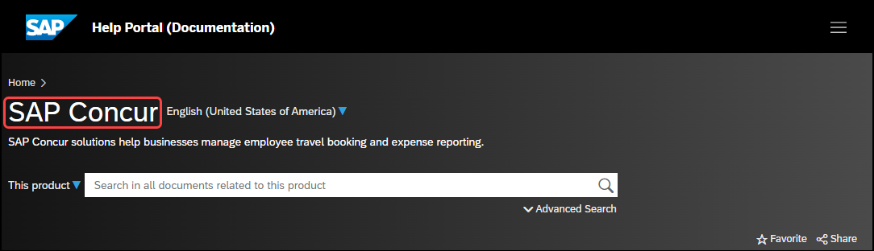

SAP Concur Support Portal – Selected Users
Access release notes, webinars, and other technical documentation on the SAP Concur support portal.
If you have the required permissions, Contact Support is available on the SAP Concur Help menu and in the SAP Concur page footer.
Click Contact Support to access the SAP Concur support portal, then click Resources.
- Click Release/Tech Info for release notes, technical documents, etc.
- Click Webinars for recorded and live webinars.

Cases

Check Support Case Status
The steps in this procedure provide instructions for checking whether a case is resolved.
To check the status of a submitted case:
- Log on to https://concursolutions.com/portal.asp.
- Click Help > Contact Support.
If you do not have the option to contact SAP Concur support under the Help menu, then your company has chosen to support the SAP Concur service internally. Please contact your internal support desk for assistance.
- Click Support > View Cases.
- In the table, view the desired type of cases based on the View list selection. Search results are limited to each company's own cases.

© 2023 SAP SE or an SAP affiliate company. All rights reserved.
No part of this publication may be reproduced or transmitted in any form or for any purpose without the express permission of SAP SE or an SAP affiliate company.
SAP and other SAP products and services mentioned herein as well as their respective logos are trademarks or registered trademarks of SAP SE (or an SAP affiliate company) in Germany and other countries. Please see http://global12.sap.com/corporate-en/legal/copyright/index.epx for additional trademark information and notices.
Some software products marketed by SAP SE and its distributors contain proprietary software components of other software vendors.
National product specifications may vary.
These materials are provided by SAP SE or an SAP affiliate company for informational purposes only, without representation or warranty of any kind, and SAP SE or its affiliated companies shall not be liable for errors or omissions with respect to the materials. The only warranties for SAP SE or SAP affiliate company products and services are those that are set forth in the express warranty statements accompanying such products and services, if any. Nothing herein should be construed as constituting an additional warranty.
In particular, SAP SE or its affiliated companies have no obligation to pursue any course of business outlined in this document or any related presentation, or to develop or release any functionality mentioned therein. This document, or any related presentation, and SAP SE’s or its affiliated companies’ strategy and possible future developments, products, and/or platform directions and functionality are all subject to change and may be changed by SAP SE or its affiliated companies at any time for any reason without notice. The information in this document is not a commitment, promise, or legal obligation to deliver any material, code, or functionality. All forward-looking statements are subject to various risks and uncertainties that could cause actual results to differ materially from expectations. Readers are cautioned not to place undue reliance on these forward-looking statements, which speak only as of their dates, and they should not be relied upon in making purchasing decisions.

