|  |  |
| --- | --- |
| SAP Concur Release Notes  Concur Expense Standard Edition | |
| **Month** | **Audience** |
| Release Date: March 18, 2023  Update #1: Friday, April 7, 4:00 p.m. | Client ***FINAL*** |

Contents

Release Notes 1

Attendees 1

Adding Attendees to a Personal Expense Report 1

Cards 2

AMEX: Reauthorization of AMEX Business Cards Required Starting November 28 and Ending March 31 2

Concur Pay 6

New Expense Pay and Invoice Pay Identifier in Transaction Details for Worldline ACH Debits 6

Expense Pay 7

Addition of Citizenship Field to Support INR Currency Processing 7

Extracts 7

VAT– Tax Line Now Follows Entry Line When Using Separate Lines 7

Planned Changes 9

Expense Pay 9

**Planned Changes** Addition of Load Number and Source ID Fields for AMEX CAD Card Configuration Program 9

Receipts 10

**Planned Changes** Add Merchant Tax ID to Expense Entry Form 10

User Interface Changes 11

**Planned Changes** Usability Changes to the User Interface 11

Client Notifications 15

Accessibility 15

Accessibility Updates 15

Sub-processors 15

SAP Concur Non-Affiliated Sub-processors 15

Supported Browsers 16

Supported Browsers and Changes to Support 16

Additional Release Notes and Other Technical Documentation 17

Online Help 17

SAP Concur Support Portal – Selected Users 17

Cases 18

Check Support Case Status 18

Legal Disclaimer

The information in this presentation is confidential and proprietary to SAP SE or an SAP affiliate company and may not be disclosed without the permission of SAP SE or the respective SAP affiliate company. This presentation is not subject to your license agreement or any other service or subscription agreement with SAP SE or its affiliated companies. SAP SE and its affiliated companies have no obligation to pursue any course of business outlined in this document or any related presentation, or to develop or release any functionality mentioned therein. This document, or any related presentation and SAP SE or an SAP affiliate company’s strategy and possible future developments, products and or platforms directions and functionality are all subject to change and may be changed by SAP SE and its affiliated companies at any time for any reason without notice. The information in this document is not a commitment, promise or legal obligation to deliver any material, code or functionality. This document is provided without a warranty of any kind, either express or implied, including but not limited to, the implied warranties of merchantability, fitness for a particular purpose, or non-infringement. This document is for informational purposes and may not be incorporated into a contract. SAP SE and its affiliated companies assume no responsibility for errors or omissions in this document, except if such damages were caused by SAP SE or an SAP affiliate company’s willful misconduct or gross negligence.

All forward-looking statements are subject to various risks and uncertainties that could cause actual results to differ materially from expectations. Readers are cautioned not to place undue reliance on these forward-looking statements, which speak only as of their dates, and they should not be relied upon in making purchasing decisions.

# Release Notes

This document contains the release notes for Concur Expense Standard edition.

1. Features and changes that apply to SAP Concur site-wide or to multiple products/services are documented in the *Shared Changes Release Notes*. For information about site-wide or shared changes in this release that might impact your SAP Concur solutions, refer to the [*Shared Changes Release Notes*](https://www.concurtraining.com/customers/tech_pubs/RN_shared_planned/_client_shared_RN_all.htm).

## Attendees

### Adding Attendees to a Personal Expense Report

#### Overview

Previously, adding attendees to a personal expense was possible only by adding attendees prior to marking the expense as personal.

Now, end-users can add attendees to a personal expense at any step in the expense creation process.

1. If an expense is switched from business to personal, a message appears warning users that allocations and itemizations will be removed.

##### Business Purpose / Client Benefit

Certain regulations require some companies to document the amount that employees spend on their customers, even when their employees pay by using their own credit card. Also, some customers require attendees for all business or personal expenses.

#### End-User Experience

When an end-user adds attendees to an expense, and then marks it as a personal expense type, they will see the following message:

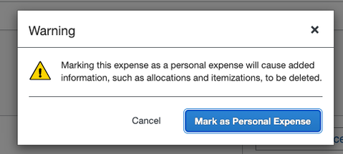

When an end-user marks an expense as a personal expense type prior to adding attendees, they will not see the message.

#### Configuration / Feature Activation

The feature is automatically available; there are no additional configuration or activation steps.

For more information, refer to the *Concur Expense: Attendees Setup Guide*.

## Cards

### AMEX: Reauthorization of AMEX Business Cards Required Starting November 28 and Ending March 31

#### Overview

AMEX has updated the Application Programming Interface (API), which affects the use of AMEX business cards for their customers. Specifically, this action replaces the existing APIs currently supporting, among other things, the import and use of transactions within the SAP Concur Expense product.

##### Business Purpose / Client Benefit

This update is required to ensure continued connectivity for AMEX business cards within Concur Expense, allowing Expense AMEX card users to enjoy the adoption of continued API services.

#### End-User Experience

For SAP Concur Expense users, once completed, this change provides continued connectivity when using the AMEX business cards. However, to ensure a seamless transition, selected clients using this business card *may* need to reauthorize their cards within Expense. This requirement is based on the date they originally authorized their card.

The following table shows which clients must reauthorize their card:

| Client Definition | Required Action Nov 28, 2022 – Mar 31, 2023 |
| --- | --- |
| Any user whose card was authorized *before* November 28, 2022 | Reauthorize your AMEX business card within Expense within the dates specified in this release note. |
| Any client authorizing their card *after* November 28, 2022 | No action is required. The updated APIs will be adopted by default for all cards authorized after this date. |

Failure to reauthorize the AMEX business card within the specified date range does not mean the card cannot be reauthorized following March 31, 2023.However, the client may experience a disruption in transaction activities following March 31, 2023, because American Express will be disabling connectivity via the older APIs after this date.

#### Administrator Experience

The admin responsible for use of AMEX business cards at their site should plan their actions, especially notification of all applicable users, based on this release note. If in doubt for any given card user, performing the reauthorization task itself will not result in adverse results and may benefit a client site seeking simplicity in messaging their users.

#### Configuration / Feature Activation

Please review the need to reauthorize your AMEX Business card.

1. To Reauthorize your AMEX Business Card:
2. Open **Profile > Profile Settings**.
3. In **Expense Settings**, click **Expense Credit Cards**. The **Expense Credit Cards** page appears.

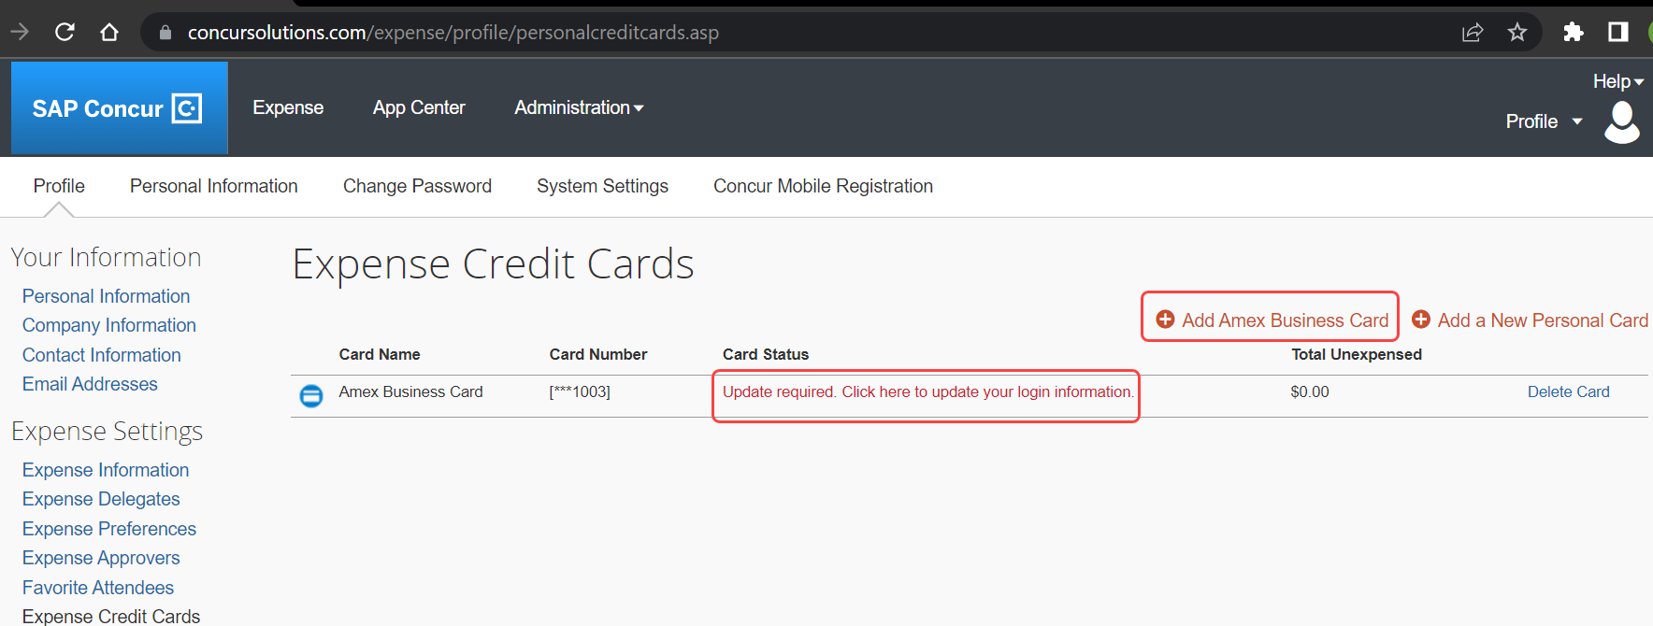

1. Click **Add Amex Business Card** to add a new Amex Card.
2. In case the card already exists on the **Expense Credit Cards** page and only needs to be reauthorized, below the **Card Status**, you will see **Update required. Click here to update your login information**. This hyperlink allows you to re-authorize your card.
3. In the **You are now leaving Concur** box, click **Continue**.

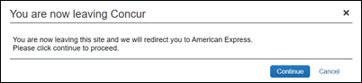

1. On the **Card Data Access User Agreement**, read the agreement and select the **I Accept the Terms and Conditions** checkbox, then click **Continue**.
2. On the **American Express** login page, type your login credentials, then click **Log In**.

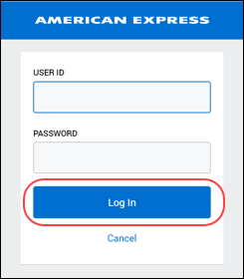

1. On the **Authorize access to Concur** disclaimer, read the information and then click **Continue**.

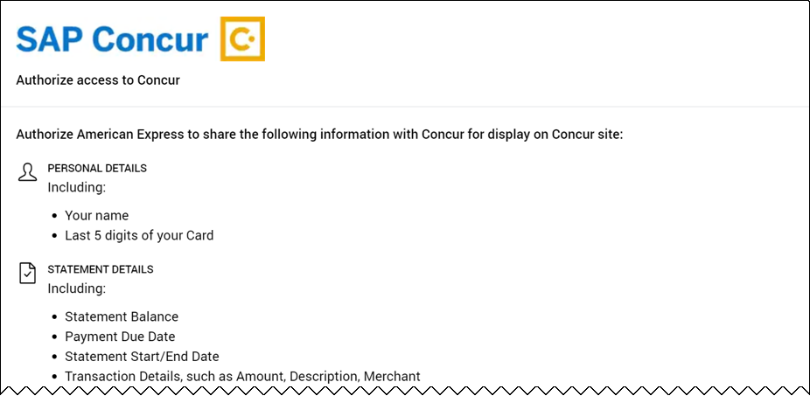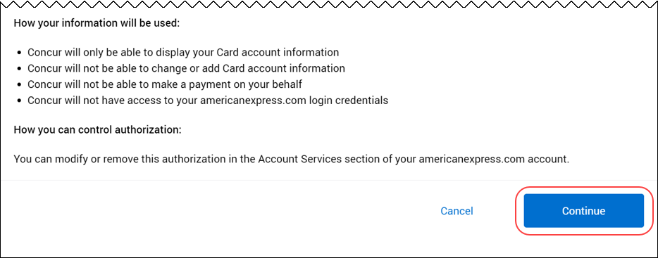

1. On the **American Express** authorization page, select the checkbox for each card you want to reauthorize.

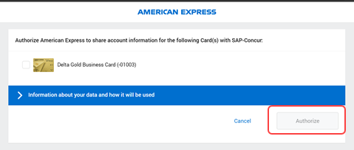

You can now see all business cards you have registered with American Express.

Supplemental cards will also display, but only if the corresponding basic card is not displayed here. For example, if you own both the basic and supplemental card, then only the basic card is shown.

Any other American Express corporate card or personal card will not appear here.

1. Click **Authorize** to synchronize cards.
2. Click the **Return to SAP-Concur** button. The AMEX card is now reauthorized.

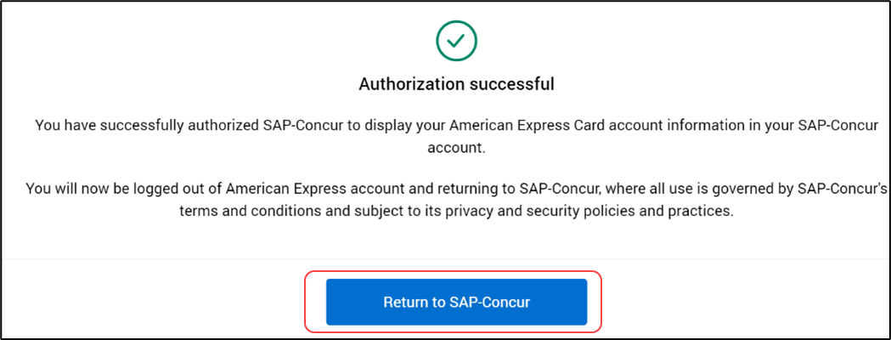

## Concur Pay

### New Expense Pay and Invoice Pay Identifier in Transaction Details for Worldline ACH Debits

#### Overview

Expense Pay and Invoice Pay ACH provider Worldline has made an enhancement to the information in the transaction details of debits made from client bank accounts for Expense Pay and Invoice Pay payments. The transaction details will now include “EX” for debits relating to Expense Pay or “IN” for debits relating to Invoice Pay.

##### Business Purpose / Client Benefit

For clients using Worldline as their ACH payment provider for Expense Pay and Invoice Pay, this enhancement will help with reconciliation of debits from their bank account for Expense Pay vs Invoice Pay payments.

#### End-User Experience

Clients whose bank provides transaction details on statements or in their online banking portal will now see “EX” or “IN” for debits made by Worldline’s bank for Expense Pay and Invoice Pay payments.

#### Configuration / Feature Activation

The feature is automatically available; there are no configuration or activation steps.

## Expense Pay

### Addition of Citizenship Field to Support INR Currency Processing

#### Overview

For payment providers processing payments in INR currency, beneficiary details now include a **Citizenship** dropdown list. This field is required for employees when updating and entering user banking details for INR reimbursement.

##### Business Purpose / Client Benefit

The collection of the beneficiary citizenship country helps payment providers efficiently process INR payments and support their compliance requirements. This is required for INR payments to succeed in the near future.

#### End-User Experience

In the **Bank Information** window, users are required to select their current legal citizenship country when updating or entering their user banking. This is the country that displays on one’s passport. Users who will be reimbursed in INR currency should fill in this newly required field in their banking to ensure their INR expense reimbursements continue to succeed without disruption.

#### Configuration / Feature Activation

The feature is automatically available; there are no configuration or activation steps.

## Extracts

### VAT– Tax Line Now Follows Entry Line When Using Separate Lines

#### Overview

With this release, Expense Standard users who configure either the tax line on a separate line, or both the entry and tax lines on separate lines and with the expense will now see the tax line appearing *after* the entry line in their extracts. Prior to this change, the order of entry and tax was unpredictable with differing outcomes. Now, this rule is enforced by a setting that ensure this behavior.

1. If customer configures grouping or ordering by another field, that logic will be honored without regard to ordering of tax lines.

##### Business Purpose / Client Benefit

This change aligns the extract to match user requests for this behavior. Historically the line order was not predictable and tax lines may precede or follow the entry line with no assurance of the order.

##### Reversing the Order of the Tax and Entry Lines

This order may be reversed if the client does not require the entry line to precede the tax line. To do this, contact Concur Support and request a change from Yes to No on the **Order Tax Lines** setting.

#### Configuration / Feature Activation

The feature is automatically available; there are no configuration or activation steps.

For more information, refer to the *Concur Expense: File Export Configuration Setup Guide for Expense Standard*.

# Planned Changes

The items in this section are targeted for future releases. SAP Concur reserves the right to postpone implementation of – or completely remove – any enhancement/change mentioned here.

1. The planned changes listed in this document are specific to this product. For information about planned site-wide or shared changes that might impact your SAP Concur solutions, refer to the [*Shared Changes Release Notes*](https://www.concurtraining.com/customers/tech_pubs/RN_shared_planned/_client_shared_RN_all.htm).

## Expense Pay

### **Planned Changes** Addition of Load Number and Source ID Fields for AMEX CAD Card Configuration Program

|  |  |  |
| --- | --- | --- |
| Information First Published | Information Last Modified | Feature Target Release Date |
| February 10, 2023 | -- | March or April 2023 |
| Any changes since the previous monthly release are highlighted in yellow in this release note. | | |

#### Overview

When setting up a new or updating an existing card program for AMEX using CAD currency, two new fields will be required: **Source ID** and **Load Number**. This data will be sent with the remittance for card vendor processing.

Load Number will be a unique six-digit value. Source ID will be a unique 10 alphanumeric value.

1. This change is intended for new clients. Existing clients can continue to use the existing remittance file format until they are provided their **Load Number** and **Source ID** from Amex Canada and the old format is deprecated.

##### Business Purpose / Client Benefit

To efficiently process AMEX Canada payments, a unique **Load Number** and **Source ID** are required per client to support a new AMEX CAD remittance file format. These fields will support payment reconciliation and help prevent missing remittance requests due to timing issues.

#### End-User Experience

In the **Add New Card Program** dialog, when the **Payment Provider** option is enabled for the Amex card program, the **Source ID** and **Load Number** fields will be enabled and required.

#### Configuration / Feature Activation

Once Amex Canada provides you with your company’s unique **Source ID** and **Load Number**, you must go to your card program configuration screen in SAP Concur and enter your IDs and then click **Save**. The next card batch opened will be sent using these new IDs with the new format.

## Receipts

### **Planned Changes** Add Merchant Tax ID to Expense Entry Form

|  |  |  |
| --- | --- | --- |
| Information First Published | Information Last Modified | Feature Target Release Date |
| March 2023 | -- | May 2023 |
| Any changes since the previous monthly release are highlighted in yellow in this release note. | | |

#### Overview

Increasingly, governments are mandating that merchants include a valid tax identifier on the receipts and invoices. This is being done to verify tax reclamation requests by the customer for the good or service provided by these vendors.

In anticipation of this, the Expense Standard’s Entry form will now include the **Merchant Tax ID** field that can transmit this data within an expense report. This feature is included in all Expense Standard edition non-U.S. country packs.

##### Business Purpose / Client Benefit

This change supports requirements to verify and display purchaser and supplier tax identifiers for clients working in, or adhering to, VAT and GST tax regulations.

#### End-User Experience

Any non-US Expense Standard Edition user who is creating an expense report will see the **Merchant Tax ID** field on their Expense Entry form whenever (and only if) the **Vendor** or **Vendor Description** field(s) are present as well.

The new field will be an optional, editable text field that is not a *Required* field type.

#### Approver and Processor Experience

Both the Approver and Processor will have read and write privileges for the **Merchant Tax ID** field when working with the expense report.

#### Configuration / Feature Activation

The feature is automatically available; there are no configuration or activation steps.

More information will be available in an upcoming release note.

## User Interface Changes

|  |  |  |
| --- | --- | --- |
| Information First Published | Information Last Modified | Feature Target Release Date |
| March 10, 2023 | -- | April 2023 |
| Any changes since the previous monthly release are highlighted in yellow in this release note. | | |

### **Planned Changes** Usability Changes to the User Interface

#### Overview

The following usability changes are part of the ongoing continuous improvement process for the user experience. The changes shown below will be available in a future release.

##### Business Purpose / Client Benefit

These changes are part of the ongoing effort to improve the user experience when working with SAP Concur products.

#### Upcoming Changes

* **Report Library:** The **Create New Report** button will be available on the right top corner of the **Report Library**. This provides more screen space to display the existing expense reports.

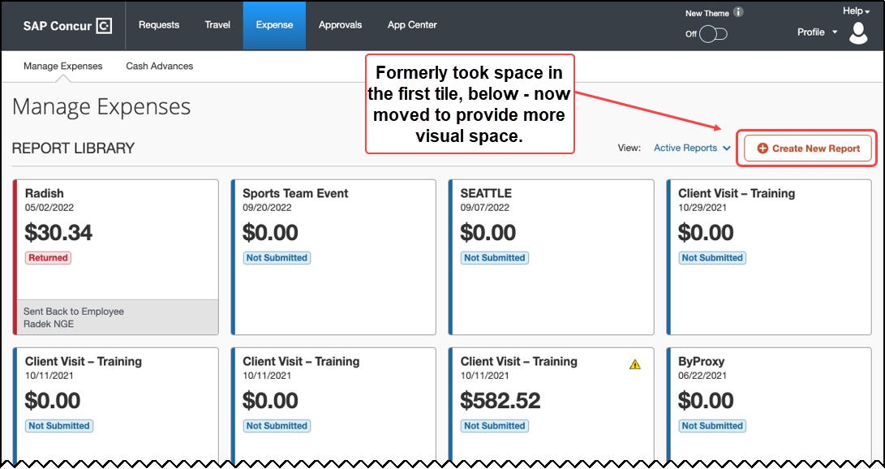

* **Available Receipts:** The **Available Receipts** button will be available on the right top corner of the **Available Receipts** section of the screen. This provides more screen space to display the existing receipt tiles.

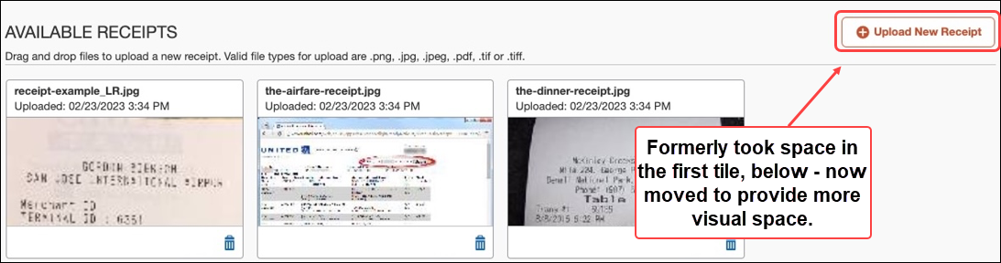

* **Available Receipts Panel in Report Page:** Toggling **Available Receipts** when a report is displayed in the **Report** page lets the user view and then drag and drop their receipts directly to an expense on the left side. Hide the entire **Receipt Viewer** panel by clicking **Hide Receipt Panel**.

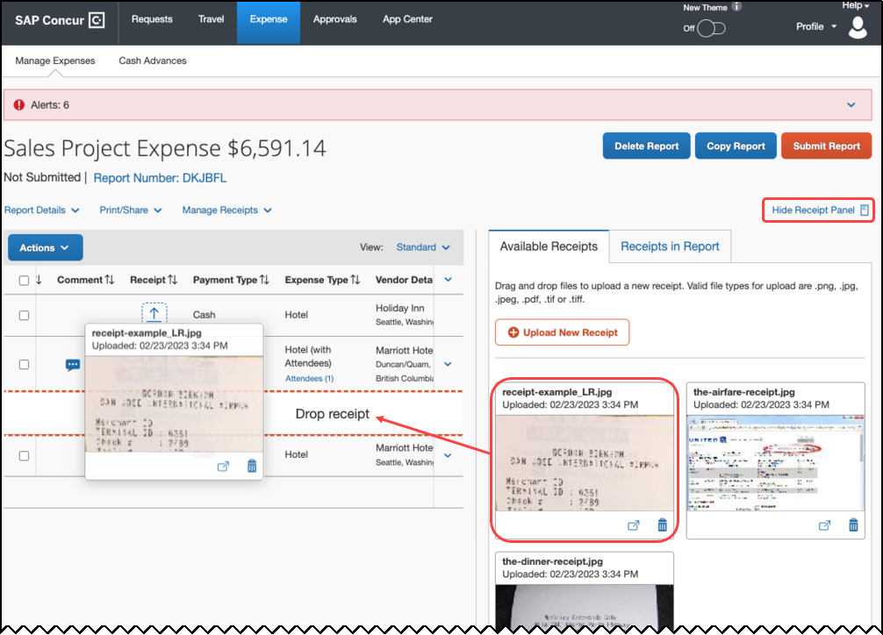

* **Full Screen Experience:** The user will be able to expand their view of Concur Expense to a full screen – this includes any page (**Home** and **Expense Detail** screens shown below).

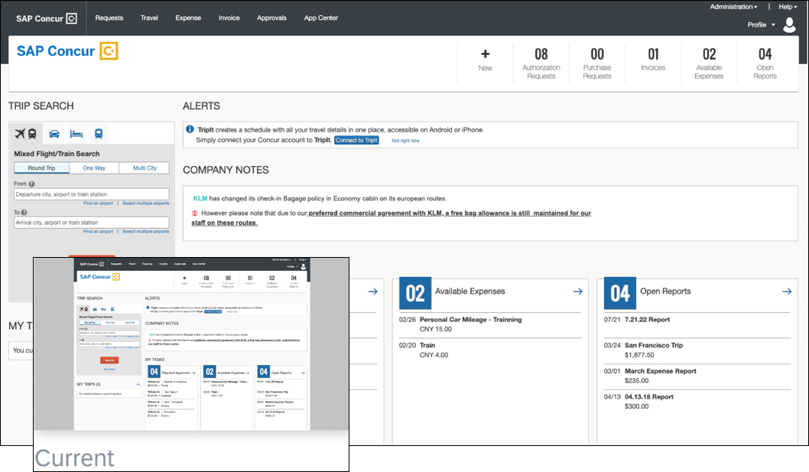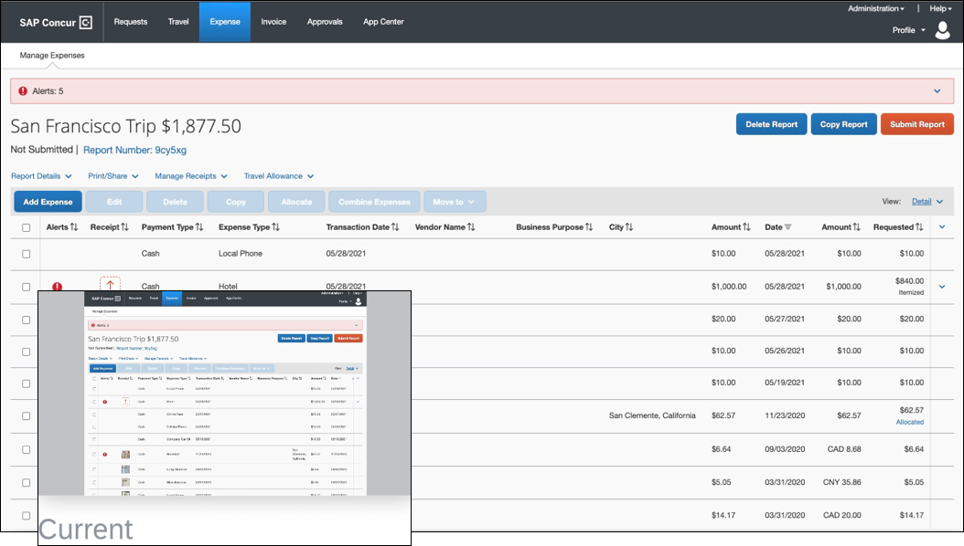

* **Resizable and Draggable Pop-ups:** Selected non-full screen pop-ups may be moved and resized so the user may set the screen as they prefer.

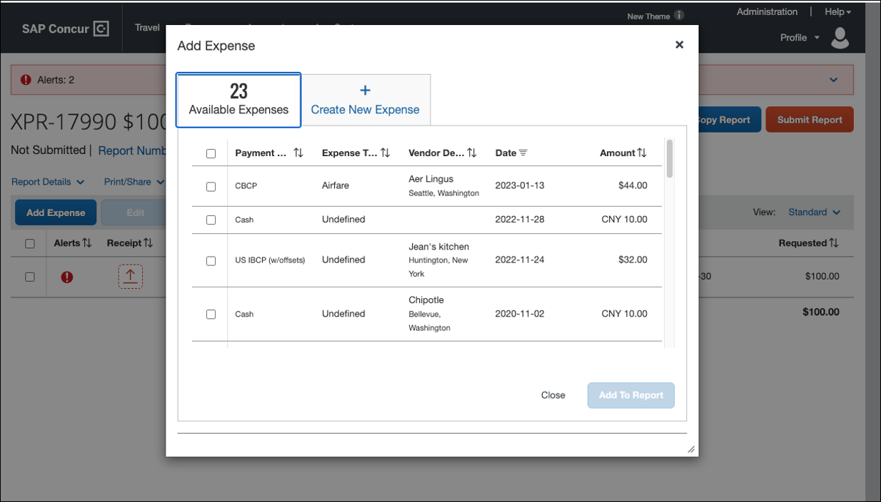

#### Configuration / Feature Activation

The feature is automatically available; there are no configuration or activation steps.

# Client Notifications

## Accessibility

### Accessibility Updates

SAP implements changes to better meet current Web Content Accessibility Guidelines (WCAG). Information about accessibility-related changes made to SAP Concur solutions is published on a quarterly basis. You can review the quarterly updates on the [Accessibility Updates](https://help.sap.com/docs/SAP_CONCUR/caf7d7289796414a91e130a5169d8e71/84234e2c0e844ca09e7a91213e6c8646.html) page.

## Sub-processors

### SAP Concur Non-Affiliated Sub-processors

The list of non-affiliated sub-processors is available from the *SAP Sub-processors / Data Transfer Factsheets* page.

1. To access the SAP Concur Sub-processors List:
2. Click the following link to navigate to the *SAP Sub-processors / Data Transfer Factsheets* page:  
   [*SAP Sub-processors / Data Transfer Factsheets*](https://support.sap.com/en/my-support/trust-center/subprocessors.html)
3. Sign in to the SAP Support Portal using your Support User ID (S-user) and password.
4. SAP customers must sign in to the SAP Support Portal using their Support User ID (S-user) and password. For information about S-User IDs, refer to [*Your New Support User ID (S-user)*](https://support.sap.com/en/my-support/users/welcome.html) and to the [*Learn All About S-User IDs*](https://blogs.sap.com/2021/03/09/learn-all-about-s-user-ids/) blog post.
5. On the *SAP Sub-processors / Data Transfer Factsheets* page, type "Concur" in the **Search** field.
6. In the **Title** column, click **SAP Concur Sub-processors List**.

If you have questions or comments, please reach out to: [Privacy-Request@Concur.com](mailto:Privacy-Request@Concur.com)

## Supported Browsers

### Supported Browsers and Changes to Support

For information about supported browsers and planned changes to supported browsers, refer to the [*Concur Travel & Expense Supported Configurations*](http://www.concurtraining.com/customers/tech_pubs/Docs/Z_SuppConfig/Supported_Configurations_for_Concur_Travel_and_Expense.pdf) guide.

When changes to browser support are planned, information about those changes will also appear in the [*Shared Changes Release Notes*](https://www.concurtraining.com/customers/tech_pubs/RN_shared_planned/_client_shared_RN_all.htm).

# Additional Release Notes and Other Technical Documentation

## Online Help

You can access release notes, setup guides, user guides, admin summaries, supported configurations, and other resources via the in-product Help menu or on the SAP Help Portal.

To access the full set of documentation for your product, use the links in the SAP Concur **Help** menu, or search for your SAP Concur product (Concur Expense, Concur Invoice, Concur Request, or Concur Travel) on the SAP Help Portal (https://help.sap.com).

## SAP Concur Support Portal – Selected Users

Access release notes, webinars, and other technical documentation on the SAP Concur support portal.

If you have the required permissions, **Contact** **Support** is available on the SAP Concur **Help** menu and in the SAP Concur page footer.

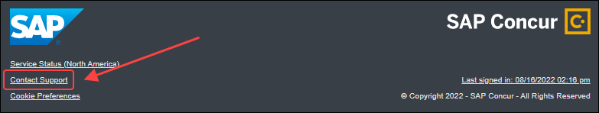

Click **Contact Support** to access the SAP Concur support portal, then click **Resources**.

* Click **Release/Tech Info** for release notes, technical documents, etc.
* Click **Webinars** for recorded and live webinars.

# Cases

## Check Support Case Status

The steps in this procedure provide instructions for checking whether a case is resolved.

1. To check the status of a submitted case:
2. Log on to <https://concursolutions.com/portal.asp>.
3. Click **Help** > **Contact** **Support**.
4. If you do not have the option to contact SAP Concur support under the **Help** menu, then your company has chosen to support the SAP Concur service internally. Please contact your internal support desk for assistance.
5. Click **Support > View Cases**.
6. In the table, view the desired type of cases based on the **View** list selection. Search results are limited to each company's own cases.

© 2023 SAP SE or an SAP affiliate company. All rights reserved.

No part of this publication may be reproduced or transmitted in any form or for any purpose without the express permission of SAP SE or an SAP affiliate company.

SAP and other SAP products and services mentioned herein as well as their respective logos are trademarks or registered trademarks of SAP SE (or an SAP affiliate company) in Germany and other countries. Please see http://global12.sap.com/corporate-en/legal/copyright/index.epx for additional trademark information and notices.

Some software products marketed by SAP SE and its distributors contain proprietary software components of other software vendors.

National product specifications may vary.

These materials are provided by SAP SE or an SAP affiliate company for informational purposes only, without representation or warranty of any kind, and SAP SE or its affiliated companies shall not be liable for errors or omissions with respect to the materials. The only warranties for SAP SE or SAP affiliate company products and services are those that are set forth in the express warranty statements accompanying such products and services, if any. Nothing herein should be construed as constituting an additional warranty.

In particular, SAP SE or its affiliated companies have no obligation to pursue any course of business outlined in this document or any related presentation, or to develop or release any functionality mentioned therein. This document, or any related presentation, and SAP SE’s or its affiliated companies’ strategy and possible future developments, products, and/or platform directions and functionality are all subject to change and may be changed by SAP SE or its affiliated companies at any time for any reason without notice. The information in this document is not a commitment, promise, or legal obligation to deliver any material, code, or functionality. All forward-looking statements are subject to various risks and uncertainties that could cause actual results to differ materially from expectations. Readers are cautioned not to place undue reliance on these forward-looking statements, which speak only as of their dates, and they should not be relied upon in making purchasing decisions.