
Analysis/Intelligence:
Data Model - Invoice Folder
User Guide
Last Revised: February 24, 2024
Table of Contents
Data Model - Invoice Folder 1
Section 1: Folder – Commonly Used Fields 2
Section 2: Folder – Payment Request Header Information 3
Payment Request Header Information > Amounts (request currency) 4
Payment Request Header Information > Amounts (reporting currency) 5
Payment Request Header Information > Exception & Approval Summaries 5
Payment Request Header Information > Supplier Invoice Information 6
Payment Request Header Information > Ship to Address Information 6
Payment Request Header Information > Concept Fields 7
Payment Request Header Information > Additional Details 7
Payment Request Header Information > Additional Employee Details 8
Payment Request Header Information > Additional Employee Details > Traveler User Fields 10
Payment Request Header Information > XML Receipt Information 10
Payment Request Header Information > XML Receipt Information > XML Receipt Keys 10
Payment Request Header Information > Keys 11
Payment Request Header Information > Keys > Prompt Keys 11
Section 3: Folder – Payment Request Dates and Statuses 12
Payment Request Dates and Statuses > Current Date Attributes 12
Payment Request Dates and Statuses > Invoice Date Attributes 13
Payment Request Dates and Statuses > First Submit Date Attributes 13
Payment Request Dates and Statuses > First Approved Date Attributes 14
Payment Request Dates and Statuses > Process Payment Date Attributes 15
Payment Request Dates and Statuses > Keys 15
Payment Request Dates and Statuses > Keys > Prompt Keys 15
Section 4: Folder – Common Payment Request Header Filters 16
Section 5: Folder – Supplier Details 17
Supplier Details > Remittance Address 17
Supplier Details > Ship From Address 18
Supplier Details > Additional Supplier Details 19
Supplier Details > Keys 19
Supplier Details > Keys > Prompt Keys 19
Section 6: Folder – Payment Request Line Items 20
Payment Request Line Items > Amounts (request currency) 21
Payment Request Line Items > Amounts (reporting currency) 21
Payment Request Line Items > Concept Fields 22
Payment Request Line Items > Additional Details 22
Payment Request Line Items > Keys 22
Section 7: Folder – Payment Request Allocations 23
Payment Request Allocations > Concept Fields 23
Payment Request Allocations > Additional Allocation Details 24
Payment Request Allocations > Keys 24
Section 8: Folder – Payment Request Attendees 24
Payment Request Attendees > Amounts 25
Payment Request Attendees > Payment Request Line Items Information 25
Payment Request Attendees > Additional Attendee Details 25
Payment Request Attendees > Associated Counts 26
Payment Request Attendees > Keys 26
Payment Request Attendees > Keys > Prompt Keys 26
Section 9: Folder – Payment Request Workflow Trail 26
Payment Request Workflow Trail > Amounts 28
Payment Request Workflow Trail > Additional Employee Details 28
Payment Request Workflow Trail > Additional Employee Details > Traveler User Fields 28
Payment Request Workflow Trail > Additional Delegate Details 29
Payment Request Workflow Trail > Keys 29
Payment Request Workflow Trail > Keys > Prompt Keys 30
Section 10: Folder – Payment Request Exceptions 30
Payment Request Exceptions > Payment Request Header Exceptions 30
Payment Request Exceptions > Payment Request Header Exceptions > Keys 31
Payment Request Exceptions > Payment Request Line Item Exceptions 31
Payment Request Exceptions > Payment Request Line Item Exceptions > Keys 32
Payment Request Exceptions > Purchase Order Matching Exceptions 32
Payment Request Exceptions > Purchase Order Matching Exceptions > Keys 32
Section 11: Folder – Payment Request Comments 33
Payment Request Comments > Payment Request Header Comments 33
Payment Request Comments > Payment Request Header Comments > Keys 33
Payment Request Comments > Payment Request Line Item Comments 33
Payment Request Comments > Payment Request Line Item Comments > Keys 33
Section 12: Folder – Payment Manager 34
Payment Manager > Batch 34
Payment Manager > Batch > Funding Account 34
Payment Manager > Batch > Keys 34
Payment Manager > Batch > Keys > Prompt Keys 35
Payment Manager > Payment Demand 35
Payment Manager > Payment Demand > Vendor Bank Account 35
Payment Manager > Payment Demand > Associated Payment Request Information 35
Payment Manager > Payment Demand > Keys 36
Payment Manager > Payment Demand > Keys > Prompt Keys 36
Section 13: Folder – Invoice Journal 36
Invoice Journal > Associated Payment Request Information 37
Invoice Journal > Associated Payment Request Line Item Information 37
Invoice Journal > Keys 37
Section 14: Folder – Lists 38
Lists > Approval Statuses 38
Lists > Payment Statuses 38
Lists > Expense Types 38
Lists > Policies 38
Lists > Ledgers 39
Lists > Dates 39
Lists > Exceptions 39
Lists > Process and Steps 39
Lists > Custom and Connected Lists 40
Lists > Currencies 40
Section 15: Folder – Audit Trail 40
Audit Trail > Request Audit 40
Audit Trail > Request Audit > Additional Details 41
Audit Trail > Request Line Item Audit 41
Audit Trail > Request Line Item Audit > Additional Details 41
Audit Trail > Employee Audit 41
Audit Trail > Employee Audit > Additional Details 42
Section 16: Folder – Purchase Order 42
Purchase Order > Purchase Order Request 42
Purchase Order > Purchase Order Request > Dates 43
Purchase Order > Purchase Order Request > Amounts 43
Purchase Order > Purchase Order Request > Supplier Details 43
Purchase Order > Purchase Order Request > Supplier Details > Additional Supplier Details 43
Purchase Order > Purchase Order Request > Additional Details 44
Purchase Order > Purchase Order Request > Keys 44
Purchase Order > Purchase Order Request > Keys > Prompt Keys 44
Purchase Order > Purchase Order Line Item 44
Purchase Order > Purchase Order Line Item > Dates 44
Purchase Order > Purchase Order Line Item > Amounts 45
Purchase Order > Purchase Order Line Item > Additional Details 45
Purchase Order > Purchase Order Line Item > Keys 45
Purchase Order > Purchase Order Line Item > Keys > Prompt Keys 46
Purchase Order > Purchase Order Allocation 46
Purchase Order > Purchase Order Allocation > Additional Details 46
Purchase Order > Purchase Order Allocation > Keys 46
Purchase Order > Purchase Order Allocation > Keys > Prompt Keys 46
Purchase Order > Purchase Order Receipts 47
Purchase Order > Purchase Order Receipts > Additional Details 47
Purchase Order > Purchase Order Receipts > Keys 47
Section 17: Folder – Purchase Request 47
Purchase Request > Purchase Request Header Information 48
Purchase Request > Purchase Request Header Information > Flags 48
Purchase Request > Purchase Request Header Information > Amounts 48
Purchase Request > Purchase Request Header Information > Ship To Address 48
Purchase Request > Purchase Request Header Information > Bill To Address - Policy 49
Purchase Request > Purchase Request Header Information > Bill To Address – Purchase Request 49
Purchase Request > Purchase Request Header Information > Additional Details 49
Purchase Request > Purchase Request Header Information > Reporting Segments 50
Purchase Request > Purchase Request Header Information > Additional Employee Details 50
Purchase Request > Purchase Request Header Information > Additional Employee Details > Traveler User Fields 51
Purchase Request > Purchase Request Header Information > Keys 52
Purchase Request > Purchase Request Header Information > Keys > Prompt Keys 52
Purchase Request > Purchase Request Items 52
Purchase Request > Purchase Request Items > Amounts 52
Purchase Request > Purchase Request Items > Vendor Details 53
Purchase Request > Purchase Request Items > Additional Details 53
Purchase Request > Purchase Request Items > Keys 53
Purchase Request > Purchase Request Items > Keys > Prompt Keys 53
Purchase Request > Purchase Request Distributions 54
Purchase Request > Purchase Request Distributions > Additional Details 54
Purchase Request > Purchase Request Distributions > Keys 54
Purchase Request > Purchase Request Distributions > Keys > Prompt Keys 54
Purchase Request > Purchase Request Exceptions 54
Purchase Request > Purchase Request Exceptions > Purchase Request Header Exceptions 54
Purchase Request > Purchase Request Exceptions > Purchase Request Header Exceptions > Keys 55
Purchase Request > Purchase Request Exceptions > Purchase Request Header Exceptions > Keys > Prompt Keys 55
Purchase Request > Purchase Request Exceptions > Purchase Request Item Exceptions 55
Purchase Request > Purchase Request Exceptions > Purchase Request Item Exceptions > Keys 55
Purchase Request > Purchase Request Exceptions > Purchase Request Item Exceptions > Keys > Prompt Keys 55
Purchase Request > Purchase Request Comments 55
Purchase Request > Purchase Request Comments > Purchase Request Header Comments 55
Purchase Request > Purchase Request Comments > Purchase Request Header Comments > Keys 55
Purchase Request > Purchase Request Comments > Purchase Request Item Comments 56
Purchase Request > Purchase Request Comments > Purchase Request Header Comments > Keys 56
Purchase Request > Purchase Request Workflow Trail 56
Purchase Request > Purchase Request Workflow Trail > Amounts 57
Purchase Request > Purchase Request Workflow Trail > Additional Employee Details 57
Purchase Request > Purchase Request Workflow Trail > Additional Delegate Details 57
Purchase Request > Purchase Request Workflow Trail > Keys 57
Purchase Request > Purchase Request Workflow Trail > Keys > Prompt Keys 58
Section 18: Folder – Payment Request Capture Service 58
Payment Request Capture Service > Capture Service Request Header 58
Payment Request Capture Service > Capture Service Request Header > Captured Values 59
Payment Request Capture Service > Capture Service Request Header > Processed Values 59

Revision History
Date | Revision Notes/Comments
February 24, 2024 | Monthly release changes; refer to the February 2024 Analysis/Intelligence release notes.
January 20, 2024 | Updated the copyright year and added the monthly release changes. Refer to the January 2024 Analysis/Intelligence release notes.
January 13, 2022 | Updated the copyright year; no other changes; cover date not updated
March 29, 2021 | Updated the copyright year; no other changes; cover date not updated
February 4, 2020 | Updated the copyright; no other changes; cover date not updated
April 13, 2019 | Monthly release changes; refer to the April Analysis/Intelligence release notes.
March 15, 2019 | Monthly release changes; refer to the March Analysis/Intelligence release notes. Also updated the descriptions of the Bill To Address fields under Purchase Request > Purchase Request Header Information > Bill To Address.
February 9, 2019 | Monthly release changes; refer to the February Analysis/Intelligence release notes.  Updated copyright.
December 8, 2018 | Monthly release changes; refer to the December Analysis/Intelligence release notes.
November 17, 2018 | Monthly release changes; refer to the November Analysis/Intelligence release notes.
August 18, 2018 | Monthly release changes; refer to the August Analysis/Intelligence release notes.
June 9, 2018 | Monthly release changes; refer to the June Analysis/Intelligence release notes.
May 29, 2018 | Updated image of the Supplier Details folder to include the new Is Deleted Flag field.
May 14, 2018 | Monthly release changes; refer to the May Analysis/Intelligence release notes.
April 14, 2018 | Monthly release changes; refer to the April Analysis/Intelligence release notes.
March 17, 2018 | Monthly release changes; refer to the March Analysis/Intelligence release notes.
February 10, 2018 | Monthly release changes; refer to the February Analysis/Intelligence release notes.
January 13, 2018 | Changed copyright and monthly release changes; refer to the January Analysis/Intelligence release notes.
December 9 2017 | Monthly release changes; refer to the December Analysis/Intelligence release notes.
October 14 2017 | Monthly release changes; refer to the October Analysis/Intelligence release notes.
July 8 2017 | Monthly release changes; refer to the June Analysis/Intelligence release notes.
June 3 2017 | Monthly release changes; refer to the May Analysis/Intelligence release notes.
March 18 2017 | Monthly release changes; refer to the March Analysis/Intelligence release notes.
February 17 2017 | Monthly release changes; refer to the February Analysis/Intelligence release notes.
January 20 2017 | Monthly release changes; refer to the January Analysis/Intelligence release notes.
December 16 2016 | Changed copyright; no other content changes.
October 25 2016 | Updated the guide content to new corporate style; no content changes.
October 14 2016 | Monthly release changes; refer to the October Analysis/Intelligence release notes.
September 9 2016 | Monthly release changes; refer to the September Analysis/Intelligence release notes.
August 15 2016 | Monthly release changes; refer to the August Analysis/Intelligence release notes.
July 8 2016 | Monthly release changes; refer to the July Analysis/Intelligence release notes.
June 21 2016 | Monthly release changes; refer to the June Analysis/Intelligence release notes.
May 19 2016 | Monthly release changes; refer to the May Analysis/Intelligence release notes.
April 21 2016 | Monthly release changes; refer to the April Analysis/Intelligence release notes.
March 23 2016 | Refer to the March Analysis/Intelligence release notes.
January 19 2016 | Changed from book "chapters" to stand-alone guides; no content changes
December 14 2015 | Refer to the December Analysis/Intelligence release notes.
April 9 2015 | Changed name from Concur Insight to Analysis/Intelligence; no other content changes
March 13 2015 | Refer to the March Concur Insight release notes.
December 18 2014 | Refer to the December Concur Insight release notes.
September 12 2014 | Added Purchase Request folders
March 7 2014 | Changed name to Concur Insight; no other content changes
February 7 2014 | Refer to the February Concur: Analysis and Intelligence release notes.
January 17 2014 | Refer to the January Concur: Analysis and Intelligence release notes.
November 8 2013 | Refer to the November Concur: Analysis and Intelligence release notes.
July 19 2013 | Refer to the July Concur: Analysis and Intelligence release notes.
January 18 2013 | Refer to the January Concur: Analysis and Intelligence release notes.

Data Model - Invoice Folder
NOTE: Multiple SAP Concur product versions and UI themes are available, so this content might contain images or procedures that do not precisely match your implementation. For example, when SAP Fiori UI themes are implemented, home page navigation is consolidated under the SAP Concur Home menu.
The Invoice folder contains these folders:  - Commonly Used Fields  - Payment Request Header Information  - Payment Request Dates and Statuses  - Common Payment Request Header Filters  - Supplier Details  - Payment Request Line Items  - Payment Request Allocations  - Payment Request Attendees  - Payment Request Workflow Trail  - Payment Request Exceptions  - Payment Request Comments  - Payment Manager  - Invoice Journal  - Lists  - Audit Trail  - Purchase Order  - Purchase Request  - Payment Request Capture Service | 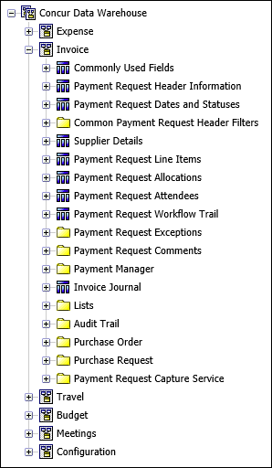

Folder – Commonly Used Fields
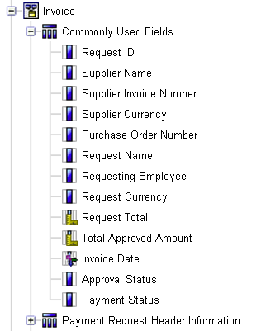

Field | Description
Request ID |  | Unique code identifying this payment request
Supplier Name |  | Name of the supplier/vendor from whom the purchase is made
Supplier Invoice Number |  | Number assigned by the supplier, identifying the invoice submitted by the supplier
Supplier Currency |  | Currency used by the supplier
Purchase Order Number |  | Number assigned by the company to authorization for the purchase
Request Name |  | Employee-entered name of the request
Requesting Employee |  | Last name, first name, and middle initial of the employee requesting the payment
Request Currency |  | Currency in which the request is submitted
Request Total |  | Total amount requested to be paid to the supplier
Total Approved Amount |  | Total amount approved to be paid to the supplier
Invoice Date |  | Date the supplier was assigned
Approval Status |  | Name of the payment request approval status
Payment Status |  | Name of the payment request payment status

Folder – Payment Request Header Information
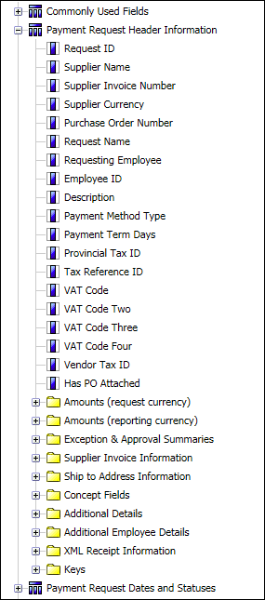

Field | Description
Request ID |  | Unique code identifying this payment request
Supplier Name |  | Name of the supplier/vendor from whom the purchase is made
Supplier Invoice Number |  | Number assigned by the supplier, identifying the invoice submitted by the supplier
Supplier Currency |  | Currency used by the supplier
Purchase Order Number |  | Number assigned by the company to authorization for the purchase
Request Name |  | Employee-entered name of the request
Requesting Employee |  | Last name, first name, and middle initial of the employee requesting the payment
Employee ID |  | Employee ID for the requesting employee
Description |  | Further description of the payment request
Payment Method Type
Payment Term Days
Provincial Tax ID
Tax Reference ID
VAT Code
VAT Code Two
VAT Code Three
VAT Code Four
Vendor Tax ID
Has PO Attached

Payment Request Header Information > Amounts (request currency)
Request Total |  | Total amount requested to be paid to the supplier - in the request currency
Total Approved Amount |  | Total amount approved to be paid to the supplier - in the request currency
Shipping Amount |  | Amount of shipping charges on the payment request for this invoice - in the request currency
Tax Amount |  | Amount of tax charges on the payment request for this invoice - in the request currency
Calculated Tax Amount
Calculated Tax Rate
VAT Amount One
VAT Rate One
VAT Amount Two
VAT Rate Two
VAT Amount Three
VAT Rate Three
VAT Amount Four
VAT Rate Four
Line Item VAT Amount
Payment Amount
Request Currency |  | Currency in which the request is submitted

Payment Request Header Information > Amounts (reporting currency)
Request Total (rpt) |  | Total amount requested to be paid to the supplier - in the reporting currency
Total Approved Amount (rpt) |  | Total amount approved to be paid to the supplier - in the reporting currency
Shipping Amount (rpt) |  | Amount of shipping charges on the payment request for this invoice - in the reporting currency
Tax Amount (rpt) |  | Amount of tax charges on the payment request for this invoice - in the reporting currency
Calculated Tax Amount (rpt)
VAT Amount One (rpt)
VAT Amount Two (rpt)
VAT Amount Three (rpt)
VAT Amount Four (rpt)
Line Item VAT Amount (rpt)
Payment Amount (rpt)
Reporting Currency |  | Common reporting currency

Payment Request Header Information > Exception & Approval Summaries
Exception Level Total |  | Sum of the severity levels assigned to exceptions this payment request generated
Exception Level Maximum |  | Maximum severity level among the exceptions this payment request generated
Exception Count |  | Total number of exceptions generated by this payment request, at both the header level and the line item level
Cleared Exception Count |  | Total number of exceptions cleared by a Payment Processor, at both header and line item levels
Invoice PO Matching Exception Count |  | The number of invoices to purchase order (PO) matching exceptions
Is Workflow Modified |  | Indicates whether the workflow was modified, for example, whether an approver added a workflow step
Delegate Approved |  | Indicates whether this payment request was approved by a delegate acting on behalf of the designated approver
Request is Exception Approved |  | Indicates whether an Authorized Approver with Exception Approval rights approved this payment request
Request is Limit Approved |  | Indicates whether an Authorized Approver with sufficient Limit Approval rights approved this payment request
Notes to Approver |  | Additional notes directed to the approver of this payment request

Payment Request Header Information > Supplier Invoice Information
Invoice Image Available |  | Indicates whether a scanned (or faxed) image of the supplier's invoice is available for the payment request
Invoice Received |  | Indicates whether an invoice has been received for this payment request
Invoice Amount |  | Total amount from the supplier's invoice
Invoice Number |  | Supplier-assigned number identifying the supplier's invoice
Notes to Supplier |  | Additional notes directed to the supplier associated with the payment request
Supplier Remittance Address |  | Name or title that identifies the supplier's remittance address
Supplier Ship From Address |  | Name or title that identifies the supplier's ship from address

Payment Request Header Information > Ship to Address Information
Ship to Address Name
Ship to Address Code
Ship To Created Date
Ship to Address 1
Ship to Address 2
Ship to Address 3
Ship to City/Location
Ship to State/Province/Region
Ship to Country
Ship to Country Code
Postal Code
Ship to Phone Number
Ship to Contact Name

Payment Request Header Information > Concept Fields
Division
Division - Code
Department
Department - Code
Business Unit
Business Unit - Code
Cost Center
Cost Center - Code
Project
Project - Code

Payment Request Header Information > Additional Details
Created by Employee
Created by Employee ID
Assigned by Employee
Assigned by Employee ID
Fully Allocated |  | Indicates whether the payment request has been fully allocated
Origin Source
Policy |  | Policy used to determine the configuration settings governing this payment request
Ledger |  | Ledger associated with the account codes to which to charge the purchases and other entries on this payment request
Ledger Code |  | Ledger code associated with the account codes to which to charge the purchases and other entries on this payment request
Country (of requestor) |  | Country of the employee requesting payment
Reporting Group |  | Code that identifies the level assigned to this payment request from the reporting hierarchy
Delegate Submitted |  | Indicates whether a delegate submitted this payment request on behalf of the requesting employee
Comment Count |  | Number of comments entered on this payment request
Number of Line Items |  | Number of line items entered on this payment request
Duplicate |  | Indicates whether this payment request is a duplicate of another existing request
Request Assigned |  | Indicates whether this request been assigned to a user for processing
Emergency Check Run |  | Indicates whether this payment request was paid using an emergency check run
Is Deleted
Deleted By Employee
Deleted Date
Check Number
Is Invoice Confirmed
Receipt Confirmation Message
Org Unit 1 - Name through  Org Unit 6 - Name |  | Name values of the customizable payment request header Org Unit fields
Org Unit 1 - Code through  Org Unit 6 - Code |  | Code values of the customizable payment request header Org Unit fields
Custom 1 - Name through  Custom 24 - Name |  | Name values of the customizable payment request header Custom fields
Custom 1 - Code through  Custom 24 - Code |  | Code values of the customizable payment request header Custom fields

Payment Request Header Information > Additional Employee Details
Employee First Name
Employee Last Name
Employee Nickname
Default Approver
Default Approver ID
Default Approver Email Address
BI Manager
BI Manager ID
BI Manager E-mail Address
Employee Email Address
Employee Login ID
Employee Active Flag
Employee Country Code
Employee Ledger Code
Employee Ledger Name
Employee Division
Employee Division - Code
Employee Department
Employee Department - Code
Employee Business Unit
Employee Business Unit - Code
Employee Cost Center
Employee Cost Center - Code
Employee Project
Employee Project - Code
Employee Company
Employee Company - Code
Employee Org Unit 1 - Name through
Employee Org Unit 6 - Name
Employee Org Unit 1 - Code through
Employee Org Unit 6 - Code
Employee Custom 1 - Name through
Employee Custom 22 - Name
Employee Custom 1 - Code through
Employee Custom 22 - Code

Payment Request Header Information > Additional Employee Details > Traveler User Fields
Purpose Of Trip
Cost Center (User)
Department (User)
Project (User)
Client Name (User)
Client Number (User)
Approval Code (User)
Is Billable (User)
Job Number (User)
Division (User)
Business Unit (User)
Approver (User)
Account Code (User)
Profile Custom 1 (User) through 20 (User)

Payment Request Header Information > XML Receipt Information
Is Assigned
Certificate Number
Vendor Description
Tax ID
XML Receipt Currency
UUID
XML Receipt Amount
XML Receipt Amount (rpt)

Payment Request Header Information > XML Receipt Information > XML Receipt Keys
XML Receipt Key
XML Receipt Legacy Key

Payment Request Header Information > Keys
Request Key
Request Legacy Key
Policy Key
Ledger Key
Employee Key
Default Approver Employee Key
Approval Status Key
Payment Status Key
Request Currency Key
Reporting Currency Key
Supplier Key
Associated XML Receipt Key
Associated Purchase Order Request Key
Purchase Order Invoice Request Key
Origin Source Key

Payment Request Header Information > Keys > Prompt Keys
Policy Prompt Key
Ledger Prompt Key
Approval Status Prompt Key
Payment Status Prompt Key
Employee Prompt Key
Supplier Prompt Key
Request Currency Prompt Key

Folder – Payment Request Dates and Statuses
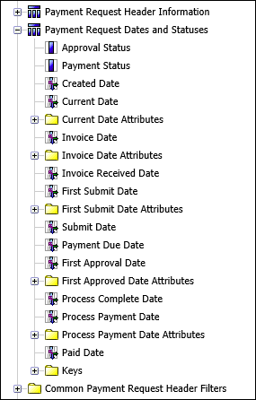

Field | Description
Approval Status |  | Name of the payment request approval status
Payment Status |  | Name of the payment request payment status
Created Date |  | Date the payment request was created
Current Date

Payment Request Dates and Statuses > Current Date Attributes
Current Date Month Number
Current Date Quarter Number
Current Date Year
Current Date Fiscal Month Number
Current Date Fiscal Quarter Number
Current Date Fiscal Year
Current Date Fiscal Year Name
Current Fiscal Year Sequence
Invoice Date |  | Date the supplier was assigned

Payment Request Dates and Statuses > Invoice Date Attributes
Day of Week
Day of Month Number
Week of Year Number
Month Number
Month
Quarter Number
Quarter
Year
Fiscal Day of Month Number
Fiscal Week of Year Number
Fiscal Month Number
Fiscal Month
Fiscal Quarter Number
Fiscal Quarter
Fiscal Year
Fiscal Year Name
Fiscal Year Sequence
Invoice Received Date
First Submit Date |  | Date the payment request was first submitted  NOTE: This may differ from the Submit Date if the request was returned to the employee and had to be resubmitted.

Payment Request Dates and Statuses > First Submit Date Attributes
First Submitted Day of Week
First Submitted Day of Month Number
First Submitted Week of Year Number
First Submitted Month Number
First Submitted Month
First Submitted Quarter Number
First Submitted Quarter
First Submitted Year
First Submitted Fiscal Day of Month Number
First Submitted Fiscal Week of Year Number
First Submitted Fiscal Month Number
First Submitted Fiscal Month
First Submitted Fiscal Quarter Number
First Submitted Fiscal Quarter
First Submitted Fiscal Year
First Submitted Fiscal Year Name
First Submitted Fiscal Year Sequence
Submit Date |  | Date the payment request was last submitted
Payment Due Date |  | Date the payment to the vendor is due
First Approval Date |  | Date the payment request received its first approval in its approval workflow

Payment Request Dates and Statuses > First Approved Date Attributes
First Approved Quarter Number
First Approved Quarter
First Approved Year
First Approved Fiscal Quarter Number
First Approved Fiscal Quarter
First Approved Fiscal Year
First Approved Fiscal Year Name
Process Complete Date |  | Date the last step in the workflow process completed
Process Payment Date |  | Date the payment request was extracted, in order to import it into an accounts payable system and generate a payment
Paid Date |  | Date payment was made to the vendor

Payment Request Dates and Statuses > Process Payment Date Attributes
Process Payment Day of Week
Process Payment Day of Month Number
Process Payment Week of Year Number
Process Payment Month Number
Process Payment Month
Process Payment Quarter Number
Process Payment Quarter
Process Payment Year
Process Payment Fiscal Day of Month Number
Process Payment Fiscal Week of Year Number
Process Payment Fiscal Month Number
Process Payment Fiscal Month
Process Payment Fiscal Quarter Number
Process Payment Fiscal Quarter
Process Payment Fiscal Year
Processing Payment Fiscal Year Name
Processing Payment Fiscal Year Sequence
Paid Date

Payment Request Dates and Statuses > Keys
Request Key
Approval Status Key
Approval Status Legacy Key
Payment Status Key
Payment Status Legacy Key

Payment Request Dates and Statuses > Keys > Prompt Keys
Approval Status Prompt Key
Payment Status Prompt Key

Folder – Common Payment Request Header Filters
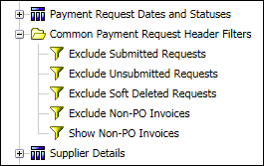

Field | Description
Exclude Submitted Requests
Exclude Unsubmitted Requests
Exclude Soft Deleted Requests
Exclude Non-PO Invoices
Show Non-PO Invoices

Folder – Supplier Details
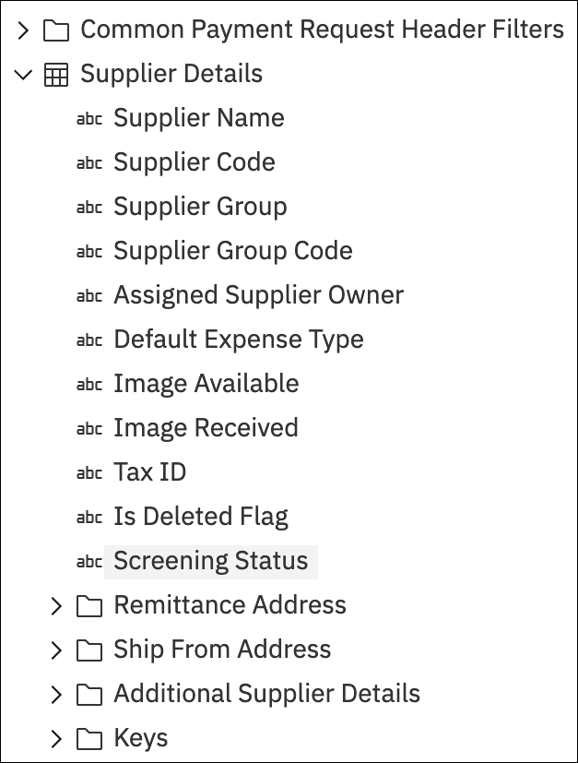

Field | Description
Supplier Name
Supplier Code
Supplier Group
Supplier Group Code
Assigned Supplier Owner
Default Expense Type
Image Available
Image Received
Tax ID
Is Deleted Flag
Screening Status

Supplier Details > Remittance Address
Supplier Remittance Address Name
Supplier Remit Address Code
Supplier Remit Created Date | This date field helps report users identify the most recent supplier addresses. For example, if there are several supplier addresses, the date that appears in this field will clearly indicate which was most recently added to Concur.
Supplier Sync ID | This date field helps report users identify the supplier remittance address import sync ID so that users can reconcile their vendors and vendor addresses in Concur with the vendor addresses in the user's own database.
Supplier Remit Address 1
Supplier Remit Address 2
Supplier Remit Address 3
Supplier Remit City/Location
Supplier Remit State/Province/Region
Supplier Remit Country
Supplier Remit Postal Code
Supplier Remit Phone Number
Supplier Remit Contact Name
Supplier Currency
Is Deleted
Is Approved
Current Address Flag (Current=1) | A 1 in the Current Address Flag field indicates the address is the supplier's current remittance address.

Supplier Details > Ship From Address
Supplier Ship From Address Name
Supplier Ship From Address Code
Supplier Ship From Created Date | This date field helps report users identify the most recent supplier addresses. For example, if there are several supplier addresses, the date that appears in this field will clearly indicate which was most recently added to Concur.
Supplier Ship From Address 1
Supplier Ship From Address 2
Supplier Ship From Address 3
Supplier Ship From City/Location
Supplier Ship From State/Province/Region
Supplier Ship From Country
Supplier Ship From Postal Code
Supplier Ship From Phone Number
Supplier Ship From Contact Name

Supplier Details > Additional Supplier Details
Custom 1 - Name through
Custom 20 - Name
Custom 1 - Code through
Custom 20 - Code

Supplier Details > Keys
Supplier Key

Supplier Details > Keys > Prompt Keys
Supplier Prompt Key

Folder – Payment Request Line Items
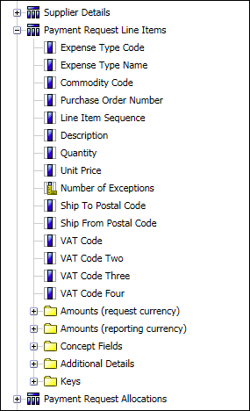

Field | Description
Expense Type Code | Code that identifies the expense type assigned to this line item
Expense Type Name | Name of the expense type assigned to this line item
Commodity Code | Commodity code associated with the expense type
Purchase Order Number | Some clients generate one monthly payment request, which contains all invoices for the month. The payment request line items on the monthly payment request may contain one or more POs. In order for the PO number(s) to display for each line item (instead of only one PO number at the header), the admin can add the Purchase Order Number field to the line item on their custom reports.
Line Item Sequence | Order or sequence of this line item on the payment request
Description | Description of the line item
Quantity | Quantity or units purchased on this line item
Unit Price | Price per unit purchased on this line item
Number of Exceptions | Number of exceptions generated by this line item
Ship To Postal Code
Ship From Postal Code
VAT Code
VAT Code Two
VAT Code Three
VAT Code Four

Payment Request Line Items > Amounts (request currency)
Total Requested
Total Approved
Total Tax
Calculated Tax Amount
Calculated Tax Rate
VAT Amount
VAT Rate
Amount without VAT
Request Currency
VAT Amount Two
VAT Rate Two
VAT Amount Three
VAT Rate Three
VAT Amount Four
VAT Rate Four

Payment Request Line Items > Amounts (reporting currency)
Total Requested (rpt)
Total Approved (rpt)
Total Tax (rpt)
Calculated Tax Amount (rpt)
VAT Amount (rpt)
Amount without VAT (rpt)
VAT Amount Two (rpt)
VAT Amount Three (rpt)
VAT Amount Four (rpt)
Reporting Currency

Payment Request Line Items > Concept Fields
Division
Division - Code
Department
Department - Code
Business Unit
Business Unit - Code
Cost Center
Cost Center - Code
Project
Project - Code

Payment Request Line Items > Additional Details
Custom 1 - Name through
Custom 20 - Name
Custom 1 - Code through
Custom 20 - Code

Payment Request Line Items > Keys
Line Item Key
Associated Request Key
Expense Type Key
Expense Type Prompt Key

Folder – Payment Request Allocations
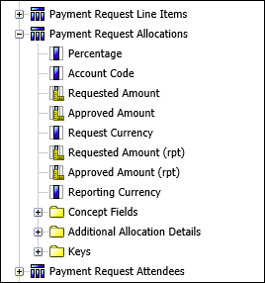

Field | Description
Percentage | Percentage of the line item amount allocated to this account code
Account Code | Account code to which this allocated portion of the line item total is charged
Requested Amount
Approved Amount
Request Currency
Requested Amount (rpt)
Approved Amount (rpt)
Reporting Currency

Payment Request Allocations > Concept Fields
Division
Division - Code
Department
Department - Code
Business Unit
Business Unit - Code
Cost Center
Cost Center - Code
Project
Project - Code

Payment Request Allocations > Additional Allocation Details
Custom 1 - Name through
Custom 20 - Name
Custom 1 - Code through
Custom 20 - Code

Payment Request Allocations > Keys
Associated Request Line Item Key
Allocation Key

Folder – Payment Request Attendees
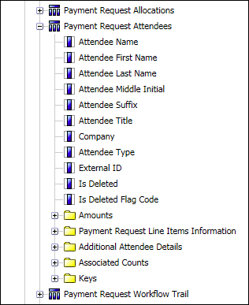

Field | Description
Attendee Name
Attendee First Name
Attendee Last Name
Attendee Middle Initial
Attendee Suffix
Attendee Title
Company
Attendee Type
External ID
Is Deleted
Is Deleted Flag Code

Payment Request Attendees > Amounts
Attendee Currency
Approved Amount (Attendee Currency)
Reimbursement Currency
Approved Amount (Reimbursement Currency)
Reporting Currency
Approved Amount (Reporting Currency)
Transaction Currency
Approved Amount (Transaction Currency)

Payment Request Attendees > Payment Request Line Items Information
Is Amount Edited
Invoice Attendee Custom 1 – Name through
Invoice Attendee Custom 5 - Name
Invoice Attendee Custom 1 – Code through
Invoice Attendee Custom 5 - Code

Payment Request Attendees > Additional Attendee Details
Custom 1 – Name through
Custom 25 - Name
Custom 1 – Code through
Custom 25 - Code

Payment Request Attendees > Associated Counts
Attendee Instance Count

Payment Request Attendees > Keys
Attendee Key
Attendee Legacy Key
Associated Request Key
Associated Request Line Item Key
Attendee Currency Key
Reporting Currency Key
Reimbursement Currency Key
Transaction Currency Key

Payment Request Attendees > Keys > Prompt Keys
Attendee Currency Prompt Key

Folder – Payment Request Workflow Trail
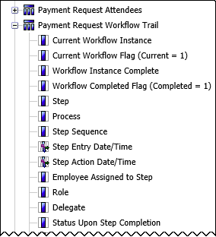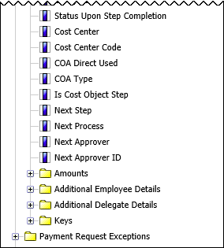

Field | Description
Current Workflow Instance | Indicates whether this is the workflow instance through which the transaction is currently progressing  NOTE: A single transaction may have more than one associated workflow instance, but only one will be active or current. For example, if a payment request is sent back to the employee, that terminates one workflow instance. When the employee resubmits the request, that action initiates a new workflow instance.
Current Workflow Flag (Current = 1)
Workflow Instance Complete | Indicates whether the workflow instance has been completed
Workflow Completed Flag (Completed = 1)
Step | Name of a particular step in the workflow
Process
Step Sequence | Number that indicates the order or sequence of this particular step within the workflow
Step Entry Date/Time | Date and time at which the transaction moved into this step in the workflow
Step Action Date/Time | Date and time at which action was taken to complete this workflow step
Employee Assigned to Step | Last name, first name, and middle initial of the employee designated to take action in this step of the workflow
Role | Role of the employee designated to take action in this step of the workflow
Delegate | Last name, first name, and middle initial of an employee acting as a delegate on behalf of the person designated to take action in this workflow step
Status Upon Step Completion | Status of the transaction when this workflow step completes
Cost Center | Name of the cost center. For cost object approvals.
Cost Center Code | Code for the cost center. For cost object approvals.
COA Direct Used | For cost object approvals
COA Type | For cost object approvals
Is Cost Object Step | For cost object approvals
Next Step | For cost object approvals
Next Process | For cost object approvals
Next Approver | For cost object approvals
Next Approver ID | For cost object approvals

Payment Request Workflow Trail > Amounts
Approved Amount
Claimed Amount
Request Currency |  | For cost object approvals
Approved Amount (rpt) |  | For cost object approvals
Claimed Amount (rpt) |  | For cost object approvals
Reporting Currency |  | For cost object approvals

Payment Request Workflow Trail > Additional Employee Details
Employee First Name
Employee Last Name
Employee Nickname
Employee ID
Employee Email Address
Employee Active Flag
Employee BI Manager
Employee BI Manager ID
Employee BI Manager E-mail Address
Employee Org Unit 1 - Name through
Employee Org Unit 6 - Name
Employee Org Unit 1 - Code through
Employee Org Unit 6 - Code
Employee Custom 1 - Name through
Employee Custom 22 - Name
Employee Custom 1 - Code through
Employee Custom 22 - Code

Payment Request Workflow Trail > Additional Employee Details > Traveler User Fields
Purpose Of Trip
Cost Center (User)
Department (User)
Project (User)
Client Name (User)
Client Number (User)
Approval Code (User)
Is Billable (User)
Job Number (User)
Division (User)
Business Unit (User)
Approver (User)
Account Code (User)
Profile Custom 1 (User) through 20 (User)

Payment Request Workflow Trail > Additional Delegate Details
Delegate ID
Delegate Email Address
Delegate Active Flag

Payment Request Workflow Trail > Keys
Workflow Instance Key
Request Key
Employee Key
Delegate Employee Key
Process Step Key
Role Key
Status Upon Step Completion Key
Status Upon Step Completion Legacy Key
Role Legacy Key
Next Step Instance Key
Next Approver Key
Is Cost Object Step Key
COA Type Key | Unique system-assigned key that identifies the cost object approver type
Cost Center Legacy Key | Legacy key for the cost center

Payment Request Workflow Trail > Keys > Prompt Keys
Employee Prompt Key
Status Prompt Key

Folder – Payment Request Exceptions
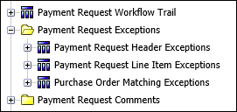

Field | Description

Payment Request Exceptions > Payment Request Header Exceptions
Exception Code | Code that identifies the exception associated to the audit rule that was triggered
Exception Level | Severity level of this exception
Exception Text | Text description of the exception
Cleared | Indicates whether a Payment Processor has cleared this exception
Exception Event | Code that indicates the point in the workflow process at which the report was checked for this exception:  - ENTRY_SAVE = Entry Save  - ENTRY_SUBMIT = Entry Submit  - PMT_HDR_POSTSUBMIT = Payment Post Request Submit  - PMT_HEADER_SAVE = Payment Request Save  - PMT_HEADER_SUBMIT = Payment Request Submit  - PMT_LINEITEM_SAVE = Payment Request Details Save  - PMT_LINEITEM_SUBMIT = Payment Request Details Submit  - REPORT_POSTSUBMIT = Post Report Submit  - REPORT_SAVE = Report Save  - REPORT_SUBMIT = Report Submit  - RL_ENTRY_SAVE = Entry Save - Receipt Limit  - TR_ENTRY_SAVE = Travel Request Category Save  - TR_ENTRY_SUBMIT = Travel Request Category Submit  - TR_POSTSUBMIT = Post Travel Request Submit  - TR_SAVE = Travel Request Save  - TR_SUBMIT = Travel Request Submit
Exception Visible By | Code that identifies the users that see this exception:  - 1 = Payment User, Payment Approver, Payment Processor  - 2 = Payment Approver, and Payment Processor  - 3 = Payment Processor

Payment Request Exceptions > Payment Request Header Exceptions > Keys
Associated Request Key
Exception Key
Exception Prompt Key

Payment Request Exceptions > Payment Request Line Item Exceptions
Exception Code | Code that identifies the exception associated to the audit rule that was triggered
Exception Level | Severity level of this exception
Exception Text | Text description of the exception
Cleared | Indicates whether a Payment Processor has cleared this exception
Exception Event | Code that indicates the point in the workflow process at which the report was checked for this exception:  - ENTRY_SAVE = Entry Save  - ENTRY_SUBMIT = Entry Submit  - PMT_HDR_POSTSUBMIT = Payment Post Request Submit  - PMT_HEADER_SAVE = Payment Request Save  - PMT_HEADER_SUBMIT = Payment Request Submit  - PMT_LINEITEM_SAVE = Payment Request Details Save  - PMT_LINEITEM_SUBMIT = Payment Request Details Submit  - REPORT_POSTSUBMIT = Post Report Submit  - REPORT_SAVE = Report Save  - REPORT_SUBMIT = Report Submit  - RL_ENTRY_SAVE = Entry Save - Receipt Limit  - TR_ENTRY_SAVE = Travel Request Category Save  - TR_ENTRY_SUBMIT = Travel Request Category Submit  - TR_POSTSUBMIT = Post Travel Request Submit  - TR_SAVE = Travel Request Save  - TR_SUBMIT = Travel Request Submit
Exception Visible By | Code that identifies the users that see this exception:  - 1 = Payment User, Payment Approver, Payment Processor  - 2 = Payment Approver, and Payment Processor  - 3 = Payment Processor

Payment Request Exceptions > Payment Request Line Item Exceptions > Keys
Associated Request Line Item Key
Associated Request Key
Exception Key
Exception Prompt Key

Payment Request Exceptions > Purchase Order Matching Exceptions
Exception Code
Exception Text
Allow Advance Workflow

Payment Request Exceptions > Purchase Order Matching Exceptions > Keys
Associated Request Key
Purchase Order Key
Purchase Order Rule Key
Purchase Order Rule Message Key
Purchase Order Ruleset Key

Folder – Payment Request Comments
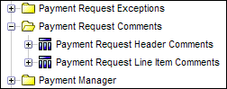

Field | Description

Payment Request Comments > Payment Request Header Comments
Commenter's Name | Last and first names of the employee entering the comment
Comment | Text of the comment
Comment Date/Time | Date and time at which the comment was entered

Payment Request Comments > Payment Request Header Comments > Keys
Associated Request Key

Payment Request Comments > Payment Request Line Item Comments
Commenter's Name | Last and first names of the employee entering the comment
Comment | Text of the comment
Comment Date/Time | Date and time at which the comment was entered

Payment Request Comments > Payment Request Line Item Comments > Keys
Associated Request Key
Associated Request Line Item Key

Folder – Payment Manager
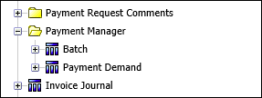

Field | Description

Payment Manager > Batch
Batch ID
Closed Date
Send Date
Sent Date
Amount
Amount (rpt)
Reporting Currency

Payment Manager > Batch > Funding Account
Funding Account Name
Funding Account Type
Funding Reference ID
Bank Country
Bank Currency
Time Zone ID
Time Zone Name
Close Time
Funding Account Active
Liability Account Code
Cash Account Code

Payment Manager > Batch > Keys
Batch Key
Funding Account Key

Payment Manager > Batch > Keys > Prompt Keys
Funding Account Prompt Key

Payment Manager > Payment Demand
Creation Date
Payment Method
Status
Failure Code
Funding Initiation Date
Funding Settlement Date
Payment Initiation Date
Payment Settlement Date
Return Initiation Date
Return Settlement Date
Reference ID
Amount
Amount (rpt)
Reporting Currency

Payment Manager > Payment Demand > Vendor Bank Account
Vendor Name
Vendor Tax ID
Transaction Type
Account Currency
Account Country
Active
Is Current Version

Payment Manager > Payment Demand > Associated Payment Request Information
Request ID
Total Request Amount
Total Request Amount (rpt)
Total Invoice Amount
Total Invoice Amount (rpt)
Request Currency
Request Reporting Currency

Payment Manager > Payment Demand > Keys
Payment Demand Key
Status Key
Vendor Key
Bank Account Key

Payment Manager > Payment Demand > Keys > Prompt Keys
Status Prompt Key
Vendor Prompt Key
Bank Account Prompt Key

Folder – Invoice Journal
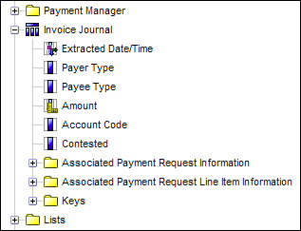

Field | Description
Extracted Date/Time
Payer Type | Code that identifies the entity responsible for paying the amount
Payee Type | Code that identifies the entity receiving the amount
Amount
Account Code | Account code to be charged with the amount
Contested | Indicates whether the transaction is currently being contested or disputed

Invoice Journal > Associated Payment Request Information
Request Name | Name or title used to identify the payment request from which this journal transaction originated
Request ID | Unique code identifying the payment request that originated this journal transaction
Requesting Employee | Last name, first name, and middle initial of the employee making the payment request that originated this journal transaction
Employee ID | Unique code or number identifying the employee

Invoice Journal > Associated Payment Request Line Item Information
Expense Type | Expense type on the request line item that originated this journal transaction

Invoice Journal > Keys
Journal Key
Request Key
Request Line Item Key
Allocation Key
Payer Key
Payee Key
Batch ID

Folder – Lists
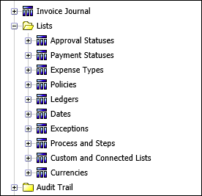

Field | Description

Lists > Approval Statuses
Status Key
Status Name
Deleted Flag

Lists > Payment Statuses
Status Key
Status Name
Deleted Flag

Lists > Expense Types
Expense Type Key
Expense Type Name
Deleted Flag

Lists > Policies
Policy Key
Policy Name
Deleted Flag

Lists > Ledgers
Ledger Key
Ledger Name

Lists > Dates
Date
Day of Week
Day of Month Number
Week of Year Number
Month Number
Month
Quarter Number
Quarter
Year
Fiscal Day of Month Number
Fiscal Week of Year Number
Fiscal Month Number
Fiscal Month
Fiscal Quarter Number
Fiscal Quarter
Fiscal Year
Fiscal Year Name
Fiscal Year Sequence

Lists > Exceptions
Exception Key
Exception Code
Exception Level
Exception Text
Deleted Flag

Lists > Process and Steps
Process Step Key
Process
Step

Lists > Custom and Connected Lists
List Key
List Category Name
List
List Item Key
List Item Short Code
List Item
List Item Deleted Flag

Lists > Currencies
Currency Key
Currency Alpha Code
Currency Name
Deleted Flag

Folder – Audit Trail
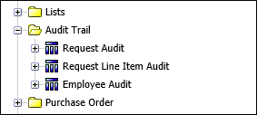
Invoice Audit Trail information is an “opt in” feature, which is not turned on by default. If you are interested in seeing this data, please contact Concur Client Support.

Field | Description

Audit Trail > Request Audit
Change Date/Time
Employee Making Change - Name
Employee Making Change - ID
Field Changed (Database Column)
Old Value
New Message
Message

Audit Trail > Request Audit > Additional Details
Audit Type
Employee Making Change - Legacy Key
Request Legacy Key

Audit Trail > Request Line Item Audit
Change Date/Time
Employee Making Change - Name
Employee Making Change - ID
Field Changed (Database Column)
New Message
Old Value
Message

Audit Trail > Request Line Item Audit > Additional Details
Audit Type
Employee Making Change - Legacy Key
Request Line Item Legacy Key

Audit Trail > Employee Audit
Change Date/Time
Employee Name
Employee ID
Employee Making Change - Name
Employee Making Change - ID
Field Changed (Database Column)
New Message
Old Value
Message

Audit Trail > Employee Audit > Additional Details
Audit Type
Employee Making Change - Legacy Key
Employee Legacy Key

Folder – Purchase Order
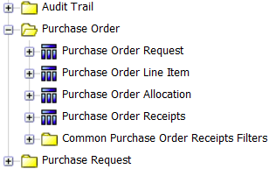

Field |  | Description

Purchase Order > Purchase Order Request
Purchase Order Number
Purchase Order Name
Purchase Order Description
Policy
Requested By |  | Full employee name associated with requested invoice, including the full first, middle, and last names of the employee
Payment Terms
Discount Terms
Discount Percentage
Order Type
Is Line Item Tax
Status

Purchase Order > Purchase Order Request > Dates
Order Date
Creation Date

Purchase Order > Purchase Order Request > Amounts
Total Amount
Shipping Amount
Tax Amount
Purchase Order Request Currency – Name
Purchase Order Request Currency – Code
Total Amount (rpt)
Shipping Amount (rpt)
Tax Amount (rpt)
Reporting Currency – Name
Reporting Currency – Code

Purchase Order > Purchase Order Request > Supplier Details
Supplier Name
Address1
Address2
Address3
City
State
Postal Code
Country

Purchase Order > Purchase Order Request > Supplier Details > Additional Supplier Details
Supplier Custom 1 - Name through
Supplier Custom 15 - Name
Supplier Custom 1 - Code through
Supplier Custom 15 - Code

Purchase Order > Purchase Order Request > Additional Details
Custom 1 - Name through
Custom 24 - Name
Custom 1 - Code through
Custom 24 - Code

Purchase Order > Purchase Order Request > Keys
Purchase Order Request Key
Purchase Order Request Legacy Key
Policy Key
Purchase Order Request Currency Key
Reporting Currency Key
Associated Payment Request Key
Purchase Order Request Employee Key

Purchase Order > Purchase Order Request > Keys > Prompt Keys
Policy Prompt Key
Reporting Currency Prompt Key
Purchase Order Request Currency Prompt Key

Purchase Order > Purchase Order Line Item
Requested By
External ID
Supplier Part ID
Line Number
Description
Account Code
Expense Type
Is Received
Receipt Required

Purchase Order > Purchase Order Line Item > Dates
Requested Delivery Date
Order Date
Received Date

Purchase Order > Purchase Order Line Item > Amounts
Unit Price
Total Price
Tax
Request Total
Purchase Order Request Currency – Name
Purchase Order Request Currency – Code
Unit Price (rpt)
Total Price (rpt)
Tax (rpt)
Request Total (rpt)
Reporting Currency – Name
Reporting Currency – Code
Quantity
Received Quantity

Purchase Order > Purchase Order Line Item > Additional Details
Custom 1 - Name through
Custom 20 - Name
Custom 1 - Code through
Custom 20 - Code

Purchase Order > Purchase Order Line Item > Keys
Purchase Order Line Item Key
Purchase Order Line Item Legacy Key
Associated Purchase Order Request Key
Purchase Order Request Currency Key
Reporting Currency Key
Expense Type Key
Expense Type Legacy Key

Purchase Order > Purchase Order Line Item > Keys > Prompt Keys
Purchase Order Request Currency Prompt Key
Reporting Currency Prompt Key
Expense Type Prompt Key

Purchase Order > Purchase Order Allocation
Allocation Percentage
Purchase Order Request Total
Purchase Order Request Currency – Name
Purchase Order Request Currency - Code
Purchase Order Request Total (rpt)
Reporting Currency – Name
Reporting Currency- Code
Order Date

Purchase Order > Purchase Order Allocation > Additional Details
Custom 1 - Name through
Custom 20 - Name
Custom 1 - Code through
Custom 20 - Code

Purchase Order > Purchase Order Allocation > Keys
Purchase Order Allocation Key
Purchase Order Allocation Legacy Key
Associated Purchase Order Entry Key
Purchase Order Request Currency Key
Reporting Currency Key

Purchase Order > Purchase Order Allocation > Keys > Prompt Keys
Purchase Order Request Currency Prompt Key
Reporting Currency Prompt Key

Purchase Order > Purchase Order Receipts
Goods Receipt Number
Delivery Slip Number
Data Source
Create Date
Received Date
Is Deleted
UOM Code
Received Quantity

Purchase Order > Purchase Order Receipts > Additional Details
Custom 1 - Name through
Custom 10 - Name
Custom 1 - Code through
Custom 10 - Code

Purchase Order > Purchase Order Receipts > Keys
Data Source Key
Associated Purchase Order Line Item Key
UOM Key
Purchase Order Receipt Key

Folder – Purchase Request
Reporting Hierarchy
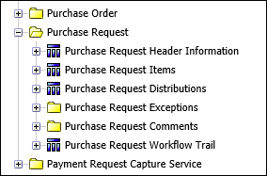

Field | Description

Purchase Request > Purchase Request Header Information
Requesting Employee
Employee ID
Policy
Description
Notes to Supplier
Approval Status
First Submit Date
Submit Date
First Approval Date

Purchase Request > Purchase Request Header Information > Flags
Is Exception Approved
Is Image Available
Is Limit Approved

Purchase Request > Purchase Request Header Information > Amounts
Request Currency
Tax Amount
Shipping Amount
Total Amount
Reporting Currency
Tax Amount (rpt)
Shipping Amount (rpt)
Total Amount (rpt)

Purchase Request > Purchase Request Header Information > Ship To Address
Address Name
Address 1
Address 2
Address 3
City
State
Postal Code
Country

Purchase Request > Purchase Request Header Information > Bill To Address - Policy
Bill To Address Name | The defaulted Bill To Address associated with the policy. This may be different than the Bill To Address on the actual Purchase Request.
Bill To Address 1
Bill To Address 2
Bill To Address 3
Bill To City
Bill To State
Bill To Postal Code
Bill To Country

Purchase Request > Purchase Request Header Information > Bill To Address – Purchase Request
Purchase Request Bill To Address Name | The Bill To Address on the actual Purchase Request.
Purchase Request Bill To Address 1 | The Bill To Address on the actual Purchase Request.
Purchase Request Bill To Address 2 | The Bill To Address on the actual Purchase Request.
Purchase Request Bill To Address 3 | The Bill To Address on the actual Purchase Request.
Purchase Request Bill To City | The Bill To Address on the actual Purchase Request.
Purchase Request Bill To State | The Bill To Address on the actual Purchase Request.
Purchase Request Bill To Postal Code | The Bill To Address on the actual Purchase Request.
Purchase Request Bill To Country | The Bill To Address on the actual Purchase Request.

Purchase Request > Purchase Request Header Information > Additional Details
Org Unit 1 - Name through
Org Unit 6 - Name
Org Unit 1 - Code through
Org Unit 6 - Code
Custom 1 - Name through
Custom 24 - Name
Custom 1 - Code through
Custom 24 - Code

Purchase Request > Purchase Request Header Information > Reporting Segments
Reporting Group
Segment 1 - Code through
Segment 10 - Code
Segment 1 - Value through
Segment 10 - Value

Purchase Request > Purchase Request Header Information > Additional Employee Details
Employee First Name
Employee Last Name
Employee Nickname
BI Manager
BI Manager ID
BI Manager Email Address
Employee Email Address
Employee Login ID
Employee Active Flag
Employee Country Code
Employee Country
Employee Ledger Code
Employee Ledger Name
Employee Org Unit 1 - Name through
Employee Org Unit 6 - Name
Employee Org Unit 1 - Code through
Employee Org Unit 6 - Code
Employee Custom 1 - Name through
Employee Custom 22 - Name
Employee Custom 1 - Code through
Employee Custom 22 - Code
Employee Division
Employee Division Code
Employee Department
Employee Department Code
Employee Business Unit
Employee Business Unit Code
Employee Cost Center
Employee Cost Center Code
Employee Project
Employee Project Code
Employee Company
Employee Company Code
Employee CRM Account
Employee CRM Account Code
Employee CRM Event
Employee CRM Event Code
Employee CRM Opportunity
Employee CRM Opportunity Code

Purchase Request > Purchase Request Header Information > Additional Employee Details > Traveler User Fields
Purpose Of Trip
Cost Center (User)
Department (User)
Project (User)
Client Name (User)
Client Number (User)
Approval Code (User)
Is Billable (User)
Job Number (User)
Division (User)
Business Unit (User)
Approver (User)
Account Code (User)
Profile Custom 1 – (User) through
Profile Custom 20 – (User)

Purchase Request > Purchase Request Header Information > Keys
Purchase Request Key
Purchase Request Legacy Key
Employee Key
Approval Status Key
Policy Key
Request Currency Key
Bill To Address Key

Purchase Request > Purchase Request Header Information > Keys > Prompt Keys
Employee Prompt Key
Approval Status Prompt Key
Policy Prompt Key
Request Currency Prompt Key

Purchase Request > Purchase Request Items
Policy
Item Type
Expense Type
Description
Shipping Method
Shipping Terms
Supplier Part ID
Needed By Date
Unit Of Measure
Quantity
Payment Term Days
Discount Term Days
Discount Percentage

Purchase Request > Purchase Request Items > Amounts
Request Item Currency
Unit Price
Tax Amount
Shipping Amount
Total Amount
Reporting Currency
Unit Price (rpt)
Tax Amount (rpt)
Shipping Amount (rpt)
Total Amount (rpt)

Purchase Request > Purchase Request Items > Vendor Details
Vendor Name
Address 1
Address 2
Address 3
City
State
Postal Code
Country

Purchase Request > Purchase Request Items > Additional Details
Employee Custom 1 - Name through
Employee Custom 20 - Name
Employee Custom 1 - Code through
Employee Custom 20 - Code

Purchase Request > Purchase Request Items > Keys
Purchase Request Item Key
Purchase Request Item Legacy Key
Associated Purchase Request Key
Associated Purchase Order Entry Key
Policy Key
Expense Type Key
Request Item Currency Key

Purchase Request > Purchase Request Items > Keys > Prompt Keys
Policy Prompt Key
Expense Type Prompt Key
Request Item Currency Prompt Key

Purchase Request > Purchase Request Distributions
Percentage
Request Item Currency
Total Amount
Reporting Currency
Total Amount (rpt)

Purchase Request > Purchase Request Distributions > Additional Details
Is Hidden Flag
Custom 1 - Name through
Custom 20 - Name
Custom 1 - Code through
Custom 20 - Code

Purchase Request > Purchase Request Distributions > Keys
Purchase Request Allocation Key
Purchase Request Allocation Legacy Key
Associated Purchase Request Item Key
Purchase Item Currency Key

Purchase Request > Purchase Request Distributions > Keys > Prompt Keys
Purchase Item Currency Prompt Key

Purchase Request > Purchase Request Exceptions

Purchase Request > Purchase Request Exceptions > Purchase Request Header Exceptions
Exception Code
Exception Level
Exception Text
Cleared
Exception Event
Exception Visible By

Purchase Request > Purchase Request Exceptions > Purchase Request Header Exceptions > Keys
Associated Purchase Request Key
Exception Key

Purchase Request > Purchase Request Exceptions > Purchase Request Header Exceptions > Keys > Prompt Keys
Exception Prompt Key

Purchase Request > Purchase Request Exceptions > Purchase Request Item Exceptions
Exception Code
Exception Level
Exception Text
Exception Event
Cleared
Users that can see this exception

Purchase Request > Purchase Request Exceptions > Purchase Request Item Exceptions > Keys
Associated Purchase Request Item Key
Exception Key

Purchase Request > Purchase Request Exceptions > Purchase Request Item Exceptions > Keys > Prompt Keys
Exception Prompt Key

Purchase Request > Purchase Request Comments

Purchase Request > Purchase Request Comments > Purchase Request Header Comments
Commenter's Name
Comment
Comment Date/Time

Purchase Request > Purchase Request Comments > Purchase Request Header Comments > Keys
Associated Purchase Request Key
Commenter's Employee Key

Purchase Request > Purchase Request Comments > Purchase Request Item Comments
Commenter's Name
Comment
Comment Date/Time

Purchase Request > Purchase Request Comments > Purchase Request Header Comments > Keys
Associated Purchase Request Item Key
Associated Purchase Request Key
Commenter's Employee Key

Purchase Request > Purchase Request Workflow Trail
Current Workflow Instance
Current Workflow Flag (Current = 1)
Workflow Instance Complete
Workflow Completed Flag (Completed = 1)
Step
Process
Step Sequence
Step Entry Date/Time
Step Action Date/Time
Employee Assigned to Step
Role
Delegate
Status Upon Step Completion
Cost Center | Name of the cost center. For cost object approvals.
Cost Center Code | Code for the cost center. For cost object approvals.
COA Direct Used | For cost object approvals
COA Type | For cost object approvals
Is Cost Object Step | For cost object approvals
Next Step | For cost object approvals
Next Process | For cost object approvals
Next Approver | For cost object approvals
Next Approver ID | For cost object approvals

Purchase Request > Purchase Request Workflow Trail > Amounts
Approved Amount
Claimed Amount
Request Currency
Approved Amount (rpt)
Claimed Amount (rpt)
Reporting Currency

Purchase Request > Purchase Request Workflow Trail > Additional Employee Details
Employee First Name
Employee Last Name
Employee Nickname
Employee ID
Employee Email Address
Employee Active Flag
Employee BI Manager
Employee BI Manager ID
Employee BI Manager Email ID

Purchase Request > Purchase Request Workflow Trail > Additional Delegate Details
Delegate ID
Delegate Email Address
Delegate Active Flag

Purchase Request > Purchase Request Workflow Trail > Keys
Workflow Instance Key
Request Key
Employee Key
Delegate Employee Key
Process Step Key
Role Key
Status Upon Step Completion Key
Status Upon Step Completion Legacy Key
Role Legacy Key
Next Approver Key
Next Step Instance Key
Is Cost Object Step Key
COA Type Key
Cost Center Legacy Key | Legacy key for the cost center

Purchase Request > Purchase Request Workflow Trail > Keys > Prompt Keys
Employee Prompt Key
Status Prompt Key

Folder – Payment Request Capture Service
Reporting Hierarchy
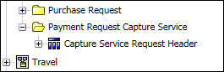

Field | Description

Payment Request Capture Service > Capture Service Request Header
Request ID
Request Name
Vendor Name
Data Source Key
Data Source
Supplier Invoice Number Flag
Invoice Date Flag
Payment Due Date Flag
Vendor Code Flag
PO Number Flag
Total Lines Flag
Currency Code Flag
Shipping Amount Flag
Invoice Amount Flag
Request Total Flag
Tax Amount Flag
Amount without VAT Flag
Invoice Timestamp | The timestamp associated with a valid invoice image for clients that use digital invoices in lieu of paper invoices. This field can help provide the timestamp information required by Japan's e-Bunsho regulations.

Payment Request Capture Service > Capture Service Request Header > Captured Values
Invoice Number Captured Value
Invoice Date Captured Value
Payment Due Date Captured Value
Vendor Code Captured Value
PO Number Captured Value
Total Lines Captured Value
Currency Code Captured Value
Shipping Amount Captured Value
Invoice Amount Captured Value
Request Total Captured Value
Tax Amount Captured Value
Amount without VAT Captured Value

Payment Request Capture Service > Capture Service Request Header > Processed Values
Invoice Number Processed Value
Invoice Date Processed Value
Payment Due Date Processed Value
Vendor Code Processed Value
PO Number Processed Value
Total Lines Processed Value
Currency Code Processed Value
Shipping Amount Processed Value
Invoice Amount Processed Value
Request Total Processed Value
Tax Amount Processed Value
Amount without VAT Processed Value

☼

