Table of Contents
Chapter 16: Folder – Persona Dashboards 16-1
Overview 16-1
Access the Dashboard 16-1
Required – BI Manager 16-1
Drill-Through and Related Reports 16-2
Budget Information 16-2
Dashboard: Combined Spend Overview 16-3
Available to:  Analysis  Intelligence 16-3
Overview 16-3
Dashboard 16-3
Section: Payment Type Filter 16-4
Section: Total Combined Spend 16-5
Section: Average Life Cycle 16-6
Section: Combined Spend Trend 16-19
Dashboard: Department Manager Spend Overview 16-21
Available to:  Analysis  Intelligence 16-21
Dashboard 16-21
Section: Spend – Current Quarter Spend 16-21
Section: Spend Overview 16-23
Section: Future Trips 16-25
Section: Top 10 Spending Employees 16-29
Dashboard: Department Manager Expense Report Overview 16-32
Available to:  Analysis  Intelligence 16-32
Dashboard 16-32
Section: Average Life Cycle 16-33
Section: Expense Reports – Unsubmitted Transactions 16-36
Section: Expense Reports – Reports Pending Approval 16-38
Section: Credit Card Adoption 16-40
Section: Average Spend 16-43
Section: Policy Exceptions by Employee 16-50
Dashboard: Expense Management Overview 16-52
Available to:  Analysis  Intelligence 16-52
Overview 16-52
Dashboard 16-53
Summary Bar 16-54
Section: Reports Pending Approval 16-55
Section: Unsubmitted Credit Card Transactions 16-56
Section: Cash Expense Transactions 16-57
Section: Personal Expense Transactions 16-59
Section: Average Life Cycle 16-60
Section: Aging of Transactions 16-61
Section: Payment Types 16-65
Section: Top 10 Spending Employee 16-68
Section: Policy Exceptions by Type 16-70
Dashboard: Invoice Management Overview 16-72
Available to:  Analysis  Intelligence 16-72
Overview 16-72
Dashboard 16-73
Section: Aging Payables 16-74
Section: Total Invoice Spend 16-77
Section: Payment Method 16-80
Section: Top 10 Vendors 16-86
Section: Top 5 Expense Types 16-89
Section: PO vs Non PO Spend 16-92
Section: PO Adoption 16-94
Appendix: Remove or Restore the Persona Dashboard Tab 16-97

Revision History
Date | Notes / Comments / Changes
January 21, 2023 | Added Dashboard: to the title of the following sections:  - Dashboard: Combined Spend Overview  - Dashboard: Invoice Management Overview
January 21, 2022 | Updated the copyright year; no other changes; cover date not updated
February 20, 2021 | Updated the copyright year; no other changes
January 8, 2020 | Changed copyright; no other content changes
August 17, 2019 | Added additional information about the reports in the Persona Dashboards folder
April 13, 2019 | Updated the overview of the Combined Spend Overview dashboard
February 9, 2019 | Added information about the new Payment Type Filter for the Combined Spend Overview dashboard, removed references to Insight Premium from the guide, and updated copyright
October 15, 2018 | The October release has moved to October 20, 2018
October 13, 2018 | Updated image of the Quick Access Menu to include the new Combined Spend Overview dashboard
September 17, 2018 | The September release has moved to September 22, 2018
September 15, 2018 | Added information about the Combined Spend Overview dashboard
January 13 2018 | Changed copyright; no other content changes
November 4 2017 | Updated the image of the Quick Access Menu to display the updated label for the Department Manager Expense Report Overview dashboard
October 17 2017 | Updated for Department Manager Dashboard changing two separate dashboards – Department Manager Spend Overview and Department Manager Expense Report Overview
June 5 2017 | Updated the tooltip information for the PO Adoption section under the Invoice Management Overview dashboard
June 3 2017 | Added additional information about the Invoice Management Overview dashboard
April 22 2017 | Added information about the Invoice Management Overview dashboard
March 18 2017 | Updated the first Questions Answered bullet for the Policy Exceptions by Employee section
February 17 2017 | Updated Average Life Cycle dashboard images to show new industry average of 12 days; no other content changes
February 8 2017 | Updated Aging of Transactions detail report image
January 25 2017 | Updated the Overview section and added additional information about the Expense Management Overview dashboard
December 15 2016 | Changed copyright and updated the Overview section; no other content changes
December 9 2016 | Added information about the Expense Spend Management Overview dashboard
December 7 2016 | Removed obsolete note
November 16 2016 | Updated report images to match the current application
October 25 2016 | Updated the guide content to new corporate style; no content changes
May 19 2016 | Added information about the Persona Dashboard tab
September 18 2015 | Added more drill-through reports to the Department Manager Dashboard  Changed the chapter number because Open Booking Changed to TripLink
September 4 2015 | Clarified the calculation information for the Policy Exceptions by Employee section
August 14 2015 | Initial publication

Folder – Persona Dashboards

Overview
The Persona Dashboard provides you all the relevant data you need to manage your business in one location. In addition, the dashboard provides visual indicators identifying the existence of potential problems.

Access the Dashboard
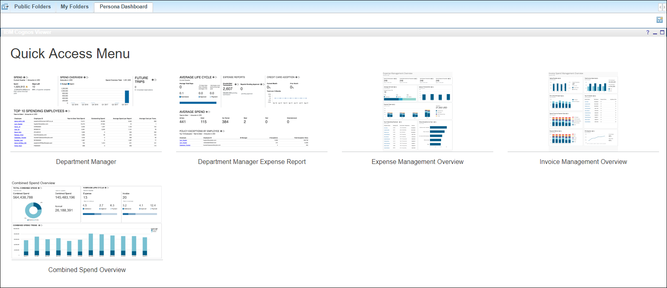
The Persona Dashboard tab appears by default for all BI Managers. To access the dashboard, click either the image of the dashboard or the dashboard label for the image.
- Refer to the appendix in this chapter for information about removing or restoring the Persona Dashboard tab.

Required – BI Manager
Any user who is also a BI Manager can access the Department Manager Overview dashboard. Users are not required to be a BI Manager to access the Expense Management Overview or Invoice Management Overview dashboards.
If a user is a BI Manager and a licensed user, when the user logs in via the Reporting menu there will be two options. Choosing the BI Manager option limits the information displayed in the reports to just the information of the BI Manager's direct and indirect reports (for all dashboards and reports). If the user logs in as the licensed user, then the user will see data based on their security access.
- For more information about BI Manager, refer to the Overview chapter in the Analysis/Intelligence documentation that is available in Cognos (Launch menu).

Drill-Through and Related Reports
Each section of the dashboards has three parts:
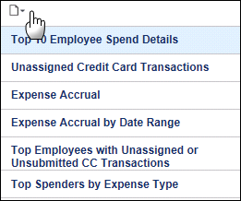
- The visual representation of the related data, like a chart, graph, or a table
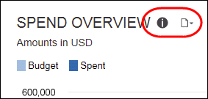
- The information icon - The user clicks this icon to access a tooltip and link to a PDF that contains helpful information like how the metric is calculated, why the metric is important, and how the insights derived from the data can help the user better manage they T&E spend.
- The reports icon – The user clicks this icon to access a drill-through report and other related reports.
The first report in the list (blue background) is the drill-through report. It has the same name as the dashboard section plus "Details." When the user clicks the "details" name, the drill-through report opens in a new window.
The other reports in the list are existing standard reports that contain data determined to be relevant to the associated metric.
When the user clicks a report name, the standard "prompt" window appears in a new window. The report user completes the prompt window as usual and runs the report.

Budget Information
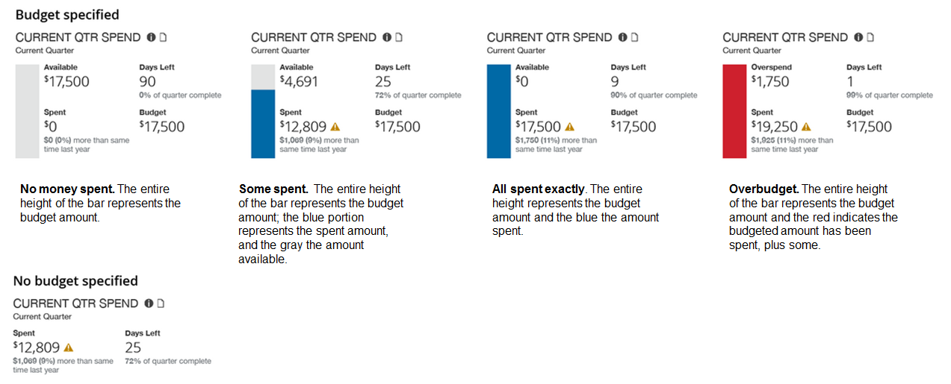
The sample above shows the various options involving the budget – between No money spent and Overbudget. The sample at the bottom – No budget specified – indicates that the user did not enter the budget information in Profile.

Dashboard: Combined Spend Overview
Available to:  Analysis  Intelligence

Overview
The Combined Spend Overview dashboard provides key metrics for your company's combined spend associated with your company's expense reports and invoices. The dashboard can help you track how the metrics are trending, the impact on cash flow and budgets, and help evaluate the need for changes in the expense report and procurement processes to optimize them.
If the fiscal calendar is enabled and set up for a company, the current quarter-to-date will be based on the fiscal calendar. If the company is not using a fiscal calendar, the current quarter-to-date will be based on the Gregorian calendar year.
While the Department Manager Overview, Expense Management Overview and Invoice Management Overview were designed for individuals with specific responsibilities within their department or the expense and invoice management teams, the Combined Spend Overview dashboard is designed for individuals who need to see spend data on a global level. However, regardless of who accesses each of these dashboards, the data viewed on the dashboards is still based on the access level assigned to the individual user viewing the dashboard.

Dashboard
Sample of the full dashboard:
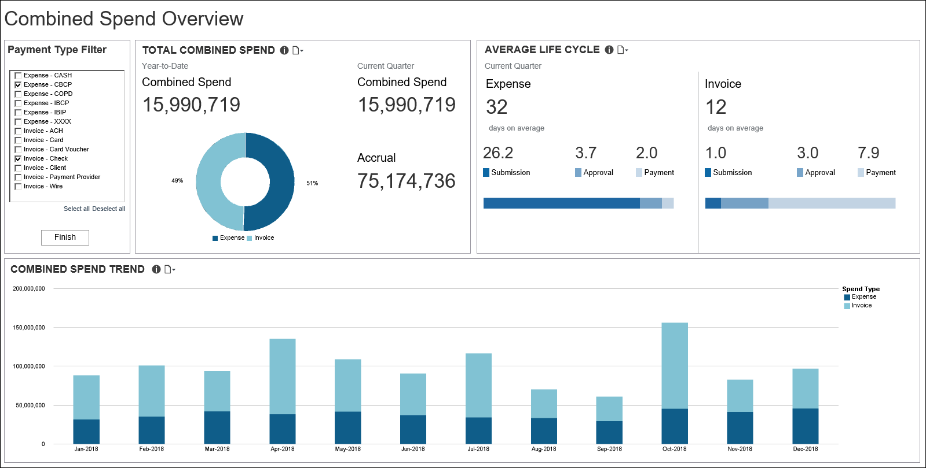

Section: Payment Type Filter
Sample of the filter:
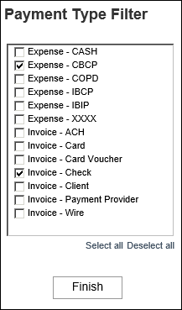
The Payment Type Filter provides a way to filter and view combined expense and invoice spend by payment type on the Combined Spend Overview dashboard. The available payment types are listed in alphabetical order with "Expense" or "Invoice" next to the payment type to indicate whether the payment type is associated with Expense spend or Invoice spend.
The first time the Combined Spend Overview dashboard runs, the dashboard displays the data for all payment types.
To filter the Combined Spend Overview dashboard by one or more payment types, select the check box next to the payment type(s) you want to view, and then click the Finish button. The dashboard can be filtered by multiple payment types at one time.

Section: Total Combined Spend
Sample of the dashboard:
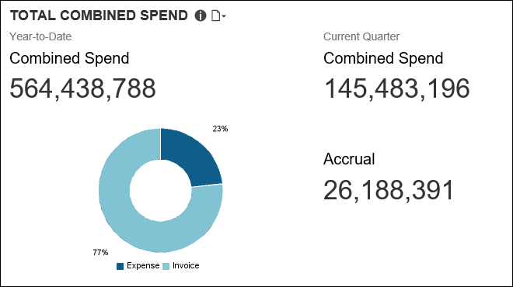
The Total Combined Spend section provides the combined spend for both Expense and Invoice for the year-to-date and current quarter-to-date, and the combined total accrual for the current quarter-to-date.
The combined spend includes all expense reports that have been sent for payment and all invoices that have been sent for payment processing. Combined spend does not include accruals. The Accrual number displayed in this section is the combined total of unpaid expense entries, unassigned credit card transactions, and unpaid invoices for the current quarter-to-date.
The graph in the Total Combined Spend section is a visualization of the percentages of the combined spend that are attributed to Expense and Invoice for the year-to-date.
Placing your pointer over a section of the graph displays the spend type (Expense or Invoice) associated with the section and the percentage of the total combined spend associated with that spend type for the year-to-date. In the example below, 23 percent of the total combined spend is from all the expense reports that have been sent for payment for the year-to-date.
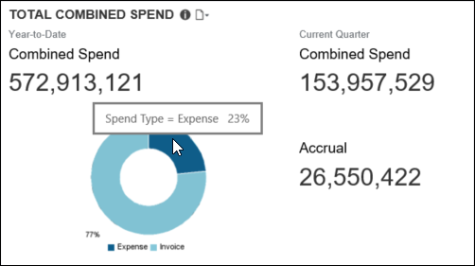

Section: Average Life Cycle
Sample of the dashboard:
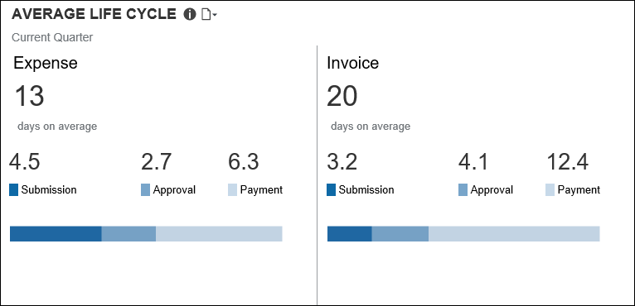
Sample of the Average Life Cycle Details – Expense drill-through report:
The Average Life Cycle Details – Expense report is a copy of the Average Life Cycle Details report associated with the Department Manager Expense Report Overview dashboard. The only difference between the reports is the name of the report.
For the Department Manager Expense Report Overview dashboard, the detail report is named Average Life Cycle – Details. For the Combined Spend Overview dashboard, the detail report for Expense is named Average Life Cycle Details – Expense.
Submitted tab:

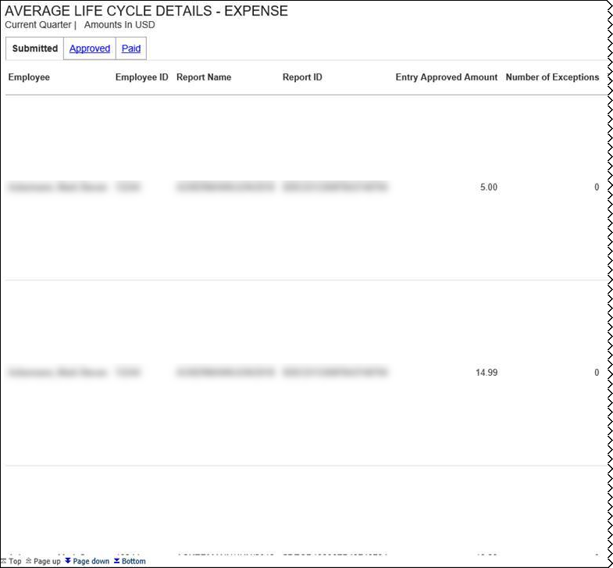
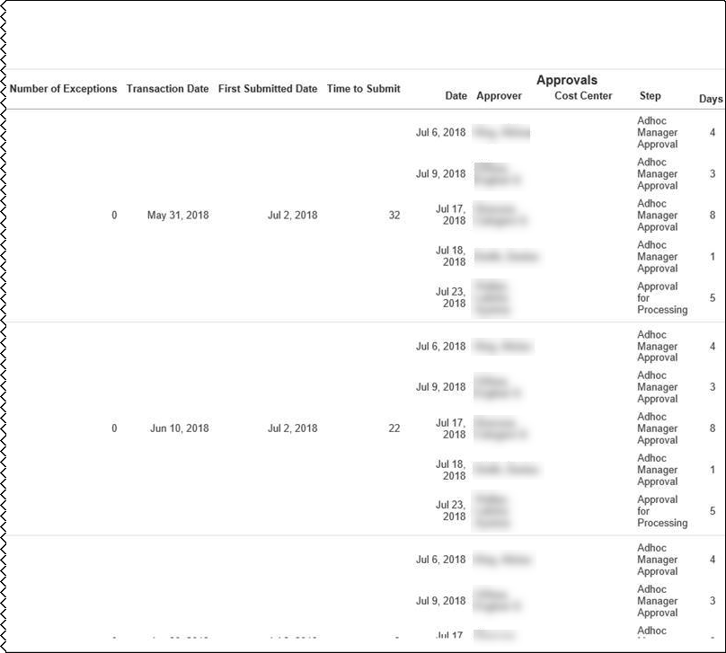
Approved tab:
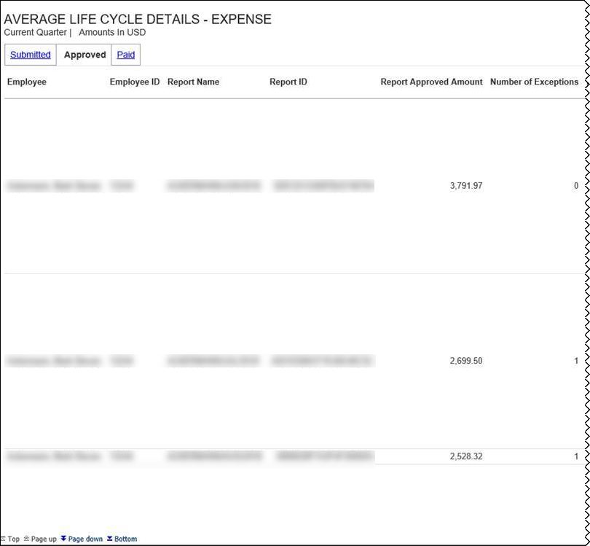
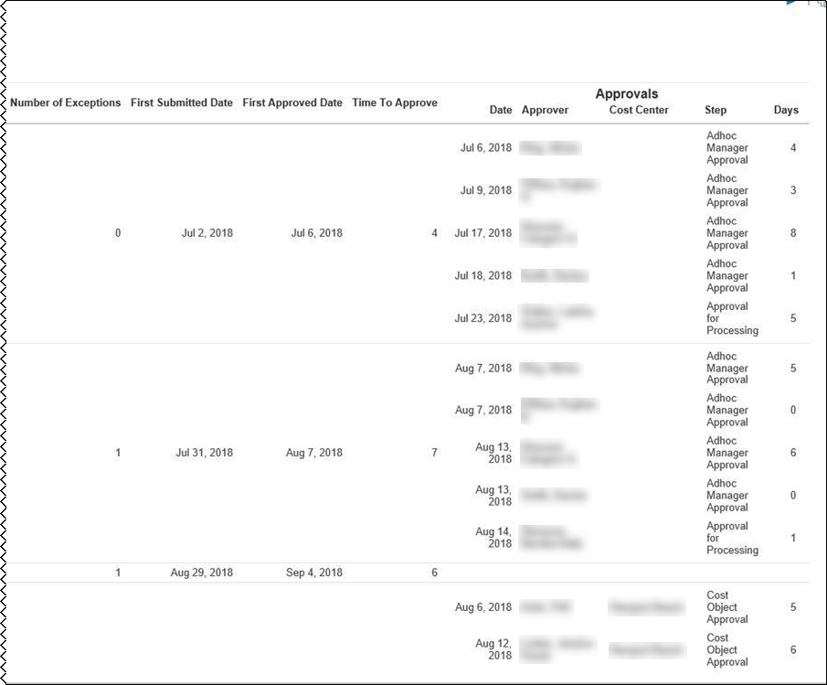
Paid tab:
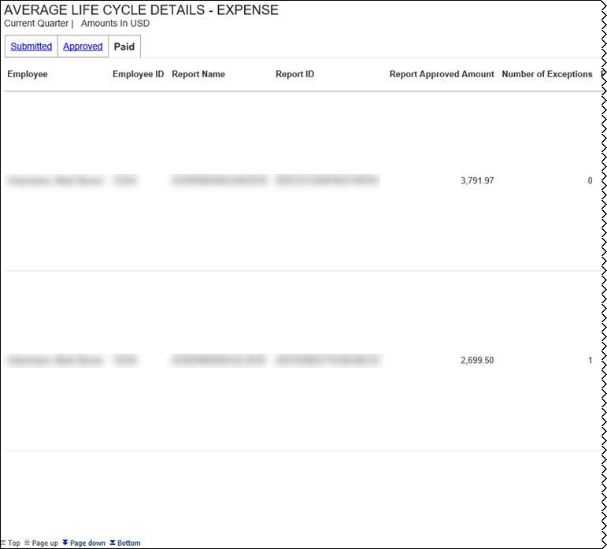
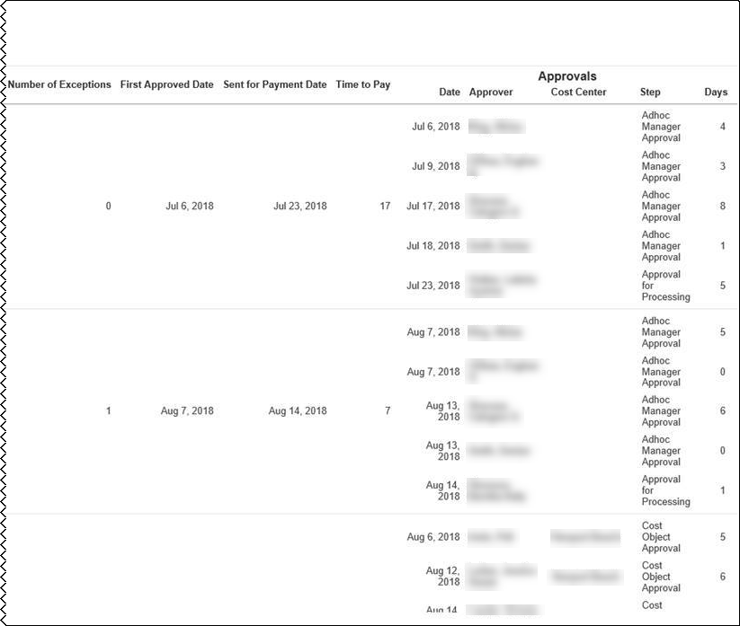

Sample of the Average Life Cycle Details – Invoice drill-through report:
Submitted tab:

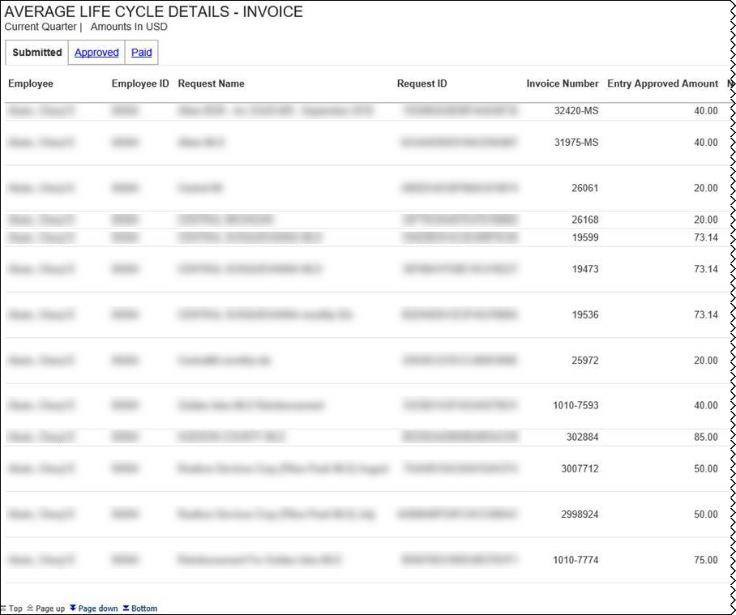
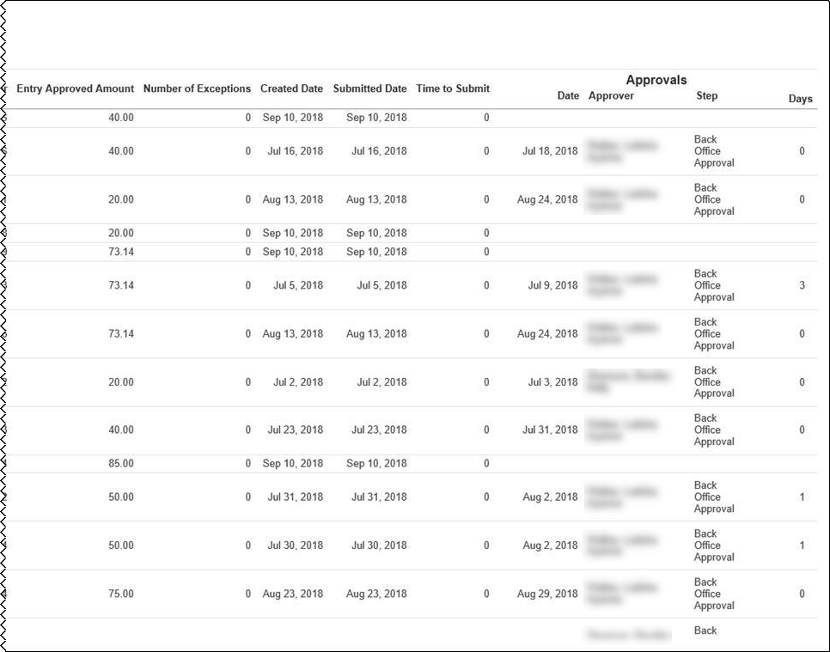
Approved tab:
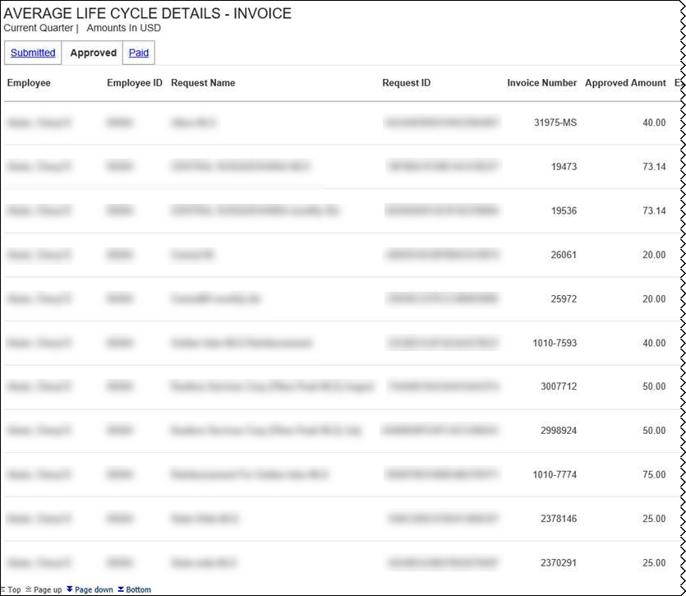
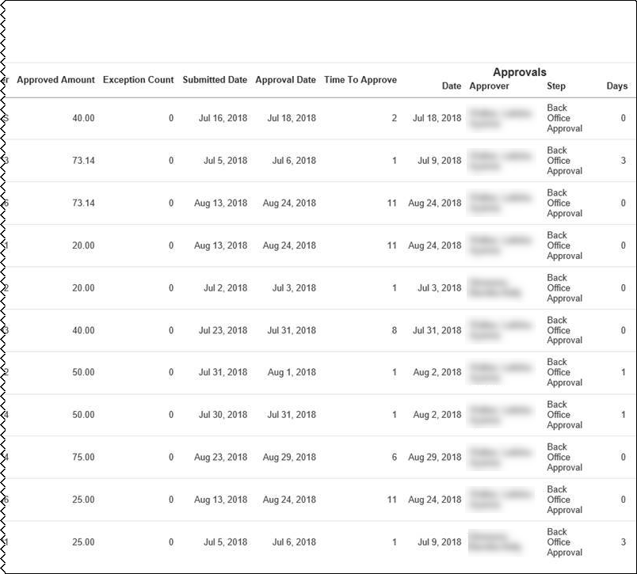
Paid tab:
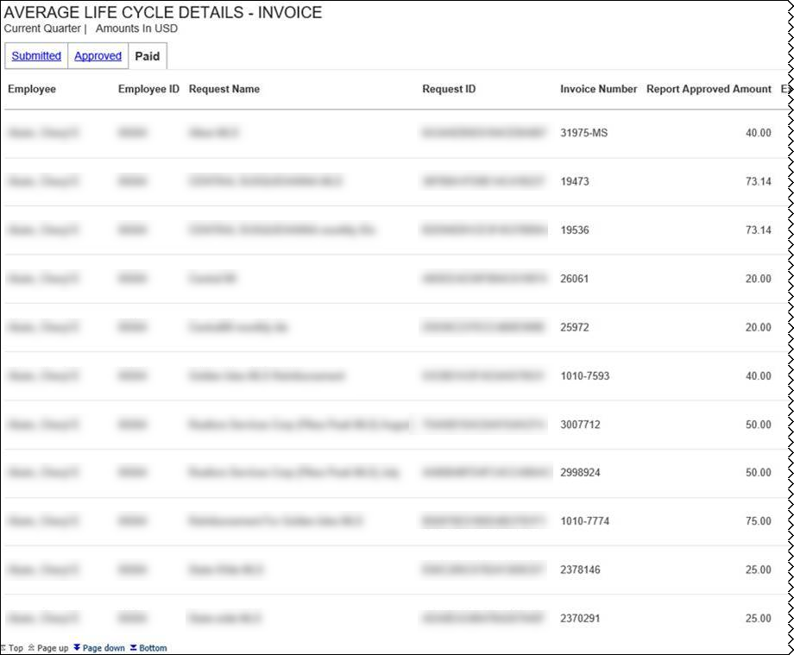
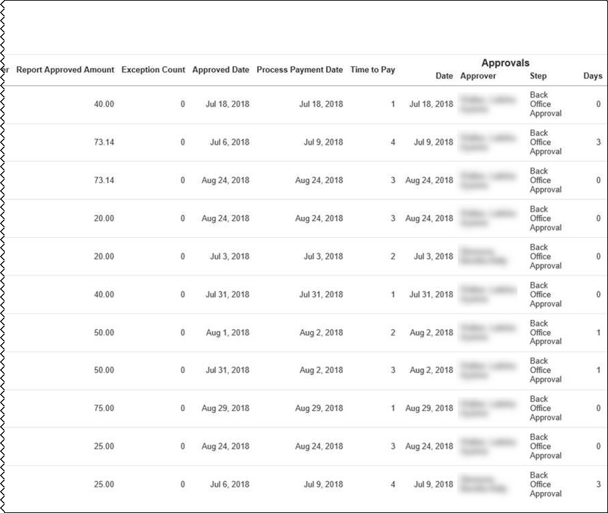
The Average Life Cycle section provides a visualization of the current quarter's life cycle averages for your company's expense reports and invoices, including the average total days for the expense report and invoice life cycle for the current quarter-to-date. All numbers displayed in the Average Life Cycle section are averages.
- The days on average number is the average of the submission, approval, and payment days for expense reports or invoices for the current quarter-to-date.
- The Submission number is the average of the days from the expense transaction date until the expense report submission or the average of the days from the invoice creation date in Invoice until the time the invoice is submitted for the current quarter.
- The Approval number is the average of the days from the first-time submission date of the expense report or invoice until the expense report or invoice is approved for the current quarter.
- The Payment number is the average of the number of days from expense report approval date until the date the expense report is submitted for payment or the average of the number of days from the invoice approval date until the invoice is submitted for payment processing for the current quarter.
Placing your pointer over a section of the life cycle bar displays the current quarter, the life cycle stage, and the average percentage of expense reports or invoices currently in that life cycle stage.
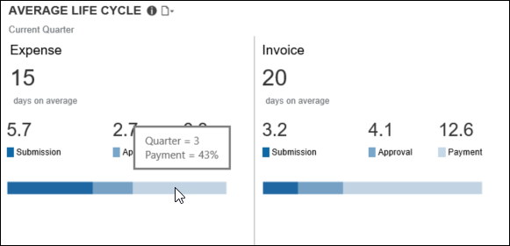

Section: Combined Spend Trend
Sample of the dashboard:
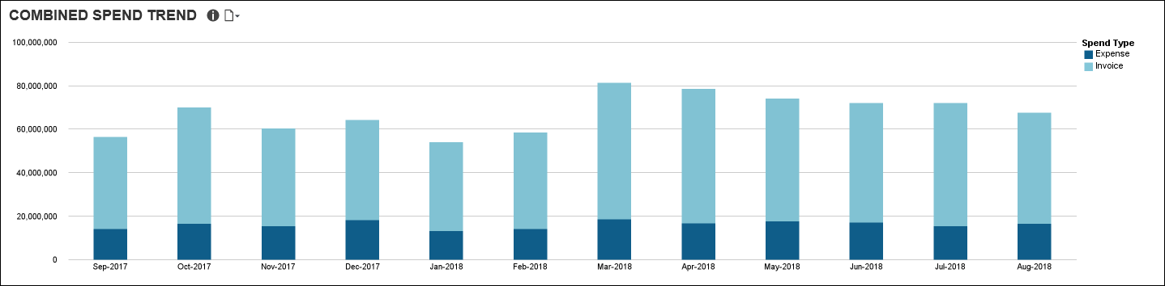
The Combined Spend Trend section provides a visualization of the combined year-to-date spend by month for both Expense and Invoice.
The combined spend includes all expense reports that have been sent for payment and all invoices that have been sent for payment processing. Combined spend does not include accruals.
Placing your pointer over a spend segment on a bar displays the month, year, spend type (Expense or Invoice), and the approved amount associated with the segment for the expenses that have been sent for payment or invoices that have been sent for payment processing for the month.
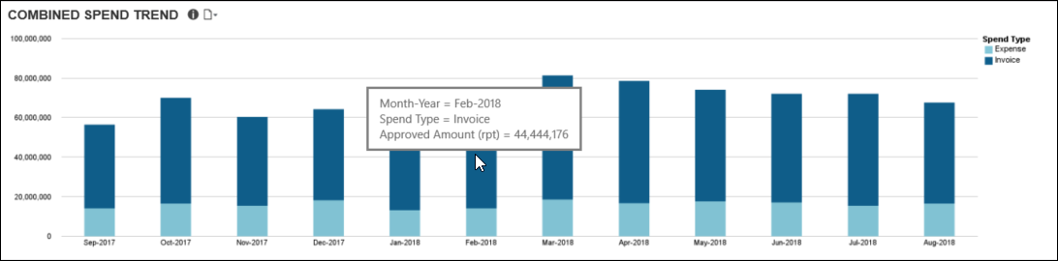

Dashboard: Department Manager Spend Overview
Available to:  Analysis  Intelligence

Dashboard
Sample of the full dashboard:
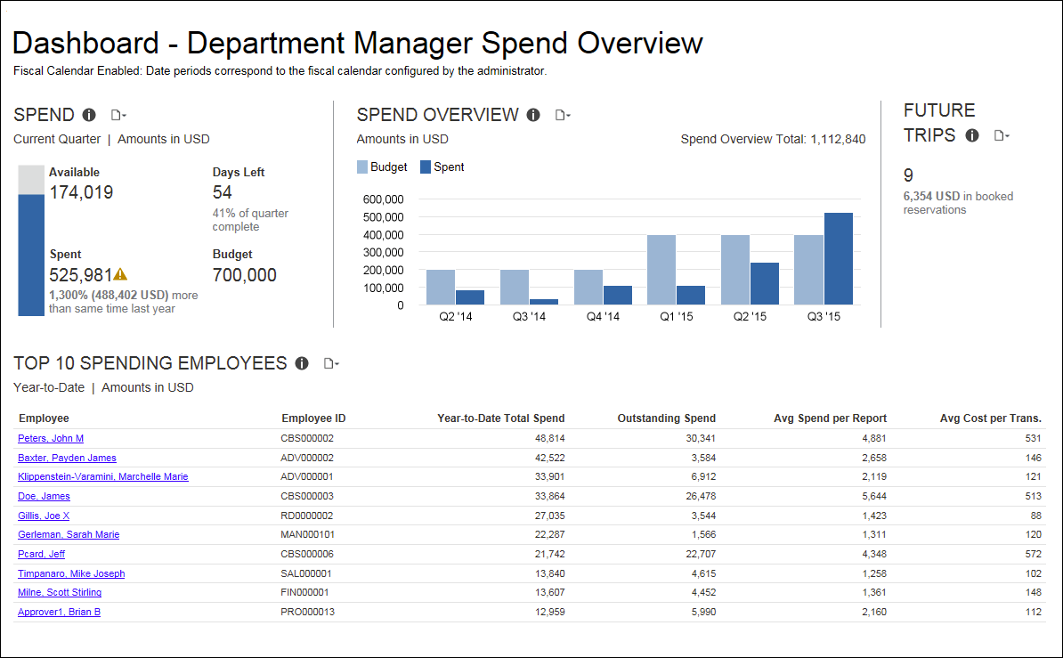

Section: Spend – Current Quarter Spend
Sample of the dashboard:
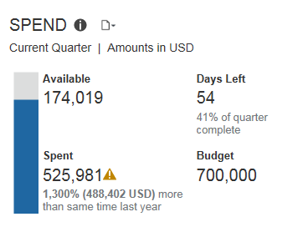
Sample of the drill-through report:
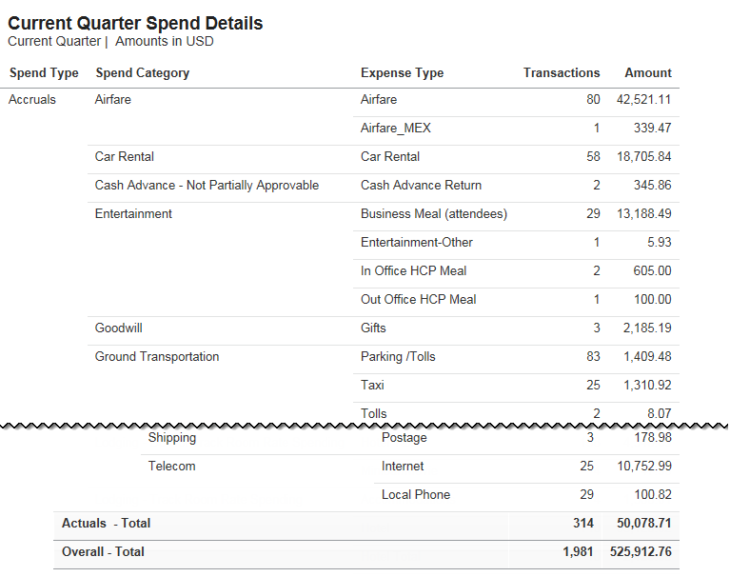

Questions Answered
- How much have I spent this quarter?
- Do I have enough budget to cover all the travel scheduled for the remainder of the quarter?
If you have not entered your quarterly budget in the budget settings in your Cognos profile, you will only see data for spend and not any comparative data to your budget.

Calculation
Budget comes from entries made by the BI Manager in the Profile settings. Spend is a combination of spend reported on expense reports and incurred expense reflected on credit card transactions.

How Can I Use This Information?
If you think your spend will exceed your budget this quarter take a look at Future Trips – trips that have been booked, but not taken. Absorbing the cost of airfare only, instead of all other expenses associated with travel, is one way to bring spending back under control. In addition, look at the Spend Details report to get a better understanding of spend. Maybe you can identify areas you can cut back on.
- Are there multiple people scheduled to attend the same conference? Consider having only one attend.
- Can a business meeting be conducted via conference call rather than face-to-face?

Section: Spend Overview
Sample of the dashboard:
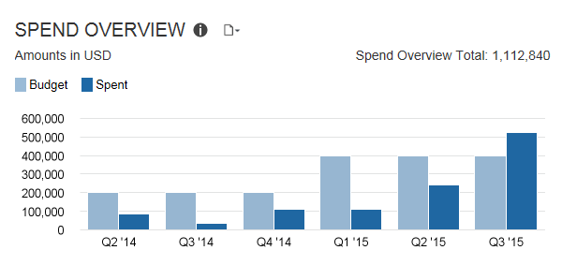
Sample of the new drill-through report – prompt:
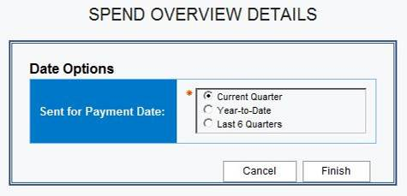
Sample of the new drill-through report:
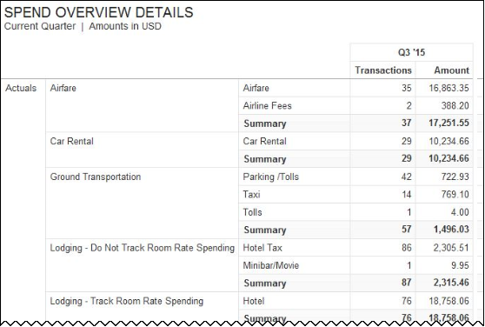

Questions Answered
- What is the trend in my quarterly spend compared to budget for the past six quarters?
- Does my spend represent an increased level of T&E spend?
If you have not entered your quarterly budget in the budget settings in your Cognos profile, you will only see data for spend and not any comparative data to your budget.

Calculation
Spend is a combination of spend reported on expense reports and incurred expense reflected on credit card transactions

How Can I Use This Information?
Understanding the trend of your T&E spend provides a quick glance of how you are performing against planned spend over the last six months. If spend is under budget, this might represent an opportunity for spend that could help you in attaining your department goals. If, however, spend is exceeding your budget, exploring the details around spend can provide insight on where you might need to curtail spend or if you need to talk to someone about their level of spend. Listed below are some areas you might consider exploring. There are several standard reports you can review for better understanding on your spending trend.
- advance airfare purchase
- class of service
- ancillary fees
- online booking
- failure to use unused tickets
- excessive baggage fees
- hotel or car rental cancellation fees
- upgrades
- extensive meal or room service charges
- rates higher than negotiated rates
- charges for breakfast or internet included in the negotiated rate
- additional insurance on car rentals
- duplicate meal expenses
- attendees
- using non-preferred vendors
Another path of action to consider is pre-approval on booking trips that exceed a certain dollar threshold or to certain destinations.

Section: Future Trips
Sample of the dashboard:
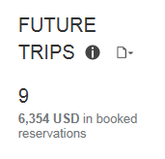
Sample of the drill-through report:
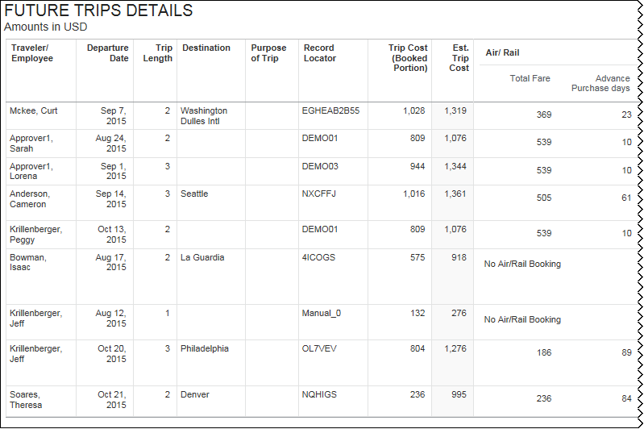
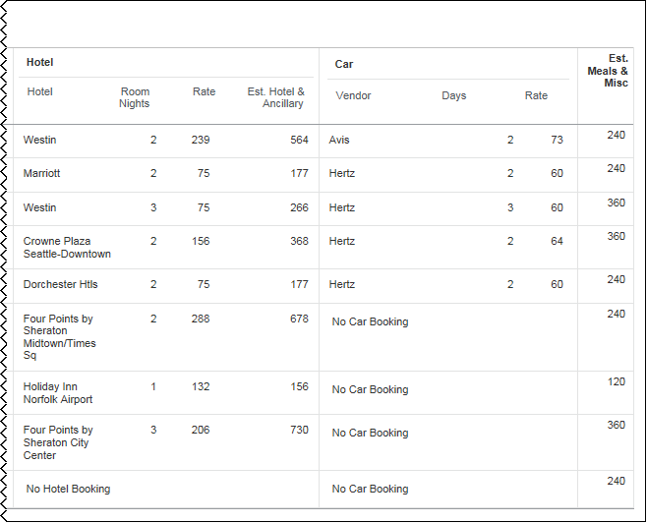

Questions Answered
How many future trips have been booked but not taken?

Calculation
Trip data pulled from all itinerary sources

How Can I Use This Information?
If you think your spend will exceed your budget this quarter, knowing what Future Trips are booked is helpful in finding ways to cut back on spend. Absorbing the cost of airfare only, instead of all other expenses associated with travel, is one way to bring spending back under control. The Future Trips Details report provides you additional information needed to make these decisions.
- Are there multiple people scheduled to attend the same conference? Consider having only one attend.
- Can a business meeting be conducted via conference call rather than face-to-face?
The following tables provide additional information about the Future Trips Details drill-through report:

Report Header and Footer
Data Item Label/Name | Data Item Expression | Data Item Description
Amounts in | [Travel].[Reservations and Tickets].[Reporting Currency] | Displays the currency code for the reporting currency (for example, USD, CAD, GBP)

Report Data Items
Data Item Label | Data Item Name | Data Item Expression | Data Item Description
Traveler/Employee | <Traveler/Employee> | [Trip].[Traveler/ Employee] | Displays Traveler/Employee
Departure Date | <Departure Date> | [Trip].[Start Date] | Displays Departure Date
Trip Length | <Trip Length> | [Trip].[Trip Length] | Displays Trip Length
Destination | <Destination> | [Trip].[Destination] | Displays Destination
Purpose of Trip | <Purpose of Trip> | [Trip].[Purpose of Trip] | Displays Purpose of Trip
Record Locator | <Record Locator> | [Trip].[Record Locator] | Displays Record Locator
Trip Cost (Booked Portion) | <Trip Cost (Booked Portion)> | [Trip].[Trip Cost (Booked Portion)] | Displays the trip cost (booked portion)
Est. Trip Cost | <Est. Trip Cost> | [Est. Meals & Misc]+[Estimated Hotel & Anc]+[Car Fare]+[Total Fare] | Displays the estimated trip cost
Hotel | <Property> | [Travel].[Reservations and Tickets].[Transportation Vendor / Hotel Property] | Displays the hotel
Room Nights | <Room Nights> | [Travel].[Reservations and Tickets].[Number of Days/Nights] | Displays the number of room nights
Rate | <Rate> | [Travel].[Reservations and Tickets].[Booking Rate (reporting currency)] | Displays the rate
Est. Meals & Misc | <Est. Meals & Misc> | [Trip].[Estimated Meals & Misc] | Displays estimated meals and miscellaneous
Est. Hotel & Ancillary | <Est. Hotel & Ancillary> | [Travel].[Reservations and Tickets].[Booking Total (reporting currency)]*1.18 | Displays the estimated hotel and ancillary
Vendor | <Vendor> | [Travel].[Reservations and Tickets].[Transportation Vendor / Hotel Property] | Displays the vendor
Days | <Number of Days> | [Travel].[Reservations and Tickets].[Number of Days/Nights] | Displays the number of days
Rate | <Rate> | [Travel].[Reservations and Tickets].[Booking Rate (reporting currency)] | Displays the rate
Total Fare | <Total Charges> | [Travel].[Reservations and Tickets].[Booking Total (reporting currency)] | Displays the total fare
Number of Days in Advance | <Number of Days in Advance> | [Travel].[Reservations and Tickets].[Number of Days in Advance] | Displays the number of days in advance

Section: Top 10 Spending Employees
Sample of the dashboard:
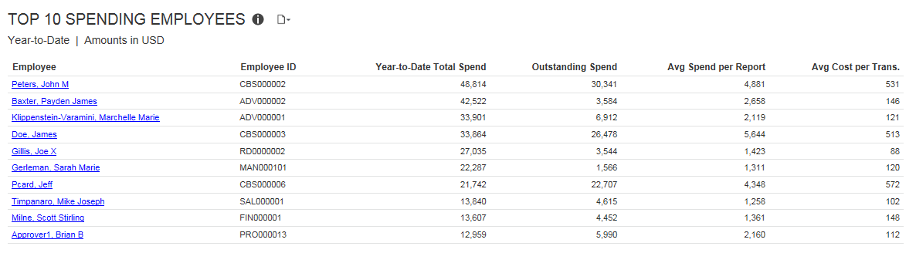
Sample of the drill-through report:
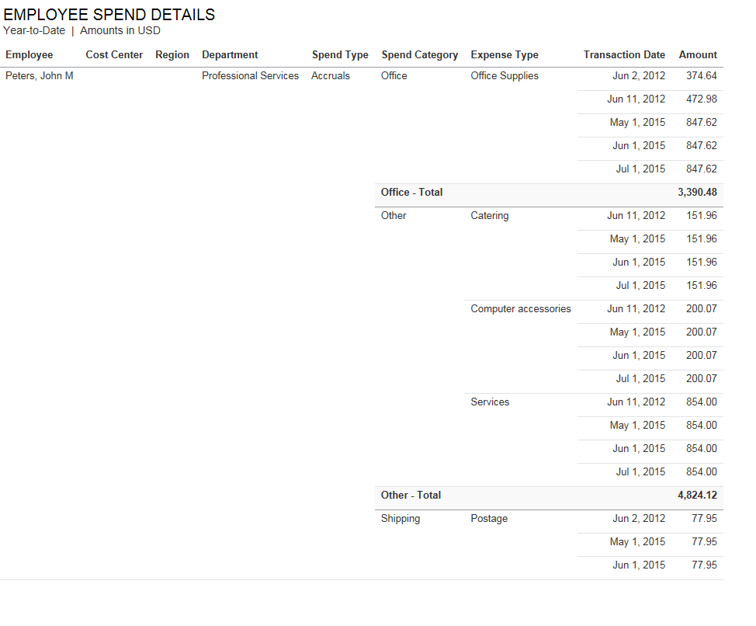

Questions Answered
This metric answers the following questions:
- Which employees expense more than others?
- How much are they expensing?
- What are they expensing?
- How much are they expensing per expense type (line item)?

Calculation
The query for this metric pulls the top 10 spenders for the manager and captures the total actual spent expense for each employee from expense reports. Accruals, bookings, parent entries, and personal entries are excluded from this calculation.

How Can I Use This Information?
If your spend is above the average, or projected to exceed your available cash to cover expenses, consider talking with travelers regarding any inappropriate past spends or the necessity of any future planned trips. Understanding costs per trip by traveler also helps you make better business decisions about the ROI of a trip.
The following tables provide additional information about the Employee Spend Details drill-through report:

Report Header and Footer
Data Item Label/Name | Data Item Expression | Data Item Description
Amounts in | [Spend Overview].[Reporting Currency] | Displays the currency code for the reporting currency (for example, USD, CAD, GBP)
N/A | AsOfDate() | Displays the date the report was run
N/A | PageNumber() | Displays the page number of the corresponding page
N/A | AsOfTime() | Displays the time the report was run

Report Data Items
Data Item Label | Data Item Name | Data Item Expression | Data Item Description
Employee | <Employee> | [Top 10 Spenders].[Employee] | Displays the employee
Cost Center | <Cost Center> | [Top 10 Spenders].[Employee Cost Center] | Displays the cost center
Region | <Region> | [Top 10 Spenders].[State/Province/Region (of Employee)] | Displays the region
Department | <Department> | [Top 10 Spenders].[Employee Department] | Displays the department
Spend Type | <Spend Type> | [Spend Overview].[Spend Type] | Displays the spend type
Spend Category | <Spend Category> | [Spend Overview].[Spend Category] | Displays the spend category
Expense Type | <Expense Type> | [Spend Overview].[Expense Type] | Displays the expense type
Transaction Date | <Transaction Date> | [Spend Overview].[Transaction Date] | Displays the transaction date
Amount | <Amount> | [Spend Overview].[Amount] | Displays the amount

Dashboard: Department Manager Expense Report Overview
Available to:  Analysis  Intelligence

Dashboard
Sample of the full dashboard:
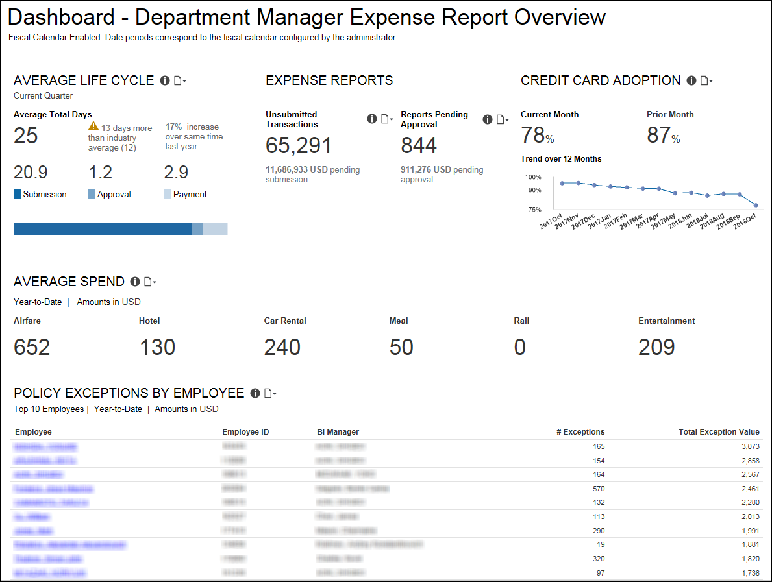

Section: Average Life Cycle
Sample of the dashboard:
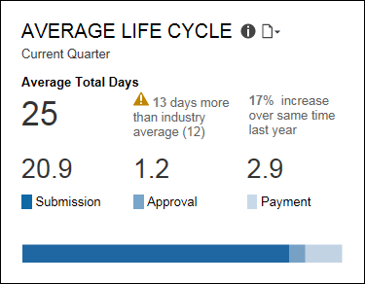
Sample of the new drill-through report – prompt:
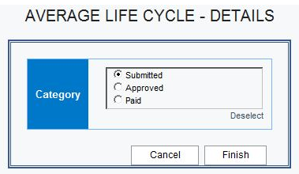
Sample of the new drill-through report:
Submitted tab
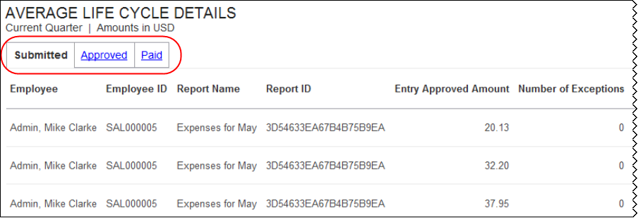
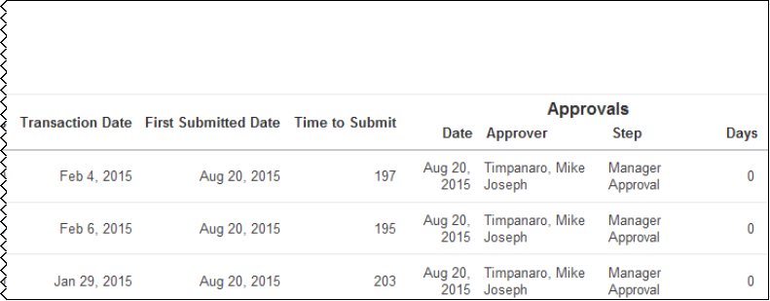
Approved tab:
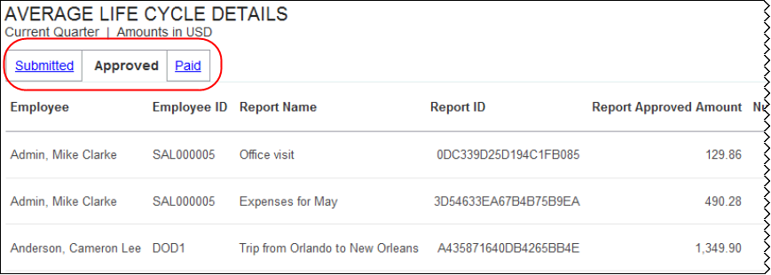
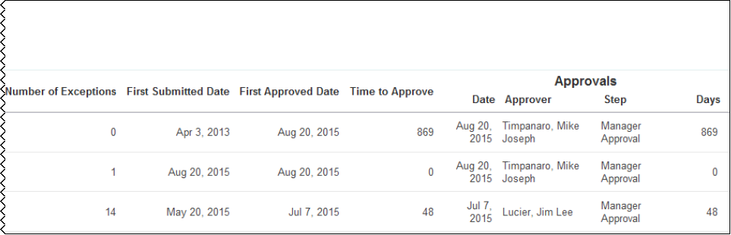
Paid tab:
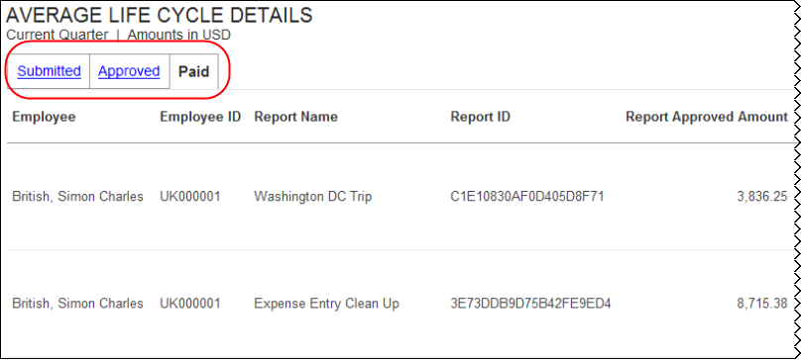
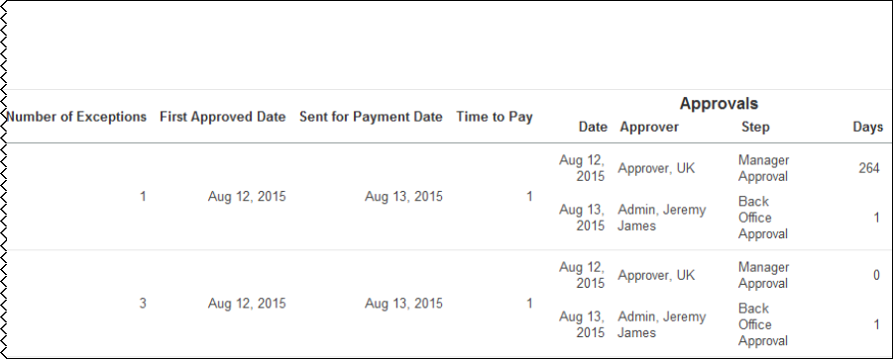

Questions Answered
- How long does it take an expense report to move through each phase of the cycle?
- How efficient is my team with this process?

Calculation
All these numbers are averages. Submission is an average of the days from the date of a transaction until the time it is submitted in an expense report. Approval is an average of the days from the time an expense report is submitted until it is approved. Payment is an average of the number of days from the time of expense report approval until submitted for payment. The Average Life Cycle number is an average of the submission, approval, and payments days.

How Can I Use This Information?
Understanding the length of time it takes for expense reports to process through each stage gives you an idea of where you can make improvements in the efficiency of processing.
This ultimately affects employee satisfaction and productivity.
- The longer it takes an employee to submit a report might suggest a need to introduce some policy or guideline regarding expense report submission.
- If there is a lag in the time to approve reports, speak to your approvers to discuss what is the appropriate time for review before approval or sending back for additional information.
- Delayed reimbursement to employees for expenses incurred on a personal card creates stress for that employee. And, there is always concern about the possibility of late fees.
- Fast turnaround on reimbursements is not only better for the employee but also for the accuracy in your cash flow projections. If possible, consider automating notifications to employees regarding expense report submission and to approvers regarding the need to approve an expense report.
- Another option is to have prompts to employees and managers regarding action required when they log into your travel portal.

Section: Expense Reports – Unsubmitted Transactions
Sample of the dashboard:
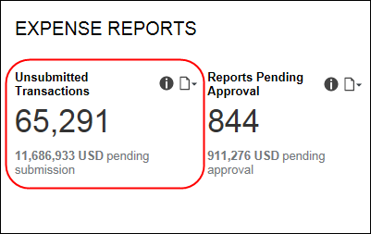
Sample of the drill-through report prompts:
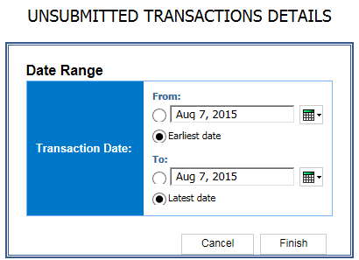
Sample of the drill-through report:
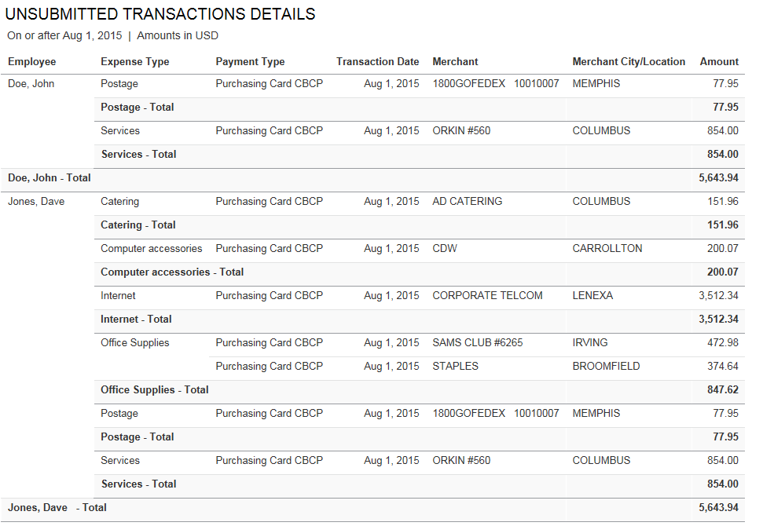

Questions Answered
- Which employees have expenses not yet submitted via an expense report?
- What is the value of the unsubmitted transactions?

Calculation
Transactions reflected on the corporate card statement without a matching expense report entry

How Can I Use This Information?
Getting your employees to submit reports that account for all their expenses in a timely fashion is critical to the company managing cash flow successfully. Once you identify an employee with unsubmitted transactions consider the following:
- Talk with the employee to understand the reason for the delay.
- Review your company's policy regarding expense report submission.
- Remind all employees of the company policy regarding expense report submission.
- Utilize automatic email reminders to employees reminding employees of transactions not yet submitted.

Section: Expense Reports – Reports Pending Approval
Sample of the dashboard:
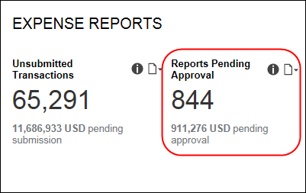
Sample of the drill-through report prompts:
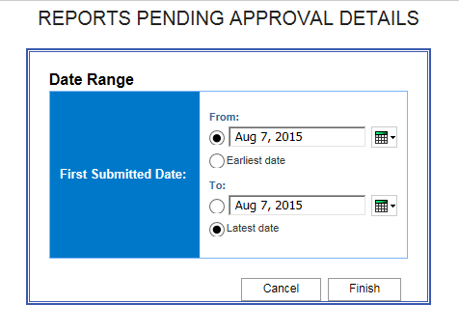
Sample of the drill-through report:
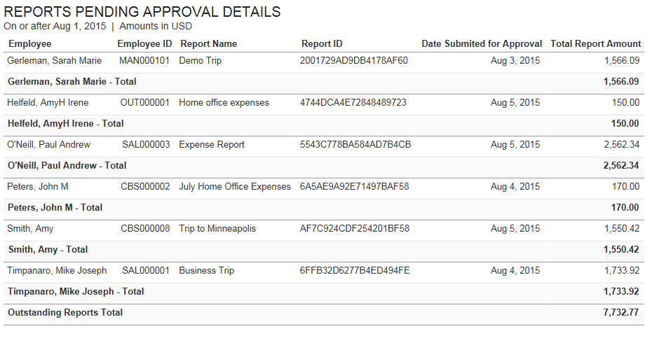

Questions Answered
- How many expense reports need my review and approval?
- What is the value of the expenses in the reports not yet reviewed?

Calculation
Expense reports with a status of submitted and with a status of "Pending Approval"

How Can I Use This Information?
Just as it is important for your employees to submit their expense reports in a timely fashion, it's just as important that you review each report and either submit it for payment or return it to the employee for change in a timely fashion. For the employee using a personal credit card or paying cash for the expense, reimbursement in a timely fashion is important so they can maintain their credit rating and avoid payment of late fees. If you are not receiving notification when an employee submits an expense report for approval, contact your expense administrator to get this corrected.

Section: Credit Card Adoption
Sample of the dashboard:
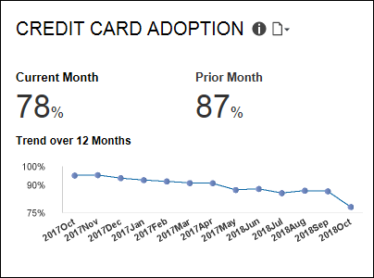
Sample of the new drill-through report – prompt:
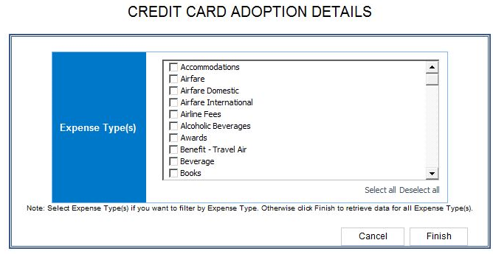
Sample of the new drill-through report:
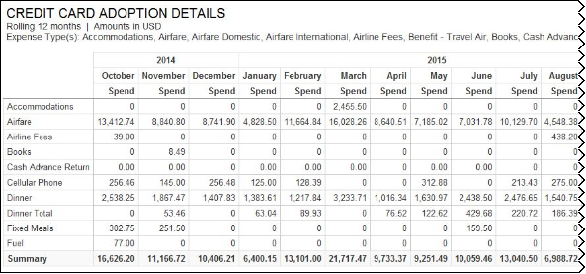
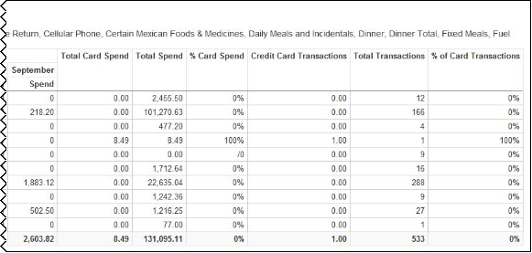

Questions Answered
- How is the use of credit cards for expenses trending?
- Do I need to take action to increase the level of card adoption?

Calculation
Credit Card Adoption is a percentage of payments in expense reports paid by credit card versus other forms of payment

How Can I Use This Information?
Use of a corporate card helps you control your T&E spend, improves employee satisfaction and creates efficiencies in the payment and reconciliation process. Low credit card utilization suggests a compliance issue. To drive compliance:
- If your company requires use of the corporate card, reemphasize the policy making sure your employees understand that only expenses made in compliance with the travel policy and on the corporate card are typically reimbursable.
- Make sure that employees are aware of any benefits available to them through use of the card such as a rewards program or emergency assistance when en route.
The following tables provide additional information about the Credit Card Adoption Details drill-through report:

Report Header and Footer
Data Item Label/Name | Data Item Expression | Data Item Description
Amount In | [Expense].[Entry Information].[Reporting Currency] | Displays the currency code for the reporting currency (for example, USD, CAD, GBP)
Expense Type(s) | ParamDisplayValue('pExpenseType') | Displays the expense type(s) selected in the Expense Type(s) prompt on the Prompts page.

Report Data Items
Data Item Label | Data Item Name | Data Item Expression | Data Item Description
N/A | Expense Type | [Expense].[Entry Information].[Expense Type] | Display Expense Type
N/A | Transaction Year Name | "CASE  WHEN ([Fiscal Flag]='Y') THEN CAST([Expense].[Entry Information].[Transaction Fiscal Year Name],varchar(50))  ELSE CAST([Expense].[Entry Information].[Transaction Year],varchar(50))  END" | Display Transaction Year
N/A | Transaction Month | "CASE  WHEN ([Fiscal Flag]='Y') THEN CAST([Expense].[Entry Information].[Transaction Fiscal Month], Varchar(50))  else [Expense].[Entry Information].[Transaction Month]  END" | Displays the transaction month
Total Card Spend
Total Spend
% Card Spend |  | [qCardTransactions - 12 Month Trend].[Total Card Spend]/[qCardTransactions - 12 Month Trend].[Total Spend] | Displays the % Total Card Spend
% Of Card Transactions |  | [qCardTransactions - 12 Month Trend].[Credit Card Transactions]/[qCardTransactions - 12 Month Trend].[Total Transactions] | Displays the % Total Card Transactions
Summary |  |  | Displays the summary of the spend

Section: Average Spend
Sample of the dashboard:
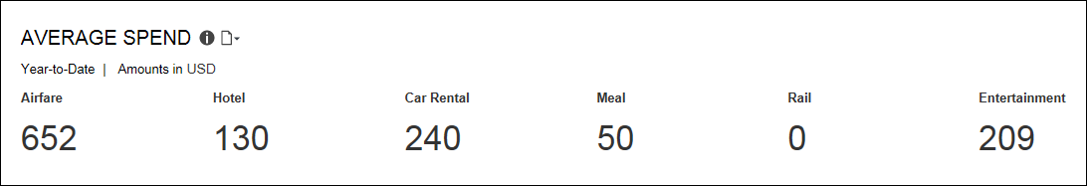
Sample of the new drill-through report – prompt:
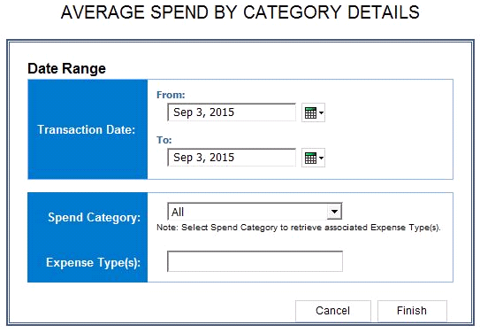
Sample of the new drill-through report:
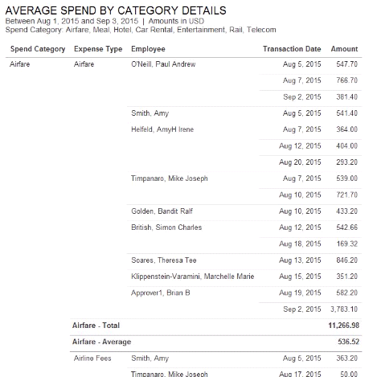

Questions Answered
- What is the average spend of your employees over six categories of spend – air, hotel (spend category: Lodging – Track Room Rate Spending), car rental, meals, rail and entertainment?

Calculation
The average spend for your department is calculated using spend submitted on expense reports of all of your direct reports on a year-to-date basis.

How Can I Use This Information?
If your department's average spend is above or below normal, use the "Average Spend by Spend Category Details" report to find out the level and type of spend by each employee. By examining spend at this level, you should be able to spot any patterns that require additional research. There are several related reports that can provide this insight so you can determine the appropriate action to take. For example:
- If one employee shows a higher level of spend for airfare, is it because that employee waits to the last minute to purchase his ticket?
- Is the employee purchasing an upgraded class of service?
- Does the distance of trips justify the higher expense?
The following tables provide additional information about the Average Spend by Category Details drill-through report:

Report Header and Footer
Data Item Label/Name | Data Item Expression | Data Item Description
Transaction Date | ParamDisplayValue('pTransaction_Date') +' | ' | Displays the date range from the Transaction Date prompt on the Prompts page
Amounts In | [Expense].[Entry Information].[Reporting Currency] | Displays the currency code in which the reporting currency is shown (for example, USD, CAD, GBP)
Spend Category | case when ParamDisplayValue('pSpendCategory') is missing then ('Airfare, Meal, Hotel, Car Rental, Entertainment, Rail, Telecom') else ParamDisplayValue('pSpendCategory') end | Displays the spend category selected from the Spend Category prompt on the Prompts page
Expense Types | ParamDisplayValue('pExpenseType') | Displays the expense type(s) entered in the Expense Type(s) prompt on the Prompts page

Report Data Items
Data Item Label | Data Item Name | Data Item Expression | Data Item Description
Spend Category | <Spend Category> | "case  when [Expense].[Entry Information].[Spend Category Code] in ('LODGA','LODGN') and # sq($runLocale )# = 'en' THEN 'Hotel'  when [Expense].[Entry Information].[Spend Category Code] in ('LODGA','LODGN') and # sq($runLocale )# = 'zh-cn' THEN '宾馆'  when [Expense].[Entry Information].[Spend Category Code] in ('LODGA','LODGN') and # sq($runLocale )# = 'zh-tw' THEN '飯店'  when [Expense].[Entry Information].[Spend Category Code] in ('LODGA','LODGN') and # sq($runLocale )# = 'en-gb' THEN 'Hotel'  when [Expense].[Entry Information].[Spend Category Code] in ('LODGA','LODGN') and # sq($runLocale )# = 'fr' THEN 'Hôtel'  when [Expense].[Entry Information].[Spend Category Code] in ('LODGA','LODGN') and # sq($runLocale )# = 'de' THEN 'Hotel'  when [Expense].[Entry Information].[Spend Category Code] in ('LODGA','LODGN') and # sq($runLocale )# = 'ja' THEN 'ホテル'  when [Expense].[Entry Information].[Spend Category Code] in ('LODGA','LODGN') and # sq($runLocale )# = 'it' THEN 'Albergo'  when [Expense].[Entry Information].[Spend Category Code] in ('LODGA','LODGN') and # sq($runLocale )# = 'ko' THEN '호텔'  when [Expense].[Entry Information].[Spend Category Code] in ('LODGA','LODGN') and # sq($runLocale )# = 'sv' THEN 'Hotell'  when [Expense].[Entry Information].[Spend Category Code] in ('LODGA','LODGN') and # sq($runLocale )# = 'nl' THEN 'Hotel'  when [Expense].[Entry Information].[Spend Category Code] in ('LODGA','LODGN') and # sq($runLocale )# ='cs' then 'Hotel'  when [Expense].[Entry Information].[Spend Category Code] in ('LODGA','LODGN') and # sq($runLocale )# ='pt-BR' then 'Hotel'  when [Expense].[Entry Information].[Spend Category Code] in ('LODGA','LODGN') and # sq($runLocale )# ='es' then 'Hotel'  when [Expense].[Entry Information].[Spend Category Code] in ('MEALS','MEALA','MEALN') and # sq($runLocale )# = 'en' THEN 'Meal'  when [Expense].[Entry Information].[Spend Category Code] in ('MEALS','MEALA','MEALN') and # sq($runLocale )# = 'zh-cn' THEN '餐费'  when [Expense].[Entry Information].[Spend Category Code] in ('MEALS','MEALA','MEALN') and # sq($runLocale )# = 'zh-tw' THEN '餐飲'  when [Expense].[Entry Information].[Spend Category Code] in ('MEALS','MEALA','MEALN') and # sq($runLocale )# = 'en-gb' THEN 'Meal'  when [Expense].[Entry Information].[Spend Category Code] in ('MEALS','MEALA','MEALN') and # sq($runLocale )# = 'fr' THEN 'Repas'  when [Expense].[Entry Information].[Spend Category Code] in ('MEALS','MEALA','MEALN') and # sq($runLocale )# = 'de' THEN 'Verpflegung'  when [Expense].[Entry Information].[Spend Category Code] in ('MEALS','MEALA','MEALN') and # sq($runLocale )# = 'ja' THEN '食事'  when [Expense].[Entry Information].[Spend Category Code] in ('MEALS','MEALA','MEALN') and # sq($runLocale )# = 'it' THEN 'Pasto'  when [Expense].[Entry Information].[Spend Category Code] in ('MEALS','MEALA','MEALN') and # sq($runLocale )# = 'ko' THEN '식사'  when [Expense].[Entry Information].[Spend Category Code] in ('MEALS','MEALA','MEALN') and # sq($runLocale )# = 'sv' THEN 'Måltid'  when [Expense].[Entry Information].[Spend Category Code] in ('MEALS','MEALA','MEALN') and # sq($runLocale )# = 'nl' THEN 'Maaltijd'  when [Expense].[Entry Information].[Spend Category Code] in ('MEALS','MEALA','MEALN') and # sq($runLocale )# ='cs' then 'Jídlo'  when [Expense].[Entry Information].[Spend Category Code] in ('MEALS','MEALA','MEALN') and # sq($runLocale )# ='pt-BR' then 'Refeição'  when [Expense].[Entry Information].[Spend Category Code] in ('MEALS','MEALA','MEALN') and # sq($runLocale )# ='es' then 'Comida'  else [Expense].[Entry Information].[Spend Category]  end " | Displays the spend category
Expense Type | <Expense Type> | [Expense].[Entry Information].[Expense Type] | Displays the expense type
Employee | <Employee> | [Expense].[Report Header Information].[Employee] | Displays the employee
Transaction Date | <Transaction Date> | [Expense].[Entry Information].[Transaction Date] | Displays the transaction date
Amount | <Amount> | [Expense].[Entry Information].[Approved Amount (rpt)] | Displays the amount

Section: Policy Exceptions by Employee
Sample of the dashboard:
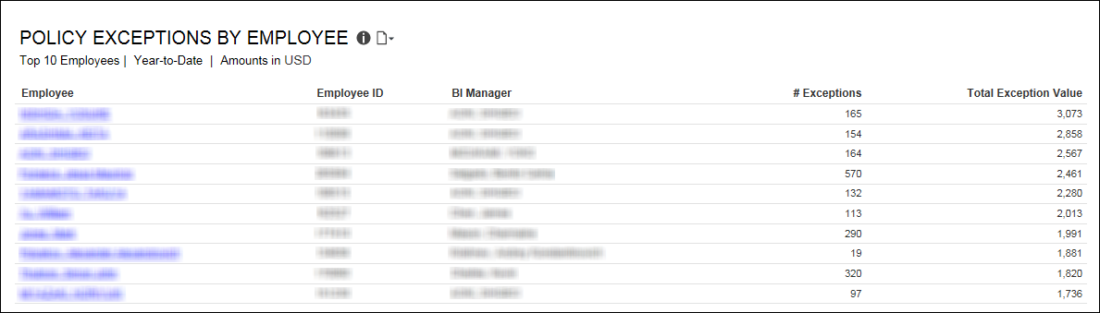
Sample of the new drill-through report:
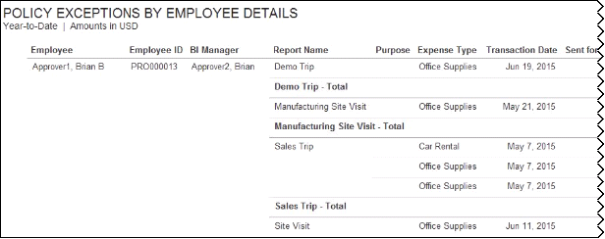
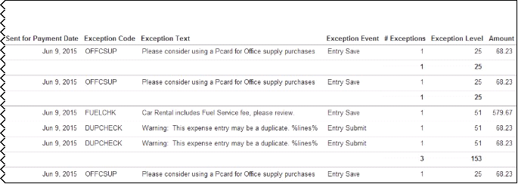

Questions Answered
- Who are the top 10 employees with policy violations (based on exception value)?
- How many policy exceptions does each employee have?
- What is the dollar value associated with those exceptions?

Calculation
This metric calculates the number of policy exceptions identified on submitted expense reports. The table shows the employee with the highest total exception value descending to the employee with the lowest total exception value.

How Can I Use This Information?
It may be difficult for there never to be any policy exceptions. However, when the number of exceptions for an employee is much higher than the average for other employees, or is increasing over time, it may be a flag for spending that is out of control or potential fraud.
Since spend policies are implemented to help control costs in your organization, exceptions might suggest one of the following.
- Employees do not understand the policy.
- They do not consider it fair so do not want to follow it.
- Employees do not feel it necessary to follow the policy.
Once you talk with the employees that have policy exceptions and understand why, next steps can be determined.

Dashboard: Expense Management Overview
Available to:  Analysis  Intelligence

Overview
The Expense Management Overview dashboard provides key metrics for your company's expense reports and expense report life cycle at a glance. The dashboard can help you track how the metrics are trending, the impact on cash flow, and help evaluate the need for changes in the expense report process to optimize it.
The Expense Management Overview dashboard is the first in a series of Spend Management dashboards. These dashboards bring visibility into all spend in the Concur connected solution wherever it occurs. With visibility into spend, users are able to make better and more informed decisions regarding spend at their company.
While the Department Manager Overview, Expense Management Overview, and Invoice Management Overview dashboards display data based on the user's access rights, the Combined Spend Overview, Expense Management Overview, and Invoice Management Overview dashboards were designed for users that typically have global access to company spend data.

Dashboard
Sample of the full dashboard:
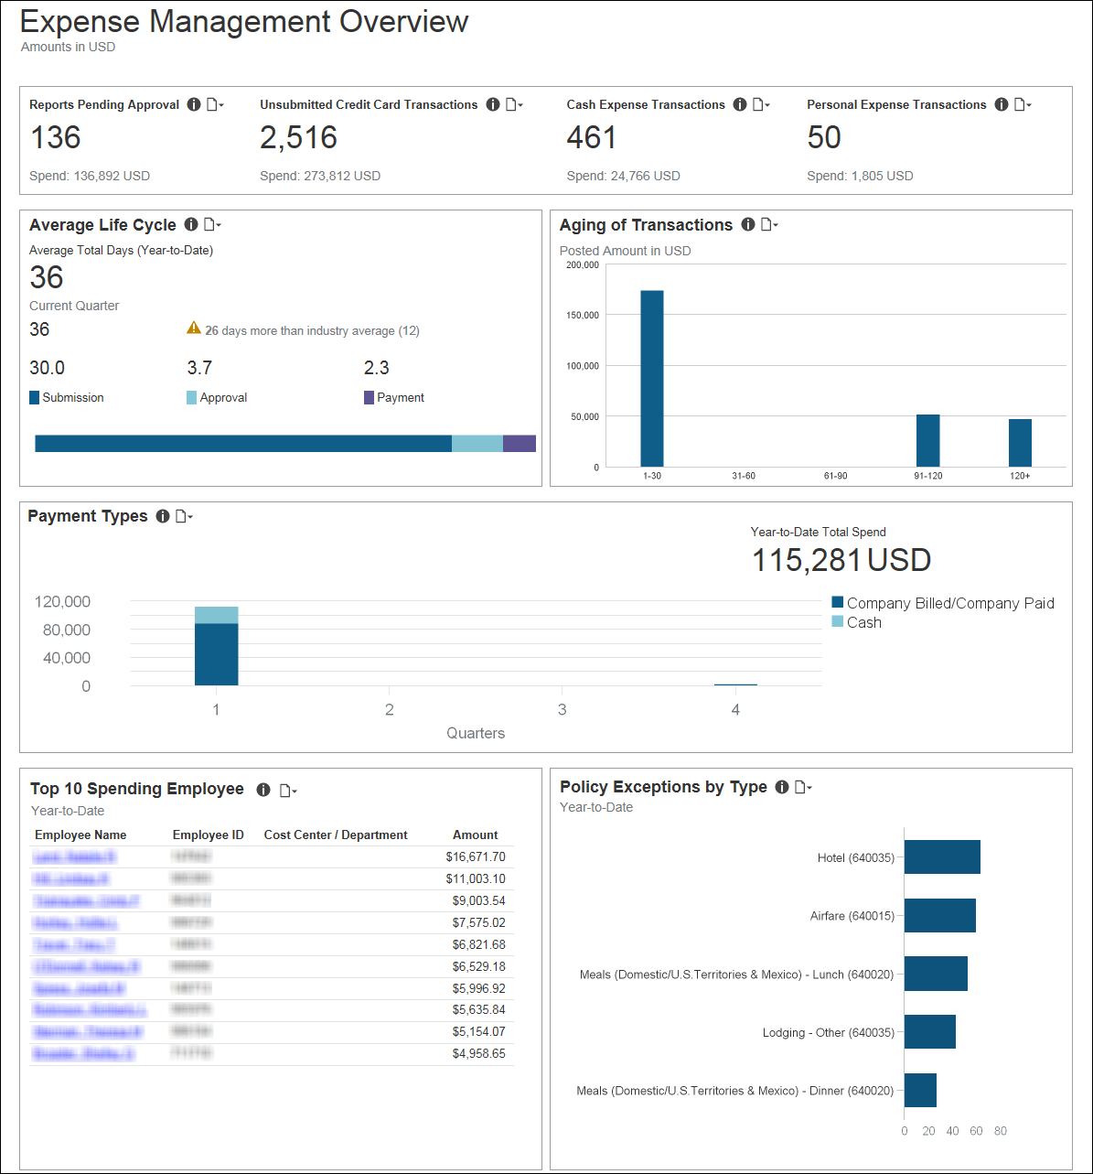

Summary Bar
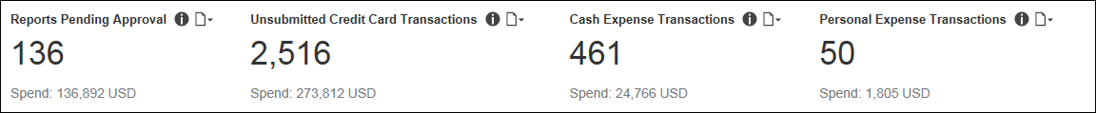
The Summary bar consists of four parts:
- Reports Pending Approval
The total number of expense reports submitted for approval but not yet approved; and the amount of money associated with these expense reports.
- Unsubmitted Credit Card Transactions
Corporate credit card transactions associated with expense report entries that are unsubmitted, and transactions on the corporate credit card statement that do not have a matching expense report entry. Also displays the amount of money associated with these unsubmitted transactions. Credits are excluded from this calculation.
- Cash Expense Transactions
The total number of expenses submitted for approval for year-to-date that have Cash as the payment type; and the amount of money associated with these expenses.
- Personal Expense Transactions
The percentage of all expense entries submitted for year-to-date that are marked Personal Expense (do not reimburse), and the amount of money associated with these expenses.

Section: Reports Pending Approval
Sample of the dashboard:
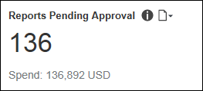
Sample of the drill-through report:
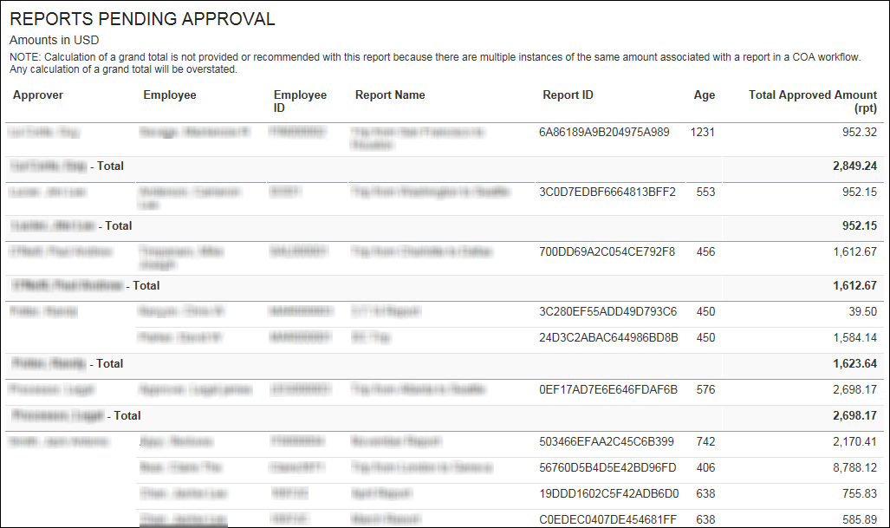

Section: Unsubmitted Credit Card Transactions
Sample of the dashboard:
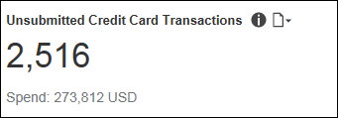
Sample of the drill-through report:
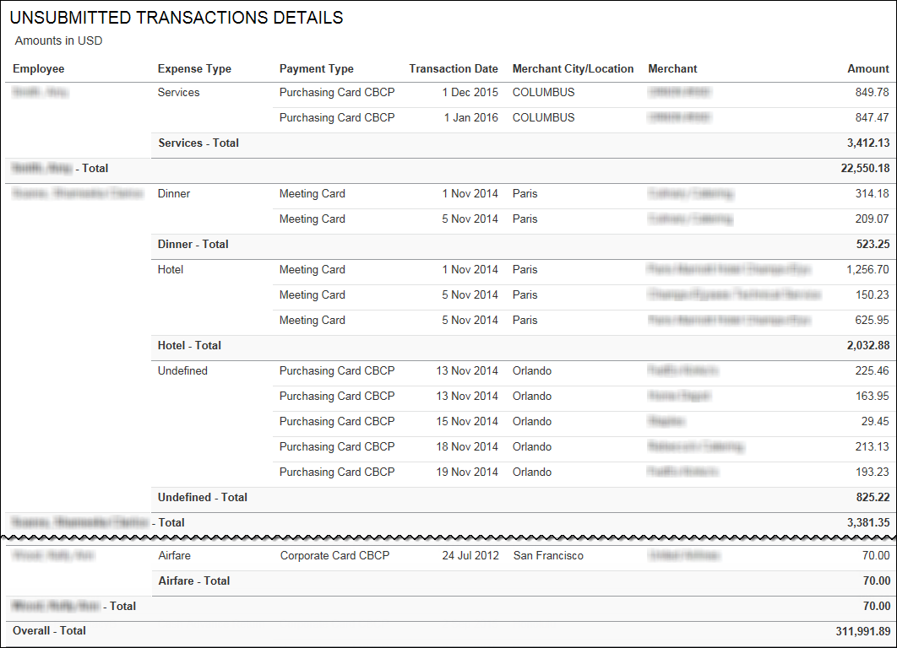

Section: Cash Expense Transactions
Sample of the dashboard:
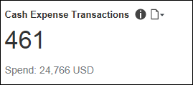
Sample of the drill-through report:
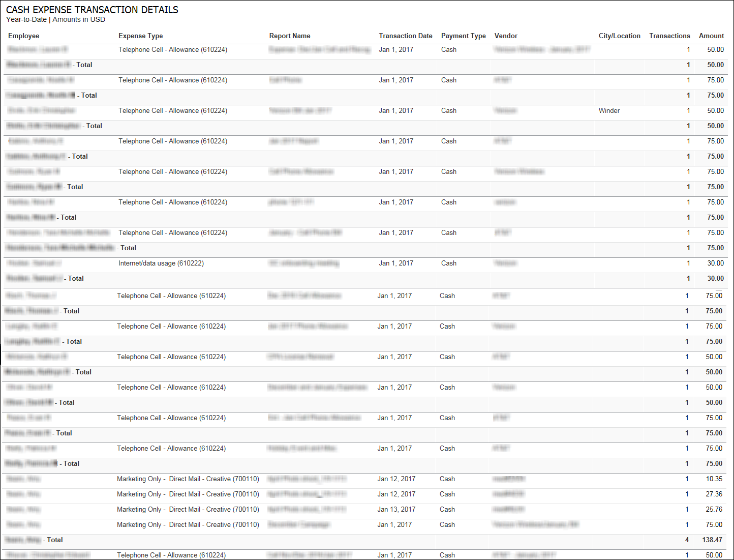
The following tables provide additional information about the Cash Expense Transactions Details drill-through report:

Report Header and Footer
Data Item Label/Name | Data Item Expression | Data Item Description
Amounts in | [Expense].[Entry Information].[Reporting Currency] | Displays the currency code for the reporting currency (for example, USD, CAD, GBP)
N/A | AsOfDate() | Displays the date the report was run
N/A | PageNumber() | Displays the page number of the corresponding page
N/A | AsOfTime() | Displays the time the report was run

Report Data Items
Data Item Label | Data Item Name | Data Item Expression | Data Item Description
Employee | <Employee> | [Expense].[Report Header Information].[Employee] | Displays the employee
Expense Type | <Expense Type> | [Expense].[Entry Information].[Expense Type] | Displays the expense type
Report Name | <Report Name> | [Expense].[Report Header Information].[Report Name] | Displays the expense report name
Transaction Date | <Transaction Date> | [Expense].[Entry Information].[Transaction Date] | Displays the transaction date
Payment Type | <Payment Type> | [Expense].[Entry Information].[Payment Type] | Displays the payment type
Vendor | <Vendor> | [Expense].[Entry Information].[Vendor] | Displays the vendor
City/Location | <City/Location> | [Expense].[Entry Information].[City/Location] | Displays the city/location
Transactions | <Transaction Count> | [Expense].[Entry Information].[Entry Key] | Displays the transactions
Amount | <Approved Amount (rpt)> | [Expense].[Entry Information].[Approved Amount (rpt)] | Displays the approved amount

Section: Personal Expense Transactions
Sample of the dashboard:
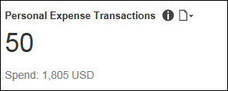
Sample of the drill-through report:
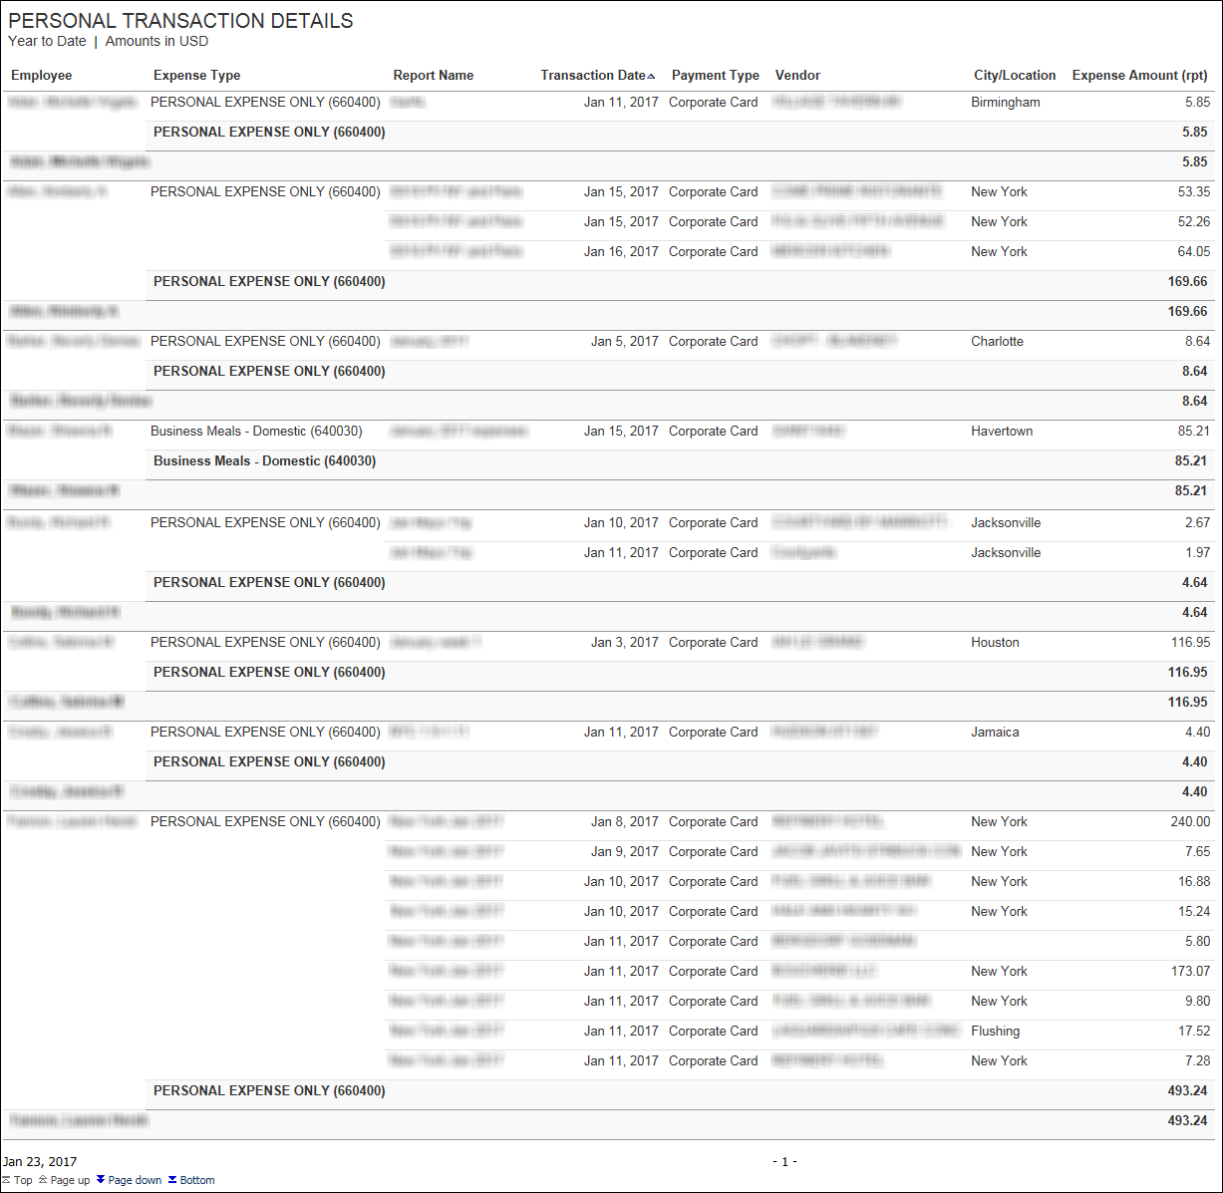

Section: Average Life Cycle
Sample of the dashboard:
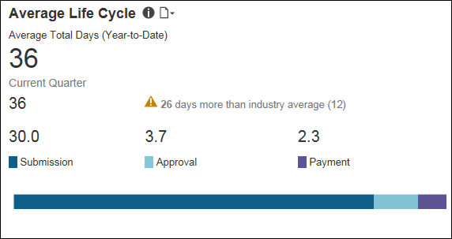
Sample of the drill-through report:
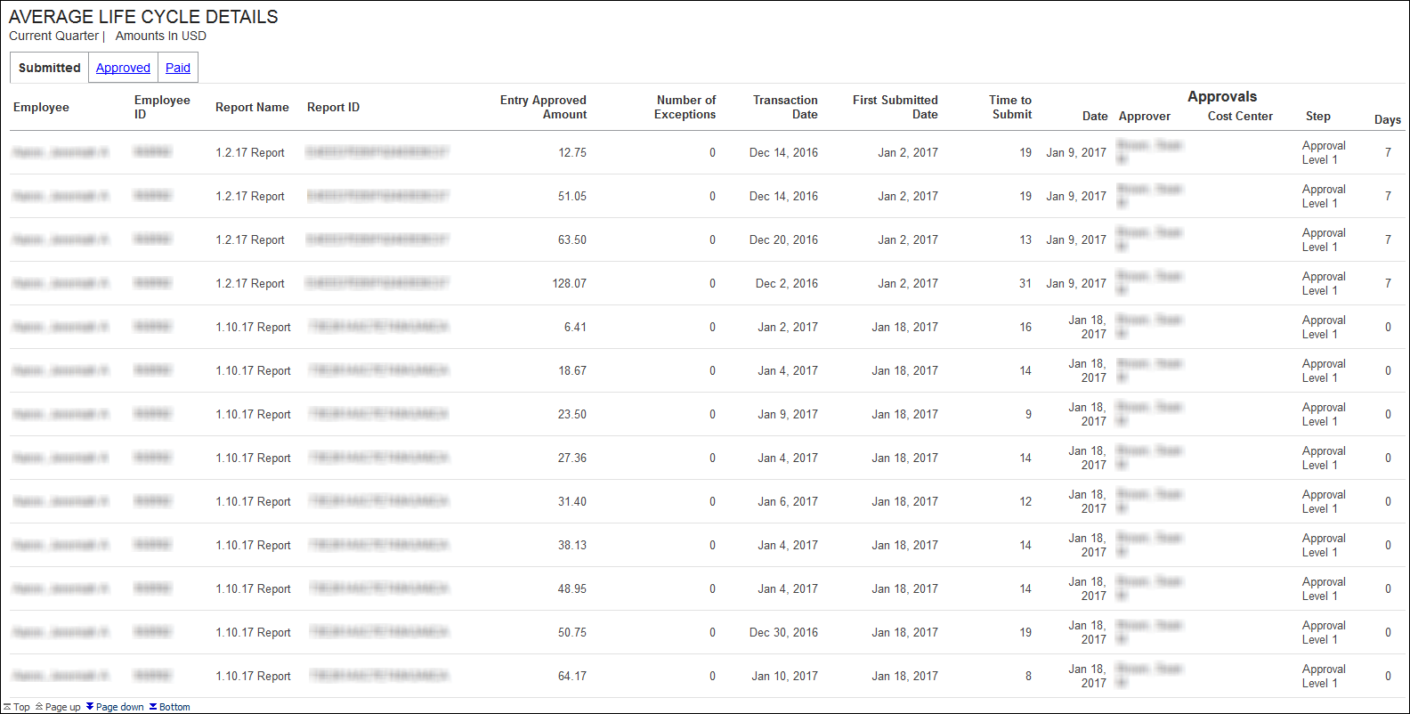
The Average Life Cycle section provides a visualization of the current quarter's life cycle averages for your company's expense reports, as well as the average total days for year-to-date. All numbers displayed in the Average Life Cycle section are averages.
- The Average Total Days number is the average of the submission, approval, and payments days for the year-to-date.
- The Current Quarter number is the average of the submission, approval, and payments days for the current quarter.
To the right of the Current Quarter value is the comparison to the industry average for an expense report life cycle. The comparison shows the difference between your company's expense report life cycle days and the industry average for expense report life cycle days. If the Current Quarter average exceeds the industry average, a warning icon, , is displayed.
- The Submission number is the average of the days from the date of a transaction until the time it is submitted in an expense report for the current quarter.
- The Approval number is the average of the days from the first time submission date of the expense report until it is approved for the current quarter.
- The Payment number is the average of the number of days from approval of the expense report until date it is submitted for payment for the current quarter.

Section: Aging of Transactions
Sample of the dashboard:
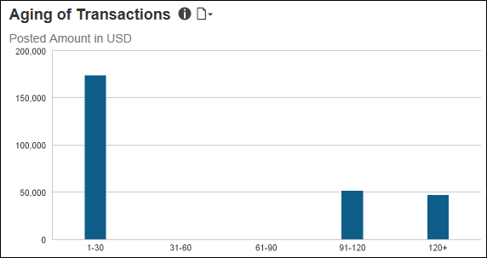
Sample of the drill-through report:
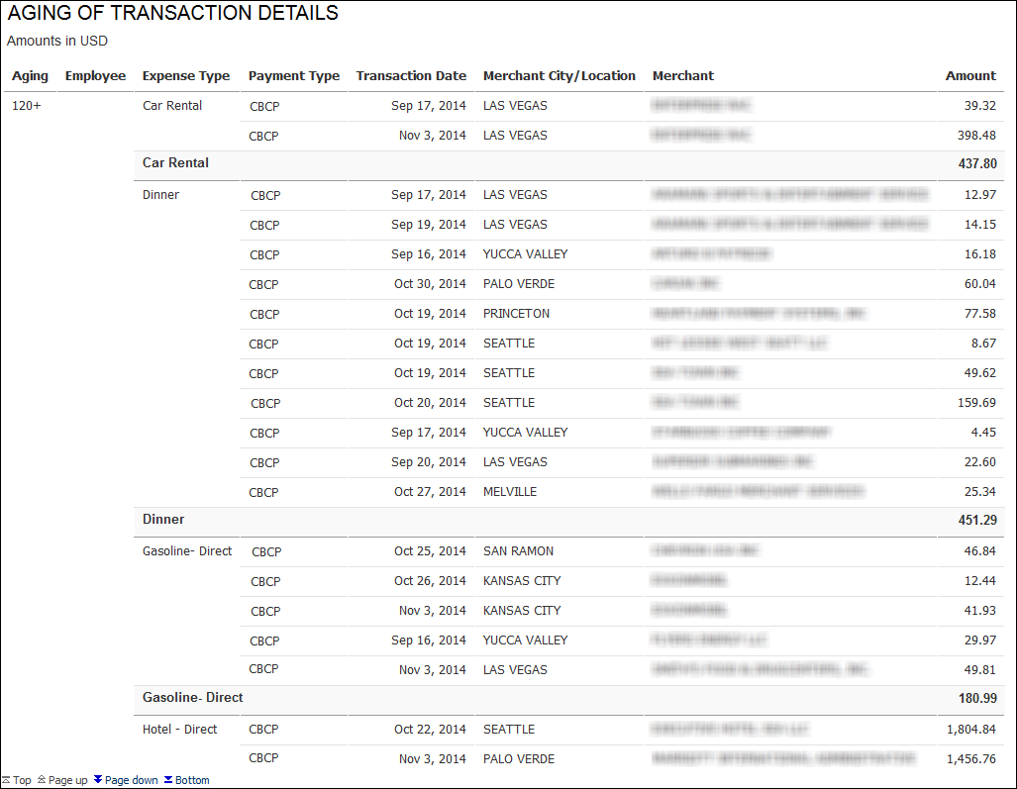
The Aging of Transactions section provides a visualization of the transaction aging for unsubmitted credit card transactions.
Unsubmitted credit card transactions are defined as transactions reflected on the corporate credit card statement that do not have a submitted matching expense report entry. The aging of a transaction is calculated from the difference between the date of the transaction and the current date. Credits are excluded from these calculations.
Unsubmitted credit card transactions are grouped in 30-day increments up to 120 days. All unsubmitted credit card transactions older than 120 days are grouped together under the 120+ bar. The graph also shows the total amount of money for the unsubmitted credit card transactions within each time period.
Placing your pointer over a bar displays the aging time period for the bar and the total amount of money associated with unsubmitted credit card transactions for the time period.
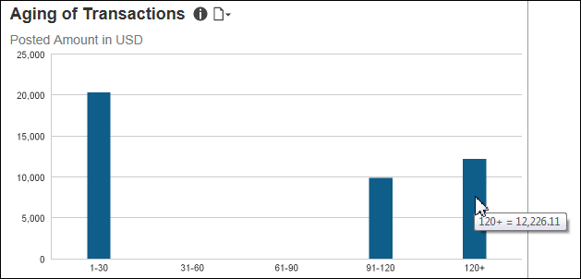
The following tables provide additional information about the Aging of Transactions Details drill-through report:

Report Header and Footer
Data Item Label/Name | Data Item Expression | Data Item Description
Amounts in | [Union3].[Reporting Currency] | Displays the currency code for the reporting currency (for example, USD, CAD, GBP)
N/A | AsOfDate() | Displays the date the report was run
N/A | PageNumber() | Displays the page number of the corresponding page
N/A | AsOfTime() | Displays the time the report was run

Report Data Items
Data Item Label | Data Item Name | Data Item Expression | Data Item Description
Aging | <Aging> | [Union3].[Aging] | Displays the aging (case  when [Expense].[Credit Card Accounts].[Age]< 31 then '1-30'  when [Age] between 31 and 60 then '31-60'  when [Age] between 61 and 90 then '61-90'  when [Age] between 91 and 120 then '91-120'  when [Age] >120 then '120+'  end,case  when [Expense].[Report Header Information].[Age]< 31 then '1-30'  when [Age] between 31 and 60 then '31-60'  when [Age] between 61 and 90 then '61-90'  when [Age] between 91 and 120 then '91-120'  when [Age] >120 then '120+'  end)
Employee | <Employee> | [Union3].[Employee] | Displays the employee ([Expense].[Credit Card Accounts].[Employee],[Expense].[Report Header Information].[Employee])
Expense Type | <Default Expense Type> | [Union3].[Default Expense Type] | Displays the expense type ([Expense].[Credit Card Accounts].[Default Expense Type],[Expense].[Report Header Information].[Default Expense Type])
Payment Type | <Payment Type> | [Union3].[Payment Type] | Displays the payment type ([Expense].[Credit Card Accounts].[Payment Type],[Expense].[Report Header Information].[Payment Type])
Transaction Date | <Transaction Date> | [Union3].[Transaction Date] | Displays the transaction date ([Expense].[Credit Card Accounts].[Transaction Date],[Expense].[Report Header Information].[Transaction Date])
Merchant City/Location | <Merchant City/Location> | [Union3].[Merchant City/Location] | Displays the merchant city/location ([Expense].[Credit Card Accounts].[Merchant City/Location],[Expense].[Report Header Information].[Merchant City/Location])
Merchant | <Merchant> | [Union3].[Merchant] | Displays the merchant ([Expense].[Credit Card Accounts].[Merchant],[Expense].[Report Header Information].[Merchant])
Amount | <Posted Amount> | [Union3].[Posted Amount] | Displays the amount ([Expense].[Credit Card Accounts].[Posted Amount],[Expense].[Report Header Information].[Posted Amount])
Total(Posted Amount) | <Total(Posted Amount)> | [Posted Amount] | Displays the total(Posted Amount)

Section: Payment Types
Sample of the dashboard:
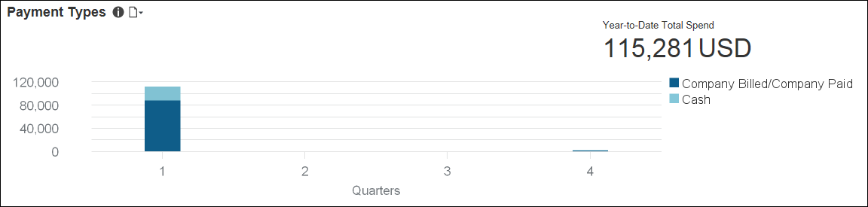
Sample of the drill-through report:
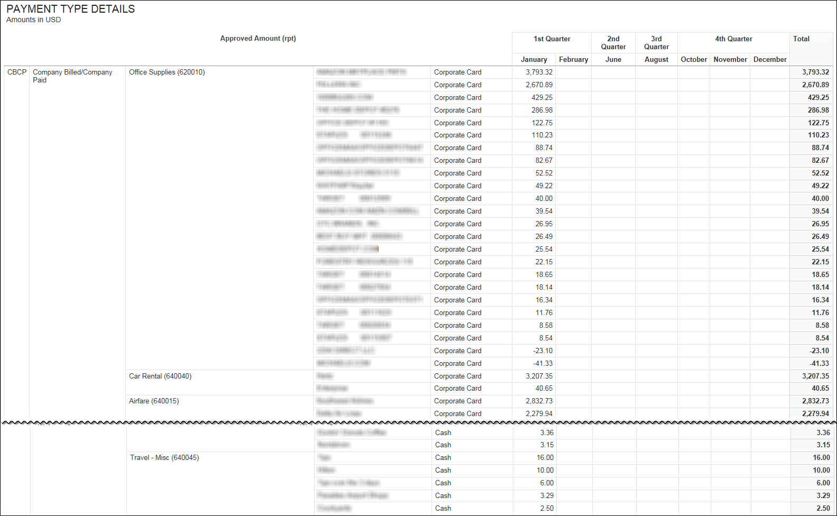
Payment types are the way an employee pays for an expense during a transaction. The Payment Types section provides a visualization of the active payment types associated with all approved expense entries by quarter; and the amount of money associated with the approved expenses for each payment type. The Payment Types section also displays the total amount of money associated with these approved expenses for the year-to-date.
Placing your pointer over a payment type segment on a bar displays the quarter, payment type, and total amount of money associated with the approved expenses for the payment type.
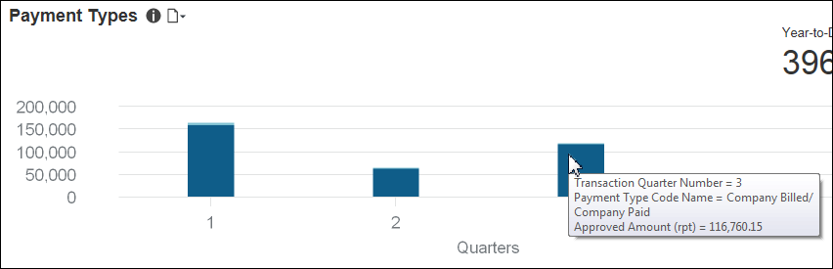
The following tables provide additional information about the Invoice Spend by Payment Method and Vendor - Details drill-through report:

Report Header and Footer
Data Item Label/Name | Data Item Expression | Data Item Description
Date | ParamDisplayValue('pDateOptions') +' | ' | Displays the current date
Amounts in | [Expense].[Entry Information].[Reporting Currency] | Displays the currency code for the reporting currency (for example, USD, CAD, GBP)
N/A | AsOfDate() | Displays the date the report was run
N/A | PageNumber() | Displays the page number of the corresponding page
N/A | AsOfTime() | Displays the time the report was run

Report Data Items
Data Item Label | Data Item Name | Data Item Expression | Data Item Description
N/A | <Payment Type Code> | [Expense].[Entry Information].[Payment Type Code] | Displays the payment type code
N/A | <Payment Type Code Name> | [Expense].[Entry Information].[Payment Type Code Name] | Displays the payment type code name
N/A | <Expense Type> | [Expense].[Entry Information].[Expense Type] | Displays the expense type
N/A | <Vendor> | [Expense].[Entry Information].[Vendor] | Displays the vendor
N/A | <Payment Type> | [Expense].[Entry Information].[Payment Type] | Displays the payment type
N/A | <Transaction Quarter> | "case when ([Fiscal Flag]='Y') then [Expense].[Entry Information].[Transaction Fiscal Quarter]  else [Expense].[Entry Information].[Transaction Quarter]  end" | Displays the transaction quarter
N/A | <Transaction Month> | "case when ([Fiscal Flag]='Y') then [Expense].[Entry Information].[Transaction Fiscal Month]  else [Expense].[Entry Information].[Transaction Month]  end" | Displays the transaction month

Section: Top 10 Spending Employee
Sample of the dashboard:
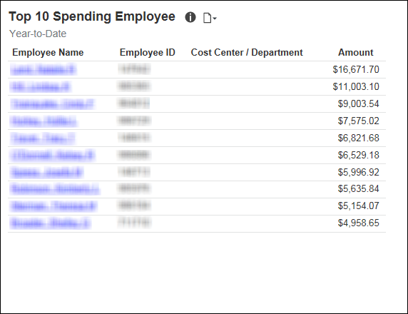
Sample of the drill-through report:
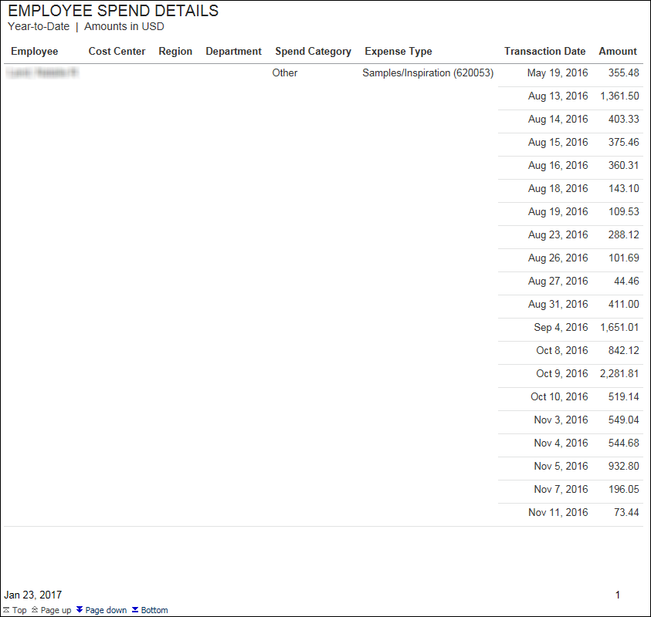
The Top 10 Spending Employee section provides a visualization of your company's top 10 spending employees, to help identify the types of spend your employees have.
Details about the types of spend are available in the Employee Spend Details drill-through report. The Employee Spend Details report lets your company know who are the top spenders and the total spend for those employees.
The Amount column displays an employee's total spend for year-to-date. For each employee in the list, the Amount column pulls the employee's spend from their expense reports, but excludes accruals, bookings, parent entries, and personal entries.
Clicking the name of an employee in the list opens a detailed spend report for the employee in a separate window.

Section: Policy Exceptions by Type
Sample of the dashboard:
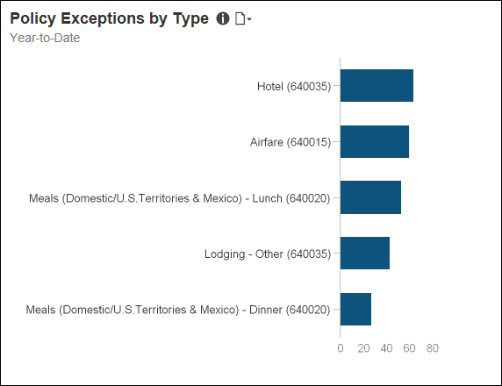
Sample of the drill-through report:
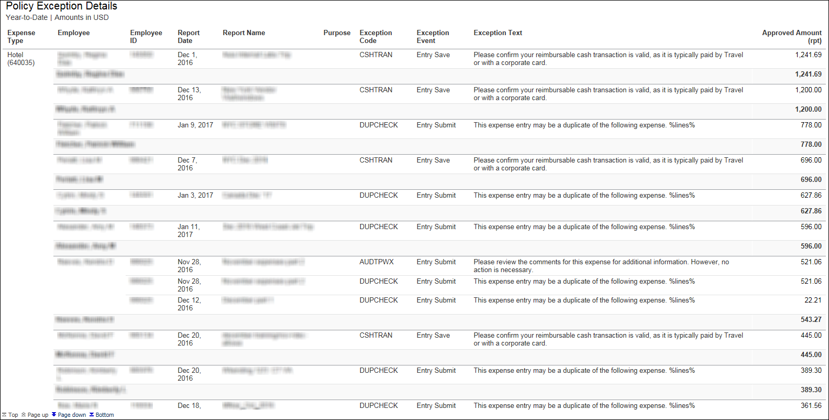
The Policy Exceptions by Type section provides a visualization of your company's top 5 policy exceptions identified on the submitted expense line items for year-to-date. The purpose of this visualization is to help identify the most common policy exceptions for expenses. Each bar represents the total number of exceptions for year-to-date.
Placing your pointer over a bar displays the expense type and the total number of policy exceptions associated with the expense type for year-to-date.
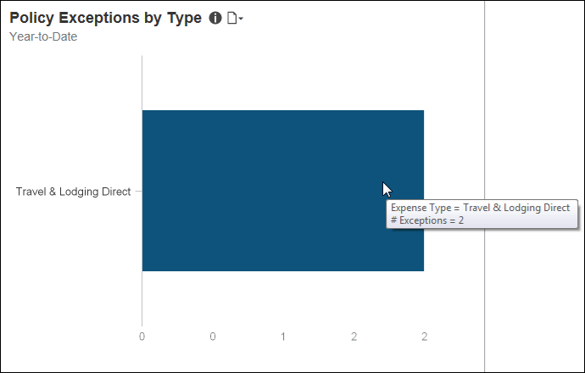

Dashboard: Invoice Management Overview
Available to:  Analysis  Intelligence

Overview
The Invoice Management Overview dashboard provides key metrics for your company's payment requests (invoices) and purchase requests, and the payment request and purchase request life cycles, at a glance. The dashboard can help you track how the metrics are trending, the impact on cash flow, and help evaluate the need for changes in the procurement process to optimize it and optimize cash flow.
While the Department Manager Overview, Expense Management Overview, and Invoice Management Overview dashboards display data based on the user's access rights, the Combined Spend Overview, Expense Management Overview, and Invoice Management dashboards were designed for users that typically have global access to company spend data.

Dashboard
Sample of the full dashboard:
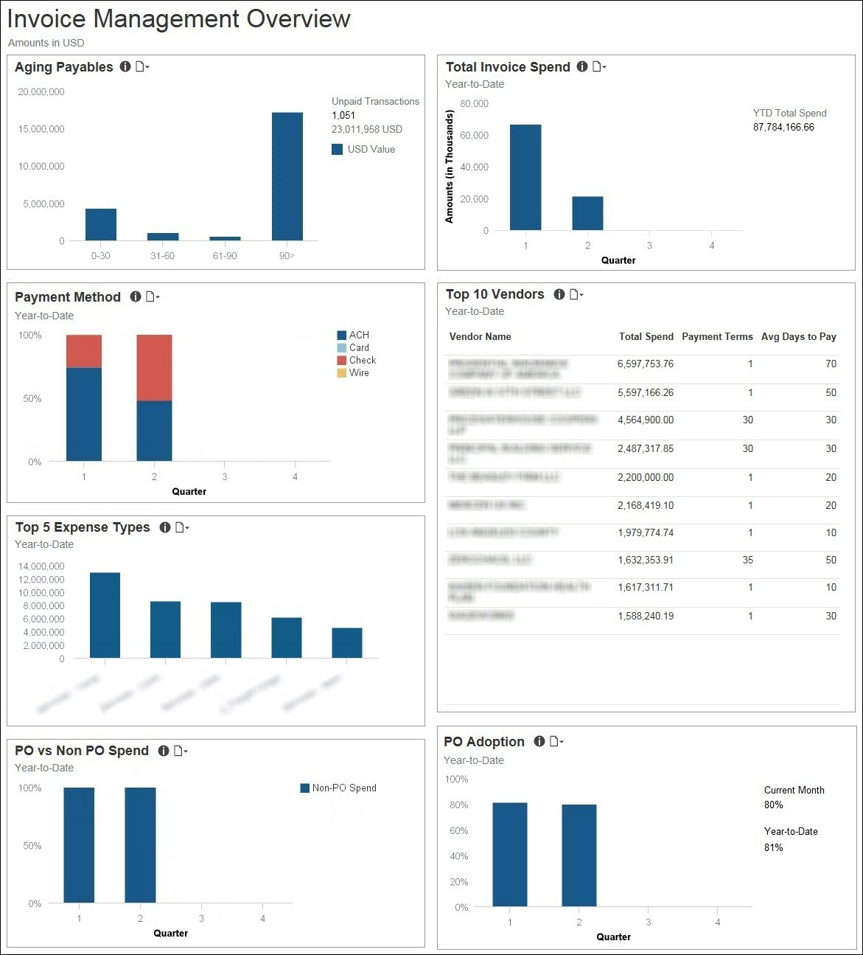

Section: Aging Payables
Sample of the dashboard:
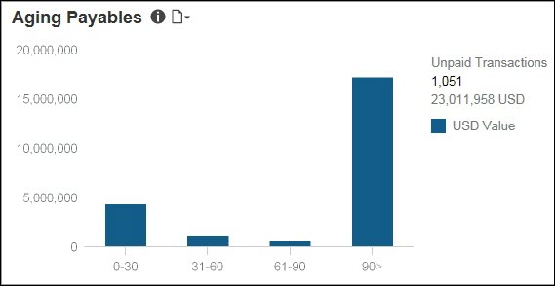
Sample of the drill-through report:
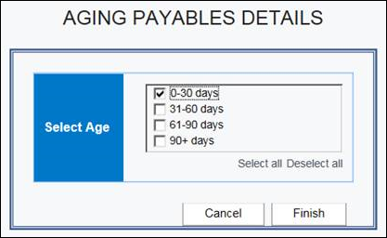
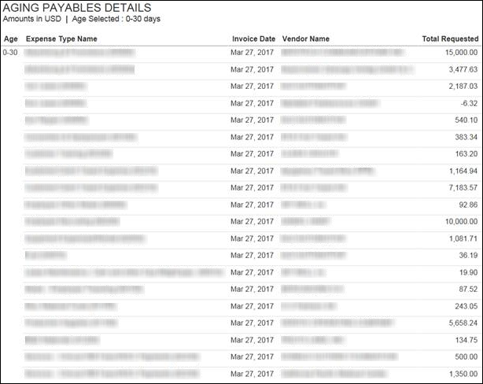
The Aging Payables section provides a visualization of the outstanding (not paid) invoice payables grouped by the age of the invoices in days. Unpaid invoices are grouped in 30-day increments up to 90 days. Unpaid invoices older than 90 days are grouped together under the 90> bar. To the right of the bar graph is the total number of unpaid invoices and the total amount due for these unpaid invoices currently in Invoice. The bar graph only includes unpaid invoices that are past due.
The data in the Aging Payables section matches the data in the existing Invoice report: Request Aging Report. The calculation for aging is the difference between the Date of Invoice and the Current Date field values. The dollar amounts are based on the Approved Amount field.
The information in this section can be used to help manage cash flow and determine whether there are outstanding accounts payables that are past due and require attention.
Placing your pointer over a bar displays the invoice aging time period for the bar and the total amount of money associated with unpaid invoices for the time period.
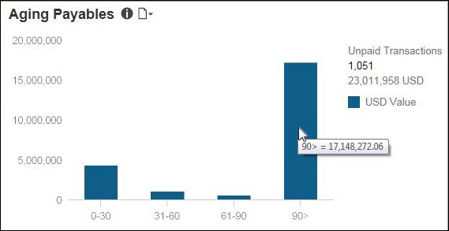
The following tables provide additional information about the Aging Payables Details drill-through report:

Report Header and Footer
Data Item Label/Name | Data Item Expression | Data Item Description
Amounts in | [Invoice].[Payment Request Line Items].[Reporting Currency] | Displays the currency code for the reporting currency (for example, USD, CAD, GBP)
Age Selected | ' ' + ParamDisplayValue('p_Age') + ' ' | Displays the age(s) selected from the Select Age prompts on the Prompts page
N/A | AsOfDate() | Displays the date the report was run
N/A | PageNumber() | Displays the page number of the corresponding page
N/A | AsOfTime() | Displays the time the report was run

Report Data Items
Data Item Label | Data Item Name | Data Item Expression | Data Item Description
Age Range | <Age Range> | "case when [Age in Days] < 31then '0-30' when [Age in Days] between 31 and 60 then '31-60' when [Age in Days] between 61 and 90 then '61-90' when [Age in Days] > 90  then '90+' else null end" | Displays the age range
Invoice Date | <Invoice Date> | [Invoice].[Payment Request Dates and Statuses].[Invoice Date] | Displays the invoice date
Expense Type Name | <Expense Type Name> | [Invoice].[Payment Request Line Items].[Expense Type Name] | Displays the expense type name
Vendor Name | <Supplier Name> | [Invoice].[Payment Request Header Information].[Supplier Name] | Displays the vendor name
Total Requested | <Total Requested (rpt)> | [Invoice].[Payment Request Line Items].[Total Requested (rpt)] | Displays the total requested

Section: Total Invoice Spend
Sample of the dashboard:
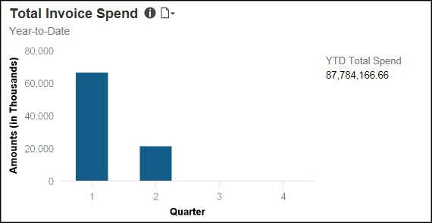
Sample of the drill-through report:
The Total Invoice Spend and Top 5 Expense Types sections have the same detail report. They both use the Invoice Expense Type Spend Trend report located in the Standard Reports > Invoice folder.
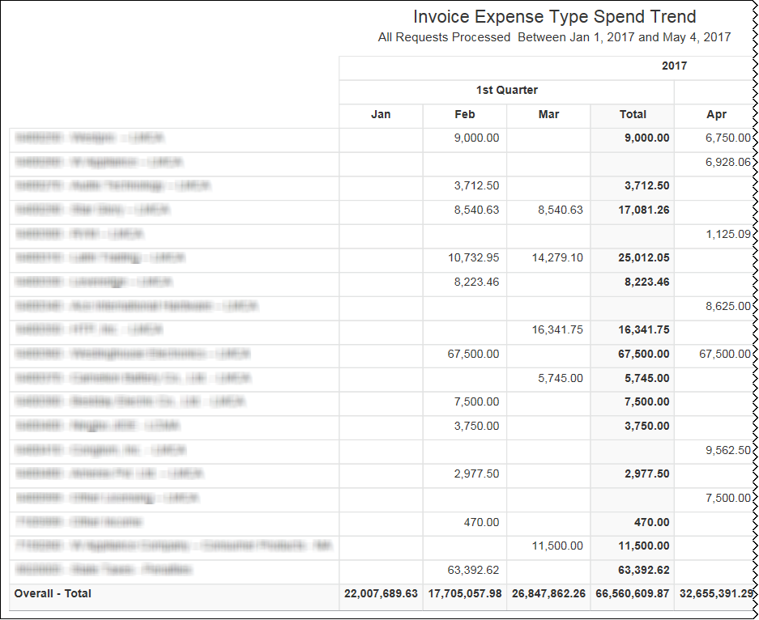
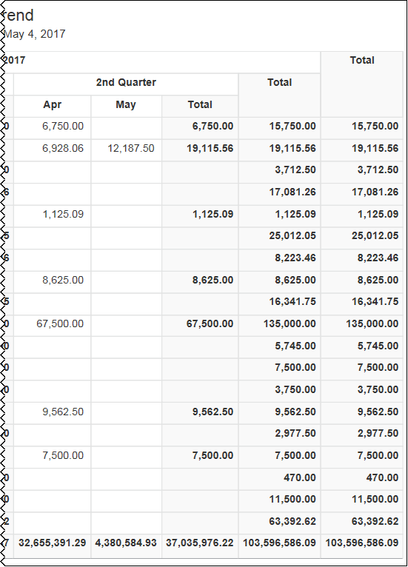
The Total Invoice Spend section provides a visualization of the total invoice spend for the year-to-date by quarter. The spend is derived from invoices that have a status of Paid.
The information in this section can be used to help forecast budgets and spend.
Placing your pointer over a bar displays the quarter and the total year-to-date invoice spend for the selected quarter. To the right of the bar graph is the total invoice spend for year-to-date.
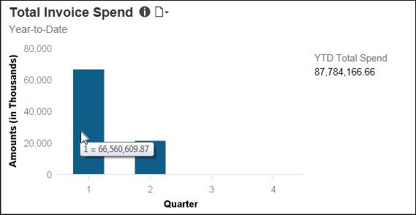

Section: Payment Method
Sample of the dashboard:
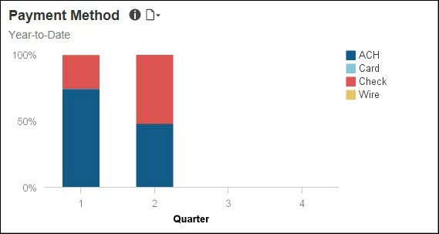
Sample of the drill-through report:
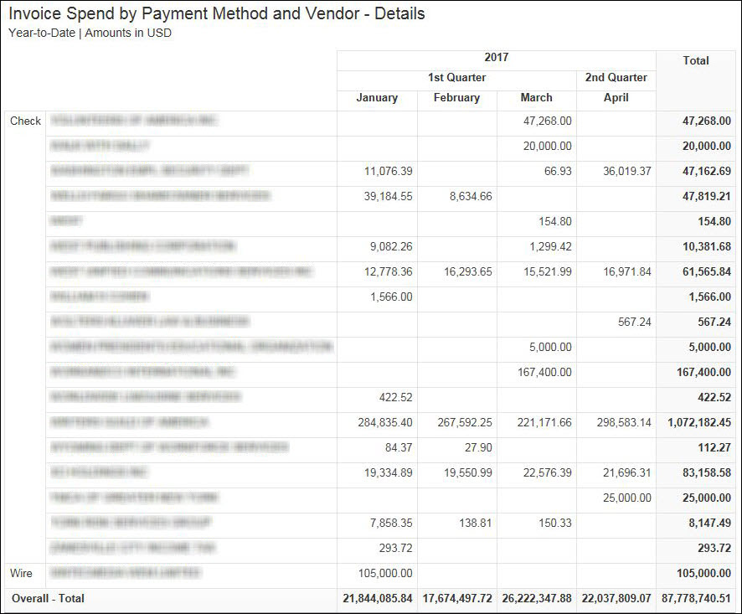
The Payment Method section provides a visualization of the year-to-date spend by quarter for each payment method used to pay for invoices. The spend by payment method is derived from invoices that have a status of Paid.
The information in this section can be used to help optimize spend on your credit card programs.
Placing your pointer over a payment method segment on a bar displays the payment method, quarter, and percentage of invoices paid by the payment method.
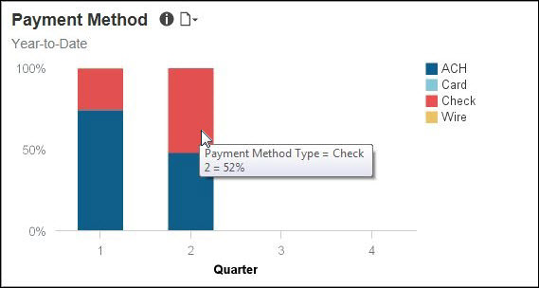
The following tables provide additional information about the Invoice Spend by Payment Method and Vendor - Details drill-through report:

Report Header and Footer
Data Item Label/Name | Data Item Expression | Data Item Description
Payment Method | ParamDisplayValue('p_paymentmethod')+' '
Quarter | ParamDisplayValue('p_quarterno')+' ' | Displays the yearly quarter
Amounts In | '+[Invoice].[Payment Request Header Information].[Reporting Currency] | Displays the currency type
Payment Method | ParamDisplayValue('p_paymentmethod')+' ' | Displays the method of payment
Quarter | ParamDisplayValue('p_quarterno')+' ' | Displays the yearly quarter
Amounts in | '+[Invoice].[Payment Request Header Information].[Reporting Currency] | Displays the currency code for the reporting currency (for example, USD, CAD, GBP)
N/A | AsOfDate() | Displays the date the report was run
N/A | PageNumber() | Displays the page number of the corresponding page
N/A | AsOfTime() | Displays the time the report was run

Report Data Items
Data Item Label | Data Item Name | Data Item Expression | Data Item Description
N/A | <Payment Method Type> | [Invoice].[Payment Request Header Information].[Payment Method Type] | Displays Method of Payment
N/A | <Supplier Name> | [Invoice].[Payment Request Header Information].[Supplier Name] | Displays Supplier of Name
N/A | <Process Payment Year Name> | "CASE  WHEN [Invoice].[Payment Request Dates and Statuses].[Fiscal Flag] = 'Y' THEN [Invoice].[Payment Request Dates and Statuses].[Processing Payment Fiscal Year Name]  ELSE  cast([Invoice].[Payment Request Dates and Statuses].[Process Payment Year], varchar(50))  END" | Displays the Year of the Processed Payment
N/A | <Process Payment Quarter> | "CASE  WHEN [Invoice].[Payment Request Dates and Statuses].[Fiscal Flag] = 'Y'  THEN [Invoice].[Payment Request Dates and Statuses].[Process Payment Fiscal Quarter]  ELSE [Invoice].[Payment Request Dates and Statuses].[Process Payment Quarter]  END" | Displays the Quarter of the Processed Payment
N/A | <Process Payment Quarter> | "CASE  WHEN [Invoice].[Payment Request Dates and Statuses].[Fiscal Flag] = 'Y'  THEN [Invoice].[Payment Request Dates and Statuses].[Process Payment Fiscal Quarter]  ELSE [Invoice].[Payment Request Dates and Statuses].[Process Payment Quarter]  END" | Displays the Quarter of the Processed Payment
N/A | <Process Payment Month> | "CASE  WHEN [Invoice].[Payment Request Dates and Statuses].[Fiscal Flag] = 'Y'  THEN [Invoice].[Payment Request Dates and Statuses].[Process Payment Fiscal Month]  ELSE [Invoice].[Payment Request Dates and Statuses].[Process Payment Month]  END" | Displays the Month of the Processed Payment
N/A | <Process Payment Month> | "CASE  WHEN [Invoice].[Payment Request Dates and Statuses].[Fiscal Flag] = 'Y'  THEN [Invoice].[Payment Request Dates and Statuses].[Process Payment Fiscal Month]  ELSE [Invoice].[Payment Request Dates and Statuses].[Process Payment Month]  END" | Displays the Month of the Processed Payment
N/A | <Process Payment Month> | "CASE  WHEN [Invoice].[Payment Request Dates and Statuses].[Fiscal Flag] = 'Y'  THEN [Invoice].[Payment Request Dates and Statuses].[Process Payment Fiscal Month]  ELSE [Invoice].[Payment Request Dates and Statuses].[Process Payment Month]  END" | Displays the Month of the Processed Payment
N/A | <Process Payment Month> | "CASE  WHEN [Invoice].[Payment Request Dates and Statuses].[Fiscal Flag] = 'Y'  THEN [Invoice].[Payment Request Dates and Statuses].[Process Payment Fiscal Month]  ELSE [Invoice].[Payment Request Dates and Statuses].[Process Payment Month]  END" | Displays the Month of the Processed Payment

Section: Top 10 Vendors
Sample of the dashboard:
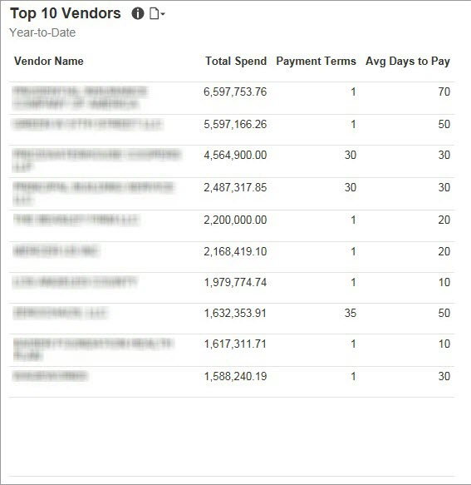
Sample of the drill-through report:
The selections you make for the Select Date prompt determine which prompts are displayed on the page. For example, if you select the Process Payment Date and YTD options, only the Select Date and Rank prompts are displayed.
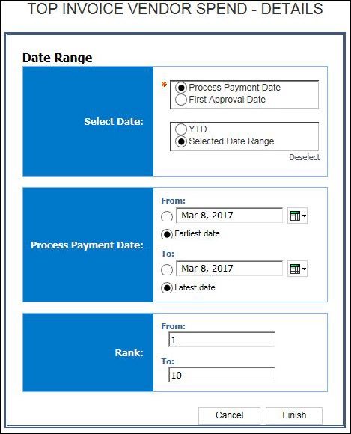
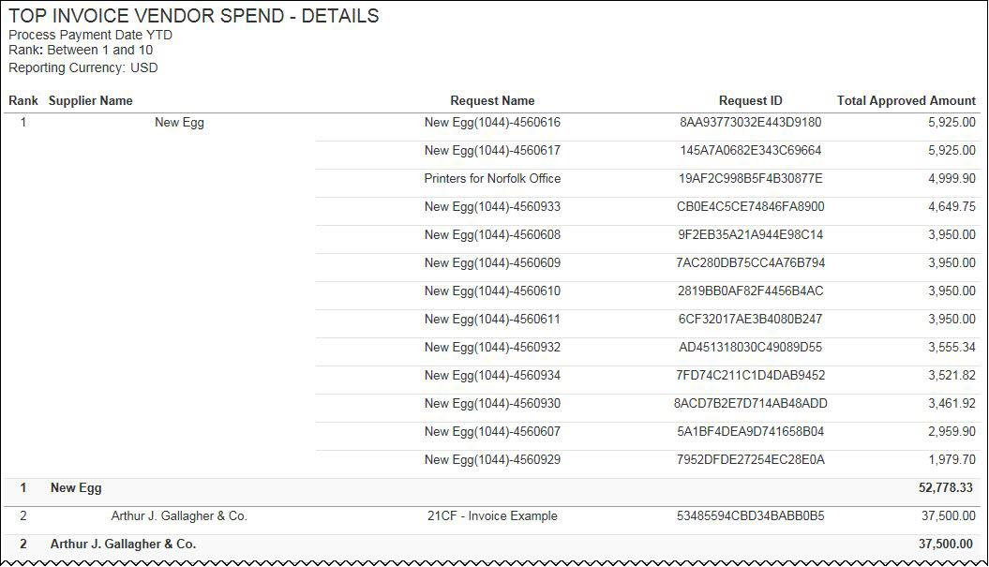
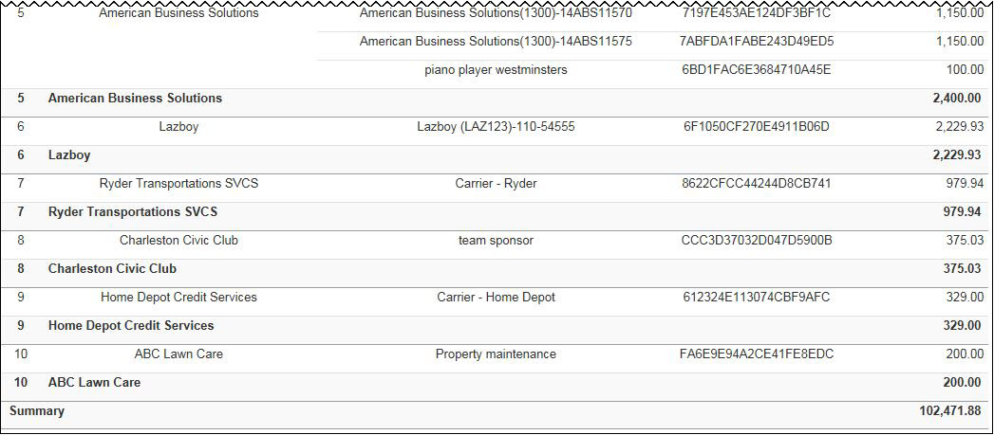
The Top 10 Vendors section provides a visualization of the company's top 10 vendors with the highest total invoice spend for the year-to-date. The Top 10 Vendors section also displays the payment terms and average days to pay for the top 10 vendors. The Total Spend value is the year-to-date spend based on the invoices with a status of Paid. The Avg Days to Pay value is calculated using the Invoice Date and the Paid Date.
The information in this section can be used to help negotiate the best rates and terms with your vendors, and determine if cash flow is maximized by not paying invoices too soon, based on the invoice payment terms.

Section: Top 5 Expense Types
Sample of the dashboard:
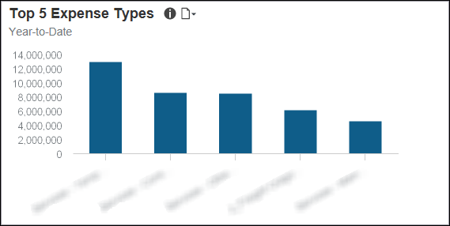
Sample of the drill-through report:
The Total Invoice Spend and Top 5 Expense Types sections have the same detail report. They both use the Invoice Expense Type Spend Trend report located in the Standard Reports > Invoice folder.
The Top 5 Expense Types section provides a visualization of the year-to-date spend for the top five Invoice expense types. The spend by expense type is derived from invoices that have a status of Paid.
The information in this section can be used to help forecast and budget for spend.
Placing your pointer over a bar displays the Invoice expense type name and the total spend from paid invoices that are associated with the expense type for the year-to-date.
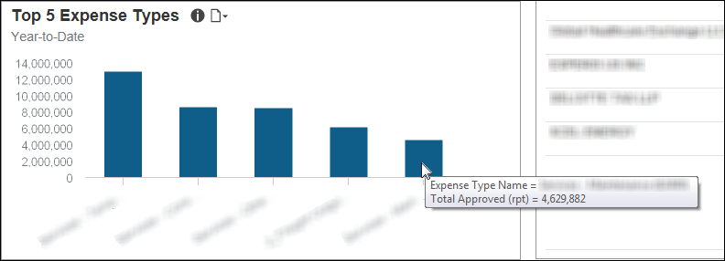

Section: PO vs Non PO Spend
Sample of the dashboard:
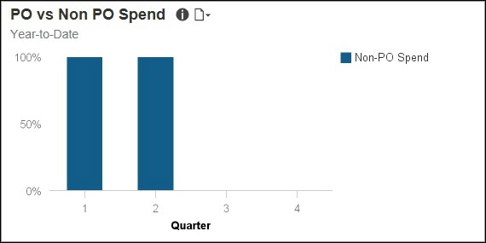
Sample of the drill-through report:
The PO vs Non PO Spend and PO Adoption sections have the same detail report.
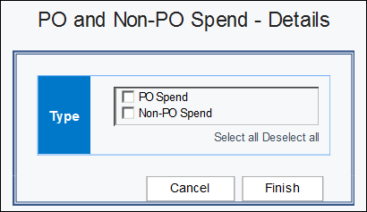
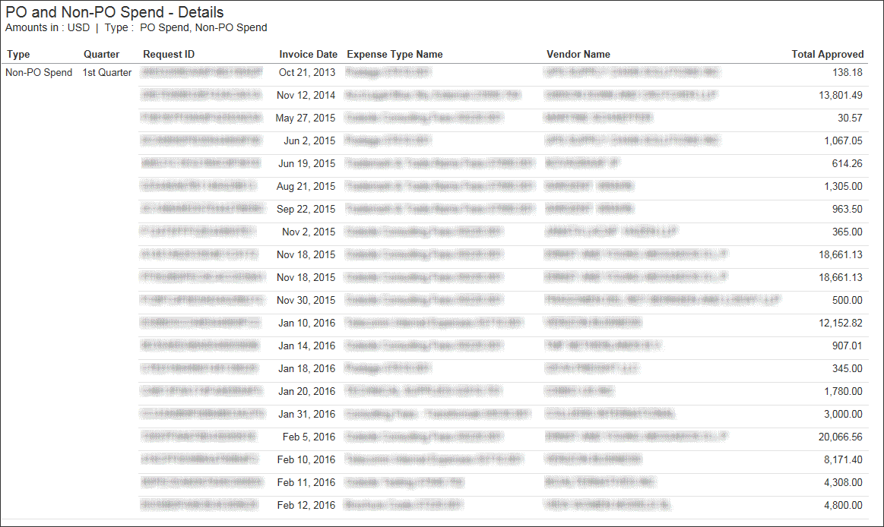
The PO vs Non PO Spend section provides a visualization of the purchase order spend versus non-purchase order spend for the year-to-date by quarter. The purchase order spend is derived from invoices that have a status of Paid and have an associated purchase order number. Non-purchase order spend is derived from invoices that have a status of Paid and do not have an associated purchase order number.
The information in this section can be used to help evaluate purchase order spend and determine the best approaches for driving more spend through the purchase order system.
Placing your pointer over a segment on a bar displays whether the segment spend is purchase order spend (PO Spend) or non-purchase order spend (Non-PO Spend), the quarter, and the percentage of PO Spend or Non-PO spend for the quarter-to-date.
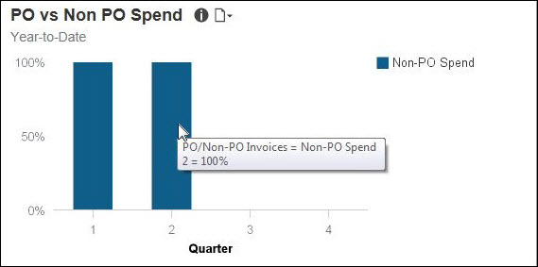

Section: PO Adoption
Sample of the dashboard:
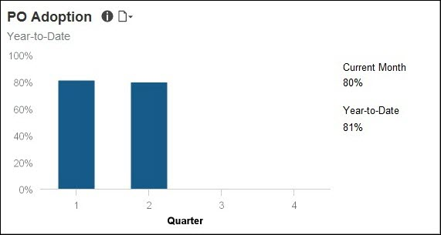
Sample of the drill-through report:
The PO vs Non PO Spend and PO Adoption sections have the same detail report.
The PO Adoption section provides a visualization of the adoption rate, represented as a percentage, for your purchase order system for the year-to-date by quarter. The purchase order adoption rate is defined as the percent of invoices that have an associated purchase order number compared to the total number of invoices.
The information in this section can be used to help evaluate purchase order adoption rate for your organization and determine the best approaches for driving more spend through the purchase order system.
Placing your pointer over a segment on a bar displays the quarter and its purchase order adoption rate percentage for the quarter-to-date.
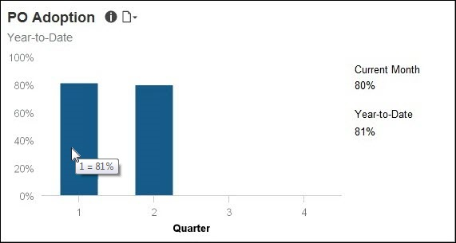

Appendix: Remove or Restore the Persona Dashboard Tab
To remove the tab from the menu bar, BI Managers must:
- With the Persona Dashboard tab displayed, click the icon on the left side of the menu bar.
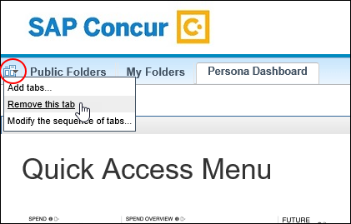
- Click Remove this tab.
If the tab does not appear (was previously turned off), to add the Persona Dashboard tab back to the menu bar, BI Managers must:
- Navigate to Public Folders ‎> Intelligence - Standard Reports ‎> Persona Dashboards.
- On the right side of the Persona Dashboard row, click the "add" icon.



