Table of Contents
Chapter 21: Folder – Travel Request 21-1
Report: Approved Travel Requests by Employee 21-1
Available to:  Analysis  Intelligence 21-1
Uses:  Expense Data R Travel / TripLink Data 21-1
***Not applicable for Standard Edition*** 21-1
Report: Authorized Travel Requests Without Expense Report Entry 21-3
Available to:  Analysis  Intelligence 21-3
Uses:  Expense Data R Travel / TripLink Data 21-3
***Not applicable for Standard Edition*** 21-3
Report: Top 10 Longest to Approve 21-4
Available to:  Analysis  Intelligence 21-4
Uses:  Expense Data R Travel / TripLink Data 21-4
***Not applicable for Standard Edition*** 21-4
Report: Travel Requests by City 21-5
Available to:  Analysis  Intelligence 21-5
Uses:  Expense Data R Travel / TripLink Data 21-5
***Not applicable for Standard Edition*** 21-5
Report: Travel Requests by Country 21-7
Available to:  Analysis  Intelligence 21-7
Uses:  Expense Data R Travel / TripLink Data 21-7
***Not applicable for Standard Edition*** 21-7
Report: Travel Requests by Segment 21-9
Available to:  Analysis  Intelligence 21-9
Uses:  Expense Data R Travel / TripLink Data 21-9
***Not applicable for Standard Edition*** 21-9
Report: Travel Requests Pending Approval 21-11
Available to:  Analysis  Intelligence 21-11
Uses:  Expense Data R Travel / TripLink Data 21-11
***Not applicable for Standard Edition*** 21-11
Report: Workflow Aging - Details 21-13
Available to:  Analysis  Intelligence 21-13
Uses:  Expense Data R Travel / TripLink Data 21-13
***Not applicable for Standard Edition*** 21-13

Revision History
Date | Notes / Comments / Changes
May 20, 2023 | Renamed the Completed Travel Requests Without Expense Report Entry the report to Authorized Travel Requests Without Expense Report Entry and updated the report images.
February 18, 2023 | Made the following updates to the Report: Completed Travel Requests Without Expense Report Entry section:  - Renamed the section from Report: Completed Travel Requests Without Expense Reports to Report: Completed Travel Requests Without Expense Report Entry. The report was renamed with the February 2023 release.  - Updated the images in the section to display the new report name.
January 21, 2022 | Updated the copyright year; no other changes; cover date not updated
February 20, 2021 | Updated the copyright year; no other changes
September 19, 2020 | Updated the Prompts page and report images for the Travel Requests by Country report. The Departure Country and Countries labels were renamed to Departure Country/Region and Countries/Region.
January 8, 2020 | Changed copyright; no other content changes
September 21, 2019 | Updated the image of the Travel Requests by Segment report to include the new Expense Type column.
April 13, 2019 | Updated the Prompts page and report images of the Travel Request by Segment report to include the updates to the Prompts page, and the addition of the Request Policy and Request Purpose columns to the report
February 9, 2019 | Removed references to Insight Premium from the guide and updated copyright
January 13 2018 | Changed copyright; no other content changes
December 15 2016 | Changed copyright; no other content changes
November 17 2016 | Updated report images to match the current application
August 15 2016 | Added the Workflow Aging – Details report
March 23 2016 | Changed the text under the heading from Travel Data to Travel / TripLink Data; no other content changes
September 18 2015 | Changed the chapter number; no other content changes
August 14 2015 | Moved from single book to individual "chapters" – no content changes

Folder – Travel Request

Report: Approved Travel Requests by Employee
Available to:  Analysis  Intelligence
Uses:  Expense Data R Travel / TripLink Data
***Not applicable for Standard Edition***
This report will display all Travel Requests that are currently in use.

Report Prompts
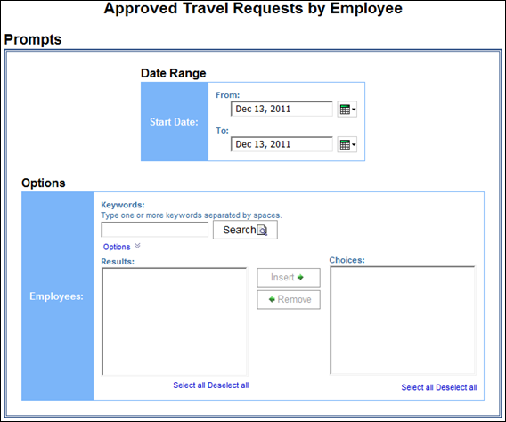

Report Output
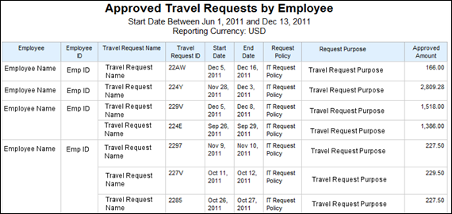

Report: Authorized Travel Requests Without Expense Report Entry
Available to:  Analysis  Intelligence
Uses:  Expense Data R Travel / TripLink Data
***Not applicable for Standard Edition***
This report will display all completed Travel Requests that do not have a Travel Request line item associated to a report entry. This will allow finance departments to identify liabilities and plan appropriately.

Report Prompts
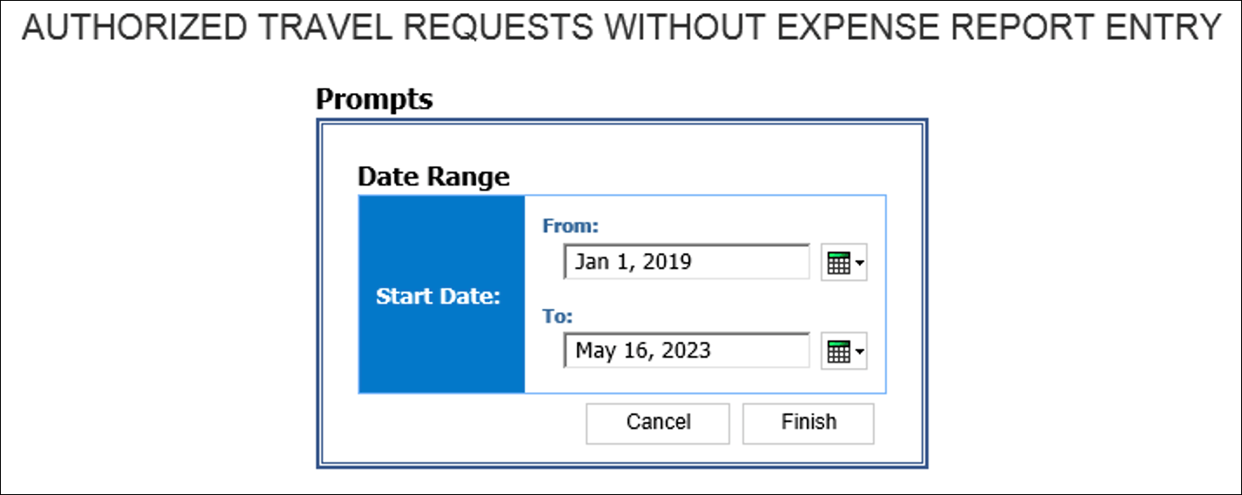

Report Output
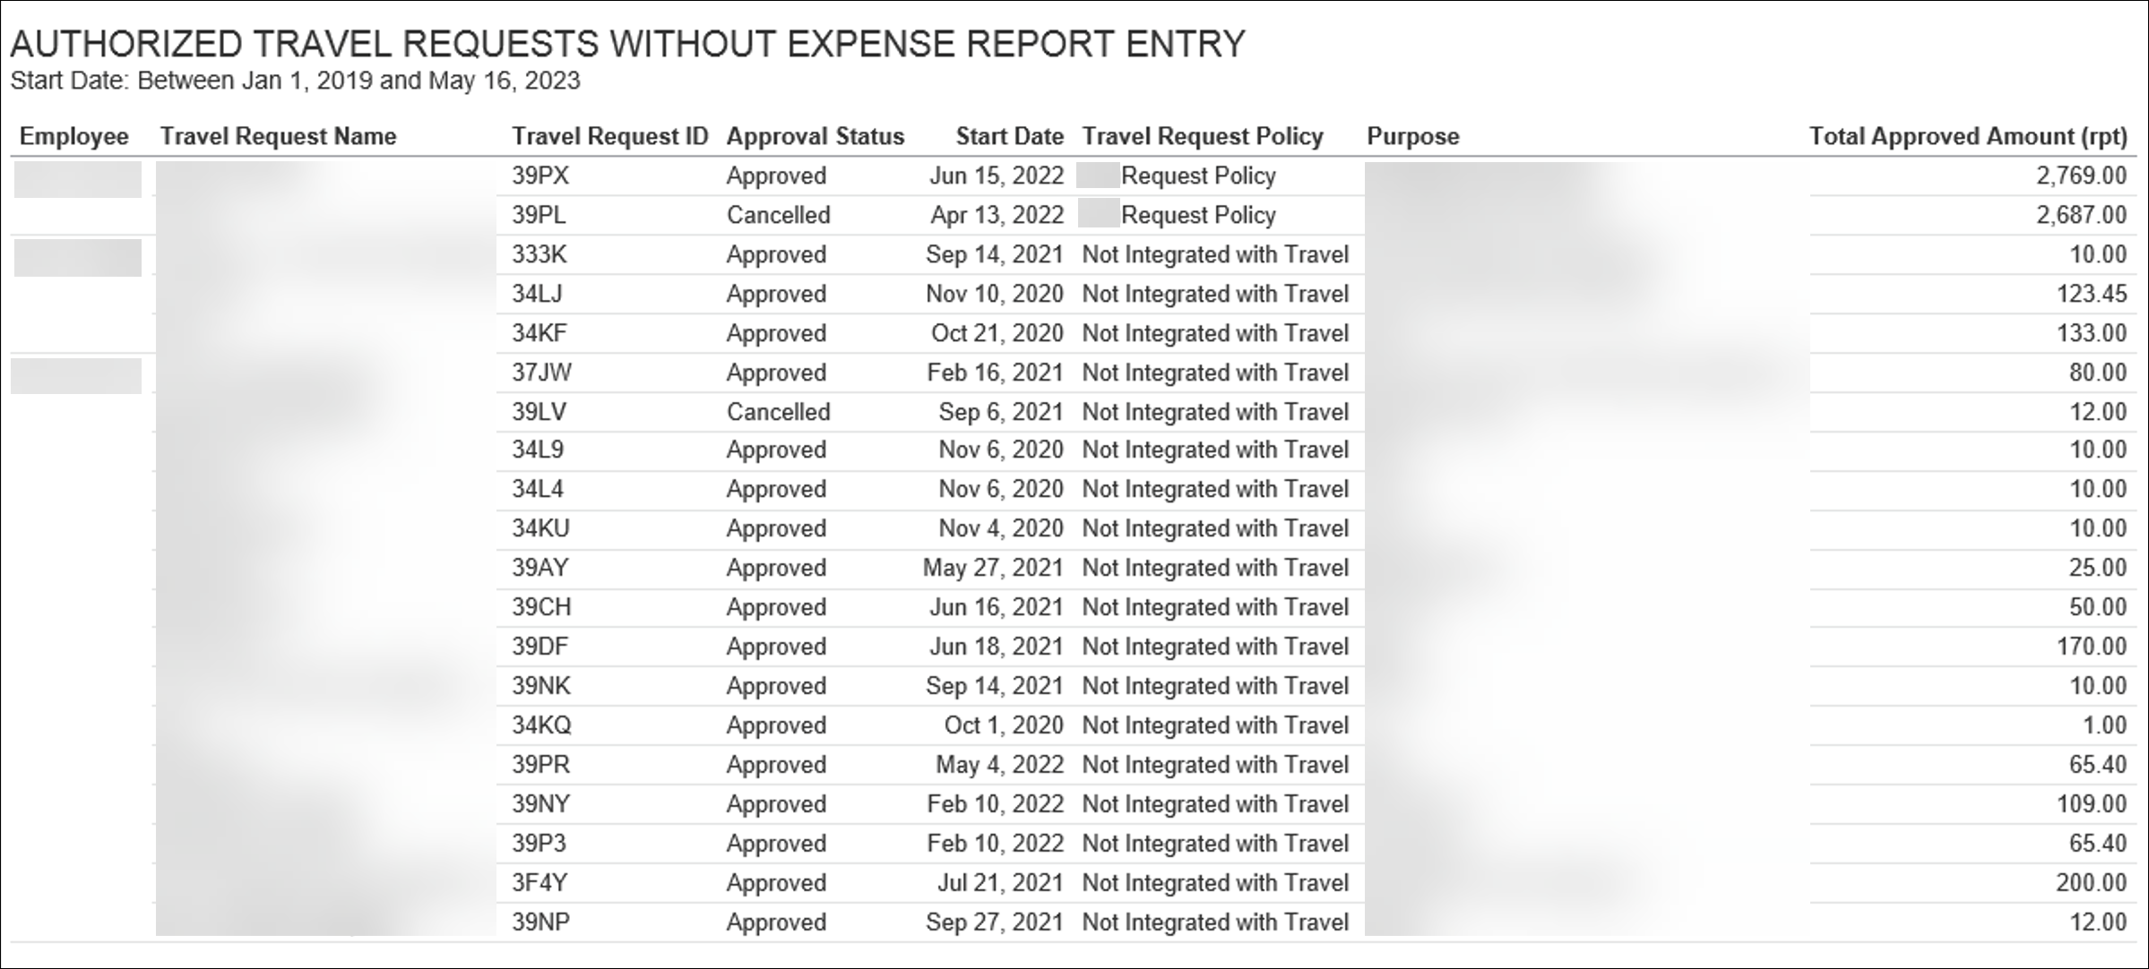

Report: Top 10 Longest to Approve
Available to:  Analysis  Intelligence
Uses:  Expense Data R Travel / TripLink Data
***Not applicable for Standard Edition***
This report provides a rank of the longest time to approve Travel Requests. This provides actionable information to the user and allows them to check whether it was due to a specific criteria or approver.

Report Prompts
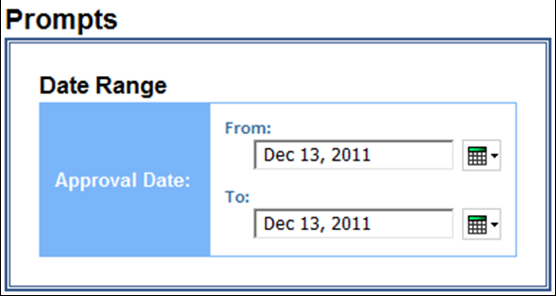

Report Output
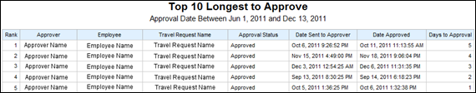

Report: Travel Requests by City
Available to:  Analysis  Intelligence
Uses:  Expense Data R Travel / TripLink Data
***Not applicable for Standard Edition***
This report displays the total number of Travel Requests filed on a city by city basis.

Report Prompts
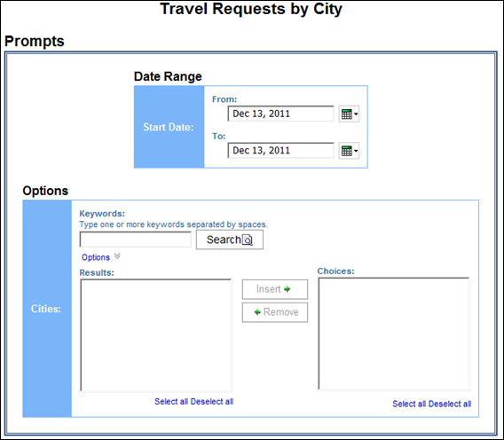

Report Output
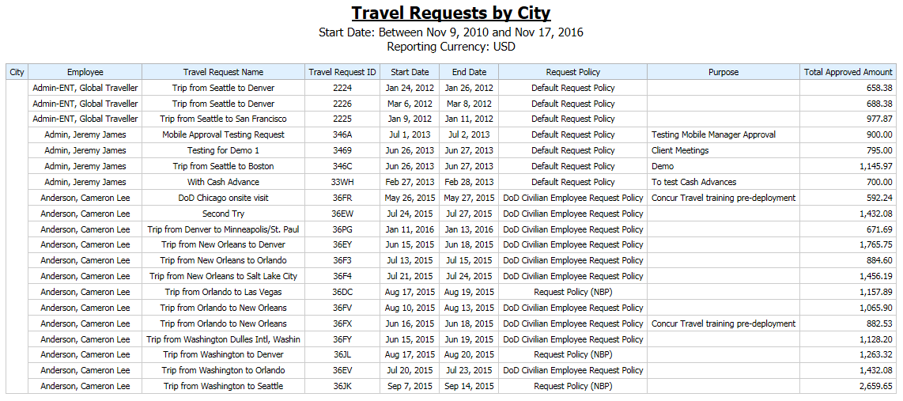

Report: Travel Requests by Country
Available to:  Analysis  Intelligence
Uses:  Expense Data R Travel / TripLink Data
***Not applicable for Standard Edition***
This report displays the total number of Travel Requests filed on a country by country basis.

Report Prompts
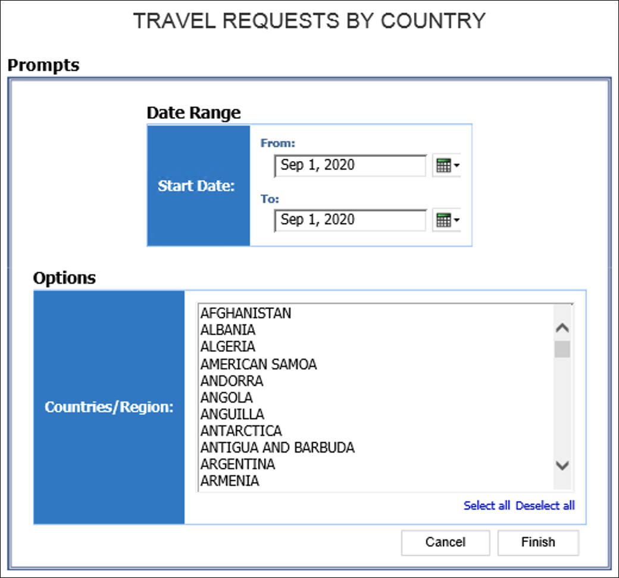

Report Output
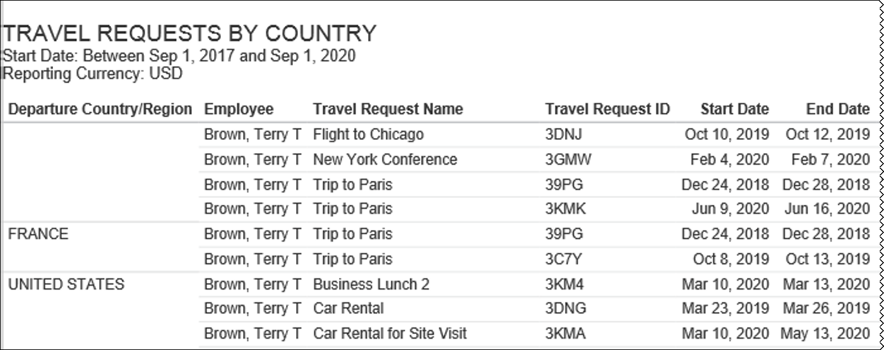
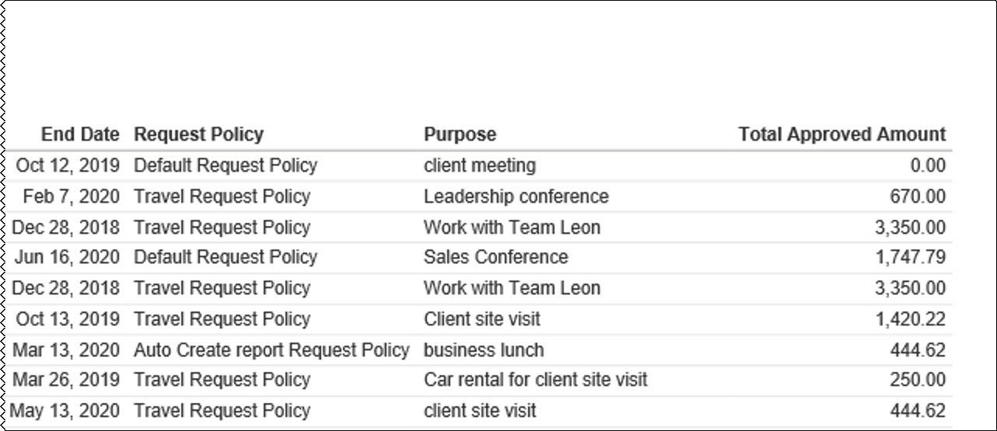

Report: Travel Requests by Segment
Available to:  Analysis  Intelligence
Uses:  Expense Data R Travel / TripLink Data
***Not applicable for Standard Edition***
This report shows the Travel Request Segment activity for a company.

Report Prompts
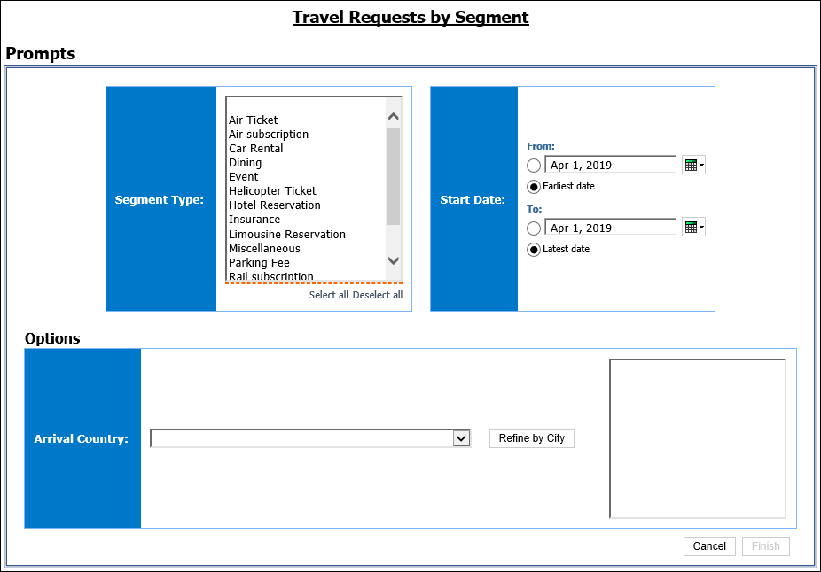

Report Output
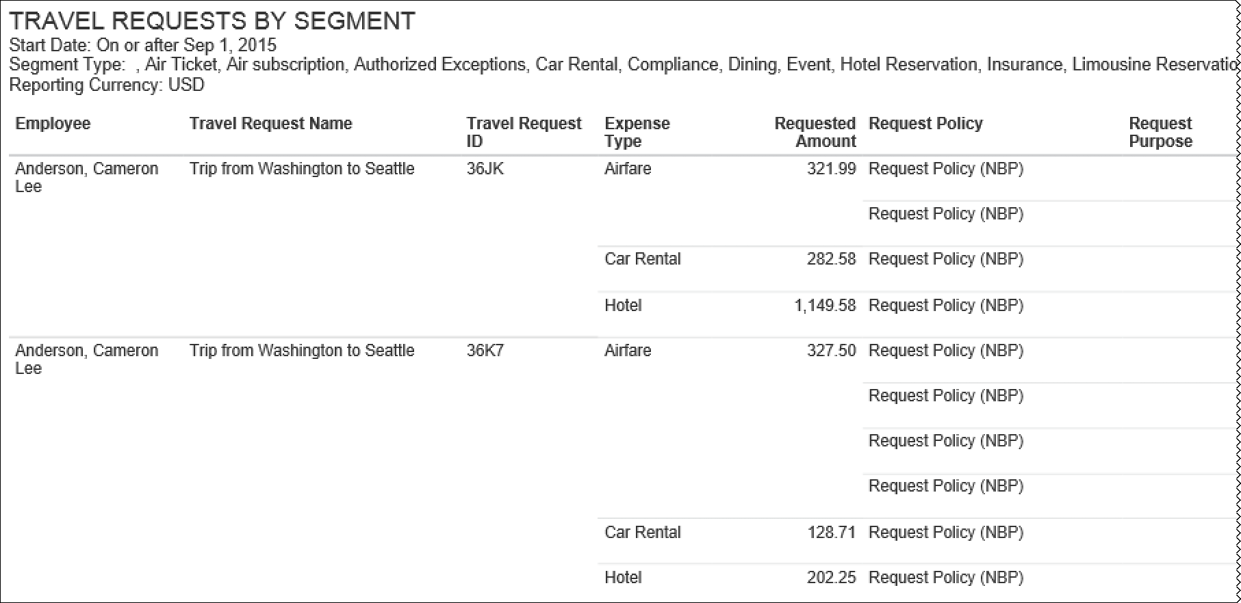
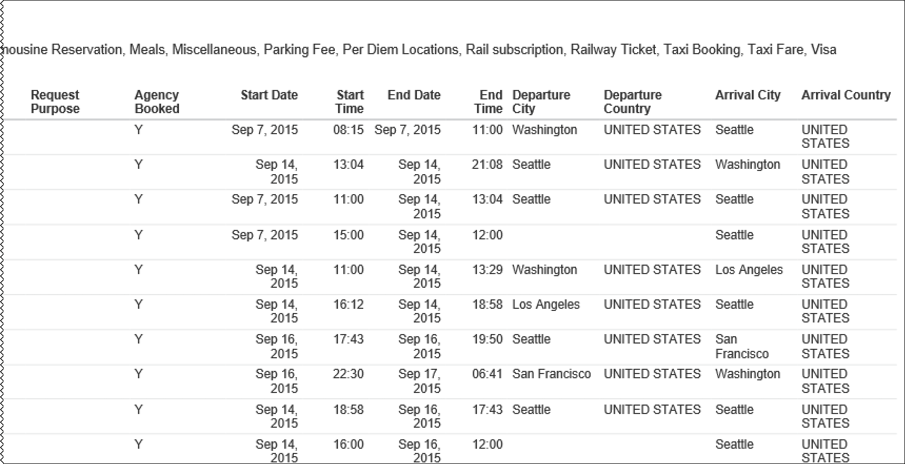

Report: Travel Requests Pending Approval
Available to:  Analysis  Intelligence
Uses:  Expense Data R Travel / TripLink Data
***Not applicable for Standard Edition***
This report will give users an immediate view of all Travel Request that need to be approved.

Report Prompts
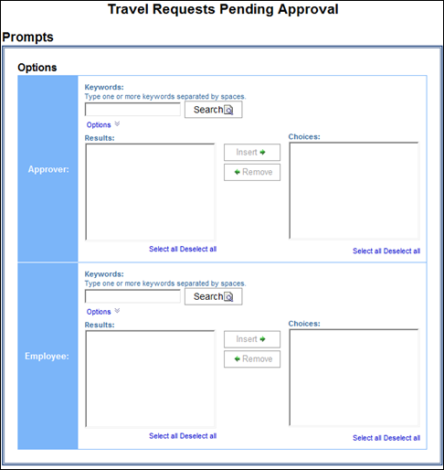

Report Output
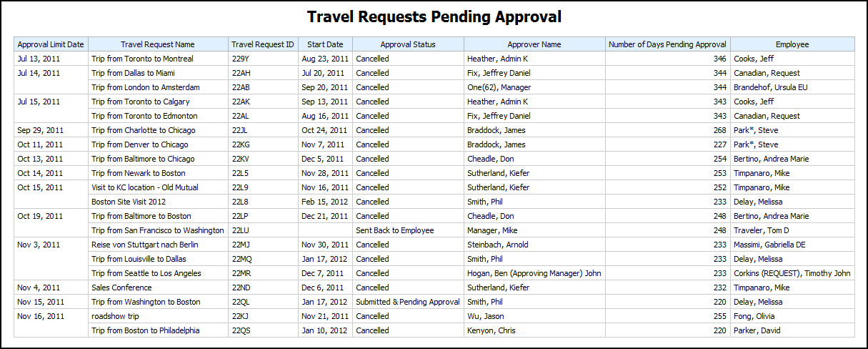

Report: Workflow Aging - Details
Available to:  Analysis  Intelligence
Uses:  Expense Data R Travel / TripLink Data
***Not applicable for Standard Edition***
This report identifies the travel requests that are pending approval, including the approvers associated with the requests, to help ensure approval of travel requests in a timely manner.

Report Prompts
When a company has Cost Object Approvals (COA) enabled, the Prompts page displays the Show Only Cost Object Steps prompt. When Yes is selected, the report displays COA fields.
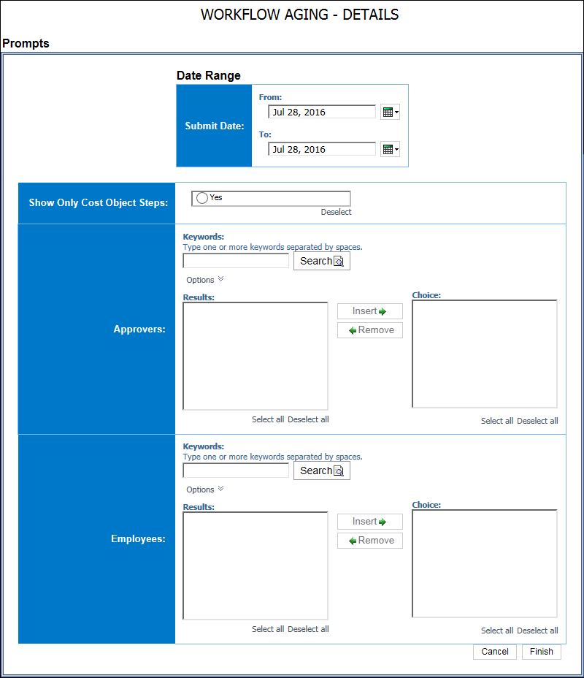

Report Output




