Table of Contents
Chapter 20: Folder – Tax 20-1
Report: Attendee Tax Amounts 20-1
Available to:  Analysis  Intelligence 20-1
Uses: R Expense Data  Travel / TripLink Data 20-1
Report: Australian Fringe Benefit Tax Analytics Dashboard 20-3
Available to:  Analysis  Intelligence 20-3
Uses: R Expense Data  Travel / TripLink Data 20-3
Report: Australian Fringe Benefit Tax Details 20-13
Available to:  Analysis  Intelligence 20-13
Uses: R Expense Data  Travel / TripLink Data 20-13
Report: Mileage/Fuel Receipt Reconciliation Report 20-19
Available to:  Analysis  Intelligence 20-19
Uses: R Expense Data  Travel / TripLink Data 20-19
Report: UK VAT Dashboard 20-21
Available to:  Analysis  Intelligence 20-21
Uses: R Expense Data  Travel / TripLink Data 20-21
Report: VAT Reclaimed Amounts 20-25
Available to:  Analysis  Intelligence 20-25
Uses: R Expense Data  Travel / TripLink Data 20-25

Revision History
Date | Notes / Comments / Changes
January 21, 2022 | Updated the copyright year; no other changes; cover date not updated
February 20, 2021 | Updated the copyright year; no other changes
January 8, 2020 | Changed copyright; no other content changes
February 9, 2019 | Removed references to Insight Premium from the guide and updated copyright
November 17, 2018 | Updated the Australian Fringe Benefit Tax Analytics Dashboard and Australian Fringe Benefit Tax Details report
February 10, 2018 | Updated the UK VAT Dashboard report
January 17, 2018 | Reverted updates to the UK VAT Dashboard
January 13, 2018 | Changed copyright and updated the following reports:  - Australian Fringe Benefit Tax Analytics Dashboard  - UK VAT Dashboard
December 15 2016 | Changed copyright; no other content changes
March 23 2016 | Changed the text under the heading from Travel Data to Travel / TripLink Data; no other content changes
September 18 2015 | Changed the chapter number  Updated the prompt page for the Mileage/Fuel Receipt Reconciliation Report
August 14 2015 | Moved from single book to individual "chapters"  Added new sample report for Attendee Tax Amounts

Folder – Tax

Report: Attendee Tax Amounts
Available to:  Analysis  Intelligence
Uses: R Expense Data  Travel / TripLink Data
This report captures the Australian requirement to report specific expenses to the Australian Tax office on a yearly basis for those expenses for each employee.

Report Prompts
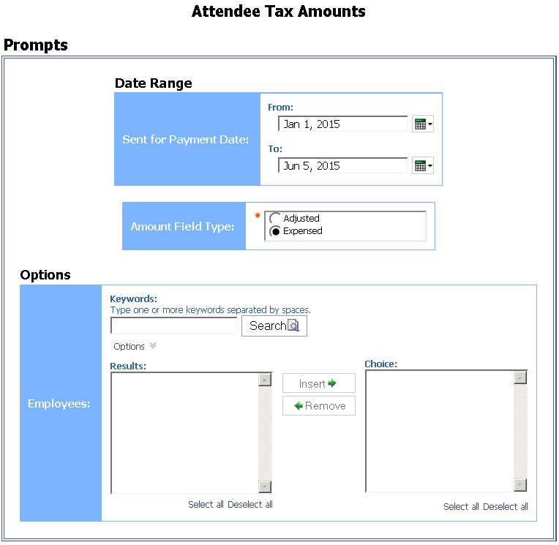

Report Output
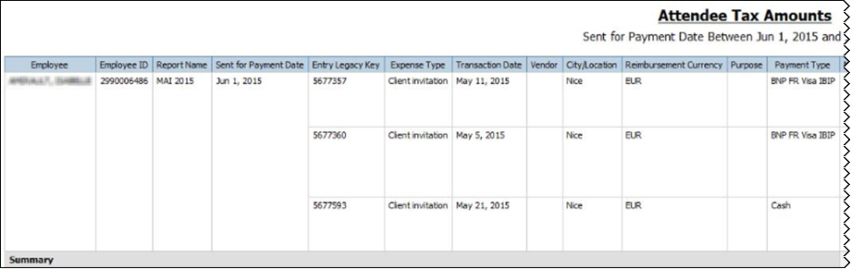
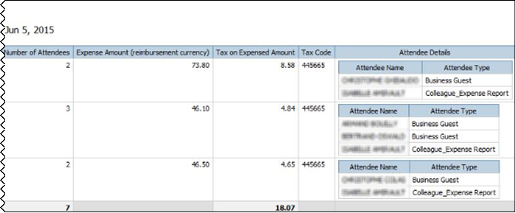

Report: Australian Fringe Benefit Tax Analytics Dashboard
Available to:  Analysis  Intelligence
Uses: R Expense Data  Travel / TripLink Data
Australian businesses are required to pay a Fringe Benefits Tax (FBT) on meal entertainment expenses where a meal benefit is extended to an employee or their associate in their home location.
The Australian Tax Office (ATO) provides businesses with two primary methods for calculating the FBT liability – Actual & 50/50 method. A business must elect – before the FBT reporting year – which method it will use.
Within Concur Expense, we provide FBT functionality where an expense can be split and prorated based on the attendee type. This allows businesses who use the "Actual" method for reporting FBT to correctly post the FBT-able portion of the expense to their finance system.
However, currently, businesses do not have the ability to easily determine which FBT calculation method will require them to pay the least amount of FBT that is associated with meal entertainment expenses. This Australian Fringe Benefit Tax Analytics Dashboard provides the solution.
- IMPORTANT: This report should be used for information only – it does not provide any financial, taxation, or accounting advice.

Report Description
The Australian Fringe Benefit Tax Analytics Dashboard provides the reporting capability to analyze the meal entertainment spend by each of the calculation methods and determine which method will realize the lowest FBT amount to be paid by the business. The dashboard also includes a calculation to determine the potential minor benefit tax exemption and its impact to the Actual method. The business will then be able to use this data to elect the optimal FBT calculation method for the upcoming year. This is based on employee country of Australia and the reimbursement currency of AUD.

Calculations
- Actual: Approved Amount (Reimbursement Currency) * Gross Up Factor Variable * Tax Rate Variable
With filters on Transaction Date, Attendee Status/Attendee Type, Expense Type, Foreign/Domestic
- Actual Method with Minor Benefit Exemption: The minor benefit exemption calculation is based on the expense type selection(s) made in the Minor Benefit Exemption Expense Type prompt on the Prompts page.
- If the minor benefit exemption expense (based on expense type selection) is over $300 AUD, the expense is NOT exempt and should be included in the Actual Method with Minor Benefit Exemption calculation.
- If the minor benefit exemption expense (based on expense type selection) is under $300 AUD and it meets either criteria A OR criteria B listed below, then the expense is NOT exempt and should be included in the Actual Method with Minor Benefit Exemption calculation.
Criteria A - For an employee/attendee combination, there are more shared minor benefit expenses than the number of expenses entered by the reporting user in the Maximum Number of Shared Employee & Attendee Expense Entries for Minor Benefit Exemption Calculation prompt. This prompt defaults to 7 per expense type.
Criteria B - For an employee/attendee combination, the total amount of shared minor benefit expenses is greater than the amount entered by the reporting user in the Maximum Amount of Shared Employee & Attendee Expense Entries for Minor Benefit Exemption Calculation prompt. This prompt defaults to $1,000 AUD per expense type.
The intent of criteria A and B is to exclude any minor fringe benefits from the exemption if they are recurring. For example, if the Maximum Number of Shared Employee & Attendee Expense Entries for Minor Benefit Exemption Calculation prompt is set to 7, and a manager takes an employee to lunch every Friday more than seven times, the lunch expenses would NOT be exempt. But if the manager took the employee to lunch only one time, the lunch expense would be exempt.
- If the minor benefit exemption expense (based on expense type selection) is under $300 AUD and it does not meet either criteria A OR B, then it is a minor benefit exemption. The expense should be totaled as a minor benefit exemption and subtracted from the Actual Method with Minor Benefit Exemption calculation.

- 50/50: Approved Amount (Reimbursement Currency) * Gross Up Factor Variable * Tax Rate Variable * 0.5
With filters on Transaction Date, Expense Type, and Foreign/Domestic

Report Prompts
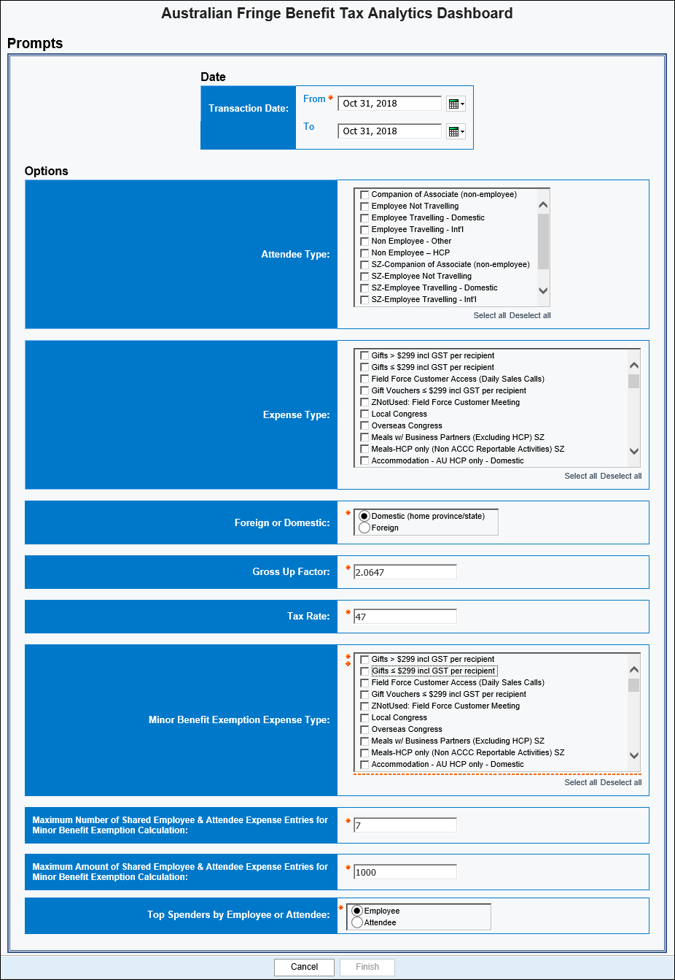
The prompts are:
- Transaction Date: The report user enters the date range.
- Attendee Status –or– Attendee Type: Only one of these prompts appears.
- If the entity has one or more records where the Attendee Status field is populated with "Non-traveling," then the Attendee Status prompt appears. The user can select Non-traveling if desired. Then, the dashboard will include only employees with the attendee status of Non-traveling.
- If the entity has no records where the Attendee Status field is populated with "Non-traveling," then the Attendee Type prompt appears. The user can select the desired attendee type.
- Expense Type: The user selects one or more expense types.
- Foreign or Domestic: The user selects as appropriate. The default is Domestic.
- Gross Up Factor: The user enters/changes the factor as desired. The default is 2.0647.
- Tax Rate: The user enters/changes the rate as desired. The default is 47.
- Minor Benefit Exemption Expense Type: The user selects one or more expense types for calculating the minor benefit exemption.
- Maximum Number of Shared Employee & Attendee Expense Entries for Minor Benefit Exemption Calculation: The user enters/changes the maximum number of expense entries allowed per expense type. The default is 7 per expense type.
- Maximum Amount of Shared Employee & Attendee Expense Entries for Minor Benefit Exemption Calculation: The user enters/changes the maximum dollar amount allowed for expense entries per expense type. The default is $1000 AUD per expense type.

Report Output
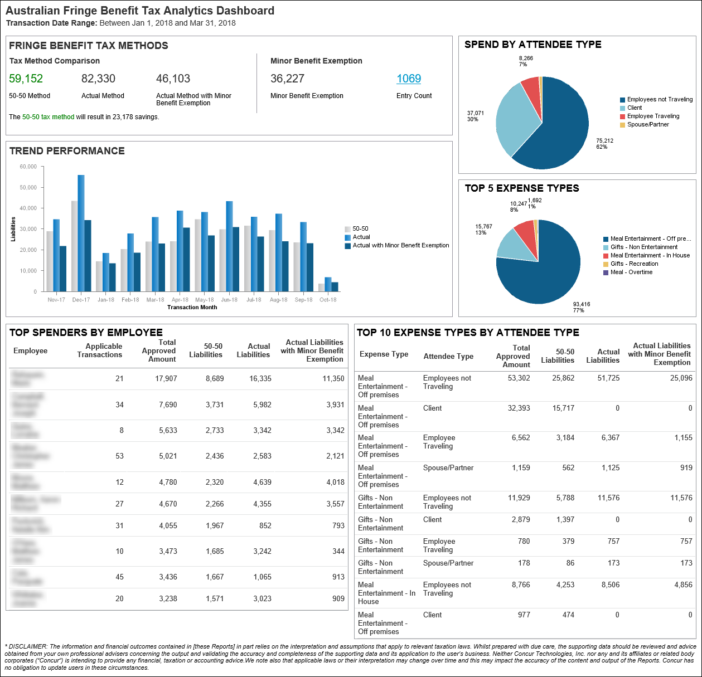
The dashboard contains the following sections:

Fringe Benefits Tax Methods
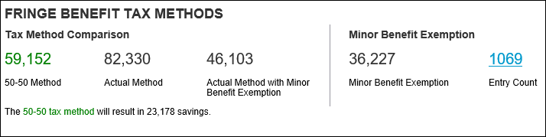
The Fringe Benefit Tax Methods section contains two subsections: Tax Method Comparison and Minor Benefit Exemption. The Tax Method Comparison section shows a comparison between the three tax calculations, with the savings listed. The calculation that has the greatest savings is colored green with the savings listed below it. The Minor Benefit Exemption section shows the Minor Benefit Exemption field amount and the number of expense entries that qualify for the minor benefit exemption displayed in the Entry Count field. Clicking the number displayed in the Entry Count field drills down to the Australian Fringe Benefit Tax Details report.

Spend By Attendee Type
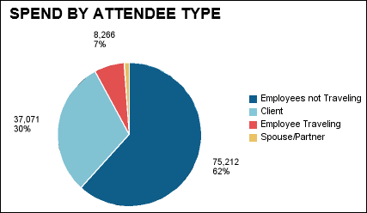
The Spend by Attendee Type section shows a pie chart with spend for each attendee type. The Spend by Attendee Type pie chart includes Traveling Status with Attendee Type.

Trend Performance
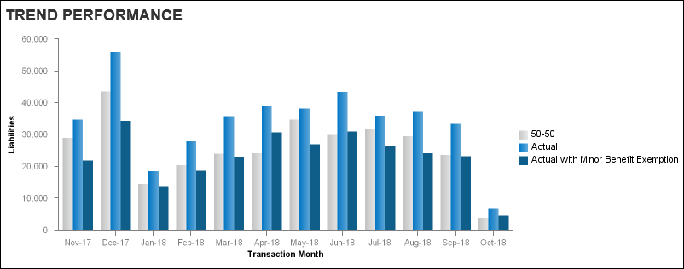
The Trend Performance section provides a comparison of the two tax methods for the preceding 12 months before the end of the date range entered. The bar graph comparison also includes visuals for the Actual with Minor Benefit Exemption field values for each month.

Top 5 Expense Types
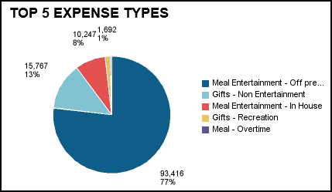
The Top 5 Expense Types section contains a pie chart that displays the top five expense types that contribute the most to the fringe benefit spend. The pie chart displays a key for the top five expense types, and for each expense type, the Total Approved Amount associated with the fringe benefit spend.

Top Spenders By Employee
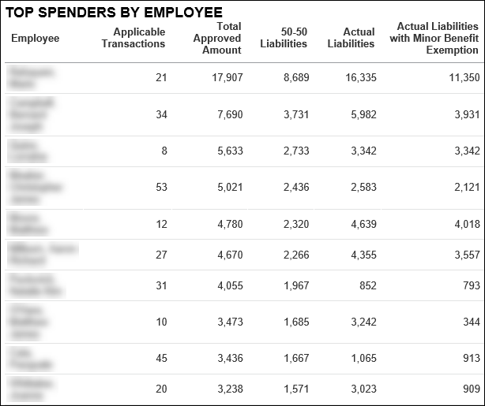
The Top Employee Spenders section lists the top 10 spenders and the tax calculations for each tax type. This section is sorted by the Total Approved Amount column, highest to lowest. This section is displayed on the dashboard when Employee is selected in the Top Spenders by Employee or Attendee prompt on the Prompts page.

Top Spenders By Attendee
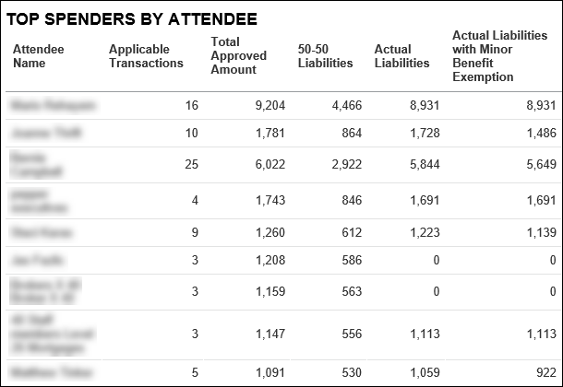
The Top Spenders By Attendee section lists the top 10 attendee spenders and the tax calculations for each tax type. This section is displayed on the dashboard when Attendee is selected in the Top Spenders by Employee or Attendee prompt on the Prompts page.

Top 10 Expense Types By Attendee Type
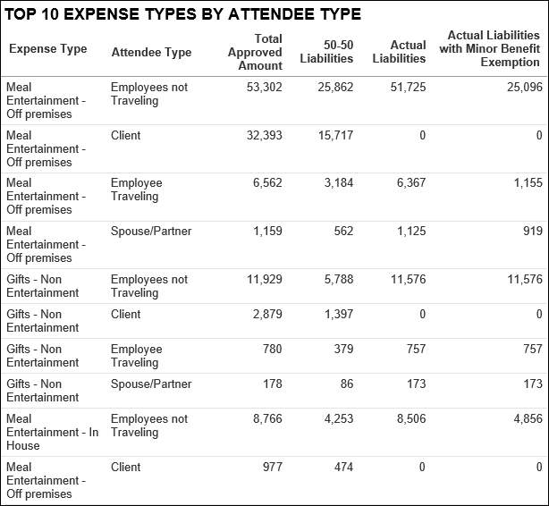
The Top 10 Expense Types by Attendee Type section lists the attendee type breakdown for the top 10 expense types and the tax calculations for each tax type.

Report: Australian Fringe Benefit Tax Details
Available to:  Analysis  Intelligence
Uses: R Expense Data  Travel / TripLink Data
Australian businesses are required to pay a Fringe Benefits Tax (FBT) on meal entertainment expenses where a meal benefit is extended to an employee or their associate in their home location.
The Australian Tax Office (ATO) provides businesses with two primary methods for calculating the FBT liability – Actual & 50/50 method. A business must elect – before the FBT reporting year – which method it will use.
- IMPORTANT: This report should be used for information only – it does not provide any financial, taxation, or accounting advice.

Report Prompts
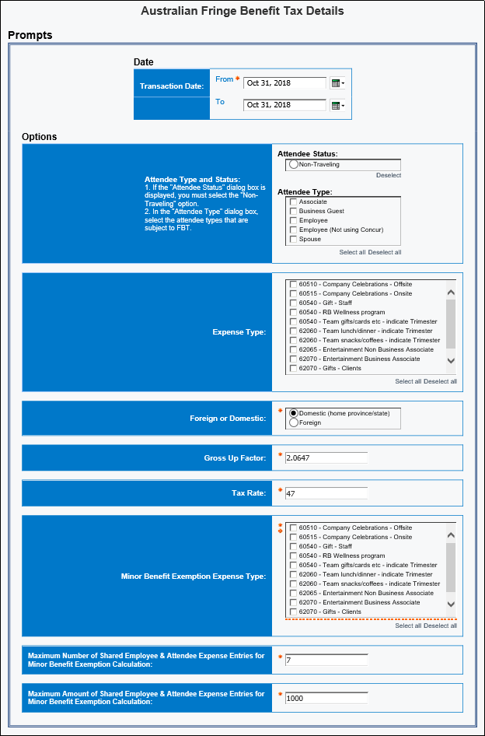
The prompts are:
- Transaction Date: The report user enters the date range.
- Attendee Status –or– Attendee Type: Only one of these prompts appears.
- If the entity has one or more records where the Attendee Status field is populated with "Non-traveling," then the Attendee Status prompt appears. The user can select Non-traveling if desired. Then, the dashboard will include only employees with the attendee status of Non-traveling.
- If the entity has no records where the Attendee Status field is populated with "Non-traveling," then the Attendee Type prompt appears. The user can select the desired attendee type.
- Expense Type: The user selects one or more expense types.
- Foreign or Domestic: The user selects as appropriate. The default is Domestic.
- Gross Up Factor: The user enters/changes the factor as desired. The default is 2.0647.
- Tax Rate: The user enters/changes the rate as desired. The default is 47.
- Minor Benefit Exemption Expense Type: The user selects one or more expense types for calculating the minor benefit exemption.
- Maximum Number of Shared Employee & Attendee Expense Entries for Minor Benefit Exemption Calculation: The user enters/changes the maximum number of expense entries allowed per expense type. The default is 7 per expense type.
- Maximum Amount of Shared Employee & Attendee Expense Entries for Minor Benefit Exemption Calculation: The user enters/changes the maximum dollar amount allowed for expense entries per expense type. The default is $1000 AUD per expense type.

Report Output
If an expense qualifies for a minor benefit exemption under the under the Actual method of valuing entertainment, the Actual Method with Minor Benefit Exemption Amount column defaults to 0.00. If not, the value in the Actual Method with Minor Benefit Exemption Amount column for the expense will be the same as the tax amount value in the Actual column.
- For more information about the minor benefit exemption calculation, refer to the Report: Australian Fringe Benefit Tax Analytics Dashboard section in this guide.
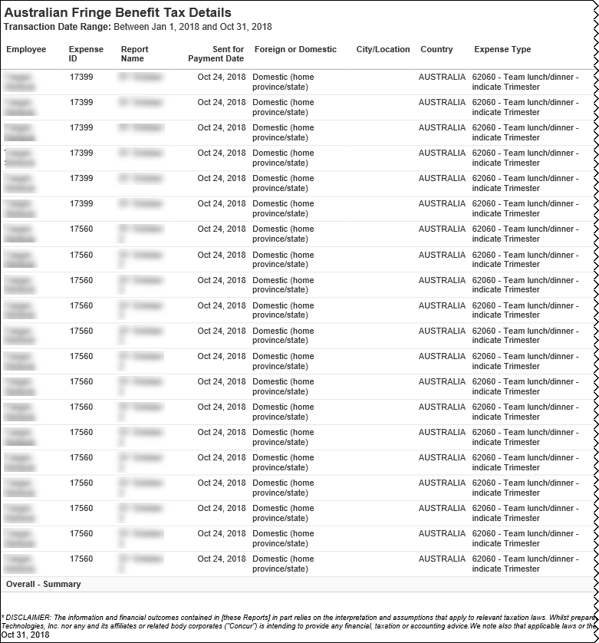
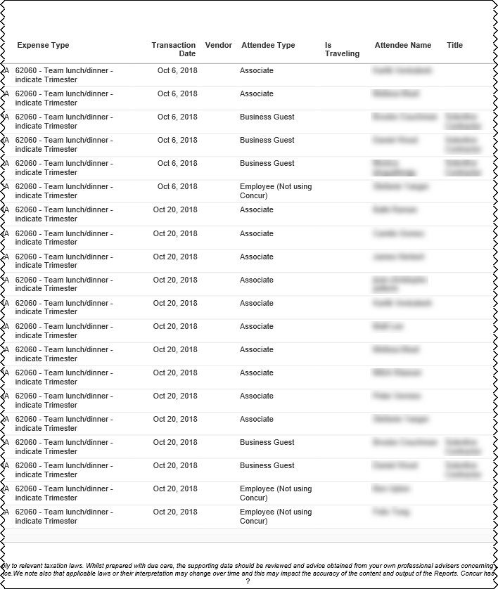
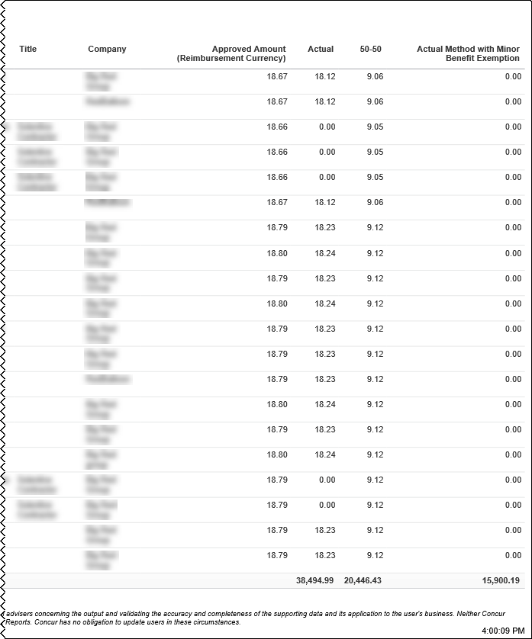

Report: Mileage/Fuel Receipt Reconciliation Report
Available to:  Analysis  Intelligence
Uses: R Expense Data  Travel / TripLink Data
This report shows:
- Report journeys where there is shortage of VAT
- Report Fuel Receipts where there is surplus VAT remaining

Report Prompts
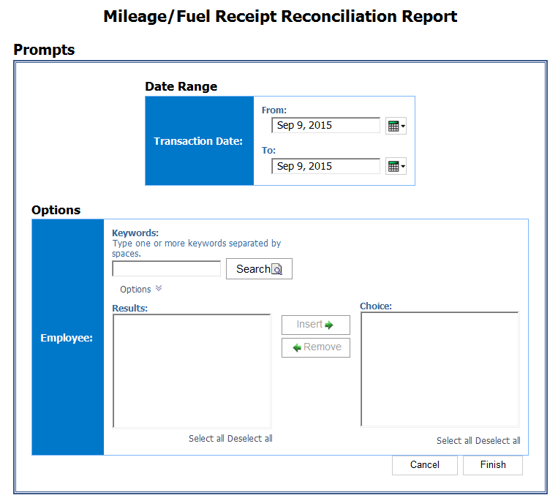

Report Output
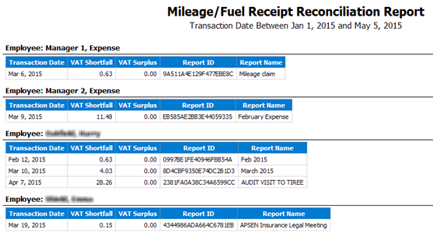

Report: UK VAT Dashboard
Available to:  Analysis  Intelligence
Uses: R Expense Data  Travel / TripLink Data
Companies that do business across national borders often incur a hidden cost – value-added tax (VAT). VAT is added to the goods and services that companies buy in some countries. This tax can add up to 25% to the cost of a business travel purchase and appear in unexpected places.
Companies that do business across country borders can generally reclaim the VAT they have paid on their purchases. However, VAT has to be recovered from each country individually, the process is complex, and the languages are different. As a result, most companies simply do not attempt to reclaim VAT or they process only large invoices.
Foreign VAT can account for up to 5% of total travel spend and, on average, annually costs business travelers $7.5 billion. Of the $7.5 billion accumulated annually, only $2 billion are recovered – resulting in approximately $5.5 billion in missed recovery opportunities.
Because the overwhelming majority of VAT accumulation occurs within the UK, our initial focus will be primarily on UK employee travel within the UK.

Report Description
The new UK VAT Dashboard gives clients who also have Audit the ability to further analyze the reasons that their VAT is not able to be claimed. The dashboard should clearly show the user: What was the amount of potential recoverable VAT? How much VAT was actually claimed? As a result, how much VAT went unclaimed (i.e. lost opportunity)? What were the reason codes for the unclaimed VAT?

Report Prompts
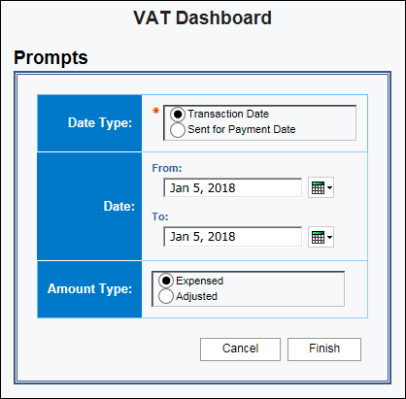
The prompts are:
- Date Type: The report user chooses whether to run the report based on Transaction Date or on the Sent for Payment Date.
- Date: The user enters the appropriate range.
- Amount Type: The report user chooses Expensed or Adjusted data.

Report Output
The dashboard has two pages:
- Lost Opportunities Breakdown
- Posted VAT Breakdown

Lost Opportunities Breakdown
The Lost Opportunity Breakdown page utilizes the benefits of the Audit offering to display the code for the reason that the VAT went unclaimed. This page has two sections on lost opportunities:
- Top 5 Reasons for unclaimed VAT
- Top 5 Expense Types for unclaimed VAT and the top 10 vendors for each expense type
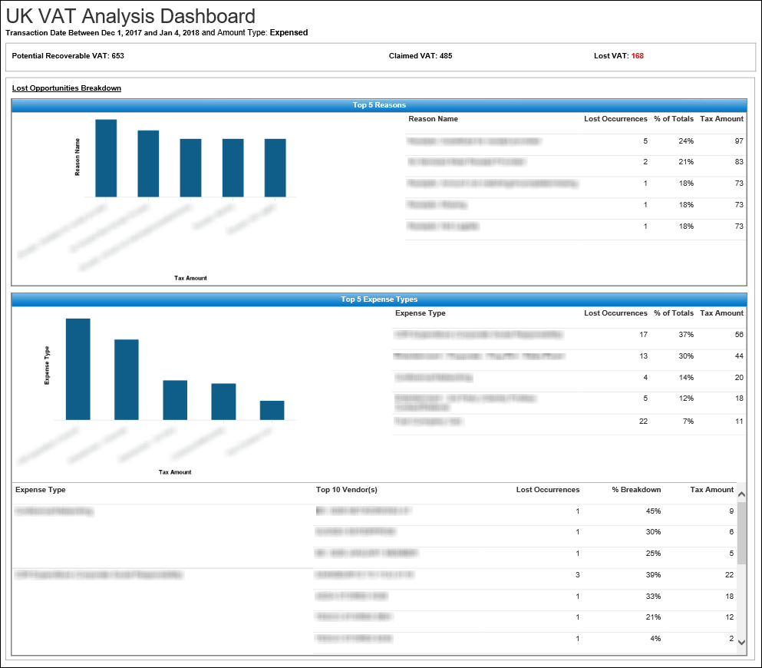

Posted VAT Breakdown
The Posted VAT Breakdown page contains two sections. The Top 5 Expense Types section contains a bar graph and grid for the posted VAT information for the top five expense types. The Top 10 Vendors section shows the posted VAT information for the overall top 10 vendors for the UK.
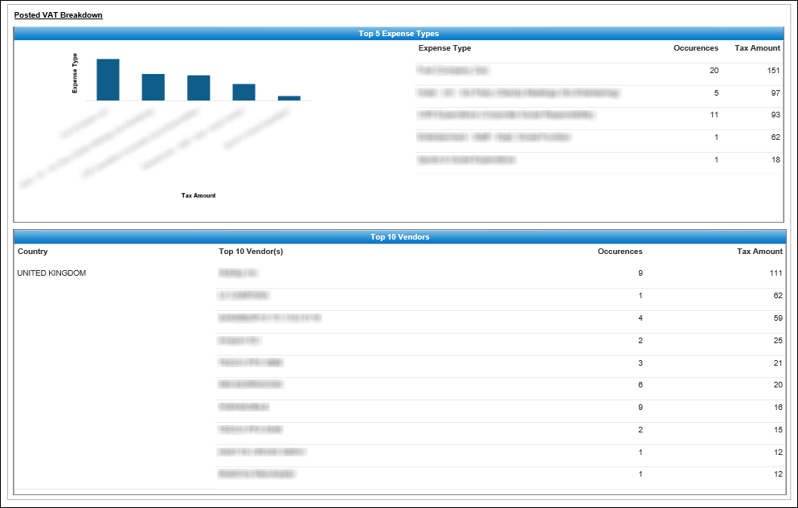

Report: VAT Reclaimed Amounts
Available to:  Analysis  Intelligence
Uses: R Expense Data  Travel / TripLink Data
This report displays report entry-level tax information for expenses that are eligible for Value Add Tax (VAT) reclamation.

Report Prompts
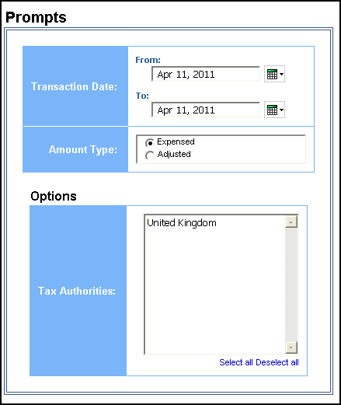

Report Output




