Table of Contents
Chapter 9: Folder – Expense Processing 9-1
Report: Airfare Booked But Not Yet Expensed 9-1
Available to:  Analysis  Intelligence 9-1
Uses: R Expense Data R Travel / TripLink Data 9-1
Report: Approver Statistics 9-4
Available to:  Analysis  Intelligence 9-4
Uses: R Expense Data  Travel / TripLink Data 9-4
Report: Expense Accounting Analysis 9-8
Available to:  Analysis  Intelligence 9-8
Uses: R Expense Data  Travel / TripLink Data 9-8
Report: Expense Entry Analysis 9-11
Available to:  Analysis  Intelligence 9-11
Uses: R Expense Data  Travel / TripLink Data 9-11
Report: Expense Entry Analysis Details (grouped by Employee) 9-15
Available to:  Analysis  Intelligence 9-15
Uses: R Expense Data  Travel / TripLink Data 9-15
Report: Expense Entry Analysis Details (grouped by Expense Type) 9-19
Available to:  Analysis  Intelligence 9-19
Uses: R Expense Data  Travel / TripLink Data 9-19
Report: Expense Summary by Employee and Year 9-23
Available to:  Analysis  Intelligence 9-23
Uses: R Expense Data  Travel / TripLink Data 9-23
Report: Expense Summary by Expense Type and Year 9-26
Available to:  Analysis  Intelligence 9-26
Uses: R Expense Data  Travel / TripLink Data 9-26
Report: Expenses With TripIt Itineraries 9-29
Available to:  Analysis  Intelligence 9-29
Uses: R Expense Data  Travel / TripLink Data 9-29
Report: Missing Receipt Audit 9-32
Available to:  Analysis  Intelligence 9-32
Uses: R Expense Data  Travel / TripLink Data 9-32
Report: Payment Type Analysis 9-34
Available to:  Analysis  Intelligence 9-34
Uses: R Expense Data  Travel / TripLink Data 9-34
Report: Reports Approved but Receipts Not Viewed 9-39
Available to:  Analysis  Intelligence 9-39
Uses: R Expense Data  Travel / TripLink Data 9-39
Report: Top 10 Longest To Approve 9-45
Available to:  Analysis  Intelligence 9-45
Uses: R Expense Data  Travel / TripLink Data 9-45
Report: Unsubmitted Expense Entry Analysis Details (grouped by Employee) 9-47
Available to:  Analysis  Intelligence 9-47
Uses: R Expense Data  Travel / TripLink Data 9-47
Report: Unsubmitted Expense Entry Analysis Details (grouped by Expense Type) 9-51
Available to:  Analysis  Intelligence 9-51
Uses: R Expense Data  Travel / TripLink Data 9-51
Report: Workflow Aging - Details 9-55
Available to:  Analysis  Intelligence 9-55
Uses: R Expense Data  Travel / TripLink Data 9-55
Report: Workflow Cycle Times - Details 9-57
Available to:  Analysis  Intelligence 9-57
Uses: R Expense Data  Travel / TripLink Data 9-57
Report: Workflow Cycle Times – Summary by Manager 9-65
Available to:  Analysis  Intelligence 9-65
Uses: R Expense Data  Travel / TripLink Data 9-65
Report: Workflow Cycle Times – Summary by Processor 9-68
Available to:  Analysis  Intelligence 9-68
Uses: R Expense Data  Travel / TripLink Data 9-68

Revision History
Date | Notes / Comments / Changes
January 21, 2022 | Updated the copyright year; no other changes; cover date not updated
February 20, 2021 | Updated the copyright year; no other changes
March 14, 2020 | The Sent Date prompt on the Prompts page for the Expense Entry Analysis (grouped by Employee) report was renamed to Sent for Payment Date. Updated the image of the Prompts page for the report to show new Sent for Payment Date prompt, and replaced the information about the Start Date prompt with information about the Sent for Payment Date prompt in the Date Range Prompt section.
January 8, 2020 | Changed copyright; no other content changes
August 17, 2019 | Added additional information about the Payment Type Analysis report
February 9, 2019 | Removed references to Insight Premium from the guide and updated copyright
December 8, 2018 | Added additional information about report prompts and reports to the reports in the Expense Processing folder
January 13, 2018 | Changed copyright; no other content changes
December 15 2016 | Changed copyright; no other content changes
October 10 2016 | Updated Prompts images for copied reports
August 15 2016 | Added the Workflow Aging – Details report
March 23 2016 | Changed the text under the heading from Travel Data to Travel / TripLink Data; no other content changes
August 14 2015 | Moved from single book to individual "chapters" – no content changes

Folder – Expense Processing

Report: Airfare Booked But Not Yet Expensed
Available to:  Analysis  Intelligence
Uses: R Expense Data R Travel / TripLink Data
This report lists users with airline tickets that have not yet been expensed. This will allow finance departments to identify liabilities and plan appropriately.

Report Prompts
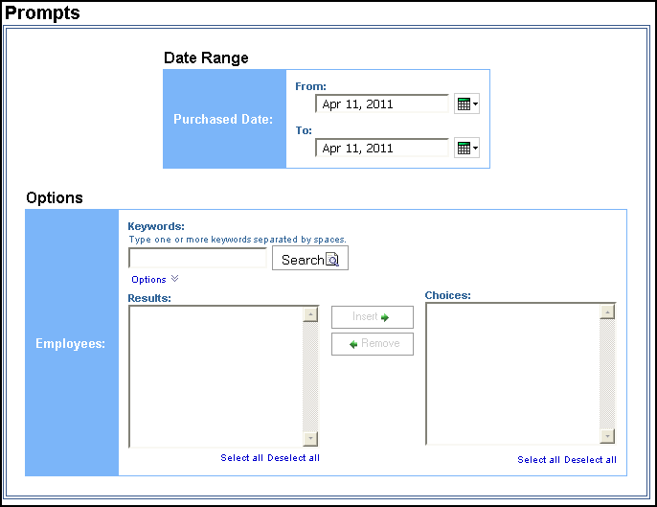

Date Range Prompt
- Purchased Date: Used to filter the report by the date range that the trips were purchased

Options Prompt
- Employees: Used to filter the report by the name of employee(s) who booked trips

Report Output
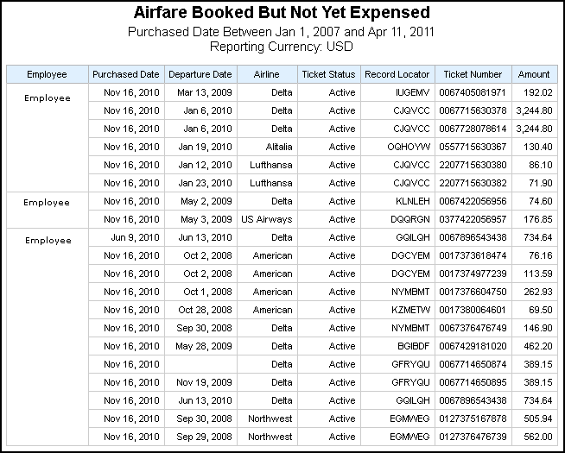

Report Header and Footer
Data Item Label/Name | Data Item Expression | Data Item Description
Purchased Date | ParamDisplayValue('purchasedDateParam') | Displays the date range from the Purchased Date prompt on the Prompts page
Reporting Currency | [Travel].[Reservations and Tickets].[Reporting Currency] | Displays the currency code in which the reporting currency is shown (for example, USD, CAD, GBP)

Report Data Items
Data Item Label | Data Item Name | Data Item Expression | Data Item Description
Employee | <Employee> | [Cliqbook Unsubmitted AIrfare Details].[Employee] | Employee who booked the trip
Purchased Date | <Purchased Date> | [Cliqbook Unsubmitted AIrfare Details].[Purchased Date] | Date the trip was purchased (month day, year format)
Departure Date | <Departure Date> | [Cliqbook Unsubmitted AIrfare Details].[Start Date] | Date the trip begins (month day, year format)
Airline | <Transportation Vendor/Hotel Property> | [Cliqbook Unsubmitted AIrfare Details].[Transportation Vendor / Hotel Property] | Name of the airline company
Ticket Status | <Ticket Status> | [Cliqbook Unsubmitted AIrfare Details].[Ticket Status] | Current status of the reserved ticket (for example, Ticketed)
Record Locator | <Record Locator> | [Cliqbook Unsubmitted AIrfare Details].[Record Locator] | Unique six-digit character that identifies the trip (for example, KUMBEI)
Ticket Number | <Ticket ID> | [Cliqbook Unsubmitted AIrfare Details].[Ticket ID] | Ticket number for the reserved air booking
Amount | <Amount> | [Cliqbook Unsubmitted AIrfare Details].[Booking Total] | Sum of the booking amount and the booking tax in the reporting currency

Report: Approver Statistics
Available to:  Analysis  Intelligence
Uses: R Expense Data  Travel / TripLink Data
This report provides expense report statistics data regarding quantities and extended cost totals by approver.

Report Prompts
The user can select date range and reimbursement currency. These prompts are optional.
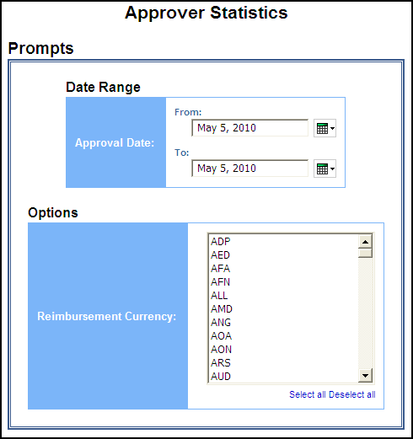

Date Range Prompt
- Approval Date: Used to filter the report by the date range that the expense reports were approved for reimbursement

Options Prompt
- Reimbursement Currency: Used to filter the report by the currency(ies) in which the employees were reimbursed

Report Output
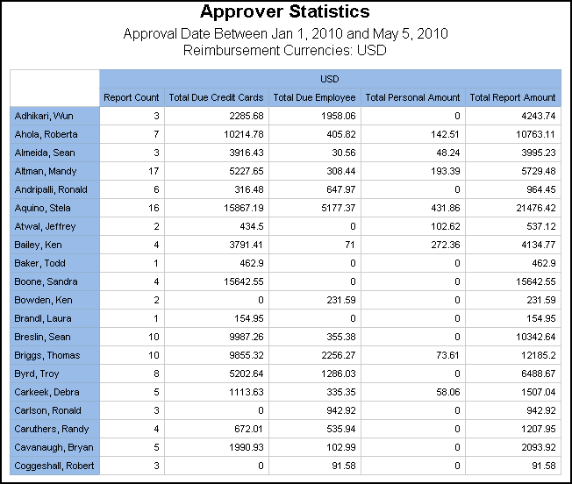

Report Header and Footer
Data Item Label/Name | Data Item Expression | Data Item Description
Approval Date Between | ' ' + ParamDisplayValue('actionDate') | Displays the date range from the Approval Date prompt on the Prompts page
Reimbursement Currencies | ' ' + ParamDisplayValue('currencyKey') | Displays the currency code(s) from the Reimbursement Currency prompt on the Prompts page
N/A | AsOfDate() | Displays the date the report was run
N/A | PageNumber() | Displays the page number of the corresponding page
N/A | AsOfTime() | Displays the time the report was run

Report Data Items
Data Item Label | Data Item Name | Data Item Expression | Data Item Description
N/A | <#Reimbursement Currency#> | [Expense].[Report Header Information].[Reimbursement Currency] | Currency in which the employee was reimbursed
Approver | <#Approver#> | [Expense].[Expense Report Workflow Trail].[Employee Assigned to Step] | Last name, first name, and middle initial of the employee designated to take action in this step of the workflow
Report Count | <#1234#> | [Expense].[Expense Report Workflow Trail].[Report Key] | Unique system-assigned key that identifies the expense report
Total Due Credit Cards | <#1234#> | CASE  WHEN [Expense].[Report Header Information].[Total Due Credit Cards] is missing  THEN 0  ELSE [Expense].[Report Header Information].[Total Due Credit Cards]  END | Total amount to be reimbursed to credit cards or other accounts
Total Due Employee | <#1234#> | CASE  WHEN [Expense].[Report Header Information].[Total Due Employee] is missing  THEN 0  ELSE [Expense].[Report Header Information].[Total Due Employee]  END | Total amount to be reimbursed to the employee
Total Personal Amount | <#1234#> | CASE  WHEN [Expense].[Report Header Information].[Total Personal Amount] is missing  THEN 0  ELSE [Expense].[Report Header Information].[Total Personal Amount]  END | Total expense amounts marked as personal (non-reimbursable)
Total Report Amount | <#1234#> | CASE  WHEN [Expense].[Report Header Information].[Total Report Amount] is missing  THEN 0  ELSE [Expense].[Report Header Information].[Total Report Amount]  END | Total amount of the expenses on the report
Total for Currency | <#1234#> | total([Total Report Amount] for [Reimbursement Currency]) | Total amount of the expenses on the report in the report reimbursement currency

Report: Expense Accounting Analysis
Available to:  Analysis  Intelligence
Uses: R Expense Data  Travel / TripLink Data
This report lists the expenses by how the expenses were allocated for accounting by payer/payee, allocation codes, account codes, and totals for debit/credit and net.

Report Prompts
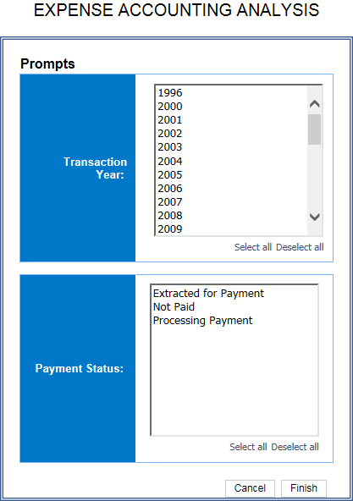

- Transaction Year: Used to filter the report by the year(s) the transactions were incurred
- Payment Status: Used to filter the report by the status of the expense reports in the payment process; Extracted for Payment, Not Paid, and/or Processing Payment

Report Output
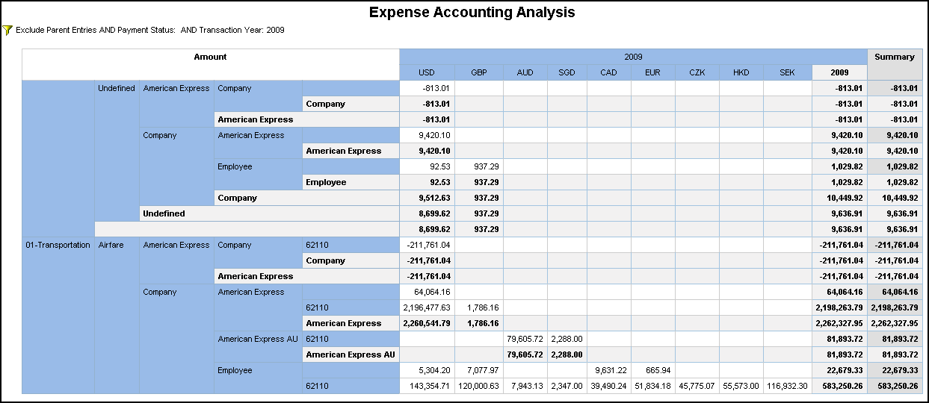

Report Header and Footer
Data Item Label/Name | Data Item Expression | Data Item Description
Payment Status | ' '+ParamDisplayValue('Payment_Status') | Displays the payment status(es) from the Payment Status prompt on the Prompts page
Transaction Year | ' '+ParamDisplayValue('Transaction_Year1') | Displays the year(s) from the Transaction Year prompt on the Prompts page
N/A | AsOfDate() | Displays the date the report was run
N/A | PageNumber() | Displays the page number of the corresponding page
N/A | AsOfTime() | Displays the time the report was run

Report Data Items
Data Item Label | Data Item Name | Data Item Expression | Data Item Description
N/A | <Parent Expense Type> | [Expense].[Entry Information].[Parent Expense Type] | Another expense type under which the entry's expense type has been grouped  For example, the expense types Breakfast, Lunch, and Dinner might be grouped under another expense type called Meals.
N/A | <Expense Type> | [Expense].[Entry Information].[Expense Type] | Expense type assigned to the expense
N/A | <Payer Payment Type> | [Expense].[Expense Journal].[Payer Payment Type] | Payment type representing the entity responsible for paying the amount
N/A | <Payee Payment Type> | [Expense].[Expense Journal].[Payee Payment Type] | Payment type that identifies the entity receiving the amount
N/A | <Account Code> | [Expense].[Expense Journal].[Account Code] | Account code to be charged with the amount
N/A | <Transaction Year> | [Expense].[Entry Information].[Transaction Year] | Year that the expense was incurred
N/A | <Reimbursement Currency> | [Expense].[Entry Information].[Reimbursement Currency] | Currency in which the employee is reimbursed
Amount | <#1234#> | [Expense].[Expense Journal].[Amount] | Amount to be posted  NOTE: Negative amounts represent a credit; positive amounts represent a debit.

Report: Expense Entry Analysis
Available to:  Analysis  Intelligence
Uses: R Expense Data  Travel / TripLink Data
This report lists expenses including expense type, payment type, and amount.

Report Prompts
The report user can choose a range of dates and optionally select other parameters in order to narrow the report results and manage grouping and subtotals. If no values are selected for the optional parameters, then all values are included by default.
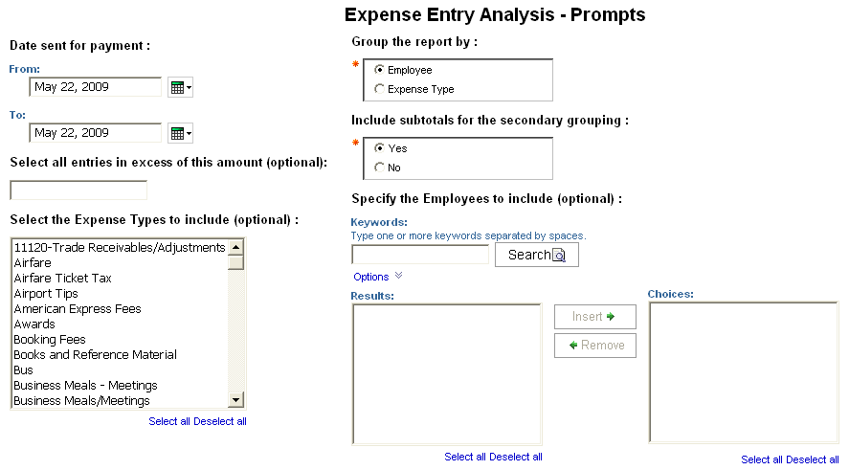

- Date sent for payment: Used to filter the report by the date range that the expenses were paid
- Select all entries in excess of this amount (optional): Used to only include expenses more than the defined amount (for example, to include expenses more than $100, enter “99”)
- Select the Expense Types to include (optional): Used to filter the report by the expense type(s) assigned to the expenses
- Group the report by: Used to group the primary report entries by “Employee” or “Expense Type”
- Include subtotals for the secondary grouping: Used to select if the secondary grouping, “Employee” or “Expense Type”, and subtotals should be included in the report
- Specify the Employees to include (optional): Used to filter the report by the name of employee(s) who booked trips

Report Output
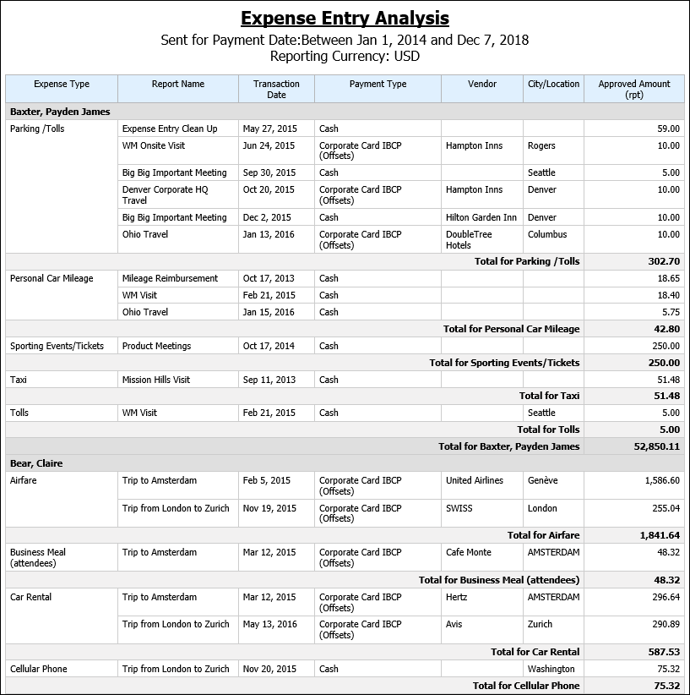

Report Header and Footer
Data Item Label/Name | Data Item Expression | Data Item Description
Sent for Payment Date | ParamDisplayValue('Date Sent for Payment') | Displays the date range from the Date sent for payment prompt on the Prompts page
Approved Amount | ParamDisplayValue('Approved Amount') | Displays the value from the Select all entries in excess of this amount (optional) prompt on the Prompts page
Reporting Currency | [Query1].[Reporting Currency] | Displays the currency code in which the reporting currency is shown (for example, USD, CAD, GBP)
N/A | AsOfDate() | Displays the date the report was run
N/A | PageNumber() | Displays the page number of the corresponding page
N/A | AsOfTime() | Displays the time the report was run

Report Data Items
Data Item Label | Data Item Name | Data Item Expression | Data Item Description
Employee | <Grouped Item> | if(?Grouping?='Expense Type') then ([Expense].[Entry Information].[Expense Type]) else ([Expense].[Report Header Information].[Employee]) | Expense type assigned to the expense if grouped by expense type, Employee last name, first name, and middle initial if grouped by employee
Report Name | <Report Name> | [Expense].[Report Header Information].[Report Name] | Employee-entered name of the expense report
Transaction Date | <Transaction Date> | [Expense].[Entry Information].[Transaction Date] | Date that the expense was incurred
Payment Type | <Payment Type> | [Expense].[Entry Information].[Payment Type] | Method by which the employee paid for the expense, such as cash or a credit card
Vendor | <Vendor> | [Expense].[Entry Information].[Vendor] | Vendor associated with the expense
City/Location | <City/Location> | [Expense].[Entry Information].[City/Location] | City or location where the expense was incurred
Approved Amount (rpt) | <Approved Amount (rpt)> | [Expense].[Entry Information].[Approved Amount (rpt)] | Amount of the expense approved for reimbursement, converted as needed to the reporting currency
N/A | <Secondary Grouping> | if(?Grouping?='Expense Type') then ([Expense].[Report Header Information].[Employee]) else ([Expense].[Entry Information].[Expense Type]) | Expense type assigned to the expense if grouped by expense type, Employee last name, first name, and middle initial if grouped by employee

Report: Expense Entry Analysis Details (grouped by Employee)
Available to:  Analysis  Intelligence
Uses: R Expense Data  Travel / TripLink Data
This report provides detailed spending information grouped by employee and then by expense type.

Report Prompts
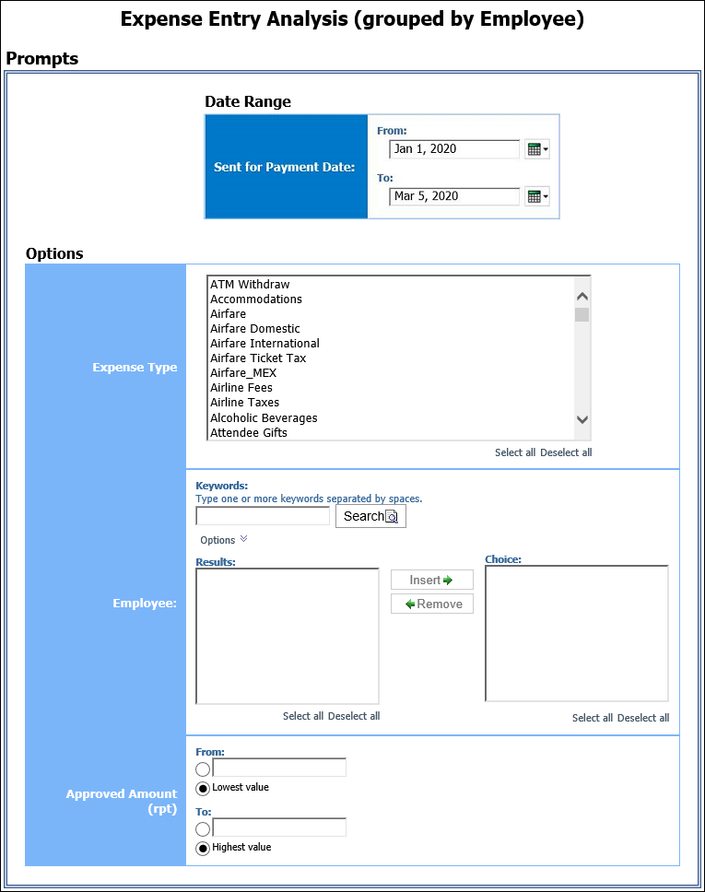

Date Range Prompt
- Sent for Payment Date:
- From: Used to filter the report using a defined start date for the sent for payment date of the trips
- To: Used to filter the report using a defined end date for the sent for payment date of the trips

Options Prompts
- Expense Type: Used to filter the report by the expense type(s) assigned to the expenses
- Employee: Used to filter the report by the name of employee(s) who booked trips
- Approved Amount (rpt):
- From: Used to filter the report using a defined minimum expense total approved for reimbursement
- To: Used to filter the report using a defined maximum expense total approved for reimbursement
- Lowest Value: Used to filter the report using the minimum expense total approved for reimbursement
- Highest Value: Used to filter the report using the maximum expense total approved for reimbursement

Report Output
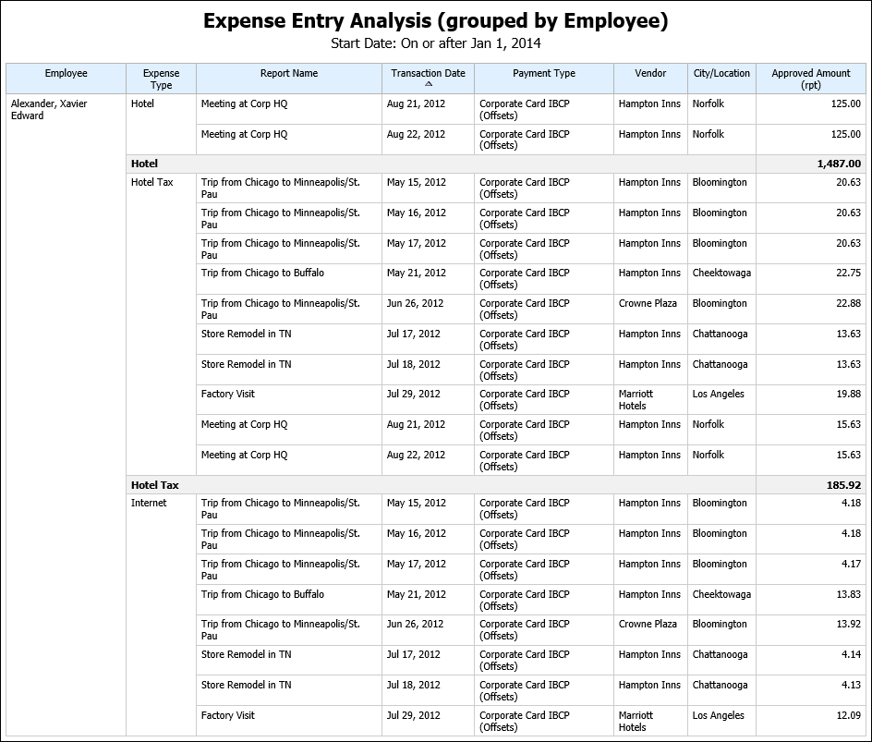

Report Header and Footer
Data Item Label/Name | Data Item Expression | Data Item Description
Start Date | ParamDisplayValue('Sent_for_Payment_Date1') | Displays the date range from the Start Date prompt on the Prompts page
N/A | AsOfDate() | Displays the date the report was run
N/A | PageNumber() | Displays the page number of the corresponding page
N/A | AsOfTime() | Displays the time the report was run

Report Data Items
Data Item Label | Data Item Name | Data Item Expression | Data Item Description
Employee | <Employee> | [Expense].[Report Header Information].[Employee] | Employee last name, first name, and middle initial
Expense Type | <Expense Type> | [Expense].[Entry Information].[Expense Type] | Expense type assigned to the expense
Report Name | <Report Name> | [Expense].[Report Header Information].[Report Name] | Employee-entered name of the expense report
Transaction Date | <Transaction Date> | [Expense].[Entry Information].[Transaction Date] | Date that the expense was incurred
Payment Type | <Payment Type> | [Expense].[Entry Information].[Payment Type] | Method by which the employee paid for the expense, such as cash or a credit card
Vendor | <Vendor> | [Expense].[Entry Information].[Vendor] | Vendor associated with the expense
City/Location | <City/Location> | [Expense].[Entry Information].[City/Location] | City or location where the expense was incurred
Approved Amount (rpt) | <Approved Amount (rpt)> | [Expense].[Entry Information].[Approved Amount (rpt)] | Amount of the expense approved for reimbursement, converted as needed to the reporting currency

Report: Expense Entry Analysis Details (grouped by Expense Type)
Available to:  Analysis  Intelligence
Uses: R Expense Data  Travel / TripLink Data
This report provides spending information group by expense type and then by employee.

Report Prompts
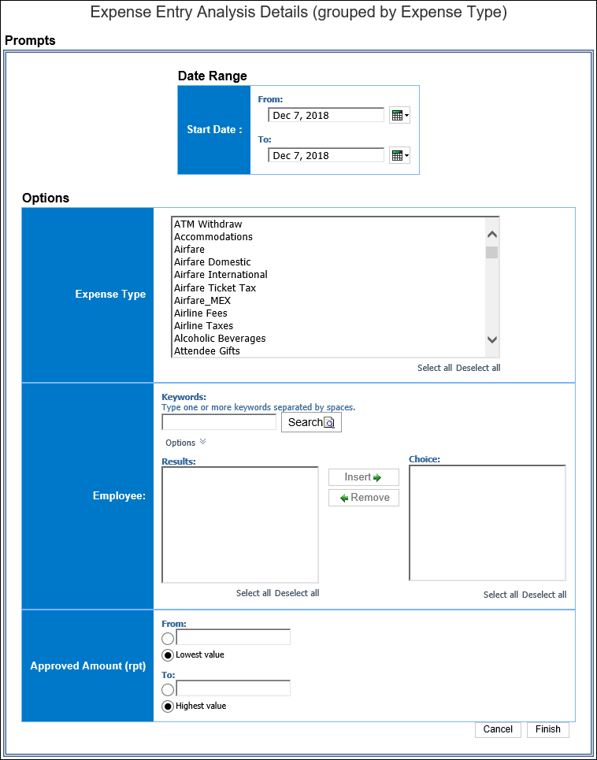

Date Range Prompt
- Start Date:
- From: Used to filter the report using a defined start date of the trips
- To: Used to filter the report using a defined end date of the trips
- Earliest Date: Used to filter the report using the earliest date that trips were taken
- Latest Date: Used to filter the report using the latest date that trips were taken

Options Prompts
- Expense Type: Used to filter the report by the expense type(s) assigned to the expenses
- Employee: Used to filter the report by the name of employee(s) who booked trips
- Approved Amount (rpt):
- From: Used to filter the report using a defined minimum expense total approved for reimbursement
- To: Used to filter the report using a defined maximum expense total approved for reimbursement
- Lowest Value: Used to filter the report using the minimum expense total approved for reimbursement
- Highest Value: Used to filter the report using the maximum expense total approved for reimbursement

Report Output
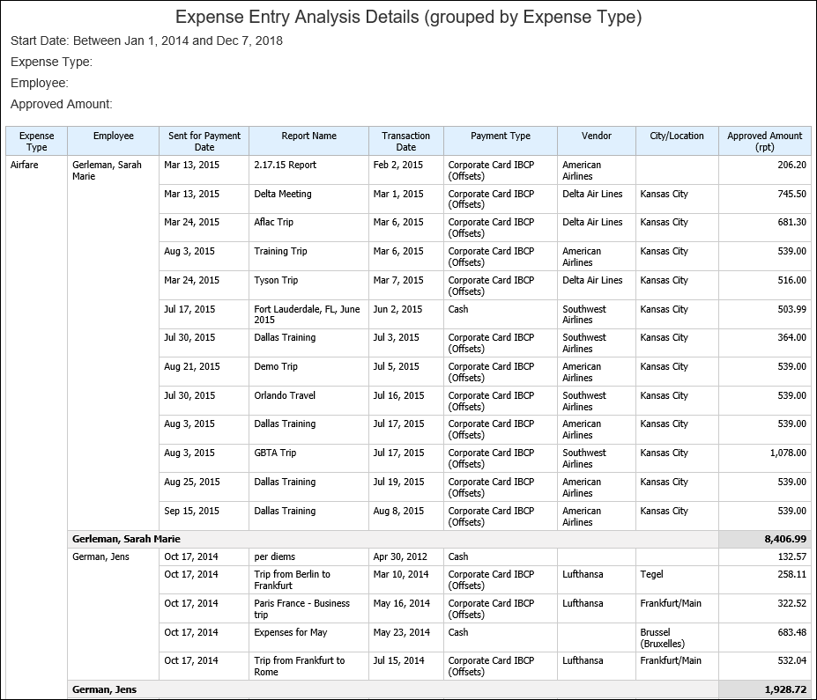

Report Header and Footer
Data Item Label/Name | Data Item Expression | Data Item Description
Start Date | ParamDisplayValue('Sent for Payment Date') | Displays the date range from the Start Date prompt on the Prompts page
Expense Type | ' '+ParamDisplayValue('Expense Type') | Displays the expense type(s) from the Expense Type prompt on the Prompts page
Employee | ' '+ParamDisplayValue('Employee') | Displays the employee(s) from the Employee prompt on the Prompts page
Approved Amount | ' '+ParamDisplayValue('Approved Amount (rpt)') | Displays the value(s) from the Approved Amount (rpt) prompt on the Prompts page
N/A | AsOfDate() | Displays the date the report was run
N/A | PageNumber() | Displays the page number of the corresponding page
N/A | AsOfTime() | Displays the time the report was run

Report Data Items
Data Item Label | Data Item Name | Data Item Expression | Data Item Description
Expense Type | <Expense Type> | [Expense].[Entry Information].[Expense Type] | Expense type assigned to the expense
Employee | <Employee> | [Expense].[Report Header Information].[Employee] | Employee last name, first name, and middle initial
Sent for Payment Date | <Sent for Payment Date> | [Expense].[Report Dates and Statuses].[Sent for Payment Date] | Date the expense report was extracted from the expense system for payment in another accounting system (such as Accounts Payable or Payroll)
Report Name | <Report Name> | [Expense].[Report Header Information].[Report Name] | Employee-entered name of the expense report
Transaction Date | <Transaction Date> | [Expense].[Entry Information].[Transaction Date] | Date that the expense was incurred
Payment Type | <Payment Type> | [Expense].[Entry Information].[Payment Type] | Method by which the employee paid for the expense, such as cash or a credit card
Vendor | <Vendor> | [Expense].[Entry Information].[Vendor] | Vendor associated with the expense
City/Location | <City/Location> | [Expense].[Entry Information].[City/Location] | City or location where the expense was incurred
Approved Amount (rpt) | <Approved Amount (rpt)> | [Expense].[Entry Information].[Approved Amount (rpt)] | Amount of the expense approved for reimbursement, converted as needed to the reporting currency

Report: Expense Summary by Employee and Year
Available to:  Analysis  Intelligence
Uses: R Expense Data  Travel / TripLink Data
This report shows summary of expenses by employee and year.

Report Prompts
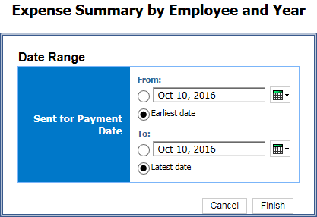

Date Range Prompt
- Sent for Payment Date:
- From: Used to filter the report using a defined begin date that expense reports were paid
- To: Used to filter the report using a defined end date that expense reports were paid
- Earliest Date: Used to filter the report using the earliest date that expense reports were paid
- Latest Date: Used to filter the report using the latest date that expense reports were paid

Report Output
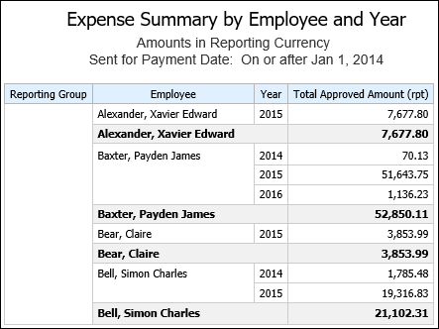

Report Header and Footer
Data Item Label/Name | Data Item Expression | Data Item Description
Amounts in Reporting Currency | N/A | Informs users that the amounts shown are in the reporting currency
Sent for Payment Date | ' ' + ParamDisplayValue('Sent_for_Payment_Date') | Displays the date range from the Sent for Payment Date prompt on the Prompts page
N/A | AsOfDate() | Displays the date the report was run
N/A | PageNumber() | Displays the page number of the corresponding page
N/A | AsOfTime() | Displays the time the report was run

Report Data Items
Data Item Label | Data Item Name | Data Item Expression | Data Item Description
Reporting Group | <Reporting Group> | [Expense].[Report Header Information].[Reporting Group] | Code that indicates the level assigned to the expense report from the reporting hierarchy
Employee | <Employee> | [Expense].[Report Header Information].[Employee] | Employee last name, first name, and middle initial
Year | <Year> | [Expense].[Report Dates and Statuses].[Year] | Year the report was paid
Total Approved Amount (rpt) | <Total Approved Amount (rpt)> | [Expense].[Report Header Information].[Total Approved Amount (rpt)] | Total amount approved to be reimbursed

Report: Expense Summary by Expense Type and Year
Available to:  Analysis  Intelligence
Uses: R Expense Data  Travel / TripLink Data
This report shows summary of expenses by expense type and year.

Report Prompts
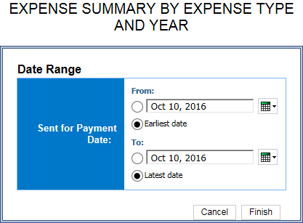

Date Range Prompt
- Sent for Payment Date:
- From: Used to filter the report using a defined begin date that expense reports were paid
- To: Used to filter the report using a defined end date that expense reports were paid
- Earliest Date: Used to filter the report using the earliest date that expense reports were paid
- Latest Date: Used to filter the report using the latest date that expense reports were paid

Report Output
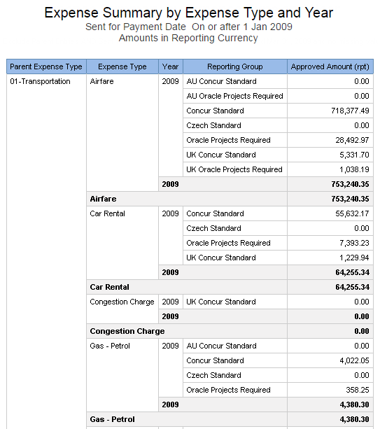

Report Header and Footer
Data Item Label/Name | Data Item Expression | Data Item Description
Sent for Payment Date | ' ' + ParamDisplayValue('Sent_for_Payment_Date') | Displays the date range from the Sent for Payment Date prompt on the Prompts page
Amounts in Reporting Currency | N/A | Informs users that the amounts shown are in the reporting currency
N/A | AsOfDate() | Displays the date the report was run
N/A | PageNumber() | Displays the page number of the corresponding page
N/A | AsOfTime() | Displays the time the report was run

Report Data Items
Data Item Label | Data Item Name | Data Item Expression | Data Item Description
Parent Expense Type | <Parent Expense Type> | [Expense].[Entry Information].[Parent Expense Type] | Another expense type under which the entry's expense type has been grouped  For example, the expense types Breakfast, Lunch, and Dinner might be grouped under another expense type called Meals.
Expense Type | <Expense Type> | [Expense].[Entry Information].[Expense Type] | Expense type assigned to the expense
Year | <Year> | [Expense].[Report Dates and Statuses].[Year] | Year the report was paid
Reporting Group | <Reporting Group> | [Expense].[Report Header Information].[Reporting Group] | Code that indicates the level assigned to the expense report from the reporting hierarchy
Approved Amount (rpt) | <Approved Amount (rpt)> | [Expense].[Entry Information].[Approved Amount (rpt)] | Amount of the expense approved for reimbursement, converted as needed to the reporting currency

Report: Expenses With TripIt Itineraries
Available to:  Analysis  Intelligence
Uses: R Expense Data  Travel / TripLink Data
This report shows a list of expenses that include itineraries linked to TripIt.

Report Prompts
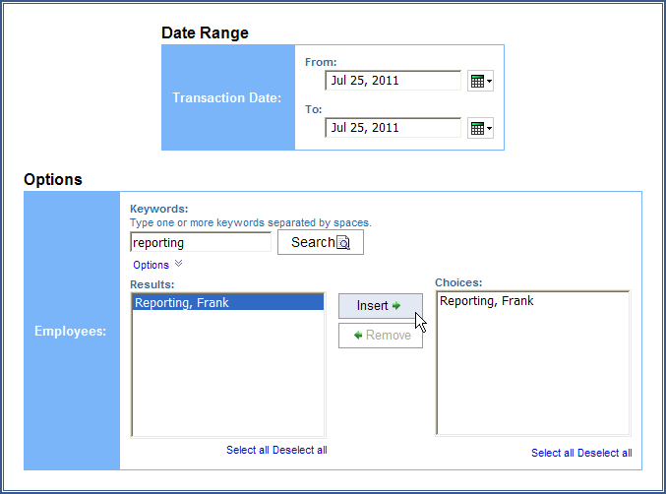

Date Range Prompt
- Transaction Date: Used to filter the report by the date range that the transactions were incurred

Options Prompt
- Employees: Used to filter the report by the name of employee(s) who booked trips

Report Output
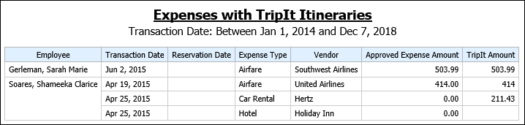

Report Header and Footer
Data Item Label/Name | Data Item Expression | Data Item Description
Transaction Date | ParamDisplayValue('transactionDateParam') | Displays the date range from the Transaction Date prompt on the Prompts page

Report Data Items
Data Item Label | Data Item Name | Data Item Expression | Data Item Description
Employee | <Employee> | [Expense].[Report Header Information].[Employee] | Employee last name, first name, and middle initial
Transaction Date | <Transaction Date> | [Expense].[Entry Information].[Transaction Date] | Date that the expense was incurred in Concur Travel and Expense
Reservation Date | <Transaction Date (TripIt)> | [Expense].[Entry Information].[Transaction Date (TripIt)] | Date that the expense was incurred in TripIt
Expense Type | <Expense Type> | [Expense].[Entry Information].[Expense Type] | Expense type assigned to the expense
Vendor | <Vendor> | [Expense].[Entry Information].[Vendor] | Vendor associated with the expense
Approved Expense Amount | <Approved Amount (rpt)> | [Expense].[Entry Information].[Approved Amount (rpt)] | Amount of the expense approved for reimbursement, converted as needed to the reporting currency
TripIt Amount | <Total Amount (reporting currency) | [Expense].[Entry Information].[Total Amount (reporting currency)] | Total amount of the expenses on the report approved for reimbursement, converted as needed to the reporting currency

Report: Missing Receipt Audit
Available to:  Analysis  Intelligence
Uses: R Expense Data  Travel / TripLink Data
This report shows a list of expenses that are missing receipts.

Report Prompts
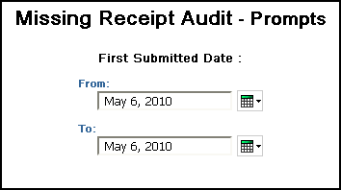
- First Submitted Date: Used to filter the report by the date range that the expense reports were first submitted for approval

Report Output
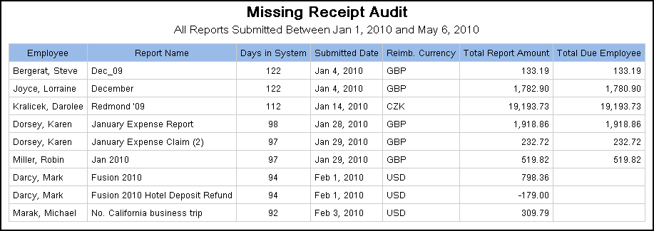

Report Header and Footer
Data Item Label/Name | Data Item Expression | Data Item Description
All Reports Submitted | ParamDisplayValue('First Submitted Date') | Displays the date range from the First Submitted Date prompt on the Prompts page
N/A | AsOfDate() | Displays the date the report was run
N/A | PageNumber() | Displays the page number of the corresponding page
N/A | AsOfTime() | Displays the time the report was run

Report Data Items
Data Item Label | Data Item Name | Data Item Expression | Data Item Description
Employee | <Employee> | [Expense].[Report Header Information].[Employee] | Employee last name, first name, and middle initial
Report Name | <Report Name> | [Expense].[Report Header Information].[Report Name] | Employee-entered name of the expense report
Days in System | <Days in System> | _days_between(getdate(),[Expense].[Report Dates and Statuses].[First Submitted Date]) | Number of days between the date the report was run and the date that the expense report was first submitted for approval
Submitted Date | <Submitted Date> | [Expense].[Report Dates and Statuses].[First Submitted Date] | Date that the expense report was first submitted for approval  NOTE: If the report was returned to the employee and had to be resubmitted, this date is the date the report was first submitted.
Reimb. Currency | <Reimbursement Currency> | [Expense].[Report Header Information].[Reimbursement Currency] | Currency in which the employee was reimbursed
Total Report Amount | <Total Report Amount> | [Expense].[Report Header Information].[Total Report Amount] | Total amount of the expenses on the report
Total Due Employee | <Total Due Employee> | [Expense].[Report Header Information].[Total Due Employee] | Total amount to be reimbursed to the employee

Report: Payment Type Analysis
Available to:  Analysis  Intelligence
Uses: R Expense Data  Travel / TripLink Data
This report allows users to evaluate employee spend by the method of payment.

Report Prompts
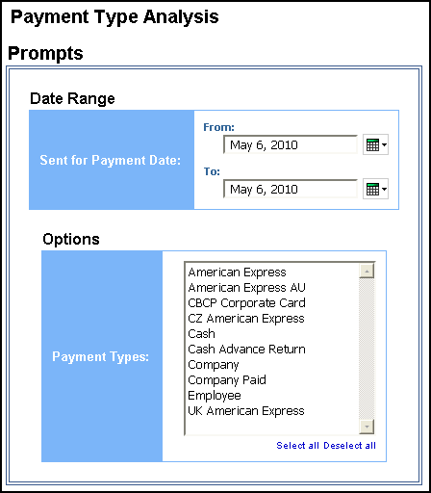

Report Output
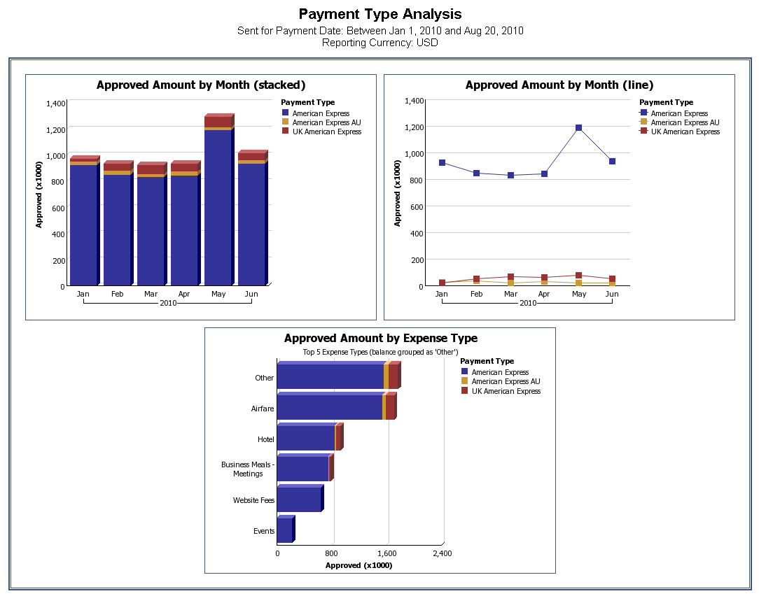
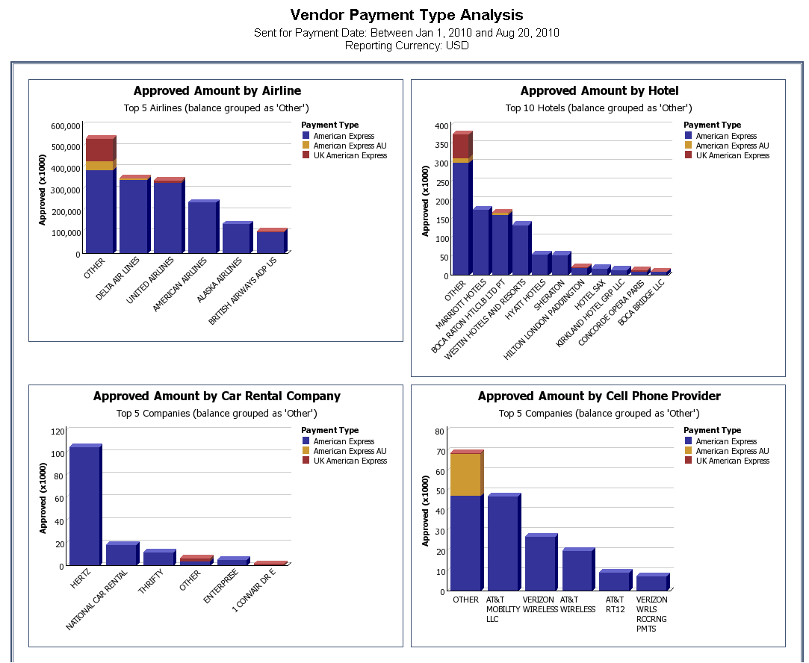

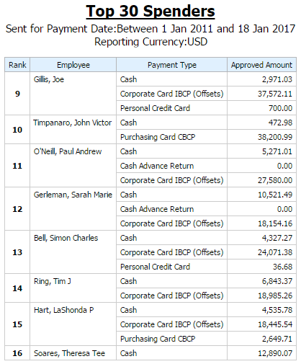
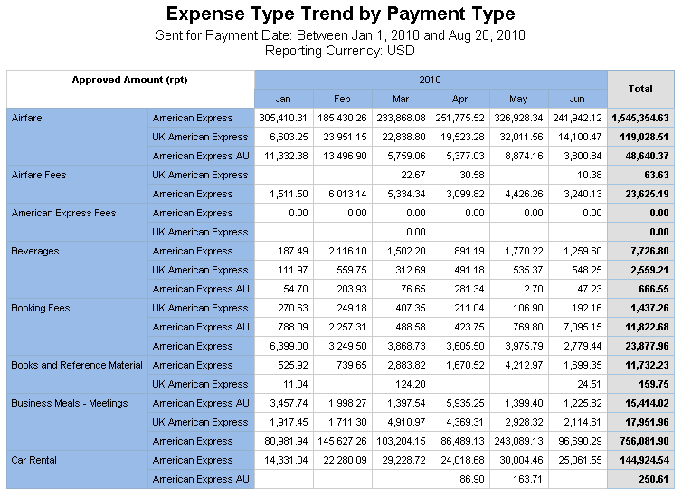
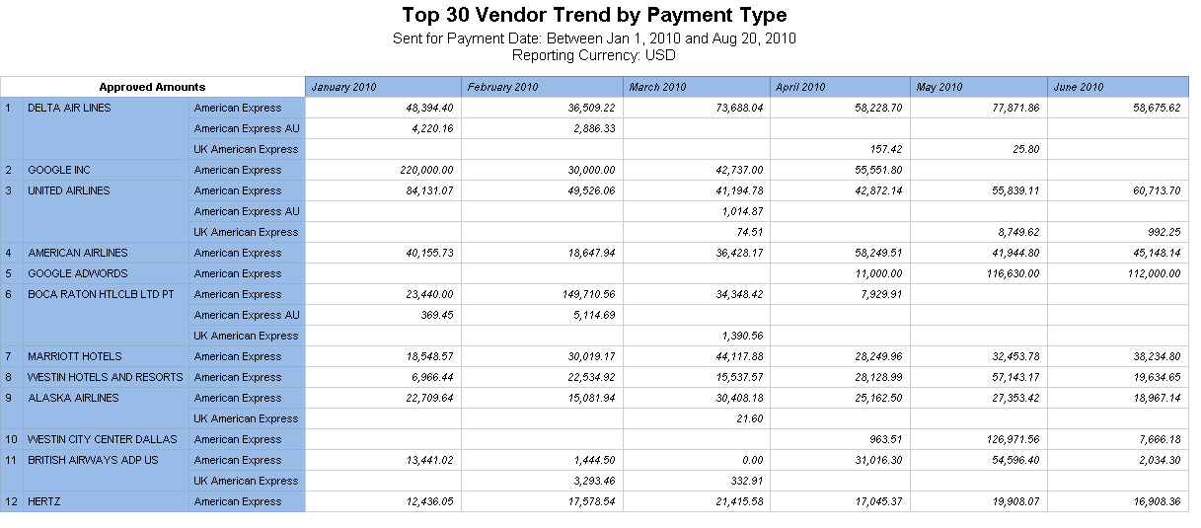

Report Header and Footer
Data Item Label/Name | Data Item Expression | Data Item Description
Sent For Payment Date | ParamDisplayValue('Date Sent for Payment') | Displays the date range from the Sent for Payment Date prompt on the Prompts page
Reporting Currency | [Expense].[Report Header Information].[Reporting Currency] | Displays the currency code in which the reporting currency is shown (for example, USD, CAD, GBP)

Report Data Items
Data Item Label | Data Item Name | Data Item Expression | Data Item Description
Approved Amount | <Approved Amount> | [Expense].[Entry Information].[Approved Amount (rpt)] | Displays the approved amount on the graph's y-axis
Payment Type | <Payment Type> | [Expense].[Entry Information].[Payment Type] | Displays the payment type
Year | <Year> | [Expense].[Report Dates and Statuses].[Year] | Displays the year on the graph's x-axis
Month Name | <Month Name> | [Expense].[Report Dates and Statuses].[Month] | Displays the month on the graph's x-axis

Report: Reports Approved but Receipts Not Viewed
Available to:  Analysis  Intelligence
Uses: R Expense Data  Travel / TripLink Data
Provide a list of approvers who are not looking at the receipts, both report and entry level, as part of the approval process.

Report Prompts
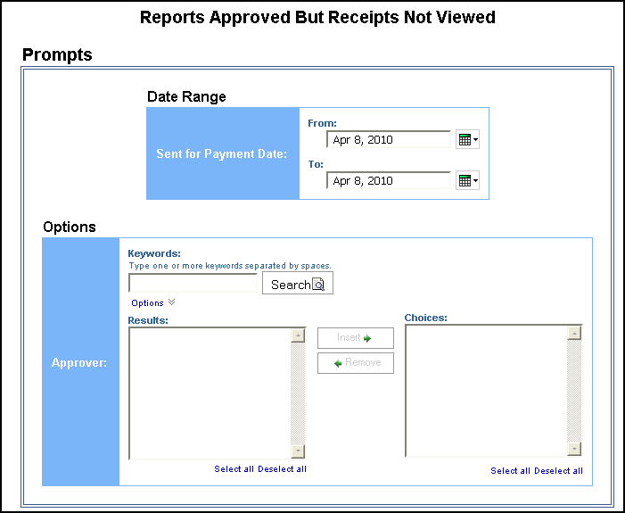

Date Range Prompt
- Sent for Payment Date: Used to filter the report by the date range that the expenses were paid

Options Prompt
- Approver: Used to filter the report by the name of the report approver

Report Output
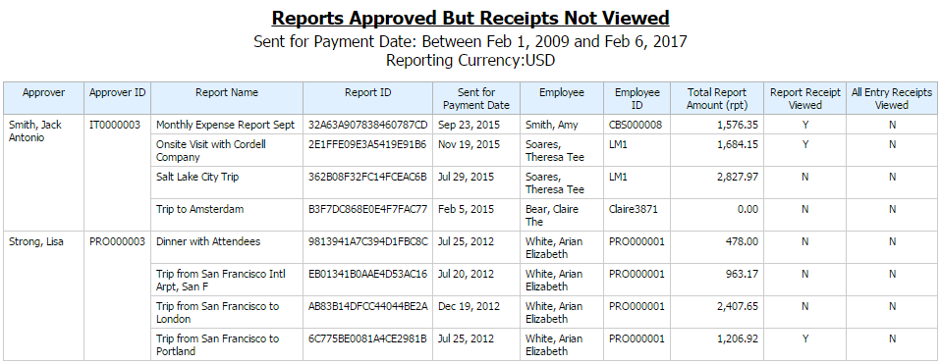

Report Header and Footer
Data Item Label/Name | Data Item Expression | Data Item Description
Sent for Payment Date | ' ' + ParamDisplayValue('sentForPaymentDateParam') | Displays the date range from the Sent for Payment prompt on the Prompts page
Reporting Currency | [Expense].[Report Header Information].[Reporting Currency] | Displays the currency code in which the reporting currency is shown (for example, USD, CAD, GBP)

Report Data Items
Data Item Label | Data Item Name | Data Item Expression | Data Item Description
Approver | <Approver> | [Expense].[Expense Report Workflow Trail].[Employee Assigned to Step] | Last name, first name, and middle initial of the employee designated to take action in this step of the workflow
Approver ID | <Approver ID> | [Expense].[Expense Report Workflow Trail].[Employee ID] | Unique number or code that identifies the employee designated to take action in this step of the workflow
Report Name | <Report Name> | [Expense].[Report Header Information].[Report Name] | Employee-entered name of the expense report
Report ID | <Report ID> | [Expense].[Report Header Information].[Report ID] | Unique system-assigned code that identifies the expense report
Sent for Payment Date | <Sent for Payment Date> | [Expense].[Report Dates and Statuses].[Sent for Payment Date] | Date the expense report was extracted from the expense system for payment in another accounting system (such as accounts payable or payroll)
Employee | <Employee> | [Expense].[Report Header Information].[Employee] | Employee last name, first name, and middle initial
Employee ID | <Employee ID> | [Expense].[Report Header Information].[Employee ID] | Unique number or code that identifies the employee
Total Report Amount (rpt) | <Total Report Amount (rpt)> | [Expense].[Report Header Information].[Total Report Amount (rpt)] | Total amount of the expenses on the report
Report Receipt Viewed | <Report Receipt Viewed> | CASE  WHEN [Query3].[Report] ='N' and # sq($runLocale )# = 'en' THEN 'No'  WHEN [Query3].[Report] ='N' and # sq($runLocale )# = 'zh-cn' THEN '否'  WHEN [Query3].[Report] ='N' and # sq($runLocale )# = 'zh-tw' THEN '否'  WHEN [Query3].[Report] ='N' and # sq($runLocale )# = 'en-gb' THEN 'No'  WHEN [Query3].[Report] ='N' and # sq($runLocale )# = 'fr' THEN 'Non'  WHEN [Query3].[Report] ='N' and # sq($runLocale )# = 'de' THEN 'Nein'  WHEN [Query3].[Report] ='N' and # sq($runLocale )# = 'ja' THEN 'いいえ'  WHEN [Query3].[Report] ='N' and # sq($runLocale )# = 'it' THEN 'No'  WHEN [Query3].[Report] ='N' and # sq($runLocale )# = 'ko' THEN '아니요'  WHEN [Query3].[Report] ='N' and # sq($runLocale )# = 'sv' THEN 'Nej'  WHEN [Query3].[Report] ='N' and # sq($runLocale )# = 'nl' THEN 'Nee'  WHEN [Query3].[Report] ='N' and # sq($runLocale )# ='cs' then 'Ne'  WHEN [Query3].[Report] ='N' and # sq($runLocale )# ='pt-BR' then 'Não'  WHEN [Query3].[Report] ='N' and # sq($runLocale )# ='es' then 'No'  else  (  case  WHEN # sq($runLocale )# = 'en' THEN 'Yes'  WHEN # sq($runLocale )# = 'zh-cn' THEN '是'  WHEN # sq($runLocale )# = 'zh-tw' THEN '是'  WHEN # sq($runLocale )# = 'en-gb' THEN 'Yes'  WHEN # sq($runLocale )# = 'fr' THEN 'Oui'  WHEN # sq($runLocale )# = 'de' THEN 'Ja'  WHEN # sq($runLocale )# = 'ja' THEN 'はい'  WHEN # sq($runLocale )# = 'it' THEN 'Sì'  WHEN # sq($runLocale )# = 'ko' THEN '예'  WHEN # sq($runLocale )# = 'sv' THEN 'Ja'  WHEN # sq($runLocale )# = 'nl' THEN 'Ja'  WHEN # sq($runLocale )# ='cs' then 'Ano'  WHEN # sq($runLocale )# ='pt-BR' then 'Sim'  WHEN # sq($runLocale )# ='es' then 'Sí'  end  )  END | Indicates if the report receipt was viewed by “yes” or “no” in the reporting country language
All Entry Receipts Viewed | <All Entry Receipts Viewed> | CASE  WHEN [Query3].[Entries] ='N' and # sq($runLocale )# = 'en' THEN 'No'  WHEN [Query3].[Entries] ='N' and # sq($runLocale )# = 'zh-cn' THEN '否'  WHEN [Query3].[Entries] ='N' and # sq($runLocale )# = 'zh-tw' THEN '否'  WHEN [Query3].[Entries] ='N' and # sq($runLocale )# = 'en-gb' THEN 'No'  WHEN [Query3].[Entries] ='N' and # sq($runLocale )# = 'fr' THEN 'Non'  WHEN [Query3].[Entries] ='N' and # sq($runLocale )# = 'de' THEN 'Nein'  WHEN [Query3].[Entries] ='N' and # sq($runLocale )# = 'ja' THEN 'いいえ'  WHEN [Query3].[Entries] ='N' and # sq($runLocale )# = 'it' THEN 'No'  WHEN [Query3].[Entries] ='N' and # sq($runLocale )# = 'ko' THEN '아니요'  WHEN [Query3].[Entries] ='N' and # sq($runLocale )# = 'sv' THEN 'Nej'  WHEN [Query3].[Entries] ='N' and # sq($runLocale )# = 'nl' THEN 'Nee'  WHEN [Query3].[Entries] ='N' and # sq($runLocale )# ='cs' then 'Ne'  WHEN [Query3].[Entries] ='N' and # sq($runLocale )# ='pt-BR' then 'Não'  WHEN [Query3].[Entries] ='N' and # sq($runLocale )# ='es' then 'No'  else  (  case  WHEN # sq($runLocale )# = 'en' THEN 'Yes'  WHEN # sq($runLocale )# = 'zh-cn' THEN '是'  WHEN # sq($runLocale )# = 'zh-tw' THEN '是'  WHEN # sq($runLocale )# = 'en-gb' THEN 'Yes'  WHEN # sq($runLocale )# = 'fr' THEN 'Oui'  WHEN # sq($runLocale )# = 'de' THEN 'Ja'  WHEN # sq($runLocale )# = 'ja' THEN 'はい'  WHEN # sq($runLocale )# = 'it' THEN 'Sì'  WHEN # sq($runLocale )# = 'ko' THEN '예'  WHEN # sq($runLocale )# = 'sv' THEN 'Ja'  WHEN # sq($runLocale )# = 'nl' THEN 'Ja'  WHEN # sq($runLocale )# ='cs' then 'Ano'  WHEN # sq($runLocale )# ='pt-BR' then 'Sim'  WHEN # sq($runLocale )# ='es' then 'Sí'  end  )  END | Indicates if all report entry receipts were viewed by “yes” or “no” in the reporting country language

Report: Top 10 Longest To Approve
Available to:  Analysis  Intelligence
Uses: R Expense Data  Travel / TripLink Data
This report provides a rank of the longest time to approve expense reports.

Report Prompts
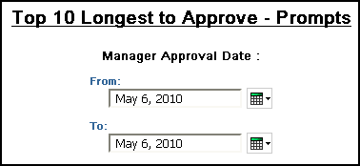

- Manager Approval Date: Used to filter the report by the date range that the workflow steps were approved by a manager in the workflow process

Report Output
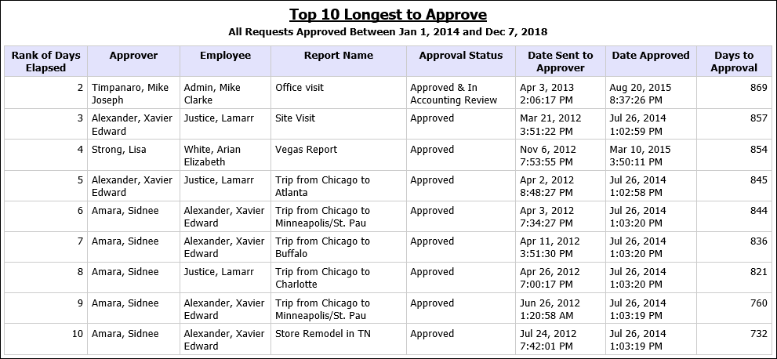

Report Header and Footer
Data Item Label/Name | Data Item Expression | Data Item Description
All Requests Approved | ParamDisplayValue('Step Action Date/Time') | Displays the date range from the Manager Approval Date prompt on the Prompts page
N/A | AsOfDate() | Displays the date the report was run
N/A | PageNumber() | Displays the page number of the corresponding page
N/A | AsOfTime() | Displays the time the report was run

Report Data Items
Data Item Label | Data Item Name | Data Item Expression | Data Item Description
Ranks of Days Elapsed | <Ranks of Days Elapsed> | rank([Days to Approval]) | Rank of the number of days between the Date Sent to Approver and the Date Approved
Approver | <Employee Assigned to Step> | [Expense].[Expense Report Workflow Trail].[Employee Assigned to Step] | Last name, first name, and middle initial of the employee designated to take action in this step of the workflow
Employee | <Employee> | [Expense].[Report Header Information].[Employee] | Employee last name, first name, and middle initial
Report Name | <Report Name> | [Expense].[Report Header Information].[Report Name] | Employee-entered name of the expense report
Approval Status | <Approval Status> | [Expense].[Report Dates and Statuses].[Approval Status] | Status of the expense report in the approval process
Date Sent to Approver | <Step Entry Date/Time> | [Expense].[Expense Report Workflow Trail].[Step Entry Date/Time] | Date and time when the transaction moved into this step in the workflow
Date Approved | <Step Action Date/Time> | [Expense].[Expense Report Workflow Trail].[Step Action Date/Time] | Date and time when action was taken to complete this workflow step
Days to Approval | <Days to Approval> | _days_between([Step Action Date/Time],[Step Entry Date/Time]) | Number of days between the Date Sent to Approver and the Date Approved

Report: Unsubmitted Expense Entry Analysis Details (grouped by Employee)
Available to:  Analysis  Intelligence
Uses: R Expense Data  Travel / TripLink Data
This report shows a list of expenses – grouped by employee – that have been entered on expense reports but not submitted during a specified timeframe.

Report Prompts
The user may select specific expense types, employees, date range, or spending amounts. All prompts are optional.
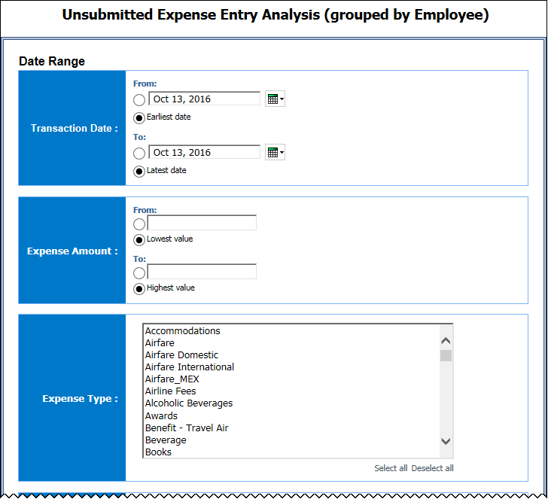
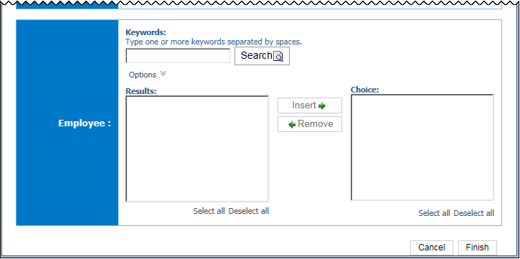

Date Range Prompts
- Transaction Date:
- From: Used to filter the report using a defined start date that transactions were incurred
- To: Used to filter the report using a defined end date that transactions were incurred
- Earliest Date: Used to filter the report using the earliest date that transactions were incurred
- Latest Date: Used to filter the report using the latest date that transactions were incurred
- Expense Amount:
- From: Used to filter the report using a defined minimum amount of the expenses
- To: Used to filter the report using a defined maximum amount of the expenses
- Lowest value: Used to filter the report using the lowest amount available of the expenses
- Highest value: Used to filter the report using the highest amount available of the expenses
- Expense Type: Used to filter the report by the expense type(s) assigned to the expenses
- Employee: Used to filter the report by the name of employee(s) who booked trips

Report Output
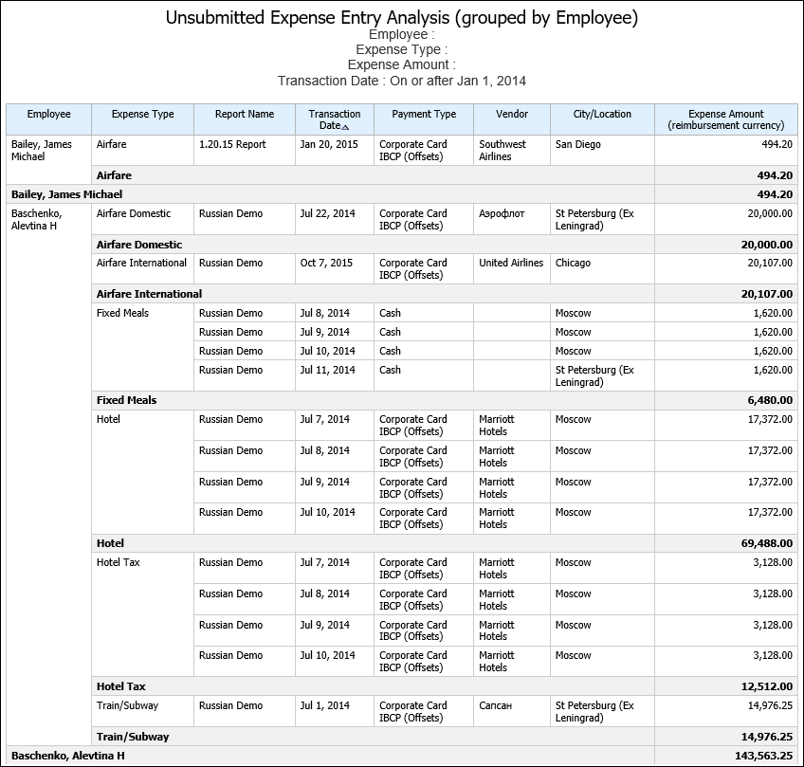

Report Header and Footer
Data Item Label/Name | Data Item Expression | Data Item Description
Employee | ' '+ParamDisplayValue('Employee') | Displays the employee name(s) from the Employee prompt on the Prompts page
Expense Type | ' '+ParamDisplayValue('Expense_Type') | Displays the expense type(s) from the Expense Type prompt on the Prompts page
Expense Amount | ' '+ParamDisplayValue('Expense_Amount_(reimbursement_currency)') | Displays the values from the Expense Amount prompt on the Prompts page
Transaction Date | ' '+ParamDisplayValue('Transaction_Date') | Displays the date range from the Transaction Date prompt on the Prompts page
N/A | AsOfDate() | Displays the date the report was run
N/A | PageNumber() | Displays the page number of the corresponding page
N/A | AsOfTime() | Displays the time the report was run

Report Data Items
Data Item Label | Data Item Name | Data Item Expression | Data Item Description
Employee | <Employee> | [Expense].[Report Header Information].[Employee] | Employee last name, first name, and middle initial
Expense Type | <Expense Type> | [Expense].[Entry Information].[Expense Type] | Expense type assigned to the expense
Report Name | <Report Name> | [Expense].[Report Header Information].[Report Name] | Employee-entered name of the expense report
Transaction Date | <Transaction Date> | [Expense].[Entry Information].[Transaction Date] | Date that the expense was incurred
Payment Type | <Payment Type> | [Expense].[Entry Information].[Payment Type] | Method by which the employee paid for the expense, such as cash or a credit card
Vendor | <Vendor> | [Expense].[Entry Information].[Vendor] | Vendor associated with the expense
City/Location | <City/Location> | [Expense].[Entry Information].[City/Location] | City or location where the expense was incurred
Expense Amount (reimbursement currency) | <Expense Amount (reimbursement currency)> | [Expense].[Entry Information].[Expense Amount (reimbursement currency)] | Amount of the expense, converted as needed to the employee's reimbursement currency

Report: Unsubmitted Expense Entry Analysis Details (grouped by Expense Type)
Available to:  Analysis  Intelligence
Uses: R Expense Data  Travel / TripLink Data
This report lists expenses –grouped by expense type – that have been entered on expense reports but not submitted during a specified timeframe.

Report Prompts
The user may select specific expense types, employees, date range, or spending amounts. All prompts are optional.
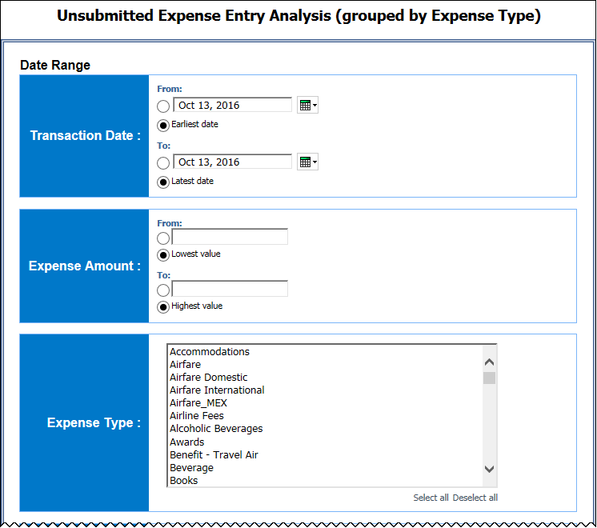
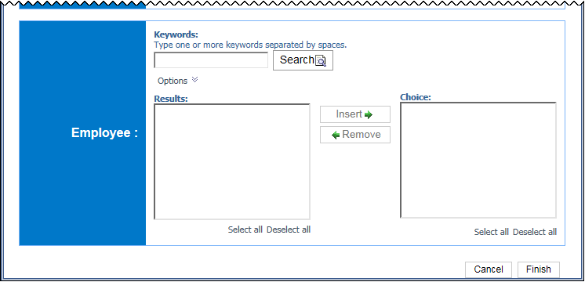

Date Range Prompt
- Start Date: Used to filter the report by the date range that the expenses were paid
- Expense Type: Used to filter the report by the expense type(s) assigned to the expenses
- Employee: Used to filter the report by the name of employee(s) who booked trips
- Approved Amount (rpt):
- From: Used to filter the report using a defined minimum amount of the expenses approved for reimbursement, converted as needed to the reporting currency
- To: Used to filter the report using a defined maximum amount of the expenses approved for reimbursement, converted as needed to the reporting currency
- Lowest value: Used to filter the report using the lowest amount available of the expenses approved for reimbursement, converted as needed to the reporting currency
- Highest value: Used to filter the report using the highest amount available of the expenses approved for reimbursement, converted as needed to the reporting currency

Report Output
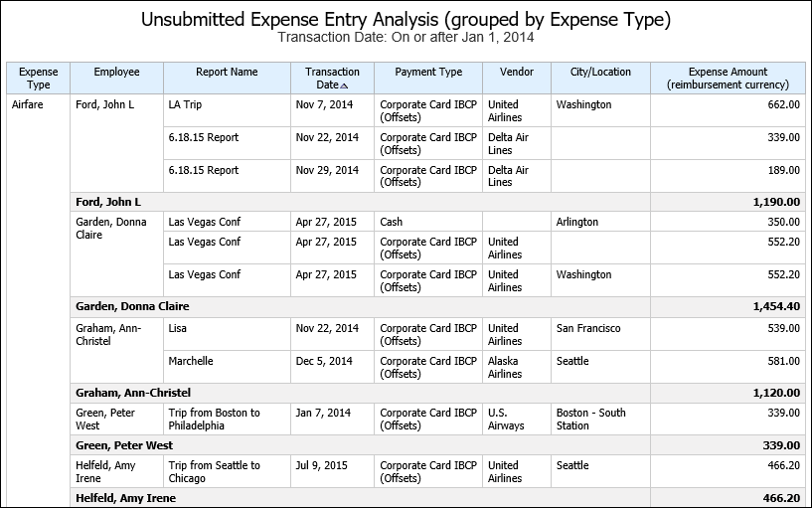

Report Header and Footer
Data Item Label/Name | Data Item Expression | Data Item Description
Start Date | ParamDisplayValue('Sent for Payment Date') | Displays the date range from the Start Date prompt on the Prompts page
Expense Type | ' '+ParamDisplayValue('Expense Type') | Displays the expense type(s) from the Expense Type prompt on the Prompts page
Employee | ' '+ParamDisplayValue('Employee') | Displays the employee name(s) from the Employee prompt on the Prompts page
Approved Amount | ' '+ParamDisplayValue('Approved Amount (rpt)') | Displays the values from the Approved Amount (rpt) prompt on the Prompts page
N/A | AsOfDate() | Displays the date the report was run
N/A | PageNumber() | Displays the page number of the corresponding page
N/A | AsOfTime() | Displays the time the report was run

Report Data Items
Data Item Label | Data Item Name | Data Item Expression | Data Item Description
Expense Type | <Expense Type> | [Expense].[Entry Information].[Expense Type] | Expense type assigned to the expense
Employee | <Employee> | [Expense].[Report Header Information].[Employee] | Employee last name, first name, and middle initial
Report Name | <Report Name> | [Expense].[Report Header Information].[Report Name] | Employee-entered name of the expense report
Transaction Date | <Transaction Date> | [Expense].[Entry Information].[Transaction Date] | Date that the expense was incurred
Payment Type | <Payment Type> | [Expense].[Entry Information].[Payment Type] | Method by which the employee paid for the expense, such as cash or a credit card
Vendor | <Vendor> | [Expense].[Entry Information].[Vendor] | Vendor associated with the expense
City/Location | <City/Location> | [Expense].[Entry Information].[City/Location] | City or location where the expense was incurred

Report: Workflow Aging - Details
Available to:  Analysis  Intelligence
Uses: R Expense Data  Travel / TripLink Data
This report identifies the expense reports that are pending approval, including the approvers associated with the reports, to help ensure approval of expense reports in a timely manner.

Report Prompts
When a company has Cost Object Approvals (COA) enabled, the Prompts page displays the Show only Cost Object Steps prompt. When Yes is selected, the report displays COA fields.
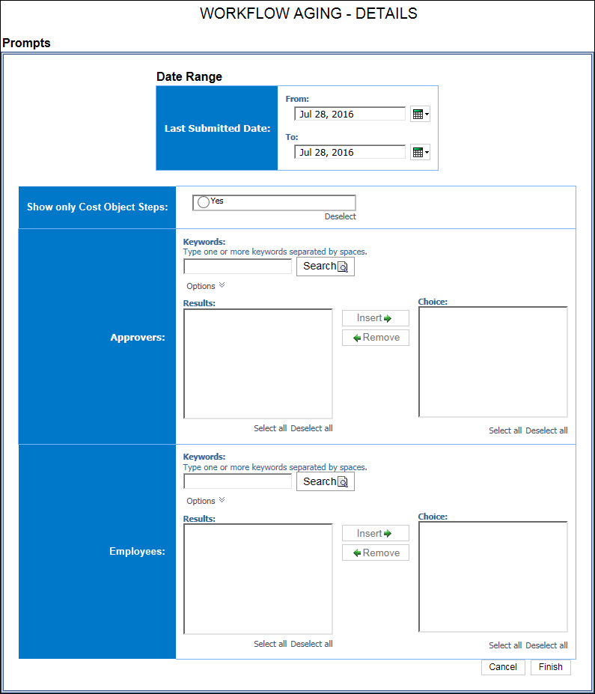

Report Output
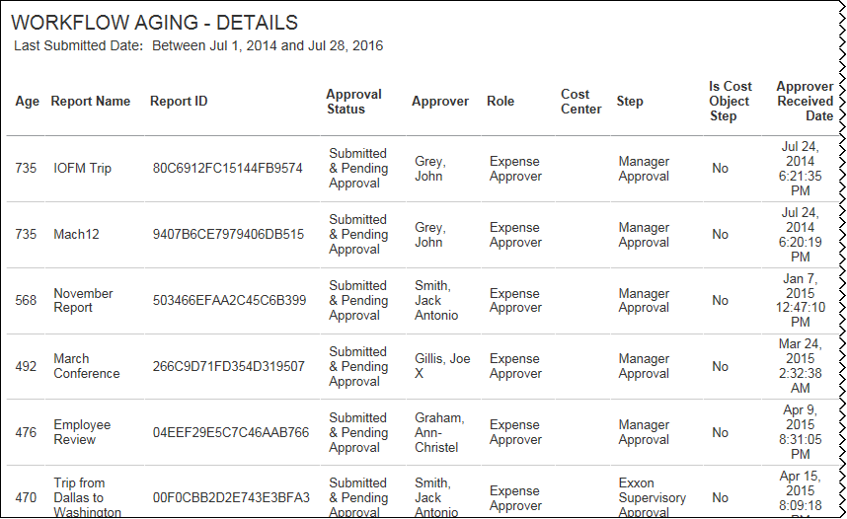
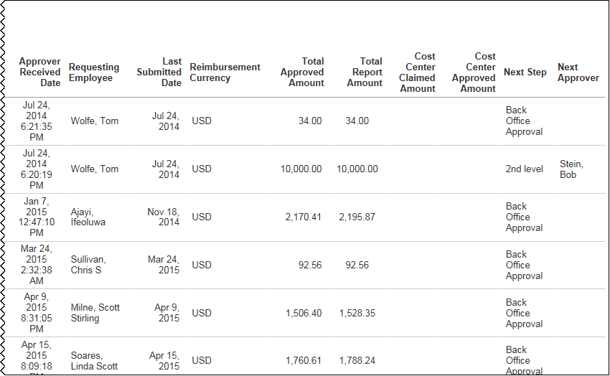

Report: Workflow Cycle Times - Details
Available to:  Analysis  Intelligence
Uses: R Expense Data  Travel / TripLink Data
This report provides details of workflow cycle times; shows the time it took for a report to move through the major workflow steps.

Report Prompts
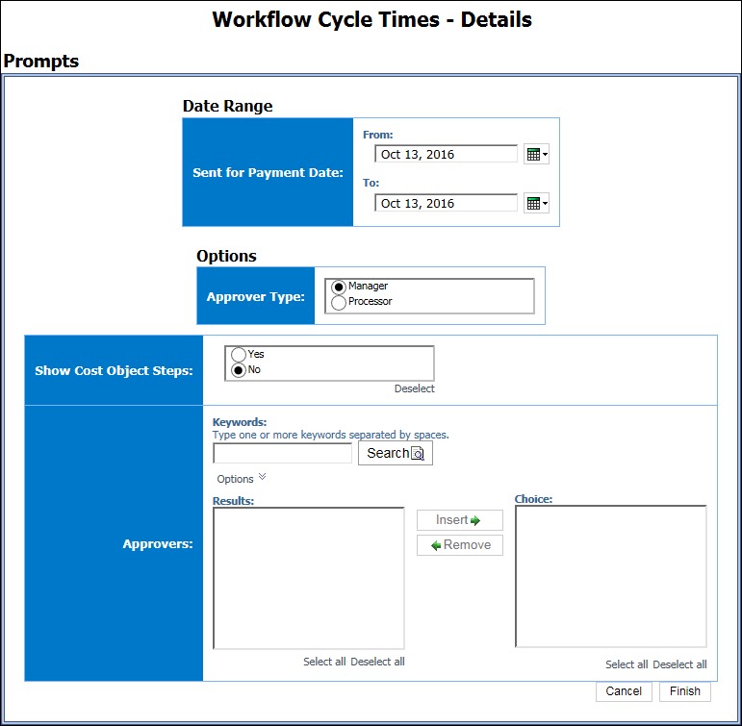

Date Range Prompt
- Sent for Payment Date: Used to filter the report by the date range that the expenses were paid

Options Prompts
- Approver Type: Used to filter the report by the approver type, Manager or Processor
- Show Cost Object Steps: Used to select whether to show the cost object steps fields in the report when Cost Object Steps (COA) are enabled
- Approvers: Used to filter the report by the name of the report approver(s)

Report Output
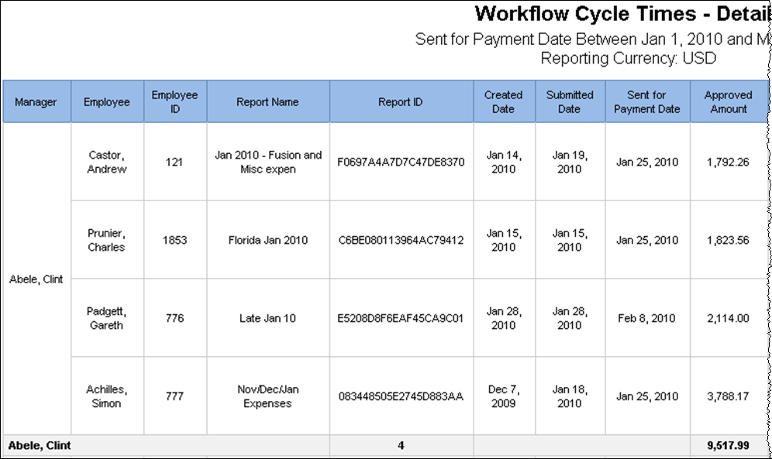
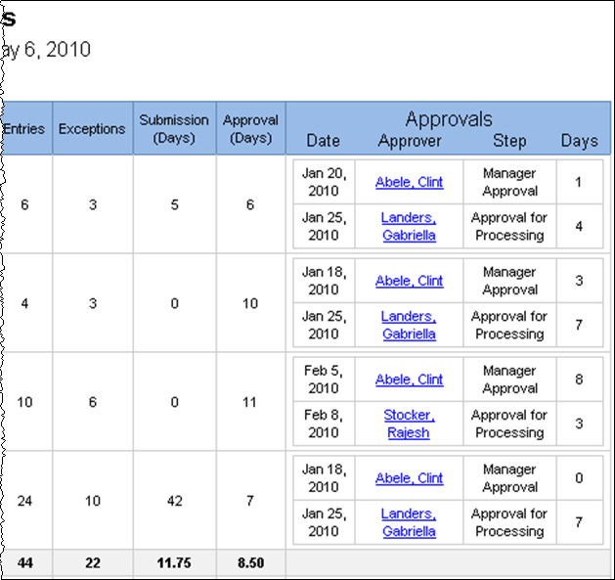

Report Header and Footer
Data Item Label/Name | Data Item Expression | Data Item Description
Sent for Payment Date | ' ' + ParamDisplayValue('dateSentForPaymentParam') | Displays the date range from the Sent for Payment Date prompt on the Prompts page
Reporting Currency | [Main].[Reporting Currency] | Displays the currency code in which the reporting currency is shown (for example, USD, CAD, GBP)
N/A | AsOfDate() | Displays the date the report was run
N/A | PageNumber() | Displays the page number of the corresponding page
N/A | AsOfTime() | Displays the time the report was run

Report Data Items

Main
Data Item Label | Data Item Name | Data Item Expression | Data Item Description
Manager | <Approver> | [Expense].[Expense Report Workflow Trail].[Employee Assigned to Step] | Last name, first name, and middle initial of the employee designated to take action in this step of the workflow
Employee | <Employee> | [Expense].[Report Header Information].[Employee] | Employee last name, first name, and middle initial
Employee ID | <Employee ID> | [Expense].[Report Header Information].[Employee ID] | Unique number or code that identifies the employee
Report Name | <Report Name> | [Expense].[Report Header Information].[Report Name] | Employee-entered name of the expense report
Report ID | <Report ID> | [Expense].[Report Header Information].[Report ID] | Unique system-assigned code that identifies the expense report
Created Date | <Created Date> | [Expense].[Report Dates and Statuses].[Created Date] | Date that the expense report was created
Submitted Date | <Last Submitted Date> | [Expense].[Report Dates and Statuses].[Last Submitted Date] | Date that the expense report was last submitted by the employee for approval  NOTE: If the employee submitted the report more than once, for example, because it was returned to the employee for corrections, this date is the date the report was last submitted.
Sent for Payment Date | <Sent for Payment Date> | [Expense].[Report Dates and Statuses].[Sent for Payment Date] | Date the expense report was extracted from the expense system for payment in another accounting system (such as accounts payable or payroll)
Approved Amount | <Total Approved Amount (rpt)> | [Expense].[Report Header Information].[Total Approved Amount (rpt)] | Total amount approved to be reimbursed
Entries | <Number of Entries> | [Expense].[Report Header Information].[Number of Entries] | Total number of entries submitted on the expense report
Exceptions | <Number of Exceptions> | [Expense].[Report Header Information].[Number of Exceptions] | Total number of exceptions generated for the expense report, at either the report header level or entry level
Submission (Days) | <Submission (Days)> | _days_between([Last Submitted Date],[Created Date]) | Number of days between the date that the expense report was last submitted by the employee for approval and the date that the expense report was created
Approval (Days) | <Approval (Days)> | _days_between([Sent for Payment Date],[Last Submitted Date]) | Number of days between the date the expense report was extracted from the expense system for payment and the date that the expense report was last submitted by the employee for approval
Approvals
Date | <Approved Date> | [Expense].[Expense Report Workflow Trail].[Step Action Date/Time] | Date and time when action was taken to complete this workflow step
Approver | <Approver> | [Expense].[Expense Report Workflow Trail].[Employee Assigned to Step] | Last name, first name, and middle initial of the employee designated to take action in this step of the workflow
Step | <Step> | [Expense].[Expense Report Workflow Trail].[Step] | Name of a particular step in the workflow
Days | <Approver Time> | _days_between([Expense].[Expense Report Workflow Trail].[Step Action Date/Time],[Expense].[Expense Report Workflow Trail].[Step Entry Date/Time]) | Number of days between the date and time when action was taken to complete the workflow step and the date and time when the transaction moved into the step in the workflow

WorkflowCostObject
Data Item Label | Data Item Name | Data Item Expression | Data Item Description
N/A | <Approver> | [Expense].[Expense Report Workflow Trail].[Employee Assigned to Step] | Last name, first name, and middle initial of the employee designated to take action in this step of the workflow
Employee | <Employee> | [Expense].[Report Header Information].[Employee] | Employee last name, first name, and middle initial
Employee ID | <Employee ID> | [Expense].[Report Header Information].[Employee ID] | Unique number or code that identifies the employee
Report Name | <Report Name> | [Expense].[Report Header Information].[Report Name] | Employee-entered name of the expense report
Report ID | <Report ID> | [Expense].[Report Header Information].[Report ID] | Unique system-assigned code that identifies the expense report
Created Date | <Created Date> | [Expense].[Report Dates and Statuses].[Created Date] | Date that the expense report was created
Submitted Date | <Last Submitted Date> | [Expense].[Report Dates and Statuses].[Last Submitted Date] | Date that the expense report was last submitted by the employee for approval  NOTE: If the employee submitted the report more than once, for example, because it was returned to the employee for corrections, this date is the date the report was last submitted.
Sent for Payment Date | <Sent for Payment Date> | [Expense].[Report Dates and Statuses].[Sent for Payment Date] | Date the expense report was extracted from the expense system for payment in another accounting system (such as accounts payable or payroll)
Reimbursement Currency | <Reimbursement Currency> | [Expense].[Report Header Information].[Reimbursement Currency] | Currency in which the employee was reimbursed
Approved Amount | <Total Approved Amount> | [Expense].[Report Header Information].[Total Approved Amount] | Total amount approved to be reimbursed
Reporting Currency | <Reporting Currency> | [Expense].[Report Header Information].[Reporting Currency] | Currency defined by the client as the corporate, common currency; various reimbursement currencies are converted to this currency in order to obtain totals in one currency
Approved Amount | <Total Approved Amount (rpt)> | [Expense].[Report Header Information].[Total Approved Amount (rpt)] | Total amount approved to be reimbursed
Entries | <Number of Entries> | [Expense].[Report Header Information].[Number of Entries] | Total number of entries submitted on the expense report
Exceptions | <Number of Exceptions> | [Expense].[Report Header Information].[Number of Exceptions] | Total number of exceptions generated for the expense report, at either the report header level or entry level
Submission (Days) | <Submission (Days)> | _days_between([Last Submitted Date],[Created Date]) | Number of days between the date that the expense report was last submitted by the employee for approval and the date that the expense report was created
Approval (Days) | <Approval (Days)> | _days_between([Sent for Payment Date],[Last Submitted Date]) | Number of days between the date the expense report was extracted from the expense system for payment and the date that the expense report was last submitted by the employee for approval
Approvals
Date | <Approval Date> | [Expense].[Expense Report Workflow Trail].[Step Action Date/Time] | Date and time when action was taken to complete this workflow step
Approver | <Approver> | [Expense].[Expense Report Workflow Trail].[Employee Assigned to Step] | Last name, first name, and middle initial of the employee designated to take action in this step of the workflow
Step | <Step> | [Expense].[Expense Report Workflow Trail].[Step] | Name of a particular step in the workflow
Days | <Approver Time> | _days_between([Expense].[Expense Report Workflow Trail].[Step Action Date/Time],[Expense].[Expense Report Workflow Trail].[Step Entry Date/Time]) | Number of days between the date and time when action was taken to complete the workflow step and the date and time when the transaction moved into the step in the workflow
Step Sequence | <Step Sequence> | [Expense].[Expense Report Workflow Trail].[Step Sequence] | Number that indicates the order or sequence of this particular step within the workflow
Role | <Role> | [Expense].[Expense Report Workflow Trail].[Role] | Role of the employee designated to take action in this step of the workflow
Cost Center | <Cost Center> | [Expense].[Expense Report Workflow Trail].[Cost Center] | Name of the cost center. For cost object approvals.
Is Cost Object Step | <Is Cost Object Step> | [Expense].[Expense Report Workflow Trail].[Is Cost Object Step] | For cost object approvals
Cost Center Approved Amount | <Approved Amount> | [Expense].[Expense Report Workflow Trail].[Approved Amount] | Amount of the expense approved for reimbursement in this workflow step, converted as needed to the employee's reimbursement currency
Cost Center Claimed Amount | <Claimed Amount> | [Expense].[Expense Report Workflow Trail].[Claimed Amount] | Amount of the expense the employee is claiming for reimbursement in this workflow step

Report: Workflow Cycle Times – Summary by Manager
Available to:  Analysis  Intelligence
Uses: R Expense Data  Travel / TripLink Data
This report provides a summary of workflow cycle times by manager; manager name is clickable for drill-through.

Report Prompts
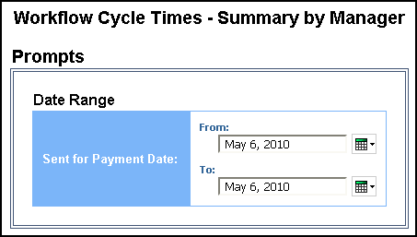

Date Range Prompt
- Sent for Payment Date: Used to filter the report by the date range that the expenses were paid

Report Output
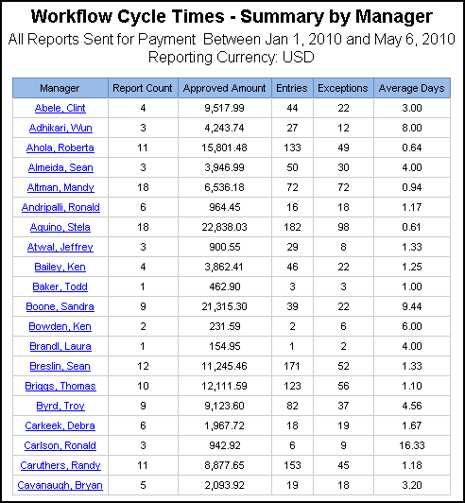

Report Header and Footer
Data Item Label/Name | Data Item Expression | Data Item Description
All Reports Sent for Payment | ' ' + ParamDisplayValue('dateSentForPaymentParam') | Displays the date range from the Sent for Payment Date prompt on the Prompts page
Reporting Currency | ': ' + [Main].[Reporting Currency] | Displays the currency code in which the reporting currency is shown (for example, USD, CAD, GBP)

Report Data Items
Data Item Label | Data Item Name | Data Item Expression | Data Item Description
Manager | <Employee Assigned to Step> | [Expense].[Expense Report Workflow Trail].[Employee Assigned to Step] | Last name, first name, and middle initial of the employee designated to take action in this step of the workflow
Report Count | <Report Count> | [Expense].[Report Header Information].[Report Key] | Count of expense reports approved by the Manager
Approved Amount | <Total Approved Amount (rpt)> | [Expense].[Report Header Information].[Total Approved Amount (rpt)] | Total amount approved to be reimbursed
Entries | <Number of Entries> | [Expense].[Report Header Information].[Number of Entries] | Total number of entries submitted on the expense report
Exceptions | <Number of Exceptions> | [Expense].[Report Header Information].[Number of Exceptions] | Total number of exceptions generated for the expense report, at either the report header level or entry level
Average Days | <Average Time> | average([Approver Time] for [Employee Assigned to Step]) | Average number of days between the date and time when action was taken to complete the workflow step and the date and time when the transaction moved into the step

Report: Workflow Cycle Times – Summary by Processor
Available to:  Analysis  Intelligence
Uses: R Expense Data  Travel / TripLink Data
This report provides a summary of workflow cycle times by processor; processor name is clickable for drill-through.

Report Prompts
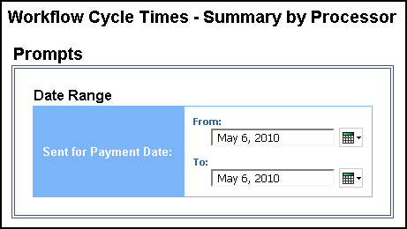

Date Range Prompt
- Sent for Payment Date: Used to filter the report by the date range that the expenses were paid

Report Output
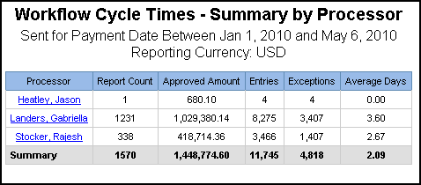

Report Header and Footer
Data Item Label/Name | Data Item Expression | Data Item Description
Sent for Payment Date | ' ' + ParamDisplayValue('dateSentForPaymentParam') | Displays the date range from the Sent for Payment Date prompt on the Prompts page
Reporting Currency | ': ' + [Main].[Reporting Currency] | Displays the currency code in which the reporting currency is shown (for example, USD, CAD, GBP)

Report Data Items
Data Item Label | Data Item Name | Data Item Expression | Data Item Description
Processor | <Employee Assigned to Step> | [Expense].[Expense Report Workflow Trail].[Employee Assigned to Step] | Last name, first name, and middle initial of the employee designated to take action in this step of the workflow
Report Count | <Report Count> | [Expense].[Report Header Information].[Report Key] | Count of expense reports approved by the Processor
Approved Amount | <Total(Total Approved Amount (rpt))> | [Expense].[Report Header Information].[Total Approved Amount (rpt)] | Total amount approved to be reimbursed
Entries | <Total(Number of Entries)> | [Expense].[Report Header Information].[Number of Entries] | Total number of entries submitted on the expense report
Exceptions | <Total(Number of Exceptions)> | [Expense].[Report Header Information].[Number of Exceptions] | Total number of exceptions generated for the expense report, at either the report header level or entry level
Average Days | <Average(Average Time)> | average([Processor Time] for [Employee Assigned to Step]) | Average number of days between the date and time when action was taken to complete the workflow step and the date and time when the transaction moved into the step

☼

